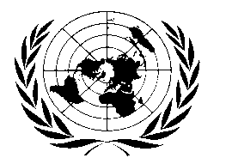
[UN BHUTAN COUNTRY FUND]

BI-ANNUAL PROJECT/PROGRAMME UPDATE

AS OF [31st December 2010]

Participating UN Organization(s) | UNICEF & UNFPA
MDTF Programme Number | 00073262
Programme Title | Health
Approved Budget  (by PO, if applicable) | UNICEF: 56,646 & UNFPA: 141,453
Expenditure  (by PO, if applicable) | UNICEF: 56,646  UNFPA: 141,453 | % of Approved Budget  (by PO, if applicable) | UNICEF: 100%  UNFPA: 100%
Forecast Final Date: | 31st December 2010 | Delay  (if applicable) | NA

Qualitative achievements against objectives and results:
Human resources within the health system was strengthened through the training of:

- Two paediatricians and a member of the National Commission on Immunization Practices vaccinology (Seoul)
- Two EPI technicians on basic maintenance of cold chain equipments and transportation of vaccines (India)
- Two health officials on Child Health Supervision and monitoring (Thailand)
- Four nurses on critical neo-natal care management (Thailand). As a result the neo-natal intensive care units at the national and referral hospitals are now fully staffed with knowledgeable and skilful staff.
- Participation of health authorities and a member of parliament in South Asia Breastfeeding forum

Supply for quality service provision:-

- Purchase of RH commodities and printing and distribution of advocacy materials
- TA support for RH review (ASHR consultant)

