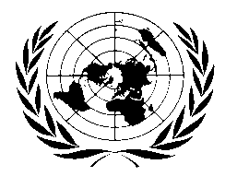
UN BHUTAN COUNTRY FUND

BI-ANNUAL PROJECT/PROGRAMME UPDATE

AS OF 30th July 2010

Participating UN Organization(s) | UNICEF
MDTF Programme Number | 00073262
Programme Title | Health
Approved Budget  (by PO, if applicable) | UNICEF: 56,646
Expenditure  (by PO, if applicable) | UNICEF: 56,646 | % of Approved Budget  (by PO, if applicable) | UNICEF: 100%
Forecast Final Date: | 30th July 2010 | Delay  (if applicable) | NA

Qualitative achievements against objectives and results:
Human resources within the health system was strengthened through the training of:

- Two paediatricians and a member of the National Commission on Immunization Practices vaccinology (Seoul)
- Two EPI technicians on basic maintenance of cold chain equipments and transportation of vaccines (India)
- Two health officials on Child Health Supervision and monitoring (Thailand)
- Four nurses on critical neo-natal care management (Thailand). As a result the neo-natal intensive care units at the national and referral hospitals are now fully staffed with knowledgeable and skilful staff.

In addition, health authorities and a member of parliament participated in South Asia Breastfeeding forum increasing awareness on this important topic.

