Lebanon Recovery Fund

Completion Report

Project Title: Socio-Economic Rehabilitation Programme in the Framework of ART GOLD Lebanon

Project Number: LRF # 19

Completed as of February 28, 2011

- Background Information

  - General project information

Project Title & Number |  | Country, Locality(s), Thematic Area(s)
- Project Title: Socio-Economic Rehabilitation Programme in the Framework of ART GOLD Lebanon  - Project Number: LRF 19  - MDTF Office Atlas Number: 00070663 |  | South Lebanon  North Lebanon  Bekaa region  Beirut Southern Suburbs

Participating Organization(s) |  | Implementing Partners
United Nations Development Programme (UNDP) |  | - National counterparts (government, private, NGOs & others): The Council for Development and Reconstruction

Programme/Project Cost (US$) |  |  | Programme Duration (months)
MDTF Fund Contribution:  - by Agency UNDP | 2,391,450 |  | Overall Duration | 22 Months
Agency Contribution  - by Agency (if applicable) |  |  | Start Date | April 2009
Government Contribution  (if applicable) |  |  | End Date  Revised End Date  (if applicable) | August 2010  February 2011
Other Contribution (donor)  (if applicable) |  |  | Operational Closure Date
TOTAL: | 2,391,450 |  | Expected Financial Closure Date

Number of extensions received and dates
One time | Extension from August 2010 till end of February 2011

Account | Amount Disbursed by project
Account | 00053003 - ARTGOLD Lebanon | 00056944 - ARTGOLD BSS | 00056945 - ARTGOLD South | 00056946 - ARTGOLD Bekaa | 00056947 - ARTGOLD North | 00073242 - Guarantee fund
Salary & Post Adj Cst-IP Staff | 8,955.68 | - | - | - | - | -
Recurrent Payroll Costs-IP Staff | 2,573.01 | - | - | - | - | -
Non-Recurrent Payroll - IP Staff | 38.00 | - | - | - | - | -
Insurance and Security Costs | 3,730.23 | - | - | - | - | -
After Service Insurance | 540.40 | - | - | - | - | -
ALD Employee Costs | 63,446.00 | - | - | - | - | -
International Consultants | 63,000.00 | - | - | - | - | -
Local Consultants | - | - | - | 2,600.00 | 500.00 | -
Contractual Services - Individual | 113,868.72 | 59,834.93 | 91,720.54 | 40,732.36 | 85,700.18 | -
UN Volunteers | 2,646.78 | - | - | - | - | -
Travel | 45,335.69 | 19,111.00 | 6,045.84 | 1,225.09 | - | -
Contractual Services-Companies | 17,138.76 | 232,916.00 | 105,361.91 | 30,850.00 | 24,000.00 | -
Equipment and Furniture | - | 5,571.00 | 77,352.40 | 10,239.55 | 69,296.57 | -
Materials & Goods | - | - | 4,836.20 | 48,557.00 | 42,573.63 | -
Communication & Audio Visual Equip | 3,994.45 | 4,556.23 | 12,665.24 | 1,317.06 | 5,917.99 | -
Supplies | 1,275.44 | 479.85 | 3,592.35 | - | 93.33 | -
Grants | - | - | 47,106.41 | 53,050.00 | 108,834.89 | 520,000.00
Information Technology Equipment | 4,755.77 | 20,183.45 | 3,644.00 | 159.50 | 10,113.70 | -
Rental & Maintenance-Premises | 32,396.45 | - | 271.00 | 13,017.13 | 9,189.27 | -
Rental & Maintenance of Info Tech Equipment | 445.50 | - | 250.00 | - | - | -
Rental & Maintenance of Other Equip | 282.02 | 3,771.48 | 7,180.58 | 1,684.27 | 385.00 | -
Professional Services | 1,589.09 | 1,589.09 | 1,589.09 | 1,589.09 | 1,589.09 | -
Audio Visual &Print Prod Costs | 13,705.98 | 13,134.00 | 12,195.00 | 482.00 | 1,045.00 | -
Contributions | 22,088.05 | - | - | - | - | -
Miscellaneous Expenses | 3,532.68 | 2,142.97 | 4,086.26 | 3,653.52 | 78.67 | -
Agency Management Support (7%) | 28,373.71 | 25,430.30 | 26,452.78 | 14,640.96 | 25,152.21 | 36,400.00
Total Expenditure per project | 433,712.41 | 388,720.30 | 404,349.60 | 223,797.53 | 384,469.53 | 556,400.00

List of Acronyms

UNDP – United Nations Development Programme
AGL – ART GOLD Lebanon
BSS – Beirut Southern Suburbs
DC – Decentralized Corporation
WG- Working Groups
LARI – Lebanese Agricultural Research Institute
FAMSI - Federacion Andaluza de Muinicipios para la Solidaridad Internacional
COCOPA- Coordinamento de Municipi de la province de Turino
IT – Information Technology
LED – Local Economic Development
LEDA – Local Economic Development Agency
TPR – Tri-Partite Review
SME – Small and Medium Enterprise
PHCC – Primary Health Care Center

Attachments to be provided
    - Financial statement
    - Project Deliverables (Final Reports)
    - Publications
    - Media coverage if any: Please refer to annex 3
    - Evaluation report

  - Background and Issues Addressed in the Project:

Through ART GOLD’s participatory methodology and instruments, the programme will tackle issues of socio-economic local development for balanced regional development. This includes strengthening local participatory planning processes, local government strengthening, local economic development and decentralized cooperation. The programme builds on potentialities and capacities in target regions, hence contributing to recovery and socio-economic rehabilitation in Lebanon.

The programme responds to national priorities of poverty reduction and the reduction of regional disparities through interventions in four underserved regions of the country, including North Lebanon, south Lebanon, West Bekaa and Beirut Southern Suburbs.

  - Name of the Responsible Officer

Mr. Raghed Assi, Social and Local Development Portfolio Manager

  - Project Partners and roles:

UNDP AGL adopts a multi-donor strategic framework with the aim to help boosting accountability and strengthening resource effectiveness through uniting and pooling donors’ contributions. The Governments of Italy, Spain, Belgium and Monaco are the major donor countries for ART GOLD Lebanon.

DC Partners: ART GOLD Lebanon has established 50 decentralized cooperation partnerships for development between local communities from Lebanon and European countries. These partnerships helped exchange technical skills, as well as best practice and know-how, benefiting hundreds of Lebanese beekeepers, fruit tree farmers and cow breeders, in addition to enhancing the tourism sector in both North Lebanon and the Bekaa region. To name a few of these DC partners: FAMSI (Federacion Andaluza de Muinicipios para la Solidaridad Internacional, SPAIN), Diputacion de Barcelona, Catalan Cooperative Agency for Development, Tuscany region, COCOPA (Coordinamento de Municipi de la province de Turino, Italy), Sint-Truiden Municipality (Belgium), and Les Amis du Liban from Monaco.

National Partners:

The Council for Development and Reconstruction is the national counterpart of ART GOLD Lebanon. All AGL activities are agreed upon and monitored with the Council for Development and Reconstruction, ensuring projects coherency with the national strategies.
Line ministries are AGL partners at the National Level. The ministry of Interior is implementing a wide scope project on building capacities for local authorities in the four target regions. AGL is partnering with the Ministry of Agriculture in supporting the cow breeding and beekeeping sectors. AGL is also coordinating with the Ministry of Public Health on the primary health care imitative being implemented across the region of BSS. Similarly, coordination with the Ministry of Environment is maintained regarding reforestation projects, falling under the national plan of the Ministry.
Other national partners to AGL are the local authorities. These entities have an intrinsic role to play not only in identifying the local needs and elaborating projects but also in being held responsible for the sustainability of the different AGL initiatives in their regions.

- Project Implementation Details

  - Project Objectives:

The specific objective is to improve the local population’s living conditions through increased access to employment, income, education, health, social integration and the environment, with a special focus on the most vulnerable population. This is done through improving the functioning of local public administration, enhancing basic social services, and promoting a wide participation of local communities in development processes.

Outputs are carried out at the local, national and international levels:

At the local level:

- Governance:
- Improved skills and capacities of local authorities and administration to plan manage and promote human development.
- Improved partnerships between the local authorities and local actors such as civil society stakeholders.
- Lebanese institutions capacitated to take advantage of international partnerships such as decentralized cooperation networks.
- Members of public institutions and civil associations better prepared to operate jointly in local development processes.

- Local Economic Development:
- LEDAs established in the four regions of intervention.
- Local economic development promoted in a balanced and integrated way, hence reducing poverty and increasing access of the deprived sectors of the population to jobs and businesses.
- Endogenous resources and regional competitiveness maximized.
- Number of small productive enterprises increased.
- Increased income for the disadvantaged sectors of the population.
- Productive activities use local resources in a more sustainable way.

- Social Wellbeing:
- Improved coverage of public services and utilities in AGL’s priority sectors of education, health and the environment.
- Improved functioning of public services in the aforementioned social sectors.
- Access for excluded and marginalized areas and persons to basic social services increased.
- Innovations aimed at improving the quality and efficiency of services introduced.
- Social cohesion and dialogue promoted through ART GOLD’s participatory approaches and methodologies.
- Increased initiatives promoting social cohesion, such as the community maps of risks and resources.

  - Project Activities (if any activity has been omitted provide relevant reasons).

Project activities have cut across the sectors of governance, Local economic development, youth, health, and environment.

- Under the governance sector, the initiative towards developing capacities of municipalities on Good Local Governance has started at the field level during the month of January 2011. Each workshop covers 3 main topics: 1. Good Governance and Municipal laws, 2. financial planning and Management, 3. Role of municipalities in Local Development.
Four main partners cooperate in the preparation and implementation of the project: Ministry of Interior and Municipalities (Management and Direction), UNDP (funding and support), Institute des Finances Basil Fuleihan (IoF) and Knowledge Development Company (KDC)(Preparation of the materials and delivery of training).

Twelve workshops have been conducted till the end of February 2011 in Akkar, Tyre, Jezzine, Jbeil, Keserwan, Minnieh/Dinnieh and Batroun.

Number | Place | Dates
1 | Akkar | January 21,22,&23,2011
2 | Akkar | January 21,22,&23,2011
3 | Tyre | February 4,5&6,2011
4 | Tyre | February 4,5&6,2011
5 | Tyre | February 4,5&6,2011
6 | Jezzine | February 11,12&13,2011
7 | Saida | February 11,12&13,2011
8 | Saida El Zahrani | February 11,12&13,2011
9 | Batroun | February 18,19&20,2011
10 | Minnieh | February 18,19&20,2011
11 | Akkar | February 18,19&20,2011
12 | Tripoli | February 25,26,27, 2011

A total of 328 municipal members participated in those workshops. 80% of the participants were Presidents, Vice Presidents. Female participants represent 26% of overall participants, due to the fact that in Lebanon the majority of municipal members are males. Female participation in local authorities should be encouraged.

In order to evaluate the project impact at the field level, two types of evaluation sheets are distributed among the participants: 1st one is filled (Annex 4) on daily basis at the end of each workshop (over three days) addressing the satisfaction of the participants and the other type is filled by the end of workshop (3rd day) for the participants to express their feedback about the trainers performance, content of the training material, logistical preparation, and express additional needs and types of future trainings. The overall, results and analysis of questionnaire have shown general satisfaction toward all aspects of the workshops and the answers ranged between good and excellent in the majority of the questions.
Following municipal elections, twenty four regional working groups were established in the four areas of operation. A participatory approach was adapted, by which all the projects were identified and implemented in full coordination with these working goups. This was coupled with regular meetings and trainings held with working groups. Additionally, around 10 DC partnerships were facilitated between local authorities in Lebanon and in Europe (Italy, spain, Belgium...). Local authorities have engaged in social, health and LED initiatives (social municipal offices, municipal primary health care centers), while some municipalities have taken rigorous steps to incorporate these established entities within their “organigram” for needs identification and projects implementation. ART GOLD works directly with those working groups that represent the local community to prioritize the needs and implement initiatives that meet those needs.

- The Local economic development projects targeted farmers, and women of North Lebanon and South Lebanon. In Abdeh, North Lebanon a soil and water testing laboratory facility has been established to help around 200 farmers and their families to know what to add to the soil for a better harvest. At the beginning, the local farmers didn’t have the facilities that allow them to test the soil to know the time, quantity, type of pesticides usage. They used to put any types of pesticides and pay money without achieving better quality and higher quantity in the production, or they went to laboratories that incurred high costs to do the soil testing. The testing laboratory facility helped them to do the testing at any time with minimal costs. The beneficiaries were able to increase the quality and quantity of their production by better determining the nature and needs of the soil. In south Lebanon, around 11 women cooperatives were grouped into a network and provided with a quality control facility at LARI/Tyre to enable them to test their food products for quality assurance through hygienic and quality control. Moreover, four local economic development offices have been established within the local economic development sector. These offices are staffed by UNDP employees. These offices are temporary until the legal framework is resolved, whereby the agencies will be registered as NGOs. BSS obtained the official registration in December 2010 while the remaining offices are under approval. The role of these offices, is to help the SME ‘s to have increase access to jobs, businesses and provide advice towards productive activities using local resources in a more sustainable way.

- Under the youth sector targeting teenagers whose age ranges from 16 till 20 years old, AGL helped enhance the IT skills and capacities of around 200 youth through the establishment of three IT centers and two cultural centers in North Lebanon. A municipal play ground and a public park in Akkarr and Minieh Dinnieh Cazas were also established targeting 350 youth and 500 children. Additionally, 36 youngsters from Tripoli received vocational training improving their skills for better integration in the job market. In Beirut Southern Suburbs, three social municipal offices were established within the «social intervention addressed to youth project» to promote cultural, recreational and artistic activities addressed to 300 youths.

- Support to primary health care centers took place in Bekaa, North Lebanon and Beirut Southern Suburbs. The rehabilitation and establishment of four primary health care centers: one in Bekaa and three in North Lebanon have allowed availing these centers with needed equipment enabling the provision of more effective services, these needs were identified through the working groups formed within these regions along with the concerned parties at the PHCCs. In Beirut Southern Suburbs, a pilot project aimed at strengthening primary health care services has provided the centers of Haret Hreik, Ghoberity and Borj Al Barajneh with needed equipment, and trained the personnel on management issues and on the provision of better services in addition to developing and implementing community-based programmes.
The equipments provided to those PHCCs varied from one place to another by which the need for updated modern equipment was common in all of them. For example in North Lebanon, the following equipments and machines were provided:
    - Gynecological examination table.
    - Gynecological examination set
    - Paravant 3 pieces
    - Height/Weight scale
    - Tension – meter and stethoscope
    - Seringue lave Oreille
    - Echography
    - Printer for echography
    - UPS for echography
    - Medical sterilizer
    - Mercury sphygmomanometer
    - Medical equipment table
    - Mobile led examination lamp

In addition to quipping them with technological equipment like desktop PCs, printers, external backup hard disks in order to ensure proper filling and maintaining different types of databases including patients records and medicines lists, schedules …etc needed for proper monitoring and functioning of these centers.
With respect to BSS, equipping was focused on procurement of clinics furniture; however, capacity development was the major intervention at those PHCCs.

Female health workers in BSS were trained to better address community’s health issues. More than 100 girls obtained skills in general health issues to support families and communities through health awareness campaigns. Questionnaires (Annex 5) were distributed to evaluate the services provided by the PHCCs.

- Environment projects included the construction of a 500 ML irrigation canal in Nahle, Bekaa allowing 80 farmers to receive irrigation water to the majority of land. ART GOLD also established two water maintenance centers in South Lebanon, which have helped respond effectively to the population’s needs for timely maintenance and repairs of major leaks in water infrastructure, benefiting more than 300,000 residents. These projects helped 80 farmers and their families in Bekaa region to have their lands irrigated and thus increase their production which was minimal due to scarcity of water network.
In south Lebanon, Marjeyoun and Tyre areas lacked water maintenance centers, and thus the inhabitants in those regions lacked from water deficiency due to major leaks in water infrastructure that halted access of water to their households. The established water centers, served timely maintenance for the needs of the population.

For more details please refer to Annex 1.

  - Project outputs (provide a comparative table between the generated outputs and the ones listed in the project document and state the progress made for every output)

Project outputs remain substantially as originally planned in the project document.
Only the environmental output: “Green spaces increased in Bekaa and water management enhanced in south Lebanon and the Bekaa areas” was additionally newly generated during the meetings with the working groups. Addressing environmental issues was a pressing need expressed by the working group members of South Lebanon and the Bekaa region.

Intended Outputs Listed in the Project Document | Generated Outputs | Indicators
Output 1: Governance:  - Improved skills and capacities of local authorities and administrations.  - Improved partnerships between local authorities and actors.  - Improved capacity to use international partnerships | Improved skills and capacities of local authorities and administrations to plan manage and promote local human development | - 12 workshops conducted as of February 2011 to enhance the role of local authorities in their areas  - 24 regional working groups established in four areas of operation following municipal elections  - Regular meetings and trainings held with working groups  - Around 10 DC partnerships facilitated between local authorities in Lebanon and in Europe  - Local authorities engage in social, health and LED initiatives (social municipal offices, municipal primary health care centers), while some municipalities are taking rigorous steps to incorporate these established entities within their organigram
Output 2: Local Economic Development:  - LEDAs established in the four regions.  - Local Economic Development promoted.  - Improved access to jobs and businesses of the most deprived sectors of the population.  - Endogenous resources and regional competitiveness maximized.  - Number of small productive enterprises increased.  - Increased outcome of disadvantaged sectors of the population.  - Productive activities use local resources in a more sustainable way | Production in key economic sectors enhanced and income increased for the disadvantaged population | A soil and water testing facility established in Abdeh, North Lebanon allowing A network of women cooperatives established and a quality control facility is equipped at LARI/Tyre availing these women to test their food products for quality assurance  15 kiosks constructed in Baalbeck, Bekaa  Around 30 youth trained as trainers on skills related to IT enhancing their employability and income generation capacity
 | Local economic development promoted in a balanced and integrated way, hence reducing poverty and increasing access to jobs and business opportunities | Four local economic development offices established while the legal framework was being resolved  Mediterranean beekeeping forum hosted jointly with the MoA resulting in recommendations for improvement of sector  Credit scheme established, bank agreement signed and basics for managing the guarantee fund is set up
Output 3: Social Wellbeing:  - Improved coverage of public services and utilities in AGL’s priority sectors.  - Improved functioning of public services in the aforementioned social sectors.  - Innovations aimed at improving the quality and efficiency of services introduced.  - Increased access to basic social services to the excluded and marginalized areas and persons  - Social cohesion and dialogue promoted.  - Initiatives promoting social cohesion, such as the Community Risk and Resources Maps, are more frequent and enjoy wider participation. | Improved coverage and quality of health services and utilities in AGLs priority areas | four primary health care centers established, one in Bekaa and three in North Lebanon  Equipment and training provided to the four PHCCs of Haret Hreik, Borj Al Barajneh and Ghobeiry in Beirut Southern Suburbs  HIS introduced and installed within most of the PHCCs supported by AGL  Initial surveys conducted shows increase in the # of patients requesting the services of PHCCs  The PHCCs are more recognized with some of them obtaining accreditation and on the right track for being sustainable  100 female workers trained to better address community’s health issues
 | Improved functioning of public services in the aforementioned social sectors. | Two offices for youth development established at Al hadatha and Furn El Chebbak in BSS  Two cultural centers established in halba and Azki in North Lebanon  Three IT centers established in Akkar, Minnieh Dinnieh and Tripoli Cazas in North Lebanon  A vocational training center established in Tripoli to provide vocational training opportunities for youth  Two public parks for children established in Akkar Caza in North Lebanon  One municipal playground established in Minnieh –Dinnieh Caza in North Lebanon
Output 4 :  Green spaces increased in Bekaa and water management enhanced in south lebanon and the Bekaa areas. |  | 7000 trees (for honey bees) planted in west Beqaa and Rachaya  A 500 ML water irrigation canal constructed in Nahle , Baalbeck  Two maintenance centers established in Tyre and Marjeyoun

For further details please refer to annex 1 and 2.

  - Immediate objectives, Desired Outcomes and Extent of Achievements (explain extent of achievements as compared to design and how and why it has deviated from original plan; provide actions required to improve future performance of similar activities)

Refer to table in part 2.3

  - Constraints (list of constraints that were encountered and measures adopted to address them)

Two hindering factors have delayed the timely delivery of projects:

- Working groups methodology represents the cornerstone of ART GOLD work. As such, in parallel to activities implementation, several efforts were exerted to capacitate and strengthen the role of working groups in the planning process, particularly in 2009. This delayed the pace of implementation of some planned activities with local authorities resulting in shifting more than 60% of project budget till 2010.

- The municipal elections which took place in June 2010 led to a practical freeze of partnering local authorities roles for a lengthy duration of four months -preparatory work before elections and formulation of municipal councils after the elections. This caused an enormous disruption to the rhythm of ART work, further exacerbated by the changes in partner municipalities’ composition, hence working groups’ membership. This prolonged the completion of project implementation given the timeframe required to acquaint the new municipal members with the ART work and their roles and responsibilities.

  - Monitoring of Project Implementation (describe the monitoring and review arrangements, who was responsible for monitoring and review, reviews that took place and what were the recommendations)

The programme’s monitoring tools comply and adhere to the UNDP rules and regulations. Monitoring includes the formal actions, as well as a lot of informal communications – in personal, by phone, e-mail. The following tools enable the implementation of monitoring activities:

- Yearly work plans: outputs, targets and indicators
- Monthly and quarterly reports in addition to an overall yearly report
- Regular field monitoring Visits: meeting with local stakeholders, and beneficiaries
- In addition to regular meetings conducted by multi-level monitoring entities such as: National Committee, TPR and technical staff.

This helps applying systematic analysis of project implementation and progress against the planned outcomes, outputs and activities in order to take remedial actions, when necessary.

  - Development Impact (estimate the probable long-term effects of the project)

The development impact of the project is to improve the socio economic conditions of communities within the marginalized regions. This is attained through the “infrastructures” which the project has established within the targeted sectors of health, economic development, social, agriculture etc… Most of these infrastructures are sustainable and have been integrated within the present government structures. Hence, the local authorities are responsible to maintain and preserve them.

Examples of these infrastructures include those for the provision of credits for SMEs, which will have a longer term impact on SMEs in Lebanon. Additionally, youth and IT centers and PHCCs are other forms of sustainable infrastructures that will continue to serve the marginalized groups of youth and women. The laboratory for soil is also a structure that will contribute to serve farmers by enhancing the quality of their production.

  - Cross-sectoral Imapct (provide an assessment of the impact of the project on poverty, gender and environment. Provide quantifiable date if possible and if not explain why?)

Within the identified and implemented projects, ART GOLD took into consideration the sectors of gender, environment, economic development etc..

Through its implemented projects ART GOLD succeeded to achieve strategic gender needs for targeted women. Empowerment of women took place through building sustainable structures for improving their conditions and hence having impact on their long term economic development. Young females have improved their IT skills at the two cultural and three IT centers which the project established in North Lebanon.

The project has also helped preserve the environment through planting 7000 pollen trees in west Beqaa and Rachaya , increasing green spaces and establishing two water maintenance centers in Tyre and Marjeyoun in South Lebanon, benefiting more than 300,000 residents.

Most of the implemented projects have had an impact on poverty reduction whether through sustainable skills gained by the targeted population or through enhanced production quality which eventually led to sustainable income increase.

Other interventions have showed an improved provision of health services at the PHCCs. Patients’ access to the center in Haret Hreik has increased from 352 patients in 2007, to 450 in 2008, 570 in 2009 and around 730 in 2010. This could be an indication of the good quality of services provided.

  - Sustainability (explain how the outcomes of the project will be sustained after the project completion; provide an overview of the sustainability of the project’s outcomes with respect to financial, technical and institutional issues)

The ART GOLD Programme through its inter communal initiatives in the most needy areas in Lebanon (North, South, Bekaa and Beirut Southern Suburbs) has worked on developing the capacities of the local authorities and key leaders at the local level to ensure projects identification, monitoring and sustainability after closing the programme. Moreover, ART GOLD is using the participatory approach for the implementation of the majority of the initiatives, i.e. the local authorities specifically the municpalities contribute a certain percentage from the municipal budget to feel the ownership of the project and to provide sustainability in the long run.

Also it is important to mention that ART GOLD implements the projects that are identified by the regional and local working groups and thus represent the urgent needs of the villages and in return these working groups play a major role in sustaining the initiatives.

The local authorities in addition to the local and regional working groups are now capacitated to approach independently the donors, through submitting proposals, work plans as a result of ART GOLD intervention through several workshops and trainings that lead to this success.

  - Beneficiaries (list of beneficiaries and participating countries)
Pls refer to Annex: 1

  - Feedback from recipients/stakeholders

A Glance at the Primary Health Care Centers (PHCC) in Haret Hreik
The Haret Hreik health centre was established in 1997, but only as a dispensary. There were only a handful of specialist doctors – but no family doctors – and the centre did not run community-based programmes. But since 2008, things have dramatically improved. This has been achieved through funding from the Italian and Spanish governments, in partnership with Arezzo Municipality (Tuscany Italy), with support from AGL. All patients now are seen by a family doctor, and then if necessary, referred to a specialist. Screenings routinely take place for diabetes and hyper-tension, a common affliction for local residents. A recent round of breast cancer screening for 100 women picked up 6 cases that would otherwise have gone unnoticed before it was too late. There is now more of a team approach with collaboration between three doctors (family doctor, pediatrician and a gynecologist) who run community-based programmes. Most wide-ranging of these is the scholastic programme, which seeks to introduce preventative health measures to children of school age. Twice a year the doctors individually ‘interview’ 600 children. This takes three days per school and they cover three schools. Health centres in other areas are only able to make one visit per school per year. More generally, the clinic now receives between 10 and 20 new patients per month. Previously each patient was seen once a year: now it is three or four times. Among the other changes the new primary health care center has seen is the number of cases they receive each year. Before 2008, it was 300 – now it is an astonishing 700. The centre extended its opening times by two hours from six to eight hours per day.

Water Maintenance centers in south Lebanon
South Lebanon’s critical water supply situation in most of its villages has prompted AGL to establish water maintenance centers in Tyre and Marjeyoun. Historically, south Lebanon has suffered from water problems, but the situation has only worsened following the 2006 destructive war. The majority of villages only receive water less than twice a week. Water supply networks are old, mostly leaking, insufficient to cover the local needs, and frequently face breakdown, which require urgent repair.

With the water maintenance centers in place, a more steady supply of water has been reaching villagers throughout the year. Upon occurrence of any network breaks, the technicians and engineers trained as part of this project can now provide timely repairs using the newly provided tools and equipment.

The project benefits more than 60,000 residents of the Union of Municipalities of Jabal Amel and 300,000 residents of the Union of Municipalities of Tyre area.

- Conclusions and Recommendations

  - Lessons learned (enumerate the lessons learned during the project’s implementation; concentrate on the design and management of the project including the principal factors which determined success or failure in meeting the objectives set down in the project document)

Lessons Learned are identified under each of the programme’s three main components:
1) Participatory approach and working groups, 2) Decentralized Cooperation and 3) Local economic Development

1) Participatory Approach and Working groups:
- Moving from numerous local working group (WG) towards regional working group: During its early stages, ART GOLD established local working groups to identify and prioritize needs at municipal level. As a result, 297 local or municipal working groups were established. Projects identified at that time were limited to a local or village level. However, in order to optimize the impact of projects reaching the largest possible number of beneficiaries, regional working groups were envisaged to serve this purpose whereby identified projects would benefit a cluster of villages or unions of municipalities. Hence, by activating regional working groups and consulting with them, the impact of implemented projects extended to a wider geographical range with an increased number of beneficiaries as opposed to projects identified by local working groups.

- Local ownership more obvious whenever a bottom-up approach is used

2) Decentralized partnerships:
- The DC Partnerships are sometimes more fruitful if the partners experience similar challenges and contexts
- Working groups’ efficient and effective cooperation with decentralized cooperation partners has contributed to sustainable local development
- DC is a learning opportunity for a country such as Lebanon with a strong centralized administration, moving towards administrative decentralization

3) Local Economic Development:
-Until the observed constraints which delayed the legal incorporation of the LEDA are resolved, it was envisaged to set up the Local Economic Development Offices in replacement providing services to SMEs, agricultural cooperatives in addition to a wide range of other vulnerable groups.

  - Recommendations (make recommendations to (a) improve the effect and impact of similar projects in the future, (b) indicate what further actions might be needed to enhance the project results)

Linkages should be strengthened between ministries and regional/local initiatives to ensure ownership of these initiatives at national level.
Annex 1
Project Activities and Beneficiaries
 | Mohafaza | Village | Project Description | Sector | Starting Date | Expected Ending Date |  | Funding Source | Beneficiaries
 | ART GOLD – South Lebanon,
 | Tyre Caza
1 | South Lebanon and Nabatiyeh | Tyre and Union of Jabal Amel Municipalities | Improvement in drinking water distribution infrastructures and the water resource management system in the districts of Tyre and Jabal Amel | Enviromentt/Water Management | Aug-09 | Dec-09 |  | Spain | 300,000 citizens of the Union of Municipalities of Tyre and 60,000 citizens of the Union of Municipalities of Jabal Amel
 | All Cazas
2 | South Lebanon and Nabatiyeh |  | Women cooperative network | LED | Aug-09 | Feb-2011 |  | Spain
 | ART GOLD – Bekaa, Status of 2009 Projects
 | Baalbeck Caza
3 | Bekaa | Baalbeck | Construction of Kiosks – Municipality of Baalbeck | Tourism | Aug-09 | Oct-09 |  | Belgium | Local community of Baalbeck City
 |  |  |  |  |  |  |  | Spain | Local community of Baalbeck City
 |  |  |  |  |  |  |  | Baalbeck Mun. | Local community of Baalbeck City
4 | Bekaa | Nahle | Nahle irrigation canal | Enviromentt/Water Management | Oct-09 | Jan-10 |  | Spain | 80 farmers
 | Hermel Caza
5 | Bekaa | Alqaser | Establishment of a PHC (equipment) | Health | Aug-09 | Sep-09 |  | Spain | Al Qaser community & 7 Neighboring villages
 | Rachaya Caza
6 | Bekaa | Khawkaba | Reforestation & Fire Prevention (nursery) | Enviromentt/Water Management | Sep-09 | Oct-09 |  | Spain | 100 farmers
 |  |  |  |  |  |  |  | Kawkaba Mun. | 100 farmers
7 | Bekaa |  | Provision of 10000 pollen trees -eucalyptus & Acacia- to beekeepers in W.Bekaa & Rashaya | LED | Mid Nov. 2009 |  |  | Spain | 1000 persons from the local community
 | ART GOLD – North Lebanon
 | Al-Minnieh Al Dinnieh Caza
8 | North | Azqi | Rehabilitation of cultural centre | Social | Nov. 09 |  | Dec. 09 | Belgium | 400 youths
 |  |  |  |  |  |  |  | Spain | 400 youths
9 | North | Bakhoun | Rehabilitation of primary health care centre | Health | Nov. 09 |  | Feb 10 | Belgium | -1200 women patients on a yearly basis  - 1200 children of mixed gender on a yearly basis
 |  |  |  |  |  |  |  | Spain
10 | North | Bakhoun | Establish Youth IT center | Youth |  |  | Dec. 2010 | Belgium  Spain
11 | North | Deir Nbouh | Establish youth IT center | Youth | Nov. 09 |  | Dec.09 | Belgium | 3400 inhabitants of mixed gender
 |  |  |  |  |  |  |  | Spain | 3400 inhabitants of mixed gender
12 | North | Kfarchalan | Build a municipal playground | Youth | Dec-08 |  | Sep-09 | Italy | 350 youths
 |  |  |  |  |  |  |  | Spain | 350 youths
 | Akkar Caza
13 | North | Abboudieh | Rehabilitation of Primary health Care center | Health | Nov. 09 |  | Feb.10 | Belgium | 1100 adult women patients  &1800 children of mixed gender
 |  |  |  |  |  |  |  | Spain | 1100 adult women patients  &1800 children of mixed gender
14 | North | Akkar | Establishment of a laboratory for soil & water testing & analysis at the LARI- Aabdeh station located in Akkar | Agriculture /LED | Nov. 09 |  | Dec.10 | Belgium | 200 farmers
 |  |  |  |  |  |  |  | Spain | 200 farmers
15 | North | Akkar Atika | Establish Youth IT Center 1 | Youth | Nov. 09 |  | Dec. 10 | Belgium | 3500 students of public schools of Akkar el Atiqua town, 420 public technical school students and 520 university students in addition to public school teachers and local inhabitants of the town
 |  |  |  |  |  |  |  | Spain
16 | North | Fneidek | Establish a public park for children | Social | Oct-09 |  | Dec-09 | Italy | 5000 children
 |  |  |  |  |  |  |  | Spain | 5000 children
17 | North | Halba | Establish a public park for children | Social | Oct-09 |  | Dec-09 | Italy | Children of Halba and Shafet Region
 |  |  |  |  |  |  |  | Spain | Children of Halba and Shafet Region
18 | North | Halba | Rehabilitation of cultural center | Social | Nov. 09 |  | Dec. 09 | Belgium | 700 students from the public school in Halba, university students in addition to youth associations and NGOs working in Halba and its neighborhood.  Public school teachers in Halba and its neighborhood  Small entrepreneurs working in Al-Shafat region
 |  |  |  |  |  |  |  | Spain
19 | North | Qobayat | Establish Youth IT center 2 | Youth | Nov. 09 |  | Dec. 09 | Belgium | 2500 students of public schools of Qobayyat town and the neighboring villages in addition to 250 teachers in public schools
 |  |  |  |  |  |  |  | Spain
 | Tripoli Caza
20 | North | Tebbeneh | Rehabilitation of Primary health Care center | Health | Nov 09 |  | Feb 10 | Belgium | 2500 patients of all ages (adult, children) on yearly basis
 |  |  |  |  |  |  |  | Spain | 2500 patients of all ages (adult, children) on yearly basis
21 | North | Tripoli | Support the Youth vocational Training project | Youth | Nov. 09 |  | Dec. 09 | Italy | 36 young people
 |  |  |  |  |  |  |  | Italian DC | 36 young people
 |  |  |  |  |  |  |  | Spain | 36 young people
22 | North | Tripoli | Establish Youth IT center | Youth | Nov. 09 |  | Dec. 09 | Belgium | 240 inhabitants of Tripoli from mixed gender
 |  |  |  |  |  |  |  | Spain | 240 inhabitants of Tripoli from mixed gender
 | ART GOLD- Beirut Southern Suburbs, Status of 2009 projects
 | Baabda Caza
23 | Mount Leb | Al Chiah, | Social intervention addressed to youth | Social | Jan-09 | Dec-09 |  | Spain | 3 staff of the youth office  100 youth from the local community
24 | Mount Leb | Hadath | Social intervention addressed to youth | Social | Jan-09 | Dec-09 |  | Spain | 3 staff of the youth office  100 youth from the local community
25 | Mount Leb | Furn El Chebbak | Social intervention addressed to youth | Social | Jan-09 | Dec-09 |  | Spain | 3 staff of the youth office  100 youth from the local community
25.1 |  |  | Provision of equipment for the social programme in Al-Chiah - Al-Hadath - Furn Al Chebbak |  | 2009 |  |  | Spain | Youth Municipal Offices
25.2 | Mount Leb | Al-Chiah - Al-Hadath - Furn Al Chebbak | Capacity Building within the 3 projects "Social development addressed to youth" |  | 2009 |  |  | Tuscany Region -ARCI network | Youth municipal offices personnel
 |  |  |  |  |  |  |  | Spain | Youth municipal offices personnel
26 | Mount Leb | Al Mreyjeh | Scholastic maps of Risk and Resources | Social | Feb-08 | Oct-08 |  | Spain | Four Intermediate Public Schools  495 intermediate students  32 teachers  4 facilitators  Parents
26.1 | Mount Leb | Al Mreyjeh | Capacity Building within the project "Scholastic maps of Risk and Resources" | Social | Feb-09 | Oct-09 |  | Spain
27 | Mount Leb | Haret Hreik | Pilot Programme for strengthening the Public Health Care Centers (PHCC) in Beirut Southern Suburbs | Health | Jul-08 | Dec-09 |  | Spain | 15000 as per catchment area
28 | Mount Leb | Haret Hreik  Ghobeiri  Burj Al Barajneh | Capacity Building within the "Pilot Programme for strengthening the Public Health Care Centers (PHCC)" |  |  |  |  | Spain | Personnel of the 3 PHCCs
 |  |  |  |  |  |  |  | Arezzo Municipality- Tuscany region | Personnel of the 3 PHCCs
29 | Mount Leb | Haret Hreik  Ghobeiri  Burj Al Barajneh | Provision of equipment within the "Pilot Programme for strengthening the Public Health Care Centers (PHCC)" | Health |  |  |  | Spain | 3 PHCCs

Annex:2

 | Performance Indicators | Indicator Baselines | Planned Indicator Targets | Achieved Indicator Targets | Reasons for Variance  (if any) | Source of Verification | Comments  (if any)
Outcome 1: Capacities of local municipalities enhanced to serve the strategic orientation in their localities.
Output 1.1  Improved skills and capacities of local authorities and administrations to plan manage and promote local human development | Indicator 1.1.1  - # of regional working groups established  - # of meetings and workshops held with WGs  - # of DC partnerships established with local authorities  - # of municipalities trained on good local governance  - # of partnerships developed between local authorities and civil society actors  - # of social (health, youth, LED) initiatives engaging local authorities | - Weak capacity of public authorities  - Absence of local entities to coordinate development needs in the areas  - Lack of expertise of newly elected local authorities  - Municipalities role is restricted to basic service delivery without tapping into social, economic problems of the region | - 42 workshops conducted to develop the capacities of Municipalities in Lebanon on Good Local Governance (with the support of different donors)  - 24 regional working groups established in four areas of operation following municipal elections  - Regular meetings and trainings held with working groups to discuss the regional problems and come up with solutions  - Around 10 DC partnerships facilitated between local authorities in Lebanon and in Europe  - Local authorities engage in social, health and LED initiatives (social municipal offices, municipal primary health care centers). | - 12 workshops conducted as of February 2011 to enhance the role of local authorities in their areas  - 24 regional working groups established in four areas of operation following municipal elections  - Regular meetings and trainings held with working groups  - Around 10 DC partnerships facilitated between local authorities in Lebanon and in Europe  - Local authorities engage in social, health and LED initiatives (social municipal offices, municipal primary health care centers), while some municipalities are taking rigorous steps to incorporate these established entities within their organigram

Outcome 2
Social status of marginalized groups enhanced and their access to quality social services (health and social activities) increased in Bekaa, North Lebanon, BSS
Output 2.1  Improved coverage and quality of health services and utilities in AGLs priority areas | Indicator 2.1.1  Number of PHCCs rehabilitated/established  - Number of PHCCs applying health informatics system (HIS) introduced by the government  - number of patients accessing PHCCs  - Number of women trained as health workers | - Inadequate health services  - Absence of necessary medical equipment to provide PHC  - Lack of awareness on basic health issues within the community | 3 primary health care centers rehabilitated in Tripoli, Minnieh-dinnieh and Akkar Cazas in North Lebanon  One PHCC established in Al Qasr, Bekaa  Equipment and training provided to four targeted PHCCs in Beirut Southern Suburbs  PHCCs applying health information system (HIS) introduced by the government  Reported increase in the number of patients accessing PHCCs  Conduct health awareness campaign within the community to promote health issues. |  | four primary health care centers established, one in Bekaa and three in North Lebanon  Equipment and training provided to the four PHCCs of Haret Hreik, Borj Al Barajneh and Ghobeiry in Beirut Southern Suburbs  HIS introduced and installed within most of the PHCCs supported by AGL  Initial surveys conducted shows increase in the # of patients requesting the services of PHCCs  The PHCCs are more recognized with some of them obtaining accreditation and on the right track for being sustainable  75 female workers trained to better address community’s health issues
Output 2.2  Improved functioning of public services in the aforementioned social sectors. | Number of offices for youth development established in targeted areas of Beirut Southern Suburbs  Number of cultural centers established in North Lebanon  Number of IT centers established in North Lebanon  Number of public parks established in North Lebanon  Number of municipal play ground built in North Lebanon | Lack of youth cultural services in the North  - Absence of information centers in towns and villages  - Weakness of the skills of young people in the IT  - Youth lacking skills required in the labor market  - Lack of youth sport place in the Al-Dennieh Region  - Lack of children recreational facilities in the Akkar region | Two offices for youth development established in BSS  Two cultural centers established in North Lebanon  Three IT centers established in North Lebanon  A vocational training center established in Tripoli to provide vocational training opportunities for youth  Two public parks for children established in north Lebanon  One municipal playground established in North Lebanon |  | Two offices for youth development established at Al hadatha and Furn El Chebbak in BSS  Two cultural centers established in halba and Azki in North Lebanon  Three IT centers established in Akkar, Minnieh Dinnieh and Tripoli Cazas in North Lebanon  A vocational training center established in Tripoli to provide vocational training opportunities for youth  Two public parks for children established in Akkar Caza in North lebanon  One municipal playground established in Minnieh –Dinnieh Caza in North Lebanon
Outcome 3: Economic status of vulnerable groups and their access to sustainable business and income generating opportunities in key productive economic sectors improved
Output 3.1  Production in key economic sectors enhanced and income increased for the disadvantaged population | - Number of farmers benefiting from soil and water testing facility  - network of women cooperatives established and a quality control facility availed to them  - number of entrepreneurs benefiting from economic opportunities  - Number of new kiosks established | - Farmers in homogeneous zones 20, 21, 22, 23 (MoA, FAO) which constitute Akkar and Minieh, the major agricultural area in North Lebanon, lack the access to a laboratory for soil testing and analysis which provide them with needed information about properties of the soil in their fields.  - Farmers use excessive amount of fertilizers which results in the increase of the crop production cost and the pollution of the soil and underground water.  - The commercial activities surrounding Baalbeck’s touristic areas lack order.  - No network for women coops in the South |  | One Laboratory established and providing water and soil tests and analysis.  A network of women cooperatives established and a quality control facility is availed to these women  - 15 kiosks constructed per year in Baalbeck city  - Around 30 youth trained as trainers on skills related to IT enhancing their employability and income generation capacity | A soil and water testing facility established in Abdeh, North Lebanon allowing A network of women cooperatives established and a quality control facility is equipped at LARI/Tyre availing these women to test their food products for quality assurance  15 kiosks constructed in Baalbeck, Bekaa  Around 30 youth trained as trainers on skills related to IT enhancing their employability and income generation capacity
Output 3.2. Local economic development promoted in a balanced and integrated way, hence reducing poverty and increasing access to jobs and business opportunities | - Four local economic development agencies established in Lebanon (two supported by another donor)  - activities to support the organization of honey value chain  -Regional Mediterranean beekeeping forum jointly with the ministry of Agriculture | - Lack of available structures that coordinate economic interventions on areas level  - Weak organization of honey sector in Lebanon  - low income entrepreneurs have low access to credit facilities due to guarantee constraints |  | Four local economic development agencies established in Lebanon  Mediterranean beekeeping forum hosted jointly with the ministry of Agriculture  Credit scheme established and instituted | Four local economic development offices established while the legal framework was being resolved  Mediterranean beekeeping forum hosted jointly with the MoA resulting in recommendations for improvement of sector  Credit scheme established, bank agreement signed and basics for managing the guarantee fund is set up |  | The offices are temporary solutions until the legal framework is resolved, where by the agencies will be registered as NGOs. BSS obtained the official registration in Dec 2010, while the remaining offices are under approval.  Credit scheme established, bank agreement signed and basics for managing the guarantee fund is set up
Outcome 4: Management of natural resources improved and preservation of the environment facilitated
Output 4.1.  Green spaces increased in Bekaa and water management enhanced in South Lebanon and Bekaa areas | Number of trees planted to help increase honey production  A water irrigation canal constructed in Nahle, baalbeck  Number of maintenance centers established in Tyre and Marjeyoun | - low green coverage in the Beqaa region  - Management practices of water resources in Beqaa region needs improvement  - limited number of natural water catchments Beqaa region  - Critical water supply situation in most villages of south Lebanon  - Serious water leaks in the public water network in the south |  | 7000 trees (for honey bees) planted  A 500 ML water irrigation canal constructed in Nahle , Baalbeck  Two maintenance centers established in Tyre and Marjeyoun that would enhance preservation and management of water resource in the region | 7000 trees (for honey bees) planted in west Beqaa and Rachaya  A 500 ML water irrigation canal constructed in Nahle , Baalbeck  Two maintenance centers established in Tyre and Marjeyoun

Annex 3:
Media Coverage: Press clippings
31 press clippings were published in the local media highlighting the projects funded through the LRF. Here are some examples:

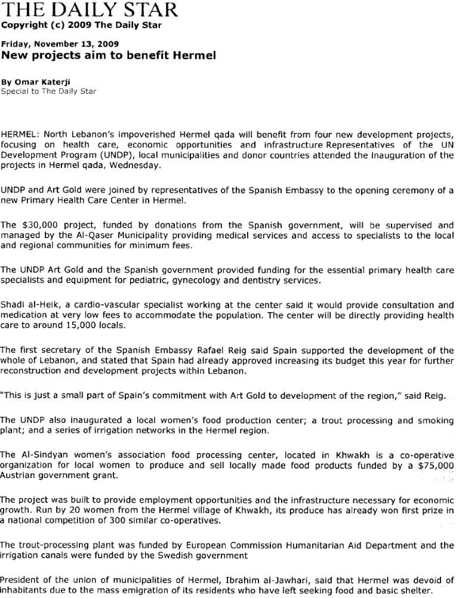

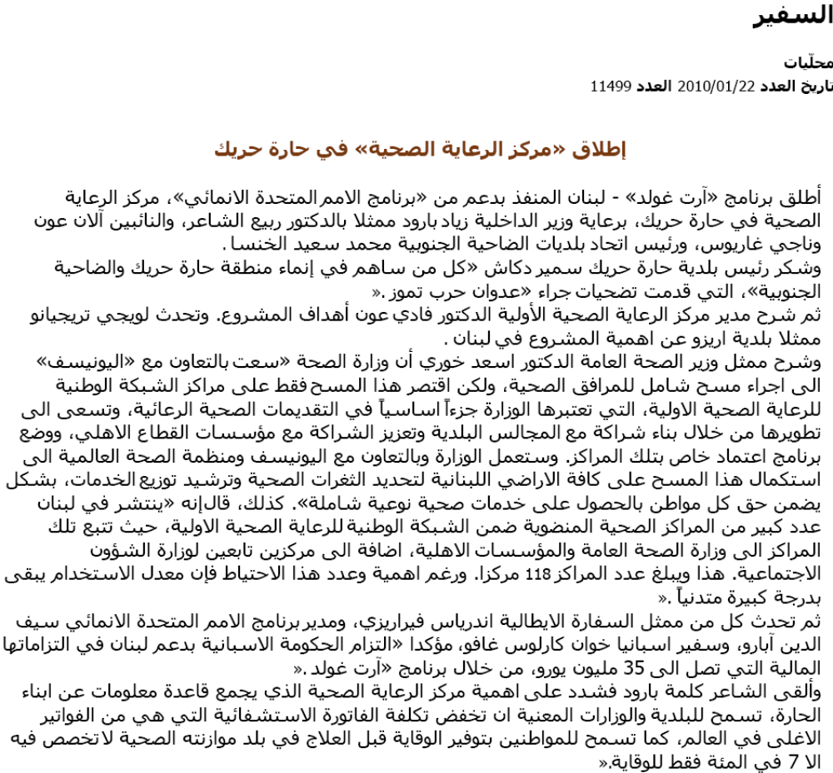

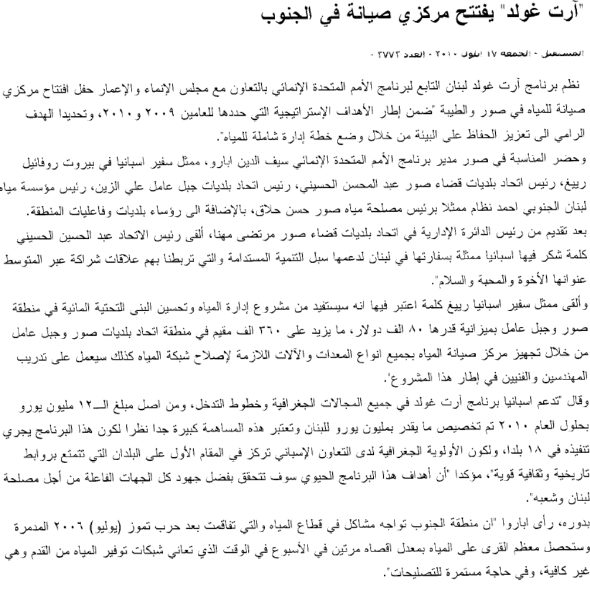
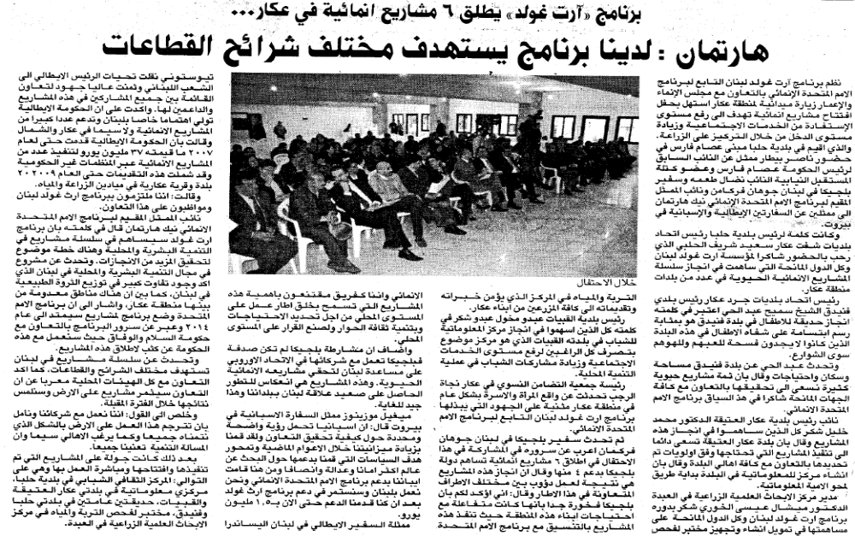
Diyar, Dec 2009

Annex 4
مشروع دعم قدرات البلديات اللبنانية في الإدارة المحلية

مواكبة تحديات العمل البلدي: القوانين والإدارة المالية والتنمية المحلية
استمارة التقييم الفوري
الحكم الصالح والإطار القانوني للبلديات |  |  |  | مُـلاحـظــات
مبادىء الحكم الصالح ، مفهوم
اللامركزية الادارية والاطار القانوني
صلاحيات المجلس البلدي ورئيس البلدية
الرقابة على البلديات

الرجاء وضع إشارة تحت اللون الأخضر اذا شعرت بأن الجلسة مفيدة وممتعة، وإشارة تحت اللون الأحمر إذا شعرت بأن الجلسة لم تكن كذلك. أما إذا شعرت بأنك لا تستطيع تحديد موقفاً من الجلسة، ضع إشارة تحت اللون الأزرق. يمكنك تفسير موقفك من الجلسة في خانة الملاحظات.

استمارة تقييــم نهائية

الاسم الثلاثي: | البلدية: | الصفة:
العنوان الكامل:
رقم الهاتف: | بريد إلكتروني:

تهدف عملية التدريب الى المساهمة في إكساب المتدربين المعارف والمهارات والمواقف، وللتأكد من نجاح هذه العملية والمساهمة في الحفاظ على نوعيتها المميزة الرجاء الإجابة بكل صراحة وموضوعية على الاسئلة المدرجة وإبداء ملاحظاتك عليها. قد تم اعتماد المعيار الرقمي الوارد ادناه لمساعدتك في التقييم، لذلك، الرجاء وضع دائرة حول الدرجة المختارة وذلك حسب تسلسل الدرجات من أدنى الى أعلى كما يلي:

1 2 3 4 5
مستوى ضعيف مقبول جيد جيد جداً ممتاز

اسئلة التقييم:
- هل كنت على معرفة بأهداف ورشة العمل التدريبية قبل اشتراكك فيها؟

نعم - - - - - - - - - - كلا- - - - - - - - - - - -

2-الى أي مدى تشعر بأن هذه الأهداف قد تمّ تحقيقها ؟
1 2 3 4 5

3- الى أي مدى تستجيب محاور الورشة التدريبية لاحتياجاتك ؟
1 2 3 4 5

4- ما هو تقييمك العام لمواضيع ورشة العمل والأساليب التي استعملت، ولمستوى الإكتساب الذي حصل؟
( اعط رقم من 1 الى 5)
المواضيع | مدى ملاءمة المواضيع لحاجاتك وطبيعة عملك | مستوى فعالية الأسلوب والمقاربة المستعملين | مستوى الإكتساب الذي حصل للمواضيع

مبادىء الحكم الصالح، مفهوم اللامركزية الادارية والاطار القانوني

صلاحيات المجلس البلدي ورئيس البلدية
الرقابة على البلديات
مفهوم واعداد مشروع موازنة البلدية

تنفيذ موازنة البلدية
القواعد العامة للموارد البلدية
مدخل الى التنمية المحلية ودور البلدية
تحديد الاحتياجات والأولويات بالمشاركة في النطاق المحلي ومدخل إلى تصميم المشاريع
تحريك المجتمع المحلي وتعزيز مشاركة المواطنين في الحكم المحلي

5- كيف تقيم المواد التدريبية التي تم توزيعها خلال الورشة؟
1 2 3 4 5

6- هل كان توقيت ورشة العمل التدريبية مناسباً بالنسبة لك؟
نعم - - - - - - - - - كلا - - - - - - - - - - - -
في حال النفي اذكر لماذا :

7- من خلال ورشة العمل التدريبية، ما هو أهم شيء تعلمت ان تفعله:

ما هو أهم شيء تعلمت ان لا تفعله:

8-تقييمك وملاحظاتك على أداء فريق التدريب :

9- كيف تقيّم الامور التالية:
الملفات والحقيبة | 1 2 3 4 5
قاعة الاجتماعات | 1 2 3 4 5
نوعية الطعام والقهوة | 1 2 3 4 5

10-ما هو تقييمك العام لورشة العمل التدريبية؟
1 2 3 4 5

11- ما هي ملاحظاتك العامة واقتراحاتك لتحسين برنامج هذه الورشة التدريبية (في حال تكرر عقدها).

12-ما هي اقتراحاتك لمواضيع وحلقات تدريبية اخرى تود ان تشارك فيها؟

______________________________________________ ______________
______________________________________________ ______________
Annex 5

استمارة رضى مستفيد
الإستقبال في المركز لسنة 2009 - 2010

اسم المسؤول عن تعبئة الاستمارة: ...........................
معيار الرضا |  | جيد | مقبول | غيرمقبول | ملاحظات
1 | الاستقبال في المركز بإحترام ومهنية من قِبل الموظفين
2 | تلبية إحتياجاتك من قِبل موظف الإستقبال
3 | ما رأيك بقاعة الإنتظار ؟
4 | مدّة الإنتظار للحصول على الخدمة
5 | مستوى النظافة في المركز
عمر المريض: ....................

استمارة رضى مستفيد
من الخدمات الطبية في المركز لسنة 2009 - 2010

اسم المسؤول عن تعبئة الاستمارة: ...............................
عمر الأب/الأم: ....................

معيار الرضا |  | جيد | مقبول | غيرمقبول | ملاحظات
1 | معالجة الطبيب للمريض
2 | خدمة التمريض
3 | خدمة صرف الأدوية من الصيدلية
4 | الخدمات الإجتماعية والنفسية في المركز
5 | بدل المعانية يتناسب مع الخدمة المُقدّمة

شكاوى وإقتراحات : ...............................................................................................................................
......................................................................................................................................................................................................................................................................................................................................................................................................................

Priority Area for the Peacebuilding Fund; Sector for the UNDG ITF.
The start date is the date of the first transfer of the funds from the MDTF Office as Administrative Agent. Transfer date is available on the MDTF Office GATEWAY (http://mdtf.undp.org).
All activities for which a Participating Organization is responsible under an approved MDTF programme have been completed. Agencies to advise the MDTF Office.
Poverty, gender and environment are internationally agreed cross-sectoral issues.

