PROJECT UPDATE
COVERING THE PERIOD SEPTEMBER 1, 2009 TO JULY 27, 2010
PEACEBUILDING FUND EMERGENCY WINDOW PROJECT
SUBMITTED BY
UNITED NATIONS OFFICE FOR PROJECT SERVICES
MONROVIA, LIBERIA
July 27, 2010

Background
The project is a critical intervention to strengthen corrections in Liberia by way of addressing the immediate security threats and support to the rule-of-law sector. Collectively the project shall ensure access to justice and respect for human rights for the people of Liberia. Furthermore, the project will promote public safety and justice, and enhance public trust in the governance system.
The project is executed using a mixture of direct and national implementation with funding through the PBF. Work is managed by a joint team from UNOPS, UNMIL/CAU and the Ministry of Justice (MoJ). UNOPS has had the responsibility to procure all the required security equipment and vehicles destined for use by PSU-LNP and MoJ. Also, procurement has been effected for the construction services at the prison facility in Sanniquelle.
The facility initially includes main prison building (5720 square feet) and two exercise areas (1959 square feet each); kitchen/store (969 square feet); security gate reception (119 square foot); two security watch towers (64 square feet each); hand dug water well with hand pump and a submersible pump powered by solar panels; concrete block wall fence about 800 linear feet and about 10 to 13 feet high. Included later within the construction works were a power house (315 square feet) that housed two generators (1-12.5kva and 1-100kva), an exercise area for female inmates, two concrete bases (128 square foot) for supporting four poly tanks 1000-gallon each.
- Procurement of transport, equipment and security materials

The procurement of transport, equipment and security materials was initiated in late 2009. Delivering supplies to MoJ and PSU commenced in January 2010; Delivery and receiving reports were signed for all supplies purchased and delivered to the client. The only outstanding item which remains for supply are the security items for which a new ITB has been issued to selected companies, as the first offers received exceeded the budgeted amount. It is expected that delivery of all security items shall be completed by November of 2010.

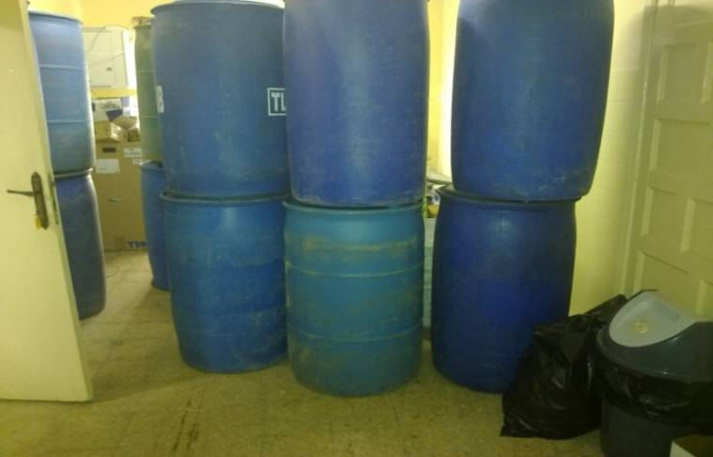
Hardware materials purchased and delivered to BCR - MoJ

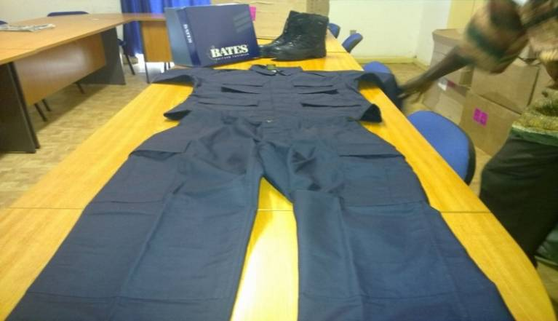
Uniforms purchased and delivered to PSU - LNP

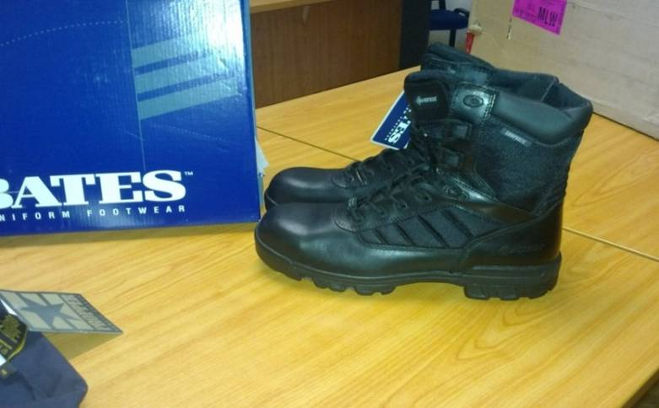
Boots purchased and delivered to PSU - LNP
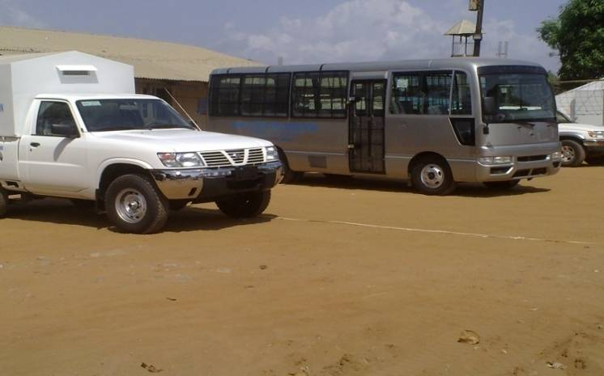
30-seated bus and a single cabin pickup with security cages and features purchased
and delivered to BCR – MoJ

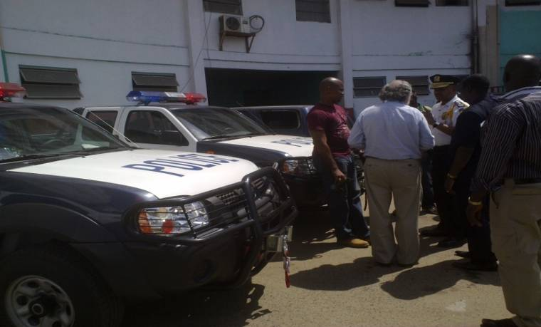
Two double cabin pickups with sirens and lights purchased and delivered
to PSU - LNP

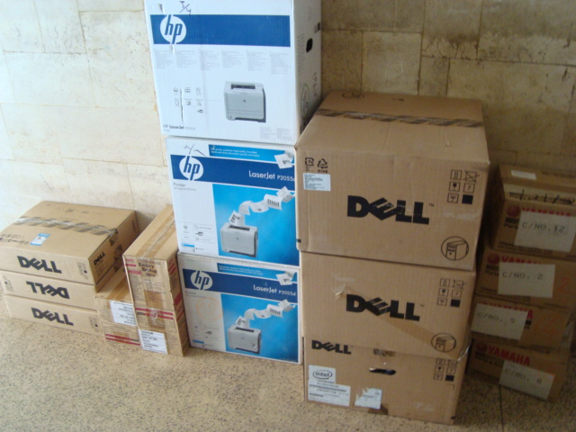
Three Desktop computers, printers and UPS purchased and delivered to BCR - MOJ

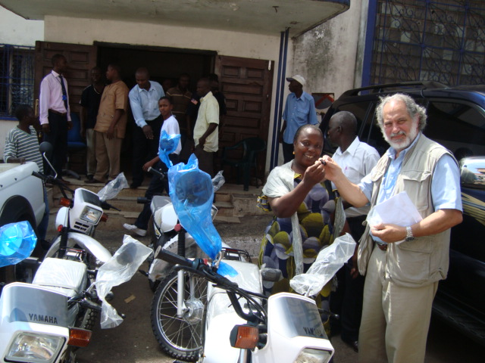
Four Motorcycles (DT Yamaha 125cc) and keys being turned over to the Assistant Minister
of Justice for Corrections and Rehabilitation by UNOPS Head of Country Office

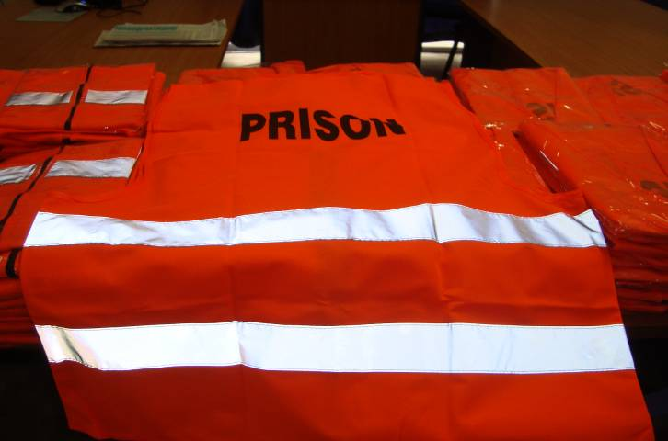
Reflector vests purchased and delivered to BCR - MoJ

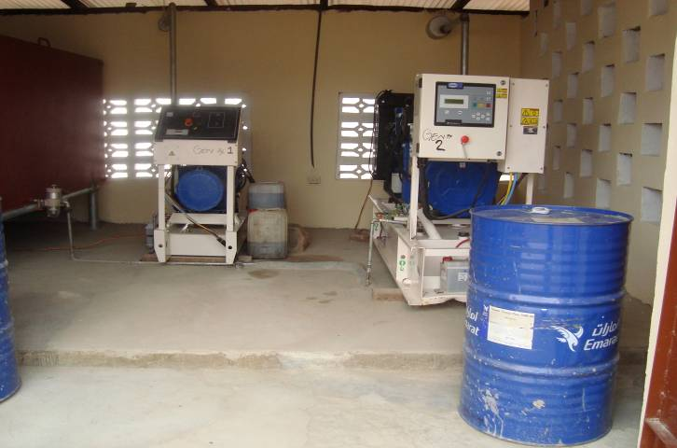
Two Generators (12.5 and 100kva) purchased and delivered at the
Sanniquellie Central Prison

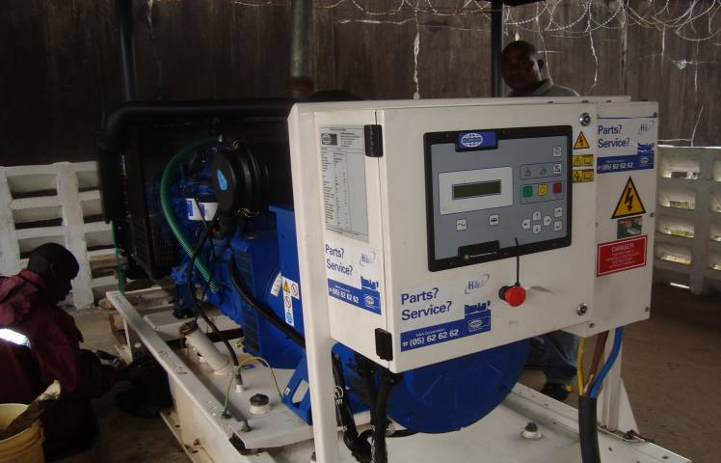

One Generator (135kva) purchased and delivered at the
Monrovia Central Prison in a newly constructed house

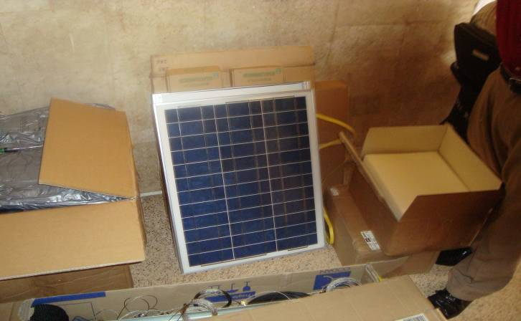
Base and Handheld Radios with Solar Panel Charging System
purchased and delivered at BCR - MoJ

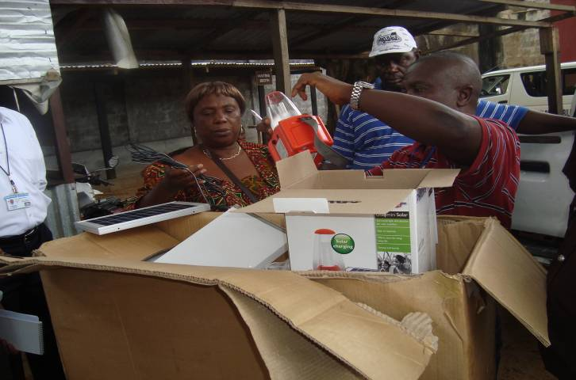
Solar Rechargeable Portable CFL Lanterns purchased and delivered to
the Assistant Minister for Corrections and Rehabilitation by
UNOPS Project Manager

Item No. | Description | Quantity | Current Status
1 | Kitchen and hygiene equipment (assorted) | 1 | Received and supplied to BCR, MoJ on 19-01-10
2 | Digital camera | 4 | Received and supplied to BCR, MoJ on 19-01-10
3 | Navy Blue BDU 4 pocket jackets | 100 | Delivered and Received by BCR, MoJ on 19-01-10
4 | Navy Blue BDU pants | 100 | Delivered and Received by BCR, MoJ on 19-01-10
5 | Black Boots | 50 | Received and supplied to BCR, MoJ on 19-01-10
6 | 4-WD single cabin Pickup | 1 | Delivered and received by BCR, MoJ on 24-02-10.
7 | Security features for Pickup, incl. security cage for transport of prisoners | 1 | Delivered and received by BCR, MoJ on 24-02-10
8 | 4-WD double-cabin Pickup with light warning bar and siren (PSU) | 2 | Delivered and received by PSU-LNP on 24-02-10
9 | Mini-Bus ; 30-seater | 1 | Delivered and received by MoJ on 24-02-10
10 | Security features for Bus, incl. inside bars, screen windows | 1 | Delivered and received by MoJ on 24-02-10
11 | Computers desktops, printers and UPS package | 3 | Delivered and received by BCR, MoJ on 17-03-10
12 | Cross Country Motorbikes DT Yamaha (125cc) | 4 | Delivered and received by BCR, MoJ on 17-03-10
13 | Reflector vests | 150 | Delivered and received by BCR – MoJ 05-10
14 | 135P KVA generator and generator house | 1 | Delivered and received by BCR, MoJ in Monrovia 05- 10
15 | 12.5P KVA generator and generator house | 1 | Delivered and received by BCR, MoJ in Sanniquellie 05-10
16 | 100P KVA generator and same generator house above | 1 | Delivered and received by BCR, MoJ in Sanniquellie 05-10
17 | Communication Radios – handheld (corrections and PSU), chargers, batteries | 30 | Delivered and received by BCR, MoJ 05-10
18 | HF Base Radios and accoutrements with solar panels (PSU) | 2 | Delivered and received by BCR – MoJ 05-10
19 | Solar portable lamps | 20 | Delivered and received by BCR – MoJ 08-10
20 | Replacement batteries for PSU Flashlights | 250 | Retendered the procurement process
21 | Security lighting (18 lamps, accessories, installation) | 1 | Retendered the procurement process
22 | Belly chain (waist cuffs) | 50 | Retendered the procurement process
23 | Leg irons | 50 | Retendered the procurement process
24 | Hinged handcuffs | 200 | Retendered the procurement process
25 | Whistles (3 per pack) | 300 | Retendered the procurement process
26 | Flashlights and batteries | 245 | Retendered the procurement process
27 | Padlocks | 1,200 | Retendered the procurement process
28 | Riot/disorder control shields (PSU) | 50 | Retendered the procurement process
29 | Helmets with face shields (PSU) | 50 | Retendered the procurement process
30 | Heavy duty flashlights (PSU) | 50 | Retendered the procurement process
31 | Flex cuffs (PSU) | 10 | Retendered the procurement process

Construction Activities

A land area of 12.8 acres of land was donated to the Government of Liberia through the Ministry of Justice by the citizens of Nimba to be used for the construction of prison facility. About 4.8 acres of this land were utilized with the above mentioned facilities erected. The land was located in both high and low forest areas, slopping at about 6 feet variation between high and low. UNOPS contracted an equipment company that cleared the site in preparation for construction work.

The plan for the construction works of the prison facility was presented to UNOPS by UNMIL CAU as a model for prison facility, similarly constructed in Tubmanburg, Bomi County. It was designed by Design Group, Inc, a local Architectural Firm in Monrovia. UNOPS Engineering team prepared the Bill of Quantities and Scope of Work, while the UNOPS Procurement Unit prepared the bidding document. Six Companies participated in the tender for the construction works. The contract was awarded to the Boywe Construction and Engineering Co. which submitted the most competitive bid and met the requirements following the thorough evaluation on the technical and financial offer.

The groundbreaking ceremonies were performed by Madam Ellen Margrethe Loj, UN-SRSG, Honorable Johnny Lewis, Chief Justice of Liberia, the Minister of Justice, and Superintendent of Nimba County. It was also attended by a host of government officials, UN staff, citizens and well wishers of Nimba County, in November 2009.

While the project was under construction, the site was visited by the DSRSG for Governance in January 2010. Staff from UNMIL-CAU and BCR MoJ periodically visited the site during joint monitoring trips. Modifications were made at three different times, which resulted into additional works and amendments of the contract. The 1st Amendment was the addition of a generator house, drainages and landscaping, while the 2nd Amendment was for the increase of the perimeter fence wire and other security modifications, and the 3rd Amendment was exercise area for female inmates, partition wall, poly tanks and concrete bases.

Some delays occurred due to the continuous effort to ensure quality of construction by the contracting company , and the adverse effect of rains totaling 20 days obstructed outdoor works. Delays were also experienced in securing adequate water supply within the perimeter of the facility. Wells were dug at three different locations including outside of the perimeter block wall fence; However for security reasons the implementation team concentrated in improving the overall depth of the well within the fenced area by contracting another company with a jack hammer and compressor from Monrovia. The outcome was improved availability of water; Also it was decided to introduce polytanks to harvest rain water, therefore the prison needs were fully covered with adequate storage.

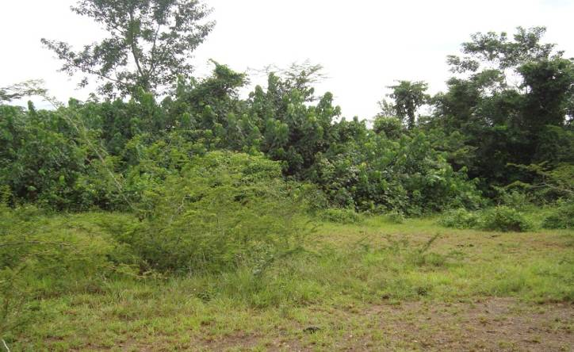
Site for the Construction of Prison Compound

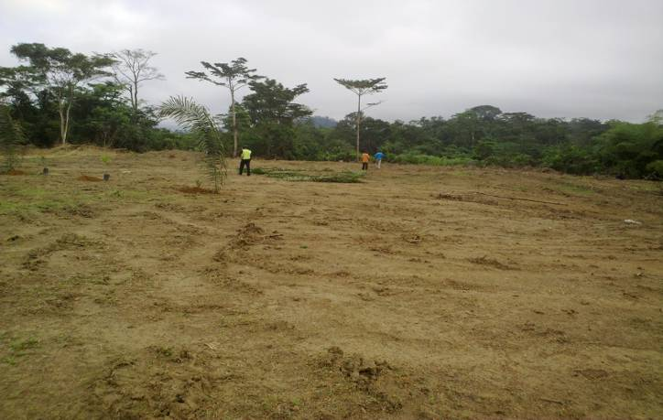
Cleared site for the Construction of Prison Compound

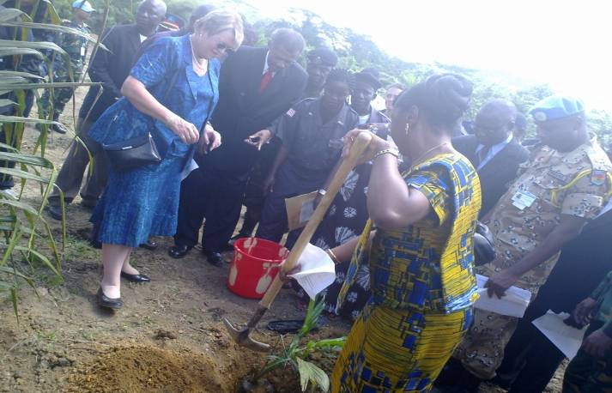
Ground Breaking Ceremonies for the Construction of Prison Compound
performed by (SRSG, Chief Justice, RL, Minister of Justice, RL and others)

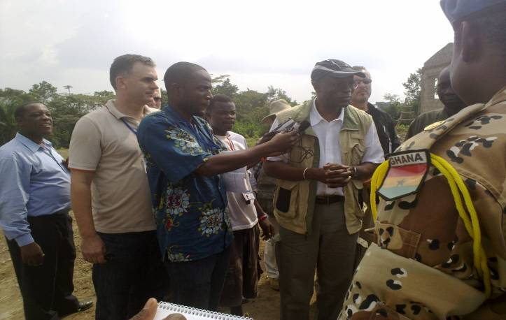
Visit of the DSRSG for Governance at the site

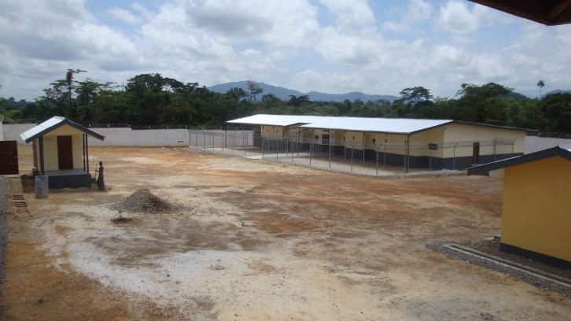
Completed Facility at SCP

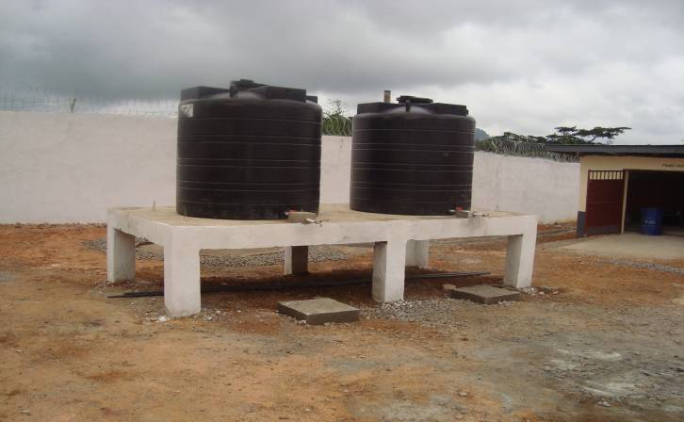
Completed Water Poly Tanks, Concrete Base and Power House

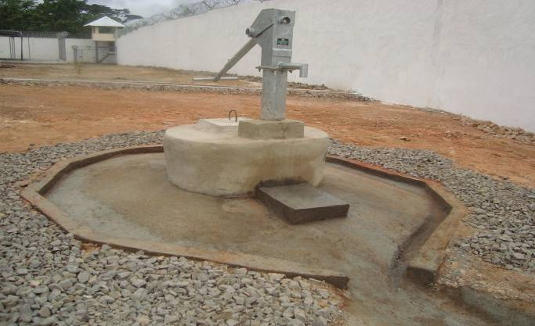
Water Well with Hand Pump and Watch Tower at rear
on the premises of the Prison Facility

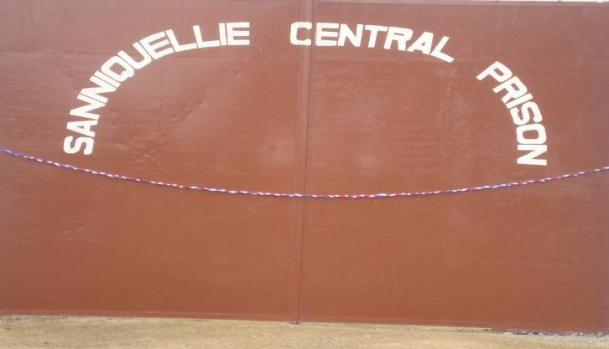
Main Entrance of SCP before inauguration by the President

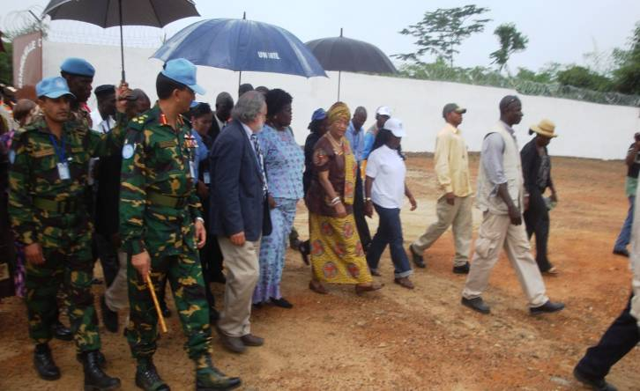
Dedication of Prison Facility by the President of Liberia
and DSRSG for Rule of Law accompanied by UNOPS Head of Country Office

Item No. | Description | Quantity | Current Status
1 | Construction of main prison building - structural, electrical and sewer works | 1 | 100% completed
2 | Exercise areas with chain link fence – for both male and female inmates | 3 | 100% completed
3 | Water well | 1 | 100% completed
4 | Construction of prison kitchen with small store | 1 | 100% completed
5 | Construction of security booth | 1 | 100% completed
6 | Construction of security watch towers | 2 | 100% completed
7 | Generator House | 1 | 100% completed
8 | Outer perimeter blocks fence with razor wires on top of block walls, approx 800rft | 1 | 100% completed
8 | Drainages and landscaping | 1 | 100% completed

Conclusion
The main part of the project which was the construction works of a new and fully functional corrections facility was completed and inaugurated in Sanniquellie by the President of Liberia on July 27, 2010. The facility is currently in the custody of the BCR of the MOJ and in operation. All the items provided in the SOW which have been procured by UNOPS have been delivered to the PSU and the BCR. The only outstanding items yet to be delivered are a number of security gear items which it is expected that by November 2010 will also be delivered.

Prepared by:
UNOPS Liberia Office

