

**[Rebuilding Liberian Collaborative Capacity]**

**ANNUAL programme[1] NARRATIVE progress report**

**REPORTING PERIOD: 1 january – 31 December 2010**

|  |  |  |
| --- | --- | --- |
| Programme Title & Number |  | Country, Locality(s), Thematic Area(s)[2] |
| * Programme Title: **Strengthening State capacity for Peace Consolidation** * Programme Number *(if applicable)* PBF/LBR/A-6 * MDTF Office Atlas Number:00070702 | *Liberia, Nationwide, Capacity Development through Training* |

|  |  |  |
| --- | --- | --- |
| Participating Organization(s) |  | Implementing Partners |
| *UNDP* | * **Woodrow Wilson International Center for Scholars** |

|  |  |  |  |  |
| --- | --- | --- | --- | --- |
| Programme/Project Cost (US$) | |  | Programme Duration (18 months) | |
| MDTF Fund Contribution:   * *by Agency (600,000.00)* |  |  | 2 years (no cost ext.) |  |
| Agency Contribution   * *by Agency (if applicable)* |  |  | Start Date[3]  1 January 2010 |  |
| Government Contribution  *(in kind)* |  |  | End Date or Revised End Date,  *(31 December, 2010)* |  |
| Other Contribution (donor)  *(if applicable)* |  |  | Operational Closure Date[4] March 31, 2011 |  |
| TOTAL: 600,000.00 |  |  | Expected Financial Closure Date  April 30, 2011 |  |

|  |  |  |
| --- | --- | --- |
| Programme Assessments/Mid-Term Evaluation |  | Submitted By |
| Assessment Completed - if applicable *please attach*  Yes No Date: __________________  Mid-Evaluation Report *– if applicable please attach*  Yes No Date: __________________ | * Name: Cllr. James N. Verdier, Jr. * Title: Rule of Law Programme Manager * **James.verdier@undp.org** |

Table of contents

1. Project information ……………………………………………………………… ………… ….1
2. Table of contents ………… ………………………………………………………………………2
3. Acronyms…………........................................................................................................................ 3
4. Purpose …………………………………………………………………………………………...4
5. Resources……… ………................................................................................................................6
6. Monitoring & Evaluation------------------------------------------------------------------------------------------------7-8
7. Results ………….......... ……………………………… ………………………………………… 8-
8. Future work plan……………………………..……………………………………………………..14
9. Constraints and recommendation.…………………………………………………………………..15

**ACRONYMS**

**ABA**- American Bar Association

**CPAP-**Country Programme Action Plan

**CSOs-**Civil Society Organizations

**GOL**- Government of Liberia

**LNBA-** Liberia National Bar Association

**LNP-**Liberia National Police

**MOJ-**Ministry of Justice

**NGO-**Non Governmental Organizations

**ROL-**Rule of Law

**UNDP—**United Nations Development Programme

**UNMIL-**United Nations Mission in Liberia

**CO-** Country Office

**MPEA**- Ministry of Planning and Economic Affairs

**SG**- Solicitor General

**UNDAF**- United Nations Development Assistant Framework

**WWICS** – Woodrow Wilson International Center for Scholars

**WANEP** -African Network for Peace building (WANEP)

**Purpose**

# In July 2009, the Project on Leadership and Building State Capacity (hereafter referred to as the Leadership Project), with financial support from the United Nations Peace building Fund via the United Nations Development Programme in Liberia, launched an 18 month training program to foster collaborative decision making and negotiation skills among key Liberian leadership. Target participants for the project include Executive and Legislative branch leadership, opposition political party leaders, and County Superintendents. The Leadership Project originally planned to host two major training workshops, guided by expert conflict resolution facilitators, and seven follow-up workshops. The focus of the project expanded in response to participant evaluations and sentiments shared by a number of our high-level Liberian stakeholders. The objective of this project was to build a network of Liberian leaders from across the political, functional, regional and societal spectrum which has the collaborative capacities, shared vision, and commitment to manage the recovery, governance, and development of Liberia. This is done by re-establishing their mutual trust, effective relationships and communication skills and creating an agreement on the way in which governance is affected through a sense of common interests and interdependence. This contributes to the broader goals of the Peace Building Fund of strengthening state capacity for peace consolidation.

# Resources

*Financial Resources:*

The United Peace Fund (PBF) was the only source of funding for the project. The total of six hundred thousand, ($600,000.00), United States dollars was allocated for the project with a six month no-cost- extension due to the delay in transferring the funds to the Country Office. The fund was managed by the United Nations Development Programm, Liberia Office.

*Human Resources:*

The Woodrow Wilson International Center for Scholars in partnership with WANEP with technical support from UNDP implemented the project. The WWICS had 3 international staff and one local sitting at WANEP who was the focal person for the project.

# Implementation and Monitoring Arrangements

WWICS has, throughout the project, polled participant views and impressions at the end of every workshop. These evaluations have been focused on the methodology, logistics, and pertinence of pedagogy, asking the participants to rank order them, and to also comment on the usefulness of the skills, tools, and relationships built in their daily professional and personal lives. The results have continually shown a positive trend among participants, in terms of using conflict resolution and negotiation skills gained from the workshops.

For the project termination, a full evaluation has been conducted by a consultant who interviewed a group of participants, strategically selected across a wide spectrum of ethnicity, political linkages, government and non-government, regional, religious and gender criteria, to also include someone from each of the four intakes of participants since the projects inception in 2006. The evaluation covered four major areas of the training:

1) Participant expectations of the workshops;

2) Application of the skills acquired;

3) The establishment and sustainability of the participant network; and

4) Identifying the strengths and weaknesses of the overall program.

During the Assessment Mission, the Leadership Team and UNDP established a Project Board to oversee and help guide this process. The Board is made up key Liberian sector representatives from the President’s office, the Governance Commission, and civil society, as well as UNDP officials, and is chaired by the Minister of Internal Affairs. WWICS works closely with the Board in its planning efforts. The most recent meeting of the Project Board was held on October 20, 2010.

# Results/achievements in summary

WWICS carried out 10 project activities during the time frame of the grant, including a preliminary assessment mission, a training mission, two full retreat workshops, four follow-ups, a Project Board meeting, and a Monitoring and Evaluation project.

Based on similar leadership capacity work done by the Center in Liberia in 2006-7, Leadership Project Consulting Director Steve McDonald began in early 2009 to review Liberia’s current political fault lines and correspond with his government, civil society and international community contacts in the country to assess the value of restarting this effort. This led to the staging of a full assessment mission in July 2009.

***July 2009 Assessment Mission***

***November 2009 Follow-Up Workshop***

From November 25 through November 27, 2009, the WWICS convened the initial follow-up workshop of its renewed initiative, Rebuilding Liberian Collaborative Capacity, with a diverse group of 39 Liberian government, civil society, faith-based, former armed faction, and youth leaders. The workshop was co-sponsored by the West African Network for Peace building (WANEP) and the Chief Facilitator was Emmanuel Bombande, the founder and CEO of WANEP. Participants had all taken part in WWICS workshops in 2006-07. This follow-up was designed to bring these past participants together to reinforce joint problem analysis and solving techniques, reinvigorate the network of previously committed Liberians, and expand the trust and cooperation of the network. Present were representatives of the Senate and House, both members and staff; the Executive Branch (Ministry of Defense, Ministry of Justice, Land Commission, and Ministry of Foreign Affairs); faith representatives, from Catholic, Protestant and Muslim communities; opposition party leaders (CDC, NDPL, LNP, NPP); and civil society groups. The participants exhibited a great commitment to the training process and maintained a core group of roughly 35 leaders for the entire workshop.

The workshop was very successful in that it provided a safe and open forum for leaders to discuss perspectives on Liberian national reconciliation across party and ethnic lines. The participants were asked to work together to analyze the core causes of conflict in Liberia, the obstacles and challenges for national reconciliation, and ways to overcome those challenges as a society. Main points of discussion focused on the most critical policy questions in Liberia, including the report of the Truth and Reconciliation Commission, issues relating to decentralization of governance, and education reform. The general consensus from participants was that the workshop was very useful and would help them to formulate policy directives and make decisions more collaboratively and in consideration of a broader range of interests, historical grievances, and political factors. The WWICS and WANEP training provided leaders and stakeholders with the 4

In July 8 - 23, 2009, the in-country assessment mission held over 40 meetings with Liberian Senators and House of Representative members, key opposition political party leaders, Truth and Reconciliation Commission executives, other civil society and NGO representatives, and senior personnel in UNDP, USAID, UNMIL, and the US Embassy. Through these meetings, the Leadership team gained perspective on current issues and concerns for Liberian governance and stability.



WWICS held the next workshop in Gbarnga, Bong County at the Catholic Compound from November 7-12, 2010 and brought together participants from four main conflict-affected counties—Lofa, Nimba, Bong and Bomi. The participants were comprised of Superintendents (or their Deputies), Superintendents for Land Commission, Education and Development, and Paramount Chiefs, elders and civil society representatives. Also present were the Deputy Ministers of Internal Affairs and Education, Assistant Minister of Health, and the Chairman of the Land Commissioner in attendance to represent Central Government, WWICS held a follow-up workshop from November 14-16, 2010 at Thinkers Village in Paynesville that attracted 22 participants from the April workshop, representing the Liberian Senate and Congress, and Government Ministers and Superintendents.

By the last day, the overriding feeling was that the workshop had been very valuable, particularly in bringing together the local-level leaders with upper-level officials from the various government ministries. While they desired follow-up workshops to expand their own skills and deepen the network that was begun here, it was also important to “take it even further to the district level” and conduct workshops in other counties where the leadership is faced with similar issues health and education, collaborating with local leaders like village elders, traditional leaders, NGOs and civil society leaders, and implementing policy on a community level such as settlement of land issues, when local officials had no experience or expertise in that area. 7

***April 2010 Full Retreat/May 2010 Follow-Up Workshop***

The first retreat workshop, over five days from April 26-30, 2010, was convened at the Thinker’s Village Hotel compound in Paynesville. This time, the workshop participants were recruited to reflect not only the divisions inherent in the Executive and Legislative branches relationship, but to bring in County Superintendents who are in the front line of development and reconciliation policy issues at the local level.

Participants in the April workshop, which included Senators, Representatives, Ministers, Deputy Ministers, an opposition party leaders, as well as County Superintendents, received training in negotiation and communication, and engaged in several simulation exercises designed to illustrate shared political interest, interdependence on a national level, and build trust and repair fractured relationships between them. Exercises included SIMSOC (a simulated society role-playing game) and the Four Quadrants conflict analysis tool. Senior Trainers Elizabeth McClintock, of CMPartners, Boston, and Ricardo Perez 5

The findings of this exercise were positive and constructive. According to 95% of the respondents, the workshop met their expectations. Meanwhile 70% of the respondents stated that they have started applying those skills in their various communities. For example, according to one of the Traditional Leaders, the skills he acquired have been able to help him mediate land disputes in his County. 95% of the respondents attested to having built relationships with colleagues from other parties and organizations. Some of the strengths of the program that were identified by respondents were the Four Quadrant Tool, the reconciliation exercise, and the interactive pedagogic format of the trainings. Two areas for improvement the respondents cited were the absence of youth representatives as part of the participant demographic, and also the limited time frame available for the trainings. The evaluation found that the overall impact of the program is somewhat indeterminable due to the short time span of program itself, but that there is a high demand for future workshops in order to ensure the sustainability of the skills and toolsets provided.

Nuckel, of Alter Négo, Paris, both conflict transformation professionals who have worked extensively in Africa, in Ms. McClintock's case, in Liberia, facilitated this historic and timely workshop.

In consultation with UNDP Liberia Programme/Operations Specialist Ishmael Dodoo, workshop participants, and other stakeholders, at the end of the April workshop, the WWICS decided to restructure the project to focus more on County focused issues of conflict, most specifically land issues, development, administration, and coordination of government at all levels. County Superintendents in the April 2010 workshop uniformly agreed that coherence of policy and coordination at the County level are lacking. Their specific challenges are wide-ranging, including difficulty coordinating with Central Government Ministries (such as Defense, Agriculture, Lands and Mines, Finance, Energy, Internal Affairs, and Cultural Affairs), the application and management of development funds, the pursuit of land use and land tenure issues in mediation processes and court proceedings, community relations, village and traditional leaders, and the national reconciliation process in general. The County Superintendents were particularly enthusiastic about the WWICS training process, and conveyed the need for greater collaborative capacity building, communication and negotiation skills, and problem solving skills, to increase their effectiveness, as Liberia works to further decentralize governance, reconcile, and rebuild.

WWICS also was motivated to carry out more County-focused workshops, due to the historical context of the conflict in Liberia, being closely linked to long-standing perceptions that Liberian governance has commonly favored the Monrovia-based elite, and left the County people disenfranchised. Deficits in both allocation of resources and decision-making power and influence continue in many of the counties, and the perception of weak or ineffective representation persists. Compounded with the fact that the Superintendents themselves are Presidential appointees, WWICS believes that a visible, overtly County-focused process is the best way to take the current project forward, and serves the best interest of government collaboration and cohesion for the Liberian state.



***January 2011 Final Follow-Up Workshop***

From January 20-22, 2011, The Wilson Center held its final workshop at Thinkers Village in Paynesville, Liberia. The purpose of this workshop was to reinforce skills and tools that have been imparted, to create a literal “toolbox” based on learned craft and applied to real life situations as identified by the participants. A goal of the workshop was to strengthen the network of participants, as well as provide the opportunity to convene a planning session that will give guidance as to how this project can be strengthened and expanded to ensure a stable and peaceful transition for Liberia in the future. Participants from all prior workshops were present and represented multiple political parties, religious leaders, civil society leaders, local leaders, and national leaders. UNDP Country Representative, Dominic Sam, attended the closing session of this workshop, and told the participants how moved he had been with the interaction, frankness, and commitment that he had witnessed around the conference room. 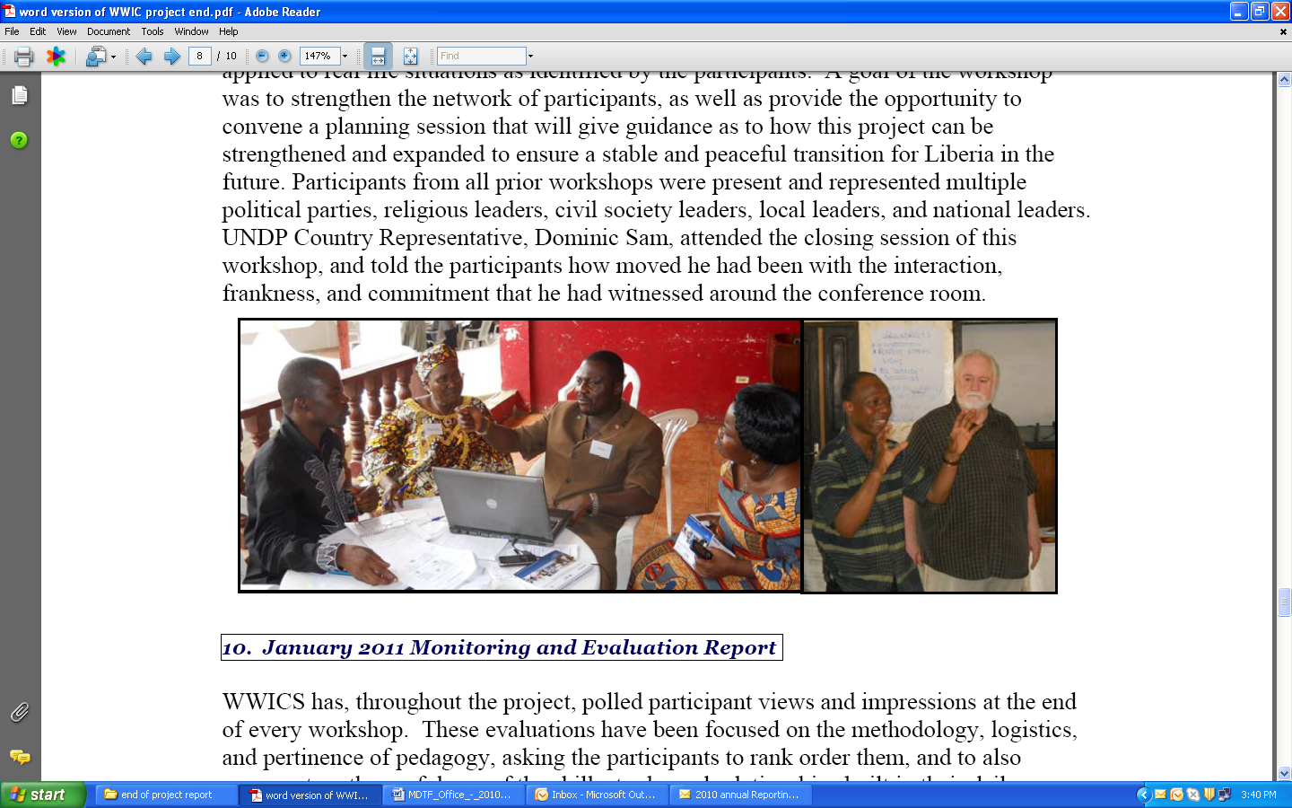

***8. November 2010 Follow-Up Workshop***

On November 14, 2010, the WWICS held a 2 day follow-up workshop at Thinkers Village in Paynesville, bringing back together the participants from the April workshop to reinforce their network, review progress and stumbling blocks they have faced, and deepen and strengthen their negotiation, communication and problem solving skills. This group was comprised of government ministers, deputy ministers and planning officers; the majority of the County Superintendents; leading members from the House of Representatives and Senate; and opposition political party leadership.

***9. January 2011 Final Follow-Up Workshop***

From January 20-22, 2011, The Wilson Center held its final workshop at Thinkers Village in Paynesville, Liberia. The purpose of this workshop was to reinforce skills and tools that have been imparted, to create a literal “toolbox” based on learned craft and applied to real life situations as identified by the participants. A goal of the workshop was to strengthen the network of participants, as well as provide the opportunity to convene a planning session that will give guidance as to how this project can be strengthened and expanded to ensure a stable and peaceful transition for Liberia in the future. Participants from all prior workshops were present and represented multiple political parties, religious leaders, civil society leaders, local leaders, and national leaders. UNDP Country Representative, Dominic Sam, attended the closing session of this workshop, and told the participants how moved he had been with the interaction, frankness, and commitment that he had witnessed around the conference room.

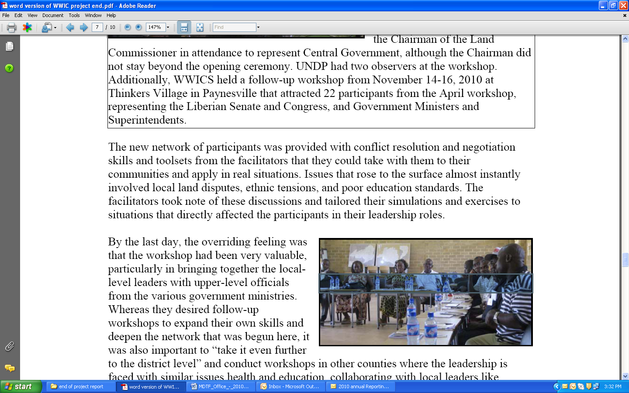

There was an overwhelmingly positive response from participants on the tools and skills that the entire project provided them with and their applicability in real life. One participant thanked the facilitators and organizers for teaching them conflict resolution principles and seeing that there are different ways to approach issues and contentious situations. Another found the mix of various levels of Liberian leaders to be valuable since they all play a part in maintaining peace and stability throughout the country.

In summary, the project strengthened reconciliation among participants of differing backgrounds and enhanced their conflict management, communication, and negotiation skills and their collaborative decision-making capacities. The relationships and skills developed made it easier for Liberian decision-makers to work together within the structures of the state and in harmony with civil society to advance Liberia’s post-war reconstruction.

The training provided an opportunity for experiential learning – through interactive exercises, simulations, and role-playing – all designed to enable the participants to learn and build upon their skills, not only through lectures and reading but also through their own experiences.

**Constraints**

One major constraint that we faced during the planning stages of the trainings was trying to work around Liberia’s rainy season. This prohibited us from doing anything outside of the metropolis area from March-September, and was one of the reasons why we weren’t able to bring our workshops to the counties earlier on.

A second major constraint that we were confronted with at the workshops was consistent attendance from participants. Many of them held high-level government positions and often had their own obligations. Unfortunately, this meant that participants were often called out of workshops to attend to other matters. In one instance, President Sirleaf requested a meeting with all County Superintendents and they had to excuse themselves from the workshop en masse for a day. Another time, we had to cancel a planned workshop all together because of the calling of an unplanned Cabinet Retreat. This has a bearing mostly on just the high-level participants. As we look to shift focus to more county and district level workshops, we do not foresee this to be as much of a major issue amongst more local level leadership. However, the rainy season will affect this future planning.

**5. Recommendations from Participants** 9

What the participants would still like to see happen is the development of a follow-up report of how the tools have been put into practice by each of them, and then disseminated to everyone to continue to share their experiences. They recommended that the program expands their audience to include leaders of multi-national corporations, district commissioners, and union leaders, as they are all decision-makers within Liberia. They would like to see a greater Training of Trainers where the participants would become the facilitators and therefore, take ownership of continuing the process. Examples of comments made include:

# “*These workshops have linked us, from government to local NGO, for working with the community and allowed us to find our common objective* Future Work Plan

In January 2010, Program Director Steve McDonald engaged in meetings in Monrovia with the UNDP leadership, the new Joint Steering Committee of the UN Peace Building Commission (PNC), including the Ministers of Planning and Internal Affairs and the Deputy SRSG, and the American Ambassador and her staff. He had previously met in Washington with the State Department and USAID, joined by Dr. Momo Rogers, Chief of Cabinet and Special Assistant to the President, to make a presentation for the continuation of funding for the project. In all meetings, there was a receptive atmosphere, and guidelines were offered on how to apply for the extension and expansion of the project.

As this grant comes to a close, the Woodrow Wilson Center will be preparing to submit a new proposal to both the US Agency for International Development and the UN Peace Building Commission that will build off of the current training program, but make significant changes in its scope and direction. The Wilson Center is very hopeful that the network can continue the hoped for county-focused workshops in other areas of the country can take place, and that we expand this work to other groups originally envisioned, including youth and women leaders, and to district level leadership. Training of trainers and local capacity-building will be a big focus of the proposed expansion, to include initiatives already undertaken by participants, such as the Woodrow Wilson Peace Ambassadors in Lofa County, initiated after the November 2010 workshop by county officials and paramount chiefs. The Wilson Center is fortunate to have President Sirleaf-Johnson’s full support in continuing the work.

1.
2.
3.
4.