Woodrow Wilson International Center for Scholars

QUARTERLY STATUS REPORT AS OF October- December, 2010
Recipient UN Organization: | UNDP |  |  | PBF Priority Area: |  | Critical Interventions to Promote and Resolve Conflict/ Governance
Implementing Partner(s): | Woodrow Wilson International Center for Scholars In Collaboration with the West African Network for Peace building, Liberia
Project Number: | PBF/CN/R3/A1/01 (PBF?LBR/A-6_ID 00070702)
Project Title: | Strengthening Liberia’s Collaborative State Capacity for Peace Consolidation
Total Approved Project Budget | $600,000
Project Objective and Scope | The underlying objective of the project is to build the collaborative capacities of leaders from key sectors to manage the governance and development of Liberia by re-establishing their mutual trust, effective relationships and communication skills and creating an agreement on the way in which governance is effected through a sense of common interests and shared vision. This contributes to the broader goals of the Peace Building Fund of strengthening state capacity for peace consolidation.  The scope of the project has shifted to focus on “County focused issues of conflict, most especially land issues, development, administration, and coordination of government at all levels.”
Funds Committed: | US$600,000 |  |  | Percentage of Approved: |  | 100%
Funds Disbursed: | US$600.000.00 |  |  | Percentage of Approved: |  | 100%
SC Approval Date: | July 2009
Expected Project Duration: | 18 Months |  | Forecast Final Date: |  | September 2010 |  | Delay (Months): |  | Two Months
Outputs: |  | Progress: |  |  |  |  |  | Percentage of planned:
The collaborative decision making skills of 80 key Liberia leaders are increased |  | Several collaborative decision making skills trainings have been conducted with County Superintendents or their proxies, members of the Senate and House, certain minister and deputy ministers, and an opposition party leader. Women’s participants account for 38%.  The workshop was conducted in partnership with CM Partners, a Boston-based conflict management group and Alternego, a Paris-based training group and the West African Network for Peace building (WANEP). |  |  |  |  |  | 90%
A networking dynamic among the participants from the Executive and Legislative branches is generated |  | Several workshops have been conducted in 2010 for the pre-existing leadership network with whom the WWICS worked. The workshop brought together participants from diverse backgrounds. The groups was comprised of youth leaders, former armed faction leaders; church leaders, women organization as well as government ministry officials and legislative branch representatives. |  |  |  |  |  | 100%
The willingness of participants to seek cooperative problem-solving strategies is enhanced |  | Participants in the April workshop received training in negotiation and communication, and engaged in several simulation exercises designed to illustrate shared political interest, interdependence on a national level, and build trust and repair fractured relations between them.  The principal objectives of the workshop were to contribute to the restoration of trust among Liberians, to help Liberians develop a common vision of their future, and to establish sustainable collaboration to insure the realization of this vision.  The workshop was a capacity building initiative, designed to strengthen reconciliation among participants of differing backgrounds and to enhance their conflict management, communication, and negotiation skills and their collaborative decision-making capacities. |  |  |  |  |  | 100%
Qualitative achievements against expected results:
Key Outputs Achieved
REBUILDING LIBERIAN COLLABORATIVE CAPACITY
REPORT ON THE RETREAT WORKSHOP ON BUILDING GOVERNMENT CAPACITY
AND COLLABORATION
NOVEMBER 7-12, 2010
FOLLOW-UP WORKSHOP
NOVEMBER 14-16, 2010
A WOODROW WILSON CENTER PROJECT FUNDED BY THE UNITED NATIONS PEACEBUILDING FUND VIA
THE UNITED NATIONS DEVELOPMENT
PROGRAMME, LIBERIA
IN COLLABORATION WITH CMPARTNERS AND THE WEST AFRICAN NETWORK FOR PEACEBUILDING, LIBERIA
STEVE MCDONALD, ELIZABETH MCCLINTOCK, COLIN MCKENZIE, JENNIFER GRAHAM, FABIEN NSENGIMANA, ALYSON LYONS¸ MAME KHADY DIOUF AND
JEAN HANNAH-THOMPSON
Strengthening Liberian Government Collaborative Capacity to Consolidate Peace
“We want to learn how to engage others in the community and teach them the skills we gain in this workshop. Because learning is one thing, but being able to pass on what we learn to others is another.”
-A participant during the opening session of the first workshop day
“If we look at each other as one group, we are the people who own the land. I think that we, as Liberians and Africans, should look at each other with respect, regardless of which tribe or clan we come from, or whether someone is rich or poor; we are all African. “
-A participant during a discussion over land conflict issues in Liberia
“The group work and the way it was presented got our minds to understand that as we leave from here we can go out and apply what we have learned.”
-A participant’s comment after the third day of the workshop
A. DESCRIPTION OF RETREAT WORKSHOP
This workshop represented the second full retreat under the Peace Building Fund grant to the Woodrow Wilson International Center for Scholars (WWICS) that targeted a new group of key Liberian leaders under the mandate of strengthening the collaborative capacity of government to consolidate peace in Liberia. There was also a follow-up two-day workshop given for the April 2010 group of participants in the WWICS project, building on the tools and skills acquired during their workshop.
The renewed focus of this workshop is a direct result of our last workshop in April 2010, which brought together executive and legislative branch officials, along with most of the County Superintendents. One key “next step” that the participants urged in April was to take the workshop to the County level, where issues such as land disputes were rife, and where both county and local leaders needed training in mediation and negotiation skills in order to help them resolve these issues. In response to this request, WWICS held the workshop in Gbarnga, Bong County at the Catholic Compound and brought together participants from four main conflict-affected counties—Lofa, Nimba, Bong and Bomi. The participants were comprised of Superintendents (or their Deputies), Superintendents for Land Commission, Education and Development, and Paramount Chiefs, elders and civil society representatives. Also present were the Deputy Ministers of Internal Affairs and Education, Assistant Minister of Health, and the Chairman of the Land Commissioner in attendance to represent Central Government, although the Chairman did not stay beyond the opening ceremony. UNDP had two observers at the workshop. The follow-up workshop attracted 22 participants representing the Liberian Senate and Congress, and Government Ministers and Superintendents (Both participant lists can be found in Appendix 1).
Workshops For Building Government Capacity And Collaboration In Liberia November 2010 2
The core concept of the workshops of building government collaborative capacity and a sense of common purpose is critical to Liberia’s peace, reconstruction, stability, and provision of basic human security. The United Nations Peace building Fund has identified the WWICS training in collaborative capacity as a powerful implement in the process of consolidating peace and strengthening state capacity, to the benefit of all Liberians. These workshops represented the fourth and fifth in a series that will run through January 2011, at which time our sixth and final workshop will take place.
The WWICS conducted the workshop in partnership with CMPartners, a Boston-based conflict management group. The West African Network for Peace building (WANEP) has worked closely with us on administrative and logistical issues. The funding was provided by the United Nations Peace Building Fund through the UNDP.
B. TRAINING OBJECTIVES AND METHODOLOGY
The principal objectives of the workshop were to contribute to the restoration of trust among Liberians, to help Liberians develop a common vision of their future, and to establish sustainable collaboration to insure the realization of this vision. The program is a capacity-building initiative, designed to rebuild relations among participants of differing backgrounds and to enhance their conflict management, communication, and negotiation skills and their collaborative decision-making capacities. Workshops are not decision-making forums. However, the relationships that emerge contribute to national reconciliation and the skills developed are designed to make it easier for Liberian decision-makers to work together within the structures of the state to advance Liberia’s post-war reconstruction.
The training methodology employs a non-traditional, interactive pedagogy, with trainers who are skilled in the techniques of institutional and conflict transformation, and who have extensive experience working with both private sector and public institutions to create more cohesive and effective structures. Training techniques are designed to address four political imperatives of sustainable post-war reconstruction: enabling former belligerents to shift from a zero-sum paradigm of winners and losers to one that recognizes interdependence and common ground; developing trust and confidence among key leaders; strengthening the skills of communication required for effective collaboration; and re-building a consensus on the “rules of the game,” i.e., on how power will be organized and decisions will be made.
All of this requires more than “book learning” and a cognitive understanding of concepts. A paradigm or mindset cannot be taught; it must be experienced. The same is true of trusting relationships that develop only over time and involve personal emotional investment. Likewise, an appreciation of the importance of process will emerge only through direct experience with others. What the training provides is an opportunity for experiential learning – through interactive exercises, simulations, and role-playing – all
Workshops For Building Government Capacity And Collaboration In Liberia November 2010 3
designed to enable the participants to learn and build upon their skills, not through lectures and reading but through their own experiences.
Workshop exercises are designed both to demonstrate the power of conditioning on perceptions and to strengthen participants’ communication skills. They also seek to transform the way in which the participants define and understand their “self-interest,” such that they come to see their long-term security and welfare as being not in opposition to, but directly dependent upon, the larger society of which they are a part. The objective is to enable the participants to comprehend that collaboration with others is not a matter of altruism or of adherence to some abstract notion of “good governance,” but is a matter of enlightened self-interest. This requires understanding the concept of “interest-based negotiations,” in which decision makers distinguish between their “positions,” or idealized aspirations, on the one hand, and their underlying “interest,” or fundamental needs, on the other. Sustainable decisions are far more likely to result from a decision-making process that turns not on attempts to impose one’s position on others but, instead, on the search for means of satisfying the core interests of all.

C. THE WORKSHOP CONTENT
The workshop agenda or syllabus is at Appendix 2. A complete description of the key concepts used in the various workshop modules and a summary of the power point slides used by trainers Elizabeth McClintock of CMPartners and Colin McKenzie of CMNZ will be found in Appendices 3 and 4. Those slides include exercise descriptions and feedback from the participants themselves. In this narrative discussion, we wish to present only a few of the workshop highlights that convey some sense of the training experience.
1. The Use of First Names
In order to reinforce the principle that all participants are at the workshop in their personal capacity, it is our practice to employ only first names in all training workshops. This also helps to establish an atmosphere of informality, and to reduce the distance between participants that ranks and titles tend to create. Participants and members of the training team, in fact, wear hanging name tags bearing only their first names throughout the five days. Moreover, people were seated at a U-shaped table and there was no pre-arranged seating, and no special places reserved for persons of high rank.
2. Arm Exercise
The workshop opened with welcoming remarks by Program Director Steve McDonald and a description of the leadership initiative’s origins and purpose. Immediately following the introduction, facilitators Liz McClintock and Colin McKenzie asked the workshop participants to get into pairs for the first exercise. They explained to the 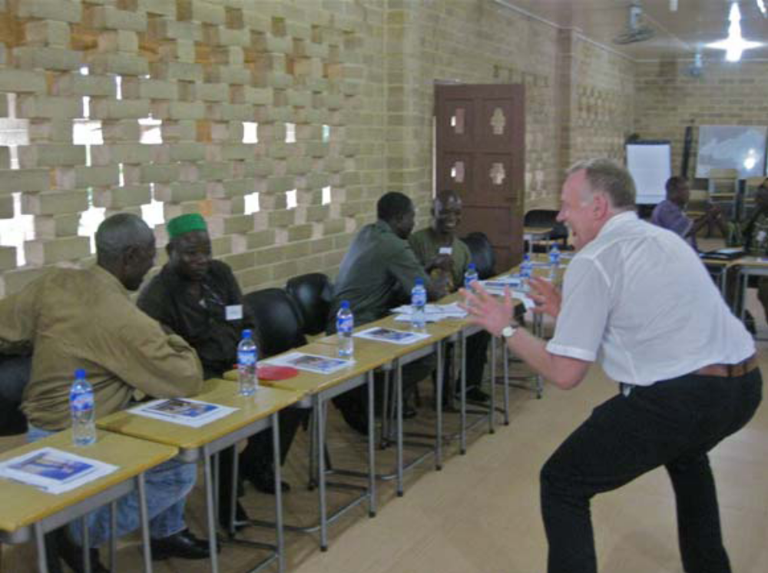
Workshops For Building Government Capacity And Collaboration In Liberia November 2010 4- facilitator demonstrates.

Participants that the objective was to try to gain as many points as possible by touching their partner’s hand to the desk. After 30 seconds, Colin asked the participants to stop and asked each pair how many points each person had. The results were similar—most pairs had very low numbers because they encountered resistance by their partner’s arm. Then, Liz and Colin demonstrated their strategy for maximizing points, which was to work together going back and forth as many times as possible in 30 seconds. This drew some confused reactions from the participants because their assumption was to only consider one’s own points rather than to cooperate with their partner in order to gain as many points as they could for both of them.
The point of the exercise was to illustrate that, in general, a competitive mindset renders concern only for one’s own interests rather than working collaboratively to fulfill both party’s interests. This often leads to a lack of communication, which results in a lose-lose outcome. When Liz and Colin demonstrated the cooperative approach to the exercise that maximized points collectively rather than singularly, they were attempting to convey to the participants that cooperation leads to positive communication that ultimately results in increasing the value of their original objective—namely, many points for both of them.
The facilitators concluded the exercise by discussing what they call the “Negotiator’s Dilemma,” which consists of three challenges:

1. How to create value at the table without becoming hostage to the relationship;

2. How to claim value at the table without negatively impacting the relationship or blocking the process; and,

3. How to manage the process of maximizing value when minimizing the risks.

Liz and Colin ended the discussion by asking the participants to share examples of real-life situations when they have encountered challenges in a negotiation. Issues that came to the surface were that of managing time constraints, strong positions, and difficult behavior; clearly defining needs and concerns, followed by sequencing both appropriately; and truly understanding the problem at the center of the negotiation.
“We talk about the root causes, but if the right people are not sitting around the negotiation table, they will not be solved. And this will affect the next generation to come. How and when the negotiations take place is important.”
Workshops For Building Government Capacity And Collaboration In Liberia November 2010 5
Once this exercise was complete, the participants were visibly more relaxed and confident in engaging in constructive dialogue that would continue throughout the workshop.
3. Participant Expectations
After the first exercise, the participants were asked to identify their own expectations for the workshop, which included the following declarations:

• Learn from each other about the traditional ways of negotiating, and understand the similarities and differences between the Western ways of negotiating and the traditional ways of negotiating by:
  - Building on the skills that we already have,
  - Adapting Western tools to our context,
  - Recognizing traditional best practices and understand how the two systems can work together;

• Gain more effective influencing skills with decision-makers in government in order to stimulate more buy-in at both national and county levels for the solutions identified;

• Learn about conflict resolution and how to identify root causes of a problem, while also gaining a shared understanding of problem;

• Learn specifically how to address land conflicts;

• Gain problem-solving skills, and then augment skills in settling disputes;

• Understand how to make our decisions and agreements sustainable;

• Emphasize process as a key part of our decisions and negotiations;

• Learn how to identify the key parties and the right people that need to be involved in the decision/negotiation process in order to ensure a sustainable result; and,

• Learn how to best share skills and tools with those in our communities immediately upon returning from workshop.

4. Communication to Inspire Collaboration
At the beginning of day two, the participants who arrived to the workshop site early began a conversation amongst themselves pertaining to land conflict issues that they are facing in their respective communities. It gradually increased in intensity as underlying root causes soon rose to the surface, such as competing systems of authority of land allocation and issues of citizenship, as can be seen in part of the exchange below:
“The elders and chiefs are actually responsible for land conflict since they are the ones who determine who gets what land within their communities. But if there is no paper trail for a piece of land, then the person who wants it can go to the land commissioner and get a deed. People have the right to have deeds.”
“What is happening in Liberia, when confusion arises over land, the parties have no where to go. Community influence can get you both on and off track. It causes
Workshops For Building Government Capacity And Collaboration In Liberia November 2010 6
confusion. The dispute gets blown out of proportion and so the party might go above the community. The land commissioner is thinking he/she will give a certificate that will resolve the issue because it will not be resolved at the local community. But the most appropriate level is at the community level.”
“The more complicated and the more deeply-rooted the issue is, the more emotional the issue, the more difficult the negotiation. I’ve learned that conflicts over resources are less difficult to solve than conflicts over beliefs or identity. I used to think that land was a resource. What I learned was that land is more of an identity. In my research, I found out that when a child is born, that child is directly from the land because the umbilical cord is buried in the land. Now I understand why land issues are so difficult to resolve. It is about identity. The nature of the issue determines the complication level of the negotiation.”
It became immediately evident based on this conversation, that land conflicts were one of the greatest concerns for Liberians in today’s post-conflict environment, particularly as the peace remains fragile. Reacting to this reality, the facilitators quickly adjusted the workshop agenda to incorporate tools and skill sets that would be beneficial for participants when entering a negotiated situation on the issue of land ownership.
The first skill set they focused on was effective communication. The ability of various levels of leadership anywhere to work together in collaborative and cohesive manner depends on both a recognition of common or shared interests, and on working relationships where leaders have the confidence that it is in fact possible to negotiate sustainable agreements with persons whose interests may be quite different from their own. This, in turn, requires the ability of individuals to communicate with, and trust one another. They must be able to see each other not as members of hostile groups or blocs, but as individuals, each with their own fears and aspirations, their own feelings and perceptions. Each participant must be able to really “hear” the point of view of “the other.” In order to better prepare the participants to negotiate with and influence others with greater success, several workshop exercises were designed to strengthen the ability of participants to listen and communicate effectively with one another.
To illustrate these principles, we had a session on “Communication to Inspire Collaboration,” which was comprised of several components, one of which addressed active listening called the “Orange Exercise.” This exercise is designed to convey to participants how individuals listen and respond to each other affects the outcome of a dispute. At the beginning of the exercise, staff members Mame Khady Diouf and Aly
Workshops For Building Government Capacity And Collaboration In Liberia November 2010 7
Lyons acted out a skit in front of workshop participants about the ownership of an orange found at the base of an orange tree. Both claimed it was theirs, arguing over why they needed the orange—Mame Khady needed the peel to add zest to a pie and Aly needed the inside to make orange juice. The facilitators intermittently stopped the enactment in order to gain participant analysis and guidance on how the argument could be resolved.
While this exercise was lighthearted and amusing, its purpose was to deepen participant understanding of how to actively listen when in a potential conflict situation. What the participants discovered was that the two people arguing over the orange could resolve their argument if they actively listened to each other’s needs, namely that they needed different parts of the orange. Rather than becoming defensive or judgmental, the participants advised Mame Khady and Aly to listen to each other strategically in order to learn each others’ interests.
The starting point of effective conflict resolution is the recognition that both parties to a conflict may well be equally sincere in the claims or grievances they advance; while they may both be looking at the same reality, because of their different needs they will see that reality in very different ways. It is useful to be reminded of the extent to which our own interests and needs determine how we look at an issue. In effect, both parties to a conflict can be wrong; both can be right. It all depends on one’s perspective.
The lessons drawn from this exercise are myriad, but, in particular, participants noted the following points:
- Be aware of and gently minimize our internal voice: silent judging, defending, planning and rehearsing;
- Listen “between the lines” for what they really care about, not just what they say;
- Understanding and demonstrating understanding are powerful, especially if we disagree;
- Listen actively when you are dealing with emotional situations;
- Encourage the other to correct your understanding of their perspective;
- Formulate ideas positively rather than negatively; and,
- Take advantage of opportunities to reinforce mutual understanding.

Among other elements in the session were a review of tools for balancing advocacy and inquiry, as well as understanding and managing partisan perceptions. They are detailed in Appendices 3 and 4.
5. The Grant
The participants were then presented with a simulated bilateral negotiation entitled “The Grant.” With a foundation of better communications skills, they were asked to use their existing negotiation skills for this exercise. “The Grant” underscores the challenges of donor-country aid negotiations. In this case, the participants role-play the representatives of a Deputy Minister of Health of the country of “Saharia” and a Program Director for the
Workshops For Building Government Capacity And Collaboration In Liberia November 2010 8
donor organization “Global Health Network.” After being assigned a specific role, the participants were asked to break into small groups to negotiate terms of a $100,000 grant for the health sector, develop and implement a negotiation strategy, and become familiar with some of the issues that arise in negotiations between donors and recipient countries.
A participant debriefing reconvened all groups in the main training room to discuss which elements of their negotiation worked well and which did not. Some of those that worked well for some groups and not for others are as follows:
- Having a common objective and understanding of the problem;
- Focusing on how we start the process;
- Identifying the true issues to be discussed;
- Exploring several proposals before committing to one;
- Recognizing need to negotiate criteria of legitimacy;
- Getting the right people at the negotiation table;
- Being careful about respecting mandate; and,
- Understanding your alternative to a negotiated agreement.

No matter what the outcome of the simulated negotiation, each group utilized the communications skills and tools from earlier that morning in an attempt to apply what they had learned in practice. Through establishing open dialogue, recognizing the importance of understanding the other’s interests, and concentrating on the process of negotiation rather than the end-goal, the participants realized the value-added of these new skill sets that they now have at their disposal.
6. A Framework for Approaching Interest-Based Negotiations
The next phase began with a discussion on managing multiple relationships, including coalition management, relationship mapping and the use of the five “Ps,” Purpose (Why are we here?); People (Who needs to be a part of this process?); Process (How will we
Workshops For Building Government Capacity And Collaboration In Liberia November 2010 9
accomplish our goals?); Place (Where will we organize the meeting and what logistics are necessary?); and Product (What do we hope to achieve?). The relationship mapping is simply identifying your own and other players’ interests, who is effected by and, therefore should be included in the negotiation, and what are the relationships between players. All of these exercises will be detailed in Appendices 3 and 4.
“It’s important to have a relationship because a relationship is the binding force that keeps people together. It builds confidence and trust in whatever negotiation you are involved with.”
7. Land Conflict Simulation- “Confusion in Fatick Town”
Responding to the participants’ comments about the issue of land conflicts in Liberia, the facilitators developed a negotiated simulation titled, “Confusion in Fatick Town” that assigned participants one of four roles—county land commissioner, returnee farmer, current farmer, or paramount elder. After spending a few minutes reading the profile of each of the roles to which they were assigned and then getting into character, participants broke into small groups to negotiate the issue of the returnee farmer’s land now being occupied by the current farmer. The facilitators took care to mirror some aspects of actual cases into the simulation, such as the issue of competing authorities between government and traditional systems. Walking around the room to the various groups, one could observe how the participants were trying to utilize their new skills into the negotiation, such as balancing advocacy with inquiry and active listening. When everyone reconvened in the plenary, participants started to compare the simulation with real cases that they were involved with in their communities or counties. They discussed the contentious issue of land deeds, which rises to the surface when traditional authorities are pitted against the national land commission. One participant offered:
“What is happening in Liberia, when confusion arises over land, the parties have no where to go. They start at the community, but then the dispute gets blown out of proportion and so the party might go above the community. The land commissioner is thinking he/she will give a certificate that will resolve the issue because it will not be resolved at the local community.”
Overall, the participants enjoyed this exercise and found it appropriate to what was really unfolding in present-day Liberia. They expressed their desire to take the skills that they learn at the workshop and implement them in the dispute or negotiation cases that they were currently working on.
8. Seven-Element Framework for Effective Decision Making
The participants were lead through an intensive lesson on “The Seven-Element Framework” for negotiations, by which leaders in any institutional context could measure the success of decisions made. The framework consists of the following elements:
Workshops For Building Government Capacity And Collaboration In Liberia November 2010 10

1. Build a relationship between the negotiating parties based on trust and trustworthy behavior.

2. Utilize effective communication between the parties, involving both “active listening” and “active speaking.”

3. Identify and understand clearly your own interests (as distinct from positions) and the interests of the other parties to the negotiation.

4. Brainstorm options for satisfying interests and to resolve the problem or conflict.

5. Identify appropriate criteria of legitimacy to be applied in weighing and evaluating the various options.

6. Compare the best option that emerges from negotiations with the best alternative to a negotiated agreement (BATNA) – what you can do without the agreement of the other party.

7. Design and implement effective commitments.

A full description of the Seven Element Framework can be found in Appendices 3 and 4.
Once the review of the framework was complete, the participants were asked to propose case studies that they were currently involved in, vote on those they wanted to address, break into small groups, and apply the Seven Element Framework to the problem, going through step by step. Those selected ranged from negotiating which days a local market should remain open, to a protocol conflict between two official entities at the county-level, to a land conflict that had a religious component to it.
The small groups reconvened to share their cases and findings with each other, as well as provide analysis for which parts of the framework they found useful for this exercise and which presented challenges. Participants suggested that clearly identifying parties’ interests and root causes was helpful, but the framework did not advise as to how to prioritize or sequence either. Ensuring the appropriate stakeholders are present at the
Workshops For Building Government Capacity And Collaboration In Liberia November 2010 11
table was another element that they selected as useful, but thought that guidance on how to identify those actors was lacking. Other things they found useful were establishing an agreed-upon process for the negotiation and being cognizant of alternative outcomes.
9. The Four Quadrant Tool: Brainstorming a Future Vision for Liberia
The fourth day of the workshop began with one final tool that is useful in approaching problem-solving more systematically. The “Four Quadrant Tool” distinguishes between four problem-solving stages: definition of the problem; diagnosis of the problem; consideration of possible approaches to its resolution; and deciding on concrete actions. A full description of the Four Quadrant can be found in Appendices 3 and 4.
Participants were invited to apply the Four Quadrant Tool to a preliminary examination of the barriers to Liberian recovery and development. As a prelude to this exercise, they were first asked to break into groups by county- Bong, Bomi, Nimba and Lofa. Then, they were asked to brainstorm a list of challenges that they are currently facing in their communities, identifying one they regarded as most critical. The participants were to analyze the challenge, carefully defining the problem they sought to address, diagnosing its causes, then developing a list of possible paths to a solution, and finally developing a concrete plan of action.
From a long list of options, four county groups identified Lack of Parental Support for Children, Mass Failure of Students in Schools, High Rates of Teenage Pregnancy, and Conflict between Different Ethnic Groups as the most critical. In the “Lack of Parental Support” working group, the two key issues were geographical separation of parents in some instances and parental separation in others. They proposed developing a Marital Awareness Education and Training Program that would be taught in schools by religious and traditional leaders, civil society leaders, and other leaders in the community to create understanding of the responsibilities involved in having a family. The second working group, which is somewhat linked to the first,
Workshops For Building Government Capacity And Collaboration In Liberia November 2010 12
decided on “Mass Failure of Students in Schools,” and was focused on young parents’ prioritization of social activities over their children’s education as one of the main causes. Since the concern is that of the children’s education, one of the possible solutions that this group chose to address this issue was to hold a sensitization meeting with all key stakeholders to establish and implement regulations that will protect students and also provide motivational support for them to stay in school, such as scholarship packages. In the “High Rates of Teenage Pregnancy” working group, the main issue that was identified was lack of sex education for youth. They proposed developing sex education in schools, as well as create awareness and sensitization programs via the radio and other media outlets. The final working group, “Conflict between Different Ethnic Groups,” felt the lack of respect for culture between and within the groups undermined peaceful coexistence in the county and that the solution lay in holding traditional reconciliation program that would encourage ongoing dialogue between elders of both parties, as well as all major stakeholders. The action steps that each group committed to are as follows:
- Group 1- Go on the radio to inform the community about the team who attended the workshop and raise the issue we developed of non-parental support for children. Then, together develop a plan to address this issue.
- Group 2- Go on radio show, and invite key community members to set up a small committee to address student failure in schools and discuss how we move forward. Set a date for the first meeting.
- Group 3- Go on the radio the following evening at 7PM and share what they have learned from this workshop and their idea regarding addressing teenage pregnancy.
- Group 4- Choose one sector in which to apply/share skills. We would like to work with the judiciary in order to introduce the idea of mediation into the system (instead of litigation). This could become an alternative to litigation.

10. Impact and Next Steps
The next steps identified by the participants are instructive. This is how each retreat workshop ends. The facilitators basically ask: “Where do we go from here?” The participants responded by making some of the following suggestions:
- Bring in all of the land commissioners and surveyors so that they can learn the skills also;
- Add other participants - women’s groups, religious leaders, youth;
- Localize the program and share the skills and tools more widely. Decentralize the program so that all can benefit from these skills and tools;
- Teach the program in schools; and,
- Train Liberian facilitators to offer the training to others here.

The overriding feeling was that the workshop had been very valuable, particularly in bringing together the local-level leaders with upper-level officials from the various government ministries. Whereas they desired follow-up workshops to expand their own
Workshops For Building Government Capacity And Collaboration In Liberia November 2010 13
skills and deepen the network that was begun here, it was also important to “take it even further to the district level” and conduct workshops in other counties where the leadership is faced with similar issues health and education, collaborating with local leaders like village elders, traditional leaders, NGOs and civil society leaders, and implementing policy on a community level such as settlement of land issues, when local officials had no experience or expertise in that area.
D. THE FOLLOW-UP WORKSHOP FOR NOVEMBER 2009 PARTICIPANTS
On November 14, 2010, the WWICS held a 2 day follow-up workshop for 22 participants from its April 2010 retreat workshop, previously reported to the donor. This group was comprised of government ministers, deputy ministers and planning officers; the majority of the County Superintendents; leading members from the House of Representatives and Senate; and opposition political party leadership (The attendance list is at Appendix 5).
1. Expectations
The two day workshop began with the participants iterating their expectations (The agenda is at Appendix 6). Amongst other things, they said:
- Further strengthen what we learned in the April workshop so can apply in a changed context/landscape to handle disputes or issues arising after the war and ahead of the elections;
- Expand the reach of the workshops to lower levels (such as workshop in Gbarnga)—expand beyond this group;
- Develop WWICS follow-up mechanism with the participants to evaluate their implementation/follow-through of the tools acquired from the workshop in order to see if the resources are resulting in the change we want to see at the local level; and,
- Strengthen personal skills in negotiating different scenarios.

The last challenge was the starting point, a review of the key communication tools that were central to the first workshop, including managing partisan perceptions, the Ladder of Inference, methods of inquiry, and active listening.
2. Lost at Sea
This review was followed by a negotiation exercise titled, “Lost at Sea,” in which the participants were broken into small groups, and told to imagine being in a lifeboat, and lost at sea. They were tasked with prioritizing a number of items that they would take with them, among them such things as a bottle of rum, a fishing kit, floating seat cushions, nylon rope, water supplies, etc. They negotiated these priority items, using the tools and relationships of the past workshops, and then reported back to the plenary their decisions. The plenary then negotiated a further reordering of the priorities for the whole
Workshops For Building Government Capacity And Collaboration In Liberia November 2010 14
group. This final list was then compared to a list made up by the U.S. Coast Guard. The details of the exercise are contained in the summary of the power point slides used by workshop facilitators, Colin McKenzie of CMNZ, Jennifer Graham of Mercy Corps, and Fabien Nsengimana of the Burundi Leadership Training Program at Appendix 7. As can be guessed, the results were uneven, with much of what the participants thought was important being seen by the experts in ocean survival as unimportant. The primary example was the number 1 item on the Coast Guard list was a hand held shaving mirror, which ranked dead last on the participants list. The reason? On the open ocean, according to the coast guard, this was the only way to signal for help by reflecting the sun, creating a beam that can be seen for miles and miles.
The lessons learned, as identified by the participants, were extraordinary. They were, in part:
- Hard to reach agreement with increased complexity (higher number of people in group);
- Context is important in designing the process—respecting local norms;
- Include someone who has expertise in the decision-making process;
- Sometimes we don’t have all the facts, but we still have to make a decision;
- Everyone has different perceptions—the purpose is not to figure out who is right and who is wrong, but rather to help people see the issue from the other’s perspective; and,
- In an emergency situation, seeking consensus would not be desirable, as it takes time--may need to designate a decision-maker to direct the process.

Workshops For Building Government Capacity And Collaboration In Liberia November 2010 15
3. Communication Skills- Engagement and Influence
Following participant expectations, the facilitators reviewed some of the communications tools that were taught during the April workshop, such as the ladder of inference and balancing advocacy and inquiry. One exercise in effective communication called for the participants to break into groups of three and take on the role of reader, responder 1 or responder 2. The reader had nine statements that he or she read out loud. Then, responder 1 gives an answer to the prompt using only Inquiry (Open or focused Questions). When responder 1 was finished, responder 2 responds to the prompt using first, acknowledgement and second, advocacy, in that order. The reader then provides coaching advice to both Responders on what statements had impact and why.
The facilitators reiterated to participants that the point of the exercise was to work to understand the other party and not to reach agreement, which is what some of the participants admitted focusing on. One participant stated, “Most of the problems that we are faced with now in Liberia have to do with mistakes we made with the past and not effect communicating with each other to resolve them today.”
Some of the lessons learned from this exercise were:
- Seek to understand. Sometimes can achieve more in the end if the emphasis is on working to understand the other party—rather than reaching an agreement at all costs;
- Acknowledge. Must acknowledge understanding of story and feelings of the other party before you seek to be understood; and,
- Inquire. Questions need to be framed to genuinely seek understanding and not hide biases. Open-ended questions are better than forced choice/closed questions.

Other exercises reviewed during this session were the Seven Element Framework, the 5 P’s, and Confusion in Fatick Town land dispute simulation.
5. Four Quadrant Tool
One of the tools that the facilitators’ thought would be beneficial to the participants to review in more detail was the “Four Quadrant Tool,” which had been a central exercise during their April 2010 workshop. The participants were asked to break into
Workshops For Building Government Capacity And Collaboration In Liberia November 2010 16
Groups of two and discuss an issue that they are currently dealing with and apply the tool in order to better understand the problem and outline possible solutions. They were asked to use the 5 P’s, as well as Inquiry, when going through the steps: 1) identifying the problem, 2) diagnosing possible causes of the problem; 3) brainstorming different approaches to resolving the problem; and 4) mapping out action steps to be taken within a specific time frame.
After regrouping in the main conference room, the participants eagerly discussed their cases and drew out some lessons learned:
- Try to understand the problem and define it in clear terms in order to avoid rushing to a resolution;
- Come up with alternative ways to identify the problem in case there is resistance with the original method;
- Focus on the problem and not the people in order to avoid placing blame, which will put those in a defensive position and make it more difficult to resolve the issue;
- Considerations such as the respective roles of traditional and ‘formal’ leaders, gender and age differences, decision-making and conflict resolution approaches in the particular setting need to be taken into account so that the process is appropriate to the local context; and,
- The brainstorming phase of the process is crucial, as this is a creative stage where potential causes can be met with valuable solutions.

4. Workshop Closing and Next Steps
The Follow-up workshop closed with a word from the Director General of the Cabinet and Assistant to the President, Dr. Momo Rogers, who underlined the importance of the participants’ willingness to convene at this workshop series in order to learn new skills that will help Liberian leaders prevent future conflict. He also underscored the President’s approval and support of the Wilson Center training program, but noted that
Workshops For Building Government Capacity And Collaboration In Liberia November 2010 17 Workshops For Building Government Capacity And Collaboration In Liberia November 2010 18
the participants themselves need to take ownership of the process and become the trainers themselves.
The participants then identified possible next steps for the Wilson Center Program. The two most recommended steps are having another workshop in early 2011 and seeking funds to host a Training of Trainers.
E. WWICS COMMENTS
The Wilson Center has organized a final workshop that will take place at Thinker’s Village from January 19-22, 2011. This workshop will bring together participants from every Wilson Center workshop that has been carried out since the inception of the program. The report for this final workshop will be included in the Final Quarterly Report, due January 31, 2011.
It should be noted that the slides containing the workshop agenda and feedback, discussion of the exercises, and undertakings by the individual participants, all contained in Appendices 4 and 7, along with the “Key Concepts” document at Appendix 3, were shared immediately after the workshop with all participants.
- Recap of Past Activities

Based on similar leadership capacity work done by the Center in Liberia in 2006-7, Leadership Project Consulting Director Steve McDonald began in early 2009 to review Liberia’s current political fault lines and correspond with his government, civil society and international community contacts in the country to assess the value of restarting this effort. This led to the staging of a full assessment mission in July 2009, led by McDonald and accompanied by staff members Sarah Cussen and Gregor Young.

Conducted from July 8 – 23, 2009, the in-country assessment mission held over 40 meetings with Liberian Senators and House of Representative members, key opposition political party leaders, Truth and Reconciliation Commission executives, other civil society and NGO representatives, and senior personnel in UNDP, USAID, UNMIL, and the US Embassy. Through these meetings, the Leadership team gained perspective on current issues and concerns for Liberian governance and stability. As this process had begun in 2006, with other donor support, past workshop participants also met with the Leadership team twice to discuss their views on Liberia’s current political needs and give insight towards how to manage the new project and where to focus, as well as pointing out shortfalls and ways to improve on the previous training initiative.

During the Assessment Mission, the Leadership Team and UNDP established a Project Board to oversee and help guide this process. The Board is made up key Liberian sector representatives from the President’s office, the Governance Commission, and civil society, as well as UNDP officials, and is chaired by the Minister of Internal Affairs. WWICS works closely with the Board in its planning efforts. The most recent meeting of the Project Board was held on October 20, 2010.

In October, 2009, WWICS staff member Gregor Young conducted a training mission for locally-based staff member Jean Hannah-Thompson. Ms. Hannah-Thompson was hired through a competitive process with the assistance of UNDP Liberia and has proved to be an invaluable asset to the progress of this current project.

In November, 2009, WWICS conducted a follow-up workshop with a select group of past workshop participants, from Liberian government, Congress (House and Senate), civil society, youth groups, women’s groups, former armed combatant leaders, and the religious community. This workshop was viewed as highly successful and received the compliments of many participants, many of whom claimed that they found the discourse fostered by the workshop to be productive and uncommonly open for Liberian leadership.

The WWICS has begun its monitoring and evaluation process of the project, tracking participant responses and reflections on training methodology, content, and impact. WWICS hopes to illustrate a positive trend in participants’ usage of conflict resolution and interpersonal communication skills in their respective positions, and demonstrate increasing cohesion and contact between the selected leadership networks that have worked together in our workshops.

- First Major Training Workshop with New Leadership Network

A five-day retreat workshop was convened from April 26-30, 2010, at the Thinker’s Village Hotel compound in Paynesville. Among participants were a majority of the County Superintendents or their proxies, members of the Senate and House, certain Ministers and Deputy Ministers, and an opposition party leader. In addition, a follow-up workshop was held on May 3, for the pre-existing leadership network with whom the WWICS worked in November, 2009.

Significant efforts were made to contact key leaders most likely to benefit and have a positive effect on the Liberian national political discourse through this training program, through Consulting Director Steve McDonald’s consultations with the President’s Office, the Governance Commission, and other Liberian contacts. Program Officer Jean Hannah-Thompson worked over the preceding months to ensure availability of our meeting site, individual hand-delivery of invitations to county superintendents and others, and keeping abreast of new developments on the Washington-based team’s behalf.

Participants in the April workshop received training in negotiation and communication, and engaged in several simulation exercises designed to illustrate shared political interest, interdependence on a national level, and build trust and repair fractured relationships between them. Exercises included SIMSOC (a simulated society role-playing game) and the Four Quadrants conflict analysis tool. Senior Trainers Elizabeth McClintock, of CMPartners, Boston, and Ricardo Perez Nuckel, of Alter Négo, Paris, both conflict transformation professionals who have worked extensively in Africa, in Ms. McClintock’s case, in Liberia, facilitated this historic and timely workshop.

IMPORTANT NOTE – The April 2010 workshop was originally scheduled to take place in early March 2010. WWICS staff invested significant time and effort to secure trainers, secure the workshop site, book travel (ultimately changed), and solicit support from the President’s Office and others to encourage participation. Just weeks before the workshop, WWICS was informed that President Johnson Sirleaf had scheduled a cabinet retreat during the same period as the proposed workshop, which effectively made the majority of the most important participants unavailable. For this reason the first major training workshop was moved to April/May 2010.

- Program Restructuring and Redefinition of Focus

In consultation with UNDP Liberia Programme/Operations Specialist Ishmael Dodoo, workshop participants, and other stakeholders, at the end of the April workshop, the WWICS decided to restructure the project to focus more on County focused issues of conflict, most specifically land issues, development, administration, and coordination of government at all levels. County Superintendents in the April 2010 workshop uniformly agreed that coherence of policy and coordination at the County level are lacking. Their specific challenges are wide-ranging, including difficulty coordinating with Central Government Ministries (such as Defense, Agriculture, Lands and Mines, Finance, Energy, Internal Affairs, and Cultural Affairs), the application and management of development funds, the pursuit of land use and land tenure issues in mediation processes and court proceedings, community relations, village and traditional leaders, and the national reconciliation process in general. The County Superintendents were particularly enthusiastic about the WWICS training process, and conveyed the need for greater collaborative capacity building, communication and negotiation skills, and problem solving skills, to increase their effectiveness, as Liberia works to further decentralize governance, reconcile, and rebuild.

WWICS also is motivated to carry out more County-focused workshops, due to the historical context of the conflict in Liberia, being closely linked to long-standing perceptions that Liberian governance has commonly favoured the Monrovia-based elite, and left the County people disenfranchised. Deficits in both allocation of resources and decision-making power and influence continue in many of the counties, and the perception of weak or ineffective representation persists. Compounded with the fact that the Superintendents themselves are Presidential appointees, WWICS believes that a visible, overtly County-focused process is the best way to take the current project forward, and serves the best interest of government collaboration and cohesion for the Liberian state.

- The Next Workshops

Flowing out of these consultations and the decision for a shift in program focus, the next WWICS workshop is slated to be held outside the Montserrado area and focus on county-specific issues. Originally it was planned for late June/early July 2010. The venue selected was Gbarnga, Bong County, though other potential meeting sites were visited in Kakata, Margibi County, and Buchanan, Grand Bassa County. The objective is to bring in superintendents, county officials, and community leaders from Bong, Nimba, Lofa, and Bomi counties, the 16epicentres of current conflict issues, along with the key national officials managing the development, reconciliation, and land dispute problems at the county level. In April, the County Superintendents and others commented on the location of the workshops having an impact on their policy-relevance, especially in regards to current issues like decentralization, land tenure disputes, and development coordination with central government ministries. The decision to explore options to bring WWICS’ workshops into counties outside of Montserrado County, and the perspective gained from the Superintendents on how they perceive their own roles and challenges in the current Liberian political system, is one early outcome of the monitoring and evaluation process.

Much planning and coordination was invested towards the now-postponed July 2010 workshop, including meeting site visits (both WWICS staff and Program Officer Hannah-Thompson), correspondence with participants and other leaders, and securing the commitment of Elizabeth McClintock, CMPartners, to serve as lead facilitator. However by mid-June, many members of the target leadership network replied asking WWICS to postpone the workshops, due to meetings and negotiations over the national budget, as well as Presidential visits to several counties and planning in conjunction with the coming national independence holiday, the timing of which corresponded to the proposed workshop dates. It was decided officially on June 14, to reschedule the workshop to a later date, to accommodate participants’ schedules and attendance and to ensure that project funds are spent as effectively as possible.

This workshop is now planned for November 7-12, 2010. In preparation for this workshop, WWICS Consulting Director visited Monrovia in mid-October to conduct a Project Board Meeting that brought together original Board members to consult on the details of the upcoming November workshops, as well as plans for the remainder of the year. Additionally, WWICS locally-based staff member took assessment trips in October to Gbarnga and Tubmanburg counties to determine where the next workshop venue.

Based on the October consultations in Monrovia, the Minister of Internal Affairs has committed to be present throughout and to open the November workshop. Ministers of Education, Public Works, and Health are invited; along with the four county Superintendents; the Grand Bassa Superintendent, given her central role in coordinating her colleagues; the Land Commission; key Congressional Committee Chair Persons, representative of the political diversity of that body; county deputies in charge of procurement, development, and education; and a representation of community leaders, to include elders, Paramount Chiefs, and civil society actors.

A follow-up workshop of two days will be held shortly after this retreat, from November 14-16, in Paynesville, bringing back together the participants from the April workshop to reinforce their network, review progress and stumbling blocks they have faced, and deepen and strengthen their negotiation, communication and problem solving skills.

3) MONITORING AND EVALUATION: STATISTICS AND ANALYSIS

WWICS will continue to collect participant views and impressions of the workshop tools for every workshop held under the current agreement. As previously mentioned, new data will be added to the current set of statistics as part of the WWICS greater Monitoring and Evaluation plan. WWICS hopes to demonstrate a positive trend among participants, in terms of using conflict resolution and negotiation skills gained from the workshops.

4) PERSONNEL CHANGE

In early August, Program Assistant Gregor Young left the Wilson Center to pursue his Masters Degree at Fletcher School, Tufts University, Boston. The Leadership Project began a wide search to replace Mr. Young and, after reviewing almost 150 applicants, decided to hire Alyson Lyons, a recent graduate of American University, to fill this position. Ms. Lyons is now fully on board and has taken over the management portfolio for the PBF grant. She will be present for the November workshops.

5) THE FUTURE

At the conclusion of the two workshops planned for November, the WWICS will have held two full retreats and three follow up workshops for a wide and representative range of national and county-level leaders, numbering approximately 85 persons. There will be funding left in the PBF grant for possibly one more workshop. Our vision is to have a final workshop bringing all 85 participants together to strategize on future directions, analyze and evaluate the strengths and weaknesses of the project, and obtain firm commitments for their continued networking and collaboration to ensure a stable and peaceful transition for Liberia. Our preliminary soundings with our stakeholders have led us to conclude that this last workshop cannot now take place until January. However, we will be able to obligate all funds needed for the workshop prior to the closing date of December 31, 2010. The final reporting date on the grant is February 15, 2011, and we will be able to include this workshop and its results in that report.

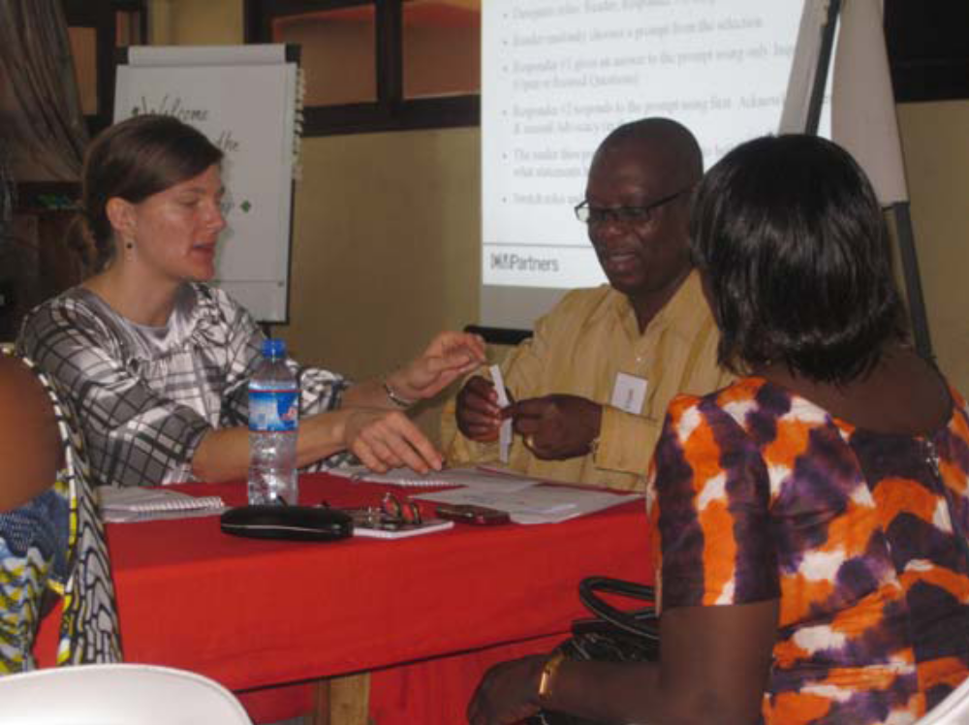
The Wilson Center is very hopeful that the network can continue, the hoped for County focused workshops in other areas of the country can take place, and that we expand this work to other groups originally envisioned, including youth and women leaders. Steve McDonald has had preliminary talks with the U.S. Ambassador and USAID Director about supporting an expanded and continuing project and they are favourable. Consultations have started in Washington. The President has expressed her interest in the work continuing and the Wilson Center will invite her Chief of Cabinet, Dr. Momo Rogers, to Washington in late-November to join in meetings with USAID and the State Department about finalizing their commitment.
Challenges{If Necessary}:
- Planned workshop conflicted with Cabinet Retreat organized by the Office of the President

- The workshop organized for July was postponed due to Presidential visits to several counties; coupled with the celebration of the National Independent Day (July 26, 2010).

- Fully understanding the mode of implementation of the WWICs project by the new UNDP’s designated focal person.

List of Acronyms and Abbreviations
- USAID – United States Agency for International Development
- PBF- Peace Building fund
- WWICS- Woodrow Wilson International Center for Scholars
- UNDP- United Nations Development Programmes
- NGO- nongovernmental organization
- M&E- monitoring and evaluation
- WANEP - West African Network for Peace
Photos of Some of PBF Sponsored Activities
Photos of the previous trainings bringing together government officials from the legislature, and executive, including representatives from youth and other sector of the society.
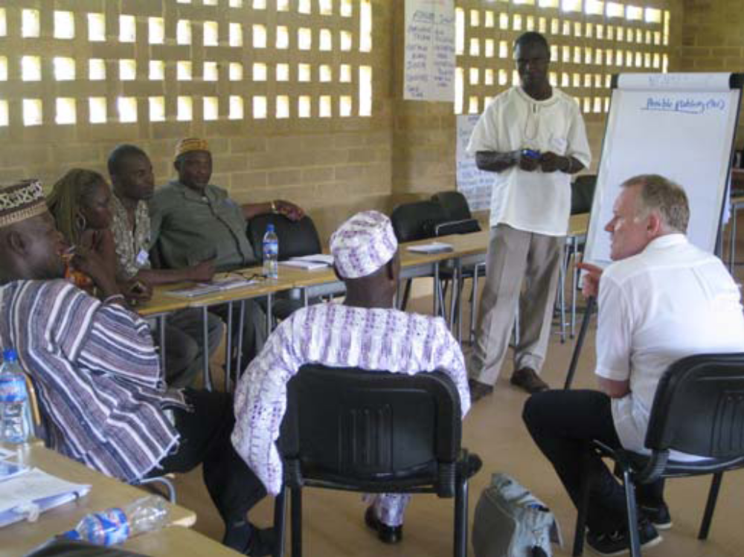
Working session with Liberian Local government Officials

