Liberia Peace Building Fund

QUARTERLY STATUS REPORT AS OF (July-September, 2010)

Recipient UN Organization: | UNDP |  | PBF Priority Area: |  | 3.3; 3.3.1
Implementing Partner(s): | Ministry of Justice , Republic of Liberia
Project Number: | (PBF/LBR/E-3) PBF/R2//A3/09
Project Title: | “Strengthening the Ministry of Justice in Improving Prosecution Services”
Total Approved Project Budget | 1, 082,000 USD
Funds Committed: | $786,090 USD |  | Percentage of Approved: |  | 72.7%
Funds Disbursed: | $999,569 USD |  | Percentage of Approved: |  | 92%
SC Approval Date: | January 22, 2009
Expected Project Duration: | 18 Months | Forecast Final Date: |  | September 2010 |  | Delay (Months): | 4 months

Outputs: | Progress: | Percentage of planned:
1.Consultant for initial strategic planning recruited  Initial training session for MoJ prosecutors’ strategic plan held.  3. Strategic plan drafted and  Validated  4. Office space for OTD identified by MoJ and refurbished/ equipped  5. The head of OTD and 2 Assistants recruited by MoJ | 1. Completed  2. Completed  3. Strategic plan being drafted  4. completed  5. The Director of Training and Development has been recalled to her position as serving as Assistant Minister for Corrections and Rehabilitation of the Ministry of Justice for the past three months. | 1. 100%  2. 100%  3. 100%  4. 100%  5. 50%
6.The Office of the Deputy Minister of Justice for Administration and Public Safety (DMA)'s capacity for operational management enhanced, and the development of standards and policies for prosecutors, including a code of conduct/ethics, supported | 6. Procurement of logistics to enhance the DMA’s operational need of the office and hiring of a Director of the OTD completed. Recruitment of consultant to develop code of conduct/ethic for the Ministry in progress. | 6. 75%
7. Prosecutorial training needs and gaps identified by the OTD in a one-day workshop | 7. completed | 100%

Qualitative achievements against expected results: July- September 2010
During the 3rd quarter under reviewed,
The United Nations Development Programme and the Ministry of Justice conducted a nationwide in service trainings for Correction Officers, and immigration, Police ERU Officers assigned within prison facilities around the country. The country was divided into four training regions.
This training discussed a number of professional areas. Prominent among them were: Protection Security, Trauma Treatment in Prisons, Grievance Procedure, Institutional Policy, Ethics & Professionalism/code of Conduct/Work Ethics, and Discipline and Courtesy. Facilitators were drawn from various partners including Carter Centre, UNMIL, and the Ministry of Justice. The participants who numbered 97 from each region, brought together: Margibi, Montserrado, Gbarpolu, Grand Cape mount and Bomi counties as Region I with the training being conducted in Kakata. Region II included: Grand Bassa, River Cess and additional representatives from Montserrado (Montserrado participants were divided between 2 counties due to the large number). The training was conducted in Buchanan. Region III which comprised mainly of counties of the central region was: Nimba, Lofa and Bong Counties and the training took place in Gabrnga, while Region IV gathered participants from Maryland, Sinoe, Grand kru, River Gee and Grand Gedeh in Zwedru. A total number of 388 personnel received certificates at the end of the more than 1 month in-service training. Marking the end of the regional training, the Solicitor General of the Republic of Liberia who also facilitated the trainings, praised the United Nations Peace Building Fund through UNDP for the continuous capacity building support which has had a far reaching impact on the reform process of
the Rule of Law sector and sustaining the peace in Liberia.

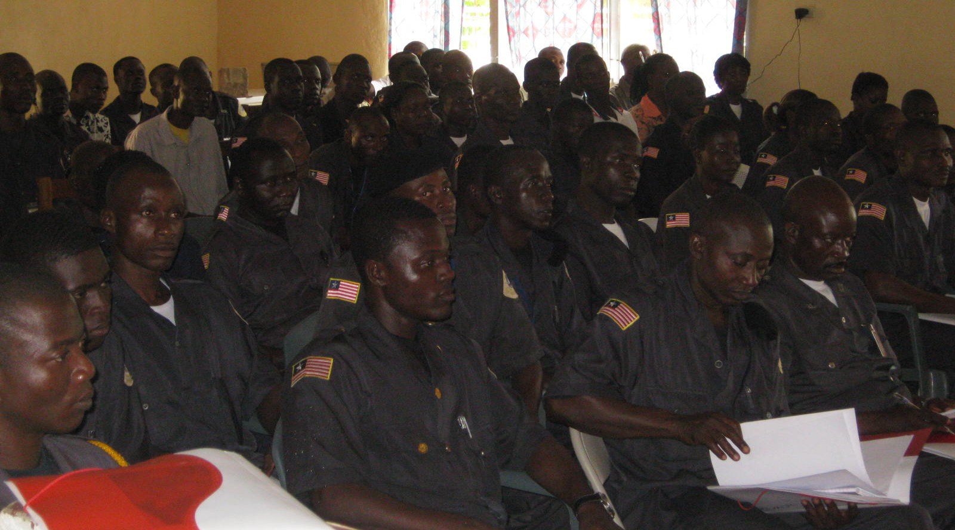

Correction officers in training session in Gbarnga, Bong county, one of the training venues.

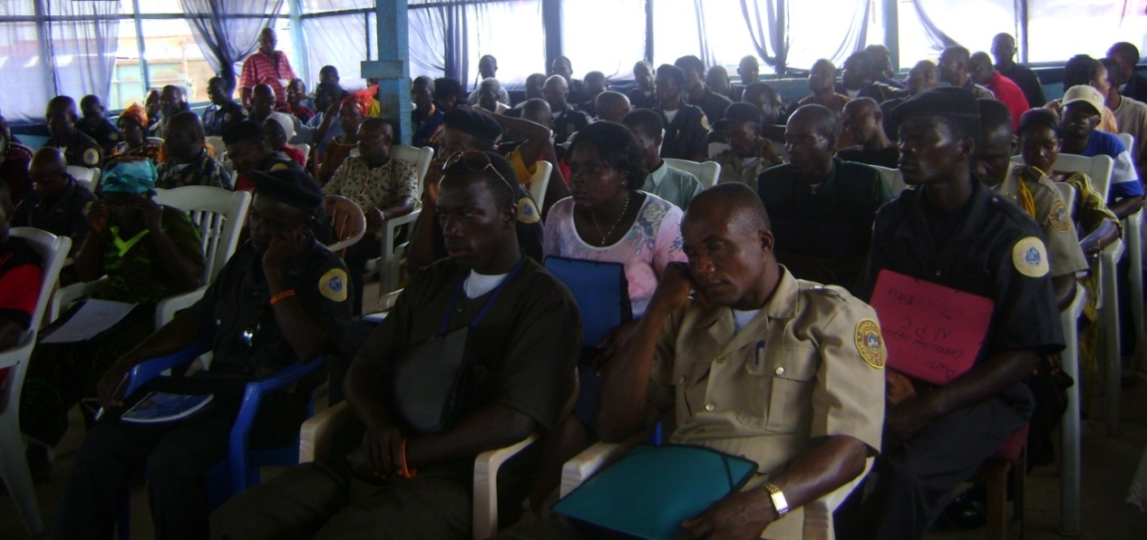

Corrections and other law enforcement personnel in training in Zwedru, Gedeh county

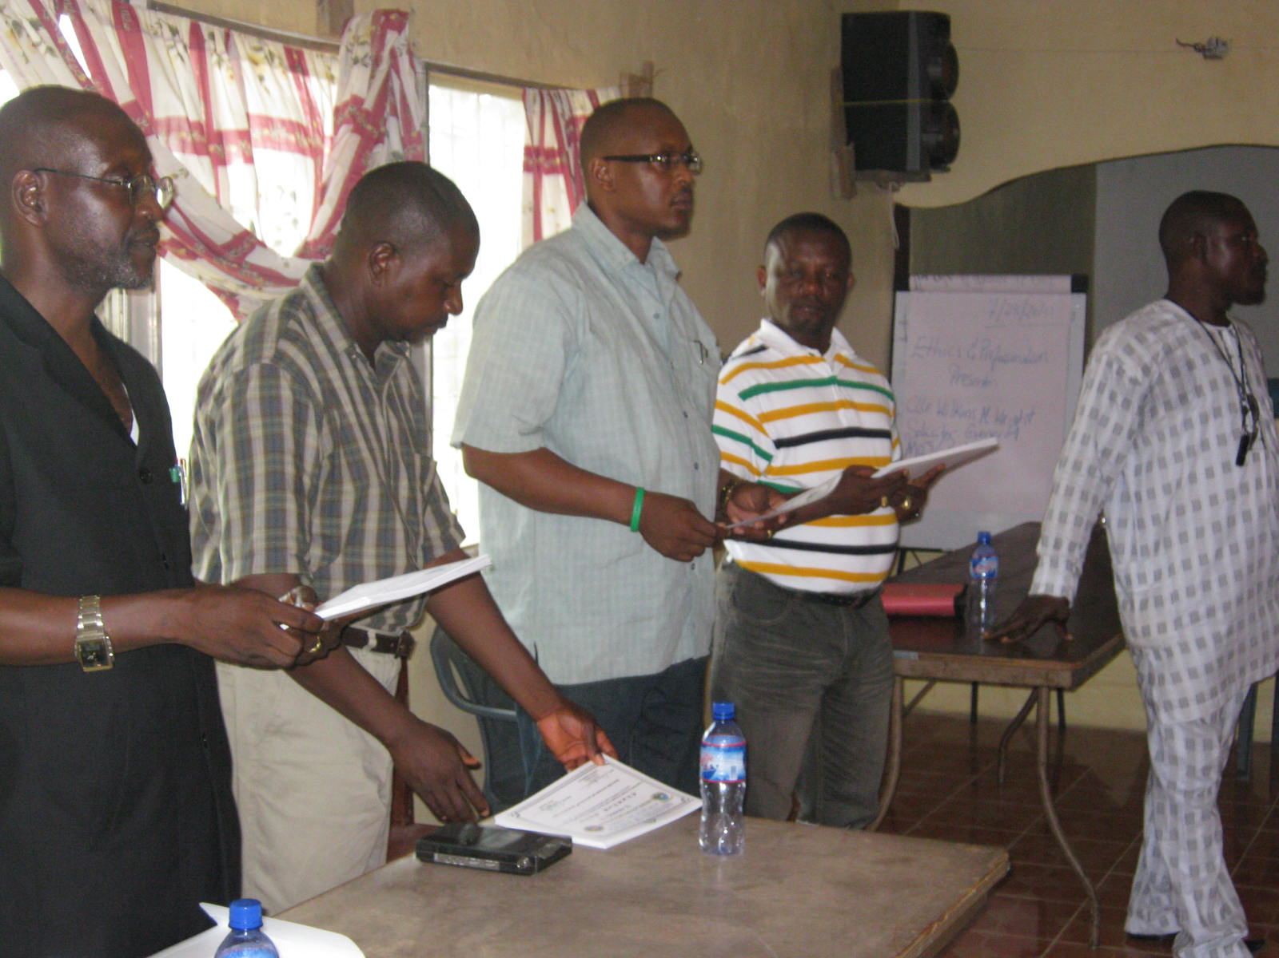

Solicitor General, Cllr. Wright and UNDP/ROL Team present certificates at the close of the workshop.

Community police forum

Two community police fora were implemented. The fora were conducted jointly with the Community Security project at UNDP. The Community Security Project had already been involved in community policing activities in many communities as part of Annual Work Plan. We jointly implemented this activity from our work plan to strengthen and enhance synergies between and amongst the peace building funded projects here at UNDP. The two fora held in Paynesville, Montserrado and Sinje Grand Cape Mount counties. Funding was provided from the MOJ/ROL/UNDP Prosecution Project to execute the fora as stipulated in the Annual work Plan.

UNDERSTANDING COMMUNITY POLICING

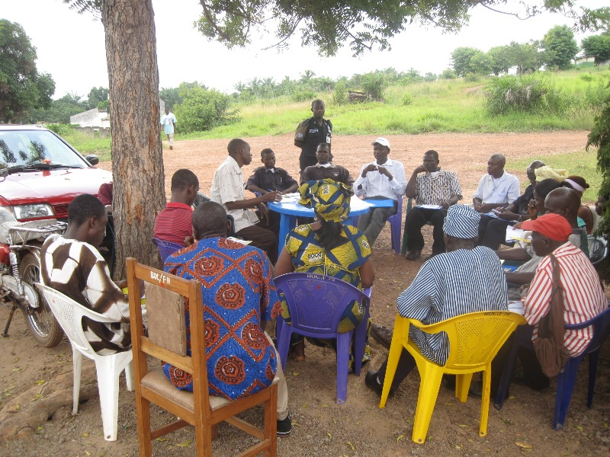
Community policing
forum in one of the
local communities.
Courtesy of the
Community police
Forum Manual

Community Policing (CP) is the aspect of policing that involves the equal and active participation of communities in partnership with the police to detect, prevent and reduce crime. It is an active partnership between the police and members of the community towards ensuring a safe and secured environment. It gives members of the community a sense of belonging and social responsibility in addressing the problems of insecurity in the communities. Community policing is facilitated through consultations in forums or town meetings between the police and members of the communities with regards to security and well being of the community dwellers.

