Liberia Peacebuilding Fund

QUARTERLY STATUS REPORT

April-June 2010

Recipient UN Organization: | UNDP |  | PBF Priority Area: |  | 3.3; 3.3.1
Implementing Partner(s): | Ministry of Justice , Republic of Liberia
Project Number: | PBF/LBR/E-3 (PBF/R2//A3/09)
Project Title: | “Strengthening the Ministry of Justice in Improving Prosecution services”
Total Approved Project Budget | 1, 082,000 USD
Funds Committed: | $786,090 USD |  | Percentage of Approved: |  | 72.7
Funds Disbursed: | $59,550.00 |  | Percentage of Approved: |  | 7.6%
SC Approval Date: | January 22, 2009
Expected Project Duration: | 18 Months | Forecast Final Date: |  | September 2010 |  | Delay (Months): | 4 months

Outputs: | Progress: | Percentage of planned:
1.Consultant for initial strategic planning recruited  2. Initial training session for MoJ prosecutors’ strategic plan held.  3. Strategic plan drafted and  Validated  4. Office space for OTD identified by MoJ and refurbished/ equipped  5. The head of OTD and 2 Assistants recruited by MoJ  6.The Office of the Deputy Minister of Justice for Administration and Public Safety (DMA)'s capacity for operational management enhanced, and the development of standards and policies for prosecutors, including a code of conduct/ethics, supported  7. Prosecutorial training needs and gaps identified by the OTD in a one-day workshop | 1. Completed  2. Completed  3. Strategic plan being drafted  4. Completed  5. The Director of Training and Development has moved to a new position, Assistant Minister of Justice for Corrections and Rehabilitation. This position Has therefore been re-advertised in the local dailies. Applications for 2 assistants have been received.  6. Procurement of logistics to enhance the DMA’s office is in progress. Recruitment and hiring of a Director of the OTD is also in progress.  7. completed | 1. 100%  2. 100%  3. 100%  4. 100%  5. 50%  6. 75%  7. 100%

Qualitative achievements against expected results: April-June 2010
During the quarter under reviewed,
The United Nations Development Programme and the Ministry of Justice ended three regional Criminal Justice trainings for prosecutors, Correction Officers, and National Police Investigators around the country.
The trainings officially launched in Ganta, Nimba County brought together District Attorneys, City Solicitors, Immigration Officers, Corrections Officers, other Ministry of Justice Prosecutors assigned in the Counties, and National Police Investigators from Grand Gedeh, River Gee, Sinoe, Grand Kru, Maryland, and Nimba Counties.
The second phase was conducted in Gbarnga, Bong County with participants drawn from Lofa, Rivercess, Montserrado, Grand Bassa and Bong Counties.

The Kakata, Margibi County training which marked the official end of the regional trainings, focused on Counties of Northern Liberia including, Bomi, Grand Cape Mount, and Gbarnpolu Counties. A total of two hundred and twenty-five (225) criminal Justice Prosecutors, Correction Officers including Police Investigators, and
Immigration officers were trained in diverse areas of the Criminal Justice system. Some of the topics discussed centered on the protection of the elderly and disabled; violence and abuse, standard of proof and criminal justice responsibilities, and cruelty and unusual punishment during the discharge of duties. The trainings were facilitated by experts within the Criminal Justice System including the Solicitor General of Liberia, Cllr. M. Wilkins Wright.
Cllr. Wright who also spoke during the official closing of the regional trainings called on participants, especially the Police Investigators to be serious owing to the importance attached to their job as investigators in the Criminal Justice System. Cllr. Wright averred that

Prosecution will be impossible in the absence of proper investigation. He told the participants to respect all brought before the law. According to him, the law is the common denominator among all and that prosecutors were themselves not above the law. Speaking further, Cllr. Wright told Law enforcement Officers to do away with the culture of arrest before investigation. He said investigation ought to be conducted before arrests are made when cases are brought before them. He also told Correction officers that Justice is not about incarceration, but that inmates should be rehabilitated while serving sentences in order to have alternative to criminal conduct when they return to the society.

participants

Also present at the closing Program was the UNDP Rule of Law Programme Manager, Cllr. James N. Verdier, Jr. who praised the Ministry of Justice for the partnership and commitment in conducting the trainings.

He said the Rule of Law Team at UNDP will shortly embark on field monitoring missions in the counties to observe how well prosecutors blend the acquired skills in the discharge of their duties.
The trainings were conducted as part of Annual Work plan activities under the Project “Strengthening Public Prosecution Services” at the Ministry of Justice. The project is funded by the United Nations Peace Building Fund (PBF) and it’s implemented by the Ministry of Justice with technical and Management support from UNDP. The advertisement for the recruitment of a Director for Training and Development at the Ministry of Justice was concluded. The advertisement was carried out in 2 major local dailies, including other media. A Technical interview panel comprising MOJ, UNDP and partners is currently being put in place. The post of Training Director was made vacant when its Director was appointed as Assistant Minister of Justice for Corrections and Rehabilitations.

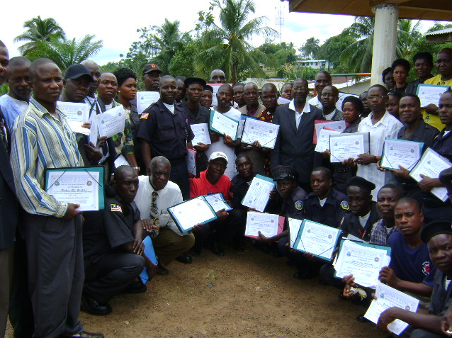

Participants with certificates at the end of the kakata’s training

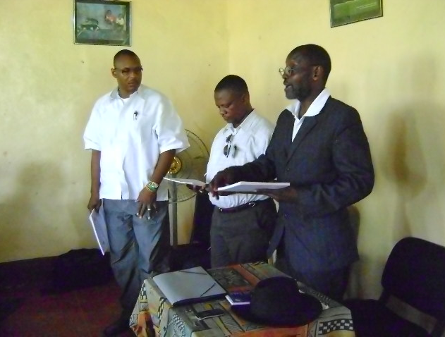

Solicitor General Wright and UNDP ROL Team presenting certificates to participants

United Nations Development Programme
Rule of Law Programme

PRESS RELEASE
LIBERIA

UNDP/MOJ ends Nationwide Criminal Justice Trainings
225 Prosecutors and Police Investigators Benefit

Monrovia, Liberia - May 11, 2010, Douglas Jones reports- the United Nations Development Programme and the Ministry of Justice have ended three regional Criminal Justice trainings for prosecutors, Correction Officers, and National Police Investigators around the country.
The trainings formerly launched in Ganta, Nimba County 3 weeks ago, brought together District Attorneys, City Solicitors, Immigration Officers, Corrections Officers, other Ministry of Justice Prosecutors assigned in the Counties, and National Police Investigators from Grand Gedeh, River Gee, Sinoe, Grand Kru, Maryland, and Nimba Counties.
The second phase was conducted in Gbarnga, Bong County with participants drawn from Lofa, Rivercess, Montserrado, Grand Bassa and Bong Counties.

The Kakata, Margibi County training which marked the end of the regional trainings over the weekend, focused on Counties of Northern Liberia including, Bomi, Grand Cape Mount, and Gbarpolu Counties. A total of two hundred and twenty-five criminal Justice Prosecutors, Correction Officers including Police Investigators, and Immigration officers were trained in diverse areas of the Criminal Justice
Participants with certificates at the end of the kakata’s training
system. Some of the topics discussed centered on the protection of the elderly and disabled; violence and abuse, standard of proof and criminal justice responsibilities, and cruelty and unusual punishment during the discharge of duties. The trainings were facilitated by experts within the Criminal Justice System including the Solicitor General of Liberia, Cllr. M. Wilkins Wright.

Cllr. Wright who also spoke during the official closing of the regional trainings called on participants, especially the Police Investigators to be serious owing to the importance attached to their job as investigators in the Criminal Justice System. Cllr. Wright averred that
Solicitor General Wright and UNDP ROL Team presenting certificates
Prosecution will be impossible in the absence of proper investigation. He told the participants to respect all brought before the law. According to him, the law is the common denominator among all and that prosecutors were themselves not above the law. Speaking further, Cllr. Wright told Law enforcement Officers to do away with the culture of arrest before investigation. He said investigation ought to be conducted before arrests are made when cases are brought before them. He also told Correction officers that Justice is not about incarceration, but that inmates should be rehabilitated while serving sentences in order to have alternative to criminal conduct when they return to the society.

participants

Also present at the closing Program was the UNDP Rule of Law Programme Manager, Cllr. James N. Verdier, Jr. who praised the Ministry of Justice for the partnership and commitment in conducting the trainings.

He said the Rule of Law Team at UNDP will shortly embark on field monitoring missions in the counties to observe how well prosecutors blend the acquired skills in the discharge of their duties.

The trainings were conducted as part of Annual Work plan activities under the Project “Strengthening Public Prosecution Services” at the Ministry of Justice. The project is funded by the United Nations Peace Building Fund (PBF) and it’s implemented by the Ministry of Justice with technical and Management support from UNDP

(02)

For further information, please contact Douglas Jones; Email: douglas.jones@undp.org: tel: +231-6533-223

