LIBERIA

PEACE BUIDING FUND

ANNUAL programme NARRATIVE progress report

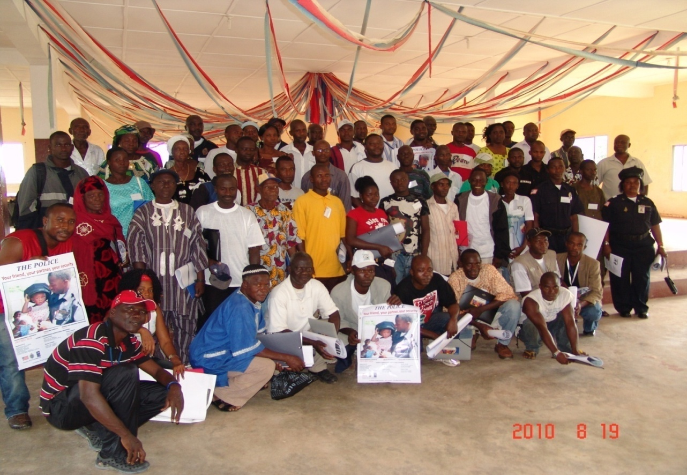

(Source: uncp/CSSC 2010)

enhancing relationship between police & civilians

REPORTING PERIOD: 1 january – 31 December 2010

Programme Title & Number |  | Country, Locality(s), Thematic Area(s)
- Programme Title: Enhancing Relationship Between Police & Civilians  - Programme Number (PBF/ LBR/ E7)  - MDTF Office Atlas Number: 00070887 |  | (Liberia/National/if applicable)

Participating Organization(s)  UNDP |  |  |  | Implementing Partners
- National counterparts (government, private, NGOs & others) and other International Organizations
- Ministry of Justice (MoJ) / Liberia National Police (LNP)
Programme/Project Cost (US$750,000) |  |  |  | Programme Duration (18 months)
MDTF Fund Contribution: 750,000 USD  - by Agency (if applicable) |  |  |  | Overall Duration
Agency Contribution  - by Agency (if applicable) |  |  |  | Start Date September 2009
Government Contribution  (in kind) |  |  |  | End Date or Revised End Date: December 2010  (if applicable)
Other Contribution (donor)  (if applicable) |  |  |  | Operational Closure Date 31 March 2011
TOTAL: |  |  |  | Expected Financial Closure Date 30 April 2011
Programme Assessments/Mid-Term Evaluation |  |  |  | Submitted By
Assessment Completed - if applicable please attach  Yes No Date: __________________  xX  Mid-Evaluation Report – if applicable please attach  Yes No Date: __________________ |  |  |  | - Name: Napoleon Abdulai  - Title: CTA  - Email address: napoleon.abdulai@undp.org

Acronyms

CPAP Country Programme Action Plan
CPF Community Police Forum
GOL Government of Liberia
LNP Liberia National Police
MDTF Multi-Donor Trust Fund
MOJ Ministry of Justice
PBF Peace Building Fund
UNDAF United Nations Development Assistant Framework
UNDP United Nations Development Programme
UNPOL United Nations Police

Contents

Acronyms 3
I. Purpose 5
II. Resources 6
III. Implementation and Monitoring Arrangements 6
V. Future Work Plan (if applicable) 13
VI. Annex ………………………………………………………………………………………………...14

Purpose

Enhancing community security and social cohesion is paramount to the recovery of post-conflict states
such as Liberia. Without comprehensive community security and social cohesion, recovery and developments become a serious challenge in this era of globalization. Community security seeks to protect communities from the lost of common or traditional relationship and values, from physical and mental violence and also economic, justice and social capital destruction.

In 2009, the Peace Building Office (PBO) through the Multi-donor Trust Fund signed an agreement with UNDP for a grant of US750, 000.00 to support the project “Enhancing Relationship between the Police and Civilians” in Liberia. The project heeds the goals of the Country Programme Action Plan (CPAP) in ensuring cross-linkages between its different components, notably peace and security consolidation. It further contributes to United Nations Development Action Framework (UNDAF) Outcome 1, “National and local authorities increasingly have the capacity to provide security, manage conflict, prevent violence and respecting human rights”. It supports the Poverty Reduction Strategy (PRS) 2008-11 in enhancing peace and security. In addition, this project supports the efforts of the Government of Liberia (GoL), through the Ministry of Justice (MOJ) in the consolidation of recovery of the country including Government effort to revamp rural communities and reduce crime thus creating a safe and secured environment for conflict prevention and development.

Hence the objectives of this project were to:
- Improve public trust in LNP and the criminal justice system;
- Increase LNP presence in rural and high crimes areas and;
- Enhance community policing (seeking the communities cooperation in identifying and solving crime- related problems through training, public awareness, logistics and infrastructural support).

Insecurity is best tackled by developing local approaches through participation of local communities with support of national government. The project focused on supporting the establishment of community security and strengthening of social cohesion infrastructure as well as strengthening traditional conflict prevention mechanism and the development of Community Policing with gender as the central cardinal point.

Given the above, this intervention was directed at core communities and respective key community leaders, Liberia National Police (LNP) officers and supervisors. The seminars/training were intended to increase capacities for joint identification and solving of community crime problems; infrastructure and logistical support were to enable community forums to be effective and increase LNP presence of uniformed officers in rural and high crime areas in order to provide more access to all citizens. In this way enhance relationship between the police and civilians.

Resources
Financial Resources:
- The only source of funding for this project was the UNDP PBF. Under the internal control framework of UNDP, 100% of grant was utilized based on the activities in the annual work plan and approved budget. There were challenges in getting funding to rural communities to conduct trainings. Best practice incorporated was to partner with local banking institution to provide direct services in covering cost of workshop activities at the various training sites. Timely planning was the key to reduction of potential bottlenecks and improvement of better coordination in the release of funds for project implementation.

Human Resources:
- National Staff: - during the period of implementation, the project utilized two national staff which included one project officer and one driver. The project officer managed the day to day implementation of the project, conducting trainings, public awareness, community consultations, monitoring and reporting. The driver provided support to the field for implementation of the project.

- International Staff: - no international staff was recruited during the existence of the project

Implementation and Monitoring Arrangements

- During the project implementation, a Project Technical Committee was formed. The committee met on a weekly basis to review progress and design strategies for successful implementation of project activities. The technical committee which included representatives of the MOJ, LNP, UNPOL and civil society organizations, coordinated the implementation process. The LNP officers led the process in community policing trainings and concepts. They engaged the communities through clean-up campaigns, consultations, public awareness, and sports to enhance relationship and community security. The project impacted students, youths, and women groups, community based organizations and trade unions, community members, local government authorities, and LNP officers assigned in communities.

- The project followed UNDP standard procurement rules in the procurement of all goods and services. For example, requests with specifications were received from LNP; the beneficiaries. Upon approval of the request in line with the annual work plan and approved budget line, Invitation To Bid (ITBs) were published for public participation. Through this process, vendors/contractors were identified to provide goods or services for the project.

- Monitoring and Evaluation trainings were conducted by the Peace Building Office and the UNDP Monitoring and Evaluation Unit to enhance the capacity of project staff in that area. Based on the training provided, regular field assessment and consultation visits were conducted by the project officer with community members and the LNP. Feedbacks from these visits served as the basis for the development of training modules and implementation strategies which resulted in the high participation of all the stake holders. A project mid-term review was also conducted by the Peace-Building Fund Office as part of the project evaluation process.

- During the reporting period, a best practice retreat was held which gave birth to the creation and production of the Community Policing Training Manual currently being distributed to all stake holders. This manual is expected to serve as a guide to the implementation of community policing in Liberia.

- Results

Progress in relation to Outputs:

- Logistical support to LNP and Community Policing forum - During the period under review, the project procured and handed over 16 Honda XL Off-road motorbikes to LNP for patrol of high crime areas.
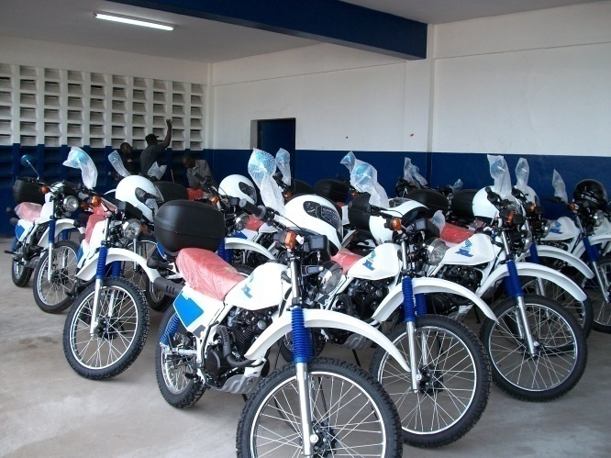

(Source: CSSC/UNDP 2010)

- Training-community policing (Best practices) and publication of Community Policing Manual - A two- days community policing best practice retreat bringing together 18 officers of the LNP from counties around the country where the concept of community policing is thought to be succeeding was held in Monrovia. The LNP officers most of whom were commanders and sectional heads, served in the capacity of both participants and facilitators of the event with several staff from both UNPOL and UNDP attending as observers. The retreat was geared at determining what the best practice in community policing was since its introduction in Liberia in 2004, primarily for the development of a practical guide manual on community policing, which will be used for training LNP officers and community leaders on the practical concept of community policing.

- The practical guide manual on community policing intended for training LNP officers and community leaders on the concept of community policing was finalized and cleared for publication by the Inspector General of the LNP and the Commissioner of the UN police in Liberia.

- Publication of the community policing practical manual completed and distribution ongoing

- Consultations
- Strengthened the participation of local community leaders through consultation with communities on community policing and planning meetings for the national launch of the nation and countywide awareness and sensitization campaign with community leaders and stakeholders.

- Formalizing of a sustainable mechanism to enable, through consultative process, the effective development and Implementation of crime prevention, public awareness activities in communities

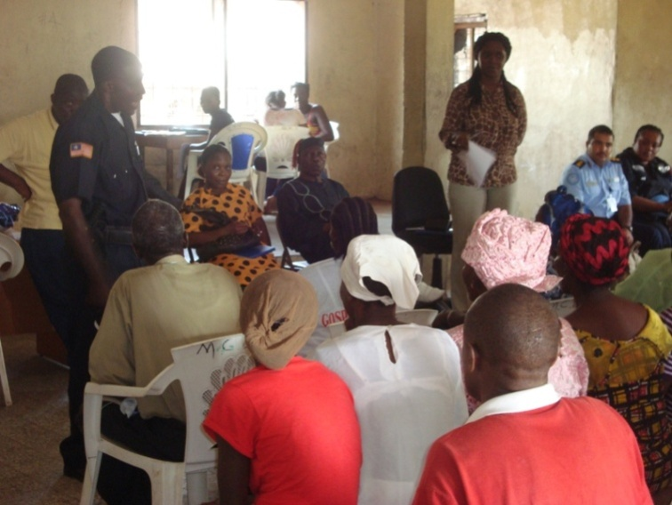
- The project also conducted at least 2 consultative meetings with local leaders and police officers on the sustainability of gains created by the sensitization campaign held in each of the fourteen counties (with the exception of Grand Kru) where the community policing nation and countywide awareness and sensitization campaign and the leadership training seminar was held. As a result of the meetings which brought together all the stakeholders involved in community policing, a CP meeting group involving a representation of every sector of the community and with the oversight of the local government authority and the police had been established in most communities around the country. These CP groups will have the responsibility of implementing crime prevention awareness at the community level.
(Source: CSSC/UNDP 2010)

- Regular weekly meetings of the project technical committee were also held with its implementing partners from the MoJ, LNP and UNPOL.
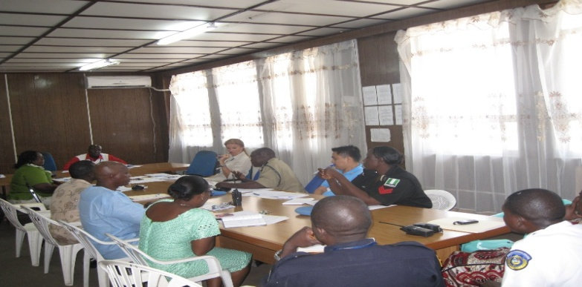

(Source: CSSC/UNDP 2010

- Development and publication of IEC materials (Brochures, Posters and T-Shirt) and promos for awareness and sensitization campaign by LNP, UNPOL, UNMIL Public Information and UNDP

- National sensitization and awareness campaigns on community policing activities

- Communities and civil society’s mobilization and planning meetings held in counties where CP sensitization and awareness was held.

- The Countywide Community Policing awareness campaign has been launched in 14 out of the 15 counties in Liberia (Grand Bassa, Margibi, Lofa, Grand Gedeh, Sinoe, Maryland, Nimba, River Gee, River Cess, Montserrado and Bong, Gbarpolu, Cape Mount and Bomi Counties) respectively

- Seminar for the LNP Patrol, Station Commanders, MoJ officers, on community Policing etc.

- Community Policing training seminar for community leaders, LNP patrol station commanders, MOJ and line ministries held in 14 out of the 15 counties in Liberia (Grand Bassa, Margibi, Lofa, Grand Gedeh, Sinoe, Maryland, Nimba, River Gee, River Cess, Montserrado and Bong, Gbarpolu, Cape Mount and Bomi Counties)

- Renovation and equipping of LNP Offices

- Assessment of offices to be renovated and specification of equipment completed.

- 11 LNP stations were identified for renovation by LNP, UNPOL and UNDP assessment team to include five (5) police stations located in the leeward counties (Bong County Police HQ, Salala Police Station, Ganta Police Station, Maryland County Police HQ and Gbarpolu County Police HQ) and six (6) police stations located within central counties (Margibi County HQ, Bensonville, New Kru Town, Hotel Africa, Grand Bassa County HQ, and Soul Clinic).

- 100% renovation completed by United Nations Operations for Project Services (UNOPS)

Progress in relation to Outcomes:

- Enhance the efficient and effective implementation of the project:

- Achieved coordination and collaboration of implementing partners from the MoJ, LNP and UNPOL through regular weekly meetings of the project technical committee

- Increase the quality of life in communities through effective crime prevention strategies

- Economic and development activities in communities have improved due to confidence and assurance in the security sector. For example police visibility in high risk communities reduced crime. Civilians’ cooperation with the police in reporting crimes and reduction of mob violence in community

- Increase public awareness created on the roles and responsibilities of citizens in crime prevention and violence reduction

- Community policing training conducted for community chairpersons and zonal heads, heads of women and youth organizations, heads of motorcycle and road transport unions and local government and traditional authorities who are in term expected to share the information acquired with their respective constituents.

- Enhanced capacity of community-police intervention to address root causes of potential conflict at the community level
- The capacity of community policing structures in communities strengthened to address conflicts resulting from civil disagreement and disorderly conduct in the community.

- Increased citizen trust and cooperation through daily positive contacts with LNP patrol officers
- Increase in # of opportunistic crimes reported during this period.
- 5 % and 11.4% increase in # of opportunistic crimes reported during (June –August) and (August-September) respectively - Crime Statistic Report LNP.

- Increase in emergency and non emergency calls/contacts with the police

- The launching of the awareness and sensitization campaign kicked off with a cleanup campaign exercise initiated by the officers and members of the communities brought the people closer to the police through voluntary community service.

- Equal access to police for all citizens/communities and Increased quality of life in communities

- More police stations and depot renovated and police capacity was enhanced.

Key outputs achieved under the reporting period including # and nature of the activities

In order to ensuring that the LNP takes ownership of community policing in Liberia and plays the lead role in its implementation (decrease in cases of police misconduct); and to also ensure increase citizens role in information sharing on crime prevention and community security;
- A community Policing leadership training seminar was conducted for police officers, community chairpersons and zonal heads, heads of women and youth organizations, heads of motorcycle and road transport unions and local government and traditional authorities in 14 out of l5 counties in Liberia. Total # of participants trained 578 (433 males and 145 females).

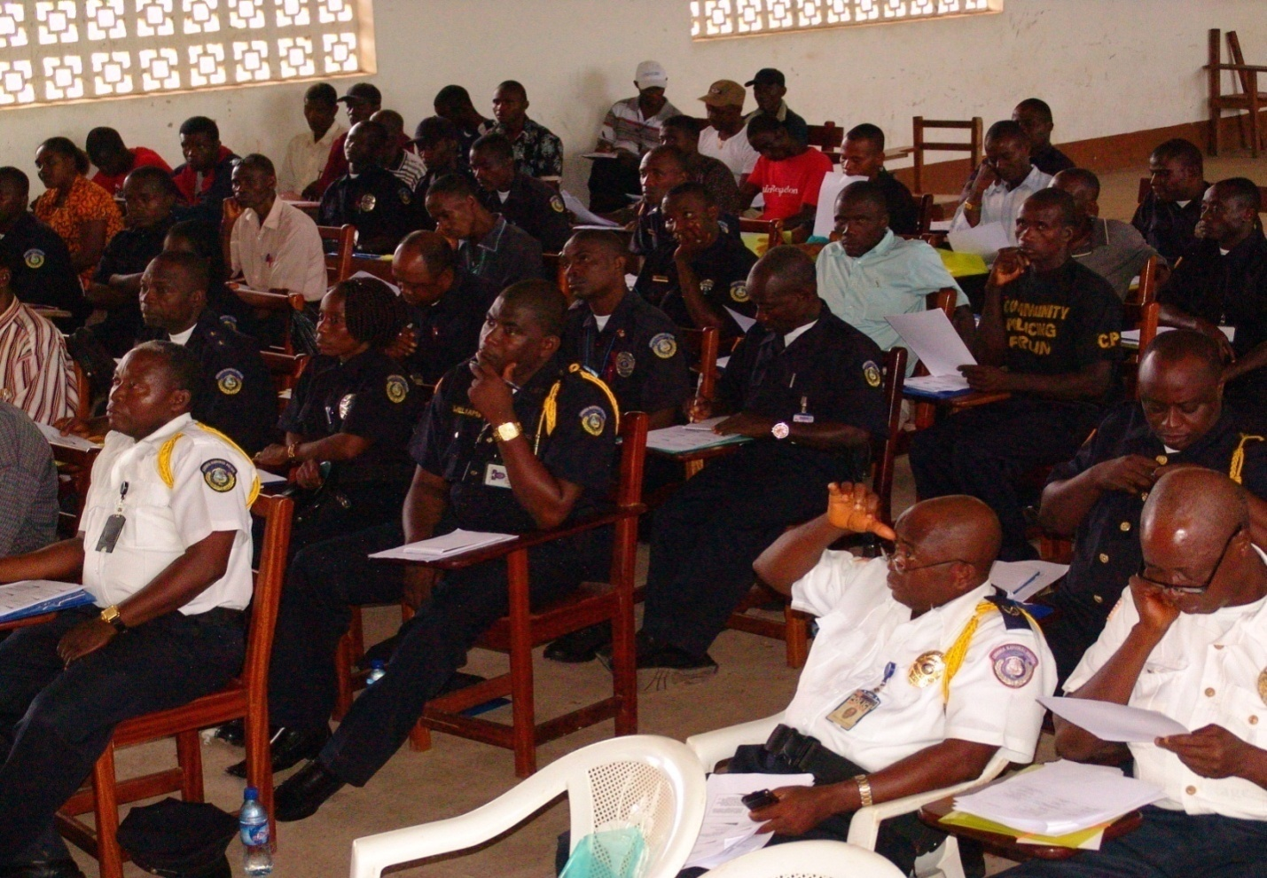

(Source: UNDP/CSSC 2010)

The community policing awareness and sensitization campaign geared at increasing awareness on the roles and responsibility of citizens in crime prevention; decrease in mob violence and vigilantism; improved public trust in the LNP and the criminal Justice system; Enhanced citizen/civil society and police cooperation has been launched in 14 out of 15 counties in Liberia.
- The launching in each county which included among other things a clean-up campaign exercise, two days leaders training seminar for police officers and community leaders, three youth sports tournament, a parade throughout the principle streets and an indoor program, saw the amazing and incredible participation of women and youth groups, the marketing association, local and traditional authorities, community leaders, High Schools, the community policing forum, the motorcycle and transport unions, the UNPOL site team, the Liberia Football Association and the traditional communicators of the UNMIL Community Outreach Section.

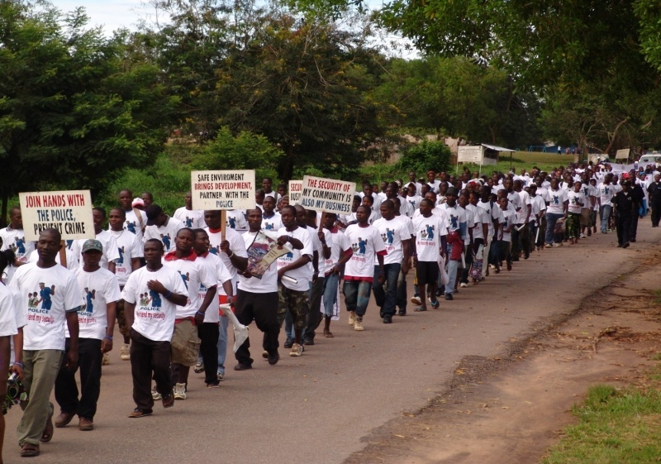

(Source: UNDP/CSSC 2010)

To increase police capacity and effective service delivery thereby resulting in the reduction in the number of opportunistic crime perpetrated (robbery, burglary, theft).
- 11 LNP stations have been identified and renovated under this project by LNP, UNPOL and UNDP assessment team. Stations renovated included five (5) police stations located in the leeward counties (Bong County Police HQ, Salala Police Station, Ganta Police Station, Maryland County Police HQ and Gbarpolu County Police HQ) and six (6) police stations located within central counties (Margibi County HQ, Bensonville, New kru Town, Hotel Africa, Grand Bassa County HQ, and Soul Clinic). 100% renovation completed by UNPOLS. See below photos from Engineers field report.

(Sources: UNDP/CSSC)
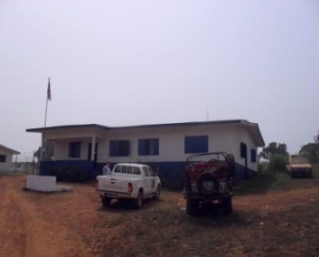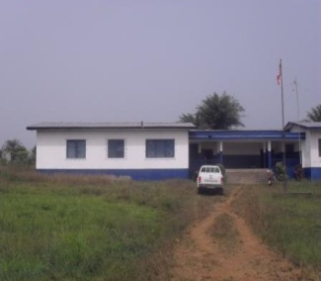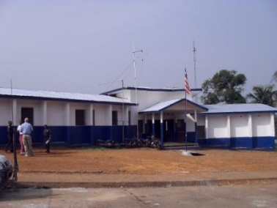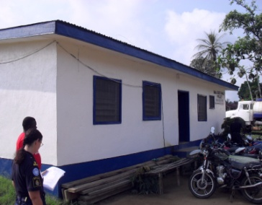
Bopolu Bensonville Harper Salala

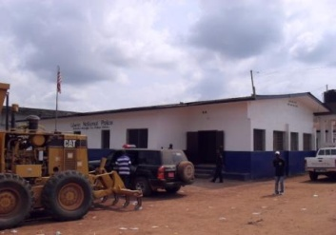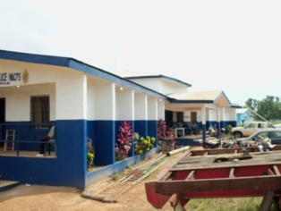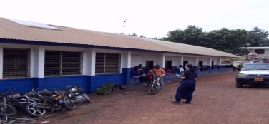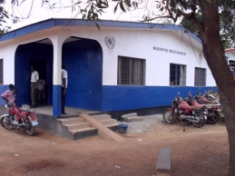
Kakata Buchanan Gbarnga Ganta

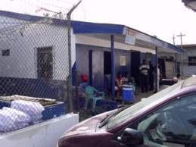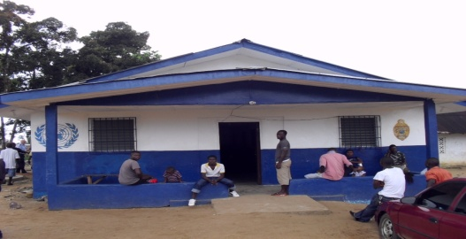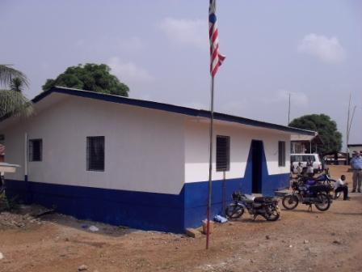
New Kru Towm Soul Clinic Hotel Africa

Constraints and actions taken to mitigate future delays and lessons learned in the process.

- UNDP procurement and finance policies particularly with regards to the sourcing of three quotations for the purchase of goods and services, pre-financing of goods and services; while these policies are easier to work with in Monrovia, in the leeward areas they are very much a challenge due to limited infrastructure and business capacities. Other challenges include Inaccessible Roads, Poor Communication Network, and delays in getting listing of participants from LNP county HQ.

Key Partners and collaboration

The key partners involved in the project were the Ministry of Justice, Liberia National Police, United Nations Police, students, youths, and women groups, community based organizations and trade unions, community members and local government authorities. All of these stakeholders contributed immensely to the achievement of project results. These partnerships and collaborations were strengthened through consultation, participations, and meetings held with the stakeholders.

Gender was highly flagged throughout the implementation of the project as a cross cutting issue. For example the security of women, children and youth were highlighted in every community and became a key issue during the discussions. This led to the project technical committee’s decision to actively engage the participation of women and youth throughout the project implementation. As a result of this decision, women and youth were actively involved and played an important role in the achievement of the project results. At the community level, women and youth participated and contributed to the conversation of community policing and security. They participated in public awareness, clean-up campaigns, sports and attended trainings and the various launches in the counties.

- Provide an assessment of the programme/project based on performance indicators as per approved project document using the template in Section VIII, if applicable.

Future Work Plan (if applicable)
- To seek financial support from the PBC Joint Programming to continue the project Enhancing Relationship between the Police, other Security Agencies and the Communities. UNDP is requesting programming support from the UN Regional Centre for Peace and Development in Lome, Togo.

- ANNEX: PICTORIAL OF IMPLEMENTED ACTIVITIES DURING PROJECT IMPLEMENTATION PERIOD
(Source: UNDP/CSSC 2010)

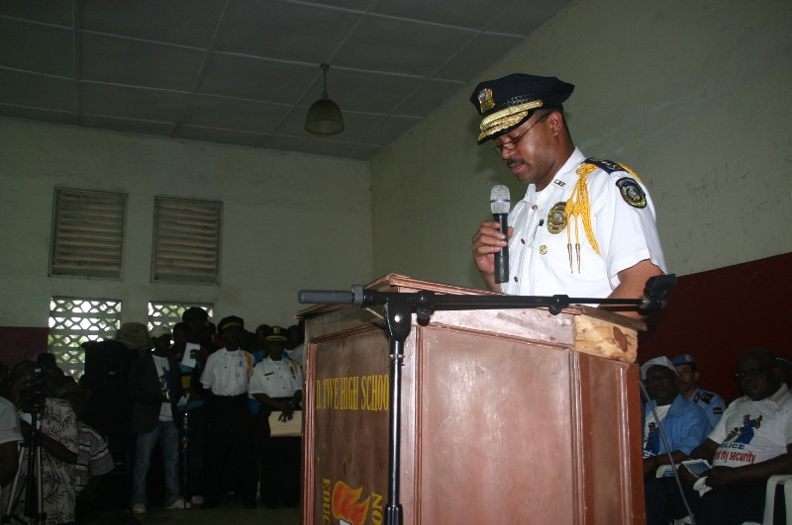
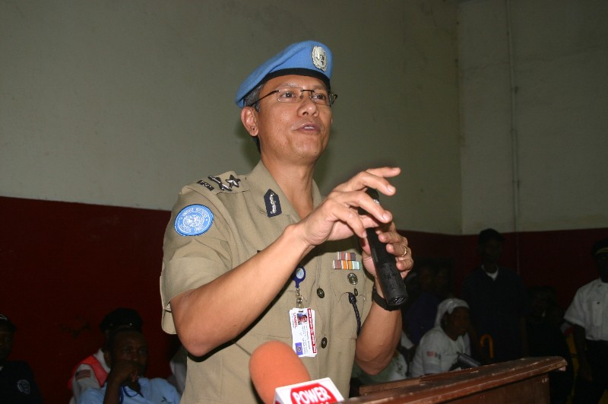

Commissioner Swang Gautam, Commissioner of UNPOL making remarks during the official event
Inspector General Marc Amblard of LNP making remarks during the official event

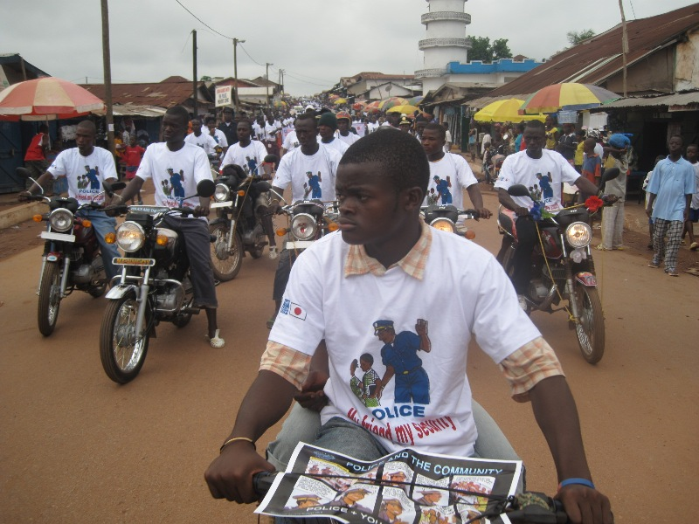
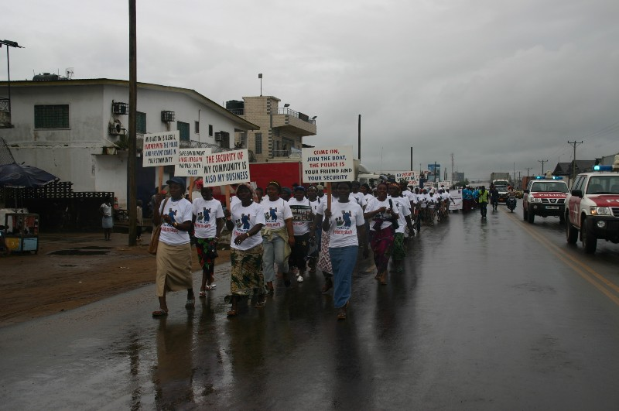

Members of the motorcycle union during the parade
Members of the women group during the parade

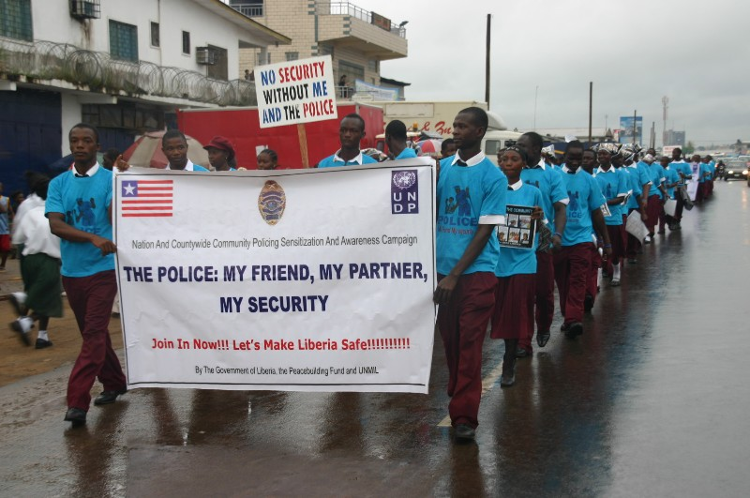
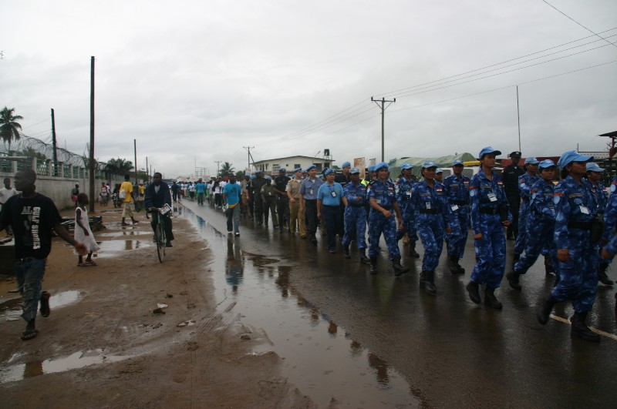

Students of the William V. S. Tubman High school; one of the six high schools partaking in the parade
Even the wet weather could not stop the UNPOL officers from partaking in the parade

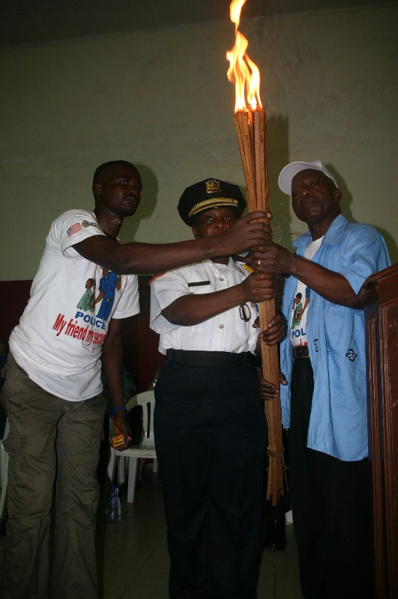
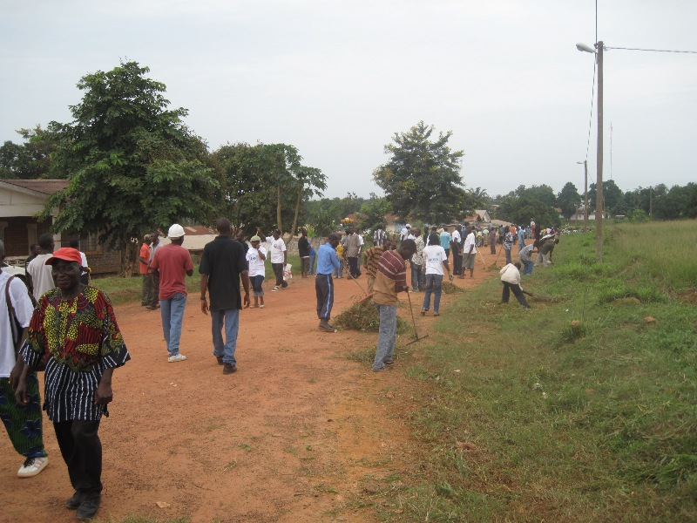
A symbolic display of a rekindled and strengthened relationship between the community and the police
Community collaboration with police in cleanup campaign

Priority Area for the Peacebuilding Fund; Sector for the UNDG ITF.
The start date is the date of the first transfer of the funds from the MDTF Office as Administrative Agent. Transfer date is available on the MDTF Office GATEWAY (http://mdtf.undp.org).
All activities for which a Participating Organization is responsible under an approved MDTF programme have been completed. Agencies to advise the MDTF Office.

