SUPPORT FOR TROPICAL INITIATIVES IN POVERTY ALLEVIATION (STIPA)

JOINT PROGRAMME FOR THE PROTECTION, RE-INTEGRATION, AND RESETTLEMENT OF IDPS IN BOSSASO

STAKEHOLDERS DISSEMINATION WORKSHOP REPORT

HELD IN GAROWE
ON
28TH OCTOBER 2010

Compiled by Peter Aggrey Oduor
Support for Tropical Initiatives in Poverty Alleviation (STIPA)
P.O. Box 6736
Kondele
40103
Kisumu, Kenya
Tel: +254-57-2027063
Fax: +254-57-2027344
Email: infoksm@stipakenya.org
Introduction

UN joint programme for the IDPs has been operating since 2007 in Bossaso, with the following strategic objectives; improved protection for IDPs in temporary and permanent settlements, improved living conditions in existing and temporary settlements and durable solutions for livelihood, resettlements and reintegration which focused on local resettlement and integration and solutions in Bossaso, and resettlement and integration solutions in alternative rural and coastal locations. Support for Tropical Initiatives in Poverty Alleviation was contracted by the joint programme to undertake a final, external, and independent evaluation of the programme. The evaluation objective is to determine the progress of the programme towards achieving its intended outcomes and impacts and to review and assess the extent to which the programme delivered on its targets, and establish whether it is on track to meet its development objectives.

Opening Remarks

The meeting was officially opened by the Director General of the Ministry of Planning and International Cooperation Mr Mohamed Ali Ismail who welcomed all the participants to the workshop and gave opening remarks that influx of IDPs from the south into Puntland is a major concern. He thanked the UN Joint programme for the initiative to make IDPs comfortable in the country and added that there is a need to find a lasting solution to the problem of IDPs. He informed the meeting that the Ministry of Planning and International Cooperation had a meeting with the UN task force for the IDPs and are working towards a comprehensive policy for the IDPs and to address existing humanitarian gaps.

Mr. Simone of UNDP conveyed apologies of the programme manager who was unable to come due to logistical problems that ensued. He thanked the participants for attending the workshop, introduced Support for Tropical Initiatives in Poverty Alleviation (STIPA), and gave an overview of the evaluation highlighting the its objectives and terms of reference. He then handed over the floor to STIPA consultants to continue with the presentation of findings.

Methodology

The workshop was organised in three main categories; presentation of findings using PowerPoint presentation, plenary presentation on evaluation findings and way-forward/recommendations by stakeholders. To maximize discussion, each session lasted for 30 minutes followed by comments from the floor (See the attached workshop programme in annex 2).

Presentation

Mr. Peter Oduor (STIPA Consultant) thanked the organisers of the workshop and the participants for attending and making the workshop a reality. He informed the participants that the exercise began in Nairobi and proceeded to Bossaso and Garowe. He added that the workshop is about reflection on the UN joint programme and a total of 90 people were consulted and they gave their views (see the attached annex 3)

Plenary Presentations

Deputy Mayor of Bossaso

- The Deputy Mayor of Bossaso wanted to know why the workshop could not be held in Bossaso and yet the joint programme works only in Bossaso?
The workshop was held in Garowe because it was important to involve the government officials so they are not left behind in the progress of the programme activities.

- Why did the report highlight security situation and harsh weather in Bossaso as limitations?

Security situation hindered smooth flow of field coordination of the beneficiaries’ interviews, the evaluators could not move freely in the community as was expected and it even forced them to invite some participants to the hotel after receiving security situation reports and alerts.

- Why do agencies plan in Nairobi and implement in Bossaso? (referring to structure of permanent settlements supported by UNHABITAT) and the programme needs to be demand driven
The UN joint programme was designed in participatory manner and the needs were identified with active involvement of the IDP and host community but OTP which is UNHABITAT partner in construction of IDP houses cited challenges faced in design of rooms, floors and roofs that the design did not take into account the harsh weather conditions in Bossaso which he stated was not designed in a participatory manner with the beneficiary community. The participant was informed that further participatory planning has been recommended for the next phase of the programme.
A lady from the community was concerned about the manner in which people have started attaching tag to the houses as “IDP houses” because of the same design, she also indicated that the houses have limited space that cannot accommodate 10 people as some households have more than 10.

- Why did the report indicate that there is no government policy on land?

The Mayor stated that the government of Puntland has a land policy, and that is why Bossaso Municipality has allocated land for resettlement of IDPs. The evaluator responded that some respondents mentioned lack of government policy on land and promised to change the statements.

- The programme has built houses for IDPs, but the municipal council of Bossaso has allocated land for their relocation.
This was a controversy that had a direct bearing on the joint programme interventions, since some of the IDP settlements have received support of permanent houses, the gains of the programme might go to waste if these beneficiaries are to be relocated. He added that valuable urban land is being used for construction of many latrines that has made Bossaso a latrine city. It would be important for the joint programme to meet and agree with the municipality on the way forward on the issue of relocation and latrines.

Awarre of UNDP

- Condense the points especially challenges and recommendations
Action will be taken by the evaluator to condense the points as requested above.

- There is need to include more impact
The evaluator responded that data on impact was collected and available; more impact will be included in subsequent reports.

Khadra of WAWA

- A needs assessment was carried out at the inception of the programme
Some respondents indicated that needs assessment was carried by individual agencies but no mention was made on joint programme assessment. The evaluator thanked WAWA for bringing up this issue since it has helped to clarify the different assessments that have been conducted including the livelihoods assessment, water and sanitation assessments and the gender audit.

- SGBV component did not come out strongly as expected in the report
There was a mention of the SGBV component in the presentation though not detailed since the presentation was just highlighting key achievements.

- Clarify on the point stating that some of the IDPs could be refugees from Ethiopia
The report had it that some IDPs were from Ethiopia and are Ethiopians but it was clarified that they are Somalis who migrated to Ethiopia during war.

Abdullahi from Ministry of Security

The ministry of Security corrected the statement that stated that IDPs were security threat instead he paraphrased it to security threat is from the host community but the participants argued that both the IDPs and the host communities are security threat and perpetrators of violence.

New Shabelle IDP settlement member
The new Shabelle IDP member from Bossaso appreciated the programme for the support and urged the programme to continue with the support. The same sentiments were echoed by Mr. Abdullahi who is Bossaso council member, stating that the programme should be expanded to other regions and should embrace participatory decision making.

Director General of the Ministry of Women and Family Affairs

Director General of the Ministry of Women and Family Affairs agreed with the findings that the government was involved in the programme as he stated that the governor was involved in the IDPs programme.

Mohamed Ahmed
There is need for a coordination office in Bossaso for the IDP programme.

Way forward and recommendations

- There is need to continue supporting the IDPs
- The programme must be expanded to address the needs of more IDPs
- The programme must be included in the national development plan being formulated by the IDPs task force
- There is need to construct uniform houses for both IDPs and host communities to avoid tagging a particular design to IDPs structures.
- There is need for the programme to concentrate also on the host community, since 80% on IDPs may cause conflicts between the two communities.
- The programme should be implemented by the local government as opposed to NGOs and other structures that have been used before.
Conclusion
Generally the workshop went on well and participants were happy at the end that their concerns were taken and will be included in the report.

ANNEX 1

LIST OF PARTICIPANTS IN THE UN JOINT PROGRAMME STAKEHOLDERS WORKSHOP ON 28TH OCTOBER 2010 AT THE MINISTRY OF PLANNING AND INTERNATIONAL COOPERATION OFFICE
S/N | Name | Title | Location/Agency | Telephone
1
2
3
4
5
6
7
8
9
10
11
12
13
14
15
16
17
18
19
20
21
22
23
24
25
26
27
28
29
30
31
32
33
34
35
36

ANNEX 2
UNITED NATIONS NATIONS UNIES

JOINT PROGRAMME FOR THE PROTECTION, RE-INTEGRATION AND RESETTLEMENT OF IDPS IN BOSSASO

STAKEHOLDERS DISSEMINATION WORKSHOP IN GAROWE ON 28TH OCTOBER 2010

TIME SCHEDULE | ACTIVITIES
8.00 – 8.30am | Welcome and registration of participants
8.30 – 9.00am | Introduction of participants
9.00 – 9.10am | Welcome remarks by the Joint Programme Manager
9.10 – 9.20 am | Overview of the Programme by the Mayor of Bossaso
9.20 – 9.30 am | Opening Speech by the Minister of Planning and International Cooperation
9.30 – 10.00am | Tea Break
10.00 – 11.00am | Presentation of evaluation findings by STIPA Consultants
11.00 – 11.30 am | Plenary discussion on evaluation findings
11.30 – 11.45 am | Way forward and recommendations from stakeholders
11.45 – 12.00 pm | Closing Remarks by the Mayor of Garowe
12.00 | Lunch and Departure

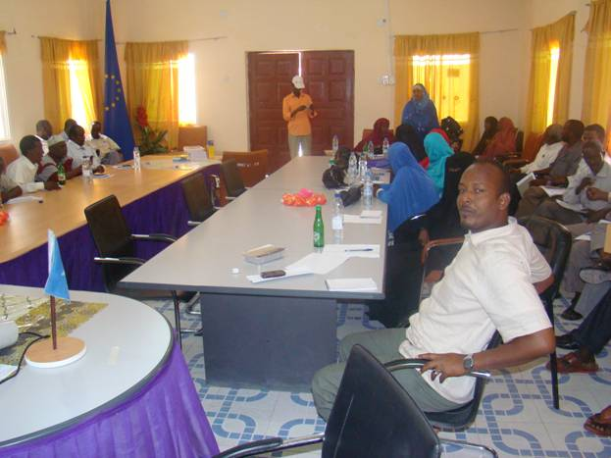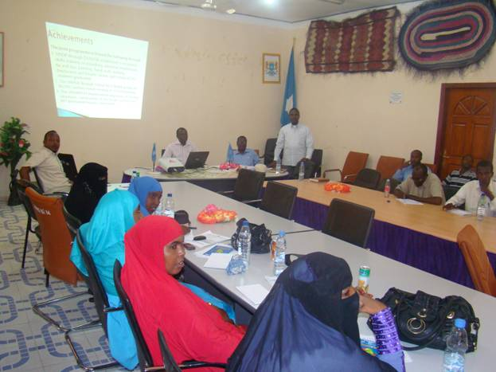

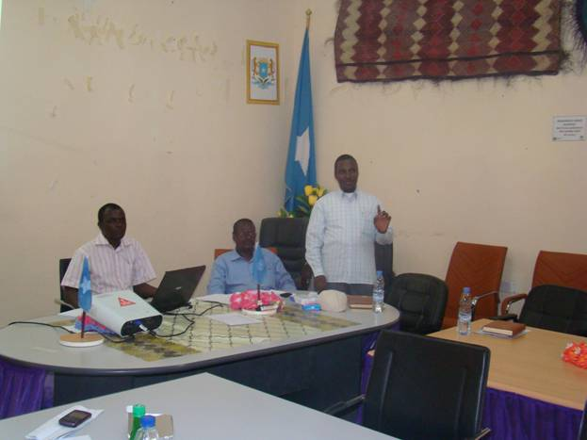

ANNEX 3
INTRODUCTION

- The UN Joint Programme had engaged, Support for Tropical Initiatives in Poverty Alleviation (STIPA) an International non governmental organization. Working in the field of community development, HIV/AIDS, project evaluations, surveys, participatory impact monitoring, and Participatory Integrated Community Development (PICD) process in the East and Central Africa for the Joint programme evaluation.

UN Joint Programme objectives

1) Strengthened protection and security for 11,000 IDPs in nine temporary and permanent settlements, as evidenced by:
- Human rights are better protected and incidences of physical violence reduced.
- Physical protection against fire in the settlements in place

2) Improved living conditions in nine existing and temporary settlements, as evidenced by:
- An upgrade of temporary settlements (fire breaks, accessibility, etc) benefiting an estimated 11,000 people;
- Improved access to basic services for 11,000 people in temporary settlements;
- Access to immediate income generating opportunities for at least 1,000 IDPs in Bossaso by implementation through community works schemes.

3) Durable solutions for livelihoods, resettlement and reintegration for up to 5,000 IDPs, as evidenced by:
- Local resettlement and integration solutions in Bossaso:
  - Sufficient land for resettlement of 550 IDP families allocated;
  - Provision of permanent shelter for 550 IDP families;
  - Access to essential services and infrastructures in areas of permanent settlement;
- Resettlement and integration solutions in alternative rural and coastal locations:
  - Resettlement to places of origin or to alternative locations for permanent settlement facilitated for 350 families
  - Opportunities for local economic recovery in alternative rural and coastal resettlement areas created for 3,000 households of IDPs and vulnerable families in host communities
Evaluation objectives

- To determine the progress of the programme towards achieving its intended outcomes and impacts
- To review and assess the extent to which the programme delivered on its targets, and establish whether it is on track to meet its development objectives.

Methodology
- The evaluation used participatory techniques thus, qualitative data collection methodology which encompassed focus group discussions, key informant interviews, observation, case studies and vision matrix with the beneficiaries, key stakeholders from the Government Ministries, Local Authority, local NGOs and UN partners.
- Purposive sampling was used for selection of the respondents.
- A total of 90 participants were interviewed.
Limitations

- Insecurity situation hindered the flow of field coordination of the beneficiaries interviews
- Dependency of the team on translation
- Harsh weather in Bossaso
- Different many levels of stakeholders

Achievements

- The UNHCR through a local NGO WAWA produced 80,000 sanitary towels instead of 50,000 planned
- UNHCR provided support to the Puntland Bar Association (PBA) which facilitated training of law enforcement personnel on human rights law
- 151 poor IDPs and host community women and girls employed through production of sanitary towels.
- Established database for SGBV cases (handled 400 cases, established SGBV task forces in IDPs, conducted awareness campaigns and training of police and law enforcement.
- The UNHABITAT implemented upgrading of existing structures, construction of fire breaks, latrines and 487 permanent houses constructed and Supported Bossaso municipality to install five (5) solar streetlights
- The project developed a systematic fire response system in each settlement which enabled the IDPs to respond more effectively during fire outbreaks.
- Established basic fire fighting infrastructures in IDP camps (Fire breaks implemented through LNGO)
- 1433 households reached corresponding to an estimated 8,598 people in temporary settlements
- UNICEF trained 50 water sources/ tank chlorinators as a strategy to provide safe water.
- . Trained 30 kiosk caretakers instead of the planned 20
- . 180 IDP camp committees and 50 TOTs trained on CHAST and PHAST
- . The trainees reached 2,300 persons (1,380 adults and 920 children) in the IDP camps
- . SORSO engaged local media (newspapers, TV and local FM radio station) to broadcast hygiene and sanitation messages to reach wide audience.
- 8,640 households (6,667 IDP and 1,973 vulnerable host community households) were provided with soap for hand washing to promote attitude and behaviors change.
- Rehabilitation of latrines affected by fire through the local NGO (SORSO).
- 25 water kiosks put up through PSAWEN and GUNCO targeting 40,000 IDPs
- Garbage collection campaigns for proper disposal were carried out
- 86 sets of sanitation tools (wheelbarrow, spade folk, pick axe and sweepers) were distributed.
- 10 mobile skips were provided and 4 incinerators for medical waste constructed
- FAO through DRC trained 250 IDPs on income generation; tie and dye, fishing and fish processing, handcrafts, tailoring and basic business management.
- Start up kits provided to the beneficiaries
- Micro enterprise skills provided to introduce business skills to the beneficiaries
- Supported formation of groups for savings and revolving funds, and Constructed 200 latrines to IDPs

Planned but not achieved
- Marketing skills of societies and co-operatives improved through training
- Transport to alternative locations
- Mid term evaluation

Challenges

  - The Joint UN partners implemented their work plans individually.
  - Acquiring land for IDPs settlement was an uphill task
  - Inadequate funding to build enough water kiosks for IDPs, housing, latrines and other physical assets to cover all IDPs.
  - Insecurity situation in Puntland is the biggest threat to the successful implementation of the UN Joint programme
  - The reporting and accountability mechanism does not embrace the principles of partnership, focal point persons report to their agencies, there is little focus on the Joint IDPs programme, only the Joint Programme Manager is 100% on the programme.
  - Lack of government policy on IDPs.
  - The local government authority of Bossaso has not effectively enforced land policy; the land belongs to individual land lords with no title deeds.
  - Limited allocation of resources for the host communities encourages conflicts between the IDPs (80%) and host community (20%).
  - The government perceives IDPs as a security threat

Lessons learnt and best practices

- The Joint programme working with the Local Authorities catalysed acquisition of permanent settlements of the IDPs.
- High turn over of the staff at the field level interrupted the flow of the programme.
- The local authorities and the government have limited capacity to respond to the needs of IDPs
Recommendations

- The Joint programme should be designed participatorily with all UN agencies, spelling out the roles and responsibilities of the partners and creating independent structure of management with a strong steering oversight committee.
- There is a need for buy in, commitment, ownership, leadership, reduced bureaucracy and good will by the JP steering committee.
- The Joint programme should have a clear policy that responds to its vision and mission.
- The UN Joint programme should develop a system of graduation and exit of the IDPs from dependency to self reliance. This can be achieved through participatory processes.
- The Joint programme should expand the vocational training institute to cater for the needs of IDP and host communities.
- The Joint programme should expand its mandate to include health, education and other development sectors.
- The Joint programme must demonstrate value addition to the existing individual UN agency operation structures to attract support and commitment.
- There is need to embrace flexibility to allow the program to adjust on the ground, as for this program the playing field changed, management changed, agencies changed and process changed.
- There is need to define who an IDP is, and who the host community is and spell out a package of support that meets their felt needs.
- There should be a clear accountability of the decision making at all levels of the Joint programme operations.
- The Joint programme should increase its funding and coverage to the remaining IDP camps before expanding to other places
- Increased involvement of IDPs in the local authority and in the government of Puntland.
- The next phase of the Joint programme should respond to current humanitarian gap analysis

