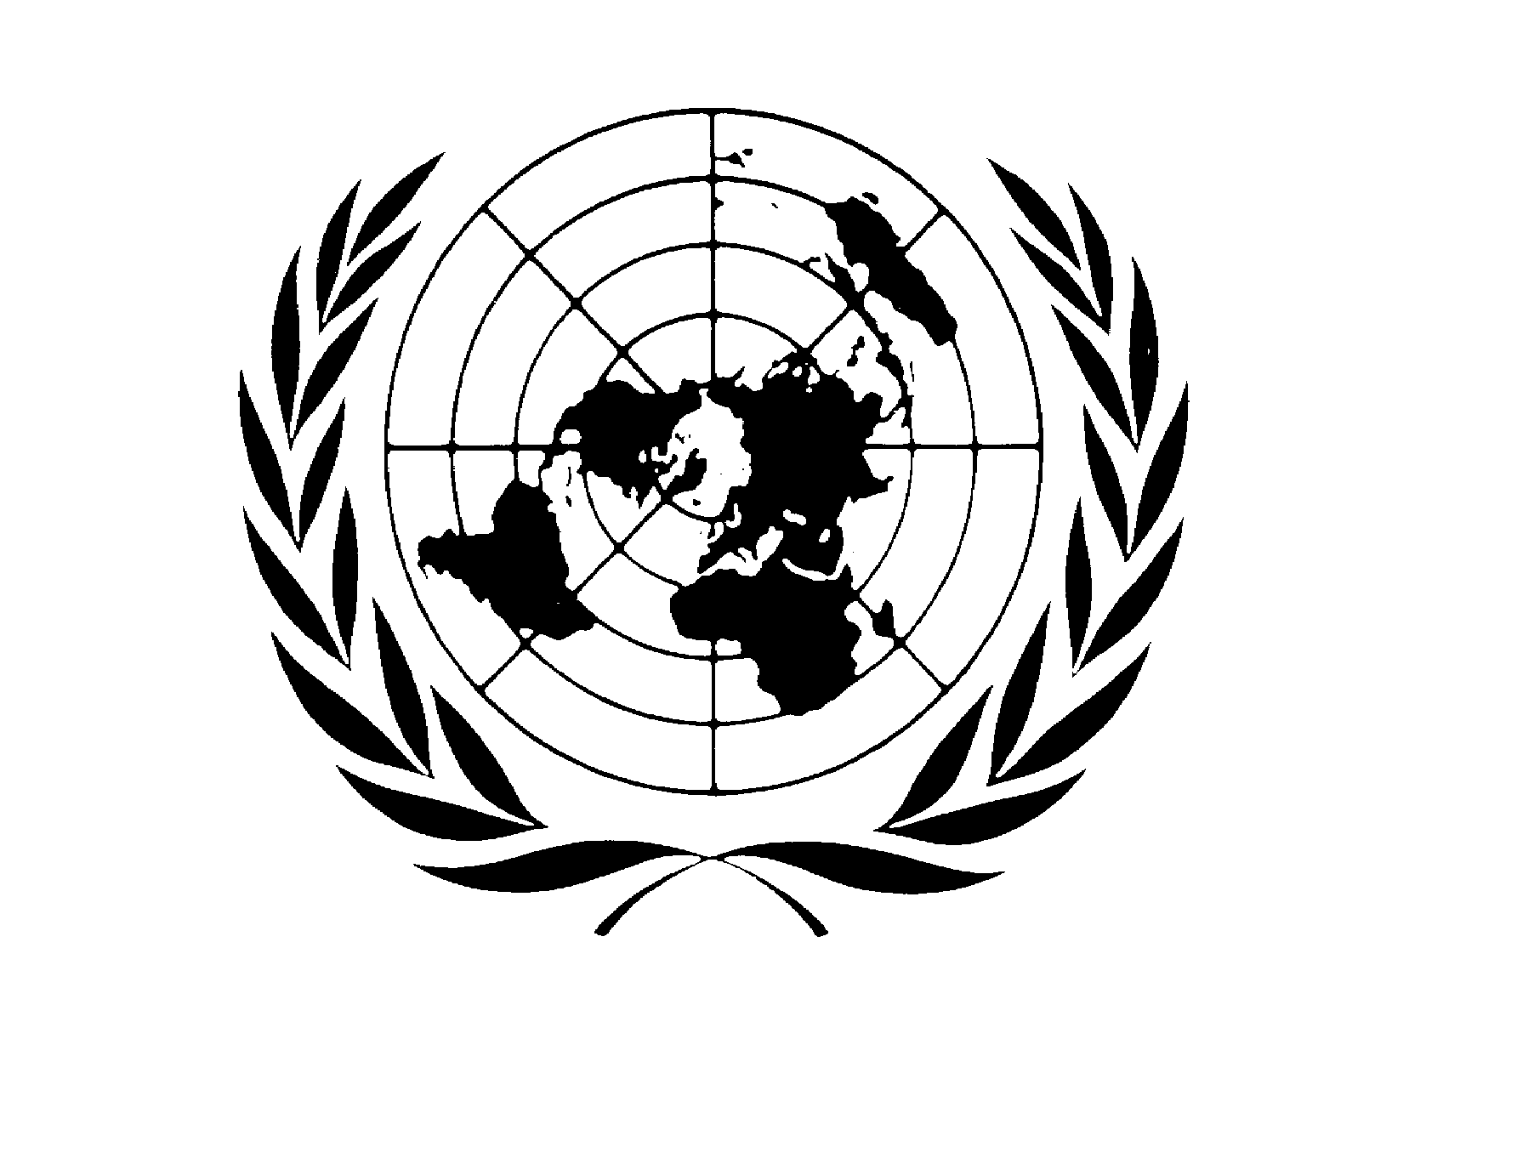
PEACE BUILDING FUND (PBF)

ANNUAL programme NARRATIVE progress report

REPORTING PERIOD: 1 january – 31 December 2011

Programme Title & Project Number |  | Country, Locality(s), Thematic/Priority Area(s)
- Programme Title: Permanent Shelter  - Programme Number (if applicable) ………………….  - MPTF Office Project Reference Number: PBF/IRF-31 (ID00078251) |  | (if applicable)  Country/Region: Puntland State, Somalia
 |  | Thematic/Priority: Permanent shelter

Participating Organization(s) |  | Implementing Partners
- Organizations that have received direct funding from the MPTF Office under this programme:  UNHCR |  | - Norwegian Refugee Council (NRC)  - UNHABITAT  - Municipality Authorities in Galkayo north and south

Programme/Project Cost (US$) |  |  | Programme Duration
MPTF/JP Contribution:  - by Agency (if applicable) | $1,111,715 |  | Overall Duration (months) | 18 Months
Agency Contribution  - by Agency (if applicable) | 00.00 |  | Start Date (dd.mm.yyyy) | 01 January 2011
Government Contribution  (if applicable) | 00.00 |  | End Date (or Revised End Date) | 30 June 2012
Other Contributions (donors)  (if applicable) | 00.00 |  | Operational Closure Date | 30 June 2012
TOTAL: | $1,111,715 |  | Expected Financial Closure Date | 31 July 2012

Programme Assessment/Review/Mid-Term Eval. |  | Report Submitted By
Assessment/Review - if applicable please attach  Yes No Date: dd.mm.yyyy  Mid-Term Evaluation Report – if applicable please attach  Yes No Date: dd.mm.yyyy |  | - Name: Bruno Geddo  - Title: Representative  - Participating Organization (Lead): UNHCR Representation in Somalia  - Email address: geddo@unhcr.org

List of acronyms

UNCT | United Nations Country Team
PBF | Peace Building Fund
FDG | Focus Group Discussions
CBA | Community Based Approach
IDP | Internally Displaced People
INGO | International Non-governmental Organisation
IOM | International Organisation for Migration
LNGO | Local Non-governmental Organisation
NRC | Norwegian Refugee Council
PAR | Participatory Action Research
PDRC | Puntland Development Research Center
UNHCR | United Nations High Commissioner for Refugees
IPFMR | Implementing Partner Financial Monitoring Report
LA | Local Authorities

NARRATIVE REPORT FORMAT

Purpose

The large scale-influx of Internally Displaced Persons (IDPs) into Puntland as a result of protracted conflict, human rights violations and natural disaster in Somalia, coupled with the presence of asylum-seekers and refugees from neighboring Ethiopia, has been contributing to rising tensions between the local and displaced population in Puntland. These tensions, exacerbated by the growing clan conflicts, threaten fragile stability in Puntland and risk the situation slipping back to an open conflict.

Against this background, UNHCR proposed to reduce the tensions between the two communities through four sets of projects: (1) peaceful coexistence and conflict resolution, (2) capacity-building of the police and judiciary in the areas of IDP concentration, (3) solid waste management in Galkacyo and (4) construction of permanent shelter and basic services for IDPs and local population in Galkacyo. All the four pillars aim to bring the local and displaced communities together towards the overall goal of the reduction of tensions between the two.

Within this context, the project aims at contributing to lessening social tensions between IDPs and the host community by improving the social infrastructure of the area where IDPs have been relocated.

The key outcome of this project is the provision of permanent shelter and community infrastructure to Halabokad IDP settlement and its surrounding local community with the goal to facilitate coexistence and local integration of IDPs. The project further looks into provision of social infrastructure to Tawakal IDPs site and its surrounding community.

The background to this project goes back to the eviction of an IDP settlement with 225 mainly minority clan households to a site 5km outside the town. The subject of shelter therefore became very urgent. There was immediate need to provide 200 permanent shelters, 100 family latrines and social infrastructure (solar lighting, a community centre, market place and a customs checkpoint). The improvement of livelihood opportunities for both IDP and local communities is also built in the project.

Resources

This project is funded by MPTF/JP to the tune of $1,111,715. There was no budget revision undertaken through out project implementation

The good practices adopted by UNHCR in financial management of the project include the following;

- Routine monitoring of the project activities by UNHCR field offices in Galkayo. This ensures that all agreed activities were implemented according to the agreed work plan

- Regular activity planning meetings between UNHCR and implementing partners engaged to carry out the different activities. This ensurs a smooth and consistent follow up of agreed specific activities

- Verification of implementing partner financial monitoring reports (IPFMRs) prior to disbursement of any subsequent installments. This ensures that there is value for money for any particular procurement or service

- UNHCR direct implementation for some activities in which the implementing partner had no comparative advantage, and also for particularly large procurements. This practice proves to be not only cost saving but also ensured safety of operational resources

- A transparent tendering process, ensuring a smooth and accountable selection of the contractors.

- Involvement of the local authorities and the IDPs in the selection of beneficiaries ensured that there was mutual trust in the selection process. Guidelines for identifying the vulnerable households provided by UNHCR helped to smoothen the whole exercise

Challenges faced:

- Whereas involvement of local authorities has been essential, their availability to attend to issues of the project has not been consistent. The officials were often absent from their duty stations, which caused some delays in analysis of bids and award of contracts

- Issuing of land titles to the beneficiaries was delayed, affecting the implementation schedule.

- During the project period the population of the site increased with persons outside of the original group coming to the site. UNHCR had to engage in negotiations with the municipality and the host community to allocate adjacent plot of land to these IDPs

- Due to the sudden appreciation of the Somali Shilling and increase in the labour cost, the contractors found it difficult to continue with the implementation within the agreed parameters. It took long negotiations by UNHCR’s partners to convince them to continue with the implementation without cost impact.

Human Resources:

International Staff

 | Title | Type | Number | Location
1 | Representative | Programme | 1 | Nairobi
2 | Deputy Representative | Programme | 1 | Nairobi
3 | Snr. Protection Officer | Operation | 1 | Nairobi
4 | Head of Field Office Galkayo | Operation | 1 | Galkayo
5 | Associate Programme Officer | Operation | 1 | Galkayo
 | Total |  | 05

National Staff

 | Title | Type | Number | Location
1 | Assistant Programme Officer | Programme | 1 | Nairobi
2 | Field Associate | Operation | 1 | Galkayo
3 | Supply Associate |  | 1 | Galkayo
 | Total |  | 03

Implementation and Monitoring Arrangements

UNHCR has been working with the Norwegian Refugee Council (NRC) as its partner to implement the project while UNHABITAT provids technical support for the project as part of collaborative efforts by UN agencies. An implementation agreement was signed with NRC, and a memorandum of understanding was signed with UNHABITAT.

UNHCR field office in Galkayo works closely with the authorities, the IDPs leadership, the local community and the implementing partner to ensure smooth implementation of the project. Procurement of project supplies and services was conducted by both UNHCR and its partners according to UNHCR’s own guidelines, which form part of the annexes to implementing partner project agreements.

UNHCR field office in Galkayo also conducts direct, on-site monitoring and coordination. NRC is also present in Galkayo throughout the project implementation cycle, ensuring direct supervision of project implementation. UNHCR holds regular meetings with NRC and UNHABITAT to update on the progress of implementation, and verifies financial reports prior to disbursements. UNHCR, relevant ministries, local authorities and sister UN agencies have also undertaken joint on-site monitoring. Meetings of the PBF Board have also been held to inform members of the progress made in implementation of the project

In the project, the most vulnerable beneficiaries have been selected through a community based approach (CBA). The community was trained in vulnerability criteria and UNHCR and NRC certified the process. The design of the permanent houses was also agreed upon through a focal group discussion and the final design was approved by the IDP community. Local building techniques were utilized and the shelters were built using stone walls, mud mortar and finished with cement rendering. The use of local materials and contractors also contributed to the local economy.

A number of solar lighting options for Halaboqad settlement were reviewed and the conclusion arrived at the multiple standalone solar lighting poles. The centrally located system initially proposed had the disadvantage of losing light at all points should there be a breakdown. 30 standalone units were procured. 2 of these units have been allocated for the host community. Trainings were conducted for the IDP committee and the host community to ensure sustainability and proper technical handling.

It was initially planned to construction 125 shared family latrines in in Galkayo. However, a large number of latrines were planned in Galkayo by other agencies and UNHCR considered that this was no longer a priority during the project period. This saving was utilized to construct two water kiosks, one water point and the repair of a water tank, benefiting both the IDP and local community. Also, the original proposal was to construction a community center in Haloboqad settlement in Galkayo, again another agency constructed a similar center in early 2011 and UNHCR decided to change its priority on this intervention. UNHCR in consultations with IDP and local populations reallocated the funds to construct 50 additional permanent shelters.

Results

  - The construction of 250 permanent shelters in Halabokad has been completed. 40 out of the 250 shelters were constructed for the most vulnerable local households. This intervention has resulted into immediate impact in the lives of IDPs and the vulnerable host communities, as they now have access to better shelters, assuring their families of sufficient space to live. It has also reduced the tension between IDPs and the host community as they view each other as beneficiaries of the project. This forms a firm ground for peaceful co-existence for the two communities

  - 220 land title deeds have been issued to IDPs, thus guaranteeing them sustainability of their stay in the settlement and eventual ownership of the shelters

  - 30 stand-alone solar lights have been installed in Halabokad settlement. This has provided sufficient lighting for the IDPs and the immediate host community, thus improving their living conditions and enforcing security in the night.

  - Systematic planning of Halabokhad has been conducted through demarcation of the land in the settlement. The contractors for all these works were identified through a competitive bidding process.

  - Identification of host community beneficiaries was done through a community based approach, which ensured fairness.

Future Work Plan (if applicable)

N/A

VI. INDICATOR BASED PERFORMANCE ASSESSMENT

 | Performance Indicators | Indicator Baselines | Planned Indicator Targets | Achieved Indicator Targets | Reasons for Variance  (if any) | Source of Verification |  | Comments  (if any)
Outcome 1 Basic infrastructure and services restored and expanded (energy, shelter, water, sanitation, transportation).

Output 1.1  All IDPs households, including vulnerable host communities, have access to permanent shelters | Indicator 1.1.1  Number of households with access to permanent shelters and proper pit latrines | There is lack of shelter among IDPs and vulnerable host communities | 200 households (160 IDPs and 40 vulnerable host communities) are provided with permanent shelters | Construction of 250 permanent shelters has been completed | In order to coordinate and align with the other projects at the some location, the funds intended for a market and community centre were re-allocated to additional 50 permanent shelters |  | - UNHCR field monitoring reports  - IP reports  - project progress reports and results frameworks | Nil
All IDPs and host commu ity residents in Halabokhad access proper pit latrines. | Indicator 1.1.2  Number of households with access to a well constructed sanitation facilities (pit latrines) | There is lack of proper prit latrines in IDPs settlements and in host areas | 100 family shared pit latrines are constructed (80 in IDPs settlement, 20 in host areas) | No family pit latrines were constructed. Instead this money was spent in the construction of 02 water kiosks in the IDPs settlement | Again, because another agency constructed 150 family pit latrines for IDPs in Halobokad settlement prior to the commencement of this project, UNHCR instead invested the money in water supply, where there were gaps. Both IDPs and the host community have benefited from increased water supply thus reducing the tensions between them |  | - UNHCR field monitoring reports  - IP reports  - project progress reports and results frameworks | The funds initially planned for construction of shared family pit latrines were used to construct 2 water kiosks
All beneficiaries of permanent shelter have land title deed | Indicator 1.1.3  Number of households issued with land title deeds | IDPs do not have land title deed to give them ownership of land permanent shelters | 200 households are issued with land title deeds | Land title deeds have been issued to 220 households. | No variance output will be achieved as planned |  | - List of title deeds holders  - UNHCR field monitoring reports  - IP reports  - project progress reports and results frameworks | Advocacy with the local authorities and the host community should continue to ensure IDPs are not threatened with evictions
Outcome 2: Halabokad becomes an integral part of Galkayo and IDPs are integrated into the social fabric and enjoy same rights and access as local community

Output 2.1  Construction of a community centre where vocational training and social events are held | Indicator 2.1.1  Number of social events, meetings and/or vocational skills training sessions held at the community centre | There is lack of a community centre for the community to hold social events | A community centre is constructed to provide access and venue for social events, vocational skills training etc | Construction of community centre did not take place as another agency put it up | The cost of constructing shelters went up, the savings from the community centre was utilized to cover for this gap |  | - UNHCR field monitoring reports  - IP reports  - project progress reports and results frameworks | A community centre was constructed by another agency for the same community
Output 2.2  Construction of a market | Indicator 2.2.1  Number of market stalls constructed and number of vendors in the market | There is lack of a market place for IDPs and the host community to engage in commerce to boost livelihoods | A market is constructed in the proximity of the IDPs settlement and the host community | Construction of the market did not take place because another agency constructed it in Hallabokhad | The cost of constructing shelters went up, the savings from the market centre was utilized to cover for this gap |  | - UNHCR field monitoring reports  - IP reports  - project progress reports and results frameworks | Nil
Outcome 3: Halahalbokhad residents have access to social infrastructure

Output 3.1  Construction of solar lighting at the site | Indicator 3.1.1  Number of households, public areas and social facilities having access to solar lights | Lack of basic lighting system in the night increases number of SGBV cases | 100% of IDP community coverage of solar lights | Installation of solar lighting system is in progress | No variance output will be achieved as planned |  | - UNHCR field monitoring reports  - IP reports  - project progress reports and results frameworks | Nil

The term “programme” is used for programmes, joint programmes and projects.
Strategic Results, as formulated in the Performance Management Plan (PMP) for the PBF; Sector for the UNDG ITF.
The MPTF Office Project Reference Number is the same number as the one on the Notification message. It is also referred to “Project ID” on the MPTF Office GATEWAY
The start date is the date of the first transfer of the funds from the MPTF Office as Administrative Agent. Transfer date is available on the MPTF Office GATEWAY
As per approval by the relevant decision-making body/Steering Committee.
All activities for which a Participating Organization is responsible under an approved MPTF programme have been completed. Agencies to advise the MPTF Office.
For PBF: Either country relevant or PMP specific.

