[Name of Fund or Joint Programme]

GENERIC ANNUAL programme NARRATIVE progress report

REPORTING PERIOD: 1 July -31 December 2011

Programme Title & Project Number |  | Country, Locality(s), Thematic/Priority Area(s)
- Programme Title: Strategic Grain Reserve in South Sudan  - Programme Number (if applicable)  - MPTF Office Project Reference Number:  Project ID 00079635  PBF/IRF-43 |  | (if applicable)  Country/Region Republic of South Sudan
Thematic/Priority

Build a Strategic Grain Reserve in South Sudan to be nationally prepared to effectively respond to emergency; to support safety net programs for the poor and early revitalization of the economy specifically the agriculture sector.

Priority Areas 3 and 4

Participating Organization(s) |  | Implementing Partners
- Organizations that have received direct funding from the MPTF Office under this programme  - World Food Programme South Sudan |  | - National counterparts (government, private, NGOs & others) and other International Organizations  - Government of South Sudan  - International Food Policy Research Institute (IFPRI)  - Private Sector Contractors

Programme/Project Cost (US$) |  |  | Programme Duration
MPTF/JP Contribution:  - US$1,990,200 |  |  | Overall Duration (months) 36 months
Agency Contribution  - Not available |  |  | Start Date (dd.mm.yyyy) | 27 July 2011
Government Contribution  (if applicable) |  |  | End Date (or Revised End Date)
Other Contributions  Government of Norway US$2.5 million  (if applicable) |  |  | Operational Closure Date 26 July 2014
TOTAL: $99,624,552 |  |  | Expected Financial Closure Date 26 January 2015

Programme Assessment/Review/Mid-Term Eval. |  | Report Submitted By
Assessment/Review - if applicable please attach  X  Yes No Date: dd.mm.yyyy  Mid-Term Evaluation Report – if applicable please attach  X  Yes No Date: dd.mm.yyyy |  | - Name: Mr. Chris Nikoi  - Title: Country Director  - Participating Organization (Lead):WFP  - Email address: Chris.Nikoi@wfp.org

PURPOSE

This project aims to establish a SGR for the Republic of South Sudan to enable the government to:

1. Effectively and timely respond to emergencies
2. Run nationally owned safety net programs for the poor.
3. Stimulate agricultural production.

While remarkable progress has been made during the six years of the Comprehensive Peace Agreement (CPA, 2005)—culminating in the January 2011 referendum and independence on 9 July, life-threatening conditions still persist in many parts of the country. After nearly four decades of conflict, rapid rural transformation and livelihood improvement are among the top priorities for the new state. The Government of South Sudan has also recognized the strong linkages between food insecurity and political instability.

Most countries have found that an effective system of food reserves is an essential part of the institutional architecture for achieving genuine food security. For the most critical moments, Strategic Grain Reserves are an irreplaceable tool. Having a Strategic Grain Reserve, that builds and strengthens national capacities, can reduce the time needed to ship in food into the region for a crisis, increasing the ability of the Government of South Sudan to facilitate a resumption of stability for the affected communities, build trust with the population and demonstrate the government commitment to the welfare of its citizens.

To support the government in creating this vital institution, in May 2011, WFP launched a three-year Special Operation (SO 200267) for the establishment of a Strategic Grain Reserve to be handed over to the Government of South Sudan in the final year of implementation. The project, with an overall requirement of US$97 million, included building five warehouses with a total capacity of 100,000 MT as well as developing the administration and logistics capacity of the Government of South Sudan to operate the reserve.

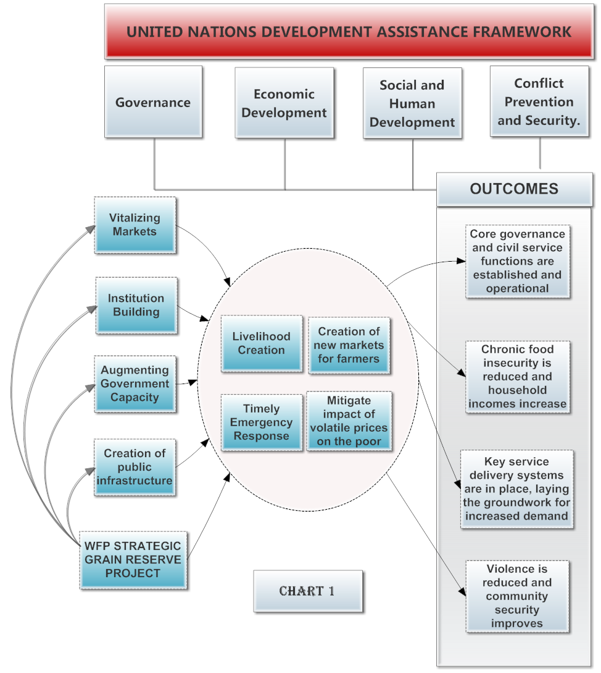
Chart 1 draws out the linkages between the objectives of the Strategic Grain Reserve and their relationship to the pillars and objectives of the United Nations Development Assistance Framework for South Sudan. There is also cross cutting alignment with the South Sudan development framework 2012-2013. In South Sudan, humanitarian agencies and commercial actors have to rely on congested ports to import food and are usually faced with a lack of transport capacity thereby increasing the lead time of bringing much needed food supplies. In a humanitarian emergency, these delays can be life threatening. The Strategic Grain Reserve can help to provide the needed food commodities to the Government and humanitarian partners in a timely and cost effective manner.

While the strategic grain reserve is envisaged as a safety net institution for ensuring timely and effectively response to food emergencies, it can also play a role in post conflict recovery by giving rural farmers a market outlet for their production and support longer-term opportunities.

II. RESOURCES

This three-year Special Operation (SO 200267) for the establishment of a Strategic Grain Reserve requires US$97 million. To date the project has received US$ 4.5 million, consisting of US$ 2 million from the Peace Building Fund and US$ 2.5 million from the Government of Norway.

With the generous support from the Peace Building Fund, which encouraged the Government of Norway’s contribution, WFP has not experienced any delays to moving forward with the first phase of the project due to lack of funds.

A Project Manager, Program Officer and support staff have been recruited and have assumed their duties early this year.
The head of the Project Management Team supervises the team of daily consultants. By using the World Food Programme (WFP) specialized staff for specific tasks, the project is able to draw on a broad range of technical expertise that otherwise would have to be hired through project funds.

The WFP South Sudan Country Office finance division manages the financial resources of the project, in accordance with its Financial Rules and Regulations and its Procurement Rules. The organizations accounts are audited annually.

WFP has entered into framework agreement for collaboration with International Food Policy Research institute (IFPRI). This agreement allows WFP South Sudan to draw on IFPRI expertise on policy and economic analysis work to support the grain reserve project.

The Peace Building fund contribution is meant to set up the foundation for establishing a SGR; during the first year the project aim:

- To develop the GOSS institutional policy framework that will officially legalize the SGR establishment through presidential decree;
- To conduct baseline survey and design the M&E system;
- To clear land for reserve locations;
- To recruit WFP specialized management team for project supervision

The South Sudan Country office has not embarked as yet on a major resource mobilization effort for this project. Once the GOSS issues the proclamation, demonstrating the government’s commitment, WFP will step up resource mobilization efforts beginning with a donor briefing jointly hosted by The Government of South Sudan and WFP.

III. IMPLEMENTATION AND MONITORING ARRANGEMENTS
WFP has conducted numerous formal and informal consultations with government counterparts. Through these consultations it becomes evident that a bottom up approach which ensured government involvement in the project from inception was the only way of guaranteeing sustainability.

The initial project strategy was to start building the infrastructure required for the reserve as the first step and then subsequently move towards operationalizing the reserve, followed by a hand over to the Government.

However during the course of our formal and informal consultations with government counterparts and IFPRI, we concluded that the project ought to be implemented in three distinct phases as outlined below.

PHASE I Building the necessary institutional requirement and formation of supporting organizational structures within the existing government bodies.

PHASE II Operationalization of those organizational structures through a small-scale pilot grain reserve jointly managed by WFP and the Government of South Sudan.

PHASE III Implementing the project at scale, including construction of additional warehouses, and finalizing the handover

World Food program with support from International Food Policy Research institute (IFPRI) will develop rigorous monitoring and evaluation systems. Preparation is underway to develop the instruments that will be used to collect outputs, outcomes and goals that will feed into the evaluation system. This will be followed by focus group discussion and eventually a baseline survey which will provide data to measure the performance of the project.

Three levels of M&E have been identified.

- Monitoring and evaluating the special operation implementation progress.
- Monitoring and evaluating the objectives set in the logical framework and implementation strategy
- Monitoring and evaluating the operational procedures and book keeping during the execution of the project.

Results

The launch of the project coincided with the declaration of South Sudan as the world’s newest nation and this, naturally focused the Government’s attention on some of its more immediate state-building priorities. At the same time WFP also had to concentrate a lot of its effort and attention on standing up its Juba office to a fully-fledged Country Office. These factors led to a delay of several months in starting the project.

Recognizing the importance of national ownership for the sustainability of the project, WFP has sought commitment in the form of fiscal and human resources from the Government. To this effect a consultative meeting was organized. The consultative meeting was attended by the Minister of Agriculture and Forestry, the Minister of Humanitarian Affairs and Disaster Management, the Deputy Governor of the Commercial Bank of South Sudan, and senior representatives of other Government Ministries of the Government of South Sudan. The meeting resulted in the formation of a Technical Working Group with the goal to develop a comprehensive framework for the conception and implementation of the SGR and to prepare a draft proclamation outlining the commitment of the Government of South Sudan to establish a SGR.

WFP and IFPRI have concluded global collaboration agreement in early 2012. This has provided the SGR project with technical analyses and policy development. The IFPRI team has done two missions to South Sudan to support WFP in project implementation.

Future Work Plan (if applicable)

Some key milestones that WFP will achieve in 2012 are:

- The Government of South Sudan will make a proclamation for establishing a SGR in South Sudan. Subsequently WFP and the government of South Sudan will organize a meeting with donors and relevant UN agencies to solicit support.
- The Technical Working Group will start addressing some of the technical pre-conditions for setting up a Strategic Grain Reserve. The areas that will be worked on are:

  - Help the government to establish a crop forecasting and food security analysis system(s)
  - Developing an early warning system, including improved weather forecasting.
  - Policy setting and guidelines
  - Comprehensive framework for monitoring and evaluation for both the governing body of the Strategic Grain Reserve and the project
  - Drafting of a capacity augmentation plan to ensure success of the project

- The Technical Working Group will undertake the necessary steps to implement the government decree and also to design the SGR framework policy and procedures for its establishment.

One of the central pillar of successful handover of SGR to GOSS will be building national capacity -human and physical capacity- to effectively manage, empirically evaluate and successfully integrate into nationally owned safety net programmes.

In this regard, WFP will carry out a series of training and study tours for GOSS officials in countries with successful SGR and safety net programs. The PBF fund is partly earmarked for this purpose.

The South Sudan Country Office, in consultation with the Regional Bureau for East and Central Africa and WFP Headquarters will be undertaking a review of the initial indicators established for this project.

VI. INDICATOR BASED PERFORMANCE ASSESSMENT

 | Performance Indicators | Indicator Baselines | Planned Indicator Targets | Achieved Indicator Targets | Reasons for Variance  (if any) | Source of Verification |  | Comments  (if any)
Outcome 1

Output 1.1  GOSS proclamation to establish a SRG in South Sudan | Indicator 1.1.1
 | Indicator 1.1.2
Output 1.2 | Indicator 1.2.1
 | Indicator 1.2.2
Outcome 2

Output 2.1  M&E system developed | Indicator 2.1.1
 | Indicator 2.1.2
Output 2.2  Baseline survey conducted. | Indicator 2.2.1
 | Indicator 2.2.2
Outcome 3
Output 3.1 | Indicator 2.1.1
 | Indicator 2.1.2
Output 3.2 recruit WFP specialized project management team | Indicator 2.2.1
 | Indicator 2.2.2

The term “programme” is used for programmes, joint programmes and projects.
Strategic Results, as formulated in the Performance Management Plan (PMP) for the PBF; Sector for the UNDG ITF.
The MPTF Office Project Reference Number is the same number as the one on the Notification message. It is also referred to “Project ID” on the MPTF Office GATEWAY
The start date is the date of the first transfer of the funds from the MPTF Office as Administrative Agent. Transfer date is available on the MPTF Office GATEWAY
As per approval by the relevant decision-making body/Steering Committee.
All activities for which a Participating Organization is responsible under an approved MPTF programme have been completed. Agencies to advise the MPTF Office.
For PBF: Either country relevant or PMP specific.

