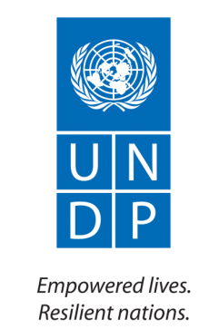
United Nations Development Programme
Support to Civic Engagement in Libya’s Transition (SCELT)
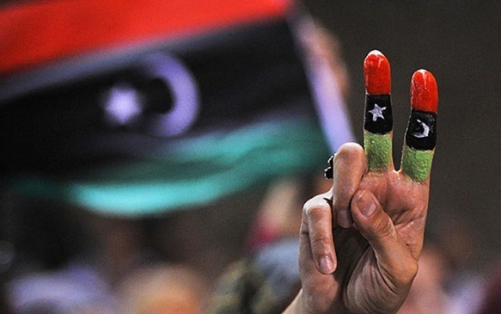
Project Progress Report, January-June 2012

Project ID: 00080491
Duration: 1 January 2012 – 31 December 2012
Strategic Plan Component: Democratic Governance
CPAP Component: N/A
Total Budget: 4,709,915$
Responsible Agency: UNDP

DONORS

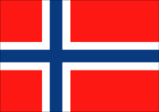 | Government of Norway
 | United Nations Peace Building Fund
 | United Nations Development Programme

ACRONYMS

CSO Civil society organization
BRIDGE Building Resources in Democracy, Governance and Elections
DGTTF Democratic Governance Thematic Trust Fund
HNEC High National Electoral Commission
LEAP Libya Electoral Assistance Project
LEAP Libyan Electoral Assistance Project
MoCCS Ministry of Culture and Civil Society
MoHE Ministry of Higher Education
MoP Ministry of Planning
NCDD National Centre on Democratic Dialogue
NGO Non governmental organization
NTC National Transitional Council
SCELT Support to Civic Engagement in Libya’s Transition
TFM Temporary Finance Mechanism
UN United Nations
UNDP United Nations Development Programme
UNSMIL United Nations Support Mission in Libya

TABLE OF CONTENTS

I. INTRODUCTION 6
II. PROGRESS 7
A. OUTPUT 1: Strengthened Civil Society Capacities to Undertake Civic Education 7
B. OUTPUT 2: Youth Civic Engagement Facilitated 9
C. OUTPUT 3: Increased Women's Participation In The Democratic Transition Process 12
D. OUTPUT 4: National Capacity Established To Undertake Public Consultations And Dialogue 14
III. RISKS/ISSUES 14
IV. LESSONS LEARNED 15
V. FUTURE PLANS 16
VI. CONCLUSION 17
VII. ANNEXES 18
A. ANNEX 1: RESULTS TRACKING MATRIX 18
B. ANNEX 2: FINANCIAL TABLE 24
C. ANNEX 3: EXPENDITURES BY OUTPUT 25
D. ANNEX 4: EXPENDITURES BY DONOR 26

INTRODUCTION
At the close of the reporting period Libya was on the verge of its first democratic election since 1952. In the six months since the establishment of UNDP’s SCELT project much was achieved by Libyans, which permits continued optimism over the direction the country is headed. The outgoing National Transitional Council started to put in place a legal framework, which, although far from complete and subject to change by incoming legislative authorities, broadly respects political and social rights. The electoral process for a National General Congress that will replace the NTC is also generating encouraging signs, driven by the willingness of Libyans to engage with the political forces shaping their country. Voter registration in May 2012 saw 2.8 million voters registered and candidate nomination, which ran in parallel, resulted in 2,501 candidates in the majoritarian race and 1,507 candidates in the proportional representation race. Election day was set for 7 July.
Even given the positivity surrounding Libya’s current political direction, the underlying rationale for the establishment of SCELT has not changed and its value has not dimmed. On the contrary, there remains a tremendous desire on the part of Libyans of all stripes to actively contribute to the dialogue about the future of their country. Nascent civil society groups, political assemblages, local councils, and media are quickly inventing or reinventing themselves in order to provide conduits for citizens’ enthusiasm for political dialogue. Driven by feelings of solidarity and newfound freedom, Libyans are eager to engage in political discourse, howeverthe vast majority of the publicstill has little first hand knowledge or understanding of democratic institutions, processes or actors, including publically accountable institutions, political parties, civil society organizations, independent media.
In this context UNDP’s SCELT project was a highly valued and sought after partner. Project staff worked collaboratively with a wide swath of actors actively engaged in the political process, including civil society, political candidates, electoral authorities, and international organizations. Efforts were focused in four broad areas: (1) increasing capacities of civil society actors to nurture civic engagement; (2) supporting university students in spearheading the spread of a democratic culture in Libya; (3) enhancing the role of women in bringing about a peaceful transition; and (4) fostering inclusive spaces to engage in dialogue about the transition process. More detail is provided below.
Part of the value of the SCELT project lies in its ability to stimulate political discourse at the level of budding civil society organization while simultaneously working with transitional institutions to encourage engagement. This is particularly important in ensuring that the climate of trust and transparency that exists in Libya today is sustained and strengthened.
Although the first hurdle in the transition process – the National General Congress election - is nearing completion there remain several more obstacles, which must be successfully cleared before the transition process is complete. The Constitutional Declaration calls for a constitutional referendum and subsequent national legislative elections. In addition, discussions were underway at the close of reporting to amend the Constitutional Declaration in order to make the constitutional drafting committee into a directly elected body. In other words, although the climate of optimism and enthusiasm endures, there is a long way to go before the populations is finished laying the political and social foundation of the new Libya. During that time civic engagement will be critical to ensuring that it is built in a manner that it accurately reflects the wishes and aspirations of the Libyan people.

PROGRESS

OUTPUT 1: Strengthened Civil Society Capacities to Undertake Civic Education
The development of a legal electoral framework in the first quarter and the scheduling of the National General Congress election just after the close of the second quarter meant that the majority of activities in the first two quarters were conducted with the goal of enabling civil society groups to build awareness of the electoral process amongst their constituents and promote dialogue on critical issues that came to the fore during this national political undertaking.
To generate a suitable operating environment for civil society groups it was necessary as a first step to fill the legal and regulatory vacuum that existed following the overthrow of the Ghaddafi regime. A new legal framework for associations should protect the fundamental rights to freedom of expression and association and prevent a return to arbitrary rule and control of the State on collective citizen action. The SCELT project partnered with the International Center for Not-for-Profit Law to ensure that the new Law on Associations followed international best practices in this regard and responded to the actual needs of Libya’s emerging civil society. An international legal consultant was fielded to support the drafting of the NGO Law, providing three sets of comments on the draft lawas well as responses to some of the Committee’s initial questions about interactional best practices.
The SCELT project organized and facilitated consultative workshops for CSOs on the new legal framework in order to establish dialogue between civil society representatives, the interim government, and the drafting committee members, and to and reinforce the need for an enabling legal environment for associations. The workshops, held in Tripoli (13-14 February) and Benghazi (20-21 February), attracted nearly 400 representatives from Libyan associations, government officials, legal experts, academics and the drafting committee to discuss various aspects of the draft law and make suggestions for improvement. The main themes tackled were: (a) the formation and internal governance of associations; (b) the funding of associations; (c) government supervision over associations and applicable sanctions. Through dialogue, participants developed a list of recommendations subsequently presented to the Ministry of Culture and Civil Society. The law.
The Government of Libya set aside $20 million to finance NGO activities in support of recovery and transition through a grant funding mechanism. The Ministry of Culture and Civil Society (MoCCS) is responsible for registering CSOs, managing grants from this fund, and strengthening the capacity of civil society membersthat are working for civic engagement during the transition period, a daunting task for a ministry that is itself only newly established and in a country where civil society was actively dissuaded over the course of a generation. To support their efforts a concept note was presented on a model, which would deliver both capacity strengthening and funding support to Libyan CSOs but would disaggregate the two. The project will continue to work closely with the Ministry of Culture and Civil Society to ensure that its ability to manage grants is strengthened. As well as working with national authorities, UNDP also is supporting CSOs directly through the establishment of an advisory facility that would support CSOs in accessing knowledge and funding to develop and implement civic awareness and engagement projects
Little is currently known about Libyans’ information needs in the transition to democracy. Tohelp CSOs design both immediate and longer term programming SCELT staff are consulting with DFID, Oxford Research Institute, Benghazi Research and Consultation Centre /BRCC about conducting a knowledge, attitudes and practices (KAP) study. The KAP study would support Libyan efforts to promote widespread participation in the forthcoming electoral and constitution-building processes
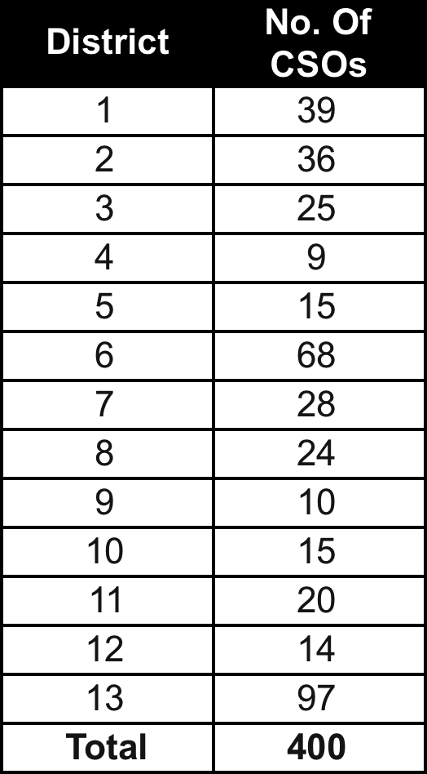
The dearth of knowledge on electoral processes - electoral laws, voter registration, candidate nomination, campaigns, polling, results - was a recurrent concern over the first two quarters of 2012 as preparations for the National General Congress were ongoing. Although a KAP study is required to more closely align civic engagement programming to needs, the urgent and overwhelming need for civic and voter educationwas identified by interlocutors at all levels. SCELT helped fill this gap through designing and implementing voter engagement activities targeting Civil society organizations’ around the country, youth groups and women candidates.
Two workshops on Voter registration Training for CSOs in Tripoli to assist the HNEC to distribute voter registration materials. (2&3/05/2012) 34 coordinators from different NGOs (Misurata, Zawia, Azizia, Tripoli) attended the 2-day events on voter registration. The coordinators carried out voter registration activities to raise the level awareness to public at large on "How & importance of registration"
Voter Education training in the 13 districts: from June 17th to the 5th of July. In each district, a number of workshops were conducted by 11 National BRIDGE facilitators trained during the first quarter of the SCELT.
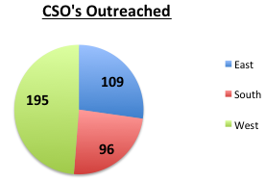
The total number of workshops conducted was 108 in the 13 districts. The workshops targeted Libyan Civil Society organizations trainers. The total number whom benefied from the Voter Education training included 400 Organizations based in the 13 districts, with 16,539 from 7,078 Female 9,461 male. In addition to the training, the participants received voter outreach materials for their use and further distribution for their Voter Awareness Campaign.

A strategic action plan development process started with the MOCCS in May, and the identification of the level of effort and technical assistance needed from both international and national consultants in Capacity Development to assist Tripoli and Benghazi Centres development. The recruitment process has started both all experts. An initial assessment about grant fund was conducted and 3 options were provided to the Ministry (1) Working with an international organization, 2) Sub grant directly with a national NGO (risk to be considered: capacity on management and transparency and finally (3) work directly with the civil society support Centres: (recruitment of a grant Fund manager).
A scenario for grant fund mechanism in partnership with Creative Associates presented to MOCCs.
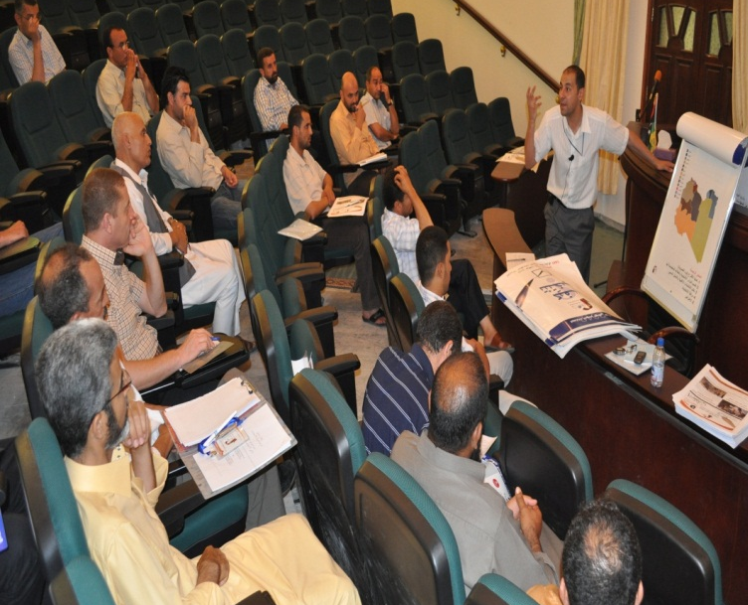
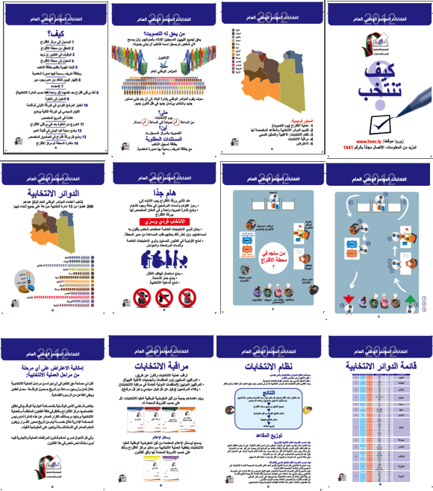
Technical guidelines were translated and disseminated to international and national organization regarding the activities of International Organizations to Support Civil Society in Libya.
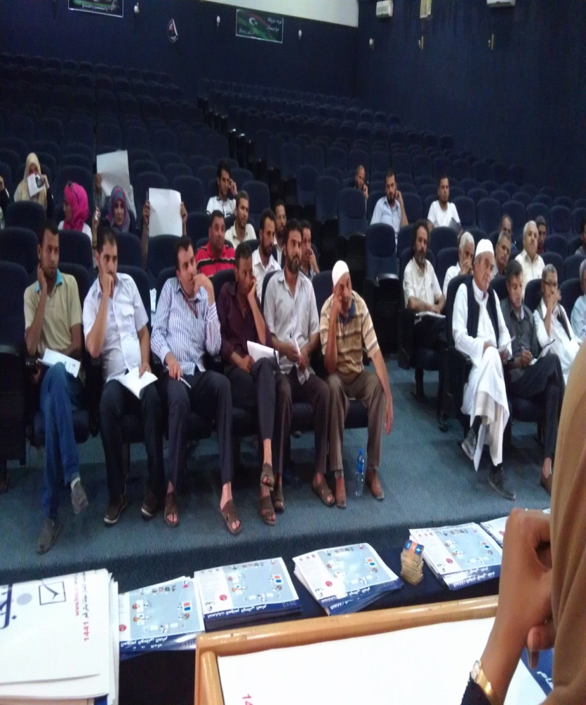

OUTPUT 2: Youth Civic Engagement Facilitated
Youth have made a contribution to Libya’s political transformation that cannot be ignored, and are today intensely interested in seizing the opportunities presented by the start of a new political era In Libya. Harnessed correctly, youth activism can be a positive or negative force in the establishment of a new status quo. Youth groups can help ensure transparency and accountability on the part of new authorities or misunderstandings about rights and responsibilities can generate tension, confrontation and conflict during the sensitive transition period. The activities of the SCELT project focus onfacilitating the constructive participation of youth groups in the political transition.
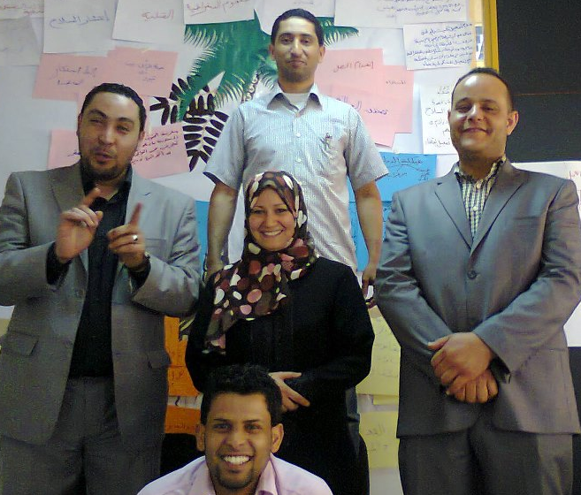
There exist several strengths in the youth sector that SCELT staff members are able to drawn on in implementing programming. Youth in Libya are, generally speaking, educated. In meetings with the Deputy Minister of Higher Education prior to the establishment of the project it was reported that some 375,000 students are registered at Libya’s network of thirteen universities and a further 180,000 are enrolled in vocational training courses in eleven national institutes. Although the education system was not allowed to impart the values necessary for the development of skills required by young people to help build and participate in modern democratic societies, a post-revolutionary sense of solidarity and newfound openness meant that youth groups were coalescing and open to engaging with civil discourse, however much they lack knowledge and know-how. Against this backdrop SCELT staff implemented a number of key activities:
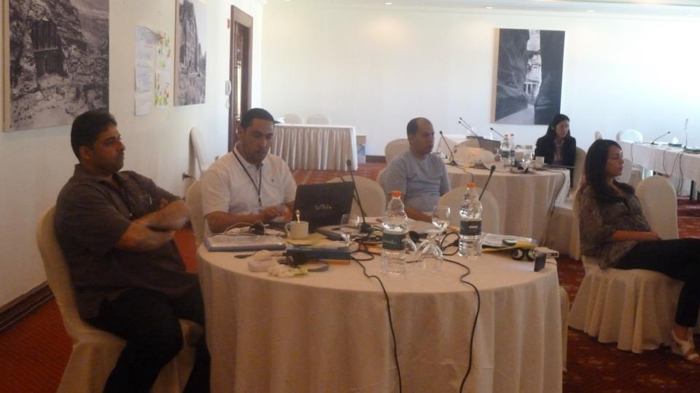
A four-phased training took place in the first quarter of the year, resulting in 23 trainers (51% women) certified in the Building Resources in Democracy, Governance and Elections (BRIDGE) system. Phase 1 saw 28 Libyans trained on good governance, elections and the democratic processes. Phase 2, implemented in March 2012, included a 2-week training workshop. Phase 3 focused on electoral cycles and systems. Finally, in Phase 4 participants were assessed on the conduct of 7 workshops. The training programme included a baseline survey to identify target groups needs as well as a mapping exercise to identify potential partners and local civil society groups. Trainers proceeded to use their knowledge to conduct trainings and awareness campaigns concerning the democratic transition, either with the High National Electoral Commission (HNEC) as master trainers, within their respective organizations, or conducting civic education classes for Tripoli university students
Motivating youth to participate may not be an issue given the enthusiasm in Libya today, however educating them in the difficult aspects of decision-making is critical to cultivating an understanding the difficult negotiations and political compromises Libyans will have to make as part of the constitutional development process, with a view to ensuring stability and sustainable economic growth. Model youth parliaments, constituent assemblies and drafting committees are expected to be launched after the elections in July, for which terms of reference have been drafted and a consultant identified.
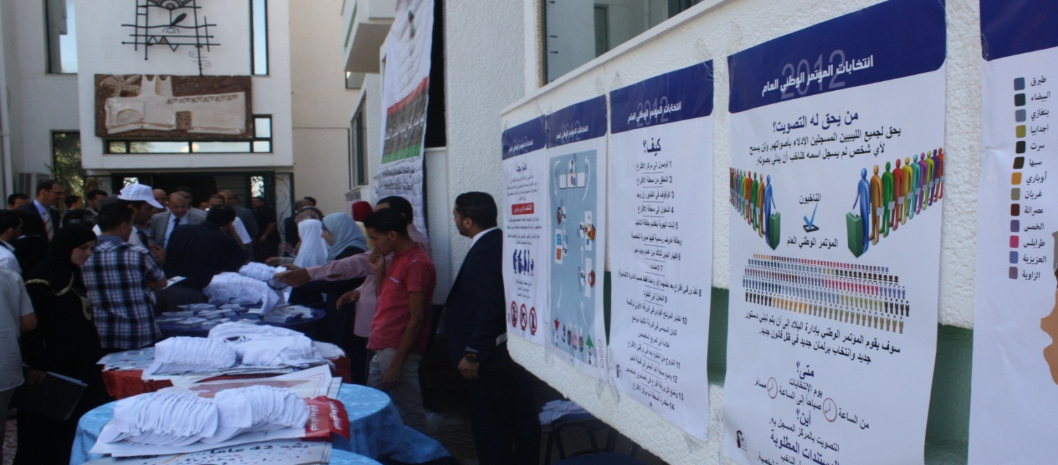

The second activity implemented was in partnership with Ministry of Higher Education targeting students in 10 universities around the country. The activity included training of 150 students by 13 of BRIDGE trainers on the National Elections and Voter Participation. The training utilized the materials developed by HNEC. The 163 individuals conducted educational session during the Open day meetings with students to educate them on the electoral process. The posters, flyers and banners have been distributed in temporary booths explaining the details of how, when and where to vote. More than 500 students in each university were reached.
SCELT Program partnered with the Scouts of Libya to conduct voter education and civic participation campaign. The scouts implemented Face-to-Face sessions to raise the level of awareness among the youth groups and local communities regarding the National Elections.
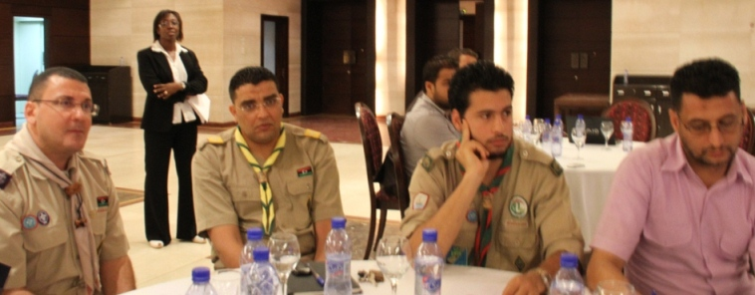
The activity included training 500 scouts leaders trainers in 24 scouts commissions throughout all 13 districts in the country on the electoral process and voter education. The commissions developed action plan at the district level to cover the two weeks prior to e-day. The scouts were able to reach 48,000 people around the country and distribute over 30,000 items on the print materials produced by the HNEC.
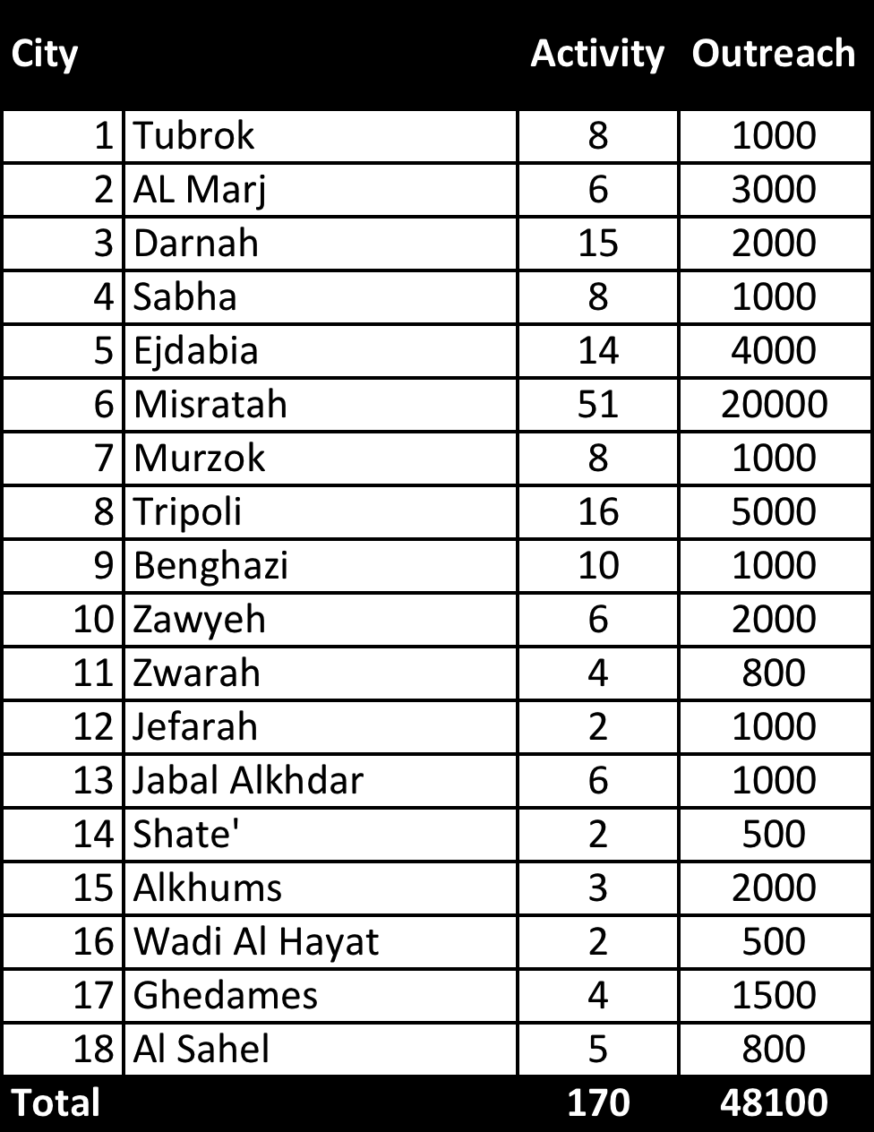
The last activity conducted between the 10 and 16/7/2012 was in partnership with the Scouts Tripoli Commission through the design and implementation of two training workshops on civic education during the Boy Scouts camp ‘’ Scouting for Brotherhood and Peace ‘
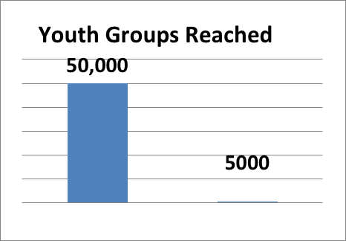
Up to 60 Libyans scouts members trained as civic educators. Up to 2000 Libyan scouts’ members trained as civic educators. Up to 80,000 of Libyan youth reached through Face-to-Face activities. A total of 100 leaders scout and youth were trained and involved in civic engagement in their communities.

OUTPUT 3: Increased Women's Participation in the Democratic Transition Process
Lessons from other transitional countries tell us that while women can be a catalyst for change, changing the nature of women’s participation is a gradual process. The revolution in Libya presented an opportunity for women to occupy newly-created political space and the enduring image of strength carved out during the revolution gives them additional credibility. Yet women had a representation of less than six percent in Libya’s first post-revolution government and very few individual women – only 3% - chose to run as individual candidates in the election.The work of the SCELT project encourages women to participate fully in the electoral and constitution-making processes by promoting the role of women in the transition, strengthening the capacity of women’s CSOs to conduct civic education, organizing national consultations on the role of women in the transition process, and creating an on-line training course on women and civic participation
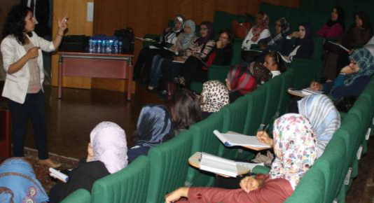
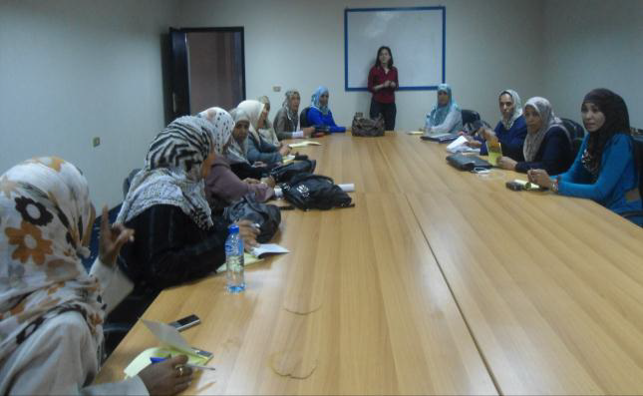
The project deployed a Gender Specialist who will provide technical assistance to the government and civil society as part of a wider awareness-building initiative to ensure women participate fully in the transition.

As part of UNDP’s commitment to provide training for women’s NGOs in key aspects of the political transition process, the SCELT project organized
During the period from 10th to 12th to 17th of May, 2012, three introductory workshops on women participation in politics were organized in Benghazi, Sebha and Tripoli. A total of 150 women were trained on Libyan electoral system and introduction to women participation in election as candidates, the women participants also exchanged and shared experience with women candidates from Tunisia on the basis of South South collaboration.
Two Workshops on campaign strategies and Public speaking communication in Benghazi 30.31 and Tripoli 2.3 /06 -Two training workshops on Election Campaign Management and Media and public speaking were organized. Women candidates received training on the element of election campaign management and media and public speaking. A total of 120 women candidates from Tripoli, Misrata, Alzawia, Gerian, Al Zantan, Benghazi, Drna, Agdabia, Tubrug, Al bayda and etc, were trained on the element of election campaign management and media and public speaking. As a result of this activity, women were empowered to take informed decisions’ about their candidacy and the election process. . Women candidates provided with educative materials on how to campaigning.
Official launch of the awareness support Campaign (My voice for her) on the 25th of June, 2012, SCELT project in collaboration national Libyan partners the women union and “Maaa Nabneeha“ Movements organized a nation campaign for supporting the women candidates who are running for the Libyan National General Congress. The campaign was organized under “My Voice for her “as a national slogan. The campaign provided an opportunity for the women candidates’ public and media exposure. As a result of the campaign, women candidates were supported and encouraged to take a lead role on the National General Congress election. Women also received necessary technical materials which assisted them in their electoral campaigns. A total of 283 women candidates were attending the event.

OUTPUT 4: National Capacity Established to Undertake Public Consultations and Dialogue
The transitional process in Libya is based on the premise that Libyans will be at liberty to choose their political system. The process will lay the political and economic foundation of the future Libya, howeverto be solid the foundation must be closely aligned with the rights, wishes and aspirations of the Libyan people.Libyan authorities, therefore, expressed the desire to engage the wider public in a consultation on the electoral system. The first major milestone of the transitional process came to a head shortly after the close of the reporting period with the election of the National General Congress. Key actors were already looking forward to the next major step: developing a national constitution.
To help develop capacity for public consultations, SCELT’s initial steps were to work with civil society organizations to identify the broad contours of the process and therefore better understand their role. In March 2012, UNDP fielded a mission of two world-renowned constitution experts, ProfessorsYashGhai and Jill Cottrel,to apprise civil society partners on lessons learned from other constitutional drafting processes and to support them in preparing for the Libyan process. Three workshops were organized forCSOs (26 March; 40 participants), women’s CSOs (28th March, 25 participants), and academia and youth CSOs (28 March; 30 participants), which aimed to increase knowledge and understanding of the issues at stake.
UNDP organized on the 3rd of July, 2012 a consultative workshop on women participation in the constitution making process. The participants to the workshop are from different parts of Libya.
Women movement and group are able to identify priority areas, develop action plan and tools for addressing the issues of women participation in the constitution making process. And to be part of the 60 comities members. 50 women representing 50 women groups and CSOs attended the event.

RISKS/ISSUES
Changes to the Constitutional Declaration which may affect the progression of project activities, for instance if additional elections are scheduled which demand continued focus on actors associated with electoral processes rather than actors associated with broader civil discourse goals (e.g. constitutional development)
Other Changes to the legislative landscape which may render some results difficult to achieve or which may require additional activities, for instance if the new National Congress scraps the Law on Associations.
Changes to the form of government, which may undermine capacity building, achieved thus far. For instance, if the government is reorganized and interlocutors disappear or are replaced.
Although optimism remains, discontent amongst youth is already brewing in areas, which may negatively affect their willingness or ability to engage constructive advocacy.
Priorities of civil society partners swerves away from issues highlighted in SCELT workplans, for instance if women’s groups decide to shelve discussion of a national action plan to implement UNSCR 1325.
Output 4 was designed to address the immediate need for consultation on an electoral legal framework and envisaged eventual application of any capacity built to consultation processes surrounding the development of the constitution. With the conclusion of the National General Congress election the latter task – consultations on the development of a constitution – takes precedence. At the same time, discussions are taking place surrounding the possible election of a Constituent Assembly to draft the constitution. Based on results, the balance of focus of this activity must be re-evaluated in order to ensure it is in line with existing needs and capacity limitations.
Emerging needs required additional resources/budgets were incorrect in a certain area, and therefore SCELT exceeded its budget in that area?
The need for immediate support to civic and voter education surrounding the national general congress election was greater than anticipated?
Security/transportation restrictions meant that mobility was limited, affecting project activities at the district level.

LESSONS LEARNED
There is a greater regional divergence and discontent than previously thought, which came to light during the election of the National General Congress. The political context remains fragile, especially in the East.
Urgent needs for civic education materials occupied project capacity, distracting from its goals in raising the level of civic awareness and encourage broader civic engagement,
The level of political knowledge amongst women is minute and there is limited will to change the status quo dramatically
For youth activities it is necessary to refine the target age from 16-24 to 15- 30 due to the inclusion of students doing their post graduate degrees.
Activities should continue to focus on major urban centres/more emphasis must be placed on areas outside major urban centres
Government ministries are occupied/limited by with timelines/leadership/administration/funding, and therefore have limited capacity to devote resources to areas outlined in the SCELT project document.
BRIDGE training was a success but there is additional need for BRIDGE-trained people for the election commission.

FUTURE PLANS
Interlocutors continue to be impressed by the motivation and commitment of civil society to building an inclusive, pluralistic discourse that includes groups from all regions of the country as well as vulnerable segments of society. Meetings with civil society have continued to make clear their determination to engage closely with the process of drawing up a new constitution, and in efforts to promote civic awareness and engagement. To assist them in this, SCELT intends to pursue several key activities as listed below.
Output 1: Strengthened Civil Society Capacities to Undertake Civic Education. SCELT will conduct specialized workshops for Ministry of Culture and Civil Society and key actors on: (i) legal framework for a CSO fund, (ii) legal/ institutional framework for a supervisory body on civil society. Technical assistance will be provided to upgrade NGO database at the MoCCS, and recruitment of an institutional development advisor to help strengthen the capacity of MoCCS. Technical assistance will also be provided to support development of grant management procedures based on principles of accountability and transparency. SCELT will help develop and provide capacity development services to potential TFM grantee NGOs in project design and civic education, including the creating of a civil society web portal
As described above, a series of studies on Libyan’s knowledge, attitudes and practices with respect to democracy will be rolled out with Tripoli and Benghazi University in partnership with Oxford Research Institute. This will inform related activities, for instance a national civic education strategic planning conference to support planning of civic education campaigns and the work of a senior civil society advisor who will oversee a civic education strategy.
A methodology will be established for civic engagement training of the religious leaders, supported by South-South cooperation, which has already been initiated. A concept note was prepared for Al-Awkaf approval. SCELT is ready to support to the conduct of training workshops for religious leaders on political transition
Output 2: Youth Civic Engagement Facilitated.Building upon previous work to certify civic education trainers in Libya, SCELT will discusscivic education classes in 10 universities in Libya The work will include the development of reference textbooks, as well as workbooks for teachers and students and printed educational and motivational materials for dissemination to youth. Further, model youth parliaments, constituent assemblies, and drafting committees will be launched after the election of the National Congress.SCELT will support the establishment of a communications production unit to design and produce a range of edutainment products (songs, video-clips, computer games, mini-series, etc.). Student community radio stations and a civic awareness website will also be created.
The program will continue with its second phase on BRIDGE Civic Education Training of Trainers, which started in January 2012. The next phase will include the training of 60 instructors. The training program will include various modules from BRIDGE Elections and BRIDGE D&G such as Civic and Voter Education, Democracy, Training of Trainers and the Electoral Cycle. The trainings iare planned to be held in Sabha and Benghazi between September and December of 2012.
Output 3: Increased Women's Participation in the Democratic Transition Process. A series of national public consultations on the role of women will be held at universities throughout the country to increase knowledge and understanding on the role of women in post-conflict transition processes and to promote engagement by women’s groups and CSOs. To accommodate women who cannot attend dissemination courses in person because of cultural restrictions, work hours, or work in the home, the project will work with Tripoli University to develop a tailored on-line course on the role of women in post conflict transitions, which will to be open to all women throughout Libya.
Output 4: National Capacity Established to Undertake Public Consultations and Dialogue. Project activities will help build national capacities for consultation and dialogue, which can be mobilized for other key aspects of the transition, for instance related to the development of key legislation. To this end the project will assist the Ministry of Civil Society and a broad coalition of NGOs to establish a National Centre for Democratic Dialogue which will offer training on civic engagement, provide information, education and communication material for awareness-raising activities, and make available expertise and facilities for training, meetings, and public debate on key issues in the transition. It will function as a space for democratic dialogue for all those with a stake in elections and constitution making in Libya. UNDP is already assisting the new ministry to develop the concept and plans for the centre and this output will be elaborated further in the coming months as planning advances.

Conclusions
As the third quarter draws to a close the project is focused on important activities preparations and development: the development of university level civic education curriculum. Start-up of the Civil Society Support Centres in Tripoli and Benghazi. Capacity building of the MOCCS and Ministry of Awqaf (MOA). Reviews of progress thus far have been good and stresses the importance of the activities planned due to the high needs level of Libya civil society sector in the transitional period.
At the same time, discussions are on going between the MOCCS, MOA and UNDP SCELT leadership to ensure that support efforts continue to be aligned with the needs of the Ministries and the Civil Society Sector during the transitional phase and are consistent with the existing mandate of the UNDP in Libya. As emphasized throughout this document, SCELT as part of UNEST plans to conduct reviews with a view to consolidating capacity built over the previous 2 quarters’, increasing public civic awareness of Libyans, building local human resources, and laying the groundwork for future initiatives in capacity building and development.

ANNEXES

ANNEX 1: RESULTS TRACKING MATRIX

Hierarchy of Results | Progress Indicators | Base-Line Information | Performance Benchmarks and Targets | Implementation Progress, January – June 2012
Output #1:
Capacities of Libyan civil society actors to nurture civic engagement in Libya are increased
1.1 New NGO law informed by international best practices | Alignment of new NGO legislation in Libya with international best practices with regards to freedom of expression and association | Libyan NGO legislation does [did?] not protect freedom of expression and association | Inclusive debate on the new NGO legislation, integrating international standards to protect freedom of association | Provided expert advice to NGO law drafting committee through ppartnership with International Center for Not-for-Profit Law (ICNL)  Recruited 1 legal international consultant to support the drafting of the NGO Law. Provided 3 sets of comments on the draft Law on Associations  Provided advocacy support to civil society around NGO law, notably through 2 consultation workshops which attracted over 400 participants (Tripoli, 13-14 February; Benghazi, 20-21 February)
1.2. Capacity of MoCCSto register CSOs is strengthened | Access to timely, official registration for Libyan CSOs | Only ad hoc measures have been taken post-revolution to facilitate NGO registration | Improved and faster CSO registration process with MoCCS | The project team is currently in discussions with the MOCCS and the Civil Society Support Centre on CSO registration process.
1.3. Support planning of civic education campaigns by national actors through studies and coordination | Availability of up-to-date statistical data on Libyans’ civic information needs  Level of coordination between civic education actors | Absence of evidence-based knowledge of civic education needs  No coordination and information-sharing platform for stakeholders working in reinforcing civic engagement | Data on people’s civic attitudes, knowledge and practices is available to all actors and serves for planning civic education strategies  A national strategic planning conference intended to enable CSOs to coordinate and exchange knowledge within their areas of activity | The project team is currently in discussions with DFID, Oxford Research Institute, Benghazi Research and Consultation Centre /BRCC about the design of a KAP survey
1.4. Set up a civil society capacity development facility to support CSO access to knowledge and funding | Number of CSOs assisted to access TFM funding  Availability of a civil society web portal | Poor capacity of Libyan CSOs impedes access to available grant fund schemes such as TFM  Government institutions willing to engage in civic education [is this language accurate?] but lack of technical capacity | At least 30 CSOs accessing TFM funding  A web portal for civil society providing access to essential information for program design and resource mobilization is up | A concept note was presented to MoCCS on a possible model for delivering both capacity strengthening and funding support to Libyan CSOs working for civic engagement during the transition period  Technical assistance to MoCCS to support development of grant management procedures based on principles of accountability and transparency.  Develop and provide capacity development services to potential TFM grantee NGOs in project design and civic education  Create civil society web portal  Recruit senior civil society advisor to oversee Civic Education Strategy
1.5. Enable religious leaders to disseminate a culture of democracy and reconciliation | Role of religious leaders in spreading civic information |  |  | Preliminary meetings were held to discuss the methodology of civic engagement training for religious leaders.  Support the conduct of training workshops for religious leaders on political transition
Output #2:
University students spearhead the spread of a democratic culture in Libya
2.1. Certification of a 4 groups of 120 graduates, CSO representatives, Sheikhs, etc. as professional civic education instructors | Number of students benefiting directly from civic education classes and/or model democratic processes | Knowledge of democracy and good governance among the youth in Libya is limited, but desire to engage actively in the transition is very high | Monitoring of the transition by students on-going | The BRIDGE curriculum was adapted to Libyan needs through the completion of a baseline survey by during Phase 1 BRIDGE training (see paragraph below) which identified target groups needs, a training plan, and potential partners and local civil society groups  The BRIDGE training of instructors Phase 1 was completed in March 2012 (28 Libyans, including 51% women). Phase 2 was implemented in March 2012 with 26 participants. Phase 3 (not originally envisaged; added to address Libya electoral cycle & systems) Phase 4 were implemented with 25 participants. 23 Libyan BRIDGE trainers were certified in civic awareness. 2 trainees of the original 28 were not certified due to poor performance (1 males, 1 female); and one trainer (male) declined
2.2 Production of reference and dissemination material | Number of reference materials produced for teachers and students | Lack of reference materials products on civic education adapted to youth | 1 civic education textbook and 1 workbook produced | Reference textbooks and workbooks for teachers and students  Printed educational and motivational materials for dissemination to youth
2.3. Involve students in civic education activities | Number of students participating in civic education classes | No civic education conducted; civic education and civic education activities neither part of the official curriculum nor accepted as extra-curricular activities | 300 Students and Youth Civil Society groups Participating in model democratic processes | Conducting 12 workshops on Civic Education and Democracy around the country by the 26 Libyan BRIDGE trainers  Training of 150 Students in 10 university on the Electoral and the democratic process and participation  Reaching out 5000 students in 10 university through Face to Face meeting during the University Open day.  Terms of reference and a consultant were identified for model youth parliaments, constituent assemblies & drafting committees, to be launched after the election of the National Congress.
2.4. Support university-based communications and outreach activities | Number of ‘edutainment’ products | Lack of outreach products on civic education adapted to youth | 1 song with video, 1 mini-series and 1 on-line game produced  3 community radios established | Establish Communications Production Unit to design and produce a range of edutainment products (songs, video-clips, computer games, mini-series, etc.)  Set up Student Community Radio Stations  Create civic awareness website  Develop tools to help students monitor the transition
Output #3 :
The role of women in bringing about a peaceful transition is enhanced
3.1. Support Libyan government to develop a national action plan to implement UNSCR 1325 | Government policy to enhance women’s role in transition | No government strategy to improve the role of women in building peace and democracy in Libya | National Action Plan to implement UNSCR 1325 issued | The project team conducted consultation with the CSOs and focus groups on the National Strategy and Action plan implemented under UNSCR 1325 SOs consultation and focus group discussion (Q4)
3.2. Support civil society to organize national consultations on the role of women in the transition process | Advocacy by civil society on enhancing the role of women in peace-building and transition | Nascent womens’ rights movement in Libya.  Women are traditionally kept out of the political sphere | Minimum 1 CSO-umbrella group organized consultations in 3 main cities | Three Introductory training workshops for the women CSOs on women political participations. 150 women trained.  Two training workshops for the women candidates on election campaign management, media and public speaking. 120 women candidates trained.  A nationwide campaign for supporting women participation on the National General congress election 282 women candidate attended.  Rent and equip Women’s CSO centre premises planned (3rd Q)  Provide training for women’s NGOs in key aspects of the political transition process (3rd Q)  Organize national consultations on the role of women in the transition process] planned (3rd Q)
Output #4:
Libyan citizens avail safe and inclusive spaces to engage in dialogue around policies shaping the transition process
4.1. Assist NTC in conducting a national consultation on the draft Elections Law and national constitution | National consultation on electoral law and constitutional development  Strengthened knowledge on the part of CSOs on constitutional development processes. | No consultations scheduled  No knowledge-strengthening events envisaged. | Consultations on electoral law and constitutional development conducted  3 workshops conducted on constitutional development processes | In March 2012, UNDP fielded a mission of two world-renowned constitution experts to support civil society organizations in preparing for the constitutional development process. Three workshops were conducted:  - CSOs (40 participants), 26March  - Women’s CSOs (25 participants), 28th March  - Academia and Youth CSOs (30 participants), 28th March  One Consultative workshop on women participation in the constitution making process. Roster list of women nominee to the constitution making committee is ready.
4.2. National Centre for Democratic Dialogue (NCDD) launched | Number of professional Libyan facilitators  Availability of a resource centre to support dialogue around constitution-building al issues | Lack of qualified dialogue facilitators in Libya and limited training opportunities  No framework for national dialogue and lack of dialogue culture  Certain population groups with little access to dialogue opportunities. | 30 dialogue facilitators trained  NCDD launched | Development of a strategy and action plan to establish and support the creation of an NCDD and to support national dialogue  Training of Libyan dialogue facilitators  Series of thematic dialogues and classes on constitution-building issues  Library of reference materials related to civic participation, elections, constitutions]

