SUN Countries in Asia take the first steps in consensus building for budget analysis
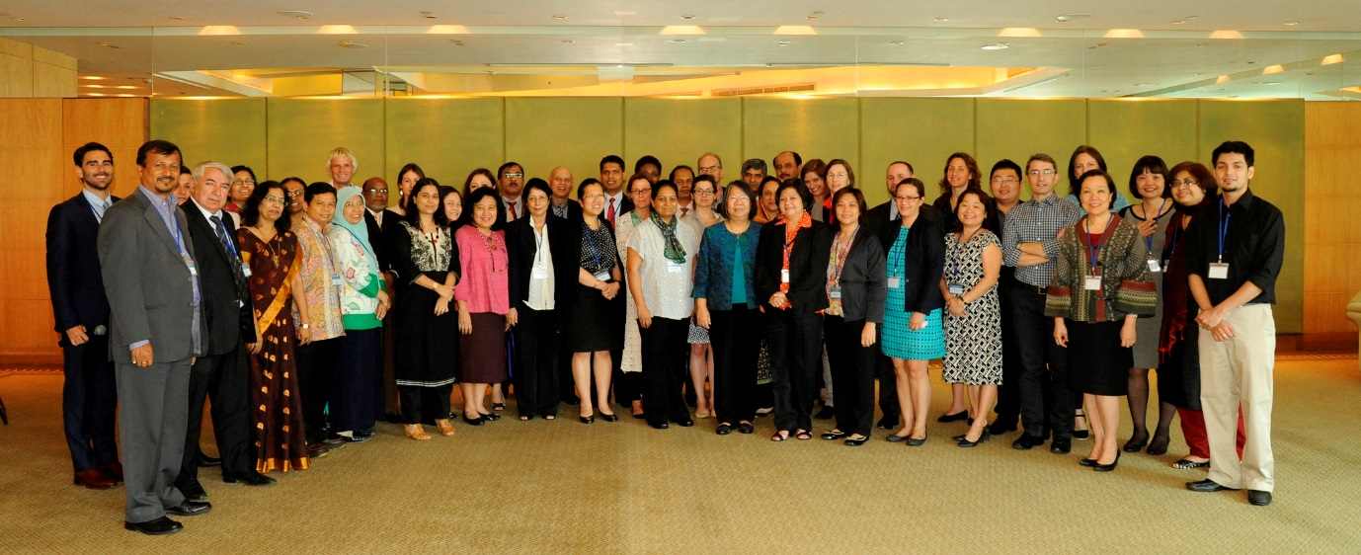
On 15th and 16th April 2015, participants from eight SUN countries met in Bangkok to accelerate efforts in budget analysis for nutrition. The workshop was the first in a series of workshops that aim to help policy makers prioritise, plan and make informed decisions on resource allocation for nutrition in national budgets. Delegations came from Bangladesh, Indonesia, Maharashtra State, Nepal, Pakistan, Philippines, Tajikistan and Vietnam. Participants included government representatives from planning, health and finance sectors and multiple stakeholder groups including the United Nations, Civil Society and Donor organisations.
SUN Countries had the opportunity to present their experience as a result of responding to a call of interest during the 17th SUN Country Network Conference Call. Most countries had made significant progress with the 3-step process for budget analysis and were able to improve their understanding in key areas including;
  - how to reach an estimate of the total budget relevant to nutrition across key sectors
  - understand with key ministries how investments can improve their effectiveness and reach
  - how the findings can be used for advocacy
  - how budget analysis forms part of a wider effort to track financial resources

Powerful quotes captured during the workshop
- The SUN Movement creates a space for trust so people can come together for nutrition – Patrizia Fracassi, SUN Movement Secretariat
- Global, regional and national level – we need to place nutrition on the development agenda to galvanise funding at all levels for nutrition – more money for nutrition and more nutrition for the money – Jakub Kakietek, Health, Nutrition, & Population Global Practice, World Bank
- We have more information than we realize, let’s learn how to use it well to invest in nutrition – Emorn Udomkemalee, Assoc. Professor, Human Nutrition, Mahidol University
- Everyone involved should know that nutrition is everyone’s business, health cannot do it alone – Professor Endang L. Achadi, Coordinator, PDRC, Faculty of Public Health, University of Indonesia
- We need more trust, more commitment and more champions. nutrition is not about investment, it is about political will – Dr. Nasreen Khan, Technical Support on Nutrition Public Health and WHO Wing, Ministry of Health and Family Welfare
- Please go back and talk to your parliamentarians! They are human too – nutrition makes sense! – Saira Iftiquar, Member of Public Account Committee, P&DD Govt. of Punja, Punjab Assembly
Christiane Rudert, Regional Adviser – Nutrition, UNICEF East Asia Pacific Regional Office (EAPRO) gave a presentation to summarise the conclusions from the workshop and recommendations for next steps.

