Global Day of Action celebrated:
June- July 2015
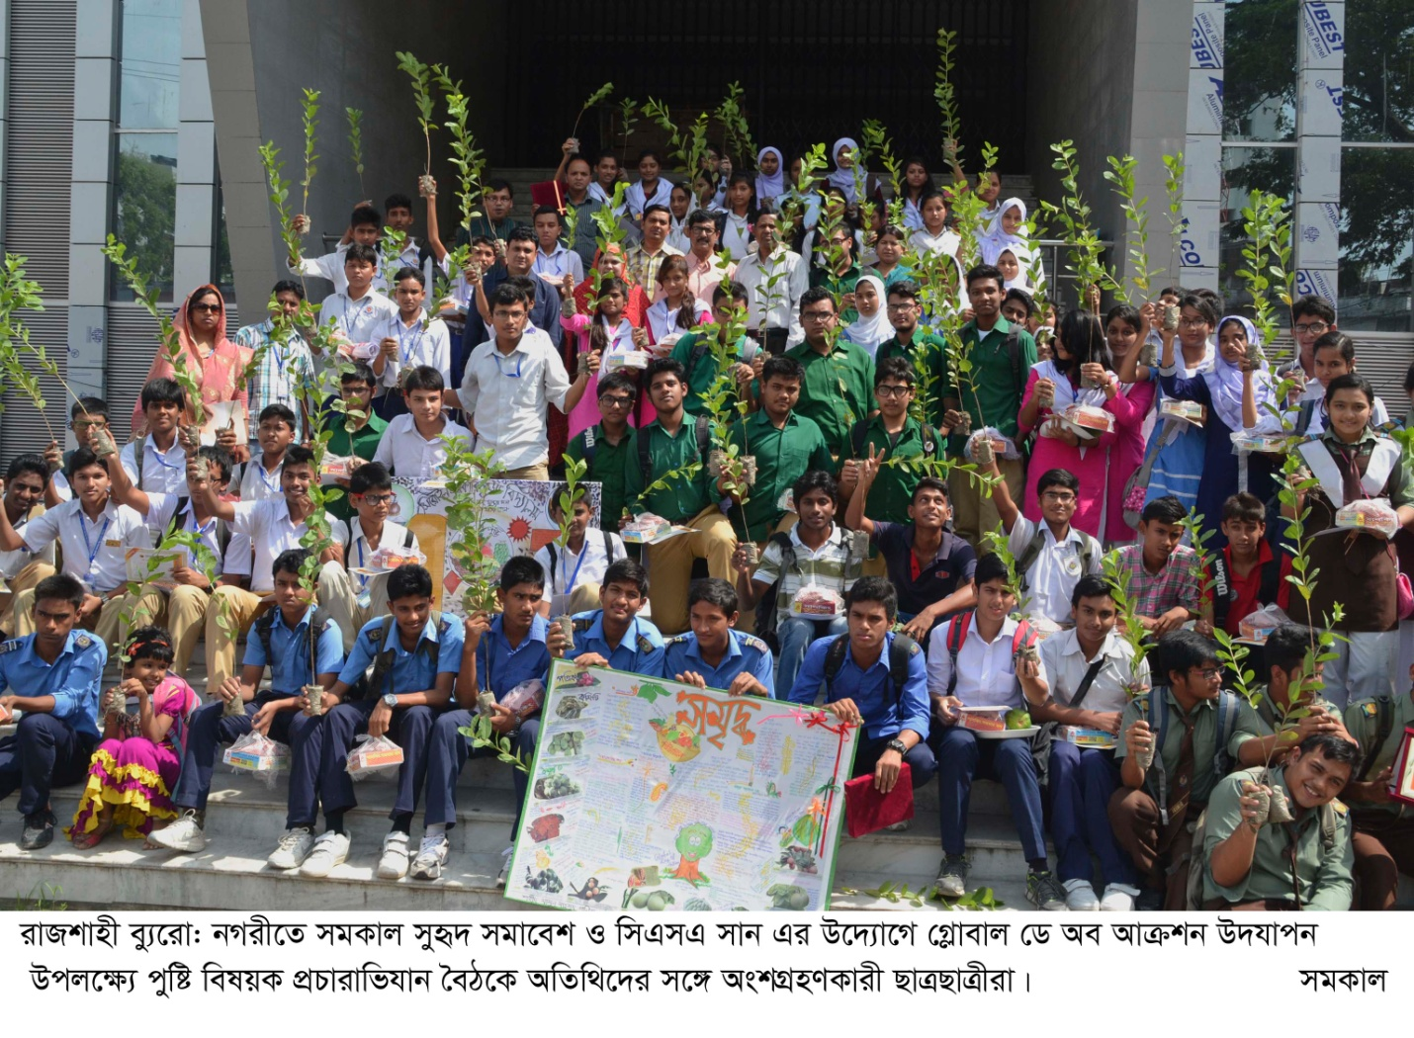
Global day Of Action has been celebrated in Chittagong, Bandarban, Cox s’ Bazar, Sylhet , Sunamganj, Rangpur,Dinajpur and Rajshahi this year. Global Day of Action highlighted on the serious public health risk due to malnutrition. Every country rich or poor, faces this problem. The focus is to push governments for transparent and sound accountability frameworks to track progress on nutrition. CSA for SUN, BD along with the renowned Bengali newspaper Somokal arranged various programs like roundtable discussion, wall magazine competition among high school students, display of nutritious food with its nutrition value. Local level influential Stalk holders including Parliaments members, Mayor, Civil Surgeon, District commissioner, Teacher, Media person, Doctors, Upazila Chairman, Religious leaders , Students were present in the event and made Commitment to Scale up Nutrition from their end.

