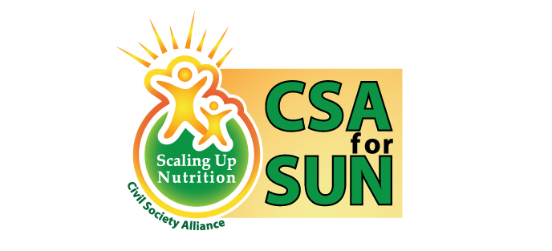

Civil Society Alliance for ScalingUp Nutrition, Bangladesh
World Health Day Observation
April-June, 2015
………………………………………………………………………………………………………………………………………………………………….
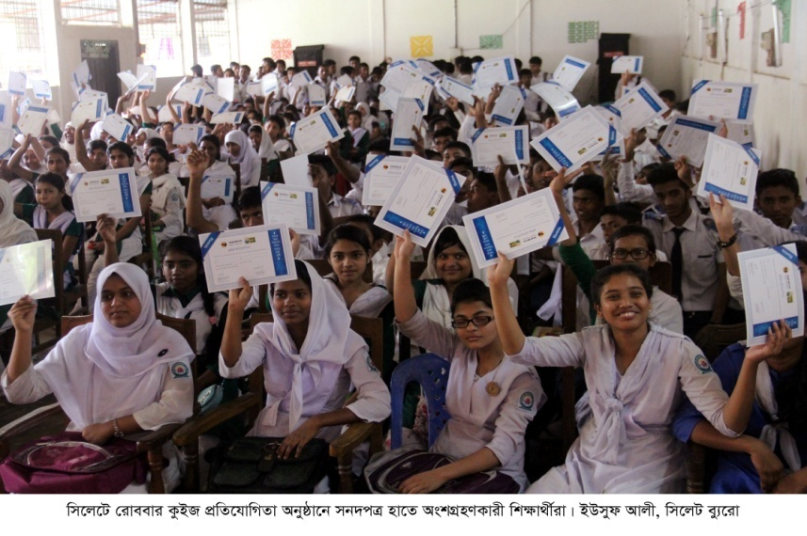
CSA for SUN, BD and well circulated Bangla newspaper Daily Shomokal celebrated World Health Day on the 12th and 13th of April in a number of divisional towns and big district towns. These are Rangpur, Barisal, Jessore and Sylhet Noakhali and Faridpur. The slogan of the campaign was Shobar Jonno Nirapod khaddo, Shobar Chai Pushti (Safe food for all, everyone needs nutrition).

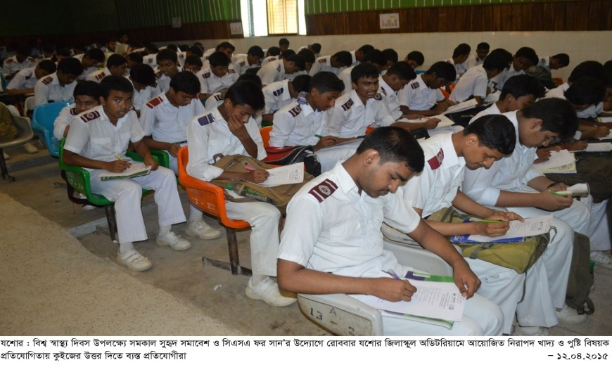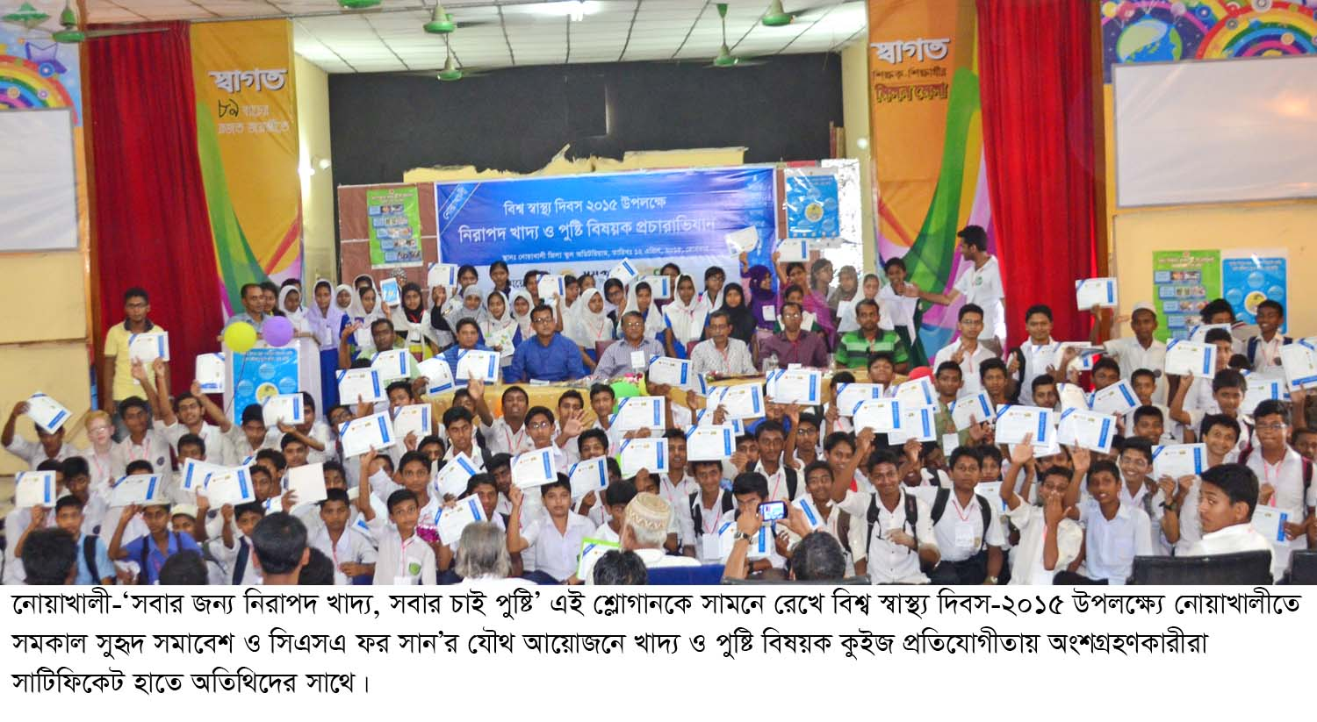
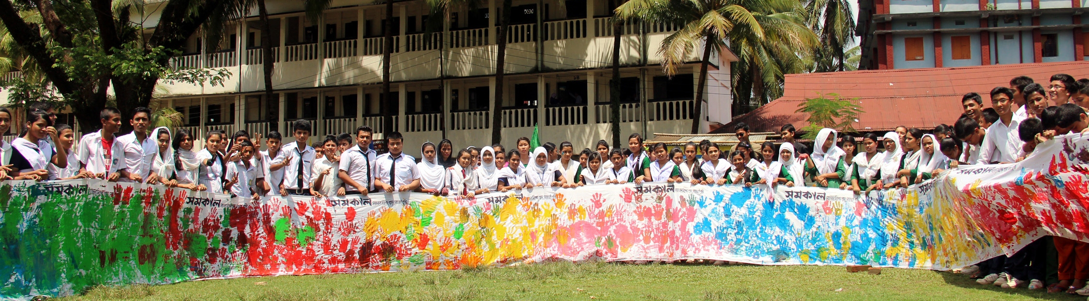
Members of Parliament, Newspaper editors, Civil Surgeons, High GOB officials, Professors, eminent writers and many more dignitaries from different sectors of the society were among the guests.
Because of mass promotion through newspaper advertisements, miking and regular visits and follow up with the schools, the campaign created a great momentum and enthusiasm throughout the divisional and district towns among population including the public figures and local government officials.
More than one thousand students from forty two schools participated in the nutrition related discussions and took part in quiz competitions. Participants were given certificate and winners were given prizes.

