[Botswana UN Country Fund]
MPTF OFfice GENERIC finalprogramme NARRATIVE report
REPORTING PERIOD: from September 2011 to december 2013
Programme Title & Project Number |  |  | Country, Locality(s), Priority Area(s) / Strategic Results
- Programme Title: Development GBV Prevention  - Programme Number : BW105  - MPTF Office Project Reference Number: 00079411 |  |  | (if applicable)  Country/Region: Botswana
Priority area/ strategic results
Thematic/Priority
Children, Youth and Women Empowerment
Participating Organization(s) |  |  | Implementing Partners
Organizations that have received direct funding from the MPTF Office under this programme : UNFPA |  |  | - National counterparts (government, private, NGOs & others) and other International Organizations  - Ministry of Labour and Home Affairs – Women’s Affairs Department  - UN M&E Group
Programme/Project Cost (US$) |  |  | Programme Duration
Total approved budget as per project document:  MPTF /JP Contribution: 25,500 |  |  | Overall Duration (months)  Start Date (dd.mm.yyyy): Sept, 2011
Agency Contribution : 10,000 |  |  | Original End Date (dd.mm.yyyy) 31.12.2014
Government Contribution  (if applicable) |  |  | Actual End date(dd.mm.yyyy): 31.12.2013  Have agency (ies) operationally closed the Programme in its (their) system? No
Other Contributions (donors)  UNDP/UNIFEM 75,000 |  |  | Expected Financial Closure date: 30 May 2014
TOTAL: 110,500
Programme Assessment/Review/Mid-Term Eval. |  |  | Report Submitted By
Evaluation Completed  Yes No Date: dd.mm.yyyy  Evaluation Report - Attached  Yes No Date: dd.mm.yyyy |  |  | - Name: Judith Shongwe  - Title: M&E Officer  - Participating Organization (Lead): UNFPA  - Email address:shongwe@unfpa.org

Abbreviations and Acronyms

List of abbreviations and acronyms commonly used in the report:

AWP Annual Work Plan
CCG Component Coordination Group
GBV Gender Based Violence
GoB-UN POP Government of Botswana-United Nations Programme Operational Plan 2010-2014
IP Implementing Partner
M&E Monitoring & Evaluation
RBM Results Based Management Training
UN United Nations
UNFPA United Nations Population Fund
USAID United States Agency for International Development

FINAL PROGRAMME REPORT FORMAT

EXECUTIVE SUMMARY

Through consultations with different stakeholders, key components that are essential for Gender Based Violence (GBV) referral system were identified. Leaders took the first initiative to run community dialogue sessions on sensitizing their communities on GBV. The dialogues covered child neglect, child labor, teenage pregnancy, alcohol and drug abuse, sexual violence, cohabitation, child abuse, abuse of the elderly. . These issues were identified as areas of concern by the community. The dialogues were conducted with the following groups; Village women’s groups, Village Multi Sectoral Committees (VMSACs), Youth groups, churches, football clubs and schools both primary and Community Junior Secondary Schools (CJSS).Community leaders in the two sites pledged through signing of commitment scrolls to address GBV and gender inequalities in their communities.

The training on Results Based Management (RBM) has resulted in each Component Coordination Group (CCG) having more people trained on RBM which has improved the planning, implementation and reporting of the Annual Work Plans (AWPs). The plans are more focused and results oriented.

Purpose
The objective of the Government of Botswana is to establish a GBV referral system ensuring coherent and systematic quality care for victims of GBV through fostering effective coordination and collaboration of GBV services between relevant organizations and departments. This entails the establishment of a referral system between key service providers in Government and NGOs in order to improve GBV data collection mechanisms, including building capacity to measure, monitor and analyse the data that will be generated through the GBV referral system. To foster a functional GBV referral system requires the implementation of communication and social mobilisation activities. The 2011 AWP included two pilots for the GBV referral system sites and this project supports the establishment of the second pilot site.

The second aim of the project was to train service providers on the referral system and RBM. However, the RBM training was extended to other Implementing Partners and UN staff. Although the UN had supported the training, there was a need for extra funding to conduct Trainers of Trainers to ensure long-term sustainable capacity building by establishing a pool of trainers within reach for effective rollout of RBM training to districts and other sectors responsible for implementing projects of the GOB – UN POP.
Expected Outcomes:
- A functional GBV referral system including the establishment of a GBV database
- Improved quality of care to GBV victims
- Improve RBM of the GOB – UN POP
- To roll out RBM Training of Trainers

Assessment of Programme Results

Establishment of Referral System in two sites

Establishment of referral system in the two pilot sites (Mochudi and Maun) is still ongoing though it has been delayed. The activities supported through this project were mainly on achieving buy-in by stakeholders in the pilot sites and capacity development in understanding of GBV.

Consultations in the process of establishing a GBV Referral System are critical to facilitate buy-in, ownership and the development of an implementable system. All of the consultations conducted with Social &Community Development (S&CD), Education Department, NGOs, Customary courts, Judiciary and Ministry of Health resulted in positive feedback and stakeholder endorsement of the GBV referral system and provided critical input into the design of the referral system and in identification of key components that are essential to the GBV Referral System.

Community leaders were successfully mobilized to spearhead efforts to combat GBV. Community leaders included the District Commissioner, Dikgosi, faith based organizations’ leaders, school heads, VDCs, representatives of Government Departments and NGOs, representatives of community choirs/sports clubs/committees, and village elders. The leaders took the first initiative to run community dialogue sessions on GBV with different groups like youth groups, in schools, and churches in their villages. Community leaders in the two sites pledged through signing of commitment scrolls to address GBV and gender inequalities in their communities.

Capacity building for GBV implementing partners and service providers

One key activity under this output was to train RBM trainers to ensure long-term sustainable capacity building by establishing a pool of trainers within reach for effective rollout of RBM training to districts and other sectors responsible for implementing projects of the GOB – UN POP. This was extended to Implementing Partners and UN staff that was identified through two trainings conducted before. Fifteen RBM trainers were trained. The expectation was that they will continue training new members of staff in the UN and from the IPs

This has resulted in improved AWPs that are more strategically and results focused. The impact has been evident in the reporting of the Annual Review Reports, there is a clear line of results chain. The 2013 reports highlighted how each thematic area contributed toward outcomes and we more results focused compared to the 2010, 2011 and 2012 reports. The training has not been rolled out to the districts as the establishment of the referral system is not yet complete.

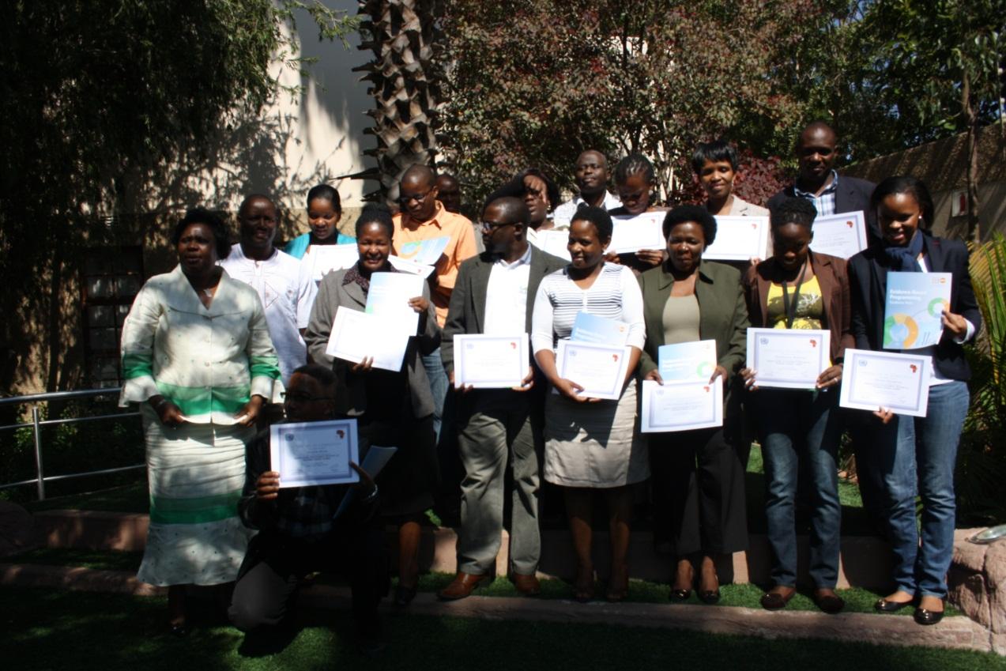
RBM Training of Trainers Certificate Ceremony attended by UNFPA Representative Ms. Aisha Camara-Drammeh (far left)

Capacity building workshops conducted in the two sites is expected to improve the understanding of GBV and related gender issues and concepts.

Lesson Learnt
One lesson learnt is that with adequate engagement and capacity development, community leaders can take a lead in addressing GBV and in engaging their communities in efforts to combat GBV.

Challenges
There has been delay in the completion of the referral system. One major constraint was on procuring consultancy to facilitate the development of key tools and the piloting of the gender based violence referral system as next steps in the establishment of this system. It was only late in the year Gender affairs Department was able to get in partnership with USAID and Measure Evaluation was brought on board to develop the tools. It is worth noting that funding for the major part of functional GBV referral system Pilot Sites mainly will come from sources outside this project as indicated above.

ii) Indicator Based Performance Assessment:
Using the Programme Results Framework from the Project Document / AWPs - provide details of the achievement of indicators at both the output and outcome level in the table below. Where it has not been possible to collect data on indicators, clear explanation should be given explaining why.

 | Achieved Indicator Targets | Reasons for Variance with Planned Target (if any) | Source of Verification
Outcome 1 Integrated approach to combat GBV, supported at all levels
Indicator:
Baseline:
Planned Target:
Output 1.1 Establishment of GBV referral system including schools & development of a GBV database  Indicator 1.1.1 GBV referral system piloted in two areas  Baseline: No  Planned Target: Yes | - Roundtable discussions were conducted with senior officers in a total of 13 (7 in Maun & 6 in Mochudi) key institutions to consult on the GBV Referral System process as a way to identify existing referral practices and build on the institutional role definition. Institutions consulted included health facilities – 80 participants, schools (guidance & counseling teachers) – 33 participants, S&CD – 28 participants, customary courts – 25 participants, magistrate courts and Directorate of Public Prosecutions – 18 participants and NGOs – 22 participants. | Please add the reason | - Quarterly CCG reports  - Annual CCG reports
Outcome 1 Government and other key players, including media, able to formulate, monitor, and evaluate Programmes that combat GBV
Indicator:
Baseline:
Planned Target:
Output 2.1 Capacity building for GBV implementing partners and service providers.  Indicator 2.1.1 Service providers at the sites trained on the referral system  Baseline: 0  Planned Target: TBD  Indicator 2.1.2 RBM training of trainers conducted  Baseline: 0  Planned Target:1 | - Eleven capacity building workshops on GBV were conducted in Maun and Mochudi for guidance and counseling teachers (2), customary court officials (2), Police (2), health workers (2), S&CD officers (2) and civil society organizations (1). The workshops resulted in improved understanding of GBV and related gender issues and concepts. Level of participation: police – 40 participants, health facilities – 86 participants, schools (guidance & counseling teachers) – 48 participants, S&CD – 58 participants, customary courts – 52 participants and NGOs – 22 participants. |  | - Quarterly CCG reports  - Annual CCG reports
 | Training of trainers on RBM for 15 participants from the UN, Government and Civil society was carried conducted. |  | GOB-UN Pop 2012 annual report.

The term “programme” is used for programmes, joint programmes and projects.

