### C:\Users\Alice\UNDP, Lavoro\Reporting\LRF\LRF Q1\LRF cover Report 2nd.jpg

**LRF Quarterly PROGRESS REPORT**

|  |  |  |
| --- | --- | --- |
| Reporting UN Organization | : | United Nations Development Programme |
| Country | : | Lebanon |
| Project No. | : | LRF 29 – Project ID 00090567  MPTF Office Project Reference Number:[[1]](#footnote-1) LRF 29 |
| Project Title | : | Selected Rapid Delivery and Immediate Impact Interventions |
| Project Start date | : | May 1st 2014 |
| Reporting Period | : | July - September 2015 |

**List of Acronyms**

DRM Disaster Risk Management

DRR Disaster Risk Reduction

PMO Prime Minister Office

NCC National Coordination Committee

COM Council of Ministers

UNDP United Nations Development Programme

NRP National Response Plan

HFA Hyogo Framework of Action

NOR National Operations Room

MOR Mobile Operation Room

CBRN Chemical – Biological – Radioactive - Nuclear

BRHIA Beirut Rafik Hariri International Airport

UN ISDR United Nations Office for Disaster Reduction

INSARAG International Search and Rescue Advisory Group

CDR Council for Development and Reconstruction

NGO None Governmental Organizations

LAF Lebanese Armed Forces

ISF Internal Security Forces

CNRS National Council for Scientific Research

LRC Lebanese Red Cross

NCLW National Commission for Lebanese Women

GARD Getting Airport Ready for Disasters

WHO World Health Organization

SOP Standard Operating Procedures

QPR Quarterly Progress Report

APR Annual Progress Report

M&E Monitoring and Evaluation

## ACTED Agence d'Aide a la Cooperation Technique et au Developpement

DRC Danish Refugee Council

ITB Invitation to Bid

PCPM Polish Center for International Aid

PV Photovoltaic

REACH Society for Rehabilitation, Education and Community Health

UNHCR: United Nations High Commissioner for Refugees

RRP: Regional Response Plan

DIM: Direct Implementation Modality

NGOs: Non-Governmental Organizations

GA: Grant Agreement

PHCC: Primary Health Care Center

MoPH: Ministry of Public Health

UoM: Union of Municipalities

MOSA: Ministry of Social Affairs

LEDA: Lebanese Economic Development Authority

MEHE: Ministry of Education and Higher Education

MoEW: Ministry of Energy and Water

|  |
| --- |
| I. PURPOSE |

The impact of the Syrian crisis on Lebanon is reaching a scale unprecedented in the history of complex, refugee-driven emergencies. In April 2012, 32,800 refugees were registered or awaiting registration with UNHCR, by end of April 2015 that figure had sharply increased to over 1,200,000 an increase equal to over 25% of the entire Lebanese pre-crisis population. To contextualize the impact further, Lebanon was already one of the most densely populated countries in the world, with an average of over 400 people per square kilometre of land. This sudden and large influx of refugees from Syria is now placing enormous pressure on the country and its people, especially those in the poorest areas, where refugee concentrations have been the greatest.

The crisis is not only challenging the country’s existing social and economic infrastructure, it is exacerbating significant development deficiencies such as unemployment, especially among women and youth, and causing profound disparities between the wealthy and the poor. In addition, the crisis brings to Lebanon a set of new tensions that threaten to undermine Lebanon’s delicate social and political balance of power while amplifying pre-existing inter-Lebanese divisions and provoking increasingly negative reactions against the Syrian refugee presence.

A robust response to the complex crisis requires a mix of both urgent and developmental responses. The project therefore includes rapid interventions, and seeks to contribute to stabilization and recovery in refugee hosting areas in Lebanon through the accomplishment of two main outcomes:

|  |  |
| --- | --- |
| **Immediate Objective** | Stabilization and recovery in the refugee hosting areas through quick impact and community support projects |
| **Outcome 1** | Livelihood and economic opportunities increased in select refugee hosting areas through upgrading, repairing and improving the production infrastructure and creating short and medium term employment opportunities |
| **Outcome 2** | Delivery of basic social services expanded and improved in target communities through equipping, rehabilitation and upgrading the infrastructure and improving the skills of service providers |
| **Outcome 3** | Social cohesion in target areas improved through positive media exposure and improved skill base for peaceful dispute resolution |

The activities are integrated within the UNHCR-led Regional Response Plan (RRP) Social Cohesion and Livelihoods and Water and Sanitation Sectors and are further coordinated with the international community via the Task Force on Support to Host Communities.

A listing of the main international and national implementing partners involved and their roles.

* **UNDP:** will be responsible for implementing the activities under this project through the adoption of the Direct Implementation Modality (DIM). It will also act as the main executing agency, forming partnerships with the governmental, non-governmental and corporate sector entities for the delivery of the stipulated goods and services. The UNDP Country Office will oversee the implementation of the initiatives through its central office in Beirut as well as its regional office network in Akkar, Bekaa, Mount Lebanon and South, and will be responsible for reporting on the progress.
* **The Ministry of Social Affairs:** will serve as the main governmental counterpart. It is represented in the Project Steering Committee/Board and participates in the approval of the work plans and progress reports.
* **Local Authorities:** will participate in the implementation of initiatives at the local level, providing day to day follow-up in addition to requesting offers whenever needed. Local authorities will collaborate directly with UNDP to achieve the goals of the project.
* **The Ministry of Education and Higher Education, the Ministry of Public Health, Ministry of Social Affairs and Ministry of Interior and Municipalities:** will serve as the main governmental counterpart for initiatives related to health and education sectors. All initiatives will be carried out based on clear recommendations and standards set by the aforementioned line ministries for standardization of quality of services at the national level.

Livelihood initiatives will be implemented in Akkar area and in the Bekaa region. Basic social services initiatives will be targeting Public Schools and PHCC countrywide and municipalities in the South and Bekaa, to solve sewage and water related problems.

Lebanon is facing a major crisis in terms of large numbers of refugees fleeing the war in Syria, and finding shelter within Lebanese cities and towns across the country. Many countries and international organizations are assisting in securing the basic needs for the Syrian refugees in terms of water, food, and shelter. However, energy is also a major problem in Lebanon both before the Syrian refuges crisis and now augmented with this crisis, where at least 9-12 hours of blackouts per day exist, and the delivery of hot water is not guaranteed; the need to deliver urgent and basic energy for lighting at the household level and the need to provide cooking and heating, especially for the cold season is critical.

These utilities are needed by both the host-communities as well as the Syrian refugees to ensure safety, well-being and security. Using solar energy seems to be the only way to provide these rural communities with an additional cost-effective and independent source of electricity. Furthermore, for household heating and cooking, sustainable briquette stoves can be used instead of highly polluting diesel fuel or worse, wood collected unsustainably and often illegally from forests.

The project aims at installing in the Akkar and Bekka region approximately 500 solar lighting kits for various host community beneficiary houses to deliver basic lighting, and 500 briquette stoves for heating and cooking.

**Project Linkages to National Priorities and Reconstruction Goals:**

The majority of refugees are being hosted in communities that are among the poorest in the country. Given the significant periods of power cuts in Lebanon, where some regions have at least 9-12 hours of power cuts per day, the need to deliver urgent and basic energy for lighting at the household level and the need to provide cooking and heating, especially for the cold season is critical.

The use of renewable energy systems, such as the ones proposed, saves on household spending while ensuring that the basic needs of local host-communities are met. The proposed equipment to be purchased and installed are: solar lighting kits capable of lighting 3 to 4 rooms with energy efficient light bulbs. Briquette Stoves (small heating unit sufficient to warm a 100 m2 room on average): The unit is fed with sustainably produced briquettes (manufactured from the agricultural waste or from sustainably managed forests) that are burnt in the system and emit heat. Some local manufacturing of briquettes has started in Lebanon and through the introduction of these systems, not only would heating be provided to Lebanese beneficiaries, but also potential new job opportunities for the manufacturing of sustainable biomass for heating from agricultural waste and forest residues.

These systems will be provided to households according to two main criteria: Humanitarian and Technical. Humanitarian criteria includes households hosting Syrian refugees, households that are defined as being ‘extreme poor’ by the Ministry of Social Affairs, and those in need as identified by municipalities. Technical criteria includes among other items the household infrastructure, ability to cover costs of monthly fees to community-based electricity generator or the availability of a privately-owned generator (refer to **Annex 1** for comprehensive selection criteria).

These units will be purchased as pilot technologies that are environmentally-friendly and will complement the Winterization Programme of the UNHCR under implementation within the Regional Response Plan. The target villages will be the poorest host-communities in Akkar and the Bekaa region which have the infrastructure needed to introduce the equipment at the household level. The selection of the houses will be coordinated closely in the field with UNHCR and other agencies working in these areas.

Under output 2.5, below are the expected achievements:

* The establishment of a National Operations Room (NOR)
* Support to four national ministries in crisis preparedness and planning
* Support to 25 local authorities in North and Bekaa to adopt resilient city charter
* Support the establishment of regional crisis response plans and operation rooms
* Awareness raising on crisis preparedness
* Distribution of emergency response kits
* Awareness raising through mobile app and leaflet distribution

With regards to output 3.2, the main objective of the programme is the Stabilization and recovery in the refugee hosting areas through quick impact and community support projects. And the outcome of this specific component (reported against here) is “Social cohesion in target areas improved through improved skill base for peaceful dispute resolution”. This outcome is related to the Output number 3: Local level dispute resolution strengthened and community security improved, under which one main activity is mentioned: Develop local level peace building strategies to mitigate tensions in selected conflict prone areas of Lebanon hosting Syrian refugees”.

|  |
| --- |
| II. RESOURCES |

|  |  |
| --- | --- |
| **Total budget approved** | **USD 5,802,053.4** |
| **Total disbursements as of 30 September 2015** | **USD 5,226,184.32** |
| **Commitments for the next quarter** | **USD 575,869.08** |
| **Available Balance** | **USD 0** |

|  |  |  |
| --- | --- | --- |
| **CATEGORY** | **TOTAL BUDGET**  **(USD)** | **TOTAL EXP**  **(USD) until end of September2015** |
| 1. Staff and other personnel | $ 590,224.17 | $ 532,578.11 |
| 2. Supplies, Commodities, Materials | $ 1,848,897.95 | $ 235,303.06 |
| 3. Equipment, Vehicles, and Furniture (including Depreciation) | $ 1,723,815.76 | $ 1,686,430.04 |
| 4. Contractual services | $ 323,169.73 | $ 1,694,242.10 |
| 5. Travel | $ 4,758.00 | $ 20,921.59 |
| 6. Transfers and Grants to Counterparts | $ 835,062.77 | $ 645,155.00 |
| 7. General Operating and other Direct Costs | $ 96,551.43 | $ 69,654.51 |
| **Sub-Total Programme Costs** | $ 5,422,479.81 | $ 4,884,284.41 |
| 8. Indirect Support Costs 7% | $ 379,573.59 | $ 341,899.91 |
| **TOTAL** | $ 5,802,053.4 | $ 5,226,184.32 |

|  |
| --- |
| III. RESULTS |

The project is progressing effectively to meet the expected outcomes and outputs scheduled for the project duration. A significant number of initiatives both in the livelihood and basic social services sectors are completed while the remaining are under implementation. For projects implementation two modalities are applied:

1. Grant Agreement (GA) modality, whereby each activity is divided into two or several phases depending on its type. Accordingly, each grant is transferred in tranches to the corresponding municipality after the accomplishment of each phase. UNDP field officers and consultants provide technical support to each municipality as needed, monitor the implementation of each phase, and approve the transfer of corresponding tranches upon successful accomplishment of the agreed tasks. The GA modality is an instrument to promote good governance and capacity-building of specific competencies of the Municipalities. It also ensures monitoring and evaluation in close cooperation with UNDP and under its guidance.
2. Direct procurement modality, in case certain municipalities do not have the capacity to implement, UNDP will do direct procurement of services in collaboration with the municipality. A similar approach applies for NGOs. For government agencies, UNDP direct procurement will apply.

**OUTPUT 1: Livelihood and economic opportunities increased in selected refugee hosting areas through upgrading, repairing and improving the production infrastructure and creating short and medium term employment opportunities**

**Activity 1.1. Support value added production of fruits and vegetables in Akkar through postharvest processing**

* **Description**

Jord Akkar is the major fruit producing area in Akkar district, where apples are the major crop in addition to some annual crops and summer vegetables. Prior to the conflict across the border, Syria served as the main transit route for the export of fresh agricultural produce. The Syrian crisis and the consequent closure of the borders had limited the demand of the local consumers and has decreased the prices of agricultural produce in this region, affecting the income of farmers and the livelihood of their families. This situation is forcing many farmers to abandon their fields and orchards

The Cooperative Association for Agriculture and Food Processing in Fnaydeq was founded in 1999 and has since been supported by many organisations. These interventions supplied the cooperative with machineries, equipment and trainings to improve its production capacities by focusing on empowering women workers to participate and/or contribute in the production process. Thus enabling the cooperative to reach a peak point where it was producing around 20 different products mainly: pomegranate molasses, eggplant makdous, peach qamareddine, tomato paste, chilli pepper paste, kishk (traditional dairy product), processed olives, grape leaves makdous, apple vinegar, green figs, dried figs and jams (apricot, cherry, pear and peach). Moreover, the latest external support to this cooperative is an intervention by MADA and Fair Trade Lebanon targeting the improvement of cooperative management, good manufacturing practices, production of peach qamareddine, light jam among it apple jam and makdouss as well as the rehabilitation of the cooperative infrastructure (paint, windows, electrical installation maintenance…).

Through this project UNDP is supporting the cooperative’s manufacturing capacity by equipping it with solar powered fruit-drying-machine and purchasing a vehicle to transport the products to different markets. The cooperative still needs to develop a business plan to highlight the costs, expenses and potential revenue, and to have a market plan that identifies potential product lines and new markets for expansion. Moreover, the cooperative will require additional support in training its members in new production processes and techniques.

* **Main achievements**

In the previous reporting period, the cooperative’s manufacturing capacity was increased through the purchase of a fruit-drying-machine. The machine was procured and delivered and the workers were trained by the contractor on its use. In addition, a van was procured and delivered to transport the products to different markets. The introduction of a new production line (dry fruits) improves the market share of the cooperative, the diversification of its product lines and allows the cooperative to enter new niche markets.

During the second quarter, the implementation of the capacity-building component started on two levels; the elaboration of a marketing strategy and the delivery of technical support for the cooperative to improve the quality of the dried food production line.

With regard to the elaboration of a marketing strategy, a team of experts was recruited. This team held an inception meeting for clarification of the scope of work and finalization of the methodology. Then, an introductory meeting took place with the cooperative management board to present the team of experts, the methodology and the scope of work to the cooperative.

Accordingly, the team initiated data collection and review and started elaborating the management and marketing history analysis. Another field visit took place to explore the current production process, cycle and steps.

As for the delivery of technical support for the cooperative to improve the quality of the dried food production line, an industrial engineer was recruited. The engineerheld an inception meeting, for a clarification of the scope of work and the finalization of the methodology. Then, the industrial engineer met the cooperative management board and presented the methodology and the scope of work to the cooperative. In addition, during his visit, the engineer explored the newly supplied machine in order to elaborate guidelines for the efficient use of the production line.

After completing the rehabilitation of the production room and discussing the findings of the experts, a workshop took place during the last week of August to present the findings of those studies and to train the members of the cooperative on how to use the machine. During this workshop the cooperative members learned about quality and hygiene standards to be applied during the production process. They were trained on how to use the production line step by step starting by the washer to grader, the slicer, and finally the dryer.

The members of the cooperative were also informed about the findings of the marketing study (prepared by the experts) that shows the potential and the increasing need of dried fruits in the local market.

**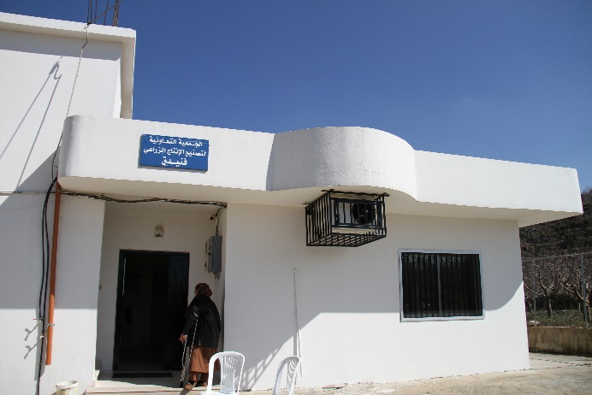 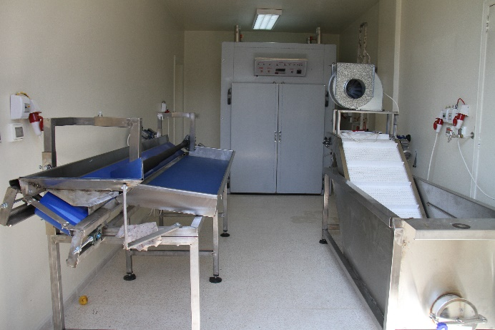**

* **Challenges, lessons learned and recommendations**

At the end of the project and in the hopes of moving forward, the below recommendations were raised to the Cooperative:

* The need for restructuring the operations team and divide the tasks.
* The need to restructure the electricity network of the Cooperative.
* The need to link the Cooperative with farmers from different areas in Akkar and Dannieh and purchase their products directly at lower cost.
* The need for the Management Board to select one of the suggested logos and package designs.

**Activity 1.2. Enhance fruit marketing in Akkar**

The **Activity 1.2 “Enhance fruit marketing in Akkar”** was amended and officially approved on the 14 January 2015.

* **Description**

Joumeh area is considered one of the most prosperous areas in apple cultivation due to the availability of water, the quality of the soil, and the appropriate elevation for apple cultivation.

The United Cooperative in Joumeh region of Akkar is a union of 3 agricultural cooperatives, which are active in fruit production in the villages of Rahbeh, Bazbina, Akkar El-Atiqua and their surrounding areas. The United Cooperative has established (in 1999) a refrigerated storage facility for the farmers in the region.

In addition, it provides agricultural guidance to its members to improve the quality and quantity of fruits while working on the reduction of chemicals used by the farmers.

The considerable increase in food production in the area and the limited resources the cooperative has it is facing various problems, including lack of management skills to the structural problems related to the segmentation of work. In addition, the absence of a proper fruit sorting and packing unit, essential for a proper preseravation of the fruit, makes the access of the United Cooperative to the market difficult and risky.

Like the farming communities elsewhere in Akkar, the Cooperative is suffering economic stress due to the closure of the transit route through Syria. The project aims at enhacing the capacity of the coopertive through:

* Providing a washing, grading and packaging machine.
* Providing a vehicle for the transportation the products to the market.
* Improving the efficiency through the establishment of a hangar in front of the facility; this will allow the easy access for trucks to deliver the apples to the facility and the transportation of the processed apples from the production line end to the freezers.
* Enhancing the capacity of the Cooperative storage by providing 3,000 boxes.

However, the equipment and the new facility provided to the United Cooperative are not enough to ensure its sustainability. During the last decade, the United Cooperative faced many problems that severely affected its proper operation and competitiveness ranging from the absence of a business plan, weak managerial skills, lack of a common vision, lack of an efficient operational structure, non-existent coordination and weak commitment and planning among the members. North LEDA will work with the different members in order to provide them with specific trainings in different business development fields such as management, business and financial planning etc. In addition to specific trainings related to cooperative management (organization, laws, etc..) North LEDA will also work with the members on the development of a comprehensive business plan. It is worth noting that for the cooperative a business plan is essential in defining a financial plan, marketing strategy and an operational modality.

* **Main achivements**

The hard component of the intervention had been finilized in the previous quarter. A hangar in front of the facility was identified as one of the main needs for storing the machine for the new production line and the works were completed. The procurement of 8,500 plastic crates, a transportation vehicle and the apple production line machine (for washing, grading and packing) for the new production line was completed in December 2014.

In the last quarter, North LEDA provided the cooperative members with specific trainings in different business development fields such as management, business and financial planning. The training covered the following topics:

* Day one: a training on entrepreneurship was delivered.
* Day two and three: a training on business models for the Union of Cooperatives was conducted. It consisted in a real life training based on the actual situation analysis and future outlook of the whole concept, the already existing services and the newly developed ones.
* Day four: the early hours were dedicated to a brief on the final outcome of the newly built business model and to agree on fast actions as the season was due to start soon.
* Day five: marketing principles and management models were presented, a marketing and communication strategy was elaborated, and data from business models were reused in presenting marketing campaign scenarios.

In addition, the inauguration of two projects supporting the capacities of the cooperatives in agricultural production in Akkar was held on October 7, 2015 at the United Cooperative in Joumeh, Akkar. Amongst those present were the United Nations Resident and Humanitarian Coordinator and Resident Representative of the United Nations Development Programme (UNDP) in Lebanon Mr. Philippe Lazzarini, UNDP Country Director Mr. Luca Renda, H.E. the governor of Akkar, Mr. Imad Labaki, representatives from the Ministry of Social Affairs, Ministry of Economy and Trade, the German Embassy in Lebanon and the Lebanon Recovery Fund, members of the Cooperative Association for Agriculture and Food Processing in Fnaydek and the Cooperative Association in Akkar.

These projects helped improve the social and economic conditions of the farmers in Akkar, and promote economic activities in the area. Three hundred farmers directly benefitted from the project implemented at the United Cooperative in Joumeh, and 37 other members and staff at the Cooperative Association in Fnaydeq.

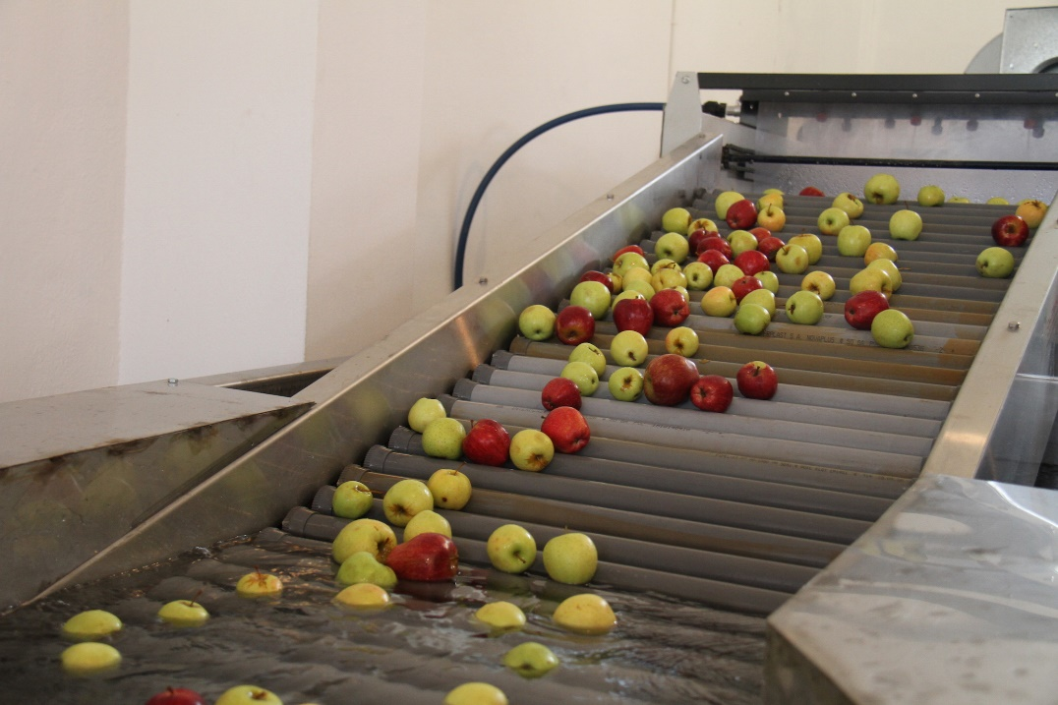

**Challenges, lessons learned and recommendations**

**Challenges:**

* One of the common features among Joumeh United cooperatives is the fact that the number of registered members is very large yet the active beneficiaries are very few and this affects the election, governance and overall stability of subsequent managements and long-term visions.
* Cooperative work is still considered voluntary.
* Weak management requires a longer timeframe for building the capacities of the members of the cooperative.

**Lessons learned and recommendations:**

* Management skills for the cooperative board require longer term intervention, additional support and close follow-up, in order to tackle the existing managerial gaps and increase their financial income.

**Activity 1.3. Implement WASH projects in Bekaa**

The **Activity 1.3 “Implement a cash-for-work reforestation activity in Bekaa”** was amended and officially approved on January 14th, 2015. Accordingly, the below are three new activities within the project/activity scope:

1. **Construction of a wastewater network for better hygiene and health conditions in Ain Kfarzabad**

* **Description**

The municipality of Ain Kfarzabad is responsible for managing the wastewater network in the village. Given the restricted budget available, the municipality is exerting big efforts to deliver the proper services. The impact of the Syrian crisis and the dramatic increase in the population residing in the village intensified the pressure on the already weak public services. On one hand, more efforts are needed to process the wastewater produced. On the other, Ain Kfarzabad municipality is overwhelmed and unable to fulfil its responsibility in providing good services. Hence, the local population and refugees face a critical hygiene and health situation, with a dramatic increase in the spread of diseases.

* **Main achievements**

The project, implemented closely with the municipality, aims at extending the sewage network. The contractor was selected and the works are completed. A 927 meters sewage network was installed in Ain Kfarzabad. The intervention has a direct impact on livelihood conditions, reducing the pollution of the agricultural lands and contributing to a better quality of agricultural products and improved health conditions of the inhabitants.

1. **Improving farmers livelihoods through the rehabilitation of the irrigation canals**

* **Description**

Chwaghir municipality is a rural area and agriculture constitutes the main economic activity for its inhabitants. Most of the farmlands are irrigated through traditional irrigation canals that are in bad condition resulting in water leakage. Given the limited financial resources and the massive work that needs to be done, the municipality and the local farmers identified the scarcity of water and modest agricultural productivity as the main problem of the sector. Limited access to irrigation water is also increasing the already high cost of production.

* **Main achievements**

The project, implemented closely with the municipality, aims at improving the conditions of the farmers in Chwaghir through the rehabilitation of the irrigation system (400 linear meters). The rehabilitation was completed and directly benefitted 200 Lebanese and 100 Syrian refugees.

The irrigation canals improved the livelihood of the farmers in Chwaghir since they increased the amount of water being saved, decreased the leakage of water that results from vaporization and inefficient distribution and utilization of water resources, resulting in improved quality of agricultural products and increased number of irrigated and cultivated lands.

1. **Integrated water resources management to improve environment and health conditions in the Lebanese host communities of Qab Elias**

* **Description**

In the village of Qab Elias, some households are connected to a local sanitation sub-network that discharged to a collective cesspit to drain the sewage. The location of the cesspit is right on the top of the main river feeding irrigation water into the agricultural plain of Qab Elias and passing through a touristic site where a number of restaurants is located. As a result, the river is directly polluted with untreated domestic wastewater posing health risks for households and leading to the contamination of irrigated crops. As such, the project is working closely with Qab Elias municipality to improve the sanitation network.

* **Main achievements**

The project consists in the provision of a non-electric sewage treatment system with a capacity of serving a community of 100 inhabitants. The treatment unit was installed and is operational.

The treatment unit in Qab Elias will lead to the following reduction of contamination: Suspended solids (SS) reduction: 80% and Organic matter reduction (BOD5): 85%.

**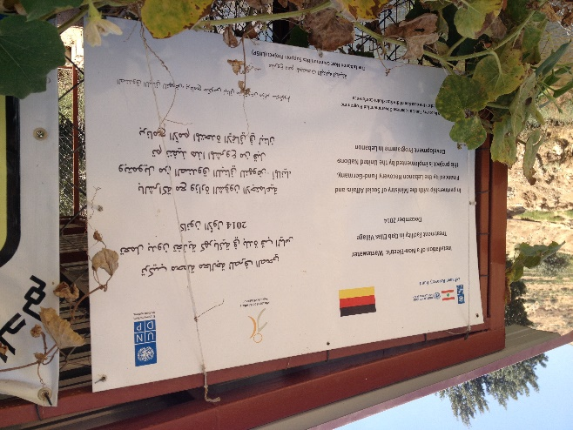 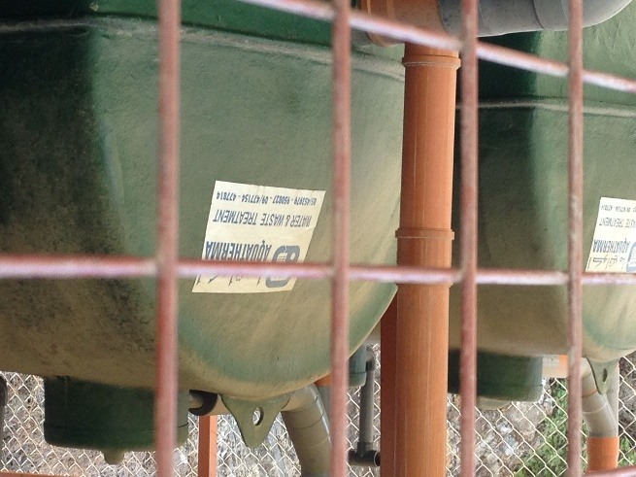**

**Activity 1.4. Increase irrigated agricultural areas in North Bekaa**

* **Description**

This activity aims at increasing irrigated agriculture areas in the refugee hosting Bekaa region through constructing irrigation canals in four villages in Northern Bekaa in the municipalities of Flawi, Boudai, Shaat (Zrazir) and Hermel. The agricultural lands in Flawi, Boudai and Shaat (Zrazir) depend on water collected from the Alyamuna stream through an infiltration gallery. The main water channel spreads into minor branches, many of which are earthen, causing massive water loss due to leakages, evaporation and perforation. Similar issues are faced by the communities in Hermel area which rely on earthen water channels. The water loss from earthen channels is a major constraint as it hinders the expansion of irrigated lands, the intensification of cropping patterns resulting in loss of economic opportunities.

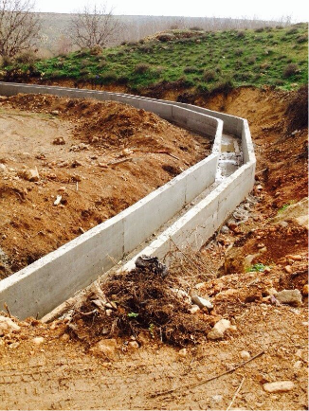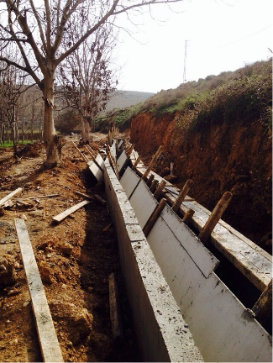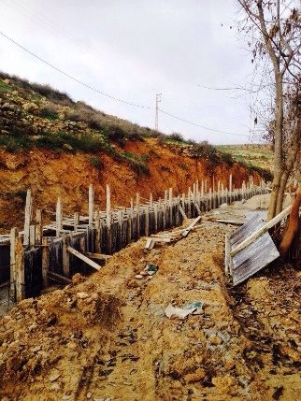

* **Main achievements**

The project, implemented closely with the four municipalities, aims at improving the irrigation canals to achieve sustainable and efficient utilization of water, increase cultivated lands and promote preservation of cultural heritage. All the rehabilitation works in the four villages of Flawi, Shaat (Zrazir), Boudai and Hermel are completed.

During implementation, the main challenge faced was finding a contractor willing to work in the area and the inability of UNDP staff to access the area due to the security situation.

Similar to the case of Chwaghir, in North Bekaa, the irrigation canals constructed in Boudai, Flawi, Hermel and Chaat helped decrease the leakage of water and resulted in more efficient distribution of water to the already cultivated lands in the area.

**OUTPUT 2: Capacity of national and local actors (government and civil society) strengthened in the delivery of health, education and basic municipal services in a participatory manner and coordination of service delivery among all stakeholders**

**Activity 2.1. Increase access to quality public primary health care services and health awareness in public schools**

During the period from the 1st of February until the 30th of September 2015, the following interventions were carried out:

* The rehabilitation of the Primary Health Care Centre of the municipality of Haret Hreik was completed. The inauguration of the Primary Health Care Center of Harte Hreik was on the 14th may 2015 under the patronage of the deputy of the Block for Fidelity to the Revolution, Mr. Mohammad Raad, the representative of the Ministry of Public Health, Mrs. Randa Hamadeh, director of the department of Primary Health Care at MoPH, UNDP Country Director, Mr. Luca Renda, the Lebanese Recovery Fund, Mr. Rony Gedeon, mayors and civil society.
* The procurement process for the rehabilitation of the Primary Health Care Center of Al Mreyjeh municipality was completed and the contractor was selected (60% of the needed funds are covered by LRF and 40% by Monaco Government). The site handover was done to the contractor in presence of the municipality representatives and UNDP on the 22nd of June 2015. The contractor is preparing the shop drawings and working on material submittal. The shop drawings were finalized by the contractor based on the indications of the director of the PHCC and the coordinator of MoPH. The rehabilitation started in mid–August 2015 and 30% of the works have so far been realized.
* The rehabilitation of the medical rooms of the public schools of Jbeil Kindergarten, Jbeil First, Jbeil Second, Jbeil Fourth in Jbeil; Abou Chabaket in Zouk Mikael; Kfarzena, Mazyara, Racheen, Ardeh in Zgharta was completed.
* The expert developer of the web application of the Health Information System of the Ministry of Public Health was hired according to the Terms of Reference of Individual Contracts at UNDP (one third is covered by LRF and two third by Monaco Government). The development of the application started on the 1st April 2015 and will last 6 months. The expert finalized the development of the web application and is preparing the final report.
* The organization of the second phase of workshops at local level started. Several meetings with experts from the American University of Beirut (AUB) and experts from the Health Agency of Arezzo[[2]](#footnote-2) in the Tuscany region – Italy was organized and the schedule and the programme of the activities at local level was decided.
* 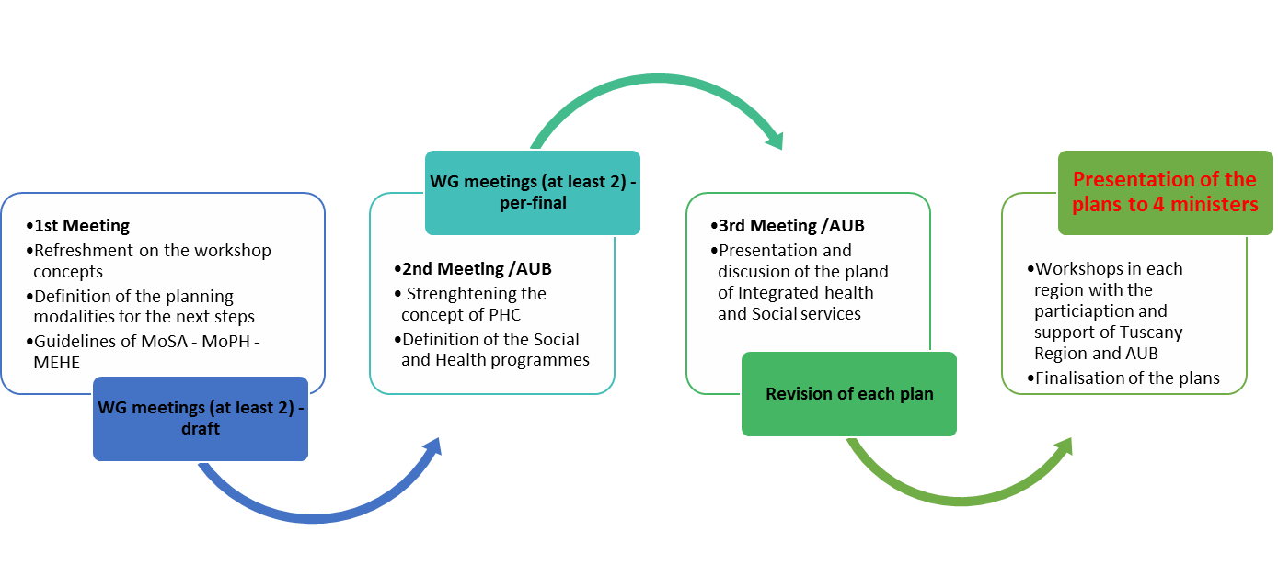The cycle of workshops started on the 25th of July 2015 and will last until the 21st of November 2015. Six experts from AUB were hired in order to facilitate the workshops. The municipalities or cluster of municipalities are the following: (i) Bourj Hammoud, Haret Hreik, Chiah, Baakline, Jbeil in Mount Lebanon; Chebaa and Binj Jbeil in Nabatiyeh; Baalbeck/Labweh in Baalbeck-Hermel, Terboul/ Bar Elias, Taalbaya/Zahleh in Bekaa; the 8 municipalities of Wadi Khaled and Halba in Akkar, the 6 municipalities of Zgharta in the North. The working groups were set up in the above mentioned municipalities or cluster of municipalities. Meanwhile, the working groups were organizing meetings in order to support the process. The members of the working groups are representatives of SDCs, PHCCs, public schools and municipalities. The total number of participants is 400. The working groups will produce the integrated health plans of each municipality. The below table is a summary of the planning cycle (Refer to **Annex 2** for the presentations of the 3 workshops).
* **Next steps**
* The rehabilitation of Al Mrayjeh PHCC is on-going and will end by November 2015
* The Medical Rooms handover to MEHE was completed
* An air conditioning system will be installed in each medical room.
* The updated Health Information System technical report will be issued by the end of October 2015.
* The drawings and BOQs of the rehabilitation of Halba kindergarten will be finalized by mid-November 2015.
* The cycle of workshops will be finalized by end of November 2015.

**Activity 2.2. Provide four septic pumper trucks and a sweeper to five union of municipalities in the South**

The **Activity 2.2 “Provide septic pumper trucks to five union of municipalities in the South”** was amended and officially approved on 14 January 2015.

* **Description**

Most of the 658,000 residents of the Chqif, Jabal Amel, Tyre, Bint Jbeil, and Iqlim Tefah regions in South Lebanon suffer from the absence of sewage networks in their villages. Thus, the majority of the houses use cesspits with entails high cleaning cost in addition to occasional leakages and resulting health problems. Presently, the households pay private dump-truck owners to periodically clear the cesspits. On average, each household has to pay around US$ 700 per year – a hefty sum for the poor. The situation has become even more precarious with the large influx of refugees from Syria, which has introduced significant additional stress on the environment.

* **Main achievements**

Given that the Union of Municipalities (UoM) of Chqif had already received a septic truck from another organization, it expressed the need for a sweeper to clean the streets and particularly the highway.

In the same context, UN-Habitat had provided a septic truck to the UoM of Jabal Rihane during the project review period while the UoM of Iqlim Tefah was identified to be in need of a septic truck due to the absence of a sewage network. Furthermore, given that DFID is supporting the UoM of Arqoub by enlarging the wastewater treatment unit of Habbarieh, there is no more need for septic truck. Bint Jbeil on the other hand, has no sewage network and is in need of a septic truck.

Therefore, the project resulted in the procurement of four septic trucks respectively for Jabal Amel, Tyre, Bint Jbeil, Iqlim Tefah and a sweeper for the UoM of Chqif. All the equipment has been procured and delivered. UNDP is currently monitoring the use of the equipment by the municipalities and assessing the impact of the project.

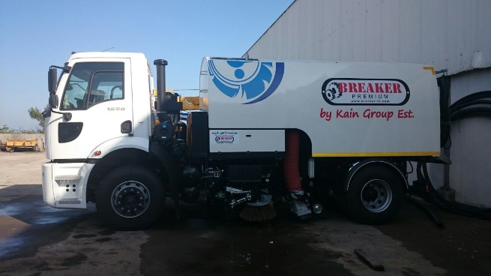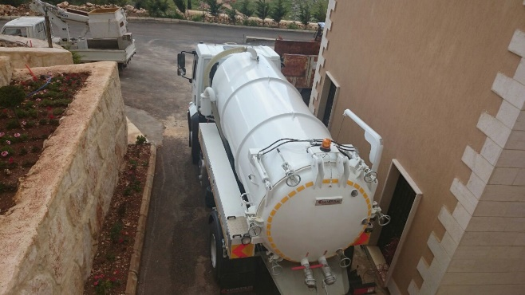

**Activity 2.3. Improve the water infrastructure in the Union of Municipalities of Kalaa**

* **Description**

Many villages in South of Lebanon suffer from shortage of household water, and the situation has worsened following the influx of Syrian refugees. One of the main reasons for this is the old water conveyance network that often breaks or leaks, causing water waste. Currently, the 80,000 inhabitants of the 10 villages within the Union of Municipalities of Kalaa (Tibnin, Haris, Kafra, Aita El-Jabal, Safad Al-batikh, Jmaijmeh, Deir Antar, Kfar Donin, Qalaway and Yater) receive drinking water only two days a week provided there is no leakage in the water network. The South Water Authority, which covers the whole South region, is unable to respond to the needed water network maintenance needs especially the ones within the villages due to the lack of proper tools for detecting and repairing the broken pipelines.

* **Main achievements**

The project is implemented closely with the Union of Municipalities of Kalaa to provide the water maintenance center with the necessary equipment and machinery for the repair of the water network. The equipment and machine were provided to the center and are operational. A training on water management and maintenance for the 5 technicians already employed by the municipalities was held on pipe network maintenance and management. The Union of Municipalities and the Water Authority are working together to establish a common Unit for Water Management and Maintenance. UNDP is currently monitoring the use of the equipment by the municipalities. An MOU between the Union of Municipalities of Kalaa and the Water Authority of the South was signed for the implementation of the training, strengthening cooperation and improving coordination on water management.

The project is benefitting not only the Union of Municipalities of Kalaa but also other neighboring villages. The project showed its effectiveness when the main pipe which irrigates Kafra, Haris and Bint Jbeil areas was repaired within 36 hours.

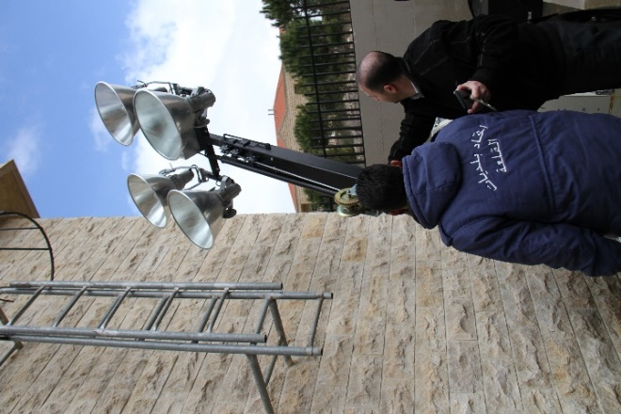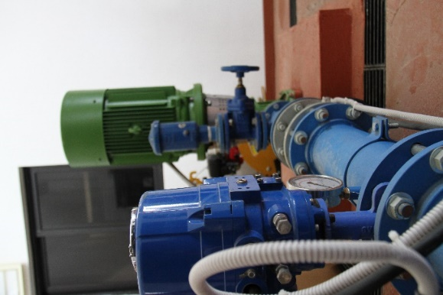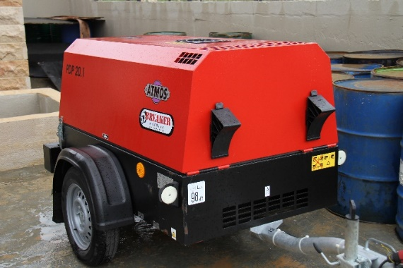

**Activity 2.4: Provide sustainable lighting and heating to host communities**

The provision of sustainable heating and cooking through stoves and briquettes and solar lighting kits involves several steps from (1) beneficiary identification, (2) site/beneficiary confirmation, (3) technical specifications of systems and procurement, (4) implementation, (5) monitoring of implementation, (6) operation and maintenance training, and (7) awareness-raising and donor visibility. These items are described below, along with respective progress.

* + 1. ***Beneficiary identification***

Beneficiary identification is one of the more challenging parts of this project in terms of identifying who best deserves to be the recipient of these systems, and what defines those most in need, i.e., the vulnerable population. To ensure that we deliver the systems and respective products to those most in need, the UNDP-CEDRO team has undertaken consultations with the Ministry of Social Affairs, the National Poverty Targeting Project (NPTP) of the World Bank coordinated by the Office of the Prime Minister, the UNHCR Office in the Bekaa and the North, and the UNDP offices in these respective regions as well.

For proper implementation of the project, and for reasons of lowering the risk of any disputes, it was decided that the systems will be delivered, to the extent possible, to clusters of communities in areas and villages within areas. On the one hand, the implementation of this project in this clustered approach would facilitate the follow-up and monitoring required as opposed to spreading the systems out to 500 beneficiaries (at most) spread over two large areas (Akkar and the Bekaa).

For Akkar, these areas were decided upon after intensive discussions with the Host Community Support Unit in Akkar consisting of the UNHCR, ACTED, DRC, PCPM, and REACH, among others. Work has been well advanced in Akkar, and a ‘vulnerability’ map has been produced, as shown below in Map1.

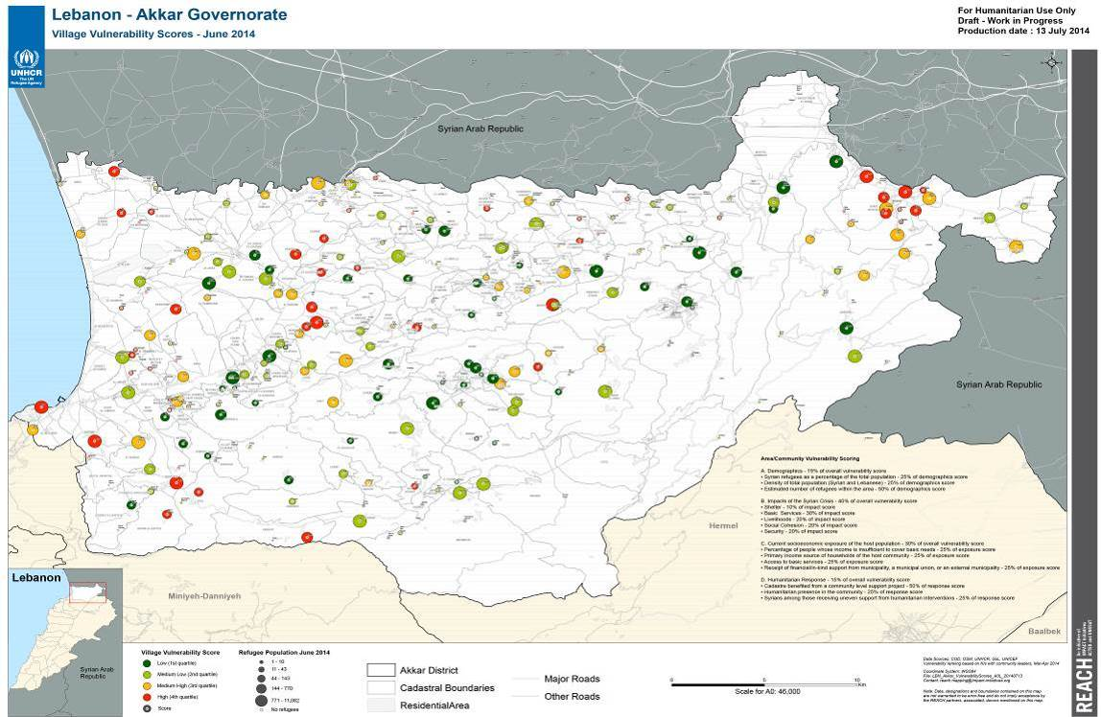

*Map1. Vulnerability mapping of REACH – UNHCR based on several criteria.*

From Map 1, work was decided to focus on the ‘red colored’ relatively higher vulnerable areas and/or villages, and these are mainly in Wadi Khaled, and some other villages like Bebnine in Akkar. To select beneficiaries within these villages, the lists from the Ministry of Social Affairs and the NPTP were officially requested for these particular areas, identifying those that are in ‘extreme poverty’ by names, contact information and addresses. These are the targets currently being focused on.

Similarly in the Bekaa, lists were also received from UNHCR Bekaa Office that included actual names and numbers of beneficiaries that the UNHCR regarded as ‘vulnerable’. The list focused on Marej, Zahleh, Baalbeck, Majdal Anjar, and Aarsel. Aarsel was later dropped out due to the security situation. The UNHCR list was augmented by a list from the Ministry of Social Affairs of those considered ‘extremely poor’, similarly with updated names and addresses and these beneficiaries are the focus of selection.

For both regions, coordination and communication with local municipalities was followed, informed the municipalities of the project objectives and work to be done. Most municipalities facilitated the work of the site engineers on the ground and preferred not to interfere with the selection process itself given the limited number of systems available.

* + 1. ***Site/beneficiary confirmation***

After the short-listing of households was completed based on the lists, the project site engineer undertook the detailed technical assessment based on the survey questionnaire (Annex 1). From the information collected, a further identification of the households that could technically support the installation of these systems and that are in need for additional electricity or heating systems (those not already connected to a private generator or that do not already have stoves or central heating systems for example) was undertaken. This exercise was supported by the CEDRO team in Beirut as well.

|  |
| --- |
| IMG_2808 |
| *Zahle, Bekaa (house) – Example from site visits* |

* + 1. ***Technical specifications and procurement***

The UNDP-CEDRO hired two international consultants to write the terms of references for (1) the biomass stove and briquettes, and (2) the solar lighting kits.

For the biomass stoves and briquettes, the terms of reference were posted on the UNDP website on August 15th 2014 and the deadline for submission was originally 11 September 2014, yet extended for 1 week after multiple requests from bidders (only 1 week was given in order to ensure winter is met). Evaluation of five bidders was undertaken by CEDRO team and the contract was awarded to the winning contractor.

For the solar lighting kits, the terms of reference was posted on August 14th 2014 and the deadline was originally for September 8th 2014, however it was extended for two weeks after multiple requests. Evaluation of eleven bidders was undertaken by CEDRO team, where a rebid had to occur given that no one of the contractors met the full required criteria set in the bidding document. Therefore, the procurement process was re-launched on the UNDP website. Six offers were received in the second process, and the contract was awarded to the most technically/financially compliant contractor.

For the briquetting plant in Andket, the terms of reference, prepared by an international consultancy (Trama Techno Ambiental) were posted on the UNDP website on January 08th 2015 and the deadline for submission was February 16th, 2015. Evaluation of three bidders was undertaken by CEDRO team and the contract was awarded to the most technically/financially compliant contractor (being Solarnet).

* + 1. ***Implementation***
* Stoves and briquettes: Given that the bidding process resulted in some financial savings as a result of competitive pricing, additional number of stove and briquettes were procured. The overall quantity distributed was 594 units for both Akkar and the Bekaa.

The stoves along with an initial supply of approximately 1,280kg of briquettes per household were delivered. A second batch of briquettes of 350kg per household was delivered in remaining regions.

**The list of locations and distributed items is as follows:**

Akkar Region:

|  |  |  |  |  |
| --- | --- | --- | --- | --- |
| **Villages** | **Selected Beneficiaries** | **Delivered Stoves** | **Briquettes 1st Delivery 1280 kg/ beneficiary** | **Briquettes 2nd Delivery 320 kg/ beneficiary** |
| **Kfartoun** | 30 | 30 | 30 | 30 |
| **Rama - Germaya** | 36 | 36 | 36 | 36 |
| **Hichi** | 25 | 25 | 25 | 25 |
| **Fnaydek** | 42 | 42 | 42 | 42 |
| **Amayer - Rajm Issa** | 30 | 30 | 30 | 30 |
| **Saed** | 7 | 7 | 7 | 7 |
| **Bebnin** | 30 | 30 | 30 | 30 |
| **Majdel** | 19 | 19 | 19 | 19 |
| **Rajem Hussein** | 22 | 22 | 22 | 22 |
| **Knaysse** | 19 | 19 | 19 | 19 |
| **Rajem Khalaf** | 18 | 18 | 18 | 18 |
| **Karha** | 10 | 10 | 10 | 10 |
| **Hnayder** | 15 | 15 | 15 | 15 |
| **TOTAL** | **303** | **303** | **303** | **303** |

Bekaa Region:

|  |  |  |  |  |
| --- | --- | --- | --- | --- |
| **Village** | **Selected Beneficiaries** | **Delivered Stoves** | **Briquettes 1st Delivery 1280 kg/ beneficiary** | **Briquettes 2nd Delivery 320 kg/ beneficiary** |
| **Zahle** | 14 | 14 | 14 | 14 |
| **Nahle** | 23 | 23 | 23 | 23 |
| **Baalbek** | 103 | 103 | 103 | 103 |
| **Younine** | 20 | 20 | 20 | 20 |
| **Majdal Anjar** | 25 | 25 | 25 | 25 |
| **Al Marej** | 27 | 27 | 27 | 27 |
| **Brital** | 7 | 7 | 7 | 7 |
| **Ein Kafar Zabad** | 27 | 27 | 27 | 27 |
| **Kousaya** | 22 | 22 | 22 | 22 |
| **EL Khodor** | 10 | 10 | 10 | 10 |
| **Heleniye** | 2 | 2 | 2 | 2 |
| **Tal Abyad** | 5 | 5 | 5 | 5 |
| **Doures** | 2 | 2 | 2 | 2 |
| **Ansar** | 3 | 3 | 3 | 3 |
| **Nabe Youchaa** | 1 | 1 | 1 | 1 |
| **TOTAL BEKAA** | **291** | **291** | **291** | **291** |

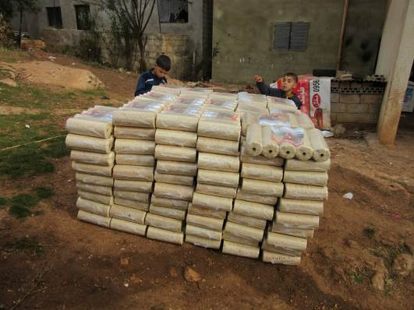 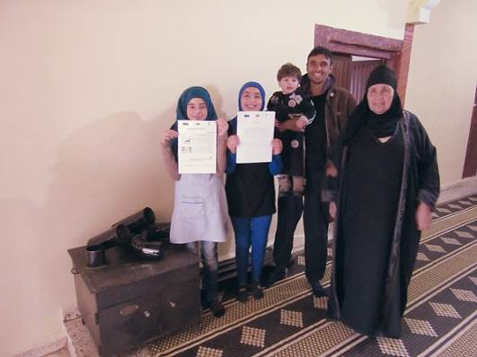

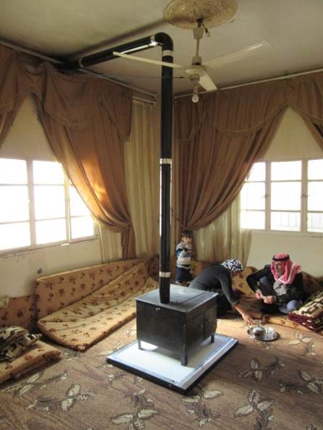

* Solar lighting kits: 550 PV lighting kits were distributed in both Bekka and Akkar areas. (Original contract for 500 with additional 50 in amended contract).

|  |  |
| --- | --- |
| IMG-20150430-WA0010 | IMG-20150430-WA0009 |

Contractor’s warehouse ready for installation beginning May 2015

**The list of locations and distributed items is as follows:**

Akkar Region:

|  |  |  |
| --- | --- | --- |
|  |  | Selected |
| **Akkar** | Bebnine | 30 |
| Qarha | 15 |
| Hnayder | 16 |
| Hichi | 15 |
| Kfartoun | 30 |
| Majdel | 24 |
| Saed | 5 |
| Knayseh | 33 |
| Amayer | 15 |
| Fnaydek | 19 |
| Rajm Houssein | 29 |
| Rajm Khalaf | 16 |
| Sir Donniyeh | 3 |
| **Total Selected** | **250** |

Bekaa Region:

|  |  |  |
| --- | --- | --- |
|  |  | **Selected** |
| **Bekaa** | Zahleh | 15 |
| Nahleh | 25 |
| Baalback | 60 |
| Younin | 18 |
| Majd Anjar | 16 |
| Al Marej | 24 |
| Britel | 6 |
| Ansar | 2 |
| Ain Kfarzabad | 21 |
| Kouseya | 11 |
| Al Khodor | 10 |
| Siriin El Tahta | 26 |
| Hadath Baalback | 26 |
| El Qaa | 26 |
| Lebanese Army | 6 |
| Hermel | 1 |
| Ansar | 2 |
| Tal Abiad | 3 |
| Doures | 1 |
| Nabi Rched | 1 |
|  | |
| **Total Selected** | **300** |

* The briquetting plant in Aandket implementation was completed in September 2015. It is currently operated by the municipality and contractor to insure adequate capacity building is transferred.
  + 1. ***Monitoring of implementation***

The UNDP-CEDRO team monitored the installations and commissioning of the equipment on daily basis to ensure that the requisites identified in the terms of reference were implemented to the standards required.

* + 1. ***Operation and maintenance training***

All the systems come with a performance guarantee for two years (with the exception of the briquettes that will be burned). However the proper operation of the systems (stoves and solar lighting kits) are critical for ensuring their longevity. To this end, the UNDP-CEDRO project finalized a simple operation and maintenance manual in Arabic for the stoves; it was distributed with the equipment. In addition, an operation and maintenance manual for the lighting kits was distributed to the beneficiaries. Also a training for the beneficiaries on the systems took place by the winning contractors and monitoring by the CEDRO team.

* + 1. ***Awareness raising and donor visibility***

The O&M manual mentioned above includes awareness-raising information on the benefits of using biomass stoves, briquettes and solar lighting kits. The operation and maintenance (O&M) manual also included the donors’ logos of the systems. In parallel, all work was indicated in CEDRO’s newsletters, website, and promotional material, inclusive of Donor recognition and/or logos. The publication of two respective reports on these two systems and products were drafted, built on experiences and feedback gained from the ground.

Most of the work is also photographed and shared on CEDRO’s website, Facebook and Instagram pages.

Furthermore, two documentaries were undertaken by the UNDP and the project; the first documentary captured the distribution and installation of the stoves, and the second documentary captured the installation of the PV lighting kits and can be found on the UNDP’s website and Facebook, as well as on CEDRO’s website;

<https://www.facebook.com/video.php?v=910369802317027&set=vb.734820073205335&type=2&theater>

**Activity 2.5. Improve government response to crisis and major civilian operations**

The third quarter of 2015, included activities that further support the implementation of the National Response Plan mainly with the procurement of the Mobile Operation Room/Vehicle, building the capacities of the Field Assessment Team and procurement of communication systems that links key sectors and Mouhafaza operation rooms with the National Operation rooms. The progress achieved to date is considerable despite the administrative and bureaucratic challenges faced mainly with our government counterparts. Meanwhile, UNDP continues to multiply efforts with the objective of attaining the results.

* + 1. ***NOR - Building capacities that support Response***

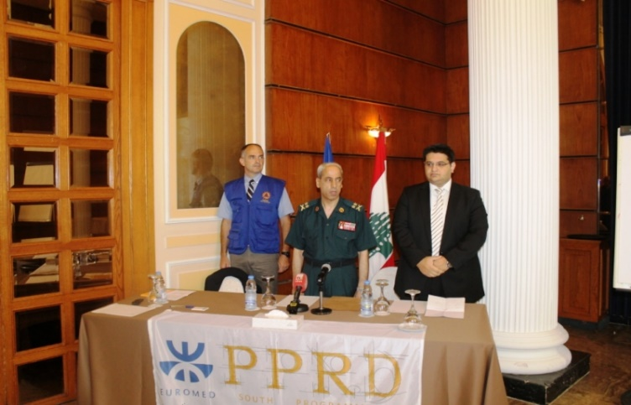With the objective of boosting coordination mechanisms between different agencies for better efficiency in responding to disasters and as part of developing the Field Assessment Team, UNDP with the support of the Euromed PPRD South II Program implemented a training workshop from the 14th till 17th of September on “Host Nation Support (HNS) *(refer to* ***Annex 3****).* The four day training gathered 20 representatives from various ministries and agencies who will support in forming the Field Assessment Team. The workshop was launched by the Secretary General of the Higher Council of Defense, Major General Mohammad Kheir, UNDP Program Manager Fadi Abilmona and PPRD Expert Laurent dePierrefeu.

Major General Kheir said *“We seek to build a team that has knowledge of the mechanism of action, civil protection procedures, and has a basic knowledge of international humanitarian law* ".

The participants who will form the Field Assessment Team had the opportunity to increase their capacities in emergency planning, management, on-site coordination and logistics based on shared experience and lessons learnt from experts in the field. The importance of the training is that it will support Lebanon to receive international assistance in the most effective and efficient manner in the event of a disaster.



* + 1. ***Mobile Operations Vehicle (MOV)***

The contract for the “Procurement of One Mobile Operations Vehicle (MOV) for the Office of the Prime Minister of Lebanon” was signed on 24 August 2015 between UNDP and Behm (French Company).

On September 4, 2015, a meeting was held in Thionville, France at the premises of Behm, between UNDP, UNDP’s technical advisor from the French Ministry of Interior and Behm to discuss and finalize the technical details of the MoV, the execution plans, the implementation timeframe *(refer to* ***Annex 4*** *for the MoV plans)…*

The MOV will be delivered to the Prime Minister’s Office within 10 months from contract signature and will ensure coordination of field relief efforts that would be directly connected to the NOR and decision makers. Its core purpose is to gather information from the field through the different security agencies (LAF, ISF, LRC, Civil Defense…), take appropriate operational action based on collected information and transfer sensitive information to the NoR for Political decision making.

The MoV is designed to host one coordinator representing the Prime Minister's Office, six representatives from concerned government agencies, and 2 vehicle operators.

It will be equipped with IT & Communication devices adapted to a crisis situation enabling agencies to remain connected to their related headquarters and to the NoR.

* + 1. ***Sendai new Indicators workshop***

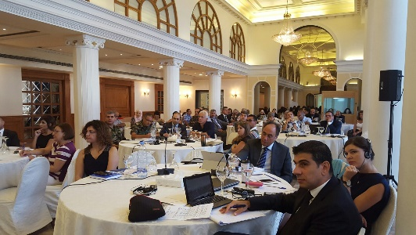The Sendai Framework for Disaster Risk Reduction (SFDRR) was approved during the third world conference on disaster risk reduction which took place in Japan during March 2015 as a continuation to the Hyogo framework for action.

A set of new indicators to measure progress in the implementation of the Sendai Framework for Disaster Risk Reduction 2015–2030 is currently in process and is expected to be completed by November 2015. UNISDR has selected Lebanon to represent Arab States in piloting the SFDRR indicator proposal. In this event, UNDP with the collaboration of UNISDR organized a workshop on the 7th and 8th of September 2015 to engage all national DRM, development and climate change adaptation actors as well as some members of the UNCT to present the concept of the new indicator system as well as linkages to SDGs and climate conventions. The workshop also served as an opportunity to gather Lebanese experiences in the collation and monitoring of various related indicators. Once adopted, the participants had the chance to practice the new reporting system and better highlight progress and challenges based on the new priorities. It is worth noting that a follow up workshop will be conducted to present the results and adopted indicators.

* + 1. ***Continued support to critical sectors/ministries and governorates***

**Operation Rooms Communication System**

Communication and coordination play an important role in disaster management as they support in keeping the flow of real-time data and information necessary for adequate decision making and intervention. To support adequate response and within the framework of supporting key sectors and governorates in DRM and in accordance with the National Response Plan, UNDP developed response plans and launched the operation rooms within key critical sectors and Mouhafaza during 2014 and 2015. The operation rooms support agencies and governorates to respond adequately to emergencies and disasters.

During the reporting period, UNDP initiated the procurement process for communication systems to link the NOR with sectors and regions. By December 2015, five operation rooms will be fully equipped with communication systems and connected to the NOR at the following institutions: Ministry of Education, Beirut Rafik Hariri International Airport, Mouhafaza of South, Mouhafaza of North-Tripoli, Mouhafaza of Bekaa.

The communication systems will enhance interagency coordination and communication and provide significant support and input for disaster management authorities at times of disaster-related crises and emergencies.

**Flood risk Assessment and Mapping for Lebanon**

According to the World Bank, approximately 70% of all global disasters are linked to hydro-meteorological events. Flooding poses one of the greatest natural risks to sustainable development. Since 2014 UNDP has been working in partnership with CNRS to develop of flood hazard mapping. To complement the work already achieved in the area of flood assessment mapping, UNDP agreed with CNRS to assess the flood risk over Lebanese watersheds and to develop a comprehensive methodology for flood risk mapping in order to protect life and property, support emergency services, promote public awareness, and encourage the development and implementation of long-term, cost-effective and environmentally sound mitigation projects. The final report was completed in September 2015 *(refer to* ***Annex 5 & 5.1****)* and will be printed and disseminated in November to major stakeholders to guide the National DRR strategy and will be integrated in the CDR land use master plan.

* + 1. ***DRR Curriculum Workshop on Mainstreaming DRM considerations into the Activities of the Public Sector – Lebanese Armed Forces***

**DRR Curriculum**

Disasters often hamper and negatively impact hard won sustainable development goals. Quoting UNISDR’s head Ms. Margareta Wahlström “Disaster risk reduction needs to be a key component of development in order to secure sustainable results”. With the objective of integrating DRR within key public sectors including public servants and the Lebanese Armed Forces and as part of UNDP's objective to raise national capacities, UNDP developed a pioneer curriculum *(refer to* ***Annex 6****)* on mainstreaming DRR within the public sector.

The curriculum includes a training of trainers manual, PowerPoint presentations with trainers outline objectives for each session, exercises, supporting documents and evaluations forms. The curriculum covers the major DRR and DRM topics and concepts including: DRR Terminology, HFA, Sendai Framework, increasing resilience in critical infrastructure, national overview of Risks in Lebanon, the national strategy for disaster risk management in Lebanon, analysis of disaster losses in Lebanon, linkages between disaster risk factors, lessons learned from across the globe on mainstreaming risk reduction considerations within public sector, sustainable development in the Arab world, financing disaster risk reduction activities for sustainable development, DRR capacity building, disaster risk governance, and early recovery.

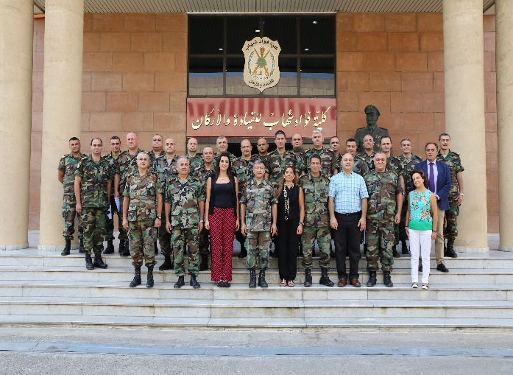

**DRR Workshop for Lebanese Armed Forced**

Following the completion of the DRR curriculum, a training of trainers' on Mainstreaming DRM Considerations into the Activities of the Public Sector was organized by UNDP at the Fouad Chehab Command and Staff College in Yarze, Lebanon. The TOT was conducted from the 28th of September till the 2nd of October and included a total of 20 ranking officers. The training was divided into two focus areas; the first three days the participants received lectures on DRM and its interaction with development and sustainable development while the last two days, participants in groups of 2, presented pre- selected topics on DRM so as to put into practice the theoretical concepts. Participants considered the topics to be relevant to their work and of high importance.

As a follow up to the training the following recommendations were proposed:

* Create a DRM mainstreaming Bureau within the Army to mainstream DRM into the work of its different directorates. One of the first tasks of this Bureau would be to review the mandates of the respective directorates and propose including DRM and DRR concepts
* Carry out a qualitative assessment of the Army installations and prioritize them according to risk categories, identify options for strengthening the installations and dentify financial needs
* Develop a Strategy for Mainstreaming DRM into the work of the Army, with an action plan; time bound activities and financial needs for implementation.
  + 1. ***Support to 25 local authorities in North and Bekaa to adopt resilient city charter***

**Municipalities DRR Training for Developing and Implementing Resilience Action Plans for Cities**

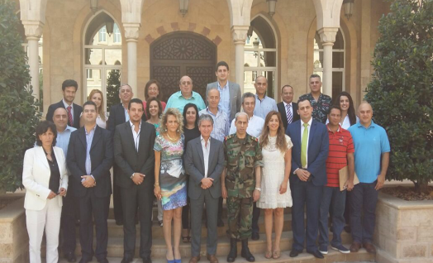Withinthe "World Disaster Reduction Campaign “Making Resilient Cities – My City is Getting Ready” which targets local governments with the objective of achieving resilient, sustainable urban communities, UNDP with the support of UNISDR regional office and UNISDR Office for Northeast Asia at Incheon – GETI conducted a Training of Trainers on building the capacity of local stakeholders (regional and Mouhafaza representatives) for Making cities Resilient to Disasters at the Grand Serail from the 23rd till the 24th of July 2015.

The TOT was attended by 20 representatives from Lebanon's governorates, Caza and major cities and focused on:

* Training a team from national, ministry and local governments on the campaign ten essentials and tools to adequately implement the campaign
* Drafting City Resilience Assessment Reports
* Drafting City Resilience Action Plans
* Drafting of Strategy paper on how to further finalize, ensure endorsement and effectively implement the City Resilience Action Plans

UNDP through the project will continue to support the trainers as they fill in the local government assessment tool LGSAT which will set priorities and, benchmark progress.

At the end of the ToT, a closing ceremony was organized and attended by Gen. Mohammad Kheir, Secretary General of Higher Council of Defense and Mr. Luca Renda (UNDP Country Director) who highlighted the importance of this training in making cities resilient through adequate implementation of the 10 checking points and support in increasing Lebanon's resilience

* + 1. ***Awareness raising on crisis preparedness***

The project distributed another 200 emergency kits targeting representatives of major stakeholders and agencies in the Mouhafaza of Beka, Mouhafaza of Mount Lebanon, Mouhafaza of Baalbak-Hermel, Beirut, Lebanese Armed Forces, NCLW, Field Assessment Team to further raise awareness on DRR and replicate the kits within their environment.

**OUTPUT 3: Local level dispute resolution strengthened and community security improved**

**Activity 3.2. Develop local level peace building strategies to mitigate tensions in selected conflict prone areas of Lebanon hosting Syrian refugees**

The main activities implemented during the reporting period (July 1st 2015- September 30th 2015) are the following:

* + 1. ***For the Conflict Mapping/Conflict Analysis***

As part of the partnership agreement with Lebanon Support, the final two conflict analysis reports were produced. The third conflict analysis report focused on Mount Lebanon and the last one on Beirut. The reports are now finalized and can be found in **Annexes 7 and 8**.

Matn report provides an analytical summary snapshot of the conflictual context, actors and dynamics in the Matn area, Mount Lebanon. The report seeks to shed light on the main actors, topics of contestation and conflict and its historical becoming as well as current expressions. A special focus lies on the relation between the Lebanese host community and Syrian refugees and its development within the last four years (since 2011).

Beirut report provides an analysis of the history and current situation of the conflict context, actors and dynamics in Beirut, Lebanon. The report seeks to shed light on the main actors, topics of contestation, conflict and mobilization in its historical becoming as well as current expressions. It includes a special focus on the social question, subsequent political and social mobilization, gender issues, the securitization of the city, as well as the interactions between the Lebanese host community and Syrian refugees and their unfolding within the last four years

It is worth mentioning that the Conflict Map produced in collaboration also with Lebanon Support is still running.

* + 1. ***For the Local Level Conflict Mitigation Activity***

During the past three months, UNDP recruited a local consultant from Tripoli to conduct a research on the conflict dynamics in Tripoli, including a mapping on who is doing what in the peace building field in Tripoli as well as a set of recommendations for potential interventions **(refer to the final report in Annex 9).**

* ***Implementation constraints, lessons learned from addressing these and knowledge gained from evaluations and studies that have taken place during the reporting period***

**Challenges:**

At the national and political level, one of the greatest challenges remains the political instability and the political deadlock which the country is facing, which makes it difficult for UNDP to implement activities with government counterparts.

**Key lessons learned during this quarter include:**

• Coordination and cooperation among key stakeholders representing sector agencies and administrations remains to be vital and has resulted in effective and efficient response to disasters.

• Making use of international expertise and cooperation is essential for innovative projects such as the mobile operation room, the in depth DRR trainings (HNS)…

• At the operational level, maintaining a high degree of effort and momentum of work with continuous follow up from the management and program has supported in attaining the targets and overcoming the challenges in due time

• Linking local and sector/ministry level stakeholders working on their response plans and within their operation rooms with the national response plan and national operation room ensures effective real time response and increased coordination among

* ***Key partnerships and inter-agency collaboration: impact on results***

One of the main recent partnerships which impacted UNDP’s results is the recent partnership made with the French General Directorate of Civil Security and Crisis Management in relation to the Mobile Operations Vehicle project (MoV). Through this partnership, UNDP was able to secure the necessary technical expertise to draft technical specifications for the MoV, participate in the technical evaluation process, and ensure the technical advisory role during the 10 month period of the project implementation. This partnership is essential to successfully complete the MoV project since the needed expertise and knowhow for such a project is not available in Lebanon.

UNDP was also keen on finding the best strategically positioned partner to implement the **Conflict Mapping/Conflict Analysis** exercise who would be able to technically perform, have a good knowledge of the context but also who would be able to follow up on it later on and ensure its sustainability regardless of the scope of this activity and funding; which is the case of Lebanon Support. Lebanon Support is a self-sustained NGO that has an already existing infrastructure that can carry on the activity beyond the scope of this project.

On another level, for this specific exercise, UNDP liaised with all agencies and partners involved in the response to the Syrian crisis and specifically with those involved in the social cohesion sector.

The key for the **Local Level Conflict Mitigation Activity** was to work directly and through local authorities. UNDP collaborated directly with the municipalities as well as with the local NGOs active on the ground; aiming through this to ensure the sustainability of the activity.

## **Progress in Project Implementation:**

**Programme Results Framework from the Project Document** **/ AWPs** - provide details of the achievement of indicators at both the output and outcome level in the table below. Where it has not been possible to collect data on indicators, clear explanation are given explaining why.

|  |  |  |  |
| --- | --- | --- | --- |
|  | **Achieved Indicator Targets** | **Reasons for Variance with Planned Target (if any)** | **Source of Verification** |
| **Outcome 1: Livelihood and economic opportunities increased in selected refugee hosting areas through upgrading, repairing and improving the production infrastructure and creating short and medium term employment opportunities.** | | | |
| **Activity 1.1 Support value added production of fruits and vegetables in Akkar through postharvest processing** | The activity is implemented through direct procurement modality. The bidding process was finalized; The machine was procured and delivered and the workers were trained by the contractor on the use of the machine. A van was also procured and delivered.  A workshop took place during the last week of August to train cooperative members about quality and hygiene standards during the production process. | N/A | Procurement of goods |
| **Activity 1.2: Enhance business skills of local farmers/producers in Akkar** | The activity is implemented through direct procurement modality.  8,500 plastic crates, a transportation vehicle and the apple production line machine (for washing, grading and packing) were procured and delivered. The hangar construction is completed. | N/A | Procurement of goods |
| **Activity 1.3. Implement wastewater and water projects in Bekaa** | The activity in Qab Elias was implemented through direct procurement modality and the procurement and delivery is completed.  For Kfar Zabad and Chwaghir, the initiatives were implemented through grant agreement modality. In this respect, two grant agreements were signed with the targeted municipalities. Both projects are completed. | N/A | Services implemented |
| **Activity 1.4. Increase irrigated agricultural areas in North Bekaa** | The works in the four localities are completed. |  |  |
| **Outcome 2: Capacity of national and local actors (government and civil society) strengthened in the delivery of health, education and basic municipal services in a participatory manner and coordination of service delivery by all stakeholders.** | | | |
| **Activity 2.1: Increase access to quality public primary health care services and health awareness in public schools** | The project is implemented through direct procurement modality. The provision of Dental Material, Dental equipment and instruments and Hygienic kits to PHCC and SDCs is finalized. The furnishing of medical rooms with IT, medical equipment and furniture in selected vulnerable schools is also finalized. The rehabilitation of the medical rooms of the public schools of Jbeil Kindergarten, Jbeil First, Jbeil Second, Jbeil Fourth in Jbeil; Abou Chabaket in Zouk Mikael; Kfarzena, Mazyara, Racheen, Ardeh in Zgharta was completed.  The rehabilitation of Al Mrayjeh PHCC in on-going and will end by November 2015.  The Medical Rooms handover to MEHE was completed.  The updated Health Information System technical report will be issued by the end of October 2015.  The drawings and BOQs of the rehabilitation of Halba kindergarten will be finalized by mid November 2015.  The cycle of workshops will be finalized by end of November 2015. | N/A | Procurement of goods |
| **Activity 2.2: Provide Septic Pumper Trucks to five Union of Municipalities in the South** | The project is implemented through direct procurement modality. The bidding process for the procurement of the septic trucks and the sweeper is finalized. The septic trucks and the sweeper were delivered. | N/A | Procurement of goods |
| **Activity 2.3: Improve the water infrastructure in the** **Union of Municipalities of Kalaa.** | The project was implemented through direct procurement modality. The bidding process for the procurement of the equipment, van and compressor is finalized and the delivery completed. | N/A | Procurement of goods |
| **Activity 2.4:**  **Provide sustainable lighting and heating to host communities** | * 1. Technical Management;   2. Financial Management;   Operational Management. | * Set up implementation team * Set up beneficiary identification system * Set up data collection system * Implementation of works * Monitor implementation of works * Prepare all technical specification documents * Undergo bidding process * Preparation of regular progress reports * Set-up operation and maintenance manual * Donor visibility and awareness | * Site engineer hired * Vehicle purchased * Beneficiary identification complete through coordination with the Ministry of Social Affairs, National Poverty Targeting Project at the Office of the Prime Minister, UNDP North and Bekaa Office, and the UNHCR * Questionnaire/survey finalized for technical assessment of identified beneficiaries (see Annex 1) * 100% of target beneficiaries identified through household-level assessment/verification * All the stoves were installed along with the briquettes supply * All the PV lighting kits were installed * Briquetting plant in Aandket completed * Specification documents prepared for both technologies: solar lighting kits and stoves and briquettes * The 550 solar lighting kits and 594 stoves and briquettes contracts were awarded to 2 different contractors * Q3 2014 progress report prepared * Q4 2014 progress report prepared * 2014 annual narrative report prepared * Q1 2015 progress report prepared * Q2 2015 progress report prepared * Q3 2015 progress report prepared * Operation and maintenance manual and training to beneficiaries plan set-up * Donor visibility to be shown on actual systems * Donor visibility planned on CEDRO website and promotional material |
| **Activity 2.5: Improve government response to crisis and major civilian operations**  **Indicator 2.1.1** Support the establishment and set up of a fully functional and operational central National Operations Room (NOR)  **Baseline:**  Increased natural and man-made disasters in Lebanon  Increased pressure from Syrian influx of refugees on resources  Settlement of Syrian refugees is concentrated in the most vulnerable and poorest areas.  Increased number of casualties from disasters.  Lack of preparedness measures within the concerned response agencies.  Weak coordination among concerned agencies during response to disasters.  No unified disaster management language.  Difficulty to access information.  National operations room not institutionalized yet.  National operations room not established.  Increasing internal and external risks  Mobile Operation Room not established  **Planned Target:**  Establishment of a National Operations Room  Software and Equipment for D  - Satellite GIS Images  - Furniture and equipment  - Back up Serves  - Exposure visit  - Training and simulation  - Finalization and integration of crisis response plan  - Deployment of technical advisor to NOR  - Establishment of the Mobile Operation Room | Development of terms of reference, technical specs and procurement of the NOR goods and services including software and equipment, backup server, furniture, IT equipment, audio equipment.  Deployment of technical advisor to support development of NOR  Evaluation, contracting, delivery and installation of NOR goods and services including furniture, IT equipment, audio equipment.  Exposure visits to USA and Europe conducted.  NoR already fully equipped with furniture, audio system, video wall, network, and communication and infrastructure systems.  NOR officially launched  MOR terms of reference developed  MOR procurement and evaluation conducted  MOR procured and in process of development | UNDP finalized the procurement and signed contract with supplier. The MOR development will take r 10 month, until the end of May 2016. As such, UNDP has already submitted a no cost time extension until the end of May 2016 to the LRF steering committee and received approval. | Terms of Reference  ITB  Evaluation documents Previous progress reports  Contract and schedule of development and delivery |
| **Indicator 1.2 Support to Four national ministries (MEHE, MoSA, MoA, BHRIA) in crisis preparedness and planning**  **Baseline:**  Ministries lack response plans.  Major ministries do not have a disaster management unit.  Coordination and networking among sectors is limited.  Sectors officers and staff have limited skills to DRM.  Ministries lack crisis cells  **Planned target:**  Compilation of sectoral response plans  Establishment of crisis cells | Development of Response Plan for MEHE , BRHIA, MoSA, MoA are accomplished  Crisis cells for ministries needs have been assessed, identified and terms of reference established.  Crisis cells / operation rooms in 4 sectors established  Capacities in MEHE , BRHIA, MoSA, MoA enhanced  Table Top Exercises at MEHE , BRHIA, MoSA, MoA implemented  Operation Rooms at MEHE , BRHIA, MoSA, MoA launched  Communication system for MEHE and BRHIA procured and expected to finalized in December 2015 |  | Copies of response plans  Terms of reference  Procurements and contracts  Photos  Press Releases |
| **Indicator 1.3 Support to 25 local authorities to adopt resilient city charter**  **Baseline:**  Major municipalities in vulnerable and critical areas re not acquainted with the resilient cities campaign  Major municipalities in vulnerable areas are not supported and presented with facilities to develop and integrate resilience within their local authorities development goals  Local authorities officers and staff have limited skills in DRM  **Planned Target:**  Local level and technical support | Development of workshop concept note  Implementation of Training workshop  Adoption of local authorities to resilient charter |  | Copy of concept note  Reports  List of Participants  Photos |
| **Indicator 1.4 Support establishment of regional crisis response plan and operations room**  **Baseline**  Major Mouhafazat , Caza and Unions do not have a response and action plan  Major Mouhafazat and Caza do not have Regional operations room (ROR)  Mouhafazat and local authorities have limited skills in DRM  **Planned target:**  Regional plan formulation for 3 Mouhafaza, 2 Caza and 2 Union of Municipalities  Training and simulation of regional response plan  Equipment of Ops room  Training and simulation of OR | Response plan for Mouhafaza of the North- Tripoli , Mouhafaza of South, Mouhafaza of Baaklbek Hermel completed  Response Plans for the Caza of Metn and Caza of Chouf, Union of Municipalities of Sour, and Minnieh Donnieh drafted.  Operations room for Mouhafaza of South, Mouhafaza of North/, Mouhafaza of Baalbek Hermel established  Capacities for regions is built in parallel to the development of the response plans  Table top exercise for Mouhafaza of North – Tripoli implemented  Simulation for Mouhafaza of South implemented  Communication system for 3 Mouhafaza procured and expected to finalized in December 2015 | Variance due Caza of Metn and Chouf not allocating space for the establishment of operation rooms. | Reports  Copies of response plans  Terms of reference for the operations room  Procurement and contracts  Photos  Contracts |
| **Indicator 1.5 Awareness Raising on crisis preparedness**  **Baseline**  Limited media campaigns on DRR  Limited public awareness on DRR and safety measures  **Planned Target**  Distribution of emergency response kits  Awareness raising through mobile app and leaflet distribution  Awareness for different segments of the population | Terms of reference for emergency kits developed, procurement established, evaluation implemented.  Procurement of goods established for the emergency kits.  Emergency kits delivered to project  First 700 emergency kits disseminated  Mobile application terms of reference developed.  Mobile application developed  Terms of reference for the DRR home guide booklet developed. Procurement of goods established.  100,000 DRR home guide produced, delivered and disseminated | Variance due dissemination of remaining emergency kits and launching of mobile application in October 2015 | Terms of references  Procurements and contracts  Sample of the emergency kit  Sample of home guide  Photos and testing of mobile application |
| **Outcome 3[[3]](#footnote-3)**  **Indicator: Social cohesion in target areas improved through and improved skill base for peaceful dispute resolution**  **Baseline:**  **-weak data on conflict mapping and conflict analysis**  **-rising tensions in communities hosting Syrian refugees**  **-weak management techniques of the crisis**  **Planned Target: support local actors in managing the crisis and produce conflict related data for all partners** | | | |
| **Activity 3.1. Promote balanced and conflict sensitive media coverage**  **Indicator 3.1.1 Conflict Assessment exercise conducted**  **Baseline**  Lack of tangible data on conflicts and lack of locally and nationally oriented conflict analysis  **Planned Target**  Develop an online open source map of conflicts and produce conflict analysis reports focusing on areas and covering eventually all Lebanon | -Production of the online map  -Production of first periodic conflict analysis report focusing on Bekaa  -Production of second periodic conflict analysis report focusing on Saida  -Production of third periodic conflict analysis report focusing on Mount Lebanon  -Production of final CA analysis focusing on Beirut | NA | Externally through experts and consultants  Internally at UNDP |
| **Indicator 3.1.2 Local Capacity building and peace building activities conducted**  **Baseline:** Weak management of the crisis resulted from the impact of the Syrian crisis  **Planned Target:** Implement peace building and social cohesion activities in affected areas | -Mechanisms for conflict prevention for the 7 municipalities and local actors from West Bekaa developed  - Implementation of LOST, SALAM, Zakira, Tafawwoq wal Saadah, Basmeh and Zeitooneh NGOs projects  - Production of a special issue of the joint news supplement on Tripoli | NA |  |
| **Activity 3.2. Develop local level peace building strategies to mitigate tensions in selected conflict prone areas of Lebanon hosting Syrian refugees**  **Indicator 3.2.3 Management and technical support provided for implementation of activities**  **Baseline:** need for a technical support for the project  **Planned Target:** Provide technical support to the project for the implementation of the planned activities | Project’s staff recruited both in central and local level (Bekaa)  -Production of an assessment on Tripoli city and the conflict dynamics there with a set of recommendations for peace building interventions | The Conflict Analysis Assistant has not been recruited since the project decided to use its own resources to follow up on the conflict mapping/conflict analysis exercise |  |

**List of activities:**

|  |  |  |  |  |  |  |  |  |  |
| --- | --- | --- | --- | --- | --- | --- | --- | --- | --- |
| **Activity** | **Brief description** | **Location** | **Direct/Indirect beneficiaries (who + Number)** | **Local partner** | **Planned budget as per AWP** | **Expenditure to date (USD)** | **Status (completed, ongoing, not started)** | **Expected completion date** | **Remarks** |
| **Output 1: Livelihood and economic opportunities increased** | | | | | | | | | |
| **1.1. Support value added production of fruits and vegetables in Akkar through postharvest processing** | Support the cooperative’s manufacturing capacity by equipping the cooperative with fruit-drying equipment that works on solar energy and by purchasing a vehicle to transport the products to different markets | Fnaydeq, Akkar | Direct: 145 Lebanese  Indirect: Farmers and their families, women and Syrian refugees residing in area | Cooperative Association for Agriculture and Food Processing in Fnaydeq | $87,000.00 | $ 104,011.00 | Ongoing | Jul-15 | Remaining $ 8,000.00 |
| **1.2. Enhance fruit marketing in Akkar** | 1)Provide a washing, grading and packaging machine 2)Provide a vehicle to the cooperative for the transportation of the products to the market  3)Improve the efficiency through the establishment of a hangar in front of the facility 4)Enhance the capacity of the Cooperative storage by providing 3000 boxes | Joumeh region - Rahbeh, Bazbina, Akkar El-Atiqua | Direct: 800 Lebanese mainly inhabitants of Rahbeh, Bazbina and Akkar El-Atiqa | United Cooperative in Joumeh region of Akkar (a union of 3 agricultural cooperatives, which are active in fruit production in the villages of Rahbeh, Bazbina, Akkar El-Atiqa and their surrounding areas) | $280,000.00 | $ 258,816.00 | Ongoing | Jul-15 | Remaining $ 43,000.00 |
| **1.3.1. Construction of a wastewater network for better hygiene and health conditions** | The project, implemented closely with the municipality, aims at extending the sewage network. 927 meters of sewage network were installed in Ain Kfarzabad municipality | Ain Kfarzabad | Direct: 5,000 Lebanese and 900 Syrians | Ain Kfarzabad Municipality | $68,000.00 | $68,000.00 | Completed | May-15 |  |
| **1.3.2. Enhancing the capacity of Chwaghir municipality in improving farmers livelihoods through the rehabilitation of the irrigation canals** | The project aims to improve the conditions of the farmers in Chwaghir through the rehabilitation of the irrigation system (400 linear meters). This results in efficient utilization of water, increase in cultivated land and preservation of cultural heritage | Chwaghir | Direct: 200 Lebanese and 100 Syrians | Chwaghir Municipality | $45,000.00 | $45,000.00 | Completed | Dec-14 |  |
| **1.3.3. Integrated water resources management to improve environment and health conditions in Qab Elias** | The provision of a sewage treatment system with a capacity of serving a community of around 100 inhabitants. The system is non-electric only based on air. The treatment unit was installed and is operational. | Qab Elias | Direct: 100 Lebanese and 45 Syrians  Indirect: All inhabitants due to decrease in contamination | Qab Elias Municipality | $70,697.77 | $ 38,200.00 | Completed | Dec-14 |  |
| **1.4. Increase irrigated agricultural areas in North Bekaa** | The project aims at improving the irrigation canals to achieve sustainable and efficient utilization of water, increase cultivated lands and promote preservation of cultural heritage. All the rehabilitation works in the four villages of Flawi, Shaat (Zrazir), Boudai and Hermel has been completed. | Northern Bekaa-Flawi, Boudai, Shaat (Zrazir) and Hermel | Direct: 160 Lebanese (including farmers in these areas) and 80 Syrians | Municipalities of Flawi, Boudai, Shaat (Zrazir) and Hermel | $290,000.00 | $ 265,306.25 | Completed | Mar-15 |  |
| **Output 2: Capacity of national and local actors (government and civil society) strengthened in the delivery of health, education and basic municipal services in a participatory manner and coordination of service delivery by all stakeholders.** | | | | | | | | | |
| **2.1. Increase access to quality public primary health care services and health awareness in public schools** | The project will support the initiation of a local referral system in collaboration with the Ministry of Public Health, the Ministry of Education and Higher Education, the Ministry of Interior and Municipalities, the CDR and the local authorities in order to increase access to quality public primary health care services by the community and to increase awareness on health in public schools. | Across the country | 5,000 students; 1,500 patients per month; 10 health educators and 10 directors from 10 public schools; 70 medical and Para medical personnel from 10 PHCCs | PHCCs, SDCs, Schools Directors | $1,100,800.00 | $ 775,308.35 | Ongoing | Sep-15 | Remaining $ 273,469.17 |
| **2.2. Provide four Septic Pumper Trucks and a Sweeper to five Union of Municipalities in the South** | The project will provide septic pumper trucks and a sweeper to the Union of Municipalities of Chqif, Jabal Amel, Tyre, Arqoub and Rihan, which will be available for residents at a low cost, subsidized by the Union of Municipalities, reducing the financial burden, especially for the poor. | South Region-Chqif, Jabal Amel, Tyre, Bint Jbeil and Iqlim Tefah | Direct: 20,000 Lebanese and 5,000 Syrians  Indirect: The 658,000 residents in these areas as well as Syrian refugees residing in these areas | Chqif Union of Municipalities | $600,000.00 | $ 535,000.00 | Completed | Apr-15 |  |
| **2.3. Improve water infrastructure in the Union of Municipalities of Kalaa** | The project provides the water maintenance center with all the equipment and machinery necessary for repairing any possible problem occurring in the water network in the most efficient way. The equipment and machine were provided to the center and are operational. A training on water management and maintenance is also provided for 5 technicians, already employed by the municipalities, for pipe network maintenance and management | Kalaa Region - Tibnin, Haris, Kafra, Aita El-Jabel, Safad Al-Batikh, Jmaijmeh, Deir Antar, Kfar Donin, Qalaway and Yater | Direct: 50,000 Lebanese and 7000 | The Federation of Municipalities of Kalaa (Tibnin, Haris, Kafra, Aita El-Jabel, Safad Al-Batikh, Jmaijmeh, Deir Antar, Kfar Donin, Qalaway and Yater | $80,000.00 | $ 78,387.00 | Completed | Dec-14 |  |
| **2.4. Provide sustainable lighting and heating to host communities** | The project aims at installing in the Akkar and Bekka region approximately 550 solar lighting kits for various host community beneficiary houses to deliver basic lighting, and 594 briquette stoves for heating and cooking. In addition to the biomass application in Aandket. The system will assist the beneficiaries in the pruning, cutting and pressing of the forest residues | - Aandket  - Bekka and Akkar areas (\*Akkar: Kfartoun, Rama-Germaya, Hichi, Fnaydek, Amayer, Saed, Bebnin, Majdel, Rajem Hussein, Knaysse, Rajem Khalaf, Karha, Hnayder, Sir Donniyeh.  \*Bekaa: Zahle, Nahle, Baalback, Younin, Majd Anjar, Al Marej, Britel, Ansar, Doures, Ain Kfarzabad, Kouseya, Al Khodor, Siriin El Tahta, Hadath Baalback, El Qaa, Hermel, Tal Abyad, Nabi Rashed, Nabi Youchaa, Heleniye) | Solar lighting kits and stoves: approximately 6,000 individuals benefiting.  Biomass application:  Directly benefiting 5,245 inhabitants. | The municipalities/localities:  -For Akkar: Kfartoun, Rama-Germaya, Hichi, Fnaydek, Amayer, Saed, Bebnin, Majdel, Rajem Hussein, Knaysse, Rajem Khalaf, Karha, Hnayder, Sir Donniyeh, Aandket.  -For Bekaa: Zahle, Nahle, Baalback, Younin, Majd Anjar, Al Marej, Britel, Ansar, Doures, Ain Kfarzabad, Kouseya, Al Khodor, Siriin El Tahta, Hadath Baalback, El Qaa, Hermel, Tal Abyad, Nabi Rashed, Nabi Youchaa, Heleniye | $554,340.00  $439,450.00  $189,492.21  **Total:**  **$1,183,282.21** | $1,183,282.21 | Completed | Sep-15 | N/A |
| **Activity 2.5. Improve government response to crisis and major civilian operations** | Establishment of National Operation Room with equipment, furniture & communication system | Presidency of the Council of Ministers- Grand Serail | Direct: Lebanese Government, concerned ministries, agencies and stakeholders, National Crisis Coordination Committee,  Indirect: Lebanese Population at large | Lebanese Government | 215,300 | 188,894.84 | Completed | NA | NA |
| Procurement of one Mobile Operations Vehicle (MOV) | Presidency of the Council of Ministers- Grand Serail | Direct Lebanese Government, National Crisis Coordination Committee, Field Assessment Team  Indirect : Lebanese Population at Large | Lebanese Government |  |  | On going | May 2016 | NA |
| Support in the development and submission of the HFA progress report for the Lebanese Government | Workshops and meetings at the Grand serial, ministries and agencies | Direct: Lebanese Government indirect: Concerned Agencies and stakeholders | Lebanese Government | 1750 | 1750 | Completed | NA | NA |
| Development of the flood risk map for Lebanon by CNRS | CNRS | Direct: Lebanese Government, CDR, concerned agencies, ministries, Mouhafaza  Indirect Lebanese population at large | CNRS | 10,350 | 10,350 | Completed | NA | NA |
| Develop response plans & Operation Rooms for Ministry of Education. Ministry of Social Affairs, BRHIA | Ministry of Education. Ministry of Social Affairs, BRHIA | Direct : Ministries, Ministries directorates  Indirect: Lebanese government Lebanese population at large | Lebanese Government | 58000 | 58000 | Completed | NA | NA |
| Development of the Ministry of Industry DRR strategy | Ministry of Industry | Direct: Ministry of Industry  Indirect: Lebanese Industries | Ministry of Industry | 10,000 | 0 | Ongoing | End of October 2015 | NA |
| Implement TOT training on DRR for ENA public servants and Lebanese Army | ENA- Hazmieh and LAF - Yarze | Direct: ENA, LAF  Indirect: Public servants | ENA and LAF | 6500 | 6500 | Completed | NA | NA |
| Develop Mouhafaza of South and Mouhafaza of North – Tripoli response plan, Operation Room  Response plans meetings  Table top Exercises | South and North Mouhafaza | Direct: Mouhafaza of North – Tripoli and Mouhafaza of South Indirect: Population within the two Mouhafaza | Mouhafaza of South and North - Tripoli | 42500 | 42500 | Completed | NA | NA |
| Procurement of 1,000 Emergency kits | Lebanon | Direct: 1000 institutions, municipality, Mouhafaza, concerned agencies  Indirect: population and staff members within the targeted institutions | Lebanese Government. | 100,000 | 123,409.1 | Completed | NA | NA |
| Study visit to Italy to the National Operation Room for the development and Management of NOR | Italy – Civil Protection | Direct: Lebanese government | Lebanese Government | 21000 | 7000 | First visit completed |  |  |
| Implementation of DRR training on resilient cities campaign and charter for municipalities in vulnerable regions | Grand Serail | Direct: over 25 local authorities, union of municipalities and CAZA  Indirect : Population within these targeted regions | Lebanese Government, Ministry of Interior, Directorate General of Municipalities | 5000 | 5000 | Completed | NA | NA |
| Capacity Development for Making Cities Resilient to Disasters Training Workshop | Grand Serail | Direct: Municipalities Indirect: Lebanese at large | Lebanese government, municipalities | 4000 | 4000 | Completed | NA | NA |
| Development of a mobile application | NA | Direct: Lebanese Gvt  Indirect: Lebanese at large | Lebanese government | 12000 | 12000 | Completed but not yet launched | NA | NA |
| **Output 3: Local level dispute resolution strengthened and community security improved** | | | | | | | | | |
| **Activity 3.2. Develop local level peace building strategies to mitigate tensions in selected conflict prone areas of Lebanon hosting Syrian refugees.** | Local peace mechanism in West Bekaa: Peace building mechanisms which aims at reducing tensions in Lebanese host communities developed in selected villages in Bekaa, targeting municipal council members and local actors | Machghara, Qaraoun, Hawch el Harimeh, Jeb Jenine, Mansoura, Gazzeh, Marj | Direct: 30  Indirect (total number of inhabitants in all villages): 60,500 | Municipalities and CSOs | USD 49,978.09 | USD 49,043.41 | Completed | NA | NA |
| Conflict Mapping/Conflict Analysis: Knowledge regarding conflicts trends increased and Peace Building and Social Cohesion actors’ (mainly involved in the response to the Syrian crisis) interventions strengthened through the provision of relevant information and evidence-based conflict analysis and research | All over Lebanon | Direct (all Social Stability members):600  Indirect: 1603 | Lebanon Support,  UNHCR and all partners in Social Stability Sector | USD 29,900 | USD 29,900 | Completed | NA | NA |
| Supporting Lebanese and Syrian youth promoting social cohesion through video production: young Lebanese and Syrians trained on videography and produce joint short movies aiming at building social cohesion between the 2 communities | Marj, Gazeh,  Mansoura | Direct: 30  Indirect: 26,000 | Zakira NGO,  Municipalities,  Local NGOs | USD 68,130 | USD 68,130 | Completed | NA | NA |
| Nihna Ahel: ground prepared for a reconciliation initiative started from local, nonpartisan and civic partners willing to play an active role in rebuilding trust and creating new means of communication between Arsal and its neighbouring villages | Labweh,  Arsal | Direct: 240  Indirect (inhabitants of Labweh and Arsal): 42,000 | LOST NGO,  Municipalities  Local NGOs | USD 10,530 | USD 10,530 | Completed | NA | NA |
| Youth promoting message of peace in times of crisis: during a period of two months promoted awareness about social stability among 30 Lebanese and Syrian youth in Wadi Khaled, Al Fared and Al Amayer localities through a capacity building programme and youth-led communal activities between Lebanese and Syrian youth, with the participation and support from the respective municipalities of the targeted localities | Wadi Khaled,  Fared,  ‘Amayer | Direct: 30  Indirect: 600 | Tafawwoq wal Saada NGO,  Municipalities and CSOs | USD 13,923 | USD 13,923 | Completed | NA | NA |
| Supporting Lebanese-Syrian- Palestinian Spaces for Cultural Dialogue through a Cultural Festival in Shatila Refugee Camp: three-day arts festival in Basmeh and Zeitooneh’s Arts and Cultural Center organized in Shatila refugee camp, in order to bring together Lebanese, Syrian and Palestinian artists, encourage social interaction between the host and refugee communities, and encourage future artistic and cultural initiatives | Shatila Camp | Direct: 35  Indirect: 300 | Basmeh and Zeitooneh NGO, Local NGOs with camp  Local Authorities | USD 8,350 | USD 8,350 | Completed | NA | NA |
| Safe spaces created for both Syrian refugees and host communities in three camps in the Bekaa and their surroundings | Marj  Jeb Jenine  Qara’oun | Direct: 324 | Salam NGO,  Local authorities | USD 19,925 | USD 19,925 | Completed | NA | NA |
| Joint News Supplement distributed for free with Annahar, Assafir and The Daily Star gathering journalists from different political and sectarian backgrounds writing about Tripoli | Lebanon | Direct: 40,000  Indirect: general public | Different media outlets  Annahar  Assafir  The Daily Star | USD 42,500 | USD 42,500 | Completed | NA | NA |
| Mapping study on Tripoli conducted including a peace building actors’ mapping and a set of recommendations for potential interventions | Tripoli | Direct: Tripoli  Indirect: All Lebanon | Individual Consultant | USD 9,900 | USD 9,900 | Completed | NA | NA |

## **Implementation Constraints and Lessons Learned during this quarter:**

|  |
| --- |
| The project is well underway; however the following issues have to be noted:   * The exacerbated unstable security situation hindering field visits to some Lebanese regions, particularly Bekaa and North. * The volatile security situation especially in Bekaa area: the project recruited a Local Level Assistant for Bekaa who can have an easier access to the areas of intervention in case the staff in Beirut office can’t go to Bekaa * Coordination with different actors involved in the crisis and stabilization response at the local level is crucial in order to avoid duplication of efforts. * Importance of the hard component of livelihood initiatives to be coupled with market studies and capacity-building activities to ensure the sustainability of the project. * Working with cooperatives requires significant investment in business and management skills training over a longer period of time in order to ensure the sustainability of the project. * The sudden death of Lebanon Support executive manager with whom the agreement with Lebanon Support has been made and with whom the agreement on the methodology of the work and mainly the part related to the conflict analysis. With his death the project had to liaise with another new focal point at LS who isn’t always on the same page with the team and has less knowledge in conflict analysis which keeps it sometimes difficult to agree on the work progress in relations specifically to that output. * Engagement and involvement of high and low level decision makers in DRM supports in elevating the momentum of work especially in response to man-made and natural disasters. * International know-how and trainings has increased the capacities at all levels. |

|  |
| --- |
| IV. FUTURE WORK PLAN |

|  |  |  |  |  |  |  |
| --- | --- | --- | --- | --- | --- | --- |
| **Outputs** | **Activities** | **2015** | | | | |
| **Oct** | | **Nov** | | **Dec** |
| **Output 1: Livelihood and economic opportunities increased in selected refugee hosting areas through upgrading, repairing and improving the production infrastructure and creating short and medium term employment opportunities** | Activity 1.1: Support value added production of fruits and vegetables in Akkar through postharvest processing. | Completed | | | | |
| Activity 1.2: Enhance business skills of local farmers/producers in Akkar | Completed | | | | |
| Activity 1.3: Implementation of wastewater and water projects | Completed | | | | |
| Activity 1.4: Increase irrigated agricultural areas in North Bekaa | Completed | | | | |
| **Output 2: Capacity of national and local actors (government and civil society) strengthened in the delivery of health, education and basic municipal services in a participatory manner and coordination of service delivery by all stakeholders** | Activity 2.1: Increase access to quality public primary health care services and health awareness in public schools   * The rehabilitation of Al Mrayjeh PHCC | x | | x | |  |
| * The updated Health Information System technical report will be issued by the end of October 2015. | x | |  | |  |
| * The drawings and BOQs of the rehabilitation of Halba kindergarten | x | | x | |  |
| * The cycle of workshops | x | | x | |  |
| Activity 2.2: Provide septic truck to four unions of municipalities (Jabal Amel, Tyre, Bint Jbeil, Iqlim El Tefah) and a sweeper for UoM Chqif | Completed | | | | |
| Activity 2.3: Improve the water infrastructure in the Union of Municipalities of Kalaa | Completed | | | | |
| Activity 2.4: Provide sustainable lighting and heating to host communities:   * Providing management and technical support for implementation of activities * Procuring and distributing renewable energy equipment and supplies | N/A | | | | |
| Activity 2.5: Improve government response to crisis and management of major civilian operations   * Launch the flood risk map * Complete the procurement and installatiion of communication systems for 2 ministries and 3 mouhafaza * Finalyze the ministry of Industry Strategy * Achieve progress in the MoV project | x | x | | x | |
| **OUTPUT 3: Local level dispute resolution strengthened and community security improved** | Activity 3.2: Develop local level peace building strategies to mitigate tensions in selected conflict prone areas of Lebanon hosting Syrian refugees | Completed | | | | |

# IV. ANNEXES

**Annex 1.** Technical questionnaire for beneficiary selection (checklist)



**Annex 2 (A-B-C):** Presentations of the 3 workshops

**Annex 3:** Training Workshop

**Annex 4:** MoV plans

**Annex 5:** Report – Flood risk assessment and mapping in Lebanon

**Annex 5.1:** Annexes – Flood risk assessment and mapping in Lebanon

**Annex 6:** DRR Curriculum

**Annex 7:** Conflict Analysis Digest, August 2015

**Annex 8:** Conflict Analysis Report, August 2015

**Annex 9:** Conflict dynamics in Tripoli

1. The MPTF Office Project Reference Number is the same number as the one on the Notification message. It is also referred to as “Project ID” on the project’s factsheet page the [MPTF Office GATEWAY](http://mdtf.undp.org) [↑](#footnote-ref-1)
2. UNDP is in collaboration with Tuscany Region since 2008 for the exchange of Best Practices on Primary Health Care Services at local level [↑](#footnote-ref-2)
3. Note: Outcomes, outputs, indicators and targets should be **as outlines in the Project Document** so that you report on your **actual achievements against planned targets**. Add rows as required for Outcome/Output 2, 3 etc. [↑](#footnote-ref-3)