LRF Quarterly PROGRESS REPORT

Reporting UN Organization | : | United Nations Development Programme
Country | : | Lebanon
Project No. | : | 00072768
Project Title | : | Recovery of Nahr El Bared Surrounding Communities Affected by the 2006 and 2007 Conflicts
LRF Signature date | : | 29 May 2009
Project Start date | : | 20/08/2009
Reporting Period | : | Third Quarterly report in 2013

List of Acronyms

BOQ Bill of quantities
FAO Food and Agriculture Organization
ILO International Labour Organization
LRF Lebanon Recovery Fund
NBC Nahr el Bared camp
UNDAF United Nations Development Assistance Framework
UNDP United Nations Development Programmme

I. PURPOSE

The main objective of the project is to promote recovery and social cohesion. It is designed to restore livelihoods of 2,000 vulnerable households (13,400 individuals) in 28 communities of North-Lebanon who have sustained significant direct or indirect losses related to the conflict of July - August 2006 and/or the NBC conflict in 2007. Additionally, the project aims to provide a solid platform for development efforts in the area by increasing local capacities of participatory planning, management and implementation of development programmes, as well as promoting local level dialogue.

The project outputs are:

- Livelihoods of farmers, fishermen and SME owners improved through socio-economic interventions targeting training, technical and asset needs
- Living conditions and livelihoods of communities improved through small scale infrastructure projects
- Dialogue improved through local level interventions, particularly targeting youth

The activities that were completed between January and September 2013 are the supply and installation of 102 greenhouses in six villages in North-Lebanon (Output 1), the finalization of the Olive Solid Waste Composting project (Output 1), the provision of support to the Halba slaughterhouse (Output 2) and the support of the rehabilitation of sewage networks and of a mini-football field in Bkarzla (Output 2).
The project is linked and contributes to the achievements of two national priorities of the UNDP Country Programme Document for 2010-2014:

- The increase of growth performance and improvement of social indicators
- The enhancement of national capacities for crisis prevention and recovery

It specifically contributes to the achievement of two outcomes which are to:

- Strengthen local governance structures in the targeted under-served regions, for better representation, participation, and basic local services delivery
- To improve living conditions and trust in Palestinian and Lebanese surrounding communities

The project also contributes to the achievement of outcomes 1 and 4 of the 2010-2014 UNDAF through the strengthening of the capacity of civil society groups to foster peace, reconciliation and conflict prevention (outcome 1) and the capacity of institutions and community groups to formulate and implement regional and local development plans effectively (outcome 4). The project also contributes to the improvement of the availability and access to support services for the development of micro, small and medium enterprises, cooperatives and other underserved populations (outcome 4) and the development of the capacity for production and marketing of quality, safe, competitive industrial, agricultural and handicraft products (outcome 4).

As per the project document, some activities are implemented in partnership with the ILO and FAO. In particular, both UN agencies are engaged in the implementation of project output 1: “Livelihoods of farmers, fishermen and SME owners improved through socio-economic interventions targeting training, technical and asset needs”. In this respect, FAO provided technical support and assistance to the design and implementation of the agricultural-related aspects of the project, including capacity building. ILO supported the implementation of the micro grant component, through its partnership with the local micro finance institution, known as Al Majmoua, which is another implementing partner.

Other implementing partners include: the Ministry of Agriculture and the Municipalities of Karkaf, Wadi el-Jamous, Kobbet Bchamra, Hmaira, Borj el-Arab, Halba, Bkarzla, Bebnine, Muhammara, Minyeh and Bhanine.

II. RESOURCES

Total budget approved | 2,499,948.00 USD
Total disbursements as of 30 September 2013 | 2,499,948.00 USD
Commitments for next quarter | 0 USD
Available Balance | 0 USD

CATEGORY | TOTAL BUDGET  (USD) | TOTAL EXP  (USD) to Date
1. Personnel (Incl. staff and consultants) | 235,400.00 | 268,206.14
2. Contracts (Incl. companies, professional services) | 1,530,000.00 | 1,690,999.01
3. Training | 285,000.00 | 242,055.31
4. Transport | 4,000.00 | 1,563.33
5. Supplies and commodities | 2,000.00 | 2,109.91
6. Equipment | 80,000.00 | 54,014.92
7. Travel | 80,000.00 | 7,940.72
8. Miscellaneous | 120,000.00 | 69,510.66
9. Agency Management Support | 163,548.00 | 163,548.00
TOTAL | 2,499,948.00 | 2,499,948.00

III. RESULTS

Progress in Project Implementation:

Project Outputs | Activities | Indicators | Reason for variance
Output 1: Livelihoods of farmers, fishermen and SME owners improved through socio-economic interventions targeting training, technical and asset needs | 1. Supply and install greenhouses for 102 farmers in Muhammara, Wadi el-Jamous, Bhanine, Bebnine, Halba and Minyeh | Indicator: Number of farmers benefiting from the socio-economic intervention  Result: 102 farmers are benefiting from the intervention | All 102 greenhouses were installed and a closing ceremony was organized in September. Plant Pulley hooks and organic fertilizers were also distributed to the 102 beneficiaries. In addition, technical and managerial trainings were conducted to support all beneficiaries in making their agricultural business more profitable.
 | 2. Finalize the Olive Solid Waste Composting project and train the beneficiaries on the composting process and management of the unit | Indicator: Number of beneficiaries and of participants in training sessions  Result: Three agricultural cooperatives and their members are benefiting from the intervention | All construction works were completed, the raw materials for the olive solid waste composting process were purchased for the three cooperatives and the technical and managerial trainings were completed.
Output 2: Living conditions and livelihoods of communities improved through small scale infrastructure projects | 1. Provide support to the Halba slaughterhouse | X | X
 | 2. Support the Municipality of Bkarzla to rehabilitate the village’s sewage network and the mini-football field | Indicator: Number of infrastructure projects completed  Result: Three sewage lines were successfully replaced and a mini-football field was constructed | The contracted company completed the rehabilitation of the three sewage lines, the asphalting and the rehabilitation of the mini-football field ahead of time.

Main activities undertaken and achievements:

Project output 1 “Livelihoods of farmers, fishermen and SME owners improved through socio-economic interventions targeting training, technical and asset needs”

- Supply and installation of greenhouses for 102 farmers in six NBC surrounding municipalities:

With technical support from FAO, a field study conducted in 2011 revealed which farmers were in most need of greenhouse support in the six targeted municipalities: Wadi el-Jamous, Muhammara, Bebnine, Halba, Minyeh and Bhanine. A total of 102 farmers were selected as beneficiaries.
The installation of the greenhouses started in January 2012 in Minyeh but the first sample greenhouse constructed by the contractor failed to comply with the required specifications. The sample was modified based on UNDP recommendations and was accepted as compliant in June but by then the contractor was unable to continue the installation of the greenhouses, especially due to the security situation in North-Lebanon.
UNDP initiated a negotiation process to amend the contract of the awarded company to include only the supply of materials and to sign a new contract with a local company for the execution of the installation works. The two new contracts were signed and an agricultural engineer was recruited to supervise the inventory of materials and ensure smooth implementation and coordination between the supply company and the contractor.
A meeting between UNDP, the six municipalities and the company in charge of the installation works was held in early January to re-launch the activity and inform the local stakeholders about the methodology of works. Separate meetings with each municipality and farmers were then held to finalize the schedule of works according to the availability of lands and readiness of farmers in each village.

After the finalization of the installation plan, a full physical inventory of greenhouse materials was conducted over 15 working days between January and February by the consultant in coordination with the supplier and the contracted company. The purpose was to identify both the quality and the quantity of materials already supplied and available in the Minyeh Warehouse and to verify their compliance with tender specifications.

Upon completion of the inventory, a detailed report was submitted to the supplier to replace all items revealed missing or damaged during the inventory. The ownership and responsibility of all inventoried items considered as compliant with specifications and in good condition was however transferred from the supplier to the local contractor. All the missing/damaged items were then replaced in June 2013 and transferred to the local contractor.

The installation works started as soon as the inventory was completed in February. The newly contracted company divided the works into 3 phases in each village:

1. Installation of the concrete bases
2. Installation of the steel structure
3. Installation of the plastic cover and irrigation system

All greenhouses were successfully installed and transferred to the 102 beneficiaries in the 6 villages between February and August 2013 and a closing ceremony was organized in September with the beneficiaries and the local stakeholders.

A company was then selected to supply 300 kg of organic fertilizers and 1000 pulley hooks to each farmer to be used in the newly installed greenhouses.

Finally, a technical and managerial training was conducted in each of the 6 concerned villages targeting all the beneficiaries of the greenhouses project. The training sessions were completed by the end of September 2013 and contributed to building the capacities of the farmers towards better managing their agricultural activity in a profit oriented manner and raising their awareness on efficient agricultural techniques. The training targeted the following topics:

- Topic 1: Organic fertilizers:
- Topic 2: Chemical fertilizers
- Topic 3: Best Agricultural Practices
- Topic 4: Pulleys
- Topic 5: Importance of farmers’ association or cooperatives
- Topic 6: Converting traditional agricultural towards agro-business

Photographs of completed and cultivated greenhouses:

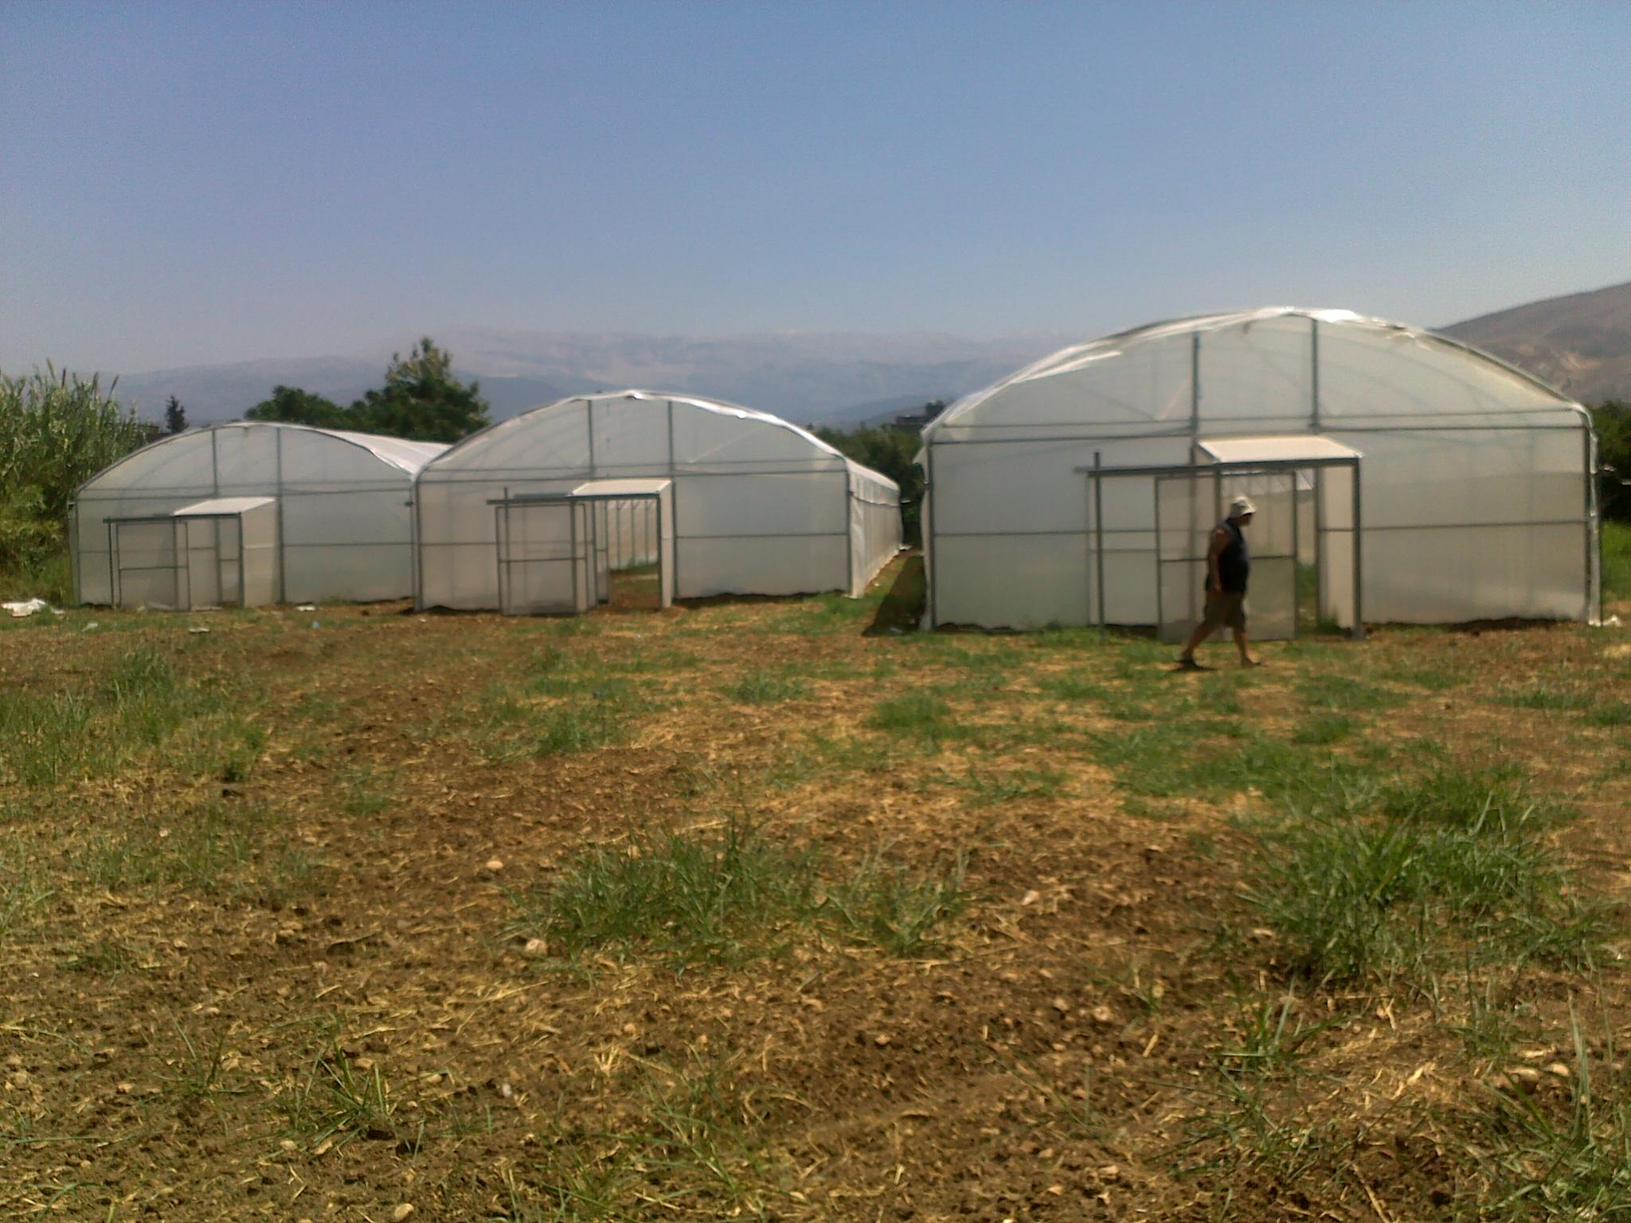

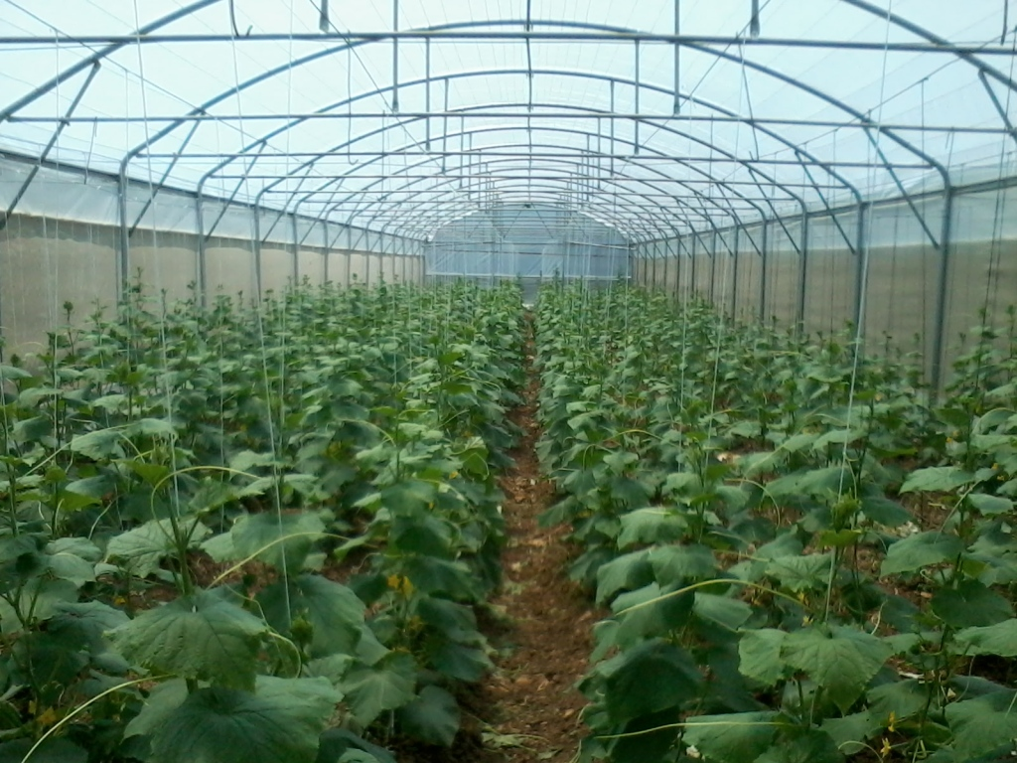

- Provision of an olive solid waste composting facility and of technical and management training to three agricultural cooperatives in North-Lebanon:

In coordination with FAO and the Directorate of cooperatives, meetings were organized with eight cooperatives and unions of farmers working in the olive sector in the targeted areas. An in-depth assessment selected the Bkarzla, Hosniyeh and Deir Dalloum cooperatives as primary beneficiaries of the olive waste composting initiative.
During the execution of the construction works for the composting facility in 2012, the risk of erosion was identified as a threat to the facility. Therefore, the contract of the construction company was amended to include the execution of cyclopean concrete that would retain and consolidate the soil, and the implementation of a storm water drainage canal that would retain all extra liquids and store them in a tank. The construction works were completed in December 2012.
A legal consultancy firm was then recruited in order to ensure a proper handover as well as maximum benefits to the beneficiaries within a legally sound framework. The consultancy firm studied all possible options and proposed the best solutions for the creation of a legal entity with a permit to produce compost while guaranteeing the rights of all beneficiaries.

The solutions were discussed with the beneficiaries and they chose the creation of a union of cooperatives. The consultancy firm then provided support to the beneficiaries in the preparation of the needed documents for each cooperative as well as for the creation of a union of cooperatives that will bring together all beneficiaries and ensure a proper handover of the project.

A consultant was then recruited to train the beneficiaries on the management of the unit and on the olive solid waste composting process. The management training will help the beneficiaries develop a management and a marketing plan and implement them together and the technical training will consolidate their knowledge and expertise in olive solid waste composting. A stock of olive pomace and cow manure (150 tons of olive pomace and 75 tons of cow manure) needed for the composting process were also purchased and donated by UNDP to help the beneficiaries make their first compost harvest.

Project output 2 “Living conditions and livelihoods of communities improved through small scale infrastructure projects”

- Upgrading the Halba slaughterhouse:

In 2010, the Municipality of Halba decided to build its own slaughterhouse in order to prevent health hazards and limit the risks of contamination of the meat that exist in many illegal slaughterhouses and butcheries.

The Halba slaughterhouse was meant to serve all 13 municipalities of the Shafat union of municipalities (around 50,000 residents). It was built close to the meat bazaar in Halba in a strategic effort to reinforce linkages with the Akkar community of butchers (starting with 25 butchers in Halba) and to strengthen the value chain of the meat market in the region.

Discussions and meetings were held with the Municipality to explore ways of supporting the constructed slaughterhouse. It was finally agreed, in coordination with FAO, that a grant will be given to the Municipality to support it in upgrading the structure of the slaughterhouse in order to improve the slaughtering process and in creating a laboratory for meat testing and quality control. All the construction works were completed in 2011 and laboratory equipment for testing and food safety were bought to the Municipality.

Upon the request of the Municipality, UNDP then provided training to the team managing the slaughterhouse in order to implement ante-mortem guidelines developed by FAO. An internal management system was also developed by UNDP and put in place through provision of training sessions to ensure the financial transparency in the management of the slaughterhouse, and the monitoring of the services.

But in October 2012, the Lebanon Recovery Fund Monitoring and Evaluation committee recommended conducting an assessment of the situation and of the food safety system in the slaughterhouse.

A food safety expert was therefore recruited in January to conduct an analysis on needed equipment and training for the slaughterhouse to function according to good hygienic and manufacturing practices requirements. Through the on-site evaluation, the expert conducted an assessment of the slaughterhouse situation and recommended the required modifications to be undertaken.

According to the report, many modifications have to be made in order for the facility to meet the international GHP/GMP requirements. Only then the facility will be able to implement a HACCP plan to and ensure that a food safety system is in place.

The report submitted by the expert was translated into Arabic and will be shared in with local institutions and foundations to gather support for the slaughterhouse and help the Municipality make the needed improvements at the facility.

- Supporting the Municipality of Bkarzla in upgrading the town’s sewerage system and mini-football field

Based on discussions with UNDP, the Bkarzla Municipality submitted a proposal to change the town’s 40-year old main sewerage pipeline and to rehabilitate its mini-football field in October 2012, which would contribute to the strengthening of local governance structures for better basic services delivery and improvement of living conditions in the area.
The Municipality was asked to prepare a detailed study including a bill of quantities for both projects to be reviewed by UNDP and a consultant (civil engineer) was recruited to review the studies and supervise the works.
Upon the consultant’s request, the Municipality amended the studies, project plans and BOQ in January. After they were approved, the Municipality prepared the requests for quotation for the civil works needed with support from UNDP. They were posted for a period of fifteen working days and three offers were received. The best bidder was then selected in coordination with UNDP consultant.
Based on the selected offers, a grant agreement was signed between UNDP and the Municipality to support it in the implementation of the two projects.

The civil works started under the supervision of the Municipality and of UNDP consultant in April and were completed in August 2013. Three sewage lines and the mini-football field were rehabilitated under the supervision of the Municipality and UNDP.

Photographs of the mini-football field:

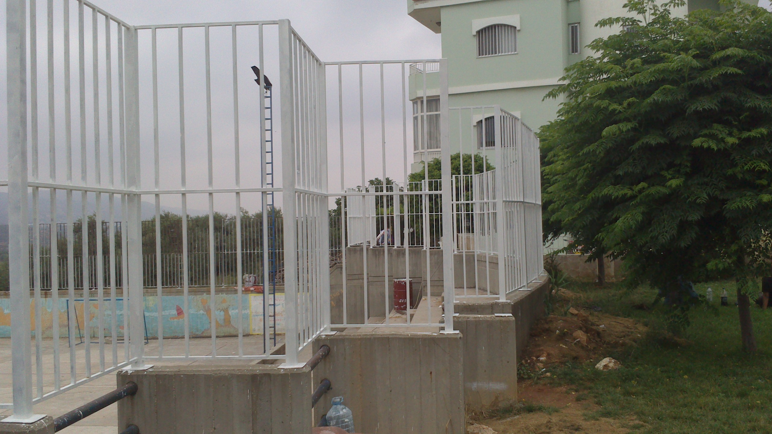

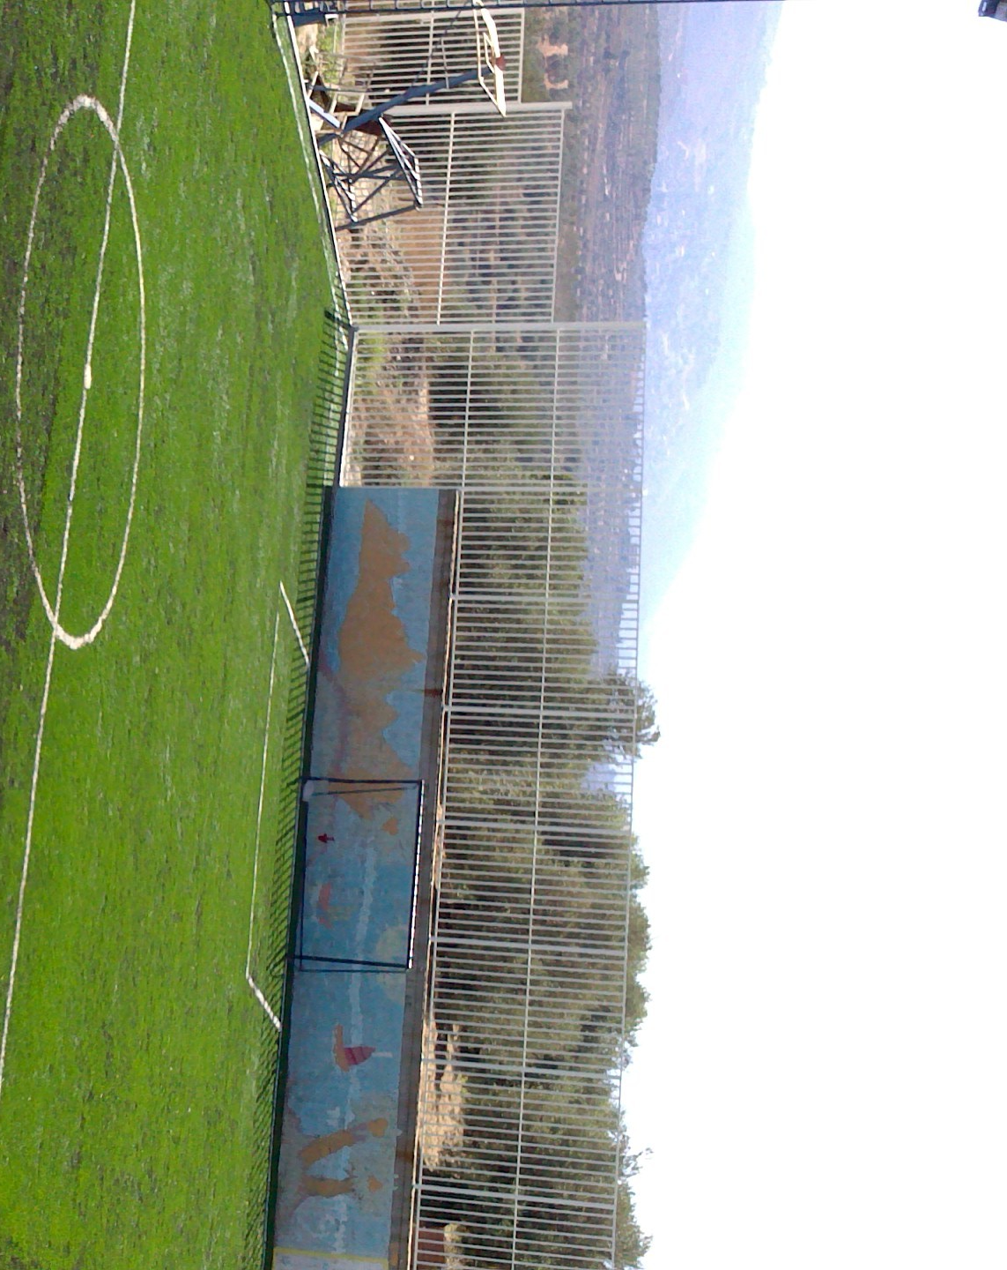
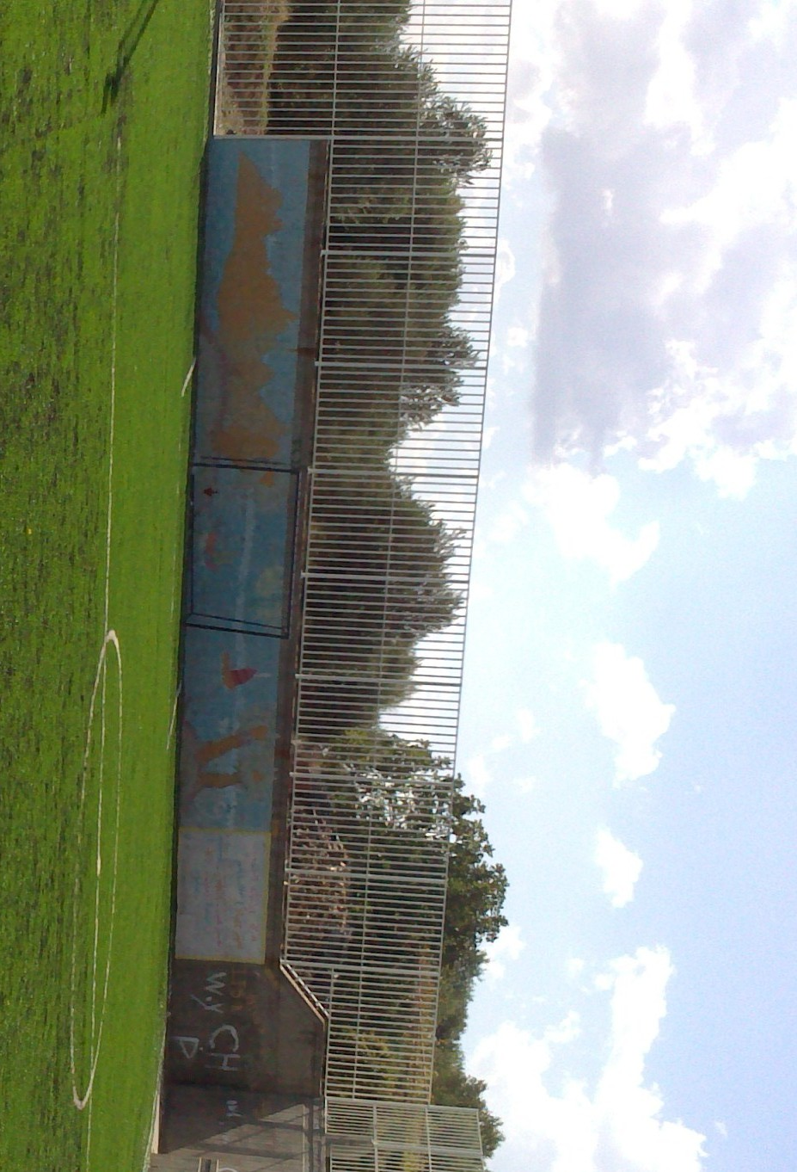

Photographs of works in the sewage main line:

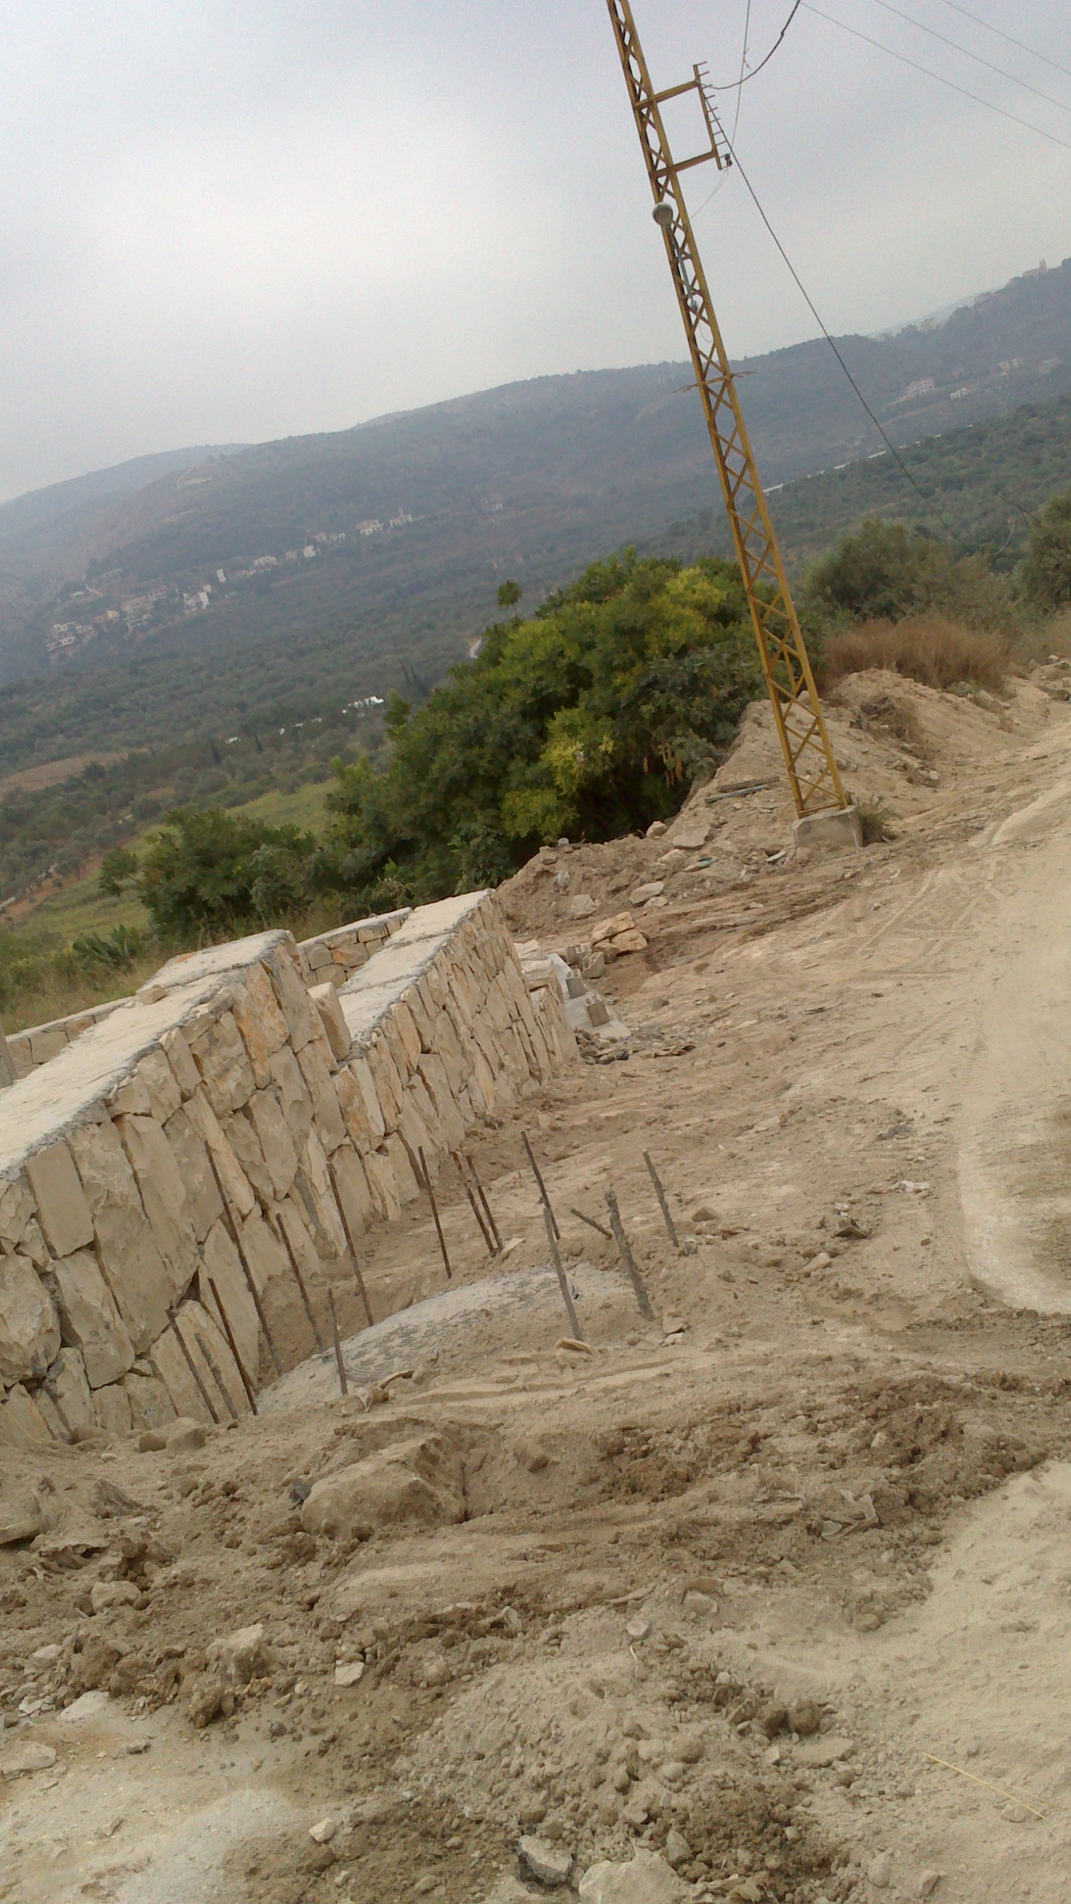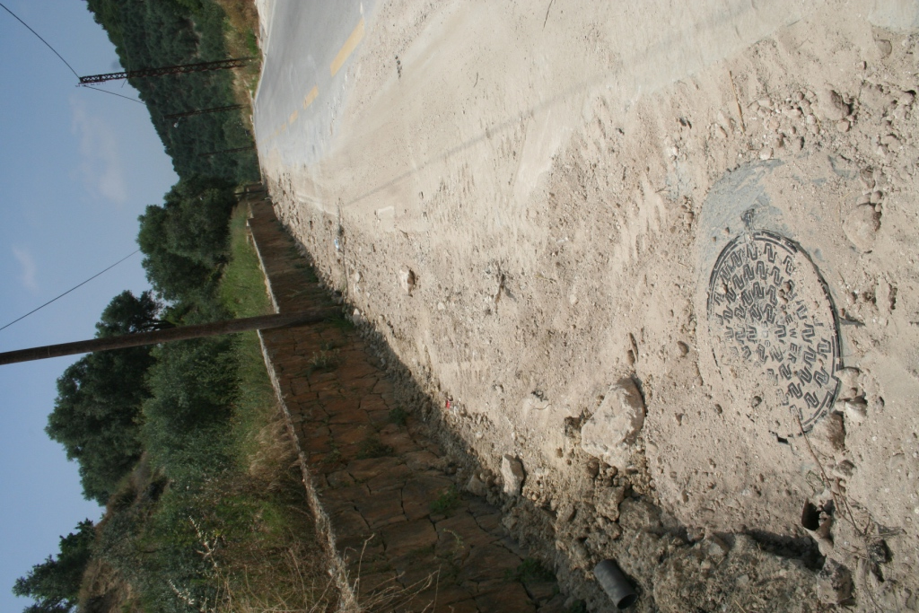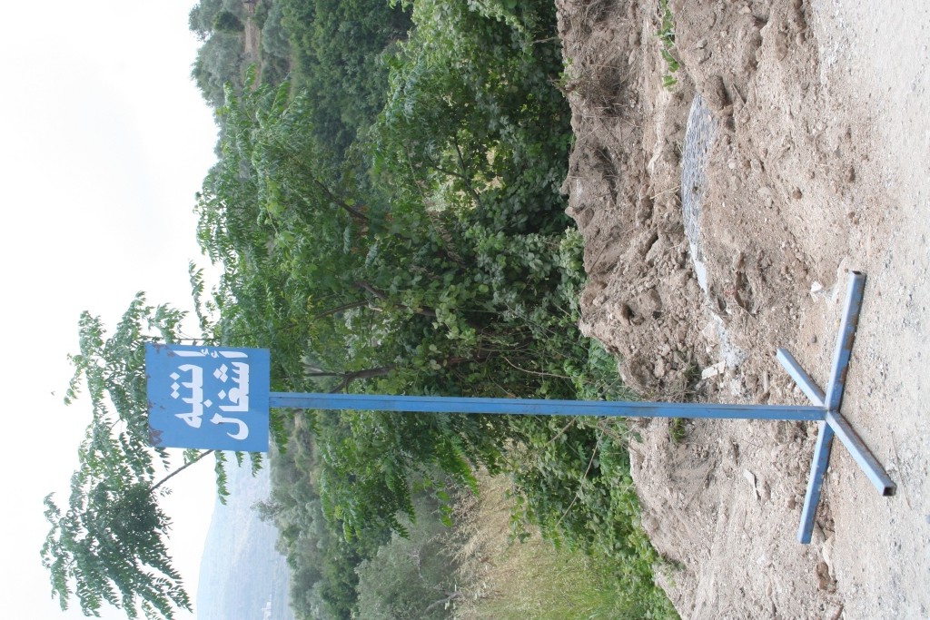

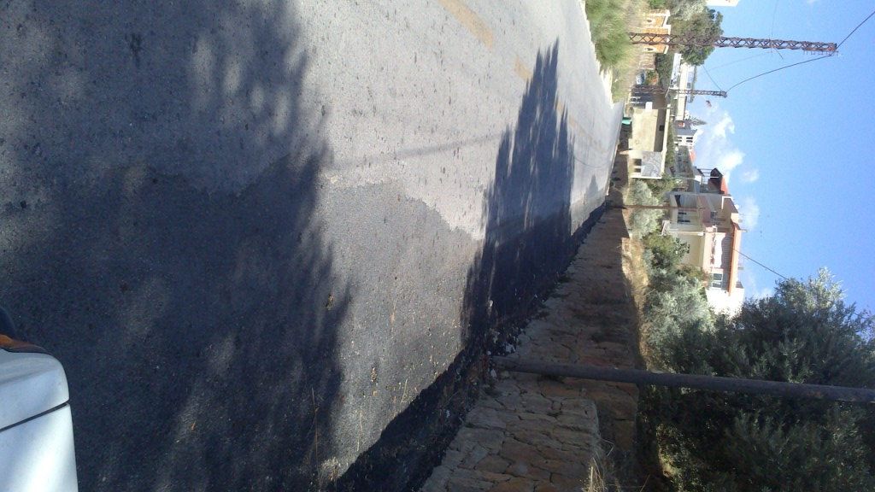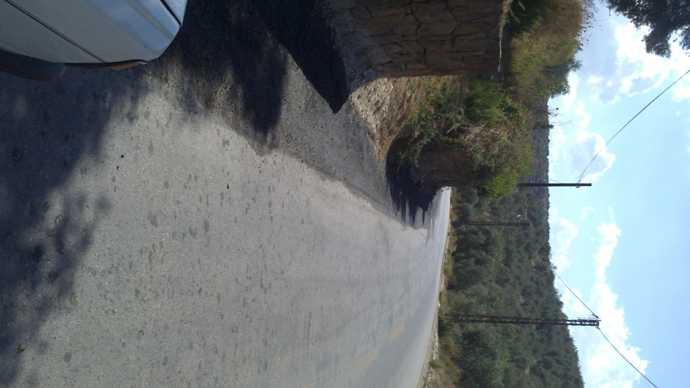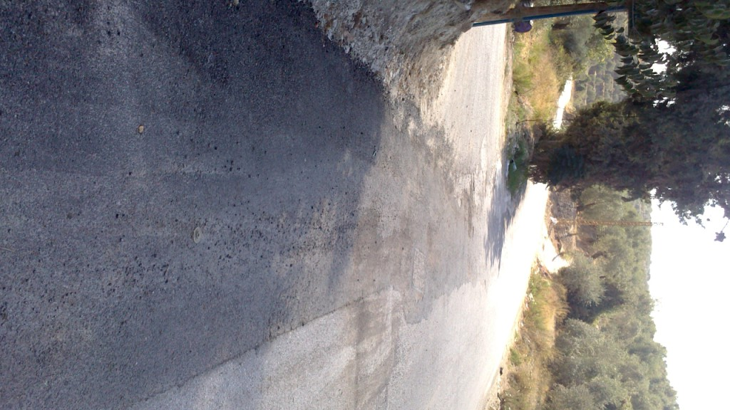

Key Partnerships & Collaboration

In 2013, the project collaborated mainly with the municipalities of Wadi el-Jamous, Muhammara, Bebnine, Halba, Minyeh and Bhanine to ensure a smooth implementation of the greenhouses activity. In addition, UNDP collaborated with several cooperatives in North-Lebanon and with the Municipality of Bkarzla to ensure a successful implementation of the olive solid waste composting activity.

Implementation Constraints and Lessons Learned during this quarter:

The biggest challenge faced during the second quarter of 2013 was the the clashes and unrest that took place on several occasions in the North and that lead to a delay in the implementation of the Olive Solid Waste Composting Facility activity, especially due to slow administrative procedures.

