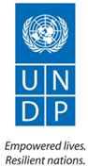
Lebanon Recovery Fund
MPTF OFfice GENERIC final programme NARRATIVE report
REPORTING PERIOD: from 20.08.2009 to 30.09.2013

Programme Title & Project Number |  |  | Country, Locality(s), Priority Area(s) / Strategic Results
- Programme Title: Recovery of Nahr el Bared Surrounding Lebanese Communities Affected by 2006 and 2007 Conflicts  - Programme Number: 00072768 – LRF 24  - MPTF Office Project Reference Number: 00072096 |  |  | Country/Region: Lebanon/North-Lebanon
Priority area/ strategic results:
- Crisis prevention and recovery
- Socio-economic development/regional disparities
Participating Organization(s) |  |  | Implementing Partners
- UNDP |  |  | - FAO and ILO  - Al-Majmoua  - Ministry of Agriculture  - Municipalities of Karkaf, Wadi el-Jamous, Kobbet Bchamra, Hmaira, Borj el-Arab, Halba, Bkarzla, Bebnine, Muhammara, Minyeh and Bhanine
Programme/Project Cost (US$) |  |  | Programme Duration
Total approved budget as per project document: 2,500,000  MPTF /JP Contribution: 2,500,000  TOTAL: 2,500,000 |  |  | Overall Duration: 43 months  Start Date: 20.08.2009  Original End Date: 28.02.2011  Actual End date: 30.09.2013 (extension until March 2012 then from October 2012 to September 2013)  Have agency(ies) operationally closed the Programme in its(their) system? Yes  Expected Financial Closure date:
Programme Assessment/Review/Mid-Term Eval. |  |  | Report Submitted By
Evaluation Completed  No  Evaluation Report - Attached  No |  |  | - Name: Fadi Abilmona  - Title: UNDP Programme Analyst  - Participating Organization (Lead): UNDP  - Email address: fadi.abilmona@undp.org

List of abbreviations and acronyms

BOQ Bill of quantities
Coop Cooperative
FAO Food and Agriculture Organization of the United Nations
HUG Hôpitaux Universitaires de Genève
ILO International Labour Organization
IT Information Technology
LRF Lebanon Recovery Fund
M&E Monitoring and Evaluation
MoA Ministry of Agriculture
MOU Memorandum of Understanding
MPTF Office Multi-Partner Trust Fund Office (Administrative Agent of the LRF)
NBC Nahr el Bared camp
OSWCF Olive Solid Waste Composting Facility
SME Small and Medium Enterprises
UN United Nations
UNDAF United Nations Development Assistance Framework
UNDP United Nations Development Programmme
UNRCO United Nations Resident Coordinator Office

FINAL PROGRAMME REPORT FORMAT

EXECUTIVE SUMMARY

This report presented to the Multi-Partner Trust Fund Office of the United Nations Development Programme covers all the activities implemented under the “Recovery of Nahr el Bared Surrounding Lebanese Communities Affected by 2006 and 2007 Conflicts” project, between August 2009 and September 2013.

One of the most significant achievements of the project is the completion of the installation of 102 greenhouses followed by a technical and managerial training in each of the 6 concerned villages surrounding Nahr el Bared camp. The training sessions contributed to raising the farmers’ awareness on efficient agricultural techniques and increasing their agricultural knowledge and expertise.

Another achievement is the completion of the Olive Solid Waste Composting Facility and the successful finalization of the first batch of olive compost. The impact of this activity should be far reaching in the North since all farmers could purchase the final product and all olive growers could benefit from the composting process at the facility.

At a more local level, infrastructure projects like the construction and asphalting of agricultural roads were successfully implemented in NBC surrounding municipalities. The upgrading of agricultural roads had a very positive impact on farmers in the area, improving their access to the fields and to the market.

Purpose

Introduction:

Less than one year after the July-August 2006 war in Lebanon, violent clashes erupted between the Lebanese Army and militants from the Fath El Islam radical group in the Nahr el Bared camp. Three months of heavy fighting took place including aerial and artillery bombardment, leaving the camp in utter destruction with the Palestinian population displaced. Similarly, the residents of the surrounding area found themselves partially displaced. The situation of poverty in the area was also aggravated and it intensified existing tensions between Lebanese and Palestinians. The instability of the political and security situation in Tripoli also had a negative impact on the livelihood opportunities for the local population.

In January 2008, UNDP launched the “Early recovery of Nahr El Bared surrounding municipalities” project aiming to reduce tensions that may have emerged between Lebanese and Palestinian communities following the NBC crisis and to promote early recovery in the 6 municipalities surrounding the camp, namely Muhammara, Bebnine, Bhanine, Minieh, Beddawi and Deir Amar. Within a similar framework and context of promoting social cohesion and economic recovery, UNDP expanded its efforts to include additional 22 NBC surrounding villages that were identified by the Lebanese government to be indirectly affected by the July-August 2006 war and/or the Nahr el Bared conflict in 2007 (the third ring villages).

Main objectives and expected outcomes:

The main objective of the project was to promote recovery and social cohesion. It was designed to restore livelihoods of 2,000 vulnerable households (13,400 individuals) in 28 communities of North-Lebanon who had sustained significant direct or indirect losses related to the conflict of July - August 2006 and/or the NBC conflict in 2007. Additionally, the project aimed to provide a solid platform for development efforts in the area by increasing local capacities of participatory planning, management and implementation of development programmes, as well as promoting local level dialogue.

The project has contributed to the achievement of two national priorities of the UNDP Country Programme Document for 2010-2014:

- The increase of growth performance and improvement of social indicators
- The enhancement of national capacities for crisis prevention and recovery

More specifically, it promoted strengthening local governance structures in target under-served regions for better representation, participation, and basic local services delivery as well as improving living conditions and trust in Palestinian and Lebanese surrounding communities.

The project also contributed to the achievement of outcomes 1 and 4 of the 2010-2014 UNDAF through strengthening the capacity of civil society groups to foster peace, reconciliation, and conflict prevention (outcome 1) and the capacity of institutions and community groups to formulate and implement regional and local development plans effectively (outcome 4). In addition, the project helped improving the availability and access to support services for the development of micro, small and medium enterprises, cooperatives and other underserved population (outcome 4) and the development of the capacity for production and marketing of quality, safe, competitive industrial, agricultural and handicraft products (outcome 4).

As per the project document, some activities were implemented in partnership with the ILO and FAO. In particular, both UN agencies were engaged in the implementation of project output 1: “Livelihoods of farmers, fishermen and SME owners improved through socio-economic interventions targeting training, technical and asset needs”. In this respect, FAO provided technical support and assistance to the design and implementation of the agricultural-related aspects of the project, including capacity building. As for the ILO, it supported the implementation of the micro grant component through its partnership with the local micro finance institution known as Al-Majmoua, which was also an implementing partner.

Other implementing partners include: the Ministry of Agriculture and the municipalities of Karkaf, Wadi el-Jamous, Kobbet Bchamra, Hmaira, Borj el-Arab, Halba, Bkarzla, Bebnine, Muhammara, Minyeh and Bhanine.

Assessment of Programme Results

- Narrative reporting on results

Project outcome: Promoting economic recovery and social cohesion in NBC surrounding communities affected by the 2006 and 2007 conflicts

In order to realize the project’s outcome to promote economic recovery and social cohesion in 28 NBC surrounding municipalities, several activities were directly implemented while others were achieved by national and local partners with the support of the project. A number of pilot initiatives which could be used for experience sharing and replication were implemented between August 2009 and September 2013.

Output 1: Livelihoods of farmers, fishermen and SME owners improved through socio-economic interventions targeting training, technical and asset needs

- Improvement of the livelihoods of SME owners

Following the NBC crisis, large numbers of businesses were totally or partially destroyed, thereby severely affecting all social and economic activities. Many Lebanese businesses operating in the surrouding areas of NBC suffered from the loss of income resulting from lack of access to the main trade routes and the interruption of labor supply, the collateral damage from the crisis extended far beyond the immediate direct destruction.

In response to impact of the crisis on the livelihood of the Lebanese of the camp surrounding area, UNDP in collaboration with the ILO and Al-Majmoua provided micro loans to small business owners affected by the crisis in an effort to recover their incomes.

At the end of April 2011, 106 SME business owners had been supported through this project, to recover businesses directly or indirectly impacted by the NBC crisis, as per the selection criteria outlined below. The loans were provided to small businesses varying from photography to farming, with the most supported businesses being grocery stores, car painting and gas stations, carpentry and fishing. The loans were mainly provided to recover incomes of existing businesses, although 20 loans were also given to establish new businesses. The loans have helped create 20 new jobs while sustaining 250 existing jobs. In an effort to target the most vulnerable groups, 49% of the loans were provided to youth who were negatively affected by the crisis.

The selection criteria for the beneficiaries of the micro loans (either individual or collective) were defined as follows:
- Lebanese entrepreneurs;
- Residents of the 28 communities targeted by the project;
- Owners of businesses sustaining direct or indirect damages from the 2007 Nahr el Bared crisis, that could be divided into the three following categories: i) business completely destroyed, ii) businesses requiring additional support to sustainably recover after the crisis and iii) SMEs whose business practices and approaches may help improve Lebanese/ Palestinian relationships.
- Owners of businesses supported in the context of early recovery interventions through grants;
- Owners of businesses in the following sectors (but not exclusively): construction, furniture, car maintenance and food processing.
- 30 to 35% of beneficiaries to be women;
- 20 to 33% of beneficiaries to be youth;
- New businesses to benefit from 5% of loans;

The selected beneficiaries were negatively affected by the 2007 conflict: 11 out of the 106 persons were displaced out of their homes; 33 of them had to close their businesses completely during the war; and 62 of them incurred financial losses during the war because they were forced to partially close their businesses.

The beneficiaries were owners of a variety of businesses:
- 36% worked in the trade and services sectors;
- 25% worked in the food processing sector and equivalent;
- 15% worked in the construction sector;
- 9% worked in furniture manufacturing;
- 9% worked in car repair and maintenance;
- 6% worked in the IT sector, technology and equivalent.

The results of the microloans were positive for 92 out of the 106 beneficiaries (87%) who used their loans to either improve their working capital such as purchase of goods or raw material (48 people), purchase or repair fixed assets in their business, for instance a vehicle or a machine (34 people), or renovate/upgrade their workplace (10 people). The results were increased productivity and profits.

The partnership agreement signed between Al-Majmoua and the ILO included an in-kind contribution on behalf of the micro-loan institution, in the form of revolving funds amounting to 80.000 US$ over 5 years. It is important to mention that a number of beneficiaries showed interest in renewing their loans because of the rapid positive impact it had on their business.

- Improvement of the livelihoods of farmers

UNDP, in collaboration with FAO, launched an in-depth assessment to evaluate the impact of the NBC crisis on the agricultural sector in the 28 targeted villages surrounding NBC. An Inter-Agency Agreement was signed between both agencies for that purpose. The results of the assessment led to the selection of the Olive and Greenhouses agricultural sub-sectors to benefit from UNDP and FAO support since they were the most affected by the crisis.

The support to farmers was provided through the main following activities:
- Provision of olive harvesters and greenhouses to farmers and agricultural cooperatives
- Construction of an OSWCF and provision of training sessions to a group of agricultural cooperatives
- Provision of capacity building trainings targeting MoA extension agents as well as olive and greenhouses farmers

- Provision of Olive Harvesters

Based on the in-depth assessment organised with technical support from FAO, UNDP selected 2 agricultural cooperatives with more than 80 active members to benefit from the olive harvesters.

The selection was based on the following criteria:
  - The cooperative is active;
  - The cooperative is already providing services to its members;
  - The cooperative has the potential of increasing the membership;
  - The cooperative’s board needs minimal training on organizational/managerial skills;
  - The cooperative works with olive farmers.

In May 2011, 28 harvesters (10 electric harvesters and 4 pneumatic harvesters for each coop) were delivered to the Karkaf and Halba cooperatives benefiting a cluster of villages with approximately 250 active farmers in the olive sector. Technical training sessions on the use of the harvesters were then provided to the coop members and specific tools were developed with each cooperative for improved administrative and financial management.

During the harvesting period from October to December 2011, the farmers successfully used the olive harvesters which reduced their harvesting costs by 30 to 40%. The approximate net profit of each cooperative was 6,000 US$ during this first harvesting season.

- Provision of Greenhouses

With technical support from FAO, a field study conducted in 2011 revealed which farmers were in most need of support in the six most vulnerable municipalities (Wadi el-Jamous, Muhammara, Bebnine, Halba, Minyeh and Bhanine) with regards to greenhouses crop production. A total of 102 farmers were selected as beneficiaries.
The installation of the greenhouses started in January 2012 in Minyeh but the first sample greenhouse constructed by the contractor failed to comply with the required specifications. The sample was modified based on UNDP recommendations and was accepted as compliant in June 2013 but by then the contractor was unable to continue the installation of the greenhouses, especially due to the security situation in North-Lebanon.
UNDP initiated a negotiation process to amend the contract of the awarded company to include only the supply of materials in order to sign a new contract with a local company for the execution of the installation works. The two new contracts were signed and an agricultural engineer was recruited to supervise the inventory of materials and ensure smooth implementation and coordination between the company supplying the goods and the contractor.
A meeting between UNDP, the six municipalities and the company in charge of the installation works was held in early January 2013 to re-launch the activity and inform the local stakeholders about the methodology of works. Separate meetings with each municipality and farmers were then held to finalize the schedule of works according to the availability of lands and readiness of farmers in each village.

After the finalization of the installation plan, a full physical inventory of greenhouse materials was conducted over 15 working days between January and February 2013 by the consultant in coordination with the supplier and the contracted company. The purpose was to identify both the quality and the quantity of materials supplied and available in the Minyeh Warehouse and to verify their compliance with tender specifications.

The installation works started as soon as the inventory was completed. The contracted company divided the works into 3 phases in each of the 6 villages:

1-Installation of the concrete bases
2-Installation of the steel structure
3-Installation of the plastic cover and irrigation system

All greenhouses were successfully installed and transferred to the 102 beneficiaries between February and August 2013. A company was then selected to supply 300 kg of organic fertilizers and 1000 pulley hooks to each farmer to be used in the newly installed greenhouses.

A technical and managerial training was also conducted in each of the 6 concerned villages targeting all the beneficiaries of the greenhouses project. The training sessions which were completed by the end of September 2013 contributed to building the capacities and managerial skills of the farmers and to raising their awareness on efficient agricultural techniques. The following topics were addressed during the training sessions:

- Topic 1: Organic fertilizers
- Topic 2: Chemical fertilizers
- Topic 3: Best Agricultural Practices
- Topic 4: Pulleys
- Topic 5: Importance of farmers’ associations or cooperatives
- Topic 6: Transforming traditional agriculture into modern agro-business

Finally, a ceremony was organized in September with the beneficiaries and the local stakeholders as a conclusion to the successful greenhouses project.

Photographs of completed and cultivated greenhouses:

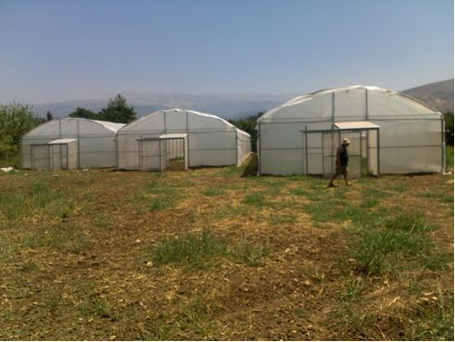

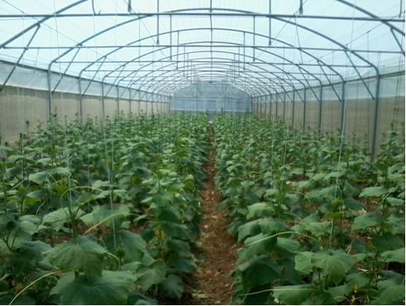

- Construction of an olive solid waste composting facility and provision of technical and managerial training to three agricultural cooperatives in North-Lebanon

In coordination with FAO and the Directorate of cooperatives and based on the agricultural in-depth assessment organized with technical support from FAO, meetings were organized in 2011 with eight cooperatives and farmers associations working in the olive sector within the targeted area. The Bkarzla, Hosniyeh and Deir Dalloum cooperatives were selected as primary beneficiaries of the olive waste composting initiative.
The selection was based on the below criteria:

  - The cooperative is active;
  - The cooperative already provides services to its members;
  - The cooperative has the potential of increasing the membership;
  - The cooperative’s board needs minimal training on organizational/managerial skills;
  - The cooperative works with olive farmers;
  - The members of the cooperative are willing to use compost in their fields;
  - The beneficiaries work within the same cluster of villages.

A comprehensive Environmental Impact Assessment was then undertaken to design and implement the OSWCF. A workshop was also organized for the three cooperatives in November 2010 to discuss the production and use of olive compost by farmers.

In 2011, the beneficiaries agreed that the OSWCF should be constructed in Bkarzla and the works started shortly afterwards. However, they were delayed due to several factors including the security issues in North Lebanon. In addition, during the execution of works in 2012, the risk of erosion was also identified as a threat to the facility. The contract of the construction company was amended accordingly to include the execution of cyclopean concrete that would retain and consolidate the soil and the implementation of a storm water drainage canal that would retain all extra liquids and store them in a tank. All construction works were completed in December 2012.
A legal consultancy firm was then recruited in 2013 in order to ensure a proper handover and guarantee the rights of the beneficiaries within a legally sound framework. The possible solutions for the creation of a legal entity with a permit to produce compost while guaranteeing the rights of all beneficiaries were discussed with the beneficiaries and they chose the creation of a union of cooperatives. The consultancy firm provided support in the preparation of the needed documents for each cooperative as well as for the union of cooperatives that will bring together all beneficiaries. The OSWCF was accordingly handed over to the beneficiaries.

A consultant was also recruited in 2013 to train the beneficiaries on the management of the unit and on the olive solid waste composting process. The aim of the management training was to help the beneficiaries develop and implement a management and a marketing plan. As for the technical training, it consolidated their knowledge and expertise in olive solid waste composting and supported them in producing the first batch of compost. The stock of olive pomace and cow manure (150 tons of olive pomace and 75 tons of cow manure) needed for this first batch were purchased and donated by UNDP.

The olive compost will cost less than the composts being sold on the market and there is already a high demand for such organic products in the North which should allow good returns. Selling the first compost batch should be sufficient to cover human resource and maintenance cost at least for the first year, which will ensure the sustainability of the project.
Photographs of the first piles of compost:

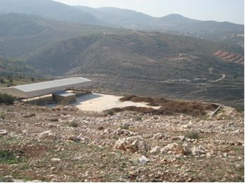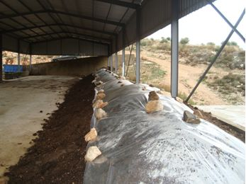

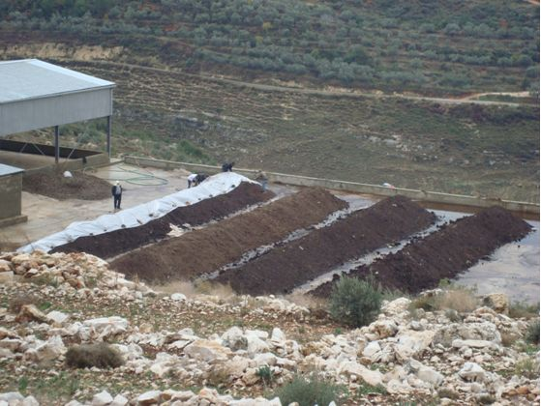

- Capacity Building for farmers and MoA extension agents

Based on consultations with the Ministry of Agriculture and with technical support from FAO, a capacity building program was developed for 16 extension agents of the MoA in North Lebanon and more than 200 farmers from the third ring area, including farmers from Karkaf and Halba cooperatives. The training sessions took place between February and May 2011.

The extension service agents from the Ministry of Agriculture participated in a Training of Trainers program on “integrated pest management” and “sustainable soil management” as well as on communication and outreach skills. The aim of the training sessions was to ensure the sustainability of the extension services provided to the farmers in the area. More than 100 greenhouse farmers also received a training on agricultural practices.

As for the cooperatives of Halba and Karkaf, they both received technical training on management and accounting skills as well as training on the management and organization of harvesters use and on cooperative work, laws, rights and duties. The third training included a section on the duties and responsibilities of each cooperative committee and the rights of the members of each cooperative.

- Improvement of the livelihoods of fishermen and women working in the fishing nets rehabilitation

- Bebnine Fishermen

Within the framework of the capacity building programme initiated in 2010 by UNDP, 135 fishermen and members of the Bebnine cooperative were trained on the objectives, principles and values of cooperative enterprises, which included the legal process to complain about the board’s activity in case it doesn’t respond to their needs. Members were provided with a copy of the law of cooperatives and they became aware of the roles and rights of each actor in the cooperative structure. UNDP also supported the fishermen in developing a job description for the coop manager which was adopted by the board of directors. The capacity building programme was closely coordinated with the Municipality of Bebnine.

- Bebnine Women cooperative

The establishment of the Bebnine Women Cooperative came in response to the assessment organized by UNDP which revealed that the women who mend fishing nets in Bebnine earned less than 1$/hour. These low wages were due to the presence of middlemen and the fact that they often received food and clothes in lieu of higher value cash payments.

150 women were selected as beneficiaries of this project based on the following criteria:
- Women aged 18 who knit and repair fishing nets in Bebnine;
- Residents of Bebnine;
- Their only economic activity is knitting and repairing fishing nets;
- They are mainly family members of local fishermen;

At the end of 2010, after the five board members and the President of the cooperative were elected, a training program on cooperative management was organized. It included the preparation of the annual report to the government, accounting requirements and procedures as well as membership and volunteers’ mobilization. All the beneficiaries attended the training sessions and participated in the debates that followed. Weekly meetings were also held with them to follow-up on the establishment of the cooperative and the issues they faced.

In 2011, a technical on-the-job training was organized for the cooperative members based on the instruments and tools designed by the Hôpitaux Universitaires de Genève to enable a more efficient production while reducing the strain on knitters’ vision and allowing better posture. In order to ensure the sustainability of the project, each beneficiary received her own instrument and tools which were composed of: a customized metal stands designed for hanging the nets while knitting, a customized seat and an adapted lighting.

Several exercises were organized for the beneficiaries in cooperation with the HUG and a brochure outlining best practices and exercises to improve the working conditions of the targeted women was designed and distributed in May 2011.

The Municipality of Bebnine was a key partner throughout the process and regular meetings were organized between UNDP and the municipality to discuss progress made by the cooperative. The Municipality also decided to appoint a focal person to provide support to the cooperative and to cover its rent fees.

By the end of 2011, the beneficiaries reported that their income was increasing as they were able to better manage their finances and better market their products. They were hence less vulnerable to middle-men activity. They also increased their client base and were better able to respond to larger orders while benefitting from improved working conditions, which made knitting faster and more comfortable.

In December 2011, the UNRCO, LRF M&E Unit and UNDP facilitated the production of a small documentary about the cooperative to promote its activity and highlight its importance.

Photographs of the women cooperative and the technical training:

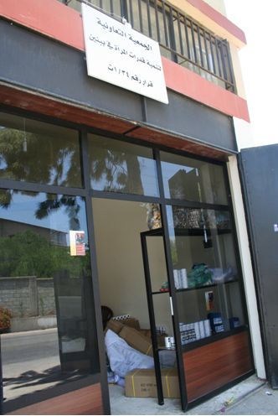

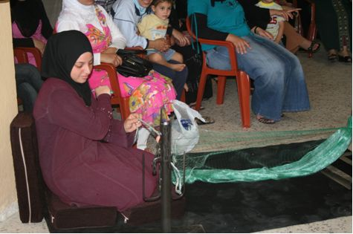

Output 2: Living conditions and livelihoods of communities improved through small scale infrastructure projects

- Construction of agricultural roads

In 2011, grant agreements were signed with five NBC surrounding municipalities for the renovation of six agricultural roads. The roads in Karkaf, Wadi el-Jamous, Kobbet Bchamra, Hmaira and Borj el-Arab were completed in 2011 and aimed to improve the farmers' access to their land and to the markets. Until then, most farmers had very limited access to their lands through roads they did not own a tractor to cut across fields.

The new asphalted roads increased the farmers’ income as the harvest became easier and the crops were more accessible to farmers and traders.

Photographs of agricultural roads construction and asphalting:

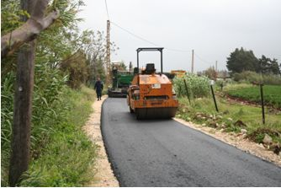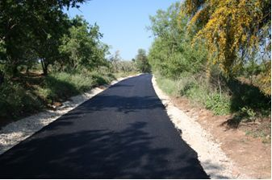

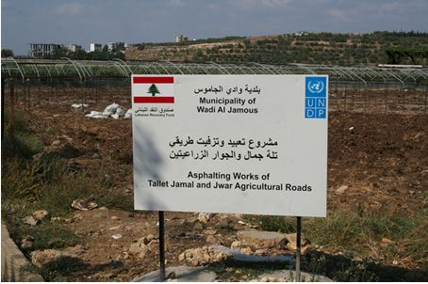

- Upgrading the Halba slaughterhouse

In 2010, the Municipality of Halba decided to build its own slaughterhouse in order to prevent health hazards and limit the risks of contamination of the meat that exist in many illegal slaughterhouses and butcheries.

The Halba slaughterhouse was meant to serve all 13 municipalities of the Shafat union of municipalities (around 50,000 residents). It was built close to the meat bazaar in Halba in a strategic effort to reinforce linkages with the Akkar community of butchers (starting with 25 butchers in Halba) and to strengthen the value chain of the meat market in the region.

Discussions and meetings were held with the Municipality to explore ways of supporting the constructed slaughterhouse. It was finally agreed, in coordination with FAO, that a grant will be given to the Municipality to support it in upgrading the structure of the slaughterhouse in order to improve the slaughtering process and in creating a laboratory for meat testing and quality control. All the construction works were completed in 2011 and the laboratory equipment for testing and food safety were bought to the Municipality.

Upon the request of the Municipality, UNDP provided training to the slaughterhouse staff members to implement ante-mortem guidelines developed by FAO. An internal management system was also developed and put in place by UNDP through the provision of training to ensure the financial transparency in the management of the slaughterhouse and the monitoring of the services.

In October 2012, more than one year after the works and trainings were completed, the LRF M&E committee recommended conducting an assessment of the situation and of the food safety system in the slaughterhouse. A food safety expert was therefore recruited in January 2013 to conduct an analysis on needed equipment and training for the slaughterhouse to function according to good hygienic and manufacturing practices requirements. Through the on-site evaluation, the expert conducted an assessment of the slaughterhouse situation and recommended the required modifications to be undertaken.

According to the report, many modifications have to be made in order for the facility to meet the international GHP/GMP requirements. Only then the facility will be able to implement a HACCP plan to and ensure that a food safety system is in place.

The report submitted by the expert was translated into Arabic and several copies of the report and its supporting documents were shared with the Municipality of Halba to gather support for the slaughterhouse and make the needed improvements at the facility.

- Supporting the Municipality of Bkarzla in upgrading the town’s sewerage system and mini-football field

Based on discussions with UNDP, the Bkarzla Municipality submitted a proposal to change the town’s 40-year old main sewerage pipeline and to rehabilitate its mini-football field in October 2012 to strengthen local governance structures for better basic services delivery and improvement of living conditions in the area.
The Municipality was asked to prepare a detailed study including a bill of quantities for both projects to be reviewed by UNDP. A civil engineer was then recruited to review the studies and supervise the works.
Upon the consultant’s request, the Municipality amended the studies, project plans and BOQ in January. After they were approved, the Municipality prepared the requests for quotation for the civil works needed with support from UNDP and selected the best bidder for the implementation of the works.
Based on the selected offer, a grant agreement was signed between UNDP and the Municipality in March 2013. Three sewage lines and a mini-football field were rehabilitated between April and August 2013 under the supervision of the Municipality and UNDP.

Photographs of the mini-football field and the sewage networks’ rehabilitation:

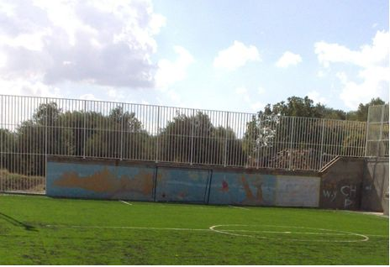

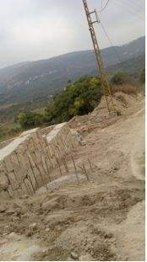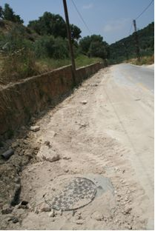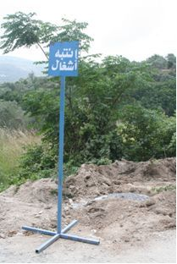
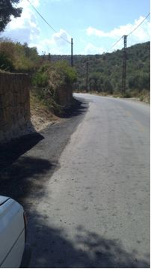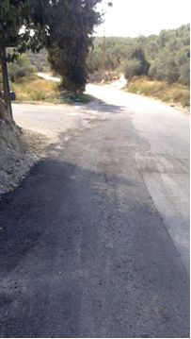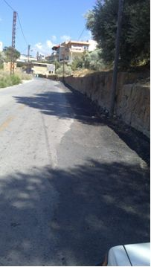

Output 3: Dialogue improved through local level interventions, particularly targeting youth

With regard to the youth component, aiming at promoting dialogue between Lebanese and Palestinian men and women, UNDP adopted an approach whereby structured spaces for dialogue were provided and continuous contact between youth was ensured through several activities.

The participating youth were selected on the basis of the following criteria:
- Age between 15 and 25;
- Diverse educational background (school, university, technical education, uneducated);
- Diverse employment status;
- Social activism;
- Diverse religious background;
- Accepts differences and respects others.

In this context, several activities were designed and implemented in 2010 and 2011:

- The “sport for peace camp” bringing together 75 Lebanese and Palestinian youth was organized in 2010. The camp provided conflict prevention skills through technical sports skills and mixed-Lebanese-Palestinian teams.

- A two-days sport tournament where mixed Lebanese and Palestinian football teams were created, also brought together young men from very different backgrounds in 2010.

- A two-day workshop for 22 Lebanese and Palestinian young men and women took place in 2010. The attendees learned conflict prevention and peace building skills.

- A mountain trail activity with 20 young Palestinian and Lebanese men and women was conducted in 2010 to provide an agreeable environment for youth to exchange and be trained on conflict prevention and conflict resolution skills.

- Through the LRF, UNDP was able to continue supporting the Lebanese/Palestinian cine club. A technical and organizational training was thus provided in 2010 to its members in order to ensure the sustainability of this initiative.

- The Lebanese Palestinian Choir composed of 35 Lebanese and Palestinian young men and women was also technically supported by the project in 2010.

- Finally, a youth perception study on Lebanese-Palestinian relations was launched in 2010 and completed in 2011 by the chosen consultant who led the study, the pooling and the administration of questionnaires to 1,600 Lebanese and Palestinian young men and women.

The survey targeted the Lebanese and Palestinian youth from Beddawi camp, NBC and the surrounding 28 municipalities. It was undertaken to provide a baseline and a future guide to designing peace building interventions primarily targeting youth in the region. The survey therefore:
a) Provided a quantitative description on intergroup perceptions and relations;
b) Identified the variables that are most relevant to addressing negative intergroup perceptions;
c) Identified the variables that are most likely to improve, life satisfaction in each community.

The main findings of the survey can be summarized as follows:
- Contact in all its dimensions significantly contributed to perceptions of prejudice for both Lebanese and Palestinian youth surveyed;
- Positive contact emerged as the strongest predictor of prejudice reduction for both Lebanese and Palestinian youth surveyed;
- Both Palestinian and Lebanese youth identified income satisfaction as the most prominent predictor of life satisfaction, closely followed by leisure satisfaction. None of the inter-community variables were significant, indicating that inter-community relations are not relevant to life satisfaction scores in both communities.

Qualitative assessment:

Overall, the project has successfully contributed to restoring livelihoods of a very large number of families, especially farmers and fishermen in the 28 surrounding municipalities of NBC which improved social indicators in the area.

The activities, the training sessions and the capacity building programs organized by the project also increased technical and practical knowledge in several fields, strengthened local governance structures and led to an improved access to local services as well as to enhanced capacities and knowledge of conflict prevention, reduction and peace building.

In this context, local dialogue platforms and groups were supported or put in place by the project and contributed to the development of the culture of reconciliation and cooperation. Channels for communication and coordination between Lebanese and Palestinians, municipalities and local communities and associations were also established, in some cases for the first time.

In addition, local structures were supported by the project to promote recovery and increase local capacities and expertise. The active engagement of the key partners, especially the concerned municipalities, contributed to these achievements and to maximizing the effectiveness of the project activities and interventions. The contribution and support of FAO and the ILO was also crucial for the success of the project’s activities.

ii) Indicator Based Performance Assessment:
Using the Programme Results Framework from the Project Document / AWPs - provide details of the achievement of indicators at both the output and outcome level in the table below. Where it has not been possible to collect data on indicators, clear explanation should be given explaining why.

 | Achieved Indicator Targets | Reasons for Variance with Planned Target (if any) | Source of Verification
Outcome 1
Promoting economic recovery and social cohesion in NBC surrounding communities affected by the 2006 and 2007 conflicts
Output 1.1  Livelihoods of farmers, fishermen and SME owners improved through socio-economic interventions targeting training, technical and asset needs  Indicator: Number of farmers, fishermen and SME owners benefitting from the interventions and trainings  Planned Target:  - Socio-economic survey in the 28 communities surrounding NBC  - Support to livelihoods restoration of 1,100 fishermen  - 5 vocational and technical training sessions for fishermen  - 250 farmers supported with necessary assets for farming  - 10 vocational and technical training sessions for farmers  - 350 households linked to cooperatives supported through assets  - 8 training sessions for SME owners on business management skills  - Women’s cooperative established & functioning  - 150 people supported with micro-finance loans  - 15 training sessions for cooperatives and / or associations in the agriculture sector and business management skills | Results of socio-economic survey in 28 communities surrounding NBC |  | Completed survey
 | Livelihoods of fishermen working in Abdeh harbor supported |  | Final report of infrastructure works in Abdeh harbour
 | 135 fishermen attended more than 5 training sessions on cooperatives, capacity building and planning |  | - Documentation & evaluation of training sessions  - UNDP progress report
 | - More than 200 olive farmers are using the olive harvesters (granted to the cooperatives of Karkaf and Halba)  - 102 farmers received fully installed greenhouses |  | - Equipment distributed and recorded  - UNDP Progress report
 | - 6 training sessions for greenhouses beneficiaries  - 4 training sessions for farmers |  | - Documentation & evaluation of training sessions  - UNDP Progress report
 | - 250 households benefited from the olive harvesters  - More than 100 farmers benefited from the OSWCF |  | - Equipment distributed and recorded  - UNDP Progress report
 | 10 training sessions for SME business owners were delivered. | Two additional training sessions were organized in the NBC surrounding area because needs were higher than expected for SME owners | - Documentation of training sessions  - UNDP progress report
 | Women’s cooperative established and functioning |  | - Minutes of meetings  - Cooperative documentation and records of contracts of loans
 | 106 loans provided | The process of providing loans to business owners was not easily accepted and implemented and the high risk of failure in some cases reduced the number of beneficiaries | Documentation and records of contracts of loans
 | - 10 training sessions targeting the newly established women cooperative in Bebnine,  - 4 training sessions for the OSWCF  - 6 training sessions for Halba and Karkaf cooperatives | More training sessions than originally planned were needed for cooperatives’ members | - Documentation & evaluation of training sessions  - UNDP progress report
Output 1.2  Living conditions and livelihoods of communities improved through small scale infrastructure projects  Indicator: Number of infrastructure projects and trainings completed  Planned Target:  - Assessment on specific infrastructure needs conducted  - 4 training sessions on infrastructure maintenance & supervision of works  - 4 sub-regional infrastructure projects connecting municipalities economic resources | Participatory needs assessments conducted including a final workshop |  | Assessment completed and documented
 | 4 training sessions were organized for MoA extension agents |  | Documentation of training
 | - Improvement of the Halba slaughterhouse  - Construction and asphalting of 6 agricultural roads  - Completion of the OSWCF  - Sewage network and mini-football field completed in Bkarzla |  | - Infrastructure projects and works completed  - Final reports
Output 1.3  Dialogue improved through local level interventions, particularly targeting youth  Indicator: Number of beneficiaries and interventions  Planned Target:  - 5 small-scale youth projects  - 2 training sessions on basic conflict prevention & reconciliation conducted  - 2 Youth camps for local youth conducted  - 12 dialogue sessions initiated | 4 completed small-scale youth projects:  - Support to Lebanese/Palestinian Cine Club  - A conflict prevention workshop,  - Support to the Lebanese/Palestinian Choir  - Youth perception survey on Lebanese/Palestinian relations | The scale of the projects was modified in order to provide a structured space where youth can meet, exchange and better know each other rather than ad-hoc activities or very small scale activities | UNDP progress report
 | 12 training sessions on conflict prevention and reconciliation organized | The big needs and the enthusiasm of the participating youth required a bigger number of training sessions on conflict prevention and reconciliation | Documentation & evaluation of training session
 | 3 camps including two sports camp and a mountain trail activity implemented |  | Documentation of youth camps
 | The 18 above mentioned activities were platforms for dialogue, especially the training sessions for youth |  | Minutes of sessions

iii) Evaluation, Best Practices and Lessons Learned

The biggest challenge faced by the project was the unstable political and security situation in North-Lebanon and the occasional clashes and unrest that lead to a delay in the implementation of several activities.

Working in close partnership with the local communities within a fast paced recovery approach was also a challenge faced by the project from the start. Then, the small progress made between 2009 and 2010 was slowed down by the municipal elections that took place at the end of May 2010. In addition, since the elections led to significant changes in the councils of several municipalities, the project had to re-build a relationship with the new local authorities and re-discuss the priorities previously established.

Working in a joint effort with other UN agencies also led to delays in some cases. For instance, the criteria of selection of the greenhouses beneficiaries and the technical input to finalize the greenhouses design were done by FAO. However the process of decision making and information sharing was complicated and time consuming. Thus, the implementation of farmers’ related activities was delayed.

The implementation of the OSWCF and greenhouses activities faced additional delays in 2012 and 2013. The installation of the greenhouses was put on hold for more than a year due to the security situation, the incapacity of the contracted company and disagreements with UNDP but an alternative solution was used by UNDP to successfully complete the works. As for the OSWCF, the construction works and the establishment of the cooperative were delayed several times due to the security situation and the lack of professionalism and experience of the cooperatives involved. Even after the works were completed, the completion of the administrative and legal documents/procedures took a lot of time and delayed the completion of the activity.

One way to avoid delays would have been to ensure better coordination with other UN Agencies working in the same field or area even prior to the beginning of the project and to plan according to the needs and requirements of all concerned agencies. Another solution could have been to make sure that the contracted companies are all fully capable of working in the North-Lebanon context despite the complicated security and political situation and to make sure that a clear risk management structure is in place for each activity.

iv) A Specific Story (Optional)

“The unstable economic situation in the country forced me to go into farming. I wasn’t always a farmer but my husband’s retirement pension was not enough to support our family,” says Rima Obeid, a wife and mother of four living in the area of Halba – Akkar. “And now with the new greenhouse provided by UNDP, I have a chance to work in planting, sowing and spraying the seeds. These conservatories are able to bear over 1,000 seeds and the crops endure for more than a year.” Rima added that her children attend private schools and universities and that the contribution which was made to her family by UNDP has helped her pay her children’s tuitions and given her hope for a better future.

Akkar has for a long time been identified as one of Lebanon’s most deprived regions. Its remoteness from the country’s capital and the ongoing economic and political tensions surrounding it continue to have an effect on its development. As such, the region’s situation in terms of education, health, employment, and agriculture has and continues to suffer to date.

Based on socio-economic assessments and agricultural needs in North-Lebanon after the 2006 and 2007 conflicts, the rehabilitation of the greenhouse crop production sector was identified as a priority at the beginning of the project. With technical support from FAO, the most suitable greenhouse design for this initiative was selected for its durability and its capacity to increase both crop production and quality while using fewer pesticides.

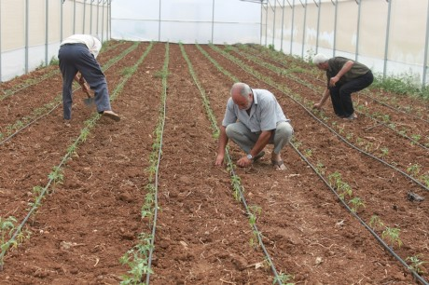

Mohammad Hamad , 57 years and Adnan El Ali, 37 years, two farmers in Halba explained that there was almost an 80% difference realized between the old types of greenhouses and new advanced ones, “ these new conservatories are higher in length which allow better ventilation to the crops and more space to grow, since the old types of houses used more than 1 meter on each side and provided less space for the plants to develop, also the extra door at the entrance forbids harmful insects to enter and ruin the harvest.” They added: “We are so thankful for the contribution provided by UNDP and the Spanish government. We were barely surviving before, but now we have a chance to live and enjoy our work.”

The term “programme” is used for programmes, joint programmes and projects.
Strategic Results, as formulated in the Strategic UN Planning Framework (e.g. UNDAF) or project document;
The MPTF Office Project Reference Number is the same number as the one on the Notification message. It is also referred to as “Project ID” on the project’s factsheet page the MPTF Office GATEWAY
The MPTF/JP Contribution is the amount transferred to the Participating UN Organizations – see MPTF Office GATEWAY
The start date is the date of the first transfer of the funds from the MPTF Office as Administrative Agent. Transfer date is available on the MPTF Office GATEWAY
As per approval of the original project document by the relevant decision-making body/Steering Committee.
If there has been an extension, then the revised, approved end date should be reflected here. If there has been no extension approved, then the current end date is the same as the original end date. The end date is the same as the operational closure date which is when all activities for which a Participating Organization is responsible under an approved MPTF / JP have been completed. As per the MOU, agencies are to notify the MPTF Office when a programme completes its operational activities. Please see MPTF Office Closure Guidelines.
Financial Closure requires the return of unspent balances and submission of the Certified Final Financial Statement and Report.
Most of these farmers are either olive farmers or greenhouse farmers.
Note: Outcomes, outputs, indicators and targets should be as outlines in the Project Document so that you report on your actual achievements against planned targets. Add rows as required for Outcome 2, 3 etc.

