LRF Quarterly PROGRESS REPORT

Reporting UN Organization | : | United Nation Development Programme (UNDP)
Country | : | Lebanon
Project No. | : | 00086602
Project Title | : | Reviving Farmers’ Livelihood in South Lebanon
LRF Signature date | : | 13/5/2013
Project Start date | : | 22/5/2013
Reporting Period | : | July - September 2014

List of Acronyms:

BOQ: Bill of Quantities
CDR: Council of Development and Reconstruction
MoA: Ministry of Agriculture
MoN: Municipality of Nabatieh
TOR: Terms of Reference
UNDP: United Nations Development Program

I. PURPOSE

The overall aim of the project is to sustain and strengthen the agricultural sector and support rural development in South Lebanon, specifically in Nabatieh Muhafazat. The project will contribute to the expansion of livelihood opportunities for vegetable farmers in South Lebanon through the establishment of a market place. This will contribute to reducing transaction costs and strengthen access to extension services to improve post-production stages which are at the heart of sector’s vulnerability. The project will benefit 426,000 Lebanese residents, including 8,000 fruit and vegetable producers, and will serve as a pilot model to be replicated in other rural areas in Lebanon.

The project aims at reducing farmer poverty and vulnerability in South Lebanon, focusing on Nabatieh as a pilot area. The immediate overall objective of the project is to promote rural development and alleviate poverty through overcoming agricultural constraints and assisting the small and poor farmers in reducing the production costs, increasing its quality and overcoming post-harvesting barriers. The integrated intervention will serve a double purpose:

- The establishment of a wholesale vegetable and fruit farmers’ market in Nabatieh city granting a safe and regulated place for the direct sale by the farmers,
- The provision of essential extension services to improve post-production stages.

The main partners involved are:

The Ministry of Agriculture: will be responsible to equip, operationalize, and manage the extension service center inside the market. The added value of establishing extension services in the market itself is the direct contact with the farmers, acting as a one-stop-shop, which will help in providing them with the solutions to their needs without any additional cost, and to work on the quality standards of the crops. The Ministry of Agriculture will also equip and manage the storage and the refrigeration unit. Lastly, it will also control the space of the organic farming part which will not only serve organic farmers in the Mohafazat of Nabatieh, but also bring benefits to other farmers from South Lebanon and other areas, since this kind of facility is not available anywhere else in the South.

The Municipality of Nabatieh will be responsible for the whole operational management of the market.

UNDP will capitalize on its comparative advantage and established experience in supporting and developing national capacities to provide technical training and advisory services to the market managerial board, in addition to overseeing procurement and the market’s autonomy according to its standards and regulations, built on best practices.

II. RESOURCES

Total budget approved: | 700,000 USD
Total disbursements: | 154,289.13 USD
Commitments for next quarter: | 78,520.27 USD
Available Balance: | 467, 190.60 USD

CATEGORY | TOTAL BUDGET  (USD) | TOTAL EXP  (USD) to Date
1. Staff and other personnel | 79,950 | 55,709.32
2. Supplies, Commodities, Materials | 15,000 | 0
3. Equipment, Vehicles, and Furniture (including Depreciation) | 30,250 | 0
4. Contractual services | 492,000 | 76,859.73
5. Travel | 0 | 0
6. Transfers and Grants to Counterparts | 0 | 0
7. General Operating and other Direct Costs | 37,005.61 | 11,626.40
Sub-Total Programme Costs | 654,205.61 | 144,195.45
8. Indirect Support Costs 7% | 45,794.39 | 10,093.68
TOTAL | 700,000 | 154,289.13

III. RESULTS

Expected result 1: A farmers’ market in Nabatieh city is established:

- Establishment of the farmers’ market in Nabatieh

UNDP HQ approved TOR and maps, and the bid was posted online on the UNDP website. The deadline for submitting the offers was on the 27th of May 2014. Interested bidders contacted the Project Manager and executed site visits to get clarifications and be able to respond to the identified technical specifications. On the deadline, 8 companies submitted the technical and financial proposals, of which 4 offers were rejected during the preliminary examination due to the below reasons:

BID 2 | Kabboud for Construction | Missing Implementation Timetable, No List of Shareholders, No Ranking from CDR or MPW, No CV of Staff, No Financial Statements, Some Reservations and additions to the BOQ
BID 6 | LED | Missing Implementation Timetable, No Ranking from CDR or MPW, No Financial Statements, No Certificate of Latest Tax Payment, No Method Statement
BID 4 | United Infrastructure | No Ranking from CDR or MPW, No Certificate of Latest Tax Payment, No Organigram CV of Staff
BID 1 | Delta Eng | Missing Implementation Timetable, No Organigram, No CV of Staff, No Company Profile, No Financial Statements, No Method Statement

The panel members are:

1. Nada Sweidan, UNDP Programme Officer
2. Hussein Nasrallah, UNDP Project Manager
3. Vatche Boyadjian, UNDP Engineer - Consultant
4. Mirvat Hammoud, UNDP Procurement Associate

The panel evaluated the four technically responsive offers and ranked the companies as follows:

Name of Offerors | Country of Origin | Technical compliance (“Yes/No”) | Original Offer  Price excluding VAT (US$) | Final/ Corrected Price excluding VAT (US$) | Ranking
1. MEAMAR for Engineering and Development S.A.R.L. | Lebanon | Yes | US$ 768,221.11 | US$ 768,569.83 | 1
2.Lebanese Engineering Masonry Co. “LEMCO” | Lebanon | Yes | US$ 926,836.20 | US$ 926,836.20 | 2
3. Hanna Khoury and Brothers Co. s.a.r.l | Lebanon | Yes | US$ 1,071,858.00 | US$ 1,071,858.00 | 3
4. Al Bonyan Co. for Engineering and Contracting | Lebanon | Yes | US$ 1,085,051.00 | US$ 1,226,017.00 | 4

MEAMAR for Engineering and Development S.A.R.L is a Lebanese limited liability company specialized in contracting, operating since 1988 with an annual turnover of USD 15.6 million in 2012 and USD 17.6 million in 2013. MEAMAR has an Attestation/Certificate from the Ministry of Public Works as a Class B Buildings prequalified contractor by the ministry and an Attestation/Certificate from the CDR confirming that MEAMAR is prequalified by CDR for more than 1 million USD projects. MEAMAR latest projects include: Solid Waste Treatment Plant in Nabatieh, Al Fakiha School and Public Gardens in Ghobairy. MEAMAR has 56 registered staff. The proposed project team consists of registered engineers. It is important to highlight that the evaluation was cleared by UNDP HQ after a thorough review and clearance of an independent engineer.

After several technical meetings with MEAMAR Company, they submitted all maps and documents requested by the UNDP engineer. The construction started by the beginning of September 2014 and all excavations works are finished. Furthermore, weekly visits to the site are being carried out by the UNDP engineer and Project team to ensure the full implementation of the project. UNDP Engineer is following up closely with MEAMAR on the advancements and implementation of the project on the ground. There is a close attention to all technical aspects of the projects from structural, electrical, mechanical and electrical details. The latest results achieved on the construction site are the following: excavations and foundation construction completed in block B, first floor columns erected in block C and lastly, excavations completed and foundations ongoing in block D. In addition, discussions with the Municipality of Nabatieh took place to agree on the preliminary list of equipment to be purchased. The following pictures provide a visual on the progression of the project:

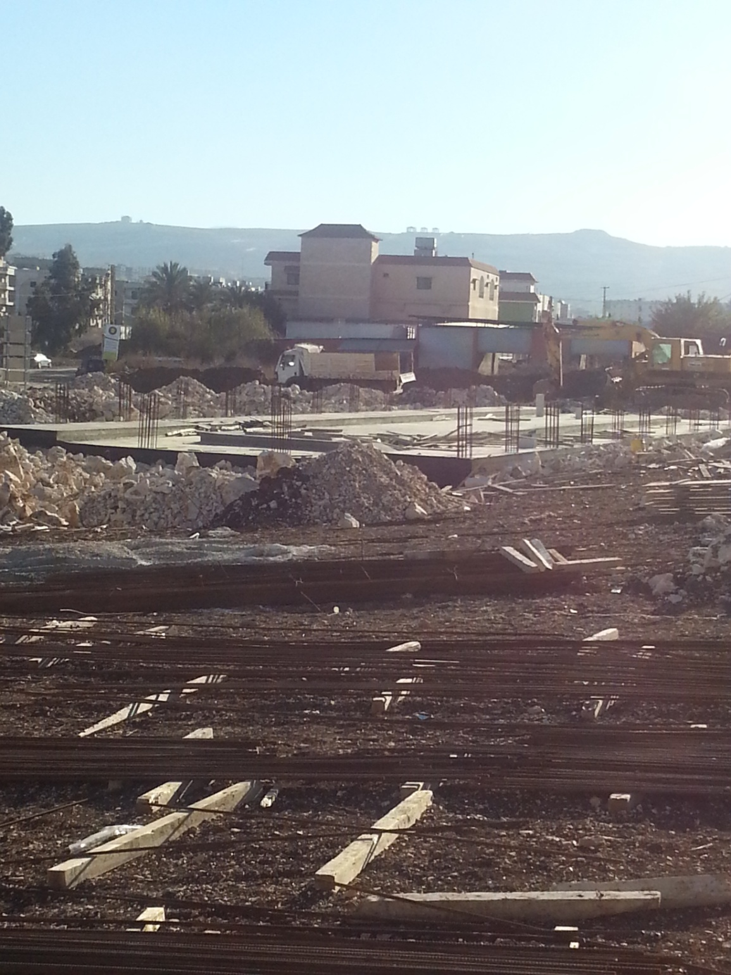
Figure 1 - Block B: Excavations and foundation construction completed

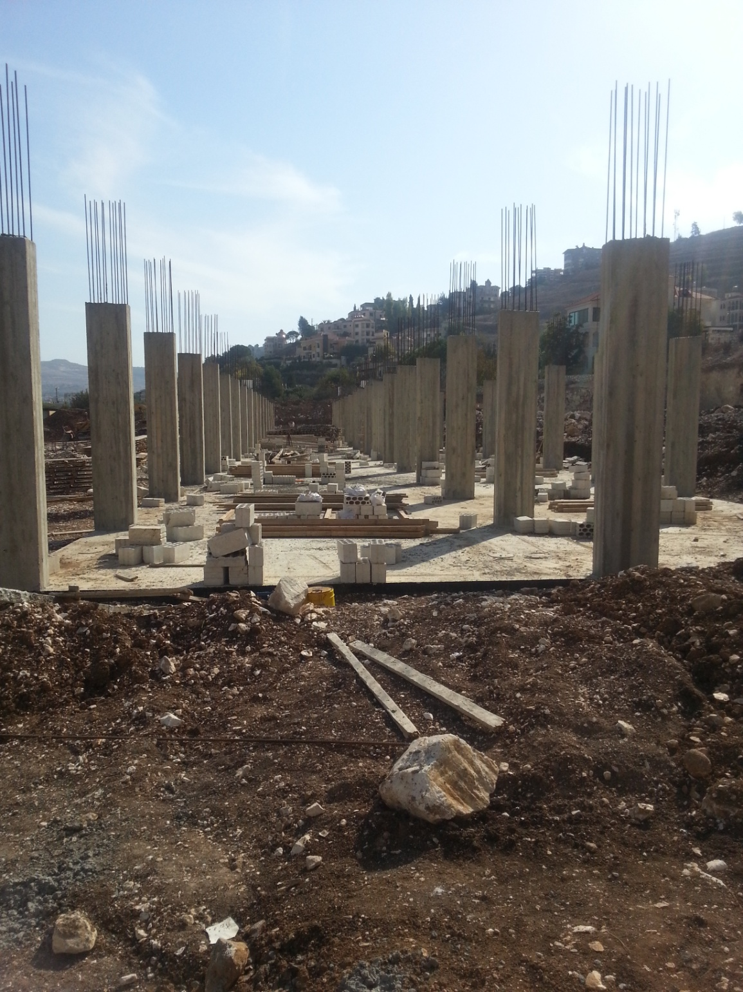
Figure 2 - Block C: Excavations and foundation construction completed. First floor columns erected.

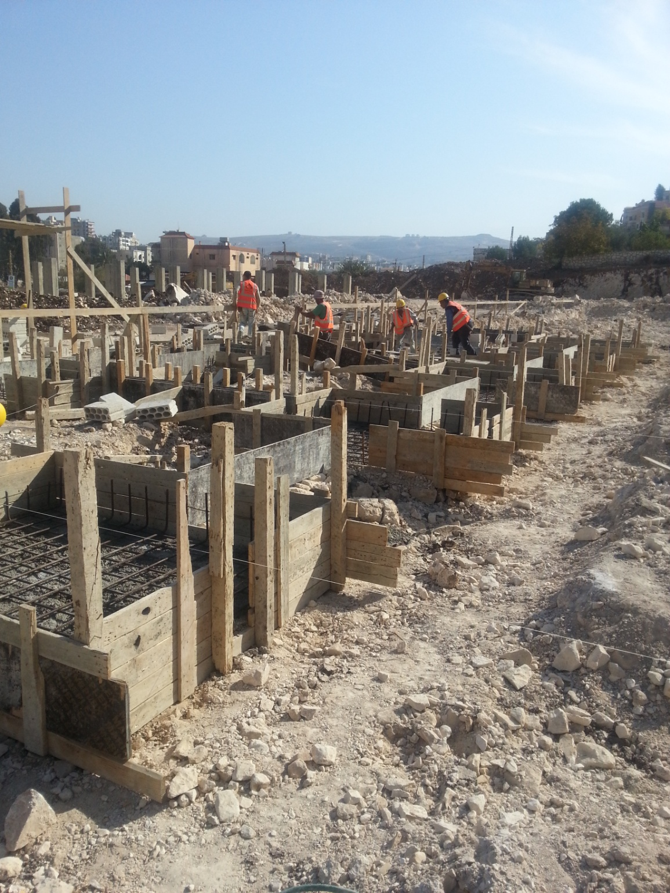
Figure 3 - Block D: Excavations completed, Foundations ongoing

Expected result 2: Access to agricultural extension services is improved:

A visit to the Minister of Agriculture (Mr. Akram Chehayib) took place on August 8, 2014 to update him on the works progress and to discuss the activities that the Ministry of Agriculture should implement:

- The provision of the cooling room inside the market. The Minister gave instructions to the Ministry’s employees to start preparing for the activity.
- The Minister further asked his team to work closely with UNDP and MoN to identify the training themes and process accordingly.
- The Minister expressed his interest in the project and the importance of such market to support the farmers, and asked UNDP for the replication of this important project in other regions of Lebanon.

Discussions took place with the MoN regarding the formulation of the Management Board and agreed that the board should consists of representatives from:
- UNDP,
- Municipality of Nabatieh
- Ministry of Agriculture
- Syndicate of fruits and vegetable traders in Nabatieh
- Fruit trees farmers
- Vegetables farmers
- Cooperatives

Progress in Project Implementation:

 | Achieved Indicator Targets | Reasons for Variance with Planned Target (if any) | Source of Verification
Outcome 1  Indicator:  Baseline:  Planned Target: | Local governance structures in target under-served regions strengthened for better representation, participation, and basic local services delivery
Output 1.1 Capacities of institutions, local authorities and community groups strengthened for effective formulation and implementation of social, environment and economic development plans in South Lebanon  Indicator 1.1.1  Baseline:  No farmers’ market is available in the region  Planned Target:  - Establishment of a wholesale vegetable and fruit farmers’ market in Nabatieh.  - At least 175 farmers will benefit from the market. | Activity 1: A farmers’ market in Nabatieh is established  Preparation of technical feasibility study for the market site  - Procurement process finalized and MEAMAR signed the contract with UNDP.  Establishment of the farmers’ market in Nabatieh  - Several technical meetings with MEAMAR company were held  - MEAMAR submitted all maps and documents requested by UNDP engineer  - Excavations works finished and construction started  - Weekly visits to the site  - Preliminary list of equipments prepared with the Municipality for procurement | - Maps were changed based on the request of the Minister of Agriculture.  - The BOQs were changed based on the available budget for constructing the market
Output 1.2 Access to agricultural extension services is improved  - Extension services accessible to farmers.  - At least 4 thematic and technical trainings will be conducted | - Meeting with the Minister of Agriculture  - Several meetings with representative of MoA in Nabatieh  - 4 thematic and technical trainings were specified (12 sessions in total to cover 4 Caza):  - Post-harvest technologies  - Farm Management  - Marketing  - Cooperatives Management  - Selection of farmers to be trained by the MoA  - Preparation for the management board formulation

Implementation Constraints and Lessons Learned during this quarter:

Delays are expected in construction works completion due to the following reasons:
- The approval of TOR and maps from UNDP HQ was delayed
- MEAMAR started the works mid of August 2014
- The security situation in the area before and after Ashoura restricted the movement of the workers
- To ensure proper delivery and installation of the requested equipment, the procurement process should be delayed until the construction works are finalized.

IV. FUTURE WORK PLAN

Outputs | Year 2014 |  |  | Year 2015
Outputs | October | November | December | January | February | March
Capacities of institutions, local authorities and community groups strengthened for effective formulation and implementation of social, environment and economic development plans in South Lebanon | Construction works | Construction works | Construction works  Establishment of information Centre in the market | Construction works  Establishment of storage and refrigerating facility  Thematic and technical trainings for farmers and cooperatives | Finalization of all construction works  Procurement of equipment | Official Launching of the Market  The Market is operational

Figures from the Agricultural Census 2011, Ministry of Agriculture and FAO

