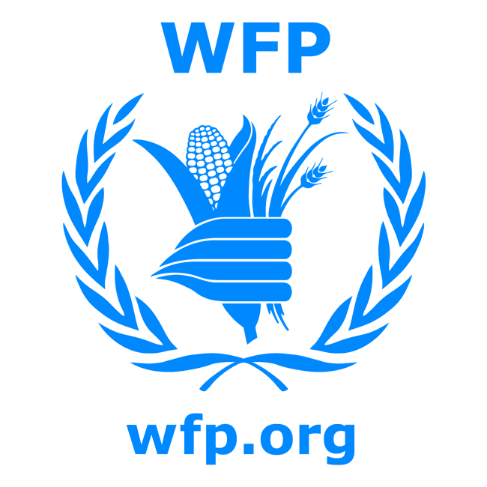
[Name of Fund or Joint Programme]
MPTF OFfice GENERIC finalprogramme NARRATIVE report
REPORTING PERIOD: from 07.2011 to 12.2013
Programme Title & Project Number |  |  | Country, Locality(s), Priority Area(s) / Strategic Results
- Programme Title: Strategic Grain Reserve in South  Sudan  - Programme Number (if applicable) PBF/ IRF-43: Project ID 00079635  - MPTF Office Project Reference Number: 00079635 |  |  | (if applicable)  Country/Region  South Sudan
Priority area/ strategic results
Build a Strategic Grain Reserve in South Sudan to be nationally prepared to effectively respond to emergency; to support safety net programs for the poor and early revitalization of the economy specifically the agriculture sector.

Priority Areas 3 and 4

Participating Organization(s) |  |  | Implementing Partners
- World Food Organization (WFP) |  |  | - Government of South Sudan  - International Food Policy Research Institute (IFPRI)  - Food and Agriculture Organization (FAO)  - National Bureau of Statistics (NBS)  - Famine Early Warning System Network (FEWS NET)  - Private Sector Contractors
Programme/Project Cost (US$) |  |  | Programme Duration
Total approved budget as per project document: $93,340,135  MPTF /JP Contribution: $1,990,200  - by Agency (if applicable) |  |  | Overall Duration (months)29  Start Date 27.07.2011
Agency Contribution  - by Agency (if applicable) |  |  | Original End Date (dd.mm.yyyy) 14.07.2014
Government Contribution  (if applicable) |  |  | Actual End date 31.12.2013  Have agency(ies) operationally closed the Programme in its(their) system? | Yes No
Other Contributions (donors) Embassy of Norway: $2,500,000  (if applicable) |  |  | Expected Financial Closure date: 30/5/14
TOTAL: $4,490,200
Programme Assessment/Review/Mid-Term Eval. |  |  | Report Submitted By
Evaluation Completed  Yes No Date: dd.mm.yyyy  xx  Evaluation Report - Attached  Yes No Date: dd.mm.yyyy |  |  | - Name: Eddie Rowe  - Title: Deputy Country Director, Operations  - Participating Organization (Lead): WFP  - Email address: eddie.rowe@wfp.org

FINAL PROGRAMME REPORT FORMAT

EXECUTIVE SUMMARY
The strategic grain reserve project which became later the National Strategic Food Reserve as the government wanted it to be a facility for the storage, handling and management of any food commodity aimed at stimulating the agricultural sector and preparing the government for an effective response to emergencies. The project managed to bring together stakeholders in the agricultural sector to discuss how best to implement and manage a food security information systems for an effective food reserve. Fifty staff from the government of South Sudan benefitted from training on the job and in a workshop setting in country and outside. The funding from PBF was relevant in hiring WFP staff to manage the project and catalytic is securing funding from the Norwegian Embassy to implement the capacity building component of the project. The government of South Sudan through four ministries, participated in the five thematic working groups related to (a) Food security and vulnerability analysis (b) Trade and market monitoring (c) Rainfall monitoring, production of crop production estimates, and national food balance sheet preparation (d) Crop production and productivity (e) Early warning for an evidence based food security information systems for the national strategic grain reserve. The Food and Agriculture Organization (FAO) and the International Food Policy Research Institute (IFPRI) collaborated with WFP for the implementation of the capacity building on food security information on one hand and the food reserve policy preparation on the other hand. The war that broke in South Sudan and limited, delayed funding have impacted the achievements of the project objectives.

Purpose
The project aimed to build a Strategic Grain Reserve (SGR) in South Sudan to be nationally prepared to effectively respond to emergency; to support safety net programs for the poor and early revitalization of the economy specifically the agriculture sector.

After almost three years of the birth of South Sudan as an independent country, the nation continues to face a series of humanitarian emergencies while major development challenges remain. The new state is still characterized by a continued lack of agreement on key issues such as border demarcation, oil transit fees, and the fate of the contested area of Abyei with Sudan. South Sudan also continued to face other major challenges as it sought to improve internal security, build state capacity and enable the shift from emergency relief to recovery. Inter-communal clashes and rebel militia activity continued to destabilize communities, disrupt agricultural production, livelihoods and education and increasing vulnerability. Resultantly, the humanitarian situation in South Sudan also deteriorated sharply due to the combination of political-economic shocks, increased conflict and displacement, and worsening food insecurity.

Faced with a multiplicity of needs that are enormous both in scale and complexity, the new government is impelled to show immediate progress in political and security sector reform, addressing underlying grievances that led to the conflict, and supporting the needs of conflict-affected populations including returnees, displaced populations and resident communities. However, the legacy of protracted civil war has left South Sudan with one of the biggest capacity gaps in Africa. Public infrastructure remains severely under-developed; rule of law weak and government capacity to provide basic services low.

Developing and stimulating economic diversification and agricultural growth are key development objectives to step out from oil dependency guaranteeing longer-term sustainable development for the country. The Government and experts agree that the key to solving oil dependence and reducing food insecurity in South Sudan is to develop a robust and vibrant agricultural sector. A project such as the National Strategic Food Reserve without doubt plays significant role to address food insecurity.

To support the government in achieving these objectives, WFP launched, in July 2011, a three-year Special Operation (SO 200267) for the establishment of a Strategic Grain Reserve to be handed over to the Government of South Sudan in the final year of implementation. The project, with an overall budget of US$97 million, included building five warehouses with a total capacity of 100,000 MT as well as developing the administration and logistics capacity of the Government of South Sudan to operate the reserve.

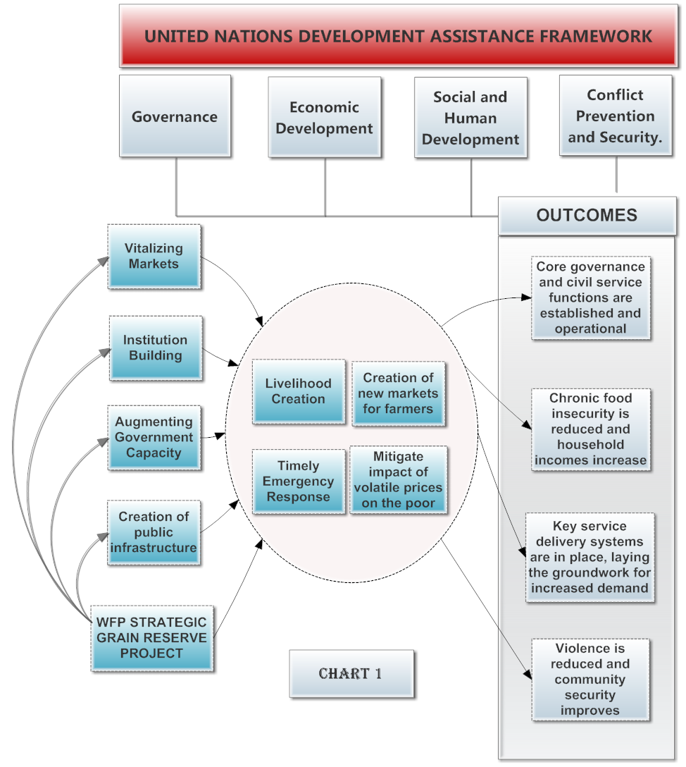
Chart 1 draws out the linkages between the objectives of the Strategic Grain Reserve and their relationship to the pillars and objectives of the United Nations Development Assistance Framework (UNDAF) for South Sudan. There is also cross cutting alignment with the South Sudan development framework 2012-2013. In South Sudan, humanitarian agencies and commercial actors have to rely on congested ports to import food and are usually faced with a lack of transport capacity thereby increasing the lead time of bringing much needed food supplies. In a humanitarian emergency, these delays can be life threatening. The Strategic Grain Reserve can help to provide the needed food commodities to the Government and humanitarian partners in a timely and cost effective manner.

While the strategic grain reserve is envisaged as a safety net institution for ensuring timely and effective response to food emergencies, it can also play a role in post-conflict recovery stimulating agriculture development, promoting smallholder farming, creating employment opportunities and shared peace dividends, consolidate government authority building the condition for broad based economic growth.

Sustainable solutions to food insecurity call for enhanced institutional capacity of the government, and in the context of South Sudan, where inadequate human and institutional capacities pose major challenges, building infrastructure without strengthening the necessary government institutional capacity to effectively manage the grain reserve will jeopardize the sustainability of the system. Cognizant of this, WFP, after extensive consultations with the Government of the Republic of South Sudan (GRSS), technical partners, donors and development partners in 2012, has revised the orientation of the Strategic Grain Reserve Special Operation to give precedence to building a conducive policy environment and strengthening the government’s institutional capacity to manage effective food security information systems that are crucial for evidence-based decision making when the Strategic Grain Reserve becomes operational first as a pilot and later on scaled-up based on lessons learned.

Assessment of Programme Results

- Narrative reporting on results:

- Outcomes:

Priority area 3: Revitalize the economy, particularly the agricultural sector and immediate peace dividends
The project managed to gather a wide range of players in the South Sudanese agricultural sector to discuss the potential for smallholder farmers to channel their produce to a guaranteed market such as a grain reserve. However, lack of resources prevented WFP and the government for building the necessary infrastructure to receive and store grains from the producers.

Priority area 4: To be nationally prepared to effectively respond to emergency through building government services and related technical human capacities
There has been a staff capacity gap assessment within the ministries of agricultural, gender, social services and humanitarian affairs and the national bureau of statistics and trainings in areas of food security information systems for an effective evidence based decision making on the implementation and replenishment of a strategic grain reserve. Late funding and late implementation of the project due to delayed staffing/staff mobility affected the timely implementation of capacity building plan; therefore, less than planned staff were trained on food security information systems. Austerity measures set by the government in 2012 led to the government not committing the resources promised at the preparation stage of the project.

- Outputs:
Five central warehouses and twenty satellite depots with a capacity of 100,000 metric tons built and filled with grain of good quality: none of the warehouses or the satellite depots were built as planned since funding from other donors or from the government of South Sudan were secured as expected. By mid-2012, an alternative plan was to use government owned buildings to be converted into storage facilities and therefore downsize the project to a pilot level. This plan never materialized either since the government never provided such facilities.

Five thematic Working Groups - (a) Food security and vulnerability analysis (b) Trade and market monitoring (c) Rainfall monitoring, crop production estimates, and national food balance sheet preparation (d) Crop production and productivity (e) Early warning - comprised of relevant government institutions and international NGOs and technically led by WFP, FAO and Famine and Early Warning System (FEWS NET), carried out assessments of the Government’s institutional capacity in food security information systems. Plans were developed to strengthen the Government’s capacity to establish and manage robust food security information systems to inform appropriate responses.

Training on how to extract and analyze data from different surveys was provided to 4 key staff from the Ministry of Agriculture, Forestry, Tourism, Animal Resources, Fisheries, Cooperatives and Rural Development (MAFTARFCRD) – Department of Planning staff working on the South Sudan Comprehensive Agricultural Management Policy (CAMP). To strengthen the National Bureau of Statistics (NBS)’s capacity in National Food Balance Sheet preparation, four staff members from the Economic Statistics Unit were trained on the compilation of agricultural sector data for inclusion in Gross Domestic Product (GDP) calculations using NBS’s household expenditure data and the Crop and Food Security Assessment Mission (CFSAM) report. To help support efforts towards equipping the Government with the capacity to design an agricultural statistics system that is harmonized with international standards, 2 staff from the MAFTARFCRD – Department of Planning and NBS participated at an agricultural statistics conference held in Morocco 2013.

Assistance was also provided to NBS in designing questionnaires on the agricultural sector for inclusion in the 2014 population census to provide a comprehensive agriculture baseline data. A week-long intensive training was given to 40 technical staff from MAFTARFCRD, NBS, Ministry of Gender, Child, Social Welfare, Humanitarian Affairs and Disaster Management and the planning departments of State Ministries of Agriculture with the objective of improving the agricultural statistics data management system guided by the General Data Dissemination System (GDDS) framework.

The Special Operation, in collaboration with the International Food Policy Research Institute (IFPRI), carried out widespread consultations on the strategic grain reserve policy framework formulation. The consultations were critical in ensuring the involvement of key government and development stakeholders in the process. The WFP-IFPRI team also undertook a reconnaissance mission to Yei and Kaya (Western Equatoria) in preparation for the grain market assessment planned for January 2014.

- INDICATOR BASED PERFORMANCE ASSESSMENT
- Qualitative assessment:

The SGR project has been a government initiative and its implementation was overseen by an inter-ministerial Technical Working Group (TWG), which was chaired by the Under Secretary of MAFTARFCRD. To ensure sustainability, the design process has been consultative from the beginning and emphasis was given to building the government’s institutional capacity and putting in place a policy framework that guides the effective establishment and management of the SGR. A high-level consultative meeting was convened in March 2012 to reach a common understanding on the role of the grain reserve in addressing food insecurity and develop a road map. In April 2012, an Inter-Ministerial Technical Working Group was established to oversee the establishment of the reserve and facilitate coordination within the government line ministries. WFP was designated the group’s Technical Lead and Secretariat. In May 2012, a resolution to establish the National Strategic Food Reserve (NSFR) in South Sudan was passed by the Council of Ministers. The government wanted the orientation of the reserve to be for any food commodity and therefore recommended the project to be converted from grain reserve to National Strategic Food Reserve. In June 2012, WFP and the Government of the Republic of South Sudan held a high-level meeting, “National Strategic Food Reserve – Concept to Action,” to articulate the role of the NSFR in addressing food insecurity in South Sudan and develop a roadmap for its realization, including the roles of key stakeholders - the government, donors and development partners.

The TWG identified five thematic areas, (a) Food security and vulnerability analysis (b) Trade and market monitoring (c) Rainfall monitoring, production of crop production estimates, and national food balance sheet preparation (d) Crop production and productivity (e) Early warning, where GRSS lacks the required capacity to support effective NSFR management. Five Thematic Working Groups comprising of technical experts from relevant government ministries, UN and other international organizations were established to play a key role in identifying the government’s institutional capacity gaps and developing a capacity building implementation plan for the five thematic areas in food security information systems.

An induction workshop was held in November 2012 to formalize the Thematic Working Groups, and under the technical leadership of WFP, FAO and FEWS NET, the groups developed their Terms of References and embarked on the government institutional capacity gap assessment to prepare a comprehensive capacity building implementation plan.

WFP secured funding in the amount of $2,500,000 from the Embassy of Norway in Juba in 2012 for the implementation of the strategic grain reserve in South Sudan.

Two separate agreements were signed by WFP with FAO and IFPRI in 2013 in an effort to implement the NSFR project by working in synergy based on complementarities of mandates and competencies. The partnership with FAO was/is still focused on the food security information systems capacity building, particularly in the thematic area of rainfall monitoring, crop forecasting and national food balance sheet preparation. The joint collaboration with IFPRI was focused on providing support to the Government to develop the NSFR policy for the effective and sustainable management of the NSFR. While close to 40% of the planned work under the FAO agreement was completed at the time of the report, the work by IFPRI was still in its infancy since the formal agreement was signed only in November 2013, a month before the war began in South Sudan.

WFP also had preliminary discussions with the South Sudan Food Security Council (FSC) to identify ways of collaboration on the NSFR project. The FSC, which was established in 2012 by Presidential decree, has the mandate of ensuring overall alignment and harmonization of food security initiatives in various government ministries, commissions, private sector and development partners.

ii) Indicator Based Performance Assessment:
Using the Programme Results Framework from the Project Document / AWPs - provide details of the achievement of indicators at both the output and outcome level in the table below. Where it has not been possible to collect data on indicators, clear explanation should be given explaining why.

 | Achieved Indicator Targets | Reasons for Variance with Planned Target (if any) | Source of Verification
Outcome 1  Revitalize the economy, particularly the agricultural sector and immediate peace dividends  Indicator: Increased agricultural productivity in areas and improved/expanded access to market by smallholder farmers  Baseline: none  Planned Target: Construction of five strategic grain reserve complexes, 20 satellite warehouse facilities | Not achieved | The lack of commitment and funding from donors and the government of South Sudan is the main reason for not meeting the targets.
Outcome 2  Be nationally prepared for food emergencies or food price volatility, thus reducing hunger and vulnerability to hunger in the longer-term through building essential government services and related technical and human capacities  Indicator: strategic grain reserve staff are trained and demonstrating the capacity to manage the reserve  Baseline: zero staff  Planned Target: Capacity building of 110 civil servants to maintain and manage the administration and operations of the grain reserves. | Fifty staff from government ministries trained on food security information systems. | The lack of commitment and funding from donors and the government of South Sudan is the main reason for not meeting the targets. | SGR standard project report  FAO project report
Output 1.1  Indicator 1.1.1  Baseline: zero storage capacity  Planned Target: Construction of five strategic grain reserve complexes, 20 satellite warehouse facilities and capacity building of the civil servants to maintain and manage the administration and operations of the grain reserves.  Indicator 1.1.2  Baseline:  Planned Target: Bagging, cleaning and drying equipment, supplies and warehouse materials | Not achieved | The lack of commitment and funding from donors and the government of South Sudan is the main reason for not meeting the targets.
Output 1.2
Indicator 1.2.1
Baseline:
Planned Target:

Indicator 1.2.2
Baseline:
Planned Target:

iii) Evaluation, Best Practices and Lessons Learned
A formal assessment of the programme has been overlooked at the preparation phase of the project. However, given the challenge in securing funding from the government and other donors, WFP undertook an analysis of the situation with key stakeholders in 2012 to redefine the direction of the progrmme. Emphasis was put on addressing capacity gap in food security information systems of the government staff. Such undertaking had also its own challenges. The initial plan was that the government would hire one hundred and ten civil servants to serve on the grain reserve. This was not possible since the physical infrastructure was not in place. Developing the capacity of the existing staff within the government was difficult since their capacity was stretched (time and skills). They were handling several projects with various donors and therefore their availability had to be negotiated. WFP offered to he government to hire two staff that would be paid from the project’s budget and work closely with the staff within the government premises; unfortunately there was no space available and the government never signed the memorandum of understanding prepared and submitted by WFP for such collaboration.

It was also established that the initial design of the programme was too ambitious for an emerging country. A decision was made to close the project earlier than initially planned to complete the focus on capacity building with the available resources. A new proposal was prepared and ready to go through the WFP review process for a smaller grain reserve with a total capacity of less than 30,000 metric tons and with less satellite depots. The war that broke in South Sudan in December 2013 has impacted on the finalization of the new plan. South Sudan’s current priorities are on ensuring peace, security and emergency relief for the entire nation.

There has been a tremendous effort from the government, partners and UN agencies (WFP and FAO) to undertake the capacity development activities in food security information systems. South Sudan is a young nation where the lack of adequate infrastructure remains a challenge that the government should overcome as it plans to establish a strategic food reserve. As the NSFR project is government initiated and owned, to ensure its sustainability, the government has to proactively mobilize resources and earmark funds for the construction and improvement of the physical infrastructure. Earmarking funds is also critical for the regular replenishment of the food reserve. Therefore, for WFP and partners to successfully such a project, a firm commitment of resources at a minimum of 50% of total expenditures should be demonstrated from the start. From WFP side, it was noticed that the strategic grain reserve had almost the same objectives as the Purchase for Progress (P4P) and therefore we were running two similar projects which could be merged and therefore benefit from concentrated resources and efforts.

iv) A Specific Story (Optional)
Not available

The term “programme” is used for programmes, joint programmes and projects.
Strategic Results, as formulated in the Strategic UN Planning Framework (e.g. UNDAF) or project document;
The MPTF Office Project Reference Number is the same number as the one on the Notification message. It is also referred to as “Project ID” on the project’s factsheet page on the MPTF Office GATEWAY.
The MPTF/JP Contribution is the amount transferred to the Participating UN Organizations – see MPTF Office GATEWAY
The start date is the date of the first transfer of the funds from the MPTF Office as Administrative Agent. Transfer date is available on the MPTF Office GATEWAY
As per approval of the original project document by the relevant decision-making body/Steering Committee.
If there has been an extension, then the revised, approved end date should be reflected here. If there has been no extension approved, then the current end date is the same as the original end date. The end date is the same as the operational closure date which is when all activities for which a Participating Organization is responsible under an approved MPTF / JP have been completed. As per the MOU, agencies are to notify the MPTF Office when a programme completes its operational activities. Please see MPTF Office Closure Guidelines.
Financial Closure requires the return of unspent balances and submission of the Certified Final Financial Statement and Report.
Note: Outcomes, outputs, indicators and targets should be as outlines in the Project Document so that you report on your actual achievements against planned targets. Add rows as required for Outcome 2, 3 etc.

