RUNO ANNUAL PROJECT REPORT TEMPLATE 4.4
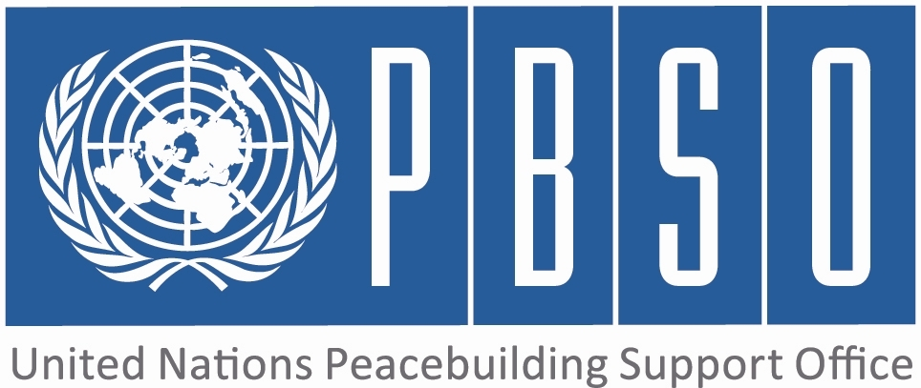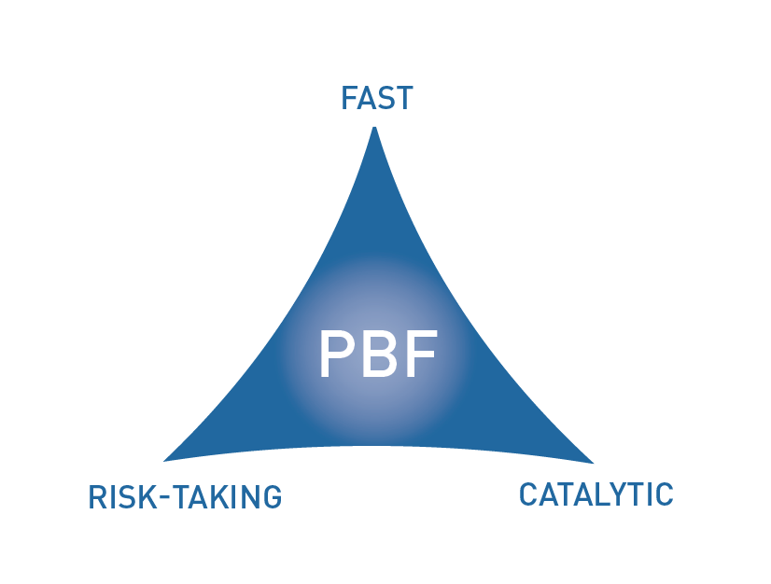

PEACEBUILDING FUND (PBF)
ANNUAL PROJECT progress report
COUNTRY: Kyrgyzstan
REPORTING PERIOD: 1 january – 31 December

Programme Title & Project Number
Programme Title: PBF/KGZ/A3 Building Trust and Confidence Among People, Communities and Authorities (Part 2 - PPP Outcome 2)

Programme Number (if applicable)
MPTF Office Project Reference Number: 00088540

Recipient UN Organizations |  |  | Implementing Partners
List the organizations that have received direct funding from the MPTF Office under this programme: UNHCR |  |  | List the national counterparts (government, private, NGOs & others) and other International Organizations: Government: Ombudsman's Office, Department of Local Self-Government and Interethnic Relations  NGOs: PU Abad, Spravedlivost, FTI
Programme/Project Budget (US$) |  |  | Programme Duration
PBF contribution (by RUNO) 1,073,287 |  |  | Overall Duration (months) 24
 |  |  | Start Date (dd.mm.yyyy) 01/01/2014
Government Contribution  (if applicable) |  |  | Original End Date (dd.mm.yyyy) | 31/12/2015
Other Contributions (donors)  (if applicable) |  |  | Current End date(dd.mm.yyyy) 31/12/2015
TOTAL: | 1,073,287

Programme Assessment/Review/Mid-Term Eval. |  | Report Submitted By
Assessment/Review - if applicable please attach  Yes No Date:  Mid-Term Evaluation Report – if applicable please attach  Yes No Date: |  | Name: Christian Langehenke  Title: Associate Protection Officer  Participating Organization (Lead): UNHCR  Email address: langehen@unhcr.org

PART 1 – RESULTS PROGRESS

  - Assessment of the current project implementation status and results

For PRF projects, please identify Priority Plan outcome and indicators to which this project is contributing:
Priority Plan Outcome to which the project is contributing. 1 and 2
Priority Plan Outcome indicator(s) to which project is contributing. 1.1;2.1;2.2
For both IRF and PRF projects, please rate this project’s overall achievement of results to date:
For both IRF and PRF projects, outline progress against each project outcome, using the format below. The space in the template allows for up to four project outcomes.
Outcome Statement 1: Under Part 1 of the Project (KGZ/B1)
Output progress
List the key outputs achieved under this Outcome in the reporting period (1000 character limit).Outputs are the immediate deliverables for a project.
Under Part 1 of the Project (KGZ/B1)
Outcome progress
Describe progress made during the reporting period toward the achievement of this outcome. This analysis should reflect the above indicator progress and the output achievement. Is there evidence of the outcome contributing to peacebuilding and to the specific conflict triggers? Is the theory of change that underpins the project design still relevant for this outcome (3000 character limit)?
Under Part 1 of the Project (KGZ/B1)
Reasons for low achievement and rectifying measures
If sufficient progress is not being made, what are the key reasons, bottlenecks and challenges? Were these foreseen in the risk matrix? How are they being addressed and what will be the rectifying measures (1500 character limit)?
N/a
Outcome Statement 2: LSGs, LSGA and other oversight entities are enabled to provide effective feedback/conflict resolution mechanisms for the population and by actively listening to the population, providing impartial feedback and taking remedial measures, thus demonstrating their accountability.
Rate the current status of the outcome:
Indicator 1:  Indicator 2.1  % increase in level of trust to local authorities that they are capable to solve  incidents/grievances/conflicts  Indicator 2:  N/A  Indicator 3:  N/A | Baseline: 30% of focus group respondents point out low problem solving capacity of local self-government entities  Target: 30% increase in trust in conflict solving capacity  Progress: Endline Results: only 15.71 % (or a 50% decrease) of survey respondents point out bad or poor problem solving capacity of LSG  Baseline:  Target:  Progress:  Baseline:  Target:  Progress:
Output progress
List the key outputs achieved under this Outcome in the reporting period (1000 character limit).Outputs are the immediate deliverables for a project.
UNHCR has worked in 26 selected local self-government entities (A/Os). Each local council was supported through trainings on budgeting, legal basics of self-government and land plot allocation. UNHCR IP developed jointly with government partners a collection of applicable legal provisions for local self-government bodies and trained representatives. UNHCR and its government partners jointly selected 107 Peacebuilding Initiatives (PBIs) for implementation in all three southern regions of Kyrgyzstan. As of November 2015, all 107 projects are completed. In 20 Ayl Okmotus (A/O, local self-government entities), open budget hearings were successfully held with the participation of the local population over 2 years. The budget hearings gave citizens the opportunity to influence the spending of their A/O, voice concerns and start a dialogue with A/O representatives. Furthermore, UNHCR (through direct implementation), provided technical support to A/O in all target areas.
Outcome progress
Describe progress made during the reporting period toward the achievement of this outcome. This analysis should reflect the above indicator progress and the output achievement. Is there evidence of the outcome contributing to peacebuilding and to the specific conflict triggers? Is the theory of change that underpins the project design still relevant for this outcome (3000 character limit)?
All measures to enhance the capacity of local self-government entities and increase their role in conflict resolution are aimed to have medium to long term effect. However, there are several hopeful signs for success: All 107 small scale Peacebuilding Initiatives (PBIs) were developed on the local level by working groups with the involvement of local self-government bodies, civil society organizations (e.g. women's councils) and agents of change (e.g. teachers or elders). Each working group was tasked to identify key conflicts in their village and develop a plan to resolve such conflicts. A small project was developed and discussed by a joint government/UNHCR selection committee. In 2014, UNHCR on average contributed USD 3000 while local governments and interest groups co-financed the vast majority of projects. During the second year of implementation, this amount was increase to USD 5000, in exceptional cases USD 10.000. One condition for these PBIs was that a significant portion of the overall budget had to finance through either the regular A/O budget and/or community contributions (both in kind and cash). Due to this requirement, all PBIs received an average of 50% co-funding from target communities which helped to increase ownership and commitment of the local self-government entities. The community based approach enhanced problem solving capacity of both people and their local authorities. Working group meetings served as a forum where problems and conflicts could be both discussed and solved with relatively small financial contributions. Often for the first time, local self-government representatives, interest groups, civil society actors and local population came together to discuss potential conflict resolution strategies. The PBIs addressed the individual conflict resolution needs of the respective communities and include water management projects (both drinking and irrigation water), intercultural dialogue clubs for school students, enhanced capacity of local self-government bodies and delivery of basic services by government entities. Open budget hearings raised citizens' awareness that they are entitled to receive detailed information on expenditures of their A/O. Trainings and awareness raising campaigns on land plot allocation and social benefits involved both government officials and the wider population. Now, both right holders and duty bearers are aware of the legal mechanisms. The technical assistance and the issuance of a legal compendium helped to institutionalize local self-government entities as a capable one stop shop in case of conflict within the community.
Reasons for low achievement and rectifying measures
If sufficient progress is not being made, what are the key reasons, bottlenecks and challenges? Were these foreseen in the risk matrix? How are they being addressed and what will be the rectifying measures (1500 character limit)?
N/a
Outcome Statement 3: Under Part 1 of the Project (KGZ/B1)

Output progress
List the key outputs achieved under this Outcome in the reporting period (1000 character limit).Outputs are the immediate deliverables for a project.
Under Part 1 of the Project (KGZ/B1)
Outcome progress
Describe progress made during the reporting period toward the achievement of this outcome. This analysis should reflect the above indicator progress and the output achievement. Is there evidence of the outcome contributing to peacebuilding and to the specific conflict triggers? Is the theory of change that underpins the project design still relevant for this outcome (3000 character limit)?
Under Part 1 of the Project (KGZ/B1)
Reasons for low achievement and rectifying measures
If sufficient progress is not being made, what are the key reasons, bottlenecks and challenges? Were these foreseen in the risk matrix? How are they being addressed and what will be the rectifying measures (1500 character limit)?
N/a
Outcome Statement 4: N/A

Rate the current status of the outcome:
Indicator 1:  Indicator 2:  Indicator 3: | Baseline:  Target:  Progress:  Baseline:  Target:  Progress:  Baseline:  Target:  Progress:

Output progress
List the key outputs achieved under this Outcome in the reporting period (1000 character limit).Outputs are the immediate deliverables for a project.
N/A
Outcome progress
Describe progress made during the reporting period toward the achievement of this outcome. This analysis should reflect the above indicator progress and the output achievement. Is there evidence of the outcome contributing to peacebuilding and to the specific conflict triggers? Is the theory of change that underpins the project design still relevant for this outcome (3000 character limit)?
N/A
Reasons for low achievement and rectifying measures
If sufficient progress is not being made, what are the key reasons, bottlenecks and challenges? Were these foreseen in the risk matrix? How are they being addressed and what will be the rectifying measures (1500 character limit)?

N/A
  - Assessment of project evidence base, risk, catalytic effects, gender in the reporting period

Evidence base: What is the evidence base for this report and for project progress? What consultation/validation process has taken place on this report (1000 character limit)? | IPs submitted weekly work plans, monthly and quarterly reports. UNHCR staff in all three provinces went on over 250 monitoring visits to verify IP's reports. UNHCR management conducts regular meetings with government partners to verify the project's progress. Through joint UNHCR/government selection committees for legal cases and Peacebuilding Initiatives, all project activities are discussed, agreed and monitored. On a monthly basis, IP coordination meetings are held. A baseline study which includes a perception study, a situation analysis and a migration survey has been conducted, endorsed by government partners and published. Additionally, UNHCR IPs conducted three in-depth analyses of local self-government performance standards. In October and November 2015, UNHCR has conducted an independent endline assessment with the assistance of an external consultant.
Funding gaps: Did the project fill critical funding gaps in peacebuilding in the country? Briefly describe. (1500 character limit) | The direct work on the improvement of conflict resolution capacity of local self-government bodies (community based approach) is generally not well funded and, due to high risks and labor intense implementation not popular with donors. The PRF funding enabled UNHCR to implement a variety of critical interventions that would have been otherwise left unfunded.
Catalytic effects: Did the project achieve any catalytic effects, either through attracting additional funding commitments or creating immediate conditions to unblock/ accelerate peace relevant processes? Briefly describe. (1500 character limit) | Often, local self-government bodies are not fully aware of their duties and the corresponding legal regulations. While preparing open budget hearings, one UNHCR IP liaised with the national Ministry of Finance. The Ministry endorsed the guidebook on financial transparency prepared by UNHCR's IP, which gives clear instruction to local self-government how to publicize budget related information. During a workshop, central government representatives explained the guidelines to locals self-government representatives from all 26 UNHCR peacebuilding locations. It is now planned by the Ministry to use this guidebook nationwide, which demonstrates how small initiatives as part of UNHCR's project can positively affect peacebuilding in Kyrgyzstan since transparency, and openness creates trust which, in turn, will prevent further conflict. It is anticipated that several initiatives that are being piloted during UNHCR's peacebuilding project will reach beyond the south of the country.  Kyrgyz government partners involved in UNHCR's peacebuilding project will continue to employ the community based approach in order to implement peacebuilding initiatives in the future. The State Agency for Local Self-Government and Interethnic Relations has already announced such a funding scheme.
Risk taking/ innovation: Did the project support any innovative or risky activities to achieve peacebuilding results? What were they and what was the result? (1500 character limit) | The close work with government partner without the incentive of large financial contributions entails several risks. Most prominent, the interest and engagement of partners might be lower than expected. High staff turnover also imposes a risk for successful project implementation. However, the close involvement of government representatives through numerous meetings, field visits and the co-financing of projects resulted in a feeling of ownership that helped to mitigate these risks.
Gender: How have gender considerations been mainstreamed in the project to the extent possible? Is the original gender marker for the project still the right one? Briefly justify. (1500 character limit) | Several project activities are directly focused on women. With regard to legal assistance, more than 46 % of the cases involve gender related issues such as marriage registration, divorce, and land plot allocation for single mothers. In addition, the project supports five women information centers in order to enhance education opportunities for women. Overall, women are involved in almost all working groups and play an active (often the main) role during the implementation of Peacebuilding Initiative. Four PBIs solely focused on gender equality and empowerment. The original gender marker is still applicable.
Other issues: Are there any other issues concerning project implementation that should be shared with PBSO? This can include any cross-cutting issues or other issues which have not been included in the report so far. (1500 character limit) | UNHCR has completed all project activities but the legal component (individual legal assistance). The project closure report fill be submitted to PBSO after project liquidation in January 2016. This report will be supplemented by the independent endline assessment which will also be shared with PBSO

1.3 INDICATOR BASED PERFORMANCE ASSESSMENT: Using the Project Results Framework as per the approved project document- provide an update on the achievement of key indicators at both the outcome and output level in the table below. Where it has not been possible to collect data on indicators, state this and provide any explanation in the qualitative text above. (250 characters max per entry)

 | Performance Indicators | Indicator Baseline | End of project Indicator Target | Current indicator progress | Reasons for Variance/ Delay  (if any) | Adjustment of target (if any)
Outcome 1 Under Part 1 of the Project (KGZ/B1) | Indicator 1.1
 | Indicator 1.2
 | Indicator 1.3
Outcome 2  LSGs, LSGA and other oversight entities are enabled to provide effective feedback/conflict resolution mechanisms for the population and by actively listening to the population, providing impartial feedback and taking remedial measures, thus demonstrating their accountability | Indicator 2.1  % increase in level of trust to local authorities that they are capable to solve  incidents/grievances/conflicts | 30% of focus group respondents point out low problem solving capacity of local self-government entities | 30% increase in trust in conflict solving capacity | Endline Results: only 15.71 % (or a 50% decrease) of survey respondents point out bad or poor problem solving capacity of LSG | n/a | n/a
 | Indicator 2.2  n/a | n/a | n/a | n/a | n/a | n/a
Output 2.1  20 LSGs have functioning feedback mechanisms and three oversight mechanisms | Indicator 2.1.1  # of LSG having functioning feedback mechanism established/improved under the project | 4 Dialogue Centers | Increased perception of improved LSG in at least 20 locations | Project targeted 26 LSGs, improved perception of LSG work in all locations as per endline study | n/a | n/a
 | Indicator 2.1.2 | n/a | n/a |  | n/a | n/a
Output 2.2  20 LSGA bodies have ability to carry out  monitoring and analysis | Indicator 2.2.1 | Low skills and insufficient structure of LSGA before project started | Increased capacity of LSGA to independently carry out analysis | As per Endline study, overall increased capacity of LSGA and Ombudsman’s office through joint project implementation and joint base- and endline assessment | n/a | n/a
 | Indicator 2.2.2  n/a | n/a | n/a | n/a | n/a | n/a
Output 2.3  At least 20 conflict resolution initiatives (PBIs) are successful in opening dialogue between communities | Indicator 2.3.1  # of PBIs successfully implemented | 0 | 20 | 107
 | Indicator 2.3.2
Outcome 3 Under Part 1 of the Project (KGZ/B1) | Indicator 3.1
 | Indicator 3.2

PART 2: LESSONS LEARNED AND SUCCESS STORY
2.1 Lessons learned
Provide at least three key lessons learned from the implementation of the project. These can include lessons on the themes supported by the project or the project processes and management.
Lesson 1 (1000 character limit) | Programme design for peacebuilding projects on community level should promote community participations as much as possible, in all stages of the project cycle. Although the employment of specialists is necessary to ensure a minimum standard, community members should be encouraged to be part of planning, implementation or monitoring through volunteering or with incentives. This guarantees as much as possible, that the intervention is tailored to the needs of the people and thus amplify the impact of the project, as well as create a sense of ownership to ensure sustainability.
Lesson 2 (1000 character limit) | When aiming at strengthening trust in local government bodies, it lies at hand that existing self-government structures in Kyrgyzstan should be recognized and efforts should be focused on strengthening the existing system, which will prevail beyond the involvement of UN or other organizations’ interventions in Kyrgyzstan. The role of local self-government bodies should be central in the realization of peacebuilding initiatives rather than the role of NGOs and international organizations in providing assistance. A failure to follow this principle could on the long run lead to aid dependency, and may worsen relations between people and authorities, owing to a perceived incapability of the local authorities to solve community issues
Lesson 3 (1000 character limit) | It is essential to ensure the communities’ and governmental partners’ commitment to and understanding of the project in order to increase the short- and longer-term benefits. Alongside active participation, this may be facilitated through continuous advocacy, and cost-sharing, where possible. Trust between all involved stakeholders in the underlying intentions of the project is of utmost importance to insure seamless implementation. Particularly with local authorities, diligent investment into building good relations throughout the project duration is essential, since their refusal to cooperate or suspicion could prove as killer risk for a project. Living up to official communication and authority lines, attending to bureaucratic standards and etiquette, and planning for tangible results at early stages of the project can facilitate mutual support, respect and sincerity.
Lesson 4 (1000 character limit) | UNHCR's experience during project implementation has shown that financial contribution from either governmental partners, community or both, and a direct stake in a project can drastically increase the dedication to its success and sustainability. Furthermore, the impact of the project can be greatly amplified, with less budget, since more communities can be reached.
Lesson 5 (1000 character limit) | N/A

2.2 Success story (OPTIONAL)
Provide one success story from the project implementation which can be shared on the PBSO website and Newsletter as well as the Annual Report on Fund performance. Please include key facts and figures and any citations (3000 character limit).
UNHCR Press Release on one PBI: SHARK, OSH, 21 October 2015 – UNHCR helped build and rehabilitate irrigation system in a village in the Shark district of Osh oblast, so that people can have safe access to drinking water without having to risk their lives.
The district of Shark in Osh oblast was one of the most affected areas when ethnic violence sweeped southern Kyrgyzstan in June 2010. According to Mr. Abdusalom Yusupov, a member of the local Parliament, 418 houses were burned and 800 people have been affected by the conflict. Already fragile infrastructure had completely collapsed in Tashtak village of Shark district, leaving residents without access to basic utilities and most critically, without access to safe drinking water. The Tashtak village, mainly ethnic Uzbek community, is situated on the busy Bishkek-Osh highway. “During last year, there were about 15 traffic accidents involving children, who are the main water fetchers for families,” the village head, Mr. Halibai Ismailov, said.
For five years since the conflict destroyed the village, the residents of Tashtak appealed to the head of the Shark district, local Parliamentarians and Government authorities requesting to bring water to the village, so children and residents wouldn’t risk their lives fetching water from the neighboring villages. Upon learning about UNHCR’s peacebuilding project, the Shark district authorities advised the representative of Tashtak village to contact UNHCR.
“We didn’t believe in the resolution of the problem, as we had already made a number of appeals with no result,” said Gulnora, a local resident.
At the joint meeting between Tashtak village residents, the local authorities of Shark district, Osh city water supply office and UNHCR’s representatives, the residents of Tashtak village and the authorities expressed their strong will to solve the problem.
However, the lack of funding was holding back the task. With contribution from every single resident of Tashtak village, the headman of the village was able to collect only 150,000 KGS (2,174 USD) and the local district could only contribute 485,000 KGS (7,029 USD) to the total cost of the project of 1,203,222 KGS (17,438 USD). Osh City Water Supply office was prepared to provide free of charge the technical layout of the water system for Tashtak village. UNHCR then agreed to provide the rest of the funding under the peacebuilding project, “Building trust and confidence among people, communities and authorities.” The project took about seven months and provided 12 access points of water through the village. Now 800 people have access to safe drinking water next to their homes.
“During the implementation of the project we have learned many lessons, which will help us in the future to collaborate with donors and local authorities. We understood that communities should unite and act in order to achieve something that would benefit everybody,” a local activist, Mr. Muzaffar Usmanov, said.
PART 3 – FINANCIAL PROGRESS AND MANAGEMENT ARRANGEMENTS
  - Comments on the overall state of financial expenditure
Please rate whether project financial expenditures are on track, slightly delayed, or off track:
If expenditure is delayed or off track, please provide a brief explanation (500 characters maximum):
N/A
Please provide an overview of expensed project budget by outcome and output as per the table below.
Output number | Output name | RUNOs | Approved budget | Expensed budget | Any remarks on expenditure
Outcome 1: Under Part 1 of the Project (KGZ/B1)
Output 1.1
Output 1.2 | N/A
Output 1.3 | N/A
Outcome 2: LSGs, LSGA and other oversight entities are enabled to provide effective feedback/conflict resolution mechanisms for the population and by actively listening to the population, providing impartial feedback and taking remedial measures, thus demonstrating their accountability
Output 2.1 | 20 LSGs have functioning feedback mechanisms and three oversight mechanisms | UNHCR | 35,346 | 35,346 | final
Output 2.2 | 20 LSGA bodies have ability to carry out  monitoring and analysis | UNHCR | 220,570 | 220,570 | final
Output 2.3 | At least 20 conflict resolution initiatives are  successful in opening dialogues between polarized  communities. | UNHCR | 631,564 | 631,564 | final
Outcome 3: Under Part 1 of the Project (KGZ/B1
Output 3.1
Output 3.2
Output 3.3 | N/A
Outcome 4: N/A
Output 4.1 | N/A
Output 4.2 | N/A
Output 4.3 | N/A
Total: | N/A
  - Comments on management and implementation arrangements

Please comment on the management and implementation arrangements for the project, such as: the effectiveness of the implementation partnerships, coordination/coherence with other projects, any South-South cooperation, the modalities of support, any capacity building aspect, the use of partner country systems if any, the support by the PBF Secretariat and oversight by the Joint Steering Committee (for PRF only). Please also mention if there have been any changes to the project (what kind and when); or whether any changes are envisaged in the near future (2000 character maximum):

UNHCR is the first agency to conclude a PRF funded project in Kyrgyzstan. The UN refugee will not seek further funding from the Peacebuilding Fund. However, we stand ready to support and independently advise the JSC, RUNOs, PBSO and the Secretariat during the remaining time of the PRF cycle and regarding potential future PRF/IRF funding cycles.

The MPTF Office Project Reference Number is the same number as the one on the Notification message. It is also referred to “Project ID” on the MPTF Office GATEWAY
The start date is the date of the first transfer of the funds from the MPTF Office as Administrative Agent. Transfer date is available on the MPTF Office GATEWAY
As per approval of the original project document by the relevant decision-making body/Steering Committee.
If there has been an extension, then the revised, approved end date should be reflected here. If there has been no extension approved, then the current end date is the same as the original end date. The end date is the same as the operational closure date which is when all activities for which a Participating Organization is responsible under an approved MPTF / JP have been completed.
Please note that financial information is preliminary pending submission of annual financial report to the Administrative Agent.

