Progress Report

A Coordinated and Mobilized Civil Society Platform in Sierra Leone in Support of Scaling Up Nutrition Movement

Submitted by UNICEF Sierra Leone to Scaling Up Nutrition (SUN) Movement

Multi-Partner Trust Fund (MPTF)

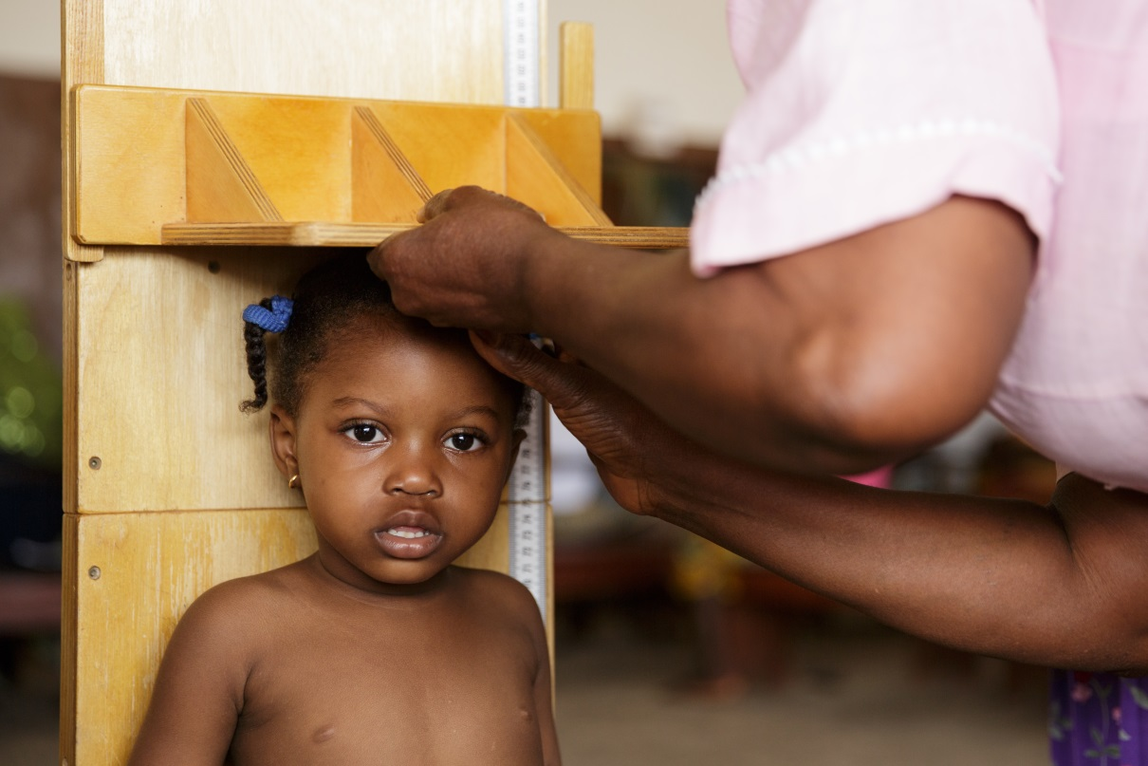

UNICEF Sierra Leone/ Oliver Asselin: A health worker measures the height of a girl at the Kenema government hospital in Kenema, Kenema district,

(Grants: SC140161)

01 March 2014 – 30 March 2015

Child Survival and Development Section

UNICEF Sierra Leone

Acronyms
CSO | Civil Society Organization
CSP | Civil Society Platform
DCB | District Coordinating Board
EVD | Ebola Viral Disease
GAVI | Global Alliance for Vaccine and Immunization
HaNSL-CSP | Health and Nutrition Sierra Leone Civil Society Platform
HKI | Hellen Keller International
KAP | Knowledge Attitude and Practice
SUN | Scaling Up Nutrition
UNICEF | United Nations Children Funds
Financial Utilization Report Summary Table

SUPPORTED COUNTRY Sierra Leone
SUPPORTED PROGRAMME Child Survival and Development
GRANT NUMBER SC140161
REPORTING PERIOD 01 March 2014 to 30 March 2015
DATE PREPARED 30 March 2015
TOTAL RECEIVED US$ 299,600
PROGRAMMABLE AMOUNT US$ 280,006

FUNDS UTILISED (Total) US$ $111,366 (as of 29.03.2015)

FUNDS UTILIZED (Reporting Period) US$ $111,366 (as of 29.03.2015)

BALANCE US$ $168,640 (as of 29.03.2015)

UNICEF CONTACTS | Roeland Monasch  UNICEF Representative  UNICEF Sierra Leone  rmonasch@unicef.org  Sandra Lattouf  UNICEF Deputy Representative  UNICEF Sierra Leone  slattouf@unicef.org  Yaron Wolman  Chief of the Child Survival and Development Section  UNICEF Sierra Leone  ywolman@unicef.org  Faraja Chiwile  Nutrition Manager  UNICEF Sierra Leone  fchiwile@unicef.org
DIGITAL PLATFORMS | Facebook: http://www.facebook.com/unicefsierraleone  YouTube: http://www.youtube.com/user/UNICEFSL  Twitter: @UNICEFSL  UN Sierra Leone Webpage: http://sl.one.un.org/category/media/news/

Map of Sierra Leone

Western
Area
Bombali
Koinadugu
Kambia
Port Loko
Tonkolili
Kono
Bo
Kenema
Kailahun
Pujehun
Bonthe
Moyamba

Executive Summary
This is a thirteen months progress report for the Scaling Up Nutrition (SUN) Movement
Multi-Partner Trust Fund (MPTF) funding provided to the UNICEF programme in Sierra Leone, for the period 01 March 2014 to 30 March 2015. More specifically, it supports the “A Coordinated and Mobilised Civil Society Platform for the Scaling Up Nutrition Movement” Project in Sierra Leone. The total programmable budget is US$ 280,006 of which a cumulative total of US$ 111,366 has been utilized during the reporting period, leaving an outstanding balance of US$ $168,640.

A Coordinated and Mobilised Civil Society Platform for the Scaling Up Nutrition Movement” Project in Sierra Leone aims to having a coordinated, effective, and inclusive platform that integrates nutrition actions into the programs of Civil Society Organizations (CSOs), thereby contributing to the national priorities on nutrition. The programme has three main outcomes:

- Outcome 1: Sierra Leonean civil society capacity strengthened to advance the national nutrition policy agenda and the implementation plan at the national, district and community levels by 2015
- Outcome 2: Increased gender empowerment in food and nutrition security programmes by 2015.
- Outcome 3: Civil Society coordinating mechanism established at National level to scale up nutrition by 2014.

Due to the impact of the Ebola Viral Disease (EVD) outbreak in Sierra Leone, the Civil Society Platform activities from outcome 2 were postponed awaiting for zero cases and most activities focused on supporting the government to respond to the prevailing emergency. However, the following activities of outcome 1 and 3 were implemented in March 2014 before the outbreak:

Develop a joint CSP nutrition strategy and plan by 2014 through an inclusive and open consultation process.
A total of 15 representatives of CSP participated in the process of validation of national Food and Nutrition Security implementation plan this facilitated the comprehensive understanding of the plan and have a knowledge of what is expected of the platform towards supporting the comprehensive implementation of the plan.

Develop the capacity of CS Platform members to support the implementation of the national food security and nutrition plan.

A total of 50 national and international NGOs (30 from health and nutrition sector), 25 media organizations, 200 market women, 300 religious and traditional leaders, farmers, fishermen, human rights defenders, women’s groups, consumer groups and trade union members participated in a two day planning and coordination meeting for SUN CSP members and media representatives on health and nutrition in March 2014.

- Set up a Secretariat and recruit a National Coordinator and Secretary
The CSP Secretariat has been established and national coordinator and secretary recruited in March 2014.

- Progress in the Implementation of Programme Activities

- Develop a joint CSP nutrition strategy and plan by 2014 through an inclusive and open consultation process.

To ensure further understanding of the SUN movement before the full development of a CSP nutrition strategy, the SUN CSP members participated in the revision and validation development of the National Nutrition and Food Security Implementation Plan 2013-2017. During this revision and validation process it was realized that a separate CSP nutrition strategy would not be required, however alignment with policy goals, objectives and strategies articulated in the Nutrition policy into priority actions for the scale up strategy will be prioritized. Clear roles and responsibilities for Civil Society Organizations have been stipulated and used to guide priority nutrition specific and nutrition sensitive actions in the CSP work plan for 2014 to 2015.

The implementation of activities under NFNSIP 2013-2017 was adjusted to support the government as CSP in responding to the EVD outbreak. In the wake of the Ebola outbreak in Sierra Leone 2014, the CSP at National level supported respective District Coordinating Bodies (DCBs) in the implementation of rapid assessments of quarantine homes to identify and follow up children in need of treatment for malnutrition and those that have missed routine immunization contributing to efforts to rebuild community trust in local health facilities. Since the outbreak, evidence has demonstrated that 38% of mothers did not attend health facilities due to fear of contracting Ebola from health workers in the facilities (KAP survey September, 2014). This has taken a negative toll on both nutrition and immunization services’ coverage especially among vulnerable populations in the country.

In addition, to ensure a comprehensive approach to supporting improvement in nutritional status of the children in Sierra Leone, the SUN CSP joint efforts with another platform where the Health and Nutrition Sierra Leone Civil Society Platform HaNSL-CSP was established. The establishment of the Health and Nutrition Sierra Leone Civil Society Platform HaNSL-CSP marked an important achievement for Sierra Leone, as it is the first country to have merged the SUN CSO platform with GAVI CSO platform into a united, coordinated civil society platform. HaNSL-CSP was established in October 2014, following recommendations by CSO members from the joint Platform meeting held in June 2014. This has resulted in the strengthening of CSO activities under one umbrella, speaking with one voice, better coordination and effective advocacy on nutrition and immunization for children and women. The platform governance and management structure is guided by Terms of Reference endorsed by the members.

Following the merger, HaNSL-CSP focus has been on establishing District Coordinating Bodies (DCBs) in all districts. To date, we have been successful in establishing 10 DCBs in the country and we aim to have functional DCBs in place, nationwide by the end of 2015.

- Develop the capacity of CS Platform members to support the implementation of the national food security and nutrition plan
The first SUN Civil Society taskforce meeting was held on 30th January 2014, to orient CSP partners on the latest development and plan for scaling up nutrition activities, followed by a two day planning and coordination meeting for SUN CSP members and media representatives on health and nutrition in March 2014. A total of 50 national and international NGOs (30 from health and nutrition sector), 25 media organizations, 200 market women, 300 religious and traditional leaders, farmers, fishermen, human rights defenders, women’s groups, consumer groups and trade union members participated in a two day planning and coordination meeting for SUN CSP members and media representatives on health and nutrition in March 2014.
The Kombra Media Network emerged from this workshop, pulling together 15 print and radio representatives who volunteered to become active advocates for the CSP and agreeing to focus reporting and broadcasting on health and nutrition related stories as well as disseminating health and nutrition messages. District level meetings were held to establish CSP’s with government participation in Kenema, Kono, Kambia, Bo and Tonkolili to date. As part of the planning phase a country call hosted by Geneva on communication and advocacy was also held in March 2014. The plans for the implementation have been postponed to allow support to government to respond to EVD. The plan is to commence as in quarter II of 2015.
- Set up a Secretariat and recruit a National Coordinator and Secretary

The CSP secretariat was established in March 2014 after the recruitment of National Coordinator and Secretary for CSP. The CSP National coordinator has supported various activities including conducting consultative meetings with SCP members as well as coordination and discussions to ensure understanding of CSP member on SUN movement.

Challenges and Lessons Learned

Impact of Ebola outbreak: Several activities have had to be adjusted and modified to the Ebola context which has resulted in an implementation delay which explains low implementation rates during this reporting period. UNICEF is working with the FOCUS 1000 and HKI NGOs to identify implementation modalities to achieve the proposed deliverable before end of quarter IV 2015.

Expenditures
The total programmable budget amount for the project is US$ 280,006: of which a total of of US$ $111,366 has been utilized during the current reporting period.

Future Work Plan
UNICEF will continue to support the CSP under FOCUS 1000 and HKI leadership in collaboration with the Food and Nutrition Directorate of the MoHS, to implement and monitor the project. Below is an overview of the activities planned to be implemented within the next six months:

Outcome 1: Sierra Leonean civil society capacity strengthened to advance the national nutrition policy agenda and the implementation plan at the national, district and community levels by 2015.

Main activities:
- Develop a joint CSP nutrition strategy and plan by 2014 through an inclusive and open consultation process.
- Develop the capacity of CS Platform members to support the implementation of the national food security and nutrition plan

Outcome 2: Increased gender empowerment in food and nutrition security programmes by 2015.

Main activities:
- Produce robust evidence on successful approaches and interventions on gender involvement in nutrition interventions with special emphasis on employment, agriculture and food security.
- CSP to undertake mass sensitization on the three gender acts for women’s empowerment and rights of women from the nutrition perspective
- Conduct training workshops on advocacy and communication skills for CSP members to promote women’s involvement and empowerment in nutrition and food security.
Outcome 3: Civil Society coordinating mechanism established at National level to scale up nutrition by 2014.

Main activities:
- Set up a Secretariat and recruit a National Coordinator and Secretary.

Annex 1
Funds Utilization report:

