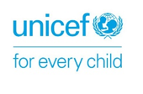 | 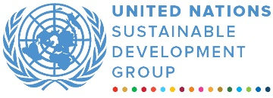 | 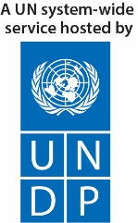

ANNUAL programme NARRATIVE progress report
REPORTING PERIOD: 1 january – 31 December 2021
Programme Title and Project Number |  |  | Country, Locality(s), Priority Area(s) / Strategic Results
- Programme Title: Improved Access to Quality Education in Tribal Districts of Khyber Pakhtunkhwa  - Programme Number (if applicable)  - MPTF Office Project Reference Number: 00119241 |  |  | Pakistan, Khyber Pakhtunkhwa (Kurram district and Orakzai district)
Priority area: Quality Education
Strategic results:
- Increased equitable access to safe, secure, quality, inclusive education and learning by girls and adolescent girls in fragile settings.
- Improved Equitable and Coordinated Provision of Safe Quality and Gender Responsive Education from early childhood to middle/elementary school for girls and adolescent girls in fragile settings.

Participating Organization(s) |  |  | Implementing Partners
Organizations that have received direct funding from the MPTF Office under this programme  - United Nations Development Programme (UNDP), and  - United Nations Children’s Fund (UNICEF) |  |  | - National counterparts (government, private, NGOs & others) and other International Organizations  Elementary and Secondary Education Department Khyber Pakhtunkhwa, Pakistan. Social Welfare Department Khyber Pakhtunkhwa and private contractors
Programme/Project Cost (US$) |  |  | Programme Duration
Total approved budget as per project document: CDN 7 million  MPTF /JP Contribution: 4,236,019  - by Agency (if applicable) |  |  | Overall Duration (36 months)
Agency Contribution  - by Agency (if applicable) |  |  | Start Date 17.12.2019
Government Contribution  (if applicable) |  |  | Original End Date (15.12.2022)
Other Contributions (donors)  (if applicable) CDN 7 million |  |  | Current End date(15.12.2022)
TOTAL: CDN 7 million
Programme Assessment/Review/Mid-Term Eval. |  |  | Report Submitted By
Assessment/Review - if applicable please attach  Yes No Date: dd.mm. yyyy  Mid-Term Evaluation Report – if applicable please attach  Yes No Date: dd.mm. yyyy |  |  | - Name: Tanya Rzehak  - Title: Programme Manager  - Participating Organization (Lead): UNDP  - Email address: tanya.rzehak@undp.org

ABREVIATIONS AND ACRONYMS

ECE Early Childhood Education
EMA Education Monitoring Authority
ESED Elementary and Education Department
GAC Global Affairs Canada
IEC Information, Education and Communication
KP Khyber Pakhtunkhwa
M&E Monitoring and Evaluation
MoU Memorandum of Understanding
NOC No Objection Certificate
PITE Provincial Institute of Teachers Education
PTCs Parents Teachers’ Committees
UN United Nations
UNDP United Nations Development Programme
UNICEF United Nations Children’s Fund

EXECUTIVE SUMMARY
The "Improved Access to Quality Education" is a three-year (2019 – 2022) project that has been designed to address and strengthen gender-responsive community resilience in two newly merged districts: Kurram and Orakzai, of Khyber Pakhtunkhwa (KP) province by reducing the barriers preventing access to quality education for girls. To achieve this aim, the project is addressing key issues related to access, quality, and oversight of schools, including pre-primary, primary and secondary schools to benefit girls while adopting rights-based and gender-responsive approaches.
The project contributes to the strategic objectives of the Canadian G7 commitment to improve learning outcomes for women and girls in crisis, conflict and fragile situations aligned with the Charlevoix Declaration on quality education for girls, adolescent girls, and women in developing countries. Focusing on pillar one of the Global Affairs Canada logic model, the project aims at reducing barriers preventing access to education for girls and it supports the intermediate GAC outcome 1100 Increased equitable access to safe, secure, quality, inclusive education and learning by girls and adolescent girls in fragile settings.
This report presents the progress made from January 2021 to December 2021 (2nd year of the project) for the realisation of the project’s goal of improved access to quality education in the project districts. During the reporting year, COVID-19 prevalence, delayed provision of No Objection Certificate (NOCs) to the implementing partner, and a local intra-tribe dispute in Kurram district on a land issue presented major challenges for project implementation. Consequent to these challenges, some of the activities were rescheduled. Thus, timeframe for rehabilitation of 50 schools and restocking these with furniture for students was delayed from December 2021 to second quarter of 2022. Likewise, one enrollment campaign was cancelled. Nonetheless, these adjustments of activities have no effect on the project objectives.
Other than that, the project is on-track with respect to implementation of the planned activities. In total, 135 schools have been accessed and engaged in different project initiatives during first two years of the project. With enrollment of new 1,086 students in two years, total enrollment in these schools has increased from 8,610 to 9,696 students. The desk review for the gender-based analysis was finalized and is currently with the Secretary of the KP Elementary and Secondary Education Department (ESED) for review. Around 9,696 girls' and 80 teachers are provided with teaching and learning materials, school in a box kit, early childhood education (ECE) and student learning kits. In total, 640 Parent Teacher Council (PTC) members and mothers’ groups members are trained on their roles and responsibilities to enrol and retain children in schools in addition to capacity building of 80 teachers on ECE, menstrual hygiene management (MHM) and health & hygiene. These 80 teachers further trained 640 health and hygiene club members in 80 schools.
In the reporting period, four technical working group (TWG) meetings were organized. Moreover, representatives from GAC, UNICEF, UNDP and ESED visited, and monitored the activities in District Kurram and Orakzai. The newly rehabilitated schools were inaugurated by GAC. Internal monitoring missions show that most students and staff of the Directorate of ESED, including district education officers, assistant district education officers, express satisfaction with the GAC support for improving access to quality education.
In the third (final year), the project will aim to complete all its deliverables according to the project document. During the final year, rehabilitation work on 50 schools will be completed and 20 more schools will be identified and rehabilitated. Incremental activities around these schools will be conducted to ensure that girls have free and fair access to quality education. Also, the UN will consolidate the performance results, considering sustainability of the rehabilitated schools and continuation of the assistance provided through GAC funds. The project will continue engagement with e KP’s Education Department to include the rehabilitated schools in its Annual Development Programme and fund the Parent Teacher Committees for overseeing the education services in their areas.

Purpose
The project aims to support the Government of Khyber Pakhtunkhwa in increasing girls’ enrolment and retention in education by improving access to equitable and gender-responsive educational services in line with SDG 4, G7 Charlevoix Declaration on Quality education; to advance education for crisis affected children particularly girls, Article 25A of the constitution of Pakistan on free and compulsory education and 37 (b) on Lifelong Learning.

Results

- Narrative reporting on results:

Intermediate Outcome 1100: Increased equitable access to safe, secure, quality, inclusive education and learning by girls and adolescent girls in fragile settings.
This intermediate outcome focuses on increasing the capacity of government and other stakeholders to reduce cultural and physical barriers to girls participating in education.

Immediate Outcome: 1110: Increased knowledge and skills of stakeholders (government, non-government, and community) to promote girls' access to inclusive and quality education in fragile settings.
This immediate outcome result aims to enhance the knowledge and skills of relevant stakeholders to promote girls’ education. Progress achieved under each contributing output is given below.

Output 1111: Girl’s enrolment and retention campaigns conducted with a focus on explaining and advocating the importance and value of girls’ education.
The programme had planned to conduct two enrolment and retention campaigns in the reporting period; however, one campaign could be conducted. One enrollment campaign was cancelled due to restrictions imposed to curb the rapid transmission of COVID-19, such as the closing of schools and public places and partial or full lockdown imposed in places with high numbers of infections.
One enrollment campaign was successfully conducted at the district and school levels, during which four mega events were organized (two in each project district) in collaboration with district education officials, school management, Parents-Teachers Councils (PTC) members, mother group members and community elders. In addition, each school has organized individual events to bring students back to school. All 80 schools supported by the project conducted corner meetings, organized school level events, walks and displayed banners at prominent locations to highlight importance of girls’ education. The interventions, synergised by other project interventions, resulted in new enrollment of 2,046 students until end of December 2021 in 135 GAC supported schools. Thus, total enrollment in the GAC supported schools has increased from baseline (8,610 students) to 9,696 students.
Output 1112: Training provided to Parents-Teacher Councils/Associations and Mothers Groups to promote and monitor girls' access to education and engage in the prevention of harmful practices adversely affecting girls.
The project is supporting the reactivation and/or formation and capacity building of PTCs and mothers’ groups to support community-led mobilization for enrollment and retention of girls in school. During the reporting period, all targeted 80 schools were supported to reactivate or form PTCs and membership was notified to the Kurram and Orakzai District Education Offices (DEO). In total 240 community sessions are conducted which were attended by 640 PTC members (all women) to understand their roles and responsibilities, including capacity-building on promoting girls’ education and creating an enabling environment for the continuation of their education. PTC members also continued to engage in the development of School Improvement Plans (SIPs) that identified the various needs of both schools and girls to create a more conducive learning environment.
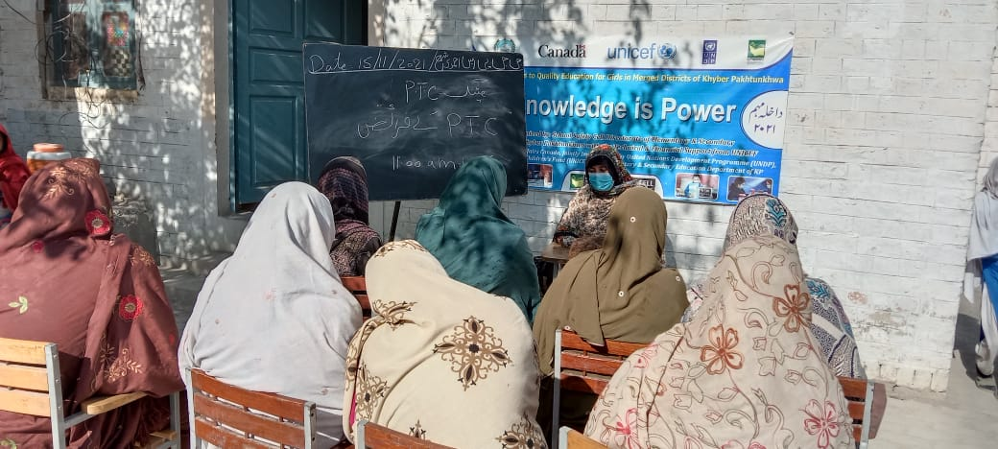
At the policy level, the financial mandate of PTCs has been supported through advocacy and further support was extended to ensure PTCs could open bank accounts. All the targeted 80 PTCs have set up bank accounts. With persistent advocacy from UNICEF, PTC funds have been transferred to these schools. Meanwhile, PTC members and school management supported the identification of mothers and grandmothers in communities, and the formation of mother groups in 80 selected schools. During the reporting period, all 640 members of the 80 mother groups were trained and engaged in school level interventions, enrollment campaign activities, Menstrual Health Management (MHM), health, and hygiene sessions. Field monitors reported that many PTC members have verbally expressed interest to contest PTC elections while the demand for membership itself appears to be increasing.
GGPS Ahmadi Shama Kurram: Session with PTC member
Output 1113: New ECE centers established and supported: New Early Childhood Education (ECE) supported for girls to ensure school readiness and on time enrollment of girls in schools centers established and supported.
In 2021, the project continued to support the delivery of ECE classrooms and associated services (distribution of teaching and learning materials, training, etc.) in the 80 schools. During the reporting period, 80 teachers were trained on ECE and teaching methods. UNICEF is providing technical support to the Directorate of Elementary and Secondary Education Department (ESED) in the effective and efficient implementation of ECE interventions. Following the ESED request for UNICEF to support the establishment of standardized ECE classrooms, UNICEF has shared a revised list of government approved items (teaching learning materials and classroom supplies) and their specifications with a vendor. The vendor has completed an assessment in the selected 80 schools and remaining work is in progress with the centers being equipped aligned with KP standardised ECE classroom guidelines.
Until end of year II (December 2021), the project assistance, coupled with other interventions, resulted in enrollment of 980 young girls in the GAC supported 80 schools.
Immediate Outcome 1120: Increased capacity of the government and stakeholders) to reduce social, cultural, and physical barriers to girls participating in education.
This immediate outcome result aims to improve access to quality education for girls by identifying barriers and improving the school infrastructure and related factors accordingly. Progress achieved under each contributing output is given below.
Output 1121: Technical assistance provided to the Ministry of Education to conduct a joint gender-based analysis in merged districts of KP, identifying barriers and bottlenecks for girls’ access to education.
The findings of the joint gender-based analysis were finalized and shared with the Secretary ESED. The analysis is pending for his review and endorsement.
Output 1122: Damaged and destroyed schools (100) rehabilitated to increase the availability of girls’ friendly school infrastructure.
For 2021, UNDP identified and selected 50 girls' schools; 25 each in Kurram and Orakzai districts, in consultation with the ESED following the selection criteria that was mutually developed and agreed upon between the UN and ESED. UNDP timely completed internal processes for hiring an engineering firm for conducting damage assessments and preparation of Bill of Quantities (BOQs). However, the Planning and Development Department of KP granted the No Objection Certificate (NOC) to the engineering firm for assessment in last quarter of fiscal year 2021. Similarly, access to the project areas was also restricted by the local law enforcement authorities owing to tribal armed conflict in Kurram district over a land issue. Due of these reasons, the assessment and subsequently timeline for the rehabilitation process had to be readjusted to allow for the lost time.
At the time of writing of this annual report, substantial civil work is completed in all 50 schools. The scope of the work includes building of boundary wall and wash facilities, land development, roof repairing, construction of toilets, installation of electric wiring and construction of additional rooms in 12 schools. The remaining civil work will be completed in 2nd quarter of the fiscal year 2022.
Year-wise target and achievement is presented in the table below.
S. No | Description | Year 1 (2020) | Year 2 (2021) | Year 3 (2022) | Total
1 | Target | 30 schools | 50 schools | 20 schools | 100
2 | Progress | Completed | Civil work is in progress in all 50 schools | Planned: Schools list finalised | 30
The project has taken all necessary steps to ensure sustainability of the environment during the rehabilitation work. Following table explains the steps taken / planned during the civil work on the rehabilitation.
Activity | Parameter | Mitigation Measures Checklist
General Conditions | Notification and Worker Safety | - The concern government departments, committees and communities have been notified of upcoming construction activities  - All legally required permits have been acquired for construction and/or rehabilitation (All sites are recommended for rehab/construction activities by concern government department.  - The contractor formally agrees that all work will be carried out in a safe and disciplined manner designed to minimize impacts on neighboring residents and environment.  - Workers will comply with good practices of civil works
General Rehabilitation and /or Construction Activities | Air Quality | - Demolition debris shall be kept in controlled area and sprayed with water mist to reduce debris dust  - The surrounding environment (sidewalks, roads) shall be kept free of debris to minimize dust  - There will be no open burning of construction / waste material at the site  - There will be no excessive idling of construction vehicles at sites.  - If any tree cut for construction purpose, the contractor will plant 10 trees to minimize effect.
 | Noise | - Construction noise will be limited to restricted times  - During operations the engine covers of generators, air compressors and other powered mechanical equipment shall be closed, and equipment placed as far away from residential areas as possible
 | Water Quality | - The site will establish appropriate erosion and sediment control measures such as e.g., hay bales and / or silt fences to prevent sediment from moving off site and causing excessive turbidity in nearby streams and rivers.  - Biological and chemical tests will be conducted of drinking water.
 | Waste management | - Waste collection and disposal pathways and sites will be identified for all major waste types expected from demolition and construction activities.  - Construction waste will be collected and disposed  - Whenever feasible the contractor will reuse and recycle appropriate and viable materials (except asbestos)

Replacement of Tagha Saam Primary Girls’ School with Kach Mela Girl's Primary School
Tagha Saam primary girls’ school, located in Orakzai district, was rehabilitated, and handed over to Education Department in year I of the project. In early 2021, UNDP was informed by the field staff that the school has been demolished by a contractor engaged by another organisation. UNDP took the matter to Education Department and found that the already rehabilitated school had been reassigned to another organisation by mistake. Nonetheless, upon follow up by UNDP and GAC an inquiry was conducted by the Education department.
To resolve the matter the education department agreed to rehabilitate Kach Mela School as a replacement of Tagha Saam primary girls’ school through its own funds and include it in the list of GAC funded 100 schools.
UNDP has shifted furniture from Tagha Saam school to Kach Mela school. Similarly, UNICEF has conducted project activities to ensure an enabling environment for learning in Kach Mela school
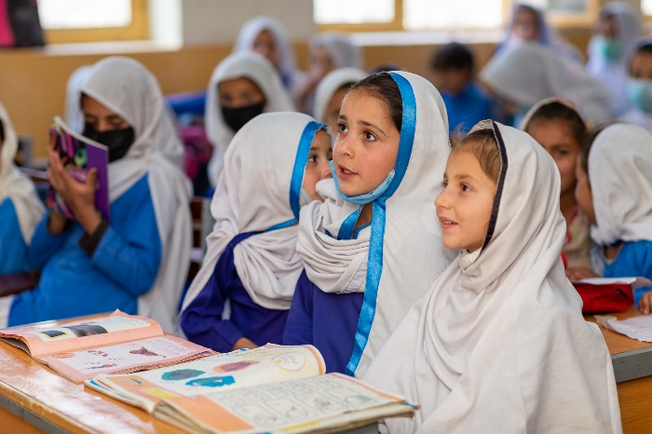
Output 1123: Furniture distributed to the rehabilitated schools:
Kurram District: Students are utilizing GAC funded furniture in GGPS Kachkeena
As per annual workplan, the project successfully provided students' furniture to 50 schools, 25 each in Kurram and Orakzai districts. Furniture package for a single school consisted of student benches and desks, following standard specifications approved by the education department. To ensure quality product is delivered, a technical consultant was engaged for quality assurance and pre-delivery inspection of the furniture. The consultant regularly inspected furniture and, as necessary, recommended rectifications on the spot in case of variations from the approved specifications. UNDP and District Education Offices conducted post-distribution monitoring of the quality and utilization of the furniture. The monitoring mission found that availability of furniture at schools has positively impacted students’ motivation to learn.
Year-wise bifurcation of total target and progress achieved is given in the table below.
S. No | Description | Year 1 (2020) | Year 2 (2021) | Year 3 (2022) | Total until 2021
1 | Target | 30 schools | 50 schools | 20 schools | 100
2 | Progress | 38 schools | 50 schools | Procurement is completed. Distribution will be done once the schools are rehabilitated. | 88

Immediate Outcome 1130: Increased capacity of girls and adolescent girls to claim their right to education and make their voices heard in decision-making processes that affect them.
Under this immediate outcome, three interventions were in focus: providing information and life skills-based education to adolescent girls; supporting families, communities, and decision makers for the protection of children from abuse; and capacity building of public authorities.

Output 1131: Information and Life Skills development provided to adolescent girls
A Life Skills Based Education (LSBE) toolkit was developed through a consultant and pre-tested on 24 adolescent girls and boys in Kurram and Orakzai and consequently finalized. After the finalization of the toolkit, a 10-day training was organised for the child protection team, to equip them with relevant understanding and skills to roll out in targeted 80 schools. During 2021, LSBE toolkit was delivered to 1,035 adolescents (655 girls, 380 boys) against a target of 630. The toolkit consists of 30 sessions and is delivered to a group of 10-15 adolescents through a 5-day training course. At the end of the 5-day LSBE training course, the adolescents who have received the training were designated as ‘champions’ and expected to further disseminate the information to approximately 6,975 peers. As the toolkit design has been completed, it will now be printed and disseminated for use at community levels.
Output 1132: Families, communities and decision makers supported to respect the rights of girls to education and support their protection from any form of abuse.
A toolkit for training of families, communities and decision makers was developed and pre-tested in the project districts. Participants in the 3-day training included schoolteachers, parents, community elders and religious influencers. During 2021, a total of 80 communities were reached. Among these communities, 490 community influencers (330 women and 160 men) have been trained against a target of 400 individuals.
Output 1133: Capacities of public authorities and services strengthened to uphold girls’ rights to education and protection.
A toolkit was also developed for capacity building of public authorities on children’s right to education and protection. Representatives from the departments of social welfare, education, health, and local government as well as district administrations participated in the pre-testing. Accordingly, 105 officials (80 men and 25 women) were trained against targeted 100 in four 2-day trainings during the reporting period.
Intermediate Outcome 1200: Improved Equitable and Coordinated Provision of Safe Quality and Gender Responsive Education from early childhood to middle/elementary school for girls and adolescent girls in fragile settings.
This intermediate outcome focuses on improving equitable and gender-responsive education from early childhood for girls in the two project districts.
Immediate Outcome 1210: Enhanced capacity of education stakeholders to ensure the provision of safe, inclusive learning spaces for girls.
Detailed progress of the contributing outputs is presented below.
Output 1211: Essential teaching and learning supplies provided for 100 teachers and 12000 students.
School supplies including School in a Box, Recreation kit, ECE kit and Student Learning Kits, MHM kits distributed benefitting 9,696 students (all girls). Field teams, Sub divisional District Education Officers and District Monitoring Officers monitored utilization of the supplies to ensure its effective use.
80 Teachers have been trained on ECE and provided Early Learning and Development Standards (ELDS), Teachers Guidebook and Teachers Handbook to use ECE material appropriately during the classroom activities. Similarly, MHM kits and information pack has been shared with 80 teachers to create awareness about MHM in adolescent girls, PTC, and mother groups.
Output 1212: Awareness sessions for health and hygiene and menstrual hygiene management conducted and dignity kits distributed in 155 schools
During the reporting period, 135 schools have participated in the health and hygiene orientation session and much work has been done to ensure safe hygiene and institutionalization of hygiene practices.
Total 80 female teachers were trained on MHM, who further organised sessions for adolescent girls in respective 80 schools, in collaboration with health and hygiene club members. The sessions were attended by 2,225 girls, who were also benefitting from 500 MHM kits. PTC members and mother groups members also attended these sessions.
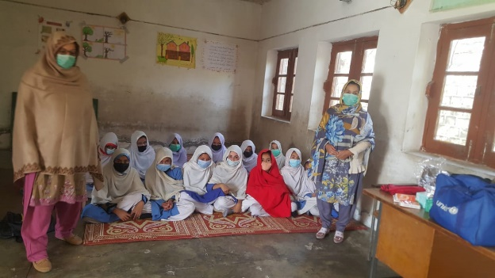
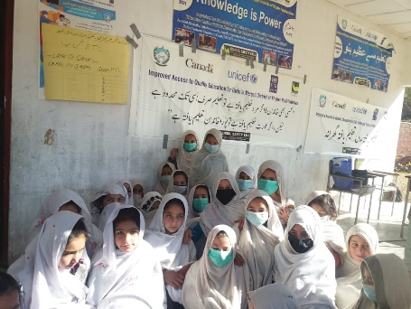
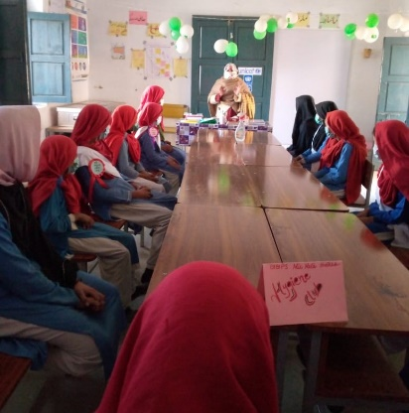
Capacity building of 55 middle schools’ teachers on MHM and distribution of dignity kits to adolescent girls is in progress. In terms of safe school operations, Assistant District Education Officers (ADEOs) and field monitors have assured that the Standard Operating Protocols (SOPs) for safe operation of schools are adhered to in the schools. Meanwhile, field staff are in the process of sensitizing teachers and students to get vaccinated against COVID-19. Most teachers in selected schools have been vaccinated while awareness raising sessions are in progress to convince students and parents to get vaccinated. Status of student vaccination coverage is yet to be received from the field.
GGPS Khail Mat Khan Killi Orakzai: Session with Health and Hygiene Club

GGPS Hassanzai Kurram: Session on MHM
GGPS Mir Mela Shekhan Orakzai: Session with Health and Hygiene Club

Output 1213: Continuous education provided to girls who previously did not have access to post-primary education and are now enrolled in 55 middle schools.
The programme supported 1,596 girls who previously did not have access to post-primary education to enroll in 55 middle schools during last two years. The 1,596 girls enrolled is a 66 per cent increase from the 960 girls who were enrolled in middle schools at the time of baseline assessment in April 2020 by E&SED supported by UNICEF, and substantial progress made towards the programme target of 1,925 girls. This achievement was a result of interventions such as community mobilisation campaigns on the importance of girls’ education and enrolment. Following successful advocacy by UNICEF, all 55 middle schools have been included in the Directorate of ESED’s routine monitoring plan. Furthermore, to ensure quality of learning and retention of girls, district education monitoring teams monitor the attendance of teachers. UNICEF’s seconded field staff also verified teacher attendance before their monthly salary is processed, conduct classroom observations, and provide mentoring support to the teachers on a need-basis. They also conduct the pacing of Scheme of Studies exercise with teachers to ensure that course contents coverage is on track and completed in time. To ensure quality learning and retention of students, 70 teachers trained on general pedagogy, content knowledge, and scheme of studies, in coordination with Directorate of Professional Development.
To foster ownership and management of schools, PTCs, Mothers’ groups and health and hygiene committees have been formed in the 55 schools, and field staff conduct fortnightly meetings with them for progress update on their activities, as per their TORs. Proper orientations of the mothers' groups and the health & hygiene committees are planned during latter half of March 2022.
Schools were further targeted as part of COVID-19 emergency response and received contextualized information, education and communication materials on prevention and SOPs. Field staff have initiated sensitizing the covid-19 affected teachers and students to get vaccinated against the virus. So far 40 out of 69 teachers in 55 middle schools have been vaccinated, with nine teachers having received their first dose. The status of student vaccination is currently being collected.
Immediate Outcome 1220: Enhanced capacity of education stakeholders to provide quality gender-sensitive teacher training.
This immediate outcome aims to build the capacity of education stakeholders to provide quality training for teachers and improve teacher attendance. In collaboration with Provincial Institute Teachers’ Education (PITE) and the Education Monitoring Authority (EMA), this initiative is providing support to monitor teacher attendance and to develop and deliver teacher trainings.

Output 1221: Professional development training provided to teachers, particularly female teachers, to improve student-centered and gender-responsive teaching practices.
UNICEF, in collaboration with Directorate of Professional Development (DPD) of ESED and GAC, has developed teachers training manual on Child Centered Approach and Gender Responsive Teaching Practices. Two workshops on manual development for teachers have been conducted as per plan in 2021. The teacher’s training manual have been reviewed, translated, and endorsed by Directorate of Curriculum and Teacher Education (DCTE).
As a next step, coordination with DPD is in progress to organise ToT during March 2022 and training will be initiated in May 2022.

Output 1222: Technical assistance provided to the Ministry of Education to reduce teacher absenteeism, and professional development training supported for teachers to improve student-centered and gender-responsive teaching practices.
The grant aimed to strengthen Education Monitoring Authority (EMA) technical capacity in improving monitoring and data system. In this regard, support was provided in refining Annual School Census (ASC) proforma in consultative manner with EMA by incorporating additional areas required for efficient planning at district and provincial levels. ESED conducted the ASC exercise and EMA field teams verified the data at school level. Technical Assistance under GAC’s support provided robust and consistent technical support to EMA in updating ASC application and monthly monitoring application to ensure real time data is collected, shared and analyzed. Furthermore, EMA 780 field staff members (281 female) including district management, are trained on revised/modified monitoring application and its analysis at district level for reviews and decision making. EMA has been supported in organizing three quarterly review meetings to take stock of the existing quarter results, challenges, and issues in the field. The Directorate of ESED was part of the third quarter review where the LITNUM (Literacy and Numeracy) initiative (which remains suspended since COVID-19 outbreak) and transition to the Single National Curriculum were discussed. The decision to continue LITNUM will be made by Secretary ESED in view of recent developments to recruit school leaders to support teachers in improving learning in schools.
For system strengthening, initially and as per need, technical experts i.e App developer and Web Developer are engaged to release latest version 4.47. This includes development and testing of different features. The release has the following new features:
- Easy search bar
- Easy to retrieve in-progress school module
- User friendly retrieving UC, VC data from web service
- Updating flows of enrollment
- Rectification and updating image option
- App bar modification to identify school name and EMIS code.

Further, the technical assistance team also provided support in modifying monitoring app and web:
- Concept development of data control and analysis
- Unit testing methods
- Comparison of data transfer libraries.
The technical team also provided support in data cleaning using android app and web-based data management system.
This output also seeks to provide capacity building to 310 teachers on child-centered and gender- sensitive teaching practices. Building on previous work done in collaboration with DPD, a teacher training manual on child centred approach and gender responsive teaching practices was developed in consultation with Directorate of Curriculum and Teachers Education (DCTE). The manual was reviewed by DCTE and translated in Urdu. DCTE has approved the manual, which will be used by DCTE for training teachers hereon.
- Describe any delays in implementation, challenges, lessons learned and best practices:
The project faced delay in rehabilitation of 50 schools in Kurram and Orakzai districts and the initially planned date (December 2021) for rehabilitation of the 50 schools had to be pushed forward to 2nd quarter of fiscal year 2022. Even though the project's third-party engineering firm (PEPAC) that is hired for conducting damage assessment and preparation of Bill of Quantities (BOQs) for 50 schools had applied for the NOC in September 2020, however, it was granted in August 2021. Cognisant of the fact to start the rehabilitation work before winters and timely completion of year II targets, UNDP adopted the contingency plan and hired services of a local Engineering Consultant Firm to conduct initial damage assessment of schools. Furthermore, UNDP maintained close coordination with the TDP secretariat, local authorities and field staff to keep updated on the changing security situation and take proactive measures to ensure safety of all. Lastly, harsh weather conditions particularly winter showers and snowfall slowed drying of cement work, thereby, reducing the overall pace of the civil work. UNDP advised civil work contractors to plan rehabilitation work taking into account weather forecast with the use of additional chemicals for quick drying of concrete.
Prevalence of COVID-19 and its successive waves in Pakistan had a major impact on programme implementation due to limited or no access to schools and communities. Furthermore, the uncertainty surrounding COVID-19 caused the planning of activities a challenge as restrictions could change on a short notice to reduce the risk. In the project areas, schools already stay closed for a longer period during winter season- this coupled with closures due to COVID-19 meant that children remained out of school for a very long time. Nevertheless, as soon as the schools reopened, field teams in coordination with Directorate of ESED had organized activities in selected schools and organized capacity-building workshop for teachers, PTC members and mother groups.

- Qualitative assessment

Both the implementing partner worked in close coordination with ESED, EMA, DCTE and the Social Welfare Department to ensure planned results are achieved as agreed with GAC. UNDP regularly conducted monitoring missions to verify quality of civil works and ensured quality furniture is delivered to the schools. UNICEF’s regular engagement with government departments to build teacher capacity to deliver quality education and continuous engagement with communities and parents that resulted in enrolment increasing from 8,610 to 9,696. EMA is being supported to ensure teacher attendance as well as engagement at the classroom level on lesson planning and delivery for effective teaching. Training manuals are developed in consultation and support with DCTE, and these manuals are beneficial for quality trainings for teachers.

Using the Programme Results Framework from the Project Document / AWP - provide an update on the achievement of indicators at both the output and outcome level in the table below. Where it has not been possible to collect data on indicators, clear explanation should be given explaining why, as well as plans on how and when this data will be collected.

Table 1: Achievement of indicators at both the output and outcome level
ii) Indicator Based Performance Assessment:

Reducing Barriers preventing Access to Quality Education for Girls in Tribal Districts of Khyber Pakhtunkhwa (2019-2022)
LOG FRAME
Ultimate outcome contributing to Global Affairs Canada G7 Commitment: | Improved learning outcomes for girls and adolescent girls in tribal districts of Khyber Pakhtunkhwa
Intermediate Programme Outcomes | 1100 Increased equitable access to safe, secure, quality, inclusive education and learning by girls and adolescent girls in fragile settings  1200 Improved equitable and coordinated provision of safe, quality and gender responsive formal and non-formal education, from early childhood to end of secondary for girls and adolescent girls
Outcome level indicator | CG7Edu1: # of schools that have implemented changes to create welcoming spaces that respond to specific needs of girls  CG7EDU2: # of schools (pre-primary, primary, secondary and non-formal learning spaces) with access to adapted infrastructure, specially trained teachers and materials (...)  CG7EDU3: # of girls, adolescent girls and women benefitting from reduced barriers to education  CG7ED4: # of teachers trained (m/f) according to national standards  CG7ED5: # of boys and girls that complete their pre-primary, primary and secondary education and non-formal equivalents  Progress against the outcome level indicators will be furnished in the final report once the indicators are matured.

X | Achieved Indicator Targets (2021) | Reasons for Variance with Planned Target (if any) | Source of Verification
Intermediate Outcome 1100: Increased equitable access to safe, secure, quality, inclusive education and learning by girls and adolescent girls in fragile settings |  | - | -
Immediate Outcome 1110: Increased knowledge and skills of stakeholders (government, non-government and community) to promote girls’ access to inclusive and quality education in fragile settings. | NA
Output 1111: Girl’s enrolment and retention campaigns conducted with a focus on explaining and advocating the importance and value of girls’ education:  Indicator: # of campaigns conducted, targeting equal numbers of women and men in HHs  Baseline: 0  Planned Target 2022: 6 | Target: 02 enrolment and retention campaigns  Achieved: 01 enrolment and retention campaign | Due to COVID-19, one planned enrolment campaign was cancelled. | NA
Output 1112: Training provided to Parent-Teacher Councils/Associations and Mothers' Groups to promote and monitor girls’ access to education, and engage in the prevention of harmful practices adversely affecting girls  Indicator: # of PTCs (minimum 33% women) and mothers groups trained and actively engaged to promote girl’s education.  Baseline: 0  Target: 155  Indicator: # of outreach community sessions completed for women and for men  Baseline: 0  Target: 300 community sessions (on average, each PTC conduct 3 sessions)  Indicator: # PTC-led record available on girls enrolled and retained in education as a result of PTC community engagement  Baseline: 0  Planned Target: 1 | Target: 80 PTCs and 80 mother groups  Achieved: 80 PTCs (eight members in each with only female members in girl schools) and Mother Groups (eight to ten members in each) formed. Targeted PTCs (with a total of 640 members) have been trained and actively engaged to promote girls ‘education  Target: 240 (cumulative FOR 2020 and 2021)  Achieved: 240 community sessions have been completed by PTC members.  Target: PTC-led record available on girls enrolled and retained in education as a result of PTC community engagement in 80 schools  Achieved: Overall PTCs in 80 schools has regular meetings / sessions to enrol girls and record available in 80 schools. | --  Not Applicable  Not Applicable | Field office activity report, pictures
Output 1113: New ECE centers established and supported  Indicator: # of ECE centers established and supported  Baseline: 0  Planned Target: 100  Indicator: # of young girls enrolled  Baseline: 0  Planned Target: 2000 | Target: 100 ECEs in year 2021  Achieved: 100 ECE center locations identified, and assessment conducted. Vendor has completed assessment and setting up of ECE classrooms is in progress  Achieved: 980 young girls enrolled | Not Applicable | Field office activity report  Partner’s report, DEO reports, field staff reports.
Immediate Outcome 1120 Increased capacity of government and stakeholders to reduce social, cultural, and physical barriers to girls participating in education.
Output 1121: Technical assistance provided to MOE to conduct a joint gender-based analysis in MDs of KP, identifying barriers and bottlenecks for girls’ access to education  Indicator: Gender analysis available with number of solutions to overcoming bottlenecks and barriers to girls' education.  Baseline: 0  Planned Target: 1 | Desk review completed, and final report presented to the Secretary Education, KP. Upon his request, disclaimer is added in the report. | The Secretary Education, KP was transferred, and so findings of the desk review shared with the new Secretary ESED, KP. | Draft report available with UNICEF
Output 1122: Damaged and destroyed schools (100) rehabilitated to increase the availability of girl-friendly school infrastructure  Indicator: No of schools rehabilitated  Baseline: 0 schools  Planned Target: 100 schools | Target: 50 schools  Achieved: 50 schools (Rehabilitation work initiated on 50 schools. 80 percent to 90 percent of the civil work has been completed at the time of writing this report.  The schools will be completed and handed over to the education department in 2nd quarter of fiscal year 2022. | Delayed provision of NOC to the partner organization for conducting damage assessment, severe snowfall, and a local intra-tribe armed conflict over a piece of land delayed the rehabilitation work. | Internal and joint monitoring reports
Output 1123: Furniture distributed to the rehabilitated schools.  Indicator: No of schools received furniture  Baseline: 0 schools  Planned Target: 100 schools | Target: 50 schools  Achieved: 50 schools received students’ furniture | Not applicable | Delivery receipt and district education offices report
Immediate Outcome 1130: Increased capacity of girls and adolescent girls to claim their right to education and make their voices heard in decision making processes that affect them.
Output 1131: Information and Life Skills Based Education provided to adolescent girls  Indicator: # of adolescents (boys and girls) who participate in group discussions on child rights  Baseline: 0  Planned Target: 1,395 (9 in each community)  Indicator: # of adolescents (boys and girls) who know their right to education and other human rights  Baseline: 0  Planned Target:  6,975 adolescents (1395 adolescents will further reach out to 5 adolescents in the community) | Target: 630 adolescent boys and girls  Achieved: 1,035 adolescents (655 boys and 380 girls) trained in LSBE. (2021 target was 630 adolescents) | The target is overachieved because of availability of students | Field office activity report, Social Welfare Department report.
Output 1132: Families, communities and decision makers supported to respect the rights of girls to education and support their protection from any form of abuse.  Indicator: # of communities reached with messages on rights of girls to education and protection  Baseline: 0  Planned Target: 155 communities | Target: 80 communities reached with messages on rights of girls to education and protection  Achieved: 80 communities reached. In these communities, a total of 490 community influencers (160 men and 330 women) provided trainings on the right to education and protection | Not Applicable | Field reports
Output 1133: Capacities of public authorities and services strengthened to uphold girls’ rights to education and protection.  Indicator: # of trained frontline workers (aiming for minimum of 33% female) who know how to identify and refer girls out of schools to alternative learning centers and for other relevant protective services  Baseline: 0  Planned Target: 100 | Target: 100 frontline workers trained (aiming for minimum of 33% female) who know how to identify and refer girls out of schools to alternative learning centers and for other relevant protective services  Achieved: 105 trained frontline workers (24% female) who know how to identify and refer girls out of schools to alternative learning centers and for other relevant protection services | Not applicable | Field office activity report, Social Welfare Department report.
Immediate Outcome 1210: Enhanced capacity of education stakeholders to ensure the provision of safe, inclusive learning spaces for girls.
Output 1211: Essential teaching and learning supplies provided for 100 teachers and 12000 students  Indicator: # of children received teaching and learning supplies, disaggregated by sex  Baseline: 0  Planned Target: 12,000 (60% girls)  Indicator: # of teachers received teaching and learning supplies, disaggregated by sex  Baseline: 0  Planned Target: 100 (50% female) | Achieved: 9,696 children (100% girls) received teaching and learning supplies  80 teachers received teaching and learning supplies (100% female) | Not Applicable | Field office activity report
Output 1212: Awareness sessions for health & hygiene and menstrual hygiene management conducted and dignity kits distributed in 155 schools.  Indicator: # of schools that have participated in health and hygiene orientation sessions  Baseline: 0  Planned Target: 155  Indicator: # of schools that have MHM kits and trained teachers.  Baseline: 0  Planned Target: 155 | Target: 135 schools participated in health and hygiene orientation sessions  Achieved: 135 schools (100% female)  Target: 155 schools  Achieved: Sessions on MHM conducted in all 135 schools while MHM kits were distributed in 20 schools as per need. | Not Applicable | Field office activity report
Output 1213: Continuous education provided to girls who previously did not have access to post-primary education and are now enrolled in 55 middle schools  Indicator: # of middle schools supported  Baseline: 0  Planned Target: 55  Indicator: # of adolescent girls enrolled  Baseline: 996  Planned Target: 1,925 | Target: 55 middle schools  Achieved: 55 middle schools supported  Achieved: 1,596 adolescent girls enrolled in 55 girls’ middle schools | Not Applicable | Field office activity report
Outcome 1220: Enhanced capacity of education stakeholders to provide quality, gender-sensitive teacher training.
Output 1221: Professional development training provided to teachers, particularly female teachers, to improve student-centered and gender-responsive teaching practices.  Indicator: # teachers trained (50% female)  Baseline: 0  Planned Target: 310 (50% female)  Output 1222: Technical assistance provided to the Ministry of Education to reduce teacher absenteeism, and professional development training supported for teachers to improve student-centered and gender-responsive teaching practices  Indicator: Functioning teacher attendance monitoring system in place  Baseline: 0  Planned Target: 1 | Target: 310 teachers for year 2021  Achieved: 0 (The target on teacher training was not achieved due to reasons mentioned in the next column)  Target: Monitoring system in place. UNICEF to add target for year 2021  Achieved: (Progress on teacher attendance monitoring system functioning under EMA and reporting on monthly basis. | Manual on Gender Responsive teaching practices and Child Centered Approach has been developed, reviewed, and approved by the authorities. Initially, the activity was delayed due to COVID-19. | EMA reports.

III. Other Assessments or Evaluations (if applicable)
Not applicable

IV. Programmatic Revisions (if applicable)
Not applicable

- Resources (Optional)

- Annexes

- List of 50 schools

The term “programme” is used for programmes, joint programmes and projects.
Strategic Results, as formulated in the Strategic UN Planning Framework (e.g., UNDAF) or project document.
The MPTF Office Project Reference Number is the same number as the one on the Notification message. It is also referred to as “Project ID” on the project’s factsheet page the MPTF Office GATEWAY
The MPTF or JP Contribution, refers to the amount transferred to the Participating UN Organizations, which is available on the MPTF Office GATEWAY
The start date is the date of the first transfer of the funds from the MPTF Office as Administrative Agent. Transfer date is available on the MPTF Office GATEWAY
As per approval of the original project document by the relevant decision-making body/Steering Committee.
If there has been an extension, then the revised, approved end date should be reflected here. If there has been no extension approved, then the current end date is the same as the original end date. The end date is the same as the operational closure date which is when all activities for which a Participating Organization is responsible under an approved MPTF / JP have been completed. As per the MOU, agencies are to notify the MPTF Office when a programme completes its operational activities.
The baseline figure includes baseline of 85 schools (Year I) plus baseline of 50 schools (Year II). Thus, baseline of 135 schools is 8,610. This baseline will increase in year III with inclusion of 20 more schools in year III.
In the year I of the project, furniture packages were provided to eight additional schools on the request of District Education Office. These schools were not rehabilitated using GAC assistance. Since UNDP follows value for money approach and conduct procurement of furniture through competitive process, lower price quotation from the competing suppliers were received. Savings from this price differential were diverted towards purchasing these furniture packages and therefore will have no impact on the total budget approved for purchasing of furniture for 100 schools rehabilitated through GAC assistance.

