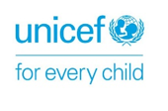 | 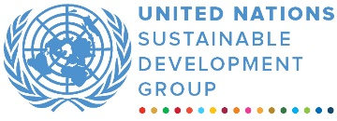 | 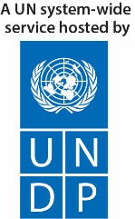

ANNUAL programme NARRATIVE progress report
REPORTING PERIOD: 1 JANUARY 2022 – 31 December 2022
Programme Title and Project Number |  |  | Country, Locality(s), Priority Area(s) / Strategic Results
- Programme Title: Improved Access to Quality Education in Tribal Districts of Khyber Pakhtunkhwa  - Programme Number (if applicable)  - MPTF Office Project Reference Number: 00119241 |  |  | Pakistan, Khyber Pakhtunkhwa (Kurram district, Orakzai district, and Upper Chitral district)
Priority area: Quality Education
Strategic results:
- Increased equitable access to safe, secure, quality, inclusive education and learning by girls and adolescent girls in fragile settings.
- Improved Equitable and Coordinated Provision of Safe Quality and Gender Responsive Education from early childhood to middle/elementary school for girls and adolescent girls in fragile settings.

Participating Organization(s) |  |  | Implementing Partners
Organizations that have received direct funding from the MPTF Office under this programme  - United Nations Development Programme (UNDP), and  - United Nations Children’s Fund (UNICEF) |  |  | - National counterparts (government, private, NGOs & others) and other International Organizations  Elementary and Secondary Education Department Khyber Pakhtunkhwa, Pakistan. Social Welfare Department Khyber Pakhtunkhwa and private contractors
Programme/Project Cost (US$) |  |  | Programme Duration
Total approved budget as per project document: CDN 7 million  MPTF /JP Contribution:  USD 5,406,812  - by Agency (if applicable) |  |  | Overall Duration (42 months)
Agency Contribution  - by Agency (if applicable) |  |  | Start Date 17.12.2019
Government Contribution  (if applicable) |  |  | Original End Date (15.12.2022)
Other Contributions (donors)  CDN 7 million |  |  | Current End date(30.06.2.2023)
TOTAL: CDN 7 million
Programme Assessment/Review/Mid-Term Eval. |  |  | Report Submitted By
Assessment/Review  Yes No  Mid-Term Evaluation Report  Yes No |  |  | - Name: Tanya Rzehak  - Title: Programme Manager  - Participating Organization (Lead): UNDP  - Email address: tanya.rzehak@undp.org

ABREVIATIONS AND ACRONYMS

ECE Early Childhood Education
EMA Education Monitoring Authority
ESED Elementary and Education Department
GAC Global Affairs Canada
IEC Information, Education and Communication
KP Khyber Pakhtunkhwa
M&E Monitoring and Evaluation
MoU Memorandum of Understanding
NOC No Objection Certificate
PITE Provincial Institute of Teachers Education
PTCs Parents Teachers’ Committees
UN United Nations
UNDP United Nations Development Programme
UNICEF United Nations Children’s Fund

EXECUTIVE SUMMARY
The "Improved Access to Quality Education" is a three and a half-year (2019 – 2023) project that has been designed to address and strengthen gender-responsive community resilience in Kurram, Orakzai, and Chitral by reducing the barriers preventing access to quality education for girls. To achieve this aim, the project is addressing key issues related to access, quality, and oversight of schools, including pre-primary, primary and secondary schools to benefit girls while adopting rights-based and gender-responsive approaches.
The project contributes to the strategic objectives of the Canadian G7 commitment to improve learning outcomes for women and girls in crisis, conflict and fragile situations aligned with the Charlevoix Declaration on quality education for girls, adolescent girls, and women in developing countries. Focusing on pillar one of the Global Affairs Canada logic models, the project aims at reducing social and infrastructure barriers preventing access to education for girls and it supports the intermediate GAC outcome 1100 Increased equitable access to safe, secure, quality, inclusive education and learning by girls and adolescent girls in fragile settings.
This report presents the progress and achievements made from January 2022 to December 2022 (Year III) to successfully achieve the project’s goal of improved access to quality education. The report takes in depth analysis of challenge encountered and solutions adapted to resolve the challenges. Moreover, the report also highlights the various quality assurance mechanisms put in place and progress review forums conducted during the 3rd year.
Overall, the project remained on-track with respect to implementation of the planned activities. GAC was informed about the progress and any deviation from the workplan. As Year III was closing year, the focus remained on timely completion, working with the Education department and PTC on transition and sustainability. During the year any final intervention that was either delayed or couldn’t be performed in previous year due to COVID was completed. In total, 156 girl’s schools (year 2020: 85 schools, 2021: 50 schools, 2022: 21 schools) have been accessed and engaged in different project initiatives during three years of the project. With enrollment of 13,940 girls’ students in three years of the project. The total enrollment in these schools has increased from 10,726 to 13,940 girls’ students. Hence increased in enrollment is 3,214 after adding the 21 schools earmarked for Year III. The desk review for the gender-based analysis was finalized and conditionally approved by the Secretary of the KP Elementary and Secondary Education Department (ESED). Around 13,940 girls' and 375 teachers (all women teachers) are provided with teaching and learning materials, school in a box, early childhood education (ECE) kits and student learning kits. In total, 800 Parent Teacher Council (PTC) members (all women) and 1,100 mother groups members are trained on their roles and responsibilities to enrol and retain children in schools. 375 teachers trained on Gender Responsive Teaching Practices and Child Centred Approaches. Out of these 375 teachers trained in total, 220 teachers were trained on ECE, whereas 156 teachers were trained on Menstrual Hygiene Management (MHM) and health & hygiene. These 156 teachers have further trained 800 health and hygiene club members in 156 schools. The Directorate of Professional Development and Directorate of Curriculum Development and Directorate of Elementary and Secondary Education Department have reviewed, and revised teacher’s training manual on Life Skill Based Education. The year 2022, witnessed further rollout of the trainings within the Kurram & Orakzai districts through LSBE Champions (Adolescents) and Master Trainers. 28 Master Trainers (13 women & 15 men) were trained to cascade the trainings within the two intervention districts. During the reporting period the master trainers further trained 3,136 adolescents (2,460 girls & 676 boys) against a target of 3,136. Around 200 LSBE toolkits were distributed as well. The trained Champions further disseminated the information to 2,197 peers (1,401 girls & 796 boys) against a target of 2,400. Furthermore, 4,163 peers (1,499 girls & 2,664 boys) were engaged in discourse on children’s right to education and other human rights, against a target of 2,400.

Two technical working group (TWG) meetings were organized in year III to discuss progress, challenges, and mitigation plans. Moreover, representatives from GAC, UNICEF, UNDP, and E&SED visited, and monitored the activities in District Kurram and Orakzai. GAC inaugurated the newly rehabilitated schools. Internal monitoring missions show that most students and staff of the Directorate of ESED, including District Education Officers, Assistant District Education Officers, expressed appreciation and satisfaction on the GAC supported project for quality education.
In the third year (2022), the project aimed to complete all its deliverables according to the project document and annual workplan. Rehabilitation work on 50 schools (year II) was completed and 21 more schools identified against the target 20 schools for rehabilitation. Incremental activities around these schools are conducted to ensure that girls have equal access to quality education. The UN will consolidate the performance results, considering sustainability of the rehabilitated schools and continuation of the assistance provided through GAC funds. The project will continue engagement with KP’s Education Department to include the rehabilitated schools in its Annual Development Programme and fund the Parent Teacher Committees for overseeing the education services in their areas.

In this year project interventions faced some challenges due to sectarian conflict in project area. Movements were restricted and communities couldn’t move to the areas of another sectarian group. The teacher’s training was conducted at different locations for each group to ensure timely completion and security of teachers. This conflict also resulted in delays of rehabilitation works in schools. However, the project ensured the time lost is made up without major delay.
On request of department two selected schools for rehabilitation have been replaced due to duplication of funds. UNDP conducted new assessments in the replaced schools and started rehabilitation works.
Pakistan currency faced free fall in 2022 against USD that resulted in availability of funds (in local currency) to do additional works. The needs were jointly identified with department. In order to complete the additional civil works, UNDP revised completion date of all civil works to June 2023.
UNDP, upon request of GAC included a girls school in Chitral that was extensively damaged due to flash flood in Brep village in 2022. The flood washed away all houses on its way, however the main building of the school was intact. UNDP initiated clearance of debris and sludge from the rooms. Due to harsh weather conditions and snow in the area, civil works was halted from January until 1st week of March.

Purpose
The project aims to support the Government of Khyber Pakhtunkhwa in increasing girls’ enrolment and retention in education by improving access to equitable and gender-responsive educational services in line with SDG 4, G7 Charlevoix Declaration on Quality education; to advance education for crisis affected children particularly girls, Article 25A of the constitution of Pakistan on free and compulsory education and 37 (b) on Lifelong Learning.

Results

- Narrative reporting on results:

Intermediate Outcome 1100: Increased equitable access to safe, secure, quality, inclusive education and learning by girls and adolescent girls in fragile settings.
This intermediate outcome focuses on increasing the capacity of government (i.e. Education department) and other stakeholders (PITE, EMA, PTC etc.) to reduce cultural and physical barriers to girls participating in education.

Immediate Outcome: 1110: Increased knowledge and skills of stakeholders (government, non-government, and community) to promote girls' access to inclusive and quality education in fragile settings.
This immediate outcome result aims to enhance the knowledge and skills of relevant stakeholders to promote girls’ education. Progress achieved under each contributing output is given below.

Output 1111: Girl’s enrolment and retention campaigns conducted with a focus on explaining and advocating the importance and value of girls’ education.
During the reporting period, two enrollment campaigns against the annual target of two were successfully conducted at the district and school level, during which four main events were organized (two per district) in collaboration with district education officials, school management, Parents-Teachers Councils (PTC) members, mother group members and community elders. In addition, each school has organized individual events to bring students back to school. All 100 schools supported by the project conducted corner meetings, organized school level events, awareness walks and displayed banners with key messages, at prominent locations to highlight importance of girls’ education. The interventions, synergised by other project interventions, resulted in new enrollment of 5,330 students until end of December 2022.
Output 1112: Training provided to Parents-Teacher Councils/Associations and Mothers Groups to promote and monitor girls' access to education and engage in the prevention of harmful practices adversely affecting girls.
The project is supporting the reactivation and/or formation and capacity building of PTCs and mothers’ groups to support community-led mobilization for enrollment and retention of girls in school. During the reporting period, all 100 schools were supported to reactivate or form PTCs and membership was notified to the Kurram and Orakzai District Education Offices (DEO). In total 340 community sessions are conducted which were attended by 800 PTC members (all women) to understand their roles and responsibilities, including capacity-building on promoting girls’ education and creating an enabling environment for the continuation of their education. PTC members also continued to engage in the development of School Improvement Plans (SIPs) that identified the various needs of both schools and girls to create a more conducive learning environment.
At the policy level, the financial mandate of PTCs has been supported through advocacy and further support was extended to ensure PTCs could open bank accounts. All the targeted 100 PTCs have set up bank accounts. With persistent advocacy from UNICEF, PTC funds have been transferred to these schools. Meanwhile, PTC members and school management supported the identification of mothers and grandmothers in communities, and the formation of mother groups in 100 selected schools. During the reporting period, all 1,500 PTC members and mother group members were trained and engaged in school level interventions, enrollment campaign activities, Menstrual Health Management (MHM), health, and hygiene sessions. Third Party Field monitors, Education Department KP reported that many PTC members have verbally expressed interest to contest PTC elections while the demand for membership itself appears to be increasing.

Output 1113: New ECE centers established and supported: New Early Childhood Education (ECE) supported for girls to ensure school readiness and on time enrollment of girls in schools centers established and supported.
In 2022, the project continued to support the delivery of ECE classrooms and associated services (distribution of teaching and learning materials, training, setting up of ECE classrooms etc.) in the 100 schools. During the reporting period, 220 teachers are trained on ECE and teaching methods. UNICEF is providing technical support to the Directorate of Elementary and Secondary Education Department (E&SED) in the effective and efficient implementation of ECE interventions. 100 ECE classrooms have been set up which is benefitting 3,500 early learners. Further, UNICEF specialized ECE kits are distributed in all 100 schools.
Immediate Outcome 1120: Increased capacity of the government and stakeholders) to reduce social, cultural, and physical barriers to girls participating in education.
This immediate outcome result aims to improve access to quality education for girls by identifying barriers and improving the school physical infrastructure and related factors accordingly. Progress achieved under each contributing output is given below.
Output 1121: Technical assistance provided to the Ministry of Education to conduct a joint gender-based analysis in merged districts of KP, identifying barriers and bottlenecks for girls’ access to education.
The findings of the joint gender-based analysis were finalized and shared with the Secretary ESED. The Secretary Education KP has conditionally endorsed the desk report.
Output 1122: Damaged and destroyed schools (100) rehabilitated to increase the availability of girls’ friendly school infrastructure.

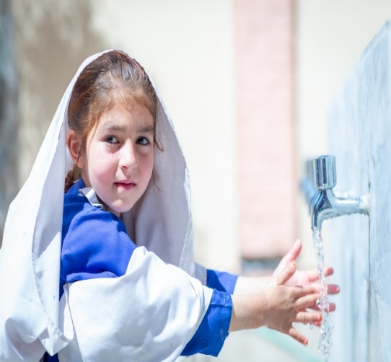
During year 2022, UNDP completed two major interventions, in terms of rehabilitation of partially damaged schools. Following are the details of these tasks.
Figure 1: A student is using hand washing station.

- UNDP completed rehibition work of 50 schools. Civil work on these schools was initiated in year 2021 and was completed in the reporting year. During the process, UNDP and the representatives of the education department thoroughly checked the quality of civil work through joint field visits and spot checks. Any issue in the civil work identified during these joint visits was reported to the civil work contractors for rectification. Finally, UNDP checked the construction work through a third-party engineering firm and randomly through its internal team of engineers. Upon quality checking of civil works and satisfactory performance, UNDP issued Schools Completion Certificates and these schools and have handed over to the education department.

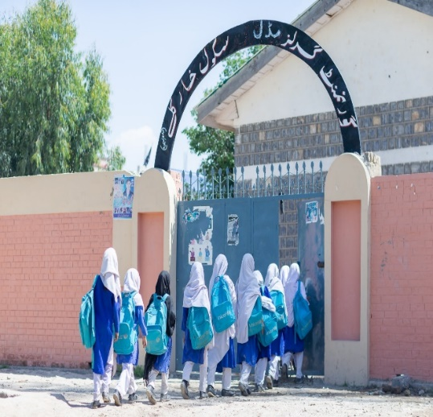
- Against the target of rehabilitating 20 schools in year 2022, the UNDP and ESED identified and selected 2I*girls' schools; 11 in Kurram and 10 in Orakzai district for rehabilitation work. After acquiring No Objection Certificate (NOC) from the TDP secretariat, the UNDP’s third-party engineering firm assessed physical rehabilitation needs of these schools in April 2022. The needs included building of boundary walls and wash facilities, land development, roof repairing, construction of disability-responsive toilets, and installation of electric wiring. The assessment also identified construction of additional seven rooms in six schools. UNDP has successfully completed the rehabilitation works in all the 21 schools through private contractors who worked under the supervision of UNDP’s internal team of engineers dedicated for the project.
Figure 2: Students back to rehabilitated school
Year 2022 has experienced unprecedented meltdown of Pakistani currency against US dollar. This PKR and USD parity has left UNDP with some budget unspent. In order to invest this unspent amount on the unmet needs in the schools, UNDP and ESED has planned to construct seven additional rooms in the selected assisted schools as result of additional funds available. Thanks to the GAC for exhibiting its consent on the UNDP’s planning for construction of additional rooms through granting a no cost extension until June 2023 to the project. At the time of authoring this report, civil work for reconstruction of these rooms is in progress.
Ms. Yasmeen, Deputy District Education Officer, Kurram, while acknowledging the support of GAC and UNDP/UNICEF for restoration of education services mentioned that project assistance has brought many positive changes that has enhanced the education experience for students and improved the overall quality of education.
He said “the rehabilitation of classrooms and other areas within the school made it more comfortable and safer environment for students and teachers. Installation of ramps for special kids made schools more accessible for students with disabilities. The construction of boundary walls made schools safer place for students’ teachers and other staff. Overall, the rehabilitation improved students moral and fostered a sense of pride in school and community. It increased students’ enrollment and decreased drop out rate of students”.
In year 2022, parts of Pakistan were hit by monsoon rains that caused widespread floods across the country. Like other sectors, the education sector also faced the major brunt of floods where many school infrastructures were partially or completely demanded to an extent that such schools were not able to house students for education. GAC requested UNDP to rehabilitate one damaged girl’s high school in village Brep, Upper Chitral district. The UNDP had time (owing to the no cost extension) and funds (owing to gain from USD exchange rate) and hence the rehabilitation was initiated. At the time of documenting this report, the rehabilitation work is in progress and includes removal of debris and mud, reconstruction of boundary wall, classrooms, Science Laboratory, IT Laboratory, and WASH facilities. UNDP will construct and rehabilitate the said school on “Build Back Better approach.”
Year-wise target and achievement is presented in the table below.
Description | Year 1 (2020) | Year 2 (2021) | Year 3 (2022) | Total
Target | 30 schools | 50 schools | 20 schools | 100
Achievement | 30 schools | civil work on 50 schools initiated. | Civil work on 50 schools of year 2021 completed.  Civil work on 21 schools is in progress | 102 (80 completed, 21 in progress, 01 planned for 2023)
The project has taken all necessary steps to ensure sustainability of the environment during the rehabilitation work. Following table explains the steps taken / planned during the civil work on the rehabilitation. These are UNDP standard risks and mitigation measure in civil works (also reported in 2021 annual report)
Activity | Parameter | Mitigation Measures Checklist
General Conditions | Notification and Worker Safety | - The concern government departments, committees and communities have been notified of upcoming construction activities.  - All legally required permits have been acquired for construction and/or rehabilitation (All sites are recommended for rehab/construction activities by concern government department.  - The contractor formally agrees that all work will be carried out in a safe and disciplined manner designed to minimize impacts on neighboring residents and environment.  - Workers will comply with good practices of civil works
General Rehabilitation and /or Construction Activities | Air Quality | - Demolition debris shall be kept in controlled area and sprayed with water mist to reduce debris dust.  - The surrounding environment (sidewalks, roads) shall be kept free of debris to minimize dust.  - There will be no open burning of construction / waste material at the site.  - There will be no excessive idling of construction vehicles at sites.  - If any tree cut for construction purpose, the contractor will plant 10 trees to minimize effect.
 | Noise | - Construction noise will be limited to restricted times.  - During operations the engine covers of generators, air compressors and other powered mechanical equipment shall be closed, and equipment placed as far away from residential areas as possible
 | Water Quality | - The site will establish appropriate erosion and sediment control measures such as e.g., hay bales and / or silt fences to prevent sediment from moving off site and causing excessive turbidity in nearby streams and rivers.  - Biological and chemical tests will be conducted of drinking water.
 | Waste management | - Waste collection and disposal pathways and sites will be identified for all major waste types expected from demolition and construction activities.  - Construction waste will be collected and disposed.  - Whenever feasible the contractor will reuse and recycle appropriate and viable materials (except asbestos)

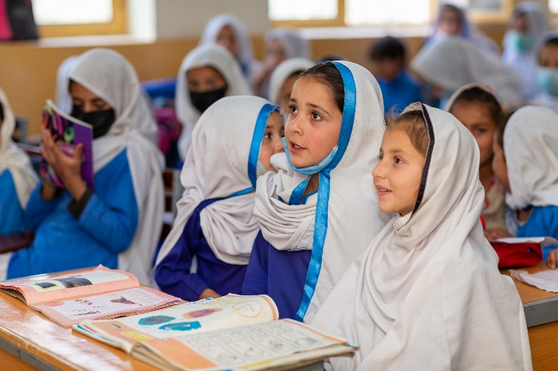
Output 1123: Furniture distributed to the rehabilitated schools:
Kurram District: Students are utilizing GAC funded furniture in GGPS Kachkeena

As per annual workplan, the project successfully provided students' furniture to 21 schools, 11 in Kurram and 10 girls schools in Orakzai districts.
UNDP selected vendors for the manufacturing and supply of furniture using a competitive procurement process based on quality, value for money, experience, and legal conditions. UNDP followed standard specifications and approved by Elementary and Secondary Education Department(E&SED). UNDP also engaged a technical consultant for quality assurance and pre-delivery inspection of the furniture supplied by the vendor. The consultant regularly inspected furniture and, as necessary, recommended rectifications on the spot in case of variations from the approved specifications. UNDP and district education officers conducted post-distribution monitoring of the quality and utilization of the furniture.
During the 3rd of project UNDP provided teachers furniture to 106 schools as per the approved standard specification. Teachers’ furniture was included tables and chairs distributed to all the targeted schools of Kurram and Orakzai districts. UNDP followed the procurement of furniture as per the standard UN procedure. UNDP and district education officials visited to schools for distributing teachers’ furniture to rehabilitated schools The provision of furniture will help improve learning environment, better utilization of classroom space, and increased teacher and students’ satisfaction.
Year-wise bifurcation of total target and progress achieved is given in the table below.
Description | Year 1 (2020) | Year 2 (2021) | Year 3 (2022) | Total until 2022
Target | 30 schools | 50 schools | 20 schools | 100
Achievement | 38 schools | 50 schools | 21 schools | 110 (Distribution to 109 schools completed and planned for 01 school in Upper Chitral district).

Immediate Outcome 1130: Increased capacity of girls and adolescent girls to claim their right to education and make their voices heard in decision-making processes that affect them.
Under this immediate outcome, three interventions were in focus: providing information and life skills-based education to adolescent girls; supporting families, communities, and decision makers for the protection of children from abuse; and capacity building of public authorities.

Output 1131: Information and Life Skills development provided to adolescent girls
A Life Skills Based Education (LSBE) toolkit was developed through a consultant, pre-tested, finalized, and implemented in districts Kurram and Orakzai during 2021. The year 2022, witnessed further rollout of the trainings within the same districts through LSBE Champions (Adolescents) and Master Trainers. 28 Master Trainers (13 women & 15 men) were trained to cascade the trainings within the two intervention districts. During the reporting period the master trainers further trained 3,136 adolescents (2,460 girls & 676 boys) against a target of 3,136. Around 200 LSBE toolkits were distributed as well. The trained Champions further disseminated the information to 2,197 peers (1,401 girls & 796 boys) against a target of 2,400. Furthermore, 4,163 peers (1,499 girls & 2,664 boys) were engaged in discourse on children’s right to education and other human rights, against a target of 2,400.

Output 1132: Families, communities and decision makers supported to respect the rights of girls to education and support their protection from any form of abuse.
The toolkit for community influencers was used to train 166 community influencers (80 women & 86 men) against a target of 100, through 15 sessions in 110 communities. The participants included schoolteachers, parents, community elders, and religious leaders.

Output 1133: Capacities of public authorities and services strengthened to uphold girls’ rights to education and protection.
The toolkit for public authorities was used to train the representatives from line departments i.e., health, education, social welfare, and local government. 95 officials (12 women & 83 men) were trained against the target of 100 in four 2-day training sessions.

Intermediate Outcome 1200: Improved Equitable and Coordinated Provision of Safe Quality and Gender Responsive Education from early childhood to middle/elementary school for girls and adolescent girls in fragile settings.
This intermediate outcome focuses on improving equitable and gender-responsive education from early childhood for girls in the two project districts.
Immediate Outcome 1210: Enhanced capacity of education stakeholders to ensure the provision of safe, inclusive learning spaces for girls.
Detailed progress of the contributing outputs is presented below.
Output 1211: Essential teaching and learning supplies provided for 100 teachers and 12,000 students.
School supplies including School in a Box, Recreation kit, ECE kit and Student Learning Kits, MHM kits, health and hygiene kits distributed benefitting 13,940 girl students in 2022. Field teams, Sub divisional District Education Officers and District Monitoring Officers monitored utilization of the supplies to ensure its effective use.
220 Teachers (20 in 2020, 50 in year 2021 and 150 in 2022) have been trained on ECE. The trained teachers received Early Learning and Development Standards (ELDS), Teachers Guidebook and Teachers Handbook to use ECE material appropriately during the classroom activities. Similarly, MHM kits and information pack has been shared with 220 teachers to create awareness about MHM in adolescent girls, PTC, and mother groups.
Output 1212: Awareness sessions for health and hygiene and menstrual hygiene management conducted and dignity kits distributed in 155 schools
During the reporting period, 156 schools have participated in the health and hygiene orientation session and much work has been done to ensure safe hygiene and institutionalization of hygiene practices. Hence this resulted in increase in awareness about adopting safe health and hygiene practices by adolescent girls, mother groups, and women PTC members. Due to the acceptance of MHM in the beneficiaries, MHM corners have been set up in the school accessible to the adolescent girls.

A total of 156 female teachers in year 2022 were trained on MHM, who further organised sessions for adolescent girls in respective 101 schools, in collaboration with health and hygiene club members. The sessions were attended by 4,085 girls, who were also benefitting from 2,096 MHM kits. PTC members and mother groups members also attended these sessions.
Besides, capacity building of 156 teachers on MHM and distribution of dignity kits to adolescent girls was conducted in the reporting period.

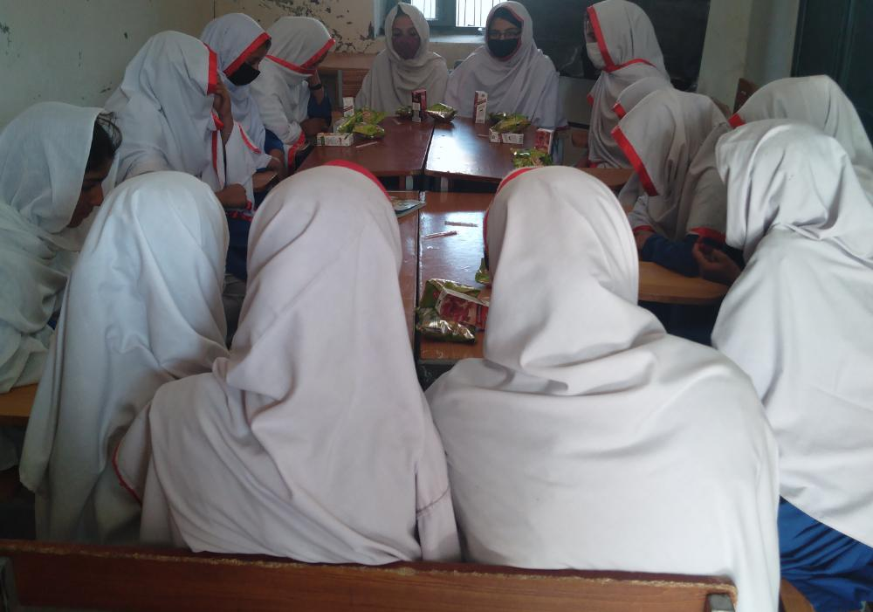
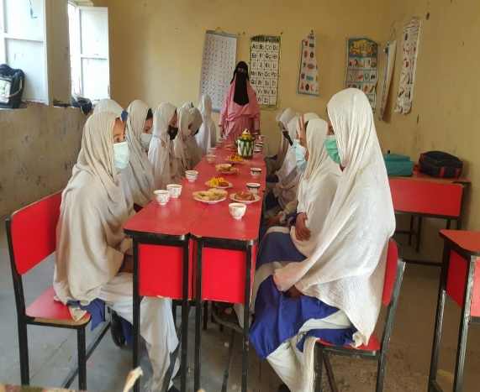
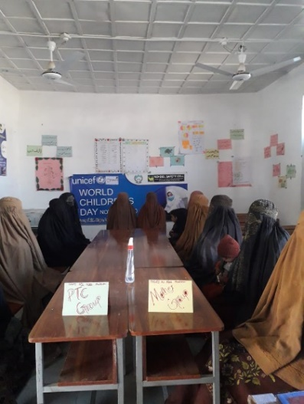
Output 1213: Continuous education provided to girls who previously did not have access to post-primary education and are now enrolled in 55 middle schools.
GGPS Khail Mat Khan Killi: Session with Health and Hygiene Club GGPS

GGPS Mir Mela Sheikhan Orakzai Session on MHM
GGPS Chapri: Session with Health and Hygiene Club

The programme supported 1,596 girls against the planned target of 1925 girls who previously did not have access to post-primary education to enroll in 55 middle schools during last two years. In the reporting period, target is achieved, and 2,019 girls (target 1925 girls) are benefitting from the interventions. This achievement was a result of interventions such as community mobilisation campaigns on the importance of girls’ education and enrolment. Following successful advocacy by UNICEF, all 55 middle schools have been included in the Directorate of ESED routine monitoring plan. Furthermore, to ensure quality of learning and retention of girls, district education monitoring teams monitor the attendance of teachers. UNICEF’s seconded field staff also verified teacher attendance before their monthly salary is processed, conduct classroom observations, and provide mentoring support to the teachers on a need-basis. They also conducted the pacing of Scheme of Studies exercise with teachers to ensure that course contents coverage is on track and completed in time. To ensure quality learning and retention of students, 70 teachers of 55 middle schools have been trained on general pedagogy, content knowledge, and scheme of studies, in coordination with Directorate of Professional Development.
To foster ownership and management of schools, PTCs, Mothers’ groups and health and hygiene committees have been formed in all 55 middle schools, and field staff conduct fortnightly meetings with them for progress update on their activities, as per their TORs.

Immediate Outcome 1220: Enhanced capacity of education stakeholders to provide quality gender-sensitive teacher training.
This immediate outcome aims to build the capacity of education stakeholders to provide quality training for teachers and improve teacher attendance. In collaboration with Provincial Institute Teachers’ Education (PITE) and the Education Monitoring Authority (EMA), this initiative is providing support to monitor teacher attendance and to develop and deliver teacher trainings.

Output 1221: Professional development training provided to teachers, particularly female teachers, to improve student-centered and gender-responsive teaching practices.
UNICEF, in collaboration with Directorate of Professional Development (DPD) of ESED and GAC, has developed teachers training manual on Child Centered Approach and Gender Responsive Teaching Practices. Two workshops on manual development for teachers have been conducted as per plan in 2021. The teacher’s training manual have been reviewed, translated, and endorsed by Directorate of Curriculum and Teacher Education (DCTE).

In 2022, DPD has successfully completed ToT and further trained 310 teachers from 156 focused schools. This output also seeks to provide capacity building to 310 teachers on child-centered and gender- sensitive teaching practices. Building on previous work done in collaboration with DPD, a teacher training manual on child centred approach and gender responsive teaching practices was developed in consultation with Directorate of Curriculum and Teachers Education (DCTE). The manual was reviewed by DCTE and translated in Urdu. DCTE has approved the manual, which will be used by DCTE for training teachers hereon.

Output 1222: Technical assistance provided to the Ministry of Education to reduce teacher absenteeism, and professional development training supported for teachers to improve student-centered and gender-responsive teaching practices.
The grant aimed to strengthen Education Monitoring Authority (EMA) technical capacity in improving monitoring and data system. In this regard, support was provided in refining Annual School Census (ASC) proforma in consultative manner with EMA by incorporating additional areas required for efficient planning at district and provincial levels in 2021. In 2022, EMA was supported in conducting 3rd and 4th quarterly review meetings to take stock of the monitoring and issues of the schools, engaging Directorate of E&SED and DCTE. During the reviews, learning and assessment was also deliberated to develop mechanism of regular student assessment and learning analysis. Since, School Leaders are being recruited therefore, E&SED will advise on the role and mandate of school leaders on quality part.
EMA was also supported to conduct an exchange visit to PMIU Punjab in the first week of June 2022The visit aimed to assess the roles, mandates, structures, and effectiveness of PMIU, Punjab in improving data systems in the Education sector and to adopt the best practices into the KP context. Similarly, PMIU has been established in 2002, assisting the School Education Department (SED) in various reforms, initiatives, and monitoring & implementation aspects in Punjab. While Independent Monitoring Unit (IMU) was established in 2013, extended in NMDs in 2019, and transformed into Authority in July 2020 as Education Monitoring Authority (EMA). The following key best practices were identified by EMA for adoption to make robust data regime in Education sector in KP:

Student Data: Individual student tracking which help in calculating actual NER, GER, and identification of out-of-school children.

School Leaders: Monitoring Quality of Education, Unbiased monitoring to replicate the successful Model of Punjab Model in KP and similar data collection software exist.
Tablet in a School; Daily data collection & school self-reporting, similar data collection software exists & management of data collection due to the district presence.

M&E Wing in EMA: Data Digitization Reporting of authentic and verifiable data to the stakeholders when the schools are being handed over to ESED by C&W

App for Monitoring by Managers: Paperless digital data collection, digital Records along with school pictures & visit coordinates

COVID-19 Response
COVID-19 response was initiated and completed in 2nd year of the project implementation to offset the possible effects of COVID-19 on the education system of the project supported schools. This response was delivered through development and distribution of materials and support for continuity of learning activities and through provision of technical assistance to E&SED for safe schools reopening and functioning of schools. Detailed progress and achievement of COVID-19 response is documented and reported in the 2nd year annual report.
- Describe any delays in implementation, challenges, lessons learned and best practices:

Weather conditions remained a challenge during the implementation of the civil works in the project. Due to the prolonged rainfall, the infrastructure work had to be stopped and hence completion was delayed. Unavailability of skilled labor in the local labour market was a challenge faced. Shorter days in winter and limited availability of supplies affected the project activities. However, UN regular monitoring and engagement with the contractor and district administration helped in addressing the challenges. Involvement of local communities developed local ownership, which in turn helped achieve better quality results and enabled the project to better respond to any shortcomings / bottlenecks in the field implementation. Capacity building of community members helped in ensuring the sustainability of the course of actions. Parent Teacher Committee members started to discuss their local problems and explore solutions to address the problems.
Conducting teachers training (from different ethnic backgrounds) was a major challenge particularly at time of high tension between the Shia and Sunni communities. Therefore, UN organised separate trainings in separate locations to avoid risk.
Continuous engagement with the communities through project interventions, resulted in enhanced ownership, participation, and sustainability. The community participated in the enrollment drives, mobilisation of parents to enroll and retain children in schools and continuous support to teacher particularly non-local women teachers.
The project observed from monitoring visits, engagement with the wider community (including mother groups, PTC members, local elders, and schoolteachers) that despite providing all facilities to improve access to education, some parents are still not encouraged to send girls to schools primarily due to poverty and lack of financial resources. In future models, UN could also address such vulnerabilities that impede sending girl children to schools due to extreme poverty through provision of skills training or TVET training.
UNDP had to 2 schools because the same schools were allocated to UNDP and another organisation for rehabilitation at the same time. This caused UNDP time and financial resources in terms of damage assessment.

- Qualitative assessment

This section is not applicable for the year 2022 as no qualitative assessment was planned for and conducted in year 2022.

Table 1: Achievement of indicators at both the output and outcome level
ii) Indicator Based Performance Assessment:

Reducing Barriers preventing Access to Quality Education for Girls in Tribal Districts of Khyber Pakhtunkhwa (2019-2022)
LOG FRAME
Ultimate outcome contributing to Global Affairs Canada G7 Commitment: | Improved learning outcomes for girls and adolescent girls in tribal districts of Khyber Pakhtunkhwa
Intermediate Programme Outcomes | 1100 Increased equitable access to safe, secure, quality, inclusive education and learning by girls and adolescent girls in fragile settings  1200 Improved equitable and coordinated provision of safe, quality and gender responsive formal and non-formal education, from early childhood to end of secondary for girls and adolescent girls
Outcome level indicator | CG7Edu1: # of schools that have implemented changes to create welcoming spaces that respond to specific needs of girls  CG7EDU2: # of schools (pre-primary, primary, secondary and non-formal learning spaces) with access to adapted infrastructure, specially trained teachers and materials (...)  CG7EDU3: # of girls, adolescent girls and women benefitting from reduced barriers to education  CG7ED4: # of teachers trained (m/f) according to national standards  CG7ED5: # of boys and girls that complete their pre-primary, primary and secondary education and non-formal equivalents  CG7ED6: “# of girls and boys accessing improved learning environments.

X | Achieved Indicator Targets (2022) | Reasons for Variance with Planned Target (if any) | Source of Verification
Outcome Indicator:  CG7Edu1: # of schools that have implemented changes to create welcoming spaces that respond to specific needs of girls.  Baseline: 0  Planned Target 2020: 85 Schools  Planned Target 2021: 50 Schools  Planned Target 2022: 20 Schools  Cumulative target (since beginning of the project) = 155 | 135 number of schools have implemented changes to create welcoming spaces that respond to specific needs of girls.  Achievement 2020: 85 schools  Achievement 2021: 0  Achievement 2022: 50 schools  Rehabilitation work in 22 schools is in progress. Out of these, soft activities (training, supplies etc.) were completed in 21. | Rehabilitation of 50 schools (achievement 2022) was continued activity from year 2021. Restricted access to the project areas by the law enforcement authorities delayed the rehabilitation work until 2nd quarter of year 2022.  Rehabilitation of 22 schools (against the target of 20) in year 2022 is delayed due to a) utilization of the unspent exchange-gained amount on additional civil work, and b) inclusion of one additional girls’ high school of village Brep, Upper Chitral district. Further details can be read under output 1122.  After the rehabilitation of 22 schools is completed (soft activities are already completed in 2022), the combined package will result in creation of welcoming spaces that will respond to specific needs of girls.
Outcome Indicator:  CG7EDU2: # of schools (pre-primary, primary, secondary and non-formal learning spaces) with access to adapted infrastructure, specially trained teachers and materials (...)  Baseline: 0  Planned Target 2020: 85 schools.  Planned Target 2021: 50 schools.  Planned Target 2022: 20 schools.  Cumulative target (since beginning of the project) = 155 | 135 schools have access to adapted infrastructure, specially trained teachers and learning material  (30 girls’ primary schools of year 1, and 55 non-formal (middle schools) learning spaces for girls  Achievement 2020: 85 schools  Achievement 2021: 0  Achievement 2022: 50  The project has made specific efforts to ensure that students with disabilities have access to the adapted infrastructure, trained teachers and materials.  The project is responding to the needs of i) physically disabled children and ii) children with learning disabilities/difficulties.  Please refer to below points that are undertaken efforts for improving access of the students with disabilities:  - At baseline stage, it is ensured that students with disabilities are identified, and their nature of disability is recorded. According to the data collected in December 2021, a total of 56 girls’ students (34 in Kurrum and 22 in Orakzai district) are identified who have learning disabilities/difficulties.  - Review secondary documents to get information on the possible pattern in enrollment of disabled students in schools of KP province. In a study conducted by the UNICEF (Disability-Inclusive Education Practices in Pakistan. August 2021), it is reported that 0.53% of the total enrollment in schools are students with disabilities.  The project determines nature of facilities for the students with disabilities. Thus, in every rehabilitated school, following interventions are implemented.  Students with learning disabilities/difficulties:  - UNICEF has developed teachers training manual to deal with children with learning difficulties. This training manual is under review with DCTE. The teachers will be trained after finalization of teachers training manual. This intervention is supported by UNICEF regular resources.  Students with physical disabilities:  Following facilities are provided in all GAC supported schools:  - Access ramps for classrooms and washrooms constructed under the project.  - Where required, ramps are provided at entrance of the schools. | Progress against target of year 2021 is achieved in year 2022. In year 2021, rehabilitation work in 50 schools was rescheduled due to the reason mentioned earlier. Whereas the soft activities are completed on time.
Outcome Indicator:  CG7EDU3: # of girls, adolescent girls and women benefitting from reduced barriers to education.  Baseline: 0  Planned target 2020: 7,636 girls’ students.  Planned Target 2021: 4,492 girls’ students.  Planned target 2022: 1,797.  Cumulative target (since beginning of the project) = 13,925 | 13,940 number of girls benefitting from reduced barriers to education.  Rehabilitation of schools, training of teachers and mobilized communities have reduced barriers of girls to enroll and continue education in the GAC assisted schools.  Achievement 2020: 5,606 girls’ students  Achievement 2021: 4,050 girls’ students  Achievement 2022: 4284 girls’ students | -
Outcome Indicator:  CG7ED4: # of teachers trained (m/f) according to national standards.  Baseline: 0  Planned Target 2020: 170  Planned Target 2021: 100  Planned Target 2022: 40  Cumulative target (since beginning of the project) = 310 | 310 teachers trained according to national standards.  Achievement 2020: 0  Achievement 2021: 240  Achievement 2022: 70 | Out of 310 teachers trained in 2022, training received on early childhood education: 220 teachers.  MHM: 156 teachers  Gender responsive teaching practices and child centered approaches: 310  In 2021, 80 are trained on ECE and MHM whereas 160 are trained on COVID-19 related SOPs.
Outcome indicator:  CG7ED5: # of boys and girls that complete their pre-primary, primary and secondary education and non-formal equivalents.  Baseline: 0  Planned Target 2021: NA  Cumulative target (since beginning of the project) = 170 |  | Progress on this indicator will be provided in the project final report.
Outcome Indicator:  CG7ED6: “# of girls and boys accessing improved learning environments.  Baseline: 0  Planned target 2020: 7,636 girls’ students.  Planned Target 2021: 4,492 girls’ students.  Planned Target 2022: 1,797  Cumulative target (since beginning of the project) = 13,925 | 13,940 number of girls accessing improved learning environment.  Rehabilitation of schools, training of teachers and mobilized communities have improved access of girls to improved learning environment.  The project assisted only girls’ schools because of following two reasons.  - Mixed or co-education primary schools exist in settled districts of Khyber Pakhtunkhwa but there are very few in NMDs.  - The project is primarily designed for assisting girls’ schools. Thus, the project has signed MoU with E&SED for girls’ schools only.  Achievement 2020: 5,606 girls’ students  Achievement 2021: 4,050 girls’ students  Achievement 2022: 3,596 girls’ students | Against the planned target of 13,925 girls’ students until end of year III, the project has improved access of 13,252 girls.  The total target was estimated based on EMIS report 2018 where average pupils per schools were estimated 120. However, when field teams started assessment, it was identified that baseline number was lower since a lot of families had not returned to the area of origin. The enrolment of 9,696 is the actual number collected by field teams and verified by the respective DEOs.

.
X | Achieved Indicator Targets (2022) | Reasons for Variance with Planned Target (if any) | Source of Verification
Intermediate Outcome 1100: Increased equitable access to safe, secure, quality, inclusive education and learning by girls and adolescent girls in fragile settings |  | - | -
Immediate Outcome 1110: Increased knowledge and skills of stakeholders (government, non-government, and community) to promote girls’ access to inclusive and quality education in fragile settings. | UNICEF to respond
Output 1111: Girl’s enrolment and retention campaigns conducted with a focus on explaining and advocating the importance and value of girls’ education:  Indicator: # of campaigns conducted, targeting equal numbers of women and men in HHs  Baseline: 0  Planned Target 2022: 6 | Target: 02 enrolment and retention campaigns  Achieved: 02 enrolment and retention campaign |  | NA
Output 1112: Training provided to Parent-Teacher Councils/Associations and Mothers' Groups to promote and monitor girls’ access to education and engage in the prevention of harmful practices adversely affecting girls.  Indicator: # of PTCs (minimum 33% women) and mothers groups trained and actively engaged to promote girl’s education.  Baseline: 0  Target: 100  Indicator: # of outreach community sessions completed for women and for men  Baseline: 0  Target: 300 community sessions (on average, each PTC conduct 3 sessions)  Indicator: # PTC-led record available on girls enrolled and retained in education as a result of PTC community engagement  Baseline: 0  Planned Target: 1 | Target: 100 PTCs and 100 mother groups  Achieved: 101 PTCs (eight members in each with only female members in girl schools) and Mother Groups (eight to ten members in each) formed. Targeted PTCs (with a total of 800 members) have been trained and actively engaged to promote girls ‘education.  Target: 240 community sessions  Achieved: 340 community sessions  Target: PTC-led record available on girls enrolled and retained in education as a result of PTC community engagement in 100 schools  Achieved: Overall PTCs in 101 schools had regular meetings / sessions to enrol girls and record available in 101 schools. | --  Not Applicable  Not Applicable | Field office activity report, pictures
Output 1113: New ECE centers established and supported.  Indicator: # of ECE centers established and supported  Baseline: 0  Planned Target: 100  Indicator: # of young girls enrolled  Baseline: 0  Planned Target: 2000 | Target: 100 ECEs centers established in year 2022  Achieved: 100 ECE established  Achieved: 2889 young girls enrolled | 2,889 total enrollment including  980 new enrollment. | Field office activity report  Partner’s report, DEO reports, field staff reports.
Immediate Outcome 1120 Increased capacity of government and stakeholders to reduce social, cultural, and physical barriers to girls participating in education.
Output 1121: Technical assistance provided to MOE to conduct a joint gender-based analysis in MDs of KP, identifying barriers and bottlenecks for girls’ access to education.  Indicator: Gender analysis available with number of solutions to overcoming bottlenecks and barriers to girls' education.  Baseline: 0  Planned Target: 1 | Desk review completed, and final report presented to the Secretary Education, KP. He has conditionally approved the desk review report. |  | Draft report available with UNICEF
Output 1122: Damaged and destroyed schools (100) rehabilitated to increase the availability of girl-friendly school infrastructure.  Indicator: No of schools rehabilitated  Baseline: 0 schools  Planned Target: 100 schools. | Target: 20 schools  Achieved: 21 schools (Rehabilitation assigned scope of works have been completed and additional scope works (including construction of seven additional rooms) will be completed in the second quarter of calendar year 2023 and will be handed over to education department. Flood affected school rehab works initiated | Non availability of material in the local market, scattered location of schools’ accessibility and extreme weather condition. were a big challenge. | Internal and joint monitoring reports
Output 1123: Furniture distributed to the rehabilitated schools.  Indicator: No of schools received furniture  Baseline: 0 schools  Planned Target: 100 schools.  Indicator: No of schools received teacher furniture  Baseline: 0  Planned Target: 100 schools. | Target: 20 schools  Achieved: 21 schools received students’ furniture  Target: 100 schools  Achieved: 106 | Not applicable | Delivery receipt and district education offices report
Immediate Outcome 1130: Increased capacity of girls and adolescent girls to claim their right to education and make their voices heard in decision making processes that affect them.
Output 1131: Information and Life Skills Based Education provided to adolescent girls.  Indicator: # of adolescents (boys and girls) who participate in group discussions on child rights  Baseline: 0  Planned Target: 3,136  Indicator: # of adolescents (boys and girls) who know their right to education and other human rights  Baseline: 0  Planned Target:  4,000 adolescents | Indicator: # of adolescents (boys & girls) who participated in group discussions on child rights.  Target: 3,136 adolescent boys and girls  Achieved: 3,136 adolescents (676 boys and 2,460 girls) trained in LSBE.  Indicators: # of adolescents (boys & girls) who know their right to education and other human rights  Target:  Achieved: 4,163 adolescents (1,499 girls & 2,664 boys) and 1,570 caregivers (704 women & 866 men) were engaged in awareness on children’s right to education and other human rights | The target is overachieved | Field office activity report, Social Welfare Department report.
Output 1132: Families, communities and decision makers supported to respect the rights of girls to education and support their protection from any form of abuse.  Indicator: # of communities reached with messages on rights of girls to education and protection  Baseline: 0  Planned Target: 155 communities. | Target:100 communities reached with messages on rights of girls to education and protection  Achieved: 110 communities reached. In these communities, a total of 166 community influencers (86 men and 80 women) provided trainings on the right to education and protection. | Not Applicable | Field reports
Output 1133: Capacities of public authorities and services strengthened to uphold girls’ rights to education and protection.  Indicator: # of trained frontline workers (aiming for minimum of 33% female) who know how to identify and refer girls out of schools to alternative learning centers and for other relevant protective services  Baseline: 0  Planned Target: 100 | Target: 100 frontline workers trained (aiming for minimum of 33% female) who know how to identify and refer girls out of schools to alternative learning centers and for other relevant protective services  Achieved: 95 officials (12 women & 83 men) with 13% female representation, were trained against the target of 100 in four 2-day training sessions. | The target was not fully achieved because of security challenges in Orakzai. Female representation was hard to achieve, and training sessions were conducted with difficulty. | Field office activity report, Social Welfare Department report.  Consultant training report.
Immediate Outcome 1210: Enhanced capacity of education stakeholders to ensure the provision of safe, inclusive learning spaces for girls.
Output 1211: Essential teaching and learning supplies provided for 100 teachers and 12000 students.  Indicator: # of children received teaching and learning supplies, disaggregated by sex  Baseline: 0  Planned Target: 12,000 (60% girls)  Indicator: # of teachers received teaching and learning supplies, disaggregated by sex  Baseline: 0  Planned Target: 100 (50% female) | Achieved: 13,925 children (100% girls) received teaching and learning supplies  220 teachers received teaching and learning supplies (100% female) | Not Applicable | Field office activity report
Output 1212: Awareness sessions for health & hygiene and menstrual hygiene management conducted and dignity kits distributed in 155 schools.  Indicator: # of schools that have participated in health and hygiene orientation sessions  Baseline: 0  Planned Target: 155  Indicator: # of schools that have MHM kits and trained teachers.  Baseline: 0  Planned Target: 155 | Target: 155 schools participated in health and hygiene orientation sessions  Achieved: 156 schools (100% female)  Target: 155 schools  Achieved: Sessions on MHM conducted in all 156 schools while MHM kits were distributed in all 156 schools as per need. | Not Applicable | Field office activity report
Output 1213: Continuous education provided to girls who previously did not have access to post-primary education and are now enrolled in 55 middle schools.  Indicator: # of middle schools supported  Baseline: 0  Planned Target: 55  Indicator: # of adolescent girls enrolled  Baseline: 996  Planned Target: 1,925 | Target: 55 middle schools  Achieved: 55 middle schools supported  Achieved: 2019 adolescent girls enrolled in 55 girls’ middle schools | Not Applicable | Field office activity report
Outcome 1220: Enhanced capacity of education stakeholders to provide quality, gender-sensitive teacher training.
Output 1221: Professional development training provided to teachers, particularly female teachers, to improve student-centered and gender-responsive teaching practices.  Indicator: # teachers trained (50% female)  Baseline: 0  Planned Target: 310 (50% female)  Output 1222: Technical assistance provided to the Ministry of Education to reduce teacher absenteeism, and professional development training supported for teachers to improve student-centered and gender-responsive teaching practices.  Indicator: Functioning teacher attendance monitoring system in place  Baseline: 0  Planned Target: 1 | Target: 310 teachers for year 2021  Achieved: 310 teachers trained on gender responsive teaching practices and child centered approaches.  Target: Monitoring system in place. UNICEF supported EMA to ensure teachers attendance regularly. | Manual on Gender Responsive teaching practices and Child Centered Approach has been developed, reviewed, and approved | EMA reports.

III. Other Assessments or Evaluations
Not applicable

IV. Programmatic Revisions
Not applicable

- Resources (Optional)

- Annexes

- List of 21 school
- Teacher furniture specification
- Students’ furniture approved by Education department.

The term “programme” is used for programmes, joint programmes and projects.
Strategic Results, as formulated in the Strategic UN Planning Framework (e.g., UNDAF) or project document.
The MPTF Office Project Reference Number is the same number as the one on the Notification message. It is also referred to as “Project ID” on the project’s factsheet page the MPTF Office GATEWAY
The MPTF or JP Contribution, refers to the amount transferred to the Participating UN Organizations, which is available on the MPTF Office GATEWAY
The start date is the date of the first transfer of the funds from the MPTF Office as Administrative Agent. Transfer date is available on the MPTF Office GATEWAY
As per approval of the original project document by the relevant decision-making body/Steering Committee.
If there has been an extension, then the revised, approved end date should be reflected here. If there has been no extension approved, then the current end date is the same as the original end date. The end date is the same as the operational closure date which is when all activities for which a Participating Organization is responsible under an approved MPTF / JP have been completed. As per the MOU, agencies are to notify the MPTF Office when a programme completes its operational activities.
As discussed in the 6th TWG meeting the project would spend the unspent budget on one additional school identified in district Kurram. The list therefore also contains particulars of 21 schools
Specification is attached as annexure.
Teacher furniture specification as annexure
In the year I of the project, furniture packages were provided to eight additional schools on the request of District Education Office. These schools were not rehabilitated using GAC assistance. Since UNDP follows value for money approach and conduct procurement of furniture through competitive process, lower price quotation from the competing suppliers were received. Savings from this price differential were diverted towards purchasing these furniture packages and therefore will have no impact on the total budget approved for purchasing of furniture for 100 schools rehabilitated through GAC assistance.

