Survey of Mentors

Having completed the trainings for mentors and having worked with SSG (Self-Support Groups), how confident are you in your understanding of mental health and peacebuilding issues in the communities?
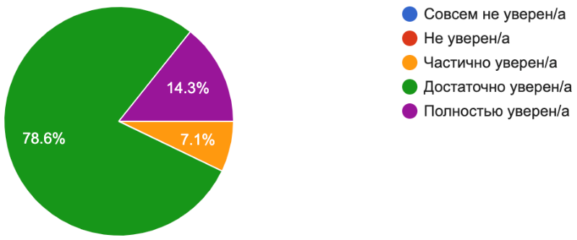
14.3% - Completely confident
78.6%% - confident enough
7.1% - partially confident

How would you rate your knowledge of methodologies for addressing mental health issues and peacebuilding in SSG communities?
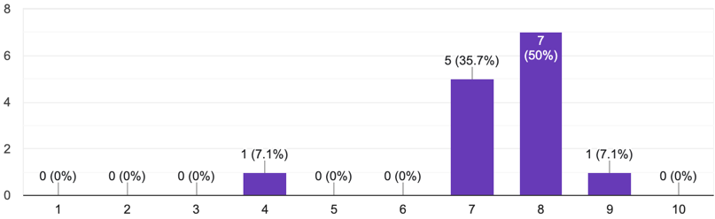
7.1% - satisfactory
35.7% - good
57.1% - excellent

Do you think that the SSG participants will be able to address their issues and needs in the field of mental health and psychosocial care after the completion of the project?
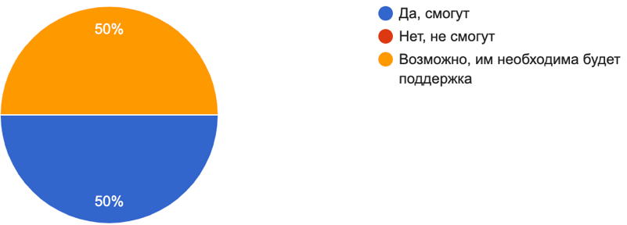
50% - Yes, they can
50% - possible, but they would need some support

In your opinion, how much has the ability of SSG participants to meet their mental health needs improved?
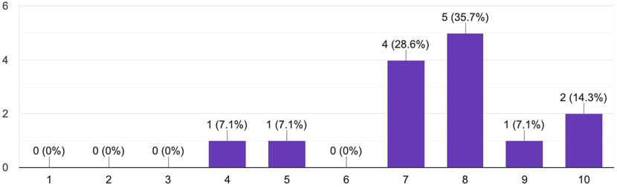
14.2% - satisfactory
28.6% - good
57.1 % - excellent

To what extent will SSG participants be able to confidently address their mental health issues?
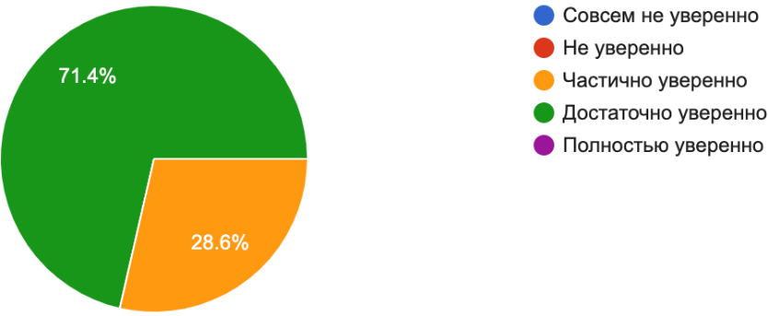
71.4% - Confident enough
28.6% - partially confident

To what extent SSG members are satisfied with the care they received within the self-support groups?
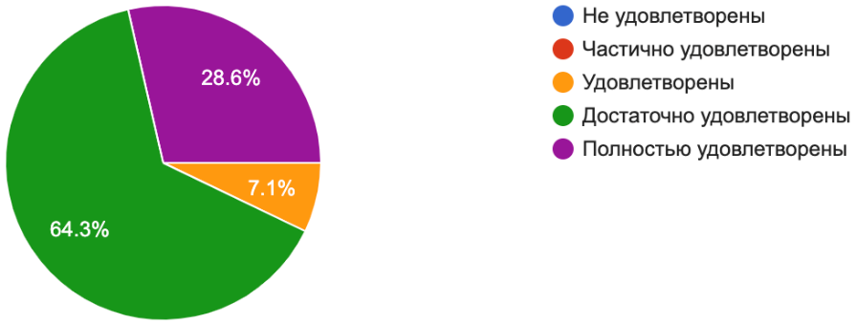
64.3% - Satisfied enough
28.6% - Completely satisfied
7.1 % - satisfied

Analysis:

The survey results provide insights into the confidence levels, knowledge, and perceived outcomes related to mental health and peacebuilding in the Self-Support Groups’ communities. Here is a summary of the findings:

1. Confidence in Understanding Mental Health and Peacebuilding Issues: When asked about their confidence in understanding mental health and peacebuilding issues in the communities after completing the trainings for mentors and working with Self-Support Groups (SSGs), the responses were as follows:
- 14.3% were completely confident.
- 78.6% were confident enough.
- 7.1% were partially confident.

2. Knowledge of Methodologies for Addressing Mental Health Issues and Peacebuilding: Participants were asked to rate their knowledge of methodologies for addressing mental health issues and peacebuilding in the communities. The responses were as follows:
- 7.1% rated their knowledge as satisfactory.
- 35.7% rated their knowledge as good.
- 57.1% rated their knowledge as excellent.

3. Expectations of SSG Participants' Ability to Address Issues and Needs: When asked if SSG participants would be able to address their issues and needs in the field of mental health and psychosocial care after the completion of the project, the responses were evenly split:
- 50% believed they could.
- 50% believed it was possible, but they would need some support.

4. Improvement in SSG Participants' Ability to Meet Mental Health Needs: Mentors were asked to assess how much the ability of SSG participants to meet their mental health needs improved after the project was completed. The responses were as follows:
- 14.2% rated it as satisfactory.
- 28.6% rated it as good.
- 57.1% rated it as excellent.

5. Confidence of SSG Participants in Addressing Mental Health Issues: Mentors were asked to assess the extent to which SSG participants would be able to confidently address their mental health issues. The responses were as follows:
- 71.4% believed they would be confident enough.
- 28.6% believed they would be partially confident.

6. Satisfaction with Help Received in SSGs: Mentors were asked to gauge the satisfaction level of SSG participants with the assistance received within the project. The responses were as follows:
- 64.3% believed they were satisfied enough.
- 28.6% believed they were completely satisfied.
- 7.1% believed they were satisfied.

Summary:

The survey results indicate varying levels of confidence and knowledge among the participants regarding mental health and peacebuilding issues in the communities. A significant percentage of respondents expressed confidence in their understanding of these issues, while a smaller proportion had partial certainty. The majority of participants rated their knowledge of methodologies for addressing mental health issues and peacebuilding as either good or excellent, indicating a strong grasp of these concepts.

Regarding the ability of SSG participants to address their mental health needs after project completion, opinions were divided, with an equal split between those who believed they could and those who thought they would need additional support. However, the survey revealed positive outcomes, with the majority of participants recognizing excellent improvements in SSG participants' ability to meet their mental health needs. Additionally, a significant portion of respondents believed that SSG participants would be confident enough to address their mental health issues.

Survey for partners
What's your gender?
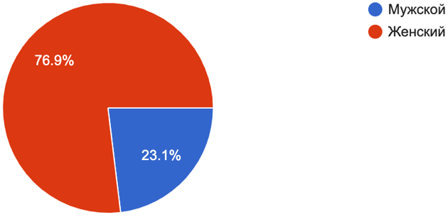
76.9% are women, 23.1% are men

How much did you increase your knowledge and understanding of the needs of young people in terms of mental health and psychosocial support during the implementation of the project?
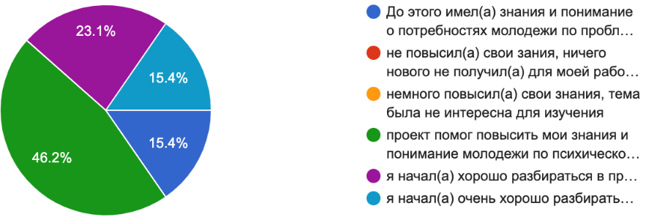
15.4 % - "I have started to gain a good understanding of the needs of young people in the field of mental health and apply the skills acquired in my further work and advocacy."
23.1 % - "I have started to gain a good understanding of the issues related to youth mental health, and I have a desire to further study this topic and work in this field."
46.2% - "The project has helped me increase my knowledge and understanding of youth mental health. It has provided me with a direction for further studying the issue."
15.4% - "Prior to this, I had knowledge and understanding of the needs of youth regarding mental health issues and psychosocial support."

Percentage of how much participation in the implementation of the Birge project and activities helped you increase your knowledge of the needs of young people for mental health and psychosocial support.
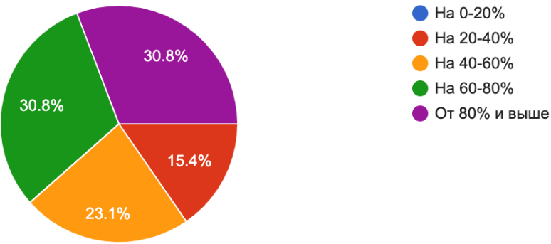
30.8% - above 80%
30.8 % - for 60-80%
23.1% - for 40-60%
15.4% - for 20-40%

Overall, how would you rate the contribution of the project to improve youth access to mental health and psychosocial support? 1- no contribution 5- high contribution
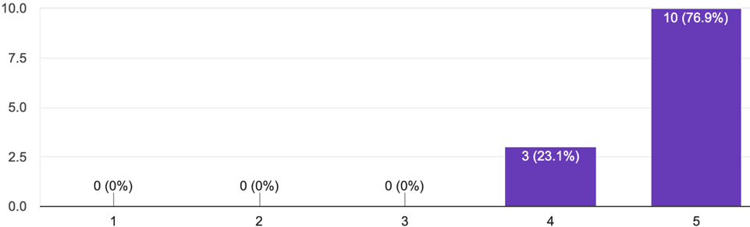
76.9% - 5
23.1% - 4

Analysis and Summary:

The survey results from the partners indicate positive outcomes regarding their knowledge and understanding of the needs of young people in terms of mental health and psychosocial support. Here are the key findings:

1. Gender Distribution: The survey participants consisted of 76.9% women and 23.1% men.

2. Increase in Knowledge and Understanding: The responses regarding the increase in knowledge and understanding of young people's needs in mental health and psychosocial support are as follows:
- 15.4% mentioned that they have started gaining a good understanding of the needs and have applied the acquired skills in their further work and advocacy.
- 23.1% stated that they have started gaining a good understanding of the issues related to youth mental health and expressed a desire to further study this topic and work in the field.
- 46.2% indicated that the project has helped them increase their knowledge and understanding of youth mental health and provided them with a direction for further study.
- 15.4% mentioned that they already had knowledge and understanding of the needs of youth regarding mental health issues and psychosocial support prior to their involvement in the project.

3. Impact of Project Participation on Knowledge Increase: When asked about the percentage of how much participation in the project and activities helped increase their knowledge of the needs of young people for mental health and psychosocial support, the responses were as follows:
- 30.8% reported an increase of above 80% in their knowledge.
- 30.8% reported an increase of 60-80%.
- 23.1% reported an increase of 40-60%.
- 15.4% reported an increase of 20-40%.

4. Overall Contribution of the Project: When rating the contribution of the project to improve youth access to mental health and psychosocial support on a scale of 1 to 5 (1 being no contribution and 5 being high contribution), the responses were as follows:
- 76.9% rated the project's contribution as 5 (high contribution).
- 23.1% rated the project's contribution as 4.

In summary, the survey results indicate that the project has positively impacted the partners' knowledge and understanding of the needs of young people regarding mental health and psychosocial support. The project has provided direction for further study, advocacy, and work in this field. The majority of participants recognized a significant increase in their knowledge, highlighting the project's effectiveness in enhancing their understanding of youth mental health. Furthermore, the high rating of the project's contribution to improving youth access to mental health and psychosocial support demonstrates its positive impact and effectiveness in addressing these important issues.

Survey of members of the self-support groups
What's your gender?
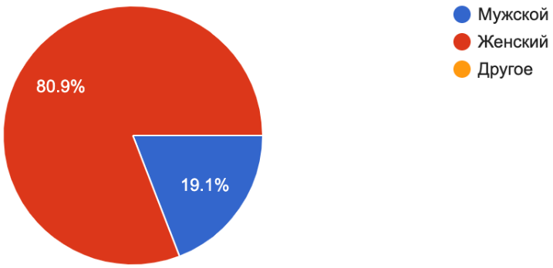
80.9 % - female, 19.1% - men (47 Russian-speaking respondents)
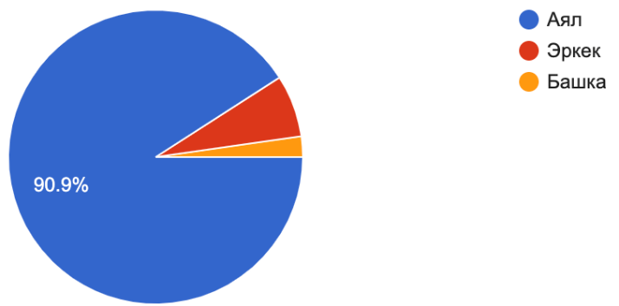
90.9 % - female, 6.8% - men (44 Kyrgyz-speaking respondents)

Your age?
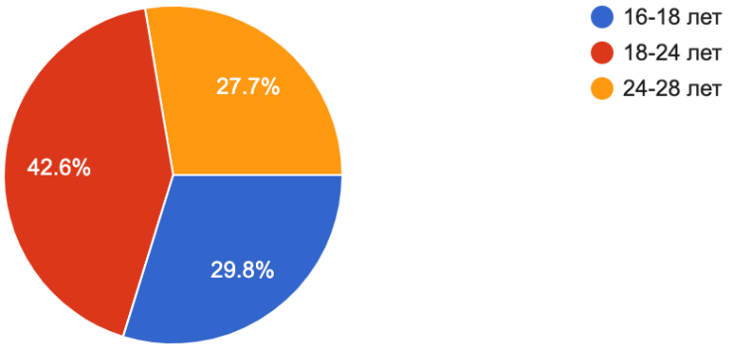
29.8% - 16-18 years old
42.6%% - 18-24 years old
28% - 24-28 years old (47 Russian-speaking respondents)
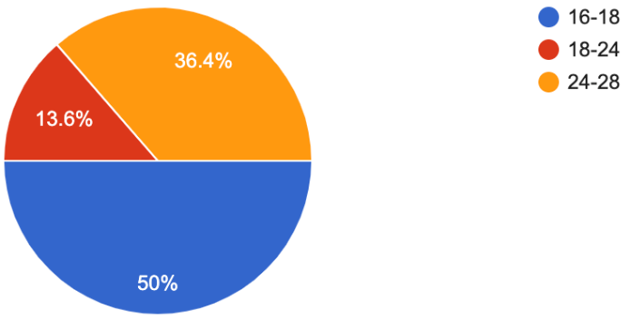
50% - 16-18 years old
13.6 %% - 18-24 years old
36.4% - 24-28 years old (44 Kyrgyz-speaking respondents)

What is your region or city where you live?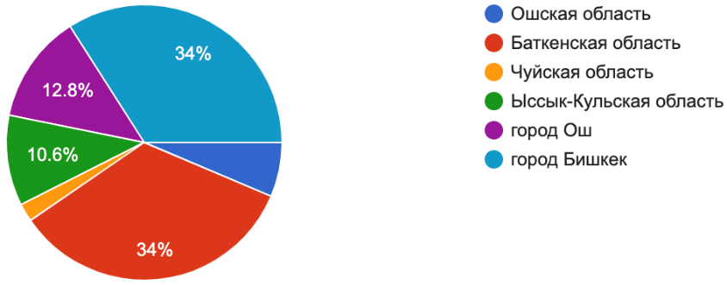
34% - Batken province
34% - Bishkek
12.8% - Osh
10.6% - Issyk-Kul
3% -Osh province
1% - Chuy province (47 Russian-speaking respondents)
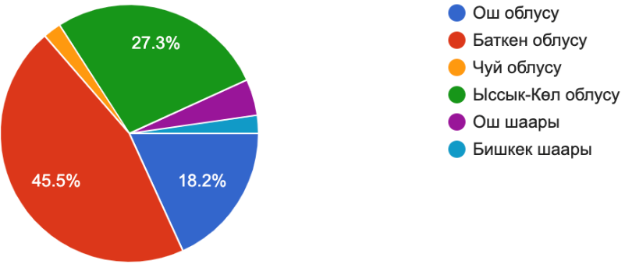
45.5% - Batken province
34% - Bishkek
2.3% - Osh
27.3% - Issyk-Kul
18.2% -Osh province
2.3% - Chuy province (44 Kyrgyz-speaking respondents)

How useful was the group (self-support group) for you?
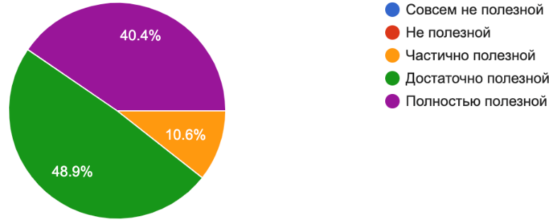
40.4 % - Completely helpful
48.9% - Useful enough
10.6% - Partially useful (47 Russian-speaking respondents)
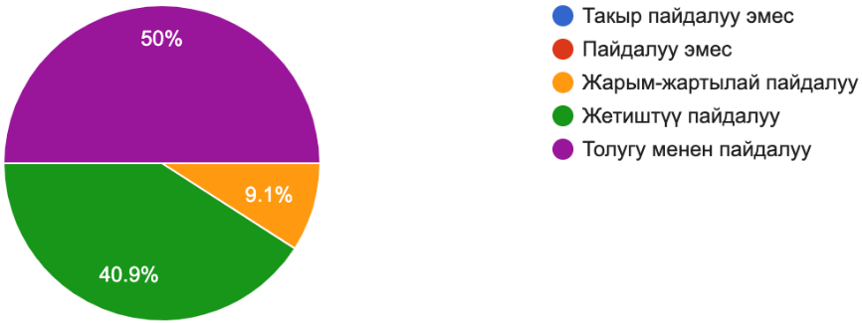
50% - Completely helpful
40.9% - Useful enough
9.1% - Partially useful (44 Kyrgyz-speaking respondents)

How did participating in the self-support group meetings help you with the problems or issues that you came to the group with? 1-3 points - "bad"; 4-5 points - "satisfactory"; 6-7 points - "good" 8-10 points - "excellent"
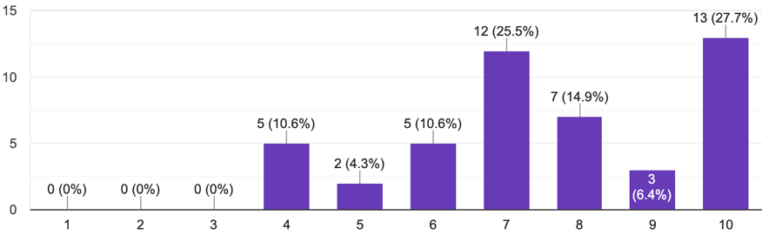
14.9% - satisfactory 36.1% - good 49% - excellent (47 Russian- speaking respondents)
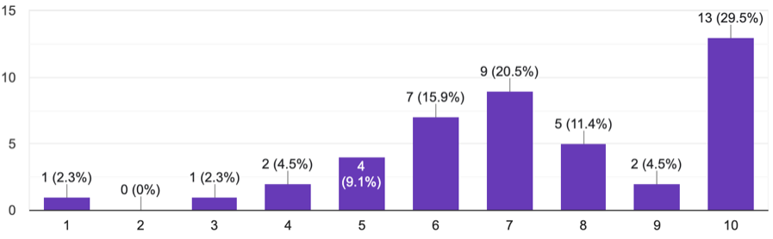
4.6% - bad 13.6% - satisfactory 36.4% - good 45.4% - excellent (44 Kyrgyz-speaking respondents)

Analysis:

The survey results provide insights into the gender distribution, age groups, regions, and the perceived usefulness of self-support groups and participation in the self-support groups in addressing personal problems or issues. Here is a summary of the findings:

1. Gender Distribution: Among the 47 respondents, 80.9% identified as female, while 19.1% identified as male. Among the 44 respondents, 90.9% identified as female, while 6.8% identified as male.

2. Age Groups: The respondents were categorized into three age groups:
- For the 47 respondents: 29.8% were aged 16-18, 42.6% were aged 18-24, and 28% were aged 24-28.
- For the 44 respondents: 50% were aged 16-18, 13.6% were aged 18-24, and 36.4% were aged 24-28.

3. Regional Distribution: The respondents mentioned the following regions or cities where they live:
- For the 47 respondents: 34% from Batken province, 34% from Bishkek, 12.8% from Osh, 10.6% from Issyk-Kul, 3% from Osh province, and 1% from Chuy province.
- For the 44 respondents: 45.5% from Batken province, 34% from Bishkek, 2.3% from Osh, 27.3% from Issyk-Kul, 18.2% from Osh province, and 2.3% from Chuy province.

4. Usefulness of Self-Support Groups: When asked about the usefulness of the self-help group, the responses were as follows:
- For the 47 respondents: 40.4% found it completely helpful, 48.9% found it useful enough, and 10.6% found it partially useful.
- For the 44 respondents: 50% found it completely helpful, 40.9% found it useful enough, and 9.1% found it partially useful.

5. Impact of Self-support Group Participation on Personal Problems or Issues: Participants were asked to rate how participating in the self-support groups helped them with their problems or issues on a scale of 1 to 10. The responses were as follows:
- For the 47 respondents: 14.9% rated it as satisfactory (1-3 points), 36.1% rated it as good (4-5 points), and 49% rated it as excellent (6-10 points).
- For the 44 respondents: 4.6% rated it as bad (1-3 points), 13.6% rated it as satisfactory (4-5 points), 36.4% rated it as good (6-7 points), and 45.4% rated it as excellent (8-10 points).

In summary, the survey findings indicate that the majority of respondents were females, primarily within the age range of 18-24 and residing in Batken province and Bishkek. The self-help group was generally perceived as helpful, with a significant portion of participants finding it completely helpful or useful enough. Participating in the meetings of the self-support groups was predominantly rated as good to excellent in terms of addressing personal problems or issues. These findings highlight the positive impact and effectiveness of the self-supports groups in supporting individuals and addressing their challenges.

