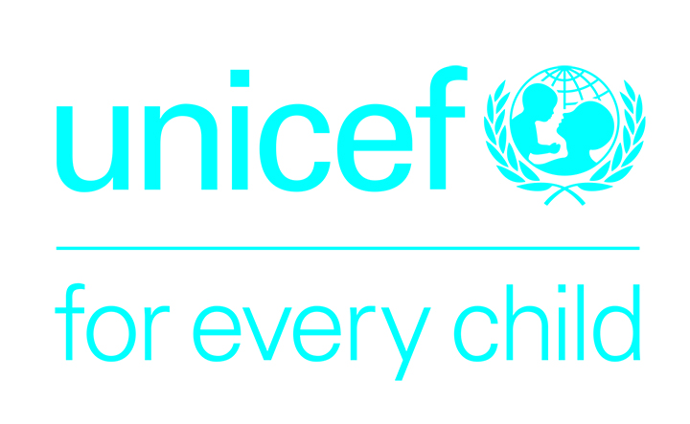 | 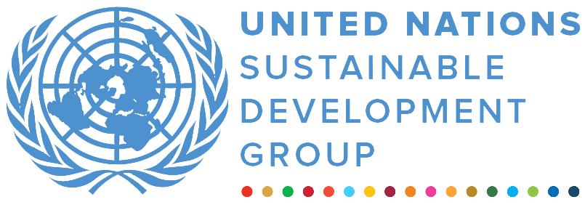 | 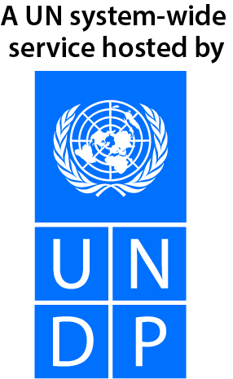
UN Uganda Multi-Partner Trust Fund – Emergency Window
Final Narrative report
REPORTING PERIOD: 12 May 2021 – 14 April 2022

Programme Title & Project Number |  |  | Country, Locality(s), Priority Area(s) / Strategic Results
- Programme Title: Improving Water, Sanitation and Hygiene services in the context of Covid-19 and flood response  - Programme Number (if applicable) SM210261  - MPTF Office Project Reference Number: 00126682 |  |  | (if applicable)  Country/Region: Uganda
 |  |  | Priority area/ strategic results: Water, Sanitation & Hygiene
Participating Organization(s) |  |  | Implementing Partners
- Organizations that have received direct funding from the MPTF Office under this programme  UNICEF |  |  | - National counterparts: (government, private, NGOs & others) and other International Organizations)  District local governments of Adjumani, Kisoro, Buliisa, Pakwach, Obongi, Kasese, Ntoroko, Moroto, and Nakapiripiriti.
Programme/Project Cost (US$) |  |  | Programme Duration
Total approved budget as per project document:  MPTF /JP Contribution:$239,775.59  - by Agency (if applicable) |  |  | Overall Duration: 12 months
Agency Contribution  - by Agency (if applicable) |  |  | Start Date (12.05.2021)
Government Contribution  (if applicable) |  |  | Original End Date (31.01.2022)
Other Contributions (donors)  (if applicable) |  |  | Current End date(14.04.2022)
TOTAL: $239,775.59
Programme Assessment/Review/Mid-Term Eval. |  |  | Report Submitted By
Assessment/Review - if applicable please attach  Yes No Date: dd.mm.yyyy  Mid-Term Evaluation Report – if applicable please attach  Yes No Date: dd.mm.yyyy |  |  | - Name: Vedasto Nsanzugwanko  - Title: Deputy Representative, Programmes  - Participating Organization (Lead): UNICEF  - Email address: vnsanzugwanko@unicef.org
LIST OF ACRONYMS

MPTF | Multi Partner Trust Fund
OPM  PSN  URCS | Office of the Prime Minister  Persons with Special Needs  Uganda Red Cross Society
WASH | Water, Sanitation and Hygiene

ARRATIVE REPORT FORMAT

EXECUTIVE SUMMARY
- The MPTF contribution of $239,775 was received following heavy rains that caused widespread flooding and a lot of destructions across Uganda from causing landslides and windstorms affecting districts in the Eastern, Western and Northern regions of the country. As per the assessment conducted by the OPM, 240,000 people were affected country wide. At least 40,000 people were displaced solely in Kasese district alone and sought shelter in churches and schools. The OPM-led emergency preparedness and response plan outlined the provision of WASH support to affected communities as a key component of the required response. Given the scale of the crisis, the humanitarian aid response by OPM and URCS was insufficient to meet the dire need of the affected communities hence MPTF funds contributed to risk reduction through provision of WASH supplies and restored decontaminated water points to ameliorate the suffering. The districts most affected were provided by OPM assessment report while UNICEF worked closely with the district local government of affected districts to identify gaps by undertaking rapid needs assessments to identify WASH needs and provide services most needed. UNICEF provided immediate response for WASH supplies to affected communities in targeted districts and also rehabilitated boreholes as a measure to bring back the previous services destroyed by the flood. In response to the floods, UNICEF provided WASH supplies and mobile toilets to the affected communities in Kasese, Ntoroko and Buliisa districts. Similarly, borehole rehabilitation in Kasese, Ntoroko, Buliisa, Nakapiripiriti and Moroto districts improved access to safe water.

Purpose
- The funding allocation was sought to enable UNICEF to support 28,000 people affected by the floods emergency with WASH supplies and services.

Results
- With funds from the MPTF, UNICEF continued to support flood affected populations with WASH supplies, safe water and sanitation facilities in the nine (9) flood affected districts of Adjumani, Kisoro, Buliisa, Pakwach, Obongi, Kasese, Ntoroko, Moroto, and Nakapiripiriti. In total, 30,006 persons were reached against the planned target of 28,000 as shown in the table below:

SN | Districts | No. people reached with safe water | No. of people reached with sanitation facilities | No. of people reached with critical WASH supplies | No. of HFs reached
1 | Adjumani | 1240 | 0 | 0 | 4
2 | Obongi | 2,704 | 0 | 5,890 | 6
3 | Pakwach | 1,240 | 0 | 0 | 8
4 | Buliisa | 1,800 | 1200 | 6,076 | 10
5 | Kasese | 3,900 | 2,400 | 8,432 | 18
6 | Kisoro | 3,600 | 0 | 2,268 | 12
7 | Ntoroko | 3,066 | 1,800 | 7,340 | 12
8 | Moroto | 900 | 0 | 0 | 0
9 | Nakapiripriti | 900 | 0 | 0 | 0
Total | 9 | 19,350 | 5,400 | 30,006 | 70

- UNICEF provided critical WASH supplies, improved water and sanitation facilities in communities and institutions through distribution of WASH supplies, rehabilitation of 20 boreholes and installed 18 mobile toilets in the nine (9) flood affected districts. The mobile toilets had provisions for persons with special needs (PSNs) and benefited 5,400 persons. UNICEF also provided WASH supplies to the affected population to promote appropriate behaviours.

UNICEF procured and distributed the supplies were as follows:

No. | Item description | Quantity
1 | Water purif (NaDCC) 67mg tabs/BOX-16000 | 200
2 | Laundry soap, Carton, 25 bars, 800 grams | 879
3 | Liquid soap, handwash, 5 L | 1,200
4 | Hand washing facility, 60 litres | 366
5 | Menstrual pad, reusable | 750
6 | Calcium hypochlorite 65-70% ** | 120
7 | Water tank, plastic, 10000 litre | 5
8 | Jerry can, rigid, 20l | 1,200
9 | Tarpaulin plastic reinforced 4x5m 22.5kg | 200
10 | Gum Boots Rubber Size 43 | 300
11 | Gum Boots Rubber Size 44 | 300
12 | Bleach | 1,000
13 | Mobile plastic portable toilet | 18

ii) Indicator Based Performance Assessment:
Using the Programme Results Framework from the Project Document / AWP - provide an update on the achievement of indicators at both the output and outcome level in the table below. Where it has not been possible to collect data on indicators, clear explanation should be given explaining why, as well as plans on how and when this data will be collected.

QUARTERLY PROGRESS REPORT RESULTS MATRIX
OUTPUT INDICATORS
Indicator | Geographic Area | Projected Target  (as per results matrix) | Quantitative results for this current reporting period | Cumulative results since project commencement (quantitative) | Delivery Rate (cumulative % of projected total)  as of date
Description of the quantifiable indicator as set out in the approved project proposal
1.1 Number of people accessing sufficient quantity of water of appropriate quality for drinking, cooking and personal hygiene | Kasese, Ntoroko, Buliisa Moroto and Nakapiripiriti, Obongi, Pakwach, Adjumani,  Kisoro | 25,000; Adults,  11,750 (Male, 5,757; Female, 5,993)  Children; 13,250 (6,758 girls and 6,492 boys), | 19,350 | 25,350 | 101.4%
1.2 Number of people in humanitarian situations accessing appropriate sanitation facilities and living in environments free of open defecation | Kasese, Buliisa, Ntoroko | 3000  Adults – 1200 (Male, 588; Female 612)  Children, 1,800 (918 girls and 882 boys). | 3,000 | 5,400 | 180%
1.3 Number of people reached with critical WASH supplies (including hygiene items) and services | Obongi, Ntoroko, Buliisa and Kasese  Kisoro | 28,000 | 12,000 | 30,006 | 107.2%
1.4 Number of health facilities supported with a minimum WASH and IPC package | Obongi, Ntoroko, Buliisa and Kasese | 70 | 29 | 70 | 100%

iii) A Specific Story (Optional)
- Field Pictures
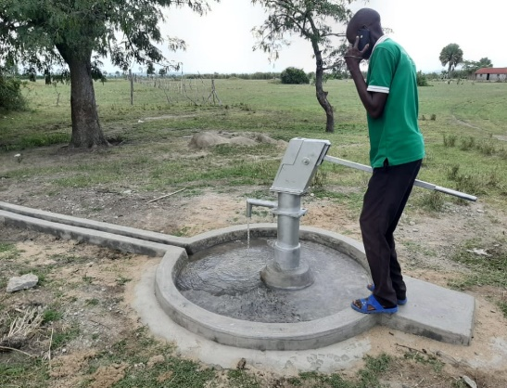
- Rehabilitation of borehole in Ntoroko
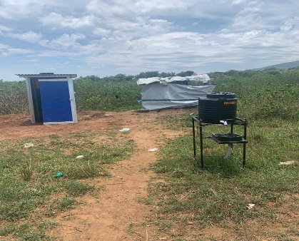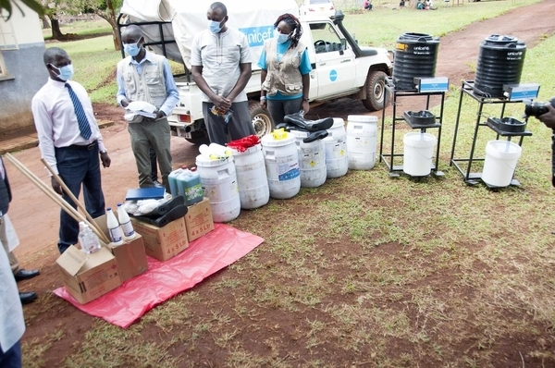
- Installed mobile toilet in Muhokya IDP Kasese Distribution of WASH supplies for flood affected population

Problem / Challenge faced: Describe the specific problem or challenge faced by the subject of your story (this could be a problem experienced by an individual, community or government).

Programme Interventions: How was the problem or challenged addressed through the Programme interventions?

Result (if applicable): Describe the observable change that occurred so far as a result of the Programme interventions. For example, how did community lives change or how was the government better able to deal with the initial problem?

Lessons Learned: What did you (and/or other partners) learn from this situation that has helped inform and/or improve Programme (or other) interventions?

Provision of safe water, sanitation facilities and hygiene supplies contributed to improved environmental and key hygiene practices thus reduced the risk of infectious disease outbreaks, in the event of floods. In addition to the immediate response, the rehabilitation of boreholes provided a long-term sustainable solution to the communities by ensuring a sustained access to safe water even after the floods are over. WASH supplies provided are inclusive of menstrual hygiene materials related supplies incorporated in WASH supplies to meet specific needs of girls/women. The project also contributed to the strengthening of COVID-19 response by creating an enabling environment for handwashing with soap and other hygiene practices. As a result of UNICEF supported WASH activities, all the planned results were achieved.

III. Other Assessments or Evaluations (if applicable)
• Report on any assessments, evaluations or studies undertaken.

IV. Programmatic Revisions (if applicable)
• None

V. Resources (Optional)
• Provide any information on financial management, procurement and human resources.
• Indicate if the Programme mobilized any additional resources or interventions from other partners.

Strategic Results, as formulated in the Strategic UN Planning Framework (e.g. UNDAF) or project document;
The MPTF Office Project Reference Number is the same number as the one on the Notification message. It is also referred to as “Project ID” on the project’s factsheet page the MPTF Office GATEWAY
The MPTF or JP Contribution, refers to the amount transferred to the Participating UN Organizations, which is available on the MPTF Office GATEWAY
The start date is the date of the first transfer of the funds from the MPTF Office as Administrative Agent. Transfer date is available on the MPTF Office GATEWAY
As per approval of the original project document by the relevant decision-making body/Steering Committee.
If there has been an extension, then the revised, approved end date should be reflected here. If there has been no extension approved, then the current end date is the same as the original end date. The end date is the same as the operational closure date which is when all activities for which a Participating Organization is responsible under an approved MPTF / JP have been completed. As per the MOU, agencies are to notify the MPTF Office when a programme completes its operational activities.

