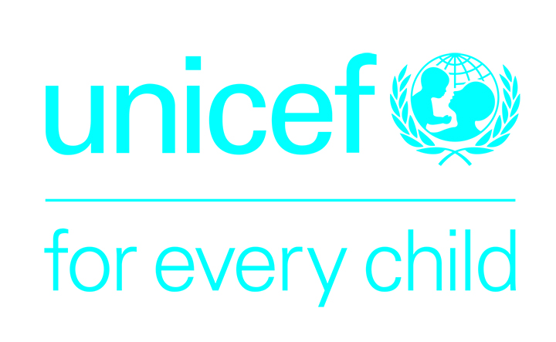 | 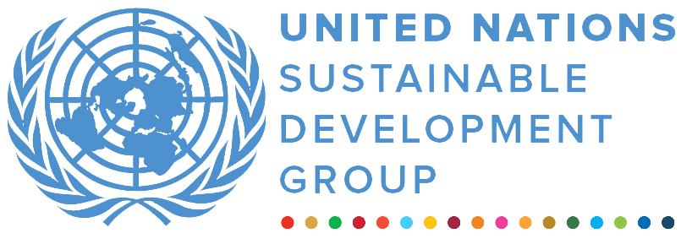 | 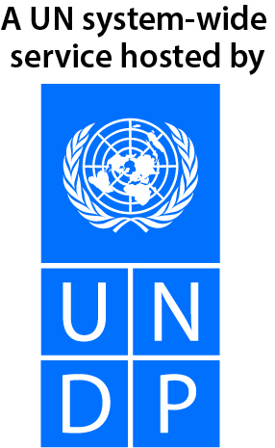

UN UgANDA MULTI-PARTNER tRUST fUND – EMERGENCY WINDOW
FINAL NARRATIVE report

REPORTING PERIOD: 12 May 2021 – 21 April 2022

Programme Title & Project Number |  |  | Country, Locality(s), Priority Area(s) / Strategic Results
- Programme Title:  Improving Availability and Utilization of Life Saving Health and Water, Sanitation and Hygiene (WASH) Services in the context of COVID-19 and flood response in Uganda.  - Programme Number (if applicable): SM210259  - MPTF Office Project Reference Number: 00126757 |  |  | Uganda / ESARO
 |  |  | Priority area/ strategic results
Participating Organization(s) |  |  | Implementing Partners
- Organizations that have received direct funding from the MPTF Office under this programme  UNICEF |  |  | National counterparts (government, private, NGOs & others) and other International Organizations  - Save the Children Italy (SCI)  - CUAMM  - Selected District Local Governments
Programme/Project Cost (US$) |  |  | Programme Duration
Total approved budget as per project document: $399,683.84  MPTF /JP Contribution:  - by Agency (if applicable) |  |  | Overall Duration: 12 months
Agency Contribution  - by Agency (if applicable) |  |  | Start Date: 12 May 2021
Government Contribution  (if applicable) |  |  | Original End Date: 31 January 2022
Other Contributions (donors)  (if applicable) |  |  | Current End date: 21 April 2022
TOTAL: $ 399,683.84
Programme Assessment/Review/Mid-Term Eval. |  |  | Report Submitted By
Assessment/Review - if applicable please attach  Yes No Date: dd.mm.yyyy  Mid-Term Evaluation Report – if applicable please attach  Yes No Date: dd.mm.yyyy |  |  | - Name: Vedasto Nsanzugwanko  - Title: Deputy Representative, Programmes  - Participating Organization (Lead): UNICEF  - Email address: vnsanzugwanko@unicef.org
NARRATIVE REPORT FORMAT

ACRONYMS

AAP | Accountability for Affected Populations
ADHO  AEFI | Assistant District Health Officer  Adverse Effects Following Immunisation
CEHS | Continuity of Essential Health Services
CFR  CTU | Case Fatality Rate  COVID 19 Treatment Unit
CUAMM | Doctors’ with Africa
DHIS  DHO | District Health Information System  District Health Officer
DHT | District Health Team
DLG | District Local Government
DTF | District Task Force
DVS | District Vaccine Stores
GoU | Government of Uganda
HACT  HIA | Harmonized Approach to Cash Transfers  Health Information Assistant
HMIS  IEC | Health Management Information System  Information Education and Communication
IPC | Infection Prevention and Control
LMIS | Logistics Management and Information System
MoH  MPTF | Ministry of Health  Multi Partner Trust Fund
NGO | Non-Governmental Organization
PPE | Personal Protective Equipment
PSEA | Protection against Sexual Exploitation and Abuse
PSS | Psychosocial Support
RRH  SCI | Regional Referral Hospital  Save the Children Italy
SEA | Sexual Exploitation and Abuse
SOP | Standard Operating procedure
UN | United Nations
UNICEF | United Nations Children’s Fund
VfM | Value for Money
WHO | World Health Organization

EXECUTIVE SUMMARY

The main objectives of the contribution were to improve individual and household behavior change and community action to prevent COVID-19 and other disease outbreaks; and to provide Personal Protective Equipment (PPE) for use by health workers. The project targeted seven districts of Kasese, Kaabong, Moroto, Karenga, Amudat, Nabilatuk, Napak that are prone to seasonal floods which lead to bouts of Cholera during the rainy season and was implemented in partnership with the district-based partners, CUAMM and Save the Children Italy, using strategic mix and linking of mutually reinforcing activities, including risk communication for enhanced awareness; community engagement on COVID-19 and hygiene promotion; training of health workers and the distribution of critical supplies like, translated IEC materials, personal protection equipment (PPEs) and WASH supplies, as mitigation measures against both COVID-19 and Cholera.

By end of the project, a total of 803,957 people were reached with basic messages in all the seven (7) districts. Communities were sensitised through radio-talk shows, house-to-house visits and community dialogue meetings. A total of 1,545 VHTs were trained on community-based surveillance and effective community engagement; 142,470 people were reached through house-to-house and community dialogue meetings and were able to share their concerns and asking questions/clarifications to address their needs through existing established feedback mechanisms. By the end of 2021, public awareness on the risks associated with COVID-19 and awareness on the importance of vaccination against COVID-19 was at 90 per cent.

UNICEF used funding from MPTF to procure and distribute PPEs, and information education and communication (IEC) supplies directly to the district local governments. The implementing partners assisted the districts to ensure last mile distribution of the PPEs to 110 Health Facilities in the seven districts and the VHTs. The VHTs were equipped with 5400 sets of job-aides on COVID-19 prevention and COVID-19 vaccination and 20,000 posters on Cholera and 20,000 booklets on Frequently Asked Questions (FAQs) in English and the respective translated versions, four local languages in Karamoja region and two local languages in Kasese district.

Purpose

The main objectives of the contribution were to improve individual and household behaviour change and community action to prevent COVID-19 and other disease outbreaks; and to provide Personal Protective Equipment (PPE) for use by health workers. Specific behavioural change objectives included compliance to COVID-19 preventive measures including COVID-19 vaccination acceptance, continuity of essential health services (CES) and the maintenance of basic household key family care practices like home hygiene, in all community-based health care and health education initiatives.

UNICEF, with funding from the Multi Partner Trust Fund (MPTF) aimed to contribute to the roll out of a new community engagement strategy that focusses on integrated messaging and direct engagement with affected population, for prevention and care of both Cholera and COVID-19, through programme collaboration with two implementing partners, CUAMM and Save the Children Italy (SCI). Seven districts benefitted from the project, i.e., six local governments in the Karamoja region (Kaabong, Moroto, Karenga, Amudat, Nabilatuk and Napak) and one (1) Kasese district.

Results

Outcome
Improved awareness: According to the U-Report (UNICEF- November 2021), nation-wide community rapid assessment, public awareness on COVID-19 vaccination is at 90 per cent. Almost twice as many people as planned targets were reached with messages on COVID-19. A total of 803,953 people were reached with interventions in all the seven (7) districts, that is, 489,743 in Karamoja region (288,948 M (59%) and 200,795 F (41%) and 314,210 in Kasese district (153,963 M (48%) and 160,247 F (52%)).

Outputs
Trained and equipped community mobilisers: 1,545 VHTs were trained on community-based surveillance and effective community engagement with 100 per cent achievement of the planned target in Karamoja region and Kasese districts. The trained VHTs and health workers (HWs)were equipped with 5400 sets of job-aides on COVID-19 prevention and COVID-19 vaccination; and 20,000 posters on Cholera and 20,000 booklets on Frequently Asked Questions (FAQs) in English and translated versions in four local languages in Karamoja region and two local languages in Kasese district.

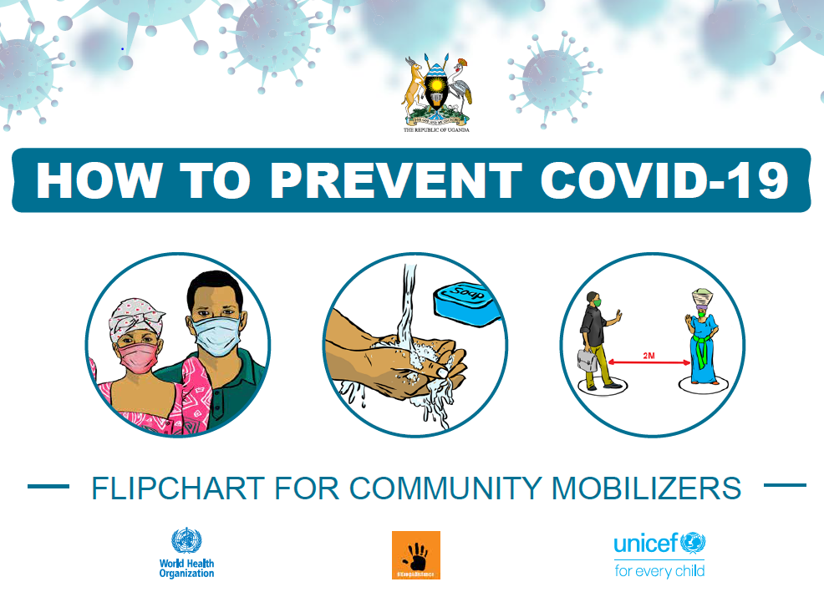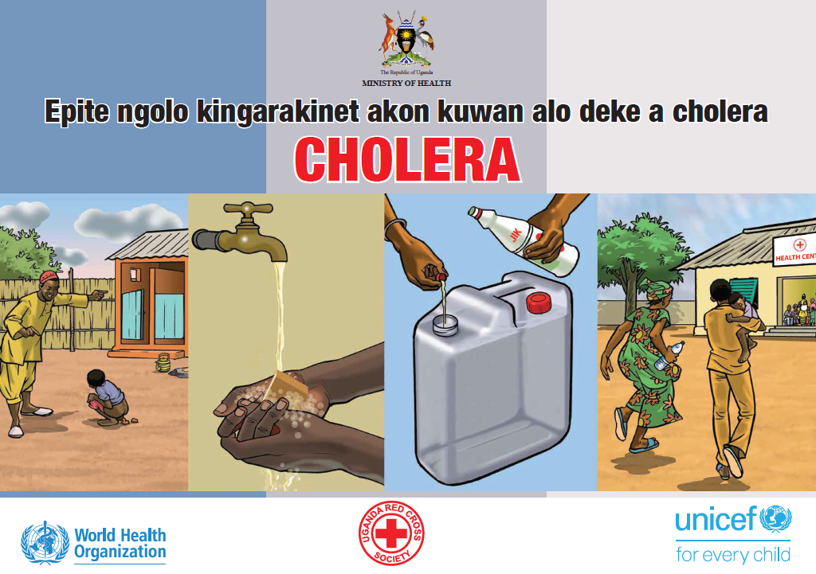
Samples of job-aide flipcards developed for health workers and VHTs

Sensitized communities through radio spots and radio-talk shows in local languages and engaged communities in dialogue on COVID-19 and Cholera prevention: The trained VHTs made house-to-house visits, informed and mobilised communities about COVID-19 vaccination using megaphones and public address system.

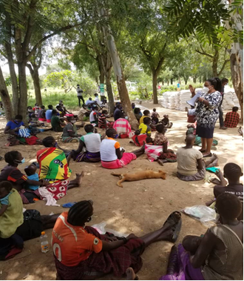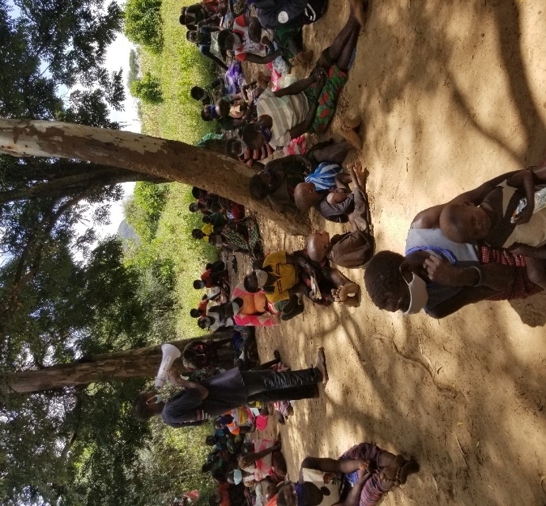
CUAMM/2021: L -R Community sensitization in Kanawat and Kacheri in Kotido on COVID response and integrated health services

Feedback from affected population: Cumulatively, 142,470 people were reached through house-to-house and community dialogue meetings and were able to share their concerns and asking questions/clarifications to address their needs through existing established feedback mechanisms.

Procured and supplied Personal Protective Equipment (PPE) to the seven districts: The following PPE items were procured and distributed to Kasese and the six districts in Karamoja for use by the health workers to prevent the spread of COVID-19 and Cholera.

Material description | Quantity
Handwashing liquid soap 5 L | 3,800
Hand sanitizer, Alcohol>60%, 1 Liter | 2,464
Gloves, exam, nitrile, pwdfree, M,BOX-100 | 186
Surgical gloves | 599
Plastic apron/PAC-100 | 866
Surgical maskspack50 | 1,420
Mask, N95, pieces | 2,274
Coveralls | 2,744

ii) Indicator Based Performance Assessment:
Using the Programme Results Framework from the Project Document / AWP - provide an update on the achievement of indicators at both the output and outcome level in the table below. Where it has not been possible to collect data on indicators, clear explanation should be given explaining why, as well as plans on how and when this data will be collected.

 | Achieved Indicator Targets | Reasons for Variance with Planned Target (if any) | Source of Verification
Outcome 1  Indicator:  Baseline:  Planned Target: | Contribute to closing gaps in logistics and supplies for an effective national COVID-19 and Cholera response in 7 districts including Kasese, Kaabong, Moroto, Karenga, Amudat, Nabilatuk, Napak.  Planned: 7 districts  Achieved: 7 districts (100%) | None | Programme Cooperation Agreement (PCA) Documents
Output 1.1  Indicator 1.1.1  Baseline:  Planned Target:  Indicator 1.1.2  Baseline:  Planned Target: | 1.1.1a Number of health facilities provided with infection prevention and control package including PPE  Planned: 70  Achieved: 110 (157%) | Demand and need on the ground to facilitate health facilities and HWs available to ensure effective reach | PCA reports from CUAMM and SCI respectively
Output 1.2  Indicator 1.2.1  Baseline:  Planned Target:  Indicator 1.2.2  Baseline:  Planned Target: | 1.2 To scale up risk communication, social mobilisation and community engagement activities in 7 districts on COVID-19 and cholera response
 | 1.2.1a Number of people reached with health education messages on COVID-19 and cholera prevention  Planned: 893,286  Achieved: 803,957 (90%) | Access to mass media (radio, TV and internet) is still very low in the Karamoja region. The innovative interventions used like community radios, display of IEC materials, use of mobile megaphone and house-to-house visits had restricted geographic reach. | PCA reports from CUAMM and SCI respectively

- A Specific Story (Optional)

Example of a human-interest story from Kasese district
Link: UNICEF and Save the Children train community health workers on COVID-19 prevention and vaccination | UNICEF Uganda
Title | UNICEF and Save the Children train community health workers on COVID-19 prevention and vaccination - Bringing COVID-19 messaging and services closer to communities
Problem / Challenge faced | The subject in the story reflects the key factors that may hinder change of behaviour at individual and social level:  - Level of awareness and perception of the COVID-19 risks – the subject was initially detached from the risk  - Disbelief, denial, and superstition  - Negative advice or risks associated with peer influence  - Stigma – as an eventual reaction by immediate community  - Exposure to misinformation e.g., political campaigns, mistrust, and propaganda  - Rumors and myths
Programme Interventions | - Public awareness through the mass-media  - Dissemination of messages on mass media e.g., radio and TV (subjects mentioned exposure to messages via TV).  - Training of 1,545 Village Health Workers (VHT) on signs and symptoms, preventive measures, home-based care treatment and how to counsel the affected  - Trained VHTs were equipped with job-aides which had basic messages;  - VHTs were deployed to work in their communities to educate, inform, reach out to infected persons, refer infected to nearest health facility, provide guidance on home-based care and;  - VHT provided regular follow up and psychosocial support.  - Mobilisation of local leaders and key influencers to support and promote compliance and participate in sensitisation of others and to promote the on-going COVID-19 vaccination process. In the story, 45 Community Resource Persons including chairpersons, local council leaders, religious leaders, and sub county technical staff were mobilized and engaged.
Results - the observable change that occurred so far as a result of the Programme interventions. | - Positive change behavior, attitude and practice: Kajumba says that after she fully recovered from COVID-19, she was advised by a VHT to go for vaccination which she agreed to do. She is now an advocate for COVID-19 vaccination within her community because she knows that vaccines help one reduce on the risk of severe illness once infected with the virus.  - Individuals and communities received messages on COVID-19 prevention and vaccination and were able to share their views and concerns through trained VHTs.  - Increase in COVID-19 vaccine acceptance, demand and uptake – Kajumba was vaccinated and a promoter.  - Community-based response to COVID-19 – Government of Uganda launched and is supporting the community engagement strategy which includes establishment of taskforces on COVID-19 at village level and it is prioritising home-based care.
Lessons Learned: What did you (and/or other partners) learn from this situation that has helped inform and/or improve Programme (or other) intervention | - It is vital to train and motivate VHTs: ‘VHTs are the true unsung heroes because they have helped to save people’s lives at the grassroots level during the pandemic’.(Kajumba)  - UNICEF will continue to support more public health education on COVID-19 preventive measures and promote demand creation for COVID-19 vaccines. People need regular updates on COVID-19 situation; knowledge gaps, doubts and hesitancy exist in communities and people are vulnerable to misinformation.  - Important to strengthen the follow up mechanisms and support to the infected e.g., home-based care and psychosocial support through the health system and at communal and family levels.  - Local leaders’ engagement is vital for the success of the COVID-19 vaccination process – important for local leaders to work very closely with the health care workers and the vaccination teams especially during micro-planning.  - UNICEF is refining the community engagement strategy to promote community health and incorporate social behavioral change processes that will lead to effective mobilisation and community-based response to the COVID-19 pandemic e.g., build skills in risk assessments, monitoring and reporting COVID-19 cases, infection trends and community perceptions.  - UNICEF is supporting the revival of village health committees building on the established village taskforces (VTFs) on COVID-19.  - UNICEF will promote integrated public health education and community resilience to common disease outbreaks (COVID-19, Cholera, Malaria etc.) - e.g., broaden roles of community-based persons and local leaders in the COVID-19 response.
Source: UNICEF and Save the Children train community health workers on COVID-19 prevention and vaccination | UNICEF Uganda

III. Other Assessments or Evaluations (if applicable)
• Report on any assessments, evaluations or studies undertaken.
Not applicable

- Programmatic Revisions (if applicable)

UNICEF will continue to support the districts that are under performing in COVID-19 response through involvement of local leadership structures from village to district level, in key processes like the mapping of hotspots, conducting simple risk and vulnerability assessments through data reviews to identify poorly performing sub counties for targeted interventions and strategic sensitisation of communities to address hesitancy among the public (the eligible groups) and to improve level of preparedness of the health workers to ably talk about and promote COVID-19 vaccination exercise.

UNICEF will support outreach services and community dialogues with population groups that are most affected by disease outbreaks through creation of coalitions with their formal and informal leaders through their smaller associations (religious, cultural, traders, youths, refugees, women groups, boda-bodas, cattle-keepers and elders).
UNICEF will continue to leverage other partner and government support to ensure prioritisation, procurement and distribution of PPE to health workers to minimise COVID-19 and Cholera transmission.

V. Resources (Optional)
• Provide any information on financial management, procurement and human resources.
• Indicate if the Programme mobilized any additional resources or interventions from other partners.

Strategic Results, as formulated in the Strategic UN Planning Framework (e.g. UNDAF) or project document;
The MPTF Office Project Reference Number is the same number as the one on the Notification message. It is also referred to as “Project ID” on the project’s factsheet page the MPTF Office GATEWAY
The MPTF or JP Contribution, refers to the amount transferred to the Participating UN Organizations, which is available on the MPTF Office GATEWAY
The start date is the date of the first transfer of the funds from the MPTF Office as Administrative Agent. Transfer date is available on the MPTF Office GATEWAY
As per approval of the original project document by the relevant decision-making body/Steering Committee.
If there has been an extension, then the revised, approved end date should be reflected here. If there has been no extension approved, then the current end date is the same as the original end date. The end date is the same as the operational closure date which is when all activities for which a Participating Organization is responsible under an approved MPTF / JP have been completed. As per the MOU, agencies are to notify the MPTF Office when a programme completes its operational activities.
Note: Outcomes, outputs, indicators and targets should be as outlined in the Project Document so that you report on your actual achievements against planned targets. Add rows as required for Outcome 2, 3 etc.
Kajumba Proscovia, 46, is one of the leaders within Kasese District and a survivor of COVID-19.

