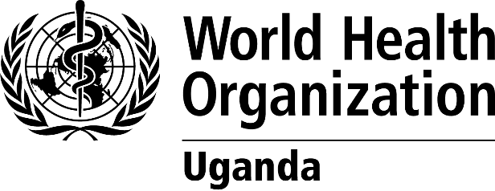 | 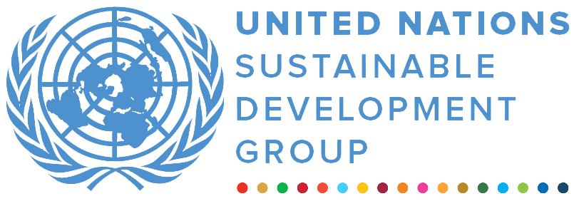 | 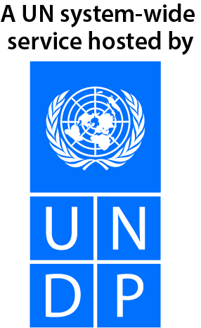
Improving Availability and Utilization of Life Saving Health Services in the context of COVID-19 response in Uganda ANNUAL programme
Final narrative report
REPORTING PERIOD: 7 May 2021 – 3 May 2022
Programme Title & Project Number |  |  | Country, Locality(s), Priority Area(s) / Strategic Results
- Programme Title: Improving Availability and Utilization of Life Saving Health Services in the context of COVID-19 response in Uganda.  - Programme Number (if applicable)  - MPTF Office Project Reference Number: 00126963 |  |  | Country/Region  Uganda
Priority area/ strategic results
Cholera hotspot districts
Participating Organization(s) |  |  | Implementing Partners
WORLD HEALTH ORGANIZATION |  |  | - National counterparts (government, private, NGOs & others) and other International Organizations
Programme/Project Cost (US$) |  |  | Programme Duration
Total approved budget as per project document:  MPTF /JP Contribution:140,570.18 USD  - by Agency (if applicable) |  |  | Overall Duration (12 months)
Agency Contribution  - by Agency (if applicable) |  |  | Start Date (07.05.2021)
Government Contribution  (if applicable) |  |  | Original End Date (02.05.2022)
Other Contributions (donors)  (if applicable) |  |  | Current End date(03.05.2022)
TOTAL: 140,570.18 USD
Programme Assessment/Review/Mid-Term Eval. |  |  | Report Submitted By
Assessment/Review - if applicable please attach  Yes No Date: dd.mm.yyyy  Mid-Term Evaluation Report – if applicable please attach  Yes No Date: dd.mm.yyyy |  |  | - Name: Komakech Innocent  - Title: Deputy Incident Manager  - Participating Organization (Lead): WHO  - Email address: komakechi@who.int

Acronyms
- CFR, Case Fatality Rate
- COVID 19, Corona Virus Disease 19
- UN, United Nations
- DTF, District Task Force
- ODK, Open Data Kit
- VHF, Viral Hemorrhagic Fever
- VHT, Village Health Teams
- IEC, Information Education and Communication
- OCV, Oral Cholera Vaccine

EXECUTIVE SUMMARY
Cholera and other diarrheal diseases remain major causes of morbidity and mortality in developing countries. In April 2020 at the peak of the COVID-19 pandemic response in Uganda, a Cholera outbreak was confirmed in the Karamoja region, starting in Moroto and eventually spreading to Kotido, Napak and Nabilatuk districts. A total of 1,105 cases were confirmed during the 7 months of the outbreak, including 18 deaths (CFR=1.6%). A preventive Oral Cholera Vaccine campaign targeted the high-risk populations in the hotspot districts with 86.2% coverage achieved by September 2021. During the implementation period all the selected districts had functional District Task Forces and applied the Incident Management System in response coordination, up to 100% of the health facilities implemented the Standard Operating Procedures for COVID-19 care and supported the home-based care strategy, all the targeted districts had improved capacity to rapidly detect, confirm and investigate outbreaks and with a strong community vigilance to diseases of outbreak potential through the training of the VHTs in community-based disease surveillance.

Purpose
To achieve the main objective and expected outcomes of Improving Availability and Utilization of Life Saving Health Services in the context of COVID-19 response in Uganda in the seven selected districts as per the strategic UN planning framework, through strengthening outbreak response coordination, leadership, monitoring and reporting mechanisms for COVID-19 and Cholera, improving the capacity of the health institutions to provide case management interventions for cholera and COVID-19 patients and districts capacity to detect, confirm and conduct investigation of suspected cases.

Results
From January to December 2021, in the seven selected districts 100% functional DTFs were achieved (baseline 22%) and 95% (97) of the planned districts teams were trained in incident management system with assigning of focal points for the different response pillars to effectively coordinate the outbreak response interventions. The DTF members were supported with airtime and fuel to facilitate the response activities within their districts and this enable them to respond effectively and address the public health concerns timely. Generally, there was marked improvement in coordination, leadership, monitoring of the response and reporting of events from the districts through the ODK, situation reports and HMIS.
A total of 193 (97%) of health workers were trained in COVID-19/Cholera case management and IPC in the selected seven districts. All the districts were provided with assorted supplies for case management, with 6 additional treatment units for COVID-19 supported during the project period. There was marked reduction in health workers infections and improvement in the patients outcome with cumulative COVID-19 case fatality rate dropping to 2.2% by the end of December, 2021. This was attributed to the support provided to the treatment units and the enhanced capacity of the health workers to manage critically ill COVID-19 patients and improved community awareness on early referral of cases.
Districts capacities to detect, report, investigate and respond to outbreaks have improved through capacity building of the 635 (135%) Village Health Teams and leaders in community based disease surveillance and provision of airtime and job aids, sample transportation to the reference laboratory was supported by providing a vehicle, fuel and allowances this reduced on the Turn Around Time for the results and therefore districts were able to effectively intervene and interrupt several clusters of COVID-19 infections. During the project period, the World Health Organization supported the Ministry of Health to conduct a reactive Oral Cholera vaccination in Moroto with a coverage of 84.6% achieved, this was due to the security challenges within the region, as well as misinformation on vaccines.
Due to the COVID-19 social and public health restrictions, implementation of some activities was delayed. However, this was addressed by having a phased approach for the trainings. In the regions of Karamoja, the insecurity due to the increased activities of the cattle rustlers was a major challenge to implementation. A multi-sectoral approach was critical in addressing gaps and that emerged during the implementation, as well as collaboration with partners and the Ministry of Health allowed for optimized utilization of the resources to meet the goals. Therefore, the project in some areas complemented on efforts by the UN partners, development partners and the Ministry of Health.
Generally, there was an improvement in the outbreak response with more notifiable diseases reported, Anthrax in Madi-Okolo, Measles suspects in Adjumani, VHF suspects in Arua all during the implementation period.
Nationally, the cumulative COVID 19 case fatality rate stands at 2.2%, vaccination uptake improved in the targeted districts due to the strong community structures that were built. All the achievements were attributed to well coordination and collaboration of the health partners by the World Health Organization and the multi-sectoral approach which was adapted.

ii) Indicator Based Performance Assessment:

 | Achieved Indicator Targets | Reasons for Variance with Planned Target (if any) | Source of Verification
Outcome 1: Outbreak response, coordination, leadership, monitoring and reporting mechanism functional in selected districts strengthened  Indicator: Proportion of districts with functional coordination mechanism  Baseline: 22%  Planned Target: 25% | 25% |  | HMIS, DHIS2
Output 1: Districts enabled to coordinate, provide leadership, monitor and report outbreaks

Indicator 1.1: Number of districts with established and functional District Taskforces  Baseline: 0  Planned Target: 7 | 7 |  | District Task Force meeting minutes
Indicator 1.2: Number of districts’ teams oriented and applying the Incident management system including pillar approach  Baseline: 0  Planned Target: 7 | (95% of the district teams were trained in incident management system) 7 |  | Open Data Kit (ODK) meeting minutes
Outcome 2: Improved Capacity of health institutions to provide case management interventions for cholera and COVID-19 patient  Indicator: Proportion of health facilities providing patient care according to set protocols  Baseline: 40%  Planned Target: 50% | 50% |  | Standard protocols and patients outcomes
Output 2: Health facilities enabled to provide case management interventions to patients suffering from cholera or COVID 19 through training and use of standard protocols
Indicator 2.1: Number of health workers trained in case management and infection prevention and control  Baseline: 40%  Planned Target: 50% | (193) 96% |  | Training reports ODK
Indicator 2.2: No of health facilities basic set of diagnostic equipment and monitoring for use at the isolation centre  Baseline: 1  Planned Target: 7 | 7 |  | Delivery notes/reports
Outcome 3: Districts Capacity to detect, confirm and conduct investigation of suspected cases improved  Baseline: 40%  Planned Target: 50% | 50%
Output 3: Suspected outbreaks rapidly detected, confirmed and investigated
Indicator 3.1: Number of VHTs from High-risk districts with capacity to conduct active case finding, contact tracing and follow up  Baseline: 0  Planned Target: 40% | 635 (135%) | Implementation cost could accommodate more VHTs to be trained, as well the need to support the role out of community engagement strategy.  Collaboration with partners | Open data kit (ODK) reports
Indicator 3.2: Number of facilities timely collecting specimen and submitting to national reference laboratory  Baseline: 15%  Planned Target: 40% | 100% | Through the use of the hub system, more facilities were able to be supported to transport samples to the national laboratory. | Laboratory and surveillance reports
Indicator 3.3: Number of VHTs trained in Community Based Surveillance  Baseline: 0  Planned Target: 40% | 635 (135%) | Variations resulted from variation in the village structures in Acholi region and the formation of new villages. | Training reports

Problem / Challenge faced: Describe the specific problem or challenge faced by the subject of your story (this could be a problem experienced by an individual, community or government).

The strict COVID 19 preventive measures interrupted and caused delays in the implementation of the activities.
Inadequate funding to support preventive and response interventions in all the hotspot districts (flood prone, refugee settlements and those near the water bodies).
The trained Village Health Teams have limited support to aid their work (VHT kits and stipend).
Lack of printed IEC materials for Cholera and COVID 19 to support community engagement.
During the implementation period, two outbreaks in Karamoja and Isingiro were responded to and these were not previously mapped, need to conduct a national risk mapping for Cholera.
The Oral Cholera Vaccination (OCV) registered suboptimal coverage due to conflicting vaccination campaigns and inadequate funds to support the activities.

Programme Interventions:

A multi-sectoral approach was critical in addressing gaps and that emerged during the implementation, as well as collaboration with partners and the Ministry of Health allowed for optimized utilization of the resources to meet the goals.
The community alerts improved with over 2,825 alerts received and responded to within 5 months during the project implementation period.
Interruption of the COVID 19 transmission among the household members with proper risk communication and engagement by the trained VHTs and community leaders in Home-based care for COVID 19. This reduced on the morbidity and mortality.
Increase uptake of COVID 19 vaccines in the selected districts due to the intensified involvement of the community structures in the mobilization,
- A multi-sectoral approach to the cholera response was critical in addressing the gaps and optimizing resources.
- Additional funding to support intervention to reduce morbidity and mortality from Cholera. (1. Address WASH needs in the high-risk districts. 2. Preventive OCV campaigns in the high-risk districts and refugee settlement).
- Maintain the support of the VHTs: Continuous capacity building and equipping the VHTs with necessary tools to carry out their work effectively.

III. Other Assessments or Evaluations (if applicable)
• Report on any assessments, evaluations or studies undertaken.

IV. Programmatic Revisions (if applicable)
• Indicate any major adjustments in strategies, targets or key outcomes and outputs that took place.

V. Resources (Optional)
• Provide any information on financial management, procurement and human resources.
• Indicate if the Programme mobilized any additional resources or interventions from other partners.

The term “programme” is used for programmes, joint programmes and projects.
Strategic Results, as formulated in the Strategic UN Planning Framework (e.g. UNDAF) or project document;
The MPTF Office Project Reference Number is the same number as the one on the Notification message. It is also referred to as “Project ID” on the project’s factsheet page the MPTF Office GATEWAY
The MPTF or JP Contribution, refers to the amount transferred to the Participating UN Organizations, which is available on the MPTF Office GATEWAY
The start date is the date of the first transfer of the funds from the MPTF Office as Administrative Agent. Transfer date is available on the MPTF Office GATEWAY
As per approval of the original project document by the relevant decision-making body/Steering Committee.
If there has been an extension, then the revised, approved end date should be reflected here. If there has been no extension approved, then the current end date is the same as the original end date. The end date is the same as the operational closure date which is when all activities for which a Participating Organization is responsible under an approved MPTF / JP have been completed. As per the MOU, agencies are to notify the MPTF Office when a programme completes its operational activities.
Note: Outcomes, outputs, indicators and targets should be as outlined in the Project Document so that you report on your actual achievements against planned targets. Add rows as required for Outcome 2, 3 etc.

