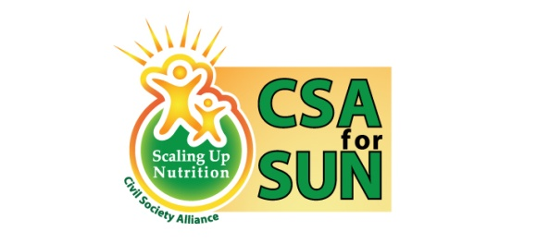

Global Day of Action
Activities for the GDA in Bangladesh were held by CSA for SUN,BD in two levels: National level event in the capital city of Dhaka, Bangladesh in May, 2015 with the Honorable Members of the Parliament, followed by a roundtable discussion” Improving Nutrition Through Collective Efforts” and Community level activities with the adolescent boys and girls of high schools from the seven Divisional and District towns which started in June and ended successfully in July, 2015.
As a follow up of the Round Table Discussion, key advocacy messages were identified for the Honorable Members of Parliament. The Parliamentarians will be able to use these in their own constituencies.
Community level activities: July, 2015
CSA for SUN, BD took the initiative of arranging a media campaign among the school children through various activities which will have a deeper impact in the mind of these children and create a greater awareness among them on nutrition. The CSA for SUN organized a series of events in July in various District towns to celebrate the Global Day of Action. A day-long activities involving the local influential and school children was held in Rangpur and Rajshahi.
School children from the selected schools of Dinajpur and Rajshahi participated in the campaign. Local Members of Parliament, school and college teachers, City Mayors, Civil Surgeons, District Commissioners, Superintendent of Police, locally elected officials and other high level GOB and NGO officials, GC members were among the present in the meeting. They made commitments as how they will support scaling up nutrition in their communities.
Wall magazine competition was held for high school students. The students developed wall magazine on nutrition. Displaying locally available nutritious foods along with the nutrient value of the foods was also part of the school children’s program. Round table discussion was held with school children and local representatives where the children had the opportunity to ask interactive question and answers. Government high officials, stakeholders from different level, media personnel and representatives from NGOs were present in the discussion and throughout the campaign. An advocacy video of CSA for SUN, BD and TVC was shown to the audience. The comic books for adolescent boys and girls were distributed among the school children prior to the program. CSA for SUN’s brochure as well as information on the Global SUN Movement were also provided through a presentation.
The school children displayed their wall magazines in their program premises. After the display there was a display of the locally available nutritious fruits and a dart throw competition was organized where they were given the fruit which they could mark in the board by throwing the dart to raise awareness on value of nutrients in fruits.

