Project Number and Title:  # -  Title: Accelerating Progress Towards Interruption of Ebola Virus Transmission | PROJECT START DATE:  31-12-2014 |  | AMOUNT ALLOCATED by MPTF  (please indicate different tranches if applicable)  $4,549,552 | RECIPIENT ORGANIZATION  United Nations Population Fund (UNFPA)
Project ID: 00093218

Project Focal Point:  Name: Brian Kironde  E-mail: kironde@unfpa.org | EXTENSION DATE:  31-12-2015 |  | FINANCIAL COMMITMENTS:  $132,170
Strategic Objective (STEPP)  SO 1 – Stop the Outbreak | PROJECTED END DATE:  30-06-2015 |  | EXPENDITURES  as of [30th June 2015]  $3,000,000 | IMPLEMENTING PARTNER(S):  Ministry of Health, 6 Counties Health and Social Welfare Teams, Africare, MERCI, Action Aid
Mission Critical Action  MCA1:  Identifying and tracing of people with Ebola |  |  | EXPENDITURES  as of [30th June 2015]  $3,000,000
Location:  Liberia |  | Sub-National Coverage Areas:  Bomi, Bong, Gbarpolu, Grand Cape Mount, Lofa and Nimba Counties

MONTHLY PROGRESS REPORT RESULTS MATRIX
OUTPUT INDICATORS
Indicator  Geographic Area | Projected Target  (as per results matrix) | Quantitative results for the (one month) reporting period |  |  | Cumulative results since project commencement (quantitative) |  | Delivery Rate (cumulative % of projected total)  as of date
Description of the quantifiable indicator as set out in the approved project proposal
Proportion of counties that have trained contact tracers in all districts. | Bomi, Bong, Gbarpolu, Grand Cape Mount, Lofa and Nimba |  | 6 |  | 0 |  | 2,645 Contact tracers trained in all counties |  | 66% of Contact tracers in all counties trained
Proportion of contact tracers that have been trained using the recommended national contact tracing standard operating procedures | Bomi, Bong, Gbarpolu, Grand Cape Mount, Lofa and Nimba |  | 3,967 |  | 0 |  | 1,919 |  | 48%
Proportion of county surveillance offices that have data processing equipment | Bomi, Bong, Gbarpolu, Grand Cape Mount, Lofa and Nimba |  | 6 |  | 6 |  | 6 |  | 100%
Proportion of county surveillance officers that have functioning internet connection | Bomi, Bong, Gbarpolu, Grand Cape Mount, Lofa and Nimba |  | 6 |  | 6 |  | 6 |  | 100%
Proportion of districts that submit surveillance reports on time, including zero reports | Bomi, Bong, Gbarpolu, Grand Cape Mount, Lofa and Nimba |  | 34 |  | 34 |  | 34 |  | 100%
Proportion of districts that have at least one supportive supervision visit conducted from national or county level per week | Bomi, Bong, Gbarpolu, Grand Cape Mount, Lofa and Nimba |  | 34 |  | 34 |  | 34 |  | 100%
Proportion of counties that conduct weekly meeting to review contact tracing and active surveillance performance during the preceding week and have written report with clearly identified action points | Bomi, Bong, Gbarpolu, Grand Cape Mount, Lofa and Nimba |  | 6 |  | 6 |  | 6 |  | 100%
Proportion of Confirmed EVD cases that we on the contact list | Bomi, Bong, Gbarpolu, Grand Cape Mount, Lofa and Nimba |  | 100% |  | 0 |  | 67% |  | 67%
EFFECT INDICATORS (if available for the reporting period)
Proportion of counties with at least 90% of districts submitting weekly surveillance reports | Bomi, Bong, Gbarpolu, Grand Cape Mount, Lofa and Nimba |  | 100% | 100% |  | 100%
At least 95% of all project staff are recruited, trained and deployed by 15 December 2014 | Bomi, Bong, Gbarpolu, Grand Cape Mount, Lofa and Nimba |  | NA | NA |  | NA
Proportion of Counties with enhanced active surveillance operations | Bomi, Bong, Gbarpolu, Grand Cape Mount, Lofa and Nimba |  | 100% | 100% |  | 100%

NARRATIVE
Situation Update
The revised project extension proposal prepared and submitted to UNMEER was approved and the new listing of personnel i.e. contact tracers, supervisors, monitors and coordinators by county has been compiled in close consultation with the various county health teams (CHTs). Work plans for implementing partners has been completed and fund allocation and disbursement process is ongoing to ensure that counties receive support with telephone, internet connectivity and funds for coordination meetings etc…..
UNFPA field personnel in the counties are supporting the CHTs in ensuring the close monitoring of surveillance and timely reporting. Counties are on course with the monitoring and regular review of contact tracing and active surveillance and timely reporting.
Key Achievements
- Work plans for implementing partners has been completed and fund allocation and disbursement process is ongoing.
- Coordination of contact tracing and monitoring of surveillance activities in the field especially within border communities.
- Contact tracing are being concentrated to high risk areas especially boarder communities and gCHVs (CT/ACS) helped identify and refer sexual and gender based violence and maternal health related cases in communities while continuing to promote hand washing for prevention of EVD.
- Sustained timely reporting of suspected and probable EVD cases and other disease conditions as part of the disease surveillance on-going.
- Process for the initiation of support to Ministry of Health Montserrado EVD response team has been finalized and the support covering the period of 5 months (August – December) initiated.

Delays or Deviations (if any, briefly describe the delays or changes in focus, approach or targets, and provide a short justification for the change (1-2 paragraphs).
According to the approved project, the total number of contact tracers has been reduced from 2,622 to 656 with emphasis on engaging communities to empower them provide sustainable disease surveillance in order to stop transmission of Ebola virus disease and strengthen community referral and health services seeking behaviour for other health related issues. The project will focus particularly on high risk areas such as boarder communities, business districts and concession areas.

Gender and Environmental Markers – based on the new listing per counties
County | Number Of Contact Tracers | Number Of Female Contact Tracers | No. Of Supervisors | No. Of Female Supervisors | No. Of District Monitors | No. Of Female Monitors | No. Of County Coordinators
Bomi | 61 | 14 | 12 | 2 | 4 | 0 | 2
Bong | 60 | 15 | 14 | 3 | 8 | 0 | 3
Gbarpolu | 38 | 16 | 13 | 2 | 12 | 1 | 2
Grand Cape Mount | 92 | 33 | 19 | 3 | 5 | 1 | 2
Lofa | 106 | 10 | 66 | 17 | 7 | 1 | 3
Nimba | 299 | 104 | 52 | 9 | 6 | 0 | 2
Totals | 656 | 192 | 176 | 36 | 42 | 3 | 14

Additional Information :
Monitoring and supplies of equipment to health facilities in Lofa County amidst the bad road condition in Lofa during this time of the year (Voinjama to Foya high way as Field Associates assisted the movement of UNFPA -Monrovia team responsible for the medical(reproductive) items distribution in Lofa County,Liberia. The team also supported the safe delivery of this teenage mother who give birth at Foya Borma Hospital during their visit.
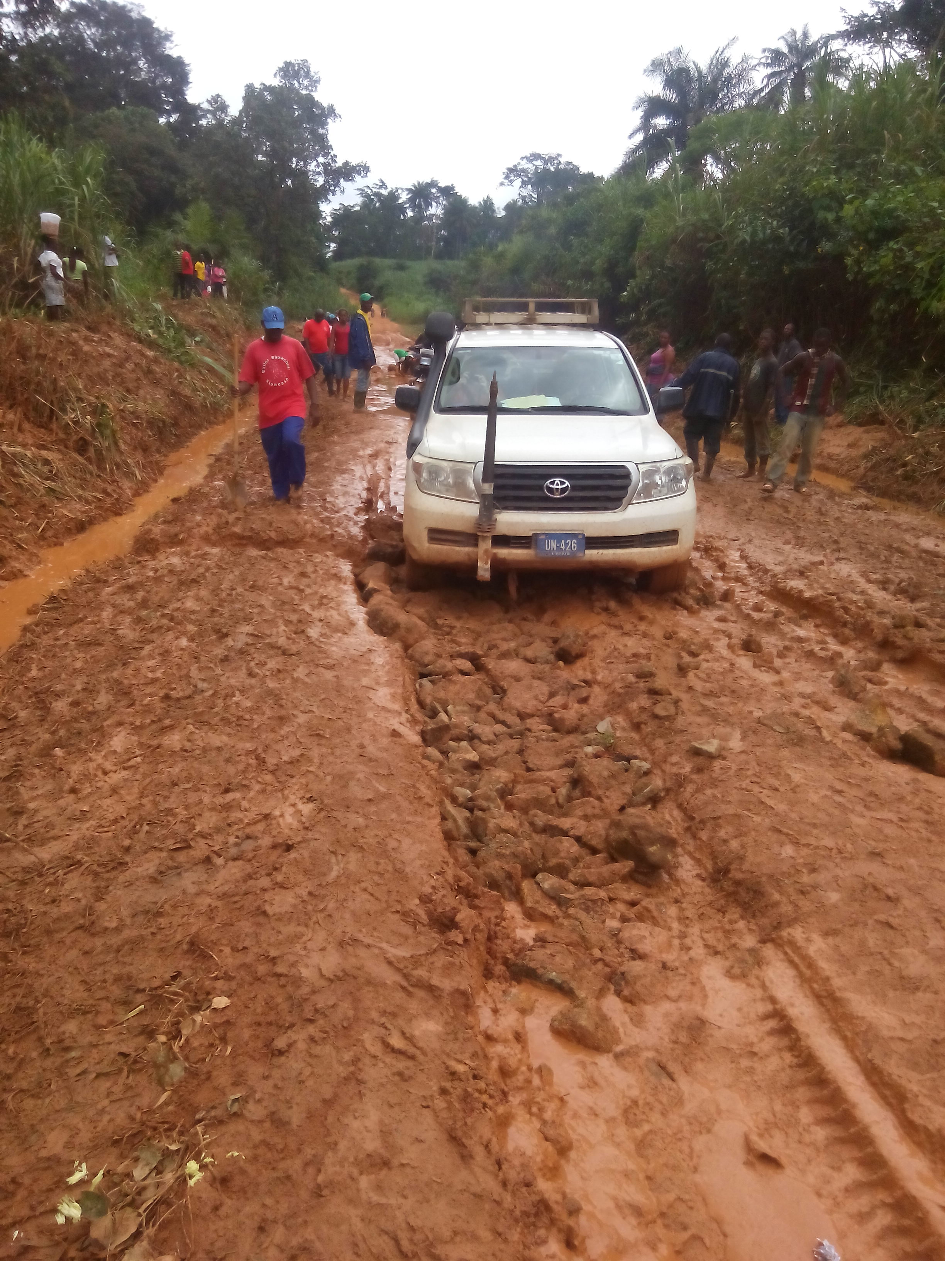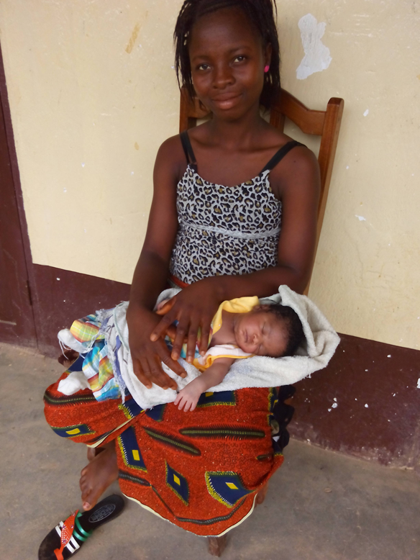

The date project funds were first transferred.
The Indicators should be disaggregated by gender, age and region as and where applicable

