 |  | 
Lebanon Recovery Fund
MPTF OFfice GENERIC ANNUAL programme NARRATIVE progress report
REPORTING PERIOD: 15 MARCH 2013 – 31 March 2015

Programme Title & Project Number |  |  | Country, Locality(s), Priority Area(s) / Strategic Results
- Programme Title: National Action Programme to Mainstream Climate Change into Lebanon’s Development Agenda (Climate Change Coordinating Unit – CCCU)  - Programme Number (if applicable)  - MPTF Office Project Reference Number: 00085932 |  |  | (if applicable)  Country/Region  Lebanon
Priority area/ strategic results
Governmental institutions/national coverage
Participating Organization(s) |  |  | Implementing Partners
- Organizations that have received direct funding from the MPTF Office under this programme |  |  | - Ministry of Environment  - Ministry of Finance  - National Council for the Environment
Programme/Project Cost (US$) |  |  | Programme Duration
Total approved budget as per project document: USD 500,000  MPTF /JP Contribution:  - by Agency (if applicable) |  |  | Overall Duration (months) | 24 months
Agency Contribution  - by Agency (if applicable) |  |  | Start Date (dd.mm.yyyy) | 15 March 2013
Government Contribution  (if applicable) |  |  | Original End Date (dd.mm.yyyy) | 31 March 2015
Other Contributions (donors)  (if applicable) |  |  | Current End date(dd.mm.yyyy) | 31 March 2015
TOTAL:
Programme Assessment/Review/Mid-Term Eval. |  |  | Report Submitted By
Assessment/Review - if applicable please attach  Yes No Date: dd.mm.yyyy  Mid-Term Evaluation Report – if applicable please attach  Yes No Date: dd.mm.yyyy |  |  | - Name: Vahakn Kabakian  - Title: Climate Change Portfolio Manager  - Participating Organization (Lead): UNDP  - Email address: vahakn@moe.gov.lb

NARRATIVE REPORT FORMAT

Purpose

Project Summary and linkage to national priorities:

The project aims at mainstreaming climate change concepts into the different governmental development agendas by climate proofing the relevant plans and actions of the various ministries. The proposed project is in line with the Government of Lebanon’s plan of action, as mentioned in the first national communication report to the UNFCCC, and reiterated in the Second National Communication report to the UNFCCC. Furthermore, the proposed project builds on the on-going renewable energy and energy efficiency objectives of the Ministry of Energy and Water and the Sustainable Energy Strategy project of the Ministry of Finance as well as Ministry of Agriculture’s adaptation efforts. Overall, this project will work to meet the national priority of achieving the 12% renewable energy mix target by 2020 to move towards a Low Carbon/Emission Economy, as well as provide a directive for national adaptation activities leading to a national low emission climate resilient development strategies.

Project Outputs:

- Output 1: Engagement of ministries and governmental and national institutions in continuous planning/decision making on climate change issues;
- Output 2: Identify and develop Nationally Appropriate Mitigation Actions (NAMAs) and pilot demonstration adaptation projects;
- Output 3: Engagement of Lebanon in the international climate change arena and promoting new national and international climate financial mechanisms.

Objectives

In order to improve climate change governance and meet the challenges that Lebanon will face as a result of climate change, there is a need to mainstream climate change concepts into national and sectoral development plans and to coordinate on-going climate change initiatives that are scattered. To achieve this, the proposed project presents a comprehensive coordination mechanism involving strategic planning, and close and effective communication with national, regional and international partners, as well as the recommendation of financial mechanisms needed at the national level.

With the issuance of the Council of Ministers’ decision during its session dated March 28, 2012, the Decree (8157/2012) establishing the National Council for the Environment (NCE) was enacted. The NCE is made up of 14 members representing 7 ministries (the Ministry of Environment – Head of the NCE; and the ministries of Finance, Interior and Municipalities, Agriculture, Public Works and Transport, Energy and Water, and Industry) and 7 non-public entities (Order of Physicians, Order of Engineers and Architects, The Bar Association, Association of Banks, Association of Insurance Companies, representative of Non-Governmental Organizations (NGOs), and representatives of the Academic sector).

Given the above, and knowing that proper climate change governance needs to build on on-going and planned national activities, the proposed project seeks to strategically align all national activities by coordinating and bringing them under the NCE. To achieve this, the proposed project aims to engage ministries and governmental institutions in planning and elaborating effective national adaptation (and pilot demonstration of adaptation technologies) and mitigation action plans (including NAMAs). The project will also address the institutional and legal barriers for the development of the national and international financial mechanisms and will improve the engagement of Lebanon in the international climate change arena.

Results

- Narrative reporting on results:

- Project Management

- Preparation of regular progress reports and financial management of expenditures;
- Organization of stakeholder meetings (with regular meetings with the Ministry of Finance (MoF));
- Daily follow-up with project staff;
- Coordination with all national stakeholders and beneficiaries;
- Providing technical and policy advice to decision-makers on climate change negotiations and other climate related issues (primarily to the Ministry of Environment (MoE));
- Coordinate work with CEDRO project (Community Energy Efficiency and Renewable Energy Demonstration) and MoF and the Lebanese Center for Energy Conservation (LCEC) on clarifying Lebanon’s 12% renewable energy strategy.

Output 1: Engagement of ministries and governmental and national institutions in continuous planning/decision making on climate change issues

This output involves the establishment of a network of climate change focal points among ministries embedded in the NCE (as mandated by the NCE Decree 8157/2012), governmental, academic and private institutions to facilitate the interaction and coordination between the different actors involved in climate change issues. This will lead to the establishment of the Government Group (GG) and the Research and Technical Support Group (RTSG).

Achievements:

Focal points meetings under the CCCU:

After internal preparation and reviewing of the Terms of References (ToRs) of the “to-be appointed” focal points has been developed, the structure and modality of work with the NCE has also been elaborated with the Ministry of Environment staff.

The first meeting under the NCE took place on July 24th, 2013, introducing the program’s objectives and the workplan as well as the expected achievements and the modality of work to the NCE members. The main discussion points evolved around the role that the project will play under the NCE, including the coordination aspect including the process to be followed with the various NCE members which entails the nomination of technical focal points from the NCE member institutions to follow-up on technical aspects. The NCE was also informed on the close coordination with the Ministry of Finance and the future plans, the outputs of the project (the Agriculture Adaptation Pilots and the Strategic Environmental Assessment of the Renewable Energy Sector) and the process/progress achieved for the preparation of NAMAs.

Following the first NCE meeting, the ToRs of the focal points was shared with the individuals whose nominations were officially received. The first meeting of the focal points of the Climate Change Coordination Unit (CCCU) was held on December 9th, 2013. The ToRs of the focal points were discussed and their comments were noted. The focal points also exchanged current projects and initiatives taking hand at different ministries and institutions. Following the first CCCU focal points’ meeting, the participants decided to meet on a quarterly basis to discuss potential collaboration, and receive updates on strategies/plans, or the research being done in the area of climate change. It was also agreed that the way forward throughout the next quarter would be to set up thematic working groups to discuss more specific issues. In specific, pressing issues will be discussed with the Middle East Airlines, Order of Engineers and Architects of Beirut, the academic sector and the Association of Banks, (see Annex 2).

The second meeting of the focal points of the Climate Change Coordination Unit (CCCU) was held on March 27th, 2014. The first session of the meeting, held for the newly appointed focal points, allowed the newcomers to get acquainted with the issues of climate change in general, its impacts in Lebanon, and the objective and structure of the CCCU and their respective TORs and roles. The second session of the meeting, gave an overview of the activities that the climate change team has undertaken and what is planned for the next quarter (see Annex 3).

The third meeting of the focal points of the CCCU was held on November 14th, 2014 (see Annex 4 for list of participants and photos). The first session of the meeting, summarized the main activities of the CCCU at the Ministry of Environment.

The second session of the meeting presented the inception of Institutional Mapping for Climate Change Activities project. The database includes information on various nationally- and internationally-funded projects that have climate change or climate change related components. This mapping presents a comprehensive coordination mechanism involving strategic planning, and close and effective communication with national, regional and international partners, as well as the recommendation of financial mechanisms needed at the national level. This also can be used in turn, as an indication of the priority given to climate change within the country. The mapping output has been submitted and will be disseminated to stakeholders.

The third session included information sharing of climate-related activities held at the different member institutions. It summarized the submissions of focal points of project sheets asking for three climate change-related activities achieved by their institutions during the past three years, and the main planned activities for the future. The final session closed with a round-table discussion for the CCCU roadmap in 2015.

Coordination under the working groups:

As part of the coordination of climate change activities undertaken by various national and international actors, the inception workshop of Increasing Farmers’ Resilience through Early Warning and Advisory Climate Service (EWCS), as part of the EU ClimaSouth project, was held at the Ministry of Environment on December 5th and 6th, 2013. The main outcome of the workshop is a detailed table based on the four identified priorities. The main two partners under this coordination stream are the Lebanese Agricultural Research Institute and the Lebanese Meteorological Service, Directorate General of Civil Aviation, Ministry of Public Works and Transport.

Moreover, a workshop was held at the Ministry of Environment for the Adaptation to Climate Change in the Water Sector in the MENA Region Programme (ACCWAM) on June 4th, 2014 as a scoping mission and initial stakeholders’ meeting. The programme aims to improve the capacities in regional and national water institutions, promote alignment between the Arab Water Strategy and national water policies, support the development of an Action Plan for the Arab Strategy for Water Security and support the development of national adaptation strategies, among others. The participating entities in the scoping mission were GIZ, Litani River Authority, Issam Fares Institute at the American University of Beirut, the Prime Minister’s Office, and Ministry of Agriculture.

Output 1 also involves the provision of capacity building and information dissemination to governmental focal points in order to promote public sector capacity and capability to tackle climate change issues in their sectoral plans and policies. Case in point, while preparing their strategy, the Ministry of Agriculture involved the climate change office in order to provide input for climate-proofing. The climate change aspects pertained to: food security, agricultural production, natural resources, education, research and cooperatives. This initiative proves the CCCU’s effectiveness in mainstreaming climate change.

Partner Ministry/agency involvements – focal points:

Additional nominations were received from the Litani River Authority, World Health Organization, Food and Agriculture Organization, Prime Minister’s Office and the Economic and Social Commission for Western Asia (ESCWA). The total number of focal points from various ministries and agencies were 32 nominations (list of agencies can be found in Annex 1).

Focal Points’ Training:

Hands-on training on the use of greenhouse gas (GHG) Inventory software (NAIIS) prepared by the United Nations Framework Convention on Climate Change (UNFCCC) Secretariat: training newly developed web-based software for the preparation and reporting of national GHG inventories for developing countries has been secured (free of charge). A total of 7 stakeholders (representing 6 different institutions) from the Ministries of Environment, Agriculture, Industry, academia, and environmental consultants, have been trained (see Annex 5).

During the first CCCU meeting, the programme requested the stakeholders to identify a series of capacity building exercises they require. The unit has established contacts with experts and institutions to conduct trainings for certain groups of focal points in four proposed areas which were identified by the focal points. These areas, as identified by the focal points, are (1) Meteorological Climate Modeling, (2) Effective Writing & Communication Skills, (3), Climate Change Finance and (4) Cost-Benefit Analysis (CBA) and Cost-Effectiveness Analysis (CEA) in appraising energy and environment projects.

Two Effective English Writing Skills training took place on June 12 and 26, 2014 respectively. Representatives from various institutions were present (see list in Annex 7). Also, these series of trainings were followed with an Arabic Writing Skills training that took place on July 16, 2014.

The training on Climate Change Finance was conducted on 7th and 8th July 2014 by the Frankfurt School of Finance & Management. Training sessions provided an overview on (1) Climate Finance architecture, (2) Climate Finance readiness, (3) recent/current experience in Lebanon with Climate Finance, (4) opportunities, barriers, and risks, and (5) Climate Finance instruments. Also, discussions were initiated in an attempt to map Lebanon’s climate finance architecture (where examples from other countries were provided), and a roadmap was given with detailed next steps to better structure Lebanon’s national climate finance architecture (see Annex 8).

Also, the training on CBA and CEA in appraising energy and environment projects took place on the 19th and 20th of August, 2014 by Dr. Tobias Schmidt (researcher at the Chair of Sustainability and Technology at ETH Zurich). The two-day training included theoretical as well as applied information on two decision support tools: CBA and CEA. It also aimed at triggering discussions among the participants on how these methods could be useful to inform Lebanese policy decisions in general, and in energy related decisions in specific. The overarching approach included de-risking renewable energy investments. Participants included the Ministry of Finance, Ministry of Energy and Water, Ministry of Agriculture, Lebanese Petroleum Authority, Lebanese Center for Energy Conservation, Higher Council for Privatization, Council for Development and Reconstruction, Central Bank of Lebanon, in addition to representatives from the academic/research sector and private consultants (see Annex 9).

As part of the CCCU trainings, two negotiations workshops have been conducted, see the “Training on Climate Change negotiations” paragraph and Annex 6 and 10.

As a part of this initiative, CCCU members were sent to specialized trainings abroad:

- The training on “Meteorological Climate Modeling” took place in Italy, from 28 to 30 April, 2014. The participants from Lebanon were representatives from the Lebanese Agricultural Research Institute and the Lebanese Meteorological Services from the Directorate General of Civil Aviation.
- A Lebanese Agricultural Research Institute representative participated in the “Climate Change communication and climate change finance seminar” in Bonn, Germany in September 2014.
- Moreover, Lebanese Meteorological Services and Lebanese Agricultural Research Institute representatives, in order to improve the capacity for analysis and decision-making on vulnerability assessment and adaptation to climate change of national services, attended the “Availability & challenges to improve information sharing to assess vulnerability and to improve information sharing to assess vulnerability and adaptation to climate change”, in Lecce, Italy.
- Also, two representatives from the Ministry of Energy and Water attended the “Greenhouse Gas Modelling Seminar” held from 10th to 14th November 2014, in Bari, Italy.

Climate Finance Studies withthe Ministry of Finance:

An agreement was reached between the Ministry of Environment and the Ministry of Finance to share the services of the incumbent joining the project; it was deemed that this will provide further opportunities in strengthening the cooperation of both ministries in financial/fiscal issues related to climate change. The recruitment of the project coordinator (economist) has been finalized. The selected candidate started work on 24th October, 2013.

The study related to the Optimal Renewable Energy mix and its impact on the macro-economy in Lebanon has been finalized and published online (climate change website). The full report can be accessed on the following web-link:
http://climatechange.moe.gov.lb/Library/Files/Uploaded%20Files/Renewable%20Energy%20-%20Investment%20Cost%20-%20Final%20Version.pdf

The above results were included as a main section of the Strategic Environmental Assessment (SEA) of Lebanon’s Renewable Energy scoping report, to serve as an alternative analysis to the National Renewable Energy Strategy (NRES) that has not been drafted yet. Therefore the SEA studies the impacts of the proposed RE optimal mix with respect to environmental, social and economic indicators.

Also, a document summarizing the existing loan schemes and eligibility criteria, as well as the planned loan schemes in Lebanon that can be considered as climate finance was finalized and published. These incorporate five main loan schemes with a number of implementing agencies and funders and/or guarantors. Additionally, the study was distributed to relevant stakeholders for a round of comments. To access the study, click here:
http://climatechange.moe.gov.lb/viewfile.aspx?id=216

Another study, “Fossil fuel subsidies; fiscal, equity, economic and environmental impacts” has the aim to highlight the inefficient fossil-fuel subsidies that distort markets, impede investment in clean energy sources and undermine efforts to deal with climate change. This study evaluates the impact of fossil-fuel subsidies on the Lebanese economy, fiscal balances, and the environment, while accounting for equity and poverty alleviation concerns. The full report can be accessed on the following web-link:
http://climatechange.moe.gov.lb/Library/Files/Uploaded%20Files/Lebanon%20Fossil%20Fuel%20Subsidies.pdf

The Mobility Cost study for Lebanon has been finalized and published online (http://climatechange.moe.gov.lb/newsmobility). The study provides an approach from the cost side of mobility to generate recommendations in order to move the Lebanese passenger transport sector towards sustainable ground. An average conservative figure for mobility cost was calculated: one passenger travelling one kilometer in a passenger vehicle, including externality components of pollution, travel time, congestion, and crashes, costs around US¢ 50. Moreover, sustainable transport indicators are set to find that the most critical ones were not emissions or safety-related, but mostly pointed to an excessive energy consumption by the passenger transport sector. The study concludes with a set of recommendations and policies to improve certain aspects of the passenger transport sector. This was achieved upon analyzing cost components and referring to sustainable mobility indicators incepted throoughout the case study.

Moreover, a Vehicles Fleet Renewal through a Scrapping Scheme in Lebanon study has been finalized and published online (http://climatechange.moe.gov.lb/newsDetails.aspx?pageid=165). This study reviews the feasibility and the available options for vehicle scrapping schemes, the current practices for recycling End-of-Life Vehicles (ELVs), and proposes future recommendations for the adoption of a renewal of car fleet strategy. The work is based on the recommendations of the Technology Needs Assessment Report for Climate Change (2012) as one of the main mitigation strategies proposed by the report is to renew the existing passenger cars fleet in Lebanon.

Also, based on this cooperation scheme, a workplan has been developed in cooperation with the Ministry of Finance on the execution of a Climate Public Expenditure and Institutional Review (CPEIR). The project coordinator (economist) also attended a workshop on Governance Challenges in Climate Change Finance on December 1st, 2013, and The Global Forum on Using Country Systems to Manage Climate Change Finance on December 2nd and 3rd, 2013, in Incheon, South Korea. The Lebanese delegation to the forum understood the general framework to undertake the Climate Public Expenditure and Institutional Review (CPEIR) for Lebanon and made use from the leanings from a number of countries.

The CPEIR involves the analysis of allocation and management of public expenditures and covers all government expenditure (or alternatively can focus on few priority sectors). It reviews how climate change related expenditures are integrated into national budgetary processes and is considered as a first step to building a climate fiscal framework. The CPEIR aims at supporting the Government of Lebanon in improving its climate public expenditure efficiency, as well as its climate governance. With a high debt-to GDP ratio at 140% at end-2013 and a primary fiscal deficit at USD 4.24 billion in 2013, national and international climate finance should be used efficiently and effectively. The outcome of CPEIR will be used to provide key guidance to strategic planning and budget preparation with the aim to improve the efficiency and effectiveness of resource allocations for climate adaptation and mitigation.

Lastly, the consultants who will conduct the Climate Public Expenditure and Institutional Review (CPEIR) for Lebanon were selected. The selected international institution specializes in expenditure reviews and climate finance, while working closely with a national Public Financial Management expert. The overall expected duration of the assignment is one year and will be funded by the Arab Climate Resilience Initiative (ACRI). Following the tendering process, and during the discussion of the contract terms with the candidate-to-be company, the project was made aware of the fact that due to the unexpected budget cuts announced last month across UNDP, the ACRI regional project unfortunately drastically reduced resources for this year (2015) and will not be capable of supporting the CPEIR project in Lebanon. The ACRI project is exploring alternative resource mobilization options to carry this support and CPEIR project forward; however, the procurement process undertaken has been cancelled.

Moreover, a new endeavor is underway with the Ministry of Finance concerning institutional GHG reporting to the Ministry of Environment while using the Value Added Tax (VAT) reporting. The concept is to integrate information needed by the Ministry of Environment in the VAT submission forms so institutions can directly input details pertaining to their energy consumption etc… Cooperation has been initiated and the relevant parties are being consulted to follow through this project which deals with a deeper level of climate change mainstreaming.

Training on Climate Change negotiations:

Training to the various national entities on climate negotiations, through a grant funding worth approximately €35,000 from the German Federal Ministry of Foreign Affairs, has been secured. The National Workshop on Climate Change Negotiations – Training to Enhance the Skills of the Lebanese Negotiators took place between December 10th and 12th, 2013, in cooperation with the Ecologic Institute. The training worked to enhance the knowledge and negotiating capacity of key Lebanese players with different institutional backgrounds. The sessions thus focused on the history of the international climate regime and its structures and bodies, challenges underlying the climate regime, and insights into the state of play on most relevant issues such as mitigation pledges, adaptation, loss and damage, and finance. The workshop also focused on Lebanon and how its internal structures and processes can strengthen its position in the negotiations. Finally, the workshop involved participants in an interactive small-scale simulation of the international climate negotiations. Annex 6 contains the list of participants. In total 15 stakeholders representing 12 different institutions underwent the training.

Building on the basic training on climate change negotiations that was held in December 2013, a more advanced training to enhance the skills of the Lebanese negotiators was conducted on 24th and 25th September, 2014. The general objective was to further enhance the negotiation capacity of the negotiations' contact group and other stakeholders. This in turn will provide effective participation of the Lebanese Climate Change negotiators at the UNFCCC sessions (see Annex 10). It is important to note that this training was conducted through a grant from the German Ministry of Foreign Affairs, through the German Embassy in Lebanon (value EUR 25,000).

Output 2: Identify and develop nationally appropriate mitigate actions (NAMAs) and pilot demonstration adaptation projects

This output builds on the assessment of the country’s vulnerability and impacts of climate change and the identification and analysis of the key emitter sectors to consequently propose detailed viable actions (short, medium and long-term) to reduce national emissions, increase resilience, and adapt to climate change.

In this output, various scenarios, opportunities, and approaches will be investigated and viable modalities, policies/regulations and mechanisms will be developed to ultimately facilitate the development of integrated and comprehensive plans for NAMAs. This will be achieved through a systematic coordination process between the public sector (GG) and the academic and private sector (RTSG) with the assistance of the Coordination Unit. Sectoral working groups will be established to allow a focused and continuous interaction between the stakeholders. The developed action plans will be consequently submitted to the Council of Ministers (CoM) for approval following the endorsement of the NCE.

Achievements:

Strategic Environmental Assessment (SEA) of the National Renewable Energy Strategy:

Discussions with the Ministry of Finance, Ministry of Energy and Water, and the UNDP CEDRO project lead to redefining the output from the development of NAMAs to the development of a Strategic Environmental Assessment (SEA) of the Renewable Energy sector, in which case the latter would provide an opportunity in fulfilling a more crucial gap within the national renewable energy sector. The SEA is finalized and will provide input to the national renewable energy strategy being currently developed, with the required directives at the strategic level in terms of environmental, social (e.g., job creation) and economic (e.g., energy security) benefits arising from the implementation of the national renewable energy strategy. Most importantly, the completed assessment identifies policy gaps, negative environmental, social and economic impacts that might arise from the implementation of the strategy, and proposed actions to be included in the national renewable energy strategy that will reduce or eliminate whenever possible the identified negative impacts. A dissemination plan is being put in place in order to identify the optimal way to utilize the SEA tool in future governmental decisions.

Nationally Appropriate Mitigation Actions:

The inception reports of the provision of professional services for the development of NAMAs for the waste/strategy and the transport sectors were submitted and reviewed. The two inception reports submitted by the international consultant institution G+H, and the national consultant ECODIT, included the overall objective and methodology of the assignment, risk management and mitigation, team composition and scope of work, as well as a delivery schedule.

The first progress reports have been submitted as well, and the waste and transport NAMAs are expected to be completed by the end of the year.

Agriculture Demonstration Pilot Project:

The agriculture expert has concluded the pilot on greenhouse rainwater harvesting for the three previously selected sites and has handed over the metering and management to the local famers.

Moreoever a company was recruited to design and implement these pilot projects and the works have been concluded.

The national guidelines for greenhouse rainwater harvesting systems in Lebanon has been finalized, and a few alterations to the three chosen pilot sites have been accomplished, and the continuous recording of collected water is being taken at the three sites (photos in Annex 11).

This particular assignment is based on the technology action plan of the Technology Needs Assessment report for the water sector. The specific adaptation technology under consideration is the rainwater harvesting from greenhouse tops (RWHG), which is expected to increase water harvesting and reduce the pressure on pumping from the underground water, therefore increasing water availability during critical months of late summer and early autumn, reducing the risk of salinity in both soil and water, and increase the resilience of crops to prolonged drought and to some fungal outbreaks. After several months of piloting, the Damour site recorded 33.5 m³ of collected water, the Choueifat site gathered 108.41 m³, and the Kfarmashoun site collected 999,840 m³ of rainwater. The total amounts to: 999,981.91 m³ which proves the success of the pilot and encourages the technology’s wide expansion.

Output 3: Engagement of Lebanon in the international climate change arena and promoting new national and international climate financial mechanisms

This output includes all activities required to reinforcing the role of Lebanon in international climate change negotiations and to enable the country to play a proactive role within the Group of 77 and China, the Cartagena Dialogue as well as the Arab League. This will be achieved through the strengthening, work organization and capacity building of the official delegation that represents Lebanon in the UNFCCC negotiations.

This output will also involve the preparation of national negotiating positions within the Ad Hoc Working Group on the Durban Platform for Enhanced Action (ADP), building blocks and the submission of these positions to the UNFCCC Secretariat.

Based on the UNFCCC negotiations and the international climate financing trends, the project will work on setting up an enabling environment in Lebanon that would promote financing mechanisms. This would include NAMA financing mechanisms, available national financing options and official development assistance or credit line programs that fit into the Low Emission Development Strategy (LEDS). This would bridge the gap in funding of climate change related development and strengthen the national financial institutions in climate issues.

Climate Change Negotiations:

The first negotiations’ contact group meeting was held on April 28th, 2014 with invitations extended to the Ministry of Finance, Ministry of Agriculture, American University of Beirut – Issam Fares Institute, University of Balamand – Institute of the Environment, Green Party, Climate Action Network and IndyAct. The group was updated on the UNFCCC negotiating session of March 2014, and the important negotiation developments for the remaining of the year. The importance of Lebanon in preparing for the subsequent meetings and getting involved in the discussions related to Intended Nationally Determined Contributions (INDCs) and UpFront Information under the negotiations was highlighted. A workplan was drafted depicting the roles and activities that the contact group has agreed upon with specific deadlines for submission.

The second negotiations’ contact group meeting was held on August 6th, 2014. The group was updated on the developments which occurred in the June ADP session and discussed the expectations for the Conference of Parties (COP) 20 in Lima in December 2014. The meeting prioritized the elements which should be addressed by Lebanon in parallel with the UNFCCC scheduled meetings. The contact group agreed to remain persistent on addressing mitigation and adaptation with the same level of priority in the INDCs since Lebanon is highly vulnerable to the adverse impacts of climate change. Moreover, the meeting stressed on the importance of the differentiation methodology and agreed on the next steps to address this sensitive issue. As far as political voicing/messaging goes, it was decided that Lebanon’s carbon-reducing plans and strategies be put forward to show ambition.

The third negotiations’ contact group meeting was held on November 14th, 2014. The group was updated on the developments which occurred in the October ADP session. This was followed by a discussion session focusing on Lebanon’s position on the INDCs, Adaptation in the 2015 Agreement, as well as the main focus points for Lebanon in the Climate Finance track. Also, the group was given the essential Logistics and Coordination guidelines for attending the UN Climate Change Conference (COP20) in Lima, Peru.

The climate change team took a leading role at the COP20 meeting in Lima, Peru as part of the official Lebanese delegation. Coordination meetings and contact group meetings were held with the League of Arab States (LAS), the Cartagena Dialogue group, and the G77 + China group. Lebanon also hosted a side event during the first week of the negotiations, on the Economic Repercussions of Climate Change on Vital Sectors of the Lebanese Economy. The team introduced the event, underscoring the economic repercussions of climate change and the need to effectively address them (see Annex 12 for media coverage). Also the study on the optimal renewable energy mix for Lebanon was presented and discussed. The Lebanese delegation followed on official and non-official negotiation sessions on Climate Finance, the Subsidiary Body for Implementation (SBI) on NAMAs, SBI on National Adaptation Plans, and ADP sessions.

Subsequently to COP20, the French ambassador to Lebanon requested a meeting with the Ministry of Environment and the Ministry of Foreign Affairs to discuss the outcome of the Lima meeting; the Intended Nationally Determined Contribution (INDC). A position on Lebanon’s way forward on the INDC, what will be included and what will be stressed on was prepared in order to convey Lebanon’s mitigation ambition to the French ambassador, whose country will be hosting COP21.

Also, the institutional process to assign a National Designated Authority (NDA) to act as an interface between Lebanon and the Green Climate Fund (GCF), was concluded with the choice of the Ministry of Environment as an NDA. The GCF has been established as an operating entity of the financial mechanism of the UNFCCC by a consensus decision of more than 190 countries that are Parties to the Convention. The Fund will promote a paradigm shift towards low-carbon and climate-resilient development pathways by supporting developing countries to address their climate change mitigation and adaptation needs. The Fund is expected to play a significant role in the mobilization of climate finance, which is planned to increase over time to reach USD 100 billion per year by 2020.

Describe any delays in implementation, challenges, lessons learned & best practices:

Two delays/challenges were experienced during the 10 months project implementation phase:

The first delay/challenge: the recruitment of the project coordinator – economist. The first round of recruitment did not result in any suitable candidate. The TORs were therefore adjusted and a second round of recruitment resulted in a successful recruitment.

The second delay/challenge:

The first round of the procurement of the equipments and installation of the agriculture adaptation pilot sites resulted with 2 bids submitted by two companies. The bids did not comply with the specifications requested in the Invitation to Bids. A second round of bidding was launched and in the first quarter of 2014, with installations to finish during the same quarter.

Qualitative assessment:

The project resulted in the creation of momentum on coordination on climate change among the stakeholders. The advanced negotiations’ training was again highly appreciated, as some of the stakeholders are looking forward to closer coordination on that matter.

While undertaking the SEA, the need arose to provide LCEC, the Ministry of Energy and Water and the Ministry of Finance with the optimum approach in reaching the national 12% renewable energy strategy. The Ministry of Finance has also requested on exploring the cost-benefits of the 12% renewable energy target by 2020, in light of the annual subsidies that are transferred to EDL on a yearly basis.

The work with the Ministry of Finance on climate change issues has been taken to a new level, whereby close collaboration is underway in studying various fiscal and financial incentives for energy efficient and renewable technologies (including transport vehicles). The CPEIR process, when and if implemented in the future, will also strengthen this collaboration.

ii) Indicator Based Performance Assessment:
Using the Programme Results Framework from the Project Document / AWP - provide an update on the achievement of indicators at both the output and outcome level in the table below. Where it has not been possible to collect data on indicators, clear explanation should be given explaining why, as well as plans on how and when this data will be collected.

 | Achieved Indicator Targets | Reasons for Variance with Planned Target (if any) | Source of Verification
Outcome 1: National Coordination on climate change issues  Indicator: (1) Engagement of ministries and governmental institutions in continuous planning/decision making on climate change issues; (2) Identification and development national sectoral NAMAs and pilot demonstration adaptation plans; and (3) Engagement of Lebanon in the international climate change arena and promoting new national and international climate finance mechanisms.  Baseline: Limited coordination and participation in climate change issues  Planned Target:  See outputs | Targets (year 1 & 2)  - Coordination mechanism established;  - Adaptation pilot sites chosen and National guidelines for rainwater harvesting from greenhouses completed;  - Training sessions for the focal points conducted;  - Fiscal/financial mechanisms identified and assessed through a number of studies in collaboration with the Ministry of Finance;  - Climate negotiations trainings conducted;  - Participation in the climate summit (COP 19 and 20).
Output 1 Engagement of ministries and governmental institutions in continuous planning/decision making on climate change issues  Indicator(s)  1.1. Assignment of focal points from ministries, governmental institutions, academia, and the private sector to establish GG and RTSG  1.2. Establishment of a cooperation scheme between ministries and governmental institutions for efficient communication and data sharing  1.3. Training of designated focal points for skills and knowledge improvement  Baseline: weak coordination among ministries on matters related to climate change  Planned Target:  Coordination scheme established and strengthened (year 1)  Training of the focal points (year 1, 2) | 2013-2015 implementation  - TORs shared and discussed with nominated focal points;  - Coordination scheme established;  - First, second and third CCCU meetings between GG and RTSG focal points were conducted;  - Trainings on the areas of CBA/CEA in environmental projects, climate finance, effective writing and communications skills, and climate modeling were conducted;  - Completion of the institutional mapping project. |  | - TORs of Focal Points;  - Letters of nominations;  - CCCU meetings summary reports;  - Trainings summary reports;  - Institutional mapping project.
Output 2 Identification and development of national sectoral NAMAs and pilot demonstration adaptation plans  Indicator(s):  2.1.: Situation analysis and preparation of sector specific NAMAs  2.2.: Situation analysis and selection of location of pilot demonstration adaptation projects sites  Baseline: availability of few NAMAs and adaptation projects  Planned Target:  2.1: Situation analysis conducted (year 1, 2)  2.2.: NAMAs prepared (year 2)  2.3.: Adaptation pilots project underway (year 2) | 2013-2015 accomplishments  - Finalized the SEA for the renewable energy sector in Lebanon, with the recruited consultants;  - The progress reports of the provision of professional services for the development NAMAs for the waste/strategy and the transport sectors were submitted and reviewed;  - Work for the preparation of guidelines completed to climate proof the EIA process;  - National guidelines for rainwater harvesing from greehouses completed; |  | - SEA final document;  - NAMA contracts awarded and first progress reports submitted;  - National guidelines for RWH document.  - Guidelines on Integrating Climate Change into EIAs (Annex 13)
Output 3 Engagement of Lebanon in the international climate change arena and promoting new national and international climate area and promoting new national and international climate financial mechanisms  Indicator(s):  3.1.: Strengthening Lebanon’s role in international climate change negotiations and obligations  3.2.: Identifying new financing mechanisms for climate change  Baseline: Weak role of Lebanon in the UNFCCC negotiations  Planned Target:  3.1.: Participation in the climate change negotiations (years 1, 2)  3.2.: Financial mechanisms promoted (years 1, 2) | 2013-2015 accomplishments  - Trainings on climate change negotiations training conducted (basic and advanced);  - A national contact group for the negotions is established, with three meetings held in 2014;  - Participation in Arab Group negotiations meetings and Cartagena Dialogue meetings;  - Participation in the COP 19 and 20;  - Fiscal/financial mechanisms identified in collaboration with the Ministry of Finance; |  | - Reports for climate change negotiations trainings;  - Climate negotiations analysis report;  - List of participants of the COP 19 and 20 and media coverage;  - Fiscal/financial studies reports prepared and published online.

iii) A Specific Story (Optional)
- This could be a success or human story. It does not have to be a success story – often the most interesting and useful lessons learned are from experiences that have not worked. The point is to highlight a concrete example with a story that has been important to your Programme in the reporting period.
- In ¼ to ½ a page, provide details on a specific achievement or lesson learned of the Programme. Attachment of supporting documents, including photos with captions, news items etc, is strongly encouraged. The MPTF Office will select stories and photos to feature in the Consolidated Annual Report, the GATEWAY and the MPTF Office Newsletter.
The CCCU project has been successful in meeting its output targets:

Output 1 - Target 1: Coordination scheme established and strengthened

- Assignment of over 30 focal points from ministries, governmental institutions, academia, NGOs and the private sector;
- Climate change mainstreaming among the different entities in the CCCU through regular meetings and trainings;
- A third output was a guidance document intended for Climate proofing Environmental Impact Assessments (EIAs) by publishing: “Guidelines on Integrating Climate Change into Environmental Impact Assessments”. This helps in mainstreaming climate change concepts into the national Environmental Impact Assessment process.
- Increased cooperation and coordination among CCCU members through the completion of the “Institutional mapping of national climate change related activities”;

Output 1 – Target 2: Training of the focal points

The CCCU project has provided over 180 individual trainings to representatives from ministries (Ministry of Environment, Ministry of Agriculture, Ministry of Industry, Ministry of Foreign Affairs, Ministry of Finance), governmental organizations (Directorate General of Civil Aviation, Green Party, Lebanese Agricultural Research Institute, Lebanese Petroleum Authority, Council for Development and Reconstruction, Lebanese Center for Energy Conservation, Presidency of the Council of Ministers, Kafalat, Banque du Liban, Higher Council for Privatization), international organizations (UNDP, CEDRO, WHO, FAO, UNEP), academia (Lebanese American University, American University of Beirut – Issam Fares Institute, Balamand University), private sector (V4 Advisors, Green Future, Blom Bank, NATCAZ, Bank Audi, JP Morgan, Association of Lebanese Banks, Credit Libanais), press (Al Akhbar, l’Orient le Jour) and non-governmental organizations (IndyAct, CAN International, SPNL). The trainings served a dual mandate: technical capacity-building for stakeholders from all important institutions and mainstreamed the idea of climate change in their respective establishments. Moreover, the trainings have involved actors outside the CCCU which translates into an increased national interest in climate change dynamics (refer to Annexes 5, 6, 7, 8, 9 and 10 for pictures of the specific trainings).

The following trainings enhanced the focal points’ skills and knowledge:
- Increasing Farmers’ Resilience through Early Warning and Advisory Climate Service (EWCS);
- Hands-on training greenhouse gas inventory software (NAIIS);
- Three effective writing and communication skills workshops;
- Two-day climate finance seminar: the national and international climate finance architecture and climate finance instruments;
- Cost-Benefit Analysis (CBA) and Cost-Effectiveness Analysis (CEA) training: De-risking renewable energy investment;
- Climate change negotiations training;
- Advanced climate change negotiations training;
- Meteorological climate modelling;
- Climate change communication and climate finance seminar;
- Availability & challenges to improve information sharing to assess vulnerability and to improve information sharing to assess vulnerability and adaptation to climate change;
- Greenhouse gas modelling seminar.

Output 2 – Target 1 and 3: Situation analysis and preparation of NAMAs

Two NAMAs are currently under preparation. The CCCU project co-financed the studies and has contributed to the initial development of two NAMAs (National Waste Management Strategy and - Market Transformation for Fuel Efficient and Hybrid Vehicles).

As another output, and based on needs assessment of the Renewable Energy sector, the development of a Strategic Environmental Assessment (SEA) of the Renewable Energy sector has been conducted. This output provides guidelines for environmentally proofing the Renewable Energy sector.

Output 2 – Target 2: Adaptation pilot projects underway

A pilot project to install Rainwater Harvesting from Greenhouse tops (RWGH) infrastructures has been implemented and concluded. The pilot has proven to be successful as the results were impressive: the Damour site recorded 33.5 m³ of collected water, the Choueifat site gathered 108.41 m³, and the Kfarmashoun site collected 999,840 m³ of rainwater. The total amounts to: 999,981.91 m³ which proves the success of the pilot and encourages the technology’s wide expansion.
Guidelines for Rainwater Harvesting from Greenhouse tops: in order to replicate this success, guidelines for this technology’s installation and record-taking have been prepared. This makes the future installations, as well as monitoring of such installations easier at the national level.

Output 3 – Target 1: Participation in the climate change negotiations

Under this project, Lebanon has participated in two Conference of Parties (COP19 and 20). This has enabled:
- Consistency of the Lebanese delegation’s presence in climate change negotiations;
- Side event at COP 20;
- Ministry of Environment as National Designated Authority for the Green Climate Fund.

Output 3- Target 2: Financial mechanisms promoted

A number of crucial studies have been published aiming at closing knowledge as well as policy gaps:
- Optimal renewable energy mix of the power sector by 2020: investment cost implications for Lebanon;
- Climate finance loans schemes: existing and planned loan schemes in Lebanon;
- Fossil fuel subsidies in Lebanon: fiscal, equity, economic and environmental impacts;
- Mobility cost: a case study for Lebanon;
- Vehicles fleet renewal through a scrapping scheme in Lebanon

Problem / Challenge faced: Describe the specific problem or challenge faced by the subject of your story (this could be a problem experienced by an individual, community or government).

Programme Interventions: How was the problem or challenged addressed through the Programme interventions?

Result (if applicable): Describe the observable change that occurred so far as a result of the Programme interventions. For example, how did community lives change or how was the government better able to deal with the initial problem?

Lessons Learned: What did you (and/or other partners) learn from this situation that has helped inform and/or improve Programme (or other) interventions?

III. Other Assessments or Evaluations (if applicable)
• Report on any assessments, evaluations or studies undertaken.

IV. Programmatic Revisions (if applicable)
• Indicate any major adjustments in strategies, targets or key outcomes and outputs that took place.

V. Resources (Optional)
• Provide any information on financial management, procurement and human resources.
• Indicate if the Programme mobilized any additional resources or interventions from other partners.

Mobilized Financial Resources:

- EUR 60,000 from the Federal Ministry of Foreign Affairs, Germany to conduct the advanced climate negotiations training.
- Pro bono agreement between the UNDP and Sindicatum Carbon & Energy Management Limited for the preparation of an outline report on a Low Emission Development Strategy for Lebanon with an estimated financial value of USD 25,000.

Human Resources:

National Project Staff:

- Project Coordinator - Economist (x1)

Expenditures to date

USD 500,000
Acronyms:

ADP | Ad hoc working group on the Durban Platform for enhanced action
CCCU | Climate Change Coordinating Unit
CEDRO | Community Energy Efficiency and Renewable Energy Demonstration
COP | Conference of Parties
CPEIR | Climate Public Expenditure and Institutional Review
EDL | Électricité Du Liban
EE | Energy Efficiency
ESCWA | Economic and Social Commission for Western Asia
GCF | Green Climate Fund
GG | Government Group
GHG | Greenhouse Gas
INDCs | Intended Nationally Determined Contributions
LAS | League of Arab States
MoE | Ministry of Environment
NAMA | Nationally Appropriate Mitigation Action
NCE | National Council for the Environment
NDA | National Designated Authority
NGO | Non-Governmental Organization
NRES | National Renewable Energy Strategy
RE | Renewable Energy
RTSG | Research and Technical Support Group
RWHG | Rainwater Harvesting from Greenhouse Tops
SBI | Subsidiary Body for Implementation
SEA | Strategic Environmental Assessment
UNDP | United Nations Development Programme
UNFCCC | United Nations Framework Convention on Climate Change

Annex 1: List of focal points/organizations to the Climate Change Coordinating Unit

Confirmed nominations
- Association of Banks in Lebanon (ABL);
- Directorate of Civil aviation (DGCA) - Beirut International Airport
- Association of Lebanese Industrialists (ALI);
- American University of Beirut – Issam Fares Institute (AUB-IFI);
- University of Balamand – Institute of Environment (BU);
- Council of Development and Reconstruction (CDR);
- Électricité Du Liban (EDL);
- Industrial Research Institute (IRI);
- IndyAct;
- Lebanese Agricultural Research Institute (LARI);
- Middle East Airlines (MEA);
- Ministry of Agriculture (MoA);
- Ministry of Education (MoEd);
- Ministry of Finance (MoF);
- Ministry of Foreign Affairs (MoFA);
- Ministry of Industry (MoI);
- Ministry of Interior and Municipalities (MoIM);
- Ministry of Public Health (MoPH);
- Ministry of Public Works and Transport (MoPWT) - التنظيم المدني;
- Ministry of Public Works and Transport (MoPWT) - المديرية العامة للنقل البري و البحري;
- Ministry of Energy and Water (MoEW) - المديرية العامة للموارد المائية;
- National Council of Scientific Research (CNRS);
- Order of Engineers (OEA);
- Litani River Authority (LRA);
- World Health Organization (WHO);
- Food and Agriculture Organization (FAO);
- Prime Minister’s Office (PMO);
- Economic and Social Commission for Western Asia (ESCWA).

Partners
- Disaster Risk Management Unit in Lebanon (Prime Minister’s Office)
- Community Energy Efficiency and Renewable Energy Demonstration (CEDRO);
- Lebanese Center for Energy Conversation (LCEC);
- Lebanese Center for Water Conservation and Management (LCWCM).

Annex 2: The first meeting of the focal points of the CCCU

- Summary report can be accessed through the below link:

http://climatechange.moe.gov.lb/Library/Files/Uploaded%20Files/First%20CCCU%20Meeting%20Report%20-%2009.12.2013.pdf

Agenda

Time | Sessions | Lead Responsibility
10 – 10.15 | Introduction of participants  Setting the context | Vahakn Kabakian
10.15 – 10.45 | Climate change  - Causes and impacts  - National vulnerability  - What is mitigation and adaptation in climate change? | Lea Kai
10.45 – 11.15 | Climate change and the economy  - Linkages between climate change and development  - General economic implications | Leila El Sayed
11.15 – 11.30 | Coffee Break
11.30 – 12.00 | Climate Change Coordination Unit (CCCU)  - General overview and mission of the CCCU | Leila El Sayed
12.00 – 13.00 | Discussion session  - Roles and responsibilities of each partner  - Questionnaire | Leila El Sayed
 | Lunch

Photos
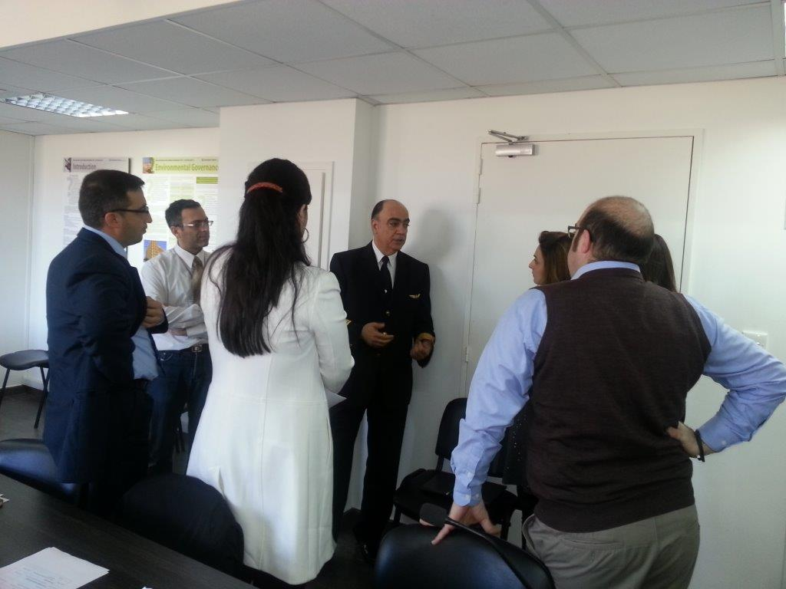
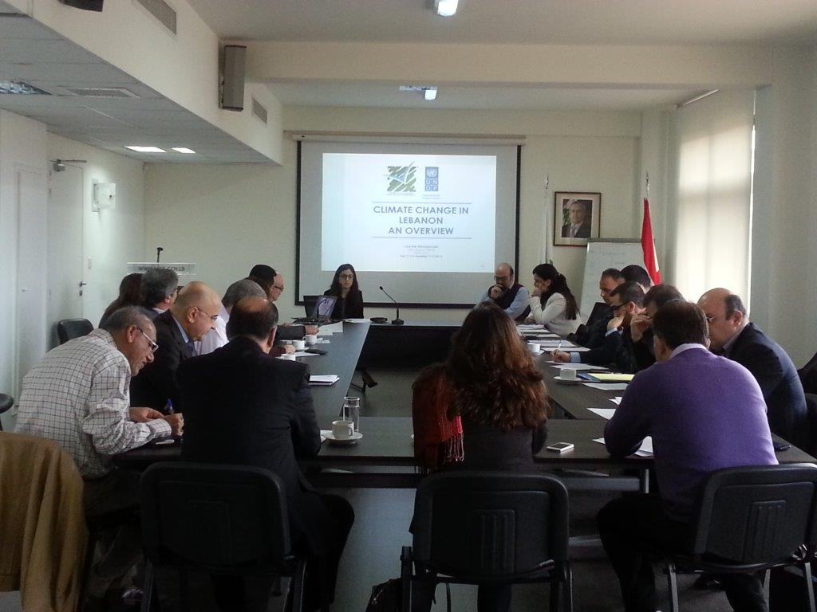

List of attendees

 | Name | Institution | Email
1 | Vahakn Kabakian | UNDP-Ministry of Environment | vahakn@moe.gov.lb
2 | Lea Kai | UNDP-Ministry of Environment | l.kai@moe.gov.lb
3 | Rola Sheikh | Ministry of Environment | rola.sh@moe.gov.lb
4 | Leila El Sayed | UNDP-Ministry of Environment & Ministry of Finance | leila.el-sayed@undp-lebprojects.org
5 | Yara Daou | UNDP-Ministry of Environment | y.daou@moe.gov.lb
6 | Wissam Tawil | Order of Engineers - Beirut | wtawil@gmail.com
7 | George Mitri | University of Balamand | george.mitri@balamand.edu.lb
8 | Marc Wehaibe | Directorate General of Civil Aviation (DGCA) - Beirut International Airport | wehaibem@beirutairport.gov.lb
9 | Ali Shaar | Directorate General of Civil Aviation (DGCA) - Beirut International Airport | ali.shaar@gotmail.com/ ashaar@beirutairport.gov.lb
10 | Jaoudat Abou-Jaoude | Council of Development and Reconstruction | jawdata@cdr.gov.lb
11 | Joseph Matta | Industrial Research Institute | chem@iri.org.lb
12 | Ramzi Shasha | Ministry of Industry | ramzi_shasha@yahoo.com
13 | Rana Tabcharani Saliba | Association of Lebanese Industrialists (ALI) | ali@ali.org.lb
14 | Said El Hage | Middle East Airlines | hages@mea.com.lb
15 | Ibrahim Nizam | Ministry of Public Works and Trasport (MoPWT) - المديرية العامة للنقل البري و البحري | ministry@transportation.gov.lb
16 | Roger Melki | Ministry of Economy and Trade | rmelki@economy.gov.lb
17 | Nadim Farajalla | AUB - Issam Faris Institute | nf06@aub.edu.lb
18 | Amin Shaban | National Council for Scientific Research (CNRS) | geoamin@cnrs.edu.lb
19 | Nada Mneimneh | Ministry of Energy and Water | nadamnh@gmail.com
20 | Ziad Khayyat | UNDP - Ministry of Energy and Water | ziad.khayat@undp-lebprojects.org
21 | Georges Abi Saleh | Association of Banks in Lebanon | gas@abl.org.lb
22 | Ihab Jomaa | LARI | ijomaa@lari.gov.lb
23 | Fuad Harb | EDL | fuad.harb@gmail.com
24 | Pierre El Khoury | LCEC - Ministry of Energy and Water | pierre.khoury@lcecp.org.lb

Annex 3: The second meeting of the focal points of the CCCU

- Summary report can be accessed through the below link:

http://climatechange.moe.gov.lb/Library/Files/Uploaded%20Files/Second%20CCCU%20Meeting%20Report.pdf

Photos
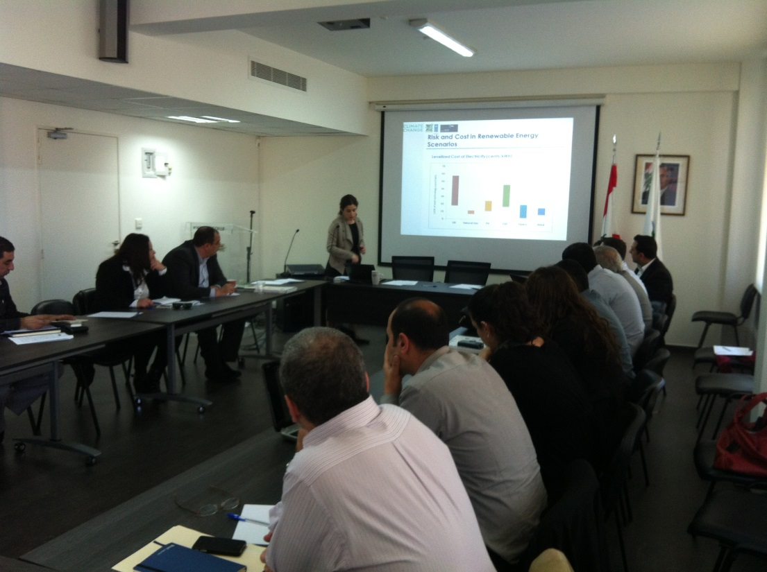
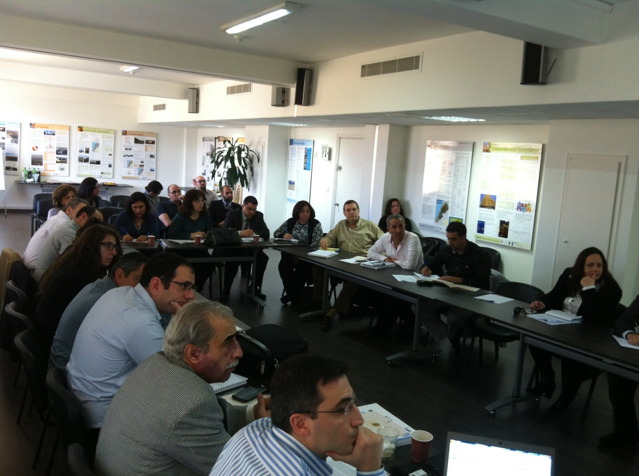

List of attendees

 | Name | Institution | Email
1 | Ali Shaar | Directorate General of Civil Aviation | ali.shaar@hotmail.com
2 | Eliane Charbel | LRI | echarbel@lri-lb.org
3 | George Mitri | University of Balamand | george.mitri@balamand.edu.lb
4 | Hisham Malaeb | Ministry of Public Works and Transportation | spu@transportation.gov.lb
5 | Ihab Jomaa | LARI | ijomaa@lari.gov.lb
6 | Jaoudat Abou Jaoude | CDR | jawdata@cdr.gov.lb
7 | Jean Stephan | FAO | jean.stephan@fao.org
8 | Michel Kfouri | Ministry of Public Health | michfouri40@hotmail.com
9 | Nabil Amacha | Litani River Authority | namacha@litani.gov.lb
10 | Nada Mneimneh | Ministry of Energy and Water | nadamnh@gmail.com
11 | Nadim Farajallah | Issam Fares Institute - AUB | nf06@aub.edu.lb
12 | Nohal Al Homsi | WHO | alhomsin@who.int
13 | Pélé Abou Abbas | Ministry of Tourism | abouabbaspele@hotmail.com
14 | Rana Tabcharani | ALI | rana_tabcharani@hotmail.com
15 | Riad Solh Al Khodari | Directorate General of Civil Aviation | dr.alkhodari@gmail.com
16 | Roger Melki | USJ | r.melki@yahoo.com
17 | Rony Gedeon | UNRCO, M&E Unit | rgedeon@economy.gov.lb
18 | Roxanne Moukarzel | Ministry of Interior and Municipalities | nassifriz@gmail.com
19 | Sawsan Nassreddine | Ministry of Finance | sawsanna@finance.gov.lb
20 | Sylvana Al Kobery | Ministry of Education | sylvanakobercy@hotmail.com
21 | Tarek Sadek | ESCWA | sadekt@un.org
22 | Tarek Salhab | Directorate General of Civil Aviation | drsalhab@hotmail.com
23 | Rola Sheikh | Ministry of Environment | rola.sh@moe.gov.lb
24 | Vahakn Kabakian | UNDP/ Ministry of Environment | vahakn@moe.gov.lb
25 | Lea Kai Aboujaoude | UNDP/ Ministry of Environment | L.Kai@moe.gov.lb
26 | Leila El Sayed | UNDP/ Ministry of Environment and Ministry of Finance | leila.el-sayed@undp-lebprojects.org
27 | Mary Awad | UNDP/ Ministry of Environment | M.Awad@moe.gov.lb
28 | Yara Daou | UNDP/ Ministry of Environment | Y.Daou@moe.gov.lb
29 | Jihan Seoud | UNDP E&E | Jihan.seoud@undp.org
30 | Hassan Harajli | CEDRO Project UNDP | Hassan.harajli@undp-lebprojects.org
31 | Ziad Khayyat | Lebanese Center for Water Conservation, UNDP/MoEW | Ziad.khayyat@undp-lebprojects.org

Annex 4: The third meeting of the focal points of the CCCU

- Summary report can be accessed through the below link:

http://climatechange.moe.gov.lb/Library/Files/Uploaded%20Files/Third%20CCCU%20Meeting%20Summary%20Report..pdf

^{Agenda}
Time | Session
9:30 – 9:40 | Registration and Welcoming Note
9:40 – 9:50 | Summary of Main Activities of the CCCU  Vahakn Kabakian
9:50 – 10:15 | Inception of Institutional Mapping for Climate Change  Dr. Nadim Farajalla
10:15 – 10:45 | Coffee Break
10:45 – 12:00 | Information-sharing of climate change achievements and future climate activities  All participants
12:00 – 12:30 | The CCCU in 2015: Next steps  Roundtable discussion
12:30 – 13:30 | Lunch

Photos
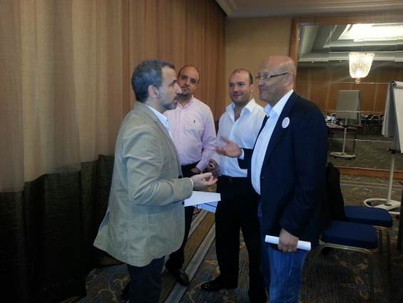
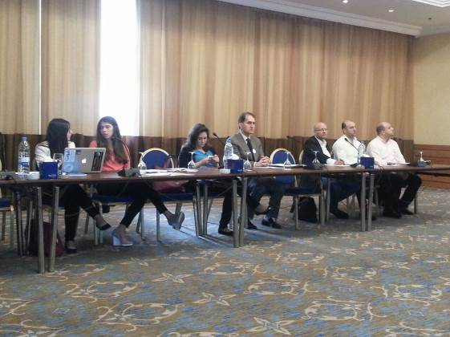

List of attendees

 | Name | Institution | Email
1 | Reine Maalouf | LCEC | reine.maalouf@lcecp.org.lb
2 | Yara Daou | MoE-UNDP | y.daou@moe.gov.lb
3 | Mary Awad | MoE-UNDP | m.awad@moe.gov.lb
4 | Vahakn Kabakian | MoE-UNDP | vahakn@moe.gov.lb
5 | Roxane Moukarzel | MoIM | nassifriz@gmail.com
6 | Jihan Seoud | UNDP | jihan.seoud@undp.org
7 | Hassan Harajli | UNDP | hassan.harajli@undp-lebprojects.org
8 | Jil Amine | MoEW-UNDP | jil.amine@undp-lebprojects.org
9 | George Mitri | University of Balamand | george.mitri@balamand.edu.lb
10 | Ramzi Shasha | MoI | ramzi_shasha@yahoo.com
11 | Leila El Sayed | UNDP-MoF/MoE | leila.el-sayed@undp-lebprojects.org
12 | Rana El Hajj | IFI-AUB | re15@aub.edu.lb
13 | Eliane Charbel | LRI | echarbel@lri-lb.org
14 | Bilal Joumi | LRA | bilojoumi@gmail.com
15 | Michelle Matta | SETS | michellematta123@gmail.com
16 | Joaudat Abou Jaoude | CDR | Jawdata@cdr.gov.lb
17 | Nadim Farajallah | AUB-IFI | nf06@aub.edu.lb
18 | Ali Shaar | DGCA | ali.shaar@hotmail.com
19 | Nabil Amacha | LRA | nabilamacha@hotmail.com
20 | Fadi Doumit | LRA | fadoumit@gmail.com
21 | Michel Kfoury | MoH | Michfouri40@hotmail.com
22 | Rana Tabcharani | ALI | ali@ali.org.lb
23 | Jean Stephan | FAO | dr.jeanstephan@gmail.com
24 | Hisham Malaeb | MoPWT | spu@transportation.gov.lb
25 | Lea Kai Aboujaoude | MoE-UNDP | l.kai@moe.gov.lb

Annex 5: NAIIS meeting

Agenda
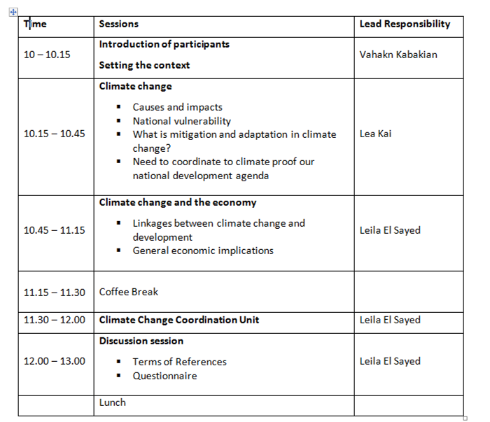

Photos
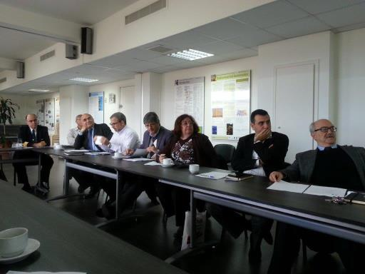
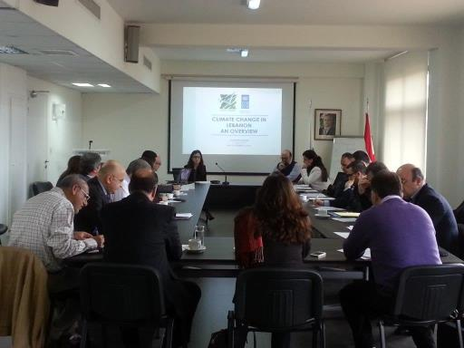

List of attendees

 | Name | Title | Field of Expertise | Organization | E-mail
1 | Ms. Lea Kai | TNC project Manager | General GHG inventory | Ministry of Environment | l.kai@moe.gov.lb
2 | Ms. Yara Daou | TNC project assistant | General GHG inventory | Ministry of Environment | y.daou@moe.gov.lb
3 | Mr. Jean Stephan | Agriculture engineer | Agriculture sector | Ministry of Agriculture | jeanstephan@hotmail.com
4 | Mr. Ramzi Shaha | Head of Department | Chemical Engineer  Industrial sector | Ministry of Industry | Ramzi_shaha@hotmail.com
5 | Mr. Charbel Mansour | Assistant professor | Transport and energy sectors | Lebanese American University | Charbel.mansour@lau.edu.lb
6 | Mr. Marwan Rizkallah | Consultant in Environmental engineering and Management | Waste Sector | Freelance Consultant | Marwan.rizallah@gmail.com
7 | Mr. George Mitri | Director of Biodiversity Programme  Assistant professor | Land use, land use change and forestry sector | University of Balamand | George.mitri@balamand.edu.lb

Annex 6: Climate change negotiations’ training

Agenda
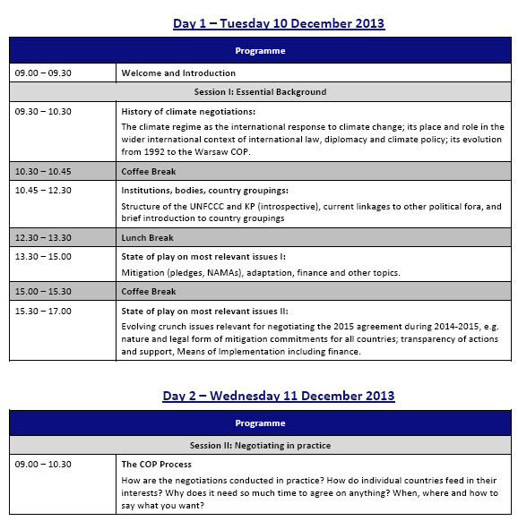
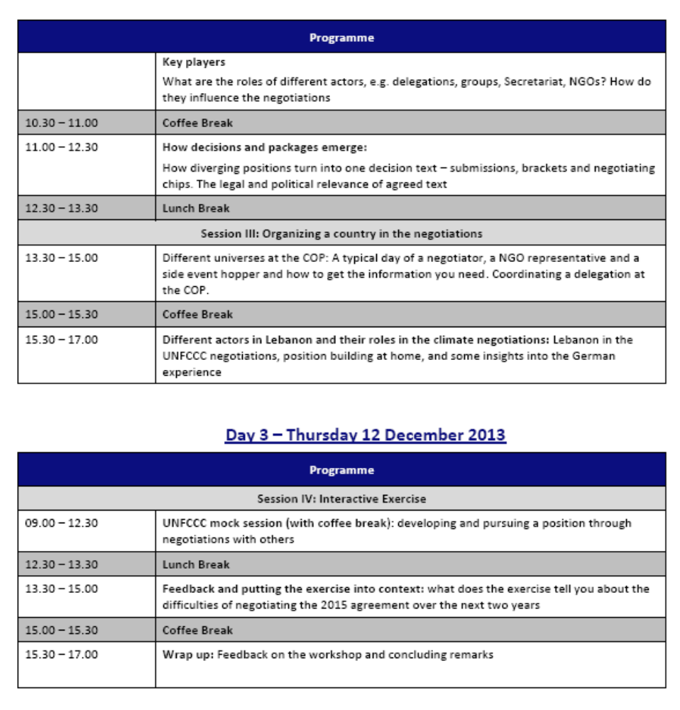
Photos
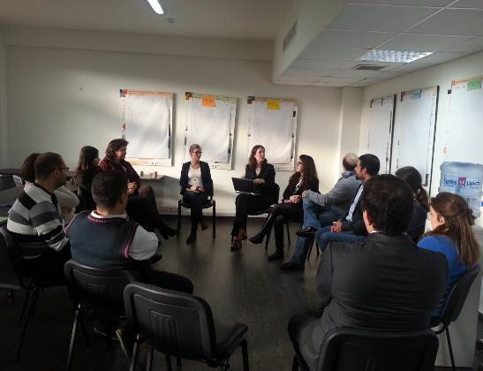
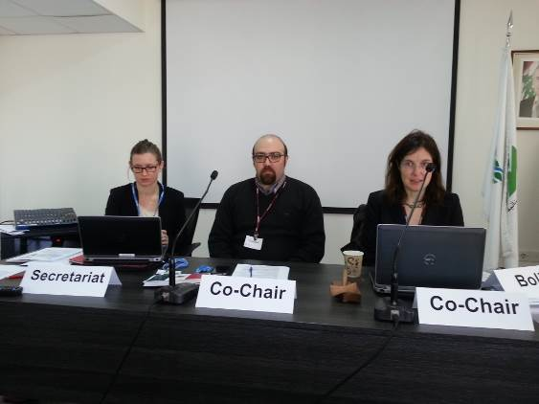

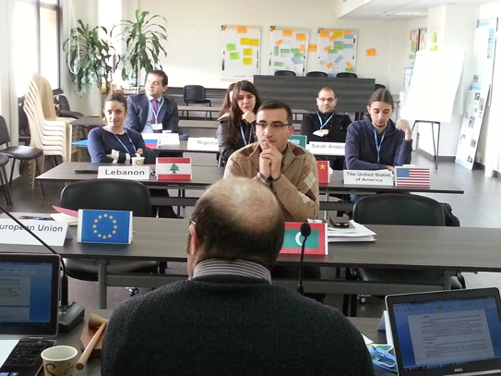
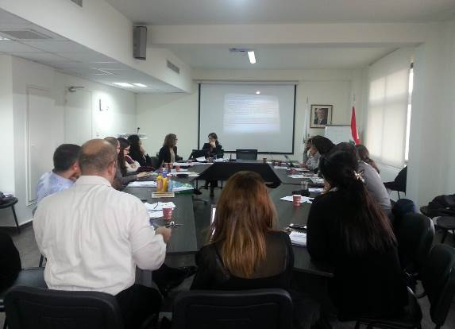

List of attendees

 | Name | Organization | E-mail
1 | Vahakn Kabakian | Ministry of Environment /UNDP | vahakn@moe.gov.lb
2 | Lea Kai Aboujaoude | Ministry of Environment /UNDP | L.kai@moe.gov.lb
3 | Yara Daou | Ministry of Environment /UNDP | y.daou@moe.gov.lb
4 | Leila el Sayed | Ministry of Environment /UNDP | leila.el-sayed@undp-lebprojects.org
5 | Rola el Sheikh | Ministry of Environment | rola.sh@moe.gov.lb
6 | Ali Shaar | Civil Aviation | ali.shaar@hotmail.com
7 | Marwan Francis | Ministry of Foreign Affairs and Immigrants | mtfrancis@gmail.com
8 | Mohammad Arayssi | Ministry of Finance | mohammadar@finance.gov.lb
9 | Lama Ghaddar | Indyact | lama.ghaddar@indyact.org
10 | Hanan Abdul Rida | German Embassy in Lebanon | hanan.abdul-rida@auswaertiges-amt.de
11 | Wiam Kordab | Civil Aviation | wiam.kordab@gmail.com
12 | Karrem Chehayeb | ASI | chehayeb91@gmail.com
13 | Najah Jaroush | Green Party | jaroushn@gmail.com
14 | Rana El Hajj | American University of Beirut/Issam Fares Institute | re15@aub.edu.lb
15 | George Mitri | Balamand University | george.mitri@balamand.edu.lb
16 | Wael Hmaidan | Climate Action Network - International | whmaidan@indyact.org
17 | Camilla Baush | Ecologic Institute | camilla.bausch@ecologic.eu
18 | Lena Donat | Ecologic Institute | lena.donat@ecologic.eu
19 | Mattias Duwe | Ecologic Institute | Matthias.Duwe@ecologic.eu
20 | Ralph Boddle | Ecologic Institute | Ralph.Bodle@ecologic.eu

Annex 7: Effective Writing and Communication Skills (Parts I, II & III)
June 12th: English Effective Writing and Communication Skills – Part I

Agenda
09.00 – 11.00 | Introduction
09.00 – 11.00 | 1. The communication pillars: Purpose, Audience and Limitations  - Brainstorming exercise  - Group work analysis
11.00 – 11.30 | Coffee Break
11.30 – 13.30 | 2. Building your argument in a paragraph  - Case study review  - General discussion
11.30 – 13.30 | 3. Five C’s of effective communication
11.30 – 13.30 | 4. Text editing: emails and memo  - Group work exercise
13.30 – 14.30 | Lunch Break
14.30 – 16.00 | 5. Engaging your audience  - Role play exercise
14.30 – 16.00 | 6. Organizing your short speech  - Role play exercise
14.30 – 16.00 | 7. Structuring communication
14.30 – 16.00 | 8. Showcasing your skills: 3 scenarios for communication  - Group work exercise

Photos
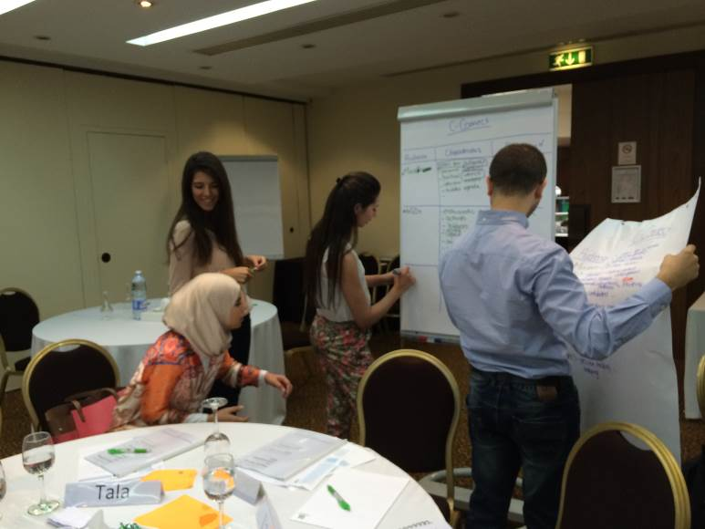

 | Name | Organization | Email
1 | Rana Youssef | Ministry of Environment/UNDP | R.Youssef@moe.gov.lb
2 | Mary Awad | Ministry of Environment/UNDP | m.awad@moe.gov.lb
3 | Ahmad Harb | Lebanese Petroleum Authority | ahmad.harb@lpa.gov.lb
4 | Carla Nassab | CEDRO | carla.nassab@undp-lebprojects.org
5 | Sawsan Nassredine | Ministry of Finance | sawsanna@finance.gov.lb
6 | Cynthia Kayem | Ministry of Environment/UNDP | cynthia.kayem@undp-lebprojects.org
7 | Mireille Jazi | Balamand University | Mireille.Jazi@balamand.edu.lb
8 | Patricia Haydamous | Issam Fares Institute - AUB | ph16@aub.edu.lb
9 | Vahakn Kabakian | Ministry of Environment/UNDP | Vahakn@moe.gov.lb
10 | Yara Daou | Ministry of Environment/UNDP | y.daou@moe.gov.lb
11 | Alaa Bashir | IndyAct | comms@indyact.org
12 | Tala Moukaddem | Society for the Protection of Nature in Lebanon - SPNL | t.moukaddem@spnl.org
13 | Lea Hakim | Ministry of Finance/UNDP | LeaH@finance.gov.lb
14 | Kourken Kadehjian | Ministry of Environment/UNDP | Kerk92@gmail.com
15 | Nohal Al Homsi | World Health Organization | alhomsin@who.int
16 | Lara Haidar | Ministry of Environment/UNDP | L.Haidar@moe.gov.lb
17 | Aya El Hajj | Ministry of Environment/UNDP | a.elhajj@moe.gov.lb
18 | Lea Aboujaoude | Ministry of Environment/UNDP | l.kai@moe.gov.lb
19 | Nada Mneimneh | Ministry of Finance | nadamnh@gmail.com
20 | Ali Shaar | Directorate General of Civil Aviation | ali.shaar@hotmail.com
21 | Ihab Jomaa | Agricultural Research Institute of Lebanon - LARI | ijomaa@lari.gov.lb
List of attendees
June 26th: English Effective Writing and Communication Skills – Part II

Agenda
09.15 – 11.00 | Introduction
09.15 – 11.00 | 1. What is a Policy Brief?
09.15 – 11.00 | 2. Policy Briefs: Components and Pillars  - Group Work Exercise  - Sample of Policy Briefs – Group Discussion
11.00 – 11.30 | Coffee Break
11.30 – 13.30 | 3. Executive Summary Components and Editing  - Practice and Examples
11.30 – 13.30 | 4. Memo Organization and Writing  - Practice and Examples
13.30 – 14.30 | Lunch Break
14.30 – 16.00 | 5. Engaging your Audience  - The Triangle Satisfaction Concept
14.30 – 16.00 | 6. Organization is Key  - Role Play Exercises

Photos

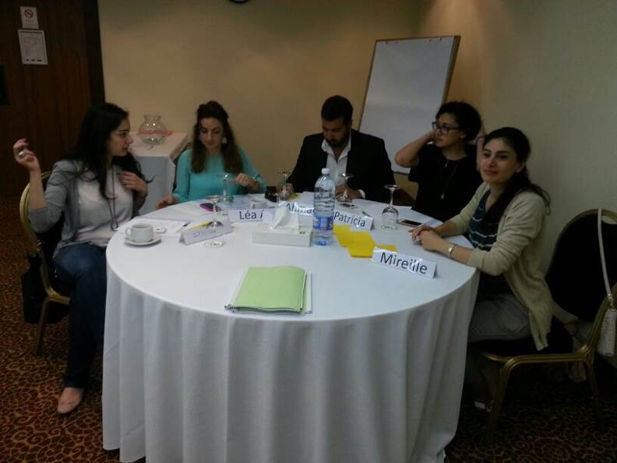
List of attendees
 | Name | Organization | Email
1 | Rana Youssef | Ministry of Environment/UNDP | R.Youssef@moe.gov.lb
2 | Mary Awad | Ministry of Environment/UNDP | m.awad@moe.gov.lb
3 | Ahmad Harb | Lebanese Petroleum Authority | ahmad.harb@lpa.gov.lb
4 | Leila El Sayyed | Ministry of Environment/UNDP | leila.el-sayed@undp-lebprojects.org
5 | Sawsan Nassredine | Ministry of Finance | sawsanna@finance.gov.lb
6 | Cynthia Kayem | Ministry of Environment/UNDP | cynthia.kayem@undp-lebprojects.org
7 | Mireille Jazi | Balamand University | Mireille.Jazi@balamand.edu.lb
8 | Patricia Haydamous | Issam Fares Institute - AUB | ph16@aub.edu.lb
9 | Vahakn Kabakian | Ministry of Environment/UNDP | Vahakn@moe.gov.lb
10 | Yara Daou | Ministry of Environment/UNDP | y.daou@moe.gov.lb
11 | Alaa Bashir | IndyAct | comms@indyact.org
12 | Abed El Rahman Zawawy | Directorate General of Civil Aviation | zawawyabed@gmail.com
13 | Lea Hakim | Ministry of Finance/UNDP | LeaH@finance.gov.lb
14 | Kourken Kadehjian | Ministry of Environment/UNDP | Kerk92@gmail.com
15 | Nohal Al Homsi | World Health Organization | alhomsin@who.int
16 | Lara Haidar | Ministry of Environment/UNDP | L.Haidar@moe.gov.lb
17 | Jean Stephan | FAO | Jean.stephan@fao.org
18 | Lea Aboujaoude | Ministry of Environment/UNDP | l.kai@moe.gov.lb
19 | Jad Stephan | Ministry of Environment/UNDP | jadstephan@live.com.au
20 | Ali Shaar | Directorate General of Civil Aviation | ali.shaar@hotmail.com
21 | Ihab Jomaa | Agricultural Research Institute of Lebanon - LARI | ijomaa@lari.gov.lb

July 16th: Arabic Effective Writing and Communication Skills – Part III

Agenda

9:15 – 11:00 |  | - اسلوب الإبلاغ باللّغة العربية
9:15 – 11:00 |  | - خصائص يتميز بها التقرير الجيد وأمثلة
9:15 – 11:00 |  | - اعتبارات لغوية
9:15 – 11:00 |  | - عبارات تستخدم في كتابة الرسائل باللغة العربية
9:15 – 11:00 |  | - نشاط تطبيقي
11:00 – 11:30 |  | استراحة
11:30 – 14:00 |  | - تصميم موجز السياسات
11:30 – 14:00 |  | - تصميم الهيكل العام
11:30 – 14:00 |  | - نماذج موجز سياسات
11:30 – 14:00 |  | - تحليل ونقد نماذج موجز سياسات
11:30 – 14:00 |  | - تصميم الكتاب الرسمي
11:30 – 14:00 |  | - المكونات الأساسية للكتاب الرسمي
11:30 – 14:00 |  | - عينات ونماذج من الكتاب الرسمي
11:30 – 14:00 |  | - نشاط تطبيقي
11:30 – 14:00 |  | - لعب ادوار
14:00 |  | غذاء

Photos

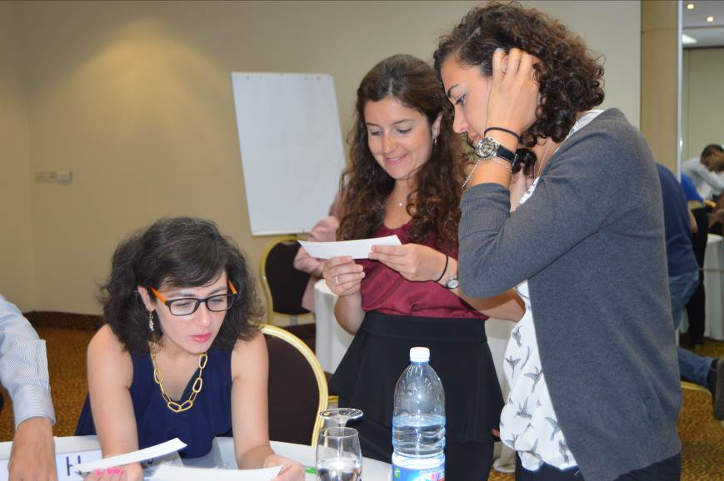

List of attendees
 | Name | Organization | Email
1 | Rana Youssef | Ministry of Environment/UNDP | R.Youssef@moe.gov.lb
2 | Mary Awad | Ministry of Environment/UNDP | m.awad@moe.gov.lb
3 | Leila El Sayyed | Ministry of Environment/UNDP | leila.el-sayed@undp-lebprojects.org
4 | Sawsan Nassredine | Ministry of Finance | sawsanna@finance.gov.lb
5 | Cynthia Kayem | Ministry of Environment/UNDP | cynthia.kayem@undp-lebprojects.org
6 | Vahakn Kabakian | Ministry of Environment/UNDP | Vahakn@moe.gov.lb
7 | Yara Daou | Ministry of Environment/UNDP | y.daou@moe.gov.lb
8 | Lea Hakim | Ministry of Finance/UNDP | LeaH@finance.gov.lb
9 | Kourken Kadehjian | Ministry of Environment/UNDP | Kerk92@gmail.com
10 | Nohal Al Homsi | World Health Organization | alhomsin@who.int
11 | Lea Aboujaoude | Ministry of Environment/UNDP | l.kai@moe.gov.lb
12 | Jad Stephan | Ministry of Environment/UNDP | jadstephan@live.com.au
13 | Ali Shaar | Directorate General of Civil Aviation | ali.shaar@hotmail.com
14 | Ihab Jomaa | Agricultural Research Institute of Lebanon - LARI | ijomaa@lari.gov.lb
15 | Anna Chadarevian | Ministry of Environment | a.chadarevian@moe.gov.lb
16 | Rachid Dhoyhe | Ministry of Environment
17 | Sami Ibrahim | AUB - IFI | Ph16@aub.edu.lb
18 | Nour Masri | Ministry of Environment/UNDP | Nour.masri@undp-lebprojects.org
19 | Jawdat Abou Jaoude | Council for Development and Reconstruction | jawdata@cdr.gov.lb
20 | Samar Malek | Ministry of Environment | samar@moe.gov.lb
21 | Marwan Moudallal | Ministry of Environment | m.moudallal@moe.gov.lb
22 | Zeina Yaacoub | Ministry of Environment | z.yaacoub@moe.gov.lb
23 | Jean Stephan | FAO | Jean.stephan@fao.org
24 | Dania Kanaan | Ministry of Environment | Dania-nn-kanaan@moe.gov.lb
25 | Rasha Kanj | Ministry of Environment | R.kanj@moe.gov.lb
26 | Nada Ghanem | UNEP/ Ministry of Environment | Nada-ghanem@hotmail.com

Annex 8: Climate finance seminar

July 7th, 2014: The national and international climate finance architecture
July 8th, 2014: Climate finance instruments

- Final Report can be accessed through the below link
http://climatechange.moe.gov.lb/Library/Files/Uploaded%20Files/CF%20Seminar%20Lebanon%20Report.pdf

Agenda for July 7th & 8th

Monday, 07.07.2014 – The national and international climate finance architecture
9:00-9:30 | Registration
9:30-9:45 | Welcoming words (MoE-UNDP)
9:45-11:15 | Session 1: Introduction to Climate Finance  This session introduces the current debate on climate finance and provides an overview about available international funding sources and eligibility criteria, as well as the importance of national sources. It is to help participants to get an insight into institutional arrangements and political framework for mobilizing, managing and monitoring of climate finance.  (Presentation)
11.15-11:30 | Break
11:30-13:00 | Session 2: Lebanon’s Experience in Climate Finance  Lebanon has already experience in climate finance. By addressing the question - who needs to be involved and why - the important stakeholders for climate finance in Lebanon will be elaborated. Moreover, based on the experience and knowledge of the participants, existing climate finance mechanism and instruments will be discussed. The focus will lie hereby on lessons learned and the perceived impact.  (Interactive session)
13:00-14:00 | Lunch
14:00–16:30 | Session 3: Getting Ready for Climate Finance  Countries want to prepare for climate finance readiness. This requires on national level to decide on an institutional set up (with different players and roles). This session introduces different options (e.g. selecting an existing or establishing a new institution) for getting ready – e.g. by introducing the institutional arrangements in other countries. Together, the important steps will be elaborated to prepare for climate finance readiness.  (Presentation and interactive session)
16:30–17:00 | Summary of day one and introduction to the next day
Tuesday, 08.08.2014 - Climate finance instruments
16:00-16:15 | Recap of day 1 and introduction of day 2
16:15-17:45 | Session 4: Barriers for Climate Investments  This session introduces the major barriers with regard to investments in mitigation and adaptation projects. Together, the participants will categorize the major barriers experienced in Lebanon.  (Presentation and interactive session to elaborate the context in Lebanon)
17:45-18:00 | Break
18:00-19:30 | Session 5: Policy Incentives for Climate Finance  Various public policy incentives and financial instruments are suitable to address GHG emissions reductions and mobilize investments in adaption and mitigation. With reference to the previous session and together with good practice samples from other countries, an overview of different instruments and criteria that define effective policy incentives will be discussed.  (Presentation and interactive session to elaborate the context in Lebanon)
19:30-20:00 | Wrap up, evaluation and Closing words
20:00 | Iftar

Photos
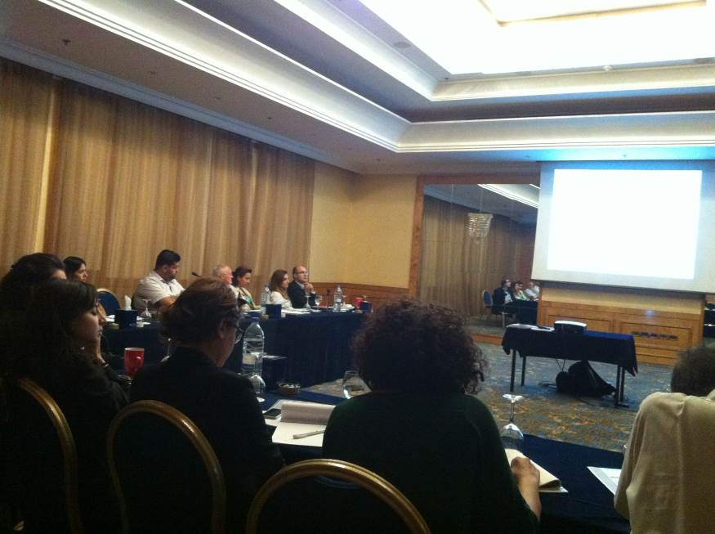
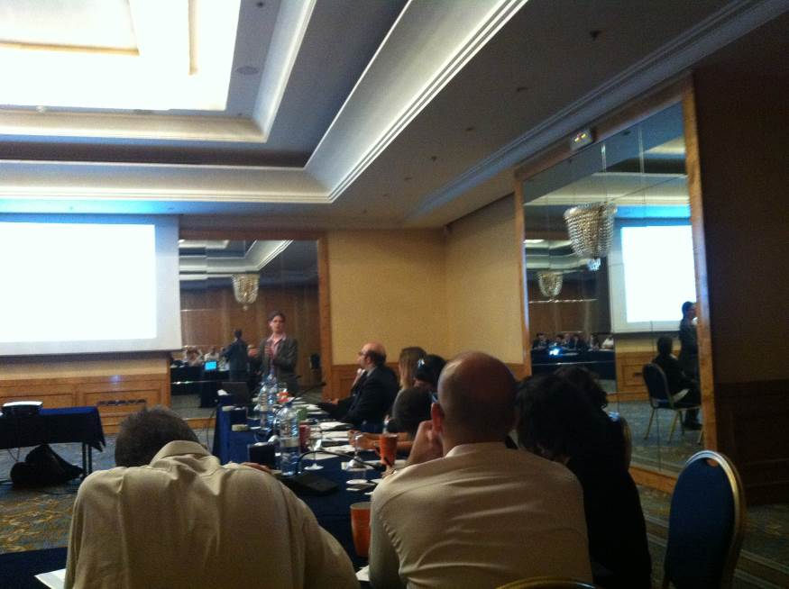
List of attendees for July 7th & 8th

Name | Institution | Email | Phone
Christine Gruening | Frankfurt School of Finance and Management | C.Gruening@fs.de | -
Carola Menzel | Frankfurt School of Finance and Management | C.Menzel@fs.de | -
Joseph Saade | NATCAZ | joseph.a.saade@gmail.com | 03-080818
Jessica Obeid | CEDRO | jessica.obeid@undp-lebprojects.org | 03-404741
Jihan Seoud | UNDP | Jihan.seoud@undp.org | 03-161370
Catherine Abdo | V4 Advisors | cabdo@v4advisors.com | 03-590779
Walid Sayegh | UNDP/MoF | walid.sayegh82@gmail.com | 70-299672
Tarek Bsat | Bank Audi | tarek.bsat@asib.com | 76-888318
Yasmine Ibrahim | UNDP/MoF | yasminei@finance.gov.lb | 03-957565
Patil Mesrobian | LCEC | patil.mesrobian@lcecp.org.lb | 03-103979
Russel Frost | Streg Project/EU/GFA | r-f121@yahoo.co.uk | -
Patricia Haydamous | IFI/AUB | ph16@aub.edu.lb | 70-811267
Cherine Daoud | BLOM Bank | cherine_daoud@hotmail.com | 03-782234
Carla Nassab | CEDRO | carla.nassab@undp-lebprojects.org | 03-397361
Celina Andrioti | JP Morgan | celina-andrioti@jpmchase.com | 03-777984
Kourken Kadehjian | UNDP/MoE | kerk92@gmail.com | 71-754073
Tala Moukaddem | SPNL | tala.moukaddem@gmail.com | 03-187479
Majd Fayyad | Green Future | majdfayyad89@gmail.com | 03-948642
Jaoudat Abou Jaoude | CDR | jawdata@cdr.gov.lb | 03-346890
Isabelle Naoum | BLOM Bank | i.naoum@blom.com.lb | 03-359454
Georges Abi Saleh | ABL | gas@abl.org.lb | 03-628188
Lamia Chamas | PCM | lchamas@pcm.gov.lb | 03-705800
Nina El Hajj Srour | Credit Libanais | nelhajj@cl.com.lb | 03-771321
Zeina Majdalani | PCM | zmajdalani@pcm-gov.lb | 03-245416
Elie Zanaty | BLOM Bank | elie.zanaty@gmail.com | 03-953045
Rawad Massoud | V4 Advisors | rmassad@v4advisors.com | 71-139943
Jad Stephan | UNDP/MoE | jadstephan@live.com.au | 03-423836
Krystel Rizk | CEDRO | krystel.rizk@undp-lebprojects.org | 03-833087
Lea Hakim | UNDP/MoF | leah@finance.gov.lb | 01-981057
Maya Damaj | Byblos Bank | mdamaj@byblosbank.com.lb | 03-616089
Lara Haidar | UNDP/MoE | l.haidar@moe.gov.lb | 03-024284
Souraya Srage | BDL | ssrage@bdl.gov.lb | 03-733162
Hassan Harajli | CEDRO | hassan.harajli@undp-lebprojects.org | 71-222555
Tarek Kazoun | KAFALAT | tarekkazoun@hotmail.com | 03-963443
Khaled Bohsali | BDL | kbohsali@bdl.gov.lb | 03-359930
Vahakn Kabakian | UNDP/MoE | vahakn@moe.gov.lb | 03-527679
Lea Kai Aboujaoude | UNDP/MoE | l.kai@moe.gov.lb | -
Yara Daou | UNDP/MoE | y.daou@moe.gov.lb | 03-312501
Leila El Sayed | UNDP/MoE/MoF | leila.el-sayed@undp-lebprojects.org | 03-940506
Mary Awad | UNDP/MoE | m.awad@moe.gov.lb | 03-394326
Annex 9: Training on Cost-Benefit and Cost-Effectiveness Analysis in appraising energy and environmental projects

August 19th, 2014: Hands-On Training on Cost-Benefit and Cost-Effectiveness Analysis in Appraising - Energy and Environmental Policies – Day 1
August 20th, 2014: Hands-On Training on Cost-Benefit and Cost-Effectiveness Analysis in Appraising - Energy and Environmental Policies – Day 2

- Summary can be accessed through the below link:

http://climatechange.moe.gov.lb/newscbacea

Agenda for August 19th & 20th

Time | Session | Description
9:00 – 9:15 | Registration and Welcoming Note
9:15 – 10:15 | Basic Terms and Principles in Finance  Presentation & Interactive Elements | This session introduces the basic terms and principles in finance such as nominal versus real value, discounting and selecting discount rates, net present value (NPV), and internal rate of return (IRR).
10:15 – 10:45 | Coffee Break
10:45 – 12:45 | Introduction to Cost-Benefit Analysis (CBA) and Cost-Effectiveness Analysis (CEA)  Presentation & Q&A | The definitions, purpose and principles of both CBA and CEA will be given, highlighting the different methodologies, difficulties and caveats of both methods. Examples of CBA & CEA will be presented.
12:45 – 13:30 | Lunch
13:30 – 16:00 | Exemplary Case Study: Feed In Tariff Policy for Wind Power  Group Exercise | A case study on CBA and CEA for a feed-in tariff (FiT) policy for wind will be used as a practical exercise (baselines, discount rates, sensitivity analysis, etc.)

Time | Session | Description
9:00 – 9:15 | Registration & Recap of Day 1 & Introduction of Day 2
9:15 – 10:15 | Risk and Public Policy  Presentation | This extends the learning of previous sessions by focusing on the role of risk for the cost-effectiveness of public policies. Examples of typical risks from the fields of energy and environment will be provided and discussed.
10:15 – 11:15 | De-risking as a Way to Improve the Cost-Effectiveness of Public Policies  Presentation | This session introduces de-risking methods and how de-risking can increase the cost-effectiveness of public policies. Specifically, de-risking is discussed in the context of Nationally Appropriate Mitigation Action policies (NAMAs) as established under the UNFCCC and the Green Climate Fund.
11:15 – 11:45 | Coffee Break
11:45 – 13:45 | De-risking Case Study on a hypothetical Wind FiT NAMA  Group Exercise | This session will implement a de-risking case study on a on a feed-in tariff (FiT)-based NAMA policy for wind. Many of the key issues of de-risking will be discussed and the participants will have to create a policy mix spurring wind investments, which include de-risking elements.
13:45 – 14:00 | Clinique – Q&A  Open Discussion | An open discussion with questions and answers covering all topics treated in the training. CBA/CEA issues specific to Lebanon’s situation will be discussed.
14:00 | Lunch
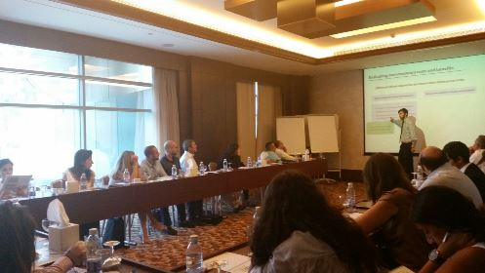
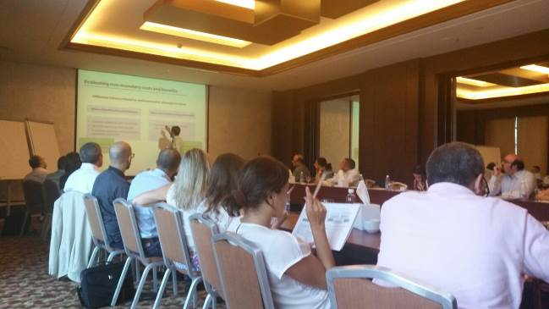
Photos

List of attendees

Name | Institution | Email
Hassan Harajli | CEDRO | hassan.harajli@undp-lebprojects.org
Marc Haddad | LAU | mhaddad@lau.edu.lb
Pierrette Zouein | LAU | pzouein@lau.edu.lb
Karim Osseiran | Ministry of Energy and Water | karim.m.osseiran@gmail.com
Michel-Ange Medlej | Ministry of Energy and Water | michelange.medlej@gmail.com
Hadi Tabbara | Consultant | haditabbara@yahoo.com
Patil Mesrobian | Lebanese Center for Energy Conservation | patil.mesrobian@lcecp.org.lb
Elie Abou Jaoudeh | Lebanese Center for Energy Conservation | eaboujaoudeh@lcecp.org.lb
Assem Abou Ibrahim | Lebanese Petroleum Authority | assem.abouibrahim@lpa.gov.lb
Rola Sheikh | Lebanese Petroleum Authority | rola.sheikh@lpa.gov.lb
Walid Nasr | Lebanese Petroleum Authority | walid.nasr@lpa.gov.lb
Mada Arslan | Banque du Liban | marslan@bdl.gov.lb
Helena Haddad | Banque du Liban | hahaddad@bdl.gov.lb
Maya Mhanna | Ministry of Agriculture | mayamhanna@gmail.com
Diala Chaar | Higher Council for Privatization | dchaar@hcp.gov.lb
Maya Chamli | Higher Council for Privatization | mchamli@hcp.gov.lb
Jaoudat Abou Jaoudeh | Council for Development and Reconstruction | jawdata@cdr.gov.lb
Jean Stephan | Food and Agriculture Organization | jean.stephan@fao.org
AbdelRahim Ayoubi | UNDP/Ministry of Finance | Abdelrahim.ayoubi@gmail.com
Walid Sayegh | UNDP/Ministry of Finance | walidsa@finance.gov.lb
Nadim Farajalla | Issam Fares Institute – American University of Beirut | nf06@aub.edu.lb
Rana El Hajj | Issam Fares Institute – American University of Beirut | re15@aub.edu.lb
Nabil Amacha | Litani River Authority | nabilamacha@hotmail.com
Vahakn Kabakian | UNDP/Ministry of Environment | vahakn@moe.gov.lb
Lea Kai Aboujaoude | UNDP/Ministry of Environment | l.kai@moe.gov.lb
Yara Daou | UNDP/Ministry of Environment | y.daou@moe.gov.lb
Leila El Sayyed | UNDP/Ministry of Environment | leila.el-sayed@undp-lebprojects.org
Mary Awad | UNDP/Ministry of Environment | m.awad@moe.gov.lb
Kourken Kadehjian | UNDP/Ministry of Environment | kerk92@gmail.com
Jad Stephan | UNDP/Ministry of Environment | jadstephan@live.com.au
Annex 10: Advanced UNFCCC negotiations training

September 24th, 2014: Negotiations in practice
September 25th, 2014: Understanding and influencing text

- Summary report can be accessed through the below link:

http://climatechange.moe.gov.lb/Library/Files/Uploaded%20Files/Final%20Workshop%20Report_%20Short%20version.pdf

Agenda for September 24th & 25th

09.00 – 10.00 | Welcome and Introduction  Where do the negotiations stand
Session I: Negotiating in practice
10.00 – 10.20 | Gathering information  Where to get useful information in short time; which sources to use and why they are important.
10:20 – 10.30 | Negotiation Exercise Part I: Introduction
10.30 – 11.00 | Coffee Break
11.00 – 11.20 | How to work effectively as a delegation  Information flow within a delegation; attribution of tasks; using resources effectively; insights from the EU and Lebanon
11.20 – 12.20 | Back channels for influencing the negotiations  How to use the media, NGOs, other parties, the Secretariat, Chairs and the Presidency
12.20 – 13.20 | Lunch Break
13.20 – 14.10 | How to say what you want where, when and how (I)  Choosing the right meeting and the right moment in the negotiations, creating the right atmosphere, which people to approach  - Statements in Plenary  - Contact groups and informals  - Group meetings
14.10 – 15.00 | How to say what you want where, when and how (II): Formal bilaterals
15.00 – 15.30 | Coffee Break
15.30 – 16.30 | Moderated discussion: Who to approach to strengthen the Lebanese position?
16.30 – 16.40 | Problem 1 and how to solve it  Difficult situations that negotiators might encounter in the negotiations, and possible solutions
16.40 – 17.00 | Negotiation Exercise Part II: Opening Plenary

Session II: Understanding and influencing text
09.00 – 09.30 | Understanding codes  Understanding the most relevant negotiation codes in the context of the negotiations on the 2015 climate agreement
09.30 – 09.50 | Working with text I: Formalities and Practicalities  How to bring text into the negotiations; with whom to work on text etc.
09.50 – 10.30 | Working with text II: Language to watch out for in decision text  Preambular and operative paragraphs and the key words at the start; slippery negotiation words; references to past decisions; cross-check with other agenda items
10.30 – 11.00 | Coffee Break
11.00 – 11.30 | Negotiation Exercise Part III: Contact Group
11.30 – 11.45 | Problem 2 and how to solve it  Difficult situations that negotiators might encounter in the negotiations, and possible solutions
11.45 – 12.15 | Using and pleasing your Minister  How to effectively use your minister; how to navigate your minister through the negotiations
12.15 – 13.15 | Lunch Break
13.15 – 13.45 | Negotiation Exercise Part III: Final Plenary + Reflections on the exercise
13.45 – 14.45 | Analysis of draft INDC decision text I – group work  Analysing the draft decision on intended nationally determined contributions that was presented by the ADP Co-Chairs
14.45 – 15.15 | Coffee Break
15.15 – 16.15 | Analysis of draft INDC decision text II – presentation and discussion of results  Analysing the draft decision on intended nationally determined contributions that was presented by the ADP Co-Chairs
16.15 – 16.30 | Problem 3 and how to solve it  Difficult situations that negotiators might encounter in the negotiations, and possible solutions
16.30 – 17.00 | Wrap up  Feedback on the workshop and open questions

Photos
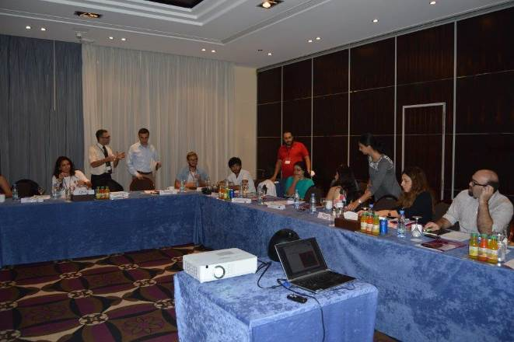
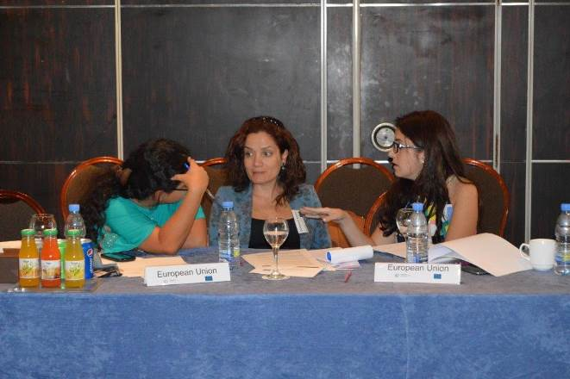
List of attendees

Name | Institution | Email | Phone
Laura Sisco | AUB | lbs05@mail.aub.edu | 76-530866
Julia Strobl | AUB | jms23@mail.aub.edu | 78-907886
Hanan Abdul Rida | German Embassy | hanan.abdul-rida@auswaertiges-amt.de | 04-935015
Vahakn Kabakian | UNDP/MoE | vahakn@moe.gov.lb | 03-527679
Lea Kai | UNDP/MoE | l.kai@moe.gov.lb | 03-744252
Christophe Maroun | IndyAct | cmaroun@indyact.org | 03-060933
Ali Shaar | DGCA | ali.shaar@hotmail.com | 03-287819
Rana El Hajj | AUB/IFI | re15@aub.edu.lb | 03-404625
Mary Awad | UNDP/MoE | m.awad@moe.gov.lb | 03-394326
Carla Jamous | Ministry of Agriculture | jamous.carla@gmail.com | 71-330834
Yara Daou | MoE/UNDP | y.daou@moe.gov.lb | 03-312501
Talal Salman | MoF/UNDP | talal.salman@finance.gov.lb | -
Sabine Saba | IoE/Balamand | sabine.saba@fty.balamand.edu.lb | 03-985469
Suzanne Baaklini | L’Orient le Jour | suzannebaaklini@lorientlejour.com | 03-363811
Leila El Sayed | UNDP/MoE/MoF | leila.el-sayed@undp-lebprojects.org | 03-940506
Bjorn Jakobson | AUB | bjornbangjakobson@gmail.com | 76-953522
Marc Wehaibe | DGCA | wehaibem@beirutairport.gov.lb | 03-613283
Bassam Kantar | Al Akhbar | bassam.kantar@gmail.com | 03-350956
Lara Haidar | UNDP/MoE | l.haidar@moe.gov.lb | 03-024284
Majed Soufi | AUB | mks30@mail.aub.edu | 70-199127
Camilla Bausch | Ecologic | camilla.bausch@ecologic.eu | -
Lena Donat | Ecologic | lena.donat@ecologic.eu | +4915785200866

Annex 11: Photos of Greenhouse Rainwater Harvesting Systems (Kfarmashoun site)

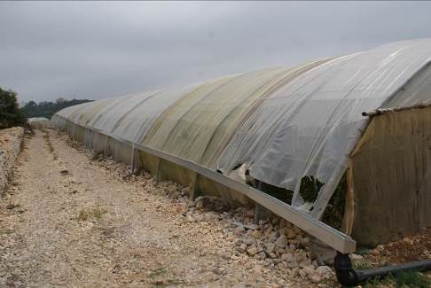

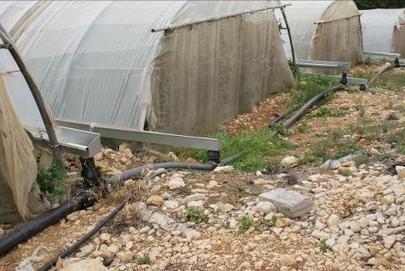

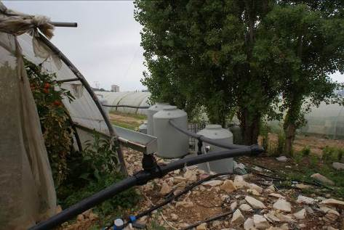

Annex 12: Media Coverage of Lebanon’s Side Event Agenda at COP20

Video coverage:

https://www.youtube.com/watch?v=Hb9UwVyKt9A

International Institute for Sustainable Development (IISD) article:

http://www.iisd.ca/climate/cop20/enbots/6dec.html#event2
Annex 13: Guidelines on integrating climate change into Environmental Impact Assessments

Published on Ministry of Environment Climate Change website:

http://climatechange.moe.gov.lb/viewfile.aspx?id=219

The term “programme” is used for programmes, joint programmes and projects.
Strategic Results, as formulated in the Strategic UN Planning Framework (e.g. UNDAF) or project document;
The MPTF Office Project Reference Number is the same number as the one on the Notification message. It is also referred to as “Project ID” on the project’s factsheet page the MPTF Office GATEWAY
The MPTF or JP Contribution, refers to the amount transferred to the Participating UN Organizations, which is available on the MPTF Office GATEWAY
The start date is the date of the first transfer of the funds from the MPTF Office as Administrative Agent. Transfer date is available on the MPTF Office GATEWAY
As per approval of the original project document by the relevant decision-making body/Steering Committee.
If there has been an extension, then the revised, approved end date should be reflected here. If there has been no extension approved, then the current end date is the same as the original end date. The end date is the same as the operational closure date which is when all activities for which a Participating Organization is responsible under an approved MPTF / JP have been completed. As per the MOU, agencies are to notify the MPTF Office when a programme completes its operational activities.
Note: Outcomes, outputs, indicators and targets should be as outlined in the Project Document so that you report on your actual achievements against planned targets. Add rows as required for Outcome 2, 3 etc.

