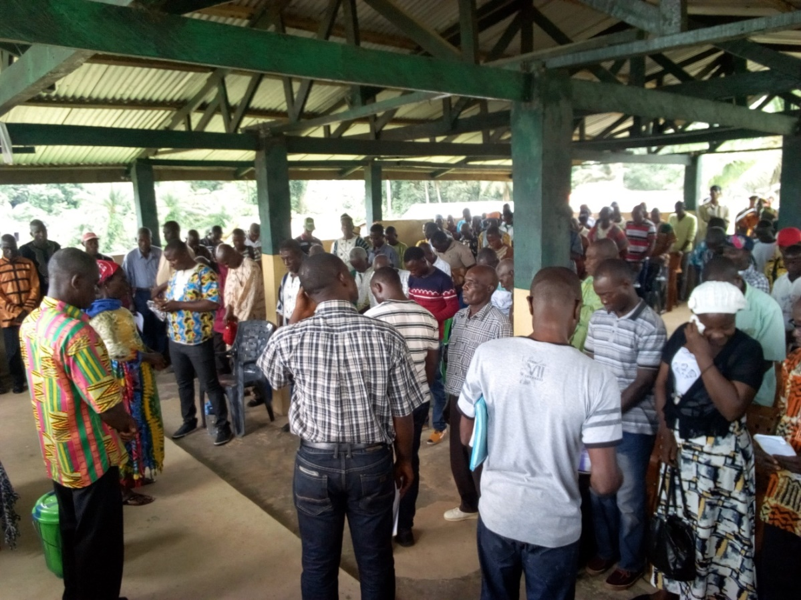**A PICTORIAL OF ACTIVITIES UNDERTAKEN**

United Communities Initiative (UCI) Multi-Stakeholder Platform (MSP) Conflict Resolution gathering in Numopoe Peace Hut

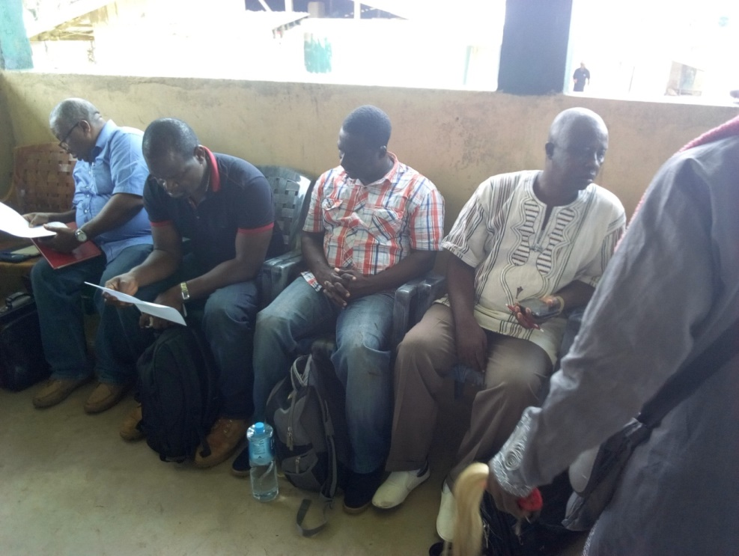

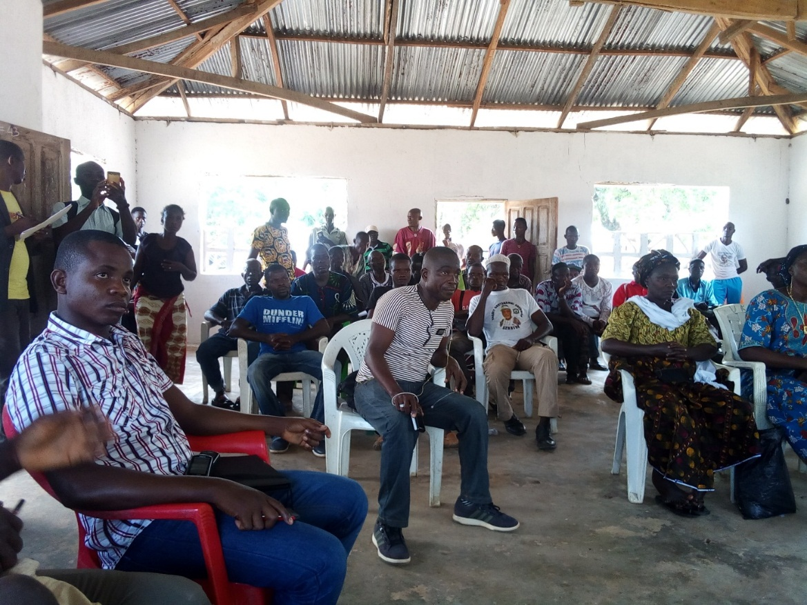Golden Veroleum Liberia (GVL) Official and National Bureau Commission (NBC) Staff at Numopoe Meeting in Sinoe County

United Communities Initiative (UCI) MSP and Citizens at Numopoe Meeting



***Project Affected Communities (PAC) MSP Conflict resolution and Participatory Mapping Survey***

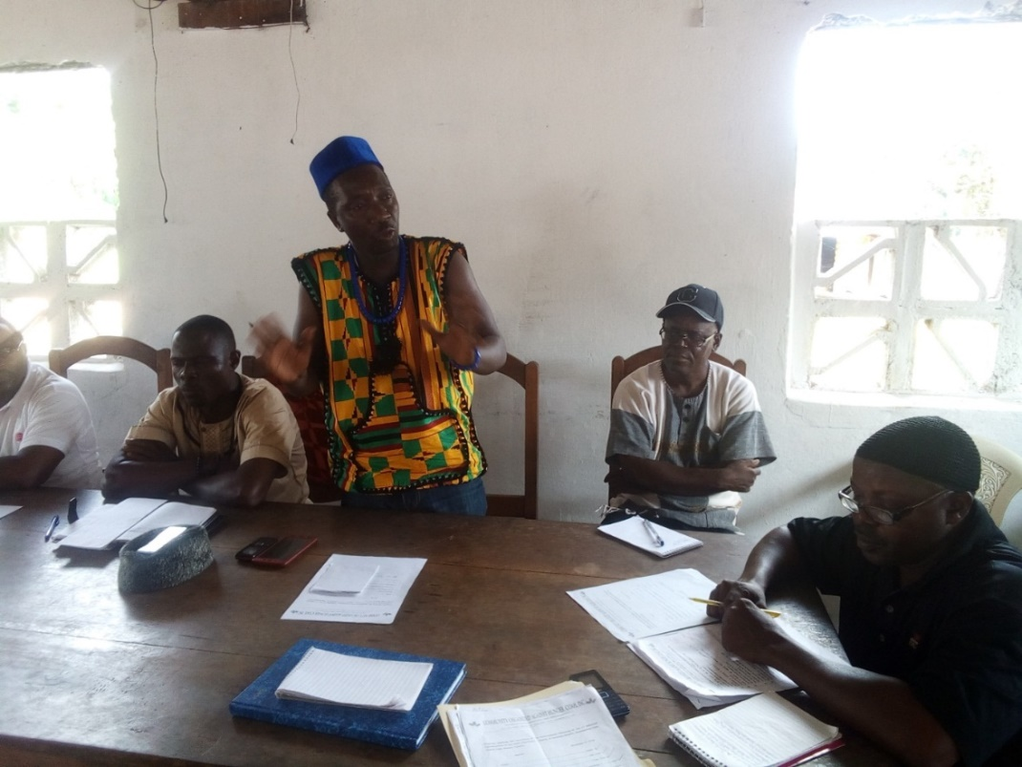

***Mr. Abraham Kromah, Chairman of the Project Affected Communities (PAC), resolves Conflict at Sime Darby***

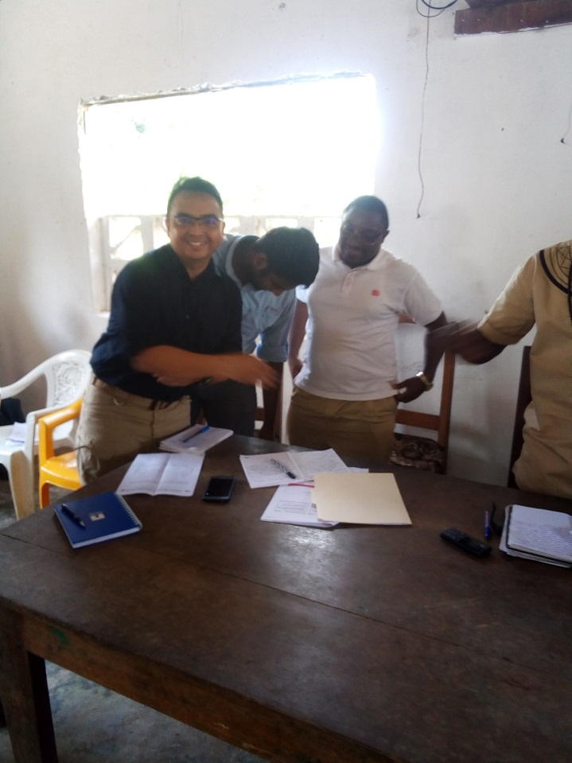

One of the concession companies, Sime Darby, Senior Staff proffering a handshake to one of the members of the Project Affected Communities after a conflict resolution meeting.

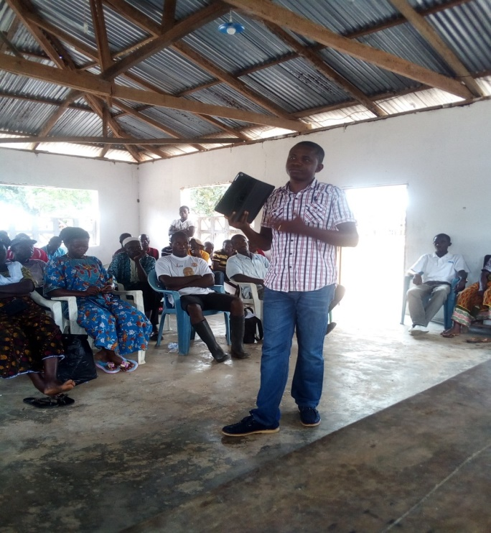

***A Consultant for Participatory Mapping providing an overview to community members in Grand Cape Mount County.***

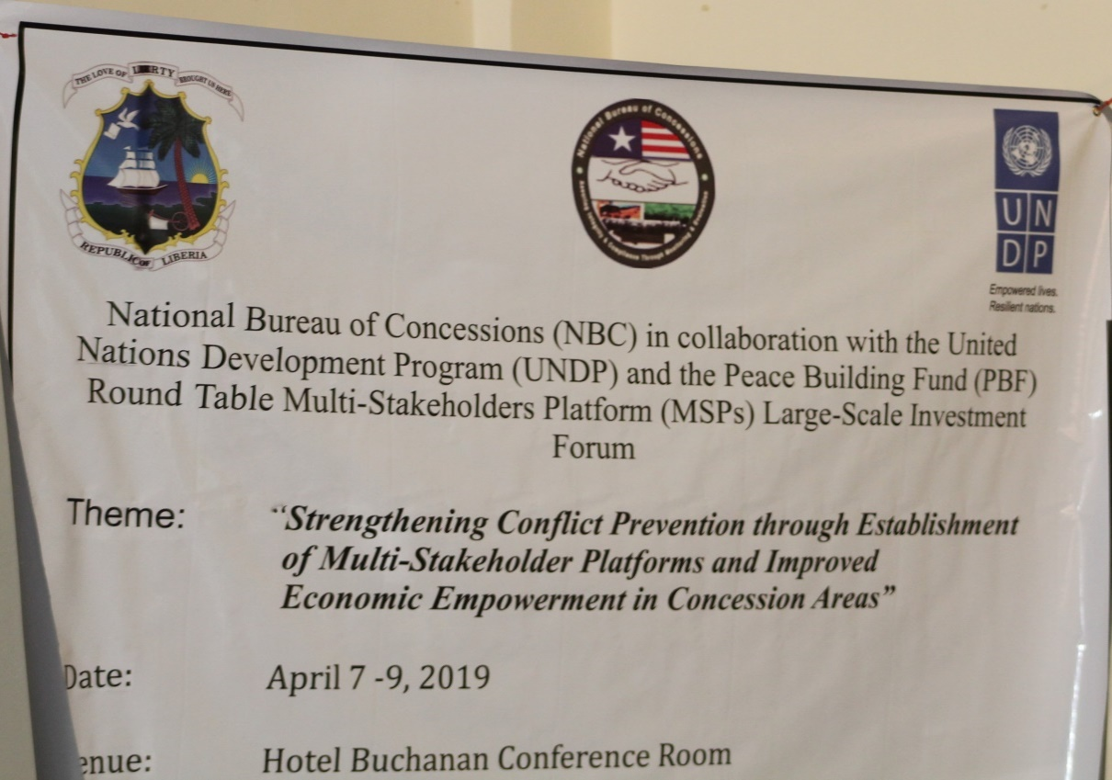

Banner for a roundtable Conference held in Buchannan, Grand Bassa County.