Mapping Women Peace Hut as Conflict Early Warning Mechanism to
Advance Women Peace and Security at Local Level
November 29- December 11, 2018
Tiama Town Peace Hut, Grand Gedeh County

Assessment Report on Early Warning and Women Peace Huts in five Communities
from Lofa, Grand Gedeh, Margibi and Cape Mount Counties

Funded by: International Organization for Migration (IOM)
Implemented by: Liberia Peacebuilding Office (PBO)

Table of Contents

- Table of content -------------------------------------------------------P. i
- Acronyms --------------------------------------------------------------p. ii
- Acknowledgement ---------------------------------------------------p. iii
- Executive summary -------------------------------------------------- p. 1
- Context ---------------------------------------------------------------- p. 2
- Purpose of the mapping exercise ----------------------------------- p. 3
- Literature Review ---------------------------------------------------- p. 4
- Survey Methodology ------------------------------------------------ p. 5
- Summary of Major Findings ---------------------------------------- p. 5
- SWOT Analysis ------------------------------------------------------- p. 8
- Key lessons learnt ----------------------------------------------------- p. 9
- Recommendations -----------------------------------------------------p. 10
- Annexes -----------------------------------------------------------------P. 12
- List of counties and communities visited
- Field Assessment photos

i

Acronyms

ADR ---------------Alternative Dispute Resolution
CPA - --------------Comprehensive Peace Agreement
CPC - --------------County Peace Committee
CSO ----------------Civil Society Organization
DPC ----------------District Peace Committee
EWER ----------------Early Warning Early Response
ECOWAS---- --- -Economic Community of West African States
GoL ----------------Government of Liberia
IOM ----------------International Organization for Migration
LNAP ----------------Liberia National Action Plan
MoG ---------------Ministry of Gender
MIA ---------------Ministry of Internal Affairs
MoGSP -------------Ministry of Gender & Social Protection
NCCERM --------National Center for Coordination of Early Response Mechanism
PAPD -------------Pro-Poor Agenda for Peace and Development
SGBV -------------Sexual Gender Based Violence
SSR ---------------Security Sector Reform
SWOT ----------- Strength Weakness Opportunities & Threats
UN ----------------United Nations
UND --------------United Nations Development Program
WANEP ----------West Africa Network for Peacebuilding

ii

Acknowledgement

The assessment team extends heartfelt thanks and appreciation to the International Organisation for Migration (IOM) and UN Women for collaborating with the Liberia Peace Building Office to support the field assessment of women Peace Huts which is aimed at mapping out early warning mechanism and conducting SWOT Analysis.

The team extends appreciation to the PBO management for the technical support and supervisory role and including effective leadership and dedication to have worked with the team to successfully complete the assessment.

Special thanks also go to the members of the peace huts visited in the targeted communities for taking off their valuable time to attend the interviews. We also acknowledge the securities and other community leaders who were able to attend to our calls and provide us with relevant information.

iii

- Executive summary

In November, the Liberia Peace building Office was engaged by the International Organization for Migration (IOM) to a conduct Conflict Early Warning Mapping Exercise which ran from 29th November – 11th December 2018. This report therefore, highlights the methodology used, the key findings, challenges, recommendations and key lessons learned. The aim of the assessment is to map out gender conflict early warning mechanism, determine SWOT analysis of the existing mechanism and lessons learned useful to guide implementation for Security Sector Reform Gender Project under joint implementation by IOM, UN Women and UNDP.

The process started with a literature review of relevant documents like legal framework on gender (UN Resolution 1325 on Peace and Security), Convention on all forms of discrimination against women, the Beijing Declaration etc. The desk review included selection of target communities based on set criteria, participatory development of the interview tools, pre testing and the holding of focus group discussions and key informant interviews during the field work. The Assessment Team visited various women peace huts and held interviews with the women of the peace huts, town chiefs, and security, youth and women leaders including, chairperson, co-chair, secretary, chaplain and treasurer using the structured questionnaire, the team had interviews with peace hut women at their various structures. The team also visited the security and local leadership in each town to establish the level of legitimacy enjoyed by the peace huts within the target communities.

The data collection process adopted a number of participatory tools including semi-structured questionnaire, focus group discussions and key informant interviews. The interviews targeted direct and indirect beneficiaries interventions including the women peace hut, women leaders, security personnel as well as local leaders, youth and ordinary women groups. Further, the total membership of the 5 peace huts visited is 418 people (Konia-50, Yealla-50, Tiama’s Town-150, Weala-118 and Bo-Waterside-50). However, the team had meeting with 4 persons of the peace hut in Yealla, 3 persons in Konia, 5 persons in Tiama’s Town, 10 persons in Weala and 11 women in Bo- Waterside.

Some of the key findings include (a) women have limited or no knowledge of early warning, (b) police not aware of the establishment and function of the peace huts, (c) The peace hubs lack sustained support and technical skills to build the women capacity and (d) no reporting mechanism in place and proper record keeping among others. Some of the key recommendations include building the capacity of the peace hut members, provide loans to booster the VSLA and material support such as chairs, tables, and ledgers, develop TOR for the management of the peace huts, among others. Some key lessons learned are lack of unity among women in most of the centers that could affect the enthusiasm, lack of support among women for women aspiring for political offices and high teenage pregnancy in targeted communities.
1
- CONTEXT

Conflict Early Warning and Response and gender mainstreaming are considered priorities by the Government of Liberia. It is ensuring that a gender analysis of various programs, policies and strategies were employed in developing indicators around which interventions are designed to foster peace and avoid conflict (violent conflict). Government and partners are making efforts to mainstream gender in its Pro-Poor Agenda for Prosperity and Development (PAPD) by ensuring that its various peacebuilding programs captured issues on women and girls, incorporating indicators that emphasize the role of women in promoting peace and security and discouraging violent behaviors in all of its work relating to Pillar three ‘sustaining the peace’ and other Pillars of the PAPD.

Peace Hut has been an initiative of the Ministry of Gender, Children and Social Protection and a number of civil society organizations including the West Africa Network for Peacebuilding (WANEP) in collaboration with UN Women over the years. It aims to promote peace and security in Liberia following several years of violent conflict. The Concept of the Peace Hut has been active since the end of the war in 2003 following the signing of the Comprehensive Peace Agreement of August 18, 2003 in Accra, Ghana. As a concept and practice, it is mostly managed and led by women in Liberia with very fewer men participating in activities of the peace huts. Over the years the Peace Huts have focused on variety of issues ranging from domestic violence, human rights abuses to advocacy for equitable access to basic social services, peacebuilding, reconciliation and girls’ education amongst others.

Premised on the motivation that both women and men should live in their communities and feel safe and secure, and share equal opportunities to take part in building their communities, the Government and partners have set up early warning and response system through the Peacebuilding Office and the National Centre for the Coordination of Early Response Mechanism. It strives to ensure that conflict analysis, including early warning traditionally include women’s rights or gender perspectives in all initiatives. While efforts are being made, it is noted that the development and implementation of early warning systems are given little consideration to the structural or conflict-specific differences between women and men’s situations, perceptions of threats and vulnerabilities, or experiences. Report reveals that when women are not included in Early Warning System (EWS), their opportunities to fully participate in conflict prevention and post-conflict reconstruction are limited and, thus, EWS risk failing to adequately predict or prevent conflict. Therefore, conflict prevention and transformative infrastructure exist across the country which of course needs to be strengthened.

2

- PURPOSE OF THE MAPPING EXERCISE

Conflict Early warning is a sound policy and a right socio-political move for maintaining peace and security. It is a strategy defining interventions that are designed to prevent the start or resumption of violent conflict by creating sustainable peacebuilding activities to address the root causes or potential causes of violence. Further, it creates a societal anxiety for peaceful conflict resolution and stabilizes society politically and socioeconomically. Coordinated by the Liberia Peacebuilding Office at the Ministry of Internal Affairs, a local conflict early warning and response system is in place through county and district peace committees, early warning reporters deployed at the county level complemented by the Early Warning Working Group comprising of civil society organizations, government officials and UN representatives. To strengthen the response capacity of the conflict early warning infrastructure, the Government in collaboration with ECOWAS established the National Centre for the Coordination of Early Response Mechanism as a strategy to enable ‘real-time’ responses to early warning. Often time cases tracked by the county and district early warning systems include domestic violence (sexual gender base violence), land disputes, public nuisance, cross border disputes, conflict between concession companies, workers and local citizens including youth; mistrust, mob violence, drug trafficking, human trafficking, as well as rape are among several categories of incidents that are reported from across the country.

The current early warning system lacks gender response capacity and indicators which in a way tend to exclude women and girls’ participation in violent conflict prevention initiatives, even though gender-sensitive early warning indicators are not only about women and girls. Observing that during and after the war, tension sporadically escalates, which on the overall are often reflected in sexual gender-based violence, domestic violence, and other gender related issues. The presence of a large percentage of unemployed or idled young men is frequently noted as an indicator of potential instability in Liberia. The data collection amongst other things was intended to measure to an extent women’s perception of their security in their respective communities and how they have changed over time.

The International Organization for Migration (IOM) in partnership with UN Women and UNDP are collaborating on the implementation of the Security Sector Reform Gender Project which focuses on ‘Inclusive Security’: "Nothing for Us Without Us". This Project is part of the ongoing transition initiatives that have focused on broader issues, aimed to implement Liberia's peace and security agenda by advancing women's human rights and engendering the ongoing security sector reform processes. It specifically focuses on women peace and security and the provision of women friendly services in the security sector. The IOM is focusing on three main components of this project: i) Peacebuilding and Conflict Prevention, ii) Community Dialogues and iii) Gender Responsive Early Warning. As a lead government entity on peace, reconciliation and conflict early

3
warning situated at the Ministry of Internal Affairs, the Liberia Peacebuilding Office was engaged by the International Organization for Migration (IOM) to partner on a number of activities including the conduct of this Conflict Early Warning Mapping Exercise which ran from 29 November – 11 December 2018. This report therefore, presents major findings and recommendations for policy and programming implications.

- LITERATURE REVIEW

The United Nations Security Council resolutions 1325 (2000) on women, peace and security and 1366 (2001) on conflict prevention highlighted the role of women and the importance of a gender perspective in conflict prevention. The Government through the Ministry of Gender, Children and Social Protection, Liberia Peacebuilding Office, UN Women, as well as national and international organizations operating in Liberia continue to undertake several initiatives to ensure that women are fully involved in data collection, data analysis, and the formulation of appropriate responses that promote peace and security within their respective communities and in the counties.

There are relevant international legal frameworks on gender that inform the development of international law that underscores women’s equal participation in responding to conflict, including Early Warning System. For example, the Convention on the Elimination of All Forms of Discrimination against Women, states that “discrimination against women violates the principles of equality of rights and respect for human dignity, [and] is an obstacle to the participation of women, on equal terms with men, in the political, social, economic and cultural life of their countries.” The Beijing Declaration and Platform for Action states that “[women’s] full participation in decision-making, conflict prevention and resolution and all other peace initiatives is essential to the realization of lasting peace.” This conclusion was echoed in United Nations Security Council Resolution (UNSCR) 1325, “Women, peace and security”, which reaffirms the “important role of women in the prevention and resolution of conflicts and in peace-building, and stresses the importance of their equal participation and full involvement in all efforts for the maintenance and promotion of peace and security, and the need to increase their role in decision-making with regard to conflict prevention and resolution.

4

V. SURVEY METHODOLOGY

The purpose of the Survey was to map out gender- conflict early warning mechanisms, determine SWOT analysis of the existing mechanism and learn lessons useful to guide the implementation of the Security Sector Reform Gender Project under this joint implementation by IOM, UN Women and UNDP. Conflict early warning is the systematic collection and analysis of information from areas of crisis to anticipate the escalation of armed conflict. The process involves the collection and analysis of data using indicators, as well as the development of appropriate response options, which are communicated ‘up’ to policy-makers and ‘down’ to communities for the purposes of decision-making and action.

The data collection process adopted a number of participatory tools including semi-structured questionnaire, focus group discussions and key informant interviews. The interviews targeted beneficiaries of previous interventions including the women peace hut, women leaders, security personnel as well as local leaders, youth and ordinary women groups amongst others.

Further, the methodology included desk review, selection of target communities based on set criteria, participatory development of the interview tools, pre testing and the holding of focus group discussions and key informant interviews during the field work. The Assessment Team visited various peace huts and held interviews with the women of the peace huts, town chiefs, and security, youth and women leaders. Other local leaders including, chairperson, co-chair, secretary, chaplain and treasurer were also met, as were as with town chiefs, youth and women leaders. Using the structured questionnaire, the team had interviews with peace hut women at their various structures. The team also visited the security and local leadership in each town to establish the level of legitimacy enjoyed by the peace huts within the target communities. The total membership of the 5 peace huts visited is 418 people (Konia-50, Yealla-50, Tiama’s Town-150, Weala-118 and Bo-Waterside-50). However, the team had meeting with 4 persons of the peace hut in Yealla, 3 persons in Konia, 5 persons in Tiama’s Town, 10 persons in Weala and 11 women in Bo- Waterside.

VI. SUMMARY OF MAJOR FINDINGS

The Survey established that the Women Peace Hut, if its capacity is adequately strengthened in terms of both technical and institutional, it could serve as an important conflict prevention mechanism acting as conflict early warning system. Because it has the potential to provide the necessary information and suggestions to justice, security and human rights actors that will help them to be proactive rather than reactive to conflict and to adequately prepare them to take early

5
action for the prevention of conflict from escalating into violence. Similarly, the women themselves would take early actions based on their capacities and not to depend entirely on external interventions to address any potential violence. The Peace Huts as conflict early warning systems could be mechanisms to predict and respond to conflicts before they go out of control, therefore, it is very important to strengthen their capacities as prerequisite for effective conflict prevention and transformation.

The Survey reveals that women have no or limited knowledge about early warning and early response even though they were playing that role to an extent in the communities. It was further revealed that in many of the targeted communities, police are not aware of the establishment and functions of the peace huts which tends to subject them to mere women group with no purpose and goal for enhancing security sector reform. Currently the peace huts do not have support in the area of technical and institutional capacity development in terms of special skills in conflict early warning, advocacy, other relevant skills for resource mobilization and sustainability. UN WOMEN supported the construction of peace huts with the exception of Konia, Tiama Town and Weala communities that already have peace hut structures while there are ongoing construction of peace hut structures in Yeala and Bo-Waterside.

The survey revealed that there is no evidence of analysis of gender equality and women’s empowerment related to the utility of the peace huts which is very important for designing gender-sensitive peace huts and conflict prevention interventions which could be helpful in assessing the likelihood of gender-based violence (GBV). Such information largely helps to understand the relationships between women’s empowerment, gender equality and potential conflicts in the communities and the regions of the peace huts.

It was established that all of the peace huts do not have capacity for formal reporting including hotline and effective and efficient method of record keeping. According to respondents they in some instances arbitrarily refer cases of gender violations to town chiefs and/or police but there has not been quick and effective response mechanism to address violence against women. Of the five peace huts assessed, it was revealed that four were completely dormant, including Yealla, Konia, Weala and Tiama’s Town. Approximately, 96% of peace hut members are women which in a way undermine the principle of gender because gender is not about women dominant society rather roles and responsibility society has assigned to them. The survey further revealed that men are not allowed to occupy strategic positions within the structure of the peace huts - chair and co-chair. Out of the 418 members within the five peace huts assessed, the total number of men constituting the membership is 29 (7%), while women were 389 (93%). Overall, the peace huts are weak and rely on village savings loan scheme or VSLA and agriculture as the strength, which excludes men from participating. On the reverse, the participation of women in decision-making

6
is limited due to cultural barriers and man dominated society. The survey revealed that respecting and adoring tradition is undermining women’s participation in decision making in most communities coupled with limitation of participatory conflict analysis in the targeted communities to discuss gender relations, including potentially taboo subjects such as domestic violence and rape which are often challenging. Respondent revealed that often these topics are not considered to be relevant for a discussion in the public. So little space is devoted to analysis of violent against women and sources of resilience in the ‘private’ sphere such that few members of the peace hut are invited for discussions on critical issues. It is implied that representatives from institutions including CSOs, government and UN should be careful when facilitating and planning interventions that bring out analysis of relevant issues and demonstrate their impartiality by been careful not to put women or other marginalized groups at risk for speaking out about sensitive issues in the communities or at the peace huts. For example, a local chief was very annoyed with an assessment team in July 2018 when issues of female genital mutilation were being discussed as violations of women human rights.

The women institute informal guidelines that protect them from violations such as ‘fines’ which have also drastically reduced violence against women in most the communities. For example, an individual is often fined LD$1,500 for insult and LD$2,500 including a goat for assault. This is common in all of the communities that were assessed. Women respondents in Konia revealed that they feel insecure when discussing their issues in the presence of local leaders and security personnel because of inadequate protection they received from them, especially when engage in cross border activities. However, they stressed that they are secured under the Mano River Union protocol when they are doing cross- border trade. Related to cross border issues, the Survey revealed that human trafficking and drug abuse are not common among young people in the target communities except commercial sex as source of livelihood for some of the girls which is contributing to increase in teenage pregnancy in all communities assessed. The women and girls in households bear most of the economic burdens such as feeding their homes and sending their children to school but they are not gainfully employed. There is high unemployment rate and limited access to basic opportunities for the women.

In summary, the survey identified that the peace huts are conflict prevention mechanism but lacks the sustained support to keep them functional. The survey established that urgent skills training opportunities are needed to empower women to foster their rights and support reform process that enhances women peace and security and conflict prevention and transformation skills. Conflict over power and control of resources is common source of conflict that breeding disunity identified in all the peace huts which in a way contributed to limited support for women candidacy observed during the 2017 presidential and legislative elections. The survey also established that that there are more girls in school than boys in the various communities and the peace huts across the

7

locations do not have terms of references. It was revealed that advocacy amongst women to protect
women’s right and violence against women is weak. And due to the capacity building support of NGO, EDU-Care Liberia, women in the peace huts assessed are aware of UN Resolution 1325 to an extent.

- SWOT ANALYSIS

Strength | Weaknesses | Opportunities | Threats
- Skills in creating awareness  - Engaged in agriculture production  - Engaged in Village Savings Loan Association | - Lack of basic skills in mediation, reporting mechanism and vocational education to empower women | - Peace Hut structures  - Cordial relationship between the PH women and local leaders | - Limited understanding/trust from the security sector  - Lack of sustained support to keep the peace huts functional  - High unemployment

- Strength:
During the assessment, peace huts members identified the creation of awareness within the communities, their engagement in agro production and the village saving loan association as their strength.

- Weakness:
The assessment also identified weakness of the peace huts as the lack of basic skills in carrying out mediation, reporting mechanism in place and vocational education to empower women.

- Opportunity:
Cordial relationship between peace hut members and community leaders

- Threats:
Limited understanding and trust from the security sector about the peace huts; lack of sustained support to keep the peace huts functional and high unemployment of members.

8

VIII. KEY LESSONS LEARNT

There are key lessons learnt upon which to develop practical actions moving forward in the implementation of project aimed to address issues affecting women in terms of their security. The peace huts serve as useful informal mechanisms for conflict transformation and accountability. But they do not have the desired capacity to adequately respond to peace and conflict issues particularly related to eliminating all forms of violence against women in their communities, because supporting organizations like UN Women and the Ministry of Gender, Children and Social Protection may not have been strategic in the kind of capacity building support require. Building capacity of the peace huts with an emphasis on gender and conflict early warning would simultaneously build the capacity of individual women and men with whom these organizations and institutions would continue to work with in responding to the Liberia National Action Plan (LNAP) related to UNSCR 1325.

However, the Peace Huts recognized by the community leadership deliberately raised the profile of the Peace Huts and gave them legitimacy as a mechanism for conflict prevention. If previous interventions had strengthened the research, conflict early warning and analytical skills of women in the Peace Huts, complemented by helping to raise their profile and deepened analysis for gender issues amongst institutions like the Liberia National Police, county authorities they would have further helped to address the number of gender issues emerging in these locations. For example, the county peace committees, early warning reporters and the police, though are committed to conflict prevention and management, but are not engaged by the women peace huts despite all having common goal of maintaining peace and stability in the communities, district and counties.

The survey confirmed that women can be effective peacebuilders given the important conflict prevention role they play in their communities. This role of theirs is widely recognized including through UNSCR 1325 and related resolutions and policies. It is however argued that women’s inclusion in conflict analysis and early warning process can help to better facilitate their participation in designing and implementing peacebuilding responses. The Survey reveals that inclusion of women in the design and implementation of the peace hut project was mostly done outside of the communities which tend to undermine capacity building of the various women’s peace huts. It is important to always involve women and gender from the onset of activities that impact women.

9

IX. RECOMMENDATIONS

Based on the important role being played by the Peace Huts as Conflict Early Warning Systems, identified by the Survey, the following recommendations are herewith advanced for consideration as per the agencies/institutions:

Liberia Peacebuilding Office, CSOs and UN Women

- It is recommended to strengthen the capacity of the Peace Huts to also serve as early warning system by integrating such system into the Peace Huts activities, and ensuring that gender takes central stage allowing for both men and women opportunity to report on their security situation at that level. By that they will identify the underlying causes for inequalities that may exist. Inequalities that already exist in the community and regions of the peace huts could be exacerbated in time of design and implementation of future projects, and this should take into consideration when analyzing information and data being gathered in order to formulate responses.

- Provide capacity building support through training of the Peace Huts and associated organizations in the areas of Early Warning System, and setting up of an Early Warning System. The setting up of the EWS should begin with a hands-on training that accounts for the following: i) Development of indicators that are able to capture the specific conflict context, ii) Collection of information using specific indicators; iii) Verification and validation of data, iv) Analysis of information, v) Communication to decision makers, dissemination of EWS reports to PBO and the NCCERM, vi) Joint-formulation of response options. Overall, the EWS training should focus on data collection, analysis and reporting as well as formulating early responses. Specifically, there should be development of gender-sensitive early warning indicators based on needs to determine which factors drive or trigger conflict in the communities and districts which could usefully be monitored as part of conflict early warning systems. The existing conflict warning indicators developed by PBO, WANEP and the NCCERM may not be applicable to the context of the peace huts and the regions;

UN Women and MGCSP

- That the peace huts amongst other things supposed to be gender-conflict early warning mechanisms, but this does not seem to be the case. Therefore, it is important that further assessment or research is undertaken involving both women and men in gathering data

10
that enable deeper understanding of gender analysis of conflict triggers. This should help to determine how the data collected could be utilized by themselves and for them to develop their own responses in the event of emerging incidents of conflicts [violent conflict];

- Hold a tripartite dialogue involving the women of the peace hut, local leaders and the security sector actors in each community to create awareness and legitimacy of the peace huts.

- Provide training in ADR and mediation to help them settle disputes among members of the community

- Provide them with loans to bolster the VSLA and material support such as chairs, tables and ledgers.

International Organization for Migration and MGCSP

- Provide capacity building training in Advocacy and Small Business Management. Also increase skills development in agriculture, soap making, tailoring, hair dressing, and animal husbandry; and

- That given the new role envisioned of the Peace Huts by the partners, it is recommended to develop specific terms of reference for the transformed peace huts so that they are guided by what is expected of them for easy appraisal of performance and functionality. As it is at the moment, it is difficult to monitor their work, and also they do not know what they were established to do as peace huts.

11

ANNEXES

- Peace Hut Counties and Communities visited
County | Community
Lofa County | Yeala
 | Kornia
Grand Gedeh | Tiama Town
Grand Cape Mount | Bo Waterside
Margibi | Weala

- Field Assessment Photos
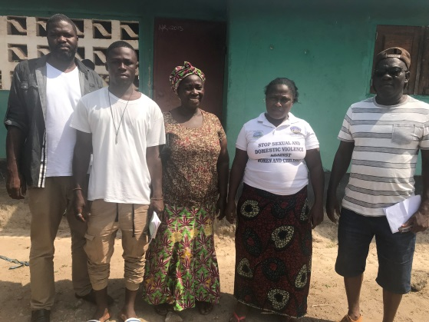
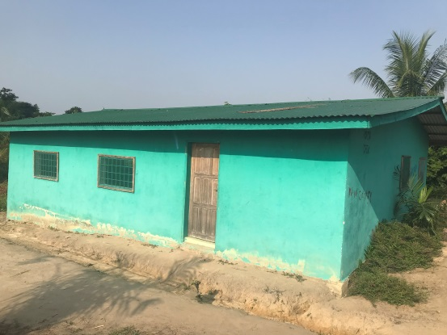

Assessment Team along with members of Konia Peace Hut in Lofa County
Weala Peace Hut, Margibi County
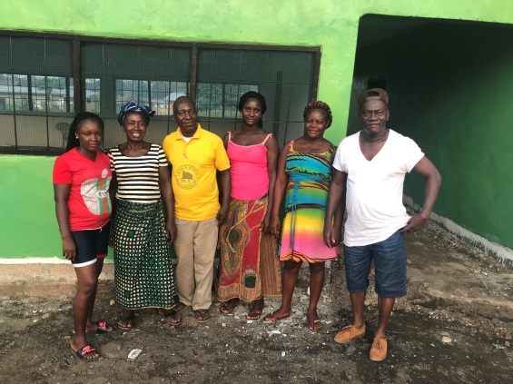
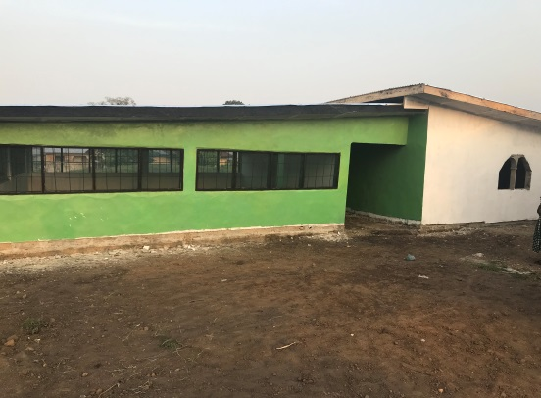
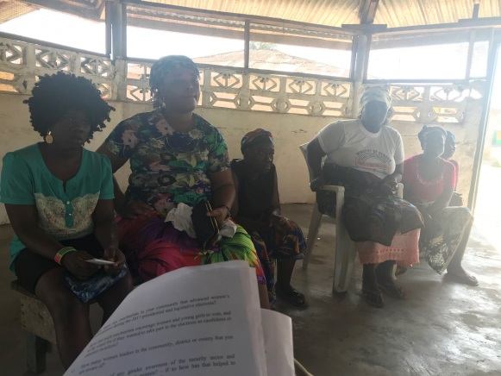
Assessment Team along with members of Peace Hut in Bo Waterside, Grand Cape Mount County
Focus group discussion in Wealla, Margibi County
Peace Hut in Tiama’s Town, Grand Gedeh County
Peace Hut in Yealla, Lofa County

Members of Yealla Peace Hut in Lofa County

12
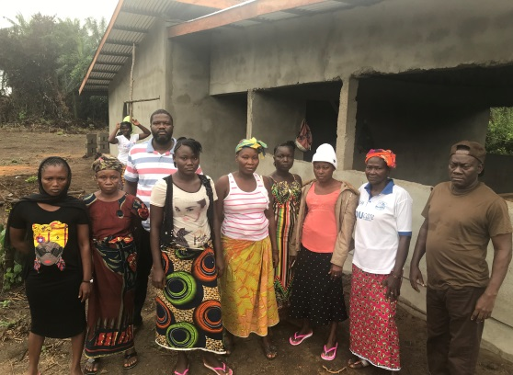
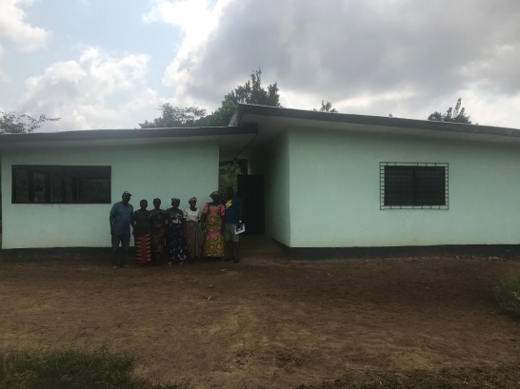

Bo-Water Side, Cape Mount County Tiama’s Town, Grand Gedeh County

13

