UNITED NATIONS DEVELOPMENT PROGRAMME

TRAVEL/MISSION REPORT SUMMARY

 | TRAVEL/MISSION REPORT SUMMARY
REPORT TITLE: Back-to-Office report on Strengthening Conflict Prevention through Establishment of Multi-Stakeholder Platforms and Improved Alternative Livelihoods in Concession Areas and Reel Peace Projects, Buchanan, Grand Bassa Counties.
SUBMITTED BY:  John R. Dennis, M&E Analyst, LMPTF-PBF Joint Secretariat.  Patrick Baysahwala, designated driver, UNRCO |  | DATE: April 10, 2019.
TRAVEL DATE: 6 – 9 April 2019 | LOCATION: Buchanan, Grand Bassa County.
PARTICIPANTS: 70 participants attended the concession meeting, out of which were 20 Multi Stakeholder Platform members (MSPs) from 7 counties; while 2 beneficiaries of the Reel Peace Project were interviewed on the status and benefits of the project.
- OBJECTIVE/PURPOSE OF TRAVEL:
The mission was intended to attend a major conference of stakeholders in concession communities and concessionaires to assess and reaffirm commitments, out of which the concept of the Strengthening Conflict Prevention through Establishment of Multi-Stakeholder Platforms and Improved Alternative Livelihoods in Concession Areas project was born. The conference begins on 8th April, with preliminary engagements with members of the Multi Stakeholder Platforms (MSPs) on 6 April ahead of the bigger meeting. The conference brought together a cross section of relevant government ministries and agencies, concessionaires and beneficiaries as well as international partners.

- EXPECTED OUTCOMES
It is expected that the following will be achieved:
- To gather firsthand information from MSPs on project progress during preliminary meetings with the National Bureau of Concession (NBC), ahead of the bigger meeting on 8 April;
- Capture progress and perspective of the concessionaires regarding the level of implementation, which will help to compare and validate information gathered on 6-8 April;
- Submission of a Back to Office Report
- Mission is expected, if possible, to visit PBF supported projects in Buchanan

- Background and Context
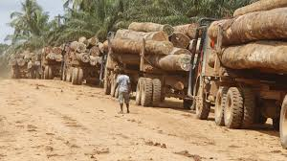
Liberia is endowed with natural resources, but exclusion, poor management and inequitable distribution of these resources contributed to 14 years of intermittent civil crises that further exacerbated the pre-war conditions of underdevelopment, which put the country among the World’s poorest nations. Another contributing factor to the civil conflicts in Liberia was the forceful acquisition of ancestral lands by the Government with whom concession companies enter into agreements to lease lands, leaving inhabitants with little or no alternative livelihoods, mostly in rural areas where job opportunities are scarce, when they are relocated. Although the crisis ended in August 2003, but the tenets of exclusion in decision making continued in 2016, leading to violent demonstrations in concession areas. REUTERS reported the April 4 violence on a palm plantation in north-eastern Liberia where owners of lands leased to the concession company were evicted with little or no compensation.
Given the importance of conflict prevention and mitigation in concession areas through strengthening the capacity of local actors, the PBF funded a project in 2017 under the Title: Strengthening Conflict Prevention through Establishment of Multi-Stakeholder Platforms and Improved Alternative Livelihoods in Concession Areas. The project seeks to prevent conflict through the empowerment of affected communities in two outcome areas:
- Increased citizen engagement in concessions management for conflict mitigation
- Improved alternative livelihoods for concession affected communities for human security.
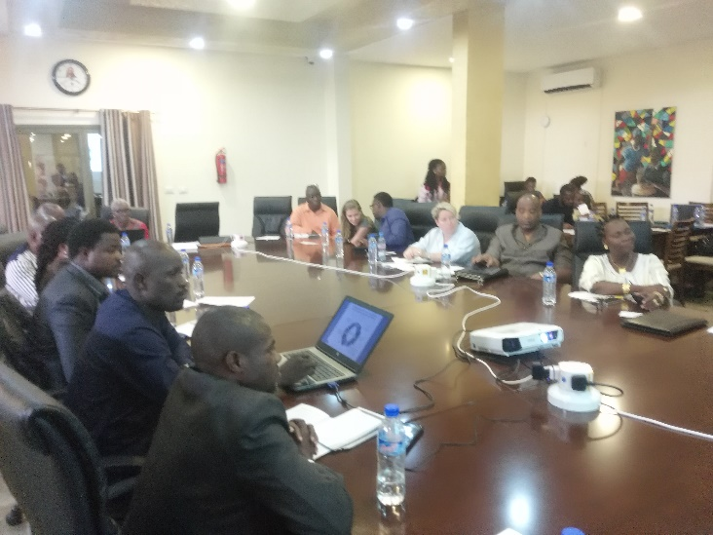
The project outcomes, each of which has 3 associated outputs, address the issues related to exclusion, empowerment and livelihoods.
To adequately address these challenges, the project, through UNDP and FAO, has been working with two key government institutions: The National Concessions Bureau (NBC) and the Central Agriculture Research Institute (CARI).
The Buchanan Conference
The conference took stock of progress and challenges; and called on concessionaires to reaffirm their commitment as was indicated in the design of the project; while MSPS went to reassure the companies of their fullest cooperation in the prevention and mitigation of conflict, after 15 months of active engagements of both parties, concessionaires (Arcelor Mittal, Maryland Oil Palm Plantation (MOPP), Liberia Agriculture Company (LAC), Sime Darby, Golden Veroleum (GVL), MNG Gold, Aversaro, Cavalla Rubber Corporation (CRC), Alpha Logging, Equatorial Palm Oil, Weala Rubber Corporation (WRC), etc) and members of the Multi-Stakeholder Platforms (MSPs). The conference brought together more than 70 participants including executives of concession companies, MSPs, NBC, Land Authority, UN, the WB, a representative of the CSOs, International Organizations including the International Financing Corporation (IFC) and Conservation International (IC). The Buchanan Conference basically focused on outcome1 of the project where its lead government counterpart, NBC, chaired.
A cross section of concessionaires, Int’l organizations and CSOs at the Buchanan Conf.
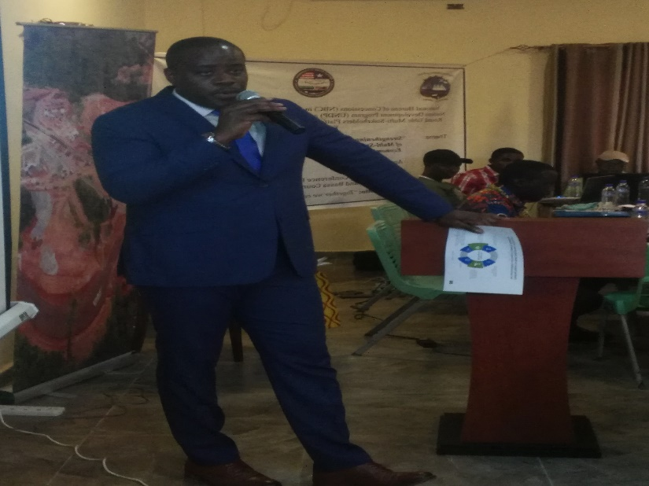
Ahead of the main conference on Monday 8 April, NBC held a working session with MSPs to enhance their understanding in the following areas:
- Importance of legalizing the MSPs to strengthen legitimacy of their existence: NBC will lobby with partners to provide funding for the legalization of the MSPS, where they will be strengthened to get involved in other creative activities, in addition to ongoing tasks.
- Business Planning and execution from the perspectives of the MSPs. The NBC is contemplating empowering MSPS through livelihood initiatives, including small business enterprises. Discussions have been initiated with Arcelor Mittal Company to sign agreement with a transportation company that has 13 heavy duty trucks. When the agreement is signed, MSPS will be hired as drivers and partners to the company with equitable distribution of income that would be generated by the company. With this, MSPs will protect the business which they would consider theirs; while at the same time promote peaceful co-existence to avoid violence that would have the tendency to stall their interests.
Gregory Coleman, NBC Director General
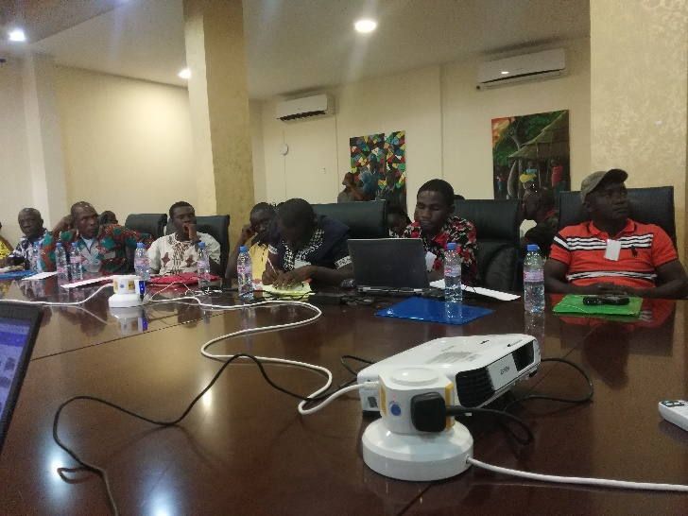
- Know your concession agreement “The Bible”: An overview of what is expected from MSPs in knowing their respective agreements was presented by NBC Deputy Director General for Concessions, Nathaniel Bracwell, Jr. It was discussed that new copies of the various agreements will be printed for distribution, replacing tattered copies in the possession of MSPS.
- Women and youth participation at MSPS meetings: CSOs representative Cecelia Danuweli recounted the difficult experience faced in Grand Kru and other counties to have the MSPS gender responsive. She expressed fulfilment by the level of gender ratio at all meetings.
- Concession Information management system: The web base system has 5 components and 4 categories of user. There are 4 operators including the NBC. The system has all concession agreements and provides updates on revenue generation. The Government is about to lose the system due to its inability to offset liabilities owed the service provider for two years. The web base was set up and initial funding provided by USAID-GEMS, an American based organization.
Partial view of MSPS at the conference
- Work planning and report writing: Mr. Wilmot Yarsiah of NBC presented on planning and good reporting. His presentation was buttressed by the Secretariat, which emphasized results-based reporting as opposed to activities-based reporting after one year of implementation.

Summary of the findings of April 8 Conference
- Concession companies and the conglomeration of Liberia agricultural companies called Liberia Agriculture Company Association (LACA) recognized the contributions the project has made through the interventions of the MSPs, whose efforts have helped to greatly minimized conflicts in concession areas. They committed to provide the needed support to enhance the works of the MSPS during and after the project;
- The companies admitted they have benefitted more from the causal relationship more than the MSPS can imagine. They told the conference it’s at their advantage to keep the relationship working to avoid losses as a result of violent demonstrations in the operational areas of the companies. All the companies that attended emphasized the imperative need to keep the MSPs functional.
- The Government through its Director General of the National Bureau of Concessions, Gregory Coleman, thanked the PBF for the support; and the companies for their respective commitments to support the sustainability of the MSPs after the expiry of the project this year. As part of the sustainability plan, Director Coleman disclosed a business plan on alternative livelihood for what he called “empowered communities”, once referred to as affected communities, prior to the intervention of the project. Under the scheme, the DG noted, communities will be part of established businesses where they see themselves as shareholders. Income generated will be equitably distributed. The pilot phase will commence in Nimba County after the agreement is signed with Acelor Mittal, the concession company operating in the County.
- The World Bank, through its representative of the International Finance Corporation (IFC), lauded the plan of the director general and committed the IFC will consider possible support in its country program for this year. The IFC is an international financial institution that offers advisory, investment, and asset-management services to woo private-sector development in less developed countries. It is a member of the World Bank Group.
- The MSPS through its representative of Bomi County, reassured the companies of their fullest cooperation to sustaining peace at all locations that have the structure operational. Mr. Abraham Combay appreciated the role of the UN and NBC in establishing the MSPS, which has become the pillar of peace in concession areas. Gratitude was expressed by Mr. Combay for the decision to establish investment opportunities for MSPS by the NBC. There were 20 representatives from 9 Multi-Stakeholder Platforms (MSPS) in 7 counties. 40% of the 20 representatives were women.

- Challenges
- Joint implementation of the project remains a challenge. There is limited information sharing between the two agencies, UNDP and FAO. UNDP did not invite FAO which implements outcome2 on alternative livelihoods for concession affected communities. While the primary discussion of the conference was on Outcome1, the conference also discussed alternative livelihood issues, with huge presence of the agriculture sector.
- Sustaining concession information management system is challenging for the Government. NBC appealed they risk losing the system if arrears owed the service provider are not paid in the coming weeks;
- The interference of local government officials and nonmembers of MSPs during official functions. Some local government officials and community members who are not part of the MSPS tend to stall activities of the group, questioning their legality. To address this, the Director General, Gregory Coleman, of the NBC promised to issue a letter of authorization to the MSPS, while the process of legalization is being addressed.

- Lessons Learned
- Engagement with MSPS by the companies has drastically reduced tensions between communities and the companies. Unlike before, consent is sought from the communities by the companies before taking decisions that affect them. The communities are also cognizant of the fact that violence that lead to property damage affect incentives for the development of their communities. This understanding has underpinned existing relations;
- NBC active engagement with the companies has increased interests by the companies who expressed their commitment to support. Sime Darby is one of the first companies that has begun awarding contracts to members of MSPs who have skills, which certifies one of PBF’s conditions of catalytic support.

- Recommendations
- That concession holders fulfill their commitment of $347,200 as indicated in the project document. The commitments by concessionaires at the conference was not clearly delineated from the outstanding contribution;
- FAO and UNDP should complement each other in the spirit of joint implementation. While the agencies are responsible to account for what each has received, they shouldn’t see the implementation of their respective outcome areas as separate projects. If this is not addressed, it may affect the way beneficiaries view the project;

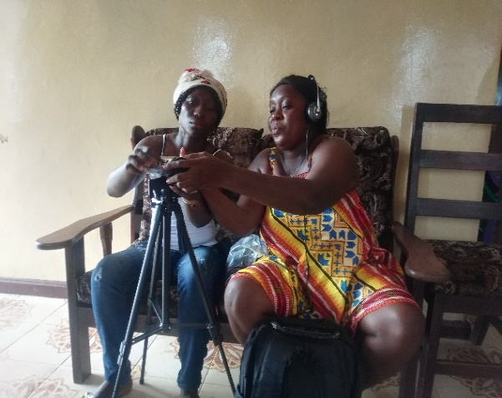
Reel Peace Project in Buchanan, Grand Bassa County:
In response to the expected outcome of the field mission, beneficiaries of the Reel Peace Project were contacted to verify results mentioned by the project in its 2018 annual report. The project seeks to empower women to tell their stories through film-making. The project is implemented nationwide with 3 mentees in each of the 15 counties. The project provided training to all its mentees in June 2018, which was followed by field exercises to consummate what was thought by local and international experts. Most of the women participating see the project as a new career path. Two of the three mentees met in Buchanan avowed the imperative need of the project, which has provided them exposure to freely communicate with their interviewees, something they thought was implausible.
From (L-R) Satta Lombeh and Comfort D. Sackie, Mentees in Buchanan
One of the women, Comfort D. Sackie, sees the project as an eye opener which has enhanced her skills as a police officer in charge of Women and Children Protection Unit in Grand Bassa County. Comfort said she took the challenge to enrol when the project was launched, considering what she encounters daily on women and children issues. Comfort and her teammate Satta B. Lombeh, a university graduate, indicated to the mission they have produced two films but only was has been selected for editing and subsequent viewing during the film festival in May. The selected film is about a single mother of three who make ends meet by selling local made cookies. The mentees believe telling stories help to reduce conflict in the community. “Once a person tells their story, the likelihood of recurrence is low”, Comfort noted.

Challenges
While the project shows positive results, it faces some challenges. The two mentees said getting people to tell their stories through film is challenging, for fear of public scorn. Most, if not all, interviewees don’t want to be exposed to the camera regardless of strong commitment from the interviewer on protection of their client’s identity. For the few who reluctantly agree to be filmed would accuse the interviewers of making money out of their situation. Comfort however said they have been able to overcome the challenge by continuously engaging and reassuring their client the peace dividends of telling their stories to the world. This, comfort assured, has encouraged disadvantaged women to come forward to tell their stories with the proviso that their identity will be protected.

Liberia ranked 5 of 10 Top Poorest Countries in the world, according to GAZETTE REVIEW- by Fresh Joe- April 15 2017. https://gazettereview.com/2016/06/top-10-poorest-countries-world
Land rights at root of palm oil conflict in Liberia, campaigners say: https://www.reuters.com/article/us-liberia-land-palmoil-idUSKCN0XX17U

