UNITED NATIONS DEVELOPMENT PROGRAMME

TRAVEL/MISSION REPORT SUMMARY

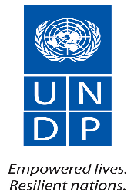 | TRAVEL/MISSION REPORT SUMMARY
REPORT TITLE: Back-to-Office report on Cross Border Project Evaluation Mission to Maryland and River Gee Counties.
SUBMITTED BY:  John R. Dennis, M&E Analyst, LMPTF-PBF Joint Secretariat.  Moses Sumo, designated driver, UNDP |  | DATE: 4 February 2019.
TRAVEL DATE: 23 – 31 January 2019 | LOCATION: River Gee and Maryland Counties.
PARTICIPANTS: 71 in three communities of Maryland and River Gee Counties, including the two capitals. 31% of the participants were females.
- OBJECTIVE/PURPOSE OF TRAVEL:
To accompany external evaluators (Local and International) “to jointly carry out a terminal evaluation of the "Cross-border Cooperation Project between Côte d'Ivoire and Liberia for Sustainable Peace and Social Cohesion" to assess its outcome/results achieved in the course of its implementation, with particular reference to the relevance, effectiveness, efficiency and impact of the actions carried out in relation to the project objectives set, as well as the sustainability of those results. Specifically, the evaluation consisted of assessing the operation and the level of performance of the project in relation to the qualitative and quantitative objectives initially planned”.

- EXPECTED OUTCOMES
It is expected that the following will be achieved:
- Agreed methodologies are scrupulously followed during the evaluation as indicated in the terms of reference of the consultants;
- That the scope of the evaluation is sufficiently covered;
- Adequate participation of beneficiaries;
- Facilitate a successful mission.

- Background and Context

After decades of civil crisis and war, and in response to situations of conflict and instability, the United Nations established peacekeeping operations in Liberia and Côte d'Ivoire that work closely with United Nations Country Teams through which, significant support has been provided to the people with funding from the Peace Building Fund (PBF). Both countries receive support from the PBF through the Peacebuilding Recovery Financing Facility (PRF).

The drawdown of UNMIL and the transfer of responsibilities to the Liberian Government to assume full responsibility for national security became effective on 30th June 2016, in accordance with Security Council resolution 2239 (2015). UNMIL activities and the programs funded by the PBF have been particularly important in reducing tensions and incidents of violence in communities along the border between Côte d'Ivoire and Liberia. These communities share many socio-economic and cultural ties, so threats to peace and security in one country have an impact on the development of the other country. In addition, in March 2014, the emergence and spread of Ebola Virus Disease (EVD) in Liberia and Guinea led to the closure of the international land borders between the two neighboring countries (Liberia and Cote d’Ivoire). The closure of the border has had a significant impact on social cohesion within and between border communities, which undermines the steady flow of people and goods; it has also contributed to the impoverishment of Liberian border communities.

In light of the mission drawdown in both countries and taking into consideration the electoral cycle in both countries and related political tensions, which spill over to communities across borders in both countries, as well as tension between indigenous and non-indigenous populations, the Presidents of both countries met and called for increased social cohesion along the border. The joint high-level meeting in Guiglo “Deuxieme réunion du Conseil Conjoint des Chefs coutumiers et des Anciens (CCCA”) in January 2016 brought together the two Heads of States and traditional leaders of the two countries to discuss and strategize towards addressing the rising cross border tensions. The meeting concluded that though there is improvement in the general security situation in the border area, continuous engagement between the two countries towards finding durable solutions for security and socio-economic development would help consolidating peace and social cohesion between the border communities that share historical and cultural ties. The Final communique outlines decisions to be implemented by the two countries and this proposal is developed to contribute to peacebuilding in the border areas.

In order to address the above-mentioned community and cross borders peace and security challenges. The Peacebuilding Fund provided $3 million to increase cooperation and trust between Ivorian and Liberian border communities by strengthening border and human security, as well as mitigating potential intra and inter-community conflict escalation and regional destabilization, through community engagement and cross-border socio-cultural contact for peaceful co-existence. The project covers community borders of Tabou and Tai in Cote d’Ivoire mirroring with community borders of Maryland and River Gee counties in Liberia.
The overall goal of this initiative is to reduce tension and prevent conflict, improve community security and strengthen relations between communities and security forces in the border areas between Côte d'Ivoire and Liberia. The expected results are of two kinds:
• Outcome 1: Trust between security forces and border communities is enhanced through capacity building of local and cross-border joint mechanisms and increased cooperation
• Outcome 2: Social cohesion and peaceful coexistence in cross-border communities are improved through frameworks for dialogues between cross-border communities and strengthening of cooperation between local mechanisms for conflict resolution and socio-economic and cultural exchanges.
The organizations that have received funds for this project are UNDP and IOM in both countries.
Given the joint nature of this project, synergies and complementarities have been developed in the planning and implementation of the main activities identified on the one hand at the level of the two relevant departments in Côte d'Ivoire namely Tabou and Taï and on the other hand, with the mirror initiatives on the Liberian side – River Gee and Maryland Counties.
The final evaluation aimed at assessing the progress made towards the overall and specific objectives, achievements, identifying the gaps in project implementation and its goals and should collect lessons learnt and provide recommendations and best practices that focus on key components to guide future programming.
After more than a year of implementation, it is important to analyze the results of the project experiences of this cross-border project in order to bring out relevant lessons learned, with a view to consolidate gains made and propose effective strategies for the sustainability of results. In addition, the documentation of the project's experiences and achievements, as well as challenges will be excellent tools for the government and development partners, who will be able to draw inspiration for the implementation of other programs and projects related to cross-border cooperation.

- Summary of Findings of the Mission

The mission to the two counties was successful, but with minimum challenges noted. The evaluation team organized focus group discussions in two border communities (Pedebo and Karblaken) and one in Harper, Maryland County. Similarly, three focus group discussions were held in River Gee County. One was held in the border community of Nyaanken, and two held in Fish Town with Joint Security and the South Eastern Women Development Association. The team met with cross section of youth and women groups as well as joint security personnel. which comprised of Liberia Immigration Service (LIS), Liberia National Police (LNP), Liberia National Security Agency (NSA), Liberia Revenue Authority (LRA), Liberia Drug Enforcement Agency (LDEA), etc. Key Informant interviews were also held with local authorities and heads of CSOs.

Below were the key findings of the mission per county:
Maryland:
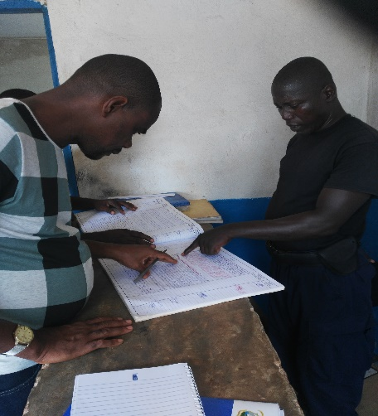
At Pedebo, the main international border with Cote d’Ivoire, the community expressed overall satisfaction of the performance of the project, which they said has harnessed relations between border communities on one hand and security and border communities from both countries on the other. They confirmed less harassment and intimidation following the implementation of the project. LIS and LNP officers informed the team that traffic has increased as the results of confidence building between border communities and security forces from both countries.
Border security shows records to evaluator.
They appealed for a second phase to have a logical conclusion of the project.
The achievement of the project was reiterated by community members of Karblaken, a beneficiary of the project. Karblaken is a border community that benefitted from conflict prevention trainings and the rehabilitation of a border post, which they said has encouraged the presence of LIS officers.
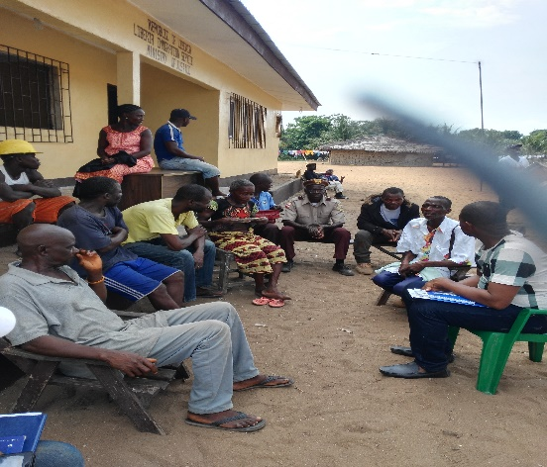
Regarding the benefits of the training received, the community noted a situation involving a Liberian woman of the beneficiary community whose two kids got drowned as a result of an accident while crossing the river to the Liberian side. The father of the kids is an Ivorian. This degenerated to confusion, accusing the Liberian side of being responsible for the death of the two kids. Counter accusations ensued that almost led to conflict, but the situation was amicably resolved by the two border communities; utilizing conflict prevention mitigation mechanisms and leveraging advantage of community engagement introduced by the project.
Community members of Karblaken, Maryland County, during a Focus Group Discussion.
River Gee
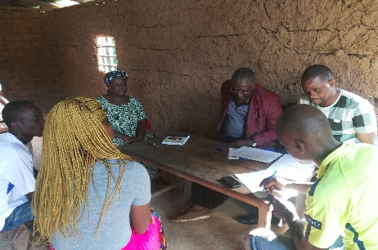
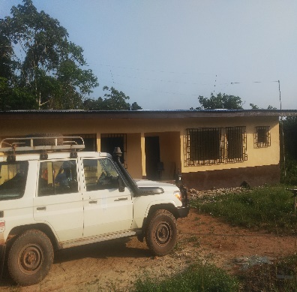
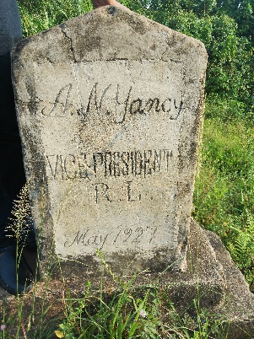
One of the two border communities in River Gee is Nyaanken, an old settlement of Americo Liberians, free slaves from the United States. It is the second oldest township in the Republic of Liberia, next to Careysburg in Montserrado County. But Nyaanken’s heritage quickly diminished when Liberia’s longest serving president, William V.S. Tubman, died in July 1971. This town was where president Tubman took vacations whenever he was in Maryland, his home county. Nevertheless, Nyaanken remained the international border in River Gee County, with limited or no presence of border security prior to the project. The town seemed abandoned by border security until the rehabilitation of a border post by the project. The building is equipped with solar panels which produce electricity to elate assigned security officers.
Landmark at Nyaanken’s border and a partial view of border post.
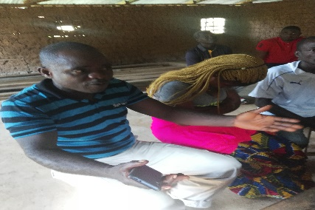
During a focus group discussion, Alex Cooper, youth leader extoled PBF for supporting the Cross-Border Project which has improved security for their community and enhanced relationship with communities across the border. This was buttressed by the township Commission, Mr. Boddy Freeman. A second phase of the project was proposed by the women leader, Ida Diggs, who appealed for a motor boat to aid people cross the border.
Focus Group Discussion with project beneficiaries in Nyaanken
Her appeal was elevated by the Commander of the Liberia Immigration Service (LIS), Alex Kpakolo, during a focus group discussion in Fish Town. The commander mentioned very low revenue intake at the border due to the absence of secure transportation, which has led to majority of the traders using the Pedebo Border in Maryland County that has means of secure transportation and easy accessibility.
Commissioner Freeman makes a point in a meeting with evaluators
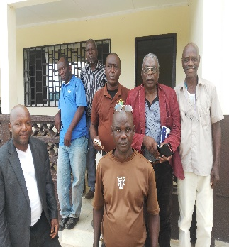

Commander Kpakolo appealed for a second phase to address challenges at the following border posts in River Gee:
            - Tarslah Border
            - Leopard Border
            - Geplaken Border, inaccessible by vehicle
            - Zlor Border
Partial view of Joint Security Officers in Fish Town, River County.
            - Saykliken Border
All these borders are relevant to improving trade and security, according to the commander.
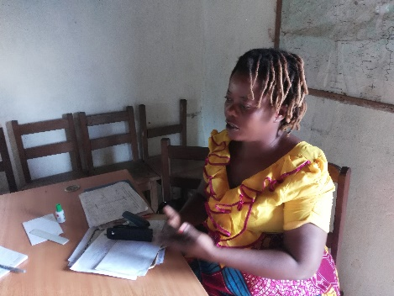
Regarding Civil Societies’ involvement, Janet Torh, head of CSOs in River Gee, outlined the participation of women in the project as rewarding. She said the respect and rights of women have increased as the result of the project. Women are involved in critical decision making when it comes to border issues. She assembled women who actively participated in the project. The women were also interviewed by the evaluators.
Janet Torh, head of CSOs in Fish Town River Gee County, stresses the importance of the project.

- General Project Implementation Issues:

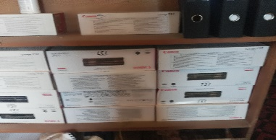
- Computers were supplied to security offices with no training provided to utilize them. Most of the computers are in Fish Town and Harper City still packaged in the boxes;
- Computer cartridges supplied are not compatible with printers;
- Solar panels supplied to LIS in Fish Town are not in working conditions. They need to be repaired;
Incompatible cartridges

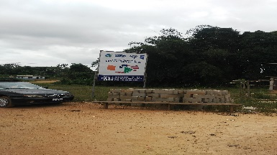
- Limited visibility of PBF support in both counties was observed. Most of the beneficiaries did not know the PBF/PBSO or donor organizations. Of the three borders visited, only one billboard was seen.
The only billboard with PBF/PBSO Logo at the Pedebo Border, Marland County
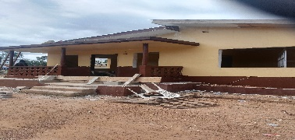
- Challenges
- It was observed all the border posts are yet to be 100% completed. This was attributed to bad roads and delays in payment by UNDP;
- Nyaanken in River Gee County and Karblaken in Maryland County are experiencing challenges in the absence of boats to enhance cross border commercial activities.

- Lessons Learned
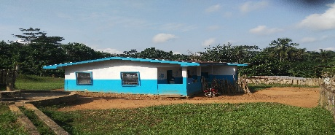
- Owing to the cordial relationship between Nyaanken and their Ivorian counterparts, access to healthcare delivery has been provided for Ivorians to seek treatment, in the absence of health services in bordering communities in Cote d’Ivoire. Many would have died if this did not exist.
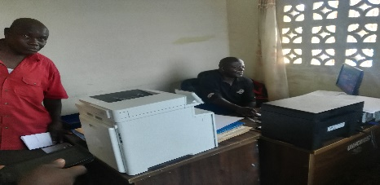
- Future project should consider training in addition to computer supply. This would effectively maximize the use of equipment issued. Computer toners should be properly assessed to ensure that they are compatible with computers for which they are purchased.
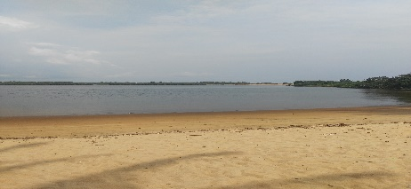
- In future project, the construction of recognized border posts should be visible on both sides of the border up entry. For example, there are no border posts on the Ivorian side of areas bordering Karblaken and Nyaanken communities. Evaluators were told citizens in these areas take security into their own hands.
- Limited visibility of PBF/PBSO in the counties. With the exception of one billboard seen during the mission, there was no visibility of PBP/PBSO anywhere during the mission. Ongoing follow up would improve viability.
The only billboard seen during the mission

- Recommendations
- Future project, if any, should consider the purchase of locally made boats with Horsepower engines to aid commercial activities at Nyaanken and Karblaken borders as well as future borders.
- Building materials for construction projects should be purchased in the capital of the county in which the project is located, to avoid delay in implementation.

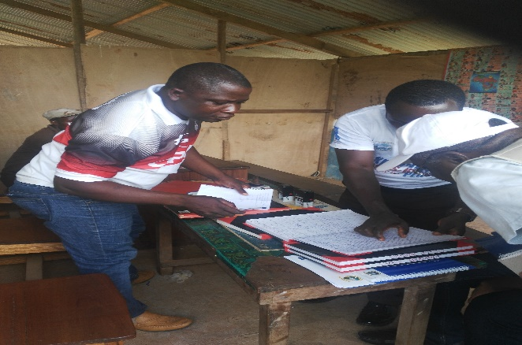
Some Photos from the Mission in River Gee and Maryland Counties
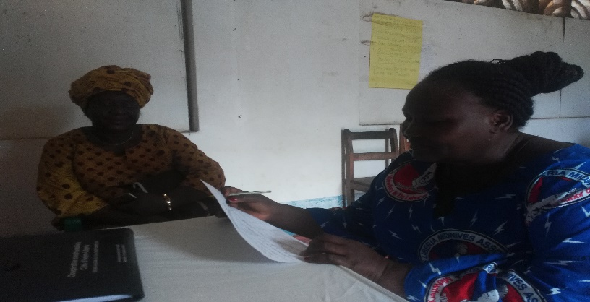

Cross border women leaders in Maryland County
Senior Evaluator analyses security data

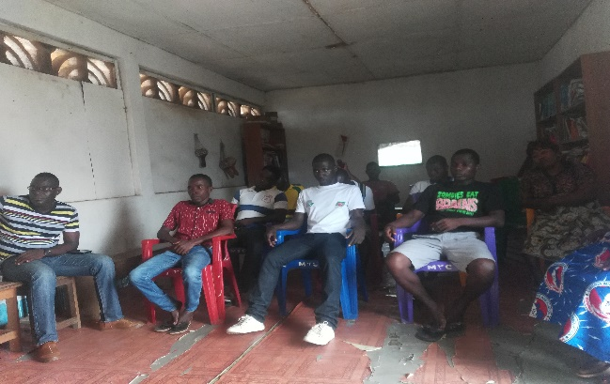
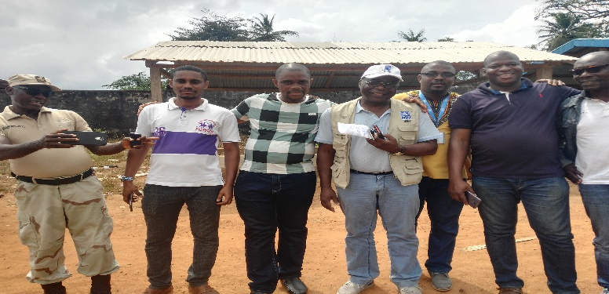

With counterparts on the Ivorian side of the border
Youth gathered for FGD in Harper

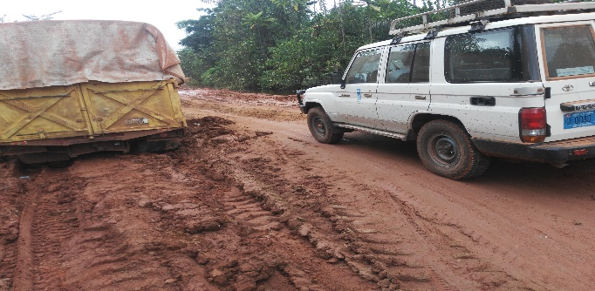
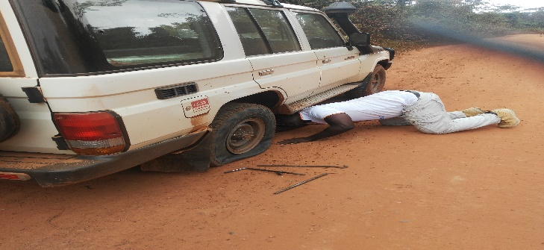

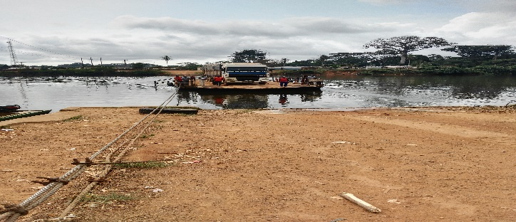
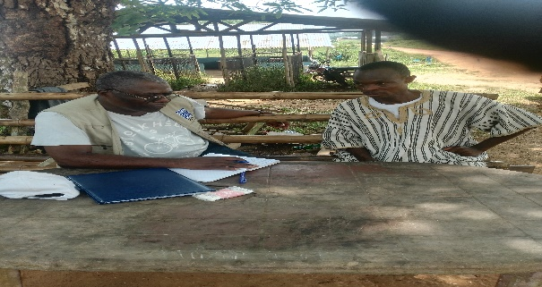
Vehicle on ferry at the Pedebo International Border
Key informant interview with Township Commissioner Awelene Harmond at Pedebo Border
Bad road conditions led to deflated tyre

