The logo includes the names of participating UN agencies- ILO, OHCHR, UNDESA, UNESCO, UNFPA, UNICEF, UN WOMEN, WHO.

**FINAL REPORT**

# Introduction

This is the final report for the United Nations Project on the Rights of People with Disabilities (UNPRPD). The report highlights the status of activities and results achieved under the UNPRPD project during the period 2015-2017. The overall purpose of the UNPRPD project was to improve access of children with disabilities to education. The project was initiated against a background of limited access to education for the children with disabilities in Sudan. Of the three million children out of school in Sudan, children with disabilities were among the most vulnerable groups that were not in school. Almost half (49 per cent) of the 6-9 year olds children with disability were out of school according to the Sudan Household Survey (SHHS) of 2010. Girls with disabilities were particularly disadvantaged with over 55 per cent girls in the 6-9 years old age group with disabilities being out of school. [1] Negative social norms and practices, inadequate capacity amongst service providers for professional care, early detection and limited physical access to schools and services are the main factors contributing to the exclusion of children with disabilities from accessing education. To address these bottlenecks, the UNPRPD project adopted a two pronged approach focusing on two main activities:

* Institutional and capacity development of front line officers including teachers and health workers to enhance their knowledge, skills, awareness and delivery of education services to ensure inclusion of children with disabilities into mainstream education.
* Provision of inclusive child friendly learning environments through revision of national school construction standards to incorporate accessible guidelines for children with disabilities. Through joint efforts of the UNCT (UNICEF, UNESCO and the WHO) – and in close collaboration with the line ministries, the National Council for Persons with Disabilities, Disabled People’s Unions, and DPOs, a holistic integrated model has been established catering for the educational, social, health and protection needs of children with disabilities in mainstream education for the first time in Sudan, serving as a model for the mainstreaming and fulfillment of the rights of people with disabilities into other development strategies across Sudan.

1. **Variations in impact and outcome indicators**

Using the table format provided below, please provide information on the variations in impact and outcome indicators that took place during the reporting period. Where it has not been possible to collect data on indicators, additional narrative information should be provided detailing why that was the case and what plans have been put in place to ensure that the relevant data are collected.

**Table 1. Variation in impact indicators**

| **Impact** |
| --- |
| Inclusive Environments in schools are promoted resulting in all children, including children with disabilities, having improved access to mainstreaming education and health opportunities. |

**Impact Indicators**

|  |  |  |
| --- | --- | --- |
| **Indicator** | **Start level**  (January 2015) | **End level**  (January 2017) |
| Ministry of education officials are equipped with the knowledge and methods for ensuring that children with disabilities are included in the mainstream schools | No existing inclusive education modules exist in Sudan, and teachers do not have skills to promote inclusive education for children with disabilities | Inclusive education modules are available and endorsed by MoE. Ministry of Education officials are equipped with knowledge and skills to promote inclusive education for children with disabilities in mainstream schools.  A teacher guide and ToT materials were also developed, with national support and 300 teachers trained, and 30 trainers were trained in Learning Difficulties and 100 trainers on the teacher toolkits. |
| State and Federal Ministry of Education officials are equipped with necessary knowledge to ensure that schools are physically accessible | Schools are not accessible, and knowledge is limited on accessible construction and retrofitting components | National school construction standards have been reviewed and revised to incorporate accessible guidelines. 40 Ministry of Education officials at State and Federal Ministry of education have strengthened knowledge on accessible school construction, including retrofitting schools. |
| Disability and CBR included in current existing mainstream community-based health schemes, programs and services at primary health care (PHC) level. | PHC services and training do not include any modules or guidelines for People with disability. | Training documents for early detection and early intervention in disability developed, and adopted by PHC directorate. |

*Please provide sex disaggregated data as relevant.

**Table 2. Variation in outcome indicators** *(add a table for each outcome in the approved project document)*

| **Outcome 1** |
| --- |
| **The knowledge and skills of policy makers, line ministry staff, and teachers on inclusive education and learning difficulties enhanced.** |

**OUTCOME INDICATORS**

|  |  |  |
| --- | --- | --- |
| **Indicator** | **Start level**  (January 2015) | **End level**  (January 2017) |
| Inclusive education Toolkit and Learning Difficulties Guide are available and contextualized to Sudan | None  (target = 2 training modules) | Inclusive Education Toolkit (Teacher Guide and ToT Guide) and Learning Difficulties Teacher Guide and ToT are available and contextualized to Sudan |
| 100 trainers are trained to use the Adapted Teacher Toolkits on inclusive education to make schools more inclusive and welcoming to all children, including children with disabilities, | Zero  (Target = 100) | 100 trainers were trained across Sudan: 35 from Khartoum state and other 9 states; 33 from the five states of Darfour with special focus on South Darfour Sate and 32 from the eastern states of Sudan with special focus on Kasala State.  Number of Females trained is 56.  Number of Males trained is 44.  Number of trainers with disabilities is 4, 2 of them being women.  30 trainers were trained in Learning Difficulties. |
| 300 teachers are trained on inclusive education for mainstreaming inclusive methodology and practices in schools | Zero  (Target = 300) | 300 teachers (187 females and 113 males) from Kassala and South Darfur have been trained for mainstreaming inclusive methodologies and practices in schools using the Inclusive Education toolkit developed by UNESCO. The number of teachers trained are:  Kassala: 58 males and 92 females  South Darfur: 55 males and 95 females |
| 50 trainers from primary teachers are trained on the learning difficulties tool to identify and put educational strategies for modification and improvement of children achievements. | Zero  (Target = 50) | 30 trainers were trained in learning difficulties. Additional 20 other MoE and national experts (from NGOs, academia and centres) were involved in preparation of the ToT materials.  The trained ToT will roll out the trainings. |
| Policy makers’ knowledge and experience on inclusive education enhanced through enhancing global and regional experience during the second inclusive education conference. | Policy makers do not have enough knowledge on inclusive education | Knowledge and experience on inclusive education of the leadership at the Ministry of Education enhanced through training workshop from 7 - 8 January 2015 and discussions with disabled community.  A National Coordinating Committee on Inclusive Education has been established at the federal level. It is chaired by the Director of Special Needs (Ministry of Education) and involves relevant Ministry of Education departments, MoH, UNICEF, UNESCO and WHO. A TOR has been developed and regular meetings are conducted at the federal level amongst education partners. 6 states have signed TORs to replicate the same committee at the state-level. This is a forum for sharing ideas, good practice and overseeing the implementation of the UNPRPD program and other inclusive education initiatives. Knowledge and experience of the MoE has also been increased on learning difficulties through the experts team of 12 participating with the MoE in developing the ToT materials. This experts team included experts from the Faculty of education in Khartoum University, members from active centers working in learning difficulties.  The first conference on Inclusive Education also added to the knowledge of the MoE and opened up further cooperation opportunities with other national and international partners. |

OUTCOME 2

| **Outcome 2** |
| --- |
| **National school construction standards are being met for new construction activities, ensuring schools and classrooms are accessible for Children with Disabilities** |

**Outcome Indicators**

|  |  |  |
| --- | --- | --- |
| **Indicator** | **Start level**  (January 2015) | **End level**  (January 2017) |
| At least 40 Ministry of Education officials, including Ministry of Education Engineers, are trained on accessible construction requirements aligned to the national school construction standards | Zero  (Target = 40) | 40 representatives from State and Federal Ministry of Education participated in a 2-day workshop to revise existing national school construction standards to be accessible for all children. |

| **Outcome 3** |
| --- |
| Mainstream disability and CBR in current existing community-based health schemes, programs and services of the Ministry of health through developing training and simplified resource materials to allow provision of a ‘minimum package of services’ as part of the Basic PHC package, and the school health services. |

**Outcome Indicators**

|  |  |  |
| --- | --- | --- |
| **Indicator** | **Start level\***  (January 2015) | **End level\***  (January 2017) |
| 3.1 Availability of disability components within the Basic PHC Package | Zero  Target: PHC package with disability component | Disability component for early detection and intervention has been developed and added to the PHC package. These include an early detection questionnaire, early intervention manual and referral forms. |
| 3.2 No of states providing the ‘minimum service package’ on disability through existing community health workers | Zero  Target: two thirds of the States by the end of the year 2016. | Zero  Package developed and orientation and advocacy session has taken place for PHC directors in the state, the training to be rolled out in the next phase. |
| 3.3 Disability is included in the training courses of existing and new community health cadres as specialists of the school health services. | Zero  Target: 5 training modules | 1 module  WHO and MOH chose to focus on the health component of the CBR modules as core mandate for WHO  To date the training manual for health component of CBR is already available.  The Training and Human resource directorate in the MOH has been approached for possibility of inclusion/adaptation into training modules for different cadres as appropriate |
| 3.4 Increasing number of children with disabilities are detected on yearly basis | Zero  Target: 60% | 0 %  Tool developed but cadre not trained yet |
| 3.5 Number of education curricula and PHC materials developed including the CRPD and CBR. | Zero  Target: 5 training modules | The number of training modules needed has been narrowed done to one module one early detection and early intervention. The module has been developed and finalized. |
| 3.6 Number of PWDs, CHWs, teachers, community leaders, volunteers, health professionals, school health personnel, CBR local workers and mass media trained on CRPD and the CBR approach | Zero  Target: 810 | To date 27 participants were trained on health component of CBR as trainers and the roll out will take place in Khartoum, Kassala and South Darfur according to plan and feasibility  Another orientation session and training on CBR and early detection and intervention was conducted in July 2016 attended by 23 PHC directors in the states. |
| 3.7 Number of related raising awareness activities and campaigns. | Zero  Target 15 | -WHO held joint advocacy meeting and orientation session for 13 states representative (director of PHC directorate and PHC centers directors).  - Advocacy meeting for the PHC directors at MoH to introduce the early detection and early intervention package in the PHC.  - Joint Advocacy meeting with NCPD |
| 3.8 Report on needs assessment for assistive devices including a plan for meeting identified needs. | Zero  Target 60 % | Zero  Currently Sudan joined a survey supported by WHO EMRO on Assistive devices starts March 2017 |

*Please provide sex disaggregated data as relevant.

1. **Overall progress**

At the management level the required committee was established and the overall progress regarding the first two objectives is satisfactory as the intended objectives are almost achieved specially for inclusive education development of materials. This included the development of the following:

* Inclusive Education Teacher Guide.
* Management of Large classrooms teacher guide.
* Positive discipline.
* Inclusive Education ToT materials.
* Learning difficulties teacher Guide.
* Learning difficulties ToT.

The project also contributed to strengthening the national capacities to scale up inclusive and gender-responsive quality literacy programs by training 100 trainers from the MoE both federal and state levels as well as NGOs working in the area of children with disability education and disability related schools. The first national education Conference on Inclusive Education was a big success in not only discussing the priorities of inclusive education but also provided a platform for discussion among main stakeholders: the MoE, the disabled community representatives and national and international partners to come together and see how to join forces and efforts. UNESCO managed also to fundraise from national partners to support the development of the Learning difficulties ToT materials and train 30 trainers. The project allowed for further cooperation among stakeholders including UNESCO and has contributed indirectly to the creation of the first Sudanese Network for NGOs working in the education of disabled children to better coordinate their work and voice. Involving the private sector to financially support the development of the MoE ToT materials was also the first time for the MoE.

300 teachers (187 females and 113 males) from Kassala and South Darfur have enhanced knowledge and skills on inclusive education and learning difficulties to be able to mainstream inclusive methodologies and practices in their schools. This was achieved through the training using the Inclusive Education toolkit developed with UNESCO support. In order to ensure that school facilities are accessible to children with disabilities, the national school construction standards were reviewed and revised to incorporate accessible guidelines. 40 officers from State and Federal Ministry of Education participated in a 2-day workshop to revise the existing national school construction standards to be accessible for all children. The revised construction standards have been approved by the ministry of education and guide all school construction in Sudan.

During this previous period, WHO together with the concerned partners were able to inject a major addition into the thinking and consideration of health care providers and certainly the decision makers in the Ministry of health specifically. Before the start of this project the planner of health services at federal and state level were not familiar with the importance of early detection and feasibility of early interventions at community and PHC level. Currently different units and department in the health sector are seriously concerned with inclusion of People with disability in health messages, the accessibility to health services and how to detect disabilities early on.

The variations reported are mainly due to unforeseen constrains such as low awareness about disability among the stakeholders, low capacity and knowledge among the implementing partners and rapid staff turnover in the MOH mainly. Therefore, WHO has been working on promoting the importance of this project, increasing the commitment toward the project and has actually expanded the circle of partners outside of the MOH in order to achieve targets set.

**Progress towards specific outcomes**

Please describe the progress made during the reporting period towards the realization of each of the outcomes envisaged in the approved project document. To the extent that is possible, clearly outline the link between the outputs delivered by the project and the described outcome-related progress. Please also comment, as appropriate, on the variations in outcome indicators reported in Table 2.

**Outcome 1: The knowledge and skills of policy makers, line ministry staff, and teachers on inclusive education and learning difficulties enhanced.**

The overall goal of this project is to ensure a comprehensive integrated approach to the inclusion of children with disabilities to mainstream education through building national capacity and increasing the enabling environment in schools in Sudan. The project started with a formation of a national team to develop a teacher guide based on UNESCO teacher guide for inclusive education in October 2014. It was decided by the national team and Beirut UNESCO regional office to work on adapting UNESCO guide into more Sudanese suitable context and then go forward to develop the training programs based on this new Sudanese adapted version. Two orientation workshops were planned and implemented to kick off the project: one for the National team developing the Teacher Guide orienting participants about the content of UNESCO Teacher Guide and suggesting strategies of adaptation; the second one was related to child development and children with disabilities. The department of Special Needs at the federal Ministry of Education worked under the supervision of Beirut UNESCO regional office to produce the teacher guide for learning difficulties through a national team and under the experts of the Special Needs Department at the Federal level. The national team worked under the supervision of the National Centre for Curriculum Development and Educational Research and developed three teacher guides: The Inclusive Education Guide, The Positive Discipline Guide and the Managing Large Classrooms guide. An international consultant was hired to prepare the Training of Trainers materials and conduct the training program. A small committee was formed by the MoE, department of Training, to coordinate for the ToT workshops (4 workshops were initially planned), from the Training Department, the Special Needs department and UNESCO Khartoum to plan and implement the training workshops to train 100 trainers in all 18 states of the Sudan.

The following packs were developed including four teacher’s Guides namely: Inclusive Education for Children with Disability; Managing Large Classrooms; Positive Discipline and Learning Difficulties. Key Teachers and Policymakers have been trained to have the required skills to deliver inclusive education and learning difficulties, this included:

a. 100 trainers of basic education teachers in inclusive education and 30 in learning difficulties.

b. All the senior staff of the Special Needs department from the Federal MoE, five of them.

c. Nine senior staff members from the NCCDER.

d. Seventeen senior staff members from the Training Department of the Federal MoE and Khartoum state Teacher Traininig department.

e. Four Heads of Schools for disabled children.

f. Members from Twelve NGO’s in each of three states (Khartoum, Kasala and South Darfour).

The knowledge and skills of policy makers and teachers on inclusive and learning difficulties enhanced through the workshops that took place at the MoE which included members from the NCPD, NGOs, INGOs, private centers for children with disability and certainly disabled teachers and trainers. Two training modules were developed, one for inclusive education and one for learning difficulties.

Capacity building for teachers and policymakers on Inclusive education achieved through the national team discussions, the orientation workshops, the validation workshop and the ToT workshops. As such now the MoE in Sudan has the tools and trained trainers to deliver inclusive education at the ground level.

A first conference on Inclusive Education was held in Sudan also added to the knowledge of the MoE and opened up further cooperation opportunities with other national and international partners. This conference, been the first, explored how far we are from the national strategy and identified certain priority area for the work to be focused in the development of MoE in inclusive education. Namely the conference concluded on the importance to build on the current momentum and go further to develop the “Resource Rooms” content and Teacher’s Assistant ToT. Another important issue was to organize better the roles and responsibilities among all partners working in inclusive education: the MoE at federal and state level, the centers and schools looking to become inclusive and the parents of the disabled students as all is at a loss on who is responsible about what. Another important issue was to try to unify the methods of training among all NGOs r INGOs working in inclusive education. The conference also recommended that individual disabilities should be addressed at the evaluation of the students, at school or at national exams.

**Outcome 2: National school construction standards are being met for new construction activities, ensuring schools and classrooms are accessible for Children with Disabilities**

With funding from the UNPRPD project, the national school construction standards have been revised to incorporate accessible guidelines. This will ensure that school facilities are accessible to all children including children with disabilities. The revision of the construction standards was participatory through a consultative 2 day workshop that took place from 11-12 March 2015. 40 representatives from State and Federal Ministry of Education participated in the workshop. The workshop involved the Head of Special Needs Department of federal Ministry of Education and technical staff from 12 states (Special Needs managers and school construction engineers), enabling a cross-fertilization of ideas and the development of recommendations for making schools more physically accessible and attractive to children with disabilities. Participants, including those with disabilities, discussed the different types of disabilities and their requirements for integration in mainstream classrooms, the challenges associated with including children with disabilities and the technical guidelines and recommendations to make schools more inclusive for children with disabilities. It was discussed that an inclusive school should accommodate for each type of disability through its design or teaching methodology and that depending on the type/severity of the disability, children may be partially or fully included in classes. For example some children with disabilities, including those with hearing impairments and intellectual disabilities may need more one-on-one support. It was determined that safety and ease of use should be the main criteria in choosing school designs and facilities for children with disabilities The inputs from the workshop are reflected in the national standards for construction and the national construction strategy. The revised construction standards have been approved by the ministry of education and guide all school construction in Sudan implemented by all partners including UNICEF and construction projects under World Bank/GPE.

**Outcome 3: Mainstream disability and CBR in current existing community-based health schemes, programs and services of the Ministry of health through developing training and simplified resource materials to allow provision of a ‘minimum package of services’ as part of the Basic PHC package, and the school health services.**

Progress towards mainstreaming disability and CBR in current existing community-based health schemes, programs and services of the Ministry of health has been the development of the training manual on the health component of CBR and their inclusion in the training package of PHC. In 2015, WHO in partnership with the MOH developed the training manual for the health component of CBR. The WHO training manual has been adapted to the context of Sudan after a robust consultative process and discussions with stakeholders such as the National Council for People with Disability, NGO working with PwD (Cheshire and Usratuna) and the health promotion directorate in the MOH.

A comprehensive two weeks training was provided to 27 participants in October 2015 that were trained as ToTs on the developed training manual to roll out the trainings in target states (Kassala and South Darfur). The participants were a selection of HCP from school health, health promotion, nutrition and PwD and from NGOs. The ToT was conducted by Dr.Kabesh - the consultant that developed the training manual as the main facilitator. Guest facilitators were invited to reflect on the Sudanese experience in CBR and working for promoting the rights of people with disability. The training methodology comprised of sessions, group work, case studies, role plays and the highlight of the training was a field visit to locations in Omdorman where Usratuna association has ongoing CBR interventions.

Another WHO expert Alaa Sebah has been hired by WHO for advocacy among stakeholder. Dr Alaa carried advocacy sessions for official at FMOH and 13 states in July 2017. The advocacy sessions in general gave an overview of disability related definitions, classification, degrees of disability and then introduction about the CBR and interventions at different level .g. national, intermediate and community level. The advocacy session for the stakeholders at state level (implementers) went further to include the basic concepts of early detection and early intervention and specific intervention for each type of disability, implementation challenges and expected outcomes. As outcome of these activities the partners on MOH became on board and got involved in the development and review process of the early detection and early intervention package. The adoption of the early detection and early intervention package into PHC package is the outcome of successful advocacy and awareness activity under taken through this consultancy

Training of care providers in the PHC on the early detection and intervention package is expected to promote the rights of the People with Disability amongst health care providers. Challenges to implementation included the continuous staff turnover and change in management at the Ministry of Health as the main partner in implementation,

1. **Other results**

Please describe in this section:

* **Spin-off effects**. Positive results generated by the project which were not anticipated in the project document result chain.

Before the beginning of the Programme, members from the Ministry of Education at a leadership level were neglecting the needs of children with disabilities. The participation of Ministry of Education staff, alongside people with disabilities, in the Inclusive Education workshop and follow up meetings made them aware of the needs of children with disabilities and has persuaded them to seriously reconsider how to integrate these needs in the current policies. The communities with disabilities participating in the process also felt that their voices were finally being heard. As a result, people with disabilities and disability advocates from national NGOs have been encouraged to take initiatives toward having an adapted curriculum for children with disabilities. This initiative is currently growing and will certainly encourage the Ministry of Education to keep taking concrete actions. An open day for was organized at one of the Alternative learning Programme (ALP) centres to celebrate the Convention on the Rights of People with Disabilities (CRPD) and NGOs in Khartoum working with children with disabilities participated in the open day to display their products. The creation of the first NGO network for organizations working for education of children with disability was a direct effect of this project. The involvement of ElTaital Company to support financially the development of the ToT materials established a window of cooperation with the MoE to explore further. An agreement of cooperation was signed between the National Council for Literacy and Adult Education (NCLAE) and the National Council for People with Disability to integrate inclusive education into out-of-school and non-formal education system was also triggered by the capacity building of the NCLAE staff who developed this project.

There is an awareness raising and education for the officials at federal ministry of health and state ministries of health and focal person who are already working towards promoting the rights of people of Disability but yet did not have the knowledge on the available resources and the proper way to plan and implement activities that will eventually prevail proper services for persons with disabilities and bring to light there rights and needs in the health system as an integral part of the community.

* **Participation and partnership-building**. How the project has contributed to promote the participation of persons with disabilities and partnership-building across key constituencies.

The UNESCO work in this project attracted the attention of our national partners to us and got us engaged with the Ministry of Higher Education through our National Council for People with Disability. This yielded in conducting a workshop about students with disability issues supported by UNESCO Cairo office and as a result all students in Khartoum state were with visual disabilities were given digital recording devices to help them. UNESCO succeeded in partnering with ElTatal Company and ElSaraa Centre to work together in supporting the MoE. UNESCO has also established very good relationship with the Italian Cooperation Development Agency and Osratuna (a national NGO working in rehabilitation of disabled children) which yielded in strengthening coordination in activities and even supporting each other activities related to inclusive education as well as them having a three years project to pilot a follow-up of disabled children from preschool and into the school in Khartoum state. UNESCO Khartoum also enjoy excellent relationship with ADD (a UK based INGO working is supporting disabled children), shred with them our expert and consult together in their three years project of enabling schools to become inclusive in Gadaref state in Sudan.

**- Similary**  this year has been a corner stone for WHO Sudan office in establishing partnerships with different entities like the National Council for people with disability, Cheshire home, *Ustrauna* association and different departments and directorates within the Ministry of health other than the disability unit.

* **UN system-wide coherence**. How the project has contributed to greater UN inter-agency collaboration in the area of disability rights in the country.

All three agencies work closely together and share all information under the close supervision of the RCO. Several consultative meetings took place during the development process and most of the relevant sectors were involved and the project has influenced the thinking an the direction of different stakeholders, government, CBOs…etc

* **Knowledge creation**. How the project has contributed to generating new knowledge on how best to promote the rights of persons with disabilities in the context of the UN system operational activities. Please also describe in this section any unique expertise and products developed by the project that could be used to support other countries in a south-south cooperation framework.

**UNESCO:** It was clear to UNESCO that people with disability in general and children in particular had several important issues, working together (Government and NGOs) can produce great results specially if a trusted neutral partners are involved. Team work and joint activities would have better impact and more sound than each working on their own. Excellent exchange of knowledge with both UNICEF and WHO.

As a result of the UNPRPD project several resources/ reference materials and guidelines and SOPs were developed namely:

1. Learning difficulties teacher guide
2. Learning difficulties ToT material
3. Inclusive education teacher guide
4. Inclusive education ToT material
5. Positive discipline teacher guide
6. Management of large classroom teacher guide
7. Assessment guidelines and directives for examination disabled student

National school construction manual that meet accessible guidelines

**WHO**: there has been exchange of knowledge among different partners on the real situation of CBR in Sudan and what has been done so far to promote the rights of people with disabilities in Sudan. An additional leap will be the development and actual use of the early detection tool as a major step in prevention and care of disability which is expected to improve quality of life and proactivity for persons with disabilities.

* **Leveraging effect**. Any catalytic effect that the project had in terms of mobilizing additional resources from the government, other parts the UN systems, the international community or other partners.

**UNESCO:** Resources associated with the project were not enough to enlarge scope or do more activities; however UNESCO gathered support from UNESCO Cairo office, from national NGOs to support disabled students and have significant input to the manuals developed. The project also triggered national discussion about children with disability education; as a result the MoE is now considering establishing a specialized center for the formation of teachers in this field. UNESCO succeeded in partnering with ElTatal Company and ElSaraa Centre to work together in supporting the MoE. UNESCO has also established very good relationship with the Italian Cooperation Development Agency and Osratuna (a national NGO working in rehabilitation of disabled children) which yielded in strengthening coordination in activities and even supporting each other activities related to inclusive education as well as them having a three years project to pilot a follow-up of disabled children from preschool and into the school in Khartoum state. UNESCO Khartoum also enjoy excellent relationship with ADD (a UK based INGO working is supporting disabled children), shred with them our expert and consult together in their three years project of enabling schools to become inclusive in Gadaref state in Sudan.

**WHO:** In this biennium WHO has an ambitious plan for promoting the rights and health of people with disability and expected to have partial funds from WHO resources to conduct some activities e.g. conducting assistive devices survey jointly with other countries in EMRO region. None the less WHO still strives at developing proposals and resource mobilization plan to ensure sustainability of the activities and scaling up of the intervention.

1. **Life stories and testimonies**

Please provide in this one or more life stories or direct testimonies to illustrate the results described in sections 2-4. To the extent that is possible, reporting teams are encouraged to share photo, video and other materials to accompany the stories described in this section.

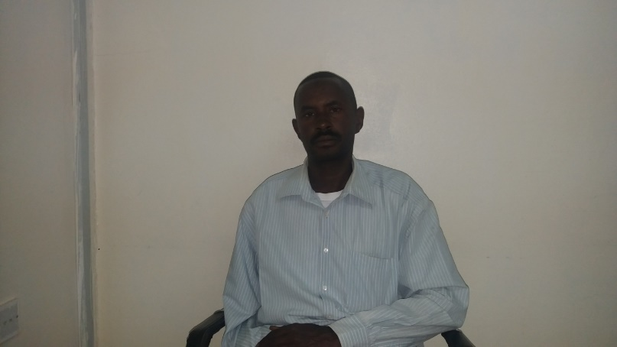

Story from a teacher - Alhadi Mahmud

Alhadi Mahmud is a secondary school teacher in Nyala he’s been teaching mathematics and physics now for almost twenty years.

Austaz Alhadi Mahmud is one of teachers who has been trained on the use the Adapted Teacher Toolkits on Inclusive Education to make schools more inclusive and welcoming to children, including children with disabilities

The six training was conducted in Nyala April 015 ,the objectives was to equipped basic and secondary school teachers with knowledge and methods for ensuring that children with disabilities are included in mainstream schools.

Austaz Alhadi has been selected for the training because he is arm disabled and supposedly the right person to understand the student with the disability needs. We talked to Austaz Alhadi, what are the benefits of that trainings and its impact on your students.

Astaz Ahadi said: Although I am teacher who graduated from education colleague and I have attended so many trainings through the twenty years Experiences in Education but two days only in the training I started feeling very sorry for not having such trainings even I felt sorry for myself and recalled all the difficulties I had because of the unfair treatment.

We have being treating all the student as they are same regardless to their needs and disabilities we really discovered that student they have different needs in term of reading ,writing ,and understanding should be considered during teaching and even in the exams

As example some student need to seat in front so that for them to hear to see well and seating as well, might affect the education.

We learnt how it is important to encourage the disabled and let them feel like they are not different for the others, and how important to create good relationship among the student

We know how important it is to use suitable color to enable student with a weak sight to read and write and many other ways to motivate student especially disabled.

This obviously impacted in our students result at the year end, we have for example one of the student who is blind he’s been integrated in our school he is so clever but sometimes he feels like if he succeeded in his education what is he going to do , I did told him many examples of the disabled people who succeeded in the life .as a result he did a very good job and scored a very good degree.

I’m really happy I have been a part of that training and I do recommend such training to all the teachers in Sudan for the befits.

APPENDICES

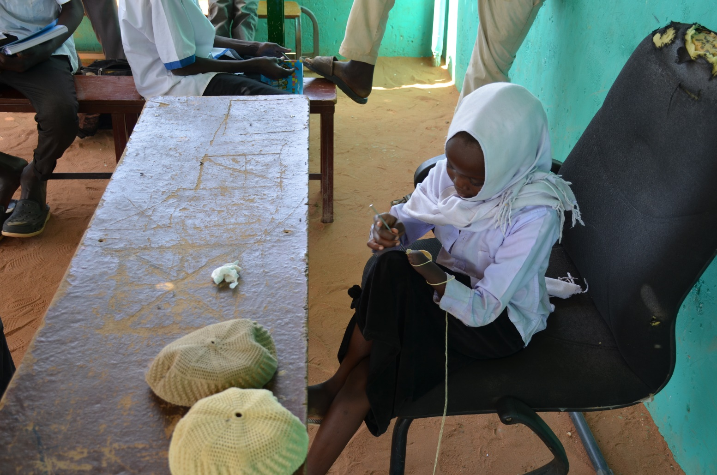

A child with disabilities demonstrating her skill during the celebration of people with disabilities at Umbadda Alternative Learning Centre

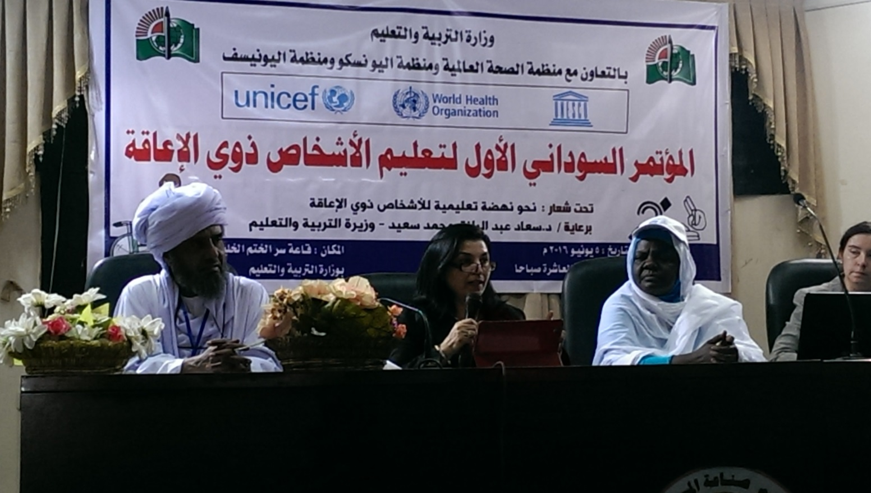

The first National Conference in Inclusive Education, From left: Gadaref State Minster of Education, WHO representative addressing the conference opening ceremony, the head of Special Needs Department MoE, the EU representative in Sudan.

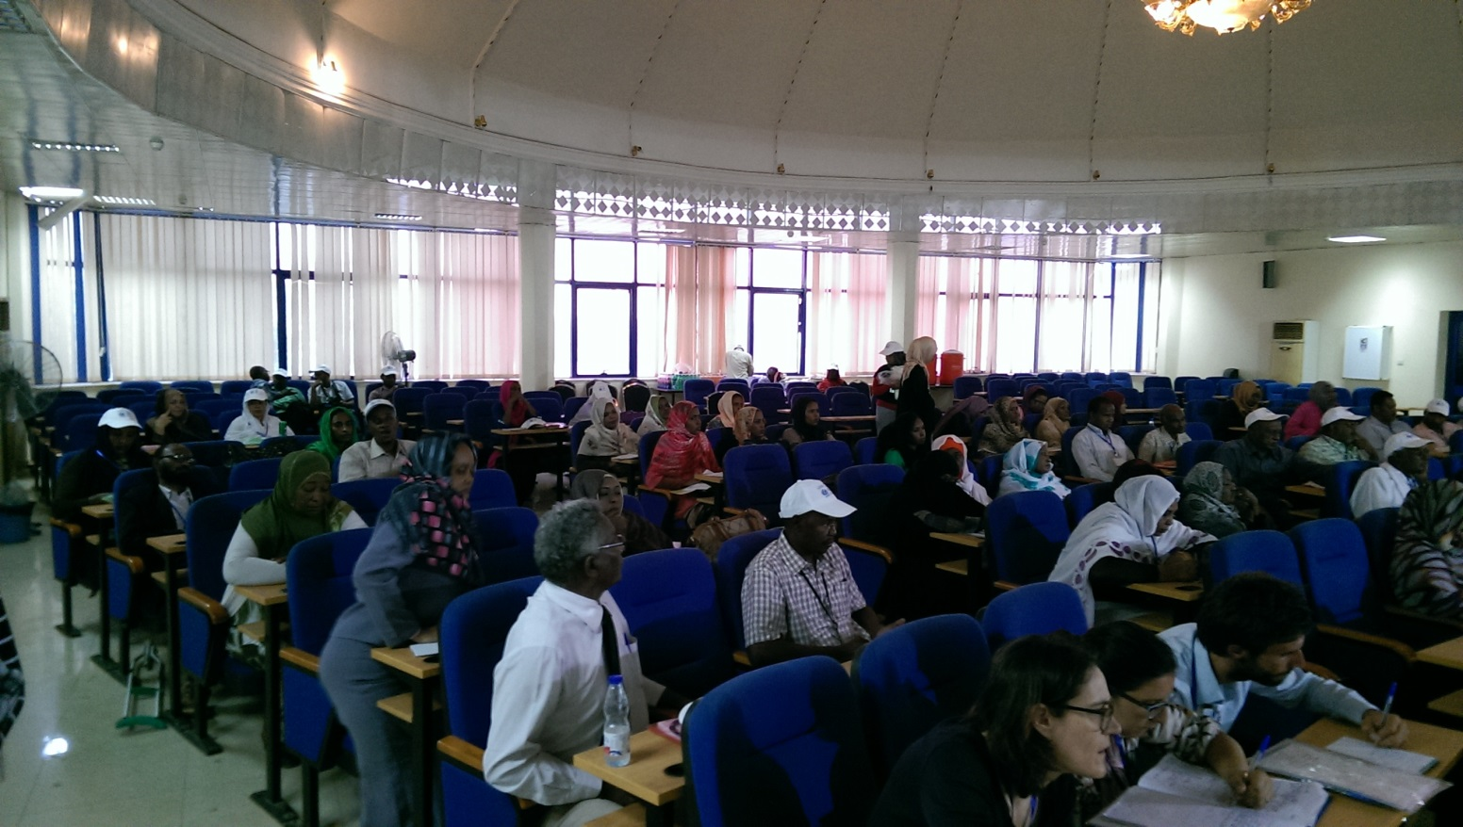

The first National Conference on Inclusive Education: Participants view

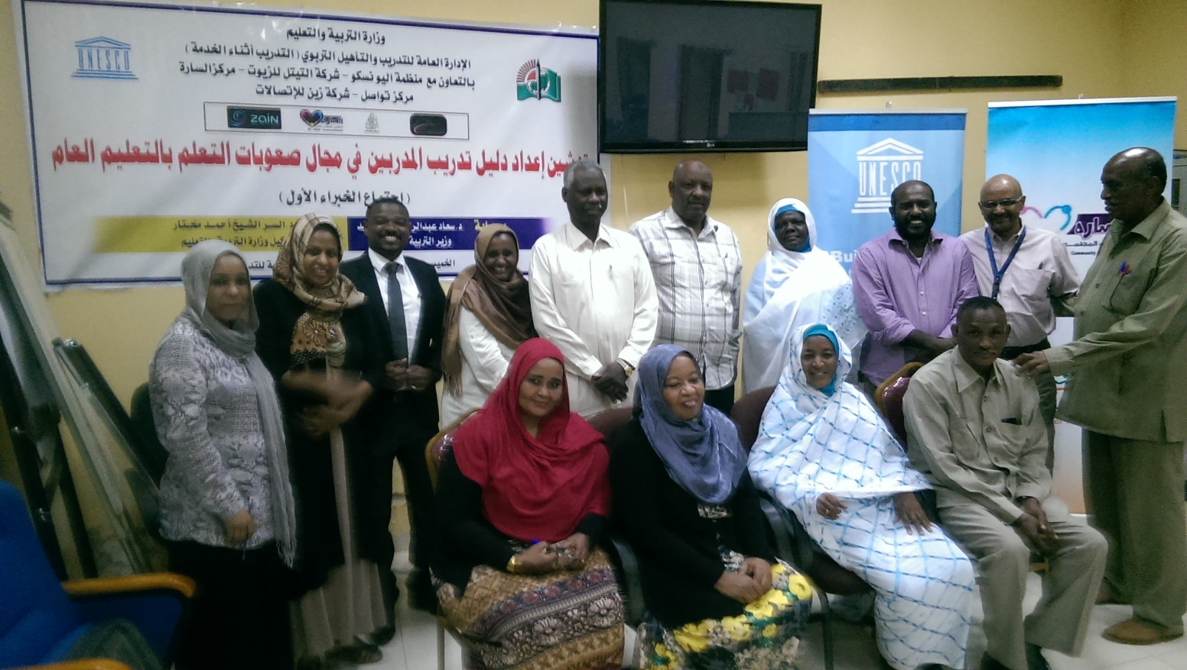

The first experts meeting for Learning Difficulties with the Head of Teacher’s Training department of the MoE

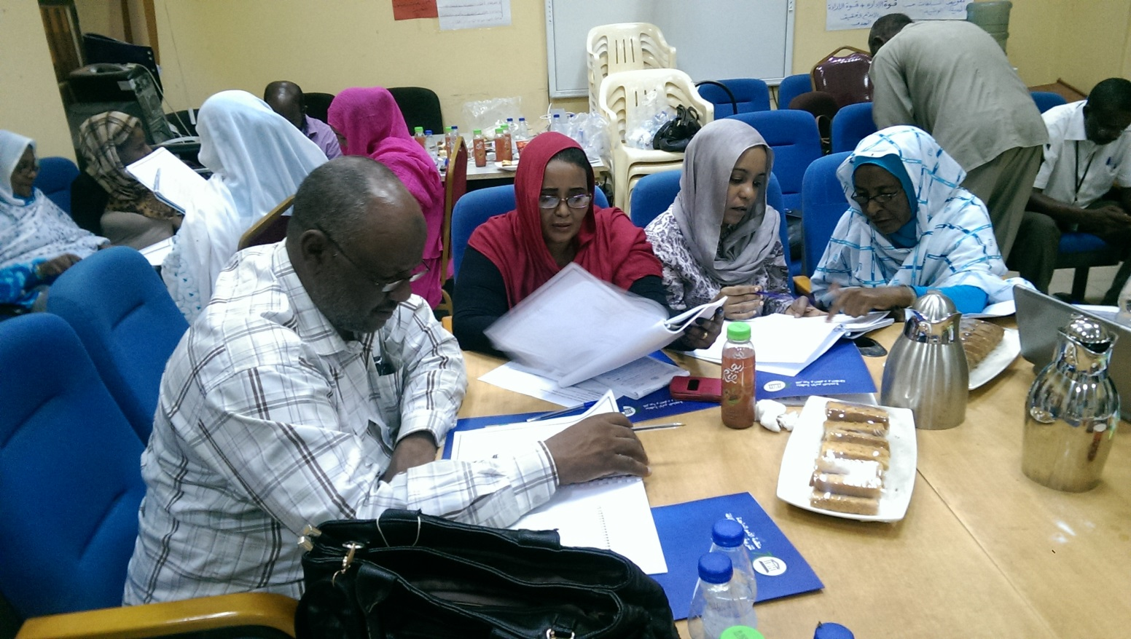

The first experts meeting for Learning Difficulties group work discussions

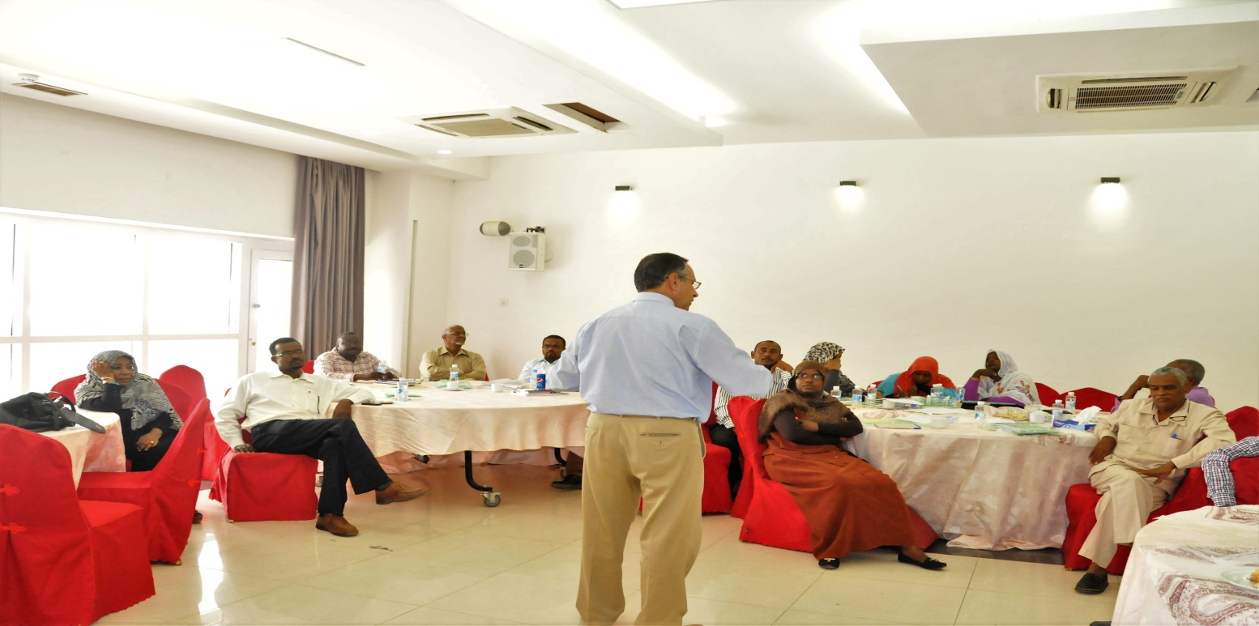

WHO: Orientation workshop for PHC directors in 13 states on early detection and early intervention package July 2016-1

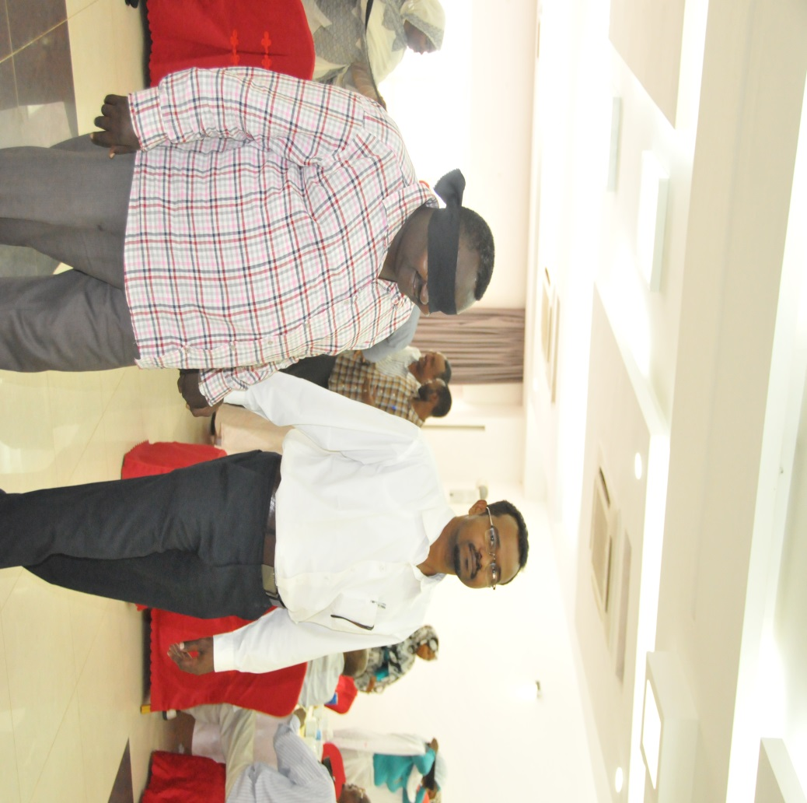

WHO: Orientation workshop for PHC directors in 13 states on early detection and early intervention package July 2016

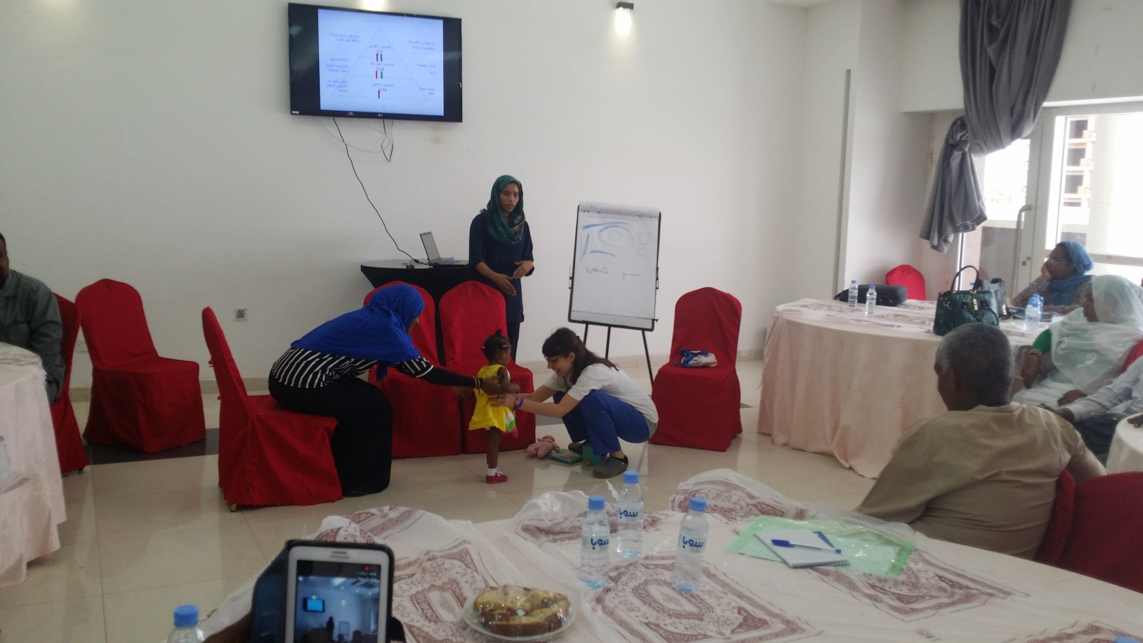

WHO: Orientation workshop for PHC directors in 13 states on early detection and early intervention package July 2016 subject a child with walking difficulty

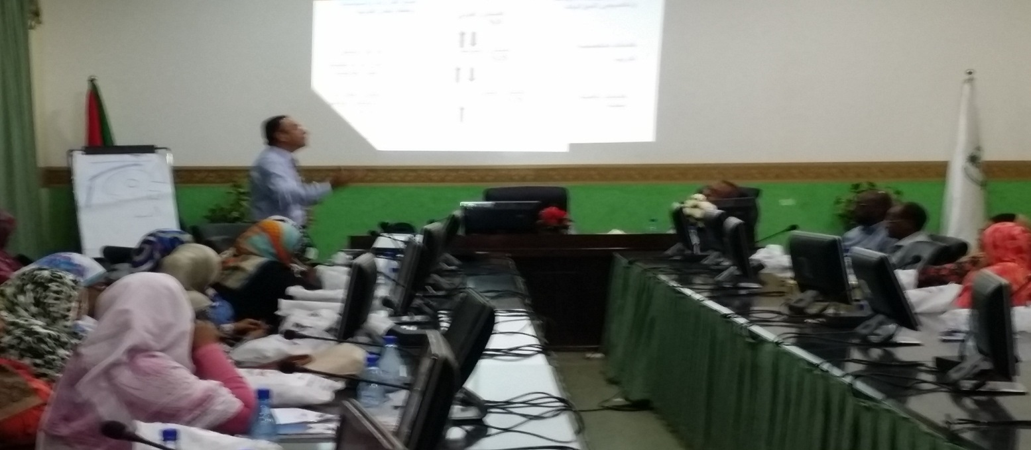

WHO advocacy meeting with stakeholders at FMOH July 2016

1. **Challenges and unforeseen events**

Please describe in this section:

* Any major challenges emerging during the reporting period and the impact they had on project implementation.
* Any unforeseen event changing the assumptions at the basis of the result chain in the approved project document.
* Plans to respond to the emerging challenges and evolving circumstances described above.

One of the major challenges to this Programme were the national elections in mid-April 2015. For at least a month, activity in the Ministries slowed down or even halted completely. To mitigate any possible risks associated with elections, we have increased our efforts to establish structures prior to this period, such as the Inclusive Education Coordinating Committee at national and state levels and the National Workshop on Construction Standards.

**UNESCO:**

The main challenge was to make all national partners agree on the wordings of the text so they can suit the MoE and the NCPD. The second challenge was related to the finance, as the allocated budget did not meet all the needs of UNESCO role to develop the materials and conduct the ToT.

Working with two departments, Department of Special Needs and Department of Training, was not always easy to manage, often UNESCO had to do mediation and careful navigation to smoothen the working environment and reach consensus.

The road is still ahead and not completed, there is still a clear need to build on what we have all achieved so far and go further to develop the resource rooms materials and a need to develop the ToT for the teacher assistance at the school level.

Although significant number of trainers have been trained, there is still a huge demand to do more at other states, only 4 states of 18 are currently partially covered.

**WHO:**

1. The original proposal suggested adaptation of all 5 modules of CBR, none the less WHO and MOH resorted to focusing only at the health component of CBR due to its importance and falling into the core mandate of the organization.
2. Another constrain is the fact that in origin there should be CBR focal person to provide the services and promote the integration of CBR components into the community, accordingly HCP and CHW will be train ned instead.
3. Needs assessment for the assistance devices has to be postpones further because WHO regional office was already conducting a regional assessment and it would overlap with the local assessment thus it was found wiser to use the findings from the regional study and build on it.
4. Once again staff turnover and low capacity of partners (MoH) in disability is an area that needs to be addressed through capacity building programs.
5. **Next steps and potential for scaling up**

Please provide:

* A brief overview of activities planned for the following reporting period.

UNESCO: Seeking financial support to develop the Resource Rooms School Guide for the MoE as well as the ToT materials for the teacher Assistance within the schools. More work needs to be done to integrate the concepts in non-formal education.

**UNICEF:**

**Scale up of teacher training:** During the life span of the project, only 300 teachers from two states (Kassala and South Darfur) were trained on inclusive education toolkit to enhance their skills to mainstream inclusive methodologies in the classrooms. The next step will focus on scaling up this activity to reach more states and more teachers. Selection of teachers to participate in the training will ensure fifty per cent or more participation amongst females. Additional efforts will be made to identify and prioritize teachers with disabilities in all trainings. This will complement the government commitment to include persons with disability in all public sector recruitments as stipulated in the existing Sudan national policy which states that 2 per cent of national service jobs to be allocated to persons with disabilities.

**Training of assistant teachers:** The UNPRPD project is grounded on the basic principle that children with disability and other special needs should be mainstreamed into regular schools and not promoting special schools. One of the gaps noted during the implementation period of the project was that the training on inclusive education did not fully equip the teachers to deal with all needs of children with disabilities. There is need to train some assistant teachers that on a regular basis will be assisting teachers to provide some individualized/specialized support to the children with special needs on an individual basis, this will be based on UNESCO work in developing the required ToT materials. Hence, in addition to the scaling up of teacher training on inclusive education toolkit, the proposed next step will also train assistant teachers from selected states to enhance their capacity to provide specialized support to children with special needs. These assistant teachers will be responsible to provide support to a cluster of 3-5 schools close to each other on a roaming basis to assist learners requiring special support such as learners with hearing disability, visual impairments and those with learning difficulties. Use of cluster school based system for teaching assistants will maximize sharing of resources. This teacher assistants will be recruited from the government existing pool of teachers based on an agreed criteria with the ministry of education and will be on a regular government pay roll in. This will ensure government ownership and sustainability of the achievements under the project.

**WHO:**

1. Training of PHC staff on early detection and early intervention package:

PHC package on disability has been developed to support early detection and early intervention by PHC staff. The package could be used by physicians, medical assistant as well as community health workers for early detection of disability since birth. The package includes several check lists that should be field at certain developmental mile stones.

1. Pilot 3 CBR projects to provide evidence on the feasibility of the implementation and its impact on the communities for policy making.

The 3 CBR projects can be implemented in different sites e.g. a populated poor area in Khartoum (the capital), one in a rural area and the third in a remote area in two other States where services are non-existent. The project can be implemented in collaboration with partners in civil societies and MoH. The CBRs workers in the project will be linked to the nearest PHC facilities for continuous training and monitoring. The findings from this project can provide evidence for expansion in the future.

1. Mapping andreviewing current rehabilitation services and developing a participatory plan to integrate rehabilitation in and between primary, secondary and tertiary levels of the health system.

Rehabilitation has been a low priority for Sudan especially due to financial limitation and this has resulted in underdeveloped and poorly coordinated services There is a strong need in Sudan to strengthen rehabilitation as a health strategy in the Sudanese health system so that quality and affordable rehabilitation services are available to everyone who needs them. This need is warranted in the Post-2015 Sustainable Development Goals which have firmly placed universal health coverage as a key target of goal 3 (health), thereby encouraging countries towards achieving equitable access to quality and affordable health services, including rehabilitation.

Rehabilitation services should be integrated in and between primary, secondary and tertiary levels of the health system. Multidisciplinary rehabilitation should be provided to those who need it. Both community and hospital rehabilitation services should be made available.

Hospitals and CSOs that provide services to persons with disabilities should include specialized rehabilitation units Financial resources should be allocated to rehabilitation services to meet the recommendations on service delivery.

1. Advocacy & capacity building for all the staff involved in the implementation of the project at federal and state level.

Major obstacle that impeded the implementation of the project was the low knowledge about the disability health related intervention at all levels (directors and staff). Disability considered as a low priority area and no much efforts were invested to support people with disability. The advocacy among different level and the knowledge provided resulted in high engagement of partners at state and federal level. Therefore continuous capacity building intervention should be continued to maintain high commitment towards disability and provide the partners with the necessary skills for planning.

**UNESCO:**

1. Integrating the MoE in the development process of the Teacher’s Guides and ToT.
2. Including NOGs and specialized centers in the capacity building of nationals.
3. Involving the National Council for People with Disability.

**WHO:**

1. Advocacy among key players and stakeholders on the importance of the this project
2. Integration of health component for promoting the rights of People with Disability and prevailing the health services As key humanitarian response

* A brief overview of activities aimed at promoting the scaling up of the work initiated by the project.

**UNESCO:**

1. Encouraging the state level MoE to start ToT programs.

2. Keeping a database about trained MoE trainers at federal and state levels for future collaboration.

**WHO:**

1. Strengthen the Monitoring and Evaluation system in the MOH to ensure the proper use of early detection tool and analyzing the data gathered through this tool to promote the use among different PHC facilities and by CHW
2. End of project evaluation of the activities implemented so far and the way forward

1. UNICEF Sudan Country Office (2015): Sudan Country Report on Out-of-School Children