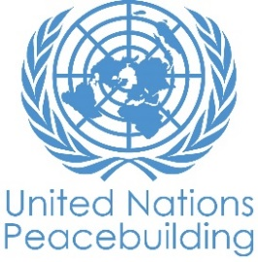
PBF PROJECT progress report
COUNTRY: SOMALIA
TYPE OF REPORT: semi-annual, annual OR FINAL:
YEAR of report: 2020

Project Title: Dhulka Nabaada (The Land of Peace): Supporting Land Reform in Somalia
Project Number from MPTF-O Gateway: 114230
If funding is disbursed into a national or regional trust fund:  Country Trust Fund  Regional Trust Fund  Name of Recipient Fund: PRF | Type and name of recipient organizations:  UN-HABITAT (Convening Agency)  UNDP  IOM  UNHCR
Date of first transfer: January 29, 2019
Project end date: January 21, 2021
Is the current project end date within 6 months? Yes

Check if the project falls under one or more PBF priority windows:
Gender promotion initiative
Youth promotion initiative
Transition from UN or regional peacekeeping or special political missions
Cross-border or regional project

Total PBF approved project budget (by recipient organization):
Recipient Organization Amount

UN-Habitat $ 597,681
UNDP $ 958,831.12
IOM $ 708,460.91
UNHCR $ 308,117.20
Total: $ 2,573,090.23
Approximate implementation rate as percentage of total project budget: 70%
*ATTACH PROJECT EXCEL BUDGET SHOWING CURRENT APPROXIMATE EXPENDITURE*

Gender-responsive Budgeting:

Indicate dollar amount from the project document to be allocated to activities focussed on gender equality or women’s empowerment:
Amount expended to date on activities focussed on gender equality or women’s empowerment:

Project Gender Marker:
Project Risk Marker:
Project PBF focus area:
Report preparation:
Project report prepared by: UN-Habitat (lead), UNDP, UNHCR, IOM
Project report approved by: Peter Nordstrom, PBF Coordinator
Did PBF Secretariat review the report: Yes. Peter Nordstrom, PBF Coordinator, Fadumo Mumin, M&E Specialist

NOTES FOR COMPLETING THE REPORT:
- Avoid acronyms and UN jargon, use general /common language.
- Report on what has been achieved in the reporting period, not what the project aims to do.
- Be as concrete as possible. Avoid theoretical, vague or conceptual discourse.
- Ensure the analysis and project progress assessment is gender and age sensitive.

PART 1: OVERALL PROJECT PROGRESS

Briefly outline the status of the project in terms of implementation cycle, including whether preliminary/preparatory activities have been completed (i.e. contracting of partners, staff recruitment, etc.) (1500 character limit):

Overall, in 2020, Dhulka Nabaada has made good advances towards the objectives of the project and implementation cycle. Some notable achievements include;
- IOM and UNHCR have under the direction of the Jubbaland Land Authority, completed the construction of a 7-room office building for the Land Dispute Committee in Kismayo.
- Under the authority of the Baidoa Land Commission, they also completed the construction of a five-room office in Baidoa.
- The construction of the two offices have also created job opportunities for 60 vulnerable youth, women and men through a cash for work model. The new constructions are only awaiting a handover ceremony scheduled for the upcoming weeks.
- IOM procured office and information technology equipment to enhance land information management.
- To compliment the construction of the new buildings, UN-Habitat is also finalizing materials that will support a resource centre, facilitating access to information for beneficiaries and end-users of the centre. The resource centre will include tool-kits and informative pamphlets that will be placed inside both centres. The tool-kits are meant for both community members to understand some of their basic land and housing rights as well as informative manuals to be used as a resource and geared toward local municipality authorities and practitioners.
- UN-Habitat has also finalized a draft land policy brief that will be shared with both Federal and FMS governments for validation.
- UN-Habitat led a training session for 28 officials (22M;6F) from Jubbaland, South West State, Hirshabelle and Mogadishu on how to develop an inclusive land policy and finalized the Pro-Poor Land Policy Training Manual.
- UN Habitat conducted training for local authorities in Jowhar and with IOM in Baidoa in October. The training consisted of reviewing the current status of land management and developing a way forward with regards to implementation of the draft land law.
- Master Trainers capacitated by UNDP have gone on to train a pool of community facilitators in all selected FMS locations.
- Alternative Dispute Resolution centers in Kismayo, Jowhar and Baidoa solved a total of 44 cases among which 16 benefited women.
- M&E mid-term review completed.

Due to the impact Covid-19 pandemic and operational restrictions, all physical gatherings for community meetings have stopped since March 2020.

Please indicate any significant project-related events anticipated in the next six months, i.e. national dialogues, youth congresses, film screenings, etc. (1000 character limit):

During the reporting period, UN-Habitat began preparations, including development of a concept note for High-Level Land Conference to be held in Mogadishu (Activity 1.1.1). Unfortunately, this was tentatively scheduled for June 2020 and the outbreak of the pandemic rendered this impossible to deliver. In the coming weeks consultations with stakeholders will be held to determine the best course of action going forward. The feasibility of study tours (Activity 1.1.2) and participation in the World Bank Land and Poverty Conference (Activity 1.1.5) will also be discussed.

The community led dispute resolution toolkit (Activity 1.2.2) and grass-roots training manual (Activity 1.2.3) will be completed by the end of the year along with training activities that will capacitate land dispute committees – in the remaining project period.

The land administration infrastructure for Jubaland State of Somalia and South West State constructed in Kismayo and Baidoa, respectively, was completed during the reporting period and preparations for handing over the offices are underway, November 2020 for Baidoa and and December 2020 in Kismayo.

Following procurement of information management systems to support the development of land tenure databases IOM will support training on information management. The Local Authorities in Jubaland and South West State identified four additional district/sites where IOM Engineers are currently supporting with the development of architectural designs and bill of quantities for Land Authority offices to facilitate possible future developments. Actual construction/rehabilitations in the additional four districts/sites will not be facilitated due to budgetary limitations.

FOR PROJECTS WITHIN SIX MONTHS OF COMPLETION: summarize the main structural, institutional or societal level change the project has contributed to. This is not anecdotal evidence or a list of individual outputs, but a description of progress made toward the main purpose of the project. (1500 character limit):

The project is establishing systems that have so far begun reducing and solving land disputes in the community. One of the most significant outcomes of the project so far has been the reduction of land conflicts as a result of a systematic approach that has been adopted to resolve land disputes to achieve peaceful co-existence and cohesion among the community members. There has been an improved administration of land issues because the project is designing informational systems to manage land track land issues. In the same regard, the establishment and training of the land dispute committees have also led to improvement and resolution of land issues. The trained judicial staff were in a better capacity to handle and manage land dispute cases.

Notably in Kismayo and Baidoa where the renovated DCs Office and the completion of land authority building were seen as potential to help improve the working environment making the flow of activities and operation in the office more efficient. The DCs Office was also well equipped with computers. The construction of offices for the community land management committee was also linked as a major factor in handling land disputes and conflicts in the area. The offices are areas where community members could freely express themselves.

In a few sentences, explain whether the project has had a positive human impact. May include anecdotal stories about the project’s positive effect on the people’s lives. Include direct quotes where possible or weblinks to strategic communications pieces. (2000-character limit):

A key project outcome has been an improved understanding of the community on the importance of having proper land documentation. The project has contributed to peacebuilding initiatives in the various districts as it has led to the reduction in conflicts and disputes relating to land in the district through educating and mobilizing the community on the approach they can use when resolving the land issues. Community members were also able to learn their rights on land ownership and means of conflict resolution. Further, community awareness and community conversation conducted by the project helped the government to identify some of the land disputes faced by the community which were also solved.

In Baidoa specifically, one of the biggest impacts of the project was the community dialogue forums between government officials and the community which improved the relationship and confidence of the community in the government. The project also reduced eviction cases as it helped improve the relationship between the IDPs and landowners in reaching agreements.

In Jowhar the establishment of mobile courts had a positive impact on the community as there was improved reception towards proper resolution of land disputes. In addition, there was improved trust in the LA due to the proper management and issuance of title deeds. Overall, it was felt that the project promoted security and peace due to the resolution of land disputes.

Through direct engagement on land issues more community members realized and accept the role and rights of women while the government itself has improved its relationship with women. There was a positive interaction between women groups and ministries whereby women’s rights were the main points of discussion.

PART II: RESULT PROGRESS BY PROJECT OUTCOME

Describe overall progress under each Outcome made during the reporting period (for June reports: January-June; for November reports: January-November; for final reports: full project duration). Do not list individual activities. If the project is starting to make/has made a difference at the outcome level, provide specific evidence for the progress (quantitative and qualitative) and explain how it impacts the broader political and peacebuilding context.

- “On track” refers to the timely completion of outputs as indicated in the workplan.
- “On track with peacebuilding results” refers to higher-level changes in the conflict or peace factors that the project is meant to contribute to. These effects are more likely in mature projects than in newer ones.

If your project has more than four outcomes, contact PBSO for template modification.

Outcome 1: Increased access to justice, remedial and adjudication on land issues through an integrated framework of the various mechanisms guided by clear policy and legislation ensuring coherence in resolution of disputes.

Rate the current status of the outcome progress:

Progress summary: (3000 character limit)

To ensure that increased access to justice is guided by clear policy and legislation UN-Habitat has been working on developing a Land Policy Brief that outlines systemic gaps, challenges and recommendations. The Policy Brief is intended to be used by both Federal and Member State governments as a guiding tool that will eventually support the development of policies, legislation, regulations, by-laws and/or decrees for the more effective management and administration of land processes. Prior to the development of the Land Policy Brief a group of officials from Jubbaland, South West State, Hirshabelle and Mogadishu were trained on how to develop a land policy. In total, 28 officials were trained, (22 Male and 6 Female). In addition, a grass-root negotiation training manual is also in its final stages and will be shared with local stakeholders. This manual, among others developed, will be used as a tool for the capacitation of the land dispute committees. Master trainers capacitated by UNDP in community conversation methodology have gone on to train a pool of community facilitators in all selected FMS locations - Baidoa, Jowhar, Dhusamareb, Kismayo and Garowe. To engage local communities in various FMS in an inclusive manner, sites and participants were selected with specific criteria to ensure representation, inclusive of women and marginalized groups such as minority clans and IDPs, different age groups, and to reach more remote areas. Community facilitators have started to conduct community conversations at sites in all locations. Initial response to the community conversations have been positive, with interest from local communities to participate. A total of 1347 people have participated in the community conversations thus far. Conversations have mainly focused on building trust within the group of participants and with the community facilitators. Land issues have surfaced as a prominent area of concern in the identification of common concerns. Land issues have surfaced as a prominent area of concern in the identification of common concerns. Unfortunately, because of the situation caused by COVID 19, community conversations had to be suspended in March 2020. Authorization to resume the activity was given in September 2020 provided that protective measures such as social distancing and PPE are applied. Given the time it took to procure the PPE, the community conversations just resumed during the first half of November and focused on COVID 19 and the impact it had on the community.

UN Habitat conducted training for local authorities in Jowhar and with IOM in Baidoa in October. The training consisted of reviewing the current status of land management, claims and conflict, understanding land legislation and legislative process and differentiating policy and legislation, decentralized land governance within the transitional federal constitution and the way forward for each state. In particular in SWS regarding the implementation of the land law.

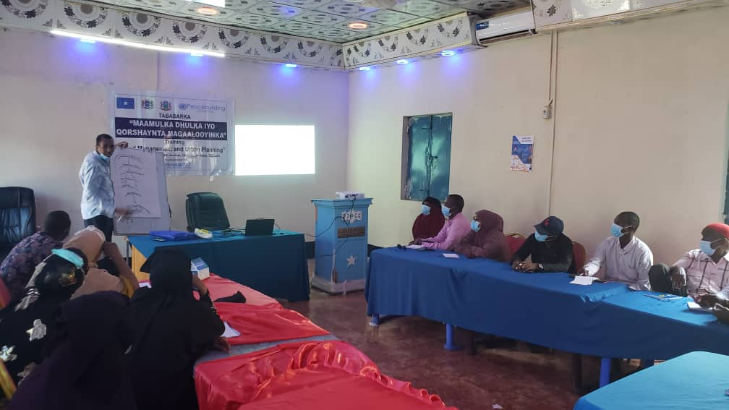
Jowhar Land Management Training, 24 October 2020, UN Habitat

Indicate any additional analysis on how Gender Equality and Women’s Empowerment and/or Youth Inclusion and Responsiveness has been ensured under this Outcome: (1000 character limit)

Ensuring gender equality, women’s empowerment and youth inclusion is critical to this project because without particular attention to this, already marginalized and disenfranchised groups will continue to struggle with lack of inclusion and access to justice. To engage local communities in various FMS in an inclusive manner, sites and participants were selected with specific criteria to ensure representation, including of women and marginalized groups such as minority clans and IDPs, different age groups, and to reach more remote areas. Community facilitators have started to conduct community conversations at sites in all locations. Initial response to the community conversations have been positive, with interest from local communities to participate. Women are engaged as active agents of transformative change in their communities, as part of the community facilitators in the community conversations, as well as women leaders at the community dispute resolution centres, that encourage the participation and leadership of women. All training materials and documents developed to date also speak on how to promote inclusive and representative methods in achieving results.

Outcome 2: Improved delivery of land administration and land rights services through institutionalization of appropriate infrastructure and information management system, thus rebuilding community’s confidence in local authorities.

Rate the current status of the outcome progress:

Progress summary: (3000 character limit)

The programme continued to support the formal justice system through mobile courts and alternative disputes resolution centres to solve land disputes. During the period under review, the judiciary in Hirshabelle, South West and Jubbaland organised mobile courts in small villages on the outskirts of the city and in IDP camps in Kismayo, Jowhar and Baidoa. Women leaders from where the mobile court sessions are taking place have been involved in cases where a woman was a party to the conflict to take better heed of women's needs. From January to Mid-March, the mobile courts in all three locations have solved 14 land disputes (Jowhar: 12:8 men and 4 women, Kismayo 2, Baidoa). Because of COVID 19, mobile courts were suspended in March and will resume in November.

Alternative Dispute Resolution (ADR) centers in Kismayo, Jowhar and Baidoa solved a total of 44 cases among which 16 benefited women. The ADR in Kismayo does not solve land cases since all those cases are transferred to the land committee. Visits to the ADR centres decreased during the period from March to June because of the COVID situation, however visitors started coming back to the centres in June- July.

A third party monitoring mission that was conducted to assess the level of satisfaction of mobile courts and ADR centers beneficiaries from 2019 and 2020 showed that respectively 35% of cases solved by the ADR centers in Hirshabelle and 53% in South West are land cases. The level of satisfaction was measured through interviews with around 20 to 40 beneficiaries in each location who were requested to measure the level of satisfaction with the services and the outcome on a scale from 1 to 10. The average response was 8.2 for both aspects. Regarding mobile courts, the level of satisfaction with mobile court services ranged between 8,2 in Hishabelle, to 8,8 in Jubbaland and 9,1 in South West, the level of satisfaction with the outcome of the cases solved by mobile courts ranged from 8,5 to 9,1 in the three locations.

Following the formulation of a land policy and development of an electronic land administration system in Jubaland as part of the first set of initiatives undertaken by the Land Authority, efforts were focused on capacity building in operationalising the land management system. A system use and manipulation training was conducted targeting municipality staff. Furthermore, in-service cadastral training service was delivered to ensure efficient use of equipment previously procured in the project.

Further efforts were invested in creating public awareness on land registration and management. Among these were trainings on procedural awareness, live television talk show, designing and production of IEC materials for distribution to the public. Furthermore, standing banners depicting land acquisition procedures were erected at strategic locations to ensure information sharing.

A total of 3 land dispute dialogues and forums were conducted which provided an opportunity for information sharing. A local dispute resolution committee was supported to ensure improved capacity in resolution of land disputes.

While these incremental achievements represent significant progress, the municipalities remain under-resourced and under-capacitated, and as a result, rendering the system operational in ways that increases access and contributes to adequate protection of HLP rights remains a challenge.

In Baidoa, there has been ongoing engagement with the Baidoa Municipality regarding a contextually appropriate and technically feasible option for the execution of the land administration system deliverable of the project. With the coming of the new District Commissioner, the previously developed land registration electronic system has been dropped in favour of a paper-based system. Efforts are underway to ensure that a more effective land registration system is adopted for delivery of land administration and management services.

The municipality has concluded that they lack the capacity and infrastructure to operationalise an electronic land management or vital information management system. The Municipality has sought to prioritise the establishment/construction of office units instead while reverting to a paper-based land registration system.

Following extensive consultations with Local Authorities in Kismayo and Baidoa, IOM coordinated and worked with UNHCR, NRC and UN Habitat to improve delivery of land administration and land rights services through construction of land authority offices, provision of office and information technology equipment as well as conducting training to directly strengthen institutional mechanisms that manage and adjudicate on land issues. The construction of land authority offices has been completed in both Kismayo and Baidoa. The construction offered short-term employment opportunities to 60 vulnerable youth, women and men (36 M; 24 F) selected from the displacement affected communities who worked on a cash-for-work basis, concurrently enhancing their skills and access to income, and promoting peaceful coexistence. Handover events for developed infrastructure are scheduled for November and December 2020. The Local Authorities in Jubaland and South West State identified four additional districts/sites where IOM Engineers are currently supporting with the development of architectural designs and bill of quantities of Land Authority Offices for possible future developments.

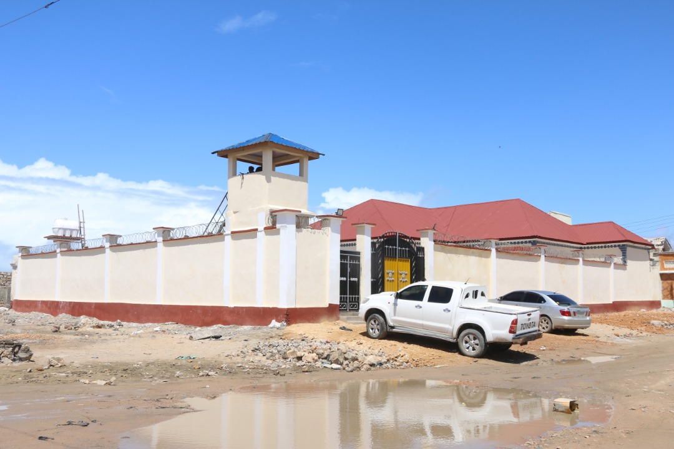
Kismayo Land Authority Building, IOM

To complement the infrastructural support, IOM procured office and information technology equipment to enhance land information management. The equipment included five office desks, five office chairs, five office cabinets, two desktop computer PCs, one printer HP, one Epson projector, one flip chart stand, one conference hall table and thirty conference hall chairs. The provision of information technology equipment was followed with the training of Baidoa Land Commission staff in information management systems that would enhance the development of land tenure databases. IOM worked with UN Habitat and NRC to facilitate the training.

The institutionalization of infrastructure and land tenure database is anticipated to rebuild the community’s confidence in local authorities’ land governance capacity, and to reduce tensions between conflicting parties. The land administration infrastructure is the foundation for more credible land management, civil and administrative adjudication. Furthermore, supporting the autonomous land authorities entrenches sustainable institutional response to land disputes and is envisaged to strength local government capacity for delivery of land administration and management services, including formalized collection of taxes related to land, geo location for improved land management and land registration processes to advance rights and welfare of IDPs, returnees and host communities in Baidoa.

Indicate any additional analysis on how Gender Equality and Women’s Empowerment and/or Youth Inclusion and Responsiveness has been ensured under this Outcome: (1000 character limit)

The Dhulka Nabada project mainstreamed gender through the following principles: it ensured participation of women, men and youths in the construction of land authority/commission offices in Baidoa and Kismayo. The agreed modality for public works through cash for work considered the vulnerabilities, needs and opportunities for men, women and youths. Location and timing of community-based activities considered gender to facilitate equitable participation and access. The project collected gender-disaggregated data for review and analysis, as exemplified by the table below on cash-for-work.

Number of beneficiaries that worked on cash for work initiatives disaggregated by gender, district and migration status

District name | Number of males | Number of females | Number of IDPs | Number of returnees | Number of host community members | Total beneficiaries
Kismayo | 16 | 14 | 2 | 6 | 22 | 30
Baidoa | 20 | 10 | 13 | 5 | 12 | 30
Total | 36 | 24 | 15 | 11 | 34 | 60

Development of training materials, information tool-kits and policy briefs also centre women and aim to enhance their participation. While being mindful of the social, political and economic barriers that are particular to their experiences in their communities and broader society.

PART III: CROSS-CUTTING ISSUES

Monitoring: Please list monitoring activities undertaken in the reporting period (1000 character limit) | Do outcome indicators have baselines?  Yes, A baseline assessment was carried out by IOM M&E team comprising of household surveys, key informant interviews, focus group discussions and field observations which provided baseline information for outcome 2 indicators.  Has the project launched perception surveys or other community-based data collection?  Yes, Monthly community-based data collection and reporting exercises were conducted.  Overall, monitoring and evaluation has been undertaken through third party contracting. Axiom is currently conducting the mid-term review and has submitted an inception report, work-plan and data collection plan. In addition to the overall ongoing monitoring and evaluation agencies have also been conducting their own monitoring of specific activities. Various monitoring activities have been undertaken by the UNDP JJP team, including review meetings to assess the progress on community conversations, inspection visits to observe sessions, and gender-disaggregated data has been collected. A conjoint experiment study that will take place in the form of interactive phone surveys has been designed, to establish baseline specific to community conversations.  Monitoring of cash for work initiatives was done through IOM field staff, Core Facilitation Team and Community Based M&E group. Attendance registers were also completed for cash for work beneficiaries.  Site visits were carried out by IOM Engineers to ascertain progress and ensure contractors comply with the specifications, construction drawings and design details.
Evaluation: Has an evaluation been conducted during the reporting period?  YES | Evaluation budget (response required): $117,052.25  If project will end in next six months, describe the evaluation preparations (1500 character limit):
National Ownership: | Local authorities in all the FMS locations community conversations have been engaged in the process of initiating the community conversations, and expressed their support for the community-led initiatives as well as their willingness to engage with the communities' action plans on locally-developed solutions. NGOs selected have been invited to the FMS Rule of Law Working Groups. They have participated in specific sessions of community conversations, where relevant. The various FMS Ministries of Justice continue to support the operations of the community dispute resolution centres.
Exit strategy/sustainability: | The community capacity enhancement/ community conversations uses dialogue tools aimed at helping the communities looking at their justice and security issues with a new perspective, and engage the communities as active leaders in addressing justice issues with localized solutions, in a community-led process.
Catalytic effects (financial): Indicate name of funding agent and amount of additional non-PBF funding support that has been leveraged by the project. | Name of funder: Amount:
Other: Are there any other issues concerning project implementation that you want to share, including any capacity needs of the recipient organizations? (1500 character limit) | Currently, the ongoing global pandemic caused by COVID-19 has of course posed particular challenges to implementation. Primarily, many gatherings and large scale in-person functions have been suspended.

PART IV: COVID-19
Please respond to these questions if the project underwent any monetary or non-monetary adjustments due to the COVID-19 pandemic.

- Monetary adjustments: Please indicate the total amount in USD of adjustments due to COVID-19:

$

- Non-monetary adjustments: Please indicate any adjustments to the project which did not have any financial implications:

The problem of COVID-19 affected the smooth implementation of the project in terms of beneficiary reach. Trainings were restricted in terms of participation to ensure adherence to social distancing

- Please select all categories which describe the adjustments made to the project (and include details in general sections of this report):

☒ Reinforce crisis management capacities and communications
☐ Ensure inclusive and equitable response and recovery
☐ Strengthen inter-community social cohesion and border management
☐ Counter hate speech and stigmatization and address trauma

☐ Support the SG’s call for a global ceasefire
☒ Other (please describe): Trainings restricted in terms of number of participants

If relevant, please share a COVID-19 success story of this project (i.e. how adjustments of this project made a difference and contributed to a positive response to the pandemic/prevented tensions or violence related to the pandemic etc.)

PART V: INDICATOR BASED PERFORMANCE ASSESSMENT

Using the Project Results Framework as per the approved project document or any amendments- provide an update on the achievement of key indicators at both the outcome and output level in the table below (if your project has more indicators than provided in the table, select the most relevant ones with most relevant progress to highlight). Where it has not been possible to collect data on indicators, state this and provide any explanation. Provide gender and age disaggregated data. (300 characters max per entry)

 | Performance Indicators | Indicator Baseline | End of project Indicator Target | Indicator Milestone | Current indicator progress | Reasons for Variance/ Delay  (if any)
Outcome 1  Increased access to  justice, remedial and  adjudication on land  issues through an  integrated framework  of the various  mechanisms guided by  clear policy and  legislation ensuring  coherence in resolution  of disputes | Indicator 1.1  Land tenure and property rights policy developed and approved | 0 | 1 | 1 |  | Completed, but not yet approved
 | Indicator 1.2  Proportion of land  dispute cases in the  target communities  successfully resolved.  (Disaggregated by  gender and age) | 0 | 50% | 0 | 60
 | Indicator 1.3  Percentage of people  who have confidence  in the state land  management system  (Disaggregated by  gender and age) | 34.46% in Kismayo  21.41% in Baidoa | 70%
Output 1.1  Capacity of federal government and member states to  advocate and influence policy on Land rights is enhanced | Indicator 1.1.1  No. of high level  forums held on land,  conflict and state  building | 0 | 2 |  |  | Preparatory activities for this output have commenced. The 1st high-level forum was scheduled to be held this June, but due to the COVID-19 outbreak it has been put on hold. Options to postpone event or consider moving it to a virtual venue will be decided on the way forward. A concept note has been developed after a series of meetings with various agencies, organizations, and partners.
 | Indicator 1.1.2  No. of government  officials trained on  policy development.  (Disaggregated by  gender) | 0 | 25 |  | 28 (22M;6F) | Policy training to government officials conducted in November 2019. Pro-Poor Land Policy Training Manual.
Output 1.2  Improved citizen participation on land issues dialogue  processes with communities and state officials on land  dispute resolutions | Indicator 1.2.1  Number of community  facilitators trained | 0 | 15 |  | 25
 | Indicator 1.2.2  No of community conversations held (including women only CC ) | 0 | 18 |  | 32 | Due to COVID-19, all physical gatherings for community conversations have stopped since March 2020
Output 1.3  Establish an integrated justice system capacitated to address land disputes with increased compliance with women's rights | Indicator 1.3.1  Land dispute tribunal  and committee  established and  functional. | 0 | 2 | 0 | 2 | Completed – handover ceremony scheduled for November 2020 in Baidoa and December 2020 in Kismayo.
 | Indicator 1.3.2  Training curricula,  number of religious,  traditional and women  leaders trained  Number of exchange  sessions  No. of land dispute  committee members trained on  management of  disputes cases  (Disaggregated by  gender) | 0 | 10 | 30
Outcome 2  Improved delivery of land  administration and land  rights services through  institutionalization of  appropriate  infrastructure and information management systems, thus rebuilding the community’s confidence in local authorities | Indicator 2.1  Proportion of  vulnerable and  disadvantaged people  effectively utilizing  justice and remedial systems on land tenure  issues | 0 | 70% | 0% |  | IOM M&E is currently gathering data since established infrastructure is now operational, information management equipment installed, and trainings conducted in Baidoa (to enhance attribution).
 | Indicator 2.2  % of court decisions  related to land disputes  executed | 0 | 50% | 0% |  | IOM M&E is currently gathering data since established infrastructure is now operational, information management equipment installed, and trainings conducted in Baidoa (to enhance attribution).
 | Indicator 2.3  % of cases on land  disputes addressed  through the formal  justice system; | 0 | 60% | 0% |  | IOM M&E is currently gathering data since established infrastructure is now operational, information management equipment installed, and trainings conducted in Baidoa (to enhance attribution).
Output 2.1  Functional formal and community system, with proper information management on land cases to improve effective delivery of services on land disputes. | Indicator 2.1.1  Functional information  management systems  in place | 0 | 2 | 0 |  | IOM M&E is currently gathering data since the established infrastructure is now operational, information management equipment installed, and trainings were conducted in Baidoa (to enhance attribution).
 | Indicator 2.1.2  Number of district and  community  stakeholders trained  on the core concepts,  principles and  methodologies for land and land dispute information | 0 | 12 | 0 | 14
Output 2.1 | Indicator 2.1.3 Number of community identified land dispute cases effectively referred to formal land adjudication systems | 0 | 10 | 0 |  | IOM M&E is currently gathering data since the established infrastructure is now operational, information management equipment installed, and trainings were conducted in Baidoa (to enhance attribution).
 | Indicator 2.1.4 Improved trust in the management of titles | Low | Moderate |  |  | IOM M&E is currently gathering data since the established infrastructure is now operational, information management equipment installed, and trainings were conducted in Baidoa (to enhance attribution).
Output 2.2  Appropriate infrastructure for land administration, land  management, civil and administrative adjudication is  established or upgraded. | Indicator 2.2.1  Number of  infrastructural capacity  assessment reports  generated. | 0 | 2 | 2 | 2
 | Indicator 2.2.2  Number of buildings  with proper designs  and costed BOQs  agreed upon  rehabilitated/developed  and fully functional. | 0 | 6 | 2 | 2 | The Local Authorities in Jubaland and South West State identified four additional district/sites where IOM Engineers are currently supporting with the development of architectural designs and bill of quantities for Land Authority offices to facilitate possible future developments. Actual construction/rehabilitations in the additional four districts/sites will not be facilitated due to budgetary limitations.
 | Indicator 2.2.3 Number of persons benefiting from “cash for work” opportunities (disaggregated by gender) | 0 | 60 |  | 60 (36M;24F)
 | Indicator 2.2.4 No. of administrative staff trained on grassroot, district level and FMS negotiations (disaggregated by gender) | 0 | 25 | 0 |  | Activity planned for next reporting cycle.
 | Indicator 2.2.5 Improved trust in the adjudication of land disputes | Low | Moderate |  | 34% (low) | IOM M&E is currently gathering data since the established infrastructure is now operational, information management equipment installed, and trainings were conducted in Baidoa (to enhance attribution).

