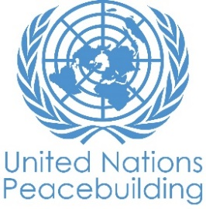
PBF PROJECT progress report
COUNTRY: YEMEN
TYPE OF REPORT: semi-annual
YEAR of report: 2021

Project Title: “Empowering Yemeni youth towards peace: ensuring access to information and participation”
Project Number from MPTF-O Gateway: IRF 00118937
If funding is disbursed into a national or regional trust fund:  Country Trust Fund  Regional Trust Fund  Name of Recipient Fund: | Type and name of recipient organizations:  United Nations Educational, Cultural, Scientific Organization (UNESCO, UN) (Convening Agency)  Main local implementing partner:  RNW Media (CSO, headquartered in The Netherlands)
Date of first transfer: 03/12/2019
Project end date: 30/11/2021
Is the current project end date within 6 months? YES
Check if the project falls under one or more PBF priority windows:
Gender promotion initiative
Youth promotion initiative
Transition from UN or regional peacekeeping or special political missions
Cross-border or regional project

Total PBF approved project budget (by recipient organization):
Recipient Organization Amount

UNESCO $ 1,499,989.77

Approximate implementation rate as percentage of total project budget: 67%
*ATTACH PROJECT EXCEL BUDGET SHOWING CURRENT APPROXIMATE EXPENDITURE*

Gender-responsive Budgeting:

Indicate dollar amount from the project document to be allocated to activities focussed on gender equality or women’s empowerment: 750,000 USD

Amount expended to date on activities focussed on gender equality or women’s empowerment: 217,379 USD

Project Gender Marker: GM2
Project Risk Marker: Medium
Project PBF focus area: 1.4 Political dialogue
Report preparation:
Project report prepared by: UNESCO- GCC and Yemen Office
Project report approved by:
Did PBF Secretariat review the report: NO

NOTES FOR COMPLETING THE REPORT:
- Avoid acronyms and UN jargon, use general /common language.
- Report on what has been achieved in the reporting period, not what the project aims to do.
- Be as concrete as possible. Avoid theoretical, vague or conceptual discourse.
- Ensure the analysis and project progress assessment is gender and age sensitive.
- Please include any COVID-19 related considerations, adjustments and results and respond to section IV.

PART 1: OVERALL PROJECT PROGRESS

Briefly outline the status of the project in terms of implementation cycle, including whether preliminary/preparatory activities have been completed (i.e. contracting of partners, staff recruitment, etc.) (1500 character limit):

Due to the political situation in Yemen and the Covid-19 pandemic, the project relied on online implementation modalities more than originally planned. This caused both underspending and delays in implementation compared to the original timeline. While online modalities have proven to be successful, they are generally less costly and more time consuming. Therefore, UNESCO requested the no-cost extension that was approved by PSO on 26 March 2021.
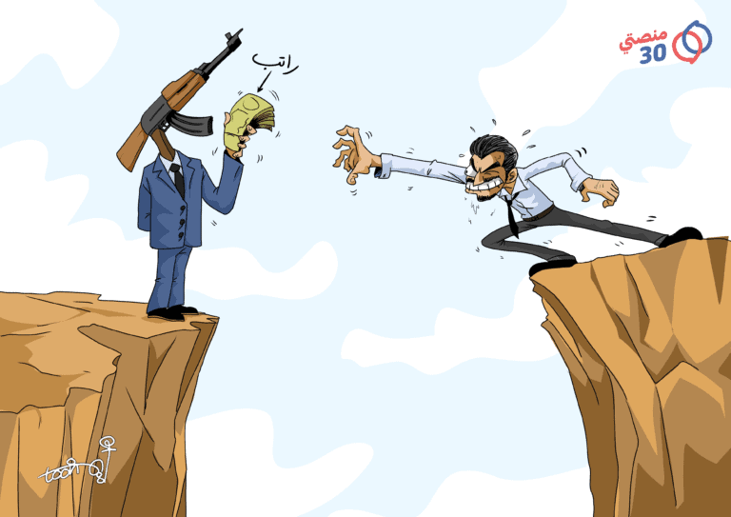
As of June 2021, the project is under full implementation phase and sequencies of activities on track. During the period under review, journalism trainings (76 young journalists trained, 57% women) and the 14 Arabic gender and youth-sensitive materials have been finalized. In addition, the project achieved 76% of production of the 144 content pieces. Furthermore, the project reached more than 55K page views in Manasati30 website which represents 110% of the target (50K). On the other hand, it has reached 2,573,679 video views for all multimedia content and that is 132% of the target. The project also supported 7 youth-led peace initiatives, with a strong women participation, and has now selected additional 7 initiatives for the new cycle. The four surveys launched got 5,246 responses and triggered interesting online discussions and engagements. Three social listening projects have been conducted so far, achieving 67% of the youth barometer component implementation. The surveys and social listening projects were edited in booklets format and disseminated to the wider public, including decision makers in and outside Yemen. Also, radio programs led by youth for youth have been produced and aired by 5 community radio stations. Finally, so far two Steering Committee meetings have been successfully held, supporting project management in milestones review and planning.

Please indicate any significant project-related events anticipated in the next six months, i.e. national dialogues, youth congresses, film screenings, etc. (1000 character limit):

In the forthcoming period, the project will carry out 5 youth led debates related to peacebuilding topics. A debate toolkit was finalized through a work group led by a regional expert.
Organizing offline debates was postponed due to Covid-19 situation, final assessment on the situation is due in early July 2021 to decide on the next steps. Moreover, UNESCO will seek opportunities to invite young activists part of this project to global UNESCO-led events, as was done for the regional and global celebration of the World Press Freedom Day in May 2021. Due to the Covid-19 situation, no physical participation to those events is foreseen but online modalities only.

FOR PROJECTS WITHIN SIX MONTHS OF COMPLETION: summarize the main structural, institutional or societal level change the project has contributed to. This is not anecdotal evidence or a list of individual outputs, but a description of progress made toward the main purpose of the project. (1500 character limit):

By using innovative digital tools, smart online moderation, persuasive methods to create engagement, the project has contributed to create a new narrative related to peacebuilding dialogue in the country, more inclusive of young and women.
A demonstration of this is the new flow of information on Manasati30, with content produced and published which reflects diverse voices across Yemen. As reported by the Manasati30 editor in chief: “Trainings have succeeded to attract new contributors from different areas of different cultural and political backgrounds who started to produce more objective and professional content that helps to bring about peace. Above all, this opportunity has given the space for those journalists to voice their opinions and concerns as young people". By far, the project page in Manasati30 website contains 119 pieces of diverse and high quality peacebuilding related multimedia content that has been distributed and promoted on social media channels to give young people the opportunity to react and engage with the developments. To trigger further participation, the project regularly highlights one of the user’s reactions in order to encourage other users to comment on it. Moderation is also key to ensure women participation, countering hate speech and disinformation. From June 2020 to May 2021, the average visits from women to Manasati30 website is 56%, this is a significant number when we consider the cultural sensitivities around women’s use of technology. From a poll among a sample of users, 80% of website visitors confirm their understanding of the peace building process has improved.
This shows how the project is changing attitudes of young people towards peace through balanced and engaging information.

In a few sentences, explain whether the project has had a positive human impact. May include anecdotal stories about the project’s positive effect on the people’s lives. Include direct quotes where possible or weblinks to strategic communications pieces. (2000 character limit):

The project is greatly supporting CSOs in Yemen, namely through its “My solution initiative” component. The project has gathered so far 7 successful stories on how the project had a positive human impact. Below one of the stories collected.

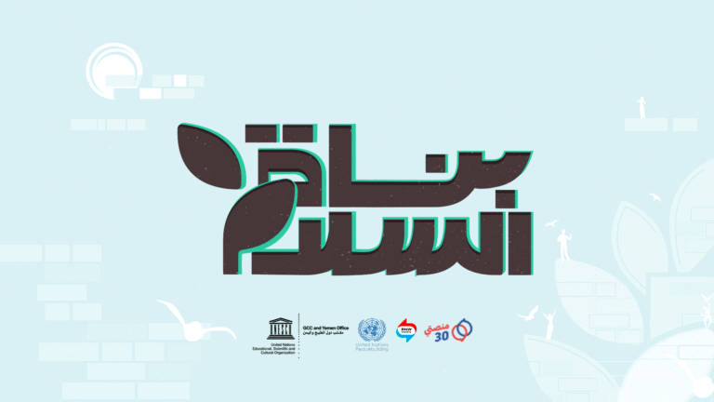
Full Stride, a youth-led initiative based in Taiz, was among the selected winners for the first “My Solution” competition, aiming to support young Yemenis in achieving peace projects in their country through small grants. Full Stride was first launched in January 2019 with the aim of enhancing youth awareness on societal issues and encouraging them to work on community development efforts towards peace and encouraging Youtubers, social media influencers and the youth in Taiz to support peace related topics. As described by one of the social activist and a founding member of the Full Stride initiative, this project was a remarkable changing point in activating the social media scene in Taiz to work towards peace development. The first activity involved selecting 5 Youtubers and 5 social media influencers from a total of 86 applicants who expressed their interests to get trained and film peace related short movies. The selected applicants participated in a 3-days training which enhanced their skills and knowledge on topics such as peace building promotion, sensitivities in digital posting in conflict context, community participation and social engagement. The founder explained that following to the capacity building activity, Full Stride was able to observe growth in the peace related content posted by the Youtubers and social media influencers and also on the level of youth engagement. Subsequently to the training, each Youtuber was matched with a social media influencer to work together on filming a short video on a peace related topic of their choice. Within a week, the young women and men delivered videos on topics such as the inclusion of people with disabilities in the community, fighting bullying and racial discrimination, gender equality and children education in war settings. Then, the 5 videos were posted part of an online competition for the public to vote on their favourite one. A successful engagement rate was noticed with the videos reaching over 7,780 individuals.

The founder highlighted that these activities were the first of their kind in Taiz. He added that participating in “My Solution” allowed Full Stride to grow as an initiative by positively engaging with a larger number of Yemeni youth on important topics contributing to peace development.

PART II: RESULT PROGRESS BY PROJECT OUTCOME

Describe overall progress under each Outcome made during the reporting period (for June reports: January-June; for November reports: January-November; for final reports: full project duration). Do not list individual activities. If the project is starting to make/has made a difference at the outcome level, provide specific evidence for the progress (quantitative and qualitative) and explain how it impacts the broader political and peacebuilding context.

- “On track” refers to the timely completion of outputs as indicated in the workplan.
- “On track with peacebuilding results” refers to higher-level changes in the conflict or peace factors that the project is meant to contribute to. These effects are more likely in mature projects than in newer ones.

If your project has more than four outcomes, contact PBSO for template modification.

Outcome 1: With improved access to information, Yemeni youth better understand the peace building process and their role within this framework

Rate the current status of the outcome progress: On track

Progress summary: (3000 character limit)

In light of the no-cost project extension with additional 6 months, the outcome progresses are on track.

With reference to the capacity building and content creation component, the highlights are:

- 76 (57% females) journalists were trained on peace building (100% of the target);
- A pool of trained journalists established and started creating independent content for the project on peacebuilding related issues;
- 83 pieces of content were published: 23 videos, 8 cartoons, 17 news items, 28 reports, 6 opinion articles and 1 quiz (76% of target);
- 2,573,679 video views that is 132% of the target;
- 80% of website visitors confirm their understanding of the peace building process has improved.
- 55K page views in our website which actually represents 110% of the target

By far, the project page in Manasati30 website contains 119 piece of diverse and high quality content ranging from videos, reports, articles, cartoons and quizzes. All that content is contributing to provide young people an access to information related to the peace building process in Yemen which includes content about peace talks, UN resolutions, major developments, opinions, survey results, stories of peace builders, analysis on Yemen crisis, survival path and rights and concepts. On the website alone, that content has received more than 57K page views with an average time spent per page of 2:16 min. Responding to major developments and events in Yemen related to the peacebuilding process, the team introduced an appropriate content to keep the audience updated with the latest information and give them the opportunity to discuss it. For example, by publishing monthly highlights about subjects such as the issue of IDPS in Marib,or Saudi peace initiative, etc.

This component greatly contributed to have a diversified and inclusive flow of information and to give access to information, especially for youth and women, in line with SDG16.

My solution phase one was successfully completed, with 7 grassroots organizations fully implementing their own designed peacebuilding initiatives. They have organized an online campaign, trainings, debates, interviews with influencers, awareness raising activities on 2250 UN resolution, photography competitions, live events, creating a social experiment and making short films and motion graphic videos. The initiatives ran a successful online campaign on Facebook and Twitter engaging thousands of people, all initiatives used these two hashtags #بُناة_السلام #PBs for their content.
Participating in the award has helped those young peacebuilders expand their skills, and develop further their initiatives, increasing the number of joining members, audience, and impact. j As a reward and to promote their work, five videos on their success stories were produced so far among which four were published, the rest of the videos are expected to be ready by the end of June. The published videos have made 230K views, giving recognition from our audience to those initiatives for their exceptional achievements. Phase II of my solution activity has already started, more than 70 applications from the most active youth initiatives working in peace field all across Yemen were received. Those applications have been sorted and evaluated, in May 23 the 7 winning initiatives were announced.

This initiative greatly contributed to support peacebuilding initiatives led by youth, particularly women, and empower them to effectively participate to the peacebuilding process in Yemen at community level. One of the participants to My Solution stated: "We were entirely depressed and about to give up and freeze all our work, however, winning the award has revived us and gave us the energy to push forward and not to give up. Award is enabling us to work hardly towards peacebuilding"

Indicate any additional analysis on how Gender Equality and Women’s Empowerment and/or Youth Inclusion and Responsiveness has been ensured under this Outcome: (1000 character limit)
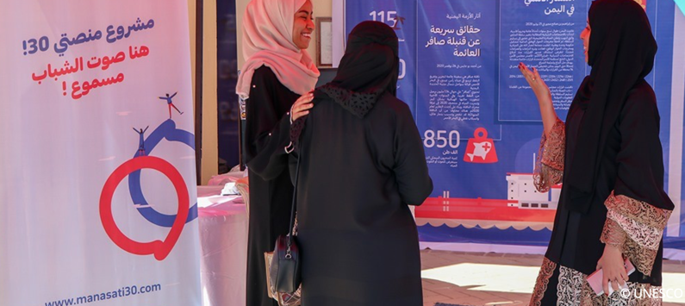
The project seeks to empower young people building on their group needs and interests. The content of the Road to Peace page is entirely produced by young Yemenis. The platform is giving them a space to tell their stories and express their interests and connect with their peers. In this way, we strengthen the narrative telling the youth’s side of the story, which positively affects the inclusion of young people in public life. By analysing data that are continuously extracted from digital media channels, the project identifies trends on what young people are looking for online. Based on these insights, content that meets the actual needs and interests of young Yemeni women and men is created. The project also created personas, fictional characters representing different users, to better understand users’ needs, characteristics, and behaviours. This allows for the creation of content catering to the needs of the different types of audiences.

The project interventions focus particularly on encouraging women to engage online as they face greater challenges accessing and using technology. By now, we tracked positive results on the gender sensitive engagement strategy with an average of 56% of the visitors of the project website being women. Moreover, the My Solution activity which encouraged civil society activists, both women and men, to develop peacebuilding activities and expand their initiatives, has showed high participation of women-led initiatives.

Outcome 2: Safe places of dialogue are created to ensure young Yemeni’s priorities for the peace building process are shared with decision makers and duty bearers

Rate the current status of the outcome progress: On going with some delay

Progress summary: (3000 character limit)

This outcome has been the most affected by the Covid-19 limitations, but significant progresses have been made since the last reporting period by shifting to online modalities.

The Youth Barometer component is gaining ground, with 4 surveys launched, 3 social listening projects carried out, edited in two booklets published online and distributed to over 250 contacts by email, in Yemen and outside Yemen, including decision makers and general public. It is worthy to note that OSESGY was consulted in the design of the surveys and the findings contributed to OSESGY efforts towards consulting youth and women in Yemen. This component directly contributed to create a digital space for expression and dialogue for young Yemenis, but also to inform decision makers on youth priorities and aspirations. "Commenting here and participating in this survey has granted me braveness to say truth as a journalist about the catastrophe we live which gets worse day by day amid the presence of the partnership government. For that matter, there need to be found an appropriate solution to avoid what can be worst", reported one respondent.

With reference to the radio component, excellent progress was made. UNESCO is partnering with Community Media Network (CMN) to support 5 Yemen-based community radios in the production of 140 Radio Programs. In March, a ten-day online training was conducted to build the capacity of 17 radio presenters and journalists (%59 male and %41 female) on radio journalism skills and production. During this period, 24 Radio Programs were aired. The program structure allows collaborative broadcasting to encourage peace discussions among the youth across the country. Moreover, around 200 young Yemeni women and men from different governates, by surveying them, inviting them to engage in the discussions and participating as guest speakers. One of the radio young leader stated: "By inviting both the youth and the decision makers to participate in the radio discussions, we were able to raise the voices of the youth and demand quick solutions to urgent issues. We also invited experts to share accurate and credible information to educate the community and raise their awareness on pressing matters such as COVID-19."

The debate component was originally meant to be implemented offline. Due to the Covid-19 crisis, the project team decided to launch the preparatory work and development of a dedicated toolkit, while postponing its actual implementation. The toolkit for debates was finalized through a work group led by a regional expert. The toolkit has already been adapted for online modalities. The project team decided to have 2 online debates targeting the north, 1 offline debate in Taiz, while assessing the situation to decide how to carry out the other 2 events. Therefore, it is anticipated that by the end of the project, the 5 debates will be implemented, either online or offline.

With regards to the strategic outreach initiative, the original idea was to support participations of young Yemenis to international events related to peacebuilding. Due to the global Covid-19 situation and travel limitations, the project supported online participations of Yemeni young voices to UNESCO led events, such as the MIL Arab Regional Conference and the Regional Arab Panel, part of the global World Press Freedom Day celebration hosted in Namibia in May 2021. Those events offered the venue to young Yemenis to be speakers in international panels discussing hate speech, media freedom and information disorder during Covid 19. Moreover, the network built by the project was invited to attend these events.

Indicate any additional analysis on how Gender Equality and Women’s Empowerment and/or Youth Inclusion and Responsiveness has been ensured under this Outcome: (1000 character limit)

The needs of Yemeni youth, a group that is often left out of the peace discussions and negotiations in Yemen, were identified by consulting directly with Yemeni youth as well as with civil society. The online surveys, social listening research and online conversations are continuously feeding the project team with insights on young people’s needs. The findings are considered carefully by the content team when developing new media stories and visuals, they are shared with decision makers and key stakeholders. This user-centered strategy ensures that all the implemented activities demonstratively meet young people’s needs.
Figures show that young Yemeni women have a lower engagement rate on social media platforms so additional efforts are made to ensure women’s participation, with specific measures to address and tackle gender gaps in online engagement. The project uses SMART targeting and moderation as well as audience segmentation to solely target women in several ads hoping to increase women reach and engagement. Women’s engagement on project social media channels stabilized at 24% by the end of this quarter which is a good percentage if we consider the low percentage of female social media users in Yemen (15%). It is worth mentioning that the women engagement percentage might be higher than registered since many women sign up as males with male nicknames.

PART III: CROSS-CUTTING ISSUES

Monitoring: Please list monitoring activities undertaken in the reporting period (1000 character limit)  The project implemented monitoring tools at activity level. For instance, capacity building initiatives have been monitored through pre and post surveys. Mid-term review to measure impact of the capacity building component is planned and will be carried out in June-July 2021.  In addition, quarterly report assessing advancement of results based on the Result Based Management are produced by RNW Media in consultation with UNESCO. Finally, online sentiment and engagement related to multimedia production are assessed on regular basis. For instance, a poll has been launched to understand if the content produced and published on the project website was found of interest by the users. | Do outcome indicators have baselines? Yes, please refer to part V below  Has the project launched perception surveys or other community-based data collection? Yes, please refer to the “Youth Barometer” component above described.
Evaluation: Has an evaluation been conducted during the reporting period?  No | Evaluation budget (response required): USD 30´000  If project will end in next six months, describe the evaluation preparations (1500 character limit): The team prepared a M&E framework and action plan, with the aim, inter-alia to prepare and collect data for the final project evaluation. In addition, a Request for Proposal for external independent evaluator companies is being drafted and will be published in July 2021 latest. The final evaluation mission is expected to be carried out (online) in October 2021 and the report finalized by end of the project.
Catalytic effects (financial): Indicate name of funding agent and amount of additional non-PBF funding support that has been leveraged by the project. | Name of funder: Amount:  Nothing to report
Other: Are there any other issues concerning project implementation that you want to share, including any capacity needs of the recipient organizations? (1500 character limit) | As above mentioned, the specific fragmented political Yemen context, the political sensitivity of the “peace building” subject, coupled with the Covid-19 outbreak,  negatively affect the project implementation rate during its first year implementation.  The project had to review the sequencing of activities, put on hold in situ activities and/ or shift to online modalities to ensure the principle of no-harm for our staff and beneficiaries. While online modalities have proven to be successful, these modalities require more time to be implemented, especially in Yemen where internet connectivity is a challenge for both beneficiaries and the project team.  While the project has successfully managed to navigate these external circumstances and be able to still implement the result-based framework, the project team and the members of the Steering Committee agreed on the need to have additional time to ensure quality of deliverables. Indeed, the 6 month no-cost extension granted in March 2021 will allow the project to fully achieve expected results.

PART IV: COVID-19
Please respond to these questions if the project underwent any monetary or non-monetary adjustments due to the COVID-19 pandemic.

- Monetary adjustments: Please indicate the total amount in USD of adjustments due to COVID-19:

As for the approved no-cost project extension, approved by PSO on 26 March 2021, the project budget is modified as follow:

- USD 47´000 from Output 1.1. Activity 1.2.1 (line 4-contruactual services) to Output 1.2 Activity 1.2.1 (line 4 contractual services). The amount of USD 47´000 is not used under the activity 1.1.1 as consultations have been carried out online. This underspending could be used under activity 1.2.1 to provide further capacity development to young Yemeni journalists, in line with the project outcomes and outputs.
- USD 20´000 from Output 2.2 Activity 2.2.3 (line 4-contruactual services) to Output 2.4 Activity 2.4.2 (line 4 contractual services). The amount of USD 20´000 is not used under the activity 2.2.3 as consultations have been carried out online. This underspending could be used under activity 2.4.2 to provide further opportunities for Yemeni youth to participate in high-level events related to peace-building dialogue, in line with the project outcomes and outputs.

- Non-monetary adjustments: Please indicate any adjustments to the project which did not have any financial implications:

As for the approved no-cost project extension, approved by PSO on 26 March 2021,
due to the Covid-19 outbreak (first wave-beginning of 2020) and its impact on-inter alia- the original implementation strategy, the project had to review the sequences of activities and put-on hold temporarily the implementation of 4 out of 7 project outputs.

As risk mitigation measures and modality to overcome implementing challenging, the project has relied extensively on digital and online tools. Shifting from off-line to online implementing modalities is ensuring the principle of no-harm for UNESCO staff and project beneficiaries, while supporting implementation of the project, in line with its original results framework. In addition, online modalities are respecting and promoting the innovative digital approach of the project.

In conclusion, online implementing modalities have proven to be a successful, relevant and effective approach to mitigate sanitary and safety risks.However, those modalities require more time to be implemented vis-à-vis offline modalities. In fact, in order to ensure that beneficiaries can fruitfully benefit from and engage in online activities in a country with scarce internet connection, measures shall be taken to ensure full access to internet. Those measures include: minimize duration of online connection for each sub-activity, distribute activities over more number of days, customize learning processes and technical support.
As illustrative example, the consultations with youth and journalists under output 1.1 were implemented through a research rather than a in situ workshop. It required over two months to be completed in quality manner and ensure full inclusion of the target in all 5 governorates, while the originally planned in-situ modality would have allowed for a much quicker completion of the activity (one week). Another example is the training-of-trainer activity, output 1.2. Workshops agenda have been customized for online implementation, per day session duration limited and distributed over two weeks, recorded and shared with participants. In addition, daily follow-up by the trainers have been carried out to ensure that the training material was absorbed by all participants equally. This has allowed to overcome differences in access to internet per governorates and household. However, this resulted in longer timeline for implementation. The same applies to output 2.2 and 2.3.

Therefore, after reviewing the timeline in consultation with UNESCO´s partners, UNESCO believes that a 6-months no-cost extension will allow the project to absorb the implementation delays generated by the outlined external factors and to fully deliver outputs and expected results in line with the originally approved result-based framework and budget.

- Please select all categories which describe the adjustments made to the project (and include details in general sections of this report):

☒ Reinforce crisis management capacities and communications
☐ Ensure inclusive and equitable response and recovery
☐ Strengthen inter-community social cohesion and border management
☒ Counter hate speech and stigmatization and address trauma

☐ Support the SG’s call for a global ceasefire
☐ Other (please describe):

If relevant, please share a COVID-19 success story of this project (i.e. how adjustments of this project made a difference and contributed to a positive response to the pandemic/prevented tensions or violence related to the pandemic etc.)

The project implementation period coincided with the Covid-19 outbreak in Yemen. The Secretary-General, in his message on 18 March 2020 on the COVID-19 pandemic, stated that “we are facing a global health crisis unlike any in the 75-year history of the United Nations, one that is spreading human suffering, infecting the global economy and upending people’s lives”. This unprecedented challenge added an extra layer of complexity to an already very complicated reality.

In line with the project results framework, the team included the Covid-19 outbreak and its impact on the whole Yemeni society as part of the topic tackled by the multimedia production. In fact, the journalists and young people were keen to have better access to Covid-19 related information and the project contributed to have a reliable and unbiased source of information on this matter as well. In addition, the project took a youth-based perspective on the topic and tried to support young Yemeni in navigating the “dis-infodemic” surrounding the actual health pandemic. As an example, the community radio engaged in the production of peace content made by youth for the youth, tackled Covid-19 outbreak, by inviting experts to share accurate and credible information to educate the community and raise their awareness on COVID-19.
Another example is featuring youth based and positive stories on resilience vis-à-vis the pandemic. An exemple is the successful story of a 25-year old engineer from Hadramout who invented a hand-held watch that he hopes can be used to prevent further spread of Covid-19. He named it "Corona cleaned". The watch has a laser detector and alerts the person when he attempts to shake hands with another person or tries to touch his/her face. The watch also has a space to store disinfectant. It discharges disinfectant to the hand at the push of a button. This invention is claimed to be the first of its kind and was registered in Hadhramout Inventions Center. On Manasati30 our Facebook page, his story made 251K views, more than 15K people have directly engaged and 2.2K people have republished the story.
Finally, with the aim of promoting peacebuilding stories and efforts, the project produced 360 degrees virtual reality videos featuring success stories of young Yemenis who were able to overcome difficulties endured due to the ongoing conflict. The videos, which are posted on Manasati30 and shared on their social media platforms, encourage the youth to engage with the peace related videos filmed using the interactive technique. One of them tell the story of Sami and Labib. With the COVID-19 outbreak, Sami and Labib decided to open a cotton factory to support the production of masks and later expanded their production to cotton clothing, employing over 45 women and 15 orphans. Such initiatives support the local economy, empower the youth, and provide them with income-generating sources, contributing to the reduction of the unemployment and the poverty rates.

PART V: INDICATOR BASED PERFORMANCE ASSESSMENT

Using the Project Results Framework as per the approved project document or any amendments- provide an update on the achievement of key indicators at both the outcome and output level in the table below (if your project has more indicators than provided in the table, select the most relevant ones with most relevant progress to highlight). Where it has not been possible to collect data on indicators, state this and provide any explanation. Provide gender and age disaggregated data. (300 characters max per entry)

 | Performance Indicators | Indicator Baseline | End of project Indicator Target | Indicator Milestone | Current indicator progress | Reasons for Variance/ Delay  (if any)
Outcome 1  With improved access to information, Yemeni youth better understand  the peace building process and their role within this framework | Indicator 1.1  Number of page views on the optimized website and content created | 0 | 50,000 |  | 110% (55K page views)  Gender: 56% women, 44% men  Age: 18-30y  Location: 80% inside the country, 20% outside the country.
 | Indicator 1.2  Number of video views on the content created throughout the project | 0 | 300,000 |  | 132%  (2,573,679  video views)
 | Indicator 1.3  % of website visitors with  increased understanding of the peace building  process | 0 | 70% |  | 83%  So far 2,161 users have confirmed it by responding to a poll
Output 1.1  Information  platform developed for  youth to find information  on the peace building  process | Indicator 1.1.1  Number of youth and gender-sensitive content strategies developed | 0 | 1 |  | 1
 | Indicator 1.1.2  New website page created optimized | 0 | 1 |  | 1
 | Indicator 1.1.3  Number of Arabic multimedia materials focused on peacebuilding created | 0 | 14 |  | 14
 | Indicator 1.1.4  Number of views of multimedia content produced | 0 | 50,000 |  | 110% (55K page views)  Gender: 56% women, 44% men  Age: 18-30y  Location: 80% inside the country, 20% outside the country.
Output 1.2  Skills of  young journalists  developed to provide  balanced coverage of the  peace building process for  youth | Indicator 1.2.1  Number of young journalists trained as trainers on reporting on the peace-building process | 0 | 10 |  | 10  60% women
 | Indicator 1.2.2  a) Number of trainings conducted by local trainers;  b) Number of journalists trained to report on the peace-building process | a) 0;  b) 11, | a) 5;  b) 60 |  | a) 5  b) 76  76 (57% females) journalists were trained
 | Indicator 1.2.3  Number of content pieces produced by young journalists via the information platform | 0 | 144 |  | 83  23 videos, 8 cartoons, 17 news items, 28 reports, 6 opinion articles and 1 quiz. Gender sensitive approach used as per editorial guidelines adopted.
Output 1.3  My solution'  video series launched to  showcase success stories  of young Yemeni  peacebuilders | Indicator 1.3.1  Amount of open calls published | 0 | 2 |  | 2  2 open calls.  Age: 18-30y  Governorates*: 4 Sana’a, 4 Aden, 4 Taiz, 4 Hodeida and 4 Hadhramaut
 | Indicator 1.3.2  Number of views for all My Solution videos produced | 0 | 50,000 |  | 230K Views  (of 5 videos produced)
Outcome 2  Safe places of dialogue are created to ensure young Yemeni's priorities  for the peace building process are shared with decision makers and duty bearers | Indicator 2.1  a) Number of youth who participate in the online  surveys;  b) reports shared with decision makers  and duty bearers | a) average of 1,000 per survey;  b) 0 | a) 1,500 per survey;  b) 6 |  | a) 5,246 as total of 4 surveys  b)4
 | Indicator 2.2  a) Number of youth who attend the debates; | a) average of 150 per debate; | a) 200 youth per debate; |  | 0 | This component has been put on hold due to the Covid-19 situation and the sensitivity of the subject, especially in some area of the country. Howevr, risk mitigation measures for both challenges have been identified and planning to implement (mix of online and offline) the component finalized
 | Indicator 2.3  Number of young people  who voice their opinion via community radio  programmes. | 0 | 200 |  | 40 | This component was put on hold due to Covid-19 in the first year of the project. However, since January 2021, the project has launched this stream of work which is now generating concrete outputs and results.
Output 2.1  Yemeni  Youth Barometer' survey  is launched to inform  decision-makers of youth  priorities on peace  building process | Indicator 2.1.1  Number of surveys produced | 0 | 6 |  | 4
 | Indicator 2.1.2  a) Number of surveys launched and promoted online;  b) Number of survey participants who share their priorities;  c) Number of social listening projects conducted | a) 82;  b) average of 1,000 per survey;  c) 0 | a) 6 new surveys;  b) 1,500 responses per survey;  c) 6 |  | - 4  b) 5,246 participated.  (74% men, 26% women)  C) 3
 | Indicator 2.1.3  Number of reports produced | 0 | 6 |  | 3
Output 2.2  Opportunities  for dialogue developed  through youth debates | Indicator 2.2.1  Number of consultation workshops conducted | 0 | 3 |  | 3
 | Indicator 2.2.2  Number of debating toolkits developed | 0 | 1 |  | 1
 | Indicator 2.2.3  Number of youth debates on peace-building conducted | 2 | 7 |  | 2 | This component has been put on hold due to the Covid-19 situation and the sensitivity of the subject, especially in some area of the country. Howevr, risk mitigation measures for both challenges have been identified and planning to implement (mix of online and offline) the component finalized
Output 2.3  Weekly  programmes on network  of community radios for  young people to voice  their opinions on building  process | Indicator 2.3.1  Number of community radio journalists trained | 0 | 10 |  | 17 from (5 Radio stations)  7 were women
 | Indicator 2.3.2  a) Number of radio programmes produced;  b) Number of youth who participate in radio programmes. | a) 0;  b) 0 | a) 140;  b) 200 |  | A) 24  B) 40 | This component was put on hold due to Covid-19 in the first year of the project. However, since January 2021, the project has launched this stream of work which is now generating concrete outputs and results.
 | Indicator 2.3.3  Number of reports summarizing key discussions prepared | 0 | 70 |  | 34 | Ibidem
Output 2.4  Strategic  outreach initiatives  organized for Yemeni  youth to convey their  messages to internationalcommunity and decisionmakers | Indicator 2.4.1  Number of side-events highlighting Yemeni youth voices organized during World Press Freedom Day in 2021 | 0 | 1 |  | 1 | In the context of the Covid-19 pandemic, the WPFD 2021 global conference was held in a hibrid format (off line in Namibia with online participants and events).  As part of the global celebrations and the main event, UNESCO organize a regional virtual panel, drawing from the historical Sana’a declaration on “promoting independent and pluralistic Arab media”. Two young experts from Yemen were invited as speakers to two different panels, respectively: economic viability and hate speech/misinformation. The event took place on 29 April.
 | Indicator 2.4.2  Number of panel discussion organized at high-level peace-building dialogue emphasizing the role of youth | 0 | 1 |  | 0

According to FB statistics in Yemen

