Justice not for all.

Overcoming justice disparity towards children in Yemen.

Gripped by years of militarized conflict, today Yemen’s justice and social systems are in shambles. And just like with the ongoing humanitarian crisis, Yemeni children appear to be the first victims of it.

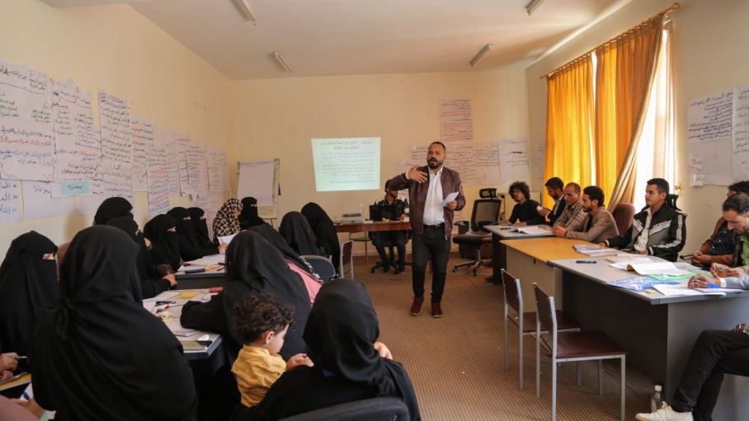
When the justice system does not do its part

Afrah Al-Jarman, a social worker in the Social Guidance Department of the Ministry of Social Affairs and Labour, says: “The challenges and difficulties that we face is that officials in the judiciary system do not understand standard procedures for child justice”.

Even when they have not been accused of a crime, children can end up in detention centers or even prisons together with adults and mature offenders. Simply being a witness or a victim to a crime can lead a child being deemed responsible for an offense. This is particularly common for cases of gender-based or sexual violence, trafficking, and child labor.
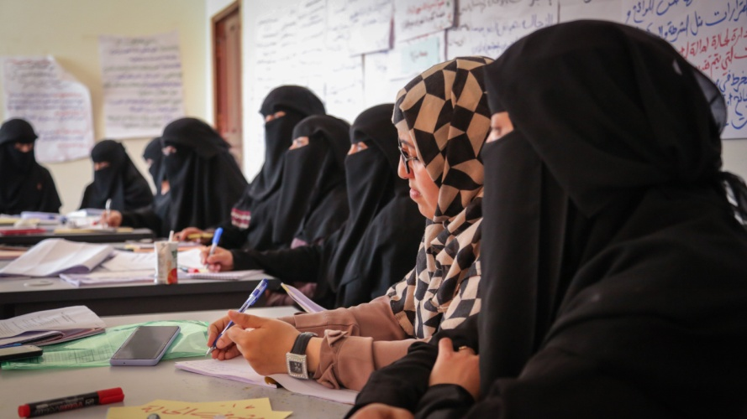The material conditions and psychological environment in detention facilities deprive children from the hope to pursue a healing path and may hinder their physical and mental development.

Changing the system from within

In order to address both the long-standing challenges of the Yemeni justice system and the child-related issues that emerged due to the conflict, UNICEF supports the government and social institutions in promoting children’s rights. UNICEF organizes training courses for social workers in Sana’a city with the aim to change the system’s approach towards children in contact with the law.
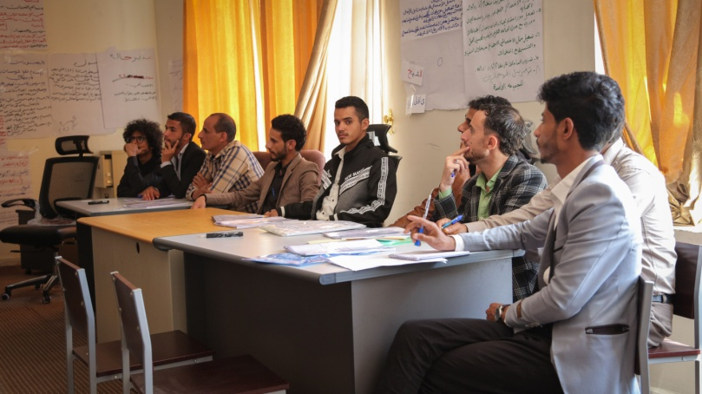
“The training course aims to provide social workers with knowledge of Yemeni and international law on how to deal with children who are in contact with the law”, says Ahmed Noman Saeed Al-Maflahi, one of the key advisors to the courses dedicated to standard procedures in the field of child justice.

The idea of the program is to help social workers raise awareness among local authorities and justice agencies about the urgency and benefits of recognizing peculiarities of law and justice towards children.
“We learned more about the duties of workers in these institutions and how to refer and receive children from one institution to another”, Musaad Mohammed Zain Al-Asfour, a social worker in the Social Guidance Department, says.
Active and efficient communication between officials and social agencies becomes key to successfully overcoming the current crisis. In addition, the course also focuses on the importance of taking into consideration the humanitarian aspect of child-related criminal activity and children’s adaptation to life outside prison walls.

“Some children do not have guarantors for their exit from the home or places of detention. For some of them, we do not know where their families are or their whereabouts; some are unknown, and some are known. In any case, their situation does not allow for integrating the child back into the family,” Ahmed Noman Saeed Al-Maflahi explains.

These factors can explain why children who fall into the vortex of the current justice system have limited chances for a favorable conclusion and a bright future.

While Yemen already faces a whole generation of youth deprived of a healthy and peaceful childhood, criminal activity fueled by despair and injustice could increase further. However, through the successful modernization of the justice system, Yemen can demonstrate its willingness to turn the tide and grant its younger citizens hope for a bright future.

