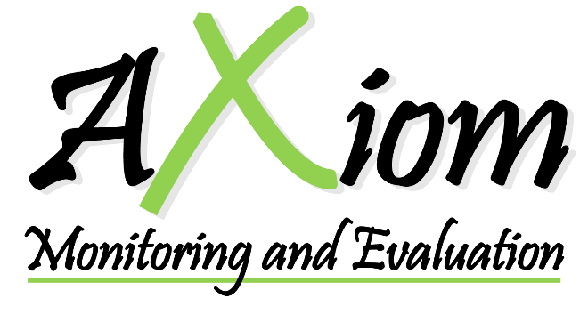

FINAL REPORT

FOR

End-Term Evaluation

OF

Youth Political Empowerment: Enabling Somali young women and men to meaningfully engage in governance, peacebuilding and reconciliation efforts

Draft Report Submission: May 2020
Final report submission: July 2020

Axiom Somalia
TABLE OF CONTENTS
ABBREVIATIONS AND ACRONYMS 3
EXECUTIVE SUMMARY 4
I. INTRODUCTION 6
II. EVALUATION SCOPE AND OBJECTIVES 7
III. METHODOLOGY 8
Qualitative Methods 8
Quantitative methods 8
Limitations 8
IV. OVERALL FINDINGS 9
Relevance of the intervention to the identified needs of the youth in the respective states and within the prevailing political context in Somalia 9
Effectiveness of the approaches employed in the implementation of the action 11
Efficiency of approaches used by the project to deliver the intervention 20
Outcome/Impact 22
Sustainability 27
V. KEY LESSONS/GOOD PRACTICES 28
VI. CONCLUSIONS AND RECOMMENDATIONS 29
ANNEXES 31
ANNEX 1: Case studies 31
ANNEX 2: DOCUMENTS CONSULTED & PERSONS CONSULTED TABLE 34
ANNEX 3: Project’s Results Based Framework 36
ANNEX 4: TERMS OF REFERENCE 40

ABBREVIATIONS AND ACRONYMS
DG Director General
DC District Council
FGD Focus Group Discussion
FGS Federal Government State
FMS Federal Member State
IP Implementing Partner
KII Key Informant Interview
LA Local Authority
MOYS Ministry of Youth and Sports
MP Member of Parliament
PBSO Peacebuilding projects
SPL Somali Peaceline
SWS South West State
TWG Technical Working Group
UNDP United Nations Development Program
UNFPA United Nations Population Fund
UN-HABITAT United Nations Human Settlement Programme
YPE Youth Political Empowerment

EXECUTIVE SUMMARY
The Youth Political Empowerment (YPE) project sought to promote social reconciliation, healing, delivering peace dividends, and improving access to local and national governance structures with a focus on youth political empowerment. The aim was to rebuild a strong state-citizen link by shrinking the top-down between the grassroots community, the civil society and the government.
The evaluation was tasked to assess the project performance and extent to which the objectives and expected accomplishments were achieved. As per the mandate, the emphasis was placed on the relevance of the objectives and activities to the identified needs of the targeted youths, the mechanisms put in place to ensure the sustainability of the results beyond the project period, and opportunities for replication.
A mixed-methods approach was used to conduct the evaluation whereby Key Informant Interviews (KIIs), Case Studies and Perception surveys with 89 respondents across Kismayo, Baidoa and Jowhar were carried out. There were no surveyed respondents in Mogadishu as this was not a core area of project implementation. Nonetheless a few KIIs were conducted in Mogadishu with government officials and governance experts. Other interviewees in the other regions included elders, governance experts, Youth Association members, Youth District Council (DC) members, Youth Forum members, Implementing Partners (IP) and various government representatives in all target districts of Baidoa, Dolow and Kismayo. The key challenge facing the evaluation team was the effects of the COVID-19 pandemic which forced data collection to be conducted on via phone. This had its challenges of high non-response rates as well as time-consumption, as some respondents had a busy schedule, and timing was particularly challenging during the month of Ramadan. There were no Focus Group Discussions (FGDs) conducted as per precautionary measures to avoid crowds as well as ensuring social distancing and safety of local communities and Axiom Somalia staff.
As per the findings, the project was relevant to the youth needs in Baidoa, Kismayo and Dolow. There was however limited effectiveness in the project implementation mainly due to the timeframe, geographical scope, number of activities as well as unexpected challenges. Nonetheless the evaluation commends the project for laying a solid foundation for future work on ensuring youth inclusion in political decision making.
The key achievements of the project include: conducting 11 youth campaigns that reached about 2,175 youth and achieving social media engagement of approximately 165,000. There were also successful youth capacity building on Communicating for Impact, Social media training, Leadership and Management cumulatively having 217 attendees. The project ensured greater women participation and inclusion in political activities. District Councils were set up in all three districts. Training manuals on leadership, peacebuilding and governance for youth were developed. 6 position papers were also developed on peace and security. Through the project’s efforts, there was also an overall sense of increased confidence of youth to take up political activities.
Comparison of baseline and endline indicators shows that majority of the indicators were achieved and met the target. One of the key improvements that is notably visible from the findings is on Indicator 1.1 where the number of young men and women from the districts who participated in parliament increased by 45% in SWS. Furthermore 99% of youth respondents felt that they are appropriately represented in political positions up from 69% at baseline. In reference to Indicator 1.2, 90% of beneficiaries from all districts also felt that their inputs translated into concrete policies or actions this is a great achievement in comparison to the 50% project target and 39% at baseline. With regards to Outcome 2, youth policies were developed, 12 intergenerational dialogue forums held that engaged up to 1,070 people with 88% of these being women. 84% of respondents strongly agreed that men and women of all ages benefit from open dialogues on peace, security and social issues up from 35% at baseline. Furthermore, due to project activities, 84% of youth also felt that they can consult the MPs to give their inputs on policy decision which higher than the 50% which was set as the target and 24% at baseline. The number of youth fellows embedded in local administrations was achieved as the project successful hired 12 youth fellows
There were key lessons learnt in the area of project planning to potentially cater for time delays that were experienced by the project due to political tension. There should also have been better organisation in the form of putting in place practical sustainable measures including management and monitoring of continuing activities. In this regard the project is limited in its sustainability particularly with regards to continued campaigns, dialogues and support from governance experts as these areas require heavy financial support that is currently lacking at both federal and state level.
As such some of the key recommendations from the evaluation are as follows:
- Provision of more representation for the youth (FMS and FGS) during the next elections as well as the constitutional review process. There should be consultation forums conducted in the communities. The inclusion should also ensure vulnerable groups such as youth with disabilities are included.
- Creation of employment and income generation streams for youth: This was stated as one of the key needs in Somalia. The government should help in providing investment areas, employment opportunities, microfinance projects and vocational centers to help keep youth engaged in positive activities and thus avoid vices. The income generated will be able to support their campaign needs as well as promote economic development.
- Increase in intergenerational dialogues conducted at least monthly to ensure that elders understand and support youth in their political ambitions. It will also be part of a gradual handover and increase in trust from elders to youth.
- MOYS requires financial support to ensure quality trainings are offered to youth. There is also a need to monitor this support to ensure it is continued. There should also be budgetary support accompanying youth policy discussions and implementation.
- Civic education: There should be more forums to educate the youth about their rights and the privileges of participating in the constitutional review process to address the issues that affect. More copies of the constitution should be printed and distributed in public libraries and universities/colleges for youth to read and understand their rights and the proposed law amendments
- Extend project coverage: The project should extend to all districts of the regional state to ensure more cohesiveness of the project. There is a need to also continue support in Baidoa, Dolow and Kismayo to ensure the youth are more skilled and better organized. With this, there should be enhanced youth links across states in Somalia
- Greater emphasis on women inclusion: The project should ensure that there are means to ensure information sharing reaches youth in all areas. There should also be specific opportunities for women capacity building programs to lobby for their rights. There are opportunities for media to have programs to cater to this.
- Streamlining and formalizing systems which should be mainstreamed across governance projects: some systems, notably the youth parliament, advisory boards, and youth districts councils are in place and should be the starting point for projects aiming to strengthen governance at district and state level. It would be important for future projects to use what is already existing and build capacity of existing systems, with the ultimate goal of creating formal systems.

INTRODUCTION
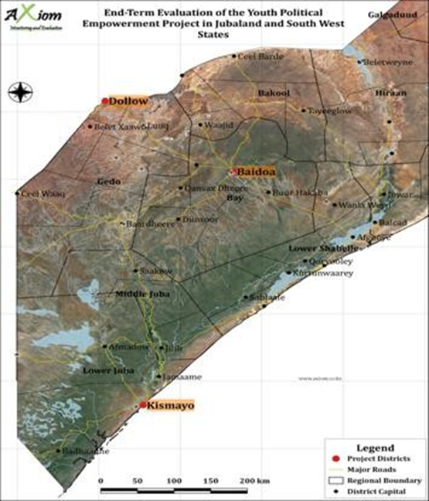
Youth make up more than two-thirds of the Somalia population. More precisely, 81.5% of the population is below the age of 35. Given the challenges faced by the youth economically as well as politically, there are susceptible to joining militant groups. The challenges faced by the youth and their high number have put a direct link to the emergence of armed militia in the country. This therefore, underscores the importance of youth in political involvement and peacebuilding of the country.
Resolution 2250 adopted On December 9, 2015, by the UNSC urged for the inclusion of youth to peace and security processes. Additionally, the inclusion of youth to peace processes also provided a holistic definition of peacebuilding. Sustainable peace as defined by the UN in 2007 is attained by employing activities to reduce the risk of lapsing or relapsing into conflict by strengthening national capacities at all levels for conflict management. This was later revised in 2018 through the adoption of resolution 2419 which recognizes the positive role the youth can play in negotiating and implementing peace agreements and conflict prevention. This was also published in the joint UN–World Bank report which emphasized adopting a people-centered approach which mainstreams citizen engagement to empower marginalized groups such as women and youth.
The involvement of youth in violent organizations in Africa in general and Somalia specifically have been documented in the 2017 UNDP report. There is a high level of discontent towards leaders who are seen as out of touch with current realities. This is further worsened in Somalia given the cultural context where women and youth are extremely marginalized and men, especially elders are revered. The pervasive inability to provide services and a conducive environment for individuals and especially the youth to prosper make the Youth Political Empowerment project relevant. The project is also in step with the 2017 launch of the Somali National Youth Policy, which indicates a recognition by the government of the potential capabilities of the youth towards a better Somalia. While armed militia provides an easy and sometimes involuntary access to youth, Somali youth have been on the frontlines of political shifts in the country for better or worse. While the armed militia has strong youth ties and with the name translating to the youth, the Somali Youth League was established by 13 youth activist who protested for the rights of the country on its way to independence in 1960.
Dealing with the dichotomy of conflict on one end and striving for peace on the other, the challenges are many and dynamic making peacebuilding in Somalia multifaceted and requiring multidisciplinary approaches. Peacebuilding projects (PBSO) have focused on rule of law; reconciliation and local governance building; community engagement and governance and inclusion and women engagement. The Youth Political Empowerment project sought to build on these projects by promoting social reconciliation, healing, delivering peace dividends, and improving access to local and national governance structures with a focus on youth. The aim was to rebuild a strong state-citizen link by shrinking the top-down between the grassroots community, the civil society and the government.

II. EVALUATION SCOPE AND OBJECTIVES
This evaluation was intended to assess the project performance and extent to which the objectives and expected accomplishments were achieved. Emphasis was placed on the relevance of the objectives and activities to the identified needs of the targeted youths, the mechanisms put in place to ensure the sustainability of the results beyond the project period, and opportunities for replication.

The scope of the evaluation comprehensively covered all outputs, and outcomes as outlined in the project log-frame, drawing comparisons on the changes from the findings in the project baseline report. Key objectives of the evaluation are:
- To assess the design, implementation and achievement of the results at the output and outcome level of the Project. This will entail the analysis of actual versus expected results achieved as per the project logical framework.
- To assess the effectiveness of the approaches employed in the implementation of the action including contents and quality of project plans, organization and project management.
- To assess the efficiency of approaches used by the project to deliver the intervention within the stipulated timelines and outline how the risks and assumptions of the project were addressed.
- To assess the relevance of the intervention to the identified needs of the youth in the respective states and within the prevailing political context in Somalia.
- Identify and assess mechanisms to put in place to ensure project sustainability and provide guidance on the potential and requirements for sustainability beyond the project period.
- Taking into account that this intervention is intended to inform the wider stakeholders on the engagement of youths in the political debate, identify lessons learned and provide recommendations for improving future in youth empowerment actions in Somalia.

III. METHODOLOGY
Axiom Somalia in coordination with UN Habitat employed a mixed-method approach, combining quantitative and qualitative data collection techniques. This included KIIs, Case Studies and Perception Surveys. Data collection took place within the month of May 2020.

Qualitative Methods
KIIs were conducted using purposive sampling to identify the respondents through the contact list issued by UN-Habitat. KIIs were conducted with the following stakeholders:
- Government: Ministry of Youth and Sports and local government representative
- Project staff: staff from UN-Habitat and UNFPA
- Youth bodies: Youth Association, Youth council leaders, Y-Peer Network
- Experts: Governance experts/Youth fellows
- Youth beneficiaries: young Somali men and women in the communities.
- Elders (women and men): older generations in the target communities.
Some of the direct quotes from the KIIs are used in the report to highlight specific points however the conclusions and findings are through the analysis of all data i.e. qualitative and quantitative.
Case studies: were collected in each of the districts with youth to capture the changes in their lives and obtain fist hand account of their experiences and hopes for the future. The youth selected for the case studies were members of the youth associations or leaders in the youth councils and their stories are used in this report to highlight the journeys of some of the project beneficiaries.

Quantitative methods
Perception surveys: were conducted to gather the roles and level of inclusion of youth, as well as the relationship between different groups, most importantly elders, government and youth. Having already used this survey for the baseline, at end line, the team replicated the same perception survey delivered to a similar group of respondents. The survey was delivered through a call centre.
87 respondents were reached by the survey i.e. Baidoa-23; Kismayo-36 and Dolow-28. 70% of all the respondents were male while 30% were female. There were no surveyed respondents in Mogadishu as this was not a core area of project implementation. The surveyed respondents were made up of 62% unemployed; 33% employed and 5% in temporary jobs or actively searching for employment. 61% of the respondents had completed secondary school education while 31% had studied up to primary school level. Only 3% of the interviewees had tertiary education and 5% had undergone only vocational training.
Table 1: Data Collection Plan
 | BAIDOA | KISMAYO | DOLOW | MOGADISHU | TOTAL
KII | 19 | 21 | 11 | 5 | 56
Case Study | 1 | 1 | 1 | - | 3
Perception Survey | 23 | 36 | 28 | - | 87

Limitations
The main challenge encountered was reaching respondents on the phone. There were numerous instances of network challenges (poor network), call dropping, caller unavailability or postponement of the interview in vain. Some of the interviewees had travelled out of the country while a few of the phone numbers shared were also incorrect or belonged to other community members who were not the project target. Furthermore, as the data collection period was during Ramadan, respondents preferred to be interviewed after iftar. Some of the respondents such as the local authority in Baidoa also noted that he had only been recently appointed therefore did not have much information to provide for the evaluation. Due to the effects of the COVID-19 pandemic, the team was unable to conduct physical FGDs. There were also challenges holding them virtually due to the high rate of non-response. As a replacement 8 additional KIIs were conducted with beneficiaries.

IV. OVERALL FINDINGS
From the evaluation findings, the project was seen as relevant to the youth needs in the target areas. There was an overall perception that the project was effective though limited in various ways including physical scope/reach and financial support. Many challenges came about some of which were beyond the control of the project for instance, the tension between FGS and FMS which limited the project effectiveness. There were however other areas such as non-payment of youth participants which was later addressed by the project after the evaluation visit. With regards to sustainability the project has had limited areas where proper sustainability, measures were put in place. Core activities such as awareness sessions and programming are said to continue however ultimately the financial resources may limit their adequacy. The following sections breakdown the core findings in detail.

Relevance of the intervention to the identified needs of the youth in the respective states and within the prevailing political context in Somalia
The core needs for youth in Somalia across the three districts were mentioned as security, peace and stability. Religious leaders in Kismayo noted that as there are some areas which were still under armed militia control such as Afmadow and Dolow. There were reportedly numerous cases of youth radicalisation therefore youth could fear and lose the support of public figures. Youth were also unable to create strong connections with their counterparts in the districts controlled by the terror groups which might affect their political ambitions.
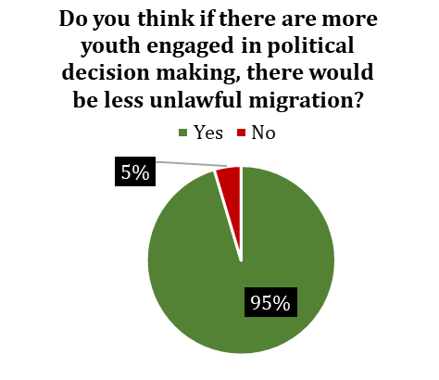  Figure 1: General perceptions on increased youth participation in political decision making | “Young people through a myriad of consultations have said that they don’t feel like they are a part of the systems which govern them and as a result turn to either joining extremist groups to gain some sort of agency or take perilous journeys to seek more fulfilling lives through tahrib”  Project Staff
According to elders interviewed, the main issues facing the youth are: high unemployment rates that lead to lack of money to sustain themselves; lack of access to education opportunities to improve themselves and acquire skills as well as lack of political participation rights and privileges.
In Baidoa youth faced a myriad of challenges mainly due to political unrest in the community. They lack political empowerment since they have not been nurtured to debate and deliberate on current issues. They also lack confidence and exposure to political processes which makes them miss out on opportunities to represent others in parliament and government processes. In addition, religious leaders noted that due to poverty and unemployment they are more vulnerable recruitment by non – state armed groups. The evaluation also found that youth also face insufficient government support as there are no special programs which are facilitated by the government to specifically empower and advance their interests.
Throughout Somalia, the 4.5 clan system was reported to be a hindrance for youth participation in politics as most of the decisions are made by elders. Elders mostly based their political decisions on financial capability, experience and age of the political aspirant hence the youth have low chances to be selected. Youth engagement was viewed as important as it diverts their attention from negative clan issues and enticement by militant groups towards meaningful and productive activities in the communities. This improves the quality of coexistence in the community as youth are occupied in constructive activities. As a result of the project, more youth contributed to social issues i.e. health-related awareness campaigns especially during the COVID-19 pandemic, participating in fundraising activities to help those affected by floods.
The Chairman of the Kismayo District Youth Council noted that more than 75% of the population is youth and therefore they had the right to participate in political decision making. He also added that the inclusivity of the youth in the political decision-making process would help protect their rights as well as enhance the overall development of the country. The project was reported to have helped the youth build the country positively instead of them joining militant groups.
In Dolow, the YPE project was relevant as the youth were getting a chance to decide their interests both politically and economically. One youth interviewed in Dolow noted that the inclusiveness in decision making will allow them to exercise their right to vote. This also means that youth can vote for the candidate of their wish and it also gives them that hope that any youth can be a leader The most important political processes according to respondents are the local council and parliamentary regional state elections. Youth participated in the parliamentary political elections. This was complemented by the support accorded by community elders.
The project was able to support youth with leadership skills before the Jubaland election which in part contributed to more youth being elected into legislative positions. 15 youth were elected as MPs. There were also approximately 10 women elected as MPs. A youth policy was developed to create economic and political opportunities for the youth, and this policy is still awaiting approval in Parliament. The electoral process committee included 7 members in total for the first time included 3 youth (2 men and 1 woman). The members were involved in overseeing the last elections. There were also various vacancies for Director Generals and other directors that were taken up by youth in ministries.
In Kismayo, the project notably improved the cooperation between government and youth. The awareness created by the project enabled better communication between the two parties and as such there was also a sense of peace-building. In Baidoa, the relationship between the youth and the government both at district and state level also improved this was because of the establishment of youth associations. The youth also received support from the government to engage in political processes in the country. In Dollow, the relationship between the youth and the government also improved in comparison to the previous year. This was acknowledged by many participants including youth and elders. This improvement was attributed to the government officials close working relationship with the youth and participation during youth discussions. As a result of the involvement of more youth in leadership positions such as district leaders as well helped improve the relationship between the youth and the government.
The project supported the Somalia National Development Plan and government priorities by enhancing collaboration and integration between leading authorities, elders and youth. A dialogue was held for the aforementioned parties where the key areas discussed included reconciliation and peacebuilding. Capacity building for the youth was also carried out and forums/workshops were held to discuss peacebuilding. The youth conducted social awareness campaigns after the workshops where they emphasized the importance of peace and stability and invited all the members of the community to participate.
"I am really happy with my level of engagement of the project. My role was mobilizing the youth for example, as a committee of mobilizing the youth we arranged sports activities and I participated awareness for encouraging youth to participate in the politics of the country."
Dolow Youth Council Member
MOYS staff affirmed that the project was relevant to key government priorities and in line with the Somali National Development Plans, since government priorities sought to encourage the participation of youth in politics, include youth in decision-making processes and state-building, in parliament elections and District Councils (DCs).
As per the bar graph below the top ranked challenge by youth was lack of knowledge of political processes hence emphasising the need for civic education. It should also be noted that 83% of the respondents stated that they had read the constitution and another 87% expressed that they would like to be involved in the constitutional review process. Interestingly, security which was the main challenge in Dolow overall was not considered one of the top challenges for youth to participate in politics.
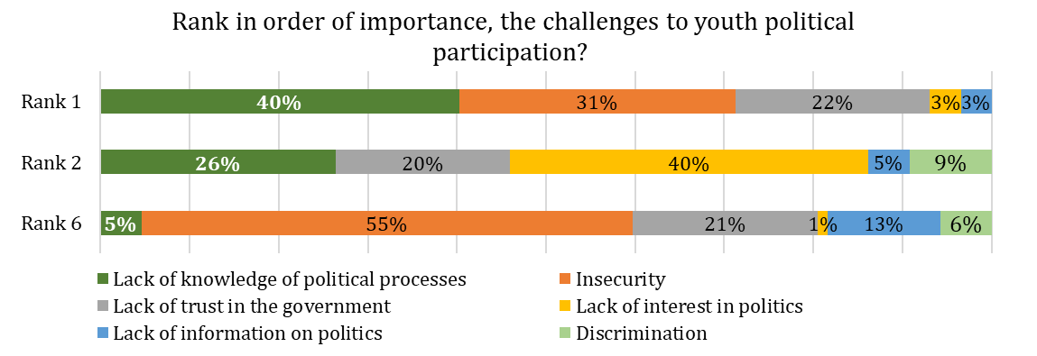
Figure 2 Challenges faced by youth in order of importance

Effectiveness of the approaches employed in the implementation of the action
Outcome 1: Young men and women can effectively participate in decision-making processes in Baidoa, Dolow and Kismayo districts and South West and Jubaland State levels by the end of the project
93% of the survey respondent felt that the YPE project has been effective. The project enabled educated youth to feel empowered and encouraged to be involved in politics. The project was able to coordinate youth meetings such as in Dolow where there were discussions on the constitutional review. Some key issues highlighted were the need to increase the women ratio in parliament from 24% to at least 30%. The youth were also asking for a 40% representation in the senate. The meeting included government representatives who noted the suggestions. Governance experts also agreed that there was political inclusivity encouraged by the project. There was however minimal inclusion with regards to people with disability.
49% of the 87 respondents interviewed mentioned that they had participated in some form of political engagement in the last year as compared to 29% at baseline. In Baidoa 74% of respondents confirmed participation in political activities which was a slight improvement from 68% at baseline. In Kismayo the youth participation improved from 9% to 64% while in Dolow there was a slight decrease from 14% to 11%. 71% of the survey respondents noted that they had been engaged in some form of capacity building in the past 4 months up from 26% at baseline.
The engagement of youth groups such as YPEER and SPL were also credited to have contributed to the improvement in youth participation. According to one of the elders interviewed in Kismayo, the Jubaland Youth Association helped to advocate for youth rights and encouraging them to work with the community for communal goals including security. The governance expert noted that the youth groups and associations act as avenues of communication from the government to the youth and vice versa. Through the project youth were included in the operationalization of the youth policy at the state level in Jubaland, they were consulted in the Roadmap on Youth Engagement.
- Awareness sessions and Media campaigns
There were 3 awareness sessions held in Kismayo. These were highlighted as the most effective means of encouraging and capturing the majority of the youth to participate in politics. Media such as televisions (Jubaland TV), radios and newspapers were integral in terms of providing information to diaspora Somalis. Social media was also a core tool to help promote youth political engagement.
Radio stations such as Radio Kismayo, Radio Muqdisho, Radio Wamo and Star FM aired programs on youth participation in politics as well as the importance of youth contribution towards peace and security in the town. Radio programs such as ‘Youth Awareness’ also sensitised youth to cease drug use and participation smuggling of drugs into the country. Another program that was aired was 'Encouraging participation of youth in politics' which was discussed on both TV and YouTube channels. The programmes engaged the audience on topics such as the role of the youth in decision- making processes, the role of the youth in peacebuilding and conflict resolution. The programs also encouraged the community and elders to support the youth in these processes and talked about the position of women in politics which was a taboo for the past years. It was conveyed that social awareness programmes were the most beneficial because the programme revealed the current political status in the district.
During the project implementation, there were radio shows that aired debates by youth participants who engaged in various topics on politics. The campaigns were successful as numerous social media pages were opened for and by Kismayo youth afterwards to enhance knowledge sharing and express political ambitions.
Though the youth fellows interviewed in Kismayo reported that they did not enjoy using radio and TV as broadcast channels, they were open to use them again as they reached a wide variety of communities. Across all districts, 86% of the respondents surveyed mentioned that they preferred radio to engage in politics. Only 11% preferred social media while 3% preferred the use of TV. In Dolow on the other hand, 71% of the survey respondents preferred the use of social media as compared to 25% and 4% who preferred the use of radio and TV respectively. Some of the TV stations used were Somali National TV and Southwest TV. Lastly in Baidoa 65% of respondents preferred use of radio while 35% opted for social media. It was therefore unanimously agreed across all districts as per the below graphs that the use of radio and social media and radio was effective to create awareness and a space for dialogue on youth issues.
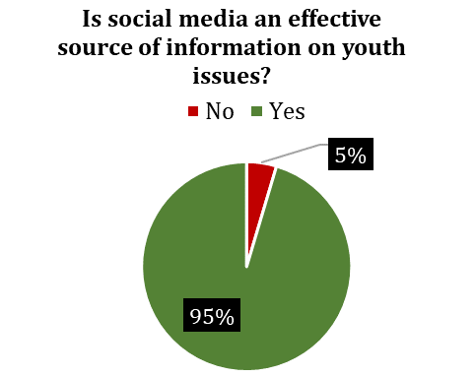  Figure 3 Social media effectiveness as media for youth | 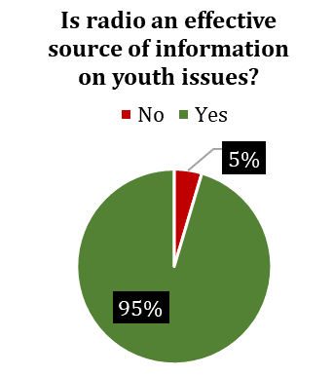  Figure 4 Radio effectiveness as media for youth
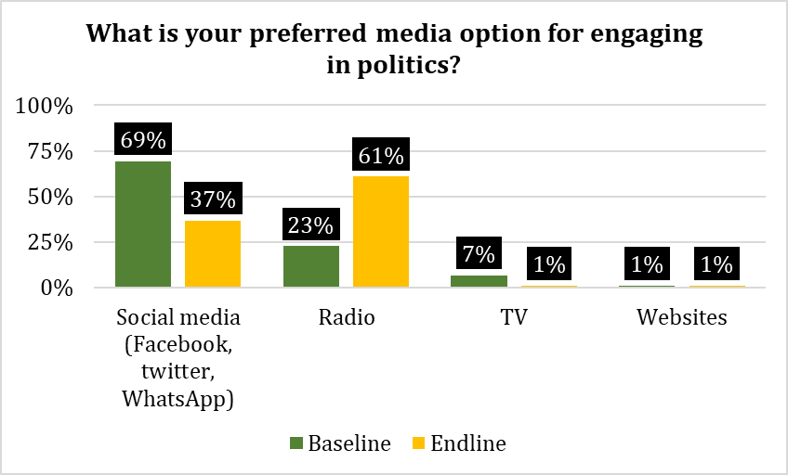

Figure 5: Preferred media options for youth engagement in political activities
A per Figures 3-5 above, social media and radio were effective means of youth engagement. Nonetheless from Figure 5 the preferred media at endline was radio as compared to social media at baseline. Youth in all target project areas mentioned that Facebook was more widely used than any other social media platforms. One of the pages mentioned was ’Fba Socdal’ where youth post issues affecting other youth as well as encouragement. Though participation through social media particularly Twitter has led to more conversations, there is need for monitoring to ensure relevant topics are discussed and sustained in the long term. The below is a summary of reach from the project annual progress report in addition to statistics from YPEER Director.
Table 2: Total number of people reached per activity
ACTIVITY | NO. OF PEOPLE REACHED
Radio programs aired | 170
Radio engagement | Kismayo: 150,000 Baidoa: 70,000 Total: 220,000
Social media engagement (Jan – Dec 2019) | Twitter reach - 110,332  Facebook reach – 54,294  YouTube reach - 297 (December only)
Social media training | Kismayo: 23 Dolow: 25
Total number of blogs | Kismayo: 20 Baidoa: 15 Dolow: 10 Total: 45
Short videos | 22
Youth Campaigns | 11 campaigns: 2,175 youth reached (Kismayo:850 Baidoa:800 and Dolow:525)
Youth forums | 3 in Baidoa and Dolow: 160 people reached
Some of the successes that came about as a result of the social media campaigns was the freeing of the Deputy Minister of Security. Furthermore, social media helped the youth campaigns for the election. The YPEER Director also noted that voter turnout could be increased through the use of mass media. The government was also challenged to ensure that leaders vote in their home areas. The Executive Director SOYVA as well as youth fellows in all areas felt that the campaigns truly enhanced and improved youth political empowerment. It was particularly noted by youth fellows in Kismayo that youth opted to use social media to solve problems and tensions in their communities.
“In my opinion, social media campaigns were successful because they helped the youth to communicate the government by posting their campaigns on social media. Majority of the youth participated in these campaigns. The campaigns that we conduct in the media is encouraging the youth to participate in the political process. I believe this campaign enhanced and improved youth political empowerment.”
Dolow Youth Fellow

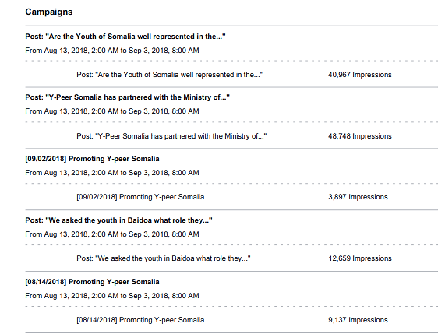
Figure 6 Social media reach as captured through post reach (impressions) between August 13th and September 3rd 2018
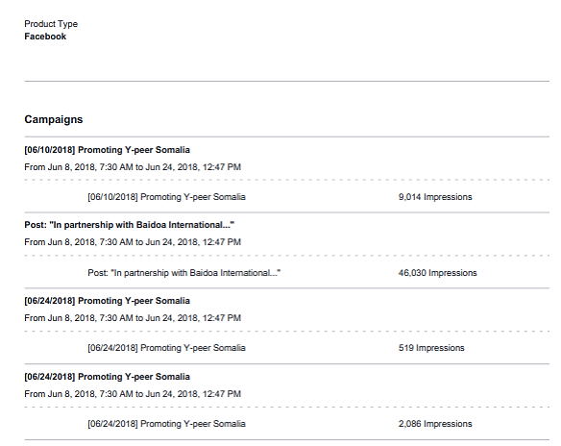
Figure 7 Facebook reach as captured through post reach (impressions) between June 8th and June 24th 2018

- Youth trainings
The project supported youth trainings on integration, leadership and decision making. 8 governance experts were trained. The governance experts were placed so as to help youth be aware of opportunities for participation and therefore support by creation of platforms for dialogue. 90% of the respondents surveyed mentioned that they had received training in the last 1 year.
The project set to develop training manuals on communication, power sources, decision making, policy making and leadership. The manual was developed to capacitate governance experts in the project who were subsequently to train youth councils and youth organizations. A training manual on ‘Communicating for Impact’ was also developed. The manual was divided into segments including Conflict Analysis, Effective Communication, Resilience and Advocacy.
30 participants from Baidoa, Dolow, Kismayo, North Galkayo and South Galkayo received a training on ‘Communication for Impact’ which was held in Mogadishu. In addition, a 3-day training was also held in Kismayo on ‘Communication for impact’ where participants learnt youth leadership and conflict analysis, effective communication and resilience. 23 participants from Baidoa benefitted from a 5-day training which focused on Conflict Analysis, Effective Communication, Resilience and Advocacy. In Baidoa, 50 people (30 men and 20 women) received a four-day training on how youth can participate in political affairs while 100 were trained on the role of youth in politics.
An additional, 20 participants from Dolow, 21 from Kismayo and 22 from Baidoa received a 3-day training on office management and leadership where they were trained on office management and communication channels, filing systems, networking, team building, contract laws and norms of the public and private sectors. A capacity assessment was conducted to determine suitable youth networks which lack office furniture. After the trainings, the South West Youth Council and Jubaland Youth Union were provided with office furniture such as chairs and tables, office stationaries and IT hardware such as desktop computers, printer.
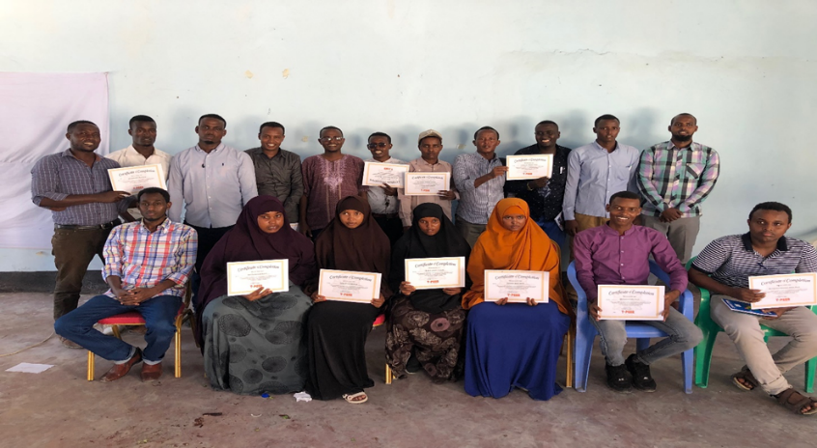
Figure 8 Youth in Kismayo awarded certificates at the completion of management and leadership training
There were however complaints that the duration set for all the trainings received was short as some members only engaged in 1-day sessions while none of the respondents mentioned any training that lasted a week. The total number of youth trainees in Kismayo were reported as per the table 3 below: :
Table 3: Total attendees for trainings in Kismayo
TRAINING | TOTAL ATTENDEES
Youth Integration | 60
Leadership | 25
Decision making | 30
Office Management | 25
Communication | 25
Policymaking | 25
Reconciliation | 29
Overall, as noted by the DG MOYS, the trainings were particularly useful in that they enabled women to become more knowledgeable and aware of various concepts where they have been side-lined. Governance experts who received Training of Trainers on youth empowerment were able to apply their trainings to develop youth policies and strategies. The Youth District Council was able to practice their trained knowledge while presenting their political ambitions to the community and federal government. Feedback from elders and religious leader showed that the trainings were also core in encouraging the youth and boosting their confidence to vocalise themselves in various political forums.
The youth fellows and governance experts noted that the trainings also supported the youth to have better coordination with the government. Due to improved communication skills particularly the youth who benefitted from trainings were perceived to be more assertive in networking with other political stakeholders including other youth association leaders thus enabling knowledge transfer across districts and states. It was also noted that the trainings were useful for youth when they mobilised youth to conduct awareness sessions within their communities. A key result of the trainings was that many more youth vied and were successful in joining parliament. Management capacity of Youth Associations also improved due to the capacity building trainings offered to youth members.
- Intergenerational dialogues
There were intergenerational dialogue forums held where different community groups assembled to interact and discuss with the youth including women on their political participation. 70% of the surveyed respondents reported in the three districts they were involved in dialogue with elders and another 70% concurred that dialogue was an effective way to engage with elders. Though at baseline 86% of youth felt that they were listened to and understood by elders this figure improved to 99% at endline.
The forums were found to have enhanced better decision making on politics as a way forward for youth to consult elders. One of the elders interviewed in Kismayo noted that before the project the elders were indeed unwilling to trust youth with leadership positions. The project, however, changed this and now there is a higher level of trust from the elders. The elders said that they could now better appreciate the role of youth in political decision making. The elders also credited the youth as having fresh minds with new and innovative ideas on how to tackle the country’s problems that hinder growth and stability. 89% of the survey respondents strongly agreed that elders trust youth to be effective political leaders. The Lifeline Executive Director however reported that the elders did not appreciate the political campaigns conducted by the youth as it resulted in less parliamentary seats for the elders. The Evaluation notes that the elders still wanted to control political undertakings even though youth were more involved.
Despite the improvements in level of trust and confident between elders and youth, some of the interviewed felt that elders were not yet fully supportive of women involvement in politics. Religious leaders also concurred that before the project, elders did not believe that youth could participate in politics because of their potential involvement in militant activities, lack of experience, ignorance as well as poor educational attainment. Through the project dialogues, elders were able to see that youth are educated and have a capability to be involved in politics for peace and stability. 97% of the youth surveyed agreed that youth have improved capacity to engage in politics. However, negative opinions remained, as some survey respondents felt that there is corruption in political processes .It was also suggested that youth be capacitated with conflict management skills to assist in case of any conflicts between youth and elders.
“The community elders’ relationship with youth members is improving year after year and elders are willing to give more space to youth in political participation.”
Elder, Kismayo
- Participation in the constitutional review process
The YPE project has proven to be effective in achieving youth inclusiveness in the electoral process, the constitution review process, DC formation and urban development. In the electoral process, the youth actively participated in the parliamentary election of the state and managed to get the majority of the seats i.e. approximately 70% of the seats. The DC empowered youth on future participation in politics. The youth were trained to strengthen their role in politics.
Youth participated in the constitutional reviews where they expressed their opinions on the process and document accordingly. The youth proposed some articles that might protect their needs e.g. the age which the youth can participate in parliamentary elections. In this regard, 25 years was the minimum age that was suggested. The youth also asked to participate in the DC elections to ensure the needs of the youth are met during the election. The DC has 21 members. The youth proposed to be allocated 13 seats which is more than 60% of the total number.
- Women participation
The project staff reported that there was high level of push back in having women inclusion as a priority specifically at the State level. Some of the youth respondents felt that young women were not appropriately represented in the government because their numbers did not reach the 30% representation assigned for women. Capacity building for young women was mentioned as a key as there were few women eligible to participate in the elections mainly due to lack of education. One of the youth council members noted that elders do not encourage women to participate in politics however there needs to be a way to change this mindset. Nonetheless organizations such as Lifeline noted that after the project interventions, they recruited 11 more female members up from 2.
One of the youth DC members interviewed noted that there were many calls made by community, civil societies, local NGOs and the UN for gender inclusion. Due to this push, the government has increased roles for women though this majorly remain as low-level positions.
“There is increased women representation in Federal Parliament, this is to be applauded, but whether this can be translated into decision making power I believe is yet to be determined. Women’s voices are not as amplified and heard as required, more needs to be done to empower women other than adhering to representation quotas.”
Project Staff
- Role of the Youth Associations and Forums
From the evaluation survey 67% of the respondents were Youth Association members as compared to 59% during the baseline. At endline, 88% of these had been members for 1-3 years and only 12% had been members for 3 – 5 years these figures were 71% and 12% at baseline respectively. It was reported that while some of the Youth Associations worked well not all did so. The Youth Associations were noted to not have been working effectively particularly with regards to communication including reporting channels. Nonetheless, through the project the Youth Associations helped to mobilize youth for workshops and awareness campaigns. Youth council members and fellows interviewed in Dolow felt that Youth Associations were not effective in lobbying for youth issues. The main reason stated for this was that they were unable to cater financially for youth political participation. Another main challenge pointed out was that Youth Associations were registered but lacked a physical office and adequate skills. As a result of this, Dolow youth felt that the DC was more effective in lobbying for youth needs.
DCs formed in Baidoa conducted social awareness sessions aimed at transforming the attitudes of the community and increase in youth participation in politics particularly women. The DCs lobbied for their participation through holding dialogues with elders and youth to break barriers which hinder their active participation in political processes of the country. The council was viewed as useful to champion the necessary changes despite lacking equipment and sufficient financial support to conduct awareness sessions. 65% of the surveyed project participants noted that lack of capital was the main challenge facing the effectiveness of youth councils and forums. 23% felt that lack of management was the key gap while 10% were of the opinion that the local youth organisations lacked sufficient skills to champion youth priorities. This was corroborated by Youth Association members who confirmed that the associations lacked financial capacity to support youth activities. The association members and leaders also lacked core management skills.
The Baidoa DC which is now part of the local administration working with the District Commissioner and other officials at the Mayor’s office received support from the LA which helps to facilitate in youth trainings and seminars. However, not much tangible support such as opportunities for skill improvement is provided by MPs as they only meet and talk about the future of the youth.
The South West Youth Association promoted social integration among community members, conducted awareness on the importance of peace and stability and mobilized youth to take part in political processes. One of its central assets was the access that it had with the Ministry of Planning, Ministry of Constitutional Affairs and Ministry of Youth both at the regional and federal level. This gave the organizations officials several opportunities to participate in important political sessions such as constitutional reviews where their inputs were valued by the local and state authorities and considered fresh, creative and useful. The youth were also involved in policy-making processes on electoral laws, human rights and constitutional affairs. This central asset was a mark of confidence that they can influence local and state-level political decision making.
The Director-General of MOYS also showed satisfaction in the role of the Youth Associations and youth in the district to influence the necessary transformation. This is because after the youth became involved in political processes of the government, they transformed the management process bringing development in the security, peace and state-building process. To scale up their advocacy to represent the interests of the youth, it was however conveyed that youth districts councils and youth associations need a lot of capacity building.
The Youth Associations were trained on some topics to strengthen their capacity to advocate. One of the factors that determined their confidence in the DC was the training they received on leadership skills and political decision making. The table below captures feedback from the Executive Director at SOYVA.
Table 4: Attendees for trainees in Baidoa
TRAINING | TOTAL ATENDEES
Office Management | 30
Communication | 20
Decision Making | 20
Policy Making | 20
Leadership | 20
Reconciliation | 20
Though the MOYS staff noted that there had been good involvement with the various groups, the IP had a contrary opinion. The IP stated that meetings that were held between the youth groups and the government did not have clear strategies to ensure that the mandate of increased youth decision making is discussed and acted upon. In summary, some of the benefits and challenges of working with Youth Association and Councils as reported by IP staff are highlighted below
Table 5: Benefits and challenges of the various youth groups (from IP view)
 | BENEFITS | CHALLENGES
Youth Associations | Participate in the political and decision process | Lack of government involvement  Poor coordination with MOYS
 | Community cohesion | Lack of capital set up
 | Trained youth | Lack of training on office management and how to organize their daily work.  Lack of understanding on where to focus and what their priorities are.
 | Better approaches to linking across youth associations and understanding of how to build advocacy locally and nationally | Lack of understanding on how to organize youth associations in the state and tap into each other’s strengthens for maximum effect.
Youth District Councils | Monitor government services | Lack recording tools  Poor governance structures  Lack of workplans or trainings
 | Establish youth groups | Ideas are ignored by the government representatives  Sustainability
 | Established structure with office support and training | Though some were established prior to the project most were non-operational
Youth Forum | Promote prolific ideas | Financial challenges
 | Hold educative meetings and awareness sessions and position papers developed | Youth confrontation and misunderstanding  Lack of productive outputs
Outcome 2: Decisions are taken by District authorities in Baidoa, Kismayo and Dolow district and South West and Jubaland State are reflecting young men and women’s priorities by the end of the project.
In general, there were mixed feeling on the support from the LA and government. From the perception survey conducted, a total of 53% of the respondents noted that they communicate with their local/state government as compared to 27% at baseline. By district, 75% of respondents from Kismayo noted that they engage with their government representatives as compared to 12% at baseline. In Baidoa 65% of youth engaged with their leaders up from 40% at baseline. Lastly in Dolow, only 14% confirmed communicating with their local government in comparison to 34% at baseline. All in all, 50% of the respondents felt that they have a good relationship with their local government with 33% and 17% feeling that the relationship was fair and poor respectively. Areas with higher interactions with their local government i.e. Kismayo and Baidoa had more positive perceptions of their relationship.
As stated by youth association members, through the project, LA and the state government prioritized youth issues which helped to build their confidence. The government prioritized their needs in decision – making by providing the necessary support to encourage their participation in political processes in the country. However, with regards to support for the vulnerable, the evaluation found that there was little to no government support for people with disabilities, as well as refugees.
The youth in Jubaland met with the president to discuss on the formation of a DC. The youth planned to conduct campaigns for the election in a bid to encourage more participation in politics by the youth. One of the youth fellows from Kismayo confirmed that the DC is wholly representative as it had representation from all the different villages. Youth councils were established and elections conducted in Kismayo, Baidoa and Dolow. The criteria to meet in order to be eligible to run for a position in the youth council were: i) Being a resident of the district; ii) Aged 24 years or below; iii) Must have at least a Secondary School Certificate and iv) Have good public speaking and advocacy skills:
The MOYS were also involved in the development of a Roadmap on youth engagement through the project. This roadmap outlines how to best target youth through various mechanisms including communication. The MOYS also provide life skills to youth through polytechnics for various courses including carpentry, tailoring and computer skills. The Ministry began to register all Youth Associations including for non-state youth who are independent of State Councils. 5 independent associations were registered in Kismayo. The newly registered associations however do not have any offices or equipment.
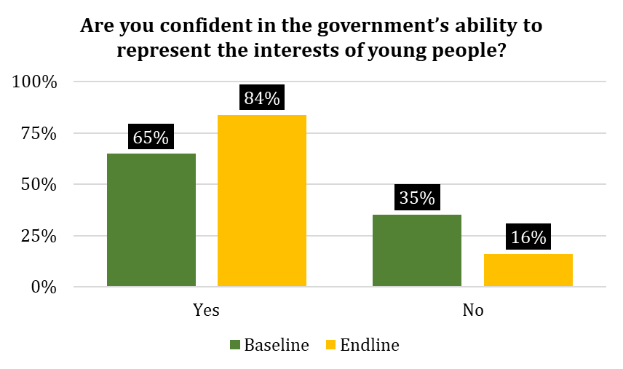  Figure 9 Rating of confidence in the government to represent youth interests | As reflected in Figure 9 alongside, There was an increased perceived confidence in the government ability to represent the interests of the youth.
The FGS MOYS staff stated that due to the project the Government recognised the useful inputs of the youth and have ensured that they are considered as priority in various activities. He also acknowledged that despite not being able to support youth financially, the government has offered encouragement for the political process, provided recommendation letters as well as invited the Youth Association during MOYS sessions. There is however no formalised system in place to ensure this encouragement and support is continued. The governance expert in Mogadishu reported that MOYS usually support the youth through verbal encouragement at meetings and the Somali National Council which nurtures talents as well as promotes employment creation.
It was nonetheless highlighted that the project did not create an effective communication channel from the youth to reach the government. The SODRA Chairman in Kismayo did not feel support from the government as there has not been direct support to the youth Associations. From the survey, 84% of the youth felt confident in the ability of the government to represent youth’ interests. Furthermore, 97% of youth were interested in regular engagement with their LAs.
“Inputs of the youth are moderately useful in policy making process of the government in terms of district, regional and country as well because, youth have fresh mind and knowledge to initiate new ideas compared to older official members of the government, but at this time there is structural challenge of the government system and community elders, they fear from youth to remove their status in the government.”
Somali Peaceline Executive Director

Efficiency of approaches used by the project to deliver the intervention
The respondents seemed to agree that there has been good positive progress of the project towards enhancing youth participation. There were however many delays MOYS staff challenged the IP’s administration as the project was delayed in each of its phases. The technical steering committee had challenges in planning meetings however this was mitigated through better inclusivity and flexibility of holding meetings in Nairobi. The project also selected Nairobi as a neutral location to hold meetings as there were clear tensions between FGS and FMS authorities. Among the technical steering committee members, there were continuous debates over ownership of resources and financial capacity. It was reported that the FGS has imposed a sanction against Jubaland and thus this affected the state economically, socially and politically. Another factor that affected the team was changes in political leadership particularly technical advisors in the Ministry. These factors led to the project requesting for a no-cost extension.
The key concern was the lack of payment of youth participants who had not been paid their dues for several months. One Youth Fellow Member reported that the contract duration was to be 10 months however the signed agreement indicated 6 months. Moreover, the Youth fellows only received a monthly salary for 2 months ($500/person). The project was also to provide monthly salaries for 6 months to government experts and youth fellows. However, the youth only received their salary for 4 months. At the time of the evaluation, project staff explained that payment had not yet been cleared, but that all payments (for both governance experts and youth fellows) were finalized after the data collection.
The youth fellows nevertheless continued working on the assignment voluntarily. The youth-produced monthly reports as was required by the project. A youth fellow in Kismayo stated that there was no feedback given to the youth by the IP or YPEER. The youth felt that YPEER was not responsive to their needs as they did not facilitate effective communication.
There was also some conflict during the selection of Youth Associations to be supported. there were issues of clannism and the 4.5 system that came up as well. These disputes caused delays in the project. It was also reported that the Jubaland Youth Association was initially Government supported but at some point, the government wanted to change officials arbitrary but they fought back through different means including social media until proper election was organized with youth input.
Mobilizing the youth to attend political empowerment sessions in Baidoa was also a challenge as the young people expressed security concerns. They feared attending sessions in government buildings for fear of becoming targeted by armed – militia groups. To mitigate this challenge, the IP conducted the trainings in hotels and engaged security agents to conduct surveillance.
There were complaints on lack of the inclusion of other districts in SWS. The youth from districts outside Baidoa were not supported directly and as such the project scope of the project felt limited to the local communities. Youth felt that the project was also limited in time as 1 year was not sufficient to implement the project. The project was also viewed to have neglected persons with disabilities and uneducated youth since no training was provided to them.
“The project has not made payments to four youth fellows (two male and two female) who were used to be given incentives as agreed between the youth fellows and UNFPA. The four youth were promised to be given the incentives in six months but the last two months (November –December -2019) was not given. We coordinated with them several times but every time they said we will make the payment.
Female Youth Fellow, Baidoa

Outcome/Impact
Comparison of baseline and endline indicators shows that majority of the indicators were achieved and met the target. One of the key improvements that is notably visible from the findings is on Indicator 1.1 where the number of young men and women from the districts who participated in parliament increased. In reference to Indicator 1.2, 90% of beneficiaries from all districts also felt that their inputs translated into concrete policies or actions this is a great achievement in comparison to the 50% project target. With regards to Outcome 2, youth policies were developed, 12 intergenerational dialogue forums held with 88% of participants being women. Furthermore, due to project activities, 84% of youth also felt that they can consult the MPs to give their inputs on policy decision which higher than the 50% which was set as the target. The number of youth fellows embedded in local administrations was also achieved as the project was to embed 12 youth fellows, which it did successfully.
The SPL Executive Director was hopeful and optimistic on the impact of the project. He noted that youth in Baidoa for instance are actively engaged in parliament as well as in supporting other political initiatives. He commended the project on playing a role that enabled the increase of youth in government positions. The evaluation found that there were plans to hire 2000 youth every 2 years in different positions. The government also enhanced at least 85% of new registrations to the Somalia Armed Forces to be youth.
As per Figure 10 and 11, most youth surveyed also felt that after the project they effectively participate in decision making at district and state level.
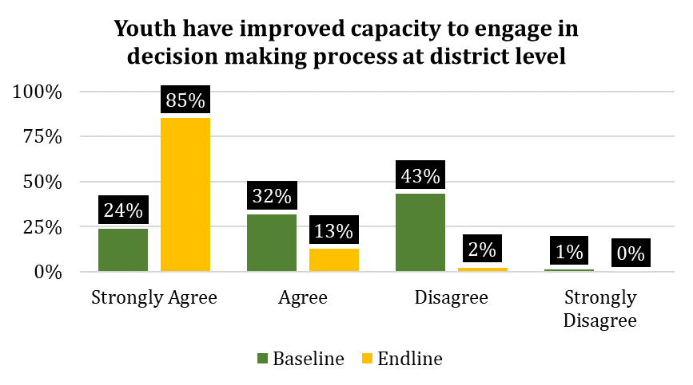  Figure 10 Perception of project effectiveness in youth decision making | The project trainings contributed to the improved perceptions of improved youth capacity to engage in decision making.
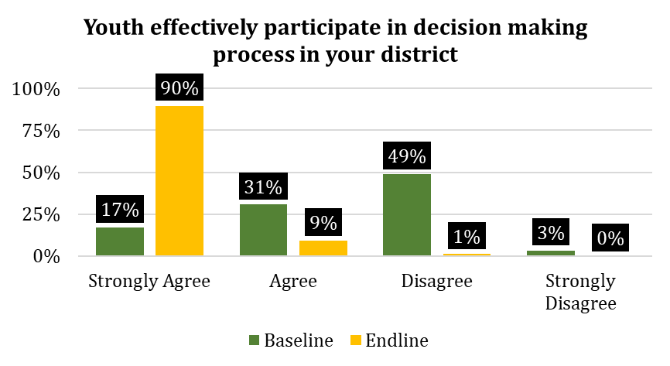  Figure 11 Chnge in youth participation in decision-making | As a result of the lobbying conducted, awareness sessions and trainings provided to the youth, the participation of the youth in decision-making processes increased in comparison to the baseline.  45% members in the SWS parliament were youth which was much more than the previous year.
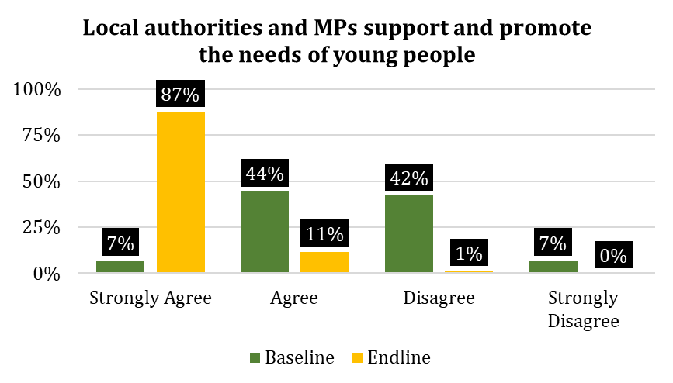  Figure 12 Overall perception of youth support from local authorities and MPs | Endline evaluation feedback showed that there was increased perceived support from government officials including the promotion of their needs.  Furthermore as per Figure 13 it was noted by 90% of the respondents that they felt their participation led to concrete plans and actions.
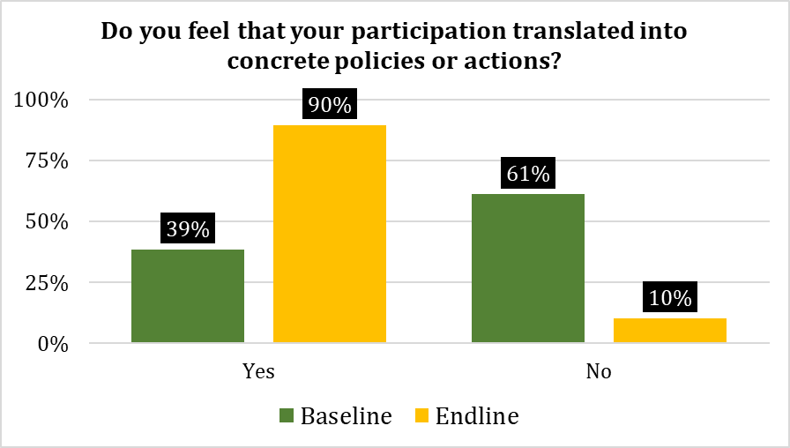
Figure 13 Overall perception of participation translating into concrete actions and policies
Despite the trainings and support from the project, the Chairman of the District Youth Council in Kismayo mentioned that the youth groups supported do not have the financial capacity to support the youth needs. He stated the financial capacity is important to ensure there is transportation and mobilization activities conducted.
Nonetheless the IP felt that youth associations in the FMS are learning and expanding their capacity. In addition to the office equipment and training provided, they are also employing their training to learn from other regional networks on what has worked for them and what models of youth engagement can be successful in their FMS. Vocational training, capacity building and workshops/forums have equipped youth with vital skills. The Jubaland Youth Union Chair however was only somewhat confident that the youth can influence local and state-level decision making.
Compared to the previous elections in FGS, there are currently a higher representation of women in parliament. This came after the project encouraged the participation of women in politics and conducted advocacy work to promote the participation of women in political processes. As a result of the advocacy sessions, women participated in electoral processes, constitutional reviews and youth empowerment programmes. Though their participation improved, it was not at the expected constitutional level of 30%. There were reported to be 8 women out of the 65 MPs. Women are also represented in the various state ministries as well as during the last election committee.
The community was encouraging to the youth as they told them that they were the future leaders of the country. They listened to the youth as they engaged in the awareness campaigns. The youth have been involved in the solving of communal issues together with elders e.g. inter-clan conflict. The project has enabled the elders to view the youth differently and there’s a better understanding of what the youth are capable at. The youth are now viewed as the backbone in the society as they are the future leaders. Thus, the importance of social coexistence has been learnt and is being embedded. Though the relationship between the youth and elders improved about some elders still have not accepted the youth in political processes.
The youth have also embraced social media to enhance conflict resolution, for instance, spreading positive messages of peace and focusing on a brighter future.
One of the interviewed elders in Kismayo noted that though the youth has not yet been able to influence political processes, they will do so in the next coming years. He noted that there has been a gradual increase in the number of youths in governance thus this is a positive sign. The Kismayo LA added that more youth including graduates now have a ‘proper appetite’ to join politics.
The relationship between the youth and the current government both district and state level also improved this is was because of the establishment of Youth Associations. The youth also received support from the government to engage in political processes in the country where the president of the FGS during the selection process of MPs of SWS acknowledged the criteria for becoming a member of parliament to include one who is an educated youth and not less than 25 years nor over 45 years.
The level of trust between the government and vulnerable groups also improved, this is because youth were empowered by the government. The community members were also happy with the role the government played in promoting youth inclusion in the government. This also made the community have confidence in the government to improve youth participation in decision-making processes.
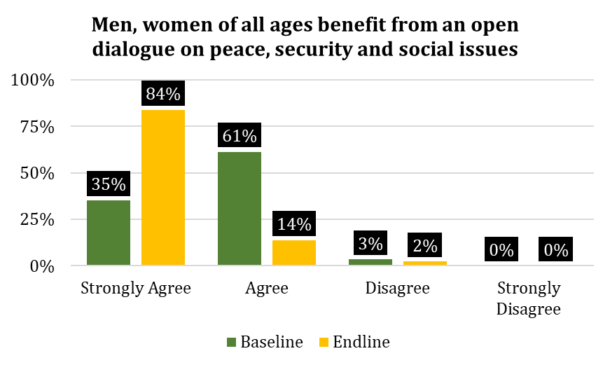  Figure 14 Comparative analysis of Youth perception of peace building process | As per Figure 14 there was increased perception that various diverse community members were able to benefit from open dialogue on peace, security and social issues.
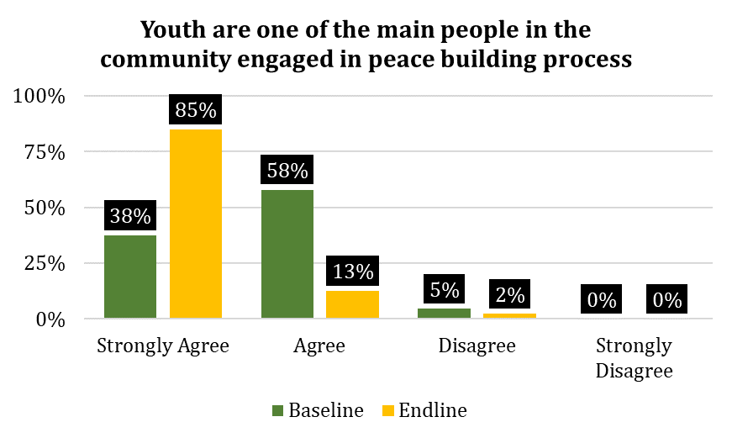  Figure 15 Youth perception of peace building process | Figure 15 alongside shows the perception of youth towards the peace building process. As compared to the baseline values there was a definite increase in these percentages indicating the effectiveness of the awareness sessions and other project activities
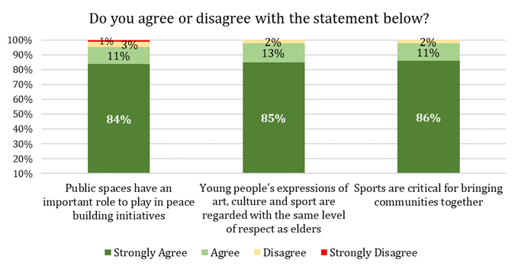  Figure 16 Youth perception to art, sports and culture in relation to peace building | Similarly Figure 16 alongside represents the perceptions of youth to art, culture and sports in relation to peacebuilding. Though these were not direct activities to improve these areas, trainings and awareness sessions had wholistic messages that were geared to enhance peace building among the youth.

Sustainability
The project put in place some sustainability measures such as housing the DC in the Mayor’s Office so as to ensure they work together. The IP also put in place election processes for officials that would take place every 2 years. On the government side, a youth strategy has been discussed and tabled and awaiting approval from the government. Implementing the priorities of the strategy offers an opportunity for the sustainability of the project The government also plans to conduct social awareness beyond the project to encourage the participation of youth in politics. SWS, for instance, planned to maintain the use of governance experts to further other projects. There are also some experts at Federal level whose salaries will be maintained by the FGS.
The Kismayo District Youth Council Chairman suggested that to encourage more youth representation in politics, there is a need to improve youth integration. He noted that in Jubaland there was only one youth forum held that included youth from all the 7 districts. In his opinion more of these forums should be encouraged as they are opportune avenues for youth political peace-building participations.
Furthermore, there is also a need to hold more face-to-face meetings between youth and government authorities including Parliamentarians, Ministers and LAs. These meetings will enhance information sharing as well as increase youth participation. The government also needs to include youth in resource sharing and the legislative process.
There were suggestions to increase the number of trainings, their duration and the attendees. The trainings were deemed as beneficial however they had limited reach with regards to the number of youths in the community.
The weekly radio program ‘Youth4Peace’ was set to continue being aired after the end of the project. The awareness campaigns also need to continue as they are an avenue to encourage women participation in politics. 95% of the survey respondents felt that it was sustainable to keep engaging in peace awareness campaigns after the end of the project, highlighting the sustainability of the project’s use of media.
Youth Associations require both technical and financial support to ensure that they can influence political decisions. Financial competence is highly regarded in the community particularly among elders. Lack of financial support was seen to hinder the success of Youth Associations as they could not meet basic expenses during community mobilization. Without financial support, they cannot conduct efficient and consistent trainings for the youth making them less active in empowering the youth.
.

V. KEY LESSONS/GOOD PRACTICES
The project was successful in establishing a foundation for increased youth participation in political activities. The following are the key lessons learnt in the project:
- Enhanced interactions between elders and youth are important to ensure the conversions for youth participation in decision making are had at grassroot level. Furthermore, in the Somalia context, elders are seen as the key stakeholders who determine future leaders.
Media awareness campaigns serve a crucial role in enhancing youth understanding of political affairs and contributing to state-building as well as the peacebuilding process. Based on the findings, the social awareness sessions were successful because more community members showed interest to work with youth programs. The media programs and trainings also worked well since the youth understood their role in politics and decision-making processes.
- Inclusion of different community members including religious leaders, elders and women during the social awareness campaigns helped to change their attitudes on the participation of women in politics.
- Strong collaboration and positive relationship between FMS and FGS are necessary pre-conditions for the successful implementation of political programmes and key assumptions to enhance youth empowerment politically. The lack of support and cooperation between the two signalled poor leadership that only affects the nationals. There was a clear sense of distrust in the MOYS in Kismayo. The better collaboration would have enabled the project to fulfil its mandate though there should be better mitigation measures including integration, sequencing to forecast potential delays.
- Having government strategic plans in place facilitates project activities including youth political participation. This has helped the youth to be more organized in their political decision making as well as mobilization of their constituency members vying for elections
- Provision of timely financial incentives as agreed in the contract is necessary to ensure continuous engagement and moral of youth fellows as well as governance experts. It is crucial to ensure financial incentives are provided to the participants on time and as per the contractual agreements in place
- The ambition of the project to enhance youth participation at all levels within a 1-year scope was not feasible. It would have been more practical to focus on a limited scope to ensure better and sustained outcomes in the future.

VI. CONCLUSIONS AND RECOMMENDATIONS
In summary, the project has begun to address the needs of young people though the efforts were not enough to ensure an impact is felt within the 2-year time frame. The scope of the project i.e. to promote youth political empowerment was a goal that was beyond the project however the project has contributed to an enabling environment that is expected to facilitate the goal in the course of the years. 2,175 youth were reached through campaigns. The overall social media reach in Baidoa, Kismayo and Dolow was about 165,000 people. Radio programs engaged approximately 220,000 people in total. As a result of these campaigns, there was a significant increase in youth participation including those who joined Youth Associations. Various youth in the three target districts received trainings in various areas including management skills, policy making and leadership. DCs were formed in all the three districts and were involved in the capacity building sessions.
Youth were included in the operationalization of the youth policy at the state level in Jubaland, they were consulted in the Roadmap on Youth Engagement. 3 Training manuals on leadership, peacebuilding and governance for youth were developed. 6 position papers were also developed on peace and security. Through the project’s efforts, there was also an overall sense of increased confidence of youth to take up political activities. The project also helped to contribute to the increase in the number of youths elected into parliament as well as appointed Ministers and Director Generals. About 24% of these newly elected officials were women.
By the end of the project there was mixed feedback on whether youth felt that their priorities are being addressed by their local government. There were no formal means of engagement between the MOYS and the Youth Associations with regards to encouraging youth participation in decision making. On the other hand, the intergenerational dialogue forums worked well and there was increased support for youth by elders.
Evaluation findings show that there were major improvements from the baseline. The percentage increase number of young men and women in Baidoa. Dollow and Kismayo District Peace and Security Committees/District Councils was 49% as this was 0% at baseline. 90% of survey respondents felt that their inputs translated into concrete policies or actions up from 39% at baseline. 464 young men and women were trained to provide regular inputs into District State level decision making processes up from 1 at baseline. The percentage of beneficiaries in Baidoa, Dollow and Kismayo that are confident in their ability to express their views clearly to decision makers by the end of the project compared to baseline decreased from 95% to 86%. There were about 84% of beneficiaries that found the trainings received useful to improve their ability to participate both at district and state-level decision making processes. 86% of respondents felt that youth priorities are being addressed by their youth council. 12 Youth fellows were embedded in local administrations. Finally, 84% of youth strongly agreed that they consult their MPs and other authorities with regards to policy discussions this is in comparison to only 24% at baseline.
Regardless of the positive progress by the project the lack of concrete sustainable measures was a major gap. Though the project was limited in the project scope including financially, there were opportunities to ensure that project initiatives could be supported by other donors working in the same areas. Though the IP worked with local NGOs their capacity beyond the project scope is also limited. As such some of the key recommendations from the evaluation are as follows:
Programme Recommendations
- Increase in intergenerational dialogues conducted at least monthly to ensure that elders understand and support youth in their political ambitions. It will also be part of a gradual handover and increase in trust from elders to youth. Some of these dialogues should be focused on issues such as women inclusion therefore having female youth to dialogue with elders on the importance of equal rights with regards to engaging in political activities.
- MOYS requires financial support to ensure quality trainings are offered to youth. There is also need to monitor this support to ensure it is continued. There should also be budgetary support accompanying youth policy discussions and implementation.
- Civic education: There should be more forums to educate the youth about their rights and the privileges of participating in the constitutional review process to address the issues that affect. More copies of the constitution should be printed and distributed in public libraries and universities/colleges for youth to read and understand their rights and the proposed law amendments
- Extend project coverage through the various youth groups and umbrella networks. The project should extend to different districts as well as rural areas to ensure more cohesiveness of the project. The YPE project provided a good platform for networking and knowledge transfer between youth members e.g. Youth Association leaders in Dolow and Beledhawa districts have been able to interact and support each other thus with some support, or youth experts and fellows can travel and interact with different youth and associations in districts of Jubaland and SWS enhancing civic education through awareness sessions and political campaigns.
- Greater emphasis on inclusivity of women and vulnerable youth including vulnerable, illiterate, minorities, IDP communities. The project should ensure that there are targeted campaigns as well as opportunities for information sharing reaches youth in all areas. There should also be specific opportunities for women capacity building programs so as to lobby for their rights. There are opportunities for traditional media to have programs to present this as not all youth are able to access social media however, they should still be included in political decision making.
- Empowerment of Youth District Councils as these were perceived to have worked well. The project should ensure they receive proper support in terms of capacity building and access to both human, physical and human resources to effectively improve youth participation in decision making.
- Creation of inter youth group linkages for all Youth Associations to enable them to participate in political processes as well as decision making. To improve coordination between the youth and the leaders’ development of proper communication channels is needed for sustainability. This will also support inter-state knowledge sharing so that youth can benchmark from different state governments, reaching more districts.
High level recommendations
- Provision of more representation for the youth (FMS and FGS) during the next elections as well as the constitutional review process. There should be consultation forums conducted in the communities.
- Cooperation between the state and non-state actors and create common associations to unite the two. This will enhance interaction and collaboration. There can be interventions established where the two parties participate equally. These interventions would enhance the capacity building as well as integration.
- Creation of employment and income generation streams for youth: This was stated as one of the key needs in Somalia. The government should help in providing investment areas, employment opportunities, microfinance projects and vocational centers to help keep youth engaged in positive activities and thus avoid vices. The income generated will be able to support their campaign needs as well as promote economic development.
- Streamlining and formalizing systems which should be mainstreamed across governance projects: some systems, notably the youth parliament, advisory boards, and youth districts councils are in place and should be the starting point for projects aiming to strengthen governance at district and state level. It would be important for future projects to use what is already existing and build capacity of existing systems, with the ultimate goal of creating formal systems.

ANNEXES

ANNEX 1: Case studies
KISMAYO
CASE STUDY 1
Rukhiya a youth fellow member from Kismayo remarked that the project was very helpful towards the involvement of youth in politics. She described that they were provided trainings on public speaking and political participation. Particularly as women she noted that they were now conscious about the importance of engaging in politics. As youth they felt energized and motivated to have achievable careers in politics. On her part particularly she says, “The project developed my understanding and confidence in taking part in political issues and I am now able to speak my mind without an iota of diffidence.”
The young and motivated lady was proud that there were about 15 Members of Parliament elected into Jubaland Regional State during the last election. She noted that this was a tremendous improvement which further inspired the other youth in the community. Rukhiya added that there were also a good number of women have also achieved their political ambitions as they are now legislators at regional and federal government positions.
The project’s main achievements according to Rukhiya were improved coordination of youth, elders and Youth Associations. This has led to better communication and more open dialogue thus youth can bring forth their agendas at intergenerational dialogues. Elders have become more open to help youth engage in politics as a result of the project. There has also been better inclusivity for women to actively participate in politics. Overall Rukhiya felt that the project has led to improved access leadership positions by the youth. “Youth were not conscious about the political affairs of the region and the country at large. The project therefore, opened the door to political representation for the youth.”
As such the respondent felt that her expectations of the project were met. She was able to be part of the protocol team during the Jubaland State presidential election. Her suggestions for sustainability was that there should be more awareness sessions and refresher trainings offered to the youth to ensure continuous uptake of political positions by youth in future.
On social media use Rukhiya noted that it was used effectively to aid discussion of youth in politics. She, herself noted, “Personally, I am very comfortable with the use of social networks (WhatsApp and Facebook) since large number of youths can be engaged with much convenience.”
CASE STUDY 2
Abdalla, one of the youth council members in Kismayo tells his story. This project promoted many campaigns in the community in a bid to encourage youth engagement involvement in politics. There were also opportunities for youth to be engaged in trainings to develop skills and knowledge in terms advocating involvement in political inclusion in the community. The youth councils and youth leaders have also benefitted from trainings on how to advocate for more youth involvement. Some of the areas of training have been office management which is a core skill area. The Youth Council Member however acknowledged that there is still high demand for more skills trainings for the youth. Abdalla said that the project was helpful to both men and women whereby women were also supported with trainings and capacity building of skills. This helped them to be more involved in politics.
The project achieved many things such as providing equipment as well as offices for the youth council. This has ensured that the members are able to conduct a meeting and have a discussion in an orderly place. He noted that this also has served as an encouragement for other youth to be involved in politics.
On the other hand, youth were full of expectations that the YPE project would support the youth to obtain gainful employment, “I expected the project to have fully supported youth access to job opportunities. Although it has tried well but it has not matched to my expectations as a youth in Somalia.” Abdalla added that there should have been more advocacy surrounding employment of youth so as to ease the job recruitment process. He also added that once youth have money, they were able to be involved in political affairs.
Abdalla added that he believes most of his community members are on social media whether directly or indirectly. Though he could not comment on whether the project adequately used social media, he noted that Facebook is the best avenue to use.
In his closing remarks Abdalla noted that there had not been any negative impact of the project in his opinion. He felt accomplished to have received trainings as well as to have been involved in the discussions surrounding the Jubbaland Youth Policy Foundation.
DOLOW
CASE STUDY 1
According to Feiza from Dolow, the project was relevant as it supported the goal of youth empowerment by boosting the youth’s confidence. The trainings provided skills in leadership, decision-making, management, politics as well as election participation.
The youth participant pointed out that after the trainings, youth were able to take part in political processes e.g. involvement with Youth District Councils. She reported that before the project was implemented there was no Youth Associations where the youth could meet and discuss their rights. The project brought hope to the youth by enabling them to stand up for their rights and participate in politics.
She said that the project improved the interaction and cooperation of youth by helping the youth to travel from different states and also facilitating meetings in one location to discuss their role in politics and conflict resolution of the country. After the youth meetings, the project created an environment where their political ideas and decisions were highly considered. The youth participated in the conflict resolutions and peace buildings of the society.
When asked about the main achievements of the project for her as a youth in your community she said, “Before the project, a politician from other states used to come to our elders and take our political positions. From example, the chairman of the local authority is from other states. Our local elders helped him to become the chairman. On the other hand, the government nominates political position to any person while we are there and looking for our political rights. However, at this current time, there is improving youth and elder collaborations since we met our elders and asked for to help and support us to join the politics and decision makings of the state.”
She indicated that the project involved young women through trainings and social awareness. The young women were part of the youth trainings that the project provided. She said that during the trainings, the emphasis was made on women participation in the policy-making of the district. She reported that some of the achievements made by young women included joining Youth Associations, district councils, improved interaction of young women and young men and participation in community awareness. Feiza said that the youth utilized social media platforms to share information and were comfortable using them.
Concerning policies, she was able to influence, she said, “We managed to substitute the district commissioner of Dolow with one member of the youth. As a youth, we consulted with the elders of the district to support the youth to take any political vacancy in the district.”
When asked what was her opinion on the biggest success of the project she said,” the project improved youth interaction and youth confidence. The project provided many trainings. This project enabled different youth from different states to meet and address their political needs. These youth members encouraged both themselves and the community to support the participation of youth in politics.”
In conclusion, Feiza recommended that in future the project should aim to provide financial support to youth political candidates for campaign and mobilization purposes.
CASE STUDY 2
Another youth in Dolow, Naima, said the project was relevant as it supported the youth through capacity building. The youth were trained on political skills as well as office management. She stated that the project was important as it created a political collaboration between youth from different areas. She noted that the project provided training to young people from different districts such as Garbaharey, Balhawo, Kismayo and Dollow. However, she indicated that there are still many youths that have not had an opportunity to take part in trainings and she hoped that more trainings would be conducted to reach more youth.
Naima felt that the project involved young women as it provided them with an opportunity to participate in trainings and also allowed them to interact with young men and have their voices/ideas heard and respected during the interactions. Her thoughts on the use of social media by the project were that it is a necessary tool in communicating issues and ideas.
When asked what was her opinion on the biggest success of the project she said, “The biggest success of the project was creating interaction to young people from different areas and all people who participated the training have clear evidence that young people can participate the political leader and bring major change to the country if they get more training that improved their skills.”
In conclusion, Naima recommended that young people could be supported more by providing more trainings on political empowerment and political stability to improve their skills as well as encourage and motivate them to lead society.
BAIDOA
CASE STUDY 1
Jamilah notes that before the project's implementation, the youth were largely excluded from decision-making processes in their communities. Therefore, the youth had no platform to raise their concerns and could not impact decisions in their areas. This also meant that the youth were not involved in the peacebuilding and social development process. According to Jamilah, this level of exclusion was a contributing factor to youth joining extremist groups such as Al-Shabaab. However, things changed for the better after the project’s implementation.
As Jamilah points out, she received training on the role of youth in taking action to achieve inclusive progress in their communities. She was also exposed to a large network of youth with a positive vision for the community. Through this network, she and several other youths were able to exchange their views and learn from one another. The network also provided a platform for youth to discuss several issues on community development such as heightening security within the district and overcoming challenges faced by the youth. Through these activities, Jamilah was able to sharpen her debate and negotiation skills. Although she has yet to attend or directly influence any policy meetings, she is hopeful about the growth of her role in community decision-making.
Thanks to the project’s activities, the youth are now more aware of their agency and role in shaping their communities. This has contributed to the increased inclusion of youth in decision-making processes as reflected in the increased number of youths that has been nominated for higher positions in government. As Jamilah reports, “There is an increased number of youths that have been nominated for higher government positions to serve as Ministers, Director Generals and District Commissionaires. This is a symbol of great progress for the youth in being included in politics. More youth are now being allowed to show their ability to lead.”
Jamilah also notes the importance of social media to youth empowerment and inclusion in decision-making, stating, “Social media has been a great instrument of communication among youth members during the project’s implementation. Through social media, I could express my feelings and thoughts while at home without needing to travel to a meeting hall. This allowed me to present my views freely. I have also come to know and exchanged views with many youths who are in other districts via WhatsApp and Facebook. The use of social media has been great progress that the project has motivated within the community.”
As a woman, Jamilah notes that the project was also very beneficial to women Like her, several other women were included in the aforementioned project activities and have therefore been exposed to empowerment training, youth networks and constructive exchanges of ideas for community development. Therefore, women have been recognized as important members of the community, who can run for office in the government. This has reduced the prevalence of the perception that women can only be wives, mothers and caregivers of children. The project also provided skills training on tailoring and henna making for women. Therefore, not only did the project contribute to the empowerment of women in decision-making, but it also contributed to women’s economic empowerment.
Jamilah is generally pleased with the project. However, she thinks that the project could be improved in some ways. For instance, she notes that the project did not give much emphasis to employment opportunities for youth. However, unemployment is a common problem among the youth, which Jamilah reports make it difficult for youth to participate in politics. Without sufficient income, youth can only think of how to earn money and meet the immediate needs of their families. Therefore, increasing youth inclusion in politics involves improving the livelihoods of youth. Jamilah adds that “The youth can impact their communities in ways beyond fighting for inclusion in decision-making. The youth can also contribute to the economic development of their communities.” Therefore, she recommends for the project to integrate aspects of livelihood support. This includes expanding the project’s provision of skills training and providing access to small grants for business start-ups.
CASE STUDY 2
Faruq, a young man living in Baidoa, is another example of a youth whose life was greatly impacted by the project. He reports that he is interested in political participation and the project helped enhance his political ambitions through motivational lectures and trainings in youth political participation. Through these trainings, his public speaking skills improved and he was able to learn about the various methods of political participation. Therefore, the project was very important to him
Faruq notes that through the project’s activities, a number of national goals were achieved. For instance, the number of youth interested in political participation increased. This has resulted in more youth appearing in government structures and decision-making. Faruq also notes that the project’s activities, young women were empowered. This has resulted in young women taking up more government positions. As he states, “The project ensured that young women took part in youth empowerment trainings and discussions to protect their rights. Young women were active in every session I attended. Young women also received special encouragement during these sessions in order to increase their political ambitions. For instance, they were often encouraged to create women’s associations through which they could promote their interests. The project also strived to recommend for the government to add women as Members of Parliament and government officials.”
Faruq also commends the project for its promotion of social media, stating, “Social media is a very important channel through which youth share knowledge and ideas. In fact, during the trainings, we created Facebook pages and WhatsApp groups to communicate. Therefore, I think this aspect of the project was successful.”
Although he is generally pleased with the project, Faruq reports that he has not attended or directly influenced any policy meetings. Therefore, he would like for the project to be expanded for more positive outcomes. He also reports that although the trainings he received were helpful, they were brief and insufficient. Therefore, he recommends a longer training period, in which youth can maximize their skills and knowledge in political participation. As he states, “The training period of the project was limited to only 2 days. That is not enough. The training sessions should be extended one or more weeks. The trainings should also be multi-dimensional in order to transfer a wide variety of skills that will increase the capacity of youth empowering in political participation.”
Lastly, Faruq reports that the project did not encourage or support the creation of youth associations. He believes that youth associations are important in sustaining youth cooperation in political participation. Therefore, he recommends for the project to create youth associations.

ANNEX 2: DOCUMENTS CONSULTED & PERSONS CONSULTED TABLE
Table 6: Documents provided to facilitate the evaluation exercise
Project Proposal
Progress reports (including all quarterly reports, annual reports and final reports)
Updated logical framework
Training manuals on communicating on impact development
Governance training manual
Road map for youth engagement in peacebuilding and Governance mechanism.
Position papers on peace and security
Policies and legislation documents (Jubaland Youth Policy, Southwest Youth Policy, Electoral Processes and Decisions for both Southwest State and Jubaland).
Intergenerational dialogue reports
Training and workshop reports
List and contacts of governance experts in ministries (phone and emails)
List and contacts of youth fellows in local administrations (phone and emails)
Relevant meeting minutes
Relevant concept notes
List of focal point of youth association (phone and email)
List of UN Habitat and UNFPA field staff contacts (phone and email)
List of beneficiaries with phone numbers (youth association members, committee and council members, forum members)
Financial reports
Table 7: People consulted table
PERSON | LOCATION | POSITION | PHONE NUMBER | DATE
Adan Omar Hassan | Baidoa | Direct General- MOYS | 615573917 | 02/05/2020
Faizo Hassan Abdule Mohamed | Baidoa | Women Elder | 715755229 | 04/05/2020
Hussein Abdullahi Mali Ibrahim | Baidoa | Executive Director- Youth Association | 615182870 | 02/05/2020
Saida Ibrahim Mohamed | Baidoa | Youth fellow | 615028282 | 04/05/2020
Abdirizack Kahiye Yusuf Abdi | Baidoa | MOYS SWS senior adviser and governance expert - | 618388092 | 02/05/2020
Said Ali Abubakar Hussein | Baidoa | Governance Expert- MOYS | 612544440 | 10/05/2020
Sharif Mohamed Sheikh Ali | Baidoa | Community Elder | 615889212 | 04/05/2020
Abdulahi Ali Moalin Abdulahi | Baidoa | Elder | 615808409 | 03/05/2020
Sheikh Hassan Doyow | Baidoa | Religious leader | 615882348 | 04/05/2020
Haji Saney Ahmed Mursal | Baidoa | Religious leader | 615571730 | 04/05/2020
Mohamed Adan Mohamed Hassan | Baidoa | Youth Council Member | 615239805 | 09/05/2020
Adam Maallim Abdirahman | Baidoa | Chair Person- SWS District Council | 617191222 | 02/05/2020
Osman Nor Adan | Baidoa | Elected MP - PBF Youth Fellowship | 612624925 | 04/05/2020
Ismahan Hassan Mohamed Hassan | Baidoa | Youth Fellow | 618294150 | 03/05/2020
Farhiyo sidiii Abdikadir Ahmed | Baidoa | Youth member | 616157944 | 03/05/2020
Abdirahman Hassan Adan Hussein | Baidoa | Youth member | 612925329 | 02/05/2020
Maxamed Sheekh Axmed | Baidoa | Youth Beneficiary | 618666680 | 02/05/2020
Abaadir Abdirahman Bashe | Kismayo | Chairman District Youth Council | 615842750 | 04/05/2020
Suladaan Ibrahim Ali | Kismayo | Community Elder | 615598734 | 10/05/2020
Osman Nor Asad Salad | Kismayo | Community Elder | 616323325 | 11/05/2020
Amino Abdi Ali Osman | Kismayo | Community Elder (Women) | 615545811 | 11/05/2020
Said Moalin Omar Ali | Kismayo | Governance Expert | +254722266429 | 07/05/2020
Abdifatah Ali Farah Abdi | Kismayo | Governance Expert | 615255424 | 09/05/2020
Ibrahim Tmajilac Ali Adan | Kismayo | Local Authority | 615595589 | 10/05/2020
Suladan Adan Maxamed | Kismayo | Religious Leader | 616537641 | 09/05/2020
Ugas Yusuf Ibrahim Ahmed | Kismayo | Religious Leader | 615825468 | 09/05/2020
Cawada Ceynabo Cilmi Yusuf | Kismayo | Women Association Member | 615856066 | 09/05/2020
Abdiwahab Bilal Ahmed Hassan | Kismayo | Jubaland Youth League Representative | 616839240 | 02/05/2020
Cabdinasir Khalif Cabdi | Kismayo | Jubaland Youth League Representative | 615290316 | 09/05/2020
Said Ali Nor | Kismayo | Youth Fellow Member | 615836473 | 03/05/2020
Sadam Ibrahim Mohamed | Kismayo | Youth Fellow Member | 615836473 | 03/05/2020
Maxamed Cabdi Abdulaahi | Kismayo | Youth Fellow Member | 619808771 | 03/05/2020
Abdihakim Mohamed Abdi | Kismayo | Youth Fellow Member | 613621577 | 04/05/2020
Fahad Ali Hassan | Mogadishu | Government Expert (MOYS) | 619999772 | 07/05/2020
Isaq Hashi Jimale | Mogadishu | Director General (MOYS) | 615566690 | 02/05/2020
Mohamed Arshad Ibrahim Hassan | Mogadishu | Executive Director (Youth Peer Network) | 619122366 | 02/05/2020
Abdullahi Mohamed Shirwa | Mogadishu | Somali Peace Line Executive Director (Tubta Organization) | 615500952 | 07/05/2020
Libad Abdi | Mogadishu | National Program Officer (UN-Habitat) | 616772299 | 10/05/2020
Farhiyo Hire Haruun Adan | Dolow | Youth | 615177018 | 03/05/2020
Nasteex Cabdi Xiiray | Dolow | Youth | 619419666 | 03/05/2020
Nurrow Adan Wacle Shuke | Dolow | Community Elder | 619999772 | 07/05/2020
Mohamed Adan Garaw | Dolow | Community Elder | 615246594 | 07/05/2020
Sheikh Hassan Ali | Dolow | Religious Leader | 615219707 | 05/05/2020
Shirar Adow Mohamed Ali | Dolow | Religious Leader | 61881183 | 11/05/2020
Fathi Mohamed Mohamud Hamud | Dolow | Woman | 615928003 | 09/05/2020
Khadija Hajji Abdi Ali | Dolow | Woman | 612061218 | 09/05/2020
Abdiqani Hassan | Dolow | Youth Council Member | 616860666 | 04/05/2020
Idiris Abdi Faqid | Dolow | Youth Fellow Member | 617441056 | 07/05/2020
Nasra Abdi Adan | Dolow | Youth | 615823262 | 02/05/2020
Maryan Dahir Farah | Dolow | Youth | 617847836 | 05/05/2020
Fatuma Muhumed | - | UN-HABITAT Staff | - | 30/04/2020
Peter Nordstrom | - | UN-PBF Staff | - | 08/05/2020
Falastin Omar | - | UN-HABITAT Staff | - | 26/05/2020
Fadumo Mumin | - | UN-PBF Staff | - | 26/05/2020
Mohamed Muqtar Amin | Baidoa | Lifeline Association Executive director | 617763939 | 09/05/2020
Mohamed Amin Mohamud | Kismayo | SODRA Youth Chairman | 612055404 | 27/05/2020
Mohamed Bille Abdi Abdulle | Kismayo | Youth Council Secretary | 617990879 | 27/05/2020
Ali Abdullahi Abdi Dhahiyow | Kismayo | Youth Council Speaker | 615544085 | 27/05/2020
Abshir Dahir Farrah | Kismayo | Youth District Council member | - | 27/05/2020
Abdifatah Hajji Adan Midow | Baidoa | Youth Member | 615523602 | 27/05/2020
Rahmo Abdullahi Issack Abdirahman | Baidoa | Youth Member | 616921467 | 27/05/2020
Nadifo Hassan Salah | Kismayo | Youth Council Member | 619024880 | 27/05/2020

ANNEX 3: Project’s Results Based Framework

Key
√= Improved from baseline √= Not improved

Outcome 1: Young men and women can effectively participate in decision-making processes in Baidoa, Dolow end Kismayo district and South West and Jubbaland State levels by the end of the project

OUTPUTS | INDICATORS | BASELINE | NEW BASELINE | TARGET | MEANS OF VERIFICATION | MILESTONES | ENDLINE |  | AXIOM COMMENTS
 | Outcome Indicator 1.1:  % increase in number of young men and women in Baidoa. Dolow and Kismayo District Peace and Security Committees/District Councils (when formed), Jubbaland and South West State Parliament by the end of the project compared to baseline. | 0% | Committees/District councils not formed hence baseline is 0 | 20% | - Official List of DPSC/District Council/FMS Parliament members disaggregated by age and gender.  - Project progress reports Media publications. | Establishment of youth fellows  -Training for youth associations and young leaders conducted | √ | 49% | District Councils established in Baidoa, Kismayo and Dolow.  Baidoa: 77 members out of 95 members in the SWS parliament are youth. Out of 15 members in the electoral committee 7 are youth.  Kismayo: 15 youth elected as MPs. They are also represented in the electoral process committee where out of 7 members 3 were youth (2 men and 1 woman). There is higher representation of women where 8 were women out of the 65 MPs  Dolow: Youth who participated in the parliamentary election managed to get 70% of the seats.
 | Outcome Indicator 1.2  % increase in number of DPSC/DC/FMS parliamentarians that find youth policy inputs constructive by the end of the project compared to baseline. | 0% | Due to the difficulties in reaching Parliamentarians this is not available | 50% | -Key informant interview (KIIs) conducted on quarterly basis disaggregated by age and gender. |  | √ | 90% | Respondents in the survey felt that their inputs translated into concrete policies or actions. In Baidoa for instance, youth organizations participated in political sessions such as constitutional reviews where their inputs were valued by local and state authorities.
Output 1.1: Young men and women in Baidoa, Dolow and Kismayo have improved their capacity to engage effectively in decision making processes at district and State level by the end of the project | Output Indicator 1.1.1.  # number of young men and women trained that provide regular inputs into District State level decision making processes. | 1BD at project onset | N/A as this is activity level. | Target26 (At least 6 in each district, and 4 in each State level) | KIIs with DC members/FMS MPs/Trained Youth/Youth Umbrella organizations/Journalists on a quarterly basis disaggregated by age and gender.  - Project progress reports | ToT's for youth finalized, youth councils formed and youth engaged in governance mechanism | √ | 464 | Young men and women received skills training on communication for impact, leadership, decision and policy making, youth integration and office management.
 | Output Indicator 1.1.2.  (%) increase in number of beneficiaries in Baidoa, Dolow and Kismayo that are confident in their ability to express their views clearly to decision makers by the end of the project compared to baseline | 0% | Baidoa: 92%  Dolow: 100%  Kismayo: 94% | 75% | - Surveys pre/post trainings disaggregated by age and gender.  - Quarterly FGDs with beneficiaries | Increased number of young women and men with a capacity to influence with a capacity to influence decision | √ | Average: 86%  Baidoa: 91%  Dolow: 71%  Kismayo: 94% | More youth from Kismayo and Baidoa believe that they have effective communication skills than youth from Dolow.  During post training surveys conducted after the 2018 training that included 30 participants from Baidoa, Dolow and Kismayo, the trainees rated confidence in effective communication as 4.2 out of 5.
Output 1.2: The Jubbaland Youth Association and the South West State Youth Union have improved their capacity to provide quality trainings and conduct effective advocacy by the end of the project. | Output Indicator 1.2,1  Both youth associations have improved their aggregate score by at least 20% on the organizational capacity assessment tool | TBD at project onset | This indicator is available from desk review of risk matrix.  Jubbaland Youth Union Score: 13.2  South West State Youth Union 2.9 | 20% | Organizational capacity assessment toot; assessments conducted at baseline, mid-term, and end evaluation; results to be clustered by sector (institutional capacity, training capacity, advocacy capacity).  - Project progress reports | Youth organizations capacity enhanced | - |  | This was not captured in the evaluation
 | Output Indicator 1.2.2  #⁻ of training manuals on leadership, peacebuilding and governance for young women and men developed. | 0 | N/A |  | - Project progress report  - Training Manual | Consultant hired training Manual developed | √ | 3 | Training manuals developed on;  -Governance;  -Communicating for impact; and  -Road map for youth engagement in peacebuilding and Governance mechanism.
 | Output Indicator 1.2.3  % of beneficiaries that found the trainings received useful to improve their ability to participate district and State decision making processes | 0 | N/A | 75% | Surveys pre/post trainings disaggregated by age and gender.  -Training/Project progress reports  -Quarterly FGD reports with beneficiaries disaggregated by age and gender. | Trainings conducted for youth leaders and youth led organizations | √ | 85% at the district level and 84% at the state level | At the district level – 86%, 79% and 91% of respondents from Kismayo, Dolow and Baidoa respectively strongly agree they have improved capacity to engage in decision making process.  At the state level- 83% of respondents from Kismayo, 82% from Dolow and 87% from Baidoa also strongly agree youth have the capacity to engage in decision making at the state level.
Output 1.3: Youth Forums have been established In Baidoa. Dolow and Kismayo are meeting regularly and producing clear policy recommendations for district and State authorities | Output Indicator 1.3.1:  # of position papers on peace and security based on the discussions developed by young women and men | 0 | N/A | 6 (including two young women lead papers) | -Youth Forum minutes Policy papers | -youth forums held, and position papers Published.  youth forums held and position papers Published. | √ | 6 | Position papers developed on topics on peace and security which covered topics on:  - Gender dynamics in public spaces;  - Social Entrepreneurship and Innovation;  - Culture, Sports, Arts and Identity;  - Say it Loud and Say it Proud: State of Youth Associations and Networks in Somalia which focused on the State of Youth Associations and Networks in Somalia;  - Role of the youth in constitutional review and inclusive politics; and  - Women's participation and representation in the political landscape.
Outcome 2: Decisions Taken by District authorities in Baidoa, Kismayo and Dolow district and South West and Jubbaland State are reflecting young men and women's priorities by the end of the project
Outputs | indicators | Baseline | New Baseline | Target | Verification | Milestones | ENDLINE |  | AXIOM COMMENTS
 | Outcome Indicator 2.1:  (%) increase in young men and women in Baidoa, Dolow and Kismayo that feel their priorities are being addressed by their District Council / FMS by the end of the project compared to baseline. | 0 | Baidoa: 40%  Kismayo: 52%  Dolow: 59% | 25% | - Key Informant Interviews (KU) conducted on quarterly basis disaggregated by age and gender.  - Social media polls conducted on quarterly basis disaggregated by age and gender | - Each targeted region has Youth Council established | √ | 86% strongly agree that youth priorities are being addressed by their youth council. | KII findings show that the LA and government prioritized youth issues which helped to build their confidence in vying for political posts. In addition, 84% of respondents from all districts are confident in the government ability to represent the interest of young people.
 | Outcome Indicator 2.2:  # of documented decisions, policies / legislations that reflect youth priorities | 0 | 2 (Strategic plan for youth development in SWS and National Youth Policy mentioned in Baidoa only) | 5 (At least 1 in each district and one in each State level |  | Decisions on policies that incorporate local and regional policies published/char ed. | √ | 5 | In Kismayo for instance a youth policy was developed to create economic and political opportunities for the youth however is pending approval by parliament. Furthermore, desk review findings note (Jubaland Youth Policy, Southwest Youth Policy, Electoral Processes and Decisions for both Southwest State and Jubaland)
Output 2.1: District Peace and Security Committees and/or District Councils (when formed) in Baidoa, Dolow and Kismayo the Ministries of Interior and the State Parliaments in Jubbaland and South West State have improved their capacity to include young women and men in decision making processes by the end of the project. | Output 2.1.1:  % of DPSC/DC/FMS MPs that have consulted the Youth Council in the last quarter over a policy decision |  | N/A | 50% | - KlIs with a representative sample DPSC/DC/MPs in each district/FMS conducted on a quarterly basis after the Youth Councils have been formed disaggregated by age and gender.  - Project progress reports | Youth councils established and consultations held | √ | 84% | 92% of youth from Kismayo, 68% from Dolow and 91% from Baidoa strongly agree they can interact and consult with the state MPs to give their inputs on policy decisions.  Youth were included in the operationalization of the youth policy at the state level in JL, they were consulted in the Roadmap on Youth Engagement
 | Output 2.1.2:  # of Youth Fellows embedded in local administrations. | 0 | N/A | 12 (6 young women and 6 your: men) | -Youth Fellowship quarterly reports  - Project progress reports | Youth fellows deployed in local and regional governance levels | √ | 12 | Findings also show that District Councils are now embedded in the local administration.
 | Output Indicator 2.1.3:  # of policy/legislations making processes for which DPSC/DC/FMSMPs have solicited the project's support | 0 | 3 (Strategic plan for youth development in SWS and National Youth Policy mentioned in Baidoa only and 1 Constitutional Review process participation by SODRA in Kismayo) | 5 (At least,1 in- each district, and tin each State level) | - Project progress reports | Municipal regulatory frameworks supported and developed | - | See output 2.2 | See output 2.2
Output 2.2: Intergenerational Dialogue forums are formed {and/or other existing forums. Are strengthened) in Baidoa, Dolow and Kismayo and provide a space for men and women of all ages to discuss peace, security and socials issues that affect them. | Output Indicator 2.2:1:  # of Intergenerational Dialogue Forums conducted with 40% female participants | 0 | N/A | 12 | - Intergenerational Dialogue Forum Minute's with picture of members disaggregated by age-and gender | Intergenerational dialogues held across regions and communication: campaigns conducted. | √ | 12 | 88% of female respondents from all districts participated in the dialogue forums.
 | Output indicator 2.2.2  (%) increase in # Of people that report having a better understanding of other generations. perspectives after hearing/reading a media post produced by young men and women by the end-of the project as compared to baseline. | 0 | Baidoa: 56%  Kismayo: 87%  Dolow: 100% | 50% | -Post radio Message SMS: poll analysis reports disaggregated by age and gender.  - social media polls comments sections analysis reports disaggregated by age and gender, |  | √ | 84% | The use of social media platforms and programs aired on radio proved to be effective to communicate issues on youth participation, gender related matters which helped to promote youth political engagement.

ANNEX 4: TERMS OF REFERENCE
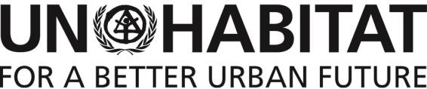
United Nations Human Settlements Programme
P.O. Box 30030, Nairobi 00100, KENYA
Tel: +254-20 7623120, Fax: +254-20 7624266/7
infohabitat@UN-Habitat.org, www.UN-Habitat.org

Terms of Reference (TOR) for the End-term Evaluation of the Youth Political Empowerment project in Jubaland and South West states, Somalia

Project: | Youth Political Empowerment
Post Title: | Consultancy, End term Evaluation of the Youth Political Empowerment  project in Somalia
Location: | South West State (Dolow and Baidoa Districts)  Jubaland State (Kismayo District)
Duration: | 25 Working days
Starting Date:  Ending Date: | January 2020  March 2020
Deliverables: | - Inception Report  - Draft Evaluation Report  - Final Evaluation Report
- Background on Youth Political Empowerment project

The Youth Political Empowerment project, also known as “YEP project” is 2-year initiative financed by the UN Peace Building Fund. The project is intended to enhance the capacities of the young women and men to meaningfully engage in peacebuilding and governance activities by establishing safe spaces for the youth to raise their voices and create tangible mechanisms for their direct participation in the development of the policies and programmes at the district and federals member state levels. Furthermore, the project is intended to increase the capacities of the local authorities it effectively address youth issues.
The project is jointly implemented by UN-Habitat and United Nations Population Fund (UNFPA) in collaboration with the Federal Government of Somalia (Ministry of Youth and sports) and Federal Member states (Ministries of youth and Sports – Jubaland and South-West) and Local CSO (Y-Peer Youth Education Network).
The project has in place structured mechanisms for management and coordination which include:
- The programme Technical Steering Committee composed of key project partners to oversee the implementation of the project.
- Project steering committee that provides strategic and management advice/decisions on implementation while addressing bottlenecks.
The two main outcomes (and respective outputs) of the project are as follows:
- Young men and women can effectively participate in decision-making processes in Baidoa, Dolow and Kismayo district, and South West and Jubaland State Levels by the end of the project.
Output 1.1: Young men and women in Baidoa, Dolow and Kismayo have improved their capacity to engage effectively in decision making processed at district and state level by the end of the project.
United Nations Human Settlements Programme
P.O. Box 30030, Nairobi 00100, KENYA
Tel: +254-20 7623120, Fax: +254-20 7624266/7
infohabitat@UN-Habitat.org, www.UN-Habitat.org

Output 1.2: The Jubaland Youth Association and the South West State Youth Union have imporoved their capacity to provide quality trainings and conduct effective advocacy by the end of the project.
Output 1.3: Youth Forums have been established in Baidoa, Dolow and Kismayo, and are meeting regularly and producing clear policy recommendations for district and State authorities.
- Decisions taken by district authorities in Baidoa, Dolow and Kismayo district, and South West and Jubaland State are reflecting young men and women’s priorities by the end of the project.
Output 2.1: District Peace and Security Committees and/or District Councils (when formed) in Baidoa, Dolow and Kismayo the and the Ministries of Interior and the State Parliaments in Jubaland and South West State have improved their capacity to include young women and men in decision making processes by the end of the project.
Output 2.2: Intergenerational Dialogue Forums are formed (and/or othr existing forums are strengthened) in Baidoa, Dolow and Kismayo and provide space for men and women of all ages to discuss peace, security and social issues that affect them.
- Purpose and objective of the evaluation
This evaluation is intended to assess the project performance and extent to which the objectives and expected accomplishments were achieved. Emphasis will be placed on the relevance of the objectives and activities to the identified needs of the targeted youths, the mechanisms put in place to ensure sustainability of the results beyond the project period, and opportunities for replication.
The scope of the evaluation will comprehensively cover all outputs, and outcomes as outlined in the project log-frame, drawing comparisons on the changes from the findings in the project baseline report.
Key objectives of the evaluation are:
- To assess the design, implementation and achievement of the results at the output and outcome level of the Project. This will entail analysis of actual versus expected results achieved as per the project logical framework.
- To assess the effectiveness of the approaches employed in the implementation of the action including contents and quality of project plans, organization and project management.
- To assess efficiency of approaches used by the project to deliver the intervention within the stipulated timelines and outline how the risks and assumptions of the project were addressed.
- To assess the relevance of the intervention to the identified needs of the youth in the respective states and within the prevailing political context in Somalia.
- Identify and assess mechanisms to put in place to ensure project sustainability and provide guidance on the potential and requirements for sustainability beyond project period.
- Taking into account that this intervention is intended to inform the wider stakeholders on the engagement of youths in the political debate, identify lessons learned and provide recommendations for improving future in youth empowerment actions in Somalia.

United Nations Human Settlements Programme
P.O. Box 30030, Nairobi 00100, KENYA
Tel: +254-20 7623120, Fax: +254-20 7624266/7
infohabitat@UN-Habitat.org, www.UN-Habitat.org

- Qualifications and Experience of Evaluation Team

The evaluation shall be carried out by an evaluation team of which the lead consultant is expected to meet the following requirements:
  - Demonstrated experience in conducting robust programme evaluations, ability to present credible findings derived from evidence and prepare conclusions and recommendations supported by the findings.
  - Specific knowledge and understanding of UN mandate in the development sector.
  - Project management experience in results-based management working with development projects/ programmes
  - Advanced academic degree in social sciences including Sociology, Governance, Political science, Development studies, International relations or other related fields.
  - Recent and relevant experience working in development aid.
  - Experience and familiarity with youth programming particularly in actions that promote youth participation in social-economic and political development.
  - Experience implementing similar work or surveys/research in the Somalia context.
- Work Schedule and deliverables
The evaluation shall be conducted over a period of one month, including the desk review, field work, data analysis, draft report, review and revision of the draft and final report. The three primary deliverables for this evaluation are:
- Inception Report with evaluation work plan
Upon selection, the consultant shall compile an inception report improving on their conceptualization on how they propose to undertake the evaluation, improved methodology, and in general bring refinements and elaboration to these Terms of Reference. The inception report will address the following elements.
  - Specific set of issues and questions to be addressed across the main project components under review.
  - Relevant documentation to be reviewed and key stakeholders to be consulted
  - Review framework, and operationalisation of the evaluation methodology.
  - Work schedule including expected deliverables and their expected dates.
Once approved, the inception report will become the key management document for the evaluation, guiding evaluation delivery in accordance with UN Habitat’s expectations throughout the performance of the contract.
- Draft Evaluation Reports
The evaluator will prepare the draft evaluation report to be reviewed by UN-Habitat and UNFPA. The report will provide the preliminary findings, likely recommendations and conclusions which will be shared with the program team and partners to provide comments by the consultant.
We expect that the report shall also provide a matrix of achievements against the indicators as set out in the project logical framework.
- Final Evaluation Report
United Nations Human Settlements Programme
P.O. Box 30030, Nairobi 00100, KENYA
Tel: +254-20 7623120, Fax: +254-20 7624266/7
infohabitat@UN-Habitat.org, www.UN-Habitat.org

The Consultant will submit a complete final evaluation incorporating comments provided within 1 week of receiving comments on the draft report.
- Dissemination Strategy and Reporting Findings
The evaluation report will be shared with the key stakeholders and other partners. It is likely a meeting will be organised by UN-Habitat from which the stakeholders will be invited to participate and review the findings. The consultant will present the findings of the evaluation in a structure agreed with UN-Habitat.
- Proposed payment schedule
The Evaluator will have a contractual agreement with UN-Habitat, and will be paid for the services as outlined below:
- 1st Instalment: 30% upon clearance of Inception Report;
- 2nd Instalment: 30% upon clearance of Draft Report; and
- 3rd Final instalment: 40% on clearance of Final Report
- Submission of expression of interest
Interested Consultant/Consultancy Firm should submit an expression of interest including technical proposal with proposed workplan and budget covering a maximum of 25 working days. The successful bidder must commit to accomplish and deliver the final report of the consultancy services and deliverables within the expected timelines.
Applicants are expected to send the relevant documents by 15th Nov 2019 to the below address: Officer-in-Charge
UN-Habitat Somalia
P.O Box 30030, Nairobi, Kenya

Terms of Reference
Governance training manual
Training Report- Communicating for Impact-Youth Political empowerment, Mogadishu, Somalia, 14- 17th October 2018
Communication training report - Kismayo
Communication training report - Baidoa
Kismayo District Youth Council Chairman and Jubaland Youth Union Chair
Executive Director SOYVA
Project Staff
SODA Youth Chairman
Name changed
Name changed
Name changed
Name changed
Name changed
Name changed

