Final Evaluation
Community Violence Reduction Pilot Project in Paoua (CAR)

“A very good start”

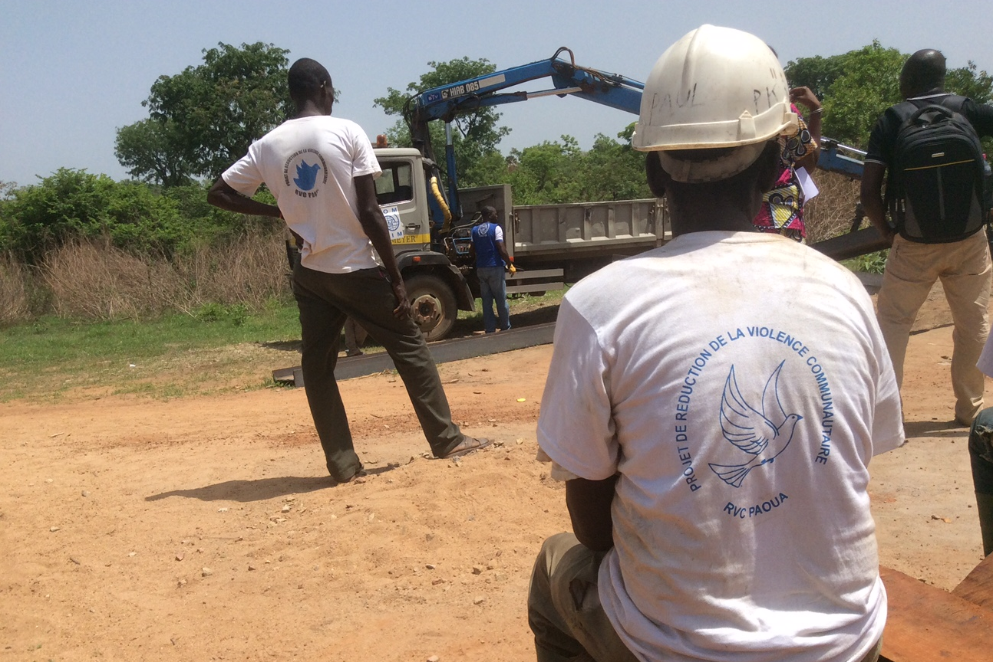
©TI/Irma Specht

IOM Central African RepubliC - June 2017
Table of Contents
Executive Summary 3
Acronyms 12
1. Background to the evaluation 13
1.1 Context analysis 13
1.2 The CVR pilot project 14
1.3 Objectives of the evaluation 17
2. Methodology 18
2.1 Evaluation questions 18
2.2 Sampling, scope and reliability 20
2.3 Tools and analysis 22
2.4 Challenges and limitations 23
3. Findings 25
3.1 Most Significant Change 25
3.2 Relevance 30
3.3 Effectiveness 34
3.4 Efficiency and Value for Money 56
3.5 Impact (outcomes) 59
3.6 Sustainability 68
3.7 Gender, Inclusivity and Do No Harm 70
4. Conclusions & Recommendations 77
4.1 Conclusions 77
4.2 Recommendations 80
References 83
Annex A. Comparative analysis of main findings mid-term and end of project evaluation 84
Annex B. People contacted 87
Annex C. Tools 95
Annex D. Primary data 127
Annex E. Results framework 128
Annex F. Financial Report April 2017 142

Executive Summary
Background and objectives
The Community Violence Reduction (CVR) pilot project is targeting 10 hotspot locations in the north-western part of the Central African Republic (CAR), the sous prefecture of Paoua, where there is a strong presence of Anti-Balaka and ‘self-defence’ groups and community violence is particularly severe. Implemented by IOM, supervised by MINUSCA-DDR, and supported by the United Nations Peacebuilding Support Office (PBSO), the project provides support to armed group elements not eligible for the national DDR programme, as well as vulnerable people in the concerned communities. The project’s general objective is to improve security at the local level, through the economic and social reinsertion of violence-prone armed groups’ elements non-eligible for the national DDR programme and community dialogue mechanisms in hotspots areas playing a stronger and positive role in the prevention of violence at the local level.
The purpose of this final evaluation is to assess the achievements of the project against its theory of change, targets and indicators; to provide recommendations on the way forward and the exit strategy; and to draw lessons from this pilot intervention that can be used in future CVR interventions in CAR and elsewhere. The evaluation reports on the relevance, effectiveness, efficiency and value for money, as well as the likely impact and sustainability. It also considers if and how these types of interventions are the right approach in these kinds of highly insecure contexts, the link between DDR and CVR, and the contribution the project made to overall stabilisation efforts by the international community.
Methodology
This evaluation is carried out from April to June 2017 and includes extensive study of project documentation and finances; consultations in Bangui with relevant stakeholders and the project’s Steering Committee; fieldwork in 5 selected project locations (North Paoua, South Paoua, Bambara, Poulao and Pendé) and an additional interview with the Local Committee (LC) of Gouzé. The methodology relied on seven tools, including a Most Significant Change (MSC) survey with a sample size of 277 people. In total, 335 interviews were held. The beneficiaries consulted (79 armed group elements and 23 vulnerable group members; 80 men and 22 women) have been identified through a random sample. Focus Group Discussions (FDGs) with community members were organised spontaneously, and other stakeholders were identified through purposive sampling. Triangulation of all data is ensured and all data is disaggregated by sex and age to analyse differences in opinions between youth, adults, male and females. Further, the report is presenting the differences in views between the different stakeholder groups.
The evaluation team would like to express concerns about the evaluability of this project due to the absence of a baseline, the poor quality of the results framework, and the lack of documentation around the approval of several revisions of the results framework. Particularly the absence of a baseline means that the reliability of the conclusions of this evaluation is compromised.

Key findings
Most Significant Change
As presented in the graph below, the most significant change according to almost half of all male and female respondents, is the improved infrastructure. In their stories, people explain that the repairing of roads has increased their mobility, facilitated commerce and trade, made it easier for children to reach school, and has increased security. The schools build improved living conditions. There are no significant differences between the views of men and women in this.
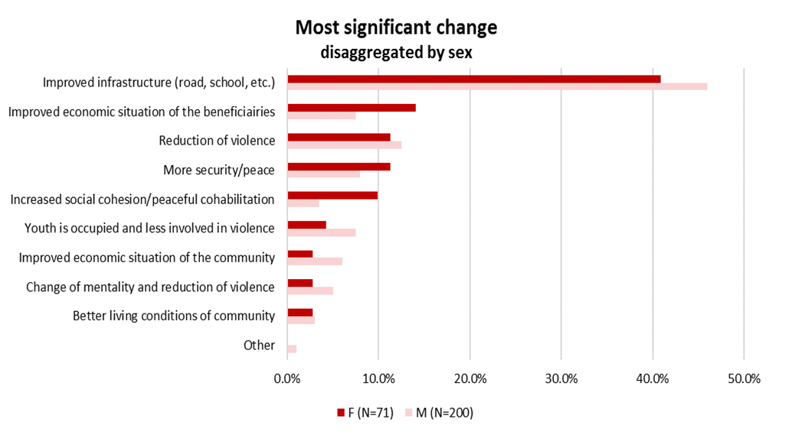
All respondents were also asked about their biggest disappointment of the project, as presented below, disaggregated by those over and under 30 years old. Both age groups agree that the cycle of 24 days of work was too short and the wages were too little to enable people to save money, especially stressed by the youth. In addition, the lack of inclusion of women and non-combatant youth has created disappointments. Additionally, not all infrastructure identified through participatory processes were materialised due to limitations in funding, and people complaint about nepotism and favouritism in the selection process to become a beneficiary.
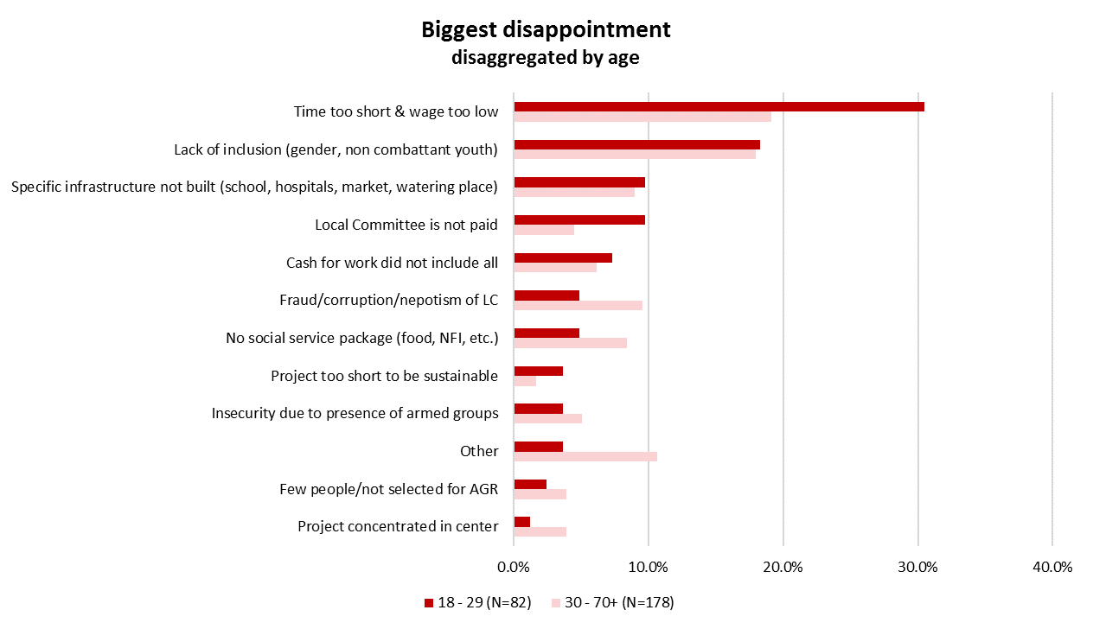

Relevance
- Almost all (95%) stakeholders regard the project approach relevant for the context of Paoua, although complaints were raised about too much concentration in the main villages;
- The project addresses the right issues, using a participatory approach and conducting a good needs assessment. However, the results framework is of poor quality and overambitious for an 18 months project;
- CVR without DDR proved to be problematic in terms of eligibility and information. Lack of clarity found about eligibility criteria for both DDR and CVR among beneficiaries, communities, local leaders and even project staff;
- Infrastructure rehabilitation (roads, schools, etc) was highly relevant, and in collaboration with line-ministries. Improved infrastructure is mentioned as the MSC of the project, leading to improved living conditions, mobility, commerce and also facilitating the efforts of MINUSCA Force and humanitarian actors;
- The project has not included pastoralists in their beneficiary group and did not work on conflict mitigation concerning the ongoing conflicts between pastoralists and farmers;
- The project targets 2,200 vulnerable people (mainly elderly women) and leaves out non-combatant youth, which is not in line with CVR objectives and creates the message that picking up an arm will pay off.
Effectiveness
- 74% of the target to provide 7,000 people with Cash for Work (CfW) is achieved. Almost all confirm that CfW has stabilised youth and given them hope, but a CfW cycle of one month proves to be too short to create lasting results;
- Almost all respondents confirm improved living conditions and positive effects of improved community infrastructure. Local sourcing of materials is a positive approach of the project;
- 502 Income Generating Activities (IGA) approved, kits are good, and a system of business support is put in place. The problem is the low number of IGAs (only approx. 10% of total target group) and related serious problems around selection, which challenged the legitimacy and previously good reputation of the Local Committees (LCs) created;
- Confirmed participation and commitment of most LCs. Strong working relation between IOM and LCs, and LCs are indeed in the driving seat;
- The evaluation largely confirms a change of mentality and reduction in violence. Dialogue sessions are organised by the LCs, however they are limited in scope and number, with more focus on mediation.
Efficiency (Value for Money)
- The project produces high value for money, especially considering the high insecurity of the target locations which increase operation costs;
- Rumours on lack of transparency, nepotism, accusations of corruption in LCs were observed;
- IGA kits are too expensive for individuals, especially as not enough kits are available;
- Partnerships to increase efficiency are hardly functional, but proof exists that the project tried hard to establish these partnerships (MINUSCA Civil Affairs, Danish Refugee Council, World Food Programme etc.). Local partnerships with CASAL and Radio Pendé highly efficient and good Value for Money. Efficient working relationship with MINUSCA Force;
- Overall, the monitoring and evaluation (M&E) system and strategies of this project are weak, which is particularly worrisome for a pilot project meant to test the appropriateness of the CVR approach.
Impact (outcome)
Outcome 1: Economic reinsertion of armed groups’ elements non-eligible for the national DDR Programme achieved through skills training and income generation activities
- 53% of the combatants and 61% of the vulnerable people directly targeted by the project state that their economic situation has improved due to the project;
- No skills training is provided (except few for agriculture), which is a missed opportunity as providers and local craftsmen are available;
- CfW and IGAs provides a start to economic integration, but time for follow-up is too short to ensure that armed groups’ elements will not be “recycled in illicit activities”. There is a strong need for consolidating the results;
- 73% of all respondents say that the economic situation of the community members has improved. Improvement is due to increased cash in communities, increase in commerce/mobility as roads are better and increased agricultural production as security increased;
- For the few IGAs available, not enough priority is given to combatants (over vulnerable people);
- Not all armed youth is included – some joined later due to lack of trust. In the selection criteria for IGAs, ‘difficult cases’ are excluded, which is against DDR/CVR principles.

Outcome 2: Social reinsertion of armed groups’ elements non-eligible for DDR and peaceful coexistence within their communities achieved through trainings and community dialogue in hotspots areas, playing a stronger and positive role in the prevention of violence; peaceful coexistence is achieved at community level, through the establishment of mechanisms for peaceful settlement of intercommunal and internal disputes as alternative to violence.
- Given the absence of a baseline, there is no reliable measurement of whether the number of violent incidents decreased. Another issue is a design fault, as one of the indicators refers to number of cases reported, while the target refers to number of actual incidents. The number of reporting most likely went up due to an innovative system set up by the project to register and track incidents, and to put a referral system in place from LCs to IOM to MINUSCA Force. However, 85% of all respondents do indicate that their community is more peaceful now than two years ago and the main reason cited for this is a reduction in violence;
- The perception of the majority of the community members and other stakeholders is that potentially violent conflicts have been resolved by the LCs. However, the evaluation team only found proof of very few cases where inter-community disputes were addressed. LCs are more focused on conflict mediation which makes them more reactive rather than proactive. The CASAL partnership is proven to be highly effective in this respect;
- Overall, 65% of respondents of this evaluation indicate that they feel safer now than 2 years ago and attribute this to the project, but the new presence of MPC and RJ creates a different source of insecurity. In addition, in some locations’ insecurity remains high due to conflicts between pastoralists and farmers, conflicts that are not treated by this project which is a missed opportunity.
Sustainability
It is too early to establish if, and to what extent, the project has created lasting change and results. The following key points can be observed:
- There is no exit explicit strategy in place. For example, the team found no plans for the future of the local arms storages in the communities, maintenance of roads after the project remains an open issue and the innovative incident reporting and referral system is likely to fall apart after the closure of the project as no capacities are built to ensure effective handover.
- Nearly all respondents indicate that the CVR project has indeed created lasting results, particularly highlighting the infrastructure put in place.
- The evaluation team sees a potential risk of revolt when DDR starts, if there is no more CVR. Of great concern is the sustainability of the stability created, especially related to the group of estimated 600-800 armed elements that are left out of the process, and the few that were expelled due to inappropriate behaviours. Closing the project before stabilising this group puts the peacebuilding effects created by this project at risk;
- There is a need to consolidate the LCs, e.g. with meeting room, new reporting lines for incidents etc, and address remaining capacity building needs of CASAL and Radio Pendé;
- Local ownership is good, except that no relation and no capacity development is found with the police and gendarmery;
- National ownership is less evident, and the team found strong complaints from national actors about insufficient involvement and no facilitated field visits;
- CfW income is too little for beneficiaries to save and start IGAs, with some exceptions;

Gender, inclusivity and Do No Harm
- The results framework does not specify targets disaggregated by sex and the progress reported is not disaggregated by sex;
- The decision to not target all female combatants in the IGAs is a missed opportunity to increase a better gender balance. It is not reported which % of the IGA kits are given to women;
- Children within the legal working age (14-18) have been excluded from the assistance provided, which has no legal basis. From a protection point of view, it creates more risk not to include them in the project activities then to leave them out. IOM tried to lobby for their inclusion but did not succeed;
- The project has not included pastoralists in their beneficiary group, and did not work on conflict mitigation concerning the ongoing conflicts between pastoralists and farmers. In this way, the project in fact strengthened one party of the conflict (the farmers) which is not in line with Do No Harm (DNH) principles;
- While it can be applauded that this project really managed to apply participatory approaches, the downside is that giving all decision making to the LCs in terms of selecting beneficiaries has led to accusations of nepotism and fraud. The project did give some basic selection criteria for IGAs, but the LCs were in charge which has exposed them too much, as they were given the impossible task to select only 10% of the people that completed CfW. This has, in the very last months of the project, challenged the credibility of the committees so carefully set-up by the project.
Conclusions
The most important conclusion is that indeed the project has had a stabilising effect on the 10 targeted communities, with increased security, reduced violent incidents and perceived increase in peaceful coexistence. Fewer arms circulate in the communities and a large percentage of the armed people not eligible for DDR have reduced violent and illegal activities and started to engage in productive activities. People also express that due to this improved security they have restarted farming. Further, the roads repaired have a direct impact on mobility and related trade and commerce, which has led to an overall improvement of the economic situation of the community as a whole.
The Theory of Change of the project is the following:
“IF the targeted elements of armed groups non-eligible for the national DDR Programme participate in economic reinsertion activities-including cash for work and skills training, among others;
and IF local mechanisms for dialogue and conflict prevention are inclusive and function effectively;
and IF local authorities succeed in the voluntary collection of weapons from elements of armed groups;
THEN security at the local level would be improved and violence reduced.”
The Theory of Change is highly relevant and a very good start has been made to foster the above change, but a consolidation phase is required.
The table below summarises the SWOT of the CVR project in Paoua.
Strengths  Highly participatory  Quality Infrastructure  Strong local ownership  Arms management and storage  Partnership CASAL, Radio Pendé  Boosted local economies  Good IGA kits  Stabilisation and increased security  Ethnic representation in LCs  Capacity development of LCs  Active team, manager and very good field presence | Weaknesses  Too short for sustainability  Weak national ownership created  Not all combatants included  Vulnerable instead of youth spread the message to arm  Too few IGAs, too much individual  14-18 years excluded  No skills training  No conflict mitigation pastoralists/agriculturists  No market studies  Lack of gender responsiveness (beyond numbers)  Link to police/gendarme  No baseline, weak M&E
Opportunities  Extension of project to consolidate results  Increase number of IGAs based on market needs  More rounds of CfW for excluded combatants  CfW away from centres  IGAs to all female combatants  Include more focus on extension of state authority | Threats  Unarmed excluded youth  CVR without DDR (eligibility and info)  Closure before DDR  CfW-only participants might go back to illegal activities without IGA  Locally led versus favouritism/fraud  Money leaving communities if market not created

Recommendations
Extent the current project with minimum one year to:
- Ensure enrolment in CVR for those that were left out and for those MPC and RJ members that will not be on the DDR list, this support of a MINISCA DDR staff member;
- Consolidate dialogue and mediation capacities of LCs and CASAL, and further support Radio Ohuam Pendé as budgeted for;
- Support LCs to finalise all dual-key arms storage structures in the 10 communities;
- Build meeting rooms (with group-IGA restaurant) for LCs;
- Initiate a new round of CfW on roads away from centres and ensure combatants included from isolated villages;
- Use last round of cash for work on building local markets, with building skills transmission. This could be done by minors in working age – with training of facilitators on child protection. As part of this, set-up group masonry IGAs. Use engineers of the project as trainers;
- Work on exit strategy, e.g. transmission of tools and boots, setting up work road rehabilitation cooperatives and advertise them to MINUSCA civil affairs, WFP, NGOs and Local Government of Paoua for future contracting. Use project engineers for training them;
- Find a way to transform the incident tracking mechanism, and actions, to a local actor;
- Add more IGAs, only for combatants with IGA kits for minimum 2 persons, possibly of the same family, include all female combatants;
- Ensure diversification based on local markets, e.g. 1 telephone, 1 carpentry workplace, 1 tea-shop and 1 animal medicine shop everywhere;
- Carpentry training on the spot to produce tables, chairs etc. for IGAs and for schools. Setting- up carpentry workshop building for 4-5 beneficiaries together (individual businesses in one location);
- Now that IGAs are established, it is more likely that cash from a new round of cash for work stays in the local community;
- Where possible add 3 month courses skills training through APAP (in Paoua and some mobile) and by contracting local tradesmen.

Recommendations for future CVR interventions:
- Ensure a massive CVR in all DDR locations to reduce tensions, ensure 100% separation of target groups, transparency, and major public information on this. However, it is recommended to implement several joint activities for CVR and DDR participants, such as social activities, but also IGAs support such as vocational and business training. Now that the DDR strategy has been drafted there is urgent need to draft a CVR strategy outlining how CVR will complement DDR;
- Stop having vulnerable old people, but local unemployed youth instead to stay within the objectives of CVR;
- Establish youth centres with solar and internet through CVR/DDR funding to again stay more in the objectives of CVR to stabilise the (armed) youth;
- Ensure economic reinsertion becomes reintegration, based on local market research and needs of the community (instead of beneficiaries’ preferences), and include skills training/transmission and longer-term follow-up;
- Establish physical markets through cash for work, so that more money stays in local communities. Start IGAs immediately after the first cycle of CfW so that the salaries can be spend on these local businesses;
- Improve gender responsiveness by gendering the M&E frameworks, including special support to female beneficiaries with babies and by working more explicitly on transforming violent masculinities;
- Continue with creation and capacity development of LCs and organisations like CASAL. The DDR programme is advised to work through the same committees where created;
- Invest in local radio stations and use them for the public information component;
- Create local DDR/CVR steering committees (sous-prefecture level) with representation of the Local Governments, which will also become a platform for cross-learning between LCs and will facilitate the information flow and involvement of the national government representatives in the national steering committee;
- Add more capacity development activities and facilitation for state actors (national and sous-prefecture) – contribute more explicitly to the extension of state authority and national ownership;
- Add literacy courses and possibly scholarships (instead of IGAs for those who prefer education);
- Add children from 14 and above, but be careful with hazardous work. Establish UNICEF partnership to train CVR implementers in relevant child protection issues;
- Do not exclude beneficiaries that are misbehaving, as it is exactly the task of a CVR project to stabilise them which should not stop if it does not succeed immediately;
- Ensure that the beneficiaries’ database can effectively track progress. The current database is not fit-for-purpose and inconsistencies were detected. Ideally use the same database as MINUSCA for DDR so that data sets can be merged and easy verification of double dipping (CVR and DDR) can easily be detected.

Acronyms
AFG Armed Forces Groups
AG Armed group
CAR Central African Republic
CASAL Local Spiritual Leaders Association for Social Cohesion
CfW Cash for Work
CPP Comité de Pilotage du Projet
CVR Community Violence Reduction
DAC Development Assistance Committee
DDR Disarmament, Demobilisation and Reintegration
DDRR Disarmament, Demobilisation, Reintegration and Repatriation
DNH Do No Harm
DRC Danish Refugee Council
FGD Focus Group Discussion
FSD Swiss foundation for Mine Action
GDV Gender Based Violence
IDP Internally Displaced Persons
IGA Income Generating Activities
IOM International Organisation for Migration
KII Key Informant Interview
LCs Local Committees
MINUSCA United Nations Multidimensional Integrated Stabilisation Mission in the Central African Republic
MPC The Patriotic Movement in the Central African Republic
MSC Most Significant Change
M&E Monitoring and Evaluation
PBF Peacebuilding Fund
PBSO United Nations Peacebuilding Support Office
PoC Protection of Civilians
RBB Results Based Budgeting
RJ Revolution and Justice
SOP Standard Official Procedures
SGBV Sexual and Gender Based Violence
THIMO High Intensity Work through Temporary Employment
TOC Theory of Change
VFM Value for Money
WAAFG Women Associated with Armed Forces and Groups
WFP World Food Programme

1. Background to the evaluation

1.1 Context analysis
The civil war in the Central African Republic (CAR) started in 2013. MINUSCA was mandated in 2014 to “support the Transitional Authorities, and the subsequently elected authorities, in developing and implementing a revised strategy for the Disarmament, Demobilization and Reintegration (DDR) and, in case of foreign elements, Repatriation (DDRR) of former combatants and armed elements” and in 2015 to “to support the Transitional Authorities, and the subsequently elected authorities, in developing and implementing Community Violence Reduction Programmes” (CVR). Subsequently, in May 2015 an agreement on a “Republican Pact for Peace, National Reconciliation and Reconstruction” was brought about. Nine armed groups (AGs) signed the “Agreement on DDR principles.” CVR is a critical component of the national DDR programme since approximately 60,000 individuals, part of the anti-Balaka movement and other armed groups, will not be eligible for the national DDR programme but still pose a serious security threat to the civilian population.
The CVR project targets hot-spot locations in the north-western part of the country, where most of the anti-Balaka and ‘self-defence’ groups are situated and community violence is particularly severe. After a joint initial assessment, MINUSCA indicated the Sous-Prefecture of Paoua (Prefecture of Ohuam Pendé) as the target area for the Pilot Project. The area south of Paoua was thus identified as the pilot zone due to high prevalence of non-DDR eligible armed actors, and 19 hotspots were identified in the zone. One of the challenges in Paoua is the lack of social services and infrastructure, and the levels of vulnerability and poverty. In addition, very few international actors operate in the zone: “The project remains the only stabilisation initiative in this region, a region critical for maintaining the stability of the peace process”.
During the implementation of the project, violence in Paoua has increased due to the new presence of two armed groups: Revolution and Justice (RJ) and the Patriotic Movement in the Central African Republic (MPC). The situation in Paoua was improving until several attacks by a RJ/MPC coalition, stealing livestock and destroying villages, which in October (2016) exacerbated the security situation. According to the International Organisation for Migration (IOM), after the village of Gouzé was occupied by the RJ/MPC coalition in November, it became clear that the coalition wants to monopolise the use of force in Paoua. As a result, it has become increasingly difficult to protect the civilian population from these armed groups. As the RJ/MPC coalition continues to be a presence in the region, fear of retaliation from either the anti-Balaka movement or the return of the Seleka has become more real and the situation in Paoua remains insecure. It is important to note that these are formal militia groups that adhered to the DDR process and are awaiting their entrance into the national DDRR programme. The delay in start-up has led them to move from their original site of concentration in the northern Paoua area to Gouze seeking monetary sustenance from banditry in the area, thus affecting the initially agreed and smooth process of the CVR.

1.2 The CVR pilot project
Project intended results
The CVR project, implemented by IOM in coordination with MINUSCA and through the support of the United Nations Peacebuilding Support Office (PBSO), has been developed to provide support to armed group elements not eligible for the national DDR programme, as well as elements of communities particularly prone to, or vulnerable against, violent activities in order to contribute to violence reduction and security enhancement in the targeted communities. The pilot project in Paoua is the first stand-alone community violence reduction project in CAR. It was developed to bridge the gap between the formal DDR process and community-based violence reduction initiatives. The donor, PBSO, compliments MINUSCA and IOM for testing the project in a difficult zone, in need of support to deal with disgruntled youths.
The CVR project entails two main operational areas: 1) economic reinsertion and 2) social reinsertion of armed groups and their associated elements, including a conflict prevention element within the target communities. The project’s overall objective is to improve security at the local level, through the economic and social reinsertion of violence-prone armed groups’ elements (non-eligible for the national DDR Programme) and community dialogue mechanisms in hotspots areas playing a stronger and positive role in the prevention of violence at the local level.
The Theory of Change of the project is the following:
“If the targeted elements of armed groups non-eligible for the national DDR Programme participate in economic reinsertion activities-including Cash for Work (CfW) and skills training, among others; and if local mechanisms for dialogue and conflict prevention are inclusive and function effectively; and if local authorities succeed in the voluntary collection of weapons from elements of armed groups; THEN security at the local level would be improved and violence reduced.”
In line with the above, the project aims to achieve the following outcomes:
- Economic reinsertion of armed groups’ elements non-eligible for the national DDR Programme achieved through skills training and income generation activities;
- Social reinsertion of armed groups’ elements non-eligible for the national DDR programme and peaceful coexistence within their communities achieved through trainings and community dialogue in hotspots areas, playing a stronger and positive role in the prevention of violence; peaceful coexistence is achieved at community level, through the establishment of mechanisms for peaceful settlement of intercommunal and internal disputes as alternative to violence.
When asking key informants (project staff, local committees, government staff, local leaders, and the police/gendarmery) what the objectives of the CVR project are, most respondents highlighted that the CVR was a peacebuilding, social cohesion and stabilisation project, occupying the youth to reduce violence, with only 10% of the respondents referring to reinsertion of armed groups or individuals.
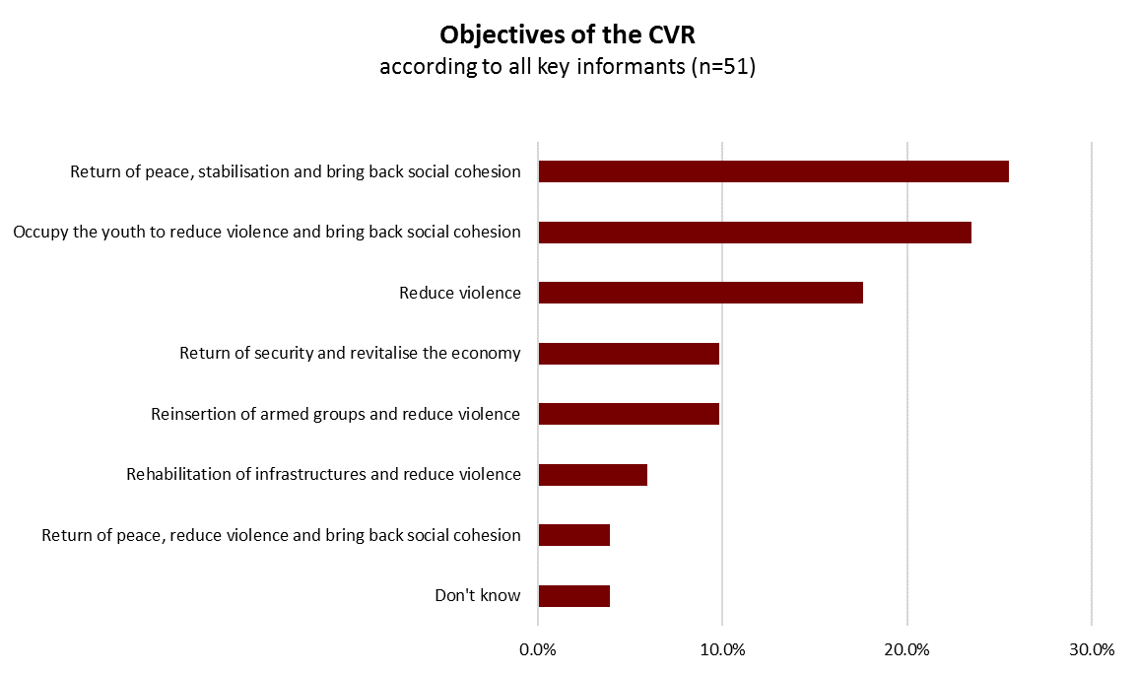
Figure 1 Objectives of the CVR

Annex E is the results framework shared by IOM as being the final version presented to the donor PBSO in its annual report in November 2016. However, the evaluation team found that the version sent to the donor is different than the version provided by IOM, as in the donor report several indicators disappeared. The team decided therefore to use the version sent by IOM, which is in line with the version sent to the donor but has additional indicators against which IOM reported financial and progress updates. The following impact indicators are presented, which form the basis of this evaluation:
Impact indicators:
1.A The armed groups’ elements non-eligible for the national DDR Programme are economically integrated and not recycled in illicit activities;
1.B At the end of the project the community members perceive their economic situation improved.

2.A Number of inter- and intra-communal violence incidents reported during the project life span;
2.B Number of inter and intra communities’ disputes resolved by peaceful means and reported by the Community Committees;
2.C At the end of the project the community members perceive their community more secure in respect at the beginning of the activities.

Institutional set-up
The project is implemented by IOM, in close coordination with MINUSCA DDR and the Office of the High Commissioner for DDR and SSR. A project steering committee, co-chaired by the High Commissioner DDR-SSR and MINUSCA DDR Section, oversees the project design and implementation at the strategic level. Members of the steering committee are: representatives of the MINUSCA DDR Section, IOM, High Commissioner for DDR-SSR, Ministry of Territorial Administration, and others invited ad hoc. Ad hoc members are Ministry of Public Security or Social Affairs and representatives of the police and gendarmerie. The ministries and international actors involved in the CVR project are presented below:
- Counsellor to the Presidency of Republic for the DDR and SSR;
- Ministry of the Economy Planning and International Cooperation;
- Ministry of Territorial Administration, Decentralisation and Regionalisation;
- Ministry of Social Affairs for Reconciliation, Gender and Humanitarian Actions;
- Ministry of Education;
- Ministry of Infrastructures;
- IOM;
- PBSO;
- MINUSCA DDR section.

Scope
The total duration of the project is 18 months. Within Paoua, 10 locations were selected: North Paoua, South Paoua, Poulao, Pendé, Bambara, Gouzé, Doula-Bavara, Taley, Bilakaré and Belé. The project had 7,000 intended direct beneficiaries, including 4,800 armed groups’ elements that are not eligible for the national DDR programme (69% of the total number of participants), together with 2,200 other members of the communities (31%). The CVR project was intended to reach an estimated total number of 7,000 beneficiaries. An estimated number of over 250 villages exist and a population of around 100,000 individuals live in communities targeted by CVR community-oriented activities.
Inputs
The total budget for this project was USD 3,500,000, fully provided by the Peace Building Fund. In addition, inputs from MINUSCA were provided (in kind) from MINISCA’s assessed budget. The expenditures to date (April 2017) amounts to USD 2,557,625. This means that 3 months before the closure of the project, the expenditure rate has been 73% of the total budget USD 3,500,000. Annex F presents the expenditure against the results framework (net costs), as requested by the evaluation team and prepared by IOM, and section 3.4 on Efficiency presents the full breakdown of inputs and expenditure.

1.3 Objectives of the evaluation
The overall objectives of this end of project evaluation are to assess the achievements of the project results, to provide recommendations on the way forward and the exit strategy, and to draw lessons from this pilot intervention that can be used in future CVR interventions in other locations in CAR.
The specific objectives of the evaluation are:
- To review the efficiency and effectiveness of the project in achieving its intended results;
- To assess the relevance and sustainability of the project components;
- To identify weaknesses and strengths of the project design and implementation strategy in order to come up with recommendations and scenarios for strengthening key components of the project;
- To assess how well matched the resources are to the objectives (Value for Money);
- To assess the: overall impact on stabilization and early recovery efforts of the communities; the sustainability of the (re)insertion of beneficiaries in the socioeconomic context; the level of ownership by the Government, the Local Committees and by beneficiaries of the results; and on the likelihood of continuation of Local Committees as civil society bodies for giving voice to the communities themselves;
- To respond to the questions on what the challenges and opportunities are in this particular context in achieving the desired outcomes.

This final evaluation has been conducted under the general supervision of the Chief of Mission of IOM in Central African Republic, under the direct supervision of the Programme Manager of the “Community Violence Reduction (CVR)” project funded by the PBSO, and in close coordination with both the DDR section of MINUSCA and the High Commission for the DDR and SSR and Ministry of Planning.

2. Methodology
This chapter presents in more detail the scope and methodology for evaluating the Community Violence Reduction project. As this is a pilot project, the evaluation methodology has a strong focus on collecting lessons learned and providing recommendations for future programming.
The evaluation team would like to express some concerns about the evaluability of this project due to the challenges and limitations specified further below in section 2.4. The project was implemented at a time of high instability, and the evaluation team has therefore considered the unforeseen contingencies, including the political, economic, and social context, along with other internal and external factors, which may have affected the achievement of targets. The evaluation also examined the relevance and effectiveness of the flexibility and adaptations made by the project management and implementing partners to this challenging and changing context.
The evaluation of the CVR project has been conducted, as per agreement with IOM CAR, against the indicators and targets of the latest results framework with updated indicator progress on April 2017 (see Annex E).
To ensure that the evaluation is serving its purpose, the TI evaluation team adhered to several basic principles in choosing the methodologies:
- The data collection was appropriate and adapted to the literacy and culture of the participants;
- Sampling was both systematic but also flexible and organic due to access and security concerns;
- The evaluation included girls, boys, men and women, and their meaningful participation was of great importance;
- The evaluation made use of tools and formats that have proven to be successful;
- TI tried to ensure triangulation of data to maximise reliability;
- The evaluation consulted with both direct and indirect beneficiaries.

2.1 Evaluation questions
The evaluation team has evaluated the CVR project against the indicators and targets outlined in the results framework, following the OECD Development Assistance Committee (DAC) criteria. As the project is still ongoing, it is too early to measure the impact of the project and therefore this evaluation attempted to measure contributions to the outcomes and likely impact. More specifically, the evaluation has sought to answer a number of specific questions, including:
Criteria | Questions
Relevance | Are we doing the right thing?
 | What is the quality of the results framework? Are the activities and outputs of the project consistent with the intended impacts and effects?
 | To what extent are the objectives of the project (still) valid?
 | Did the project respond to changes in context?
 | Was the project design based on a solid needs analysis, gender analysis, market analysis and baseline?
 | Are the skills training and IGAs responsive to local market demands?
 | Are the infrastructure projects chosen relevant for the context?
 | The project intends to complement DDR efforts, is this achieved?
 | Do communities, beneficiaries and other stakeholders perceive the project relevant for peacebuilding, stabilization and the economic recovery of the area?
Effectiveness | To what extent were targets reached?
 | To what extent were the outputs achieved?
 | What were the major factors influencing the achievement or non-achievement of the outputs?
 | To what extent have targeted populations been reached?
 | To what extent has gender responsiveness been implemented?
 | Were the planned activities and outputs implemented in a timely manner?
 | Have the project managers integrated recommendations made by the mid-term evaluation?
Efficiency | Is the project implemented in the most efficient way?
 | Does it produce Value for Money?
 | Was the project implemented in the most efficient way compared to alternatives?
 | Have partnerships been established to maximise efficiency?
 | What is the balance between operation and actual project activity costs?
 | Are there signs of non-transparency, corruption or nepotism?
 | What is the quality of the infrastructure realised by the project?
Impact (outcome) | What are the positive and negative effects on direct beneficiaries?
 | How many men and women have been positively affected?
 | What real difference has the project made to the beneficiaries?
 | Did the project change behaviour of the participants?
 | What is the potential positive and negative impact of the project on indirect beneficiaries?
 | Are there any unintended outcomes of the project?
 | Did the project adhere to Do No Harm principles and to what extent was this monitored?
 | What are the externalities associated with the project?
 | To what extent can the Most Significant Changes, as expressed by project stakeholders and beneficiaries, be attributed to the project?
 | Did the project create any gender transformative results?
Sustainability | To what extent is it likely that the benefits of the project continue after donor funding has ceased?
 | What were the major factors which influenced the achievement or non-achievement of sustainability of the project?
 | To what extent is it expected that armed elements not eligible to DDR have been reinserted in their communities in a lasting manner?
 | Is the length of the activities long enough to enable beneficiaries to save money to start their own businesses?
 | Is there a maintenance plan in place for the infrastructure realised?
 | How effective have capacity development activities been?
 | How likely is it that the dialogue structures supported will remain operational after the closing of the project?
 | To what extent has national and local ownership been created?

2.2 Sampling, scope and reliability
This evaluation took 2 months and included:
- Extensive study of project documentation and finances;
- Fieldwork in 5 field locations namely: North Paoua, South Paoua, Bambara, Poulao and Pendé. An additional interview with the Local Committee of Gouzé took place in Paoua, as Gouzé proved inaccessible due to security events;
- Interviews in Bangui with IOM, relevant MINUSCA units, members of the Steering Committee and the relevant Government agencies.
This evaluation produced a detailed inception report in which the evaluation framework with the research questions per DAC criteria, the sample, the approach and tools were presented. Seven tools were developed, tested and adapted to consult with direct beneficiaries, community members (indirect beneficiaries) and 4 categories of stakeholders namely local leaders, Government in Bangui, staff of other organisations and IOM/MINUSCA/PBSO staff. In addition, a Most Significant Change (MSC) and Disappointment survey among all respondents was conducted. The beneficiaries have been identified through a random sample, complemented with some snowballing. Other stakeholders were identified through purposive sampling.
A total of 335 people (93 women and 241 men) were consulted, of which 102 beneficiaries (79-armed group elements and 23 vulnerable group members; 80 men and 22 women), 67 local leaders (17 women and 50 men), 95 indirect beneficiaries (community members; 48 women and 47 men), 20 local authority members including mayors, police, gendarmery, prosecutor etc. in Paoua (all men), 46 project staff of IOM and MINUSCA (6 women and 40 men), and 5 people from other organisations in Paoua (all men).
Sampling
The evaluation team has, as far as possible given the short timeframe, taken great care to ensure that the sample of respondents is representative, covering all relevant stakeholders involved in the project. Purposive sampling and snowball sampling have been applied to key informants and community members (indirect beneficiaries). The evaluation team strived for a gender balanced group of community members participating in the focus group sessions.
The tables below represent the sample of respondents for the evaluation of the CVR project. It presents the sample set, as per inception report, and the actual sample reached. According to the Results framework, presented in Annex E, the project targets 69% of its project beneficiaries as members of armed elements and 31% as vulnerable group members. Therefore, the sampling for this evaluation was equally based upon approximately the same divide between the two groups of beneficiaries (69/31).

Sample | Type of respondents | Targets set by the evaluation | Targets reached by the evaluation
Direct beneficiaries | Armed groups elements not eligible for the national DDR programme.  Unfortunately, the participant lists provided by IOM was not disaggregated by age. Therefore, while originally planned, TI was unable to draw a random sample taking into account the age variable. | Target: 70  6 women and 64 men  Balance in age groups | Reached: 79  8 women and 71 men  Balance in age groups
 | Vulnerable members of the communities (women head of households, GBV survivors, IDP and returnees, religious and ethnic minorities, and female dependents of armed groups) (31% of the targeted direct beneficiaries). | Target: 34  21 women and 13 men | Reached: 23  14 women and 9 men
Indirect beneficiaries | People from the communities including: non-participants to the project, beneficiaries from the renovated/ built infrastructures, people working within the new infrastructures, family and relatives of the direct beneficiaries, radio listeners, police officers, non-targeted neighbouring villages etc. | Target: 50  25 women and 25 men | Reached: 95  48 women and 47 men
Stakeholders | Local leaders, members of the Local Committees (LCs), local authorities, CSOs and project staff from IOM, MINUSCA and other organisations. See complete list in Annex B. | Approximately 10 in Bangui and 50 in the field | Reached: 138
Totals |  | 214 | 335

Sampling of direct beneficiaries | Location
 | Paoua North |  | Pendé |  | Poulao |  | Bambara
Gender | Male | Female | Male | Female | Male | Female | Male | Female
Armed groups elements | 15  16 | 2  3 | 15  20 | 3  4 | 15  18 | 3  0 | 15  17 | 3  1
Vulnerable members of the communities | 3  4 | 6  4 | 3  1 | 5  2 | 3  3 | 5  3 | 3  1 | 5  5
Totals | 18  20 | 8  7 | 18  21 | 8  6 | 18  21 | 8  3 | 18  18 | 8  6
Based upon the above principles, TI has drawn a random sampling of 26 direct beneficiaries per location. The sample is based upon the numbers presented in the table below. The red figures present the number of this sample list actually interviewed.

2.3 Tools and analysis
This evaluation started with the drafting of a detailed inception report in which the evaluation framework, with the research questions per DAC criteria, the sample, the approach and tools were presented and approved. In summary:
- A mixed methods approach has been applied and seven tools have been developed, tested and adapted to consult with: direct beneficiaries, community members (indirect beneficiaries) and four categories of stakeholders (local leaders, Government in Bangui, staff of other organisations and IOM/MINUSCA/PBSO staff);
- Triangulation has been ensured;
- Most significant Change (MSC) and Disappointment has been harvested from 277 people;
- All data is sex and age segregated;
- All data was entered in excel and cleaned in STATA; graphs were produced accordingly. A large amount of post-categorisation has taken place to open questions.
Annex C presents the tools. A summary of the tools used for the evaluation is presented below:
1) An adaptation of the participatory method Most Significant Change (MSC), the major method to establish the change created by this project, as regarded by the key stakeholders, direct and indirect beneficiaries. Beneficiaries and key stakeholders were asked to express their opinion on the MSC this project has created, as well as what the biggest disappointment of the project was. Information contained in MSC stories has consequently been processed and coded for quantitative analysis;
2) A survey with direct beneficiaries about their perception of the CVR project;
3) Focus Group Discussions (FGDs) with groups of indirect beneficiaries composed of six to ten people. A topic list was designed to structure the discussion, but participants had the opportunity to address any subject. In order to enable participants to speak without apprehension, the team created (with one exception) separate groups of men and women;
4) Key Informant Interviews (KIIs) topic lists for consultations both in Bangui, Paoua and the 4 field locations with project staff (IOM and MINUSCA DDR), government staff, local committees, donors, local leaders, other organisations, and police/gendarmery. The questions to all respondents have been asked in French or Sango (depending on the language skills of the participants). In order to protect the identity of the beneficiaries, all Most Significant Change forms, and the interviews with direct beneficiaries have been conducted anonymously. An online questionnaire was distributed to former project staff and other UN staff, but unfortunately the team received no responses.

In addition, completed infrastructure projects, ongoing CfW activities and distribution of Income Generating Activities (IGAs) have been observed, contributing to an assessment of the quality of the projects completed and the transparency of selection principles.
Regarding the gender responsiveness of the project, the evaluation team has assessed all targets set in terms of gender, (e.g. 20% of Local committee members are female, 60% of the Cash for Work vulnerable group are women) and will assess if indeed most WAAFG are part of CVR as they are non-eligible to DDR, as per the “Agreement on DDR principles”.
Finally, the evaluation team has undertaken a review of the project’s financial documentation based on available data, and made use of the concept of Value for Money (VFM) to assess the balance between inputs-outputs and outcome. This part of the evaluation has assessed, in broad terms, the way resources have been used and may give additional recommendations on how this pilot project can be replicated in a highly cost-effective manner.

2.4 Challenges and limitations
The following challenges have been encountered:
Evaluability
As expressed in the inception report, the evaluation was complicated by the absence of a baseline, the lack of documentation around the approval of several revisions of the results framework, the lack of systematic preparation of documentation for this evaluation, late submission of financial information, and the lack of systematic monitoring data. Especially the absence of a baseline means that the reliability of the conclusions of this evaluation is compromised. The team has attempted to partly reduce this by asking questions about the situation 2 years ago, as compared to today.
Further, the evaluation was complex and time-consuming as reporting against the results framework was incomplete and corrected several times. There was no clarity at the beginning and during the evaluation on what the final results framework was. A joint decision with IOM was made to take the last version submitted to the donor, which was provided by IOM (see Annex E), when the team was already in country, which required a last-minute revision of the evaluation framework and the draft tools. In this version, changes appeared in comparison to the results framework revision proposed by the mid-term review, even in reformulation of outcomes. There was hardly any documentation and little track-record in IOM why the proposed revision was not accepted and how last-minute additions and revisions were made. Also, steering committee members, MINUSCA and the Government counterparts, proved not to be aware of the changes (except of receiving copies of English mid-term and donor reports), and were not part of the revision processes. The important significant change is to outcome 1.1, with the addition to the first impact indicator: “…. are economically integrated and not recycled in illicit activities” which has in fact set up the project for failure against this over ambitious outcome indicator given the timeframe and the funds available. Further, as stated above, the final results framework shared by IOM, against which finances and progress was reported, proved not to be the same version as the one shared with the donor.
Security
Several security events took place which limited the movement of the team, to some extent. Access to some of the pre-selected hotspots was complicated and the evaluation team took the decision to not select the locations that are requiring military escort, as this will seriously distort data. IOM managed to get the 19 LC members of the community of Gouzé to travel to Paoua, which was very helpful.

Data collection
During the first week of the evaluation in the field, only 31 beneficiaries were interviewed. Most of the beneficiaries from the random sample list were present when the evaluation team visited the targeted localities, thanks to the IOM facilitators. Still, some beneficiaries were absent with the following reasons provided: beneficiaries being sick, in jail, too far to reach, location unknown or travelling, To reach the set target, the evaluation team therefore decided to apply an extension of the fieldwork of two weeks to try to find the missing and non-surveyed beneficiaries.
The diversity of the selected informants and the ensured triangulation in the tools have served to produce differing perspectives on the project, and to minimise bias.

3. Findings

3.1 Most Significant Change
All people consulted were asked to fill a form with two questions: what is the Most Significant Change this project has created, and what is the biggest disappointment of this project. The results are presented below, segregated by sex and further analysed by sub-categories of respondents. In total, 277 people responded to the two questions.
Most Significant Change
As presented in the first graph below, the change most often mentioned, by almost half of all male and female respondents, is the improved infrastructure. In their stories, people explain that the repairing of roads has increased their mobility, increased commerce and trade, made it easier for children to reach school, and has in itself increased security. World Food Programme (WFP) also explains how the improved roads and repaired bridges have facilitated their efforts to distribute food, and MINUSCA Force confirms that the accessibility of the force also improved due to this. The construction of concrete and solid infrastructure such as schools and a day-care centre is highly appreciated and quoted as creating major changes, in the present and for the future.
The improved economic situation of the direct beneficiaries that participated in the CfW and IGAs is the second frequently mentioned change, although many people say it has been too short to be sustainable. The third, reduction of violence and fourth, more peace are often seen as direct consequences of the improved infrastructure and the engagement of the armed elements in productive work, also reflected in the 6th most often mentioned change, that the youth is now occupied and less involved in violence.
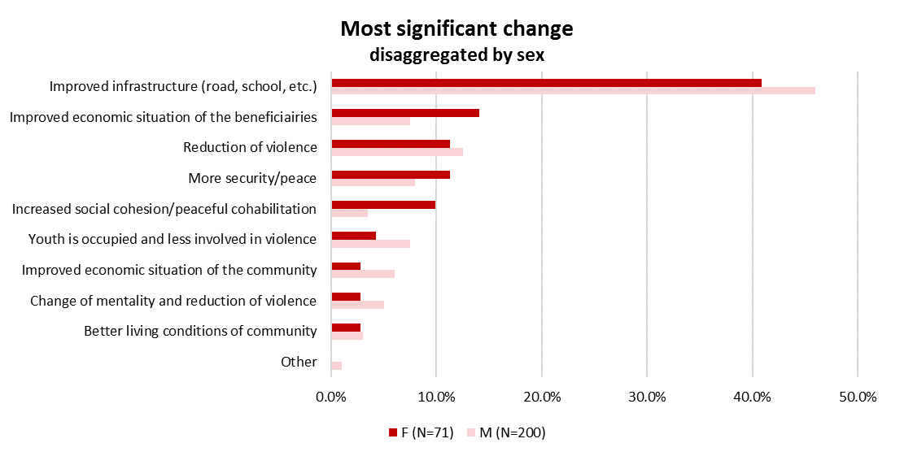FIGURE 2 mOST sIGNIFICANT cHANGE, per SEX
The overall improvement of the economic situation is furthermore related to this improvement of security, which allows people to go to the field more regularly and without fear. Lastly, the changes in mentality and consequent reduction of violence are mentioned by some, as well as the overall improvement of the living conditions of the community as a whole.
The differences between the most significant change mentioned between men and women are not significant; however, women highlight more the youth being occupied, the change of mentality and the overall improvement of the economic situation of the community, while men highlight the improvement in the economic position of the beneficiaries and the increase in security, peace and social cohesion.
When comparing the responses between those under and over 30 years old it can be noted that among the youth the infrastructure is even regarded as more important (53%), as many have noted how road safety has improved. A young male beneficiary in North Paoua, when asked about the most significant change, explains; “It is the road rehabilitation that IOM has achieved. A rehabilitated road reduces the rate of traffic accidents. Before, we could count 2 to 3 accidents daily that sometimes resulted in fatalities but today this is no longer the case.”
Interestingly, older people mention reduction in violence as the most significant change much more than young people.
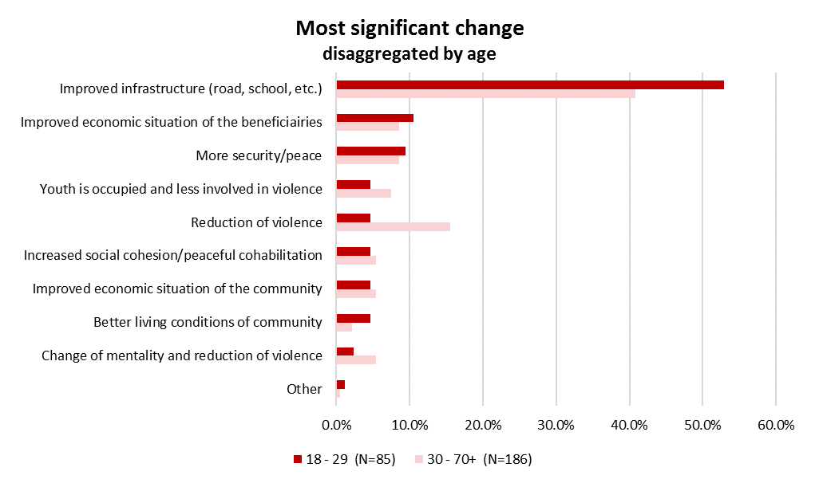
FIGURE 3 mOST sIGNIFICANT CHANGE, PER AGE group

In comparing the answers between direct beneficiaries and community members it can be observed that reduction of violence and increase in peaceful coexistence is more highlighted by community members, while direct beneficiaries refer more to their own improved economic situation.
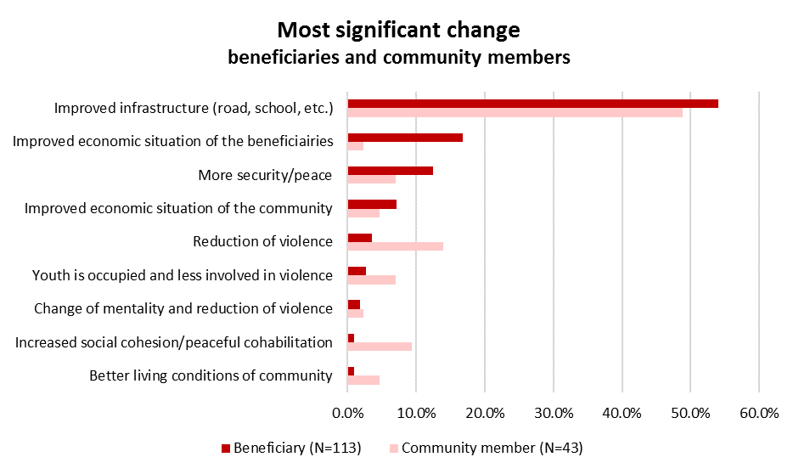
FIGURE 4 mOST sIGNIFICANT CHANGE PER GROUP
When further comparing changes mentioned in rural versus urban settings, infrastructure activities prove to have higher visibility in rural settings, while reduction of violence is more observed in town.
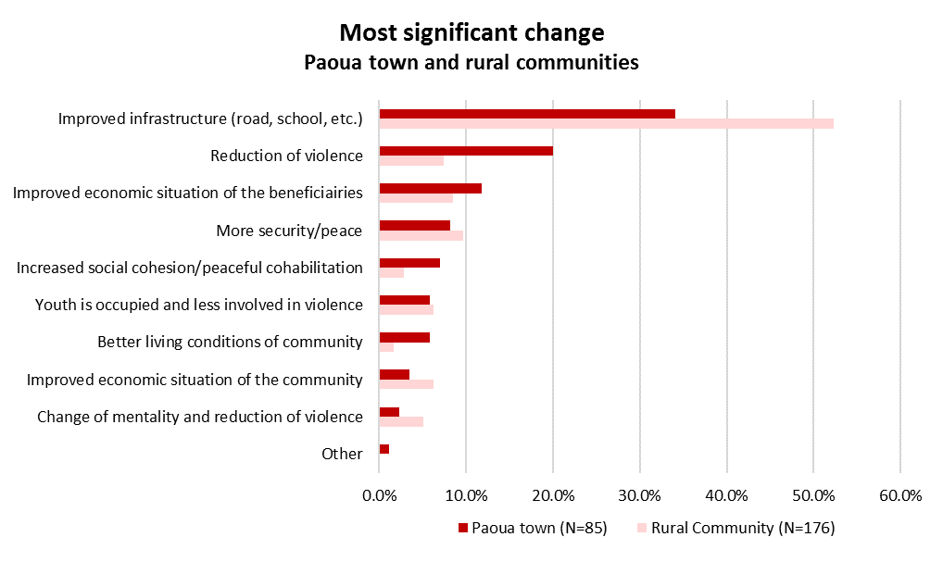
FIGURE 5 mOST sIGNIFICANT CHANGE uRBAN/rURAL

The responses were also categorised to reflect the most significant change at macro level, in terms of economic and social conditions, security and peace, as presented in the graph below. The differences between men and women are not significant; both groups recognise improvements in security and social conditions, and men highlight the economic benefits slightly more than women.
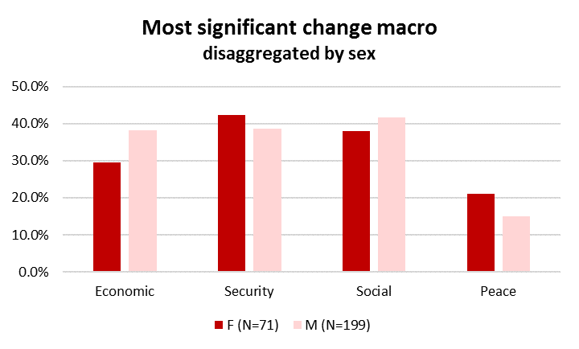
FIGURE 6 mOST SIGNIFICANT cHANGE mACRO

Biggest disappointment
The graph below presents the biggest disappointment of the project according to all people consulted, separated by those over and under 30 years old. Both age groups are in agreement that the cycle of 24 days of work was too short and the wages were too little to enable people to save money, especially stressed by the youth. In addition, the lack of inclusion of women and non-combatant youth has created disappointments. Further, not all infrastructure identified through participatory processes were materialised due to limitations in funding. Also, local committee members are disappointed not having received any financial support. Especially older people mention the lack of distribution of non-food-items and fraud, nepotism and corruption of local committees in selecting beneficiaries, as their highest disappointment.
Some respondents state that they have to pay part of their salary from the CfW, while others report having to pay the chairman or secretary of the local committee to even be selected as an IGA beneficiary. A young man in North Paoua made the following statement: “I condemn the way in which the identification of IGA beneficiaries by the members of the Local Committee is made. Indeed, to be a beneficiary, it is necessary to negotiate 20,000 or 25,000 CFA to the Local Committee. This means that many of the beneficiaries do not have access and those who have kits are not necessarily normally identified as beneficiaries.”
In Bambara, a young woman made a similar comment, stating that; “I criticise the management of the Cash for Work activities. To be able to access it, one must give 5,000 CFA to the chairman or secretary of the local committee. I am a farmer; how will I get the 5,000 CFA in order to benefit from this activity?”
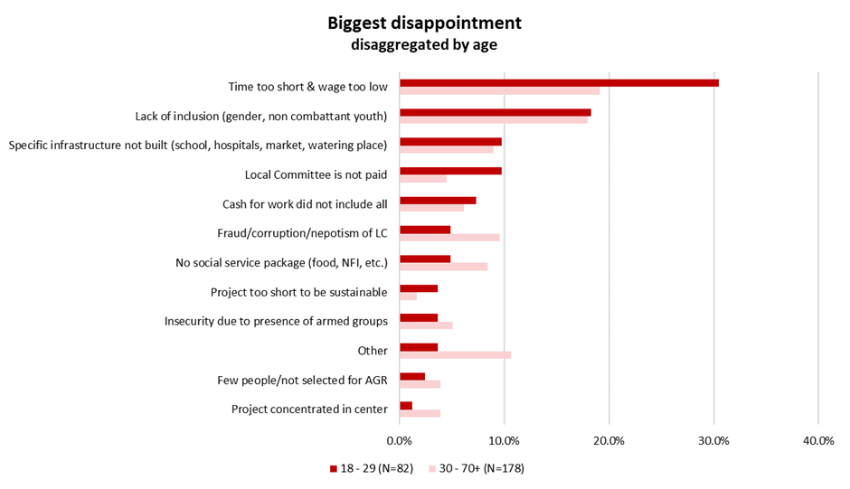
FIGURE 7 Biggest disappointment, per age group
When disaggregating the data on disappointments between direct and indirect beneficiaries, it becomes evident that the direct beneficiaries are most disappointed by the short cycle and low wages of the CfW component, and that specific infrastructure was not built. For community members, in addition to infrastructure not being built, the biggest disappointment is the continued presence of armed groups and resulting insecurity, as well as cash for work not including everybody. Community members also voice greater concerns about the sustainability of the project.
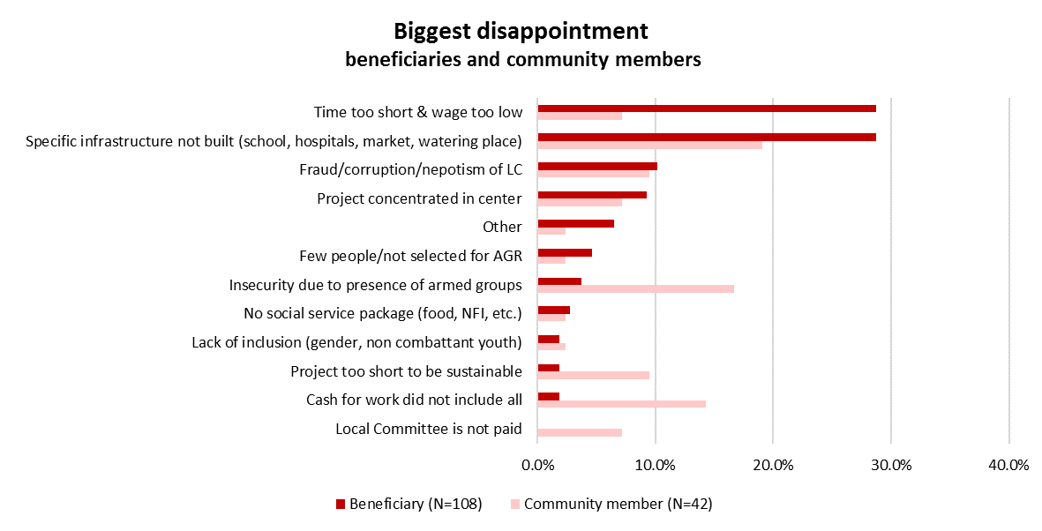
FIGURE 8 Biggest Disappointment per Group

3.2 Relevance
The graphs below present the perceptions of the government and project staff consulted on the relevance of the CVR project in the context of Paoua. All men and nearly all women (95%) think the project is relevant for the local context of Paoua.
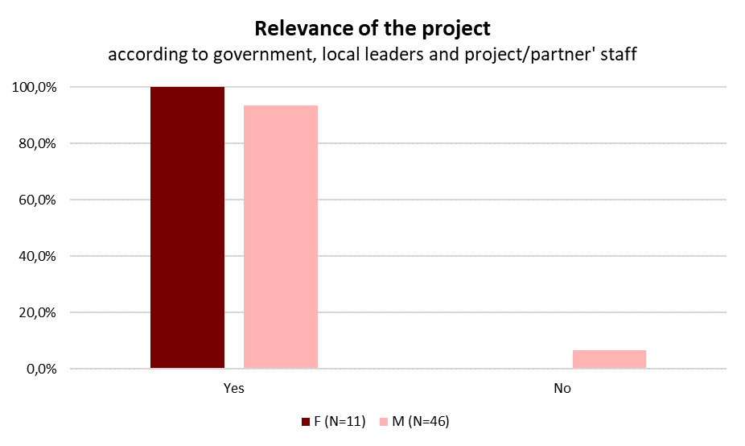
Figure 9 Relevance of the project
From a focus group held in Paoua, one of the participants stated that: “[CVR] is good because before there was violence and robberies but with this project there is a reduction of all these evils. Inter-community conflicts have been considerably reduced”. A female local leader in Paoua further added that; “Through IGA activities it helps people who have lost everything to resume activity and reduce violence”.
Indeed, also the evaluation team found that the project addressed the right issues. This can be largely attributed due to a solid process of needs assessment and the participatory approach applied, combined with the strong presence and commitment of the IOM project leam and project manager. However, the results framework drafted and approved for this project is of poor quality and over-ambitious for an 18 months project, which will be discussed in more detail below.
The CfW is especially highly appreciated and has good effects, but the cycle of one month is too short. Both the CfW and the rehabilitation of infrastructure are particularly relevant in the context of Paoua where road conditions are bad and where very little infrastructure exists.
In this context, there are however complaints that the project focussed too much on the centre (‘’groupement’’) and indeed little to no activities were noted in the more isolated villages around the 10 locations. It is interesting to observe and note that while according to international standards this project has a great reach into the local areas and is heavily decentralised in terms of activities and decision making through the LCs, according to the target population it is still not trickling down far enough.
An important note on the relevance of CVR in general, is that without a DDR-list it is problematic to select the beneficiaries for the CVR projects, as CVR targets armed elements non-eligible for DDR. In the beginning of the project, MINUSCA deployed a DDR staff member to the project sites which was highly relevant and has made positive contributions, such as the storage of arms in several localities. Later in the project cycle this person was withdrawn due to budget limitations of MINUSCA and higher DDR priorities in other locations, but this has negatively affected the CVR intervention. For example, the lack of DDR and pre-DDR results in 4 out of 10 non-operational areas due to security concerns caused by groups that are eligible for DDR, and therefore groups where the CVR project could not engage with. Another effect of the withdrawal of the MINUSCA staff member is that the support to LCs to store their weapons, which created a great stabilisation effect in Pendé, for example, was reduced as IOM was not mandated to work on SALW control on its own.

Eligibility criteria
The evaluation team also found that indeed there is a lot of confusion among both beneficiaries and key informants interviewed on what the selection criteria is for being eligible for the CVR project. Among the 164 respondents, only 6.7% are able to identify the correct answer, namely; being a combatant non-eligible for DDR or a vulnerable. On the other hand, when asked about their opinion of the selection criteria, 80% of men and 60% of women say the selection criteria is good. The reasons cited for this positivity are mainly that the respondents believe the CVR project would occupy the young people which would lead to a reduction in violence. One male ex-combatant in Bambara comments on the selection criteria as follows; “As everybody wants money, we are obliged to submit to these criteria and thanks to this, several young people have stopped the acts of violence because they know that they will have something in return and also, the community begins to accept them because they have changed their behaviour”
The evaluation team also found that the knowledge of the population and combatants on the criteria to enter a future DDR programme was very limited, which is likely to create tensions and possibly revolts in the future. As shown in the graph below, among consulted combatants, 37% do not know whether they would be eligible for the national DDR programme or not, whereas 35% say that they would be, which is in fact not the case.
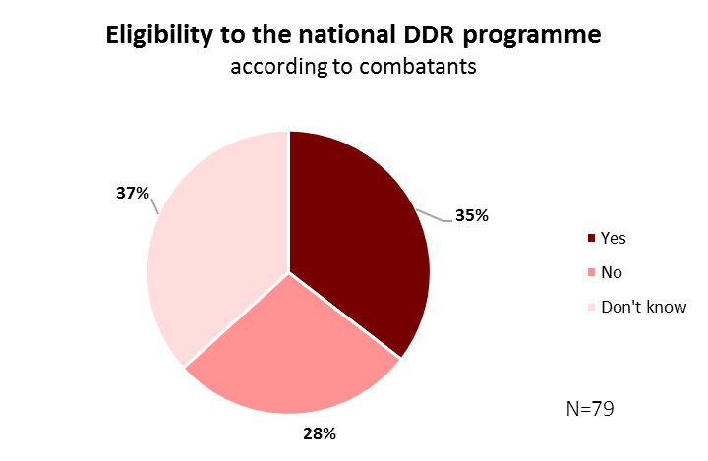
Figure 10 Eligibility to DDR
The team found that even among IOM national staff and other key stakeholders the criteria were not clear. As shown below, among the interviewed beneficiaries, project staff and government representatives, over a third are not aware of the eligibility criteria for the national DDR programme. Less than ten percent are able to list the actual criteria, namely: being a combatant of an armed group signatory to the Bangui agreement and handing over a weapon of war.
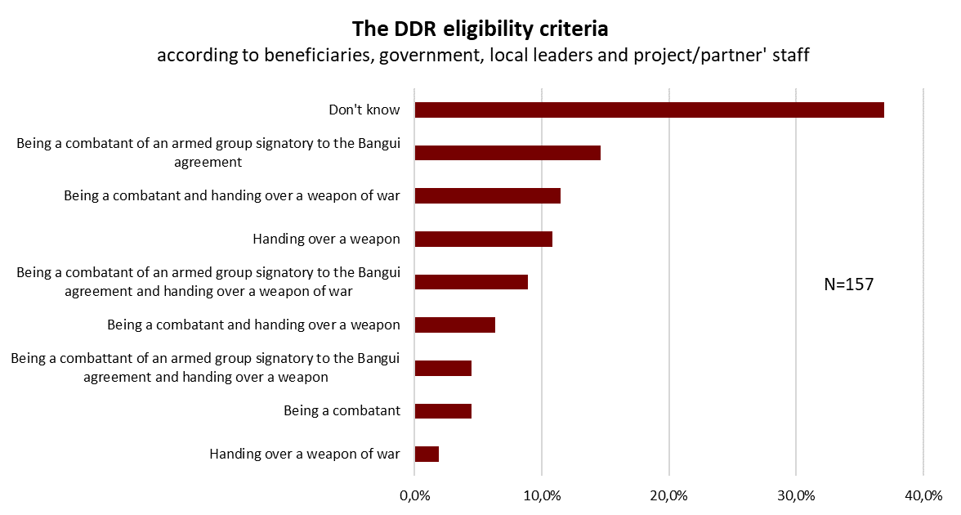
Figure 11 DDR Eligibility criteria

A MINUSCA DDR staff member could have worked on providing accurate information on who will, and who will not be included; one of the great benefits created by the pre-DDR activities implemented in other locations.

The evaluation team asked the key stakeholders about how they viewed the supposed complementarity of CVR to DDR. The PBSO Coordinator in Bangui, made the following statement; “The difference with the pre-DDR is not huge since the pre-DDR is basically THIMO. Strategically, MINUSCA has to come up with a strategy. The gap between the two (pre-DDR and CVR) is not being addressed right now. The CVR is good for those who want to get reinserted but if you take a look between the two, people would choose pre-DDR because income are higher. In Paoua, there is a lot of pressure because the CVR is the only alternative.” In a similar vein, a staff of MINUSCA DDR, concluded that; “There is no pre-DDR, it is not complementary. The CVR was created for a security situation in a specific area. DDR does not even exist, there is no pre-DDR in order to not have two programmes. For the moment, it [CVR] is the stabilisation programme in Paoua.” Furthermore, in terms of who is serving the eligible combatants – as the CVR project is for the armed elements non-eligible for the national DDR programme – the following comments were made by MINUSCA: "Our CVR is like a thorough pre-DDR. We register the participants of the CVR so if someone comes back a year and a half later with a weapon of war, we can know about it. It should not be forgotten that in the process of disarmament, tests are being carried out to verify whether people are true combatants".
The evaluation team furthermore asked a question to key stakeholders if an armed element is handing over a weapon, is he eligible to the DDR programme. The majority opinion of local leaders surveyed claim that the armed element would be eligible to the DDR programme, but added that he should have a weapon of war and be on the list of the commander. All project staff and partner’s respondent shared that opinion. According to the head of MINUSCA DDR: “Someone who has handed over a weapon in the CVR setting may be eligible to the DDR programme if he is on the combatant list produced by his military hierarchy. One member of the government in Bangui did not mention that being on the commander list was a criterion; “If someone in Paoua hand over a weapon of war, he needs to keep the certificate that would be later useful to be registered and to enter in DDR”
Selection criteria for starting up Income Generating Activities to about 10% of the beneficiaries that finalised the CfW. Selecting such a small number has created serious problems, including accusations of impartiality of the LCs. For example, in Pendé, only 40 people were selected for IGAs of the over 450 people who put down their weapons. The criteria for the selection of beneficiaries to IGAs included to have participated in CfW, and not have any disciplinary remarks – those who did not follow the code of conduct would be expelled from the project. In addition, the youth was said to be a priority for IGAs, and 60% of the vulnerable selected should be women. One of these conditions, namely being well behaved in the CfW activities, is problematic from a stabilisation point of view, as in DDR and CVR interventions alike, the focus should actually be on those at highest risk to return to violence, future recruitment etc. On the other hand, some committees decided to apply random sampling to avoid being accused of nepotism and prove transparency of the IGA kit allocation. The chief of the patriots in Pendé explained the randomized allocation process; “We have the list with numbers, we have made a randomised selection for IGA for vulnerable and combatants. Regarding the combatants, we pool men and women together so it might be possible that no women are in the IGA”. But the IGA kit allocation process does not stop here, after having randomly selected the beneficiaries, members of the local committee conduct a background check to remove “those we think are not going to succeed”. IOM further verifies the list against the criteria provided. Despite the fact that transparency of the selection process is assured, the chief of patriots highlighted that he had difficulties to justify the low number of IGAs to beneficiaries; “I am between a rock and hard place.”
The greatest concern in terms of relevance to the evaluation team is however the selection criteria for the vulnerable people, which ended up being mainly elderly women. The project targeted 31% vulnerable people and left out non-combatant youth, which is not in line with CVR objectives. The elderly selected based on the standard vulnerability criteria were largely not fit for work, and proxies were taking their place. Importantly, while appreciated by the population that these poor old people were assisted in a context where there are almost no social services, these old people are not a security threat and do not challenge stabilisation. There is however a large group of un- or under-employed youth, that are currently not armed, but could easily be drawn into future projects, which are not included in the project. This brings an important risk, as it spreads the message among youth that it is better to join an armed group, as otherwise you will not be assisted. This was expressed extensively in the focus groups with local youth.

Furthermore, even in the selection of the very limited number of people for IGAs, many vulnerable people were included, at the expense of selecting those beneficiaries with the potential to go back to violence if not further engaged. This has also led to the failure to ensure that the few female combatants (less than 10% of the total group of combatants), were stabilised further as no priority was given to them in the selection criteria provided from the project to the LCs. It is recommended that in future CVR interventions, this is corrected, as otherwise CVR will spread too wide and become a social welfare programme, which is not the objective. However, this is a difficult issue as hardly any other organisations actually support vulnerable people in Paoua.

Relevance of Local Committees
In terms of the relevance, inclusiveness and representation of the LCs, the results are positive. However, the evaluation team interviewed only 12 women compared to 55 men who are part of 5 of the 10 LCs set up by the project. While more women are said to be members, many did not show up when the team called for meetings. The women who were present, in general, were strong, spoke out and were representatives of women’s organisations. All LCs consulted had youth representation and all but one had representation of the armed groups participating in the CVR project. Most ethnic groups were represented, while some dominating, and only in one LC was a Peul representative found.

3.3 Effectiveness
This section presents the effectiveness of the project to reach its targets at output level. The tables present the self-reporting of IOM against the targets. Further findings from the evaluation on these are presented.

3.3.1 Cash for Work
Output 1.1: Priority target groups engaged in Cash for Work (CFW) and enabled to improve living conditions and local community infrastructures
Indicator 1.1.1 Number of participants enrolled in cash for work
So far, 5120 people of the targeted 7000 people completed cash for work, and 6,926 are on the verified list to finalize the work soon. Overall, the CfW had very positive results and is highly appreciated by all. Both the improved roads but also engaging young people to work, and be sensitized at the same time is appreciated by beneficiaries, community members and local leaders. Almost all confirm improved living conditions such as mobility and increased commerce due to the repaired roads, as outlined in the MSC chapter above. Almost all confirm that CfW has stabilised youth and given them hope, but was too short to create lasting results. Other complaints are on too much concentration on centres and the fact that people were left out, including combatants. In terms of gender, 100% of the target was reached. However, many elderly women were replaced by proxies.
Target | Actual reached | % achieved
Original target  7,000 participants across the 7 target communities (4,200 members of armed elements non-eligible for national DDR program and 2,800 vulnerable community members, of which 60% women) have benefitted from one cycle of CfW  Adjusted target  7000 across the 10 target communities: 4,800 members of armed groups non-eligible for national DDR programme and 2,200 vulnerable community.  Reach at least the 25% of women over the total of beneficiaries. | Approved list of CfW of 6926.  5120 total CfW beneficiaries (3426 ex-combatants with 300 females; 1,694 vulnerable with 1,040 females)  Of these, 67% are from armed groups (less of 10% of which are women), and 33% are from vulnerable groups (48 % of which are women) | Total across 10 communities: 74%  Armed groups: 67%  Vulnerable community: 33%  Women: 26%

Indicator 1.1.2 Number of man/day
Regarding the number of man per day, as seen in the table below, over the period covered by this evaluation 72% of the target has been reached.
Target | Actual reached | % achieved
Original target: Project total of 168,000 person/day in CfW  Adjusted target: 168,000 man/day | Over 120,300 persons/day | 72%

Indicator 1.1.3 Number of CFW projects implemented per community
Regarding community members, nearly 90% of women and 70% of men interviewed during focus group discussions assert having applied to the activities of the CVR project. When this question was asked, 60% of the respondents belonging to the four localities visited plus South Paoua state that they could not be part of the project because the local committees were corrupted. A student encountered in North Paoua explained over the course of the focus group discussion that; “often when a youth wants to benefit from this project, most local committee ask for a compensation. More specifically, they demand to the candidate an amount of 5,000 FCFA. This practice happens in all local committees. That’s why the youth sometimes try to create troubles, to be identified.” Despite the fact that the evaluation team is not able to verify allegations of corruption expressed by community members, similar stories were told by community members in some other focus group discussions as well. IOM has been aware of the corruption in Paoua North, and took action, but not in the other locations, which is largely due to the fact that this issue was not addressed in IOM’s perception survey.
Throughout interviews with beneficiaries, around 60% of women and 40% of men declare being willing to receive a little less money in exchange for food. The request of beneficiaries to receive food support during CfW was also a point highlighted by the mid-term evaluation team (see Annex A). Since money is distributed at the end of the CfW cycle, 20% of the respondents reveal that they were borrowing money to buy food during CfW. However, as shown in the graph below, more than 50% of the respondents express their willingness to manage their own money instead of receiving food, since the money is already too little to receive less.
As revealed by project and WFP staff, the project did not distribute food since the WFP did not have enough supplies for the CfW. Other problems cited by the WFP staff explaining the difficulty to provide food in project locations refer to insecurity and road deterioration.

Figure 12 Less money in exchange for food
Indicator 1.1.4 Number of community infrastructure rehabilitation project implemented
Target | Actual reached | % achieved
Original target  14 community infrastructure rehabilitation projects implemented  Adjusted target  20 community infrastructure rehabilitation projects implemented | Identification, design and tenders completed for 23 rehabilitation/construction projects of infrastructures  21 works have started and 7 have been completed | Identification, design and tenders: 115%  Infrastructure projects completed: 35 %  Started works: 105%

Almost all the respondents assert that infrastructures in the community have improved. This percentage is a bit smaller for beneficiaries, as several vulnerable and combatants interviewed in Bambara point out the fact that infrastructures were not finished due to the recent armed group attack in the community.
Nearly two thirds of the respondents identify the local committee as the structure selecting the infrastructure projects, as shown in the graph below. According to the majority of local leaders and government staff surveyed, the number of infrastructures built varies from 2 to 3 per locality. Around 30% of the respondents see the local committee as fully in charge, or partially in charge, of the supervision of the construction of infrastructures, while a small share of the sample view IOM, IOM engineers, local authorities, ministries and the community as partially or fully responsible for the supervision during the construction of infrastructures.
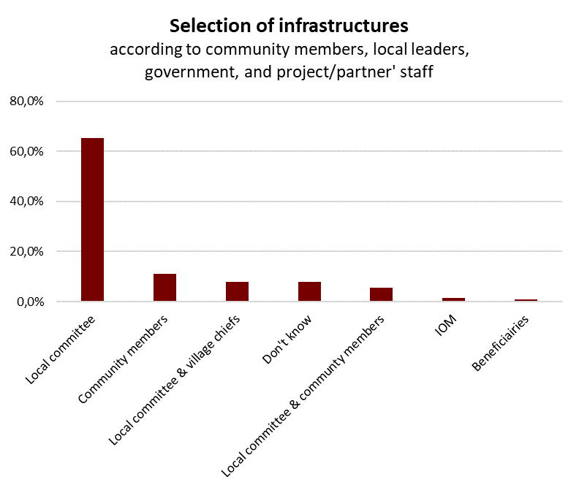
Figure 13 Selection of infrastructures

Some respondents complained about the delay in infrastructure construction. IOM and MINUSCA DDR staff consider the length of the administrative procedures of line ministries, as one of the main causes for the delay of infrastructures. Others also highlight the rainy season and the current security situation as important barriers. Further, engineers refer to logistics problems, for instance to the low number of trucks (2 for 10 locations).
To the question of who is in charge of the maintenance of the infrastructures, one third of the respondents cite the community. In the meantime, those respondents acknowledge that even though the responsibility of the maintenance of the infrastructures was entrusted to communities, the latter did not have the means to do it. The remainder of the answers refer either to local authorities, local committees or to the government in Bangui.

3.3.2 Skills training and income generating activities

Indicator 1.1.5 Number of Beneficiaries enrolled in on-the-job training, job placement, salary subsidies and stipend assistance
While job placement, salary subsidies and stipend assistance were not provided by the project, at the time of writing, 48 skills trainings have taken place. In addition, facilitators have started to receive training.

Target | Actual reached | % achieved
Original target  Indicator does not exist in the August 2016 results framework.  Adjusted target  300 beneficiaries enrolled in on-the-job training, job placement, salary subsidies and stipend assistance | 48 skills training (Benef)  20 Facilitators trained to supervise and mentor 600 IGA participants on the job in 10 target communities | Skills training: 16%  200% of beneficiaries can be reached with the trained facilitators

Indicator 1.1.6 Number of beneficiaries receiving trade specific tool kits or small grant, along with basic business skills training, for micro business set up
The results framework has no separate output on IGAs but includes one indicator related to IGAs. Up to date, 502 IGAs are approved, kits are good, and a system of business support put in place. The problem is the low number of IGAs, also due to choose to make kits individual, creating serious problems around selection of the 10% for IGA and jealousy.
Target | Actual reached | % achieved
Original target  350 beneficiaries assisted in formulating their own income generating project and receiving business skills training and professional tools  Adjusted target  300 beneficiaries assisted in formulating their own income generating project and receiving business skills training and professional tools | IGAs for 502 beneficiaries were already identified, verified and approved:  110 beneficiaries already received their equipment and materials. The goods and service for the remaining 502 beneficiaries are being procured.  Only 65 beneficiaries for the community of Gouzé are being verified with LC as all the activities were suspended because of the occupation of the locality by RJ/MPC since last November.  14 IGA kits in spare  No small grants  Business training for all 600 IGA beneficiaries just started | Explanation:  The overall number of beneficiaries supported with training and IGA was initially targeted at 700 in the Pro-doc (350+350), but in the budget the funding allocated for this activity only covers 600 beneficiaries.  There are scarce opportunities of qualified professional training and job placement. These beneficiaries may be oriented to IGAs which may include also professional training.  Participative planning exercise needing to wait for the full efficiency of the LCs, their training on this matter. Delays in receiving outputs from some of them.
The rate of satisfaction with the type of IGA received is high, with 81% of the respondents stating that the attribution of the IGA corresponded to their choice.
Few respondents express that they are making enough money to live on (5% men, and over 20% women). Comparing those who did and did not receive an IGA kit, it can be observed below that those who did receive IGA kits, even if the numbers are low, were more likely to state that they have enough money to live on.
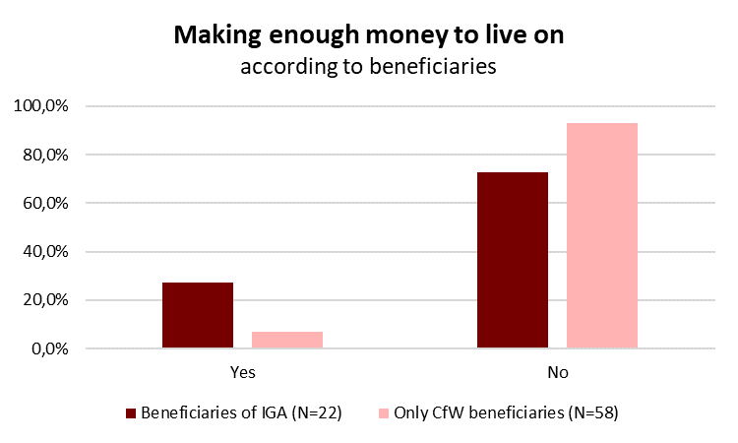
Figure 14 Making enough money
According to local leaders, project and government staff, business training has not yet started. The team however found at the end of the mission that the first training of IGA facilitators, who are going to train beneficiaries, started. This is rather late as many beneficiaries already received their kits without being trained, which increases the risks of mismanagement. However, the mentoring and assistance decentralised framework was already in place, with 20 facilitators for 10 localities.
Box.1 Beneficiary of IGA in North Paoua
I am thirty-six years old, a father of 3 children and member of the self-defence group of my neighbourhood in Paoua. I have joined the self-defence in 2003, and I am currently Secretary General of my neighbourhood group “NOVICIAT”. Following the multiple acts of violence, assassinations and massacres perpetrated by the rebellion of the former Head of State François BOZIZE, including the Zakawa coming from Chad, I have decided to come back home to defend my community. In the meantime, my merchandises have been seized by these elements. Facing this situation, it was impossible to stand here and do nothing, that’s why I joined the self-defence group. During the crisis, I suffered a lot with my family as with my self-defence [combatant] status, I could not go far in the field to make a living for my family. With the presence of the CVR project, I started to take a breather with the support they give to combatants. I have first worked in the CfW activities for 24 days and earned 36,000 FCFA. That money helped me to do business to feed my family. Thanks to IOM, I benefited from a business IGA kit. Even though the kit is not yet complete, I started to sell and have saved more than 300,000 FCFA. I got out of the hospital yesterday and it was thanks to this money that I was able to receive care, otherwise I would be dead.

3.3.3 Local committees functioning
Output 2.1: Local committee have a key role in community project implementation decisions (community priority needs, beneficiary’s selection (40% of community member’s beneficiaries), M&E etc..) and in community dispute mediation

Indicator 2.1.1 Number of coordination meetings with peacebuilding and social-cohesion actors including Min. of Reconciliation
Target | Actual reached | % achieved
Original target  30 meetings (central and regional level)  Adjusted target  60 meetings (Central and regional level)  [Of which 6 steering committee planned] | UN Coordination mechanisms meetings at the national level (HCT, CM Coordination, Protection Cluster) and the local Paoua level (MINUSCA Office, UN agencies, INGOs and NGOs, Civil Society Organization, concerned Local Authorities.) Total: 197 regional meetings.  CVR Steering Committee meetings completed: 4  Min. of Reconciliation: present in 4 steering committee meetings | 335% of adjusted target  Total meetings: 201  Explanation  IOM as member of the UNCT participate at the national level UN Coordination mechanisms and at the local level (for the latter to HCT, CM Coord., protection Cluster) and established coordination mechanism with several international actors in Paoua (MINUSCA Office and bilaterally with INGOs and NGOs, Civil Society Organization, concerned Local Authorities.)  Additionally, social cohesion activities are coordinated with Civil Affairs MINUSCA section.  3 Ministers are represented in the Steering committee meeting on a bi-monthly base: Planning, Social affairs and Territorial administration

In broad terms, the staff of the project has succeeded in establishing partnerships and collaborations with organisations based in Paoua. More than half of the local leaders, and 75% of the project/partner’s staff interviewed said that the project was collaborating or having a partnership with civil society organisations or other programmes.
Regarding local NGOs, the Programme Manager of the CVR states that the project had established good relations but established no collaboration with IRAD and APAP, a good functioning vocational centre - a missed opportunity. However, according to him, the project has succeeded in establishing partnerships with AGDA and also with Radio Pendé, for the broadcasting of sensitisation messages on risks related to weapons. CASAL, the organisation of inter-fait senior religious leaders, proved to be a key partner in the project, and was already implementing sensitisation campaign on risks related to weapons and facilitating dialogues on conflict mitigation. Being a local NGO, they are able to work on the ground in localities difficult to access for IOM and report to the project.
However, at the national level the consulted project and partner staffs do not have a positive view of the steering committee. Some respondents highlighted the lack of capacities of the government, while the government expressed feeling excluded by MINUSCA in decision making and monitoring. Additionally, issues with lack of sufficient communication of MINUSCA DDR are one of the main points reported by respondents. At local levels, more and better collaboration is observed than in Bangui.
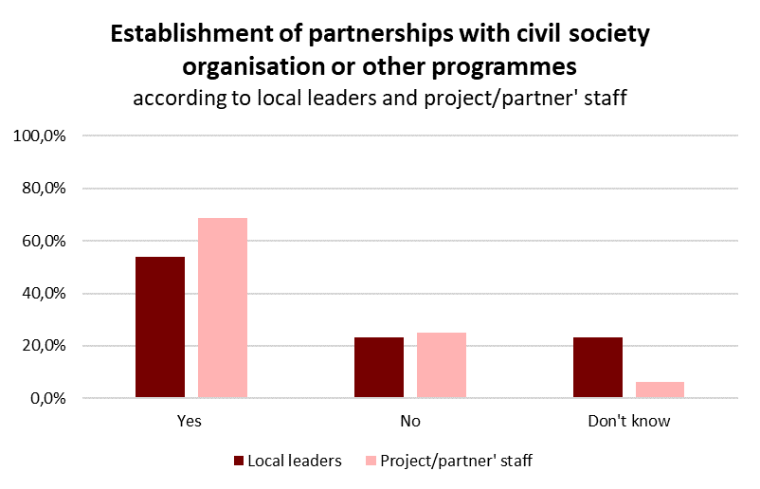
Figure 15 Establishment of partnerships

Partnerships and projects collaboration cited by local leaders and IOM and MINUSCA staff
AGDA (Min of Agriculture)
AVIDESCA
CARITAS
CASAL
Danish Refugee Council (DRC)
Doctors without Borders (MSF)
Food and Agriculture Organisation of the United Nations (FAO)
IRAD
Local Committees
MINUSCA DDR
MINUSCA Force
MINUSCA Civil Affairs
The Oxford Committee for Famine Relief (OXFAM)
Radio Pendé
Swiss foundation for Mine Action (FSD)
United Nations High Commissioner for Refugees (UNHCR)
World Food Programme (WFP)
In the table below is a list of partnerships, cited by the key stakeholders.

As mentioned before, the project had exchanges with WFP to establish a partnership to distribute food to the beneficiaries working in the CfW, but for security reasons and due to financial constraints, it has not been done. Similarly, there have been discussions with DRC and OXFAM but no partnership was created. In addition to the local committees set up by IOM during this project, in some locations there are also local committees for social cohesion set up by the Danish Refugee Council (DRC) meaning some villages have two local committees. The evaluation team learned that IOM had unsuccessfully tried to discuss merging the committees with DRC, but that there was reluctance from DRC to include armed group’s representatives on their committees; a common concern from most humanitarian actors most likely due to humanitarian principles on neutrality. The other reasons also cited for this are that the committees have different mandates and different objectives, while one respondent indicate it is an issue of pride.
Concerning internal dialogue between MINUSCA DDR and IOM, relations were more effective when one person of MINUSCA staff was based in Paoua. There is no partnership between the MINUSCA DDR section and MINUSCA Youth Lead, while there would be scope to learn from each other and to collaborate. Collaboration on security is effective with MINUSCA Force with a two-way effective sharing of information. On internal relations with MINUSCA civils affairs, there was a period during the project where MINUSCA civil affairs had no senior staff which affected the collaboration. As the project staff declared “In the past, relationships were good. Recently, there have been a collaboration which is less strong than before.” However, the new staff who recently arrived is open and motivated to increase collaboration.
Indicator 2.1.2 Number of local community committees set up and/or empowered
Target | Actual reached | % achieved
Original target  7 Local community committees are set up/or empowered, with agreed SOPs  Adjusted target  10 Local community committee are established with clear roles and responsibilities and workable SOPs in regard of the project | All 10 LCs are set up and functional, with agreed SOPs and code of conduct. Training completed. | 100% of adjusted target  Explanation:  High fragmentation of communities, dispersion of population, difficulties of movements and lack of transports; rivalries between groups

The vast majority of beneficiaries, both men and women, perceive the local committees as having done a good job, as seen in the graph below. Close to 20% of male beneficiaries have a negative opinion on the quality of the work realised by the committees, mainly referring to issues such as corruption and nepotism. One male beneficiary in Pendé comments that; “the local committee does not work really well, that’s why a lot of beneficiaries that are on the list did not have the opportunity to work. There are people who work during 2 or 3 cycles, others work but their names are not on the list.”
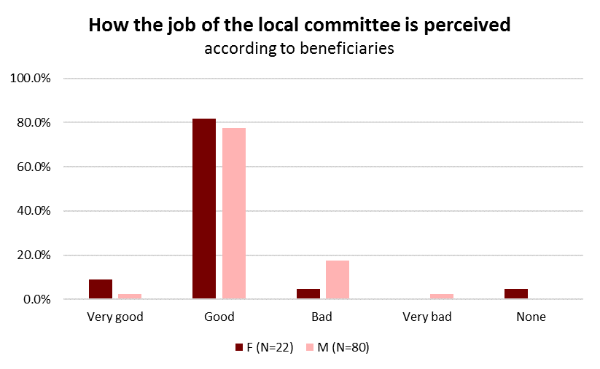
Figure 16 Perception of Local committee

Indicator 2.1.3 Number of community members involved in the local community committee (gender and duty breakdown included)
Target | Actual reached | % achieved
Original target  At least 12 people engaged in each local community committee (30% of women, 10% local authorities, 10% community leaders, 30% youth, 30% civil society representative, 10% community auto-defence group)  Adjusted target  Over 20 members are engaged in average per each Local Committee. (20% women, 10% local authorities, 10% community leaders, 30% youth, 30% civil society representative, 10% self-defence group) | 203 community members participating in the 10 Local Communities  Local Authorities: 8%; Community Leaders: 20%; youth: 12%; women 23%, self-defence: 11%; Civil society 38%.  In cases where women are also Local authorities (2) there were counted as such, as well as women, so the numbers don't add up to 100%. | 102% of adjusted target  Women: 115%  Local Authorities: 80%  Community leaders: 200%  Youth: 40%  Self-defence: 110%  Civil society: 126%  Explanation  High fragmentation of communities, dispersion of population, difficulties of movements and lack of transports; rivalries between groups

Overall, most of the key stakeholders consulted confirm that there is wide representation of different groups and stakeholders in the local committee set up by the project. The committees are less inclusive of people with disabilities, as seen in the graph below, but there is also no target on the representation of people with disabilities in the results framework. Some members of the local committee of Poulao explained how they got selected, such as a female local leader who states that; “community members have chosen who will be part of the local committee after a vote. I have been elected by all women of the village”.
Not all respondents answered that chiefs of armed groups were part of the local committees despite the fact that their presence constitute one of the criteria. The local committee of Poulao explained over the course of a discussion that “the chief of the armed group was in the local committee but he created troubles and consequently was transferred to the prison of Paoua”. Almost all stakeholders interviewed confirm that gendarmery is not part of the local committee, also not in Paoua town where they have presence.
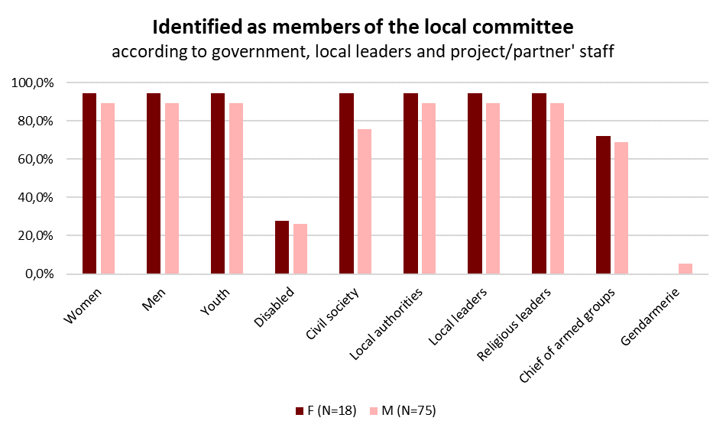
Figure 17 Members of the local committee
Furthermore, according to a majority of the consulted respondents, there is equal representation of different ethnic groups in the local committees of Pendé, Gouze and North Paoua. In Bambara, out of the 7 ethnic groups living in the community, Gbaya are not part of the local committee. From what members of the local committee of Bambara have indicated, there are 4 Gbaya households living in the village. According to the local committee of Poulao, their community is composed of only one ethnic group. Further, a local leader of the Peul ethnic group states that; “It is not easy to that my opinion be fully taken into account. I represent a minority; I do not have any relatives. All ethnic groups are represented but not in an equitable manner, it depends on the size of the group.”
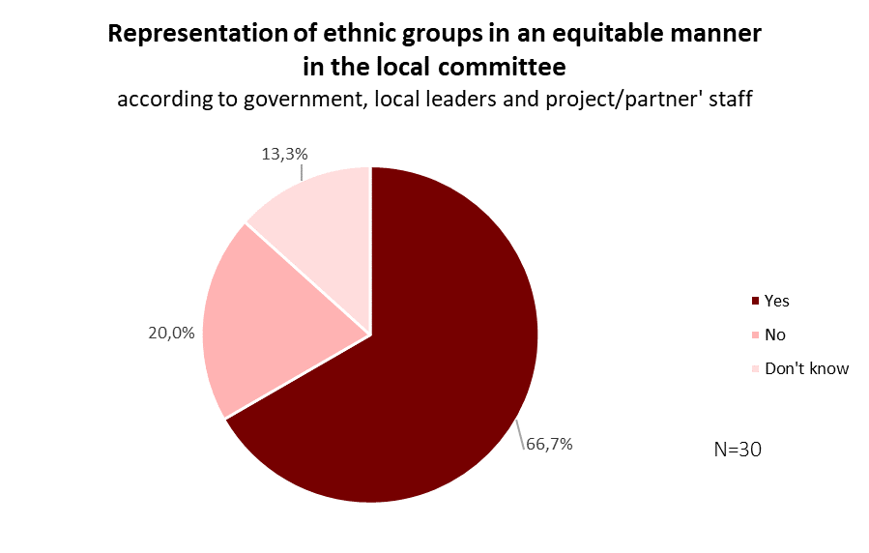
Figure 18 Representation of ethnic groups

Indicator 2.1.4 Local committees’ members are trained on conflict prevention including mediation, conflict management and peaceful settlements of intercommunal disputes, rumour managements
Target | Actual reached | % achieved
Original target  120 Local Committees members score 80% at the final test of the conflict prevention including mediation, conflict management and peaceful settlements of intercommunal disputes, rumour managements  training  Adjusted target  160 local committees’ members | 136 capacity building sessions and information sessions to the Local Committees on CVR project objectives, principles, ToRs, eligibility criteria code of conduct and procedures, including IGA principles and preparations;  106 sessions of training for over 160 participating Local Committee members completed on: peaceful coexistence, reconciliation, rumours management, protection of property, rights and obligations of vulnerable groups, culture of non-violence and peace, mobilization techniques, psychosocial support, prevention of SGBV, 1 workshop for LC members and community leaders have been held | 100% of the targeted local committee members participated in training sessions  Explanation  Increased number of committees and increased average of the number of members for each one (206) members

A majority of local leaders, government staff and project/partner staff consulted by the evaluation team indicates that the local committees have had a key role in decisions on the implementation of the project, the selection of infrastructures, mediation in community conflicts and in monitoring and evaluation.
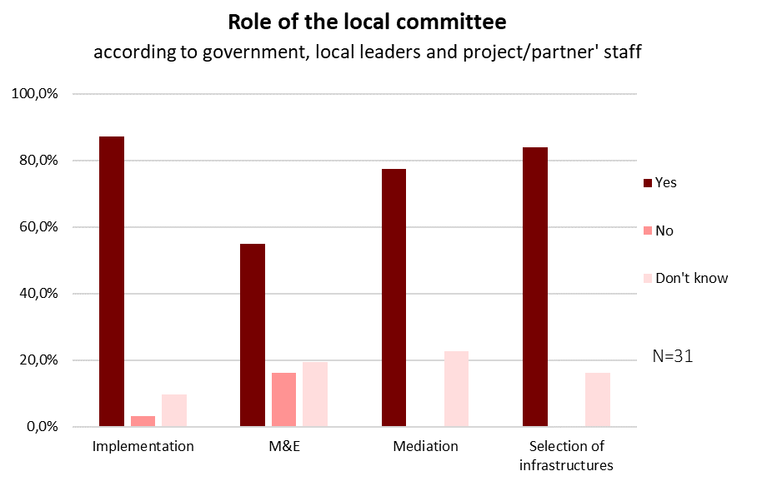
Figure 19 Role of the local committee

3.3.4 Disarmament and SALW management
Output 2.2: Community-based sensitization campaigns launched to inform on risks related to illegal circulation of weapons
Indicator 2.2.1 Number of sensitization sessions carried out to inform on risks related to illegal circulation of weapons
Target | Actual reached | % achieved
Original target  At least 70 sensitization sessions are held on risks related to illegal circulation of weapons in the 7 communities  Adjusted target  At least 70 sensitization sessions are held on risk related to illegal circulation of weapons in the 10 community | There were 12 dedicated training sessions covering all 10 LCs, and there was a total of 110 sensitization sessions (one for every THIMO rotation) and each includes a component on the risk of illegal weapons circulation. Additionally, there have been 5 media campaigns that included a risk awareness component on circulation of illegal weapons. | 181%  Explanation:  Number of communities targeted by the project increased therefore at least 10 sensibilisation sessions should be undertaken per community.

As shown by the bar chart below, almost all male and female respondents have seen sensitisation campaigns and affirm that the project contributed to the awareness on small arms and light weapons. According to stakeholders, the sensitisation is diffused through sensitisation signs, radio programmes, posters, pamphlet or training organised in collaboration with FSD.

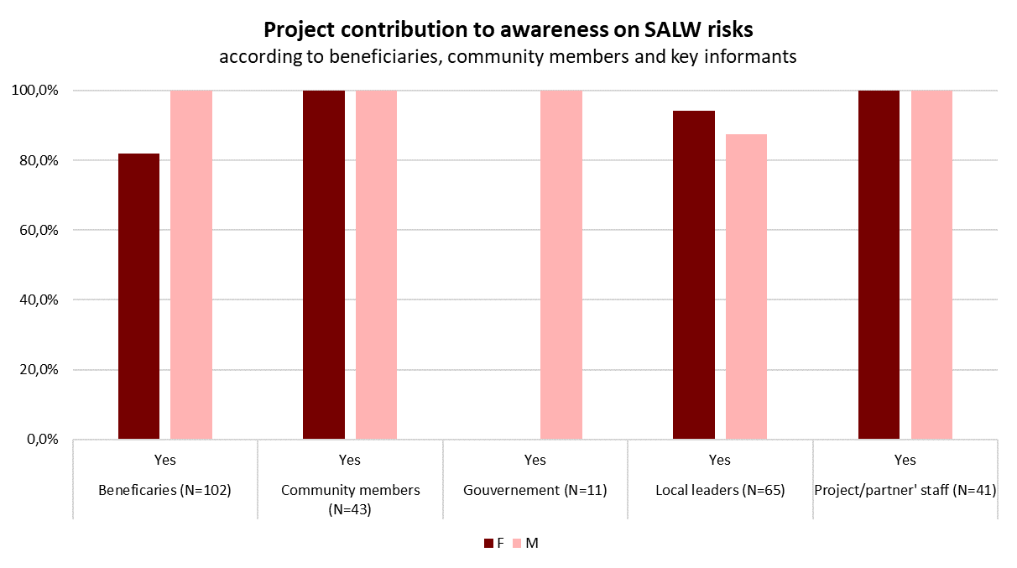
Figure 20 Awareness on salw risks

Indicator 2.2.2 Number of local authorities-led initiatives supported by the project for voluntary handover of weapons to local authorities
Target | Actual reached | % achieved
Original target  At the end of the project at least 7 local authorities-led initiatives (1 per targeted location) are undertaken for voluntary hand-over of weapons  Adjusted target  At the end of the project at least 7 local authorities-led initiatives are undertaken for voluntary handover of weapons | 1 weapons collection and storage initiative completed in a participating community;  Other 6 storages construction supported by the project and weapons control by community under implementation | 14%  100% under implementation
When asked, 60% of the female respondents and nearly half of the male respondents indicate that some disarmament or arms management has been done by this project. However, almost all respondents specify that the project had not done disarmament but rather arms management with the construction of weapons storage. Two thirds of the government, local leaders and project staff affirm that the project financed the construction of weapons storage places in support of the LCs. However, the collection of weapons was entirely an initiative by LCs and leaders of armed groups. The IOM Programme Manager states that; “Disarmament is an output and not an input of CVR. The effect that elements of the project have on the ground is a fundamental factor in the changing of attitudes.“ The evaluation team had the opportunity to observe the local weapons storage in one community and expresses its concerns in terms of safety as the construction is part of a household setting.
The weapons collected are stored and a dual-key system is installed with one key held by the leader of the armed group and one by a (anonymous) LC leader. The two key-holders can together open the weapon storage in extreme cases, such as an attack from armed groups. There is differentiation in the level of arms storage per location, in one location it is explained that security does not allow for this process. The storage facilities built have great impact, as already highlighted in the mid-term evaluation report, but MINUSCA stopped IOM to invest in this after MINUSCA staff was withdrawn, as it is challenging IOMs mandate. Serious disagreement on this exists and the evaluation team concludes that indeed MINUSCA should take the lead, or at least have supervision over this, and therefore needs to be present on the ground.
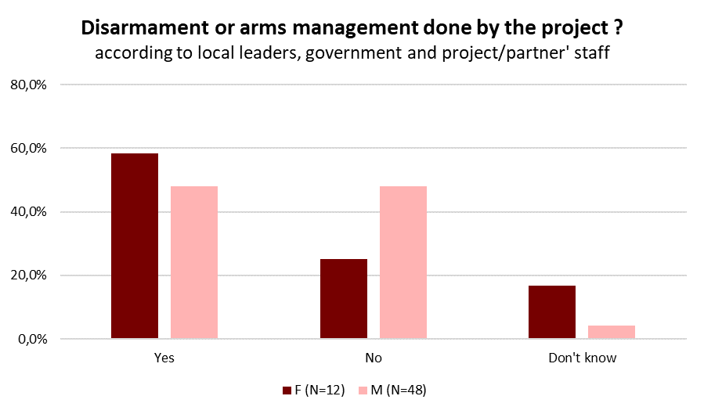
Figure 21 Disarmament or arms management done
Indicator 2.2.3 Number of weapons handed-over during local authorities-led initiatives
In line with the above, indeed large numbers of arms of different types are handed in and stored, verified by all beneficiaries, stakeholders and community members as being a great achievement of this project. The team asked for access to a storage but this was denied as the armed group wants to keep the exact amount secret. No plans were found on the future of the storages and the weapons in them, and they are likely to be used by non-eligible armed group leaders to put political pressure to the government to receive benefits.

Target |  | Actual reached |  | % achieved
Original target  700 weapons have been voluntarily handover to local authorities  Adjusted target  During the project life span at least 7 local authorities-led initiatives (1 per targeted location) will be supported by the project for voluntary handover of weapons; estimated 1000 weapons, at least, will be voluntarily handed-over to local authorities | Unconfirmed but likely over 1,000 weapons were voluntarily handed over to local authorities/LCs and stocked in: a) the community armories built by the LC with the material support of the project b) community storage facilities |  | Unconfirmed but likely over 100%  Explanation  Seeing the increased number of communities targeted by the project and the unexpected number of artisanal weapons owned, the final number shall be higher. Proper estimation is not possible at the moment but at least 200 per community is foreseen. Weapons are handed over to the Local Committees/Local Authorities, and stocked in the communal armories built by the project

All vulnerable beneficiaries state that they have not handed over weapons, while 60% of combatants actually declare they did hand over a weapon, as seen below. Most of the combatants admit that they handed over a weapon to benefit from the project. A young male combatant in Pendé states that; “to benefit from project activities, the local committee demands that all combatants hand in their weapons”. 16% of the beneficiaries did not hand over their weapons either because they were not asked to, or because they were waiting for the disarmament to start (such as in Bambara where the construction of the local weapon storage is not finished).
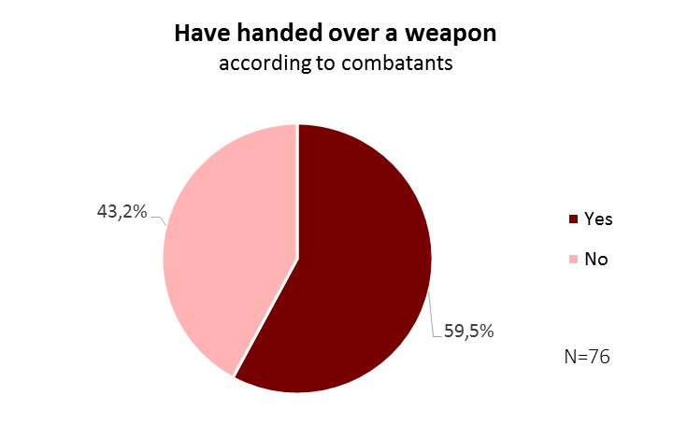
Figure 22 Handed over a weapon
Reasons for handing over or not handing over a weapon are presented below:

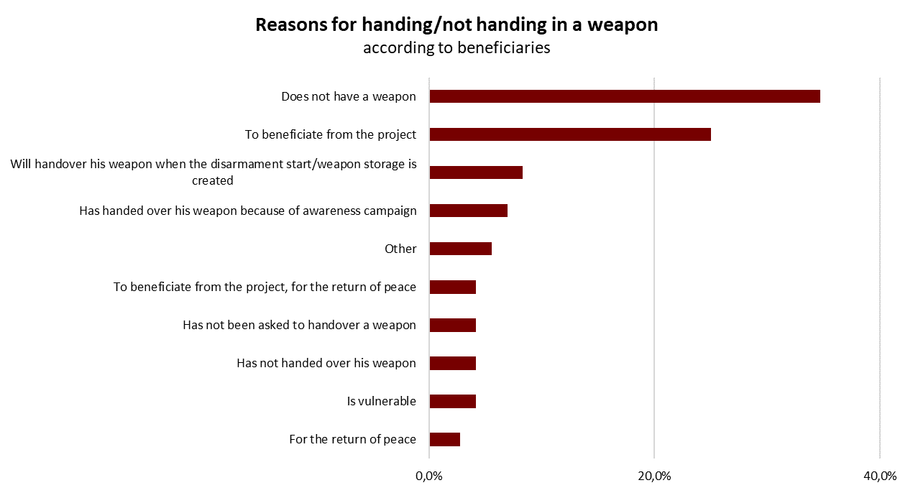
Figure 23 Reasons for handing/not handing in a weapon

3.3.5 Peacebuilding activities
Output 2.3: Armed groups’ elements non-eligible for DDR and the community are engaged in community dialogue on peaceful means of dispute resolution, as an alternative to violence
The evaluation team has largely been able to confirm that a change in mentality and reduction of violence has taken place due to the project. The fact that armed groups are represented in the LCs has greatly contributed to bringing communities and armed groups around the table. The larger community dialogues have however been somewhat limited, as discussed in the above section, and larger intra-community dialogues would be useful.
A decisive majority of beneficiaries and key stakeholders consulted by the evaluation team indicate that there has been a reduction in the number of violent incidents in the communities targeted by the project compared to two years ago. Among the beneficiaries, men are slightly more positive than women, but for the local leaders it is the opposite and more women highlight a reduction in violence. Taken as a whole, 85 % of respondents state that indeed, there have been less violent incidents over the past two years.
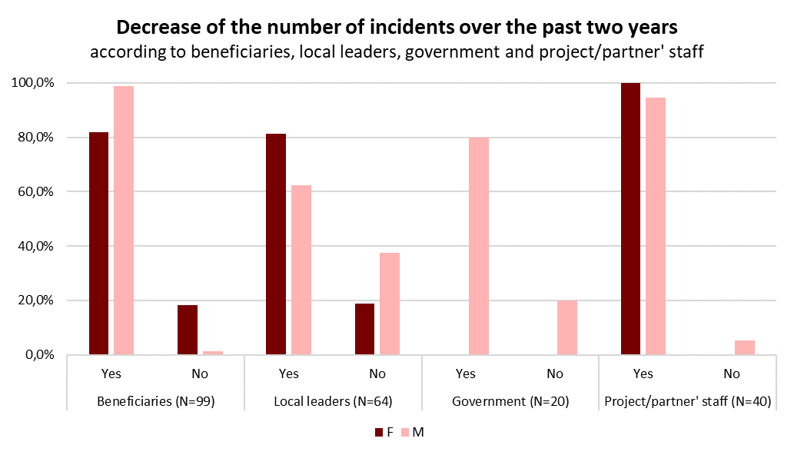
Figure 24 Decrease in number of incidents
A large share (63% of the government, local leaders and project staff respondents) indicate knowing how the project keep records of violent incidents. The head of MINUSCA DDR said he was not aware that the project was recording violent incidents and that in principle the incidents mapping was the mandate of and realised by MINUSCA. The IOM system in fact builds upon the MINUSCA (UNDDS) reports but complements this at the local level by additional sources, including from the LCs. They are provided with phones and forms and a voucher system is in place for LCs to send a message to IOM in Paoua via local motorcycle taxies. Once the message is delivered, the moto taxi person exchanges the voucher he was given for money at IOM. IOM pointed out that “the early alert system has enabled MINUSCA Force to intervene in a lot of situation”, which was confirmed by MINUSCA Force. The voucher system is further discussed in section 3.5 on impact.
All respondents who know the incidents record system(s) also report that they have a good opinion on it and IOM facilitators in North Paoua and Bambara highlight that the record of violent incidents system is a good thing to protect whistleblowers. No critics appears except some local committee members, expressing that they could not use mobile phones as they do not have electricity and no credit.

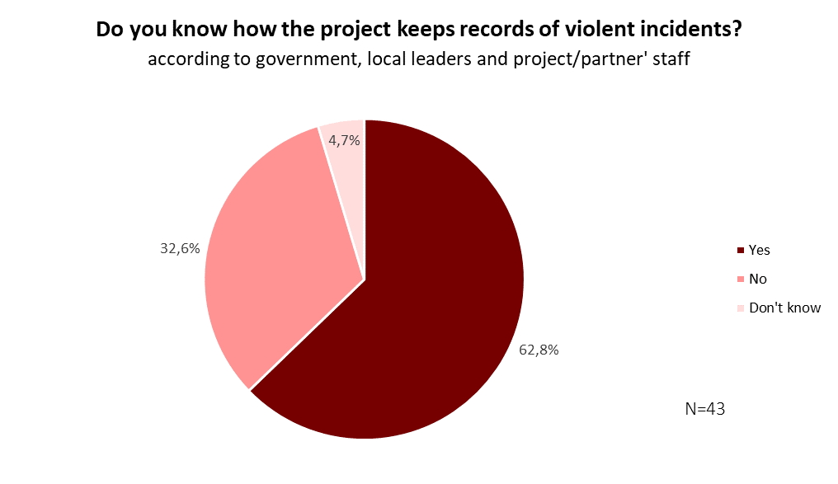
Figure 25 Record of violent incidents

Indicator 2.3.1 Social/cultural/sport events organized by the project at community level
In total, the project organised 15 events, estimated to have reached an attendance of 7,000 people.
Target | Actual reached | % achieved
Original target  70 social/cultural/sport events are organized in the 7 communities during the life span of the project  Adjusted target  21,000 community members, attended community cohesion events during the implementation of 70 social/cultural/sport events in their communities | 9 matches of the CVR football championship have been done;  6 traditional dance and music festivals have been organised,  Estimated attendance 7,000 | Attendance: 33%  Events organized: 21%  Explanation  Mismatch between original Output indicator (social/ cultural/sport events organized) and the related milestone (21,000 community members sensitized on community dialogue). Adjustment present a more coherent milestone

Indicator 2.3.2 Number of civic education and peaceful coexistence sessions organized at the benefit of members associated with armed groups
Target | Actual reached | % achieved
Original target  350 civic education and peaceful coexistence sessions in the 7 communities  Adjusted target  350 civic education and peaceful coexistence sessions in the 10 communities | 3 sessions of training for community and religious leaders (25) selected for the implementation of the socialisation activities in the CfW sites (14).  181 socialization sessions already conducted in all 10 communities over 14 localities | 53%

More men than women among the consulted community members and key stakeholders state that the project did indeed organise dialogue sessions. Nearly 50% of women, however, indicate that there were no sessions organised and the target number of sessions has indeed been far from reached, as seen in the table above. The IOM Programme Manager explained that there are three actors for the dialogue session process; “IOM take the lead and ‘oblige’ CASAL to be active and give them the logistical means, we help the committee get going. For the technical process, we are observers, it’s rather [the responsibility of] CASAL. Committee are not going to do themselves the dialogue. At least, they have not currently the initiative.”
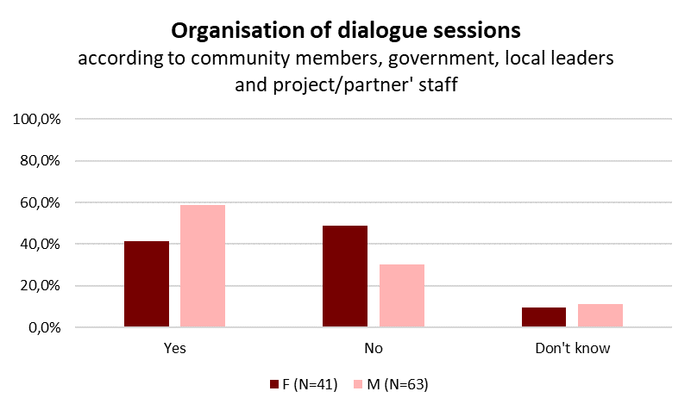
Figure 26 Organisation of dialogue sessions

Overall, the respondents confirm that the dialogue sessions organised have been useful. Beneficiaries specify that it helped to bring back peace, solve conflicts and improve social cohesion in the community.
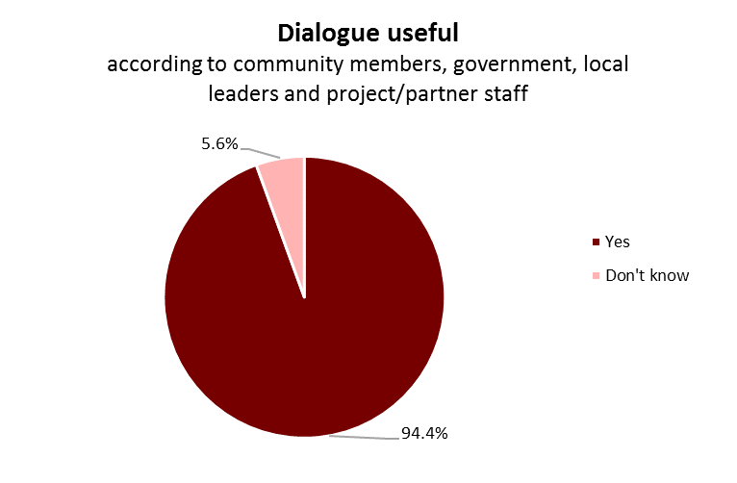
Figure 27 Dialogue useful
According to a majority of consulted community members and key stakeholders, the local committees have been successful in resolving potentially violent conflicts. A female beneficiary in Pendé interviewed by the evaluation team describes the following situation: “There was a dialogue session held in Pendé. This session gathered the local committee of Poulao and Pendé, following a dispute that opposed two individuals from these communities related to an adultery problem. After deep discussions, there was reconciliation.” Another example of issues that the local committees have been dealing with peacefully comes from Paoua, where the local committee explains that a few months ago, the populations from North and South Paoua were not collaborating; “In South Paoua there is a quarry. We did not want the other people [from North Paoua] to exploit it, that’s why the local committee of Paoua has contacted the local committee of South Paoua to discuss and solve the problem.”
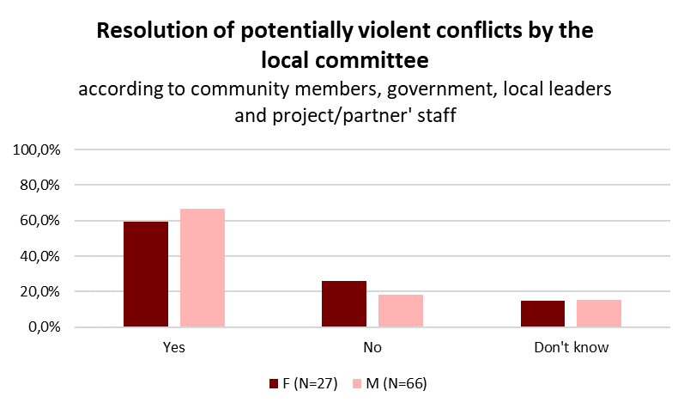
Figure 28 Resolution of conflicts

Indicator 2.3.3 Number of members of target groups attending successfully the civic education and peaceful coexistence sessions
Target | Actual reached | % achieved
Original target  5,600 target groups beneficiaries reaching 80% mark at the post training evaluation  Adjusted target  5,600 target groups beneficiaries reaching 80% mark at the post training evaluation | Almost 4,500 beneficiaries have been trained on principle of civic education, GBV prevention, peaceful coexistence and risks of uncontrolled circulation of arms. Activities and survey still ongoing. | Reached: 80%

A majority of the project beneficiaries interviewed by the evaluation team state that they have indeed taken part in the project activities. Women report participating less in civic education activities, but there are otherwise no clear differences between men and women’s participation.
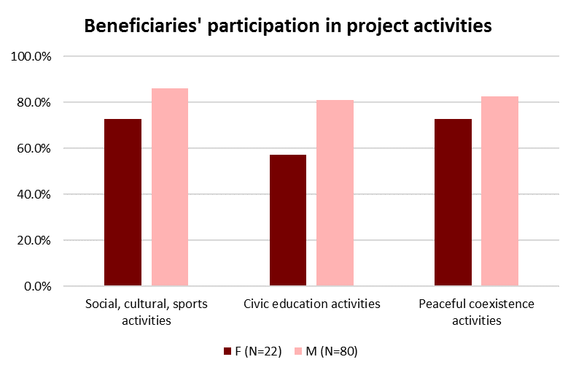
Figure 29 Beneficiaries' participation in project activities
45% of beneficiaries report participating in project activities four times, while another 27% indicate they participated two or three times. All surveyed participants express that activities are important to change behaviour, for social cohesion, to bring back peace or for reconciliation.

Indicator 2.3.4 Number of community based sensitization campaign on social cohesion, peaceful coexistence carried out
Target | Actual reached | % achieved
Original target  At least 14 sensitisation campaigns on social cohesion a peaceful coexistence carried out  Adjusted target  At least 14 sensitization campaigns on social cohesion and peaceful coexistence carried out | Radio broadcast through the local radio “la Voix de Pendé” in French and in Sango of:  9 spots: 2 on arms proliferation; 1 on peace; 1 on reconciliation; 1 on peace and development; 1 on sensitisation for the maintenance of community infrastructures and rehabilitated roads by the CVR project; 1 on living together; 1 on culture of peace; 1 on inter community dialogue;  1 sketch on peace and consolidated security;  22 statements;  4 media coverage: reconciliation ceremony in Gouzé and Poumbaindj, training workshop on the CVR of local leaders and social cohesion demonstration (championship of football CVR);  1 poem on “living together”. | 264%

PBSO, in its mission report from December 2016, already highlighted that “the CVR approach has a strong social cohesion dimension that focuses on addressing the cause of violence through community sensitization and dialogue on the cause of violence. The project appears to be gradually building trustful relations within communities, hence putting in place the conditions conducive to meaningful dialogue. The mission therefore encourages project staff to strengthen the peacebuilding dimension of this approach during the remaining life of the project”.
According to the beneficiaries surveyed in this evaluation, around half the women and nearly 80% of the men have not been a part of any dialogue sessions organised by the project. Most of the beneficiaries state that they received no information about such dialogue sessions. The beneficiaries who did receive information, and decided to participate, report participating two or three times (15%).
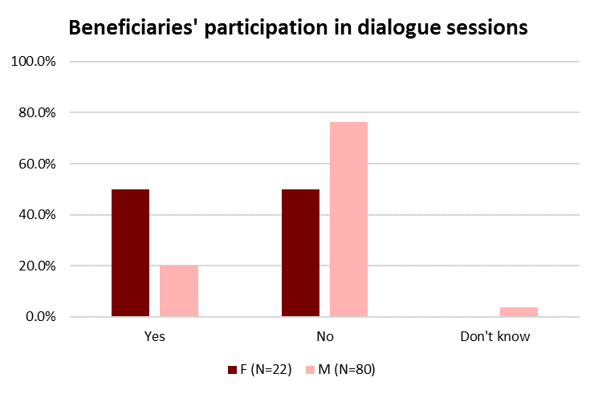
Figure 30 Beneficiaries' participation in dialogue sessions

The beneficiaries who did participate in dialogue sessions confirm that most of the sessions treated subjects such as reconciliation and peace, and social cohesion in the community, as seen below.
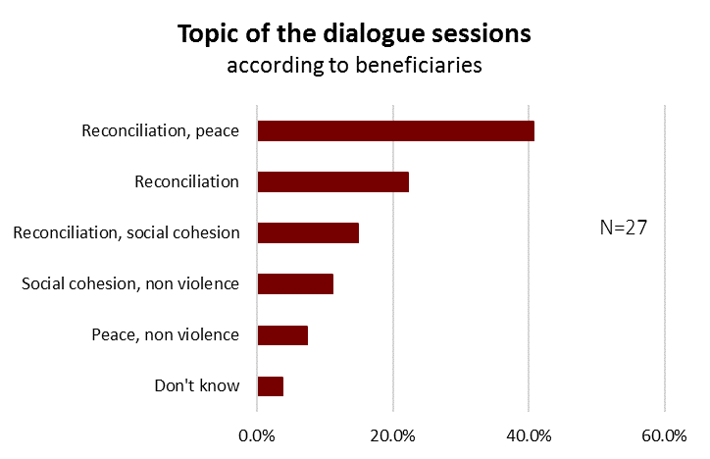
Figure 31 Topic of dialogue sessions

Nearly all respondents who were asked about the inclusivity of the dialogue sessions organised by the project indicate that they were indeed inclusive in terms of gender, ethnicity, and youth. The assistant programme manager explained that “dialogue sessions are inclusive because the committee is a social representation of the village. All youth and leaders are involved in the search for a solution.”
Although the sample is small compared to other questions, nearly 90% of community members confirm that the project improved relations between different communities and groups, as seen below. During the focus group discussions, women interviewed in Paoua indicate that there was no prior division in the community, whereas all other respondents point out that the activities of the project improved relations between different communities.
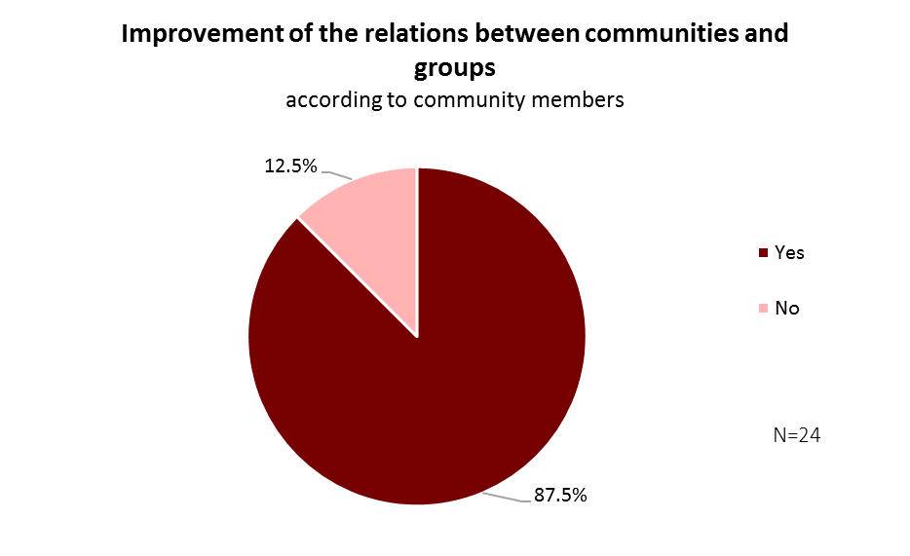
Figure 32 Improvement of relations

3.4 Efficiency and Value for Money
The overview of the finances was received late (one month into the evaluation process). The evaluation included a review of the budget, revisions and separation of actual project expenditure to beneficiaries versus operation costs. The aim was to assess the efficiency of the project and to establish if the project has produced Value for Money.
Finances
The total of expenditures to date (April 2017) amounts to USD 2,557,625. This means that in April, 3 months before the closure of the project, the expenditure rate has been 73% of the total budget USD 3,500,000. Annex F presents the expenditure against the results framework, as requested by the evaluation team and prepared by IOM, with a total net costs (direct expenditures to beneficiaries and communities) of 1,383,182 USD, separated by outcome and outputs. In April 2017, the total amount of other operational and support costs is USD 1,007,121, and the overhead is USD 167,321. This means that currently 38.3% of the total budget is spent on operational and direct support costs, but when adding the overhead this becomes 44.8%, which is high. However, some of this is explained by the high insecurity in the region, increasing operational costs significantly (USD 252,000 is running costs - fuel, maintenances, supplies, security, etc.).
Also, it must be highlighted that almost all staff costs (USD 474.891) are of staff directly deployed in the field, and in most financial reporting these costs would be presented as direct costs, as indeed the staff of IOM is doing direct implementation and is highly visible on the ground.
Staff capacity building (USD 39,023) is reported on in the financial report; USD 6,546 was spent under outcome 1 and USD 32,477 under outcome 2. All staff received training on SSAFF, IM system, corruption and fraud, Logistics and Operations, Do No Harm and Gender focus in Project Design. Technical staff received additional training on GIS, conflict resolution and LTB (logement, terres et biens). IGA and Relais Communautaires also received extra staff training. Based on this, it is unclear why staff capacity training under outcome 2 was overspent with 271% and why only 55% was realised under outcome 1.
M&E (USD 58,388) is only 2.3% of the total expenditure, which is too low and the relatively weak M&E of this project, as explained below, including the lack of investment in a baseline study, reflects this under spending for M&E. However, the budget foresaw USD 140.000 on M&E (5.5%), which is in line with international standards, but if this would indeed have been spent, the M&E would most likely have been better. Additionally, the team found inconsistencies in the random sample between the name and the cards of the beneficiaries and the names registered in the database against the same identification number.
On the operational side the budget it is not always clear how the budget was established. This is specially the case with the “lumpsum” budgets. Further, several staff personnel (Chief of Mission P5, Resources Management Officer, Logistic & Procurement Officer) were planned for (20% of salary) but have not actually been charged to the project, therefore decreasing the operational side of the budget.
When assessing the expenditures, the figures indicate a good realization of the available budget of outcome 1 (93%), focussing on economic reintegration. This is mainly caused by the overspent on the “Cash for Work” interventions (134%) and the costs for field travel. However, the target of 7000 beneficiaries for Cash for Work has not been achieved, pointing to higher costs than foreseen. Up to date 71% of the target for outcome 1 has been reached.
For outcome 2, focussed on peacebuilding activities, the expenditure is seriously below the budget, despite a high overspent (271%) on staff capacity building. Most of the items have expenditures of under 50% of the planned budget. In the mid-term review, when a revision of the results framework took place. The 46% of expenditure on outcome 2 is also due to the underspending on 3% on radio programmes (3%) and on the planned socio-cultural events (17%). Due to the lack of baseline it is impossible to state to what extent targets have been reached in any detail. However, there is proof found of a functioning tracking system of inter- and intra- communal violence incidents, and the role LCs play in the peaceful resolution of community disputes. Also, 65% of the people consulted by the evaluation team confirm that they feel safer. No baseline was done to measure how safe people felt at the beginning of the project, but recently 17% reports the security in their community is ‘good’ and 60% reports the security is ‘average’ between November and May 2017 in the perception survey completed by the project. Between January and October 2016, 13,8% reported the security was ‘good’ and 45% was ‘average’.
As underspending of outcome 2, and overspending on cash for work (outcome 1) are essential changes in policy and expenditure of the available budget, it would have been important to have proof of donor and Steering Committee approval of this strategic change, which was not found by the evaluation team.
The detail of the direct expenditures to beneficiaries and communities are as follows:

Item Description | Budget | Expenditures to April | balance | % of actual spending | % of targets reached
Cash for Work operations (incl. supervision & cash handling costs) | 434.000 | 582.707 | (148.707) | 134% | 1.1.1: 73%  1.1.2: 72%  1.1.3: 84%
Community capacity building to NGOs/CSOs in hotspot areas (outcome 1) | 50.000 | 38.072 | 11.928 | CODING MISTAKE | CODING MISTAKE
On the job training, job placement, salary subsidies, stipend | 150.000 | 70.460 | 79.540 | 47% | 1.1.5: 100%
Trade specific tool kits, small grants for micro business set up | 150.000 | 100.783 | 49.217 | 67% | 1.1.6: 143%
Community Infrastructure Rehabilitation Projects | 560.000 | 515.115 | 44.885 | 92% | 1.1.4: 105%
Community capacity building to NGOs/CSOs in hotspot areas (outcome 2) | 50.000 | 27.784 | 22.216 | 56% | 2.1.4: 100%
Civic education, socialisation & sensitisation activities | 50.000 | 34.020 | 15.980 | 68% | 2.3.2: 53%  2.3.3: 80%
Radio campaigns information and comics productions | 70.000 | 2.074 | 67.926 | 3% | 2.3.4: 264%
Community based sociocultural activities & workshops | 70.000 | 12.167 | 57.833 | 17% | 2.3.1: 33% & 21%
Total | 1.584.000 | 1.383.182 | 200.818 | 87%

The table above does not list the costs and budget of all output indicators and indicators 2.1.1, 2.1.2, 2.1.3, 2.2.2 and 2.2.3 are not included in the table of detailed direct expenditures to beneficiaries as these activities were undertaken directly by the project staff and are therefore part of the staffing budget and other project resources (vehicles, fuel, drivers). Hence, no record or breakdown of costs exists for these indicators which makes it difficult to assess the value for money for these indicators. In addition, the activity ‘community capacity building to NGOs/CSOs in hotspot areas’ has two cost components; one for each outcome. However, the costs allocated for this activity were reported against output indicators 2.1.4 and 2.2.1 by mistake of coding. Therefore, the evaluation team could not assess what is actually done and achieved, and spent on the important activities of output 2.2 related to awareness on SALW and arms storage facilities built. However, a cost overview of weapons storages built, part of output indicator 2.2.2, does exist. 7 arms storages were built (one for each participating community) at a cost of USD 550 each, adding up to a total of USD 3.850.
As a standard, lower net costs should be in line with the support costs. In this case, the expenditure of the budget is 93% for outcome 1 and 46% for outcome 2. The expenditure rates of the support staff costs and other support costs are, respectively, 52% and 79%, indicating the expenditure rates are largely in line with each other.
Overall, the financial reporting has proven rather complex and IOM is advised to move to Results Based Budgeting (RBB), reporting expenditure against each output. In addition, there are no elements of Gender Based Budgeting (GBB) found and there is no breakdown presented on actual spending on men versus women.
An underspending of 27% of the available budget is caused mainly by the long and difficult start-up period, which could have been foreseen but was not planned for, and due to the security situation where some activities had to be suspended. It is expected that in case IOM is granted a no-cost extension, that the full budget will be spent and results against targets will be increased.
Note: As presented in the section below, the evaluation team found narratives on cases of corruption such as beneficiaries paying part of salary to committees and pressure of commanders on staff to give building materials. As far as can be judged, there are no signs of IOM implication in this and that IOM, when informed, tried hard to address these cases rigorously. The only criticism is possibly that while the evaluation team was told many stories on this, IOM management was not fully aware, pointing to the lack of M&E in terms of perception surveys, which should have taken place more often, and should have include satisfaction levels of beneficiaries and communities with the functioning of the project.
Value for money
Despite the difficulties, the overall impression is that the project produced high value for money, especially taking into account the high insecurity of the target locations which increase operation costs.
Rumours on lack of transparency, nepotism, accusations of corruption by Local Committees are observed, which is most likely a direct price for putting the committees in the driving seat, making them vulnerable to accusations and possibly in a position to politicise resources.
The payment for CfW is lower (1500 per day) than other programmes (pre-DDR, Youth at Risk etc.) and should be increased, especially as the provision of additional food for work was not achieved.
As outlined above, the biggest criticism is that the IGA kits are too expensive for individuals, especially as not enough IGA kits are available (10% of the beneficiaries).
Partnerships to increase efficiency were hardly functional, but proof exists that the project tried hard to establish these partnerships (MINISCA Civil Affairs, DRC, WFP etc.) Local partnerships with CASAL and Radio Pendé are highly efficient and good Value for Money. Efficient working relation with MINUSCA Force.

3.5 Impact (outcomes)
The project has two intended outcomes, and five related outcome indicators. Findings in terms of impact, or at least outcome, are presented against these. As usual, reporting on impact is impossible at the end of an ongoing project as the real impact can only be measured at least one year after closure of an intervention. However, initial outcomes and likely impact are reported on in this section, per indicator. The lack of baseline information, while foreseen but not done, further compromises the reliability of the findings presented below.
Outcome 1: Economic reinsertion of armed groups’ elements non-eligible for the national DDR Programme achieved through skills training and income generation activities

Indicator 1.1
The armed groups elements non-eligible for the national DDR Programme are economically integrated and not recycled in illicit activities.

Overall, the CfW and IGAs made a good start to reinsertion, with 53% of the combatants targeted by the project saying their economic situation has improved due to the project. Those who do not agree with this mainly refer to the fact that there are too few IGAs available and the CfW was too short to save money and start some other activities. On the question if the economic situation of the beneficiaries has improved, a majority of beneficiaries and project/partner staff below say that indeed, it has improved. Only among local leaders did a majority of both men and women say the economic situation of beneficiaries had not improved, whereas the government staff also expressed scepticism. A member of the local committee in Bambara highlighted the following: “The situation of beneficiaries improved a little because they collaborated, for instance, some pooled some money to buy a bike. This bike is used when someone fall sick as a mean of transport. Others raise money to create a ‘tontine’.”
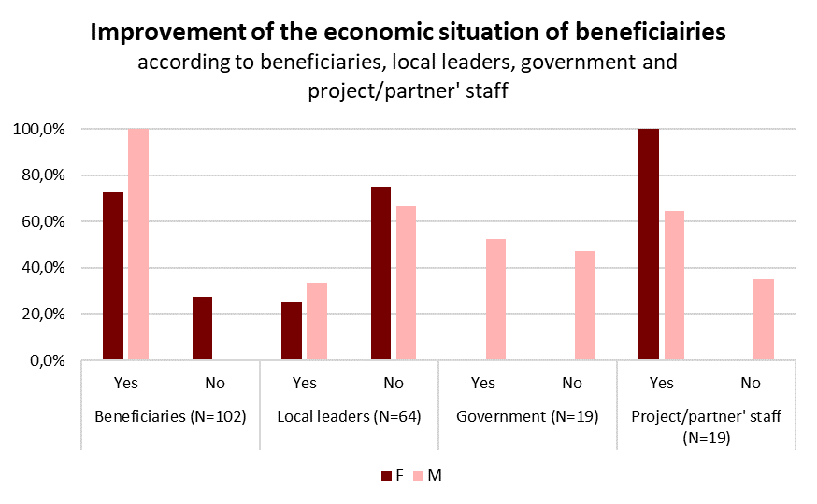
Figure 33 Improvement of beneficiaries economic situation
In comparison to the beneficiaries, in the focus group discussions with community members – the indirect beneficiaries of the project – 31% state that their economic situation improved. 42% of men see their economic situation improved, whereas only 19% of women stated it is the case.
On the question if beneficiaries of the cash for work activities managed to save money from the salary received, 23% of the beneficiaries indicate they did manage to save. However, a majority of them state it was not enough to save money, which was confirmed by the project staff. In addition, local authorities have also taken note of the inability of beneficiaries to save money and the perils that follow; “We have arrested two men in Pendé with handmade weapons. We have found cards from IOM beneficiaries on them. They told me that they have worked for IOM but they do not have money anymore. They spent all their salaries so now they have to steal.” A female local leader in North Paoua indicate that the security situation has also had a negative impact on the economic situation of beneficiaries; “to go to Betoko, there are 7 roadblocks held by armed elements. For each barrier, they ask 500 FCFA, so when you go there and come back all the benefits you have made are lost.”

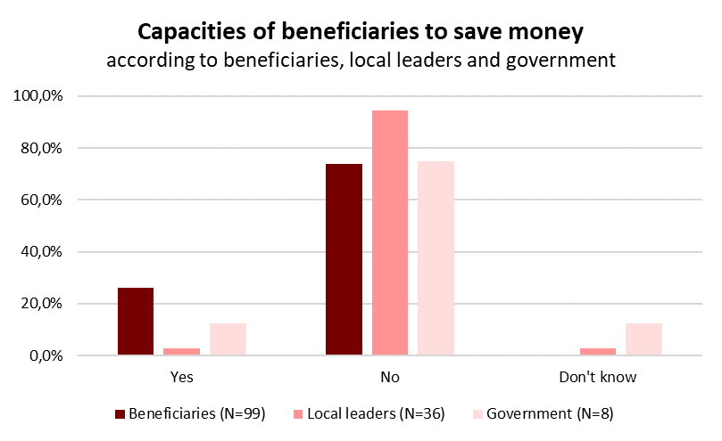
Figure 34 capacities of beneficiaries to save money

In the FGDs with community members, almost all women and 60% of the men confirmed that the project was successful in ensuring the economic reinsertion of armed people that are not eligible to DDR.
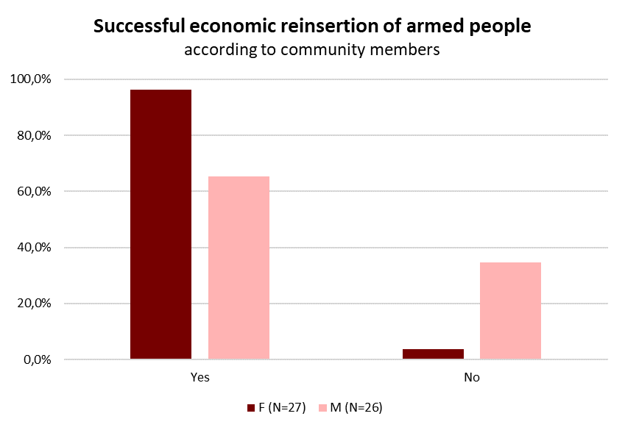
Figure 35 Successful economic reinsertion of armed people

However, the interventions have been too short and IGAs too limited in number, to ensure real lasting results. Also, no skills training has been provided (except very few for agriculture), which is a missed opportunity as providers are available, both a training centre of reasonable quality and local crafts people who could have been mobilised to train young people. When asked about effectiveness of the CfW to prevent beneficiaries to return to illegal activities, the answers were equally divided between respondents. Respondents who disagree state that money was not enough and that the project is too short to be sustainable. While the stakeholders estimating that the project achieved its objective, highlight that this result is also due to other activities such as sensitization or the development of IGA.

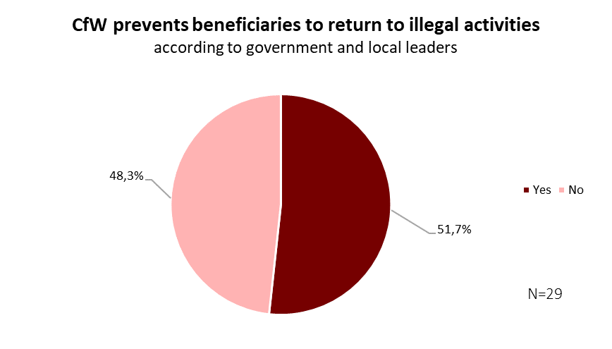
Figure 36 CfW prevents beneficiaries to return to illegal activities

Indeed, CfW and IGAs made a start towards economic reinsertion, but time for follow-up is too short to ensure that armed groups’ elements will “not recycled in illicit activities”, as was added in the last revision of one of the over-ambitious indicators for this outcome. Therefore, there is need for consolidation of the initial results; it is indeed just reinsertion and not reintegration.

Furthermore, difficult cases were excluded to receive IGAs, as a manner to reward good behaviour. However, from a reinsertion and eventual reintegration point of view, it is actually important to put serious energy in those people that need more support in transforming their mentality from combat to becoming productive citizens.

The outcome of the project was furthermore diluted as the few IGAs available were not given with priority to combatants (over vulnerable people), further reducing the stabilising effect on armed groups’ elements. This also resulted in the fact that not all female combatants received IGAs, while their number is low, which is a missed opportunity to create a better gender balance.

Also, not all armed youth were included – some joined later due to lack of trust and there were no more opportunities to join, which is also creating risks in terms of security and stabilisation. The CfW targets for armed elements is largely in line with the project objective as there is an insignificant difference between the original target (68,6%) and the target reached (66,9%). In total, the current completed or enrolled number of people for CfW is 5120 but the objectives are not reached as the original number of beneficiaries objective was 7000.

Another indicator of this outcome is that at the end of the project the community members perceive their economic situation improved, with a target of 80% and attributed to the project. It has proven impossible to measure progress against this indicator in the absence of a baseline. A perception survey was conducted but did not address this indicator. The evaluation team asked respondents whether the economic situation of the community as a whole has improved, and 73% of all respondents state the situation has indeed improved. There is a significant difference between responses of community men and women in this: with 100% of the men but only 48% of the female community members interviewed say the economic situation of the community has improved, as presented in the graph below. Project and partner staff are almost all of the opinion that this is the case, while less than 50% of the local leaders confirm that the economic situation of the whole community has improved.

Further, the team found that in the 10 villages where the project was implemented, indeed the overall economic situation has improved, largely due to increased security, cashflow and mobility. But in the over 200 villages around these centres the impact has been much lower. In addition, in some localities such as Poulao, there is no market, so money leaves the community to Paoua which reduces the impact in terms of cash flow into the local economy. In Pendé, one beneficiary made the following comment; “Today on the markets, goods are mostly bought with the money from CfW activities. The prices of some goods have even increased.” As stated in the midterm review: Local sourcing of materials for infrastructure rehabilitation, through opening of quarries for sand, gravel, rock and laterite extraction, is a very important positive approach of the project, and the project has indeed made a start to boost the local communities where operations took place.
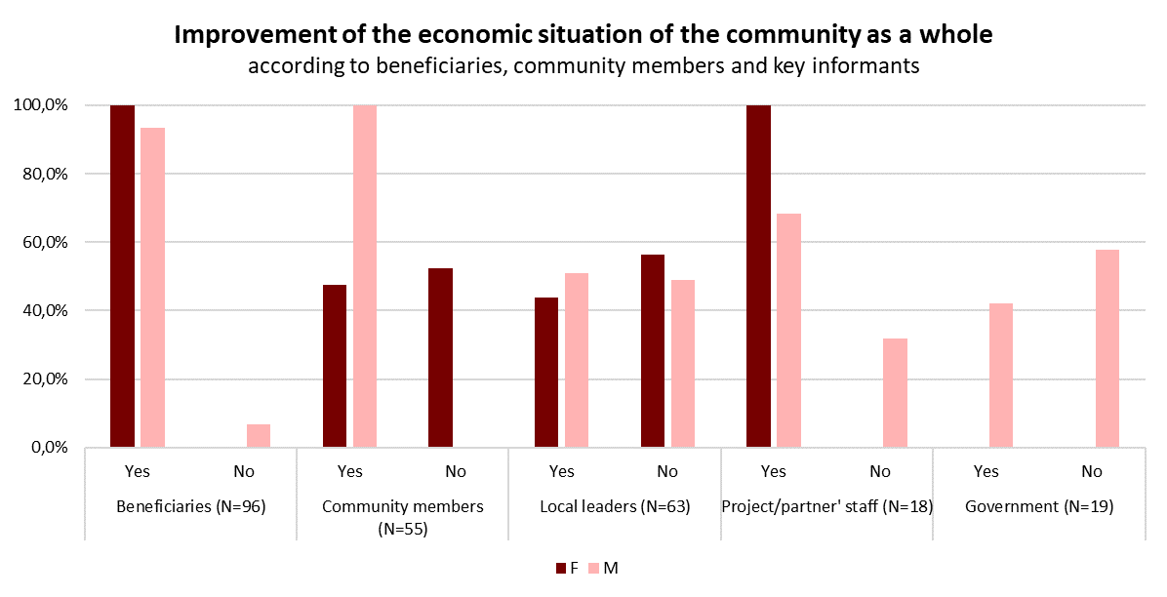
Figure 37 Improvement of economic situation in community
Outcome 2: Social reinsertion of armed groups’ elements non-eligible for DDR and peaceful coexistence within their communities achieved through trainings and community dialogue in hotspots areas, playing a stronger and positive role in the prevention of violence; peaceful coexistence is achieved at community level, through the establishment of mechanisms for peaceful settlement of intercommunal and internal disputes as alternative to violence.
Due to the lack of baseline it has proven hard to measure change. Measuring change in peacebuilding requires regular perception surveys and other participatory monitoring tools, which were provided too late.
The overall impression however is that the outcomes are good on conflict mitigation, except not on conflicts between the agriculturalist and pastoralist communities. Further there are the incidents related to MPC and RJ attacks, and transforming this conflict is beyond the scope of the CVR project. However, the project results did contribute to de-escalation of the conflicts, with arms in storage and people in the project deciding not to counter-attack, as this would mean being expelled from the project. One of the strength in this is the very strong relationships established by the project with the commanders of the armed groups not eligible for DDR, such as the Patriotes.
After receiving the database on the incidence tracking system from the IOM, the evaluation team analysed the data and produced the graph below to show the evolution of the number of incidents from January 2015 to May 2017.
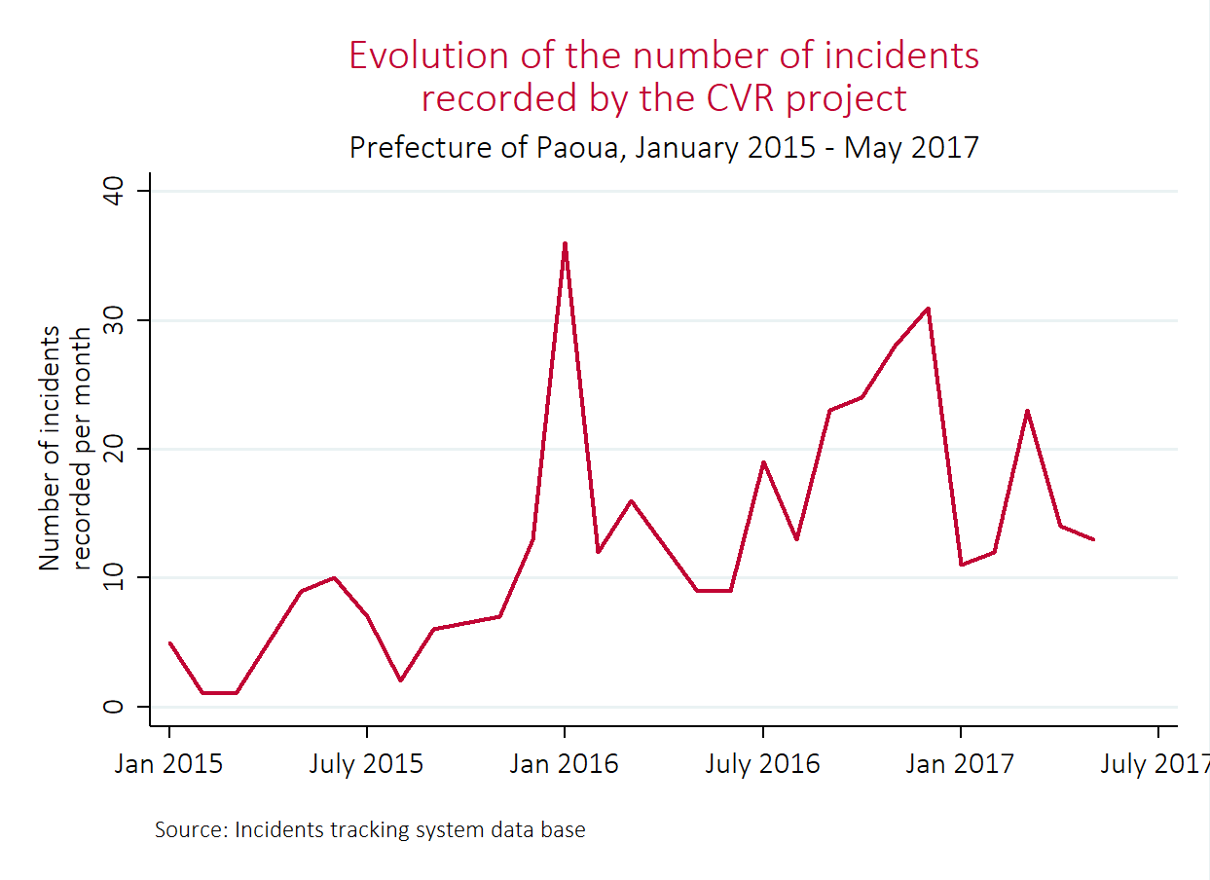
Figure 38 Evolution of number of incidents
The first indicator under this outcome refers to the number of inter-intra-communal violence incidents reported during the project life span, with a target that: critical security incidents as a result of inter/intra-communal violence decrease by 25% during the project life span. The first problem is that there is no baseline established on the incidents so again it is impossible to measure the level of achievement. The other problem is a design fault as the indicator refers to number of cases reported, while the target refers to number of actual incidents. The number of reporting most likely went up due to an innovative system set up by the project to register and track incidents, as described earlier, and to put a referral system in place from LCs to IOM to MINUSCA Force. IOM reports on regular systematic reporting on conflicts and cases per forms, telephones provided by the project and vouchers to motorbikes (early warning system established). An increase in reporting is thereby not related to an increase of incidents but to an improved reporting system.

There are indications of a downward trend for the community based self-defence armed groups and increased for the armed groups’ alliance RJ/MPC because of the progressive expansion of their activities of. In the project perception survey done by IOM, 17% report that their impression of the security in their community is good and 60.4% report it is average, as shown in the graph below.

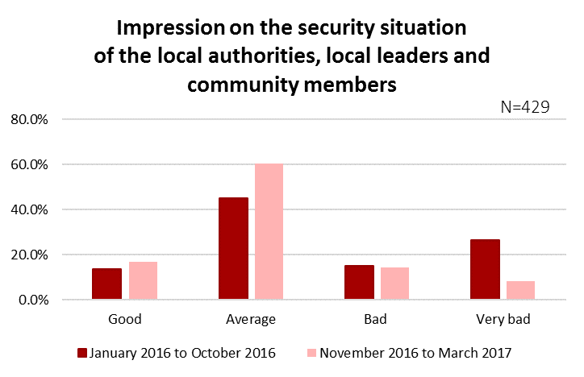
Figure 39 Impression on security situation

The second indicator under this outcome relates to the number of inter and intra community disputes resolved by peaceful means and reported by the Community Committees. The target is that: peaceful means of inter and intra- community dispute resolution are used in at least 10 cases, and the community committee keep records of these dispute resolution paths for future applications. IOM reports that three inter-community and one intra-community dispute resolution case are organized with the respective LCs and planning for conflict analysis and mediation is underway for additional five cases. According to the consultations with 5 LCs the team believes that this is seriously under reported, with LCs undertaking many more cases locally. However, it is found that the LCs are mainly involved in local conflict resolution within communities, and focus on mediation in line with the previously system of Chief courts. The advantage of mediation trough this inclusive group of community representatives is that more people, including women, now have a voice.

The intra-community dialogues and dispute resolution are mainly organised by the project’s partner CASAL, with IOM and the LCs. No cases were found where LCs organise bigger dialogue sessions, something to work on further. Lack of baseline on perceptions of the communities is not available but perceptions, measured during this evaluation, highlight that beneficiaries are satisfied with the LCs, while among community members there is more ambivalence due to the suspicion of nepotism and favouritism of the community members that were not selected to benefit directly from the project. 65% of community members and key stakeholders consulted state that conflicts that would have otherwise led to violence have been resolved by the LCs.

The third impact indicator under this outcome states that: at the end of the project the community members perceive their community more secure in respect at the beginning of the activities. The target set is that: at the end of project 80% of the community members interviewed perceive their community more secure than at the start of the project. Level of achievement is not identifiable due to lack of baseline.
The majority of the direct and indirect beneficiaries interviewed during this evaluation say yes (65%) to the question if they feel safer than 2 years ago, and attribute this to the project, with beneficiaries feeling safer than community members. The new presence of MPC and RJ has created a different source of insecurity and in some villages insecurity remains high due to conflicts between pastoralists and farmers, conflicts that are not treated by this project which is a missed opportunity. The table below shows the reasons beneficiaries and community members gave for feeling safer than 2 years ago. However, almost one third does not feel safer because of the presence of armed groups, the lack of presence of the police and MINUSCA, and the presence of pastoralists.
Reasons for feeling safer | %
Reduction in violence | 22,2%
Do not live in/have to run to the bush anymore | 13,9%
Presence of MINUSCA/Police/Gendarmery | 12%
Awareness (on peace and non-violence) | 5,6%
Decline in the circulation of weapons | 3,7%
Awareness (on peace and non-violence), presence of MINUSCA/Police/Gendarmery | 3,7%
Free movement in Paoua | 2,8%
Return of security | 2,8%
No presence of armed groups | 0,9%
Reduction in violence and decline in the circulation of weapons | 0,9%

Further, 85% of all respondents indicate that the community is more peaceful now than 2 years ago. This percentage varies according to the categories of respondents, as seen below. Almost all the beneficiaries and project/partner’s staff find the community more peaceful now than two years ago. Meanwhile, between one quarter and one third of the community members, government staff and local leaders consulted do not view the community as safer now. In Bambara, a participant in a focus group expressed the following: “There is no security for me and for the village, when we go to the field we are scared because there are some armed peuls. This project has not enhanced our relations with peuls; there is not that much dialogue.”
Regarding youth and those above the age of 30, there is a visible difference between community members, where more youth say that the community is not safer. In addition, more female community members and female local leaders say the community is safer now, as compared to men in the same categories, but the difference is not statistically significant.
Nearly all respondents who say that the community is more peaceful now also declared it’s due to the project. Most of their reasons for why the community is safer now relate to the activities of the project including awareness campaign on peace, social cohesion, risks related to the use of weapons and non-violence, the effects of CfW and income generating activities in occupying the youth and the reduction of the circulation of arms. On the contrary, only 1,6% of the sample of respondents indicate that peaceful coexistence is worse than before.
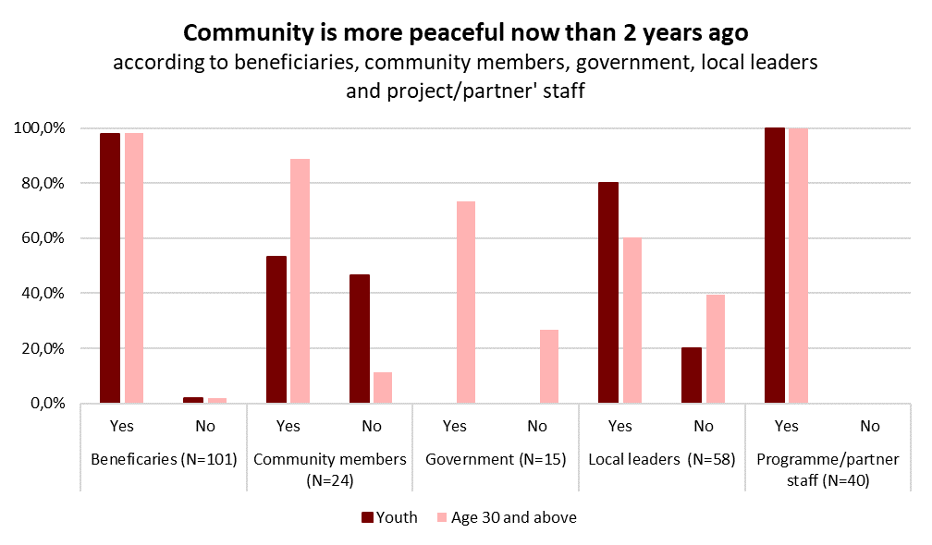
Figure 40 Community more peaceful
Finally, the project had an overall positive impact on the living conditions in the targeted communities, as shown in the graph and table below.

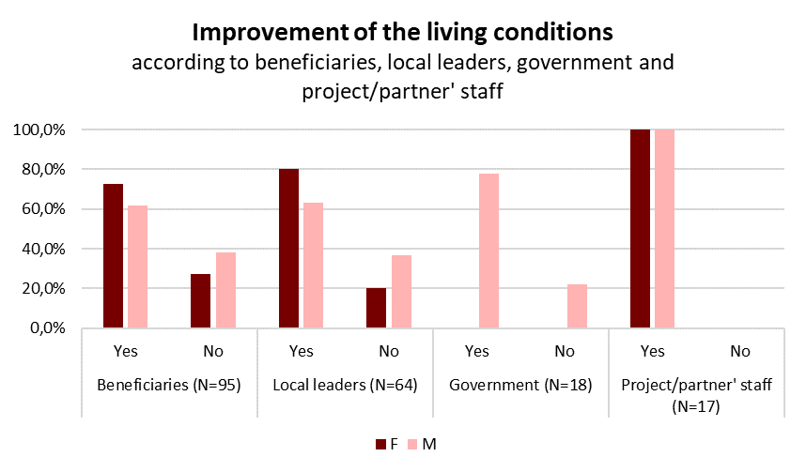
Figure 41 Improvement of living conditions

When asked to explain their answers, people provided the following explanations on their living conditions:
Opinions | %
Not enough money | 21.8%
Developed IGA | 11.9%
Return of security | 7.9%
Not living in the bush anymore | 7.9%
Developed IGA, schooling | 5.0%
Insecurity | 5.0%
Able to meet their needs, various purchases | 5.0%
Various purchases | 4.0%
Relaunched economic activity | 4.0%
Purchase for agriculture | 3.0%
Circulation of money in the community | 3.0%
Construction of infrastructures | 3.0%

3.6 Sustainability
It is important to recognise that it is too early to establish if, and to what extent, the project has created lasting change and results. However, sustainability can be predicted to a certain extent.
According to the stakeholders consulted, nearly all the respondents of all categories agree that the CVR project has indeed created lasting results. Two issues are highlighted in terms of lasting results created by the project: 47% of respondents point to the infrastructure that have been put in place, and 33% mention both the development of IGAs and the infrastructure. The IOM Programme Manager made the following statement; “We are trying to look for lasting results with the project extension as we have a lot of difficulties with the exit strategy. If we were to close it today, there would still be the work done by Local Committees but their capacities are still lacking. Also, the training on conflict analysis, IGA, and infrastructures would remain, but the ministries need to be in charge of the maintenance.”
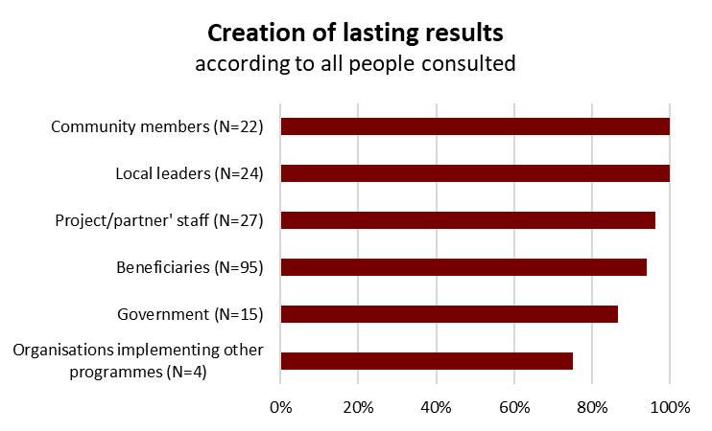
Figure 42 Creation of lasting results

Indeed, the high quality of the infrastructure projects completed, under the supervision of professional engineers, has been impressive and the linking of the infrastructure to the relevant line-ministries must be applauded and is likely to make these investments sustainable. On the CfW road rehabilitation there is less in place to ensure the maintenance of roads in the future.
This weakness related to the overall absence of an exit strategy. Another example of this is while an impressive early warning and incident reporting system was put in place, already discussed in section 3.5, the local police or gendarmery are not part of the system and no clear vision was found on how to ensure this system continues to work after the closure of the project.
In terms of national ownership, the local ownership is good, (except that no relation and no capacity development is found with the police and gendarmery who have presence in Paoua, the agencies responsible for increasingly ensuring security). Local Government at all levels are informed and play active roles, and most of the LCs are likely to remain operational after the closure of the project. However, what is required is to strengthen the advocacy and lobby capacities of the LCs in order to attract support from other donors and organisations. There is also a need to consolidate LCs, e.g. with meeting room (could be done through an additional round of CfW for combatants left out), new reporting lines for incidents etc. The DDR programme is advised to work through these same committees, where created.
National ownership is however less evident, with strong complaints to the evaluation team from national actors. They express frustration on insufficient involvement and no facilitated field visits. The Steering Committee met only 4 times instead of the planned 8 times. A government representative on the Steering Committee expresses his frustration: “MINUSCA has monopolized the management of the CVR; every time we are told it is the funds of MINUSCA. There is no national ownership, they went alone each time to assess the project on the ground, we never went with them and every time we were disregarded… It is up to the us, to for example involve the mayors or sous prefect, to be informed by us and decentralize. The state must be there to regulate. The state faults MINUSCA for the lack of national ownership.”
In terms of the sustainability of the economic reinsertion, as stated the one round of 24 days was too short to create lasting results, and only 10% of the beneficiaries received IGA kits. Of great concern regarding the sustainability of the stability created is the group of estimated 600-800 armed elements that are left out of the process, and the few that were expelled due to inappropriate behaviours (of which some are in jail and who will come out) needing reinsertion support. Closing the project before stabilising this group puts the peacebuilding effects created by this project at risk.
Local leaders interviewed by the evaluation team mention that to support sustainability of the IGAs, beneficiaries should be trained and supervised. Two local leaders (in Pendé and Poulao) declare that the only sustainable IGAs are the ones involving agriculture and livestock. A local leader in North Paoua indicates that it is a good thing that the beneficiaries selected for the business IGA already have business experience, as this increases the likelihood that their activities will be sustainable.
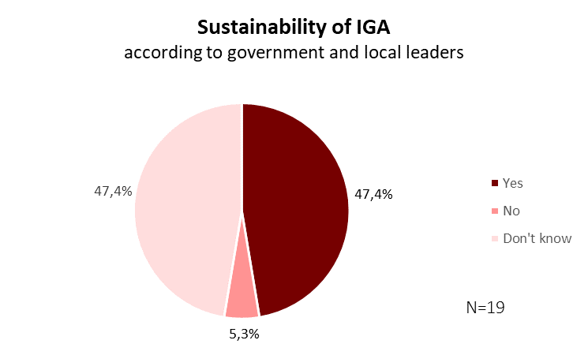
Figure 43 Sustainability of IGA

Furthermore, no skills training except for some agriculture (3 weeks) took place and therefore IGAs are vulnerable, while on the other hand the kits are of fantastic quality and some of the risks have been reduced by providing kits to those people who are already familiar with that type of business. However, tailors that received a machine, tables and equipment, explained they only had three months of training years ago and that they need more training to become professionals. Another weakness is the lack of solid market research at local levels, with risks of oversupply of certain sub-sectors and missed opportunities in others.
The sustainability of CASAL and Radio Pendé, two partners that played an important role in the stabilisation of the area, is likely as both organisations existed before the project. However, at the closure of the CVR project more emphasis is needed to strengthen their capacities, as was planned for but has not been completed to date.
The sustainability of the local arms storage is another issue that should be reflected upon by MINUSCA in an exit strategy. The team found no thinking or planned action on this, while the storage of the arms, which seriously reduced incidents, might not last if the project closes, as tensions and insecurity remains high, and external treats have in fact increased.
The biggest risk in terms of sustainability is the likelihood of revolt (possibly armed) when the DDR starts and there is no more CVR. The evaluation found a lack of clarity and information on entry criteria for DDR and if the MPC and RJ will start receiving good benefits through the DDR, and there is nothing provided at the same time to the other armed groups, the team is almost certain that the stabilisation results of this project might largely vanish.

3.7 Gender, Inclusivity and Do No Harm
This section takes a closer look at specific aspects of the project and project outcomes which relate to gender and inclusivity.

Gender
In the initial project document for CVR, it is stated that “A gender-sensitive approach will be adopted throughout the project, to ensure that both men’s and women’s gender-specific human security needs are identified and addressed, and that inclusivity, local ownership, oversight, accountability are ensured and respect of human rights enhanced.”
It is also indicated that gender marker score 2 have been applied to the project. Nevertheless, in a letter from the Special Representative of the Secretary General for MINUSCA, it was stated that until gender analysis, activities, indicators and expected results have been improved, the project should remain categorised as gender marker score 1. The evaluation team, having reviewed several revised documents including the results framework, has not found any information that specifies the final gender marker score of the project. In an interview with project staff, it was stated that gender equality is not an aim of the project, which would therefore mean that gender marker 1 is more appropriate. This scoring means that “Gender equality is an important and deliberate objective, but not the principal reason for undertaking the project”.
One of the minimum requirements of gender marker 1 is to present and report all data disaggregated by sex and to have gendered targets. The results framework (Annex E) is however largely gender blind in its target and reporting progress. For example, the target for IGAs is: 350 beneficiaries assisted in formulating their own income generating project and receiving business skills training and professional tools. There is no separation of target for men and women and no reporting on progress divided by sex.
In the mid-term evaluation of this project, the revised gender analysis specified that; “Training of the Local Committee members will include prevention, referral and community mobilization regarding SGBV, as well as on conflict management and prevention including mediation, peaceful settlements of inter communal disputes, rumour management and verification of information on security threat, to prevent panic among population (often cause of population displacement) and prevent violent self-response/self-justice/retaliation, including SGBV, by community members”. The evaluation team confirms that local committee members have received training on gender and referral of cases of SGBV to the appropriate service providers. However, during the evaluation two cases were found where women were victims of domestic violence while no actions were taken. Nevertheless, other cases exist where the LC actually refer the women to the Safe house, negotiate with families, and in case of sexual abuse refer them to Danish Refugee Council, who has a stronger SGBV programme and motorbike transport for victims.
A female beneficiary in Bambara indicates that: “The project has not developed a strategy for the participation of women in the project to promote their autonomy after the hardships that particularly women have endured. For example, I was raped by four elements of the RJ and [there was] no response to my situation. I do not know if I am healthy after what I experienced because [there is] no psychological or economic support for me.”
In terms of numbers, the inclusion of women in CfW activities reached 48% of the vulnerable category. Compared to the target of 60%, this is an underachievement. In addition, many of these female beneficiaries were older women that were replaced by proxies, often their sons. Women only made up less than 10% of the ex-combatants who benefited from the CfW. This is particularly troubling given that “women associated with armed forces and groups, especially those in supporting roles that did not carry weapons, or women ex-combatants that had their weapons taken away from them, or young women under the age of 18, do not fulfill the DDR eligibility”. It is not reported which % of the IGA kits were given to women. The decision to not target all female combatants in the IGAs was a missed opportunity to increase a better gender balance.
Among the LCs, the project has reached its target of having 20% women among the community members on the committees, although this target was lowered from the initial target of 30%. In the meeting of Steering Committee meeting conducted, there were no women present. A female local leader from Bambara indicates in an interview that the local women’s association was never contacted or informed on the selection of committee members.
When asked if the project had the same impact on both men and women, 44% of women and 37% of men say the project did not. Among the reasons cited by respondents is that the money received from CfW activities is spent differently; a woman is more likely to spend the money on the household and issues like children’s education, whereas men more frequently keep the money to themselves and their individual needs. Similarly, when community members were asked if the economic situation in the community had improved, 100% of men but only 48% of women say yes.
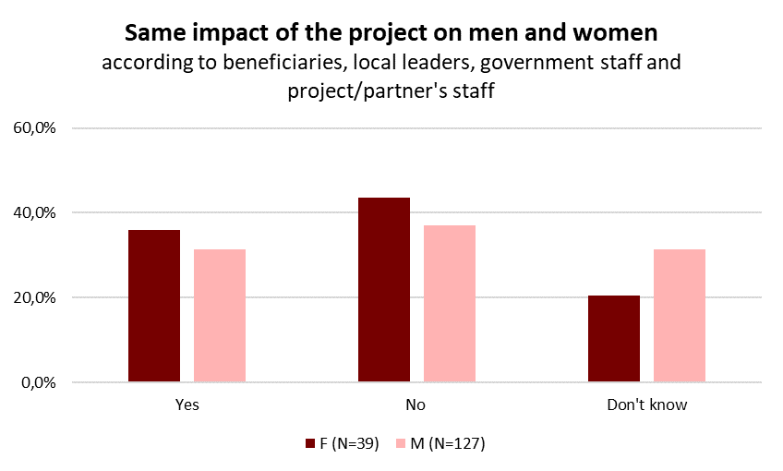
Figure 44 Same impact on men and women
Interestingly, many more local leaders, largely composed of the members of the local communities, think the project had the same impact on men as on women, while government and project staff express this is not the case.
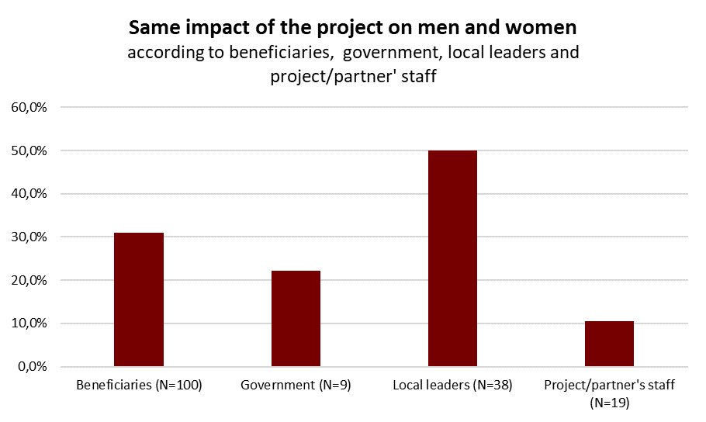
Figure 45 same impact on men and women by category
When government and project and partner staff were asked what the CVR project did to address the specific needs and ambitions of women, a third of respondents say “nothing” and almost another third say they do not know. A mere 17% list the training and awareness raising on gender, including sexual and gender-based violence, as one way the project addressed the needs of women. Some expressed the positive practice of consulting women’s preferences for IGAs, and the inclusion of women in the project is only mentioned by 8% of respondents, but it should be noted that the frequency here is low compared to other questions. A positive example of how women’s needs were addressed comes from the community of Ban in Paoua, where a pregnant woman working on the project was granted two weeks of maternity leave and received all her salary.
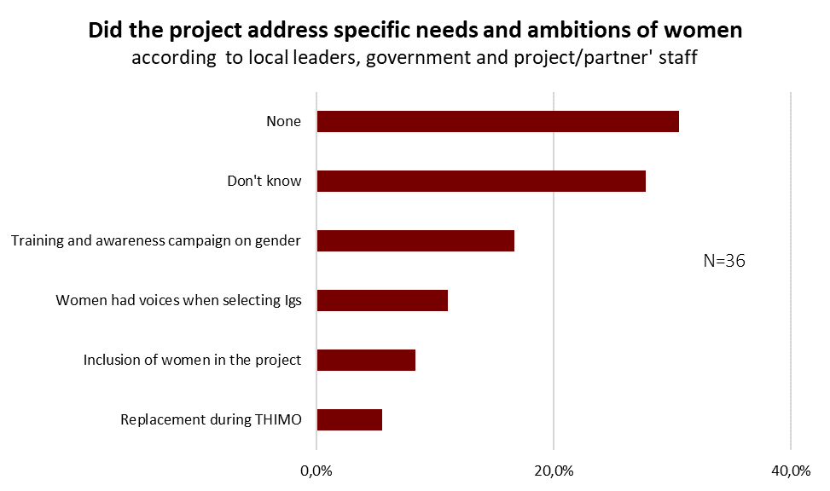
Figure 46 Specific needs addressed

The evaluation team asked 102 beneficiaries if they had heard the radio campaign on the prevention of gender-based violence, and a majority say they have not. However, among the beneficiaries who had heard the campaign, more than 20% think the campaign will contribute to a change in attitudes and behaviours. According to one male ex-combatant in Bambara; “For those who don’t have time to participate in the sensitisation activities, the radio programme gives access to the same level of information on gender-based violence. From what I listened to, I changed my attitude towards women and made my friends aware that they should not use violence against women anymore.”
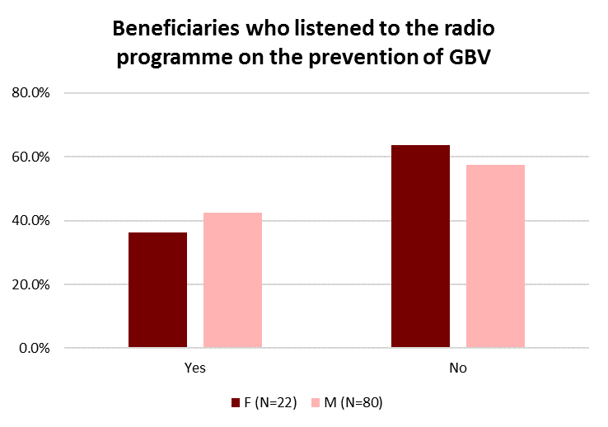
Figure 47 Listened to radio programme on GBV
Inclusivity
As explained above, the LCs have good representation of the government, civil society, and social and ethnic groups of the communities, although representation of pastoralists communities living in the same region, at least part of the year, is absent. The same applies or beneficiaries, and the evaluation heard no complaints about ethnic or religious exclusion.
Further, over two million people are under 18 in CAR, comprising 47% of the total population in 2012 and the percentage of children in several anti-Balaka groups is higher than 50%, for example in Bocaranga. Children within the legal working age (14-18) have been excluded from the assistance provided, which has no legal basis. From a protection point of view, it actually creates more risk not to include them in the project activities then to leave them out. The issue has been brought up extensively by IOM but unfortunately it has not been solved. The evaluation team met with UNICEF and UNICEF is open to support the inclusion of armed children and other children at risk of being drawn into the conflicts, who are now left without much support in most places. What is required is protection training for CVR implementers and adapted cycles of work to not interfere with education.

Do No Harm
In terms of DNH, the project did not monitor DNH through perception surveys, or any other participatory monitoring tools. However, the strong field presence of the programme manager did lead to several ad-hoc corrections based on informal conversations, mainly with the LCs.
A question on the unintended effects of the project was asked during focus group discussions with local committees and in-depth interviews with other local leaders, government and project/partner’s staff. More than 40% of the respondents state that the CVR project has not had any negative unintended effects. In contrast, 45% of the respondents do identify some negative unintended effects.
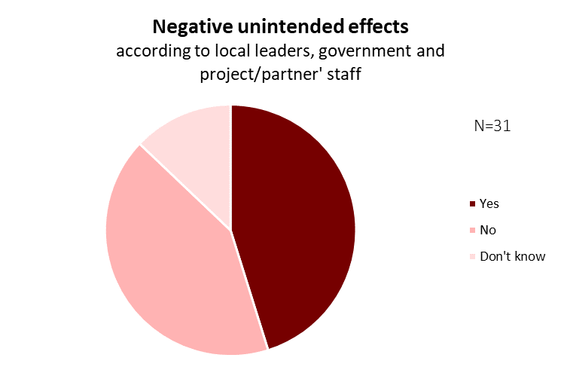
Figure 48 Negative unintended effects

Over the set of responses collected, local leaders, IOM and government staff in Paoua voice concern that the project is actually creating new troublemakers since non-combatant youths are mostly excluded from the project. During the meeting with local authorities in Paoua, the chairman of the tribunal emphasized that; “There was a problem regarding beneficiaries. When the project has targeted armed elements, it had the tendency to create new ones. People were taking arms. This tended to create instabilities in the community.” The IOM project staff, facilitators, and local leaders surveyed regret the lack of budget to take into account all beneficiaries, including the rest of the combatants. For that reason, the IOM Programme Manager reflected on the need to integrate other categories of beneficiaries; “Youth combatants take up weapons to become beneficiaries, as there are no other actors around and the CVR project is exposed to everything, our option would be to replace the vulnerable by unarmed youth. But an important component of the project is a humanitarian one; we have to do something for the vulnerable.” Further, some of the remaining responses provided by other stakeholders consulted highlight frustrations in terms of the quality of materials used for infrastructures, the suspension of activities due to presence of armed groups, or conflicts related to the level of the CfW salary.

Four issues in terms of DNH should be highlighted:
- The low inclusion of unarmed youth has indeed led to the message that in order to get assistance you need to join an armed group. In a country that has seen several DDR interventions, which had the same downside, this is a major issue. The vulnerable group that complements the focus on armed youth (“the bad behaved boys and girls”) should be focused on well behaved youth in order to avoid stimulating them to join the other camp, especially in rural villages where these selection, and thus exclusion criteria are highly visible.
- One of the IGA kits was composed of cigarettes and related items to start a cigarette stand. While indeed high in demand, the evaluation team would like to express the opinion that investing in and handing out cigarettes bought with tax payer money to assist poor people might have ethical problems, especially in a region like Paoua where the needs for basic items and services are extremely high. Instead, the selling of animal drugs, for example, also has a high demand and would actually contribute to improving the health of people.
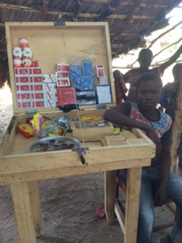
- The project has not included pastoralists in their beneficiary group, and did not work on conflict mitigation concerning the ongoing conflicts between pastoralists and farmers. In this way, the project in fact strengthened one party of the conflict (the farmers) which is not in line with Do No Harm (DNH) principles. While complicated, next rounds of CVR in Paoua and in other locations must include more efforts to bring these groups on board, especially in the dry season when they are close to the Paoua villages and tensions increase. Specific IGAs adapted to their modes of production can be initiated and especially in relation to outcome 2 of this project, more can be done to facilitate dialogue and conflict mediation between farmers and pastoralists.
1. Cigarette stand in Bambara
- While it can be applauded that this project really managed to apply context driven and locally led approaches, the downside is that giving all decision making to the LCs in terms of selecting beneficiaries for IGAs has led to accusations of nepotism and fraud. The project did give some basic selection criteria, but the LCs were in charge which has exposed them too much, as they were given the impossible task to select only 10% of the people that completed CfW. This has, in the very last months of the project, challenged the credibility of the committees so carefully set-up by the project.

4. Conclusions & Recommendations

4.1 Conclusions
The evaluation team found that the project addressed the right issues and has proven relevant for the context of Paoua. This can be largely attributed due to a solid process of needs assessment and the participatory approach applied, combined with the strong presence and commitment of the IOM project leam and project manager.
The most important conclusion is that indeed the project has had a stabilising effect on the 10 targeted communities, with increased security, reduced violent incidents and perceived increase in peaceful coexistence. Less arms circulate in the communities and a large percentage of the armed people not eligible for DDR have reduced violent and illegal activities and started to engage in productive activities. People also express that due to this improved security they have restarted farming. Further, the roads repaired have a direct impact on mobility and related trade and commerce, which has led to an overall improvement of the economic situation of the community as a whole.
The rehabilitated, or created, social infrastructure has furthermore increased the living conditions of people, in an area where hardly any infrastructure or social services exist. The increase in production, trade and goods made available through the IGA kits, has increased the number of goods available in the villages, which further increases living conditions and increased cash-flow in most of the locations. The Infrastructure rehabilitation is done in collaboration with line-ministries, which caused some delays but shows good practise and attempts to optimise the sustainability and relevance of the investments in the long run.
The increase in peaceful coexistence is achieved at community level, through the establishment and constant support to the LCs and also due to the support of CASAL, the project’s partner of religious leaders. The LCs are impressive and inclusive mechanism that give the impression to work well, with the exception of the LC in North Paoua town. Ethnic representation in LCs is confirmed. Further consolidation of the LCs is however required, including to activate them to go beyond inter-community conflict mediation and resolution, to organise larger intra-community dialogue events.
The highly participatory nature of the project, applying real bottom-up approaches, can be applauded. Extensive capacity development of LCs, facilitators and engineers was done through the highly active team and project manager, who ensured extensive field presence. The downside is that accusations of nepotism and fraud of the LCs were observed, especially when they were given the impossible task to select only 10% of the target group that completed CfW for IGAs. The evaluation found strong actions of the project to monitor and avoid further cases.

The Theory of Change of the project was the following:
“If the targeted elements of armed groups non-eligible for the national DDR Programme participate in economic reinsertion activities-including cash for work and skills training, among others;
and if local mechanisms for dialogue and conflict prevention are inclusive and function effectively;
and if local authorities succeed in the voluntary collection of weapons from elements of armed groups;
THEN security at the local level would be improved and violence reduced.”
The TOC is highly relevant and a very good start has been made to foster the above change, but consolidation phase is required.
It must be concluded that the theory of change for this project has proven relevant and that the foreseen change has largely been created by the project. In this, the project has created value for money. The main concerns are the sustainability of these results, which are challenged due to the short duration of the project, the increase in external threats and the lack of an explicit exit strategy. Furthermore, the upcoming DDR programme is likely to create major tensions and if the CVR project is closed by then, this is likely to create major frustrations, revolt and possibly even armed violence by the excluded armed youth.
As in every intervention, there are issues that can improve and should possibly be done differently in future interventions. Some of the points below were already highlighted by the mid-term evaluation (see Annex A), while other new issues have come up:

- The withdrawal of the MINUSCA DDR staff from the project site has had a negative effect and the CVR project is likely to close before the start of the DDR project. This is likely to create major problems, also as people are not aware on the entry criteria of DDR. CVR and DDR need to go hand in hand and should ideally be implemented at the same point in time. Some activities can then be organised to merge the CVR and DDR participants in order to reduce divides and tensions;
- Of great concern is the sustainability of the stability created, especially related to the group of estimated 600-800 armed elements that are left out of the process, and the few that were expelled due to inappropriate behaviours. Closing the project before stabilising this group puts the peacebuilding effects created by this project at risk;
- The inclusion of vulnerable people is good but should target non-armed youth without a source of livelihood or opportunities for education, to avoid the message, which was spread, to youth that they need to join an armed group to get assistance. The system of proxies should be avoided and youth with disabilities included, for administrative jobs in the CfW etc;
- Gender was mainly addressed in terms of numbers, while gender responsiveness should go beyond % of women included. A solid gender analyses is required to make CVR more gender responsive and indicators on gender responsiveness should be included. Gender in CVR needs to include issues around transforming violent masculinities, targeting the young men, and support young women with babies, with special measures, to become full beneficiaries;
- While a good start was made, the project reduced the attention to SALW management. Results from some locations (e.g. Pendé) show that this is a crucial element of the CVR interventions which require more support. No plans were identified on the future of the weapons storages and their contents, and they are likely to be used by non-eligible armed group leaders to put political pressure to the government to receive benefits;
- The number of IGAs was way too low and the IGA kits too few and too big for individual distribution. Distribution to small groups, preferably from the same family, would have been better as it would have increased the number. IGAs were not based on market studies and almost no vocational training took place, making the implementation of this component weaker than planned, while there were opportunities to implement this part of the project in a more solid manner. The IGAs activity also started to late in the project, whereby follow-up by the IGA facilitators, a good system set-up by the project, will be too short;
- The exclusion of children in the legal working age (14-18) from the assistance provided has no legal basis. From a protection point of view, it actually creates more risk not to include them in the project activities than to leave them out. What is required is child protection training to CVR implementers and adapted cycles of work, to not interfere with education. If not addressed and meaningfully engaged, this might be a future generation of combatants;
- No conflict mitigation took place on the pastoralists/agriculturists conflicts. Pastoralists were not included in this project, neither in the LCs nor as beneficiaries. This results in a negative performance in terms of DNH, as the project has strengthened one side of the conflict. This conflict is however crucial to work on in CVR interventions, as the team found one community where women do no longer farm due to presence, and fear of, pastoralist groups. Pastoralist groups can be included in the dry season with adapted CfW activities, related to their livelihoods and their leaders need to be involved in the peacebuilding and social reintegration activities;
- The M&E of this project has been weak, starting with the lack of baseline which seriously reduced the opportunity for IOM and MINUSCA to monitor change and to take corrective actions where required. It also compromises the evaluability of this project, which especially for pilot interventions is crucial. Several revisions of the results framework were done without any consultative processes, and without being discussed and approved by the Steering Committee. At the start of the evaluation there was confusion on what the last version of the results framework was. Information on the evaluation team on progress on targets came in very scattered, and is in some cases not in line with the IOM database on tracking beneficiaries;
- While the project is already very decentralised, in comparing to other projects, people from more isolated communities complain about the focus of attention to the centre only. Indeed, roads and infrastructure are built in the centres, and little to no presence of the project can be found in the surrounding villages, with the exception of a hand-full of people that received IGA kits;
- Overall, results seem higher in rural than in urban areas, and the CVR interventions in town, where government, police and gendarmery are present (although weak), might need to have an adapted approach. As also noted by the chief of office of MINISCA Paoua: “I think the project worked better in the village than in Paoua. Perhaps because they were more people who were members of the armed groups, and the motivation is stronger. It seems to me that in the south of Paoua town it has been better than in the north, given the profile of the beneficiaries. In the north, it is more vulnerable people, whereas in the south it is more armed elements”;
- The project has been too much diluted towards social welfare, which is explained by the complete lack of social services in Paoua, and the power of decision given to the LCs to prioritise people with greatest needs, instead of highest capacity to destabilise the communities;
- The sort duration, lack of national ownership, lack of an exit strategy, and the failure to work with and build capacities of the local police and gendarmery, which should be part of CVR, is challenging the sustainability of the results;
- The partnership between IOM and MINUSCA DDR has proven effective on the ground, especially when the MINUSCA DDR staff member was on the ground (later removed). At national level the partnership was effective, at the technical level but less in terms of creating national ownership at Bangui level, the task of MINUSCA DDR. The partnership with MINUSCA Force was highly effective, but with MINUSCA Civil Affairs there are missed opportunities to better work together and have multiplying effects. Partnerships with OCHA, WFP and DRC were established through regular meetings but at operational level no partnerships were found. There is no partnership between the MINUSCA DDR section and the MINUSCA Youth at Risk programme, while there are many opportunities to cross-learn and collaborate, especially on the savings and IGA component.
In short, the SWOT analysis below summarises the conclusions of this evaluation.
Strengths  Highly participatory  Quality Infrastructure  Strong local ownership  Arms management and storage  Partnership CASAL, radio Pendé  Boosted local economies  Good IGA kits  Stabilisation and increased security  Ethnic representation in LCs  Capacity development of LCs  Active team, manager and very good field presence | Weakness  Too short for sustainability  Weak national ownership created  Not all combatants included  Vulnerable instead of youth spread the message to arm  Too few IGAs, too much individual  14-18 years excluded  No skills training  No conflict mitigation pastoralists/agriculturists  No market studies  Lack of gender responsiveness (beyond numbers)  Link to police/gendarmery  No baseline, undocumented results framework revisions
Opportunities  Extension of project to consolidate results  Increase number of IGAs based on market needs  More rounds of CfW for excluded combatants  CfW away from centres  IGAs to all female combatants  Include more focus on extension of state authority | Threats  Unarmed excluded youth  CVR without DDR (eligibility and info)  Closure before DDR  CfW-only participants might go back to illegal activities without IGA  Locally led versus favouritism/fraud  Money leaving communities if market not created

4.2 Recommendations
In addition to the points raised above, the evaluation team would like to make the following recommendations for the current project and future CVR interventions:
Overall recommendations
Project extension of minimum one year with:
- Ensure enrolment in CVR for those that were left out and for those MPC and RJ members that will not be on the DDR list, this support of a MINISCA DDR staff member;
- Consolidate dialogue and mediation capacities of LCs and CASAL, and further support Radio Ohuam Pendé as budgeted for;
- Support LCs to finalise all dual-key arms storage structures in the 10 communities;
- Build meeting rooms (with group-IGA restaurant) for LCs;
- Initiate a new round of CfW on roads away from centres and ensure combatants included from isolated villages;
- Use last round of cash for work on building local markets, with building skills transmission. This could be done by minors in working age – with training of facilitators on child protection. As part of this, set-up group masonry IGAs. Use engineers of the project as trainers;
- Work on exit strategy, e.g. transmission of tools and boots, setting up work road rehabilitation cooperatives and advertise them to MINUSCA civil affairs, WFP, NGOs and Local Government of Paoua for future contracting. Use project engineers for training them;
- Find a way to transform the incident tracking mechanism, and actions, to a local actor;
- Add more IGAs, only for combatants with IGA kits for minimum 2 persons, possibly of the same family, include all female combatants;
- Ensure diversification based on local markets, e.g. 1 telephone, 1 carpentry workplace, 1 tea-shop and 1 animal medicine shop everywhere;
- Carpentry training on the spot to produce tables, chairs etc. for IGAs and for schools. Setting- up carpentry workshop building for 4-5 beneficiaries together (individual businesses in one location);
- Now that IGAs are established, it is more likely that cash from a new round of cash for work stays in the local community;
- Where possible add 3 month courses skills training through APAP (in Paoua and some mobile) and by contracting local tradesmen.

Further, the team recommends extending the current project to the whole prefecture of Ohuam Pendé, where CVR is urgently needed. As highlighted by the WFP representative of Pauoa: “I think the project should be replicated in Bocaranga and Ngaouanadaye. These are two priority regions where youth are the most agitated. These activities could reduce violence in the area.” The same point is stressed by MINUSCA chief of office: “We manage the prefecture of Bocaranga, so in the second phase, we must put them in this project to help them lay down their weapons.” It would be a shame to close down the project and much more cost-effective to extend the project, from its current base, to the other hot-spots in Ohuam Pendé.

Recommendations for future CVR interventions
- Ensure a massive CVR in all DDR locations to reduce tensions, ensure 100% separation of target groups, transparency, and major public information on this. However, it is recommended to implement a number of joint activities for CVR and DDR participants, such as social activities, but also IGAs support such as vocational and business training. Now that the DDR strategy has been drafted there is urgent need to draft a CVR strategy outlining how CVR will complement DDR;
- Stop having vulnerable old people, but local unemployed youth instead to stay within the objectives of CVR;
- Include UNICEF partnership to ensure also those under 18 are also stabilised;
- Establish youth centres with solar and internet through CVR/DDR funding in order to again stay more in the objectives of CVR to stabilise the (armed) youth;
- Ensure economic reinsertion becomes reintegration, based on local market research and needs of the community (instead of beneficiaries’ preferences), and include skills training/transmission and longer-term follow-up;
- Establish markets through cash for work so that more money stays in local communities. Start IGAs immediately after the first cycle of CfW so that the salaries can be spend on these local businesses;
- Improve gender responsiveness by including special support to female beneficiaries with babies and by working more explicitly on transforming violent masculinities;
- Continue with creation and capacity development of LCs and organisations like CASAL. The DDR programme is advised to work through the same committees where created;
- Invest in local radio stations and use them for the public information component;
- Create local DDR/CVR steering committees (sous-prefecture level) with representation of the Local Governments, which will also become a platform for cross-learning between LCs and will facilitate the information flow and involvement of the national government representatives in the national steering committee;
- Add more capacity development activities and facilitation for state actors (national and sous-prefecture) – contribute more explicitly to the extension of state authority and national ownership;
- Add literacy courses and possibly scholarships (instead of IGAs for those who prefer education);
- Add children from 14 and above, but be careful with hazardous work. Establish UNICEF partnership to train CVR implementers in relevant child protection issues;
- Do not exclude beneficiaries that are misbehaving, as it is exactly the task of a CVR project to stabilise them which should not stop if it does not succeed immediately;
- Ensure that the beneficiaries’ database can effectively track progress. The current database is not fit for purpose. Ideally use the same database as MINUSCA for DDR so that data sets can be merged and easy verification of double dipping (CVR and DDR) can easily be detected.

References
Accord sur les principes de désarmement, démobilisation, réintégration et rapatriement (DDRR) (et intégration dans les corps en uniforme de l’état centrafricain entre le gouvernement de transition et les groupes armés) – May 2015.
Community Violence in the Central African Republic, Mid-term Evaluation Report, August 2016.
Davies, R. and Jess Dart. (April 2005). “The ‘Most significant change’ (MSC) Technique”.
IOM, “Formulaire d’évaluation du projet RVC’’. Perception survey database. 25th April 2017.
IOM, “Incident tracking system” database. 6th June 2017.
IOM, Rapport des activités au 1er Mars 2017.
IOM, RVC - Rapport Hebdomadaire du 02 au 08 Mars 2017.
IOM, RVC - Rapport Hebdomadaire du 09 au 15 Mars 2017.
IOM, RVC - Rapport Hebdomadaire du 16 au 22 Mars 2017.
IOM, RVC - Rapport Hebdomadaire du 23 au 29 Mars 2017.
IOM, RVC - Rapport Hebdomadaire du 30 Mars au 05 Avril 2017.
IOM, RVC - Rapport Hebdomadaire du 06 au 12 Avril 2017.
IOM, Results Framework, updated April 2017.
IOM, Activities matrix, received 13 April 2017.
IOM, Terms of References: Consultancy for the Final Evaluation of the Community Violence Reduction Pilot Project – Paoua (CAR) 2017
MINUSCA & High Commission for DDR & SSR, 23 February 2016 Minute du Comité de Pilotage du Projet (CPP) RVC-RCA.
MINUSCA & High Commission for DDR & SSR, 20 April 2016 Minute du Comité de Pilotage du Projet (CPP) RVC-RCA.
MINUSCA & High Commission for DDR & SSR, 20 July 2016 Minute du Comité de Pilotage du Projet (CPP) RVC-RCA.
MINUSCA & High Commission for DDR & SSR, 27 January 2017 Minute du Comité de Pilotage du Projet (CPP) RVC-RCA.
OECD-DAC Network on Gender Equality. (December 2016). “Definition and minimum recommended criteria for the DAC gender equality policy maker”
Transition International, Inception report: Final evaluation of the Community Violence Reduction Pilot Project in Paoua (CAR). April 2017.
Pacte républicain pour la paix, la réconciliation et la reconstruction – Bangui May 2015.
Peacebuilding Fund (PBF), Annual Project Progress Report, Community Violence Reduction in the Central African Republic. 2016. Submitted by Mario Tavolaj.
Peacebuilding Fund (PBF), Mission to CAR report, 6 – 13 December 2016
United Nations Peacebuilding Support Office (PBSO)/Peacebuilding Fund (PBF), Project document for CVR, 11 November 2015.
UN Security Council resolution 2149 (10 April 2014)
UN Security Council resolution 2217 (28 April 2015)
UNICEF, Central African Republic: Statistics. 2013. Accessed on May 15, https://www.unicef.org/infobycountry/car_statistics.html#121
United Nations Letter from Oscar Fernandez-Taranco, Assistant Secretary-General, to the Special Representative of the Secretary General of MINUSCA.

Annex A. Comparative analysis of main findings mid-term and end of project evaluation
Mid-term evaluation report | End-evaluation
The CVR project is fully operational and is overall on-track to achieve its main goals. | Confirmed
The security situation in the project area is still unstable, but has improved over the last 6 months, and in some aspects markedly so (as confirmed by the CVR Incident Tracking system). | Confirmed, new security threats led to closure of some operations, due to presence of MPC and RJ
Local authorities, MINUSCA officers, UN and NGO partners, and programme beneficiaries credit the CVR programme with having contributed to the improved security situation through its engagement with members of local armed groups and criminal gangs. | Confirmed
Authorities in Paoua indicated that the project is helping to “mentally and morally disarm” the members of the armed elements/gangs. | Confirmed
Support of local authorities-led initiatives of arms control approach is well understood and seems an optimal approach to enhance security in the communities while the contextual situation remains difficult. | Confirmed and applauded
Roadblocks have almost completely been dismantled in the programme area, under the positive influence of MINUSCA patrols, and facilitated by the CVR requirement for participants to renounce violence and illegal activities. | Confirmed
Local sourcing of materials for infrastructure rehabilitation, through opening of quarries for sand, gravel, rock and laterite extraction, is a very important positive approach of the programme. | Confirmed and applauded. More can be done in terms of carpentry, masonry etc.
The LC leaders approached the CVR management to request support in mediation and the reconciliation process. This clearly demonstrates the increasing level of trust with the programme and the relevance of the community sensitization activities particularly regarding the reconciliation and mediation support components of CVR.  Local authorities, committee members and programme beneficiaries almost unanimously indicated that the main problem of the CVR currently is the low level of benefits: number of days of work per beneficiary (24) is too low to allow for savings, and does not assure sufficient time of engagement with the programme to stabilize the armed group/gang members. | Confirmed  Confirmed and no actions taken to ratify this problem
Beneficiaries requested food support, especially outside Paoua city itself, indicating that this would be an important complement to the daily fee, allowing for a higher degree of savings (and investment) from their fees. | Confirmed, IOM tried to get food through WFP, but according to WFP there is not enough food and transport challenges to provide. WFP is open to discuss how to make it happen.
Initial reaction to the CVR by local authorities included concerns that the programme was “bringing bandits into the towns” and was “supporting the thieves”, but this view has clearly shifted as the local authorities who were attributed these critiques were the ones that now confirm its’ usefulness and importance. | Confirmed
The differences in benefits between CVR and other (apparently) similar projects (Londo, Pre-DDR, other THIMO) create frustration with the project both among beneficiaries and local authorities. | Not observed, no other projects were operational
A recurrent issue in the region, especially among the leaders of armed elements/gangs, is the immediate and strong reaction that is generated by any indication of differential treatment between groups (Christians/Muslims, Tale/ Kaba, Bangui Forum signatory/non-signatory). | Upcoming DDR programme is discussed and likely to create revolt due to exclusion of e.g. Patriots. The leadership is informed that they will not be part of DDR but armed elements are not.
Recent high profile arrests of armed group leaders have created both negative and positive responses: i) some leaders have threatened CVR staff, indicating that they hold IOM responsible for having convinced them to “come out in the open”, and thereby facilitating their arrest; ii) on the other hand, these arrests seem to have incentivized a higher degree of collaboration of some other leaders with the police, judicial authorities and MINUSCA. | Currently relations are good, improved
The Community Infrastructure projects have been identified and prioritized by all 10 LCs and the technical proposals developed and sent to the respective line ministries since May. However, until now none of the ministries have responded, and the lack of timely approval of the projects threatens the schedule of project implementation. | Solved and applauded that this delay was allowed for to ensure line-ministries ownership over the infrastructure.
Optimal implementation of CVR would require a higher level of information exchange, consultation and coordination between CVR/MINUSCA and the Paoua-level authorities, particularly with security and judicial officials. This would allow for the development of a coordinated strategy of engagement with the armed group leaders in the area. | Confirmed but no action observed and a weak part of the project, related to lack of exit strategy
The roll-out of a Pre-DDR activity in northern Paoua presents a high potential level of risk, of which MINUSCA DDR is well aware. | Not agreed, the remaining presence of Pre-DDR would have leverage the current security threats of MPC and RJ, and would have increased information about eligibility.
CVR funding should, in any case, be strengthened ASAP, either by additional direct funding by PBSO and/or other donors, or through complementary actions by potential partners like WFP and possibly UNDP. The focus of this additional support should go to increasing the THIMO benefits –mainly in order to allow the programme to establish at least 2-3 cycles of work for each beneficiary, and so keep them in the programme for a much longer period-, as well as expanding the number of potential beneficiaries of the IGA packages. | Agreed but no action taken by the project; Pending request for additional funding from PBSO, MINUSCA DDR, and additional funding provided by CSO.
Though operationally challenging, it would also be interesting to consider the possibility of including some basic alphabetization and basic business start-up training within the current training package to THIMO participants, which could also serve to extend their period of engagement. Given the multiple constraints, it may be necessary to substitute some of the foreseen training for these activities, as well as extend the participation period. | No alphabetization started. Business training started. No skills training (except for few Bull training) started while providers exist, needs are high and interest is there.
As indicated, the roll-out of Pre-DDR activities in Paoua should be carried out in co-relation with the on-going CVR, assuring that armed group populations – many of which will be similar to those currently in the CVR programme-, receive the same benefits as the current CVR beneficiaries (either by replicating the current CVR modalities and benefits in the new CVR support, or by upgrading the support to the current CVR to provide benefits that are fully aligned with the new CVR-type intervention). | The DDR benefits need to be higher as otherwise there is no benefit to give in their weapon of war. However, the evaluation team suggest to do the IGAs part of DDR together with the CVR participants, as well as all the social components.
The CVR programme, designed as a pilot experience for a community-based socio-economic (re)insertion of armed elements/gangs’ members, local authority-led arms control and promotion of community reconciliation and peaceful co-existence, is beginning to deliver results that are strong indicators of a successful approach to this difficult and challenging task. An effort should now be made to develop an integrated Pre-DDR and CVR strategy to guide the future roll-out to the whole country. | Agree, now that the DDR strategy is in place the CVR strategy needs to be developed and provide clarity on the overlap and complementarity. The CVR strategy should include a clear DDR/CVR SOP.

Annex B. People contacted

Bangui
Last Name and first name | Organisation | Occupation | Contact | Age | Sex
UN – Bangui
TAVOLAJ Mario | IOM | Programme Manager IOM Paoua | mtavolaj@iom.int | M | 67
SCHAEFER Anne Kathrin | IOM | Chief of Mission IOM | aschaefer@iom.int | F | 34
TRAORE Amadou | IOM | Assistant Programme manager |  | M | 41
DANZIGER Richard | IOM | Regional director | rdanziger@oim.net | M
CASTRO Alejandro | IOM |  | acastro@iom.int | M
KUNAMA Natacha | PBSO | PBF coordinator Bangui | natacha.kunama@undp.org | F | 32
 | UNICEF | Chief Child Protection
 | UNICEF | Child protection officer
TAFANI Jean Marc | MINUSCA DDR | Chief DDR | tafani@un.org | M | 58
GEJROT Martin | MINUSCA DDR | DDR soutien aux opérations | gejrot@un.org | M | 30
KUMBRIC Jasminka | MINUSCA DDR | DDR officier des opérations | kumbric@un.org | F | 37
SINARINZI Mamert | MINUSCA |  |  | M
ADAREMI | MINUSCA Youth at risk |  |  | M
Government
BETINDJI Jean Pierre | Government | Chargé de mission en relation avec les groupes politico militaires | betindji@hotmail.com | M | 58
BETINDJI Sylvestre | Government | Ministère des Affaires Sociales
BANGUI Michel | Government | Ministère de l’Administration du Territoire
Colonel GOELEYEN Maurice | Government | Représentant du Ministère de l’Economie et de Plan

Paoua
27 Beneficiaries (19 combatants and 8 vulnerables, 20 M and 7 F)
10 Community members interviewed during focus group discussions (8 M and 23 F)
Last name and first name | Organisation |  | Occupation |  | Contact |  | Age | Sex
Government
MARZENE Celiac |  | Ministère de l’Agriculture |  | Directeur Générale du département agricole |  |  | M | 44
YANDOBA Camille |  | Autorité locale |  | Président du Tribunal |  |  | M | 43
ALI Amsami |  | Autorité locale |  | Adjoint au Maire |  |  | M | 48
LAIWEN Prospère |  | Autorité locale |  | Représentant du Commissaire |  |  | M | 37
YAGANI Benoit |  | Autorité locale |  | Représentant du Maire de Bilakaré |  |  | M | 42
HEREVATOU Médard |  | Autorité locale |  | Représentant du Maire de Gouzé |  |  | M | 40
NDINGA Luc Nicolas |  | Autorité locale |  | Sous-préfet intérimaire |  |  | M | 63
DJAINBET Brack |  | Autorité locale |  | Directeur de la Maison des Jeunes |  |  | M | 60
EREGANI Lambert |  | Autorité locale |  | Représentant du Chargé de Brigade |  |  | M | 45
YAVORO Clément |  | Autorité locale |  | Représentant du Maire de Taley |  |  | M | 38
Local leaders
 |  | Woman leader |  | Présidente du comité de cohésion sociale |  |  | F | 62
BETELOUM Fred Martial |  | Youth leader |  | Président de la jeunesse |  |  | M
GOLE Francis |  | Youth leader |  | Conseiller |  |  | M
DONGOMBE Maturin |  | Youth leader |  | Chef de Projet Oxfam |  |  | M | 42
WALYA Eric Anicet |  | Youth leader |  | Vice président |  |  | M
NDEI Alis |  | Youth leader |  | Protocole |  |  | M
TOUNDAM Passi Florentin |  | Youth leader |  | Secrétaire général |  |  | M
GUEDEMA Clarisse |  | Youth leader |  | Trésorière général |  |  | F
BONADO Bertrand |  | Youth leader |  |  |  |  | M
Saleh Moussa |  | Peul leader FNEC |  |  |  |  | M | 42
Local committee members
NDOMBALA Edwige |  | Comité Local |  |  |  |  | F | 38
MAKIABE Robert |  | Comité Local |  | President du Comité Local |  |  | M | 50
WOINDJE Gaston |  | Comité Local |  |  |  |  | M | 65
NDOUNDO Angele |  | Comité Local |  |  |  |  | F | 43
DILLA Rachelle |  | Comité Local |  |  |  |  | F | 52
MBAINABEUR Jean Paul |  | Comité Local |  |  |  |  | M | 50
NDOUNDO Sylvain |  | Comité Local |  |  |  |  | M | 39
Autres organisations
DENAMGANE Cherubin |  | WAR CHILD Paoua |  | Chef de Projet |  |  | M
TOUNDAML Miskine |  | APAP Paoua |  |  |  |  | M | 52
NDINDO Blaise |  | APAP Paoua |  |  |  |  | M | 30
NEAFIO Saint Samuel |  | APAP Paoua |  |  |  |  | M | 31
DOUMBAI Paul |  | APAP Paoua |  |  |  |  | M | 42
DABOU Benoit |  | APAP Paoua |  |  |  |  | M | 60
DOKOU Modeste |  | APAP Paoua |  |  |  |  | M | 34
NGUENDJI Raphael |  | CASAL |  |  |  |  | M | 52
TCHEBO Wafio |  | CASAL |  |  |  |  | M | 50
NOET Abdel |  | CASAL |  |  |  |  | M
DINGAMNAEL Zuiransky |  | Radio Pendé Paoua |  | Chef de la station
BERANGOTO Charlot |  | Radio Pendé Paoua |  | Journaliste |  |  | M
DATOLOUM Ernest |  | Radio Pendé Paoua |  | Journaliste |  |  | M
LOTARTINA Samuel |  | Radio Pendé Paoua |  | Journaliste animateur |  |  | M
PELAGIE |  | Radio Pendé Paoua |  | Présidente du Comité local de Paoua Sud
NYAMWANA Dismas |  | UNHCR |  | Chef de bureau HCR Paoua |  | nyamwana@unhcr.org | M
APAYAKA Severin Narcisse |  | PAM |  |  |  |  | M
MOUTOUBE Sammy Santos |  | DRC |  | Agent de terrain chargé de la protection |  |  | M
SARAMANDJI Edouard |  | OCHA |  | Coordonnateur |  |  | M
MUSOMBWA Dominique |  | OXFAM |  | Chef de projet |  |  | M | 42
UN – Paoua
MOUKONDI Aimé |  | MINUSCA Force |  | Commandant/Chef de force |  |  | M | 35-40
AMADOU Moctar Diallo |  | MINUSCA |  | Political Affairs Officer |  | Diallo100@un.org
ADDEH Alamine Simon |  | MINUSCA |  | Chef de bureau Paoua |  | Alamine@un.org
FERNANDEZ DELGAEB Emma |  | MINUSCA |  | Civil Affairs officer Paoua |  |  | F
SIODOT Estella |  | OIM |  | Assistante de Programme Protection |  |  | F | 37
SENGATHE Urbain |  | OIM |  | Chauffeur |  |  | M | 39
MBAIBEANG6GAM Patrice |  | OIM |  | Chauffeur |  |  | M | 44
AMADOU Tidjani |  | OIM |  | Chauffeur |  |  | M | 47
ADAMOU BABA |  | OIM |  | Chauffeur |  |  | M | 48
KOBADOBO Gilles Wilfried |  | OIM |  | Assistant de Terrain |  |  | M | 37
DONANG Dimitri J.B. |  | OIM |  | Assistant de bureau |  |  | M | 31
WILIFIO Modeste |  | OIM |  | Chauffeur |  |  | M | 34
BAYOUAN Fernand |  | OIM |  | Chauffeur |  |  | M | 40
GOMOBOU Brice |  | OIM |  | Ingenieur |  |  | M | 35
BOMAL-GONDJE Esaie |  | OIM |  | Assistant Protection |  |  | M | 42
LAMADDI |  | OIM |  | Assistant |  |  | M | 39
NGANA Prince |  | OIM |  | RT |  |  | M | 35
LAKOE Cedric |  | OIM |  | RT |  |  | M | 29
KOTTO Synthia |  | OIM |  | Assistante Programme |  |  | F | 30
SALBAYE-GON Denis Marcel |  | OIM |  | Assistant Programme Protection |  |  | M | 30
TIRO Jean Gael |  | OIM |  | Assistant aux operation |  |  | M | 37
LIMO Miguel Love |  | OIM |  | Chargé des operations |  |  | M | 46
DJIKOLOUM Lazare |  | OIM |  | Assistant AGR |  |  | M | 26
GAWAKA Privat Cyrille |  | OIM |  | Assistant Administratif |  |  | M | 36
OUENEMBI Geneve |  | OIM |  | Assistant data base |  |  | M | 28
BERO Teddy Hector |  | OIM |  | Assistant THIMO |  |  | M | 27
MANGA KOKONDJI Marien |  | OIM |  | Chauffeur |  |  | M | 28
DJIM AREM Jean Christophe |  | OIM |  | Facilitateur THIMO |  |  | M | 38
BOMBAIDJE Luther |  | OIM |  | Facilitateur AGR |  |  | M | 54
BERETO NOUDJOUKEM Evrard |  | OIM |  | Facilitateur AGR |  |  | M | 25

Pende
27 Beneficiaries (24 combatants and 3 vulnerables, 21 M and 6 F)
19 Community members interviewed during focus group discussion (12 F and 7 M)
Last name and first name | Organisation | Occupation | Contact | Sex | Age
UN – Pendé
KOETANTOU Dieu-Donné | OIM | Faciliateur |  | M | 29
DOLIA Judes | OIM | Facilitateur |  | M | 41
KAMBA Dieu-Donné Isidore | OIM | Facilitateur |  | M | 32
DIHORO Fidèle | OIM | Facilitateur |  | M | 44
Local committee members
GANGUE Joel | Comité Local | Rapporteur du Comité Local |  | M | 36
KABA Isidor | Comité Local |  |  | M | 31
BOLIA Judes | Comité Local | President du Comité Local |  | M | 40
NGAKA-GOTO Seraphin | Comité Local |  |  | M | 24
BIRAHOUL Helene | Comité Local | Vice president |  | F | 42
MAYAN Jeremie | Comité Local | Chargé de materiel |  | M | 48
DIHORO Fidel | Comité Local |  |  | M | 43
WOIN GUELBAI Stella | Comité Local |  |  | F | 27
GANDJO Bertille | Comité Local |  |  | F | 44
YIBATIA Dieu Béni | Comité Local | President Jeunesse |  | M | 29

Bambara
24 Beneficiaries (18 combatants and 6 vulnerables, 18 M and 6 F)
37 Community members interviewed during focus group discussions (23 F and 14 M)
Last name and first name | Organisation | Occupation | Contact | Sex | Age
UN – Bambara
BAHI Prospère | OIM | Facilitateur THIMO |  | M | 49
WELETIA Victorien | OIM | Facilitateur AGR |  | M | 42
Local committee members
NGANAHOUL Salomon | Comité local | President Comité Local |  | M | 24
SENEKPING Muspard | Comité local | Secrétaire du Comité Local |  | M | 31
WELETIA Victorien | Comité local | Animateur |  | M | 42
SEMBA Felix | Comité local | Conseiller |  | M | 40
TIRIMBAI Roger | Comité local |  |  | M | 39
HOULNAKA Samuel | Comité local | Vice Présidente Comité |  | M | 56
POUKONE Jean de Dieu | Comité local | Secrétaire G. Adjoint |  | M | 44
MBAIHINE Prospere | Comité local | Conseiller |  | M | 39
SERAWAI Dieu Merci | Comité local | Chargé de matériels Comité Local |  | M | 25
BARAHIMIA Désiré | Comité local |  |  | M | 33
Local leaders
KERENDE Christine | Leader Woman |  |  | F | 24

Poulao
24 Beneficiaries (18 combatants and 6 vulnerables, 21 M and 3 F)
17 Community members interviewed during focus groups discussions (11 F and 6 M)
Last name and first name | Organisation | Occupation | Contact | Sex | Age
UN – Poulao
MASSORANG Didier Sylver | OIM | Facilitateur AGR |  | M | 32
HEYA HOULZIA Pelerin | OIM | Facilitateur AGR |  | M | 27
GAGUIA Felix | OIM | Facilitateur CfW |  | M | 36
KELEYA Roger Blaise | OIM | Facilitateur CfW |  | M | 44
SENEPOU Elie | OIM | Facilitateur CfW |  | M | 41
Local committee members
NDINGKPING Clement | Comité Local | President du Comité Local |  | M | 63
NZAMIA Etienne | Comité Local | Membre de Comité Local |  | M | 45
GAGUIA Felix | Comité Local | Secretaire G. du Comité |  | M | 36
KELEYA Roger Blaise | Comité Local | Vice President |  | M | 44
KELEYA Albert | Comité Local | Relais Communautaire |  | M | 62
BISKILA Samuel | Comité Local |  |  | F | 37
LENGAMI Madeleine | Comité Local |  |  | F | 62
WONYANTOU Marcel | Comité Local |  |  | M | 45
KOEWA Modeste | Comité Local |  |  | M | 32
WELEBAI Rufin | Comité Local |  |  | M | 40
MINIMBA Odile | Comité Local |  |  | F | 57
NGANAHOUL Marcel | Comité Local |  |  | M | 52
KOROKAMI Jacques | Comité Local | Chef de village |  | M | 58
HOUHOTOU Mathieu | Comité Local | Chef de village |  | M | 61
SEMBA Boniface | Comité Local | Chef de village |  | M | 79
POUAMBONA Leopold | Comité Local | Chef de village |  | M | 54
NZOUHAI Edward | Comité local | Chef de village |  | M | 49

Gouzé
Last name and first name | Organisation | Occupation | Contact | Sex | Age
Local committee members
MBREMANDJI Boris | Comité Local | Président de la Jeunesse |  | M | 31
NGAMABIRE Phillipes | Comité Local | Chef de groupe |  | M | 68
KAMANDOKO Désiré | Comité Local | Enseignant |  | M | 40
YAWAME Thimoté | Comité Local |  |  | M | 39
NGAMABARE Aimé | Comité Local |  |  | M | 35
KETTE Valentin | Comité Local | Chef du Village |  | M | 39
HARI Amadou | Comité Local | Commerçant |  | M | 40
MBREMANDJI Justin | Comité Local |  |  | M | 37
MBREMANDJI Félix | Comité Local | Catéchiste |  | M | 35
HOUHIMIGAOU Nicaise | Comité Local | Pasteur |  | M | 32
KEREGUEROM Albert | Comité Local |  |  | M | 55
BISSI Suzanne | Comité Local |  |  | F | 38
POMBINDORI Gisèle | Comité Local |  |  | F | 30
HOULTOMZOULE Patrice | Comité Local | Chef du Chef |  | M | 43
WAYANGA Jean | Comité Local | Adjoint Maire |  | M | 45
YORO François | Comité Local | Secrétaire du Maire |  | M | 35
KEREGUELE Félix | Comité Local | Président des Orphelins |  | M | 22

Paoua Sud
13 Community members interviewed during focus group discussions (13 M)
Last name and first name | Organisation | Occupation | Contact | Sex | Age
Local committee members
ELIEN Pélagie | Comité local | Présidente du comité locale |  | F | 39
BANIAN Isodore | Comité local |  |  | M | 48
GRABANDAI Clotilde | Comité local |  |  | F | 56

Annex C. Tools
The table below summarises the tools used in this evaluation.
Method | Type of respondent/sources
Most Significant Change Stories | All respondents
Focus groups | Only for indirect beneficiaries
Key informants interview, 6 tools | Local committees, Government staff, Project staff (IOM and MINUSCA DDR), Donor, Other organizations, Local leaders, Police/Gendarmery
Beneficiaries survey | Direct beneficiaries
Value for money | Review of financial documentation
Observation | Database, Cash for work, IGAs operational, distribution of IGAs etc.

Changement le plus significatif
Sexe : Age: Occupation: Lieu:

⃝ Government ⃝ Local leader ⃝ Beneficiary
⃝ Community Member ⃝ OIM ⃝ NGO ⃝ UN

Quel est le changement le plus significatif apporté par le projet?
(What is the most significant change this project created?)

Quelle est la plus grande déception de ce projet?
(What is the biggest disappointment of this project for you?)

Focus group – indirect beneficiaries
Sexe: Âge: Occupation: Lieu:

Relevance
- a) Que savez-vous du projet de réduction de la violence communautaire (RVC) de IOM?
(What do you know about the CVR project of IOM)
b) Quelle est votre avis sur le projet?
(What is your opinion about the project?)
Functioning of the project
- Avez-vous demandé(e) à faire partie des activités t du Timo du projet CVR de IOM? (compter les réponses)
(Have you applied to be part of the activities of the CVR project?) (count responses)
Veuillez expliquer.
- a) Est-ce que vous êtes d’accord avec le choix des projets d’infrastructures?
(Are the choices of the infrastructure project well done?)
b) Qui sélectionne les projets d’infrastructure?
(Who selected the infrastructure projects?)

Peacebuilding
- a) Est-ce que des séances de dialogue ont été organisé par le projet? (compter les réponses)
(Did the project organise any dialogue sessions) (count responses)
b) Si oui, ont-elles été utiles?
(if yes, was this helpful)
c) si oui, est-ce que les séances de dialogue ont été inclusives en termes de groupes ethniques, d’hommes, femmes et jeunes?
(if yes, were these dialogue sessions inclusive in terms of different ethnic groups, men/ women, and young people?)
- a) Est-ce que le comité local de ce projet a résolu des conflits qui auraient conduit autrement à de la violence? Comment ?
(Has the local committee of this project resolved conflicts that would have otherwise led to violence?)
b) Est-ce que le projet renforce les relations entre les communautés et entre les groupes dans la communauté? Comment ?
(Did the project improve relations btw different communities and groups? How ?)

Disarmament
- Est-ce que le projet de IOM a contribué à la sensibilisation sur les risques liés aux armes légères et de petits calibres? (compter les réponses). Comment ?
(Has this project contributed to awareness on small arms and light weapons risks?)
Impact
- a) Est-ce que votre situation économique s’est améliorée grâce au projet? (compter les réponses)
(Has your economic situation improved by the project?) (count responses)
b) Est-ce que la situation économique de la communauté dans son ensemble s’est améliorée grâce au projet? (compter les réponses). Veuillez expliquer.
(Has the economic situation of the community as a whole improved?) (count responses) Please explain
- Le projet vise à assurer la réinsertion économique des personnes armées non éligible pour le programme national de DDR. Est-ce que le projet a réussi cela?
(The project aims to ensure economic reinsertion of armed people that are not eligible to DDR, did the project succeed in this?)
- Est -ce que les infrastructures de la communauté ont été améliorées? (compter les réponses).
(Do you think the local community infrastructure has improved?)
- Est-ce que vous vous sentez plus en sécurité maintenant, qu’il y a 2 ans ? (compter les réponses)
(Do you feel more safe now than two years ago ?)
- a) Est-ce que la communauté est plus pacifique maintenant, qu’il y a deux ans?
(Is the community more peaceful now than two years ago?)
b) Quelle a été la contribution du projet à cela?
(What was the contribution the CVR project made to this
- Est-ce que le projet a créé des effets durables? Veuillez expliquer.
(Do you feel this project has created any lasting results?)
- Est-ce que vous connaissez le comité local de ce projet? Qui sont les membre?
(Do you know the local committee created by this project? Who are in there?

Beneficiaries

Sex: Age: Occupation: Location:

Relevance

- Que savez-vous du projet de réduction de la violence communautaire (RVC) ?
(What do you know about the CVR project ?)
- a) Quels sont les critères d’éligibilité pour faire partie du projet de RVC ?
(What are the eligibility criteria for being part of the CVR project?)
b) Quelle est votre avis sur les critères de sélection du projet?
(What is your opinion about the selection criteria of the project?)
- Très bon
- Bon
- Mauvais
- Très mauvais
- Aucune
Veuillez expliquer.
c) Quels sont les critères d’éligibilité du programme national de DDR?
(What are the eligibility criteria for the national DDR programme?)
d) Êtes-vous éligible au programme national de DDR?
(Are you eligible to the national DDR programme?)
- Oui
- Non
Pourquoi/pourquoi pas?
Cash for work activities
- Avez-vous participé aux activités CFW du projet?
(Have you participated in the CfW activities?)
- Oui
- Non
Si oui, pendant combien de temps avez-vous travaillé?
Considérez-vous que la période a été suffisante?
(if yes, how long? was this long enough?)
Si non, pourquoi pas?
(if no, why not?)
- Avez-vous réussi à épargner à partir des salaires reçus?
(Have you managed to save money from the salaries received?)
- Oui
- Non
Si non, pourquoi pas?

Si oui, était-ce suffisant pour débuter des activités génératrices de revenus?
(If yes, was this enough to start other income generating activities?)
- Oui
- Non
Si non, pourquoi pas?
(If no, why not?)
Si oui, qu’est-ce que vous avez fait ?
(if yes what have you done ?)
- a) Avez-vous reçu de la nourriture?
(Did you receive any food?)
- Oui
- Non
b) Auriez-vous souhaité(e) recevoir un peu moins d’argent en échange de nourriture?
(Would you have appreciated a little less money and to get (more) food?)
- Oui
- Non
- Ne sait pas
Veuillez expliquer.
- Est-ce que vous êtes d’accord avec le choix ces projets infrastructure?
(Are the choices of the infrastructure project well done?)
- Oui
- Non
Veuillez expliquer.
Skills training & business start up

- a) Avez-vous bénéficié d’une formation professionnelle?
(Did you receive skills training?)
- Oui
- Non
Veuillez expliquer
b) Est-ce que vous êtes bénéficiaire des AGR?
(Are you a beneficiary from IGA ?)
- Oui
- Non
c)Est-ce que vous êtes content de votre kit?
(Are you satisfied with your kit?)
- Oui
- Non
Veuillez expliquer
- Avez-vous bénéficié d’une des assistances suivantes :
(Did you receive any other support?)
Une formation à la gestion de votre AGR
- Oui
- Non
Si oui, la formation a-t-elle été utile?
(In case you ticked the box, was the training helpful?)
- Oui
- Non
- Ne sait pas
Veuillez expliquer.
- a. Gagnez-vous suffisamment d’argent pour subvenir à vos besoins?
(Are you making enough money to live on?)
- Oui
- Non
b. Est-ce dû au projet?
(Is this due to the project?)
- Oui
- Non
Peace building
- a) Avez-vous participé à l’une des activités suivantes organisée par le projet:
(Have you been part of any of the following events or sessions organised by the project)
activités sociales, sportives ou culturelles
(social/cultural/sports activities)
- Oui
- Non
séance d’éducation civique
(civic education activities)
- Oui
- Non
séance sur la coexistence pacifique
(peaceful coexistence activities)
- Oui
- Non

Si oui: a) A combien d’activités avez-vous participé?
(How many events did you participate in?)

b) Quelle est votre avis sur les activités organisées?
(What is your opinion about this event?)
- Avez-vous entendu à la radio, la campagne de sensibilisation sur la violence basée sur le genre?
(Have you heard about the radio programme on the prevention of gender based violence?)
- Oui
- Non
- Ne sait pas
Si oui, qu’en pensez-vous?
(if so, what is your opinion about the programme?)
- a) Avez-vous participé à l’une des séances de dialogue organisée par le projet?
(Have you been part of any dialogue session organized by the project?)
- Oui
- Non
- Ne sait pas
Si non, pourquoi pas?
Si oui:
a) A combien de séances de dialogue avez-vous participé?
How many dialogue sessions did you attend?
b) Quel(s) était le sujet des séances de dialogue?
What was/were the topic(s) of the dialogue session?
c) Quel est votre avis sur les séances de dialogue?
What is your opinion about the dialogue session?
d) Est ce que les séances de dialogue étaient inclusives en termes:
(Were these dialogue sessions inclusive in terms of?)
- Groupes ethniques
- Hommes
- Femmes
- Jeunes
- Est-ce que le nombre d’incidents violents a diminué au cours des deux dernières années à Paoua?
(Have the number of violent incidents decreased over the past two years?)
- Oui
- Non
- Ne sait pas
Si oui, est-ce que la réduction du nombre d’incidents violents est dû au projet?
(If so, do you think this is due to the project?)
Si non, pourquoi pensez-vous que le nombre d’incidents violents a diminué?
(if not, why do you think violence was not reduced?)
Disarmament
- Avez-vous remis une arme?
(Did you hand over a weapon?)
- Oui
- Non
Veuillez expliquer.
- Connaissez-vous quelqu’un qui remit une arme?
(Do you know anybody who handed over a weapon?)
- Oui
- Non
- Avez-vous vu des activités de sensibilisation sur les risques liés aux armes?
(Have you seen any events (sensitization) on risks related to weapons?)
- Oui
- Non
- Ne sait pas
Functioning of the local committee
- Comment évalueriez-vous le travail réalisé par le comité local de ce projet?
(Do you feel the local committee, who has been managing this project, has done a good job?)
- Très bon
- Bon
- Mauvais
- Très mauvais
- Aucun avis
Veuillez expliquer.
- Est-ce que les membres du comité local sont inclusif en termes de:
(Do you feel the membership of the local committee is inclusive in terms of)
- Femmes
- Hommes
- Personnes handicapées
- Groupes ethniques
- Jeunes
Impact
- a) Est-ce que votre situation économique s’est améliorée grâce au projet?
(Has your economic situation improved by the project?)
b) Est-ce que la situation économique de la communauté dans son ensemble s’est améliorée grâce au projet?
(Has the economic situation of the community as a whole improved?)
Veuillez expliquer.
- Est-ce que les infrastructures de la communauté ont été améliorées?
(Do you think the local community infrastructure has improved?)
- Oui
- Non
- Ne sait pas
Veuillez expliquer.
- Est-ce que vos conditions de vie se sont améliorées grâce au projet?
(Have your living conditions improved due to the project?)
- Oui
- Non
- Ne sait pas
Veuillez expliquer
- Est-ce que vous vous sentez plus en sécurité maintenant qu’il y a 2 ans ?
(Do you feel more safe than 2 years ago ?)
- Oui
- Non
- Ne sait pas
Si oui pourquoi, si non pourquoi pas
- a) Est-ce que la communauté est plus pacifique maintenant, qu’il y a deux ans?
(Is the community more peaceful now than two years ago?)

b) Quelle a été la contribution du projet à cela?
(What was the contribution the CVR project made to this?)
- Est-ce que le projet a eu le même impact sur les hommes et sur les femmes?
(Do you feel this project has had the same impact on men and women?)
- Oui
- Non
- Ne sait pas
Veuillez expliquer.
- Est-ce que le projet a créé des effets durables?
(Do you feel this project has created any lasting results?)
- Oui
- Non
- Ne sait pas
Veuillez expliquer.

3A. KII or FGD Local Government, Local Leaders, Local Committees, Police/gendarmery etc.
sex: age: occupation: location:
Relevance
- a) Que savez-vous du projet de réduction de la violence communautaire (RVC)?
(What do you know about the CVR project ?)
b) Quelle est l’objectif du projet de RVC ?
(What is the goal of the CVR project ?)
- a) Quels sont les critères d’éligibilité pour faire partie du projet de RVC?
(What are the eligibility criteria for being part of the CVR project?)
b) Quelle est votre avis sur les critères de sélection du projet?
(What is your opinion about these selection criteria of the project?)
- Très bon
- Bon
- Mauvais
- Très mauvais
- Aucune
Veuillez expliquer.
c) Quels sont les critères d’éligibilité du programme national de DDR.
(What are the eligibility criteria for the national DDR programme?)
- Est-ce que l’approche du projet est pertinente pour le contexte de Paoua ?
Is the project approach relevant for the context of Paoua?
- Oui
- Non
- Ne sait pas
Veuillez expliquer.

- Faites-vous parti du comité local?
(Are you part of any local committee?)
- Oui
- Non
Si non, pourquoi pas?
Si oui, qui vous a sélectionné?
Cash for work activities
- Est-ce que les bénéficiaires du cash for work ont été capables d’épargner à partir des salaires reçus?
(Have beneficiaries of the cash for work activities managed to save money from the salary received?)
- Oui
- Non
- Ne sait pas
Si oui, était-ce suffisant pour débuter des activités génératrices de revenus?
(If yes, was this enough to start other income generating activities?)
Si non pourquoi pas?
- Combien d’infrastructures ont été construites ou rénovés dans votre communauté?
(How many CfW projects were implemented in your community?)
- a) Qui sélectionne les projets d’infrastructures?
(Who selected the infrastructure projects?)
b) Sous la supervision de quelle entité ?
(Under supervision of which entity?)
c) Quelles sont les raisons du retard des projets d’infrastructures?
(What are the reasons for the delay of the infrastructure projects?)
- Qui sera en charge de la maintenance des infrastructures à la fin du projet?
(Who will maintain the infrastructure after the closure of the project?)
- Est-ce que vous pensez que les activités de CFW ont empêché les bénéficiaires de revenir à des activités illégales?
(Do you think CFW activities prevented beneficiaries to return to illegal activities)
Skills training
- a) Est-ce que des formations professionnelles ont été organisés?
(Did skills training take place?)
- Oui
- Non
- Ne sait pas
Veuillez expliquer.
b) Est ce que les nouveaux AGR seront durables?
(Do you think the new businesses will be sustainable?)
- Oui
- Non
- Ne sait pas
Veuillez expliquer.
c) Si non, selon vous, que doit-on faire pour assurer le mainitien et le développement des AGR?
(if no, what should be done to ensure they will stay and grow)
Peacebuilding
- a) Est-ce que des séances de dialogue ont été organisé par le projet?
(Did the project organise any dialogue sessions?)
b) si oui, ont-elles été utiles?
(if yes, was this helpful?)
- si oui, est-ce que les séances de dialogue ont été inclusives en termes de:
(if yes, were these dialogue sessions inclusive in terms of)
- groupes ethniques
- hommes
- femmes
- jeunes
- Est-ce que le nombre d’incidents violents a diminué au cours des deux dernières années?
(Have the number of violent incidents decreased over the past two years ?)
- Oui
- Non
- Ne sait pas
Si oui, est ce que la réduction du nombre d’incidents violents est due au projet?
(If so, do you think this is due to the project?)
Si non, pourquoi pensez-vous que le nombre d’incidents violents a diminué?
(if not, why do you think violence was not reduced?)
- a) Savez-vous comment le projet enregistre les incidents violents ?
(Do you know how the project keeps records of violent incidents?)
- Oui
- Non
- Ne sait pas
b) Quel est votre avis sur le système de suivi des incidents du projet de réduction de la violence communautaire?
(What is your opinion of the CVR incident tracking system?)
- Est-ce que le projet collabore avec:
(Is the project collaborating with:)
- la police
- la gendarmerie
- UNPOL
Veuillez expliquer.

- Est-ce que le comité local de ce projet a résolu des conflits qui auraient conduit autrement à de la violence?
(Has the local committee of this project resolved conflicts that would have otherwise led to violence?)
- Oui
- Non
- Ne sait pas
Si oui, pouvez-vous citer un exemple?
(if so, can you please give an example?)
Disarmament
- Est-ce que le projet a contribué à la sensibilisation sur les risques liés aux armes légères et de petits calibres ?
(Has this project contributed to awareness on small arms and light weapons risks?)
- Oui
- Non
- Ne sait pas
Veuillez expliquer
- a) Est-ce que des désarmements ou la gestion d’armes ont été réalisés par le projet?
(Was any disarmament or arms management done by this project?)
- Oui
- Non
- Ne sait pas
Si oui, comment cela s’est-il déroulé?
Si non, pourquoi pas?
b) Si une personne armée remet une arme aux autorités locales dans le cadre du programme de RVC, est-il non-éligible au programme de DDR ?
(if an armed element hands in a weapon, is he then not eligible for DDR ?)
- Est-ce que OIM finance des lieux de stockages d’armes?
(Did IOM finance the weapons storage places ?)

Functioning of Local Committees
- a) Pouvez-vous dire si les personnes suivantes font partie du comité local du projet:
(Are the following actors members of the project Local Committee:)
- femmes
- hommes
- jeunes
- handicapés
- société civile
- autorités locales
- leaders locaux
- leaders religieux
- chef des groupes armés
- gendarmerie/police
- autres
b) Est-ce que les groupes ethniques sont représentés de manière équitable ?
(Are all ethnic groups represented in an equitable manner?)
- Est-ce que le comité local a joué un rôle clé dans la prise de décision générale du projet, concernant:
(Do you think the local committee has had a key role in overall project decisions, regarding:)
-Décisions sur la mise en œuvre du projet
- Oui
- Non
- Ne sait pas
-Suivi et évaluation
- Oui
- Non
- Ne sait pas
-Médiation lors de conflits communautaires
- Oui
- Non
- Ne sait pas
-Sélection des infrastructures
- Oui
- Non
- Ne sait pas
Veuillez expliquer.
- Est-ce que le comité local a organisé l’une des activités suivantes ?
(Have any of the following events or sessions been organized by local committees?)
- activités sociales, sportives ou culturelles
- Oui
- Non
- séance d’éducation civique
- Oui
- Non
- séance sur la coexistence pacifique
- Oui
- Non
Si oui: a) combien d’activités ont été organisé?
(if yes, how many were organised?)
b) Quelle est votre avis sur les activités organisées?
(What is your opinion about these events?)

- a) Combien de comités existent dans cette communauté?
(How many committees exist in this community?)
b) Est-ce qu’ils devraient être fusionnés?
(Do you think they should be merged?)
- Oui
- Non
- Ne sait pas
Veuillez expliquer.

- a) Au cours du projet de RVC, est-ce que des partenariats ont été établi avec la société civile ou d’autres programmes?
(Have any partnerships been established with civil society organisations during the CVR project?)
b) Si oui, quelles organisations?
(Which civil society organisations?)

Impact
- a) Est-ce que la situation économique des bénéficiaires s’est amélioré grâce au projet?
(Has the economic situation of beneficiaries improved by the project?)
- Oui
- Non
- Ne sait pas
Veuillez expliquer.
b) Est-ce que la situation économique de la communauté dans son ensemble s’est amélioré grâce au projet?
(Has the economic situation of the community as a whole improved?)
Veuillez expliquer.
- Oui
- Non
- Ne sait pas
Veuillez expliquer.

- Est-ce que les infrastructures de la communauté ont été améliorées?
(Do you think the local community infrastructure has improved?)
- Oui
- Non
- Ne sait pas
Veuillez expliquer.
- Est-ce que les conditions de vie de la communauté se sont améliorées grâce au projet?
(Did the living conditions of the community improve due to the project?)
- Oui
- Non
- Ne sait pas
Veuillez expliquer.

- a) Est-ce que la communauté est plus pacifique maintenant, qu’il y a deux ans?
(Is the community more peaceful now than two years ago?)
b) Quelle a été la contribution du projet à cela?
(What was the contribution the CVR project made to this?)

- a) Est-ce que le projet a eu le même impact sur les hommes et sur les femmes?
(Do you feel this project has had the same impact on men and women?)
- Oui
- Non
- Ne sait pas
Veuillez expliquer.
b) Qu’a fait le projet pour répondre aux besoins et ambitions spécifiques des femmes ?
(What did the project do to cater for specific needs and ambitions of women?)
- Est-ce que le projet a créé des effets durables?
(Do you feel this project has created any lasting results?)
- Oui
- Non
- Ne sait pas
Veuillez expliquer.
- Est-ce que le projet a eu des effets inattendus négatifs?
(Did the project have negative unintended effects?)
- Oui
- Non
- Ne sait pas
Veuillez expliquer.

3B. KI MINUSCA DDR, PBSO and IOM
sex: age: occupation: location:
Relevance
- Quelle est l’objectif du projet de RVC à Paoua?
(What is the goal of the CVR project in Paoua?)
- a) Quels sont les critères d’éligibilité pour faire partie du projet de RVC?
(What are the eligibility criteria for being part of the CVR project ?)
b) Quel est votre avis sur les critères de sélection du projet?
(What is your opinion about the selection criteria of the project?)
- Très bon
- Bon
- Mauvais
- Très mauvais
- Aucune
Veuillez expliquer.
- a) Quels sont les critères d’éligibilité du programme national de DDR.
(What are the eligibility criteria for the national DDR programme?)
b) A Paoua, il y a le CVR mais pas de DDR ni de pre-DDR, comment le CVR est-il complémentaire au DDR dans ce cas?
(In Paoua there is CVR but not DDR or pre-DDR, so how is CVR complementary to DDR in this case?)

c) Le projet sert les élements armés non éligibles au programme DDR, donc qui sert les combattants réels?
(The project serves the armed elements non-eligible for the national DDR programme, so who serves the real combatants)

- Est-ce que l’approche du projet est pertinente pour le contexte de Paoua
Is the project approach relevant for the context of Paoua?
- Oui
- Non
- Ne sait pas
Veuillez expliquer.

Functionning of the project

- a) Quelle est votre opinion sur le fonctionnement du comité de pilotage du projet?
(What is your opinion about the functioning of the project steering committee?)
b) A quelle fréquence se réunit -il?
(how often do they meet?)
- Quelle est votre avis sur la coopération avec les autres partenaires du projet (IOM, les ministères, et le Haut-Commissariat du DDR et SSR?
(What is your opinion about the cooperation with other partners involved (IOM, Ministries and the High Commission of DDR & SSR)?)
- a) Avez-vous été impliqué dans la conception du projet?
(Have you been involved in the design of the project?)
b) Le cadre des résultats a été révisé plusieurs fois, est-ce que vous avez suivi ou participé à la révision du cadre des résultats du projet?
(the results framework was revised several times, have you been part of it)

c) Pourquoi n’y a-t-il pas eu de données de base pour le projet ?
There was no baseline, do you know why ?

- a) Qui sélectionne les projets d’infrastructures?
(Who selected the infrastructure projects?)
b) Sous la supervision de quelle entité ?
(Under supervision of which entity?)
c) Quelles sont les raisons du retard des projets d’infrastructures?
(What are the reasons for the delay of the infrastructure projects?)
- Qui sera en charge de la maintenance des infrastructures à la fin du projet?
(Who will maintain the infrastructure after the closure of the project?)
- Avec quel(s) autre(s) projet(s) le RVC collabore-t-il ?
(With which other projects is the CVR collaborating?)

Peacebuilding
- Est-ce que des séances de dialogue ont été organisé par le projet?
(Did the project organise any dialogue sessions)
- si oui, ont-elles été utiles?
(if yes, was this helpful)
- si oui, est ce que les séances de dialogue ont été inclusives en termes de:
(if yes, were these dialogue sessions inclusive in terms of different ethnic groups, men/ women, and young people?)
- Groupes ethniques
- Hommes
- Femmes
- Jeunes

- Est-ce que le nombre d’incidents violents a diminué au cours des deux dernières années à Paoua?
(Have the number of violent incidents in the project locations decreased over the past two years?)
- Oui
- Non
- Ne sait pas
Si oui, est ce que la réduction du nombre d’incidents violents est dû au projet ?
(If so,do you think this is due to the project?)
Si non, pourquoi pensez-vous que le nombre d’incidents violents a diminué?
(if not, why do you think violence was not reduced?)

- a) Savez-vous comment le projet enregistre les incidents violents ?
(Do you know how the project keeps records of violent incidents)
- Oui
- Non
- Ne sait pas
b) Quel est votre avis sur le système de suivi des incidents du projet de réduction de la violence communautaire?
(What is your opinion of the CVR incident tracking system?)

- Est-ce que le projet collabore avec:
(Is the project collaborating together with:)
- La police
- La gendarmerie
- UNPOL
Veuillez expliquer.
- Est-ce que le comité local de ce projet a résolu des conflits qui auraient conduit autrement à de la violence?
(Has the local committee of this project resolved conflicts that would have otherwise led to violence?)
- Oui
- Non
- Ne sait pas
Si oui, pouvez-vous citer un exemple?
(if so, can you please give an example?)
Disarmament
- Est-ce que le projet a contribué à la sensibilisation sur les risques liés aux armes légères et de petits calibres ?
(Has this project contributed to awareness on small arms and light weapons risks?)
- Oui
- Non
- Ne sait pas
Veuillez expliquer
- a) Est-ce que des désarmements ou la gestion d’armes ont été réalisés par le projet?
(Was any disarmament or arms management done by this project?)
- Oui
- Non
- Ne sait pas
Si oui, comment cela s’est-il déroulé?
Si non, pourquoi?
b) Si une personne armée remet une arme aux autorités locales dans le cadre du programme de RVC, est-il non-éligible au programme de DDR ?
(if an armed element hands in a weapon, is he then not eligible for DDR ?)

- Est-ce que OIM finance des lieux de stockages d’armes?
(Did IOM finance the weapons storage places ?)

Functioning of the local committee
- a) Pouvez-vous dire si les personnes suivantes font partie du comité local du projet :
(Are the following actors members of the Local Committee:)
- Femmes
- Hommes
- Jeunes
- Handicapés
- Société civile
- Autorités locales
- Leaders locaux
- Leaders religieux
- Chef des groupes armés
- Gendarmerie/police
- Autres
b) Est-ce que les groupes ethniques sont représentés de manière équitable ?
(Are all ethnic groups represented in a equitable manner ?)
- Est-ce que le comité local a joué un rôle clé dans la prise de décision générale du projet, concernant:
(Do you think the local committee has had a key role in overall project decisions, regarding?)
- Décisions sur la mise en œuvre du projet
- Oui
- Non
- Ne sait pas
- Suivi et évaluation
- Oui
- Non
- Ne sait pas
- Médiation lors de conflits communautaires
- Oui
- Non
- Ne sait pas
- Sélection des infrastructures
- Oui
- Non
- Ne sait pas
Veuillez expliquer.
- a) Au cours du projet de RVC, est-ce que des partenariats ont été établi avec la société civile ou d’autres programmes?
(Have any partnerships been established with civil society organisations during the CVR project?)
b) Si oui, quelles organisations?
(Which civil society organisations?)

Impact
- a) Est-ce que la situation économique des bénéficiaires s’est amélioré grâce au projet?
(Has the economic situation of beneficiaries improved by the project?)
- Oui
- Non
- Ne sait pas
Veuillez expliquer

b) Est-ce que la situation économique de la communauté dans son ensemble s’est améliorée grâce au projet?
(Has the economic situation of the community as a whole improved?)
- Oui
- Non
- Ne sait pas
Veuillez expliquer.

- Est-ce que les infrastructures de la communauté ont été améliorée?
(Do you think the local community infrastructure has improved?)
- Oui
- Non
- Ne sait pas
Veuillez expliquer.

- Est-ce que les conditions de vie de la communauté se sont améliorées grâce au projet?
(Did the living conditions of the community improve due to the project?)
- Oui
- Non
- Ne sait pas
Veuillez préciser.

- a) Est-ce que la communauté est plus pacifique maintenant, qu’il y a deux ans?
(Is the community more peaceful now than two years ago?)
b) Quelle a été la contribution du projet à cela?
(What was the contribution the CVR project made to this?)

- A) Est-ce que le projet a eu le même impact sur les hommes et sur les femmes?
(Do you feel this project has had the same impact on men and women?)
- Oui
- Non
- Ne sait pas
Veuillez expliquer.
b) Qu’a fait le projet pour répondre aux besoins et ambitions spécifiques des femmes ?
(What did the project do to cater for specific needs and ambitions of women?)

- Est-ce que le projet a créé des effets durables?
(Do you feel this project has created any lasting results?)
- Oui
- Non
- Ne sait pas
Veuillez expliquer
- Est-ce que le projet a eu des effets inattendus négatifs?
(Did the project have negative unintended effects?)
- Oui
- Non
- Ne sait pas
Veuillez expliquer.

3C. KI interview Government in Bangui
sex: age: occupation: location:
relevance
- a) Que savez-vous du projet de réduction de la violence communautaire (RVC) à Paoua?
(What do you know about the CVR project in Paoua?)
b) Quel est l’objectif du projet de RVC à Paoua?
(What is the objective of the CVR project in Paoua)
- a) Quels sont les critères d’éligibilité pour faire partie du projet de RVC?
(What are the eligibility criteria for being part of the CVR project ?)
b) Quelle est votre avis sur les critères de sélection du projet?
(What is your opinion about the selection criteria of the project?)
- Très bon
- Bon
- Mauvais
- Très mauvais
- Aucune
Veuillez expliquer.
- a) Quels sont les critères d’éligibilité du programme national de DDR.
(What are the eligibility criteria for the national DDR programme?)
b) A Paoua, il y a le CVR mais pas de DDR ni de pré-DDR, comment le CVR est-il complémentaire au DDR dans ce cas?
(In Paoua there is CVR but not DDR or pre-DDR, so how is CVR complementary to DDR in this case?
c) Le projet sert les éléments armés non éligibles au programme DDR, donc qui sert les combattants réels.
(The project serves those armed elements non-eligible, so who serves the real combattants?)

- Est-ce que l’approche du projet est pertinente pour le contexte de Paoua
(Is the project approach relevant for the context of Paoua?)
- Oui
- Non
- Ne sait pas
Veuillez préciser
Functioning of the project
- Combien de réunions sur le projet de RVC avez-vous eu avec
(How many meetings did you have on the cvr project with:)
- IOM
- Les agences des Nations Unies
- La société civile
- MINUSCA
- Le comité de pilotage du projet
- Les leaders locaux
- Les autorités locales
- Êtes-vous satisfait du niveau de communication entre le projet et vous?
(Are you satisfied with the level of communication between the project & you?)
- Oui
- Non
- Ne sait pas
Veuillez expliquer.
- Recevez-vous des informations régulières sur le projet?
(Do you receive regular information on the project?)
- Oui
- Non

- a) Quelle est votre opinion sur le fonctionnement du comité de pilotage du projet?
(What is your opinion about the functioning of the project steering committee?)
- A quelle fréquence se réunit -il?
(how often do they meet?)
- Pourriez-vous décrire le rôle de votre agence gouvernementale dans le projet de RVC?
(Can you describe the role of your agency of the national government in the CVR project?)
- a) Avez-vous été impliqué dans la conception du projet?
(Have you been involved in the design of the project?)
b) Le cadre des résultats a été révisé plusieurs fois, est-ce que vous avez suivi ou participé à la révision du cadre des résultats du projet?
(the results framework was revised several times, have you followed or participated to it)

c) Pourquoi n’y a-t-il pas eu de données de base pour le projet ?
There was no baseline, do you know why ?

- a) Qui sélectionne les projets d’infrastructures?
(Who selected the infrastructure projects?)
b) Sous la supervision de quelle entité ?
(Under supervision of which entity?)
c) Quelles sont les raisons du retard des projets d’infrastructures?
(What are the reasons for the delay of the infrastructure projects?)
d) Qui sera en charge de la maintenance des infrastructures à la fin du projet?
(Who will maintain the infrastructure after the closure of the project?)

Peacebuilding
- Est-ce que des séances de dialogue ont été organisé par le projet?
(Did the project organise any dialogue sessions)
- si oui, ont-elles été utiles?
(if yes, was this helpful)
- si oui, est ce que les séances de dialogue ont été inclusives en termes de:
(if yes, were these dialogue sessions inclusive in terms of different ethnic groups, men/ women, and young people?)
- Groupes ethniques
- Hommes
- Femmes
- Jeunes

- Est-ce que le nombre d’incidents violents a diminué au cours des deux dernières années à Paoua?
(Have the number of violent incidents in the project locations decreased over the past two years in Paoua?)
- Oui
- Non
- Ne sait pas
Si oui, est ce que la réduction du nombre d’incidents violents est dû au projet?
(If so,do you think this is due to the project?)
Si non, pourquoi pensez-vous que le nombre d’incidents violents a diminué?
(if not, why do you think violence was not reduced?)

- a) Savez-vous comment le projet enregistre les incidents violents ?
(Do you know how the project keeps records of violent incidents?)
- Oui
- Non
- Ne sait pas
b) Quel est votre avis sur le système de suivi des incidents du projet de réduction de la violence communautaire?
(What is your opinion of the CVR incident tracking system?)

Disarmament
- Est-ce que ce projet a contribué à la sensibilisation sur les risques liés aux armes légères et de petits calibres ?
(Has this project contributed to awareness on small arms and light weapons risks?)
- Oui
- Non
- Ne sait pas
Veuillez expliquer

- Est-ce que des désarmements ou la gestion d’armes ont été réalisés par le projet?
(Was any disarmament or arms management done by this project?)
- Oui
- Non
- Ne sait pas
Si oui, comment cela s’est-il déroulé?
Si non, pourquoi?
b) Si une personne armée remet une arme aux autorités locales dans le cadre du programme de RVC, est-il non-éligible au programme de DDR ?
(if an armed element hands in a weapon, is he then not eligible for DDR ?)
- Est-ce que OIM finance des lieux de stockages d’armes?
(Did IOM finance the weapons storage places ?)

Impact
- Est-ce que la situation économique des bénéficiaires a été amélioré par le projet?
(Has the economic situation of beneficiaries improved by the project?)
- Oui
- Non
- Ne sait pas
Veuillez expliquer

- Est-ce que les infrastructures de la communauté ont été améliorées?
(Do you think the local community infrastructure has improved?)
- Oui
- Non
- Ne sait pas
Veuillez expliquer.

- Est-ce que les conditions de vie de la communauté se sont améliorées grâce au projet?
(Did the living conditions of the community improve due to the project?)
- Oui
- Non
- Ne sait pas
Veuillez préciser.

- a) Est-ce que la communauté est plus pacifique maintenant, qu’il y a deux ans?
(Is the community more peaceful now than two years ago?)
b) Quelle a été la contribution du projet à cela?
(What was the contribution the CVR project made to this?)

- a) Est-ce que le projet a eu le même impact sur les hommes et sur les femmes?
(Do you feel this project has had the same impact on men and women?)
- Oui
- Non
- Ne sait pas
Veuillez expliquer.
b) Qu’a fait le projet pour répondre aux besoins et ambitions spécifiques des femmes ?
(What did the project do to cater for specific needs and ambitions of women?)

- Est-ce que le projet a créé des effets durables?
(Do you feel this project has created any lasting results?)
- Oui
- Non
- Ne sait pas
Veuillez expliquer.

- Selon les résultats du projet, est-ce que vous pensez le projet devrait être répliquer dans d’autres localités ?
(Depending on the results of the projet, do you think that the project should be replicated in another area ?)
- Est-ce que le projet a eu des effets inattendus négatifs?
(Did the project have negative unintended effects?)
- Oui
- Non
- Ne sait pas
Veuillez expliquer.

3D. Organisations implementing other relevant programmes
sex: age: occupation: location:

name of project:

- Quelles sont les activités de votre projet ?
(What are the activities of your project?)
- Est-ce que le projet sur lequel vous travaillez, implique la mise en œuvre d’activités dans les localités suivantes:
(Is your ongoing project implementing any activities in the following locations)
- Poulao
- Paoua
- Pendé
- Bambara
- Gouzé
- Doula-bavara
- Taley
- Bilakaré
- Bélé

- a) Que savez-vous du projet de réduction de la violence communautaire (RVC) à Paoua?
(What do you know about the CVR project in Paoua?)
b) Quel est l’objectif du projet de RVC à Paoua?
(What is the objective of the CVR project in Paoua?)
- Coordonnez-vous avec le projet de RVC
(Do you coordinate with the CVR project?)
- Oui
- Non
Veuillez expliquer.
- Travaillez-vous avec un comité local?
(Are you working with a local committee ?)
- Oui
- Non
Si oui, est-ce le même comité que le projet de RVC?
(If yes, is this the same committee as the CVR project ?)
Veuillez expliquer.

- a) Est-ce que vous connaissez les critères d’éligibilité pour faire partie du projet de RVC ?
(Do you know the eligibility criteria for being part of the CVR project ?)
b) Quelle est votre avis sur les critères de sélection du projet?
(What is your opinion about the selection criteria of the project?)
- Très bon
- Bon
- Mauvais
- Très mauvais
- Aucune
Veuillez expliquer.

- Est-ce que le projet de RVC a contribué à rendre Paoua plus sûr?
(Do you feel the CVR project has contributed to making Paoua safer?)
- Oui
- Non
- Ne sait pas

- Est-ce que le projet a créé des effets durables?
(Do you feel this project has created any lasting results?)
- Oui
- Non
- Ne sait pas
Veuillez expliquer.
- Selon les résultats du projet, est ce que vous pensez que le projet devrait être répliquer dans d’autres localités ?
(Depending on the results of the projet, do you think that the project should be replicated in another area ?)
- Oui
- Non
- Ne sait pas
Veuillez expliquer.
- Est-ce que le projet a eu des effets inattendus négatifs?
(Did the project have negative unintended effects?)
- Oui
- Non
- Ne sait pas
Veuillez expliquer.

Annex D. Primary data
See database shared with IOM

Annex E. Results framework

Outcome/  output | indicator | Indicator baseline | End of project indicator target | Indicators progress (31 December 2016) | Reasons for variance/delays  (if any) | Adjustment of target (if any) | Current indicator progress (12 April 2017) | Net expenditures as of 12 April 2017
Outcome I  Economic reinsertion of armed groups’ elements non-eligible for the national DDR Programme achieved through skills training and income generation activities. | The armed groups’ elements non-eligible for the national DDR Programme are economically integrated and not recycled in illicit activities | 0 | 4,200 armed elements non-eligible for the national DDR Programme have received support for their socio-economic reinsertion | 1966 members of armed elements non-eligible for the national DDR Programme have completed a 24-day cycle of work and 360 of them are already selected for implementing sustainable IGAs. | Variance  Some initial reluctance of some of the potential beneficiaries thinking to be entitled to DDR, presence of spoilers, fear of some of them to declare themselves as element involved in violence. Work with the LCs has resulted in a higher number of armed group’s members being accepted onto the beneficiary lists, reflecting the respective communities’ priorities Acceptance by the project justified by the need to avoid conflicts and limit the actions of project spoilers. | 4,800 armed elements non-eligible for the national DDR Programme have completed a 24-day cycle of work and 360 had access to training and/or sustainable IGAs. | 3,426 (300 females) armed elements’ non-eligible for the national DDR Programme are, or have been, enrolled in CfW, with one 24-day cycle  539 beneficiaries registered for IGAs, of which 314 are members of armed groups (and of these, 47 are women)  A total of 356 beneficiaries have already received their kits for IGAs | 1.289.477
 | At the end of the project the community members perceive their economic situation improved. | Quality survey still ongoing: almost the 100 % of the LCs and local authorities' members attribute the main causes of the violence and banditries to lack of employment and sources of revenues other ethnic and historical rivalries | At the end of the project 80% of the community members interviewed perceive the economic situation improved thanks to project activities | Tbc | Tbc | The economic situation perception survey will in fact capture the comparison between the situation before start of the project and at the end of the project, so setting a baseline in not necessary or practical. | Quality survey ongoing
Output 1.1. Priority target groups engaged in Cash for Work (CfW) and enabled to improve living conditions and local community infrastructures | Number of participants enrolled in cash for work | 0 | 7000 across the 7 target communities:  4,200 members of armed groups non-eligible for national DDR program and 2,800 vulnerable community. | 1966 already occupied in CfW  40 occupied in rehabilitations works | Variance:  10 communities instead of 7  4,800 members of armed groups non-eligible for national DDR program and 2,200 vulnerable 5instead of 4,200 and 2,800);  Registered women part of armed groups represents only the 7% of the total  For the vulnerable the % of women will reach the 60. | Increase of number of communities due to the dispersion of the communities and to conflicts among them/respective armed groups.  Reach at least the 25% of women over the total of beneficiaries. | Approved list of CFW of 6926.  5120 total CFW beneficiaries (3426 ex combatants (300 females) and 1,694 vulnerable (1,040 females) are, or have been, enrolled in CfW (73 % of the overall target).  Of these, 67% are from armed groups (less of 10% of which are women), and 33% are from vulnerable groups (48 % of which are women) | 582.707
 | Number of man/day | 168,000 Man/day | 0 | 47,280 Man/day |  |  | 5,120 individuals received (/are receiving) daily income for 24 days, for over 120,300 person/days.
 | Number of CFW projects implemented per community | 0 | 70 CFW project implemented (at least 10 per community) | 14 work sites prepared and opened. 4 infrastructure rehabilitation sites prepared;  40 beneficiaries working in 4 rehabilitation/ construction projects;  16 km of roads rehabilitated, including three small culverts; 12 km of road cleaning; 20 quarries under exploitation. | Variance:  Implementation of CVR activities in the communities cannot be tracked or measured by number of projects but by outputs delivered through the various types of works. | At least20 km of road rehabilitation, 30 quarries development (sand, stone, gravel and laterite), 20 site clearance and preparation works for community infrastructure and 10 support interventions for rehabilitation/construction works | 14 Road rehabilitation projects on-going over a total of over 38 kms of road in all 10 communities.  25 quarries have been developed in these 10 communities, provided locally sourced materials for road rehabilitation work and for future projects.  21 ongoing rehab projects of community infrastructures
 | Number of community infrastructure rehabilitation project implemented | 0 | 14 community infrastructure rehabilitation projects implemented | 4 projects under development, 4 tenders already launched. | Variance:  The increase of the number of communities from 7 to 10.  Delay:  Delays in approval of the projects by concerned Ministries in Bangui. Two communities have changed recently their priorities. | At least 20 community infrastructures rehabilitated/constructed. | Identification, design and tenders completed for 23 rehabilitation/construction projects of infrastructures.  21 woks have started and 7 have been completed. | 510.353
 | Number of Beneficiaries enrolled in on-the-job training, job placement salary subsidies and stipend assistance | 0 | 300 beneficiaries enrolled in on-the-job training, job placement, salary subsidies and stipend assistance | 4 beneficiaries in on the job training  List of 586 beneficiaries for IGAs approved | Variance:  The overall number of beneficiaries supported with training and IGA was initially targeted at 700 in the Pro-doc (350+350), but in the budget the funding allocated for this activity only covers 600 beneficiaries.  There are scarce opportunities of qualified professional training and job placement. This beneficiaries may be oriented to IGAs which may Include also professional training.  Delay:  Participative planning exercise needing to wait for the full efficiency of the LCs, their training on this matter. Delays in receiving outputs from some of them. | 300 beneficiaries assisted in formulating their own income generating project and receiving business skills training and professional tools | 48 skills training (Beuf)  20 Facilitators trained to supervise and mentor 600 IGA participants on the job in 10 target communities | 70.460
 | Number of beneficiaries receiving trade specific tool kits or small grant, along with basic business skills training, for micro business set up | 0 | 350 beneficiaries assisted in formulating their own income generating project and receiving business skills training and professional tools | Lists of 586 beneficiaries approved. Interview with beneficiaries ongoing, project profiles elaborated, procurement in progress. |  |  | IGAs for 502 beneficiaries were already identified, verified and approved :  110 beneficiaries already received their equipment and materials. The goods and service for the remaining 502 beneficiaries are being procured.  Only 65 beneficiaries for the community of Gouzè are being verified with LC as all the activities were suspended because of the occupation of the locality by RJ/MPC since last November.  14 IGA kits in spare  No small grants  Business training for all 600 IGA beneficiaries just started | 125.957
Outcome 2:  Social reinsertion of armed groups’ elements non-eligible for the national DDR programme and peaceful coexistence within their communities achieved through trainings and community dialogue in hotspots areas, playing a stronger and positive role in the prevention of violence; peaceful coexistence is achieved at community level, through the establishment of mechanisms for peaceful settlement of intercommunal disputes as alternative to violence | Number of inter-intra-communal violence incidents reported during the project life span | Baseline assessment in progress:  CVR Incident tracking system report from 2015. Period to be considered as baseline May December 2016. | tbc | 195 incidents tracked from January 2015, organized in 9 categories. Criteria and methodology currently under review based on results and lessons. | Critical security incidents occurred in the communities decreased of 25% during the life span of the project |  | CVR incident tracking system operational, and mapping/analysis component under enhancement.  Critical incidents on downward trend for the community based self-defence armed groups and increased for the armed groups’ alliance RJ/MPC because of the progressive expansion of their activities of. | 114.117
 | Number of inter and intra communities’ disputes resolved by peaceful means and reported by the Community Committees | 0 | Inter and intra communities’ disputes resolved by peaceful means reported increase of 30% during the project life span | Several mediations sessions and 3 reconciliation ceremonies already organized and on the records. | Variance:  The target expressed as “increase of 30%” cannot be used, as the baseline is effectively 0, given that no records exist of previous dispute resolutions.  Therefore the target is expressed as 10 such dispute resolutions carried out and recorded during the life of the project. | Peaceful means of inter and intra- community dispute resolution are used in at least 10 cases, and the community committee keep records of these dispute resolution paths for future applications | 3 inter-community and 1 intra-community dispute resolution case organized with the respective LCs: Planning for conflict analysis and mediation underway for additional 5 cases.  Regular systematic reporting on conflicts and cases per form, telephones provided by the project and vouchers to motorbikes (early warning system established)
 | At the end of the project the community members perceive their community more secure in respect at the beginning of the activities | 0 | At the end of project 80% of the community members interviewed perceive their community more secure than at the start of the project | Qualitative survey done in August: over 95% of the interviewed (over 300 members of LCS, religious leaders, members of Relais Communautaire) declared that they perceive an improvement in the security situation since the project started its full implementation |  |  | A qualitative survey is under implementation and it will be completed by end of April.
Output 2.1  Local committee have a key role in community project implementation decisions (community priority needs, beneficiaries selection (40% of community members beneficiaries), M&E etc..) and in community dispute mediation | Number of coordination meetings with peacebuilding and social-cohesion actors including Min. of Reconciliation | 10 | 30 meetings (Central and regional level) | 30 | Variance  IOM as member of the UNCT participate at the national level UN Coordination mechanisms and at the local level (for the latter to HCT, CM Coord., protection Cluster) and established coordination mechanism with several international actors in Paoua (MINUSCA Office and bilaterally with INGOs and NGOs, Civil Society Organization, concerned Local Authorities.)  Additionally social cohesion activities are coordinated with Civil Affairs MINUSCA section.  3 Ministers are represented in the Steering committee meeting on a bi-monthly base: Planning, Social affairs and Territorial administration | 60 meetings | UN Coordination mechanisms meetings at the national level (HCT, CM Coordination, Protection Cluster) and the local Paoua level (MINUSCA Office, UN agencies, INGOs and NGOs, Civil Society Organization, concerned Local Authorities.) Total: 197 regional meetings.  CVR Steering Committee meetings completed: 4  Min. of Reconciliation: 4 steering committee meetings
 | Number of local community committee set up and/or empowered | 0 | 7 Local Community Committees are set up or empowered | 10 Local Committees already established, empowered and trained. SOPs agreed. | Variance:  High fragmentation of communities, dispersion of population, difficulties of movements and lack of transports; rivalries between groups | 10 Local community committee are established with clear roles and responsibilities and workable SOPs in regard of the project | All 10 Local Committees are set up and functional, with agreed SOPs and code of conduct. Training completed.
 | Number of community members involved in the local community committee (gender and duty breakdown included) | 0 | At least 12 people engaged in each local community committee (30% women, 10% local authorities, 10% community leaders, 30% youth, 30% civil society representative, 10% self-defence group) | A number of 206, over 20 members are engaged in average per each Local Committee.  All the indicators are met except for the % of women which is 21%. | Variance:  High fragmentation of communities, dispersion of population, difficulties of movements and lack of transports; rivalries between groups | Over 20 members are engaged in average per each Local Committee. (20% women, 10% local authorities, 10% community leaders, 30% youth, 30% civil society representative, 10% self-defence group) | 203 community members participating in the 10 Local Communities; Local Authorities: 8%; Community Leaders: 20%; youth: 12%; women 23%, self-defence: 11%; Civil society 38%. In cases were women are also Local authorities (2) there were counted as such, as well as women, so the numbers don't add up to 100%.
 | Local committees members are trained on conflict prevention including mediation, conflict management and peaceful settlements of intercommunal disputes, rumour managements | 0 | 120 local committees members score 80% at the final test of the conflict prevention including mediation, conflict management and peaceful settlements of intercommunal disputes, rumours management trained | Training are concluded: on the principles of CVR and DDR, ToR of the Committees, (responsibilities, rules and regulations), eligibility criteria of beneficiaries.  GBV (Prevention, psychosocial assistance and referral, community mobilisation); Pacific coexistence | Variance:  Increased number of committees and increased average of the number of members for each one (206) members | 160 LCs members | 136 capacity building sessions ad information sessions to the Local Committees on CVR project objectives, principles, ToRs, eligibility criteria code of conduct and procedures, including IGA principles and preparations.  106 sessions of training for over 160 participating Local Committee members completed on: peaceful coexistence, reconciliation, rumors management, protection of property, rights and obligations of vulnerable groups, culture of non-violence and peace, mobilization techniques, psychosocial support, prevention of SGBV, 1 workshop for LC members and community leaders have been held | 27.784
Output 2.2  Community-based sensitization campaigns launched to inform on risks related to illegal circulation of weapons | Number of sensitization sessions carried out to inform on risk related to illegal circulation of weapons | 0 | At least 70 sensitization sessions are held on risks related to illegal circulation of weapons in the 7 community | Training to LCs and “Relais Communautaires” members done.  Sensitisation campaigns to beneficiaries ongoing. 40 sessions already done.  Sensitisation to communities by the means of the 160 members of the“Relais Communautaires” ongoing. | Variance: Number of communities targeted by the project increased therefore at least 10 sensibilisation sessions should be undertaken per community. | At least 70sensitization sessions are held on risk related to illegal circulation of weapons in the 10 community | Several sensitisation campaigns to communities (by radio and distribution of information material, banners in community on SALW) and to beneficiaries (weekly socialisation sessions).  12 dedicated training sessions covering all 10 LCs, and there were a total of 110 sensitization sessions (one for every THIMO rotation) and each includes a component on the risk of illegal weapons circulation. Additionally there have been 5 media campaigns that included a risk awareness component on circulation of illegal weapons. | 38.072
 | Number of local authorities-led initiatives supported by the project for voluntary handover of weapons to local authorities | 0 | At the end of the project at least 7 local authorities-(1 per each location) led initiatives are undertaken for voluntary handover of weapons | 1 weapons collection and storage initiative already done in a community; 5 already under construction. | Variance:  number of Local Committee increased from 7 to 10 (one community too far away from the LC base requested to have its own initiative) | At the end of the project at least 7 local authorities-led initiatives are undertaken for voluntary handover of weapons | 1 weapons collection and storage initiative completed in a participating community;  Other 6 storages construction supported by the project and weapons control by community under implementation
 | Number of weapons handed-over during local authorities-led initiatives | 0 | 700 weapons have been voluntarily handover to local authorities | 300 weapons have been voluntarily handover to local authorities/committees and stocked in the community armouries built by the community with the support of the project | Variance:  Seeing the increase number of communities target by the project and the unexpected number of artisanal weapons owned the final number shall be higher. Proper estimation is not possible at the moment but at least 200 per community is foretell. Weapons are handover to the Local Committees/Local Authorities, and stocked in the communal armouries built by the project | During the project life span at least 7 local authorities-led initiatives (01 per targeted location) will be supported by the project for voluntary handover of weapons; estimated 1000 weapons, at least, will be voluntarily handed-over to local authorities | Unconfirmed but likely over 1,000 weapons were voluntarily handed over to local authorities/LCs and stocked in: a) the community armoires built by the LC with the material support of the project b) community storage facilities
Output 2.3  Armed groups’ elements non eligible for the national DDR Programme and the community are engaged in community dialogue on peaceful means of dispute resolution, as an alternative to violence | Social/cultural/sport events organized by the project at community level | 0 | 70 social/cultural/sport events are organized in the 7 communities during the life span of the project |  | Variance:  Mismatch between original Output indicator (social/ cultural/sport events organized) and the related milestone (21,000 community members sensitized on community dialogue). Adjustment present a more coherent milestone | 21,000 community members, attended community cohesion events during the implementation of 70 social/cultural/sport events in their communities | 9 matches of the CVR football championship have been done;  6 traditional dance and music festivals have been organized,  Estimated attendance 7,000 | 12.167
 | Number of civic education and peaceful coexistence sessions organized at the benefit of members associated with armed groups | 0 | 350 civic education and peaceful coexistence sessions in the 7 communities | 40 Socialisation sessions already conducted with beneficiaries in 10 communities, including peaceful coexistence and civic education |  | 350 civic education and peaceful coexistence sessions in the 10 communities | 3 sessions of training for community and religious leaders (25) selected for the implementation of the socialisation activities in the CfW sites (14).  181 socialization sessions already conducted in all 10 communities over 14 localities | 34.020
 | Number of members of target groups attending successfully the civic education and peaceful coexistence sessions | 0 | 5,600 target groups beneficiaries reaching 80% mark at the post training evaluation |  |  |  | Almost 4,500 beneficiaries have been trained on principle of civic education, GBV prevention, peaceful coexistence and risks of uncontrolled circulation of arms. Activities and survey still ongoing.
 | Number of community based sensitization campaign on social cohesion, peaceful coexistence carried out | 0 | At least 14 sensitization campaign on social cohesion an peaceful coexistence carried out | 1 radio campaign on the CVR concepts and principles  3 radio campaigns already done on GBV prevention, peace and development, and reconciliation.  2 information campaigns with interviews of participants on ceremonies of reconciliation between communities Poubandji-Ziko and Gouzé-Gouzé Belge. |  |  | Radio broadcast through the local radio “la Voix de Pendé” in French and in Sango of:  9 spots: 2 on arms proliferation; 1 on peace; 1 on reconciliation ;1 on peace and development;1 on sensitisation for the maintenance of community infrastructures and rehabilitated roads by the CVR project; 1 on living together; 1 on culture of peace;1 on inter community dialogue ;  1 sketch on peace and consolidated security;  22 statements;  4 media coverage: reconciliation ceremony in Gouzé and Poumbaindj, training workshop on the CVR of local leaders and social cohesion demonstration (championship of football CVR) ;  1 poem on “living together” | 2.074

Annex F. Financial Report April 2017
The following financial report is dated April 28, 2017 and signed by the Chief of Mission, Anne Schaefer.
BUDGET LINE ITEM DESCRIPTION | Units | Number | % | Months | Unit Cost USD | Total Cost USD | Total Expenditures | Available | Percentage
DIRECT OPERATIONAL COSTS
Outcome 1
Staff capacity building | Lump Sum | 1 | 100% | 1 | 12,000 | 12,000 | 6,546 | 5,454 | 55%
Monitoring and evaluation | Lump Sum | 1 | 50% | 1 | 140,000 | 70,000 | 39,610 | 30,390 | 57%
Cash for Work operations (incl. supervision & cash handling costs) | Beneficiary | 7,000 | 100% | 1 | 62 | 434,000 | 582,707 | (148,707) | 134%
Community capacity building to NGOs/CSOs in hotspot ares | Lump Sum | 1 | 100% | 1 | 50,000 | 50,000 | 38,072 | 11,928 | 76%
On the job training, job placement, salary subsidies, stipend | Beneficiary | 300 | 100% | 1 | 500 | 150,000 | 70,460 | 79,540 | 47%
Trade specific tool kits, small grants for micro business set up | Beneficiary | 300 | 100% | 1 | 500 | 150,000 | 100,783 | 49,217 | 67%
Community Infrastructure Rehabilitation Projects | Projects | 14 | 100% | 1 | 40,000 | 560,000 | 515,115 | 44,885 | 92%
Field Vehicle Purchase | Vehicles | 4 | 50% | 1 | 35,000 | 70,000 | 66,622 | 3,378 | 95%
Communication equip. (VSAT, Sat phones, VHF) | Unit | 1 | 50% | 1 | 28,000 | 14,000 | 5,561 | 8,439 | 40%
Field Vehicle Running Costs & Maintenance | Months | 4 | 50% | 18 | 2,000 | 72,000 | 41,609 | 30,391 | 58%
Field travel | Mission | 5 | 50% | 16 | 400 | 16,000 | 20,037 | (4,037) | 125%
Subtotal Outcome 1 |  | 1,598,000 |  | 1,487,123 |  | 110,877 |  | 93%
Outcome 2
Staff capacity building | Lump Sum | 1 | 100% | 1 | 12,000 | 12,000 | 32,477 | (20,477) | 271%
Monitoring and evaluation | Lump Sum | 1 | 50% | 1 | 140,000 | 70,000 | 18,778 | 51,222 | 27%
Community capacity building to NGOs/CSOs in hotspot areas | Lump Sum | 1 | 100% | 1 | 50,000 | 50,000 | 27,784 | 22,216 | 56%
Civic education, socialisation & sensitization activities | Lump Sum | 1 | 100% | 1 | 50,000 | 50,000 | 34,020 | 15,980 | 68%
Radio campaigns information and comics productions | Months | 1 | 100% | 14 | 5,000 | 70,000 | 2,074 | 67,926 | 3%
Community based sociocultural activities & workshops | Months | 1 | 100% | 14 | 5,000 | 70,000 | 12,167 | 57,833 | 17%
Server & ID Badge Printing System & accessories | Unit | 1 | 100% | 1 | 10,000 | 10,000 | 3,460 | 6,540 | 35%
Field Vehicle Purchase | Vehicles | 4 | 50% | 1 | 35,000 | 70,000 | 59,648 | 10,352 | 85%
Communication equip. (VSAT, Sat phones, VHF) | Unit | 1 | 50% | 1 | 28,000 | 14,000 | 7,592 | 6,408 | 54%
Field Vehicle Running Costs & Maintenance | Months | 4 | 50% | 18 | 2,000 | 72,000 | 24,955 | 47,045 | 35%
Field travel | Mission | 5 | 50% | 16 | 400 | 16,000 | 9,502 | 6,498 | 59%
Subtotal Outcome 2 |  | 504,000 |  | 232,456 |  | 271,544 |  | 46%

SUPPORT STAFF COSTS
Project Manager P3 | Months | 1 | 100% | 18 | 16,900 | 304,200 | 261,000 | 43,200 | 86%
Project Officer P2 | Months | 1 | 100% | 18 | 13,500 | 243,000 | 115,277 | 127,723 | 47%
Information Management Expert | Months | 1 | 100% | 2 | 10,000 | 20,000 | 5,690 | 14,310 | 28%
Chief of Mission P5 | Months | 1 | 20% | 18 | 19,900 | 71,640 | – | 71,640 | –
Resources Management Officer P3 | Months | 1 | 20% | 18 | 16,900 | 60,840 | – | 60,840 | –
Logistic & Procurement Officer P3 | Months | 1 | 20% | 18 | 13,900 | 50,040 | – | 50,040 | –
Security Officer P2 / | Months | 1 | 20% | 18 | 10,000 | 36,000 | 10,335 | 25,665 | 29%
Finance Assistant | Months | 1 | 100% | 18 | 1,650 | 29,700 | 20,242 | 9,458 | 68%
Logistics & Procurement Assistant | Months | 1 | 100% | 18 | 1,350 | 24,300 | 19,285 | 5,015 | 79%
Security Assistant | Months | 1 | 100% | 18 | 1,150 | 20,700 | 2,881 | 17,819 | 14%
ITC Assistant | Months | 1 | 100% | 18 | 1,000 | 18,000 | 13,208 | 4,792 | 73%
Senior Information Management Assistant | Months | 1 | 100% | 18 | 1,500 | 27,000 | 12,427 | 14,573 | 46%
Driver Bangui | Months | 1 | 100% | 18 | 860 | 15,480 | 14,546 | 934 | 94%
Subtotal Support Staff Costs |  | 920,900 |  | 474,891 |  | 446,009 |  | 52%
OTHER SUPPORT COSTS
Office Rent | Months | 1 | 70% | 18 | 2,000 | 25,200 | 36,062 | (10,862) | 143%
Security Provisions (guards) | Months | 1 | 70% | 18 | 2,000 | 25,200 | 32,892 | (7,692) | 131%
Donor & Project Partner Visibility | Months | 1 | 70% | 18 | 2,750 | 34,650 | 8,834 | 25,816 | 25%
Office Communication Costs (internet, phones) | Months | 1 | 70% | 18 | 2,750 | 34,650 | 29,200 | 5,450 | 84%
Miscellaneous office costs i.e. bank charges | Months | 1 | 70% | 18 | 832 | 10,478 | 765 | 9,713 | 7%
ID and profiling materials | Lump Sum | 1 | 70% | 1 | 5,000 | 3,500 | 5,079 | (1,579) | 145%
Office Utilities, consumables | Months | 1 | 70% | 18 | 2,500 | 31,500 | 30,805 | 695 | 98%
IT equipment (computer, printers, miscellaneous) | Work Stations | 7 | 70% | 1 | 1,500 | 7,350 | 13,402 | (6,052) | 182%
Office Stationary, Equipment | Months | 1 | 70% | 18 | 1,500 | 18,900 | 13,869 | 5,031 | 73%
International Travels and Subsistence | Lump Sum | 1 | 70% | 18 | 3,000 | 37,800 | 8,505 | 29,295 | 23%
Office Vehicle Running Costs & Maintenance Bangui | Months | 1 | 70% | 18 | 1,500 | 18,900 | 16,419 | 2,481 | 87%
Subtotal Other Support Costs |  | 248,128 |  | 195,833 |  | 52,295 |  | 79%
Subtotal Operations |  | 2,102,000 |  | 1,719,579 |  | 382,421 |  | 82%
Total Staff, Support and Operational Costs |  | 3,271,028 |  | 2,390,303 |  | 880,725 |  | 73%
Overhead 7% |  | 228,972 |  | 167,321 |  | 61,651 |  | 73%
Grand Total |  | 3,500,000 |  | 2,557,625 |  | 942,376 |  | 73%

United Nations Peacebuilding Support Office (PBSO)/Peacebuilding Fund (PBF), Project document for CVR, 11 November 2015. p. 3.
A perception survey was conducted by IOM, but was done after the start of the project. See IOM, “Formulaire d’évaluation du projet RVC’’. Perception survey database. 25th April 2017.
UN Security Council resolution 2149 (10 April 2014).
UN Security Council resolution 2217 (28 April 2015).
IOM Terms of References: Consultancy for the Final Evaluation of the Community Violence Reduction Pilot Project – Paoua (CAR), p. 1.
IOM Terms of References: Consultancy for the Final Evaluation of the Community Violence Reduction Pilot Project – Paoua (CAR), p. 1.
IOM Terms of References: Consultancy for the Final Evaluation of the Community Violence Reduction Pilot Project – Paoua (CAR), p. 2.
IOM, Peacebuilding Fund (PBF) Annual Project Progress Report, Country: Central African Republic, Reporting period: 1 January – 31 December 2016.
IOM, Rapport des activités au 1er Mars 2017, p. 1.
IOM, Rapport des activités au 1er Mars 2017. P. 2
IOM, Peacebuilding Fund (PBF) Annual Project Progress Report, Country: Central African Republic, Reporting period: 1 January – 31 December 2016.
PBSO mission to CAR report, 6 – 13 December 2016.
United Nations Peacebuilding Support Office (PBSO)/Peacebuilding Fund (PBF), Project document for CVR, 11 November 2015. p. 11.
Peacebuilding Fund (PBF) Annual Project Progress Report, Community Violence Reduction in the Central African Republic. 2016
The last results framework shared by IOM with the donor does not include impact indicator 2.3 and performance indicators 1.1.3, 1.1.4, 1.1.5, 1.1.6, part of the target of 2.1.1, 2.1.3, 2.1.4, 2.2.3, 2.3.3 and 2.3.4. The results framework used in this report is based on the framework that was shared by IOM with TI on April 21, 2017.
IOM, Peacebuilding Fund (PBF) Annual Project Progress Report, Country: Central African Republic, Reporting period: 1 January – 31 December 2016, p. 22
United Nations Peacebuilding Support Office (PBSO)/Peacebuilding Fund (PBF), Project document for CVR, 11 November 2015, p. 17
United Nations Peacebuilding Support Office (PBSO)/Peacebuilding Fund (PBF), Project document for CVR, 11 November 2015, p. 17
See Annex E. Results Framework.
United Nations Peacebuilding Support Office (PBSO)/Peacebuilding Fund (PBF), Project document for CVR, 11 November 2015, p. 7.
IOM, Peacebuilding Fund (PBF) Annual Project Progress Report, Country: Central African Republic, Reporting period: 1 January – 31 December 2016, p. 9
United Nations Letter from Oscar Fernandez-Taranco, Assistant Secretary-General, to the Special Representative of the Secretary General of MINUSCA, p. 1
Annex IV Interim Financial report April 2017.
In fact, the Local Committees created are not civil society bodies as they have strong presence of local government, but they do include broad civil society representation.
Definition of externality: Externalities are a loss or gain in the welfare of one party resulting from an activity of another party, without there being any compensation for the losing party.
A Local Committee in South Paoua was interviewed by the evaluation team and a focus group discussion was held with 13 male community members.
Accord sur les principes de désarmement démobilisation réintégration et rapatriement (et d’intégration dans les corps en uniforme de l’état centrafricain entre le gouvernement de transition et les groupes armés). May 2015
Peacebuilding Fund (PBF), Mission to CAR report, 6 – 13 December 2016
According to IOM, however, the targeting on those that are the highest risk is supposed to be done before entry into the THIMO, and is what is requested of the LCs to assess. The conditionality regarding good behaviour is a conditionality applied during the THIMO, and it seeks to maintain enhanced security during the implementation process, to maximise the benefit of the programme to non-participants in the community.
PBSO mission to CAR Report, December 2016.
Annex IV Interim Financial report April 2017.
The M&E expenditure in the financial report does not include all the costs of the final evaluation, the costs are an estimated USD 15,000 to 20,000 higher than the M&E costs reported in the April 2017 financial report to the donor.
IOM, “Formulaire d’évaluation du projet RVC’’. Perception survey database. 25th April 2017, covering the period of November 2016 – May 2017
Based on a review of the two Steering Committee minutes submitted to the team, and the 2016 Annual Report submitted to the donor.
Interview with the Chairman of the Court in Paoua.
‘’Formulaire d’évaluation du projet RVC’’. Perception survey database shared by IOM. 25th April 2017
‘’Formulaire d’évaluation du projet RVC’’. Perception survey database shared by IOM. 25th April 2017.
“Incident tracking system” database shared by IOM. 6th June 2017.
‘’Formulaire d’évaluation du projet RVC’’. Perception survey database shared by IOM. 25th April 2017.
The police and gendarmery are supported by UNPOL but no effective working relations were found between UNPOL and the CVR project either.
OECD 2013. Gender and State building in Fragile and Conflict-Affected States. Paris: OECD
United Nations Peacebuilding Support Office (PBSO)/Peacebuilding Fund (PBF), Project document for CVR, 11 November 2015.
See the Inception report for the evaluation of CVR, Transition International 2017.
OECD-DAC Network on Gender Equality. (December 2016). “Definition and minimum recommended criteria for the DAC gender equality policy maker”
Community Violence in the Central African Republic, Mid-term Evaluation Report, August 2016.
Community Violence in the Central African Republic, Mid-term Evaluation Report, August 2016.
See Results Framework in Annex F.
https://www.unicef.org/infobycountry/car_statistics.html#121
Interview local leader field visit.
Article 259 - Chapitre 4 – Journal officiel de la République Centrafricaine (2010) Edition Spécial loi portant code du travail de la République Centrafricaine
Minute du Comité de Pilotage du Projet (CPP) – RVC RCA - 20 Juillet 2016
The indicators shown in yellow in the results framework are indicators that were not included in the results framework shared with the donor in the annual report (November 2016).

