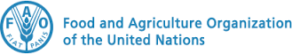 |  | 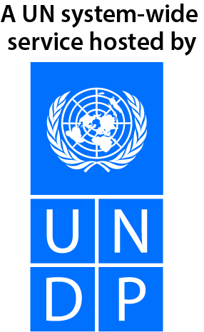
ONE UN JOINT PROGRAMME on Enhancing Climate Resilient and Integrated Agriculture in Disaster Prone Areas of Rwanda

MPTF OFfice ANNUAL programme NARRATIVE progress report
REPORTING PERIOD: 1 january – 31 December 2020

Programme Title & Project Number |  |  | Country, Locality(s), Priority Area(s) / Strategic Results
ONE UN JOINT PROGRAMME on Enhancing Climate Resilient and Integrated Agriculture in Disaster Prone Areas of Rwanda  Project Number 00120072 |  |  | Rwanda: Kayonza, Bugesera, Nyagatare, Gakenke, Rulindo, Nyagatare
Priority area/ strategic results

Priority 1: Innovative approaches to promote sustainable and integrated crop, Livestock and Aquaculture production systems promoted
Priority 2: Food security, nutrition and climate and other shocks resilient agriculture improved through sustainable and diversified production systems

Participating Organization(s) |  |  | Implementing Partners
Food and Agriculture Organization of the United Nations (FAO)  United Nations Development Programme (UNDP) |  |  | Ministry of Agriculture and Animal Resources (MINAGRI), Ministry of Environment (MoE), Rwanda Meteorology Agency (Meteo Rwanda)
Programme/Project Cost (US$) |  |  | Programme Duration
Total approved budget as per project document:  USD 2,930,025  MPTF contribution:  By Agency:  UNDP: USD 662,321  FAO: USD 581,895 |  |  | Overall Duration 38 months
Agency Contribution (core):  UNDP: USD 500,000  FAO: USD 329,621 |  |  | Start Date : April 2020
Government Contribution: N/A |  |  | Original End Date June 2023
Other Contributions  TOTAL: USD 2,073,837 |  |  | Current End date:
Programme Assessment/Review/Mid-Term Eval. |  |  | Report Submitted By
Assessment/Review - if applicable please attach  Yes X No Date: dd.mm.yyyy  Mid-Term Evaluation Report – if applicable please attach  Yes No Date: dd.mm.yyyy |  |  | - Name: Maxwell Gomera  - Title: Resident Representative  - Participating Organization (Lead): UNDP  ° Email address: maxwell.gomera@undp.org

Acronyms

AWP: Annual Work Plan
BEFS: Bioenergy and Food Security

CSA: Climate Smart Agriculture
ENR: Environment and Natural Resources
FAO: Food and Agriculture Organization of the United Nations
FFS: Farmer Field School
GHG: GreenHouse Gas
GV: Green Village
IDP: Integrated Development Programme
MINAGRI: Ministry of Agriculture and Animal Resources
MoE: Ministry of Environment
NGOs: Non-Governmental Organizations
RAB: Rwanda Agriculture Board
SPIS: Solar-powered irrigation systems
UN: United Nations
UNDAP: United Nations Development Assistance Plan
YAHOPROC: Yanze Horticulture Production Cooperative

NARRATIVE REPORT FORMAT

EXECUTIVE SUMMARY
- In ¼ to ½ a page, summarise the most important achievements of Programme during the reporting period and key elements from your detailed report below. Highlight in the summary, the elements of the main report that you consider to be the most critical to be included in the MPTF Office Consolidated Annual Report.

Through the Ministry of Environment, the Ministry of Agriculture and Animal Resources and Rwanda Meteorological Agency and in close collaboration with the Ministry of Local Government, the Ministry of Youth and Culture, districts and local communities, the Joint Programme on climate resilient and integrated agriculture supported Rwandan institutions and communities to strengthen their capacities for addressing climate change and building their resilience. The support and collaboration entail capacity building trainings and distribution of supplies/materials to help in integrated farming and on weather advisory. This narrative report gives details on key achievements in year 2020:

With the collaboration of the participating agencies in this programme and partners, activities such as Greening Internally Displaced Person (IDP) model villages in critical areas, strengthening the national capacity for production of agriculture related weather data and forecast products, biogas renewable energy assessment farming using smart agriculture techniques and creation of start-up projects on climate resilient agriculture were realized to respond to persistent challenges identified as obstacles to resilience and better livelihoods of small scale farmers where the agricultural productivity needs to be boosted in a sustainable and resilient manner, Climate Information that has to be strengthened, Integrated Development Programme / Green Villages to be ‘greened’, Access to sustainable energy that has to be enhanced comprehensively and where Educated Youth needs to be engaged in agricultural transformation

The report also provides an update on the project progresses against the indicators as well as the challenges, lessons learnt, and best-practices observed during the reporting period.

Purpose
- Provide the main objectives and expected outcomes of the programme in relation to the appropriate Strategic UN Planning Framework (e.g. UNDAF) and project document (if applicable) or Annual Work Plan (AWP).

The joint programme ‘Enhancing Climate Resilient and Integrated Agriculture in Disaster Prone Areas of Rwanda’ is addressing the issue shared by two key sectors, Environment and Natural Resources (ENR) and Agriculture, through the joint effort of two UN agencies, UNDP and FAO. The programme is being implemented as part of a concerted effort with other UN agencies, Ministry of Agriculture and Animal Resources (MINAGRI), Ministry of Environment (MoE), Rwanda Meteorology Agency (Meteo Rwanda) and districts.

The objective of the Joint Programme is to improve women and men farmers’ livelihoods and climate resilience through the adoption of agro-ecological production technologies, improved climate information-based planning and early warning in the selected drought and landslide prone areas of the country.

The Joint Programme is contributing to the UNDAP 2018-2023 Outcome 2 ‘By 2023 Rwandan institutions and communities are more equitably, productively and sustainably managing natural resources and addressing climate change’, and to the Sustainable Development Goals 2 “No hunger”, 5 “Gender equality”, 7 “Affordable and clean energy”, 8 “Decent work and economic growth”, 13 “Climate action”, 15 “Life on land” and 17 “Partnerships for the goals”.

Results
- This section is the most important in the Report and particular attention should be given to reporting on results / and changes that have taken place rather than on activities. It has three parts to help capture this information in different ways (i. Narrative section; ii. Indicator based performance assessment; and iii. A specific story).

- Narrative reporting on results:
From January to December 2020 respond to the guiding questions indicated below to provide a narrative summary of the results achieved. The aim here is to tell the story of change that your Programme has achieved in 2020. Make reference to the implementation mechanism utilized and key partnerships.

- Outcomes: Outcomes are the strategic, higher level of change that your Programme is aiming to contribute towards. Provide a summary of progress made by the Programme in relation to planned outcomes from the Project Document / AWP, with reference to the relevant indicator(s) in these documents. Describe if any targets were achieved or explain any variance in achieved versus planned results during the reporting period. Explain who the main beneficiaries were.

During the reporting period, the project contributed to the outcome 2 of the UNDAP under the Economic Transformation which stipulated that “By 2023 Rwandan institutions and communities are more equitably, productively and sustainably managing natural resources and addressing climate change” The programme worked hand in hand with district staff, farmers and staff from different government institutions that have agriculture and natural resources in their mandate.

On one hand, the UN support has increased the resilience of the local community in Mudende IDP Model Village through provision of green components and training on sustainable livelihoods. The project also enhanced the capacity of youth entrepreneurs to pilot climate resilient agriculture projects in five districts (Bugesera, Rulindo, Kayonza, Nyagatare and Gakenke). In addition, the project supported Meteo Rwanda’s to strengthen its capacity for climate data management, analysis which enable the generation of required climate information for agricultural activities.

On the other hand, the programme facilitated the integrated farming to enhance income generation and sustainable farming in Yanze (Rulindo). On top of that, for climate adaptation, resilience and water use efficiency, solar powered irrigation systems have been adopted in Rulindo. Along that, weather and crop calendar services were introduced to boost and improve production and productivity in Rulindo, (see success story provided) and Bioenergy and Food Security (BEFS) Assessment and capacity building have been conducted.

UN support also contributed to the promotion of youth employment in Agri-Food systems through the development of the National Strategy on Youth Employment. This strategy did not only contribute to the Rwanda’s effort to increase youth employment in the agriculture but also it contributed to the decent job creation target as stipulated in the National Strategy for Transformation 1.

Furthermore, the UN support has strengthened the capacity of experts (from public, private, civil society, academic institutions, NGOs, financial institutions and district agribusiness officers) to formulate small-scale rural investment projects by using the RuralInvest tool.

- Outputs: Outputs are the more immediate results that your Programme is responsible for achieving. Report on the key outputs achieved in the reporting period, in relation to planned outputs from the Project Document, with reference to the relevant indicator(s) in these documents. Describe if any targets were achieved or explain any variance in achieved versus planned results during the reporting period. If possible, include the percentage of completion of the outputs and the type and number of beneficiaries.

Environmental conservation and crop intensification demonstrated through introduction of proven climate smart agricultural technologies

Solar-powered irrigation systems (SPIS) are a clean technology option for irrigation, allowing the use solar energy for water pumping, replacing fossil fuels as energy source, and reducing greenhouse gas (GHG) emissions from irrigated agriculture. The adoption of solar powered irrigation system in Rulindo is key in climate adaptation, resilience and water use efficiency. Solar-powered pumps offer opportunities for farmers who are in rural areas without access to electricity. Using solar irrigation lowers costs compared to running petrol-powered pumps, and addresses other constraints related to fuels.

The programme has promoted clean energy in vegetable irrigation by providing three solar irrigation pumps to YAHOPROC (Yanze Horticulture Production Cooperative).

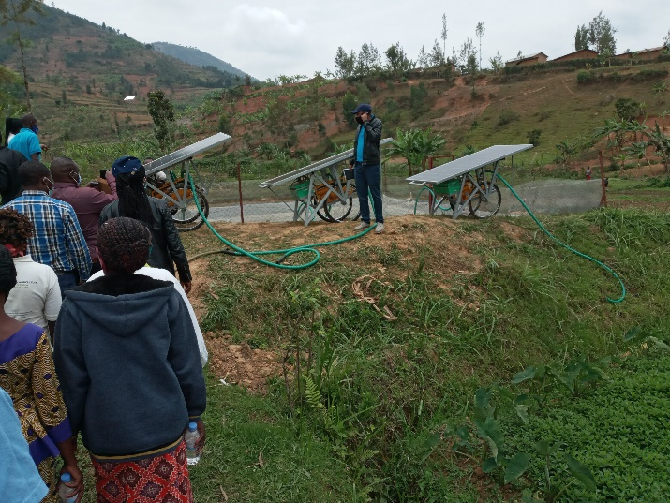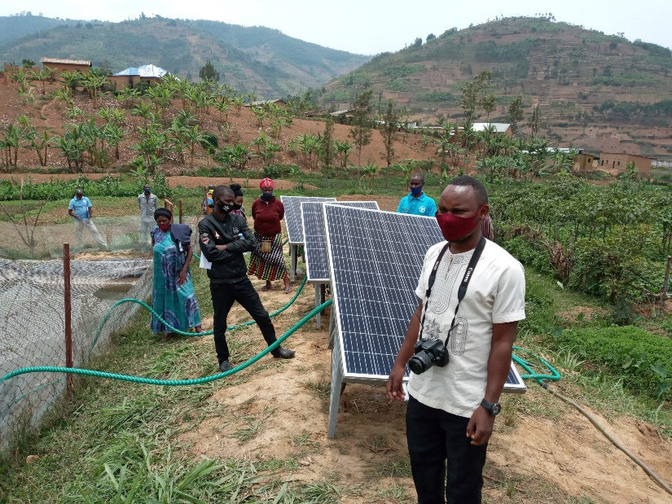
Solar powered irrigation materials distributed to the Cooperative
Photo Credit: Food and Agriculture Organization of the United Nations (FAO)

Integrated crop, livestock, and aquaculture demonstrated adopting the Songhai Model livestock

The programme facilitated the integrated farming through distribution of 30 piglets and 15,000 fish fingerlings (Tilapia) to YAHOPROC cooperative vegetable growers in Yanze, Testimonies from farmers is that not only will this boost their production but also will ease their agricultural works by providing organic manure.
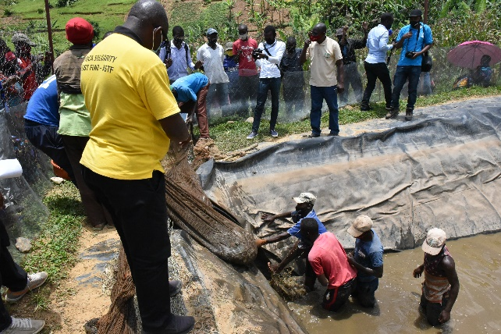
YOHOPROC members installing fish pond
Photo Cr: FAO

Bioenergy and Food Security assessment conducted and capacity for integrating bioenergy in agricultural

A rapid appraisal on Biogas system at country level was completed. The final report is available and suggests short term and a longer-term solution on sustainable bioenergy options such as using crop residues to make pellets. The Crop residues use survey, Biogas Household survey and Wood processing survey were completed in Karongi, Gasabo, Kicukiro, Rulindo, Musanze, Nyamagabe, Huye, Karongi, Nyamasheke, Nyagatare and Kirehe district

Training on Bioenergy and Food Security approach and tools was conducted where best practices and knowledge in Bioenergy were shared among 21 trainees (16 men, 5 women) from government bodies and UN trainers.

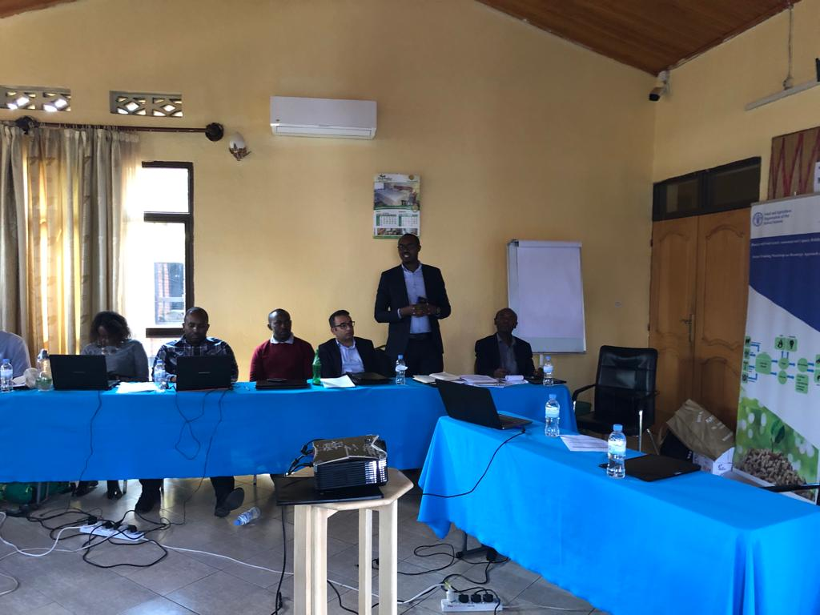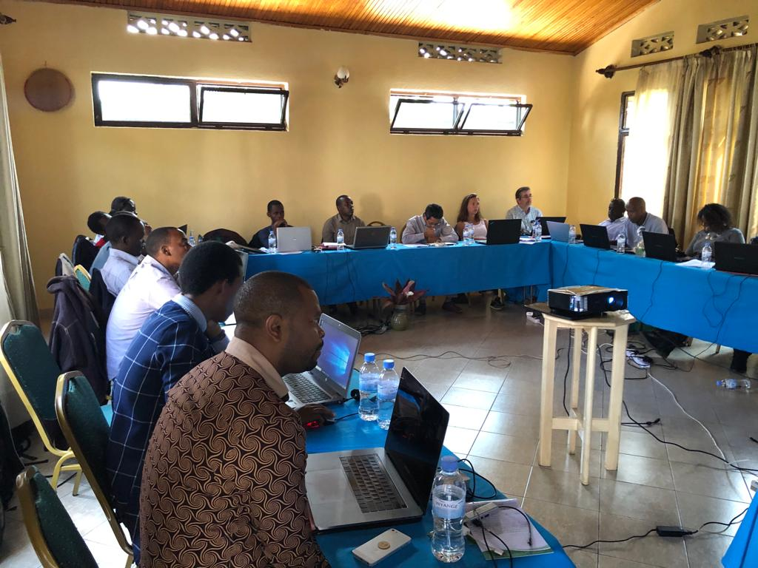
Photo Cr: FAO

Technology for climate change adaptation

Through technical assistance, the UN contributed to strengthening capacities on new methods of producing and integrating weather and climate information into policy and practices among 224 experts (36% female) from different government institutions and academia. Training was provided on data collection and analysis of weather and climate information and collaboration fostered amongst national partners for information dissemination to farmers. Better weather forecasts, use of crop models, development of crop calendars and advanced software training enabled the agencies to improve their data sets and increase their capacity to provide tailored weather and climate information to the agricultural users.

Greening Integrated Development Programme (IDP) Model Villages in critical areas

Through UN financial support to the inhabitants of Mudende Green Village, in Ruvabu District. 32 households (including 17 female-headed households and 15 male-headed households) i.e 16% of the overall project target for 2023 were equipped with green components based on the Green Village (GV) Toolkit. The green components received included tree seedlings that were planted around the village. The village was also equipped with a biomass-saving cook stove for each household while the construction of the bio-gradable waste compost facility of 6.9/5.5sqm size and the underground water tank 50m³ was achieved at 30%.

In addition, the UN provided technical assistance to 30 inhabitants of Mudende Green Village (21 women and 9 men) to strengthen their capacities on new livelihood opportunities for raising income while increasing their resilience, and participants are now capable of deigning small-scale projects. The trainings were provided on cooperative formation and management, livelihood improvement opportunities including milk value chain and smart greenhouse farming.

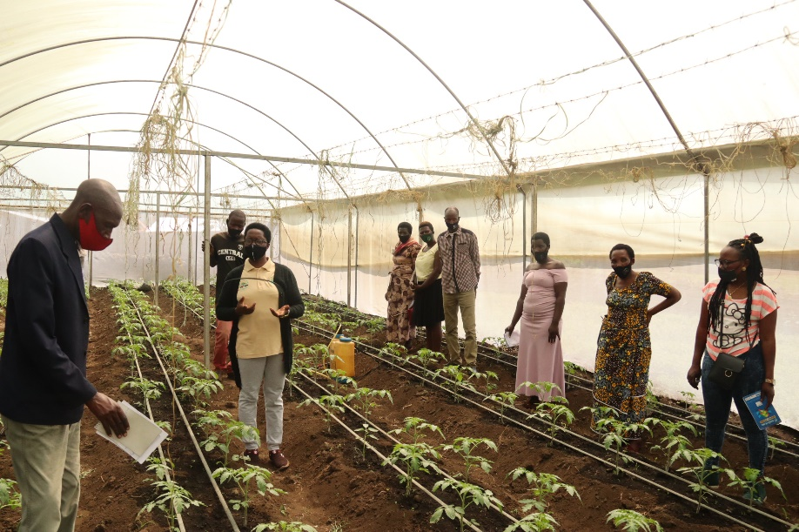
Training of Mudende Village inhabitants on smart greenhouse farming.
Photo Cr: UNDP

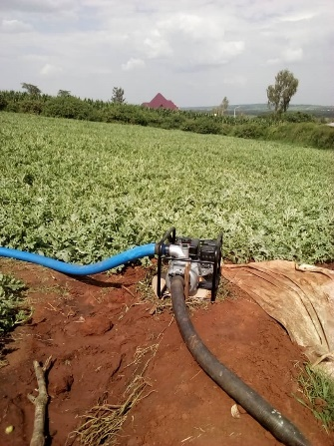
Furthermore, under the same output, the UN through MINAGRI provided financial support to start-up 66 sustainable agri-business youth (including 26 women owned vs to 40 men owned) projects from Bugesera, Kayonza, Nyagatare, Rulindo and Gakenke Districts. The types of projects include among other horticulture, mushroom farming, livestock (pigs, cows) projects among others.

Youth horticulture project in Bugesera.
Photo Cr: UNDP

Strengthening the national capacity for production of agriculture related weather data and forecast products

In its continued efforts to strengthen the national capacity for climate-based agricultural policy-making and planning processes, the UN provided financial support to Government of Rwanda through Meteo Rwanda to increase the production of weather data and forecast products. In the reporting period, the UN support focused on ensuring the safeguard and availability of data and ease of recovery in case of IT systems breakdown or natural disasters through provision of onsite backup and remote disaster recovery site. The existing server’s memory at Meteo Rwanda primary data center was upgraded. A new server was also acquired and installed for setting up 3 copies of data (production/primary data, onsite backup, offsite backup), for all climate data collected since 1907. Also, through the provided support, the Meteo Rwanda staff have access to a centralized data bank; with high performing laptops that are able to accommodate advanced tools and software which are used to conduct the data correlation tests. Furthermore, having a safe and permanent data bank enabled a continual and uninterruptible data and information access by internal and external users including agriculture sector.

Improved use of weather and climate information including agricultural advice by farmers

For improved use of weather and climate information and advisory services to farmers, the UN supported the Government of Rwanda to develop a comprehensive information dissemination system for farmers and the dissemination of produced weather and climate information products. Through technical assistance and financial support, the seasonal climate outlook for September to December 2020 was jointly developed and disseminated by Meteo Rwanda and Rwanda Agriculture Board (RAB) and MINAGRI
.
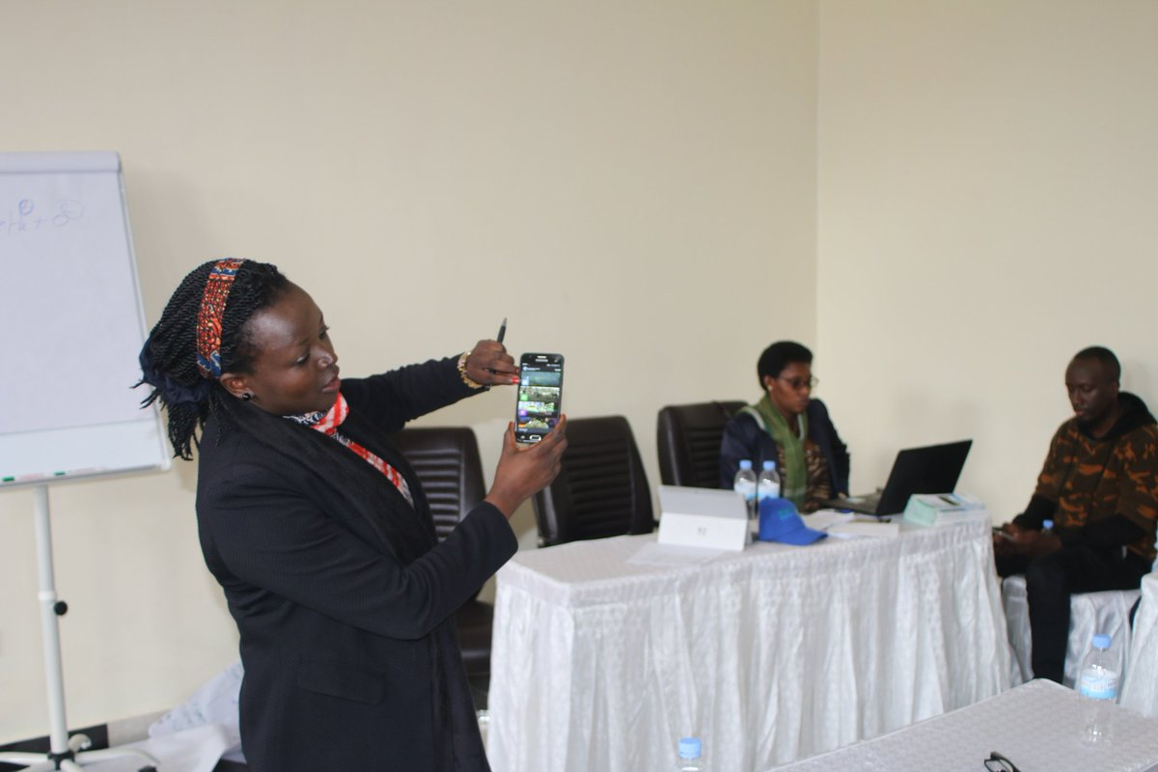

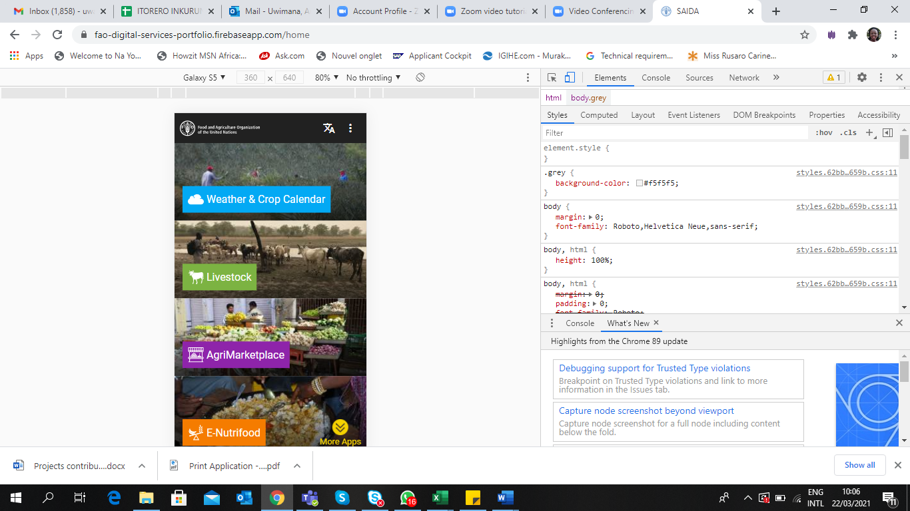

Training on the agriculture digital mobile applications
Photo Cr: FAO

Four digital/mobile applications and services (weather and crop calendar, Cure and Feed your livestock, Agri-Market Place and E-nutrifood) were also developed and officially launched with an objective of providing better access to essential information to smallholders and family farmers.
The dissemination was done through radio programmes and social media such as whatsapp groups, twitters, text messages and use of mobile applications that are accessible by farmers and other users in the agriculture sector.

30 District Agronomist Officers and existing farmers on current list continued to receive data through whatsapp, text messages, twitters, Meteo Rwanda website and those who have means have accessed more detailed information on the online portal ‘The Maproom” which is updated every ten days by Meteo Rwanda. In addition, 42 “Farmer Field School” facilitators representatives and 5 district staff from Rulindo were trained on “weather and crop calendar services”, and how to make decision based on weather and climate information.

- Describe any delays in implementation, challenges, lessons learned & best practices:

Since the Covid-19 outbreak in March 2020, the situation has been challenging. Due to lock-down and movement restrictions, field work was prohibited and many of planned trainings and workshops did not take place. This have affected the timely planning and implementation of project activities.

Best practices include:

- A close collaboration with project implementing partners (MINAGRI, RAB and Meteo Rwanda and other relevant government institutions such Ministry of Youth and Culture, Ministry of Local Governance, Districts, Youth Councils) as well as local community has has increased ownership, transparency and accountability among stakeholders which has been key for a successful project implementation.

- The involvement/participation of the private sector in the project implementation through the procurement process has helped to find the required expertise and to fast-track the implementation of project activities.

- Qualitative assessment: Provide a qualitative assessment of the level of overall achievement of the Programme. Highlight key partnerships and explain how such relationships impacted on the achievement of results. Explain cross-cutting issues pertinent to the results being reported on. For Joint Programmes, highlight how UN coordination has been affected in support of achievement of results.

With the collaboration of the UN agencies participating in this programme together with the Ministry of Agriculture and Animal Resources (MINAGRI), Ministry of Environment (MoE), Rwanda Meteorology Agency (Meteo Rwanda) and districts, some of the activities have been implemented, regardless of the conditions that the COVID-19 brought on board that would not allow the activities to go smooth as planned. With the new working style, the partnership with the government bodies and among UN agencies have played a big role in the implementation of activities. Quarterly meetings between participating UN organizations were organized to increase synergy and effectiveness in the project implementation as well as to mobilize the required resources to support the Government to Rwanda.
ii) Indicator Based Performance Assessment:
Using the Programme Results Framework from the Project Document / AWP - provide an update on the achievement of indicators at both the output and outcome level in the table below. Where it has not been possible to collect data on indicators, clear explanation should be given explaining why, as well as plans on how and when this data will be collected.

 | Achieved Indicator Targets | Reasons for Variance with Planned Target (if any) | Source of Verification
Outcome 1
Indicator:

Baseline:
Planned Target:

Output 1.1  Indicator 1.1: % of farmers in the selected sites that demonstrate at least one climate smart farming technique  Baseline: 5%  Target: 80  Indicator 1.2: % of farmers in the selected sites that are using drought tolerant crop varieties  Baseline: 5 %  Planned Target: 80 | Out of 5 districts of the programme implementation are, one district 5 Rulindo) received 3 Solar-powered irrigation systems (SPIS) | The COVID-19 situation that prohibited movements in districts | Technical report
 | Not yet | Distribution activities were not supported by government bodies because of COVID-19 measures, activity will resume in Quarter 4-year 2021. | Technical report
Output 2  Indicator 2.1: % of the farmers in the selected sites practice fish farming by 2023  Baseline: 0  Planned Target: 30 | One fish cooperative in Rulindo having more than 250 farmers have been supported |  | Report
Output 3: Farmer capacity developed for increased CSA and improved value chain through participatory learning with gender and youth fully integrated

Indicator 3.1: % of FFS groups integrating youth and gender in the selected sites have been trained in Climate smart agriculture and demonstrate increased production
Baseline: 0
Planned Target: 100

Indicator: 3.2 % of the trained FFS farmers practice skills that are demonstrative of Climate Smart and nutrition sensitive agriculture, disaggregated by sex
Baseline: 0
Planned Target 60: (M: 60%, F: 60%)
 | Not Yet | Activity planned to be realized in Quarter 3 of year 2021 | Report
Output 4:  Sustainable Agricultural intensification and food security enhanced  Indicator 4.1 % of farmers strengthened in improved productivity and healthier nutrition levels  Baseline: 0  Target: 50%  Indicator 4.2 % Farmers with raised productivity and increased profitability within context of CSA  Baseline: 0  Target: 80%  Indicator 4.3: % farmers with increased productivity and resilience to climate volatility through application of technologies and best practices in efficient water use  Baseline: 0  Target: 80% | Not Yet | Activity planned in Quarter 4 this year, after the curriculum on climate smart agriculture, nutrition sensitive agriculture and capacity development is fully developed | Project report
 | 30 piglets and 15,000 fish fingerlings were distributed to facilitate agriculture integration to 250 farmers  The programme has promoted clean energy in vegetable irrigation by providing 3 solar irrigation pumps to one cooperative in Rulindo. |  | Report  Technical report
Indicator 4.4: % farmers provided with matching grants and have purchased and use irrigation equipment effectively  Baseline: 0  Target: 90% | Not yet |  | Technical report
Indicator 4.5: % of individual farmers or farmers organizations supported in market linkages and can access to finance  Baseline: 0  Target: 50% | 24 (8 women and 16 men) experts from public, private, civil society, academic institutions, NGOs, financial institutions and district agribusiness officers enhanced their capacity in using the RuralInvest tool.  This has resulted in the formulation of 23 agri-business plans through the RuralInvest toolkit. |  | Training report
Output 5: Bioenergy and Food Security assessment conducted and capacity for integrating bioenergy in agricultural resilience strategies supported
Indicator 5.1: Bioenergy Assessment for the selected district completed and report available  Baseline: NO  Target: YES | Yes, the BEF assessment was conducted in different districts of Rwanda including Rulindo and Nyagatare that are covered by the programme. |  | Technical report
Indicator 5.2 Comparison of solar and bioenergy options completed and report available.  Baseline: NO  Target: YES | Yes, bioenergy is a key form of renewable energy that can be sourced from a number of biomass options including crops, crop residues, livestock residues and sustainably managed forest resources and residues. Potential bioenergy feedstock and technologies that can be developed in Rwanda for both decentralized energy production and for cooking purposes were analysed and identified. |  | Report
Output 6: IDP / Green Villages in critical areas equipped with green components  Indicator 6.1: # of households in IDP model villages newly benefiting from green components based on the GV toolkit, disaggregated by sex of the head of household  Baseline: 0  Target: 200 (F: 100, M: 100) | 32 households have benefited from the tree planting in their gardens and around the village. Also, 30 people (21 women and 9 men) from Mudende Green Village were trained on cooperative management and livelihood improvement opportunities including milk value chain and greenhouse farming. | COVID-19 related challenges delayed the construction of water tank and compost facility for Mudende village | Project and training reports
Output 7: Technical capacity of Meteo Rwanda strengthened to produce agriculture related weather data and forecast products  7.1: Level of validation (data source-quality correlation) of weather and climate data in the data bank  1) Maproom onset definition is general (country wide)  2) Maproom onset definition specific for each climatic zone  7.2: # of tailored packages validated by key stakeholders  Baseline:0  Target: 3 | Server’s memory for climate data center was upgraded.  A new server was also acquired and installed for setting up 3 copies of data (production/primary data, onsite backup, offsite backup), for all climate data collected since 1907 onward to ensure safety and ease of access for analysis and generation of weather and climate information. | - Maproom Onset definition was not done due to COVID-19 challenges
Output 8: Improved use of weather and climate information including agricultural advice by farmers  Indicator 8.1: Comprehensive information dissemination system for farmers developed and functional  Baseline: No  Target: Yes  Indicator 8.2: # of farmers in pilot areas receiving climate information with farming advice  Baseline: 0  Target:  100/District (50:50 men and women)  Indicator 8.3: # of farmers using newly developed weather information to improve crop productivity in selected areas  Baseline: 0  Target: 60 farmers/District  using newly developed weather information to improve crop productivity  Indicator 8.4: # of RAB and target district officials supported on the usage of climate information  Baseline: 0  Target: 50 (M 25; F 25) | Yes. The seasonal climate outlook for September to December 2020 was jointly developed and disseminated by Meteo Rwanda and RAB (MINAGRI). The dissemination was done through radio programmes and social media that are accessible by farmers and other users in the agriculture sector.  No achievement recorded  42 farmers and 5 district staff from Rulindo were trained on “weather and crop calendar services”, and how to make decision based on weather and climate information  No achievement recorded | Due to COVID related challenges this activity was not planned for 2020  This activity was delayed due to COVID | Report

iii) A Specific Story (Optional)
- This could be a success or human story. It does not have to be a success story – often the most interesting and useful lessons learned are from experiences that have not worked. The point is to highlight a concrete example with a story that has been important to your Programme in the reporting period.
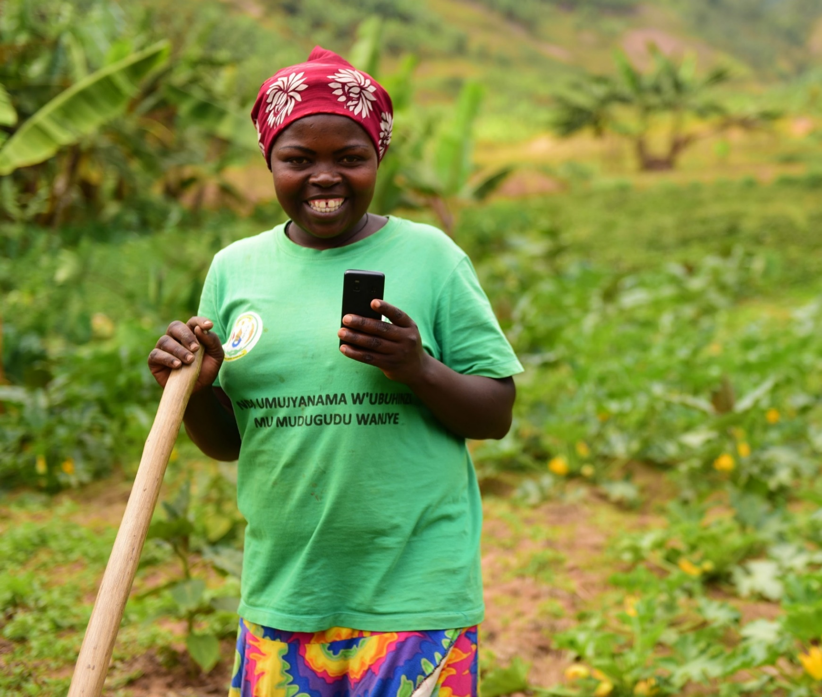

“Technology brings new innovative ideas which farmers adopt and develop. Poverty will be eliminated because you will grow crops knowing how much production you will get and how much money to be generated,” says Akingeneye Marie-Chantal, a farmer in Rwanda.

“I wanted to become a farmer since I was a child. I went to the university and pursued agriculture related course to enable me become a good farmer. The mobile phone applications make it easy for me to get information than sitting through a weeklong training. Also, we veterinary doctors here are hard to get and when you get them you have to pay them. The apps provides me information on prevention and treatment of my livestock free of charge,” says Daniel Nshimiyimana, a university graduate, now a farmer in Rulindo District.

Agriculture applications use by farmers
Photo Cr: Food and Agriculture Organization of the United Nations (FAO)

- In ¼ to ½ a page, provide details on a specific achievement or lesson learned of the Programme. Attachment of supporting documents, including photos with captions, news items etc, is strongly encouraged. The MPTF Office will select stories and photos to feature in the Consolidated Annual Report, the GATEWAY and the MPTF Office Newsletter.

Problem / Challenge faced: Describe the specific problem or challenge faced by the subject of your story (this could be a problem experienced by an individual, community or government).

Programme Interventions: How was the problem or challenged addressed through the Programme interventions?

Result (if applicable): Describe the observable change that occurred so far as a result of the Programme interventions. For example, how did community lives change or how was the government better able to deal with the initial problem?

Lessons Learned: What did you (and/or other partners) learn from this situation that has helped inform and/or improve Programme (or other) interventions?

III. Other Assessments or Evaluations (if applicable)
• Report on any assessments, evaluations or studies undertaken.

No assessments, evaluations or studies were undertaken.

IV. Programmatic Revisions (if applicable)
• Indicate any major adjustments in strategies, targets or key outcomes and outputs that took place.

Due to COVID-19 challenges some activities notably field-based assessments and community workshops were postponed to 2021. Also, virtual meetings were adopted as a strategy to conduct consultations and some specific trainings/workshops.

V. Resources (Optional)
• Provide any information on financial management, procurement and human resources.
• Indicate if the Programme mobilized any additional resources or interventions from other partners.

Strategic Results, as formulated in the Strategic UN Planning Framework (e.g. UNDAF) or project document;
The start date is the date of the first transfer of the funds from the MPTF Office as Administrative Agent. Transfer date is available on the MPTF Office GATEWAY
As per approval of the original project document by the relevant decision-making body/Steering Committee.
If there has been an extension, then the revised, approved end date should be reflected here. If there has been no extension approved, then the current end date is the same as the original end date. The end date is the same as the operational closure date which is when all activities for which a Participating Organization is responsible under an approved MPTF / JP have been completed. As per the MOU, agencies are to notify the MPTF Office when a programme completes its operational activities.
Note: Outcomes, outputs, indicators and targets should be as outlined in the Project Document so that you report on your actual achievements against planned targets. Add rows as required for Outcome 2, 3 etc.
The programme will count the number of households anew from the start of the programme, however it is worth noting that up to 2018 the MoE have provided greening components to 12 IDP model villages.

