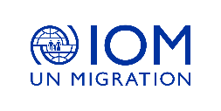  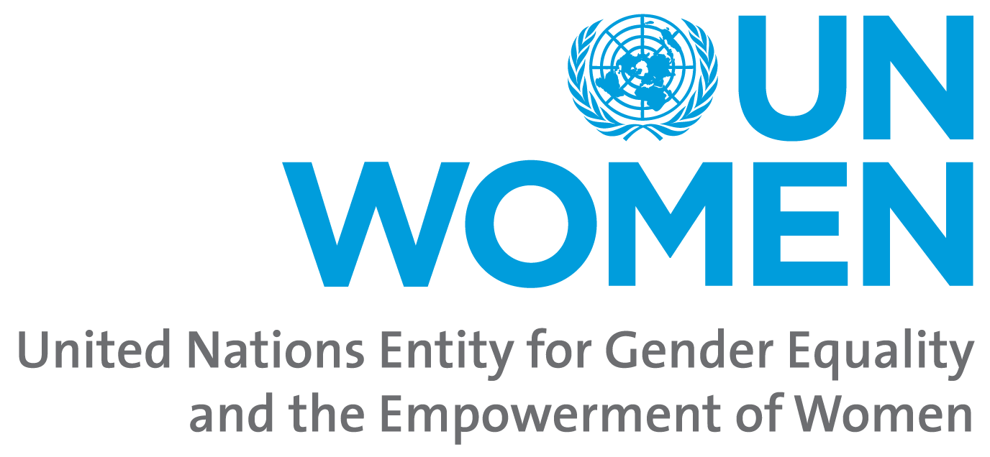 | 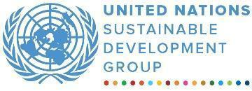 | 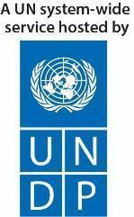

Joint Programme
Leveraging the Full Potential of Gender Equality and Women’s Empowerment to Achieve Rwanda’s Transformation

MPTF OFFICE ANNUAL PROGRESS REPORT
REPORTING PERIOD: 1 JANUARY – 31 DECEMBER 2020

Programme Title & Project Number |  | Country, Locality, Priority Area / Strategic Results
- Programme Title: Joint Programme – Leveraging the Full Potential of Gender Equality and Women’s Empowerment to Achieve Rwanda’s Transformation  - Programme Number: 00120074  - MPTF Office Project Reference Number: 00120074 |  | Country/Region: Rwanda
 |  | Priority area/ strategic results: Transformational Governance
Participating Organizations |  | Implementing Partners
MPTF: UN Women, IOM,  All JP Gender participating organizations: UN Women, IOM, UNDP, UNFPA, UNHCR, UNICEF, and OHCHR |  | Ministry of Gender and Family Promotion (MIGEPROF), Gender Monitoring Office (GMO), National Women Council (NWC), Rwanda Local Government Association (RALGA), Forum for Women Parliamentarians (FFRP), Rwanda Investigation Bureau (RIB), Imbuto Foundation, Profemmes Twese Hamwe, Action pour le Developpement du Peuple (ADEPE), Rwanda Religious Leaders Initiative (RRLI), New Faces New Voices (NFNV), Media High Council, National Forum of Political Parties Organization
Programme/Project Cost (US$) |  | Programme Duration
Tot approved budget per project document: USD 19,096,661  MPTF /JP Contribution: 10 000 000 SEK (approx. 1 000 000 USD)  - UN Women: USD 522 108 (received)  - IOM: USD 100 000 (received)  Agency Contribution (core):  - UNHCR: USD 1,186,700,  - UNDP: USD 318,105  - UNICEF: USD 400,000  Other Contributions (donors):  - Netherlands: USD 720,000  - SDC: 2,000,000  Government contribution: USD 2,778,783 (as per the ProDoc, this is not included in the programme budget)  TOTAL: USD 5,246,913 |  | Overall Duration: 4.5 years (54 months)  Start Date (11.02.2020)  End Date (30.06.2023)
Programme Assessment/Review/Mid-Term Eval. |  | Report Submitted By
Assessment/Review  Yes No  Mid-Term Evaluation Report  Yes No |  | - Name: Fatou Lo  - Title: UN Women Rwanda Country Representative  - Participating Organization (Lead): UN Women  - Email address: fatou.lo@unwomen.org

ACRONYMS AND ABBREVIATIONS

AfCFTA African Continental Free Trade Area
AFAWA Affirmative Finance Action for Women in Africa
AWLN Africa Women Leaders Network
FFRP Forum for Women Parliamentarians
GAD Gender Accountability Day
GBV Gender-based Violence
GBV MIS Gender-based Violence Management Information System
GEPM Gender and Economic Policy Management
GEWE Gender Equality and Women’s Empowerment
GGGR Global Economic Forum Gender Gap Index Report
GMIS Gender Management Information System
GMO Gender Monitoring Office
GRB Gender-responsive Budgeting
IECMS Integrated electronic Management System
IOSC Isange One Stop Centers
JP Gender Joint Programme on Gender
JP-RWEE Joint Programme - Rural Women’s Economic Empowerment
MIGEPROF Ministry of Gender and Family Promotion
MINAGRI Ministry of Agriculture and Animal Resources
MINECOFIN Ministry of Finance and Economic Planning
MPTF Multi Partner Trust Fund
NGFC National Gender and Family Cluster
NFPO National Forum of Political Organization
NPPA National Public Prosecution Authority
NST National Strategy for Transformation
NWC National Women Council
NYC National Youth Council
RCS Rwanda Correctional Services
RIB Rwanda Investigation Bureau
RALGA Rwandan Association of Local Government Authorities
SDC Swiss Development Cooperation
SOP Standard Operating Procedures
SERP Social Economic Recovery Plan
SGBV Sexual and Gender-based Violence
UNDAF United Nations Development Assistance Framework
UNDAP United Nations Development Assistance Plan
UPR Universal Periodic Review

EXECUTIVE SUMMARY
The United Nations in Rwanda contributes to the realization of national development aspirations expressed through the National Strategy for Transformation and the United Nations Development Assistance Programme (UNDAP2). Through the One UN Joint Programme on Gender (JP Gender) “Leveraging the Full Potential of Gender Equality and Women’s Empowerment to Achieve Rwanda’s Transformation” promising gains on gender equality and women’s empowerment were registered over the reporting period. These gains include the strategic support and technical assistance leading up to the restructuring of the National Gender and Family Cluster; the normative support through the contribution to the Universal Periodic Review (UPR) process, under which the implementation of six recommendations on gender equality and women’s empowerment was rated highly satisfactorily by the Human Rights Council; the policy support that culminated into the revision of the National Gender Policy in 2020 (approved by the Cabinet in February 2021). The new policy is aligned with Vision 2050, the National Strategy for Transformation (NST1) and SDGs. It identifies eight strategic priority areas including women’s economic empowerment, gender mainstreaming in all sectors and district development plans, engaging Men, addressing negative social norms, and increasing accountability. This was the result of a multi-stakeholder collaboration, bringing together national institutions, civil society organizations and the One UN (namely UN Women, UNFPA, UNHCR, UNDP, FAO, WFP and UNICEF) to provide strategic and technical support with a view to enhance the policy framework for gender equality in Rwanda.
The Joint Programme on Gender continues to contribute to further strengthening the national accountability systems on Gender Equality and Women’s Empowerment (GEWE). Over the reporting period and despite the difficult context due to COVID-19 in 2020, the JP Gender through its national partners facilitated one of the most successful Gender Accountability Days (GAD) to date. Initially, the GEWE accountability day was a one-day event, but it now stretches over an entire month in several districts. The GAD attracted over 500 community and village leaders from Eastern Province mostly Gatsibo, Nyagatare and Kayonza districts, leading to the community-based signing of contracts and commitments to advance gender equality. One of the specific commitments made was to challenge social and cultural norms that perpetuate gender inequalities, discrimination and SGBV in the Eastern Province, one of the most severally hit provinces when it comes to SGBV and teenage pregnancies.

Further investment was made into the capacity enhancement of SGBV service providers through the JP Gender, with targeted support to legal service providers, prosecution and psychosocial and medical service providers. These were vital services during the year 2020 to address the increased number of teen pregnancies and to respond to when a drastic increase of SGBV cases resulting from the impact of the COVID-19 pandemic. In 2020, the UN continued to leverage foundational studies and assessments, including the rapid gender assessment of the impact of COVID-19 on women and men in Rwanda, the UN report on the socio-economic impact assessment of COVID-19 in Rwanda, as well as the ongoing study on trade barriers for women. The findings and recommendations of these various studies have contributed to and informed the One UN Joint Programme in support to the Social Economic Recovery Plan (COVID-19 JP SERP) and continues to inform evidence-based programming and advocacy.

Activities under the JP Gender are funded through various sources, including the Multi Partner Trust Fund, Development Partners, and agencies contributions. In 2020, two UN agencies (UN Women and IOM) received funds through the MPTF. However, UNFPA, UNHCR, UNDP, UNICEF and OHCHR all participate in and make tremendous contributions to this programme and to advancing the Gender Equality Agenda in Rwanda, through core funds.

Purpose

The Joint Programme on Gender contributes to the achievements of the outcomes 1, 4, 5, and 6 of the UNDAP II (2018/2023) which has three areas of focus, Economic Transformation, Social Transformation, Transformational Governance. The main objective of the Joint Programme is to ensure that "Women and girls, especially the most vulnerable, participate in, contribute to and benefit from political, economic and Social transformation in Rwanda". This will be achieved through the below outcomes:

- By 2023, people in Rwanda benefit from enhanced gender equality, justice, human rights, peace, and security. (UNDAP Outcome 5)
- By 2023, people in Rwanda participate more actively in democratic and development processes and benefit from transparent and accountable public and private sector institutions that develop evidence-based policies and deliver quality services. (UNDAP Outcome 6)
- By 2023, people in Rwanda benefit from more inclusive, competitive, and sustainable economic growth that generates decent work and promotes quality livelihood for all. (UNDAP Outcome 1)
- By 2023, people in Rwanda, particularly the most vulnerable, have increased resilience to both natural and man-made shocks and enjoy a life free from all forms of violence and discrimination. (UNDAP Outcome 4).

Results

Outcome 1: By 2023, people in Rwanda benefit from enhanced gender equality, justice, human rights, peace, and security. (UNDAP Outcome 5)

Rwanda remains a leader in closing the gender gap globally and across Africa, although the 2020 Global Gender Gap Report (GGGR) slightly lowered Rwanda's performance and ranked the country at the 9th place globally (down from 6th place) in promoting gender. Through technical assistance offered to the line Ministry, under the JP Gender an analysis of the 2020 GGGR was carried out to understand the drivers of these changes so that concrete corrective measures could be taken to enhance the country’s performance on gender in line with its commitments. Consequently, strategic programming has been undertaken to bolster the women’s economic participation and opportunities which was the most critical in the score. This is done through strategic advisory services to effectively position businesswomen in Rwanda for emerging opportunities including AFAWA (Affirmative Finance Action for Women in Africa) and the AfCFTA (African Continental Free Trade Area).

- JP Output 1.1: Women’s capacity to compete for leadership positions and to lead decision making processes at local and national level strengthened

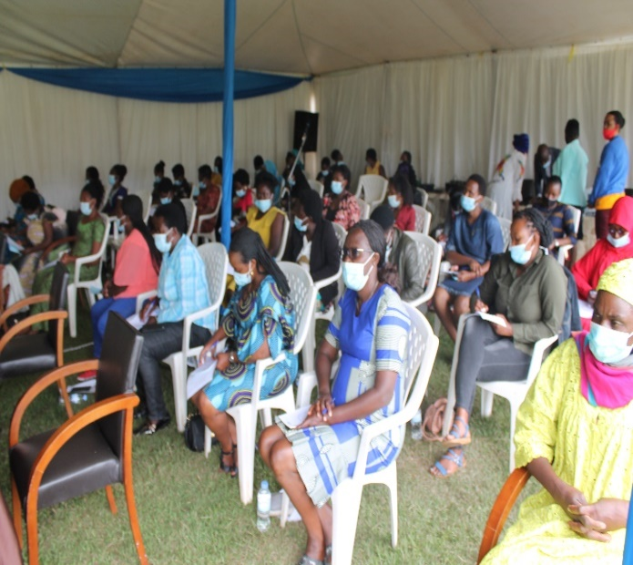
In a bid to increase women’s capacity to compete for leadership positions and to lead decision making processes at local and national level, the JP Gender through UN core funding and the National Forum for Political Organizations (NFPO), held trainings and coaching sessions aimed at promoting women’s participation in democratic processes. The NFPO is a constitutional entity officially recognized as a platform for political dialogue, working to promote consensus, national cohesion and capacity building in political activities and service provision. As a result of this partnership, 220 women leaders and members in political parties at district and regional level gained practical skills to become transformative agents of change through decision-making positions and play an active role in political parties. To sustain the implementation of gender-responsive development frameworks, policies, and strategies at both national and local level, political empowerment of women remains a priority for the JP Gender. Through the women political empowerment initiative, women leaders from political parties at district and regional level enhanced their skills through experience sharing, awareness raising on political and business orientation and career guidance.
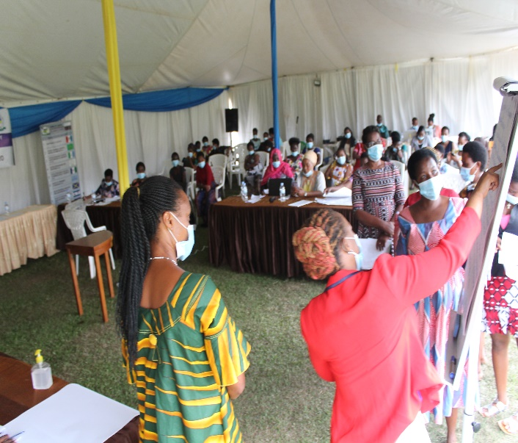
Photo: Training of women wing leaders in political organization, participation and empowerment
This emulate political parties to engage more women through decision making positions, allowing participants to understand leadership perspective values with a focus on restoring values that have been characterizing Rwandan society in terms of leadership and service delivery and to exchange on gender equality incentives among the 11 political parties. With the contribution from the JP on Gender in mainstreaming gender equality in political parties, women political empowerment in Rwanda maintained good track of women participation in decision making organs.

Through MPTF funding, the JP Gender in partnership with MIGEPROF and RALGA (a membership organization that brings together local government entities in Rwanda), are supporting a professional internship initiative to promote leadership for young women graduates. The initiative which started in 2020 and will continue in 2021, is targeting 120 young women recently graduated from various public and private universities recognized by the Government. The programme also raises awareness and ownership of local government as a potential employer among the recent graduates; strengthens and empowers the inherent capacities of young women through internships skills in leadership; connecting young women with mentors, equips women graduates with skills and experience in governance, thus increasing the number of experienced women to influence decision-making both in the local and central government, and increasing exposure and employability opportunities of target groups in local and central government. Ultimately, this will allow young women to obtain skills necessary to compete for leadership positions and result in more women in leadership and decision-making positions both at the local and central levels.

Additionally, to increase women’s capacity to compete for leadership positions, the JP Gender will continue its close collaboration with the National Gender Machinery in the local government elections with awareness raising campaigns to engage aspiring women candidates and trainings to strengthen women’s capacity and skills. The elections initially planned to be held in 2021 were postponed sine die, due to COVID-19.

- JP Output 1.2: National and local level Government institutions’ capacities to execute gender-responsive development strategies, sector strategies, district development plans and budgets increased

Strengthening coordination capacities and mechanisms
In 2020, the JP Gender through MPTF funding supported the functioning of the National coordination mechanism on gender namely the Gender and Family Cluster (NGFC) through ensuring adequate staffing, technical capacity of its secretariat, finalization of the national coordination strategy and the roll-out of a new coordination architecture at national and local level. As a result, MIGEPROF is adopting a Sector Wide Approach for effective coordination of stakeholders and their work across the four Sub-Clusters (GEWE, Family Promotion and SGBV prevention, Early Childhood Development and Child protection). With the support from the JP Gender, MIGEPROF recruited a Planning and M&E specialist for the NGFC Secretariat. Two additional recruitments are underway: A Coordinator of the NGFC and the recruitment of the JP Gender Manager (the former JP Gender Manager for MIGEPROF resigned). To further strengthen the sector wide approach, coordination and financing for gender equality, the ToR to revamp the national gender-responsive budgeting (GRB) steering committee was developed and approved by the national GRB technical committee. Revamping the national gender-responsive budgeting steering committee will further help the sector to entrench gender mainstreaming in the national planning and budgeting processes.

The UN campaign on Generation Equality was launched in 2020, demanding equal pay, equal sharing of unpaid care and domestic work, an end to sexual harassment and all forms of violence against women and girls, health-care services that respond to the needs of women and girls and their equal participation in political life and decision-making in all areas of life. The campaign is marking the 25-year anniversary of the Beijing Platform for Action which set out how to remove the systematic barriers that hold women back from equal participation in all areas of life whether in public or private. As part of this, the UN organized a Gender Café under which the Generation Equality was launched in November 2020, under the theme “Generation Equality: Realizing Women’s Rights for an Equal Future,” Through an interactive intergenerational dialogue, the Gender Café brought together the next generation of women’s rights activists with the gender equality advocates and visionaries who were instrumental in creating the Beijing Platform for Action more than two decades ago, to tackle the unfinished business of empowering women and girls. Rwanda is also playing a key role as co-lead of the Generation Equality Action Coalition on Innovation and Technology.

The 2020 World Economic Forum Gender Gap Report shows progress made in terms of gender equality in political leadership positions, yet, women’s participation in the labour market is stalling and ﬁnancial disparities are slightly larger. There is a need to close the economic participation and increase the gap in opportunities for women. More women are needed in the science, technology, engineering and mathematics tracks to tap in the immense potential of the fourth industrial revolution. Rwanda role as co-lead of the Generation Equality Action Coalition on Innovation and Technology, is therefore an important aspect of building forward better.

To strengthen local and national level government institutions' capacities to coordinate and execute gender-responsive development frameworks and budgets, meeting were organized for the Gender and Family Promotion Cluster and for the four sub-clusters (GEWE, Family Promotion and SGBV prevention, Early Childhood Development and Child Protection) with the aim to enhance stakeholders’ involvement, collaboration and coordination. A stakeholder’s mapping was undertaken in 2020 using a dedicated software and is expected to be completed in 2021. Once completed it will be populated with stakeholder’s data including stakeholders annual workplans and achievements. This will also contribute to the development of the cluster’s five-year strategic plan. To ensure efficient use of the tool, 20 staff from several partner organizations of MIGEPROF have increased their knowledge through trainings. The tool was developed by MIGEPROF, with the support from the Joint Programme through MPTF funds.

Strengthening capacities for gender-responsiveness in planning and reporting
Media houses and journalists are increasingly aware of gender equality and their role in challenging negative stereotypes and raising awareness on gender equality issues including violence against women. Through the collaboration between the Joint Programme through MPTF funding in partnership with MIGEPROF, 45 media practitioners representing different media houses were equipped with analytical skills and knowledge on gender mainstreaming in the media, gender analysis, gender-based violence, contributing to enhancing gender responsiveness in media sector as well as advocacy for gender equality through the media.

Additionally, through UN core funding and in partnership with Media High Council (MHC), six additional trainings were held in 2020, reaching a total of 161 participants (68 women, 93 men). The MHC is an independent constitutional body responsible for media capacity building and working with the implementation of policies and strategies. Through this partnership, trainings were held in media content and editorial management (31 participants), on communicable disease including COVID-19 reporting (31 participants), on climate change and disaster management (12 participants), on sign language (14 participants) as well as investigative justice reporting (25 participants).
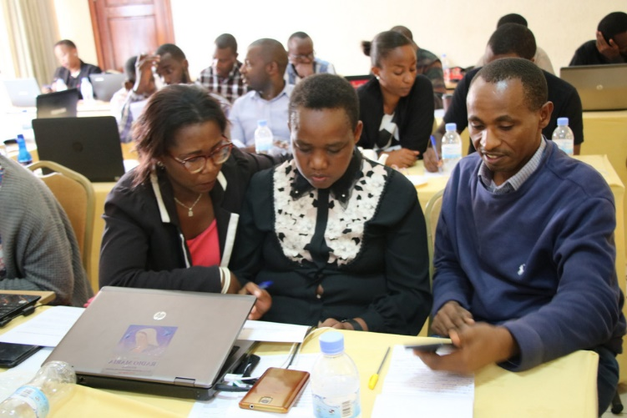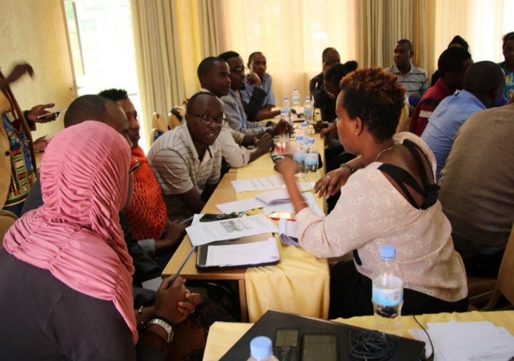
Photo: Training held for 31 participants in media content and editorial management
Another was training was held for 32 journalists (11 women, 21 men), focusing on family planning to enhance their capacities and responsive reporting on these topics and to contribute to knowledge sharing on women’s reproductive health during the COVID-19 period. As a result, the trained journalists produced and published 48 stories in their respective media outlets. Additionally, the Joint Programme has supported a mentorship programme for 12 media practitioners (5 women, 7 men) aimed at strengthening skills in media business sustainability and professionalism, and organized an online conference on strengthening media in fighting and preventing early pregnancies for 69 participants to address the issue of increasing teenage pregnancies in Rwanda. The JP Gender has also planned an activity on 2 media houses to be awarded for having disseminated programme on GEWE. Due to COVID-19, this activity was postponed to May 2021. The citizen satisfaction with access to information stands at 92.06% (2020).

Local and central government staff and management are increasingly invested in gender responsive planning, budgeting and monitoring. In 2020, the JP Gender through MPTF funds have collaborated with MIGEPROF and provided technical and financial support to strengthen capacities in Gender Economic Policy Management (GEPM). As such, a five-day training was held with the aim to equip Directors of Agriculture in districts with the necessary skills in effective Gender-responsive Budgeting (GRB), gender analysis and mainstreaming skills to support and advocate for the implementation of gender responsive policies and programs. Thirty directors from all 30 districts of Rwanda as well as six staff from central level, (including MIGEPROF, MINAGRI, MINECOFIN) participated in the training. A second training will be held in 2021, targeting district gender officers, and will contribute to improved gender-responsive planning, budgeting and monitoring. Starting from January 2021, gender is mainstreamed in the accountability mechanism Imihigo (a performance contract for districts based on their annual work plans). Each year, the districts are rated against their performance and starting 2021, the districts will report against, and be rated on their progress in terms of gender equality.

The capacity of implementing partners (IPs) to the JP Gender continues to be strengthened. For example, to enhance the quality of programmes and improve the IPs capacity to deliver meaningful results across programmes, the JP Gender, with the support of MPTF, organized a Result-based Management training. In total, 17 IP organizations and a total of 42 participants joined the four-day training held on the 20-23 of July 2020. As a result, the implementing partners increasingly submit quality reports in a timely manner and only 6% of the reports were returned to implementing partners for major corrections in 2020.

- JP Output 1.3: Community awareness of gender equality and civic understanding of women’s right to equal participation in decision making increased.

Gender Accountability Days
The Gender Accountability Day (GAD) is an annual event organized by the Gender Monitoring Office (GMO) with the support of the Joint Programme through MPTF funding in selected districts to discuss key issues on Gender Equality. During the 2020 Gender Accountability Day in Gatsibo in the Eastern Province organized between 26-30th of October, over 300 village leaders from the province gathered to participate in a dialogue on social norms and attitudes perpetuating negative gender stereotypes and in particular on the role of women as leaders and the need for women’s voices to be heard. The leaders committed to continue working towards equal rights and the participation of women in leadership and decision-making roles. As a result, gender accountability was institutionalized in Gatsibo District accountability mechanisms, increased awareness on the role of village leaders and the community in general in the fight against GBV, challenges faced by teenage pregnancy victims were brought to the attention of district authorities and its stakeholders for appropriate remedies and reintegration.

Furthermore, GMO in collaboration with Gatsibo district identified and documented 14 initiatives that have transformed the lives of people in the district and disseminated them during the Gender Accountability Day. The documented initiatives include role of cooperatives in improving livelihood of beneficiaries and participation of women in cooperative leadership, establishment of facilities for easy access to clean water, construction of health facilities, promotion of men and women’s access to jobs. Following the identification of impactful initiatives, the initiatives were documented to produce a 15-minute documentary that was used to showcase the impact of these initiatives in promoting gender equality in Gatsibo district.

Training Youth on Gender Equality Principles and Women’s participation in decision-making
The 2030 Agenda for Sustainable Development highlights the importance of delivering equal gains for youth. The force and inspiration of the youngest leaders are critical drivers for accelerating progress on sustainable development and gender equality. Through MPTF funding, the Joint Programme in partnership with MIGEPROF and the National Youth Council (NYC), organized a two-day training (divided in two cohorts: 2-3 September, 8-9 September 2020) for 127 members (86 men, 41 women) of the National Youth Council Committee to enhance their skills and capacities in Gender Equality Principles and shape their roles as leaders and role models. The training held virtually due to COVID-19 restrictions was aimed at building capacities in gender analysis, and applying gender principles in their daily work, and decision making. The training also had a Training of Trainers component, for the members of the Youth Council to continue sharing their knowledge with other young people, hoping to reach 3418 youth once face-to-face trainings are allowed to take place. Currently, the 127 members have started to train youth at sector level on basic skills and knowledge in gender equality principles to serve as gender agents of change in their respective forums and community in general.

Scale up of Indashyikirwa GBV Project
To empower individuals and families by engaging men and women to change behavior through building a positive non-violent relationships and equitable gender power dynamics that lead to family welfare and economic empowerment, the JP Gender through MPTF funding supported MIGEPROF to scale up the implementation of the Indashyikirwa GBV prevention model to change lives in 7 sectors of Gatsibo District. The “Indashyikirwa” project was initiated to empower individuals and families by engaging men and women to change behavior by building positive non-violent relationships with equitable gender power dynamics, leading to family welfare and economic empowerment. Additionally, the project promotes positive forms of masculine behaviors and engage men and boys as positive and supportive partners of their partners in women's socio-economic empowerment and in prevention of gender-based violence. Due to its success, the JP Gender is scaling up the project. In 2020, the preparatory phase took place and involved the inception report preparation, submission and validation, recruitment of the trainers as well as the review of the training module has been completed. This initiative will further strengthen community level mechanisms for GBV prevention through engaging both men and women and hence leading to positive relationships and equitable gender power dynamics among families.

During 2020, refugee leaders have recorded 54% of active female participants in leadership/ management structures. However, in some sites like Mahama camp only 37% of community leaders are women. Negative perceptions continue to prevail in refugee communities with fewer women being elected for leadership positions as a result, which was evident from the participatory assessments conducted in 2017 and 2018 through UNHCR and UN Women. The UN led assessment suggested an inclination to promote gender stereotypes and hierarchies where refugee men occupy top positions and women lower positions. Sensitization within the refugee communities continued during the reporting period in response to negative perceptions against women in leadership/management of community structures. This was part of an awareness raising plan in refugee hosting areas on women's participation in leadership and decision making have continued as well.

Empowering CSO’s to promote GEWE at community level
The JP Gender is continuing to strengthen its partnership with civil society organizations to strengthen community engagement by promoting GEWE at community levels. Through UN core funding, and in partnership with Rwanda Governance Board, a total of seven Civil Society Organizations are supported to implement activities aimed at promoting Gender Equality and Women’s Empowerment at community level. The Civil society organizations are primarily targeting teenage mothers and young mothers living in poverty and work at community level to promote gender equality and to empower teenage and young mothers and victims of sexual and gender-based violence. Additionally, the One UN have built capacities of CSOs by supporting people with disability for economic recovery in the COVID-19 aftermaths. In collaboration with the umbrella organization for CSOs for People with disabilities, NUDOR and the Nation commission for people with disability (NCPD), a total of 11 cooperatives of people living with disabilities (107 women, 120 men) were supported to restart their businesses after being adversely affected by the COVID-19 lockdown measures. This was mainly done through awareness raising on health and preventive measures including safe return to work, provision of Personal Protective Equipment (PPE) and hygiene materials, and business capital injections.
Outcome 2: By 2023, people in Rwanda participate more actively in democratic and development processes and benefit from transparent and accountable public and private sector institutions that develop evidence-based policies and deliver quality services. (UNDAP Outcome 6)
Through the JP Gender through MPTF funding, an upgrade of the Gender Management Information System (GMIS) was carried out in 2020 to increase the functionality of the application and its use by the NGM. The upgrade has facilitated increased coordination in terms of availability of updated gender data used for evidence-based programming and advocacy for gender equality and women empowerment and the enhancement of gender accountability frameworks. It will also help to avail updated data to track indicators and monitor progress in terms of advancing gender equality and ending violence against women. In 2020, GBV cases increased by 19.6% between 2018/19 fiscal year and 2019/20, while reported cases have increased by 28.3% between March and June 2020 (the lockdown period set by the government to limit the spread of COVID-19).

- JP Output 2.1: Accountability mechanisms on gender equality and women’s empowerment in government agencies, CSOs, FBOs, I/NGOs and political parties are monitored and strengthened

To increase availability and harmonization of gender data across the country, the JP Gender through MPTF funding has provided support to the upgrade of the Gender Management Information System (GMIS), including developing a handbook and training of Gender Monitoring Office (GMO) staff. The new features facilitate the view of the GMO parametric report by the public, the data interpretation and infographics, data upload and validation by responsible institutions. A 7-day technical training was held to equip the team with skills to effectively manage and maintain the system, including on data collection as well as report production and wider dissemination of the information on the public portal. The application will help avail important gender data and ease the access of gender sensitive and evidence-based data for planning, monitoring, and reporting of progress as well as advocacy for the gender equality journey at country level.

Outcome 3: By 2023, people in Rwanda benefit from more inclusive, competitive, and sustainable economic growth that generates decent work and promotes quality livelihood for all. (UNDAP Outcome 1)

In 2020, the JP Gender successfully created an interface with other Joint Programmes such as Rural Women’s Economic Empowerment (JP-RWEE), the complementarity which was supported by the steering committee is a strategic move to efficiently achieve UNDAP2 and NST1 gender equality results through synergy across Joint Programmes. Within that framework and leveraging the MoU signed between MIGEPROF and service providers for rural women engaged in agriculture transformation in both Ngoma and Nyaruguru District, the Joint Programme contributed to availing the tools for agriculture transformation directly targeting women in rural areas.

Furthermore, the JP’s theory of change supports the interconnection between women’s economic empowerment and women’s agency, their potential and recognition for leadership either political or corporate leadership. For that reason, the JP Gender supports the drive towards women’s entrepreneurship skills development, gender disaggregated economic and financial data gathering and management to back up policy decisions and strategies.

- JP Output 3.1: Women have enhanced skills and access to finance and markets to leverage business opportunities
During 2020, entrepreneurship training reached around 9,053 individuals in refugee settings covering both refugees and their host community. About 30% of the individuals reached are in host communities while women represent about 62% of total small business owners reached by the programme. The provided training increased women’ business skills particularly on how to start up or grow a business while strengthening their knowledge on how to do business in Rwanda. In total, 3,128 small business owners were provided business recovery grants to cope with challenges due to COVID-19 (with 52% female business owners) while another group of 608 female beneficiaries received cash grants to start up small businesses. In terms of loans, 1,171 beneficiaries received loans as capital support to expand their small businesses with women representing on average 50% of the total recipients. Both the grants and loans were provided by One UN partners including Inkomoko (a business consulting firm working with SME and entrepreneurship development), Caritas Rwanda and Umutanguha microfinance facilitated by Access to Finance Rwanda (AFR) and Alight. Additionally, 175 women artisans received refresher trainings to build new and support them to build confidence in their market such as Made in Rwanda Ornament orders. Through Indego Africa, (a Rwandan non-profit social enterprise supporting women through economic empowerment and education) products/designs continued to be created, regular quality control was ensured, and the US was one of the destinations for export during the reporting period. Other partners include GIZ (German Development Cooperation), Food for the Hungry (an NGO working to end all forms of poverty), and Maison Shalom (an NGO working to promote human development to those who need it most) who contributed to the promotion of employment opportunities for refugees, and women in particular.
- JP Output 3.2: Women’s capacity and opportunities to access remunerated off-farm employment increased
Revamping businesses and livelihood for women in informal cross-border trade
Over 1000 women involved in informal cross-border trade in Rusizi and Rubavu district have benefited from support to revamp their businesses in the context of COVID-19 and enhanced capacities in entrepreneurship and cooperative management which has opened new opportunities for their business development. This is a result of the collaboration between the JP Gender and its partners, NWC, Duterimbere NGO (a national NGO working to empower women towards eradication of poverty), Profemmes Twese Hamwe (an umbrella CSO aimed at advancing the status of women in Rwanda) and ADEPE (a CSO seeking to promote education socio-economic empowerment, and self-reliance of the women and vulnerable groups), with the financial support from SDC, aimed at enhancing capacities in entrepreneurship, financial literacy, and cooperative management. As a result, the women could register their groups as cooperatives and have acquired provisional cooperative certificates from administrative sector levels while they continue to process for formal cooperative registration from Rwanda Cooperative Agency (RCA). This allows them to access to different facilities and to obtain permission to cross the borders which is vital for women involved in cross-border trade. The COVID-19 crisis caused major interruptions for women involved in cross-border trade as border closures and lockdown measures were imposed. With small savings, many women struggled to cope with basic needs which lowered their resilience and opportunity to re-start their businesses. Therefore, the programme provided them with start-up capital equivalent to 87,667,250 Rwf (around 91,000 USD) as well as business advisory services and COVID-19 protective masks. Each of the 1284 women received 100 000 RWF (equivalent to 100 USD), apart from 120 women in Rubavu who received 70 000 RWF (equivalent to 70 USD). The smaller amount was provided as it was decided to increase the number of recipients in Rubavu to 120 women. This support helped women to revamp their business, initiate income generating activities to sustain their families and to form successful Village Savings and Loan Associations (VSLAs) and to create connections with micro finance institutions.

Advancing women’s economic empowerment and participation in business and trade
Research and capacity development have been at the centre of the JP Gender and its work in Rwanda’s to unlock financial barriers that impede women to create and profit from current and emerging economic opportunities. Drawing on the results of the assessment of women’s participation in Public procurement in Rwanda in 2019, as both beneficiaries and actors in the public tenders, the JP Gender through MPTF funding has taken further steps to improve women entrepreneurship and women led companies’ abilities and opportunities to compete on equal terms. In a bid to expand opportunities for women, the JP Gender has also engaged with partners and commissioned a study on trade barriers hindering women businesses in Rwanda with the main objective of feeding the knowledge base for decision making as regards to promoting a gender responsive business environment for both domestic and international trade. The study is ongoing, and the results will be disseminated in mid-2021.

Bridging the digital gender divide and unlocking economic opportunities for women
The digital gender divide including limited access to technological devices and limited knowledge in the use of ICT exacerbates gender inequalities, during a crisis such as the COVID-19 pandemic, to overcome business challenges during lockdown and movement restrictions. In a bid to bridge the digital gender divide, the UN in collaboration with New Faces New Voices, a women’s network advocating for women’s participation in finance, and the consulting IT company Hexakomb, are leveraging the existing Buy From Women digital platform (launched in July 2016 to connect women farmers to climate resilient agricultural information, markets, finance, and value chains) by adding e-commerce functionalities to facilitate digital market access and financial opportunities for women entrepreneurs across various value chains. The upgrading of the system will for example market products online, incorporate purchase workflows, and integrate online payments. The launch of the E-Commerce platform will take place in April 2021.

- JP Output 3.3: Corporate sector actors demonstrate increased understanding of and commitment to implement gender equality and women’s empowerment practices

As a result of the complementarity between the JP Gender and the Gender Seal Certification Programme, more companies are committed to undertake business and operational reforms aimed to enhance Women’s Empowerment Principles. In 2020, a total of four new companies joined including Rwanda Energy Group, WOLFRAM Mining and Processing Ltd, MTN Rwanda, and SANLAM Insurance Ltd. Additionally, as the private sector actors in Rwanda are becoming increasingly aware of the importance of gender responsiveness of their operations, the private sector federation of Rwanda collaborated with the UN in the development of the 2016-2020 gender mainstreaming strategy, as well as the second generation of gender mainstreaming strategy (2020-2024).

UNDAP Outcome 4: By 2023 people in Rwanda, particularly the most vulnerable have increased resilience to both natural and man-made shocks and enjoy a life free from all forms of violence and discrimination.

The Government of Rwanda has made ending Gender Based Violence (GBV) a national priority and established a “zero tolerance” policy against GBV across all sectors, supported by strong legal frameworks including the anti-GBV Law, providing severe punishment for all offenses related to GBV. Despite strong political will and the great progress achieved, recent official data from the Ministry of Gender and Family Promotion (MIGEPROF) shows an increase of 19.62% in reported GBV cases with 10,842 SGBV cases reported between July 2019 to June 2020, compared to 9,063 cases reported between July 2018 and June 2019. More specifically, the number of SGBV cases rose from 969 to 1243 between March and June 2020, representing a 28.3% increase, coinciding with the lockdown period. The achievements made during the past decade, in setting up functional centres providing holistic support, capacity building and coordination among service providers, and the availability of systems to gather GBV data through the GBV MIS has allowed the JP Gender to continue leveraging support to GBV victims even during and in the recovery phase of the COVID-19 crisis.

Access to justice for victims of SGBV is increasingly institutionalized and equipping more non-state actors with required knowledge, to ensure women and girls, men and boys' victims of SGBV get equitable justice and the perpetrators punished nationwide including in refugee settings. The JP Gender supported capacity building for service providers to collect and preserve forensic evidence such as DNA tests in case of paternity search or other SGBV cases that require DNA test as evidence in investigations. This went along with institutional tools like the development of the five-year Strategic Plan for Isange One stop Centre (2020-2025) and the GBV training manual developed in collaboration with Rwanda Investigation Bureau (RIB) to harmonize GBV prevention and response as well as key messages and training materials. The Standard Operating Procedures (SOPs) guiding the Isange One Stop Centres have also been revised to accommodate the emerging trends and challenges. New SOP’s for the Rwanda Investigation Bureau were developed that are child and gender sensitive and a pilot Child Friendly Space has been established in one Kigali RIB office that includes a separate and private space for children – whether victims, witnesses or suspects. Institutional capacity of the justice sector is being strengthened through the development of a 6-month Diploma programme by the ILPD (Institute for Legal Practice and Development) focused on justice for children. This will be rolled out to justice practitioners, inclusive of Judges, Prosecutors and Lawyers. As a result, the institutional arrangements to prevent and respond to GBV have been strongly enhanced.

- JP Output 4.1: Increased awareness among target communities on Sexual and Gender Based Violence prevention, reporting, response, and service availability for survivors

Increasing awareness and strengthening capacities on Child Protection systems
The JP Gender through the partnership between UNICEF and the Government has initiated the development of a case management framework for child protection and carried out an assessment of the child protection service deliveries. An orientation was also carried out with Child Protection and Welfare Officers across all 30 districts on the principles and processes of case management. To strengthen the community-based child protection system, the JP Gender partnered with the National Child Development Agency and World Vision to strengthen the Inshuti Z’Umuryango (IZU) in all 30 districts through trainings and collection of baseline data on IZU capacity to help determine needs. Additionally, mobile phones, vests, and COVID-19 protective materials were distributed to all 29,674 IZU’s to further strengthen the visibility and functionality of the IZU’s.
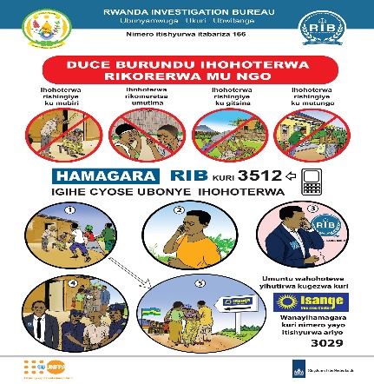
During COVID-19, the JP Gender partnered with government institutions, ICT and Innovation, and the National Child Development Agency to increase awareness of the risks of child protection violations and abuse, risk messaging and the implementation of a campaign around Child Online Protection which reached over 200,000 people through social media, radio and television. Additionally, with financial contribution from the Royal Netherlands Embassy to Rwanda and SDC, around 5.5 million people were reached with messages on GBV prevention and response and child defilement using different communication channels including radios (national and community), TV, street ads and face to face awareness raising campaigns. This also included the one yearlong national awareness campaign launched by the Ministry of Gender and the then National Commission for Children (NCC) during the international Day of the Girl Child.
Raising awareness on GBV in the context of COVID-19
During the COVID-19 pandemic, the world has witnessed an increase of GBV globally. Data from the Rwanda Investigation Bureau (RIB) shows that the number of GBV cases reported have increased with 28.3%, from 969 cases in March 2020 to 1,243 cases in June 2020, which coincides with the lock down period due to preventive measures of the COVID-19. To address this issue, the JP Gender through SDC funding, have involved various partners including the GMO, Rwanda Religious Leaders Initiative (RRLI) and Rwanda Correctional Service (RCS).
In partnership with GMO and RRLI, a drama series titled “Ziririza”/”Stop GBV” was developed and played on national and community radios, as well as talk shows on TV , reaching over 5.5 million people with messages on GBV prevention and response (including toll free lines), the need for mindset and social norm change, and GBV laws incriminating both perpetrators and anyone not reporting GBV. The TV broadcasting helped the programme to increase awareness raising during the lockdown period due to COVID-19 in which people remained in their home. As a result of the broadcasting, 211 cases were reported to the GMO toll free line, and 98 cases were received immediately after airing the Ziririza drama series, including 58 cases of economic violence, 16 cases of sexual violence, 26 cases were related to the rights of children, and 3 cases to psychological abuse. These cases were referred to the right service providers and advocacy was done to ensure that they receive fair services. Consequently 14 GBV victims were provided with legal support offered by Haguruka; a Rwanda non-governmental organization working for women’s and children’s rights and the elimination of all forms of violence. Those 14 cases have been assigned dedicated lawyers who are following up and advising the victims accordingly. However, as shown by the study on ”Knowledge, attitude and practices on GBV, perceived GBV root causes and IOSC service delivery” conducted by MIGEPROF in mid-2019, there are still a number of key social norms and issues among the community which continue to hinder effective GBV Prevention and response.
Building on the study/research on trafficking and legal framework guide for practitioners in Rwanda which was developed by UN Women, IOM, UNHCR, and UNICEF in 2019, to the response towards trafficking in persons, the UN is continuing its work on awareness raising and sensitization campaign on trafficking in persons in Rwanda. As part of this, communication material is developed in partnership between the JP Gender and MINIJUST, through MPTF funding. Face to face trainings was planned for 2020 but postponed to 2021 due to COVID-19.
Ending GBV together
In collaboration with RRLI and through funding by the SDC, 170 religious’ leaders from the interfaith community including Muslims, catholic and protestant members have increased their understanding, knowledge, and skills in GBV Prevention and response. As a result, religious leaders committed to meet the local government leadership on a semester basis (e.g. in Musanze) to tackle the issues of and reporting of GBV cases and to continue the dialogues on GBV, early pregnancies and mindset change of religious leaders to embrace gender equality and fight against GBV as they are amongst the most influential leaders in the community. A handbook on GBV Prevention and response were developed to help the religious leaders in harmonization of messages during their awareness campaigns.
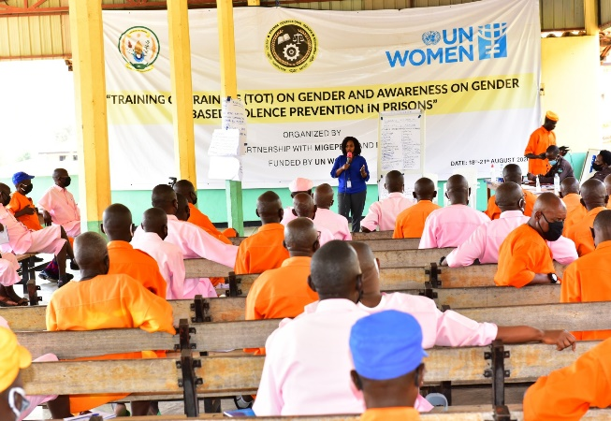
In collaboration with SDC, the JP Gender in partnership with the Rwanda Correctional Service (RCS) a pool of 82 GBV trainers (41 women and 41 men) were established and additional 45 RCS senior management increased their understanding in GBV Prevention and response. As a result, all 13 prisons and 3 TIG (Travaux d’interets generaux/Community services for genocide convicts) Camps of Rwanda, including a total of 918 inmates (250 women, 668 men) could be reached. The focus on prison is envisioned to have a great impact in the prevention of GBV as inmates (GBV and non GBV perpetrators) will return to their communities and there is a crucial need to reduce the risk of recidivism. In addition, many inmates have been in detention since 1994/1995 for committing the Genocide against the Tutsis are in their last phase of their sentence. They need to be reintegrated and to build their knowledge and understanding on GBV Prevention and response, including laws on GBV that were enforced during their sentence. Thanks to the JP Gender, awareness-raising and training reached nearly 1000 prisoners in 2020 and with the training of trainers (82 RCS staff), this is expected to multiply in the coming year. RCS has committed to undertake and continue the journey of transformation in all prisons but expressed the need of joint efforts from various stakeholders to bring sustainable change in prisons.
Photo: Photo of participants (prisoners) to the awareness raising training
During the past decade, men and “Men Engage” networks are increasingly participating at the frontline to fight for gender equality, women’s rights and to promote positive masculinities and challenging the status quo. In this framework, the UN supported the organization of the third edition of Men Engage Alliance Global Symposium “Ubuntu Symposium” through Rwanda Men Resource Centre (RWAMREC), a Rwandan NGO aiming to address issues of negative masculine behaviours, gender-based inequalities and violence. The event was held in Kigali 10-12 November 2020, seeking to ‘transform masculinities and engage men and boys’ in advancing women’s rights, and gender and social justice. The Symposium was attended by more than 120 participants, and many more connected virtually due to COVID-19. It provided space to share experiences, evidence, and insights, and to take stock of how the work on Men Engage has evolved in the past years. It also helped to reaffirm the alliance's commitments and accountability towards gender equality, women’s rights, and social justice movements through critical ‘men and masculinities’ approaches in a context of 25th anniversary of Beijing platform for action and Generation Equality Agenda promoted by the One UN.

Changing the lives of teen mothers
Through the financial support of the SDC, the JP Gender have provided socio-economic reintegration of GBV victims with a specific focus on teen mothers. In total, 512 teen mothers and their parents have participated in counselling and parent-adolescent communication (PAC) and knowledge building of SRHR and positive behaviors and communication. In addition, 171 teen mothers benefited from psycho-social support, medical and family planning services, as well as trainings in micro projects/business management. As a result, 169 teen mothers were reintegrated in their families, 157 teen mothers could pay for health insurance with support from their parents, 9 teen mothers returned to school, 154 children of teen mothers were legally registered, and 148 teen mothers started small businesses whilst six are in vocational training (sewing and hair dressing).

Preventing and responding to GBV in refugee settings
Under the JP Gender through UNHCR funding, GBV prevention and response services reached 600 survivors (89% women and girls) in refugee settings (both camps and urban areas), in 2020. The case management support (including psycho-social and medical services, material support and legal assistance) continued to be provided to survivors. The SASA! Methodology, a community driven methodology developed the NGO Raising Voices and implemented by the UN with the aim to transform cultural power imbalances between women and men to prevent SGBV and HIV, continues to be used by the UN for in SGBV prevention. This includes using trainings, communication materials, media advocacy and local activism. Under the local activism strategy, community activists were engaged to raise awareness on the negative effects of SGBV with significant emphasis on power imbalances between men and women. Other activities included community dialogue sessions, theatres, community campaigns, engaging couples in family dialogues, and sports competitions with youth. Prevention activities also included conducting door-to-door activities, public campaigns on the effects, the root causes and contributing factors to SGBV, celebration of international days such as IWD and 16 days of Activism, as well as organizing fireplace activities to create space for refugees to dialogue on how communities can spearhead SGBV response mechanisms.
Although the COVID-19 crisis initially hindered many activities to be undertaken as planned, this prompted partners to quickly adopt new approaches such as disseminating SGBV messages on community broadcasting, and providing remote case management services to the survivors (using phone calls, hotlines and internet). Various refresher training sessions were provided to 1557 key stakeholders, including 86 UN staff, 170 schoolteachers and 1301 refugees. The targeted refugee groups included community-based committees/groups and school-based clubs on SGBV prevention as well as community volunteers team leaders.
- JP Output 4.2: Strengthened capacity of relevant institutions/GBV service providers to handle/respond to S/GBV cases including capacity to harmonize and preserve forensic evidence

Although the Isange one Stop Centre programme (IOSC) started in Rwanda in 2009 providing holistic response to GBV and child abuse across the country, no strategic plan was developed to guide its operations across the country. Under the Joint programme and with financial support from the Netherlands Embassy to Rwanda, and in partnership between the JP Gender and Rwanda Investigation Bureau (RIB), a five-year IOSC strategic plan (2020-2025) and operational plan 2020/21 were developed to serve as a national instrument to harmonize operationalization of IOSCs across the country. These documents were finalized, designed, and printed for dissemination and use by different key stakeholders but due to COVID-19 prevention and restriction measures, the dissemination is waiting to be done once these measures are lifted.
In addition, the study “Knowledge, Attitude and Practices on perceived GBV Root causes and IOSC service delivery” was conducted by MIGEPROF with the technical support from the Joint Programme on Gender and disseminated in over 1000 copies in English and Kinyarwanda, and in full and summarized versions. The findings confirmed that women remain most exposed to GBV, that more women than men have knowledge of GBV except for in the age category 15-17 years. The study found that people generally have limited knowledge on GBV law and its provisions, but demonstrate a fairly high level of knowledge on the Law governing matrimonial regimes, donations and successions and the Land law, both of which address power imbalances between men and women, a factor in the occurrence of GBV. On IOSCs, the knowledge its existence and work reveal that education is a significant factor. Cultural and patriarchal stereotypes and attitudes still play a big role in fueling GBV in Rwanda as elsewhere. The culture of silence still prevails, and families report to prefer to resolve GBV issues within and among themselves. This compromises reporting, service seeking and justice for survivors.
Through financial support to MIGEPROF, the dissemination as well as a discussion on the findings and ways forward was held in the Eastern Province in November 2020 at the Coordination meeting on Family Promotion and Child Rights chaired by the Honorable Minister of MIGEPROF, and attended by 156 participants (National level:10, Provincial level:8, Districts and stakeholders: 138), including the Honorable Minister of State in charge of Social Affairs/ MINALOC, Chief Gender Monitor, Deputy Secretary General of RIB, Deputy Director General of National Institute of Statistics of Rwanda (NISR), Executive Secretaries of National Children Commission (NCC) and National Women Council (NWC) as well as the National Coordinator of National Early Childhood Development Programme (NECDP).
Through SDC funding, GBV service providers have enhanced capacities to provide quality services to GBV Victims and in GBV Management Information System (MIS) which is a newly developed system integrated to Integrated electronic Management System (IECMS). The system is managed by the Ministry of Justice (MINIJUST) and integrates National Public Prosecution Authority (NPPA), Rwanda Investigation Bureau and the Rwanda Correctional Services (RCS). IECMS was initiated to improve Judicial Service Delivery by reducing delays and transaction costs associated with judicial cases processing through the whole justice chain from the beginning of a case to its final adjudication/closing. Therefore, GBV MIS system will help to harmonize the information gathering on the victim and the perpetrator, data analysis, storage and dissemination in a more harmonized manner but also immediately reporting the case into IECMS.
The reporting of GBV cases is now further harmonized because of the support provided by the UN through SDC funding. In collaboration with RIB, 279 GBV service providers (168 males, 111 females) have enhanced their skills and capacity to use GBV MIS and report GBV cases in a more harmonized way. These include 160 investigators at different levels (29 chief investigators at district bureaux, 4 Chief Investigators at Provincial Bureaux, 83 investigators from different RIB stations, 44 investigators attached to Isange One Stop Centers) and 39 doctors, 41 psychologists, and 39 GBV officers from Isange One stop centres countrywide. With this pool of trained users of GBV MIS, it is envisaged that the next step is to roll out the GBV MIS to ensure that GBV cases are reported through the system in a more harmonized way which will help to generate data and share with stakeholders for advocacy and evidence based planning and decision making. Additionally, with the financial support from the Royal Netherlands Embassy to Rwanda and in collaboration with RIB, the IOSC Standard Operating Procedures (SOPs) were revised and translated in Kinyarwanda and French. A total of 1,300 copies of the SOPs were printed for distribution to all IOSCs service providers. The revised SOPs were disseminated to service providers during the training on the GBV IMS. The revised SOPs considered changes in the operating environment and referral mechanisms for effective service provision.

Challenges, best practices, and lessons learned in 2020
Challenges
- The COVID-19 pandemic and its related preventive measures include mobility restrictions, gatherings, and meetings as well as school closures. During the period of lockdown, all non-essential businesses remained closed. This caused major interruptions and delays to the implementation of the programme, as many activities could not be carried out as planned. This particularly includes face to face training. These challenges had a direct and negative impact on financial performance. To mitigate the challenges, the programme adapted its implementation modalities and used to the extent possible, digital solutions for meetings, awareness raising and knowledge sharing.
- It is evident that the impacts of COVID-19 are disproportionately affecting women and girls. During the pandemic, there has been a reported increase in violence against women and girls and lost learning opportunities for girls as school drop-out rates, care responsibilities and child marriages rise. Tens of millions more women plunged into extreme poverty and lost their jobs at a higher rate than men. In Rwanda, the unemployment rate for women increased with 11% in comparison to 6% for men between February and May (Source: NISR, Labour Force Survey, February and May 2020 Reports) and reported S/GBV cases increased with 28.3% between March and June in 2020 (Source: Rwanda Investigation Bureau Report, fiscal year 2019/2020). As such, focus had to be redirected and allocations were made to respond to the urgent needs of women.
- During the initial stage of the COVID-19 pandemic, child protection was not considered an essential service, even though children continued to be at risk of violence, exploitation and neglect. It is important to recognize that in health/infectious disease pandemics, certain services, such as child protection, continue to be essential and should be identified as such from the beginning.

Lessons learned
- The COVID-19 crisis has shown the importance of women’s leadership and women’s empowerment in times of crisis. While women are the hardest hit by the pandemic, they are also at the frontline of the COVID-19 response, as caregivers, health workers, the backbone of communities and effective leaders, in fighting the pandemic. In several countries around the globe, women are at the helm of effective and inclusive COVID-19 prevention, response and recovery efforts, despite being frequently under-represented at the highest levels of decision-making. While Rwanda is a notable exception with 61.3 % of women in the parliament, women only made up 25 % of national parliamentarians on a global average. In 2020, as a global average, women were 4.4 % of CEOs, occupied just 16.9 % of board seats, and 13 % of peace negotiators.
- To address the growing numbers of child abuse, violence and neglect, there is a need for a strong child protection system and case management. This was made more apparent through 2020 when cases of violence rose, due in part to the impacts of COVID-19, but also due to increased knowledge and channels for reporting.
- GBV and violence against women is entrenched in social norms and beliefs and need to be tacked using multisectoral approach and bringing on board non-traditional partners such as religious and local community leaders for mindsets change and joint planning among key stakeholders increases the ownership of the programme and boost the teamwork spirit among the technical team
Best practices
- In a bid to prevent the spreading of the COVID-19 virus, virtual meetings were held with partners and beneficiaries during 2020 when possible. This has proven to be both cost and time efficient and allowing a large number of people to be reached.
- Strong partnerships with the government in the area of child protection led to quick adaptation and response to child protection during COVID-19. For example, airtime was extended to all 29,674 IZU and Child Protection and Welfare Officers to ensure continuity of contact with vulnerable families and children. In addition, masks and sanitizers were procured for all the child protection workforce to facilitate their work safely and the JP Gender partnered with the government to establish a new hotline (711) for reporting cases.
- To support the socio-economic integration of GBV victims, and in particular teen mothers, comprehensive packages have been developed to tackle the many issues that they face. The develop packages include psycho-social support, parent-adolescent communication, medical as well as economic support to rebuild the lives of the victims, to restore families, build self-confidence, esteem and resilience of the victims.
- In the beginning of the year, engagement with community activists and other community-based drama groups, and the camp executive committee to implement SASA! Activities such as community dialogue sessions, theatres, community campaigns, engaging couples in family dialogues, and sports competitions with youth. Prevention activities also included conducting door-to-door activities, public campaigns on the effects, the root causes and contributing factors to SGBV, as well as organizing fireplace activities to create space for refugees to dialogue on how communities can spearhead SGBV response mechanisms. However, all activities were destabilized due to COVID-19 prevention measures and this prompted partners to immediately adopt new prevention approaches such as disseminating SGBV messages on community broadcasting and providing remote case management services to the survivors (phone calls, hotlines and internet).
Qualitative assessment

The year 2020 was marked by COVID-19 causing not only a global health crisis but also a socio-economic crisis that has deepened pre-existing inequalities, exposing weaknesses in social, political and economic systems globally. Across every sphere, from health to the economy, security to social protection, the impacts of COVID-19 are disproportionately affecting women and girls and the gains in advancing gender equality and women’s empowerment are at risk of being reversed. During the pandemic, the world has witnessed increased violence against women and girls and lost learning for girls due to school dropouts, losses of income for the many women in the informal sector, increased care responsibilities and a rise of child marriages.

Despite great efforts by the UN and its partners to not only responds to the emerging crisis but to reprogramme and reallocate funds for existing programmes to meet needs, implementation delayed on some activities as they could not be implemented due to restrictions, or as focus was needed elsewhere to respond to urgent needs of women. In this process, the close and transparent collaboration and dialogue with partners has proved essential in the work to overcome the hinders presented by the pandemic this year, and to keep delivering for women and girls, men and boys in achieving an equal world – not at least as we build back better.

In this regard, the UN in collaboration with the Ministry of Gender and Family Promotion commissioned a phone-based study to look into the impact of the COVID-19 on women and men in Rwanda so as to better understand the gendered impacts of the pandemic and to inform national development planning for the recovery. The study highlighted the negative impact on income, the health of women and men, and safety, including the increase in GBV cases during the lockdown.

Women’s political empowerment and increased participation of women in leadership at all levels is the pillar of JP Gender in Rwanda. The results on this impact area come from a combination of processes and outputs that all culminate into electoral processes. However, due to COVID-19 pandemic the pre-planned awareness raising, capacity development for the aspirant women, engagement of Elections Management Bodies and actors on gender mainstreaming of the rescheduled 2021 local government elections could not happen as planned and this postponement delays the materialization of the gender joint programme expected results on the increase of women’s representation in leadership positions which is highly desired to positively influence the forthcoming Global Gender Gap Report (GGGR).

As part of this, in 2020, the UN continued to leverage foundational studies and assessments to support evidence-based programming, monitoring and reporting. Foundational studies and assessment were supported and undertaken by the UN, including the rapid gender assessment of the impact of COVID-19 on women and men in Rwanda initiated in the beginning of the emerging crisis and the UN report on the socio-economic impact assessment of COVID-19 in Rwanda. The findings and recommendations have contributed to and informed the One UN Joint Programme in support of the Social Economic Recovery Plan (COVID-19 JP SERP) but also in evidence-based programming and advocacy.

In terms of UN coordination, gender is considered both as a standalone and a cross cutting issue in the United Nations Development Assistance Plan (UNDAP 2018-2023) as a result of increased support, advocacy and coordination efforts for gender equality enhancement. The implementation of the first ever Gender Mainstreaming Strategy is ongoing and continues to guide the implementation of the UNDAP (2018-2023) and goes hand in hand with the implementation of the JP Gender. The close cooperation within the One UN Rwanda, and through the joint programmes, has created an enabling environment for joint Gender Equality initiatives and gender mainstreaming through the One UN and synergy effects in terms of knowledge generation, communication and focused implementation. The UN Coordination structure consisting in delivering results through Results Groups have contributed to further enhancing synergy and conductively influence the results achieved. Transformational Governance Results Group spearheading most of the gender results areas have served as a driving force behind the inter-agency collaboration.

In addition, the document on legal assistance to GBV victims conducted in collaboration with Haguruka and Rwanda Bar Association (RBA) compiled key achievements and success stories from beneficiaries who had sought support for years and could now finally restore dignities, self-confidence and esteem as a result of the legal support, including DNA tests for paternity searching. This showed the importance of GBV mobile legal clinics its cost and time effectiveness in providing legal services to the community. Men's engagement in GBV prevention and response at different levels was highlighted as key in challenging the negative masculinity behaviors which condone GBV. Key challenges highlighted by different stakeholders including the beneficiaries of the legal assistance were mainly community limited legal literacy, connivance between the perpetrators and some local leaders which help the perpetrators to escape, public humiliation and stigma to the GBV Victims especially sexual violence which prevent the victims to report or seek assistance as well as limited knowledge on preservation of forensic evidence and referral mechanisms.

ii) Indicator Based Performance Assessment:
 | Achieved Indicator Targets | Reasons for Variance with Planned Target (if any) | Source of Verification
Outcome 1  By 2023, people in Rwanda benefit from enhanced gender equality, justice, human rights, peace and security. (UNDAP Outcome 5)  Indicator 5.5:  Gender Gap Index (GGI).  Baseline: 0.82 (2017)  Planned Target: 0.85 (2023)  Indicator 5.6:  % of women holding positions in decision making organs.  Baseline: (July 2018)  1) Parliament lower chamber: 63.7%  2) Parliament -Senate: 38%  3) Cabinet: 40%  4) Districts Mayors: 20%  Planned Target: 2023  (1) 63.7%, (2) 40%, (3) 45%, (4) 30%.  Indicator 5.7:  Number of state institutions (disaggregated by ministries and districts) whose budget planning process and implementation meet gender responsive planning and budgeting principles.  Baseline: 2018  Allocation: Ministries: 8, Districts: 15  Budget expenditure: Ministries: 10, Districts: 15  Planned Target: 2023  Allocation: Ministries: 17, Districts: 30  Budget expenditure: Ministries: 17, Districts: 30 | Indicator 5.5:  0.791 (2020)  Indicator 5.6:  1) Parliament, lower chamber: 61.3% (2020)  2) Parliament, Senate: 38% (2020)  3) Cabinet: 51.6%  4) District Mayors: 30% (2020)  Indicator 5.7:  1) Ministries: 12 (4 additional ministries in 2020)  2) Districts: 30 | Indicator 5.5:  The gender gap index has slightly declined from the baseline of 82.2% to 79.1%. Although the UN has made considerable contribution to GEWE in Rwanda, attention will be focused on analyzing causes of the drop in GGI which the World Economic Forum gender gap report attributes to limited human capital development and gaps in women’s economic participation and opportunity.  Indicator 5.6:  1) On track  2) On track  3) Achieved  4) Achieved  Indicator 5.7:  1) On track. 4 additional ministries in 2020.  2) Achieved | Indicator 5.5:  GGI  Indicator 5.6:  National Institute of Statistics of Rwanda (NISR), National Gender Statistics Report 2019; and Premature website.  Indicator 5.7:  GBS reports /MINECOFIN /GMO.
Output 1.1  Women’s capacity to compete for leadership positions and to lead decision making processes at local and national level strengthened  Indicator 5.1.4:  No. of women candidates with skills and capacities to participate in the electoral process.  Baseline: July 2018  1) Parliament: 221, 2) Local government: 209, 3) Mediators: TBD  Planned Target:  2018 1) Parliament:543  2020 1) Parliament: 743  2021 3) Mediators: 200  2022 2) Local government: 418  2023 1) Parliament: 442 2) Local Government: 418 3) Mediators: 200  Indicator 5.1.5:  Number of women and girls reached out to through mentorship program in leadership and entrepreneurship  Baseline: 7900 (2017)  Planned Target:  2019: 8,700, 2020: 9,000, 2023: 10,000  Target values are cumulative over the years) | Indicator 5.1.4:  1) Parliament: 221 (no change in 2020)  Indicator 5.1.5:  UNW 773 (2020)  UNHCR: 5612 (2020)  UNDP: 220 (2020)  Additionally, 4100 women and girls participated at the Youth Connekt in 2019/2020) | Indicator 5.1.4:  The last parliamentary election took place in 2018 and the next election is scheduled for 2023. Local government elections were scheduled for March 2021 but postponed until the COVID-19 situation can allow for elections to take place. This is also the reason why no women candidates were trained in 2020.  Indicator 5.1.5:  On track | Indicator 5.1.4:  NWC, NEC, GMO, MIGEPROF annual reports.  Indicator 5.1.5:  MIGEPROF Annual reports
Output 1.2  National and local level Government institutions’ capacities to execute gender-responsive development strategies, sector strategies, district development plans and budgets increased  Indicator 5.1.1:  Gender budget tracking tool for use by state institutions developed.  Baseline: 2018 No  Planned Target:  2019: Advocacy starts with GMO to develop a gender budget allocation tracking tool  2020: Prototype of the gender budget tracking tool tested  2023: Yes. Budget tracking tool in place and in use.  Indicator 5.1.2:  Number of government institutions with at least 2 staff who have skills to systematize gender budget planning and execution tracking and reporting.  Baseline: 2018  Ministries: 2, Districts: 5  Planned Target:  2019: Ministries: 10 Districts: 18  2020: Ministries: 12 Districts: 20  2023: Ministries: 17 Districts: 30 | Indicator 5.1.1:  GRB remains the only tool in use but the UNDAP2 targets a more systematic tool  Indicator 5.1.2:  1) Ministries:10  2) Districts: 30 | Indicator 5.1.2:  1) On track  2) Achieved | Indicator 5.1.1:  MINECOFIN, GMO, MIGEPROF (Gender Barometer Report by MIGEPROF).  Indicator 5.1.2:  MIGEPROF/GMO annual reports, UN Women annual reports.
Output 1.3  Community awareness of gender equality and civic understanding of women’s right to equal participation in decision making increased.  Indicator 5.1.3:  Proportion of media houses with gender mainstreaming editorial policies in place  Baseline: < 5% (2018)  Planned Target: 20% (2023) | Indicator 5.1.3:  Not available | Indicator 5.1.3:  Not available  Gender-mainstreaming of media have been done on individual levels with 73 media practitioners received capacity building in gender equality and mainstreaming, family planning and sustainable environmental | Indicator 5.1.3:  UNESCOs reports, RMB.
Outcome 2  By 2023, people in Rwanda participate more actively in democratic and development processes and benefit from transparent and accountable public and private sector institutions that develop evidence-based policies and deliver quality services. (UNDAP Outcome 6)  Indicator 6.1:  Proportion of population who believe decision-making is inclusive and responsive  Baseline: 77% (2018)  Planned Target: 80% (2023)  Indicator 6.3:  % of citizen satisfaction in their participation in elections.  Baseline: 87% (2018)  Planned Target: 90% (2023)  Indicator 6.5:  % of citizens' satisfaction with holding leaders accountable.  Baseline: 81.6% (2018)  Planned Target: 85% (2023)  Indicator NSTI 54:  % of citizens satisfaction in their participation in planning and budgeting processes  Baseline: 25.6% (2017/2018)  Planned Target: 90% (2023/2024)  Indicator NSTI 50:  % level of transparency and accountability in public sector  Baseline: 85.78% (2017/2018)  Planned Target: 97% (2023/2024) | Indicator 6.1:  (CRC pg. 150)  1) 72% of women are satisfied with their involvement in decision making  2) 66.2% of men are satisfied with their involvement in decision making  Indicator 6.3:  91.4%  Indicator 6.5:  75.8%  Indicator NSTI 54:  76.9% (RGS 2020)  Indicator NSTI 50:  74.9% | Indicator 6.1:  On track  Indicator 6.3:  Achieved  Indicator 6.5:  Decreased 5.8% from baseline  Indicator NSTI 54:  On track  Indicator NSTI 50:  Decreased 10.8% from baseline | Indicator 6.1:  RGB/RGS, CRC 2020 (pg. 150)  Indicator 6.3:  RGB/RGS, CRC  Indicator 6.5:  RGB/RGS, CRC  Indicator NSTI 54:  CRC reports  Indicator NSTI 50:  CRC reports
Output  JP Output 2.1: Accountability mechanisms on gender equality and women’s empowerment in government agencies, CSOs, FBOs, I/NGOs and political parties are monitored and strengthened  Indicator 6.4.2:  Level of citizen satisfaction with service delivery in local administration.  Baseline: 72.9% (2018)  Planned Target: 80% (2023)  Indicator NSTI 53:  % of citizen satisfaction with the performance of local government councils  Baseline: 47.5% (2018)  Planned Target: 90% (2023) | Indicator 6.4.2:  71.3%  Indicator NSTI 53:  80.6% (CRC, 2020) | Indicator 6.4.2:  On track  Indicator NSTI 53:  On track | Indicator 6.4.2:  RGS  Indicator NSTI 53:  CRC/Imihigo Evaluation
Outcome 3  By 2023, people in Rwanda benefit from more inclusive, competitive and sustainable economic growth that generates decent work and promotes quality livelihood for all. (UNDAP Outcome 1)  Indicator 1.4:  Unemployment rate by sex and age.  Baseline: Total: 16.7% (Youth: 21%; Male: 16.1%; Female: 17.5%)  Planned Target: Will be based on final NST Labour force survey 2017  Indicator 1.7:  % of total employment with main job in informal sector.  Baseline: 2017 91%  Planned Target: 2023: 85%  Indicator NST1 38:  %age of learners enrolled in STEM related subjects  Baseline: 2017/2018: 58.0% (TVET)  Planned Target: 2023/2014: 63.6 (TVET | Indicator 1.4:  Youth: 20% (August 2020)  Male: 13% (August 2020)  Female: 19.7% (August 2020)  Total unemployed population: 16% (August 2020)  Indicator 1.7:  Total of informal employment: 89.5%  Indicator NST1 38:  1) % of STEM students enrolled in Upper secondary schools in 2019: 58.3%  2) % of STEM students enrolled in tertiary institutions in 2019: 43% | Indicator 1.4: During the lockdown, the unemployment rate increased but employment rates recovered partially after the lockdown period as registered in the August survey. The Labour Survey conducted by the National Institute of Statistics of Rwanda (NISR) in May 2020, showed the unemployment rate among women over the age of 16 increased from 14% to 25% between February and May 2020, compared to 13 to 19% for men. The same survey found the female labour force participation rate at 47%, much lower than the rate of men at 64.3%.  Indicator 1.7:  On track  Indicator NST1 38:  On track | Indicator 1.4:  NISR: Labour force survey  Indicator 1.7:  NISR: Labour force survey.  Indicator NST1 4:  NEP Reports EICV survey, Labour Force Survey  Indicator NST1 38:  WDA, MINEDUC (2019 Education Statistical yearbook)
Output  JP Output 3.1: Women have enhanced skills and access to finance and markets to leverage business opportunities  Indicator 1.4.1:  No. of target population with entrepreneurship skills. (Disaggregated by sex, rural/urban, age range).  Baseline: 0 (2018)  Planned Target: 2019: 2,060, 2020: 5,120, 2021: 7,240, 2022: 9,300, 2023: 10,600  Indicator 1.4.2:  No. of people reached through new financial products (e.g. new products, UN Supported Women's Investment Funds). (Disaggregated by sex, age and rural/urban).  Baseline: 2018: Women’s Investment Fund: 0 clients  Planned Target: 2023: Women’s Investment Fund: 80,000 clients | Indicator 1.4.1:  UNHCR: 5,612 (2020)  UNW: 2,623 (2020)  Indicator 1.4.2:  NA | Indicator 1.4.1:  Achieved | Indicator 1.4.1:  Programme progress reports, UN Women Annual Report 2020  Indicator 1.4.2:  BNR and WB reports  UN Women Annual Report 2020
Output  JP Output 3.2: Women’s capacity and opportunities to access remunerated off-farm employment increased  Indicator 1.4.5:  Number of youth led organizations and networks participating in national policy dialogue, advocacy and programming, including in humanitarian settings.  Baseline: 1 (2018)  Planned Target: 10 (2023)  Output  JP Output 3.3: Corporate sector actors demonstrate increased understanding of and commitment to implement gender equality and women’s empowerment practices  Indicator 1.4.1:  No. of target population with entrepreneurship skills.  Baseline: 0 (2018)  Planned Target: 2019: 2,060, 2020: 5,120, 2021: 7,240, 2022: 9,300, 2023: 10,600. Target values are cumulative over the years. | Indicator 1.4.5:  NA  Indicator 1.4.1:  UNHCR: 5,612 (2020)  UNW: 2,623 (2020) | Indicator 1.4.1:  Achieved | Indicator 1.4.5:  African Youth and Adolescents Network on Population & Development (AfriYan) reports.  Indicator 1.4.1:  Programme progress report
Outcome 4  By 2023, people in Rwanda, particularly the most vulnerable, have increased resilience to both natural and man-made shocks and enjoy a life free from all forms of violence and discrimination. (UNDAP Outcome 4).  Indicator 4.2:  % of women aged 15-49 who have ever experienced violence (by type).  Baseline: 2015 (DHS)  Sexual violence 22%  Physical violence 35%  Intimate violence from partner 37%  Planned Target: 2023  Sexual violence: 15%  Physical violence: 30%  Intimate violence from partner: 32% | Indicator 4.2:  Sexual violence: 22%  Physical violence: 35%  Intimate violence from partner: 37% | No updated data as the DHS is to be released in 2021. However, the Rwanda Investigation Bureau (RIB) reported updated figures in 2020, showing an 19.62% increase of reported GBV cases with 10,842 SGBV cases reported between July 2019 to June 2020, compared to 9,063 between July 2018 and June 2019. Additionally, the number of GBV cases reported increased from 969 cases in March 2020 to 1,243 cases in June 2020 (28.3% increase), which coincides with the lockdown. (Source: Rwanda Investigation Bureau report, fiscal year 2019/2020). | Indicator 4.2:  Demographic and Health Survey.
Output  JP Output 4.1: Increased awareness among target communities on available S/GBV services (e.g. at the IOSC), how to prevent and/or timely report and how to respond to incidents of S/GBV.  Indicator 4.2.3:  # of individuals that have improved knowledge and awareness on S/GBV prevention and response (by target group).  Baseline: 2017  MDIT: 300  Security organs: 250  HeforShe outreach: 4,200  Women and men in cross border trade: 40  Inmates convicted of SGBV: 1,000  Refugees: 224  Planned Target:  MDIT: 500  Security organs: 500  HeforShe outreach: 20,000  Women and men in cross border trade: 2,000  Inmates convicted of SGBV: 2,000  Refugees: 446 | Indicator 4.2.3:  MDIT:  Security organs:  HeforShe outreach:  Women and men in CB trade:  Inmates: 918 (250 women and 668 men) +45 people from Rwanda Correctional Services senior management  Refugees:1301 (2020)  170 religious’ leaders from interfaith community including Muslims, catholic and protestant members have increased their understanding, knowledge and skills in GBV Prevention and response. | Indicator 4.2.3:  An additional 5.5 million people were reached with information on GBV prevention and reporting and referral mechanisms through Ziririza drama series, radio spots, posters in all IOSCs and use of street Billboards and markets to relay prevention messages during the COVID-19 crisis. | Indicator 4.2.3:  RNP, MINISANTE, MIGEPROF, UN Women reports. UNHCR reports.
Output  JP Output 4.2: Strengthened capacity of relevant institutions/GBV service providers to handle/respond to S/GBV cases including capacity to harmonize and preserve forensic evidence  Indicator 4.2.4:  # of service providers with the capacity to respond to cases of SGBV, child abuse, exploitation and neglect.  Baseline:  IOSC: 4  (Inshuti Z’Umuryango) IZU: 0  Other Service Providers (MAJ/ MINIJUST, MINISANTE, RNP, NCC, CSOs, etc): 2  Planned Target:  IOSC: 23  IZU: 29,674  Other Service Providers (MAJ/ MINIJUST, MINISANTE, RNP, NCC, CSOs, etc): 27 | Indicator 4.2.4:  IOSC: 0  IZU: 0  Other Service Providers: 279 (111 women, 168 men) +82 (41 women and 41 men)  Details: 279 GBV service providers increased their capacity in GBV MIS. Among them, 160 RIB and IOSC investigators, 39 doctors, 41 psychologists, 39 GBV officers).  A pool of 82 trainers in GBV prevention and response has been established at RCS | Indicator 4.2.4:  464 teen mothers supported with psychosocial and income generating opportunities | Indicator 4.2.4:  MAJ/MINIJUST, MINISANTE, RNP, CSOs, UN Women reports. NCC/ MIGEPROF reports.

iii) A Specific Story
As part of Rwanda’s ambition to continuously advance Gender Equality and Women’s Empowerment, a review of the 2010 National Gender Policy was conducted in 2020, with a view to align it with the fast-evolving development policy agenda and the country’s new aspirations articulated in the Government’s seven-year program – the National Strategy for Transformation (NST1, 2017-2024). The new policy is also aligned with Vision 2050, the SDGs and the AU Agenda 2063. Importantly, it builds on the achievements made under the previous policy and proposes policy actions to address the identified gaps and emerging issues pertaining to gender equality and equity in Rwanda. It identifies eight strategic priority areas including women’s economic empowerment, gender mainstreaming in all sectors and district development plans, Engaging Men, addressing negative social norms, and increased accountability.
The newly adopted policy reinforces the strategic positioning of gender equality and women's empowerment as a key pillar of Rwanda’s socio-economic transformation.
The policy review process relied on a collaborative approach with a technical committee comprising representatives from various government institutions, civil society organizations, UN agencies and other relevant partners to validate early drafts of the policy, including identifying gaps and emerging issues pertaining to gender equality in Rwanda. Issues such as the effective engagement and involvement of men and boys as well as the private sector in accelerating the Gender Equality agenda were central to the discussions. The review process supported under the Joint Programme on Gender was significantly enhanced by the fact that it coincided with national consultations around the 25 years of Beijing Declaration and Platform for Action. The new national gender policy which was approved by the Cabinet in February 2021 was therefore significantly informed by the country’s Beijing+25 report. This important result in terms of supporting policy formulation was the outcome of an effective multi-stakeholder collaboration, bringing together national institutions, civil society organizations and the One UN (namely UN Women, UNFPA, UNHCR, UNDP, FAO, WFP and UNICEF) to provide strategic and technical support to advance gender equality in Rwanda.

- Other Studies, Assessments or Evaluations

Study on Trade Barriers for Women (page 9)
In a bid to expand opportunities for women, the Joint Programme on Gender together with its partners commissioned a study on “Trade barriers hindering women businesses in Rwanda” with the main objective of generating knowledge and evidence to guide decision-making around the promotion of a gender-responsive business environment for both domestic and international trade. The study underway and the results will be disseminated in mid-2021.

Study on GBV and IOSC delivery (page 14)
A study on “Knowledge, Attitude and Practices on perceived GBV Root causes and IOSC service delivery”
conducted by MIGEPROF in 2019, with technical support from the JP Gender and financial support from the Netherlands, was published and disseminated in over a thousand copies in English and Kinyarwanda

Studies in the context of COVID-19
In 2020, the UN in Rwanda carried out foundational studies in the context of COVID-19, namely the “Rapid gender assessment of the impact of COVID-19 on women and men in Rwanda” and the “UN report on the socio-economic impact assessment of COVID-19 in Rwanda”. While, these studies are not part of the Joint Programme on Gender, their findings continue to inform evidence-based programming and advocacy for all joint programmes under implementation, including the One UN Joint Programme in support to the Social Economic Recovery Plan (COVID-19 JP SERP).

Study on gender compliance among Rwandan Laws
In 2020, as part of Equality at Law initiative and in partnership with Legal Aid Forum (LAF) and Rwanda Women Parliamentarians Forum (FFRP), UN Women commissioned a comprehensive assessment of gender compliance among Rwandan Laws. The final validation workshop of the report on “Fast Tracking Gender Equality in Law in Rwanda: Comprehensive Legal Analysis of Gender Compliance under Rwandan Laws”. The analysis was undertaken through a collaborative partnership between the UN and Legal Aid Forum with valuable input and active engagement from Rwanda Women Parliamentary Forum (FFRP). A steering committee composed of experts and practitioners in gender equality from government and civil society organizations was set up for quality assurance. The analysis provided a comprehensive and up-to-date assessment of the status of gender compliance in Rwanda by reviewing around 235 laws in force to identify those that may discriminate explicitly or implicitly based on gender. While this study was not part of the Joint Programme on Gender, it contributes to the strategic and normative achievements in advancing the gender equality agenda in Rwanda.

- Programmatic Revisions

As the joint programme approached its mid-term mark and in light of challenges to mobilize additional resources, as well as the challenges posed by the unprecedented health and socio-economic crisis linked to the COVID-19 pandemic, the project Steering Committee recommended a strategic review of the programme with a view to refine, prioritize and adjust its planned interventions to new contingencies, while preserving the initial programme logic. As a result, an addendum to the programme document was approved by the steering committee in December 2020.

