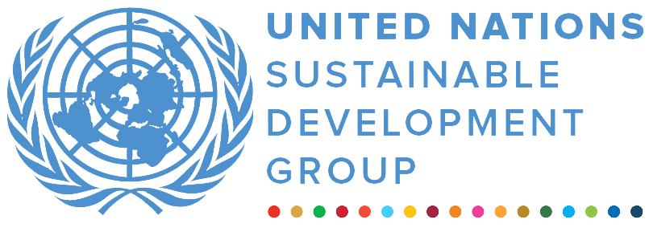  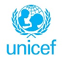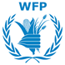 |  | 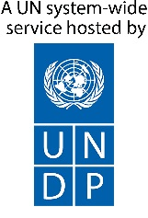
Joint Programme on Girls’ Education II: Poverty Reduction through Improved Quality Education and Basic Life Skills for In and Out of School Adolescent Girls in Malawi
finalprogramme NARRATIVE report
REPORTING PERIOD: 6 FEBRUARY 2018 – 31 march 2021
Programme Title & Project Number |  |  | Country, Locality(s), Priority Area(s) / Strategic Results
- Programme Title: Joint Programme on Girls’ Education II: Poverty Reduction through Improved Quality Education and Basic Life Skills for In and Out of School Adolescent Girls in Malawi.  - MPTF Office Project Reference Number: 00108951 |  |  | Country: Malawi  Districts: Dedza, Mangochi, Salima
 |  |  | Priority area/ strategic results Girls Education
Participating Organization(s) |  |  | Implementing Partners
- UNFPA  - UNICEF  - WFP |  |  | Ministry of Education; Ministry of Health; Ministry of Youth, Sports and Culture; Ministry of Gender; Ministry of Agriculture; Ministry of Information and Communication
Programme/Project Cost (US$) |  |  | Programme Duration
- Total approved budget: $20,931,838  MPTF /JP Contribution:  - UNFPA - $ 7,248,275  - UNICEF - $ 5,414,590  - WFP – $ 8,268,973 |  |  | Overall Duration (32 months)  Start Date (06.02.2018)
 |  |  | Original End Date (30.06.2020)
Government Contribution  (if applicable) |  |  | Actual End date(31.03.2021)  Have agencies operationally closed the Programme in their system? | Yes No  X
Other Contributions (donors)  (if applicable) |  |  | Expected Financial Closure date:
TOTAL: $ 20,931,838
Programme Assessment/Review/Mid-Term Eval. |  |  | Report Submitted By
Evaluation Completed  Yes X No Date: n/a  Evaluation Report – n/a  Yes No Date: dd.mm.yyyy |  |  | - Name: Margherita Coco  - Title: Coordinator, UN JPGE  - Participating Organization (Lead): WFP  - Email address: margherita.coco@wfp.org

Table of Contents

LIST OF ACRONYMS 2

EXECUTIVE SUMMARY 4

I. PURPOSE 5

II. ASSESSMENT OF PROGRAMME RESULTS 6

i) Narrative reporting on results 6
a. Overall Programme Results 6
b. Beneficiaries reached 6
c. Key Indicators - Progress Results 6
d. Results by Outcome 7
e. In Focus: Implementing the JPGE during COVID-19 13
f. Partnerships and coordination 14
g. Best Practices and Lessons Learnt 15
h. Monitoring and Evaluation 15
i. A Success Story 15
ii) Indicator Based Performance Assessment 17

LIST OF ACRONYMS

CBE Complementary Basic Education
CFS Child Friendly Schools
CPD Continuous Professional Development
CSE Comprehensive Sexuality Education
DET Digital Education Technology
DEC District Executive Committee
DEM District Education Manager
GBV Gender Based Violence
HGSM Home Grown School Meals
HTA Head Techers’ Association
IFA Iron and Folic Acid
JPGE Joint Programme on Girls’ Education
MOEST Ministry of Education, Science and Technology
OVCs Orphan and Vulnerable Children
PTA Parent Teacher Association
RNE Royal Norwegian Embassy
SRHR Sexual and Reproductive Health Rights
UN United Nations
UNFPA United Nations Population Fund
UNICEF United Nations Children’s Fund
WFP World Food Programme
YFHS Youth Friendly Health Services

EXECUTIVE SUMMARY
The Joint Programme on Girls’ Education (JPGE) started with a first phase (2014-2017) and continued through a second phase (2018-2020). A new four-year phase (2021-2024) was approved in December 2020. The JPGE is a collaborative effort by the Government of Malawi with technical support from three United Nations agencies (UNFPA, UNICEF and WFP) and financial support of the Royal Norwegian Government. Phase II aimed to improve quality education and basic life skills for adolescent girls in and out of school, through a multi-sectoral approach addressing multiple socio-economic, cultural, health, nutrition, and gender barriers. It was implemented in three districts of Dedza, Mangochi and Salima, targeting 169 primary schools and surrounding communities.
The report takes stock of the final results achieved throughout the programme duration, while highlighting some achievements and challenges encountered in the last year marked by the COVID-19 pandemic. The situation created by the pandemic, naturally affected the implementation of JPGE. Despite prolonged schools closure and limitations due to preventive measures, the programme adapted modalities for most of its components and was able to provide some continuity of support to the learners and young people targeted, in line with the National COVID-19 response plan.
Aside from these challenges, implementation of the programme remained on track (though a no-cost extension was necessary). Targets were met or a marked improvement was recorded for about 95% of planned outcomes and outputs indicators. Approximately 94% of key deliverables were achieved (representing 139 deliverables over a total of 148).
JPGE II directly reached 224,666 learners in school (51% girls, and 49% boys). They benefitted from activities implemented in school targeting all learners (e.g. provision of school meals, improved delivery and quality of education, safety and protection and comprehensive sexuality education).
Over 305,000 young people benefitted from Youth Friendly Health Services (YFHS) through static and outreach service. And 37,082 out of school adolescents, (81% girls) directly benefitted from activities specifically targeted to the out-of-school youth, including trainings on comprehensive sexuality education, functional literacy, complementary basic education, vocational skills programmes.
The programme contributed beyond JPGE directly targeted areas. Some interventions reached entire communities or were implemented with a “whole district” approach, and it contributed at national level, by supporting policies and guidelines, offering opportunities for replication of the model.
The overall results show that from the start of phase II in targeted schools, more children - and particularly girls - are staying in school, consistently attend classes and have improved learning outcomes such as pass rates and lower repetitions.
Drop-out reduced (rates among Standard 5 – 8 learners decreased to 6% for girls and boys from 9.7% and 9.6% for girls and boys respectively at baseline). Pass rates improved (to 77% for girls and 86% for boys against the baseline of 66.2% and 69% for girls and boys respectively).
Average repetition rates decreased for learners in classes standard 5 - 8 throughout the implementation of phase II to 22.7% for both girls and boys (from 34.7% for girls and 29.8% for boys). School attendance significantly improved with average attendance rates for standard 5-8 learners at 87.4%, above the baseline of 80% and it was even higher for girls at 88.5%).
The involvement of community-based structures such as “mother groups” is one of the best-practices of the programme. Mother groups have been instrumental in supporting vulnerable girls and encouraging girls who had dropped out to return to school. They have mobilized 4,700 girls to enroll or return to school in this second phase.

PURPOSE
Access to education has been steadily increasing in Malawi, with primary school net enrolment rate (NER) reaching 91 percent and the net intake rate (NIR) improving from 71 percent in 2008 to 92 percent in 2018. Gender parity in primary school enrolment was reached by 2015, and annually girls’ enrolment has been growing at a higher rate than boys (2.7% vs 2.3%).
Girls still face additional disadvantages, to ensure they remain in school, perform and progress. In most rural households in Malawi, parents are smallholder farmers with limited income. If having to choose, they rather invest in a son's education, since girls are expected to work at home and join their husband's families at marriage. Limited reproductive health information, knowledge, and services results in girls becoming more susceptible to early sexual debut, early marriage, and pregnancy. Malawi has one of the highest rates of child marriage in the world with approximately 1 in 2 girls between the age of 20-24 married before the age of 18, and 9 percent of the same age group married before turning 15 years old. Among girls aged 15-19, 29 percent are already mothers or pregnant with their first child. In addition, challenges for the education sector remain to ensure quality of the education provided and improved learning outcomes. Children in Malawi can expect to complete 9.4 years of schooling by age 18, when adjusted for quality of learning, this is only equivalent to 5.4 years, highlighting a learning gap of 4 years.
The Joint Programme on Girls Education is designed as a multi-sectoral intervention, recognizing the different factors impacting girls’ access to education and their ability to complete it. It addresses education, nutrition and sexual and reproductive health concerns in a holistic manner by also focusing on other aspects such as life skills, gender equality and community engagement.JPGE contributes to key national strategies. The Malawi’s National Girls’ Education Strategy, envisions that all girls in Malawi should be enabled to succeed with education, empowering them to contribute to the country’s social and economic development. The programme contributes to the Malawi UNSDCF 2019-2023.
JPGE Phase II has 3 strategic objectives:
- Adolescent girls remain and complete primary school leading to transition to secondary school.
- Out of school adolescent girls acquire basic life skills to allow them to tackle adult life.
- Government structures at district and national levels effectively design, implement and monitor girls’ education programs in Malawi.
The strategic objectives are achieved through 9 outcome areas:
- Adolescent girls and boys are effectively taught and learn in inclusive and gender sensitive environment
- Girls and boys in targeted schools are provided with diversified school meals.
- Girls and boys in the targeted schools have access to SRHR information and services
- Reduced violence against girls in primary schools
- Parents and community engaged in education
- Adolescent girls out of school acquire basic numeracy and literacy skills.
- Adolescent girls out of school acquire SRH and life skills.
- Adolescent girls out of school acquire basic livelihood skills
- Government district and national level staff acquire coordination, networking, design and programme and implementation skills.

ASSESSMENT OF PROGRAMME RESULTS

Narrative reporting on results

Overall Programme Results
The programme coverage in terms of schools, learners and communities doubled in JPGE phase II. It reached 169 primary schools marking a significant expansion from the first phase (81 schools). The programme also reached 53 health facilities. JPGE II reached 26 percent of all public primary schools and 56 percent of all health facilities in the three districts. However, the contribution of the JPGE has gone beyond directly targeted areas in two ways. Firstly, some of the programme interventions were implemented with a “whole district” approach. Examples of these are: community mobilization activities; support of chief councils for the enforcement of community by-laws in support of girls’ education; the standardization process of the by-laws involving all traditional authorities in the districts; formation of head teachers associations covering the whole district promoting professional development and networking.
Additionally, the programme contributed at national level to strengthen the policy framework and availability of tools that can be used beyond JPGE, by supporting the development and dissemination of policies, guidelines, and training manuals in several disciplines. Examples include: Readmission Policy; Youth Friendly and Health strategy; Parent-Child Communication manual; Safe schools manuals; adaptation and standardization of Communication for Development (C4D) manuals; manual on role modelling and mentorship, Home-grown school meals standard operating procedures.

Beneficiaries reached
- JPGE II has directly reached 224,666 learners (51% girls, and 49% boys). They benefitted from activities implemented at the 169 schools targeting all learners (ie. through provision of school meals, improved delivery and quality of education, protection services and comprehensive sexuality education).
- Over 305,000 young people benefitted from Youth Friendly Health Services (YFHS) through static and outreach services.
- Some 37,082 out of school adolescents, (81% girls) directly benefitted from activities specifically targeted to the out-of-school youth, including trainings on comprehensive sexuality education, functional literacy, complementary basic education, vocational skills programmes.
- A total of 164,488 adolescent girls aged 10-19 years, in and out of school, were reached with iron and folic acid supplements, representing 54 per cent of total adolescent population in the 3 districts.

Key Indicators - Progress Results
To measure progress towards the achievement of the strategic objectives a set of key performance indicators were selected and tracked throughout the JPGE II implementation. The overall results show that from the start of phase II in targeted schools, more children - and particularly girls - are staying in school, consistently attend classes and have improved learning outcomes such as pass rates and lower repetitions. More limited impact was seen to improve transition to secondary school, though results are above national average. This is possibly an indication of structural issues affecting the ability of learners to progress to secondary education (eg. limited space/quota in secondary schools, higher costs to the families for schooling material, transport, boarding and opportunity costs; low qualification level of secondary school teachers).
The data presented for results as of last year of the phase was mainly collected by the Districts Education Management Information Systems between the end of 2020 and first quarter of 2021, while some relate to the period before COVID-19. It could therefore have limitations due to the impact of COVID-19 on the regular school schedule which might have affected learning outcomes as well as quality of data recording at school level. While some interpretation can be made considering COVID-19, the full extent of its impact cannot yet be ascertained.
- Examination Pass rates: At baseline the examination pass rates for girls and boys in Standard 8 in the targeted schools were 66% and 69% respectively. At the end of phase II on average 81.5% of learners in Standard 8 passed the exam, marking a slight improvement from previous year (79%), and meeting the programme target of 80%. For girls, the average pass rate was slightly below at 77% and for boys was 86%.
- Transition rates to secondary school: Overall transition to secondary school remained low. In 2019, a slighter improvement in transition rates was recorded for girls in the targeted schools (48.9% against 47.8% from the 2018 baseline) and less for boys (39.4% against 43.9%). In 2020, transition rates for boys remained at 39.7% while reduced for girls to 42%. However, they are above national rates (37.3% for boys and 37.8% for girls).
- Repetition rates (standard 5-8 learners): average repetition rates for learners in classes standard 5 to standard 8 in targeted schools improved throughout the implementation of phase II to 22.7% for both girls and boys (from 34.7% for girls and 29.8% for boys).
- Dropout rates: registered a significant reduction from the baseline values of 9.7% for girls and 9.6% for boys to 6% for both girls and boys in 2020. Compared to previous year, there was a slight increase from 5.2% (5% for girls and 5.3% for boys). There could have been some impact by the disruptions of the school year due to COVID-19.
- Attendance rates: of learners in Standard 5-8 in supported schools improved steadily throughout the phase II implementation from average of 79.8% to 87.4%. The increase was even higher for girls (from 79.7% to 88.5%) and well above the target of 80%.

Results by Outcome
Below is a description of overall results achieved in each of the 9 outcome areas based on the progress towards the achievement of the set targets. It is based on implementation reports, as well as the analysis and technical discussions undertaken with implementing partners in the districts and at national level when designing the third phase of the programme in the second half of 2020. For about 95% of outcomes and outputs indicators the targets were met or marked an improvement. Details of achievements of outcome, output indicators are included in the Indicators based Performance Assessment (ii).

Outcome 1: Adolescent girls and boys are effectively taught and learn in all-inclusive and gender sensitive environments

The first outcome of the programme focused on improving learning outcomes and safe environments conducive for learning for both boys and girls, while nationally promoting an enabling environment in both policy and institutional frameworks. Desired outputs under this outcome were largely achieved and the implementation was on target, with 97% of key deliverables indicators met or improved.
The programme enhanced availability and access to gender responsive and child friendly methodologies (Output 1.1) through investment in continuous professional development and increasing the number of teachers with skills to use participatory teaching methodologies.
Over 2,000 teachers were trained in child-centred methodologies that improve child participations and a focus on learning that curricular coverage. The teachers were specifically trained in “Handling large classes” and “Holistic assessment” module. In response to the Covid-19 pandemic, the project built the capacity of 1,400 teachers in Contagious diseases: prevention at school level in the 3 districts. These modules have contributed to how teachers are responding to challenging teaching landscape that the pandemic has presented and have also enabled the teachers to ensure learners returned to a safe environment after reopening of schools.
In selected schools, learners were able to access digital learning platforms to expedite literacy and numeracy skills in early grades. Improved teaching practices, provision of ongoing teacher support through peer networking, integration of innovation technology and other teaching resources positively contributes to attainment of literacy, numeracy, and essential life skills of learners.
The learning environment in the target schools was enhanced (Output 1.2) by the establishment of girls resources rooms and learning centres, teachers resource centres, promotion of monitoring and adherence to national education standards, supporting girls through mentoring programmes, learning camps, community bursaries and scholarships for transitioning to secondary schools.
JPGE has contributed to the schools improving on attainment of the National Education Standards (NES). The programme strived to improve achievement of the standards, but more importantly aims to contribute to the processes required for tracking the performance and ensure that these reports can then be used as decision making tools to identify, at school and district levels, critical areas of focus for improvement.
About 84% of the JPGE schools attained the minimum standards learning in Lesson (NES 1); 70% of the schools attained the required standards for the fulfilment of outcomes of the national curriculum (NES 2). More than 40% of the schools fulfilled the required standards in school leadership (NES 18). The inspection identified other areas that needed strengthening such as teachers practices and accountability. Few schools (40%) met the minimum required standards in effective teaching and preparedness standards 10 and 11 respectively.

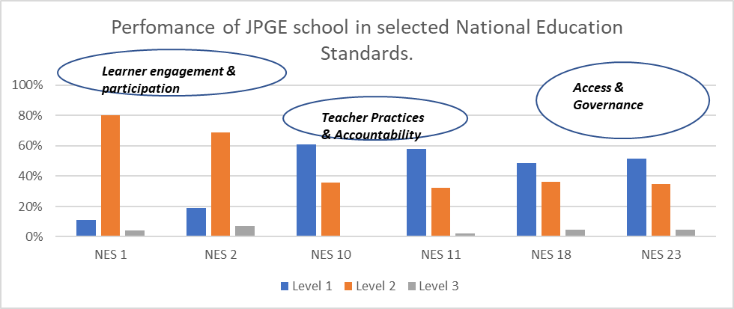

Outcome 2: Enhanced access to nutritious meals by boys and girls in targeted schools for improved learners school attendance
The programme expected result of enhanced access for learners in the targeted schools to daily nutritious school meals and other nutrition services was met and has contributed to a substantial improvement in learners daily school attendance. All of the outcome and output indicators targets were met, and implementation was largely on track.
School meals were consistently provided during the implementation of phase II until the closure of schools and national suspension of school feeding due to COVID-19 (the shift to take-home support is outlined in the section focused on 2020 and adaptation to COVID-19) (Output 2.1).
JPGE promoted school feeding through the Home-Grown School Meals (HGSM) model – whereby schools were provided with funds to procure diversified and seasonal food commodities locally produced by small-holder farmers. Farmers were in turn supported so they were able to meet the demand and make a profit from the sale to the schools (e.g with formation of farmer organizations, increased production of diversified crops/commodities, knowledge on agricultural marketing, post harvesting handling management, food processing and utilization).
The programme had therefore wider impact, contributing to the economic development of the rural communities surrounding the schools. JPGE has empowered schools to manage their funds and promoted higher dietary diversity and timely sourcing of locally produced food (Output 2.2).
In 2019, the HGSM was scaled up to the new 88 schools introduced in JPGE II. These schools were previously supported through WFP’s other donor funding and were implementing a centralized model with provision of a daily hot porridge made with Super Cereal.
Daily attendance rates for boys and girls in Standard 5-8 in the supported schools progressively increased during phase II from the baseline of 79.8% and surpassed the minimum target of 80%, and it was even higher for girls. These trends were common across the three districts.
Table 1: Attendance rates in standard 5 to 8 by district (2020)
District | Girls attendance rate (%) | Boys attendance rate (%) | Average attendance rate (%)
Dedza | 91.0 | 88.5 | 89.8
Salima | 89.3 | 87.9 | 88.6
Mangochi | 85.2 | 82.7 | 84.0
Overall | 88.5% | 86.4% | 87.4%

In addition, the programme supported improved adolescent nutrition through nutrition education and provision of micronutrient supplementation (iron and folic acid - IFA), reducing risk of anemia for 10-19-year-old girls due to chronic iron depletion during the menstrual cycle (Output 2.3)

Outcome 3: Adolescent girls and boys in the targeted schools and out of school have access to SRHR information and services
The outcome focused on empowering in-school girls and boys and increased access to age-appropriate information on Sexual Reproductive Health Rights (SRHR) from trained teachers and through a variety of means: in class through Comprehensive Sexuality Education (CSE) and life skills subjects, radio programs, school-based health talks (Output 3.2).
To ensure that learners that need more than information have access to Youth Friendly Health Services (YFHS), all the schools were linked to YFHS facilities and community-based distribution agents within their catchment areas, as the education policy does not allow provision of SRH services within the school premises (Output 3.1). In addition to the school setting and health facilities, the programme also takes into consideration the role that families and communities play in ensuring that the adolescent girl has access to the right information and appropriate services (e.g engagement of parents through promotion of parent-child communication – see outcome 5).
At outcome level the measurement of key results was not fully possible at the end of the programme as the evaluation of phase II could not be conducted due to COVID-19. For instance, in 2018, 53% of girls that needed SRH services were accessing Youth Friendly Health Services. Follow up on level of access to services will be collected through the JPGE III baseline.
According to available records, the total number of pregnancies reported in the supported schools depicts a declining pattern between 2018 (529) and 2019 (427) and compared to the baseline value of 867 pregnancies reported in the previous year. Higher numbers were recorded in Mangochi (325). In 2020 there is likely to be an increase in reported pregnancies compared to previous year. Data for 2020 is not yet complete but is currently standing at 368 for two districts (124 in Salima and 244 Dedza) while data collection is ongoing in Mangochi. Closure of schools coupled with limited household economic resources during the COVID-19 period, contributed to an 11 per cent increase of teenage pregnancies in Malawi from January to August 2020 compared to the same time in previous year.

Outcome 4: Reduced violence against girls and boys in primary schools
Girls experiencing violence are vulnerable to many factors including- early pregnancy, child marriages, health issues and psychological distress- all which negatively impact their ability to stay in school and achieve their potential through education. The programme ensured that schools provided a safe environment for learners and targeted areas where violence and abuse that deter children from being in school and attaining a good education occur (the school, on the way to school and the home).
Overall results for this outcome showed improvement, with a reduction in experience of physical violence in school for both girls and boys and an increase in reporting of cases of sexual violence by girls thanks to the strengthened reporting and referral systems. These are an indication of positive impact the interventions implemented are having in breaking barriers to access to protection mechanism by ensuring there are effective reporting and referral pathways (Output 4.2), that girls feel confident to use, are able to speak out and are empowered to protect themselves (Output 4.1). Under this outcome efforts were also made to ensure that key protection stakeholders (in the schools, communities, police force) acquired the relevant capacity to prevent alongside responding to violence against boys and girls (Output 4.3).
Output results under this outcome were achieved (with all indicators showing improvement and 4 out of 5 having met the target). The implementation of activities was on target, with 97% of key deliverables indicators meeting the target or improved.

Outcome 5: Parents and local community engaged in education
Community and school-based supporting structures have been strengthened and capacity of local leaders to eliminate social cultural barriers to education has been enhanced through the interventions implemented, which promoted active engagement of parents and key gatekeepers in the communities to provide a safe and supporting environment for adolescents’ development.
Key strategies employed: community mobilization, engagement and awareness to support and implement actions that contribute to the fulfilment of girls’ education; social behavior change communication to change behaviors to eliminate harmful social and cultural practices, and change social norms and address structural inequalities.
Standardization of by-laws related to education was promoted and the process facilitated by the Chief Council for girls’ education. More influential leaders and gatekeepers including religious leaders and traditional counsellors were reached to support girls’ education. Community theatre and radios were utilized to raise awareness and highlight the value of education.
All outcome and output targets were met, and implementation of key deliverables was on track. A key result of combined interventions under this outcome, but particularly thanks to the investment made into “mother groups” and the role they have been able to play is that 4,700 girls over the course of the programme enrolled or returned back to school.

Outcome 6: Adolescent girls out of school acquire basic literacy and numeracy skills
The second strategic objective of JPGE II focused on ensuring that out of school adolescent girls acquired basic life skills to allow them to tackle adult life.
Through this outcome, girls that dropped out of school or have never joined school were provided a second chance to education, through two main programmes: a nine-month functional literacy programme; and a Complementary Basic Education (CBE) programme. About 3,000 girls returned to primary schools after CBE. Girls who were unwilling or unable to go back to formal schooling were empowered through enrolment in community technical colleges or vocational skills training.
The functional literacy program also encouraged parents’ and community’s participation in girls’ education to reduce dependency. Some 9,953 adolescent girls have completed a 9-month functional literacy programme (99.5% of the target) and 87% of those enrolled. Girls that completed the programme are now able to read and write, run small businesses as well as take care of their families. Child Care and Development (CCD) was included as one of the functional areas for the adolescent girls. This is in recognition of the fact that most of the adolescent girls who enroll for the functional literacy classes are mothers. The CCD provides the girls the skills for caring their children
On overall the implementation under this Outcome was on track as outcome and output indicators target were largely met.

Outcome 7: Out of school adolescent acquire SRH and life skills
In complementarity with the strategies for adolescents in school, the programme aimed at addressing the needs of adolescents that are out of the school setting, to ensure they have access to integrated youth friendly health services (YFHS) from health facilities and community-based structures, and that they have increased information and knowledge on SRHR issues.
Similar to outcome 3, the measurement of key results at the outcome level was not fully possible as the evaluation of phase II could not be conducted due to COVID-19. In 2018, 53% of girls that needed SRH services were accessing Youth Friendly Health Services. Follow up on level of access to services will be collected through the JPGE III baseline. However, based on the trends of youth accessing health services both at facilities and through outreach activities, the reach of YFHS services was significantly expanded thanks also to the support of the programme.
For example, the number of young people accessing YFHS at health facilities in the last year of the programme was 1.5 times higher than in the first year of implementation (going from 188,000 to 305,000 youths). At output level all targets were met and 90% of the key deliverables were achieved. Activities implemented under this outcome were also complementary to intervention strategies under Outcome 5 that ensured engagement of leaders, parents and communities (such as through the Parent-Child Communication initiatives where parents and adolescents are trained on communication for addressing critical SRHR issues between parents and children).

Outcome 8: Out of school adolescent girls acquire basic livelihood skills
Interventions under this outcome provided girls graduating from the functional literacy programme with basic livelihood and vocational skills to enable them to earn a living. It aimed at reducing poverty and economic dependency amongst adolescent girls.
A participatory evaluation observed a successful facilitation of vocational skills with nine out of ten girls who acquired relevant trade skills with ability to practice. The programme empowered beneficiaries through imparting vocational skills which have added another dimension and value to the functional literacy program. It also enhanced positive change of mindset in community values through combatting gender barriers and enhancement of self-esteem, as girls were empowered to learn skills traditionally associated with males.
All interventions under this outcome were implemented but at a reduced scale. The final budget allocated to activities under this outcome was insufficient to achieve the initially set targets, both at outcome and output level. About 300 functional literacy graduates were trained in vocational skills by being attached to qualified local artisans in the community with quality assurance by the Technical, Entrepreneurial and Vocational Education and Training (TEVETA). About one third of the graduates are already engaged in self-employment initiatives within their communities (graduates started utilizing the skills either through being employed, attached to local artisans, or started own businesses such as tailoring, barber shops, hair dressing and motorcycles repair workshops).

Outcome 9: Government district and national level staff acquire coordination, networking, design and programme implementation skills
The third strategic objective of the programme was aimed at promoting the national uptake of a multi-sectoral integrated model to support girls’ education. To contribute to this objective the implementation under this outcome enabled strengthening of Government structures both at district and national levels to effectively design, implement and monitor programmes. Building capacities, strengthening government coordination and implementation skills were the key strategies employed to form the basis for the sustainability and exit strategy of the programme. Capacity strengthening activities were mainstreamed across the programme. Activities undertaken under each outcome that improved knowledge and skills of local authorities and professionals also contributed to this strategic objective.
A number of programme activities reached beyond JPGE schools through a whole district approach (e.g development of guidelines and manuals; formation of head teachers associations; training of PEAs and inspectors on CPD quality assurance, Chiefs councils formation facilitating enforcement of bylaws, the standardization process of the community by-laws involving all the TAs and chiefs etc.). However, the idea that schools outside of the targeted areas would be able to adopt a comprehensive model faces primarily resource constraints. While the programme has made progress in capacity building at district level, and the development of tools, guidelines, manuals that can be roll out beyond JPGE schools, the implementation of some activities still requires resources. The adoption of a comprehensive model, which evidence from the JPGE implementation shows that can have positive impacts, requires further commitment from Government. The question of Sustainability was further articulated in the third phase.
A key shift in strategic approaches introduced with the second phase of the JPGE was the transferring of the implementation responsibilities to the districts. JPGE’s combination of capacity building approaches at institutional, organizational and individual level has proved to be successful. Capacity was built in terms of hardware (including school upgrading, sanitation, functional literacy centres, youth corners in health centres) as well as through trainings to increase knowledge and skills, especially at local level. The shift of the responsibilities of implementation to the district councils increased commitment and ownership at district level and has been instrumental in influencing change. District councils have led in the programme cycle implementation, from planning to being accountable for the results and resources. However, challenges remain with lack of adequate human resource capacity and the competing priorities among many programmes implemented in the districts, as well as technical gaps (knowledge and skills). At the national level, JPGE contributed to strengthening the normative framework and tools for implementation, supporting the development and dissemination of policies, guidelines, and training manuals for several disciplines, to be utilized beyond the three districts.

In Focus: Implementing the JPGE during COVID-19
Like every country, aspects of life, and public sectors, the evolving of the COVID-19 global pandemic in 2020 and its impacts reached Malawi. In March 2020, the Government declared a State of Disaster, with mitigating measures including the closure of schools for a five months period. Schools gradually reopened in September 2020 with a staggered approach prioritizing classes for examinations and by beginning of October all classes had resumed with adoption of prevention measures and utilization of a shifts system to reduce congestion in classes. Schools later closed again between 18 January and 22 February 2021 due to a second and more serious wave with higher infection rate and mortality than in 2020.
The situation created by the COVID-19 pandemic, naturally affected the implementation of the Joint Programme on Girls Education, especially given its focus on school-based interventions. As soon as the school closure was ordered, the UN and the Ministry of Education discussed ways to adapt to the situation and provide some level of continuity of support to the learners and young people targeted by the programme, in line with the National COVID-19 response plan and the preventive measures put in place. An analysis on how implementation of JPGE II could continue in the time of COVID-19 was developed and efforts were made to support some continuity.
Given that the programme was initially set to end in June 2020, one of the first action taken was to extend, at no additional cost, the programme duration up to December 2020. Following initial analysis, the implementation changed and adapted to evolving context. The period between September and December 2020, with relatively low number of COVID-19 infections in the country and reopening of schools also offered a window of opportunity to catch up on implementation of some of the planned activities.
On overall, despite the challenges posed by COVID-19, the programme achieved or recorded substantial progress on 94% of its key deliverables during its lifespan. The full extent of the impact of COVID-19 on the overall programme results and learning outcomes for girls cannot yet be fully established as data for the school year is still being collected and analysed by the Ministry of Education (ref. to section 2.1.3).
The programme implementation was adapted to COVID-19 and even supported efforts for prevention, response, and mitigation of its impacts. Key examples below:
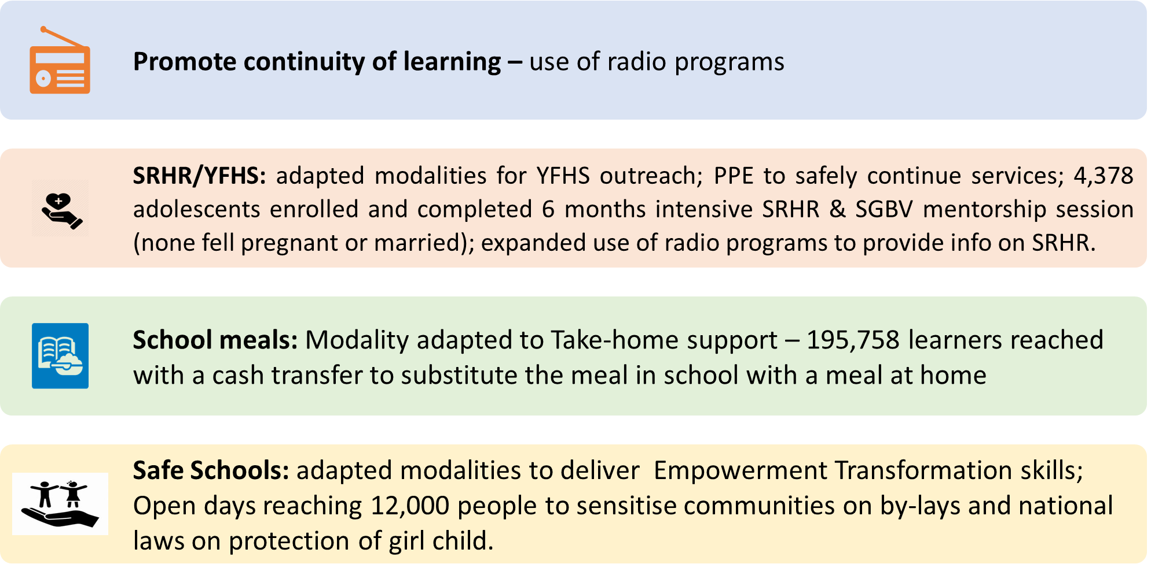
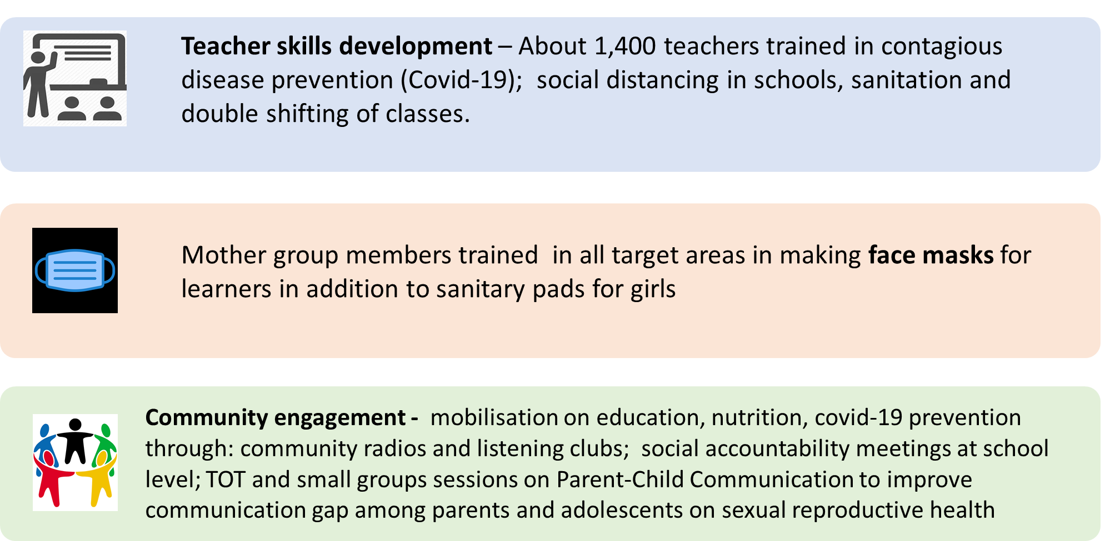

In the implementation of activities since the onset of the COVID-19 pandemic preventive measures were employed: hand-washing facilities; wearing of masks for facilitators and participants; social distancing measures (small groups; observing physical distance among participants). The implementation was not without challenges, adapting to new modalities required in some cases complete restructuring of the interventions, higher operational costs, increased resource needs for implementation of COVID-19 prevention measures. Learners’ interest and motivation to participate was affected especially during the school closure period. The timeline of the programme implementation was affected also by intermittent closure of public offices in response to COVID-19 pandemic at district level.

Partnerships and coordination
The second phase of the JPGE was mainly implemented by relevant government sectors at national and district level. Such sectors included Education, Health, Gender and Social Welfare, Youth and Sports, Agriculture, Home affairs (Police), Information, and Community Development.
Selection of implementing partners was based on the following principles:
- National Government partners with mandate in the relevant thematic areas, support the coordination with District level implementation and activities that are implemented at national level. The Ministry of Education, Science and Technology is the leading and coordinating ministry.
- District Councils in Dedza, Salima and Mangochi lead the implementation at district level;
- NGOs, CSOs or other partners were brought in as Support partners when government and UN efforts need complementing, e.g. when specific technical expertise and experiences are required.
Phase II promoted a strengthened coordination and ownership at national level of the multi-sectoral approach advanced by the JPGE. A national Technical Committee, which involves the participation of all the key focal points in the respective ministries, was formed and supported to undertake a joint field visit in all three districts. However, overall coordination mechanisms for multi-sectoral education interventions, still require to be institutionalized and better linked with structures beyond the JPGE, as the intention is to move beyond a project-based approach. The strategy on how to move forward the concept of scalability of the programme together with its sustainability was further elaborated in the design of phase III.

Best Practices, Lessons Learnt and Challenges
Lessons were learnt throughout the implementation of JPGE. In 2020, a documentation exercise was conducted to consolidate learnings, including challenges, best practices and evidence on results of the JPGE from 2014 to date, to support the design process of the third phase.
Government leadership: From the implementation of the first phase it was learnt that the government involvement in coordination, monitoring and supporting of the programme was necessary to increase sustainability.
A key challenge in the earlier stages of the programme was that it was more reliant on the engagement of non-governmental organizations. JPGE II adopted working with Government partners in the relevant sectors, while NGOs, CSOs or other partners were brought in when government and UN efforts needed complementing. Working with government has proved effective on service delivery, as government sets policies and standards for the services and has presence at grass-root level. For example, through collaborative efforts of JPGE and government there is increased support for facilities such as mentoring, learning camps that have increased their access to school but also transition to secondary schools.
JPGE II focused on establishing and consolidating these multi-sectoral partnerships with government leadership and attempted strengthening the government coordination role. District commitment and ownership of the intended programme outcomes and outputs have been crucial to influencing change. Delegating key decision-making to the district helped ensure grass-root level relevance and ownership of programme activities.
Challenge: while the programme has made progress in capacity building at district level, and the development of tools, guidelines that can be rolled out beyond JPGE schools, there are still challenges in the capacity both in terms of human and financial resources for districts to fully take on the approach of the programme and expand it to other schools. The shift of the responsibilities of implementation to the district councils has promoted commitment and ownership at the local level and has been instrumental in influencing change. However, there are still gaps to be addressed – and the programme is still relying on the JPGE district coordinators to support Districts in implementation. The comprehensive multi-sectoral model promoted by JPGE requires further commitment from Government to be expanded to scale. The critical issue of sustainability and how the programme can support to address it has been further articulated in the design of the third phase.

The critical role of parents and communities: Lessons from JPGE clearly indicated the importance of working with community members in improving access to education. Community members, especially parents/guardians, local leaders, cultural and religious leaders are key in influencing behaviour change.
The JPGE I final evaluation, found a strong community engagement, through the active participation in various structures (eg. mother groups, school management committees, child protection committees, food committees, etc.) and over 98 percent of JPGE schools reported that the community had relevant bylaws, in particular on mandatory sending girls to school and on preventing violence against children. The capacity and attitude of local leaders, teachers and people who participated in committees were positively changed under JPGE. However, the evaluation also noted gaps in parental support towards girls’ education as parents had not sufficiently been engaged in the early phase of the programme. Parents play an integral part in influencing the direction their children take especially in education.
Several strategies have been implemented to ensure community engagement. The involvement of community-based structures such as “mother groups” is one of the most successful and best-practice of the programme. Mother groups have been instrumental in providing support to vulnerable girls, through small scale business activities thanks to the school funds, teaching girls to saw sanitary pads, and mentoring and encouraging girls who had dropped out to return to school. The use of community radio programmes, theatre, performances, recreation activities, sports days have been very successful to attract and engage young people. The involvement of traditional leaders in the programme activities has fostered a sense of ownership of the programme. In all three districts, Chiefs’ funds from the proceeds of fines from violations of community by-laws are being established and is a feasible and replicable approach, and proceeds realised are being used to support needy learners with their education needs.
Challenge: Many of the issues affecting girls’ education are rooted in mindsets and cultural practices in the community. If a community does not adopt the goals, the achievement will be minimal, despite the implementation. Behavioural change however takes time to be achieved and as such some of the key results cannot be achieved within a short project lifespan. Prioritising girls’ education requires constant engagement at the community level as cultural conceptions need to be understood and respected. Further robust data is essential in convincing stakeholders about the need to prioritise girls. This aspect has also been strengthened in the design for the third phase.

Expanding reach: The programme made efforts to contribute beyond the JPGE directly targeted areas. Some interventions reached entire communities or have been implemented with a “whole district” approach. JPGE contributed at national level, by supporting policies and guidelines. Initiative of harmonization of training guides across the three districts offers opportunity for replication of the model.
Improved gender equality: The use of role modelling and mentoring was one of successful strategies of the programme. In addition to mobilizing women from different professions, within and outside the communities, (including military officers, nurses, clinicians, teachers, administrators, project managers) community level role models were also successfully utilized as an even more sustainable approach. JPGE contributed to decreasing gender inequality. The JPGE I final evaluation found that lower dropout rates and better pass rates strengthen the position of girls in their adult life and together with gender sensitive environment in schools (e.g. supporting girls who have dropped out of school, helping girls to achieve leadership positions and strengthening access to youth friendly health services) have helped closing the gaps between girls and boys.
Challenge: On the reverse side, a critical challenge has been to ensure that boys feel engaged. The JPGE I final evaluation, found that boys felt excluded and their needs not fully considered and that it did not include sufficient means to ensure that boys fully understood the programme approach and primary focus on girls. Boys (and other stakeholders) felt it was unfair that girls received more support and would sometimes be found to be frustrated as a result. Boys had the impression that they received much less support than girls of the same age, who live under comparable circumstances. While in JPGE II efforts have been made to purposely engage boys, this has called for further consideration in the design of JPGE III, to ensure a holistic approach, so that the specific needs of both girls and boys are met.
Fostering of linkages between programme interventions: For example, access to vocational skills by youth accessing YFHS within the same premises has led to increased participation to the Youth Centres. In addition, mother groups managing school funds’ seed money for businesses that can support vulnerable learners, are providing fruits and vegetables to the schools through the HGSM programme.

Monitoring and Evaluation
Through support of the programme, Government ministries and UN agencies reviewed and standardized the set of tools required for data collection to ensure they are adapted to the Phase II framework. Training of staff was conducted for the monitoring of the JPGE to foster government ownership and ensure M&E activities are well coordinated from the central/national level to district level. Participants included district teams, Head Teachers, Health Facility staff, mother groups, and community-based distribution agents.
While availability and tracking of data for key indicators has improved- demonstrated by more complete reports received by the district- further review on the actual utilization and functionality of the tools is required in phase 3 to ensure that these are streamlined and that the district M&E teams are indeed taking the lead. Due to COVID-19 the JPGE II evaluation could not be conducted. ToRs were drafted and contracting process of an external international evaluation company had been initiated when the pandemic started to evolve in the country. The closure of the airports and general restrictions for non-essential travel and field-level work, made it neither feasible nor appropriate to conduct it. A review of documentation of best practices, results and lessons learned was done instead to support the design of the third phase.

A Success Story

Going back to school: Rosemary’s story
By James Chavula, UNICEF
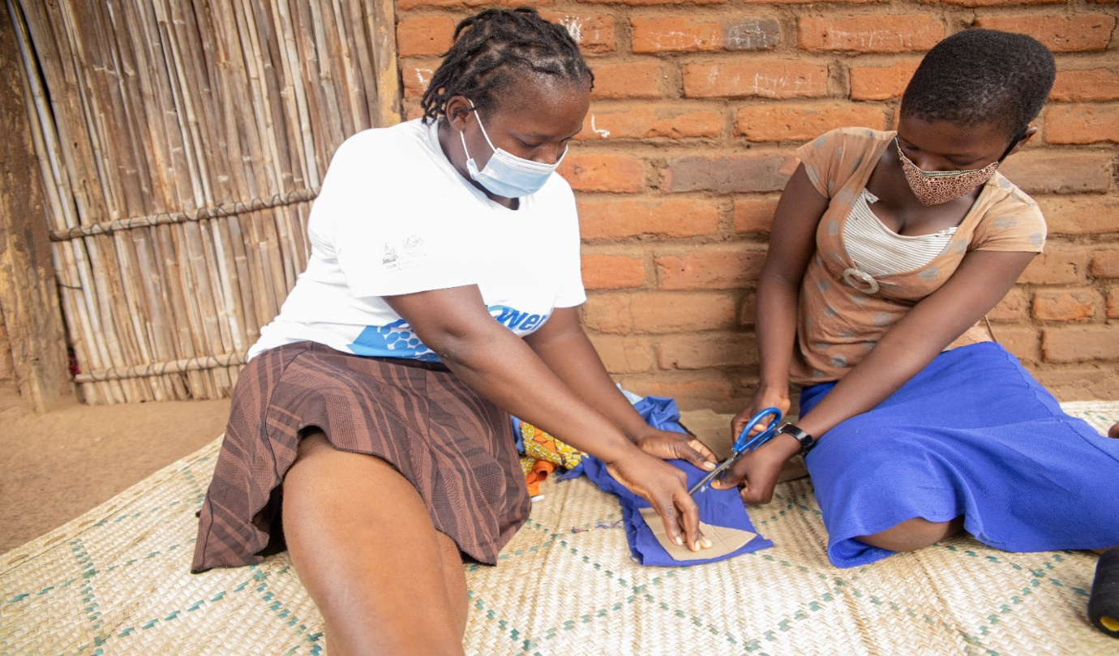
Rosemary and her teacher making reusable menstrual pads © UNICEF Malawi/2021/Simwaka
Rosemary Chiwaya fell pregnant in March 2020 when schools in Malawi suddenly closed for six months due to the COVID-19 pandemic. The 17-year-old, who is a student at a primary school in Mangochi was among 12,995 teenagers impregnated during the emergency school break; about 44,874 got married.
“I was devastated. I didn’t want to become a mother at my age. I began a relationship with a 22-year-old barber who had just returned from South Africa, as my mother couldn’t afford my basic needs, but the pregnancy almost disrupted my dream to become a nurse,” she says. Rosemary had a miscarriage in her second month.
Rosemary and her two younger sisters live with their mother, Asyatu Rajabu, 35, who depends on meagre pay from piecework in neighbouring homes and fields. She was happy when the teenager returned to school in October 2020 when classes resumed.
Rosemary thanks Mercy Makumba, her teacher-turned-mentor, for giving her sound advice on the benefits of going back to school. “I was desperate to stay in school. When Ms. Makumba visited me and asked if I could return to school, I willingly took the second chance,” she explains.
The mentorship Rosemary received is part of the UN Joint Programme on Girls Education funded by the Royal Norwegian Embassy. UNICEF, the World Food Programme and UNFPA are implementing the programme in Mangochi, Dedza and Salima to improve girls’ access to education and address issues of sexual violence and harmful cultural practices that force girls to quit school.
Almost half of Malawian girls marry before their 18th birthday and a third fall pregnant before the age of 19. Makumba works with the school committee as well as with a mother’s group to convince students who have dropped out to return to school. They regularly visited Rosemary during the COVID-19 school closure up until she went back to class, albeit a week late, for fear of backlash from her peers.
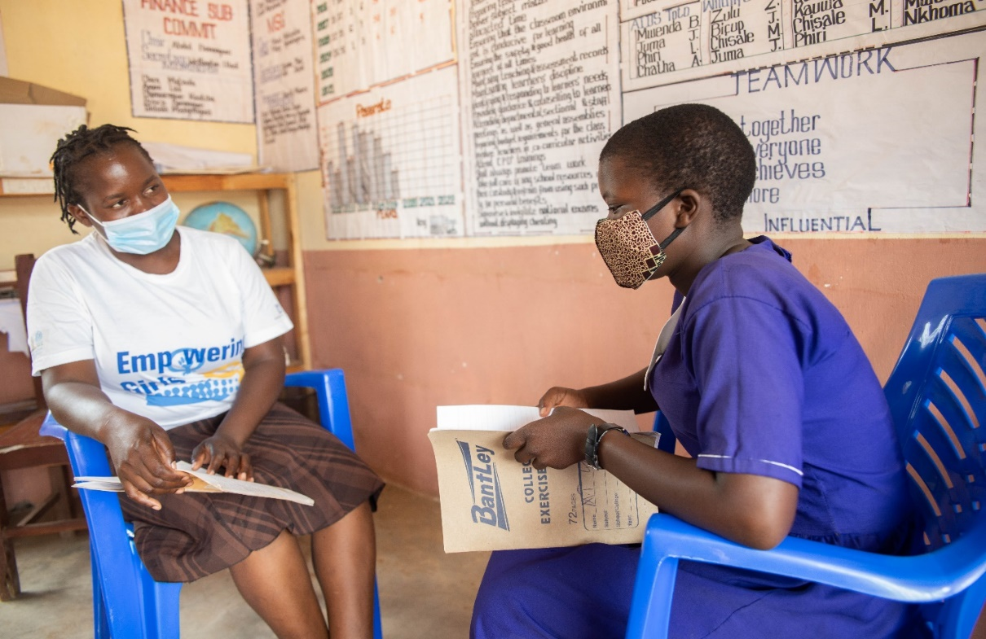
Rosemary interacting with her teacher after school pads © UNICEF Malawi/2021/Simwaka
“She is a bright girl. After a week without seeing her in school, I visited her and she assured me that she would be back soon. The next week, we were all happy to see Rosemary back in school and advised her to focus on her future,” Makumba illustrates. A combination of strict rules, a responsive student council and a confidential complaints box has created a safe learning environment for readmitted girls such as Rosemary. “The student council works as the eyes and ears of the school management. Students found bullying those who have re-enrolled after getting pregnant or married are dealt with accordingly,” says head teacher, Wellington Uladi.
Makumba also invites successful career women from different fields to speak to and motivate the girls. The school has a girl’s club where Rosemary has shared her story to warn her peers against risky sexual activity. The club gives them a safe space to share experiences and life skills, including on menstrual health, body hygiene and prevention of gender-based violence, child marriages, teen pregnancies and access to sexual reproductive health services.
Uladi said many girls are staying in school and those who had dropped out are increasingly re-enrolling, as Rosemary did. “Due to increased awareness and community involvement, many parents are realising the importance of sending a girl to school instead of forcing her to marry. Dropout rates are falling. We used to have fewer girls than boys reaching standard eight, but we now have 44 students and 24 of them are girls,” he says.
Local farmers also receive support to produce diverse food crops for school meals that in turn enhance the nutrition, enrolment and performance of students.
Rosemary’s mother is thrilled to see her daughter back in school uniform and not in a maternal gown. “Education is a trusted weapon against poverty”, she declares. “If she takes it wisely, she won’t need a man to solve her problems. She will be able to take care of herself, her sister and me in future.”
Rosemary also shares her joy despite their struggle to raise fees for primary school leaving examinations and other educational needs. She is grateful to everyone who assisted her along the way and hopes they can help other girls in need. As challenging as it may be, Rosemary is determined to work hard to fulfil her dreams to lift her family out of poverty.

Indicator Based Performance Assessment

 | Achieved  Indicator Targets | Reasons for Variance with Planned Target (if any) | Source of Verification
Strategic Objective 1: Adolescent girls remain and complete primary school education leading to transition to secondary school
Examination Pass rates for boys and girls in Standard 8 disaggregated by sex  Baseline: 66.2%girls; 69% boys;  Planned Target: 80% | 81.5%  (77% girls; 86% boys) |  | District Education Management Information System (DEMIS)
Repetition rate for Standard 5 - 8 disaggregated by sex  Baseline: 34.7%girls; 29.8% boys  Planned Target: 10% | 22.7%  (22.7% girls; 22.7% boys) | While the ideal target was not reached repetition rates have substantially improved and are now falling into line with national averages, while before they were worse. | DEMIS
Transition rates to Secondary school in the targeted schools disaggregated by sex  Baseline: 47.8% girls; 43.9% boys  Planned Target: >47.8% girls; 43.9% boys | 41.3% (42% girls; 39.7% boys) | Overall transition to secondary school remained low – albeit above national average (37.3% for boys and 37.8% for girls). This highlights some of the structural issues with transition related to space available, costs etc, beyond the programme control. | DEMIS
Dropout rates and numbers for girls and boys (standard 5 - 8)  Baseline: 9.7% girls; 9.6% boys  Planned Target: 5% | 6% (6% for girls; 6% boys) | A significant reduction from the baseline. Target was almost reached in 2019, at 5.2% (5% for girls and 5.3% for boys). In 2020, there could have been some impact by the disruptions of the school year due to COVID-19. | DEMIS
Promotion rates for girls and boys (standard 5-8)  Baseline: 65.3% girls 70.3% boys  Planned Target: > 65.3% girls 70.3% boys | 62% girls; 62% boys |  | DEMIS
Outcome 1
Adolescent girls and boys are effectively taught and learn in an all-inclusive and gender sensitive environments
Output 1  Enhanced gender responsive, life skills based and CFS teaching methodologies  Indicator 1.1.1: Number of teachers oriented to Child Friendly School methodologies  Baseline: 810; Planned Target: 1,710  Indicator 1.1.2: Number of targeted schools with at least 50% of the Teachers oriented on CFS methodologies  Baseline: n/a; Planned Target: 169 | 2,860 (40% female; 60% male) | More than planned thanks to additional orientations in 2020, including COVID prevention trainings. | Programme reports; Training reports
 | 105 | Teachers were trained in all targeted schools on CFS methodologies, as shown from indicator above. However, the n. of teachers trained per school would not reach the target of 50% of all teachers in each school - based on the resources available for the activity. | Programme reports
Output 2  Enhanced optimal learning environment provided for boys and girls  Indicator 1.2.1  Number of targeted schools with operational Teacher Resource Centres  Baseline: 81; Planned Target: 169  Indicator 1.2.2  Number of targeted schools with functional box library centres  Baseline: 5; Planned Target: 164  Indicator 1.2.3  A Girls Education Scholarship fund to support vulnerable girls for post primary education established and functional in all the 3 districts  Baseline: 0 Planned Target: 1  Indicator 1.2.4  Number of vulnerable girls provided with education scholarships for secondary education  Baseline: 200; Planned Target: 460 | 56 | Progress from previous reports. Although, there were challenges, with schools’ lack of space. | Programme reports
 | 54 | Progress from previous reports.
 | 1 |  | Programme reports
 | 717 |  | Programme reports
Outcome 2  Enhanced access to nutritious meals by boys and girls in targeted schools for improved learners school attendance  Indicator 2.1  Attendance rate for boys and girls in Standard 5-8  Baseline: 79.7% girls; 79.9% boys  Planned Target: 80%  Indicator 2.2  Attendance rate for orphans and vulnerable children (OVC) in Standard 5 - 8  Baseline: 70%; Planned Target: 80%  Indicator 2.3  Average number of school days per month when at least four food groups were provided  Baseline: 17; Planned Target: 20 | 87.4%  (Girls:88.5%; Boys: 86.4%) |  | School records
 | 87% |  | School records
 | 20 |  | School feeding records
Output 1  Girls and boys in primary schools are timely provided with nutritious school meals and Take Home Ration  Indicator 2.1.1  Number of learners (boys and girls) receiving diversified meals  Baseline: 86,116; Planned Target: 94,000  Indicator 2.1.2  Number of girls and orphan boys receiving Take home rations (food and cash)  Baseline: 12,790; Planned Target: 32,000 | 212,106 (Girls: 108,174 - 51% and Boys: 103,932 - 49%) | In 2019, Home-grown school meals was expanded to the phase II schools, thanks to additional funding as per amendment of the programme, hence number more than doubled from original plan. | School feeding records
 | 35,150 (89% girls; 11% boys). |  | School feeding records
Output 2  Increased capacity of district government staff, communities and smallholder farmers around the targeted schools in management of school meals programme  Indicator 2.2.1  Number of farmers registered under Farmer Organizations contributing to the aggregation system towards food supplies to the schools. Baseline: 12,130; Planned Target: 15,000  Indicator 2.2.2  Number of registered farmer organizations in the targeted communities supplying diversified food commodities for school feeding programme.  Baseline: 15; Planned Target: 50 | 16,113 (50% women) | Achievement above target as HGSM expanded to phase II schools in 2019. | Programme reports
 | 302 | Reported include clubs in addition to formal FOs. The idea is to build the capacity of farmers to associate also in clubs, and eventually form FO and cooperatives. | Programme reports
Outcome 3  Adolescent girls and boys in the targeted schools and out of school have access to SRH information and services  Indicator 3.1  Proportion of girls that need SRH services accessing youth friendly health services  Baseline: 62% (MTR JPGE I) Target: 80%  Indicator 3.2  Number of pregnancies reported in the targeted schools  Baseline: 867 Target: -  Indicator 3.3  N. of STI cases of young people recorded in the targeted facilities  Baseline: - Target: - | 53% | Source of data is JPGE Phase II baseline report which was finalized in 2019. The reduction is due to the expanded scope of Phase II with areas where interventions have recently started. This indicator was supposed to be updated with the final evaluation which was not conducted due to COVID. | YFHS facility records
 | 1,324  19,606 | Figures are cumulative from year 1. Declining pattern between 2018 (529) and 2019 (427) and compared to the baseline value of 867 pregnancies. | School records; Programme Reports  HMIS; Facility records
Output 1  Enhanced capacity of health workers to provide comprehensive SRH services, information and education.  Indicator 3.1.1  Number of health facilities in the targeted zones that have at least 2 trained health workers providing Youth Friendly Health services according to national guidelines and standards  Baseline: - Target: 53  Indicator 3.1.2  Number of health facilities conducting outreach activities on SRH in the targeted schools at least once every quarter  Baseline: 0 Target: 53 | 53 |  | Monitoring reports; Training reports;
 | 47 | All 53 facilities conducted outreach activities, with 89% doing so at least once per quarter. | Health facility records; Health facility outreach reports
Output 2  Enhanced capacities of targeted schools to facilitate access to SRH information and services for in school adolescents.  Indicator 3.2.1  Number of schools with over 50% of Teachers trained in Comprehensive Sexuality Education  Baseline: - Target: 169  Indicator 3.2.2  % of Teachers trained in CSE, teaching life skill subject in the targeted schools  Baseline: - Target: 100%  Indicator 3.2.3  Number of targeted schools linked to accredited YFHS sites  Baseline: 81 Target: 169 | 148 | A total of 1,802 teachers have been trained in CSE. Most schools have at least 2 teachers trained. The count was adjusted take into consideration only teachers from Std 5-8 | Monitoring Reports; Programme Reports
 | 100% |  | Monitoring Reports; Programme Reports
 | 169 |  | Programme Reports
Outcome 4  Reduced violence against girls in primary schools  Indicator 4.1  % of boys and girls that reported to experience physical violence in school within the past 12 months  Baseline: 62.6% Target: 30%  Indicator 4.2  % of girls that reported to experience sexual violence in school within the past 12 months  Baseline: 13.2% Target: 5%  Indicator 4.3  % of girls and boys that are aware of any formal violence protection structures within their school or communities.  Baseline: 91.1% (g); 90.4% (b)Target: > baseline  Indicator 4.4  % of girls and boys that ever experienced any form of violence at school or home who reported to formal structures  Baseline: 34.9% (g) 15.8% (b) Target: < baseline | 40%  22% | Results based on partner UJAMAA’s reports (same as for baseline value) for consistency in methodology. JPGE II evaluation could not be conducted due to COVID.  This highlights that sexual violence remains a critical issue that girls in schools are faced with, but it also indicates that more girls are coming forward to report and seek support. | Evaluation report
 | 80% | Results based on partner UJAMAA’s reports. JPGE II evaluation could not be conducted due to COVID. | Evaluation report
 | 16% | Results based on partner UJAMAA’s reports. JPGE II evaluation could not be conducted due to COVID. | Evaluation report
Output 1  Girls and boys in targeted schools are empowered to participate in their own protection  Indicator 4.1.1  Number of targeted schools that have formal structures for reporting of violence cases  Baseline: 65 Target: 169 | 169 |  | Programme reports
Output 2  Survivors of violence in schools have access to effective referral pathways  Indicator 4.2.1  Number of targeted schools that are linked to at least one community-based violence protection structures  Baseline: 65 Target: 169 | 169 |  | Programme reports
Output 3  Key protection stakeholders have relevant capacity to prevent and respond to violence against boys and girls  Indicator 4.3.1  % of reported violence cases in schools referred to formal communit- based violence protection structures for redress  Baseline: - Target: 100%  Indicator 4.3.2  % of reported violence cases against pupils in the targeted schools that are followed up by relevant authorities and concluded  Baseline: - Target: 100% | 100% |  | Programme reports
 | 81% | Some cases such as defilement and abduction are taking more time in the court because of the procedure of establishing the evident without reasonable doubts. | Programme reports
Outcome 5  Parents and local community engaged in education  Indicator 5.1  % of targeted communities implementing community by-laws in support of girls’ education Baseline: 63.2% Target: >baseline | 98% |  | Programme reports; evaluation report.
Output 1  Strengthened community and school based education supporting structures and institutions to support girls' education  Indicator 5.1.1  Number of out of school girls in the targeted communities mobilized and supported by mother groups to enroll/return to school  Baseline: 0 Target: >baseline  Indicator 5.1.2  Number of targeted schools that have functional trained mother groups  Baseline: 79 Target: 169  Indicator 5.1.3  Number of targeted schools that have functional PTAs  Baseline: 79 Target: 169 | 4,699 |  | Programme reports; Mother group records
 | 169 |  | Programme reports
 | 169 |  | Programme reports
Outcome 6  Adolescent girls out of school acquire basic literacy and numeracy skills  Indicator 6.1  Number of adolescent girls that complete a 9 months literacy programme  Baseline: 562 Target: 10,000  Indicator 6.2  Number of adolescent girls that complete complementary basic education  Baseline: 0 Target: 3,000 | 9,953 |  | Programme reports
 | 3,762 |  | Programme reports
Output 1  Out of schools adolescent girls provided with 9 months functional literacy course.  Indicator 6.1.1  Number of out of school girls enrolled in functional literacy programme  Baseline: 12,000 Target: 15,000  Indicator 6.1.2  Number of functional literacy centres operational Baseline: - Target: 504 | 15,002 | (of these, 5,880 out of school girls enrolled in functional literacy programme in November 2019). | Programme reports
 | 168 |  | Programme reports
Output 2  Out of school adolescent girls completing Complementary Basic Education linked to formal basic education  Indicator 6.2.1  Number of out of school girls enrolled in complementary basic education  Baseline: - Target: -  Indicator 6.2.2  Number of complementary basic education centres established  Baseline: - Target: 75  Indicator 6.2.3  % of out of school girls graduating from complementary basic education integrated into formal education  Baseline: 20% Target: 40% | 1,530 | The CBE programme is being re-organised to scale up to 18 districts. Most of the graduates who were enrolled last year had now been graduated | Programme reports
 | 75 |  | Programme reports
 |  | About 3,000 girls have returned to primary school after graduating from CBE. | Programme reports
Outcome 7  Out of school adolescent girls acquire SRH and life skills  Indicator 7.1  Proportion of girls that need SRH services accessing youth friendly health services  Baseline: 62% Target: 80%  Indicator 7.2  Proportion of sexually active adolescent girls reporting to use a condom during last sexual encounter Baseline: - Target: - | 53% | Source of data is JPGE Phase II baseline report which was finalized in 2019. The reduction is due to the expanded scope of Phase II with areas where interventions have recently started. This indicator was supposed to be updated with the final evaluation which was not conducted due to COVID. | Evaluation report
 | - | Evaluation could not be conducted due to COVID-19 | Evaluation report
Output 1  Increased access to integrated youth friendly services for out of school adolescent girls  Indicator 7.1.1  Number of Youth Friendly Health Services facilities that are functional  Baseline: 10 Target: 53 | 53 |  | Programme Reports; Monitoring Reports
Indicator 7.1.2  Number of young people accessing YFHS in the targeted facilities  Baseline: - Target: - | 305,952 (60% female; 40% male) |  | HMIS; Programme Reports
Indicator 7.1.3  Number of young people accessing integrated YFHS through outreach services  Baseline: - Target: - | 143,737 |  | Facility records; Programme Reports
Indicator 7.1.4  Number of targeted communities with at least one functional YFHS community based distribution agent Baseline: - Target: - | 317 |  | Programme Reports
Output 2  Increased knowledge amongst out of school adolescents in Sexual and Reproductive Health issues  Indicator 7.2.1  Number of out of school adolescents trained in comprehensive sexuality education  Baseline: 480 Target: 3,000 | 20,873 | Through utilizing various channels, including NGO partners (such as Malawi Girls Guide Association) it was possible to have a wider reach than initially planned. | Programme Reports; Training Reports
Outcome 8  Adolescent girls out of school acquire basic livelihood skills  Indicator 8.1  Number of vocational skills graduates engaged in self employment  Baseline: 0 Target: 3,000 | 300 | Completed. Resources allocated to this activity were not sufficient to meet target. | Market Labour Survey Reports; Programme Reports; Monitoring Reports
Output 1  Functional literacy graduates linked to vocational training community colleges  Indicator 8.1.1  Number of functional literacy graduates trained in vocational skills at vocational training community colleges  Baseline: 0 Target: 3,000 | 300 | Completed. Resources allocated to this activity were not sufficient to meet target. | Programme Reports; Training Reports
Indicator 8.1.2  Number of functional literacy graduates completing vocational skills training course  Baseline: 0 Target: 3,000 | 300 | Completed. Resources allocated to this activity were not sufficient to meet target. | Programme Reports; Training Reports
Indicator 8.1.3  Number of livelihood skills graduates receiving start-up equipment  Baseline: 0 Target: 3,000 | - | The start-up materials component was not implemented due to resource constraints. However, the Ministry of Youth, through district Youth officers encouraged to facilitate access to loan facility implemented by Government. Some graduates started utilizing the skills either through being employed by local artisans or started own businesses. | Programme Reports; Training Reports
Indicator 8.1.4  Number of vocational skills graduates trained in entrepreneurship skills  Baseline: 0 Target: 3,000 | 300 | Completed. Resources allocated to this activity were not sufficient to meet target. | Programme Reports; Training Reports
Outcome 9  Government district and national level staff acquire coordination, networking, design and programme implementation skills  Indicator 9.1  Number of non-targeted schools adopting a comprehensive model of HGSM, safe school and SRH  Baseline: - Target: - | 0 | The adoption of a comprehensive model, which evidence from the JPGE implementation shows that can have positive impacts, requires further commitment from Government. The issue of Sustainability was further articulated in the third phase. | Programme reports
Output 1  Strengthen government programme coordination for replication of programme  Indicator 9.1.1  HGSM management manual and guidelines developed and distributed  Baseline: No Target: Yes | Yes |  | Programme reports; copies of the manuals
Indicator 9.1.2  Safe schools manual developed and distributed  Baseline: No Target: Yes | Yes |  | Programme reports; copies of the manuals
Indicator 9.1.3  Adolescent sexual and reproductive health manual developed and distributed  Baseline: No Target: Yes | No | This was not implemented as the Ministry of Health reviewed priorities. | Programme reports; copies of the manuals

The term “programme” is used for programmes, joint programmes and projects.
Strategic Results, as formulated in the Strategic UN Planning Framework (e.g. UNDAF) or project document;
The MPTF Office Project Reference Number is the same number as the one on the Notification message. It is also referred to as “Project ID” on the project’s factsheet page the MPTF Office GATEWAY
The MPTF or JP Contribution, refers to the amount transferred to the Participating UN Organizations, which is available on the MPTF Office GATEWAY
The start date is the date of the first transfer of the funds from the MPTF Office as Administrative Agent. Transfer date is available on the MPTF Office GATEWAY
As per approval of the original project document by the relevant decision-making body/Steering Committee.
If there has been an extension, then the revised, approved end date should be reflected here. If there has been no extension approved, then the current end date is the same as the original end date. The end date is the same as the operational closure date which is when all activities for which a Participating Organization is responsible under an approved MPTF / JP have been completed. As per the MOU, agencies are to notify the MPTF Office when a programme completes its operational activities. Please see MPTF Office Closure Guidelines.
Financial Closure requires the return of unspent balances and submission of the Certified Final Financial Statement and Report.
A technical no-cost extension up to 31 March 2021 was approved to finalize expenditure processes for a limited number of activities.
NIR is the proportion of new entrants to Std 1 who are 6 years old (official primary school entry age) compared to the total populated aged 6 years.
2018-2019 Education Sector Performance Report – Government of Malawi
UNICEF. State of the World’s Children 2016
National Statistical Office (NSO), 2017. 2015-16 Malawi Demographic and Health Survey.
www.worldbank.org/humancapitalproject
Outcome 5: Girls and boys 6-17 years, particularly the most marginalized, benefit from an integrated package of quality education, health, nutrition, HIV/AIDS and protection services.
2019/2020 Enrolment data from districts in JPGE supported schools
Education indicators: progress data source: Districts Education Management Information Systems (DEMIS). Baseline source: JPGE II baseline survey.
Average among the JPGE schools and 3 districts.
Draft 2020 EMIS report.
National Education Standards were approved in 2015 and schools are inspected annually to check compliance. The supervisory unit supports the schools to address issues raised in school inspection.
According to inspection conducted by Ministry of Education, Directorate of Inspectorate and Advisory Services (DIAS) in 2019. NES 1- Learning in lesson; NES 2 - Students’ outcomes in the curriculum; NES 10-Well-planned lessons; NES 11-Teaching for effective learning; NES 18-School Leadership; NES 23-Access, Equity and Inclusion
Malawi Government, 2020, Rapid Assessment of Child Marriage and Teenage Pregnancies During COVID-19,

