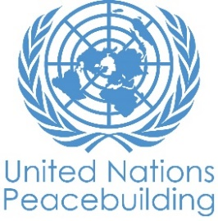
PBF PROJECT progress report
COUNTRY: SOMALIA
TYPE OF REPORT: semi-annual, annual OR FINAL: semi-annual
YEAR of report: November 2020 (annual report)

Project Title: Supporting Reconciliation and State-Building Processes
Project Number from MPTF-O Gateway: 00114146
If funding is disbursed into a national or regional trust fund:  Country Trust Fund  Regional Trust Fund  Name of Recipient Fund: | Type and name of recipient organizations:  UNDP (Convening Agency)  UNSOM  Responsible Parties Implementing the Project include;  - Office of the Prime Minister  - Ministry of Interior, Federal Affairs and Reconciliation of Federal Government of Somalia (MoIFAR-FGS)  - Ministry of Constitution and Federal Affairs-Jubaland State of Somalia (MoCFA-JSS)  - Ministry of Reconciliation and Federal Affairs - Galmudug State of Somalia (MoRFA-GSS)  - Office of the President, Southwest State (OOP-SWS)  - Office of the President, Hirshabelle State (OOP-HSS)  - The Ministry of Interior, Federalism and Democratization, Puntland State (MoIFAD-PLS)
Date of first transfer: 31st December 2018
Project end date: 31st August 2020
Is the current project end date within 6 months? Yes

Check if the project falls under one or more PBF priority windows:
Gender promotion initiative
Youth promotion initiative
Transition from UN or regional peacekeeping or special political missions
Cross-border or regional project

Total PBF approved project budget (by recipient organization):
Recipient Organization Amount

UNDP: $ USD 2,598,173
$
$
$
Total: $ USD 2,598,173
Approximate implementation rate as percentage of total project budget: 60%
*ATTACH PROJECT EXCEL BUDGET SHOWING CURRENT APPROXIMATE EXPENDITURE*

Gender-responsive Budgeting:

Indicate dollar amount from the project document to be allocated to activities focussed on gender equality or women’s empowerment: $ 779,452
Amount expended to date on activities focussed on gender equality or women’s empowerment: $261,396

Project Gender Marker: 2
Project Risk Marker: 1
Project PBF focus area: National Reconciliation
Report preparation:
Project report prepared by: Amjad Bhatti-UNDP REFS Chief Technical Specialist
Project report approved by: Peter Nordstrom, PBF Coordinator
Did PBF Secretariat review the report: Yes. Peter Nordstrom, PBF Coordinator, Fadumo Mumin, M&E Specialist

NOTES FOR COMPLETING THE REPORT:
- Avoid acronyms and UN jargon, use general /common language.
- Report on what has been achieved in the reporting period, not what the project aims to do.
- Be as concrete as possible. Avoid theoretical, vague or conceptual discourse.
- Ensure the analysis and project progress assessment is gender and age sensitive.

PART 1: OVERALL PROJECT PROGRESS

Briefly outline the status of the project in terms of implementation cycle, including whether preliminary/preparatory activities have been completed (i.e. contracting of partners, staff recruitment, etc.) (1500 character limit):

The Letters of Agreement (LoAs) covering 12 months period (January-December 2020) were signed with one FGS and five FMS counterparts: Ministry of Interior, Federal Affairs and Reconciliation (MoIFAR); Office of the President South West State of Somalia (OOP-SWS); Ministry of Constitution and Federal Affairs-Jubaland State of Somalia (MoCFA-JSS); Office of the President - Hirshabelle State of Somalia (OOP-HSS); Ministry of Interior Federalism and Democratization - Puntland State of Somalia (MoIFAD-PLSS); Ministry of Reconciliation and Federal Affairs - Galmudug State of Somalia (MoRFA-GSS)

Particularly, Project’s strategic, technical, operational and logistic support remained instrumental in facilitating the multifarious processes of reconciliation, state formation and holding an election in Galmudug. A combination of these processes has successfully led to the election of Speaker of the State Assembly, Mohamed Nur Ga’al, new president H.E. Ahmed Abdi Kaariye (Qoorqoor) and new vice-president H.E. Ali Dahir Eid. The new leadership of Galmudug endeavored to reach out to disaffected political actors to form an inclusive political administration in Galmudug.

To fine tune the options developed by the relevant institutions, three weeks of a broad-based technical sessions have been conducted, engaging all federal level relevant institutions, to develop a coherent political approach of the contentious issues of the constitution. Tto concretize those efforts, a cabinet retreat is expectedwas planned to be formulated in early April, but it was delayed by the spread of Covid-19 Pendamic.

Conflict mapping: Online training of line ministries of FGS and FMSes was conducted on conflict mapping explaining the background, process and methodology of conflict mapping exercise and development of Regional Reconciliation Plan to be led by the respective line ministries of FGS and FMSes. The data collected through conflict mapping exercise would be used as a baseline to develop/update Regional Reconciliation Plans as part of NRF/NRP. In order to achieve this outcome, three key activities would be undertaken by REFS counterparts under active LOA: (a) data collection, (b) data triangulation and (c) conducting validation conference at the FMS levels.

Policy Framework on Participatory Federalism and Decentralization: REFS supported the Ministry of Interior, Federal Affairs and Reconciliation (MOIFAR) and the Ministry of Constitutional Affairs (MOCA) jointly prepared the draft Policy Framework on Participatory Federalism and Decentralization for broader consultation. The draft policy framework describes objectives and scope of decentralization in Somalia in the long term and identifies tasks and activities to enable transfer of responsibilities addressing three tiers of governance over the next five years.

Civic engagement on strengthening Somali social contract: In pursuance of the NRF’s five pillars, REFS project has launched a flagship initiative to foster Civic Engagement on Reconciliation and Federalism in Somalia (CERF - Somalia). So far 85 proposals from civil society organisations have been received. The CERF-Somalia will be engaging with non-state actors/civil society organizations to support activities and interventions that can build bridges across social divisions. CSOs would be facilitated to participate in the efforts to (re)build trust within and between communities, as well as to reestablish the state-society relationship and renegotiate a social contract as third sector stakeholders.

Consultation for the establishment of National Resource Centre on Reconciliation: Two-day consultation was conducted in connection with establishing a Resource Centre on Federalism and Reconciliation. The proposed centre is intended to respond to the growing need for clear and readily accessible data, information and knowledge on Federalism and Reconciliation within institutions of the Federal Government of Somalia and the Federal Member States, academic institutions, partners and the donor community. The centre will serve as a dedicated point of technical backstopping and facilitate knowledge and information exchange, policy discussions, documenting lessons learned and international best practices on all dimensions of Federalism and Reconciliation in a holistic manner.

Oral historiography for peacebuilding in Somalia: In pursuance of the National Reconciliation Framework (NRF) and National Reconciliation Process (NRP), the Ministry of Interior, Federal Affairs and Reconciliation (MOIFAR) in collaboration with United Nations Development Program (UNDP) has initiated a pilot project on Oral History for peace building in Somalia. The Project targets to use audio and video equipment for the recording, reviewing, packaging and producing quality interviews and oral narratives contributing to rebuild a new social contract by involving people’s perspectives towards peace building, reconciliation and construction of a collective identity as a nation. Core Objectives: (a) Generate inclusive understandings based on oral stories/narratives and create a space for historical dialogues between competing communities and identities. (b) Addressing the past, understanding the present and enabling new visions of the future aimed at peacebuilding, reconciliation and social healing in Somalia.

Regional Reconciliation Plans: Ministry of Constitution & Federal Affairs of Jubaland State of Somalia and Ministry of Interior, Federal Affairs & Reconciliation (MOIFAR) undertook a joint activity in Kismayo aimed to sensitize its relevant stakeholders on the new strategies and develop Jubaland-owned implementation plan based on the NRF and NRP. The activity was supported by REFS.

In terms of community level conflict resolution, the Project-supported technical experts/advisors in collaboration with other actors (International Organization of Migration – IOM) were able to facilitate and coordinate the peace-making interventions in Afbarwaqo-Towfiq conflict. The quick interventions led by the federal counterparts aimed to resolve the conflict of Afbarwaqo and Towfiq villages between the two Somali sub clans Reer Nim’aale of Sa’ad (Habargedir) and Saleban Abdalle of Dir clan respectively. The conflict of these two sub clans was related to clan revenges, shortages of pasture, water and other resources in the last 40 years. MoIFAR-FGS mission was detailed to solve the disputes and conflicts between the two clans and finally this mission has succeeded, and peace agreement was reached between the two clans with a violent conflict history of 40 years.

Additionally, the project also supported, the MoIFAD-PLS’s peacebuilding and conflict resolution conference which was held in Qardho in February with an aim to strengthen the peace agreement and reconciliations between the two embattled clans in Qardho surrounded areas. Similarly, the project also supported the reconciliation conference held in Kismayo in February which was led by MoCFA-JSS mediating between the two embattled clans (Owrmale and Majerten) in Kismayo corridor.

Apart from the support of reconciliation activities, the project also provided infrastructure support (rehabilitation and construction of offices), provision of office equipment, supplies, stationaries, and other operational support to its project counterparts to enhance and improve the quality of working environment and sustain functions of these institutions. Finally, the project also covered the salaries of engaged advisors and interns to support and provide technical assistance to the project counterparts which contributed to enhance quality of their functions and mandated roles.

Please indicate any significant project-related events anticipated in the next six months, i.e. national dialogues, youth congresses, film screenings, etc. (1000-character limit):

The LoAs with eight counterparts (three FGS and five FMS) were signed initially for six months (by June 2020) and then extended LoA were signed until December 2020, identifying key strategic interventions which could create trigger effects and potentially engage donors for more funding. However, posing a new global risk, the COVID-19 caused programmatic implications for the Project as most of the activities enlisted in the AWP 2020 were related to public gatherings, conferences, consultations, training sessions and field-based surveys focusing on boundary delimitation and stakeholders’ engagement at FGS and FMS levels.

The project implementation framework has been revised to adjust the new realities in the wake of the pandemic. Integrating preventive measures in project planning, the SoPs on social distancing will be complied with by reducing the degree and frequency of physical interactions. Building on the concept of “connective action” , alternative modes of project functioning would be deployed by creating digital, virtual and social media platforms for information, communication, content development, public outreach, multi-stakeholder interaction, experience/knowledge sharing, capacity building, consensus building, policy development, decision making, and monitoring and evaluation. The ICT tools would be used to realign the project implementation mechanisms in view of Covid-19 risks.

The Project learning have led into the development and subsequent endorsement of five key strategic interventions designed in the backdrop of Covid-19, deploying ‘institutional development approach’ and to be implemented in the no-cost-extension period and beyond in collaboration with eight FGS and FMSs counterparts. Key strategic interventions are enlisted below:

- Establishment of Reconciliation and Federalism Resource Centre (RFRC) at FGS and FMS levels
- Establish a Study Group on Reconciliation and Federalism (SGRF)
- Launch a pilot initiative on the Oral Historiography for Peacebuilding in Somalia
- Establish Somalia Reconciliation Management Information System – including a baseline study on conflict mapping of Somalia
- Civil Society Engagement on Reconciliation and Federalism – by launching low-value grants

Moreover, in the following months, the project will further continue to support the political reconciliation activities between FGS and FMS as well as social reconciliation activities to reconcile and reach peace agreements between conflicting clans. Currently, some clan conflicts have been reported by the project counterparts in their respective locations. It was suggested by the counterparts that immediate intervention would require by organising reconciliation conferences to mediate and address prevalent conflicts between different clans including: (a) Wanlawayn district of Lower Shabelle region – conflict between Galjecel and Shanta Caleemod, (b) Diinsor district of Bay region: conflict between Dabarre and Gelidle, (c) Warsheikh district of Middle Shabelle region: conflict between Eli Omar and Abdalle Arone- sub clans of Abgaal, and (d) Qalanqale village near Dhusamreb of Galgudud region: conflict between Saleban and Ayr sub-clans of Habargidir. Additionally, the project will support some of the key activities which were halted due to the Covid19 crisis period. These activities include; stakeholder meetings, conferences, workshops, trainings, field visits/consultations, and/or any other activity which involves physical interaction.

In view of the Covid-19 and revised project implementation strategy, a no-cost extension for the six months (September 2020 to February 2021) was approved. An amendment in the ProDoc was approved and made part of the No-Cost-Extension allowing support to the Puntland Development and Resource Centre (PDRC) on community-oriented project on peacebuilding with geographical focus on Sool and Snaag and Galkacyo.

FOR PROJECTS WITHIN SIX MONTHS OF COMPLETION: summarize the main structural, institutional or societal level change the project has contributed to. This is not anecdotal evidence or a list of individual outputs, but a description of progress made toward the main purpose of the project. (1500-character limit):

Structural level:
- Formation of Galmudug state and establishment of new administration through a peaceful transition at the FMS level.
- Structural integration of reconciliation and federalism as ‘two sides of the same coin’ reflected through a renewed framework of constitutional review process.
- The project supported Dhusamareb Summit Dialogue which was convened in three phases. The Dhusamareb-I was initiated and hosted by the President of Galmudug on 9th-12th July 2020 with comprehensive consultative sessions between heads of the Federal Member States (FMS), i.e. Hisrhabelle, South-West, Puntland, Jubaland and Galmudug. The Presidents of FMSes agreed to enhance the corporation of FMSes in area of politics, security, economy and strengthening Somali’s state building process. The Dhusamareb – I issued a communique suggesting that, “As National Independent Election Commission stated, one person one vote election can’t happen in the country on the scheduled time, therefore an alternative electoral model should be decided in inclusive and consultative manner.” The Communique also solicited that the President of Somalia, the Prime Minister and FMSes to come together for consultative meeting to discuss the technical issues and the road map of 2020/2021 elections.
- Dhusamareb – II was held on 19-22 July which was attended by the President and Prime Minister of Somalia agreeing to the formation of Technical Committee representing FGS and FMSes, with a mandate to analyze and advise mechanism and way forward of Somalia election. Subsequently, a 17-member Technical Committee was formed which had rigorous consultations with different stakeholders on 5-15 August.
- Dhusamareb – III was held on 15-19 August wherein the Technical Committee proposed three models for the consideration of leadership. In the absence of representatives of Puntland and Jubaland, the remaining leaders resolved to proceed with the discussions and unanimously settled for a model.
- Following efforts to engage the two FMS presidents who did not participate in the Dhusamareb III, Somali President hosted a summit with all five FMS leaders and the Governor of Banadir to negotiate further over the proposed “Dhusamareb model.” On 17 September, they reached an agreement on the electoral model that should start on 1 November. The agreement includes: both the FGS and FMSes will appoint federal and regional-level electoral commissions, the number of delegates voting for each seat shall be 101 delegates representing the community sharing the seat, the selection of delegates will be conducted in collaboration with traditional elders, civil society and the State Government and that the election will take place in two places, down from four as had been previously agreed. It was also agreed that both national and regional governments would provide security during the elections. The leaders also agreed to retain 30 percent quota for women.
- It was significant that the “Mogadishu agreement” was approved by the two chambers of Somali parliament on 27 September, paving a way for electoral preparations to start in earnest.
- The Dhusamareb process opened an avenue of dialogue which culminated into the national consensus endorsed by the Federal Parliament, providing firm foundations for peaceful transition of power. The months-long consensus-building process prevented potential risk of conflict in Somalia. This is how the Dhusamareb dialogue process leads the Somali nation into a promising and stable future.

Institutional level:
- The institutional capacity of counterparts was enhanced through the project interventions and activities embedding a diverse technical, specialized and professional assistance with the eight FGS/FMS counterparts. Particular areas of capacity and skill improvement included: policy research, strategic communication, networking, partnership building, office management, project planning and management and audits and accounts management.
- The NRF and NRP: The National Reconciliation Framework (NRF) was formed and validated by Federal Cabinet in March 2019; and MoIFAR has been taking lead to internalize the NRF within FGS institutions by engaging line-departments through inter-ministerial dialogues.
- Subsequent upon the approval of NRF, a Preliminary National Reconciliation Process (NRP) Implementation Plan was designed and the same has been rolled out, contributing to the Somali mission towards inclusive reconciliation.
- Representation of FMSs in the National Reconciliation Framework Advisory Board: National Reconciliation Framework (NRF) Advisory Board (AB) originated from MoIFAR initiative as NRF Project Steering Committee funded by Finland. The platform later included other supporters of the process specifically UNSOM, UNDP, Norway and Sweden (and Germany supporting through one of its Foundations). After the Federal Cabinet’s approval of NRF, the NRF Project Steering Committee has been re-named as NRF Advisory Board and became a coordination platform for actors supporting the implementation of National Reconciliation Process (NRP). It is by-monthly coordination meeting between MoIFAR, donors and implementing agencies. NRF-AB is led by MoIFAR and co-chaired by periodically selected international partners that support NRP. The membership of the AB has been expanded to include one member from each FMSs. The last AB meeting in May had effective representation from FMSs. The AB decided to strengthen FMSs networks for the socialization and general understating of NRF at societal level.
- A meeting was held between MoIFAR, Friends of Reconciliation Group and the UN SRSG. The discussion was facilitated by SRSG James Swan and was attended by Minister Abdi Mohamed Sabrie, the Ambassadors of Finland Erik Lundberg and Staffan Tillander from Sweden who are the co-chairs of Friends of Reconciliation. The main purpose of that meeting was to discuss as what reconciliation partners can do during these critical circumstances to support the implementation of NRF and the practical possible activities which can be implemented during Covid-19 pandemic period and beyond. The meeting considered possibility of carrying out some activities while fully following the SoPs on Covid. It was also discussed as what kind of opportunity does this pandemic context avail to reconciliation and social harmony. The planned NRF launch event was also discussed and how it could be ensuring inclusivity and acceptance from all concerned parties. However, the possibility of country wide NRF launch remains undecided and was left for further discussion to the AB participants. The NRF launch, which was one of the Mutual Accountability Framework benchmarks, was also main agenda for this meeting
- In the last well attended NRF-Advisory Board Meeting, an alternative plan in lieu of the ceremonial launch of the NRF was discussed. It was suggested that a small working group should be set up drawing representation from FMSs and FGS to chalk out NRF launching strategy. It was also suggested that before NRF launch there is a need to establish NRF networks at FMS level.
- The Project has also been able to enhance and strengthen the formal and informal spaces for communication, consultation and coordination between FGS and FMSs counterparts focusing on the policy issues related to reconciliation and federalism. Particularly, the REFS’ Project Management Board and NRF-Advisory Board provide such an opportunity/forum where contesting stakeholders from FGS and FMS levels can exchange their perspectives, insights and concerns towards a negotiated reconciliation and political and administrative settlement on contentious issues.
- The Project has enhanced the spaces for Inter-Governmental and Inter-ministerial dialogues on reconciliation as a number of activities have been conducted at FGS and FMS levels engaging different line ministries and departments in the policy issues related to reconciliation at multiple levels including community.

Societal level:
In general, the main purpose of the project is to support the Somali national reconciliation processes which are the pathways to a wider conflict resolution and conflict prevention leading to sustainable peace in Somalia. Likewise, the FGS has taken significant steps to make the national reconciliation process its national priority under the leadership of the MoIFAR. It was observed that the Galmudug reconciliation conference and state building process was a Somali-owned and Somali-led dialogue process which finally resulted in a comprehensive solution resolving the clan conflicts, as well as political conflicts between Ahlu Sunna Waljama’a (ASWJ) and former Galmudug Administration.

It is also worth mentioning that during these processes, UNSOM, the project and international partners emphasized through their counterparts (MoIFAR, OPM and MoRFA-GSS) to ensure the representational inclusivity by all key stakeholders from Galmudug including; clan elders, scholars, women, youth, civil society, ASWJ, and other politicians in all reconciliation and state building processes leading to the newly elected Galmudug Administration. These interventions helped bridge the mistrust among politicians, inter- and intra-clans which often hinder the establishment of a viable state in post-conflict situations.

The project has demonstrated its capacity to produce success stories on community-led conflict resolutions involving local elders, clan leaders, aggrieved parties and other stakeholders. As a lesson learnt, the Project underlines the need of deepening international communities’ understanding on the dynamics of locally informed customary and traditional instruments of conflict resolution and transitional justice. The better understanding of local dynamics would hugely benefit programmatic designing and thematic planning for investments in Somalia’s reconciliation and peacebuilding.

In a few sentences, explain whether the project has had a positive human impact. May include anecdotal stories about the project’s positive effect on the people’s lives. Include direct quotes where possible or weblinks to strategic communications pieces. (2000-character limit):

The project ensured to create and keep inclusivity by all community members in all stages of reconciliations and state formation processes through a comprehensive engagement with all concerned stakeholders including; traditional clan elders, scholars, religious leaders, civil society organizations (CSOs), businessmen, youth and women groups. For instance, peacebuilding and conflict resolution conference organized by the MoIFAD-PLS in Qardho from 29th February to 15th March 2020 was a remarkable example that resulted in ending of clan conflicts perpetuating over the last three decades between Osman Mohamud and Dubeys - the sub-clans of Majeerteen and Warsangeli clans respectively. Thus, inclusive participation by all categories of community was ensured such as civil society groups, traditional clan elders, scholars, religious leaders, university students, women, and youth groups to take part the peace building process.

Another significant example was Galmudug state building process which concluded in February 2020, and the project ensured to promote the inclusivity culture and inclusion of all various community members without excluding some of them from the processes involving political and social reconciliations leading to the state formation of Galmudug. The project ensured to include marginalized groups especially women, youth groups, minority clans, in all processes of state building.

As an additional dividend of the inclusivity approach, the business community from all clans of Galmudug came together and supported the peace building and the state formation processes in Galmudug and finally in doing so they decided to cover some of the logistical expenditures such as accommodations, side meetings, and flights of non-sponsored delegates. Furthermore, they took part in the political dialogue between the FGS and ASWJ as mediating force.

Moreover, there have been examples where peace agreements at community and clan level have been celebrated by embracing old enemies and making them new friends. Somali society has become tired of the fatigue of continuous violence in last three decades. Any sincere and well-meaning effort on reconciliation can have a ripple effect on collective potential of society building a peaceful future at clan, community and country level.

These and other such examples have helped reinvigorating the dormant social and cultural capital of Somalia bringing communities together in resolving long-standing issues and conflicts around resources, land, water, power and identity. If support to the local level peacebuilding efforts remains a consistent consideration of international development community, there is a great potential of triggering a bottom-up social movement of reconciliation and peacebuilding in Somalia.

PART II: RESULT PROGRESS BY PROJECT OUTCOME

Describe overall progress under each Outcome made during the reporting period (for June reports: January-June; for November reports: January-November; for final reports: full project duration). Do not list individual activities. If the project is starting to make/has made a difference at the outcome level, provide specific evidence for the progress (quantitative and qualitative) and explain how it impacts the broader political and peacebuilding context.

- “On track” refers to the timely completion of outputs as indicated in the workplan.
- “On track with peacebuilding results” refers to higher-level changes in the conflict or peace factors that the project is meant to contribute to. These effects are more likely in mature projects than in newer ones.

If your project has more than four outcomes, contact PBSO for template modification.

Outcome 1: Strengthened capacity to prevent and/ or resolve conflicts in Somalia towards state-building.

Rate the current status of the outcome progress: On Track

Progress summary: (3000-character limit)
The project supports the social and political reconciliations as well as state building activities. The following results were achieved through various planned activities during January to June 2020 under project outputs.

Output 1.1: An agreed framework and standing capacity to prevent conflict and promote reconciliation in Somalia is established. Under this output, the following activities were undertaken during the reporting period:
- Consultation of National Reconciliation Process (NRP) – between MoIFAR-FGS and Banadir Regional Administration was conducted from 27th to 28th January 2020. Members from MoIFAR-FGS, BRA institutions and Civil Society groups participated in the NRP consultations and discussions. Each consultation meeting was assigned for one day and attended by different participants including high level delegates from BRA and from MoIFAR-FGS. During the consultations, participants were updated on the history of NRP and the National Reconciliation Framework (NRF) and its five key pillars. Below were the major outcomes of the consultation:
- The consultation created a great and everlasting common understanding of the NRP among the concerned members
- The consultation enabled BRA officials and civil society groups to share their insightful ideas on the NRP.
- The consultation accorded an opportunity and time for NRP team in collecting the required data necessary on NRP.
- The consultation enhanced a collaborative relationship between BRA and MoIFAR-FGS.

- On 2nd of March 2020, MoIFAR-FGS organized the National Reconciliation Framework Advisory Board meeting (NRF-AB). The Meeting led to following decisions: (a) Participants will comment the AB ToR within two weeks; (b) NRF launch will also be discussed in the upcoming Friends of Reconciliation meeting scheduled in late March 2020; (c) It was agreed that all FMS relevant ministries and BRA shall be included to the NRF AB meetings in order to enhance and promote the commitment of the process. They will be invited to the upcoming meeting.
- Similarly, on 18th May 2020, MoIFAR-FGS organized the NRF-AB bi-monthly consultative meeting through Zoom. This has been the first ever NRF-AB meeting where FMS counterparts participated and agreed to take the NRF at the grassroots level through the active participation and ownership of FMSs. For the NRF launch it was agreed to set up small groups within AB members to come up strategies how we can materialise the launch and what could be the other options to roll out NRF at inter-governmental level.

- MoCFA-JSS organized a peace and reconciliation conference in Kismayo to facilitate a ceasefire and initiate mediation forums so as to reach peaceful agreement between the two rival tribes (Owrmale and Majeerteen) fighting over the ownership of pieces of pastoral land, water and pasture in the vicinity and outskirt of Kismayo. This tribal rivalry has claimed a number of lives and caused destruction of properties including living domestic animals. However, after several mediation forums, the two communities have concluded their last reconciliation and mediation functions witnessed by H.E President of Jubaland State, Ahmed Mohamed Islam “Madoobe”.

- Peaceful reconciliation between two clans in Afbarwaqo and Towfiq villages, Mudug region (which are located along the fault line between Puntland and Galmudug) was accomplished with the support of the Ministry of Interior, Federal Affairs and Reconciliation of Federal Government of Somalia (MoIFAR-FGS), and Ministry of Reconciliation and Federal Affairs of Galmudug State of Somalia (MoRFA-GSS). Several mediation forums have finally led to resolve the four decade-long conflict between Reer Nim’ale, the sub-clan of Sa’ad (Habargedir clan) and Saleban Abdalle, the sub clan of Qubeys (Dir clan). The conflict was related to the acts of clan revenge, and discord over limited pasture, water and other resources. Following the security response to the conflict by the Somali National Forces, MoIFAR-FGS and MoRFA-GSS deployed a mission which contributed to the peace agreement.

- A peacebuilding and conflict resolution conference was organized by MoIFAD-PLS in Qardho district. The conference was aimed to address grievances and hostilities from the long-lasting clan conflicts between Osman Mohamud and Dubeys, the sub clans of Majeerteen and Warsangeli clans. After long discussions, and site meetings, both clans agreed on the outstanding issues case by case such as number of deaths, injuries, loss of property/animals, and the real damages that each clan is considering the other clan has done to them. Lastly, both clans reached a historic peace agreement which closed a bitter chapter experienced by the two clans in the neighboring districts of Qardho and Dhahar. In addition, elders from both clans agreed that all the agreed points particularly the blood-money (Diah) and other evaluated lost properties will be paid within one year.

Output 1.2: Strengthened capacity of the UN to provide good offices in support of peaceful resolution of conflict and improved relations between the FGS and FMS.

Although UNSOM has engaged in important national processes as per its mandate, these processes have struggled to show real advancement for various reasons during this reporting period. These delicate political processes are largely guided by Somali political actors’ pace and will and UNSOM stands ready to extend flexible support to their genuine requirements, when opportunities arise.

In the past months, UNSOM extensively worked, by engaging FGS and FMS leaders, other Somali political leaders and international partners, to support the long-waited FGS-FMS leaders’ summit. As guided by Somali President Mohamed Abdullahi Mohamed “Farmajo”, a Secretariat comprised of representatives of FGS and FMSs was formed in May and started its work, according to the Work Plan and Terms of Reference that UNSOM had provided support in preparing, to materialize a FGS-FMS summit in end June. As a matter of national priority, the UN has been ready to support activities of the Secretariat and the summit. However, the inability of the Secretariat to reconcile different views on the date of the summit stagnated the process, which prompted some FMSs to disengage from the Secretariat.

UNSOM also worked closely with the FGS, Somaliland and Puntland, along with partners such as the African Union (AU), Intergovernmental Authority on Development (IGAD), and the diplomatic corps, to promote peace and stability in the dispute regions of Sool and Sanaag and to promote dialogue between the FGS and Somaliland. The meeting between Somali President Farmajo and Somaliland President Bihi in February 2020 in Addis Ababa and the former’s subsequent public apology to Somalilanders raised a hope that the long-awaited dialogue would resume soon. In preparation, UNSOM held several meetings with the National Committee of Dialogue and Genuine Reconciliation that President Farmajo formed in 2019. In light of new developments in Djibouti where two presidents met again in June, UNSOM renews its readiness to support the outcome.

UNSOM has provided good offices extensively to unlock the political stalemate in Jubaland, offering readiness to support any reconciliation efforts. Heightened tension in the Gedo region as a result of increased presence of Somali National Army raised serious concern. Although tensions have subsided through diplomatic and political efforts, no lasting political solution has been found yet.

Output 1.3: Capacity and willingness of the state towards citizen engagement in reconciliation and State-building efforts are strengthened. Under this output, the following activities were undertaken during the reporting period:

- Ministry of Interior, Federal Affairs and Reconciliation of Federal Government of Somalia (MoIFAR-FGS) conducted Civic Engagement Workshop at Dhusamareb of Galmudug State in January before Presidential elections. The purpose of conducting the civic education and civic engagement was aimed to build trust between government and its citizens. Therefore, a team from MoIFAR-FGS helped to conduct Civic Engagement training which involved educating citizens about key processes and services that lie within the jurisdictions of local governments (LG) and how these are delivered by the local administration; LG’s in the various FMS are better capacitated to engage women and youth in political participation forums. This includes district council formation (DCF) and inclusion in the executive and decision-making processes.

- Galmudug Youth and Women Consultative Workshop on National Reconciliation Process was organized in Dhusamareb to consult with and seek inputs from women and youth groups to develop Galmudug Regional Reconciliation Plan (GRRP). The Workshop was also aimed at creating enabling environment for women and youth groups to voice out their concerns, opinions and ideas in an interactive way. Over 190 women and youth participants benefited from this session. The first day session was to give an orientation to participants on the NRF/NRP roadmap, the process of development of NRF and other related policy background information. On the second day, participants were divided into groups to pre-test and apply the knowledge they gained from previous day to develop GRRP. The Ministry of Reconciliation and Federal Affairs of Galmudug (MoRFA-GSS) as well as Ministry of Women & Human Rights Development remained by co-organizing the event. Following are the key outcomes:
- MoIFAR-FGS team presented both NRF and NRP implementation plan to Galmudug Youth & Women from relevant Ministries, Local Institutions, Civil Society Groups by engaging the leadership of MoRFA-GSS.
- MoRFA-GSS documented women’s inputs and new ideas and added it to the GRRP implementation plan with the assistance of MoIFAR-FGS Reconciliation Department team.
- Strengthened relationship and trust between MoIFAR-FGS and Galmudug’s relevant ministries such as MoRFA-GSS and Ministry of Women and Human Rights Development.

Indicate any additional analysis on how Gender Equality and Women’s Empowerment and/or Youth Inclusion and Responsiveness has been ensured under this Outcome: (1000 character limit)

- During the reporting period, the project emphasized and ensured through its responsible partners, the participatory and inclusionary opportunities of gender equality and women’s empowerment and/or youth inclusions in all undertaken processes whether reconciliation activities or state building processes.

- During the reporting period, a significant number of women and youth participated in all reconciliation conferences in Galmudug, Puntland, Jubaland, as well as in Mogadishu. In other words, the representation of women and youth who partook and attended in all conducted reconciliation conferences from the various project locations was 65 percentage.

- The project also collaborates with the UNDP’s Gender Unit, CSOs and other key partners to support training/mentoring of women in government. The project provided technical assistance and other support to its counterparts to increase the capacity of women’s groups and youth (and other CSOs) in the areas of governance and government/community engagement.

- Positive development is that both Hirshabelle and Galmudug States assemblies elected female deputy speakers which demonstrates that female participation in the decision-making roles is gradually increasing in Somalia. At the community level as well, youth inclusion and women’s participation in reconciliation and peace building dialogue activities is seemingly increasing as it women and youth’s proactive participation was witnessed in the interventions leading up to the reconciliation between Towfiq and Afbarwaqo villages in the Mudug region.

Outcome 2: N/A

Rate the current status of the outcome progress:

Progress summary: (3000-character limit)

Indicate any additional analysis on how Gender Equality and Women’s Empowerment and/or Youth Inclusion and Responsiveness has been ensured under this Outcome: (1000-character limit)

Outcome 3: N/A

Rate the current status of the outcome progress:

Progress summary: (3000-character limit)

Indicate any additional analysis on how Gender Equality and Women’s Empowerment and/or Youth Inclusion and Responsiveness has been ensured under this Outcome: (1000-character limit)

Outcome 4: N/A

Rate the current status of the outcome progress:

Progress summary: (3000-character limit)

Indicate any additional analysis on how Gender Equality and Women’s Empowerment and/or Youth Inclusion and Responsiveness has been ensured under this Outcome: (1000-character limit)

PART III: CROSS-CUTTING ISSUES

Monitoring: Please list monitoring activities undertaken in the reporting period (1000 character limit) | Do outcome indicators have baselines? Yes.  Has the project launched perception surveys or other community-based data collection?  COVID-19 has delayed the implementation of main activities of this annual term, thus disrupted the planned monitoring activities for the reporting period. However, HACT assessment was conducted to enhance and improve the financial management, and accountability of the project. The following project RPs were assessed during the reporting period; MoIFAR-FGS, OOP-HSS, OOP-SWS, and MoRFA-GSS. In other words, the HACT framework is aimed to improve the capacity of the government and nongovernmental Responsible Partners (RPs). This would eventually improve the individual rating of the RPs on the HACT, and they could successfully implement the cash transfers through the new National Procurement System of the Federal Government of Somalia (FGS).
Evaluation: Has an evaluation been conducted during the reporting period? | Evaluation budget (response required): $50,000 USD  If project will end in next six months, describe the evaluation preparations (1500 character limit): A final evaluation will be undertaken by an independent evaluator, hired by the UNDP country office, to assess the overall impact of the project. A budget of USD 50,000 will be allocated for final evaluation of the project. Evaluation findings will be shared with the Project Board and PBSO.
Catalytic effects (financial): Indicate name of funding agent and amount of additional non-PBF funding support that has been leveraged by the project. | Name of funder: Amount:  Germany 3,142,250  SIDA-Sweden 328,602  Switzerland-SDC 208,395
Other: Are there any other issues concerning project implementation that you want to share, including any capacity needs of the recipient organizations? (1500 character limit) | No

PART IV: COVID-19
Please respond to these questions if the project underwent any monetary or non-monetary adjustments due to the COVID-19 pandemic.

- Monetary adjustments: Please indicate the total amount in USD of adjustments due to COVID-19:

$

- Non-monetary adjustments: Please indicate any adjustments to the project which did not have any financial implications:

- Please select all categories which describe the adjustments made to the project (and include details in general sections of this report):

☐ Reinforce crisis management capacities and communications
☐ Ensure inclusive and equitable response and recovery
☐ Strengthen inter-community social cohesion and border management
☐ Counter hate speech and stigmatization and address trauma

☐ Support the SG’s call for a global ceasefire
☐ Other (please describe):

If relevant, please share a COVID-19 success story of this project (i.e. how adjustments of this project made a difference and contributed to a positive response to the pandemic/prevented tensions or violence related to the pandemic etc.)

PART V: INDICATOR BASED PERFORMANCE ASSESSMENT

Using the Project Results Framework as per the approved project document or any amendments- provide an update on the achievement of key indicators at both the outcome and output level in the table below (if your project has more indicators than provided in the table, select the most relevant ones with most relevant progress to highlight). Where it has not been possible to collect data on indicators, state this and provide any explanation. Provide gender and age disaggregated data. (300 characters max per entry)

Outcome | Performance Indicators | Indicator Baseline | End of project Indicator Target | Indicator Milestone | Current indicator progress | Reasons for Variance/ Delay  (if any)
Outcome 1: Strengthened capacity to prevent and/ or resolve conflicts in Somalia towards state-building. | Indicator 1.1  Number of successful reconciliation / mediation process established towards state building process. | Unpredictable and unstable political situation in country. | At least four successful reconciliation processes established towards state building process. |  | - N.B only Progress during the reporting period was recorded not the cumulative  - -MoCFA-JSS organized a peace and reconciliation conference which was held in Kismayo  - -Peaceful reconciliation between two clans in Afbarwaqo and Towfiq villages by Ministry of Interior, Federal Affairs and Reconciliation of Federal Government of Somalia (MoIFAR-FGS), and Ministry of Reconciliation and Federal Affairs of Galmudug State of Somalia (MoRFA-GSS)  -Peacebuilding and conflict resolution conference organized by MoIFAD-PLS in Qardho.
 | Indicator 1.2  Overall trends in  inter-clan conflict. | Approximately 45 incidents of armed conflict registered by UNDSS in month of November 2018. |  |  | - - during the reporting period of 2020, the project supported the following peaceful reconciliation of inter-clan conflicts; such as (Owrmale vs Majerten in Kismayo corridor) implemented by MoCFA-JSS.  - - MoIFAD-PLS conducted peacebuilding and conflict resolution conference aimed to reconcile between Osman Mohamud-sub clan of Majeerteen and Dubey-sub clan of Warsengali in Qardho, Puntland ,
Output 1.1:  An agreed. framework and standing capacity to prevent conflict and promote reconciliation: in Somalia established. | Output Indicator 1.1.1  Number of workshops: conferences/forums conducted to inclusive and gender-responsive national reconciliation efforts and-draft national reconciliation framework/strategic plan. | No National reconciliation framework and limited capacity of national and local partners to support reconciliation processes. | National Reconciliation framework in place and capacity of national and local partners enhanced to enable implementation of reconciliation framework/action plan. |  | - - Consultation of National Reconciliation Plan (NRP) – between MoIFAR-FGS and Banadir Regional Administration was conducted  - - The Ministry of Interior, Federal Affairs and Reconciliation of Federal Government of Somalia (MoIFAR-FGS) organized the National Reconciliation Framework Advisory Board meeting (NRF- AB)
 | Output Indicator 1.1.2 Number of national and local level peace building, conflict mitigation /reconciliation processes supported; Number of political mediation processes supported and resolved. | Peacebuilding and reconciliation support is ongoing in-Galmudug, Southwest, Hirshabelle and Jubaland and needs to be further addressed and engaged to resolve pending issues. | At least 4 political mediation processes supported and resolved. |  | - Consultation of National Reconciliation Plan (NRP) – between MoIFAR-FGS and Banadir Regional Administration was conducted  - - Ministry of Interior, Federal Affairs and Reconciliation of Federal Government of Somalia (MoIFAR-FGS) organized the National Reconciliation Framework Advisory Board meeting (NRF- AB)  - - Reconciliation committee of Galmudug was formed undertaking the base work towards agreed reconciliation framework
 | Output Indicator 1.1.3: Number of national and local partners trained in conflict mitigation, reconciliation processes; qualitative assessment of capacity enhancement; including focus on women and youth peace-makers. | Limited capacity of national and local partners to facilitate and conflicts. | MoIFAR and-all federal members reconciliation ministries’ core staff trained on conflict management and reconciliation along with CSOs, women-groups representatives on conflict mitigation and reconciliation facilitators developed. |  | On-going. REFS UNDP Project conducted a consultative online meeting through Zoom, chaired by the DG of MoIFAR-FGS and this meeting resulted to enhance cooperation, understandings and information sharing between FGS and FMS counterparts of REFS project. It also improved the spirit of Federalism platforms and institutional discussions between FGS and FMS.
 | Output Indicator 1.1.4. Number of office spaces rehabilitated in support of reconciliation. and peace building process support. | Lack of basic office: space/equipment at FMS and federal level | All FMS receives need-based office equipment/rehabilitation: support to facilitate peace building efforts. |  | - - Galmudug Ministry office building is complete  - - Hirshabelle state house under process of rehabilitation  - - Office of the SWS Ministry of Interior was renovated and expanded and Office equipment, furniture and supplies was provided.  - - An office with four rooms and partitioned hall was provided for the use of MoCFA- JSS
Output 1.2:  Strengthened capacity of the UN to provide. good offices in support of the peaceful resolution of conflict and improved relations between the FGS and FMS. | Output Indicator 1.2.1. Number of reconciliation/mediation. processes supported to strengthen FGS and FMS roles and responsibilities in context of federalism process. | Limited support provided to mediate: between FMS and. FGS towards establishing effective federal structure. | FMS and FGS agree on election model constitution review process and federalism model (in at least three sectors). |  | - - The project supported Dhusamareb Political Reconciliation Dialogue between Federal Government and Federal Members State leaders which finally led to peace agreement on the electoral model enabling peaceful transition of power.
 | Output Indicator 1.2.2: Number of Group of Friends of Reconciliation forums conducted. | Friends of reconciliation seminar was conducted in early 2018 in order to establish to seek external expertise in the area of reconciliation-and peace building process. | At. least two friends of reconciliation forums conducted every year to share lessons learned and exchange inputs from best practices |  | A meeting was held between MoIFAR, Friends of Reconciliation Group and the UN SRSG. The discussion was facilitated by SRSG James Swan and was attended by Minister Abdi Mohamed Sabrie, the Ambassadors of Finland and Sweden, Erik Lundberg and Staffan Tillander who are the co-chairs of Friends of Reconciliation.  There was follow-up meeting between MOIFAR and UN where they also discussed possible ways of continuing implementing NRF
 | Output Indicator 1.2.3. Number of UN agencies and implementing partners trained on mediation and reconciliation process qualitative assessment of capacity enhancement. | UN agencies and implementing partners have limited training support in the area.  of mediation and reconciliation baseline capacity survey to be undertaken. | At least 70% of UN agencies. and implementing: partners’. focal points involved. in reconciliation/political settlement processes are trained on mediation and reconciliation process. |  | - - The project supported training on Conflict Mapping involving FGS and FMSes line-ministries  - - MoCFA-JSS conducted Jubaland Regional Reconciliation Training inviting MOIFAR to launch NRF orientation for the FMS line ministries
 | Output Indicator 1.2.4: Number of needs-based political and conflict analyses to facilitate peacebuilding processes conducted. | Limited knowledge products and conflict analysis available in context of ever-changing political situation. | At least three conflict analyses conducted to understand -grassroot perspectives towards state building process. |  | Ongoing  Under NRP, the MOIFAR decided to conduct FMS conflict mapping exercise entailing profile of the conflict, root causes and triggers for each conflict in collaboration with FMS line ministries.
Output 1.3:  Capacity of the state towards citizen engagement in reconciliation and State- building efforts strengthened  List of some of the activities under this Output:  1 | Output Indicator 1.3.1: Number of gender- responsive State and Non-State Actors engaged in Conflict Mitigation and Government-Citizen public engagement. | Absence of regular structural forum to engage citizen and government on development and governance processes. | At least one public accountability forum conducted in each FMS. |  | Women’s peace building participation played a vital role during the reconciliation dialogues in Galmudug, Hirshabelle, South-West,  Puntland and Jubbaland. Youth and women are now understanding that they are the first point of response to conflict and they are trying to take part in peace-building processes.  Civil society actors have been engaged at large, including women, youth, business community and elders. And they are the backbone of deescalating conflicts/tensions between clans.
 | Output Indicator 1.3.2: Number of outreach campaigns are designed and implemented towards peace building process, and citizen perceptions/confidence improved of Government. | Absence of Reconciliation outreach strategy and advocacy tools; limited confidence of-citizens in Government [measures to be established] | Peace building outreach strategy is developed and implemented in all FMS, resulting in improved citizen perceptions of role of the state. |  | - Peace-building outreach strategy is built in the Revised project implementation strategy and plan for 2020.  - Strategy for civil society engagement through low-value grant has been launched and 85 proposals have been received. The selection process would be concluded by early December.
 | Output Indicator 1.3.3: % of FMS develop basic citizen reports, resulting in improved citizen understanding of and trusting state systems. | Lack of tools/information-system.  through which government reports to citizens limited levels of: citizen awareness [measures to be established]. | Citizen report cards are developed and disseminated in all FMS, leading to improved citizen understanding and trust. |  | - Consultations with PDRC conducted and four activities of Swiss-PDRC agreement have been earmarked for support until 28th February 2021. The disbursement on approved deliverables would be initiated based on the invoices generated by PDRC. NTF is being finalised to be signed by DRR(P).

Outcome 2  N/A | Indicator 2.1
 | Indicator 2.2
 | Indicator 2.3
Output 2.1 | Indicator 2.1.1
 | Indicator 2.1.2
Output 2.2 | Indicator 2.2.1
 | Indicator 2.2.2
Output 2.3 | Indicator 2.3.1
 | Indicator 2.3.2
Output 2.4 | Indicator 2.4.1
 | Indicator 2.4.2
Outcome 3  N/A | Indicator 3.1
 | Indicator 3.2
 | Indicator 3.3
Output 3.1 | Indicator 3.1.1
 | Indicator 3.1.2
Output 3.2 | Indicator 3.2.1
 | Indicator 3.2.2
Output 3.3 | Indicator 3.3.1
 | Indicator 3.3.2
Output 3.4 | Indicator 3.4.1
 | Indicator 3.4.2
Outcome 4 | Indicator 4.1
 | Indicator 4.2
 | Indicator 4.3
Output 4.1 | Indicator 4.1.1
 | Indicator 4.1.2
Output 4.2 | Indicator 4.2.1
 | Indicator 4.2.2
Output 4.3 | Indicator 4.3.1
 | Indicator 4.3.2
Output 4.4 | Indicator 4.4.1

ANNEX 1: ACTIVITIES IN PICTURES (January 1 --Nov 15, 2020)
- Jubaland Peaceful Reconciliations held in Kismayo. February 2020.

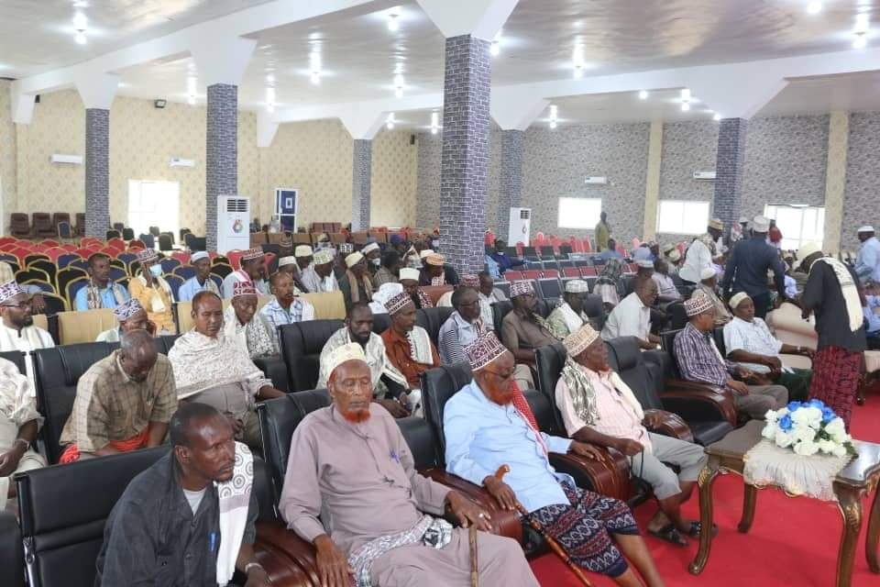 | 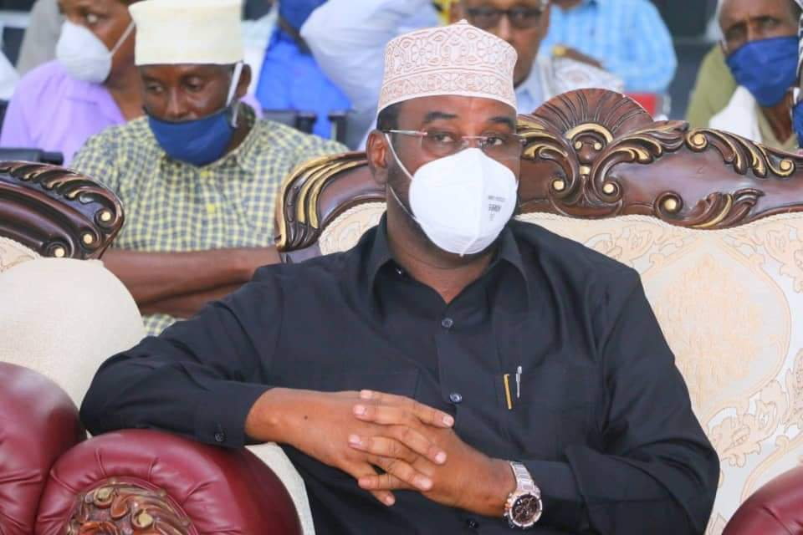 | 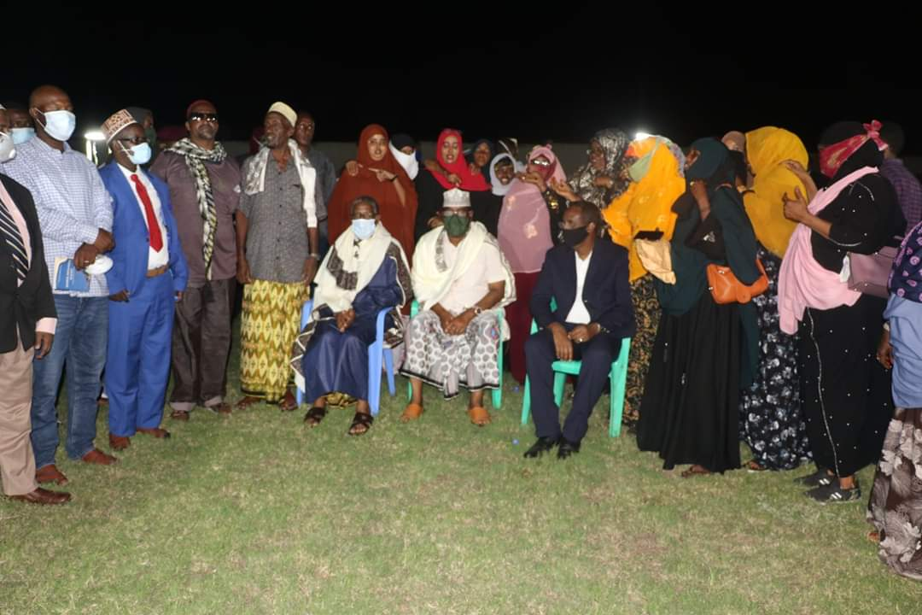

- Galmudug Reconciliations Conference held in Towfiq and Afbarwaqo, January 2020.

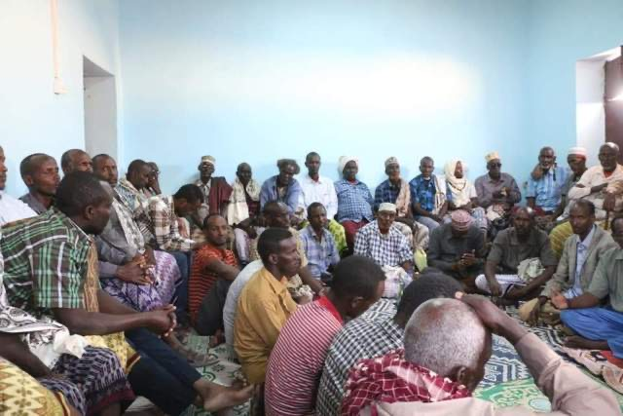 | 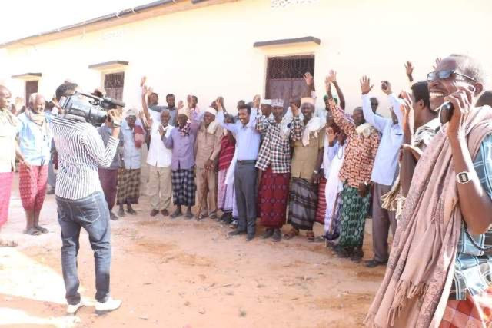 | 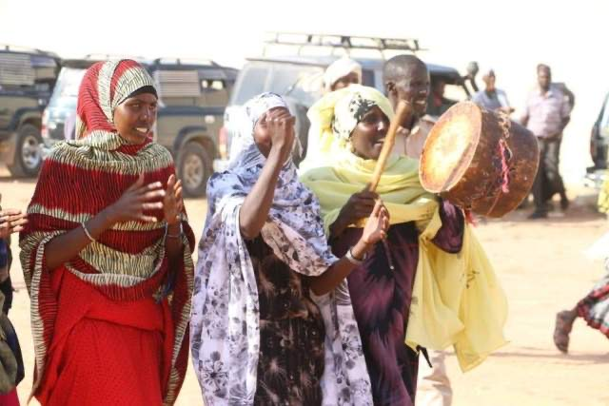

- Puntland Reconciliation Conference held in Qardho. February 2020
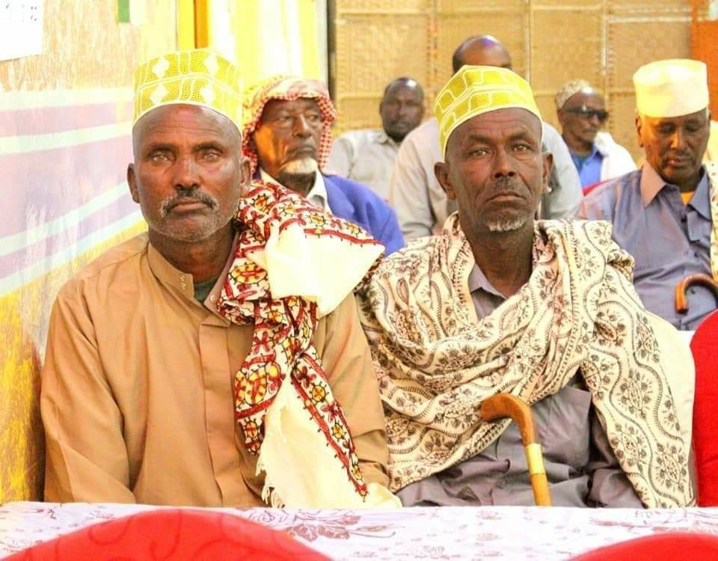 | 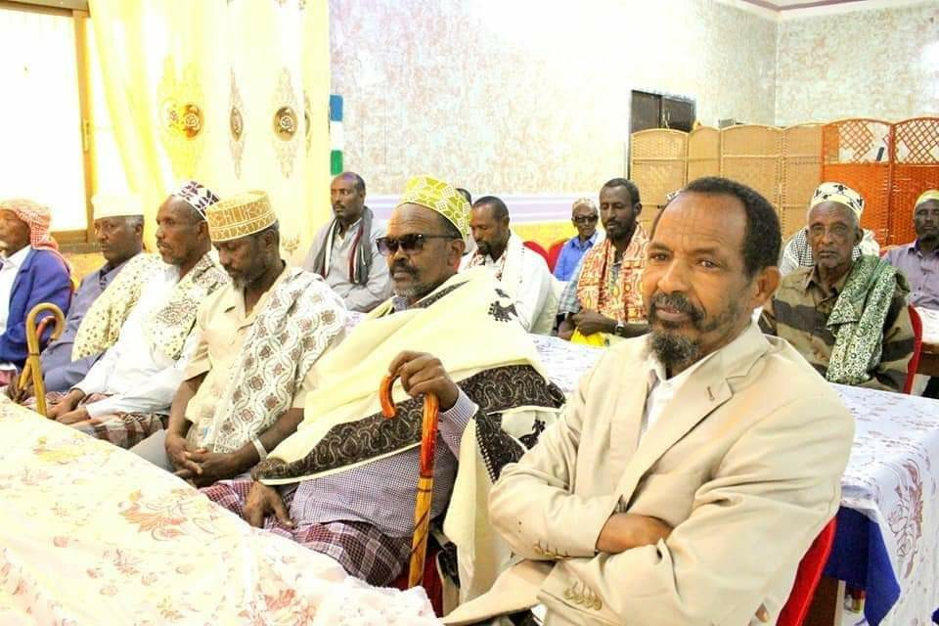 | 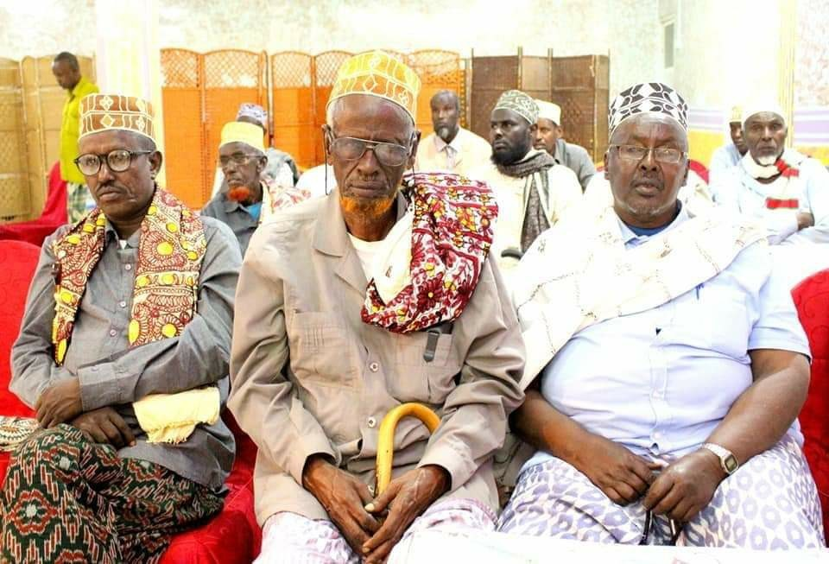

- Jubaland Regional Reconciliation Plan Conference held in Kismayo. September 2020
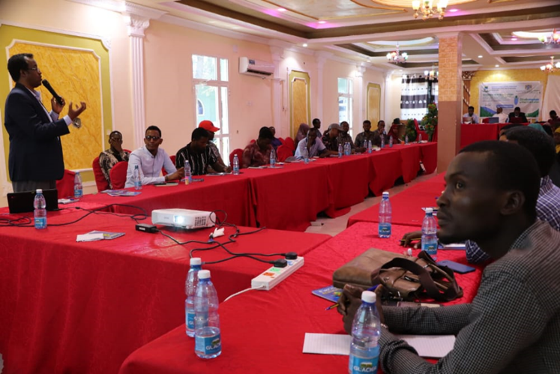 | 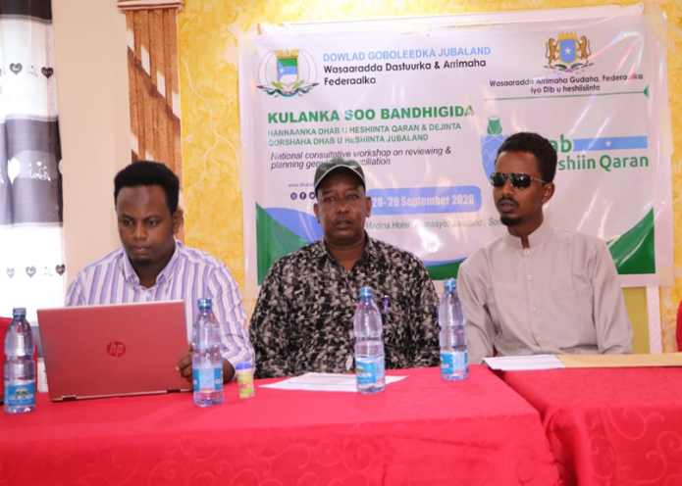 | 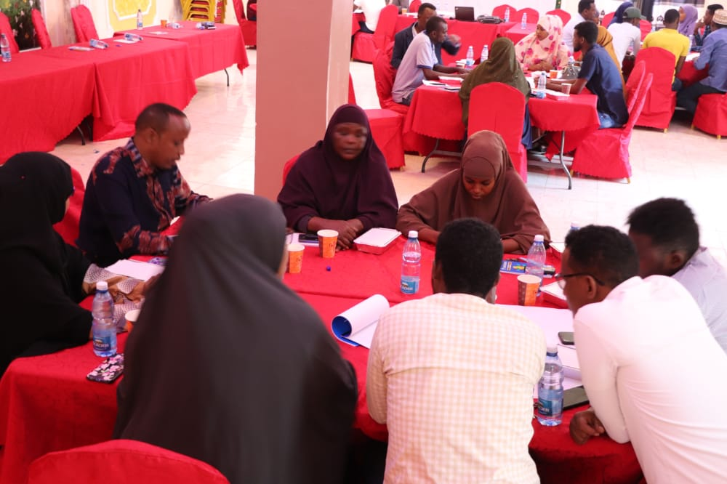

Photos of Dhusamareb Dialogues
