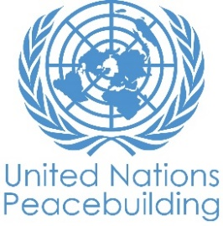
PBF PROJECT progress report
COUNTRY: South Sudan
TYPE OF REPORT: annual
YEAR of report: 2020

Project Title: Protecting women and girls in South Sudan: Addressing GBV as catalyst for peace
Project Number from MPTF-O Gateway: PRF 00117249
If funding is disbursed into a national or regional trust fund:  Country Trust Fund  Regional Trust Fund  Name of Recipient Fund: | Type and name of recipient organizations:  UNFPA (Convening Agency)  UNDP  UN Women  UNICEF
Date of first transfer: 05/ 09/2019
Project end date: 25/02/2021
Is the current project end date within 6 months? Yes
Check if the project falls under one or more PBF priority windows:
Gender promotion initiative
Youth promotion initiative
Transition from UN or regional peacekeeping or special political missions
Cross-border or regional project
Total PBF approved project budget (by recipient organization):
Recipient Organization Amount
UNFPA $ 1,000,000
UNDP $ 500,000
UN Women $ 500,000
UNICEF $ 1,000,000
Total: $ 3,000,000
Approximate implementation rate as percentage of total project budget: 52.26 (as on 31 August 2020)
*ATTACH PROJECT EXCEL BUDGET SHOWING CURRENT APPROXIMATE EXPENDITURE*

Gender-responsive Budgeting:

Indicate dollar amount from the project document to be allocated to activities focussed on gender equality or women’s empowerment: 100%
Amount expended to date on activities focussed on gender equality or women’s empowerment: $1,567,884 (as on 31 August 2020)

Project Gender Marker: GM3
Project Risk Marker: Low
Project PBF focus area: 3.2; equitable access to social services
Report preparation:
Project report prepared by: UNFPA
Project report approved by: RCO
Did PBF Secretariat review the report: Reviewed by PBF Focal Point.

PART 1: OVERALL PROJECT PROGRESS

During the reporting period of 1 year, the project reached 8711 individuals (approximately 90% women and girls) through case management support and 693,166 individuals through community outreach using integrated approach for prevention of and addressing GBV as catalyst for peace. The Covid-19 pandemic and the floods in Bor necessitated the project partners to adapt strategies to continue services for GBV survivors in the project areas. As a result of these timely adaptations, the life-saving GBV services and community engagement were continued in times when the risk of GBV increased even further.

Output | Lead Agency | Collaborating partners | Beneficiaries reached till 31 October 2020
Output 1 | UNFPA | - UN Joint programme agencies  - Ministry of Gender, Child and Social Welfare  - Smile Again Africa Development Organization  - ADAFIN  - Nile Hope | GBV survivors: 92  GBV service providers: 68  GBV duty bearers: 80  Community Action Groups: 15  Community outreach: 49,660 (35 radio shows)
Output 2 | UN Women | - UN Joint programme agencies  - UNMISS  - American Refugee Committee (ARC)  - Steward Women  - INTERSOS | Women including survivors: 1,428; men including local authority, community leaders: 195
Output 3 | UNDP | - UN Joint programme agencies  - Action for Children Development Foundation –South Sudan (ACDF)  - Humanitarian Aid for Change and Transformation (HACT)  - Humanitarian and Development Consortium (HDC)  - Upper Nile Youth Mobilization for Peace and Development Agency (UNYMPD) | Survivors: 580 (413 women, 167 men)  Service providers and duty bearers: 40 (11 females)  Community members: 417, 564 (57 percent female)
Output 4 | UNICEF | - UN Joint programme agencies  - American Refugee Committee (ARC)  - African Initiative for Rural Development (AIRD)  - CARE International South Sudan | GBV response and prevention messages: 5,528 individuals (900 girls, 632 boys, 3,293 women, 703 men)  Individual case management: 410 women and 95 girls  Distribution of dignity kits: 140  Community outreach: 225,942 people  (35,200 girls, 12,742 boys, 154,000 women, 24,000 men) through community outreach

To provide integrated services for the GBV survivors, UNFPA in Aweil and Akobo in collaboration with the Ministry of Health and Ministry of Gender, Child and social Welfare set up two Family Protection Centres, also known as One Stop Centre to provide immediate, urgent and confidential medical, psychosocial and legal services to the survivors of GBV. During the reporting period, total 92 women and girl GBV survivors received services. 17 cases of intimate partner violence, 28 cases of sexual violence. Through these OSCs, 45 survivors received medical services, and all the 92 survivors provided with psychosocial support. Total 68 service providers trained on provision of multi-sectoral GBV services, GBV concepts, guiding principles and referrals, and 80 duty bearers were engaged in GBV advocacy messages, coordination and updated referral pathways. Total 15 Community Action Groups are established to coordinate and act as community level support system for the survivors.

State ministry of Gender, Child and Social Welfare were supported to lead inter-sectoral and inter-agency coordination for survivor centric services in Aweil and Akobo. To address the increased risk of rise in GBV and impunity to the perpetrators, in June 2020 a joint statement (Annex 1) was issued by the National MOGCSW, Ministry of Health, Ministry of Interior, Ministry of Justice and Ministry of Youth.

To promote women’s participation in peace initiatives, in Aweil, the Women empower Centre (WEC) has been constructed and equipment for the centre has been procured. Referral pathways in Bor and Akobo have been updated based on mapping of available services available. Overall, 1,428 women including survivors and 195 men including local authority and community leaders were reached to strengthen women’s groups participation in local peace processes and increase civic engagement on GBV prevention and response. Community neighbourhood watch groups were established in Bor and Akobo to provide tracking, referrals and reporting on violence against women, group/family counselling, prevention of and ongoing discussions on ending violence against women and girls. In Akobo, 113 (all female, 29 >18 years) participated in business training on embroidery, knitting, hair dressing and bed sheet decoration.

Addressing the access to justice, UNDP worked with partners to provide legal representation for the survivors of GBV and legal awareness across communities while continuing counselling and referral services for GBV survivors to institutions that provide psychosocial support in Bor and Aweil. During the reporting period 580 survivors, i.e. 89 males, 204 females in Aweil, 78 male, 209 female in Bor received counselling and legal assistance through the help desks at the police stations. Of these, 98 (74 female) were represented in court and 33 (18 female) received judgements. This was made possible through two new Justice and Confidence Centres (JCCs) established and renovation of four pre-existing JCCs in Aweil and Bor. The JCC served as central operating units employing various approaches, i.e. (i) establishment of four auxiliary help desks operating at police stations; (ii) recruitment, training and deploying forty-four community volunteers; and (iii) strengthening the linkage between community volunteers and Special Police Units, Women and Girls’ Friendly Spaces and other relevant government institutions.

These approaches ensured speedy and timely reporting, investigation and processing of GBV cases for prosecution and referral to relevant services for their recovery including medical, psychosocial and counselling support. Additionally, UNDP built the capacity of justice actors such as judges, investigators, prosecutors and social workers and customary chiefs was undertaken to empower them to conduct fair investigation, prosecution and prevention of GBV related cases.

Focusing on social norm change, UNICEF used the ‘Communities Care’ approach to support the communities to engage in transforming social norms that perpetuate gender inequality and violence against women and girls. Through this approach, total 94 community discussion leaders (CDLs) were trained. 76 (14 girls, 6 boys, 34 women, 22 men) in phase 1; 18 (9 men, 9 women) in phase 2) new community discussion leaders (CDLs) undertook 300 community discussion meetings, engagement with local authorities and traditional leaders and the inclusion of women in peace-building processes. Fifty (26 females, 24 male) community leaders, chiefs and other first responders were trained on safe referrals for survivors.

The community groups focussed on child marriage, child labour, domestic violence, sexual violence at home and discrimination in the community in the messaging shared through radio talk shows, door to door awareness, church campaigns and community gatherings. CDLs served as community focal points to provide Psychological First Aid (PFA) to the community members, especially the survivors of GBV. To cope with the Covid-19 related challenges to community outreach, social media campaign were enhanced to advocate to apprehend the perpetrators and raise awareness about available services to women and girls.

Significant project-related events planned in the next six months:
As per the project plan, following significant events are scheduled –
- As part of the 16 Days’ Activism Campaign, a high level dialogue was hosted by the project partners in collaboration with the Ministry of Gender, Child and Social Welfare and Office of the Vice President on Gender and Youth. The programme concept note is attached as Annex 2 for reference. During the sixteen days of activism (25 November- 10 December 2020), community discussions will be held at the state level to encourage the community members to make public statements/ declaration for individual or collective actions against GBV. Communities in Aweil and Bor will collectively make public declarations to engage community members, civil society organizations (CSO), local government officials and other stakeholders.
- Intensify the advocacy to enact the Anti-GBV Bill at the parliament and post-enactment awareness raising amongst the main duty bearers, especially police, judiciary and GBV frontline staff.
- Continue awareness raising campaigns against GBV while continuing to provide legal aid to survivors of GBV.
- A training for female paralegals in Bor and Aweil using the endorsed training manual developed by UNDP.

Structural, institutional, societal level change the project has contributed to so far:
The project provided an opportunity for the four UN agencies to plan and execute joint actions harnessing each one’s operational as well as programmatic strength. The technical level team members have consistently made efforts to engage with the government counterparts not as individual agencies, but as a joint force, which helps in engaging with the government duty bearers as One UN.

The project has contributed to building grassroots cadre of women, men, girls and boys who have a better understanding of linkages between gender based violence and peace that echoes the Secretary General’s message of ‘Peace in Home, to Peace in the World’.

One major achievement the project reports is the behaviour change with the traditional leaders as there is an increase in traditional leaders referring GBV cases to various services, including the Justice and Confidence Centres, One Stop Centres and Community Discussion Leaders’ meetings. This sends a strong signal to perpetrators and community members at large that resolving GBV cases would be done through statutory courts and this might deter some perpetrators.

Human Impact Stories:

1. Court representation in forced abortion case yields positive judgement
Yaar Kuol (identity withheld), a 16 years old girl, was brought to HDC by her mother who had attended the HDC SGBV awareness campaign and learned about the legal aid services provided at the Justice and Confidence Centre. She registered a case of forced abortion on her daughter by her daughters’ boyfriend, who refused to take responsibility of the pregnancy and abandoned her after the termination of pregnancy. Yaar Kuol was immediately provided psychosocial support, and referred for medical services which was followed by legal advice. With her consent, the pro-bono lawyer registered a court case. HDC facilitated transportation ensuring that she attend court sessions and had legal representation. During the court proceeding, the court suggested for another medical check up to confirm the termination of pregnancy. The court ruling charged the boy for intentionally and forcefully aiding abortion and charged to pay thirty (30) head of cattle for aiding abortion and dowry for the girl (when she turns 18) according to the Dinka culture. During a follow up visit after the closure of the case, the survivor and the family appreciated HDC for the support through the JCC for facilitating access to justice.

2. Legal justice for a survivor of GBV in a divorce case
Twenty-two-year-old Abuk* (identity withheld) was referred to HACT through the State Ministry of Gender. She lives in Aweil and had been forced to marry a prominent politician working in Juba. Following payment of dowry and the traditional wedding, she relocated to Juba where she lived with her co-wife and husband. Abuk reported that while living in Juba, the husband and co-wife started mistreating her and it escalated to physical assault. She escaped and opened a case against the husband about the mistreatment. The husband was summoned to court, but he failed to honour the summons. In a bizarre event, shortly after filing her case, Abuk was abducted and tied to a tree in the forest where her mother found her after three days, she did not know who her abductors were and therefore this was not pursued. She proceeded with her case against her husband in Aweil High court and requested the court to grant her divorce through her lawyer. Following court proceedings, the judge ruled in her favour granting her divorce and instructing the now ex-husband to handle the return of dowry with Abuk’s father as the divorce was finalized. When HACT visited Abuk at her parent’s house, she expressed her gratitude for the legal aid she had received as she was living happily as a free woman. This case also charts a positive path as in the past, women could not file for divorce and such cases were referred for mediation even if woman was seeking divorce.

3. The hotline became a lifeline: COVID-19 made it difficult for GBV survivors to seek help, a hotline became the solution
Aweil, South Sudan - The black mobile phone starts chiming again. Before, the hotline would receive only two to four calls a week, now they receive two to three per day. The digital high-pitch sound stops.

“Many people don’t have money to call, so this is the sign that we should call them back,” Laura Abuk Ajang says. She is a case worker at the women friendly centre in Aweil which is also operating the hotline for gender-based violence (GBV).

“Before, the women would come to the centre to seek guidance, get counselling and for referrals, but COVID-19 changed that,” Laura explains.

When a semi-lockdown was introduced in South Sudan, it became more difficult for GBV survivors to seek help as there was no means of transport to get to the centre. Later, when public transport was allowed the prices had gone through the roof. If you got to the centre, the number of people who could be there at the same time was limited due to the COVID-19 regulations.
American Refugee Committee (ARC) which is operating the hotline with support from UNICEF, printed the hotline number and distributed it in public places such as Primary Health Care centres, nutrition centres, churches and mosques, for more women to be aware. The hotline became the lifeline for many women.

“Since the beginning of the pandemic, the number of emotional abuse cases have risen every day and it has continued to rise,” says Lual Deng. He is the Senior GBV Project Officer for ARC and explains that the spike comes as a result of many men being laid off from work due to covid-19 and they take their frustration out on their wives.

Most of the abuse happens at night and the hotline is open 24 hours, but most of the calls are received during the day. “They call after an incident or when an unbearable situation has prevailed too long. They call when they are alone, when they have no support or when they have worked up the courage. The cases vary from emotional violence to beatings and rape. We try to be as near to the survivor as we can, even if we are far in reality,” Laura says.

Laura says she likes her job, but it is challenging not to be able to help all the women in need. “Some areas outside Aweil have poor network and they can’t call, and they can’t come.”
https://www.unicef.org/southsudan/stories/hotline-became-lifeline

4. Community dialogues on GBV issues in Bor leads to increase reporting of GBV
Following the training facilitated by UN Women, the office of Special Protection Unit in Bor headed by Mr. Joseph said “after training, the reporting of GBV cases at the SPU is on the rise by the community leaders. With the actions of some of the participants in the seminar on the legal and human right of women and girls already, it is fair to say, the activity improved the capacity of local authority to manage GBV survivors.”

PART II: RESULT PROGRESS BY PROJECT OUTCOME

Output 1: Increased access comprehensive GBV support services

Current status of the progress: On track

Progress summary:
During the reporting period, the two OSCs at the Aweil Civil hospital and Akobo County Clinic provided immediate, integrated and confidential services to 62 survivors at Aweil and 30 survivors at Akobo. To reach out to the survivors through community awareness, 15 sessions in Aweil, 6 in Akobo were organized. Due to Covid-19, the door-to-door community outreach was replaced with 35 radio shows and use of mega phones, reaching approximately 49,660 listeners.

To comply with government regulations related to Covid-19, handwashing facilities were installed at the OSCs, staff rotation were put in place and physical distancing measures were adopted. A guideline was issued for all the partners on how to conduct case management to follow Covid-19 preventive measures (attached as Annex).

Akobo and Aweil OSC Caseload (covering the period January to September 2020)
FPC | Total Caseload | GBV Type
 |  | Physical violence | Sexual violence | Rape | Emotional violence | Child/force marriage | Denial of resources
Akobo | 30 | 7 | 6 | 1 | 2 | 9 | 5
Aweil | 62 | 10 | 4 | 17 | 13 | 4 | 14
Total Case | 92 | 17 | 10 | 18 | 15 | 13 | 19

Actions to ensure gender equality and women’s empowerment and youth inclusion:
The GBV and ECM needs assessment carried out in March 2020, assessed the situation of GBV on women and girls, which highlighted the importance of working to end harmful traditional practices such as ‘honour’ related crimes and addressing domestic violence. The focus group discussion and key-information interviews (KII) with 300 people (100 women aged 18-35, 100 men aged 18-45, 50 girls aged 13-17, and 50 boys aged 15-17), and KII with the chiefs, pastors, police matron, prison representative, Criminal Investigation Department representative, head teachers, and local authorities in Akobo East indicated that 90 per cent of GBV and ECM were caused by financial crisis and harmful traditional practices within community. The most affected population were women and girls, and persons with disability.

The report also showed that GBV and ECM cases increased due to lack of police protection and weak law reinforcement from local authorities. Thirty per cent of GBV cases occurred at the borehole, where women and girls go to fetch water. The lack of borehole management triggered physical assault among women, and girls. Fifty-five per cent of ECM were caused by financial crisis, where parents and relatives forced their daughters to get married for financial security; 10 per cent of cases were caused by harmful traditional practices, i.e. honour related crimes, and revenge killing; and 40 per cent of the GBV cases were domestic violence. Youth participation and representation is ensured in the Community Action Groups linked with the OSCs.

Output 2: Strengthened women’s groups participation in local peace processes in Bor, Aweil and Akobo and increase civic engagement on GBV Prevention and response

Current status of the progress: On track with some delays

Progress summary:
With some delay in commencing the project, UN Women leveraged partnership with UNMISS in Akobo by using the Women Empowerment Centre constructed by UNMISS as a local peace hut to engage women for their empowerment and to promote their participation in local peace building mechanisms.

In Akobo GBV case management has responded by INTERSOS to 9 cases including 1 rape, 4 physical assault, 3 denial of resources and 1 case of abandonment. All cases were referred to the appropriate assistance including medical, psychosocial support (PSS), counselling, and livelihood upon consent. Identification of survivors was done through voluntary reporting during house to house visits by Case Workers, Community Mobilizers, or Community Based Protection Network members as well as from those reporting during GBV awareness sessions and community dialogues

44 women in Akobo (<18 years, 10 widows, 6 single parents, 11 elderly, 17 women with specific need) acquired facilitation skills through training to intervene in cases of violence against women and girls (VAWG) through protection and response services while following and including COVID-19 prevention and response messages.

129 people (9 females and 21 male in Akobo and 59 female and 40 male in Bor) including elders, community leaders, women living with disabilities, and local authorities were reached through community level dialogues on VAWG/SGBV. The dialogues highlighted child marriage, physical abuse, access to resources and destructive cultural practices as the common forms of abuse. Insufficient wash facilities, fetching firewood on the outskirts of the payams as well as overcrowded households were highlighted as factors that heighten the risk of abuse. As action from the dialogue sessions, community based 'neighbourhood watch' groups were formed in Akobo and Bor. These groups comprise of 10 men and 20 women who gather on fortnight to feedback on protection concerns around the community. The communities enabled to provide ongoing tracking, referrals and reporting on violence against women, group/family counselling, prevention of and ongoing discussions on ending violence against women and girls through the groups.

A total of 1,337 community members (948 female and 17 male in Akobo, 97 female and 60 male in Bor and 158 female and 57 male in Aweil) were reached to awareness focussed on S/GBV prevention and response services, peace building and conflict mitigation mechanisms, livelihood activities available at Women and Girls Friendly Space (WGFS), women’s rights, dangers of mob justice or revenge killings and dangers of early and force marriage. Awareness was conducted through door to door as well as small gathering events within COVID- 19 restrictions in Akobo and neighbourhood assemblies in Bor.

A mapping of women led initiatives and mechanisms on local peace building processes and participation of women was carried out. The results of this mapping highlight the need of updating referral pathways in Bor and Akobo with continues need for removing barriers that limit women participation in peace building processes.

In Akobo 113 (all female, 29 >18 years) acquired embroidery, knitting, hair dressing and bed sheet decoration skills through business training based on the findings of a skills development assessment for women groups (including most vulnerable groups such as women with disabilities, widows, and elderly ones). The assessment informed training on women economic empowerment activities. These initiatives include income generating activities of their interest and individual skills. The needs identified by the women include life skills activities such as knitting, bed sheet decoration, beadwork, fuel efficient stove making as well as business skills.

Actions to ensure gender equality and women’s empowerment and youth inclusion:
Activities under this output focussed on addressing the needs of women and girls through conducting skill needs assessment through participatory approaches that informed training on livelihoods initiatives such as embroidery and knitting that would contribute to improved household incomes. Furthermore, women and girls were provided with safe spaces that serves as platforms for empowerment and raising issues affecting daily lives. The output also engages with male community members to improve their knowledge on women and girls’ rights as human rights through dialogue sessions on social norms and harmful cultural practices that heighten the risk of violence against women and girls. A project risk assessment conducted in Bor highlighted the need to adjust the time of activities involving women and girls to minimise risk of exposing them to harm e,g. all activities to be completed before 2pm.

Output 3: Increased access of GBV survivors to justice mechanisms

Rate the current status of the outcome progress: On track

Progress summary:
The table below provides a summary of the GBV cases registered by the four CSO providing legal aid in Bor and Aweil.

 | Aweil |  | Bor |  | Grand total (Bor & Aweil)
 | Total | Female | Total | Female
Cases recorded at JCC | 293 | 204 | 287 | 209 | 580 | 413
Cases referred to court | 38 | 33 | 60 | 41 | 98 | 74
Cases that have received judgement in court | 17 | 15 | 16 | 3 | 33 | 18

An analysis of the data reflects an increase in the number of GBV cases reported. Total 580 cases (413 female) were recorded between the period January to November in comparison to the 14 registered four months earlier. All the survivors were provided with counselling and referred to other institutions for other specialized services. A total of 98 (74 female) cases were referred to court and 33 (18 female) have so far received judgement which is 33.7 percent of the total referred cases. The significant difference in the numbers of cases reported at the JCC and the cases referred to court is largely due to cultural norms where GBV is not considered a crime and though survivors report it, they are unwilling to take legal action against the perpetrators.

The CSOs tried to address this by intensifying their awareness raising efforts through outreaches and radio campaigns focusing on the rights of women and girls, sexual and gender based violence including rape, early and forced marriage, domestic violence and human rights. The CSOs also informed their audiences about the legal consequences for perpetrators of GBV and information dissemination about the available services for survivors at the JCCs and help desks. As a result, 417, 564 (57 percent female) people were reached in Bor and Aweil.

In parallel, to ensure professional handling of GBV cases, the program provided specialized training to investigators, social workers, chiefs, prosecutors, and judges on investigation, prosecution, prevention, response and adjudication of SGBV and related offences in Aweil and Bor. In this regard, the project trained 40 (11 females) in Bor and Aweil with participants reporting and 78 percent and 80 percent increase in knowledge on the subject in Aweil and Bor respectively thereby equipping them to handle GBV cases professionally and in line with human rights standards. Following the training. while acknowledging how influential traditional leaders are in local community administration, traditional chiefs were invited to speak out against GBV during radio shows and outreaches. The project records recognizable success as some GBV cases were referred to the JCC by the traditional leaders that had been sensitized on Human Rights both through the project which reflects a change in perception.

Main challenge during the reporting period has been the COVID-19 outbreak and the consequent adaptation of activities to comply with preventive measures and Government issued guidelines regarding social gatherings. Handwashing facilities were installed at activity points, face masks were provided to training participants and physical distancing measures were adopted during implementation of activities. The project also notes that harmful cultural norms where GBV is not considered a crime impact the number of GBV cases presented to court as most survivors are unwilling to pursue legal justice due to fear of ostracization by their communities.

Actions to ensure gender equality and women’s empowerment and youth inclusion:
The project has included women in all efforts to support access to justice for GBV survivors. Notably, the community volunteers are all female. These community volunteers were trained and mentored on how to respond to GBV cases and how to raise awareness and proactively advocate against GBV. Additionally, majority of the beneficiaries to the services provided at the Justice and Confidence Centres are female, thereby focusing on empowerment of the women and girls.

Output 4: Communities in Bor and Aweil transform harmful social norms that contribute to GBV into positive norms that promote gender equality

Total 5,528 individuals (900 girls, 632 boys, 3,293 women, 703 men) were reached through GBV response and prevention messages by UNICEF. A total of 410 women and 95 girls benefitted from case management, psychosocial support (PSS) counselling, skills building courses, risk mitigation information and referrals for other specialised and non-specialised services at the Women and Girls Friendly Space (WGFS). A total of 134 GBV survivors who sought support at the WGFS were provided with GBV response services and/or referred for other specialised services according to their needs. In addition, 201 beneficiaries (161 women, 40 girls) completed the skills-building course on tailoring and bead-making and graduated in October. Furthermore, 140 girls of reproductive age received dignity kits during sessions on menstrual health and hygiene at three primary schools in Aweil.

A GBV hotline was launched in Aweil, with community leaders instrumental in creating awareness on the existence of the hotline to promote continued access to information on services available as well as PSS remotely. Eighteen people (9 women, 9 men) were trained on facilitating community discussions, including on conflict and peacebuilding strategies to ensure the involvement of women and girls. An additional eight new community discussion groups were created to facilitate and engage in discussions on changing harmful social norms and conflict resolution in the community.

A total of 225,942 people (35,200 girls, 12,742 boys, 154,000 women, 24,000 men) have been engaged in awareness raising and discussions on harmful social norms and identification of actions to transform the norms to positive measures that promote gender equality and women’s engagement in peace building.

The COVID-19 outbreak has continued to pose a challenge, especially in the implementation of community actions by community discussion groups. Public declaration events had to be cancelled in Aweil - and this is still pending - but alternative modalities are being discussed to ensure this continues. The number of participants in the groups has also been reduced to comply with COVID-19 preventive measures. Despite the challenges posed by the COVID-19 restrictions on limiting the number of members engaged, UNICEF and implementing partners increased the number of discussions held to ensure that the information dissemination is continued.

Actions to ensure gender equality and women’s empowerment and youth inclusion:
Through the Communities Care approach, community discussion groups were established with women only, men only, mixed men-women groups, and youth and community leaders. Group composition ensured better representation of women’s issues in women only groups, gave them a platform to air their views and increased their engagement. Girls and boys were engaged to ensure that they participate in resolving issues that affect them and the community in general. Through the WGFS, 201 women and adolescent out of school girls are currently engaged in skills building activities to ensure that they are empowered with hands-on skills and knowledge for economic and life skills empowerment. This has also increased social cohesion and networking amongst the women in the communities and ensured that they strengthened relations and created a network of peers to support each other especially during the COVID-19 restrictions and limitations in interactions and movements.

PART III: CROSS-CUTTING ISSUES

Monitoring: Please list monitoring activities undertaken in the reporting period  During the project inception, three joint missions were conducted by UNFPA, UNDP, UNICEF, UN Women and the Resident Coordinator’s Office. Due to COVID-19, no physical monitoring could be conducted thereafter, however, online monitoring were carried out by each partner agency. The Technical Working Group for the project met regularly for joint planning and implementation.  Tracking results progress: At the monthly TWG meetings, the project progress was reviewed to learn about the areas where the implementation challenges are experienced and adaptation needed  Programme review Meetings: Programme Review meeting was organized in July 2020 to learn about the bottlenecks and plan to adapt the implementation  Project reporting: Regular project reports were produced and dialogues held to learn from each other’s experiences of project implementation.  Following programme monitoring visits were conducted by respective agencies:  Output 1 –  - Weekly reports on GBV trends analysis and COVID-19 awareness are being done.  - A monitoring meeting was organized by UNFPA with the partner in February 2020.  - Virtual/ online reporting and meetings have been conducted with the partners on a weekly basis since the week of 20 March for monitoring and guidance during the COVID-19 pandemic.  - Regular debriefs through phone and emails are being done especially on the onset of COVID-19. Weekly reports on GBV trends analysis and COVID-19 awareness are also being done.  - Technical briefs have been developed and shared with the partners for adaptation of case management.  Output 2 –  - Participated in three joint inception missions to Aweil, Bor and Akobo.  - Regular correspondence (email and telephones) with identified implementing partners is ongoing and done weekly, in particular on the adaptation of activities in line with COVID-19 measures and restrictions.  - Conducted monthly zoom meetings with partners on project progress.  Output 3 –  - Participated in two joint inception mission to Aweil and Bor.  - Participated in the technical working group meetings.  - UNDP field staff in the areas of implementation hold regular monitoring meetings with the implementing partners to assess their progress.  - Regular team debrief through a weekly zoom meeting and follow up through phones.  - Remote monitoring continued due to COVID-19 outbreak  Output 4 –  - UNICEF undertook a monitoring visit in January to support the implementing partner as well as provide technical oversight in implementation in Bor.  - UNICEF’s Communications and Child Protection teams held a focus group discussion with women and adolescent girls in Aweil.  - Remote/online support include weekly activity reports after mid-March 2020 to update on activity progress and gaps.  - Online meetings have been held to orient implementing partners on adaptation on programme modalities and on the guidance notes on programme adaptation.  - Regular debriefs through phone and emails were conducted at the onset of COVID-19 to ensure continuum of services for survivors of GBV and adapt outreach modalities. | Do outcome indicators have baselines?  There is a baseline data existing for the participants of Communities Care model under Outcome 4. No baseline data exists for the overall outcome level indicators. Data collection tools have been designed and the partners will conduct an assessment to capture the results against the outcome indicators.  Has the project launched perception surveys or other community-based data collection?  No perception survey is initiated.
Evaluation: Has an evaluation been conducted during the reporting period?  No | Evaluation budget (response required): $150,000 (including M&E costs)  Evaluation preparations: As the project baseline has not been conducted, the evaluation will factor in a methodology to capture the progress during the project period and results achieved, and lessons learned
Catalytic effects (financial): | SDC: $586,000 (UNFPA)  ECHO: 100,000 (UNICEF)  OFDA: 100,000 (UNICEF)
Other issues concerning project implementation | Due to COVID-19 pandemic delayed implementation of some planned activities. Additionally, the project had to modify their implementation method to comply with the Government issued COVID-19 guidelines.

PART IV: COVID-19
- Monetary adjustments: Please indicate the total amount in USD of adjustments due to COVID-19: $ None

- Non-monetary adjustments: Please indicate any adjustments to the project which did not have any financial implications:
All partners adjusted the implementation approach to adhere to the guidelines issued by the government of South Sudan regarding COVID-19 preventative measures. To adhere to these following measures were taken –
- The trainings were staggered to not include more than 15 members in each training
- The trainings would be conducted in one hall wherein the participants were split into two groups and facilitation conducted separately. Additionally, the training facilitators ensured to echo the message of COVID-19 urging participants to adhere to guidelines as well as take protective and preventative actions.
- Handwashing facilities were installed at all the GBV service provision centres, including OSC, WGFS, JCC, peace huts
- Community mobilization was adapted to reach through mega phones, and radio programmes instead of previously used in-person community outreach
- At the GBV service delivery points, staff rotations were set up to reduce staff footprint while continuing the services

- Please select all categories which describe the adjustments made to the project
☐ Reinforce crisis management capacities and communications
☒ Ensure inclusive and equitable response and recovery
☐ Strengthen inter-community social cohesion and border management
☐ Counter hate speech and stigmatization and address trauma
☐ Support the SG’s call for a global ceasefire
☐ Other (please describe):

PART V: INDICATOR BASED PERFORMANCE ASSESSMENT

Using the Project Results Framework as per the approved project document or any amendments- provide an update on the achievement of key indicators at both the outcome and output level in the table below (if your project has more indicators than provided in the table, select the most relevant ones with most relevant progress to highlight). Where it has not been possible to collect data on indicators, state this and provide any explanation. Provide gender and age disaggregated data. (300 characters max per entry)

 | Performance Indicators | Indicator Baseline | End of project Indicator Target | Indicator Milestone | Current indicator progress | Reasons for Variance/ Delay  (if any)
Outcome 1  Increased empowerment of women in South Sudan by strengthening prevention mechanisms for GBV by transforming harmful social norms into positive behaviour that promotes gender equality. | Indicator 1.1  % increase in women and girls’ participation in local peace and justice activities | 0 | 40% | Baseline to be set up | To be measured at the end of the project | Outcome indicators will be measured at the end of implementation through an independent expert.
 | Indicator 1.2  Women’s perception of their inclusion and equality in society | TBD | TBD | Baseline to be set up | To be measured at the end of the project | Outcome indicators will be measured at the end of implementation through an independent expert.
 | Indicator 1.3  proportion of women and girls who feel confident to report GBV and know where to access relevant services in case they become victim of GBV | TBD | 40% | Baseline to be set up | To be measured at the end of the project | Outcome indicators will be measured at the end of implementation through an independent expert.
Output 1.1  Increased access to comprehensive GBV support services in Bor and Aweil | Indicator 1.1.1  Number of GBV survivors accessing and using the integrated GBV services in One stop centre (SADD | 0 | 1000 | Based on the track record | 92 | Total cases where direct holistic support provided is as per GBV survivors approaching the OSCs
 | Indicator 1.1.2  Number of GBV One Stop centres established and operational | 0 | 2 | Based on the baseline | 2 | Target achieved.
 | Indicator 1.1.3: Number of service providers (disaggregated by sex and profession) with increased skills and other capacity in providing integrated response services | 0 | 100 | Establishment of the OSCs | 148 | Target achieved.  In total, 148 GBV case management related actors, i.e. OSC staff, chiefs, representatives from police, youth representatives and women representatives, have been trained in Aweil and Akobo.
 | Indicator 1.1.4: Number of People (SADD) which are aware of the existence and services of the One stop centre in the intervention areas | 0 | 20000 | Outreach campaigns/ activities | 49,660 | Target achieved.  Community awareness conducted through 35 radio talk shows and road shows through microphone rallies. These new strategies also create an opportunity to sensitize the communities and create awareness on COVID-19 and how best the community could keep their families and friends safe from COVID- 19.
Output 1.2  Strengthened women’s groups participation in local peace processes in Bor and Aweil and increase civic engagement on GBV Prevention and response | Indicator 1.2.1  Number of advocacy issues raised by women through peace huts initiatives | 0 | 5 | Establishment of the peace huts | 5 | Target achieved.  - Early marriage  - Wife inheritance  - Property ownership  - Girl – child education  - Revenge killings
 | Output indicator 1.2.2  Number of women’s peace huts/ women centres functional | 4 | 5 | Establishment of the peace huts | 1 in Aweil | 3 in Bor delayed due to delays in timely land allocation and procurement of building materials due to COVID-19 travel restrictions and flooding.
 | Output indicator 1.2.3  Number of community members reached on GBV response and importance of women participation (SADD). | 0 | 5000 (60% women and girls) | Establishment of the peace huts | 1,428 women  195 men | COVID-19 restrictions such as social distancing and flooding in Bor and Akobo contributed to decreased number of women and girls reached.
 | Output indicator 1.2.4  # of women trained on facilitation skills on women participation in peace | 0 | 350 | Establishment of the peace huts | 44 Women | COVID-19 restrictions such as social distancing and flooding contributed to decreased number of women and girls reached.
Output 1.3  Increased access of GBV survivors to justice mechanisms | Indicator 1.3.1  Output Indicator 3.1  Existence of functional mobile court system to adjudicate GBV cases | No | Yes | Mobile court setting up preparation | Yes. | Target achieved. Three mobile courts dispatched to Kapoeta, Yambio and Terekeka [prioritized the adjudication of 8 GBV cases. The mobile court teams continue to be engaged to prioritize adjudication of GBV cases.
 | Indicator 1.3.2  % of cases prosecuted to completion | 0 | 5% | Cases currently in court | As per the set target in the project document | Target achieved
 | Indicator 1.3.3  Number of community-based paralegals with skills to support dispensation of justice for survivors (SADD) | 0 | 25 per state (min 25% men) | List of paralegals | As per the set target in the project document | In progress
Output 1.4  Communities in Bor and Aweil transform harmful social norms that contribute to GBV into positive norms that promote gender equality | Indicator 4.1  % of target population that views GBV as less acceptable after participating in the perception survey | 0 | 75% | 113% | 85% | Target achieved
 | Indicator 4.2  # of community action groups addressing GBV, peacebuilding, social cohesion, social norms and negative cultural practices | 0 | 16 | 100% | 16 | Target achieved
 | Indicator 4.3  # of trained community action group members with increased knowledge on addressing negative social norms and increasing women and girl’s engagement in peace building and social cohesion | 0 | 200 | 85% | 169 | There was need to reduce the number of participants in line with COVID-19 prevention measures.

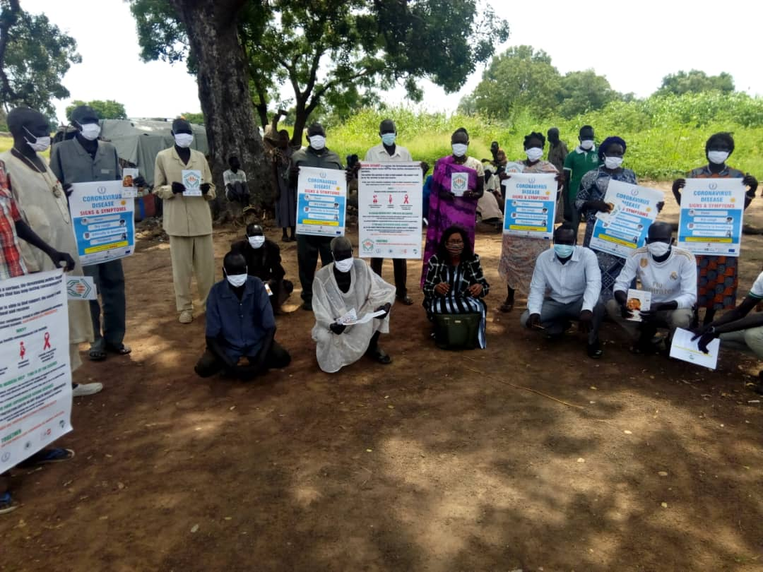  Figure 1: Ongoing key stakeholder dialogue sessions, Maper East, Photo courtesy: ADAFIN | 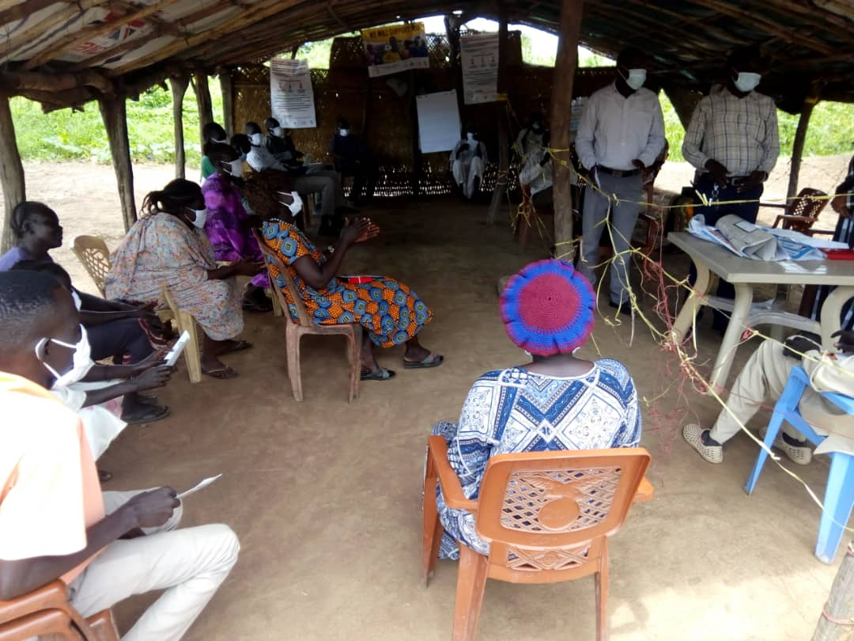  Figure 2: Key stakeholder meeting, Apada; Photo courtesy: ADAFIN
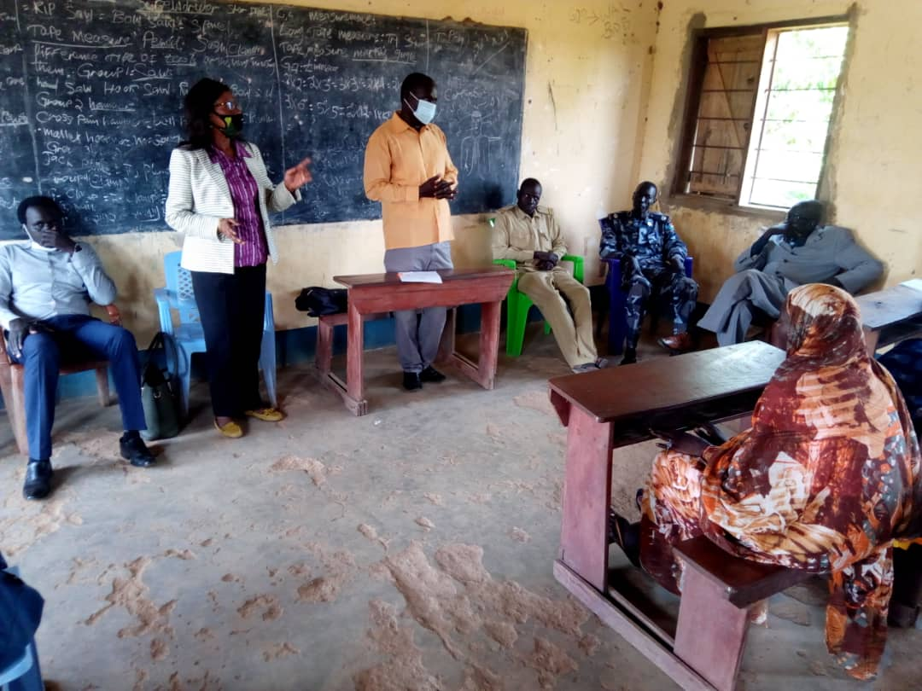  Figure 3: Ongoing Payam level meeting on ending early/ forced marriages; Photo courtesy: ADAFIN | 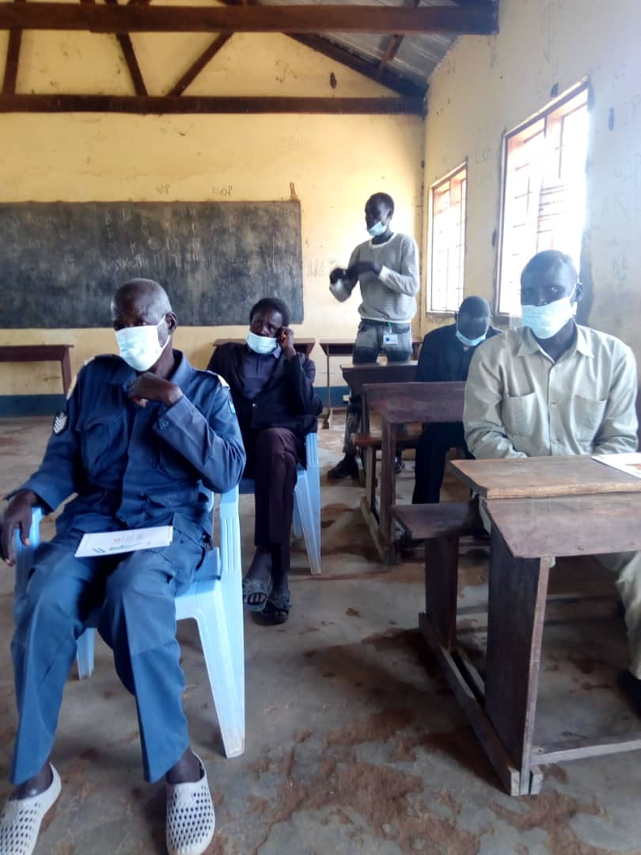  Figure 4: Participants listening to an ongoing advocacy session, Maper; Photo courtesy: ADAFIN

