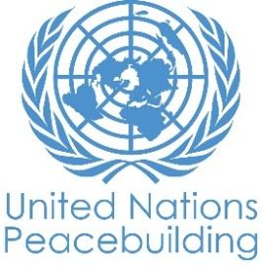
PBF PROJECT PROGRESS REPORT
COUNTRY: South Sudan
TYPE OF REPORT: SEMI-ANNUAL, ANNUAL OR FINAL:
YEAR OF REPORT: 2021

Project Title: Strengthening Young Women Participation in Local and National Peacebuilding Processes in South Sudan
Project Number from MPTF-O Gateway:
If funding is disbursed into a national or regional trust fund:  ☒ Country Trust Fund  ☐ Regional Trust Fund  Name of Recipient Fund: | Type and name of recipient organizations:  Search for Common Ground (Convening Agency)  Crown the Woman South Sudan  National Women Empowerment and Rehabilitation Organization (NWERO)  Anataban  Eye Radio
Date of first transfer: December 6, 2019
Project end date: September 12, 2021
Is the current project end date within 6 months?

Check if the project falls under one or more PBF priority windows:
☒ Gender promotion initiative
☐ Youth promotion initiative
☐ Transition from UN or regional peacekeeping or special political missions
☐ Cross-border or regional project

Total PBF approved project budget (by recipient organization):
Recipient Organization Amount

Search for Common Ground $ 958,085.00
Crown the Woman South Sudan $ 101,250.00
NWERO $ 100,545.00
Anataban $ 121,750.00
Eye Radio $90,583.00
CRN Radio $26,250.00
Total: $ $1,398,463
Approximate implementation rate as percentage of total project budget: 84%
*ATTACH PROJECT EXCEL BUDGET SHOWING CURRENT APPROXIMATE EXPENDITURE*

Gender-responsive Budgeting:

Indicate dollar amount from the project document to be allocated to activities focussed on gender equality or women’s empowerment: $1,306,974.99

Amount expended to date on activities focused on gender equality or women’s empowerment: $1174671.54

Project Gender Marker:
Project Risk Marker:
Project PBF focus area: 2.3
Report preparation:
Project report prepared by: Peter Kuot Ngong, Project Coordinator
Project report approved by: Kenneth Ganna-Conteh—Country Director
Did PBF Secretariat review the report:

NOTES FOR COMPLETING THE REPORT:
- Avoid acronyms and UN jargon, use general /common language.
- Report on what has been achieved in the reporting period, not what the project aims to do.
- Be as concrete as possible. Avoid theoretical, vague or conceptual discourse.
- Ensure the analysis and project progress assessment is gender and age sensitive.
- Please include any COVID-19 related considerations, adjustments and results and respond to section IV.

PART 1: OVERALL PROJECT PROGRESS

Briefly outline the status of the project in terms of implementation cycle, including whether preliminary/preparatory activities have been completed (i.e. contracting of partners, staff recruitment, etc.) (1500 character limit):

The project implementation progressed well despite many challenges encountered as a result of outbreak of the COVID-19 pandemic in early 2020. All project partners, namely: An-Ataban Arts Initiatives, Eye Radio, Crown the Woman, National Women Empowerment and Rehabilitation Organization (NWERO) and Catholic Radio Network (CRN), completed the implementation of their scope of work by February 28, 2021. In addition to the originally agreed project locations of Juba, Torit, Bor and Aweil, the local partners were successful in extending their implementation coverage to strengthen peacebuilding skills and empower young women in Yei, Maridi, Yambio, Rumbek and Bentiu towns – leading to the project being implemented in a total of 9 locations in South Sudan.

Specific to outcome achievement, the project implementation progressed well in relation to Outcome 1 and 2, however, the COVID-19 pandemic presented numerous challenges towards activity implementation relevant to Outcome 3. However, significant progress continues to be made, including the completion of a case study on the impact of youth efforts on peace processes in South Sudan. Actions such as the case study contribute to laying a foundation for young women-led advocacy campaigns for women- and youth-inclusive peace processes in South Sudan. These campaigns target both national, regional and international institutions to be provided with policy briefs and good practice guidance documents.

Please indicate any significant project-related events anticipated in the next six months, i.e. national dialogues, youth congresses, film screenings, etc. (1000 character limit):

The following are planned to take place in the next six months:
- Partners’/key stakeholders’ workshop to share and validate the case study findings and recommendations on youth (and especially young women) participation in peace processes in South Sudan;
- Young women-led international advocacy to be organized in Addis Ababa and Juba on effective young women participation in peace processes in South Sudan;
- Women and youth workshop and good practice guidance materials provided on mediation and mapping of youth mediators/peacebuilders;
- Production and sharing on social media of short success story videos;
- What works podcast produced and strategically distributed to share the key project impacts;

FOR PROJECTS WITHIN SIX MONTHS OF COMPLETION: summarize the main structural, institutional or societal level change the project has contributed to. This is not anecdotal evidence or a list of individual outputs, but a description of progress made toward the main purpose of the project. (1500 character limit):

In a few sentences, explain whether the project has had a positive human impact. May include anecdotal stories about the project’s positive effect on the people’s lives. Include direct quotes where possible or weblinks to strategic communications pieces. (2000 character limit):

Search has been working with local partners to strengthen young women leaders with peacebuilding skills and abilities to lead peacebuilding initiatives and promote peaceful coexistence at local and national levels. As a result of peacebuilding skills training and mentorship programs conducted from March 2020 to February 2021, more than 240 young women in Juba, Torit, Bor, Aweil and Maridi, were able to increase their participation in peacebuilding, with participants identifying and developing their own peace efforts to address issues in their communities. These young women formed a total of 18 local peacebuilding networks in which they initiate their peacebuilding efforts to address family to community level conflicts. Additionally, these young women feel increasingly empowered and confident to take leadership roles in their communities. This is further reflection in testimonies such as that by Ifuho Flora, a 3rd year student at the University of Juba who stated that she gained confidence and courage to take up leadership roles at the university, expressing, “Initially when I joined the university I was a nervous and shy lady that I could barely positively interact with male students. However, through the training and mentorship program with NWERO, I gained self-confidence and the courage to overcome my fears. I evenually won the position of a Faculty Coordinator, at the University of Juba.” Also, Agau Bul Deng, a student of Catholic University who joined the mentorship program with Crown the Woman became a mentor for a group of 5 younger girls in secondary schools that she established. She also disseminates elements of the peace agreement to grassroots women.

According to Search’s monitoring data collected in April 2021, 89% of young women involved in the project say they share information with their family members, friends and community members on how young women can break free from societal stereotypes and negative cultural practices that have kept them away from freely taking part in the current peace efforts in the country.

PART II: RESULT PROGRESS BY PROJECT OUTCOME

Describe overall progress under each Outcome made during the reporting period (for June reports: January-June; for November reports: January-November; for final reports: full project duration). Do not list individual activities. If the project is starting to make/has made a difference at the outcome level, provide specific evidence for the progress (quantitative and qualitative) and explain how it impacts the broader political and peacebuilding context.

- “On track” refers to the timely completion of outputs as indicated in the workplan.
- “On track with peacebuilding results” refers to higher-level changes in the conflict or peace factors that the project is meant to contribute to. These effects are more likely in mature projects than in newer ones.

If your project has more than four outcomes, contact PBSO for template modification.

Outcome 1: To strengthen the ability of young women leaders and groups to collaboratively lead local and national-level peace efforts

Rate the current status of the outcome progress:

On track

Progress summary: (3000 character limit)

The project implementation made significant progress towards Outcome 1. From March 2020 to February 2021, Search and partners have conducted peacebuilding skills training and mentorship for over 240 young women leaders in 9 project locations of Juba, Torit, Bor, Aweil, Maridi, Yei, Yambio, Rumbek and Bentiu. To promote collaboration among the participants for effective community engagements, these young women formed 18 local peace networks in their communities. Thus, these simple structures have emboldened and helped young women participants rediscover their full potential to reclaim their spaces at the ongoing local and national level peace processes.

Additionally, in Torit, two young women networks have done tremendous work after participating in a training on how to contribute to the current peace efforts in the country. The groups meet to document issues affecting their communities and initiate mediation sessions to address such issues. Additionally, they also design themes for media dialogue on the issue identified and discussed. With support from Search, they have conducted 9 mediation sessions and 13 media awareness campaigns on domestic violence, forced marriage, use of young girls as compensation for men killed in rival communities, child abduction, inter-communal violence, high bride prices, and cattle raiding.

Further, these peace groups have extended their peacebuilding activities to the hard-to-reach neighbouring villages where the voices of young women are largely suppressed due to negative cultural practices and beliefs. Through the data collected by Search in April 2021, 89% of the respondents (young women) admitted to having shared awareness messages related to issues affecting their communities (raised during the peace groups) with other community members.

Overall, the young women who have been engaged through this project have grown stronger in their leadership skills through this project and have played a significant role in disseminating the Revitalized Agreement on the Resolution of Conflict in South Sudan (R-ARCSS). While disseminating, they have put increased emphasis on the women component, especially related to the 35% affirmative action on women representation at all levels of government – to ensure its effective implementation by all parties to the agreement.

One participant of the mentorship program, Regina Nyakuma Adams, who lives in the Mangateen IDP camp, took the lead in advocating for implementation of the 35% affirmative action. Eventually her significant leadership role was recognized by the political leaders of her state, leading to her appointment as Minister of Labor and Public Service in the Unity State Government.

The imparting of skills and collaborative efforts promoted by the project among women created a greater impact in their participation in the peace process. According to the survey data collected by Search during the implementation, 80% of the civil society organization respondents see added value in collaborating with the young women in ensuring they equally take an active role in the peace efforts in South Sudan.

Indicate any additional analysis on how Gender Equality and Women’s Empowerment and/or Youth Inclusion and Responsiveness has been ensured under this Outcome: (1000 character limit)

The project activities under this outcome focused mainly in imparting peacebuilding and leadership skills in women, and more specifically, the young women who face numerous societal challenges and stereotypes that hinder them from being equal with men in the local and national peace processes.

An internal program assessment was conducted of which the findings indicate that 80% of the civil society organizations’ respondents see added value in collaborating with the young women in ensuring they take an active role in the peace efforts in South Sudan. After attending mediation training and mentorship programs, the participants established their local networks in which they organized community-level peace mediation programs where they discuss issues affecting their communities with other community members, including elderly men and youth. Notably, 89% of young women assessed during the project monitoring visits said they share information with their friends and families about how women can overcome societal stereotypes and negative cultural practices that hinder them from equal participation in local and national peace processes.

Outcome 2: To transform attitudes and behaviors about women and youth (and young women in particular) and their role in peace and security

Rate the current status of the outcome progress:

On track

Progress summary: (3000 character limit)

Under this outcome, media was extensively utilized to amplify voices of women and youth to transform stereotypes that undermine their critical roles in addressing issues of peace and security. Under this Outcome, rural outreach and small peacebuilding initiatives were also used to place women and youth at the center of decision-making in their communities.

In the mediation training delivered under Outcome 1, five (5) male champions were selected to be exemplary in driving change for women in communities. One of these male champions was Dominic Sarwosi, a doctor in the South Sudan defense forces and following the training, Dominic was inspired to take lead in organizing mediation sessions in his community of Jondoru in Juba. However, at the time he himself was facing challenges with being a peacebuilder as he admitted that he did not treat his wife right at home and wanted to reconcile with her before taking part in work throughout the community. After opening up to NWERO about this and with support from his local church, he reconciled with his wife and began looking for leadership opportunities in his community. Dominic expressed, “ I was a military officer, yet I could not amicably handle my domestic problems and therefore I separated from my wife for 3 years. After listening to the wonderful sessions in the training, I felt I could be of help in resolving the common local disputes in my neighborhood but the question that came into my mind was, how will I start resolving other people’s conflict, yet at home, I am unclean? Who would trust me, when I have no peace at my own home? I regained my normal senses, and invited our relatives from both sides and my eldest sister championed the mediation process and we reconciled within no time. Happiness, peace and harmony that was absent in my family for 3 years was restored that day.”

Other young mediators like Nancy Acayo, also saw opportunities through her participation in this project. Nancy was among the young women mentored throughout the project by Crown the Woman and with support from Search, she developed an initiative of working with young women with special needs to ensure their meaningful participation in peacebuilding and decision making in the community.

Additionally, via the peace festivals and outreach programs, our partner, Anataban, engaged a number of violent gang youth in areas around Juba through the ‘Juwa Hela’ (Youth in the neighbourhood) program, in which they help violent youth to transition to nonviolence and peace, counsel them to abandon violent activities, drugs consumptions and become members of Anataban Arts Initiative. Following the COVID-19 outbreak, one of the gang groups that call themselves “Al-Sufud,” converted their meeting place to a COVID-19 awareness point and even replaced their violent and offensive writings on walls with COVID-19 awareness messages.

In relation to media engagement, the media programs of Nuswan Salaam, She Nurtures Peace, Sergeant Esther and Hagana (Ours) Youth radio were used to engage young women and youth in relevant peacebuilding themes and topics around issues affecting their communities. The local women networks also used live radio talk shows on community radio stations to generate dialogue on issues affecting communities. A total of 218 radio programs were aired, reaching a total of 13058 listeners, with male participation being recorded as higher at 75.7%, indicating that men were significantly interested in women-led media discussions.

It is useful to note that the partnerships with locally based radio stations in the different project sites has had significant positive effects as the stations have contributed to developing appealing themes and resources to discuss issues in local languages compared to the national radio stations that broadcast in either English or Arabic.

Indicate any additional analysis on how Gender Equality and Women’s Empowerment and/or Youth Inclusion and Responsiveness has been ensured under this Outcome: (1000 character limit)

In the three areas of Juba, Yei and Torit project monitoring data was collected, indicating that 90% of respondents expressed that radio programs can empower more young women to actively participate in peace processes in the country, and 64% of the data indicated that young women’s issues on peace, security, social and political issues have been well captured on the radio programs. Additionally, 82% of the respondents agreed that radio dramas can empower and equip the young women with the necessary skills and knowledge on peacebuilding in their families and communities. Only 9% of respondents said “no” and 9% indicated “not sure” if the radio drama can empower the young women.

Outcome 3: To contribute guidance, best practices, and lessons learned to the global field of youth engagement in peace and security

Rate the current status of the outcome progress:

Off track (due to COVID-19)

Progress summary: (3000 character limit)

Under this outcome, Search has been working collaboratively with partners to conduct a case study into the impacts of youth efforts in influencing the peace process in South Sudan, develop good practice guidance materials for youth (especially young women) mediators and mapping guides for youth inclusion in peace processes. These are then used as basis for local and international advocacy on strengthening women and youth participation in local and national peace processes.

Due to the challenges posed by the COVID-19 pandemic, progress towards this outcome has been quite slow, however, significant efforts have been made in the research into youth’s influence on the South Sudanese peace processes. The research was conducted within the framework of “We are Here” model (“in the room,” “around the room” and “outside the room) to analyze and identify youth engagement in the negotiation and implementation of the peace agreement and peacebuilding efforts in South Sudan. According to the findings as per this framework;

In the room: At the onset of peace negotiations in Addis Ababa to try and find an immediate solution to the conflict that erupted in 2013, there was limited participation of youth in the process. The mediators focused on engaging largely the warring parties to end the war as quickly as possible, and ultimately ended up largely ignoring the roles of youth in the process. However, in the renegotiation of the peace agreement under the High-Level Revitalization Forum (HLRF) in Addis Ababa and Khartoum in 2018, there was an increased participation of youth as well as other stakeholders who were not much involved in the first peace negotiations. The inclusion and participation of youth in the room brought fresh energy, ideas and experiences to the parties. For example, the presence of the youth delegate was instrumental in the inclusion of articles that ensured creation of a youth ministry led by young people at the national level and prioritization of young people participation in all peace implementation mechanisms. As a result, across the peace mechanisms, the youth have six representatives. As the RARCSS implementation takes shape, the youth representatives occupy vital positions in peace mechanisms and government structures.

Around the room: Beyond the negotiations inside the room, the young people mobilized in different networks and coalitions were critical in exerting pressure on the parties. The youth help to ensure that the public has access to information on the peace process, bridging the gap between the citizens and political elites. Obtained information suggests that the approach used by the youth around the room resulted in the 35% affirmative action for women and affirmative action for youth as witnessed in the inclusion of young people in all mechanisms of the peace agreement.

Outside the room: The young people utilize media, especially social media, to launch different campaigns including the popular “South Sudan is Watching” hashtag, that contributed to increasing access to information. This was further amplified with the support of the Search and its partners’ media activities around youth and women voices in the peace process. For example, the several peace festivals and camps organized by Search and partners has helped youth in communities to exchange ideas and increase community outreach to preach messages of peace. Externally, the youth have increased advocacy with regional and global entities to push for speedy resolution of the conflict. The visit of the African Union (AU) and UN Youth Special Envoys were identified as key initiatives that amplified the voices of youth.

Indicate any additional analysis on how Gender Equality and Women’s Empowerment and/or Youth Inclusion and Responsiveness has been ensured under this Outcome: (1000 character limit)

Gender Equality and Women’s Empowerment and/or Youth Inclusion and Responsiveness has been ensured under this Outcome through the format of the study itself. In total, 252 people participated in the study, of whom 49% (n=123) were female and 51% (n=129) were male. Out of the 252, 63% (n=158) respondents were between 15-35 years old and 37% (n=94) were 36 years and above. The study interfaced with different youth leaders, civil society, academia, government, peace monitoring mechanisms, religious and community leaders and political actors. The study locations were pre-selected by Search as key youth peace building interventions and thereby were conducted in these areas. The enumeration areas in these major towns were carefully selected to reflect ethnic diversity of young people and stakeholders who play a critical role in enabling youth participation and inclusion in peacebuilding.

Outcome 4:

Rate the current status of the outcome progress:

Progress summary: (3000 character limit)

Indicate any additional analysis on how Gender Equality and Women’s Empowerment and/or Youth Inclusion and Responsiveness has been ensured under this Outcome: (1000 character limit)

PART III: CROSS-CUTTING ISSUES

Monitoring: Please list monitoring activities undertaken in the reporting period (1000 character limit)  - Pre-post session activities with the participants during the training sessions conducted;  - Reflection meetings with the target beneficiaries was conducted with the participants who attended all the training sessions conducted by Crown the Woman and NWERO as well as the Search outreach activities and peacebuilding initiatives;  - A visit was made to the listeners group members in Torit and Juba and constructive feedback was provided in relation to the programs.  - Radio Program monitoring was conducted related to the five radio programs including: Sgt Esther drama, Profiling show, Hagana Show and Nuswan Salaam. The monitoring reports for the programs indicate that they have attracted a number of callers across South Sudan. | Do outcome indicators have baselines?  Three of the ten outcome indicators have baseline indicators  Has the project launched perception surveys or other community-based data collection?  Yes, during this reporting period, a program assessment was conducted in Torit, Yei and Juba targeting the community members who participated in the activities.
A mentee from Crown the Woman says, “With the knowledge and skills gained, I was able to form an association called Nyakuron East Indigenous youths association (NEIYA) with a number of girls that I'm trying my best to ensure the take leads and play different roles in their communities in bringing peace and social cohesion and also leading a network of youths called Youths for peaceful co-existence (YPC). mind idea of coming up with this is to mold young women and transforms our communities into a peaceful society and the main activities we conducted are peace initiative on January 15th 2021 bringing in different Artist, musicians influential individuals, poems, dramas etc including Covid-19 awareness on 13th march 2021”.  Meanwhile another mentee of ‘‘She Nurtures Peace Program’ by Crown the woman said, “She nurtures peace has presented to me a unique opportunity that amplify my transformational leadership skills and build my expertise on young girls’ empowerment. The program has built my capacity in terms of gaining in-depth knowledge on the peace processes which has empowered me to confidently disseminate the Revitalized Agreement on the Resolution of the Conflict in the Republic of South Sudan (R-ARCSS) and echoing the role that women have played in peace building, facilitation of a successful workshop on Strengthening women participation in local and national peace processes conducted in Maridi, Western Equatoria State and conduct a research in Lologo, Juba and developing a Project: “She Knows Her R-ARCSS”, with the objective of building the foundation of young girls on Transformational Leadership so as to bring rise a generation of women leaders who will utilize their competence to identify and address challenges South Sudan is facing at all levels, local and national, utilizing the R-ARCSS as an advocacy tool”. “I also did learn how to address people in various platforms. The radio talk shows enrich my communication skills and knowledge as it challenged me to be enlighten with global issues so as to meaningfully engage in challenging conversations.”  A leader for young women in Malakia Young Women in Torit expressed; “Through the training conducted by Search for the young women in Torit, there are a lot of changes in the areas identified where we live. The young women were able to solve and settle conflicts within the community and now have become local peace ambassadors in the community. For example, I myself through the training am now able to have peace within myself and also help fellow neighbours in settling their differences and conflicts.”  A mentor and an administrator for Spirit FM in Yei stated, “After the training conducted by Crown the Woman, I now fully understand the R-ARCSS through the various chapters we got trained on and I now mentor young women besides training others on handcrafts and also providing them with counselling. I also use the knowledge during talk shows on Spirit FM and I have even received positive feedback from the listeners.” A young woman during the focus group discussion said, “We as young women need to be empowered so that various communities can be reached with messages of awareness. We women understand our issues better than men especially when its about rape and for reasons such as some of the young women can’t open easily to share their stories as they don’t think men can keep secrets.”  A young local leader in Torit expressed, “I have liked the topics on Sgt. Esther drama and I continue to share with my own community members in Ikotos so that they are aware. The topic on barrenness among women has created a stigma for women who have not produced and I have talked to some community members on the issue so that people are treated in a better manner regarding that issue.”  Feedback from the listeners of PBF radio programs indicate that the content of the radio programs was relevant and interactive to all community members. This was mainly noted in Sgt Esther drama episodes as most listeners have interacted with the presenters from across the ten States of South Sudan. 74% of the target respondents accepted and admitted hearing or being engaged in the radio programs that target the young women and creating more platforms and opportunities to actively engage in peacebuilding activities. However, 36% indicated that they have not heard any of these radio programs. | Evaluation budget (response required): $78000  If project will end in next six months, describe the evaluation preparations (1500-character limit):  In early March 2021, the ToR for potential candidates/firms to carry out the end of project evaluation was drafted and uploaded to Search advertisement system, “Lever.”  The qualified candidates have been shortlisted and pending interviews for the final selection. Once the recruitment process is completed in the month of June 2021, the successful consultant will start developing the data collection tools and an inception report.  The final evaluation is expected to be out by the end of August 2021.
Catalytic effects (financial): Indicate name of funding agent and amount of additional non-PBF funding support that has been leveraged by the project. | Name of funder: Amount:
Other: Are there any other issues concerning project implementation that you want to share, including any capacity needs of the recipient organizations? (1500 character limit)

- Need for follow up strategies to reach out to the callers. Sometimes they give very insightful information. This could also help identify and link some of the members to right organizations for help.

- Regular and committed callers require more motivation. Some of the callers who participated in the mediation training were indeed happy to be given the opportunity alongside other young peacebuilders.

- Close coordination with security elements to ensure timely clearances can be beneficial as well as careful attention to observe the SOP’s for COVID-19. .

PART IV: COVID-19
Please respond to these questions if the project underwent any monetary or non-monetary adjustments due to the COVID-19 pandemic.

- Monetary adjustments: Please indicate the total amount in USD of adjustments due to COVID-19:

$37000

- Non-monetary adjustments: Please indicate any adjustments to the project which did not have any financial implications:

- Please select all categories which describe the adjustments made to the project (and include details in general sections of this report):

☒ Reinforce crisis management capacities and communications
☐ Ensure inclusive and equitable response and recovery
☐ Strengthen inter-community social cohesion and border management
☒ Counter hate speech and stigmatization and address trauma

☐ Support the SG’s call for a global ceasefire
☐ Other (please describe):

If relevant, please share a COVID-19 success story of this project (i.e. how adjustments of this project made a difference and contributed to a positive response to the pandemic/prevented tensions or violence related to the pandemic etc.)

When COVID-19 was declared in South Sudan in early April and the subsequent government guidelines and restrictions put into place to curb the spread of the virus, some of the project activities were modified to suit the situation and ensure relevancy. The following adapted activities are outlined below:

- Rural outreach activities: The outreach activities were initially designed to engage and empower women at the grassroots on peacebuilding. However, with COVID-19 presenting numerous challenges in vulnerable communities, including increasing rates of poverty, domestic violence, and sexual and gender-based violence, the outreach activities were modified to include components of COVID-19 response and to address the specific emerging conflict dynamics. Specifically, women leaders at the grassroots level were empowered to help address conflict at family and community levels. With approval from the government’s COVID-19 taskforce, meetings that sought to empower such women to act in their communities were organized (involving 15 or less participants) and personal protective equipment was provided and required. Importantly, this approach to the activity increased documentation and reporting of cases of SGBV among women, with our media partner, Eye Radio, playing a key role in bringing such reports to light.
- Media programs: New media programs were produced and aired that included COVID-19 awareness, as well as a youth-led campaign against stigmatization, rumours and hate speech. This activity also included the production of communication (IEC) materials.
- Coordination and Capacity Building: This activity was adapted to include a new strategy of bridging the information gap among communities. Messages pertaining to COVID-19 awareness were played on loudspeakers mounted on Boda-Bodas (motor cycle taxis commonly used in East Africa). Notably, the Boda-Boda street broadcasts helped to provide information to hard-to-reach areas and provided critical awareness to communities through the loud-speaker.

PART IV: INDICATOR BASED PERFORMANCE ASSESSMENT

Using the Project Results Framework as per the approved project document or any amendments- provide an update on the achievement of key indicators at both the outcome and output level in the table below (if your project has more indicators than provided in the table, select the most relevant ones with most relevant progress to highlight). Where it has not been possible to collect data on indicators, state this and provide any explanation. Provide gender and age disaggregated data. (300 characters max per entry)
ACTUAL BASELINE RESULTS
 | Performance Indicators | Indicator Baseline | Women: Indicator Baseline | Men: Indicator Baseline | End of project Indicator Target | Indicator Milestone | Current indicator progress | Reasons for Variance/ Delay  (if any)
Outcome 1 | Outcome Indicator 1a: % of participants who can cite one concrete example of how the project has improved their ability to lead peacebuilding efforts (Disaggregated by age, sex, location, stakeholder group) | 0% | n/a | n/a | 75% | 75% at endline | 75%
 | Outcome indicator 1b: # of young women participants who participate in the local or national peace efforts | 0 | n/a | n/a | 40 | 40 | 90
 | Outcome Indicator 1b: % of participants who report participating in at least one women-led peacebuilding initiative as a result of this project (Disaggregated by age, sex, location, stakeholder group) | 0% | n/a | n/a | 70% | 70% at endline | 70%
 | Outcome Indicator 1c: % of participants who state that their role as peacebuilders has been strengthened as a result of project activities (Disaggregated by age, sex, location) | 0% | n/a | n/a | 80% | 80% at endline | 90%
Output 1.1 | Output Indicator 1.1.1: % of participants who can explain at least two specific peacebuilding concepts they learned as a result of project trainings (Disaggregated by age, sex, location, stakeholder group) | 0% | n/a | n/a | 65% | 50% by the end of first year | 75%
 | Output Indicator 1.1.2: % of participants who describe themselves as confident in their ability to lead peacebuilding efforts as a result of project trainings | 0% | n/a | n/a | 75% | 50% by the end of first year | 77%
 | Output Indicator 1.1.3: # of young women peacebuilders identified in relational analysis (Disaggregated by age, location, stakeholder group) | 20 | 100% | n/a | 40 | After completion of Activity 1.1.1: 40, 20 were identified on the baseline | 39
 | Output Indicator 1.1.4: # of young women trained in peacebuilding principles and leadership (Disaggregated by age, location, stakeholder group) | 0 | n/a | n/a | 40 | After completion of Activity 1.1.2: 40 | 90
Output 1.2 | Output Indicator 1.2.1: % of target participants who report increased access to platforms which link local and national-level women-led peace efforts | 51% | 30% | 21% | 60% | 60% at endline | 63%
 | Output Indicator 1.2.2: % target participants who report improved collaboration between younger and older women involved in peacebuilding | 84% | 60% | 24% | 65% | 65% at endline | 68%
 | Output Indicator 1.2.3: # of mentorship sessions conducted | 0 | n/a | n/a | 10 | After completion of Activity 1.2.1: 10 | 10
 | Output Indicator 1.2.4: # of women mediators trained (disaggregated by sex, location, stakeholder group) | 0 | n/a | n/a | 50 | After completion of Activity 1.2.2: 50 | 55
Output 1.3 | Output Indicator 1.3.1: % of CSOs who report they see added value in collaborating closely with young women to promote peace in their communities | 95% | 61% | 34% | 70% | 70% at endline | 80%
 | Output Indicator 1.3.2: % CSOs respondents who report they have a plan for activities that improve young women’s participation in peace efforts beyond the project’s end | 88% | 56% | 32% | 70% | 70% at endline | 62%
 | Output Indicator 1.3.3: # of Intergenerational CSO Forums held | 0 | n/a | n/a | 5 | 3 by the end of the first year
 | Output Indicator 1.3.4: # of Information Sessions of R-ARCSS Progress Held | 0 | n/a | n/a | 4 | 3 by the end of the first year | 4
 | Output Indicator 1.3.5: # of Advocacy Visits to R-ARCSS & Corresponding Mechanisms’ Representatives | 0 | n/a | n/a | 2 | 1 by the end of first year | 8
Outcome 2 | Outcome Indicator 2a: % of respondents who believe women are listened to as valued contributors to peace and security | 86% | 59% | 27% | 70% | 50% by end of first year | 77%
 | Outcome Indicator 2b: % of respondents who believe youth are listened to as valued contributors to peace and security | 84% | 58% | 26% | 70% | 50% by end of first year | 77%
 | Outcome Indicator 2c: % of women and youth who find the initiatives implemented useful in advancing their roles in peace and security. | 0% | n/a | n/a | 80% | 50% by end of first year | 80%
 | Outcome Indicator 2d: % of respondents that view the participation of women and youth in peace and security efforts as more acceptable after participating in or being exposed to project activities | 0% | n/a | n/a | 75% | 75% at endline | 80%
Output 2.1 | Output Indicator 2.1.1: % of listeners who can cite at least one instance of positive leadership by women from one of the radio programs (Disaggregated by age, sex, location, stakeholder group) | 0% | n/a | n/a | 65% | 65% at endline | 86%
 | Output Indicator 2.1.2 % of listeners who display a greater understanding of concepts related to gender sensitivity and inclusion after being exposed to the project’s media programming (disaggregated by age, sex, location, stakeholder group) | 0% | n/a | n/a | 65% | 65% at endline | 75%
 | Output Indicator 2.1.3 # of radio programs produced and broadcast | 0 | n/a | n/a | 100 | 50 by the end of the first year | 108
 | Output Indicator 2.1.4: # of episodes of Sergeant Esther produced and broadcast | 0 | n/a | n/a | 20 | 15 by the end of the first year | 25
 | Output Indicator 2.1.5: # of new peace leaders profiled through radio programming and social media (disaggregated by age, sex, location, and stakeholder group) | 0 | n/a | n/a | 20 | 10 by the end of the first year | 20
Output 2.2 | Output Indicator 2.2.1: % of community members who believe that women are prepared to lead peace initiatives in their communities (disaggregated by age, sex, location) | 94% | 66% | 28% | 70% | 70% at endline | 77%
 | Output Indicator 2.2.2: % of community members who believe that youth are prepared to lead peace initiatives in their communities (disaggregated by age, sex, location) | 88% | 61% | 27% | 70% | 70% at endline | 77%
 | Output Indicator 2.2.3 # of young women-led peacebuilding initiatives | 0 | n/a | n/a | 30 | 15 by the end of the first year | 31
 | Output Indicator 2.2.4: # of rural outreach activities conducted (disaggregated by location and activity type) | 0 | n/a | n/a | 30 | 20 by the end of the first year | 12
 | Output Indicator 2.2.5: # of peace festivals held | 0 | n/a | n/a | 2 | 1 by the end of the first year | 3
 | Output Indictor 2.2.6: # of viewers that interact with content produced as a part of the social media campaign | 0 | n/a | n/a | 2000 | 1,000 by the end of the first year | 232,414 | Exceeded target
Outcome 3 | Outcome Indicator 3 a: % of targeted national, regional, and international-level policymakers who report access to improved information on the role of youth engagement in peace process as a result of materials produced from this project | 0% | n/a | n/a | 50% | 50% at endline
 | Outcome Indicator 3b: % increase in access to information and collaborative platforms on youth engagement in peace processes | 51% | 30% | 21% | 50% | 50% increase by end of project | 60%
Output 3.1 | Output Indicator 3.1.1: # of case studies produced on the influence of youth in the R-ARCSS process | 0 | n/a | n/a | 1 | 1 by endline | 1
 | Output Indicator 3.1.2: # of What Works Podcast produced and broadcast | 0 | n/a | n/a | 1 | 1 by endline
Output 3.2 | Output Indicator 3.2.1: # of policy briefs on participation of women & youth in peace processes produced | 0 | n/a | n/a | 2 | 1 by the end of the first year
 | Output Indicator 3.2.2: # of good guidance materials produced for peace mediators | 0 | n/a | n/a | 2 | 2 by the end of the project

ANNEX 1

REPORT OF MONITORING VISITS

S
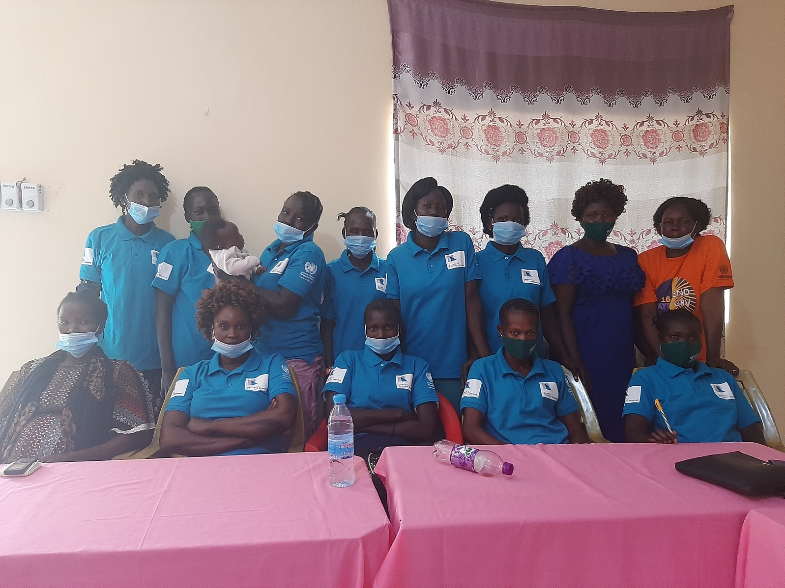
Young women network group members in Torit after a focus group discussion session:

Prepared by Stephen Wani-DM&E Officer

22nd .April. 2021

Table of Content

- Abbreviations………………………………………………………….………….…………………….……....3

- Introduction………………………………………….……………………………………………………….....4

- Methodology………………………………………..………………………………………………………......5

- Findings……………………………………………...……………………………………………………….....6

- Conclusions……………………………………….………………………………………………….….….….16

- Recommendations…………………………………….………………………………………………….….....16

- Lessons Learned……………………………………………………………………………………….…..…...17

- Indicator’s measurement table…………………………….…………………………………………….….…..18

- Appendices……………………………………………………….………………………………………..……19

Abbreviations and Acronyms

CRN | Catholic Radio Network
CRW | Crown the Woman
COVID-19 | Coronavirus Disease
FGD | Focus Group Discussion
IDP | Internally Displaced Persons
KII | Key Informant Interviews
NWERO | National women empowerment and rehabilitation organization
R-ARCSS | Revitalized agreement on the resolution of conflict in South Sudan
SFCG | Search for Common Ground
SGT | Sergeant Esther
SOP’s | Standard Operating Procedures
UNPBF | United nations Peacebuilding fund

Introduction:

Search for Common Ground (Search), through the lead of the DM&E Officer and the technical support of the Regional DME Officer covering South Sudan conducted the monitoring visit for the UNPBF project activities in the project locations of Torit, Yei and Juba. The assessment targeted mainly the areas where partners of Search (NWERO, Crown the Woman, Ana-Taban Art Initiative and CEDAR) conducted activities. Additionally, the monitoring visit aimed at assessing the partner radio stations that have mainly aired its radio programs that included Sgt. Esther drama, Nuswan salaam and profiling of young women peace builders across the project sites. While in the field, the DME Officer contracted the services of research assistants and community mobilisers in the respective locations.

The Monitoring Visit Objectives:

To monitor the activities implemented by Search and its partners in UNPBF project activities in Torit, Yei and Juba respectively. The exercise assessed the quality, level of implementation (progress/timeline) and intended and unintended changes achieved;
- To monitor the reach, resonance and response of UNPBF radio programs for both the drama series and live talk shows in the selected radio stations across the project locations. Besides Eye radio, the 5 CRN radio stations have been selected to broadcast mainly Sgt Esther radio drama.
- To assess the effects of COVID-19 on the peacebuilding activities conducted by Search and its partners across the project sites with main focus on the quality, timeliness, reach of the target population, and changes achieved.
- Clearly document key lessons and successes as well as the best practices

Monitoring visit questions based on objective(s).

Objective-1
- Are the activities reaching the expected target groups?
- Are activities implemented leading to enduring change among the target groups and communities?
Objective-2
- Reach: Who has hard the show-Has the target audience hard the UNPBF radio programs?
- Resonance: Is the content of the UNPBF radio programs relevant for the context? Does it resonate with the target audience? What could be changed/improved?

Objective-3
- What has been the collective effect(s) of COVID-19 on project implementation? What challenges has it posed? Opportunities?
- What is the level of success of activity implementation in delivering project results given the effects of COVID-19?
- How does future programming need to be adapted taking into account Covid-19?
Objective-4
- What lessons can be drawn from the implementation of UNPBF activities?

Purpose of the internal assessment:

Internally, Search would be able to measure the impact created among the target groups/communities as well as document lessons learned on how the program activities have been implemented to provide concrete reasons for decision taking by management. The findings meanwhile would provide Search for Common Ground program team a strong basis for how decisions can be taken in terms of planning for continued programming as well as documenting best practices. Additionally, the assessment also aimed at assessing the indicators progress compared to the baseline figures obtained prior to the start of the project.

Methodology of the assessment:

The methodology developed for this assessment was both qualitative and quantitative. Qualitative data was collected through Key Informant Interviews (KIIs) and Focus Group Discussions (FGDs) (with members of listeners groups and non-listeners), while quantitative data was collected through the use of surveys. The DME Officer led the team of research assistants with support from the project partner staff in ensuring the target respondents were reached out to in the particular project sites.

Data collection tools:

The monitoring visit engaged partners and project beneficiaries through KIIs and FGDs mainly to assess the level of implementation (progress/timeline), changes achieved and the effect of COVID-19 towards attaining results. KIIs aimed at getting information from influential people at both local and national level perspectives on some of the issues they observe as pertains to young women led initiatives, while FGD sessions aimed at gathering the general views of the members who are beneficiaries and those who have not been reached by the program. In total, the assessment reached 162 out of the planned 180 respondents where 123 (76%) were females and 39 (24%) males.

Meanwhile 8 focus group sessions and 8 KIIS were conducted. Majority of the respondents ranged from the age of 20-34 (68%) and this was followed by respondents aged 35 years and above (24%). Only 8% represented respondents from the age groups of 14-19 respectively. The total respondents reached were 62 in Torit, 53 in Yei and 46 in Juba. 87% of the respondents have atleast attained secondary and above in their levels of education and only 13% have completed primary or have not attended school.

Analysis of the Data and Reporting:

The data analysis was led by the DME Officer and reviewed by Regional M&E Officer. The raw data analysis was started with checking raw data from the closed ended items on the interview guide and the questionnaires mainly to establish the accuracy, usefulness and completeness. The data collected was processed by use of Kobo-collect where frequencies and percentages were generated to summarize the data in line with the survey questions. Meanwhile qualitative data was cleaned and sorted to identify the themes based on the objectives of the assessment. was code by the DME Officer and entered into Kobo-collect for accurate analysis. Quotes from KIIs and FGDs were added to provide detailed information to substantiate the quantitative data.

Limitations during the assessment:

Covid-19 restrictions could not permit meeting of all the target respondents in all the three locations and this could not permit the target of the respondents to be reached as planned. Respondents expected more benefits after taking part in the exercise as this was more evident in Juba. Delays from the partners focal points that were tasked to mobilize the participants hence causing delays in data collection.

Key Findings
Objective-1
- Are the activities reaching the expected target groups?
- Are activities implemented leading to enduring change among the target groups and communities?
The young women formed networks in Torit by NWERO have already done tremendous work after attaining their training on how to contribute to the current peace efforts in the Country. The groups have conducted awareness campaigns on domestic violence that is rampant among family members which has been attributed to the current economic hardships as well as engaging the young men engaged in criminal activities within Torit town. The members of the networks have done this through having community meetings as well as conducting radio talk shows. The use of these network groups seems to have worked well since the same activities can be rolled out to the neighboring villages where the voices of young women are still kept low due to suppression by negative cultural practices and beliefs. The data collected indicate 89% of the respondents admitting to have shared the awareness messages with other community members.

The group of the CSO partners largely acknowledged and appreciated the mentorship sessions conducted in Yei and Torit through Search’s partner organizations, NWERO and Crown the Woman in an effort to reach out to the young women so that they can also take part in the peace initiatives like their counterparts in Juba as regards to the implementation of the peace agreement. However, due to the low levels of education and restrictions from their husbands, the participation of the young women in the peace efforts has been low. According to the survey data, 80% of the civil society organization respondents see added value in collaborating with the young women in ensuring they equally take an active role in the peace efforts in South Sudan.
A mentor and an administrator in Spirit Fm in Yei says “After the training conducted by Crown the woman, I now understand fully the R-ARCSS through the various chapters we got trained on and I now mentor young women besides training others on handcrafts and also providing them with counselling. I also use the knowledge during talk shows on spirit Fm and I have got positive feedback from the listeners”. A young woman during the focus group discussion said, “We young women needs to be empowered so that various communities can be reached with messages of aware. We women for example understand our issues better than men especially when its about rape. Some of the young women can’t open easily to share their stories as they don’t think men can keep secrets”. A young local leader in Torit says, “I have liked the topics on Sgt. Esther drama and I have always shared with my own community members in Ikotos so that they are aware. The topic on barrenness among women has created stigma for women who have not produced and I have talked to some community members on the issue so that people are treated in the same way”.

Sgt. Esther radio drama in Yei has been appreciated for creating awareness on where community members can report cases such as rape and sexual gender-based violence to the right authorities. Community members initially would report such cases directly to the military and this caused a lot of deaths, as the victims would be killed in the process of managing the cases. This came as feedback from the listeners of Radio Emmanuel, which airs Sgt. Esther radio drama in Yei. However, it’s also worth to note that the listenership of Sgt. Esther drama didn’t go well due to the security situation as government and opposition forces have always clashed in and around the town. Most of the young women who took part in the focus group meetings were well aware of the activities of young women and women led peace building initiatives with a notable number indicating continued advocacy towards overcoming the barriers that impede them from active participation such as negative cultural beliefs among others.
Based on the surveys conducted in the three locations, 83% agreed that radio dramas can create more awareness and break the negative barriers that impede young women from active participation in the peace initiatives in their respective communities.

Participants during focus group sessions conducted in Yei and Juba confirm that older women and former legislators in Yei and Juba have started working and gaining confidence for the young women and have embarked on providing guidance to them on leadership issues and how they can reach their individual career plans. This has not been the case in Torit as participants reported a gap between the senior women and their young counterparts mainly because they feel the young ones don’t have the requirements and still don’t have the needed experience. However, in Yei and Torit, based on KII’s interviews conducted, the young women have not sufficiently utilized the opportunity to make use of the women led radio programs despite been allocated enough time to advocate and voice out their concerns and issues as regards to the current implementation of the peace agreement. This was confessed by the station managers of Radio Emmanuel (Torit), Easter Fm (Yei), including Spirit FM (Yei). Largely the young women in Juba were able to effectively use the radio programs to express their concerns and share experiences especially during the Nuswan salaam and young women profiling radio programs all on Eye radio.

Based on the data, largely young women are listened to and valued as peace contributors to the country, though their absence as registered party members have led them to be left out in the current Unity government, as the appointments are done based official members of the party. The groups of young women in Torit pointed out the need for a women’s resource center where they can carry out their meetings. These centers would also work as their counselling clinics to their fellow women.

A leader for young women in Malakia Young Women in Torit says; “Through the training conducted by Search for Common Ground for the young women in Torit, there a lot of changes in the areas where we live as members. The young women were able to solve and settle conflicts within the community and now have become local peace ambassadors in the community for example I myself through training am able to have peace within myself and also help the neighbors in settling their differences and conflicts”.

Gap exist in terms of engaging the people with disabilities with special needs. Young women with disabilities especially the visually impaired still feel that the project through its partners have not done enough to ensure that women with disabilities are given consideration and this has limited their participation in the current peace efforts in the Country. This was mentioned in Juba by a group of young disabled women who benefited from the small peace initiatives. This gap has also been identified in Torit and Yei during the monitoring visit.

Specific recommendations

- More program activities be uploaded on social media platforms so that they can easily follow
- Young women programs in peacebuilding initiatives should be put on television channel
- Drama activities
- Broadcast more repeat programs on the radios.

Focus group meetings in Juba with mentees for Crown the Woman and NWERO indicate that mentorship programs tailored to empower the young women in various fields has yielded more results, including building confidence and self-esteem of the young women as well as widening their networks.

A mentee at Crown the Woman says, “Through the mentorship program I was able to get new network of young vibrant girls in the country. I have learnt about the peace process and this has made me to get the confidence to facilitate on the topics. Through the mentorship program, I was able to be awarded a grant to facilitate activity on the peace process to the young women with disability”. While another young woman mentee from NWERO and also a form three in Juba Diocese secondary school narrates that, “I feel empowered a lot, I can address people, control my anger, resolve conflicts, conduct mediation, of a family issue. I have shared with my colleagues and classmates at the school the information from the trainings I have attended more especially on peacebuilding”.

89% of the participants say they share information with their family members, friends and community members on how young women can break free from societal stereotypes and negative cultural practices that have kept them away from freely taking part in the current peace efforts in the country. During the focus group meetings, the young women in Juba and Torit have indicated sharing all that they learnt with their fellow community members.

A Program Officer for Crown the Woman adds,

“The mentorship of the young women in Juba, which was the first activity we conducted, has had an effect on the growth of the young women in peace building, communication skills, public speaking and presentation, research work and dedication from most of the young women mentored by different mentees helped them to become independent strong young women that have been able to not only travel to the different states Rumbek, Maridi, Yei to disseminate the peace agreement and mentor young women in the communities and schools which shows their growth and maturity to speak on matters that affect the nations and especially young women participating in the local and national peace processes”.

Objective-2

- Reach: Who has hard the show-Has the target audience hard the UNPBF radio programs?
- Resonance: Is the content of the UNPBF radio programs relevant for the context? Does it resonate with the target audience? What could be changed/improved?

90% of data collected in the three areas, the respondents showed that radio programs can empower more young women to actively participate in peace processes in the country. The partnership with the locally based radio stations in the different project sites worked out well. Due to network issues, the locally based radio stations’ signals have been received clearly well by the audience in Yei and Torit as the signals have not been strong enough.

Radio Emmanuel and Easter Fm aired Sgt. Esther drama well without any interruption. Though in Yei respondents preferred Spirit FM instead of Easter FM. Much as radio programs have been appreciated by most respondents, there is a need to provide some capacity building to the radio presenters so that they also clearly understand some of the programs produced by Search that aim at creating impact in the different target groups. The particular presenters for radio programs such as Sgt. Esther radio drama and Nuswan Salaam can be engaged in training that aims to equip the presenters with skills on how to get feedback from the audience through better ways of follow up questions, as well as ensuring that dramas on completed episodes are reported through the provided template.

A mentee in the ‘She Nurtures Peace Program’ by Crown the woman said, “She nurtures peace has presented to me a unique opportunity that amplify my transformational leadership skills and build my expertise on young girls’ empowerment. The program has built my capacity in terms of gaining in-depth knowledge on the peace processes which has empowered me to confidently disseminate the Revitalized Agreement on the Resolution of the Conflict in the Republic of South Sudan (R-ARCSS) and echoing the role that women have played in peace building, facilitation of a successful workshop on Strengthening women participation in local and national peace processes conducted in Maridi, Western Equatoria State and conduct a research in Lologo, Juba and developing a Project: “She Knows Her R-ARCSS”, with the objective of building the foundation of young girls on Transformational Leadership so as to bring rise a generation of women leaders who will utilize their competence to identify and address challenges South Sudan is facing at all levels, local and national, utilizing the R-ARCSS as an advocacy tool”. “I also did learn how to address people in various platforms. The radio talk shows enrich my communication skills and knowledge as it challenged me to be enlighten with global issues so as to meaningfully engage in challenging conversations”.

Through the mentorship sessions and information sharing that the mentees were able to conduct the young women proved that they were capable of sharing not only about the peace agreement but also about different skills for peacebuilding as well as expanding on their peacebuilding networks across the country. With the activities of the young women peacebuilding initiatives have been conducted, 75% of the respondents mainly in Juba and Torit indeed agreed that there has been increased awareness and knowledge among the young women on the peacebuilding issues at local and national levels.

Key identified issues within the three areas that require redress through the media programs.

Based on the data collected from the survey, early marriages and domestic violence stand out as the most identified issues or concerns that the respondents feel should be addressed through our media programs. The issue of early marriages and teenage pregnancies has been further worsened by the Covid-19 pandemic.

Meanwhile in Torit during focus group discussion, participants pointed more to girl child compensation issues which have become rampant and traumatizing for most of the young girls. Additionally, the issues on tribalism, farmers and cattle keepers have been mentioned in Yei and Torit which has largely been attributed to the recent conflict between the government and opposition forces, hence worsening the relationship of the community members from different regions who had initially co-existed together.

The respondents in both Torit and Yei identified the need for continued awareness of the 35% female participation in the current R-ARCSS. As most of them have noticed that women have not taken up positions in the various parties, which has resulted in the majority being left out of both state governments in Eastern Equatoria and Central Equatoria respectively.
Apart from Juba, young women in Yei and Torit have not taken up the provided platforms through the radio stations of Emmanuel Fm and Easter Fm to voice out their issues or concerns in regards to the current peace initiatives in the country. This was according to Lilian, the radio manager for Emmanuel Radio in Torit and Esther, the station Manager for Easter Fm in Yei.

The data collected indicate that 60% of the target beneficiaries agreed have gained access to information through the available platforms that link them to local and national peace processes.

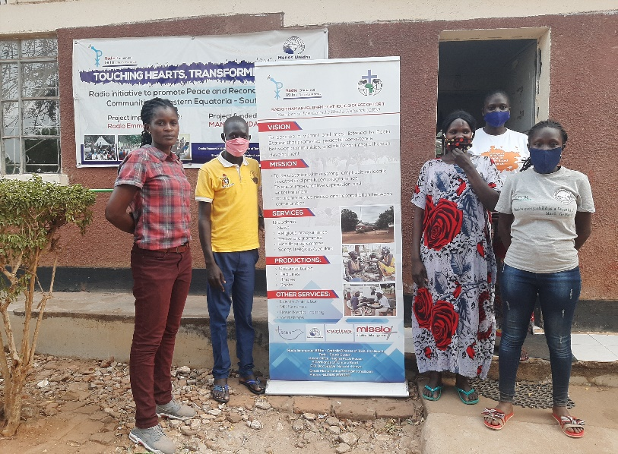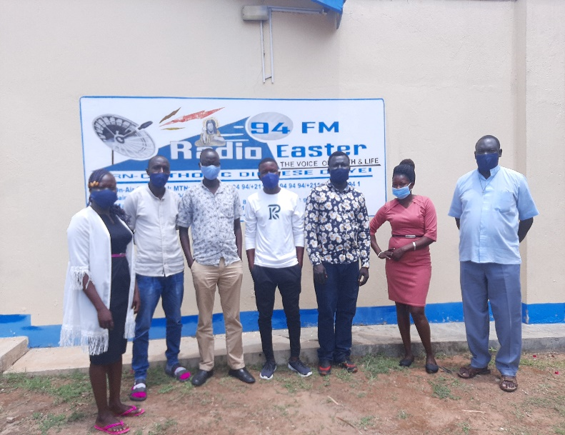
Reporters and senior Staff of Radio Emmanuel in Torit Reporters and senior staff of Easter Fm in Yei

Sgt. Esther radio drama stands out from the other radio programs that Search for Common Ground and its partners have designed and it has remained the most listened to radio program, especially in Torit, Yei, and Juba based on the findings from the respondents as well as members from the listeners groups. The radio drama aired mainly through CRN radio stations and Eye Radio, has been widely listened to with listeners from both project target beneficiaries and community members, based on the monthly feedback from the station managers.
However, much as the program has pulled listenership across the Country, the listeners groups and other target beneficiaries in Yei and Juba have not had enough time to closely follow it due to personal commitments.

Feedback from Voice of Reconciliation in Bor indicates that, Sgt. Esther drama was equally popular among the community members with most members appreciating its content and also its relevancy to the community, based on the issues that have been aired, especially on early marriages and negative cultural practices towards women. Nuswan Salaam (Women for peace) has been widely mentioned by the project beneficiaries in Juba only, however few people participated on the show as invited guests.

Though a considerable number of beneficiaries have been following the designed radio programs, a small amount of them have not been able to find time to listen due to personal commitments, mainly because of work and school programs that kept the young women away from actively engaging in the radio programs.

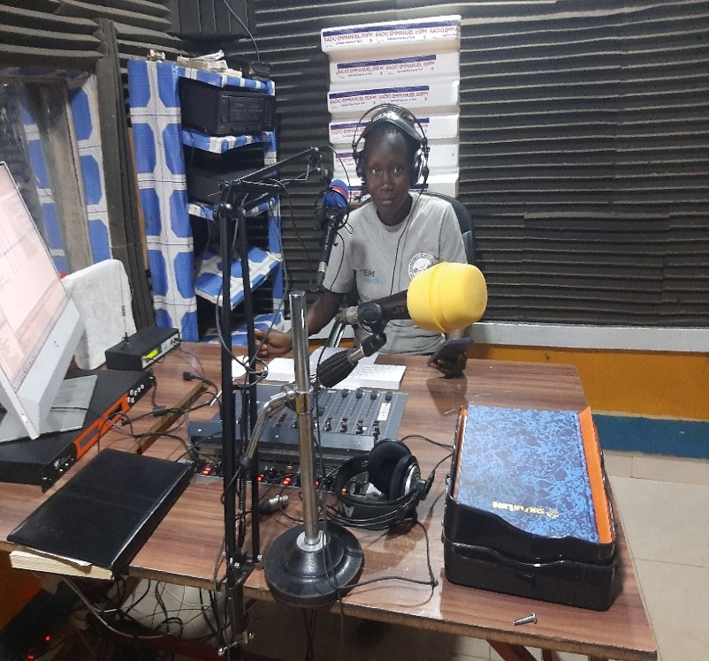
Female presenter in studios of Radio Emmanuel in Torit
Close to Nuswan Salaam, through the profiling radio program, the young women were able to get other young women from different partners nominated for the great work they have been doing, which showcased the power young women have, their voice, what they have done and continue to do to promote peace in their different communities.

82% of the respondents agreed that, radio dramas can empower and equip the young women with the necessary skills and knowledge on peacebuilding in their families and communities. Only 9% said no and 9% indicated not sure if the radio drama can empower the young women.

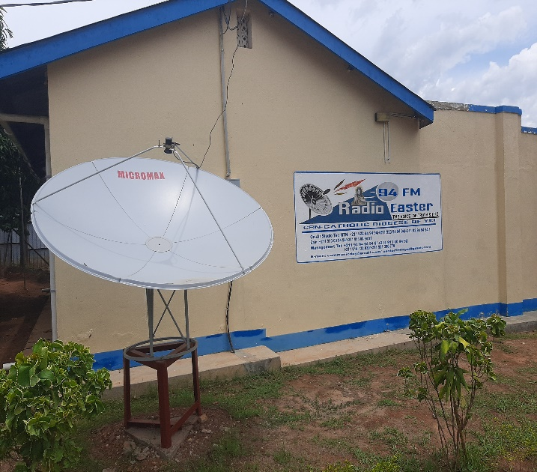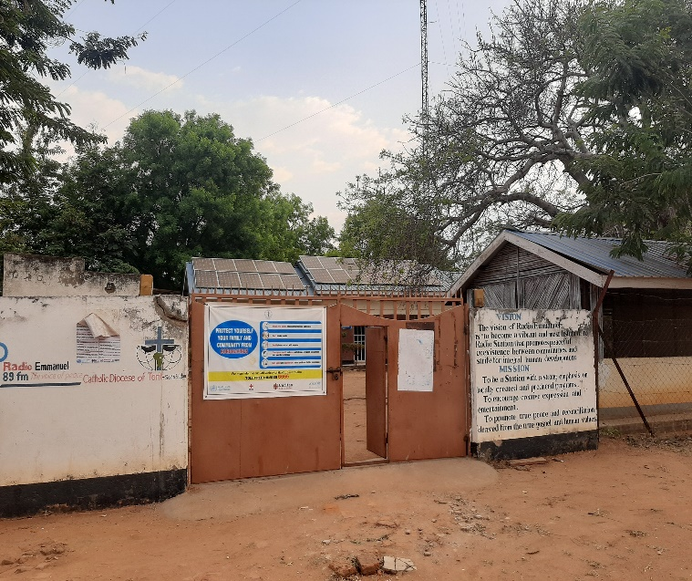
Easter Fm in Yei Radio Emmanuel in Torit

64% of the data shows that young women’s issues on peace, security, social and political issues have been well captured on the radio programs. However, 35% feel the issues have not been taken care of in the radio programs as expected. FGD sessions confirm that though the radio programs have been appreciated by target community members, a small number of participants admitted tuning in and following the radio programs.

Radio Format:

The respondents have liked the format of all the radio programs, especially the content of the topics and its relevancy to the communities. Feedback from the listeners met during the visit indicate that, the radio programs are largely liked given the language used. Section of listeners in Yei preferred additional use of local language besides the Arabic.

While listeners in Juba seem comfortable with the time of the radio programs, the ones in Yei and Torit preferred change of the time to evening hours.

The table below shows the preference of the listeners on the radio drama broadcasts in terms of time and particular days of the week.

Location | Day of the week | Time
Torit | Friday | 8:00-9:00 Pm
Yei | Saturday | 6:00Pm-7:00Pm
Juba | Saturday | 10:00-11:00 Am

Specific recommendations

- Journalist’s training on content development of peace building, this will target the state journalists for selected locations, it will create a platform for more stories to be captured and published on many other media forums for positive change.
- Translation of some programs into the major native languages that will be easily and warmly welcomed in other locations where local languages are preferred, this will equip the beneficiaries with knowledge on sensitive topics such as female empowerment and the roles they play in peace building, this will be especially useful in areas where English and Arabic aren’t understood.
- Video documentation and publication online on Eye Radio Facebook and Youtube channel to archive some of the amazing untold stories of peace makers.

Based on the monthly feedback reports from the radio stations, the radio programs have reached to all the ten states across the country, including the border towns with Uganda and Sudan. Additionally, the use of the local partner stations helped to reach out to wider communities that would not listen to radio stations based on Juba like Eye Radio whose signals may not clearly reach some of the locations.

According to the feedback from the listeners, the content of the radio programs was relevant and interactive to all community members. This has been noted in Sgt Esther drama episodes as most listeners have interacted with the presenters from across the ten States of South Sudan. 74% of the target respondents accepted and admitted hearing or being engaged in the radio programs that target the young women and creating more platforms and opportunities to actively engage in peacebuilding activities. However, 36% indicated that they have not heard any of these radio programs.

A reporter for Easter Fm in Yei and also a presenter for Sgt Esther drama narrates, “The training offered to me by Search for Common Ground in 2016 on causes of conflict, sensitive reporting and good journalism fundamentals improved my skills on how to make some follow up questions while engaging with the callers of Sgt Esther during the saw. I now understand well the issues that are depicted in the drama and I have also shared with some of my family members”.

Social Media:

The social media campaigns on the radio programs have been followed by online audiences from across the country. Based on the shared reports from Eye radio, Sergeant Esther Radio Drama reached over 60,796 people and 1,837 engagements. Most of the followers on Facebook liked and appreciated the program. “She Natures peace” radio profiling program reached over 28,011 people and 611 engagements.

Meanwhile Nuswan Salaam radio program posts stand out as the most followed program on Eye Radio’s official Facebook page with over 143,607 people reached, and 2,724 engagements since the start of the program. According to Eye Radio’s Programs Manager, “This is one of the programs that has reached out to more audience and viewers /followers on line. Through the Facebook posts, it has increased visibility for the radio programs and also allowed more feedback and interaction from the audience following online”. The overall total of people reached stands at 232,414 with 5,172 engagements.

Specific Recommendation (s)

- Need for partners to actively engage the online audience through sharing program activities/events. This would further popularize the programs across the target groups and communities.

Overall total reach for Outreach and Radio/Media Programs:

More people were reached through the outreach activities and the radio programs. The use of phone calls to get feedback from the listeners made the programs to be more popular as the participation and interaction of the callers increased the total reach. However, its worth noting that, profiling show attracted more followers and people reached on social media compared to when its aired on Eye Radio. It should be noted that, profiling show was the only radio pre-recorded program without assigned presenter at its time for broadcast.

Outreach Activities | Total | Media/Radio Programs | Total
Males | 9879 | Sgt. Esther drama | Male | 476 | 744
 |  |  | Female | 268
Females | 3179 | Nuswan Salaam | Male | 243 | 267
 |  |  | Female | 24
 |  | Profiling Show |  | 0 | 0
Overall Total: | 13058 | 1011

EFFECTS OF COVID-19
Objective-3
- What has been the collective effect(s) of COVID-19 on project implementation? What challenges has it posed? Opportunities?
- What is the level of success of activity implementation in delivering project results given the effects of COVID-19?
- How does future programming need to be adapted taking into account Covid-19?
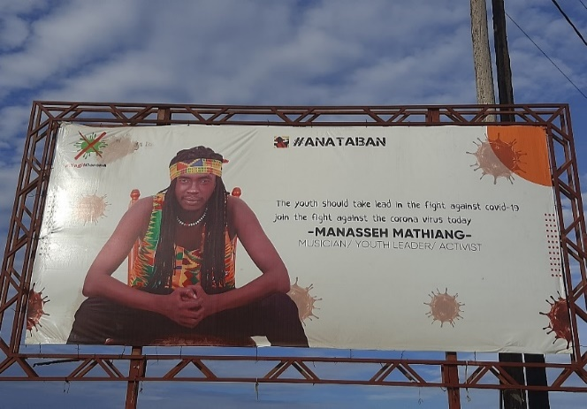
80% of the beneficiaries/respondents indicated that, Covid-19 had affected their work as most of them could not easily reach out to community members to create awareness and dissemination of information based on the revitalized peace agreement (R-ARCISS) and this limited the wider consumption of the content of the peace agreement and other related issues that bring conflict within their homes and communities. Participants in the FGD sessions in Yei and Torit also attributed the worsening cases of early pregnancies and rape among the young girls as a direct effect of Covid-19 since the Schools remained closed. Radio Managers for partner radio stations in Torit, Yei and Juba confirmed challenges while inviting guest speakers to take part in the planned live talk shows hence affecting the planned activities across the project sites. Ana-taban activities that often times bring large crowds together were affected with little been done under strict adherence to Covid-19.
The outreach activities through PBF project have been largely affected by Covid-19 as most activities got delayed from being rolled out to some of the project areas. Some of the mentees experienced challenges in meeting with their mentors as it became expensive for them to ensure that they provide online sessions.

Ana-Taban billboard on Covid-19 awareness in Yei
Also, most of the participants noted that their action plans were disrupted due to the continued and increased cases of Covid-19 and prolonged lockdown measures. Relatedly, the planned activities were not thoroughly covered by reporters from the partner radio stations (Eye Radio and Catholic Radio network reporters) and this limited further circulation of some of the issues that had been shared during workshops and training sessions.

Though the activities didn’t go as planned due to Covid-19, more of vulnerable communities were reached within Juba and the surrounding rural areas that have never been reached with messages on the peace agreement hence the this provided them with the opportunity to participate in the small initiatives on peacebuilding that were spearheaded by young women (mentees) within PBF project. The areas of Mangateen IDP, Kapuri and Shirikat areas. Through adherence to the Covid-19 SOP’s, the use of masks and handwashing as well as observing the social distance got adopted easily and this helped to minimize the further spread of Covid.

In Yei, during a meeting with reporters of Easter Fm, Covid-19 restrictions and cases of insecurity, Sgt. Esther drama managed to create the needed awareness to the majority of the rural surrounding areas of Lainya, Morobo and Kajo-keji, as the outreach activities by humanitarian organizations were reduced. This came through the monthly feedback reports from the radio. The data collected from the surveys administered indicate that 89% of the beneficiaries have shared the information got during the trainings hence this equally confirms that more community members were able to receive the Covid-19 awareness messages since topics on Covid-19 were integrated into the sessions during the implementation period.

The planned activities faced some challenges in terms of getting clearance from the security agents that have been tasked to oversee any planned activities during the time of Covid-19. The delay in clearing program activities further affected the work plan and reporting since some of the activities had to be moved ahead.

Participants throughout the focus group meetings and the KII’s interviews observed and recommended that;
- Continued adherence to Covid-19 restrictions during program implementation in all the project locations.
- More radio programs and less on outreach activities that tend to bring people together
- More awareness sessions still on Covid-19 through drama and social media

A mentee from Crown the Woman says, “With the knowledge and skills gained, I was able to form an association called Nyakuron East Indigenous youths association (NEIYA) with a number of girls that I'm trying my best to ensure the take leads and play different roles in their communities in bringing peace and social cohesion and also leading a network of youths called Youths for peaceful co-existence (YPC). mind idea of coming up with this is to mold young women and transforms our communities into a peaceful societies and the main activities we conducted are peace initiative on January 15th 2021 bringing in different Artist, musicians influential individuals, poems, dramas etc including Covid-19 awareness on 13th march 2021”.

Program Sustainability:

Though 80% of the respondents see added value when collaborating with young women in peacebuilding initiatives, only 62% still believe CSOs have plans to carry on and sustain the young women programs beyond end of the project. KII’s interviews and FGD’s conducted with CSO members in Torit and Yei suggest that more focus should be put on strengthening the local partners at the State levels with the needed capacity on peacebuilding initiatives so they would continue to engaging and creating awareness on the local community members. The CSO members did recommend follow up visits by Search for Common Ground to the formed groups in the State as this could further boost the continued engagement of the young women at the State level.

The approach of the small peacebuilding initiatives targeting organized young women led groups can contribute to more results leading to enduring change among the individual participants and the respective communities.
Objective-4
What lessons can be drawn from the implementation of UNPBF activities?
General Conclusions
- Mentorship programmes have largely been appreciated by the CSO partners and the mentees of both Crown the Woman and NWERO.
- The small peacebuilding initiatives exposed and provided the young women groups with opportunity to practice and apply the skills and the knowledge gained during the various trainings they attended and how they can handle and manage conflict within their families and respective communities. Three small initiatives were effectively implemented by selected mentees in the areas of Lologo and Gudele in Juba.
- The formation of the young women network group members worked well in enhancing unity and social cohesion of the members from different communities across South Sudan.
- For effective participation of the young women in the current implementation of R-ARCISS, more young women have to join the various political parties so more opportunities of being appointed are increased as well as closing the 35% gap offered to women.
- The partnership with local radio stations worked well in enhancing young women’s participation in peace efforts. The use of the different local languages has provided the platform for the rural women to actively take part in the discussions that pertains peace. The use of English has been considered for the urban elite hence limiting participation of the rural young women.
- Sgt Esther radio drama still remains the top most listened to radio program and followed by Nuswan Salaam. While Nuswan salaam leads in the Urban areas like Juba, Sgt Esther takes the overall lead across the country with considerable number of callers from the different States as indicated in the feedback reports after every episode.
- Social inclusion of the target beneficiaries has not been done effectively. The selection criteria for the participants needs to be revisited so that people with special needs can be equally engaged in the peace building initiatives. During a FGD session in Juba, members with special needs echoed this as a great concern.
- Continuous support of the young women through small peacebuilding initiatives would further sharpen and broaden the skills and knowledge of the target group members in reaching out to more community members through creation of awareness sessions on identified social issues such as on domestic violence, rape, tribalism and peaceful co-existence among others that have created social fabrics among the community members.
- Continued adherence to Covid-19 restrictions contributed a lot in terms of program implementation in all the project locations.
General recommendations:
- Media trainings are needed to strengthen the capacity of the radio presenters in terms of understanding the content of the radio programs produced by Search, so that she/he is fully aware of the issues being discussed. Additionally, Easter Fm (Yei) and Radio Emmanuel (Torit) don’t have enough equipment to support their work effectively. The two radio stations have small studios which may not be convenient for invited guests during radio talk shows. Institutional development support would boost and strengthen the work of the partner radio stations.

- Need for regular follow up visits with the target groups once they are trained. These visits would help to ensure the participants work on their action plans and further dissemination of the awareness messages to the grassroot levels.

- Young women centers need to be identified/established, so that issues that concern them can be discussed at the centers without any interruptions. Mentoring, coaching and counselling sessions can also be held within the centers through the use of the mentor mothers and could additionally reach women in rural areas.

- Continued radio awareness through conducting more talk shows and allocating more slots to the active young women in the selected radio stations.

- Peace agreement content disseminations should equally be shared through the radio stations besides during workshops. The hard to reach rural communities would gain from this arrangement hence wider information dissemination.

- Radio programs could be aired repeatedly on the radio stations, so that more people can get chance to listen to previously broadcasted episodes.
- Regular follow up visits to the listeners groups as this would encourage more of the members to listen to the radio programs.
- Engage more experts to interact with the young women for experience sharing in the different thematic areas

- More days should be allocated to training programs instead of only 1 or 2 days especially for sessions on dissemination of Peace agreement chapters (R-ARCSS) require more time and comprehension of the content.

- Members in the focus group sessions conducted in the three locations of Torit, Yei and Juba have requested that Search continues to further extend its activities of awareness creation on young women participation to the grassroots levels.

- Need for Search and its partners to further consider engaging people with special needs, so that the gap is narrowed so they equally participate in the peace initiatives in their respective communities.

- More focus should be put on young men as another target group since cases of rape and criminality have been on the rise which have been largely attributed to them as reported in Yei, Torit and Juba.

Lessons learned

- Young men stand to benefit from the program activities in the 3 locations visited based on the current rate of criminality and rape cases that have been attributed to them by the participants through KII’s and focus group feedback.
- Integration of Covid19 messages into program activities continues to create more awareness to the wider community members on the dangers of the disease.
- Civil society partners collaborate well with the UNPBF partners at the State levels and this has strengthened their engagement efforts.
- Covid-19 cases and insecurity may affect the target beneficiaries/communities from achieving the desired change.
- Partners did little to ensure they make follow up activities to the target beneficiaries especially in Torit and Yei. Frequent visits would ensure more consolidation of results.
- The radio programs have been well followed by the online audience compared to the outreach activities

Table showing indicators measured during the assessment:

Indicators | End of Project indicator target | Current indicator Progress
Indicator 2a: % of respondents who believe women and youth are listened to as valued contributors to peace and security | 70% | 77%
The members of my community believe that young women and older women can have collaborative relationships in the community (PERCEPTION) | 65% | 68%
Indicator: % of target participants who report increased access to platforms which link local and national-level women-led peace efforts | 60% | 60%
Indicator:1.2.1 % of participants who can explain at least two specific peacebuilding concepts they learned as a result of project trainings | 65% | 75%
Indicator 2.1.1: % of listeners who can cite at least one instance of positive leadership by women from one of the radio programs | 60% | 86%
Indicator 1.3.1: % of CSOs who report they see added value in collaborating closely with young women to promote peace in their communities. |  | 80%
Indicator 1.3.2: % CSOs respondents who report they have a plan for activities that improve young women’s participation in peace efforts beyond the project’s end |  | 62%

Project: | Monitoring Visit Tool
Activity: | UN-PBF
Persons Responsible: | DME Officer and Research Assistants
Project Locations: | Juba, Bor, Torit & Aweil

Introduction: “My name is ________________ and I am conducting a media and outreach activities monitoring visit on behalf of Search for Common Ground. We are asking people in this area about the participation of young women in peacebuilding efforts in South Sudan. The results of this survey will be used to inform the sponsored UN-funded project, Strengthening Young Women’s Participation in Local and National Peace Processes in South Sudan. Your participation is voluntary, you can choose to quit the discussion at any time. Your name will remain confidential and will not appear in connection with the information you provide. We will anonymize and aggregate the data. The survey will last approximately 10-15 minutes of your time. Do you have any questions before we begin?”
Do you consent to participate in this survey?
Yes, No (if no, stop the survey)

- Do you believe young women have been taking an active role in the current peace efforts in the country?

- Yes
- No
- Not Sure

- Do you think through radio programs, more young women can be empowered and take part in the peace processes in the country?

- Yes
- No
- Not Sure

- If yes, could you kindly mention a radio station that has aired a women-led program?
- Classic FM
- Eye Radio
- Capital FM
- Bakhita Radio
- Miraya FM
- SSBC Radio
- Emmanuel FM
- Esther FM
- Spirit FM
- Others (Specify)_________________________________________________________

- If no, what could be the reasons?

____________________________________________________________________________________

____________________________________________________________________________________
- Do you think young women's concerns on peace, security, social and political issues are clearly addressed on the radio (measure for resonance - is the content relevant)?
- Yes
- No
- Not sure

- Do you think discussing more of young women’s concerns on the radio can change the negative stereotypes of women in the community?
- Yes
- No
- Not Sure

- Have you heard of the [description of radio or online program] (measure for reach)?
- Not at all’
- someone in my network told me about it’
- I know about it’
- I am engaged in the program

- Are you sharing information on young women’s participation in the peace processes or women’s leadership that you have heard on the radio in conversations with your friends or family (measure for response)?
- Yes
- No
- Not Sure

- Do you think through radio programs like Sergeant Esther radio drama being broadcast on Eye Radio and CRN Radio stations across South Sudan would lead to more young women participating in leadership roles in local and national levels?
- Yes
- No
- Not Sure

- What issues that affect young women’s participation in the peace processes would you like to hear being addressed through the radios and the outreach programs (this is more input / feedback rather than resonance)?
- Early marriages
- Domestic Violence
- Drug Abuse
- Child abductions
- Others (Specify)_________________________________________________
- Can radio dramas such as Sergeant Esther create more awareness and break the barriers that hinder young women from participating in peace initiatives across South Sudan?

- Yes
- No
- Not Sure

- Do you think the radio programs will be able to equip the young women peace builders with enough information on the issues of gender and social inclusion in South Sudan?
- Yes
- No
- Not Sure

Likert Scale for listeners:
To what extent do you agree with these statements: please rank on a scale from 1 to 5:
1 – Strongly disagree
2 – Disagree
3 – Neither agree or disagree
4 – Agree
5 – Strongly agree

1. Young Women are listened to as valued contributors to peace and security in the current peace processes (Indicator 2a: % of respondents who believe women and youth are listened to as valued contributors to peace and security).
1.1. The members of my community believe that young women and older women can have collaborative relationships in the community (PERCEPTION)
2. Young Women have gained access to information through available platforms that link them to local and national peace processes. (indicator: % of target participants who report increased access to platforms which link local and national-level women-led peace efforts)
3. There has been increased awareness among the young women on understanding the peacebuilding issues at both local and national levels (indicator:1.2.1 % of participants who can explain at least two specific peacebuilding concepts they learned as a result of project trainings)
4. The radio programs have increased awareness on the role of the women leadership in conflict transformation (Indicator 2.1.1: % of listeners who can cite at least one instance of positive leadership by women from one of the radio programs)
5. CSOs see added value in collaborating closely with young women to promote peace in their communities (iindicator 1.3.1: % of CSOs who report they see added value in collaborating closely with young women to promote peace in their communities)
6. CSOs have a plan for activities that improve young women’s participation in peace efforts beyond the project’s end (indicator 1.3.2: % CSOs respondents who report they have a plan for activities that improve young women’s participation in peace efforts beyond the project’s end)

Characteristics of the respondent
Date of interview: |  | Enumerators code:
Gender: | Female | Male
Location:  Juba: (Yei, Maridi & Yambio)  Bor:  Aweil:  Torit: |  | Education Level:  - No education  - Primary school  - Secondary school  - University / higher studies  - Vocational training
Age:
- 14-17 18-19 20-24 25- 29
- 30-34 35-49 50 et +

Thank you for your time and participation. We will hopefully meet again after three months to talk about similar topics.

Altiok and Grizelj (2019). We Are Here: An integrated approach to youth-inclusive peace processes

