EMERGENCY SUPPLY CHAIN SUPPORT TO THE COVID-19 RESPONSE IN MALAWI
June – December 2020
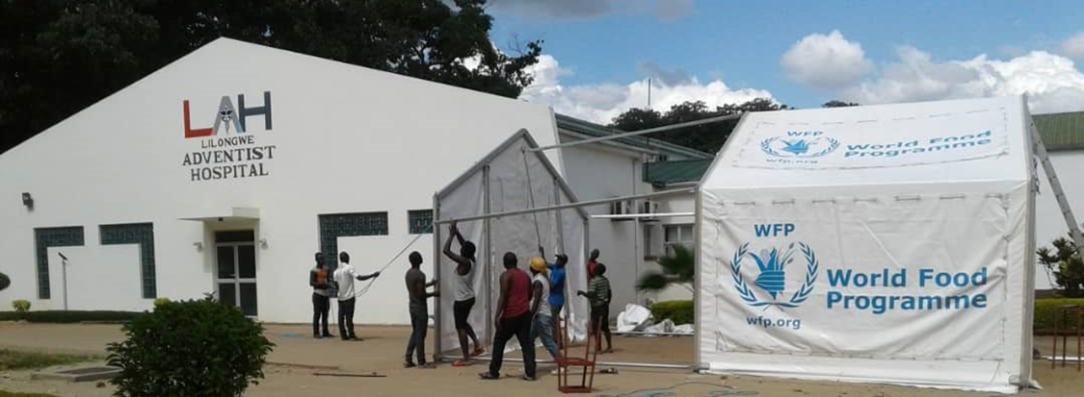

Alignment with the National Response Plan: National Transport and Logistics Cluster

Geographic areas reached: Lilongwe, Blantyre, Mzuzu, Mwanza, Nsanje, Dedza, Ntcheu, Mchinji, Karonga or other COVID-19 at risk districts identified by the Government

Beneficiaries assisted: Over 41 humanitarian organisations delivering assistance to the most vulnerable

Total budget: US$ 120,000

BACKGROUND
Even though the Government of Malawi and the humanitarian community obtained significant accomplishments in restraining the spread of COVID-19 and in limiting the impacts of the pandemic on the Malawian society and economy, as of December 30th confirmed COVID-19 cases in Malawi amount to 6,471 cases and total deaths to 189 across all districts since the outbreak of the pandemic, out of which 398 are active cases.
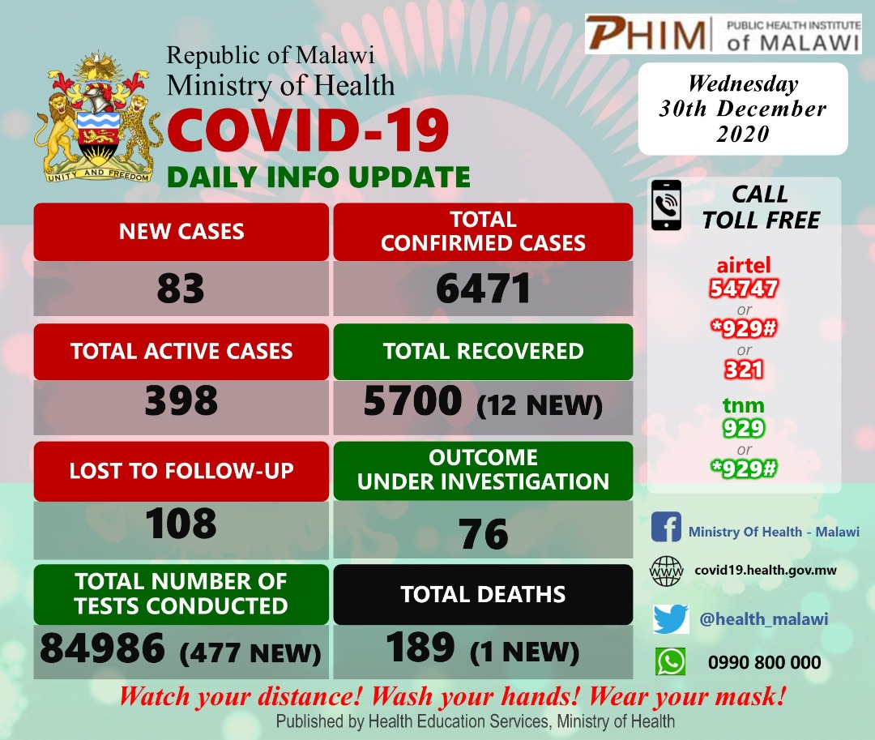
COVID-19 Daily Info Update Malawi

While these numbers might appear low as compared to other parts of the world, scarce screening and isolation capacities, the persistence of supply chain challenges such as limited storage and infrastructure capacities, delays in the sourcing and the delivery of essential goods, reduced aviation capacity as well as new challenges to logistics coordination and information sharing due to social distancing, have posed an unprecedented threat to the functioning of logistics operations and hence the livelihoods of the Malawian population in recent months.
Thanks to support from the Malawi SDG Acceleration Fund, WFP Malawi, as co-lead of the National Logistics Cluster, has facilitated the delivery of humanitarian assistance by augmenting logistical support in line with the government-led COVID-19 Preparedness and Response plan and thereby significantly contributed to mitigating the effects of COVID-19 in Malawi.
This final report seeks to point out the key achievements and successes attained by WFP Malawi with financial assistance from the Malawi SDG Acceleration Fund between the months of June and December 2020, amidst the global COVID-19 pandemic. Moreover, it is the aim of this report to account for progress made against planned activities and to outline experienced challenges and lessons learned during this period.
PROJECT OBJECTIVE
In close cooperation with the Government of Malawi, WFP Malawi and the National Logistics Cluster strive for strengthening supply chain capacity and augmenting infrastructural capacity in Malawi. The primary objective is to ensure the timely and uninterrupted delivery of essential and lifesaving relief items to the beneficiaries in affected communities, even under conditions impeded by the COVID-19 pandemic.
SUMMARY OF INTERVENTION
Between June and December 2020, WFP has supported 41 organisations in Malawi, including key government entities, to ensure an efficient COVID-19 logistics response. The key operations, divided into Service Provision and Logistics Coordination as the two focal areas presented in the proposal and Emergency Flash Appeal, are highlighted below.

Service Provision

In close collaboration with the Government and other members of the National Logistics Cluster in Malawi, WFP has provided three core services to logistically support the COVID-19 response.

Storage – In order to store personal protective equipment (PPE) and other COVID-19 supplies to be used in health facilities and by Malawian returnees, partners, including the Ministry of Health, UNICEF, UNHCR, Last Mile Health and the Malawi Red Cross Society, were able to utilize over 600 m² of WFP common storage space in Lilongwe and Blantyre.

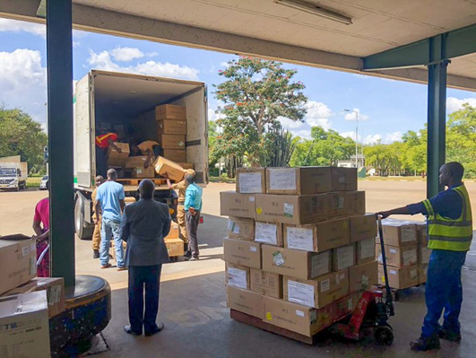
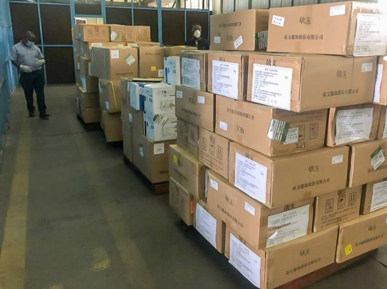
The storage of vaccinations presents a major challenge to logistics during the COVID-19 response in Malawi due to a lack of cold chain infrastructure, equipment and personnel trained for the handling of vaccines. Therefore, discussions on Malawi’s cold chain capacity with government entities and other partners were initiated to plan for the storage of the COVID-19 vaccine in the course of contingency planning for 2021.
Personal Protective Equipement (PPE) and other COVID-19 emergency supplies were transported and stored for government partners and other organisations due to the support of the Malawi SDG Acceleration Fund.

Transportation – A total of 48,9 MT cargo has been transported by WFP Malawi during the COVID-19 response so far.

- 39,9 MT of cargo have been transported by road to 13 districts: Blantyre, Dedza, Karonga, Lilongwe, Mangochi, Mchinji, Mulanje, Mwanza, Mzimba, Ntcheu, Nsanje, Chikwawa and Zomba.

- 9 MT of light cargo were transported for other UN agencies and NGOs by air to Kamuzu International Airport from WFP’s regional and international humanitarian logistics hubs established under the Global Humanitarian Response Plan.

- With approval from the Malawi Government for operating humanitarian passenger flights, WFP Aviation successfully facilitated 22 flights transporting 168 passengers to and from Lilongwe and other countries in the region. The last flight was conducted in September 2020 since airports reopened as per Government directive.

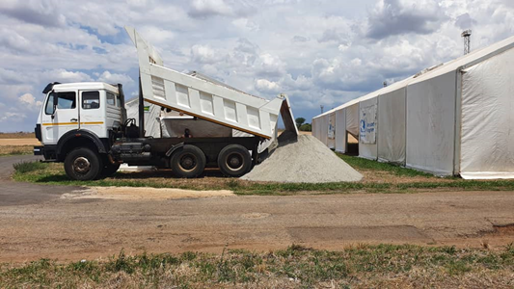
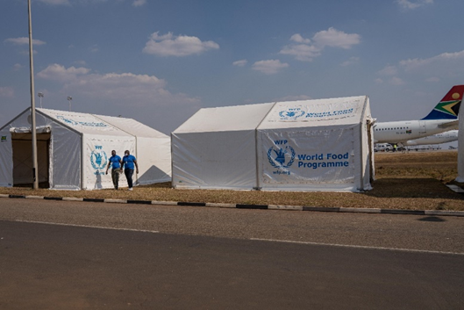
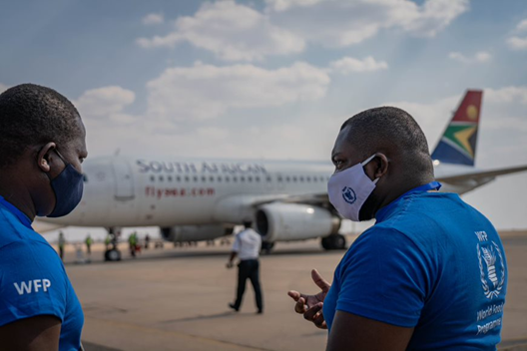

WFP Malawi has facilitated air transport for 168 passengers while commercial flights remained suspended in Malawi and set up mobile units at Kamuzu and Chileka International Airports to serve as screening areas for passengers as they arrive now that commercial flights are operational again.

Light engineering
In consultation with the Department of Disaster Management Affairs (DoDMA), the Ministry of Health, the Health Cluster and other key stakeholders, WFP provided engineering support through the:

- Deployment of 22 Mobile Storage Units (MSUs) at border posts (Dedza, Karonga, Mwanza, Ntcheu and Mchinji) for screening and isolation to support the reception of returnees; at health centers (Kamuzu Central Hospital in Lilongwe, Partner in Hope Medical Centre, Mzuzu Central Hospital) and the Dzaleka Refugee Camp to facilitate the isolation and quarantine of COVID-19-infected patients.
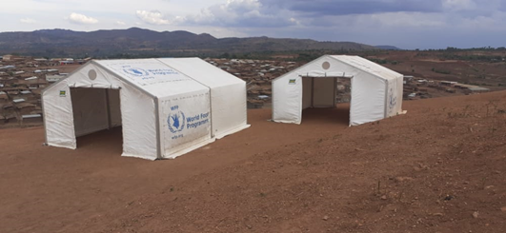
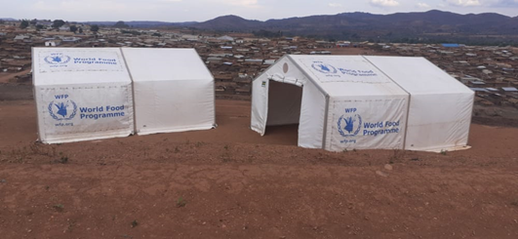

Thanks to the support of Malawi SDG Acceleration Fund, Mobile Storage Units were erected at the Dzaleka Refugee Camp and are used as shelters for quarantine and isolation of patients with mild COVID-19 symptoms.

- Installation and upgrading of 6 tents in cooperation with the Department of Civil Aviation and Airports at Kamuzu International Airport and Chileka International Airport, that are used as centers for screening and temporary isolation during the on-going re-opening for commercial flights in Malawi to improve the flow of passengers upon arrival.

- Development of a concept for converting shipping containers into mobile COVID-19 laboratories to expand the testing capacity of the Ministry of Health. The handover of the first container labs site occurred on December 8th and initiated the process of installing five container lab units in the districts of Dedza, Karonga, Mwanza, Mchinji and Chitipa.

Logistics Coordination and Supply Chain Information Management

Weekly online logistics coordination meetings were organized by WFP Malawi and held together with the Ministry of Transport and Public Works via Zoom. These meetings enabled partners to discuss transport planning, storage needs and district-level assessments. Moreover, the participating organizations and government counterparts presented their course of action during the COVID-19 response as well as experienced challenges. The imposed COVID-19 restrictions regarding social gatherings as well as the recommendations for remote working challenged the operation of logistics coordination and supply chain information management for everyone involved. To facilitate increased information sharing and enable operational planning between National Logistics Cluster partners, a dedicated COVID-19 logistics webpage was utilized and 55 information management products have been shared so far via this platform.

Furthermore, a Logistics Emergency Preparedness Technical Working Group was set up in October 2020 to update the Preparedness Action Plan and the National Contingency Plan and to actively discuss logistics and emergency preparedness related topics with eight key partners. So far, three technical working group meetings were successfully held with attendance of MSF Belgium, the Ministry of Transport and Public Works, MSF France, the Department of Civil Aviation, Concern Worldwide, Last Mile Health, FAO and UNICEF.

List of Partners
-Technical working group members and other key partners are highlighted-
Department of Disaster Management Affairs (DoDMA)
Ministry of Transport and Public Works (MoTPW)
Ministry of Health
Malawi Defence Force (MDF)
Roads Authority
Malawi Police Service (MPS)
Marine Department
National Food Reserve Agency (NFRA)
Airport Development Limited (ADL)
Department of Civil Aviation (DCA)
Partners in Hope
Welthungerhilfe
Adventist Development and Relief Agency (ADRA)
Oxfam
Save The Children
Medecins Sans Frontieres (MSF)
ActionAid
Concern International
Concern Worldwide
Plan International
United Purpose
Tearfund
Care Malawi
Evangelical Lutheran Development Services
Shelter Box
Department for International Development (DFID)
Last Mile Health
Catholic Relief Services
Clinton Health Access Initiative (CHAI)
Eagles Relief Development Programme
Malawi Network of Older Persons' Organizations (MANEPO)
Adventist Health Centre
Dee Yang Luke Hospital (UN Clinic)
Malawi Red Cross
United Nations World Food Programme (WFP)
United Nations Children's Fund (UNICEF)
United Nations Office for the Coordination of Humanitarian Affairs (OCHA)
UN High Commission for Refugees (UNHCR)
United Nations Food and Agriculture Organisation (FAO)
United Nations residents Coordinators Office (UNRCO)
World Health Organisation

Another key accomplishment was the pilot launch of the new Logistics Information Exchange (Log:ie) platform for Malawi in cooperation with the Global Logistics Cluster. Data on partners’ capacity in the country were collected and uploaded to the system. The goal is to create an interactive map that visualizes logistics capacity in Malawi and enables all stakeholders to regularly update logistics information by means of rapid data collection tools. In order to engage partners in the data collection for the Log:ie system, an introduction session was held on November 25th for interested partners, namely the Malawi Defense Force, Save the Children, SPRODETA, GOAL Malawi, Tearfund and Concern Worldwide. A training exercise was sent out thereafter to the participants and discussed in a second meeting on December 2nd. The official launch of Log:ie is scheduled for January. In the meantime, the test version is accessible here: https://logie-mwi.netlify.app/ .

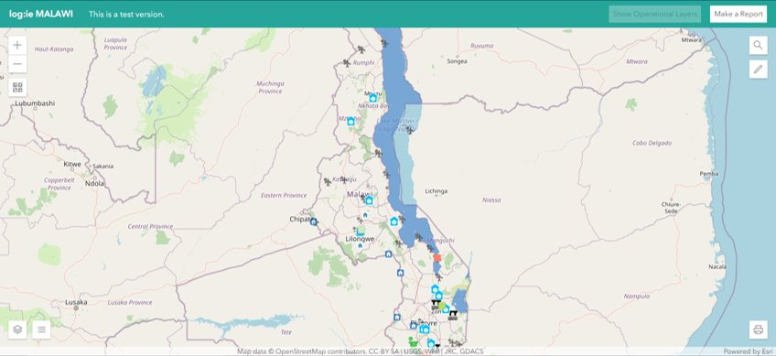

Preview of the Log:ie test version for Malawi including the new data entries on partners’ capacity in the country.

MONITORING & EVALUATION

MONITORING AND EVALUATION TABLE

Indicator | Baseline | Target | Achieved | Data source
Amount of storage space availed | n/a | 500m² | 600m² | Maps, stock reports, infographics
Number of Mobile Storage Units (MSUs)/tents deployed at health centers or points of entry | 10 MSUs | 30 MSUs | 38 MSUs | Maps, physical verification
Amount of cargo handled | 10 MT | 40 MT | 48,918 MT | Infographics, stock reports
Percentage of logistics service requests fulfilled | 80% | 90% | 100% | Service request forms completed
Number of coordination meetings held | 8 | 20 | 37 | Meeting minutes
Number of organizations utilizing logistics coordination, Information Management (IM) and services | 20 | 30 | 41 | Infographics, contact lists, external shared drive, email statistics
Number of IM products developed, disseminated and made accessible to cluster members | 15 | 30 | 55 | Infographics, meeting minutes, external shared drive, logistics cluster website/tool

CONTACTS

Marco Cavalcante - | Deputy Country Director | marco.cavalcante@wfp.org
Badre Bahaji | Head of Partnerships, Reports and Communications | badre.bahaji@wfp.org
Franck Aynes | Head of Supply Chain | franck.aynes@wfp.org
Patrick Mills Lamptey | Logistics Cluster Coordinator | patrick.millslamptey@wfp.org

SUCCESS STORY
New Challenges, New Partnerships: WFP’s and Last Mile Health’s joint combat against COVID-19

The National Logistics Cluster and WFP have played a significant role in the humanitarian COVID-19 response by coordinating between the various stakeholders in Malawi and by supporting partners with the provision of free-to-user logistics services. In this way, existing partnerships were strengthened, and new ones were established. One prime example of such a new alliance is the collaboration between WFP and Last Mile Health.

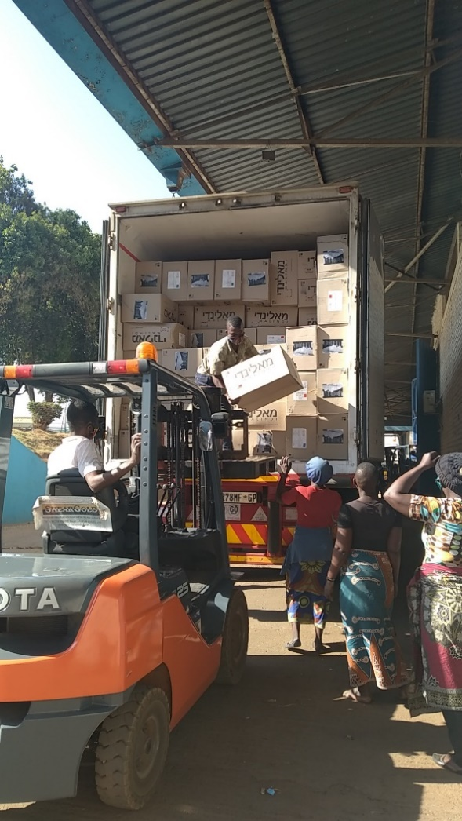
Founded in 2007 in Liberia, Last Mile Health officially expanded their reach to Malawi in 2020 after undergoing preparatory arrangements in 2019. “Bringing a health worker within reach of everyone” – the significance of their guiding principle has become even more tangible with the global COVID-19 pandemic threatening the livelihoods of the most vulnerable in countries already facing a lack of health personnel and supplies. As COVID-19 has been impeding the operations of humanitarian actors on an unprecedented scale, Last Mile Health’s opening in Malawi came at a time most needed and most challenging.

Supporting the Ministry of Health in implementing the National Community Health Strategy, Last Mile Health is providing essential health care to communities in the rural and remote parts of Malawi where one-tenth of the population is situated more than eight kilometers from the nearest health facility. Whilst building on resources and experiences of their work in Liberia, the establishment of new relationships and the mastery of the challenges brought about by the COVID-19 pandemic were among the major tasks for Last Mile Health when starting its projects in Malawi.

Offering support services to its partners, the Global Logistics Cluster assisted Last Mile Health with the transportation and storage of much needed PPE to district hospitals and health centres in Chikwawa and Nsanje district. Apart from ensuring the timely supply
The WFP Lilongwe warehouse team loading off the PPE supplies for Last Mile Health
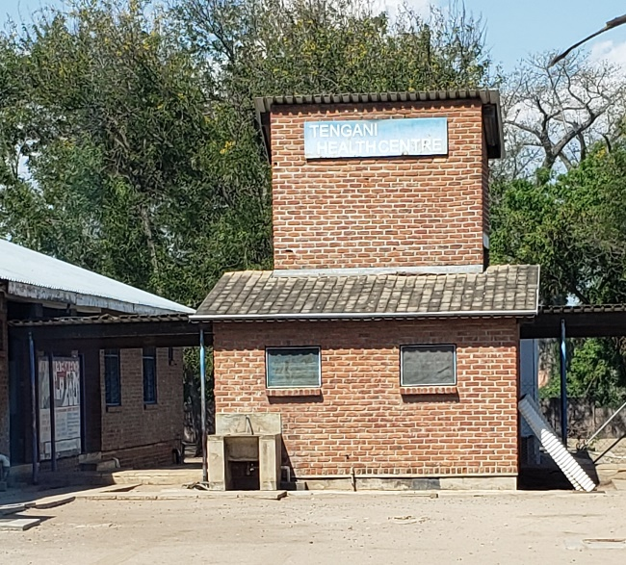
of PPE to the health facilities and therefore enabling Last Mile Health to dedicate more funds to the actual purchase of PPE, WFP’s knowledge and experience in inventory management has helped to build up Last Mile Health’s institutional capacity as a new organisation in the country. Charity Solomon, Last Mile Health’s Operations Manager, appreciates the partnership and expresses that the collaboration has “inspired and motivated the organisation for more teamwork and collaboration with the National Logistics Cluster and other partners in Malawi”.
Tengani Health Centre – one of the health centres in Nsanje district where PPE was delivered to.

